Exercise 4

Visual depth

The purpose of this exercise is to understand the principles of perspective.

Produce three drawings from a room in your house, use one, two and three point perspective, find a place that exaggerates these points, then produce an isometric view point.
A fifth drawing where you break the rules, and a flat drawing, no need to do finished illustrations, then write 200 words analysing how the different points affect the meaning of the space.

I had a look at a book I had on art and the perspective pages, after doing some research I decided to do my drawings on my iPad again for this exercise, I find using the iPad a bit quicker than traditional work at present, and having done my last year in traditional work, I though it would be good to experiment with digital more this year.
Hobbs J (2014) Sketch your world [Apple]

Carter D (2012) A beginners guide to drawing [Igloo]

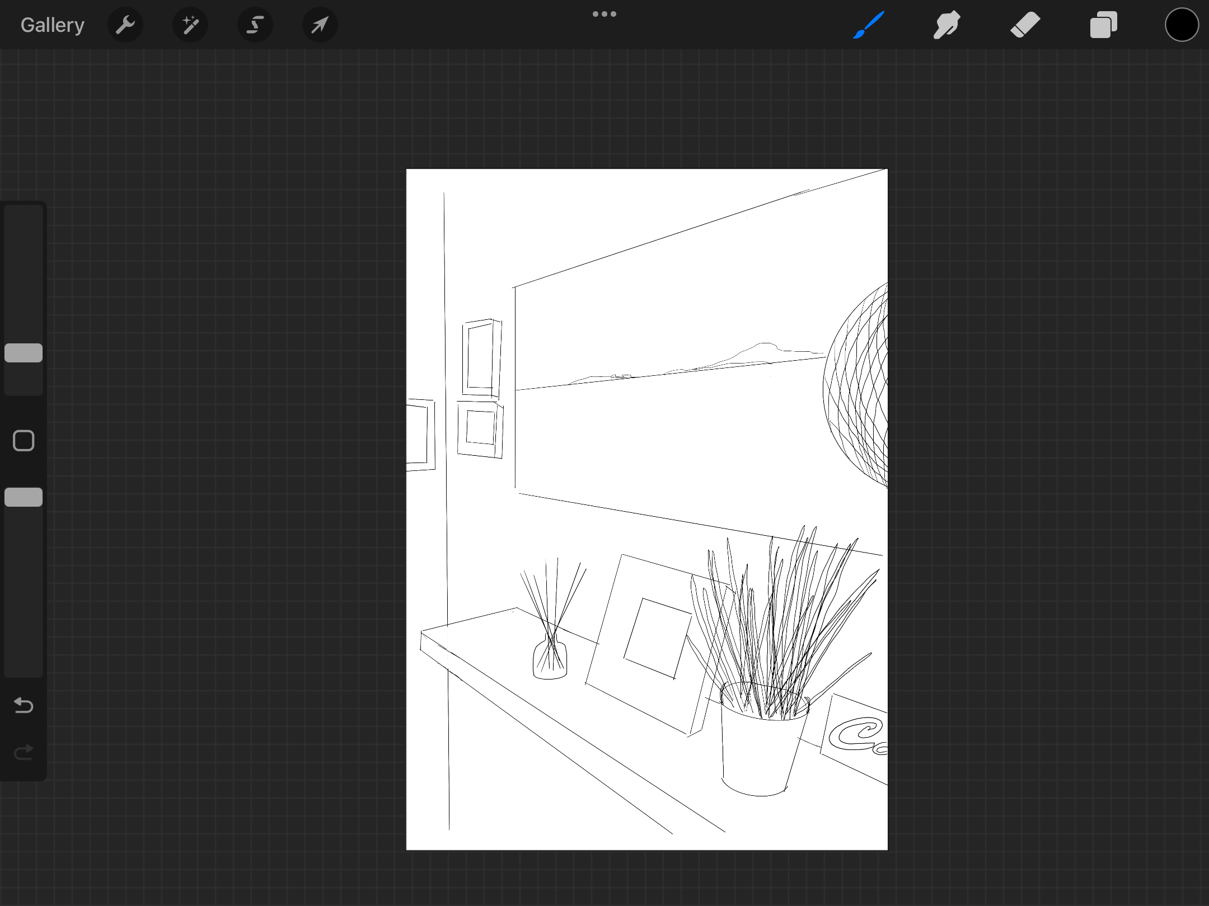
One point perspective, the line is going towards the wall to the left of the page.

Two point perspective, I had a bit of trouble with this one, as there was nowhere in my house that had this two point perspective, but I used this view from looking from the hall into the room on the right and the hall wall to the left, hopefully this is some kind of two point perspective?
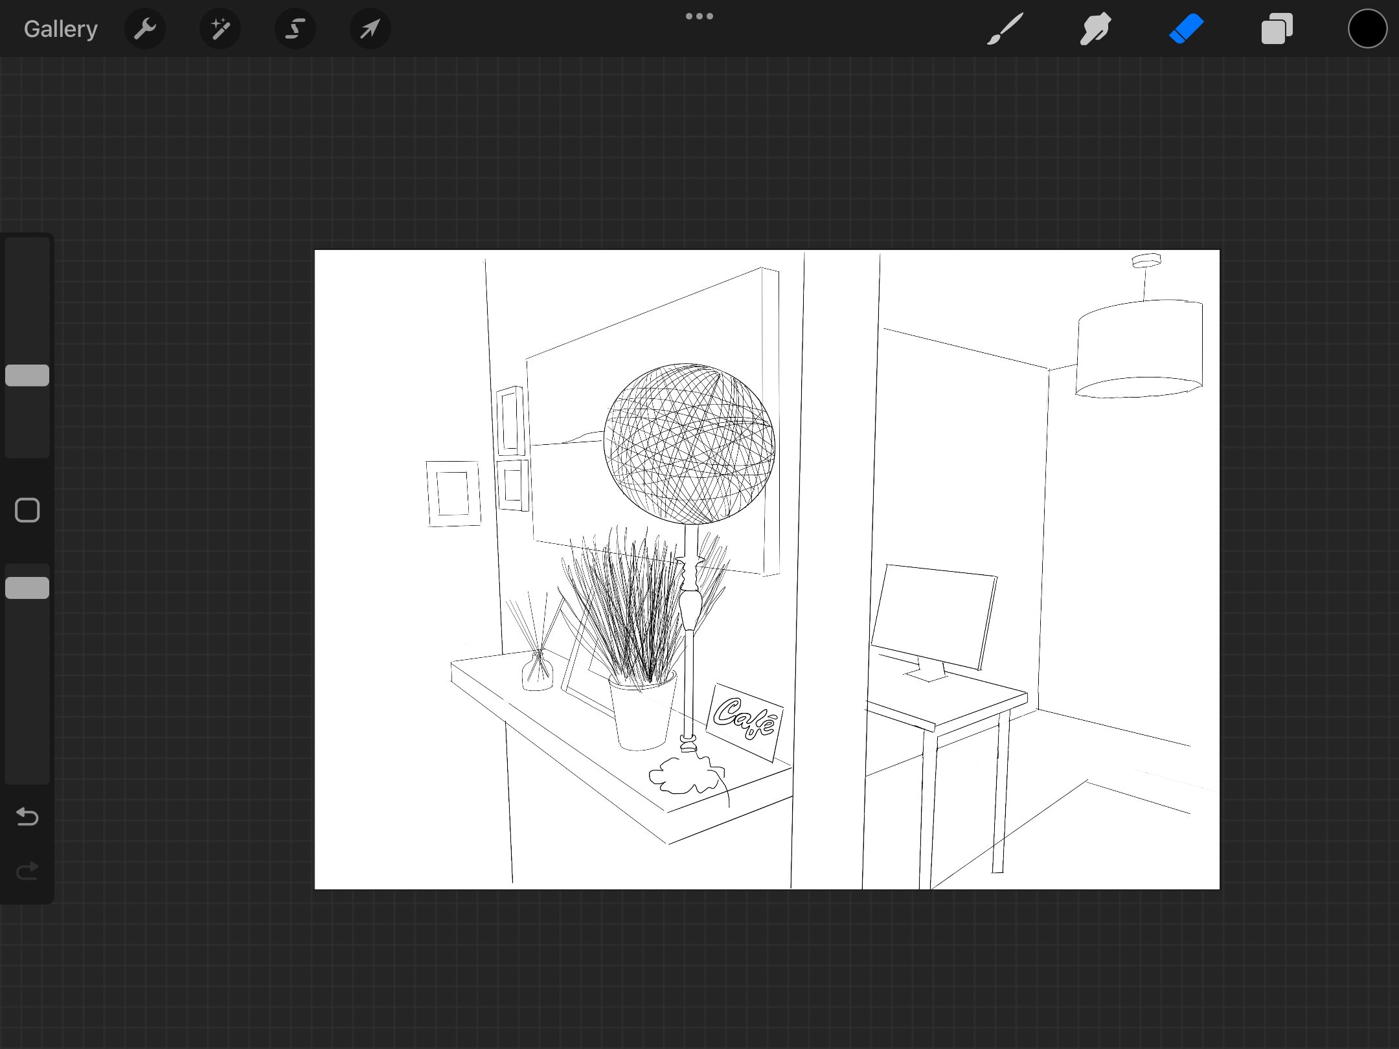
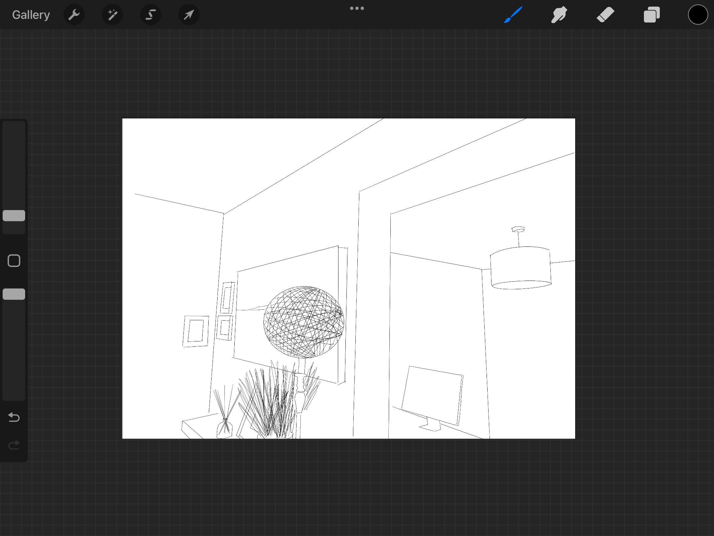
Three point perspective, again I found this hard, but I used the previous angle then just looked up to try to create the three point perspective, hopefully this comes across.

Now for the isometric projection of a room again I had a little bit of trouble with this, I started by drawing a flat diagram of my apartment but then I realised this was not right.
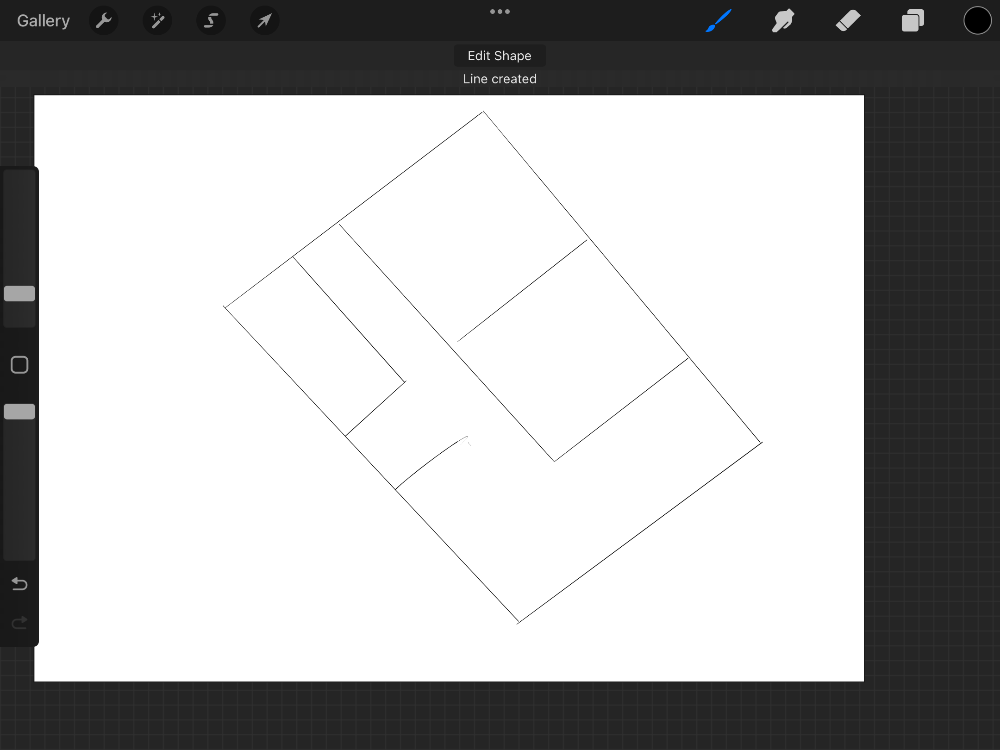
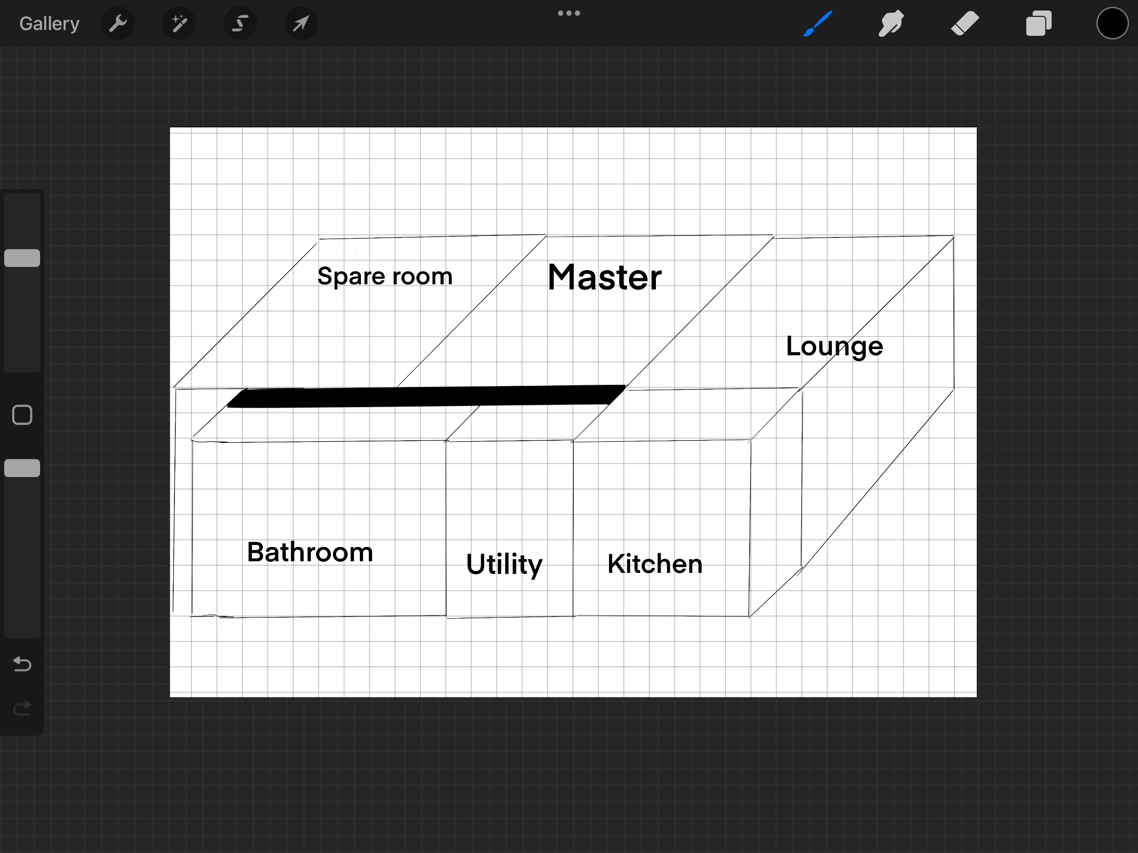
I then went on to draw box shapes where all the angles match, I used a drawing guide for this (graph) this helped get the shapes I wanted, I then added a hall way, which I must say I did forget and left out! I think this diagram works well and has the isometric rules.

Next was the fifth drawing of the room where you deliberately break the rules and draw the space in its own visual logic, so with this I just drew the hallway as it was but deliberately missed out the lines that showed the perspective, so the floor lines the skirting boards and the ceiling and wall lines, I literally just drew what was in the hall. Im not sure if it broke the right rules or not, but I feel as though the rug, boots and shelf look like they are floating, so it does not anker them as a drawing should!
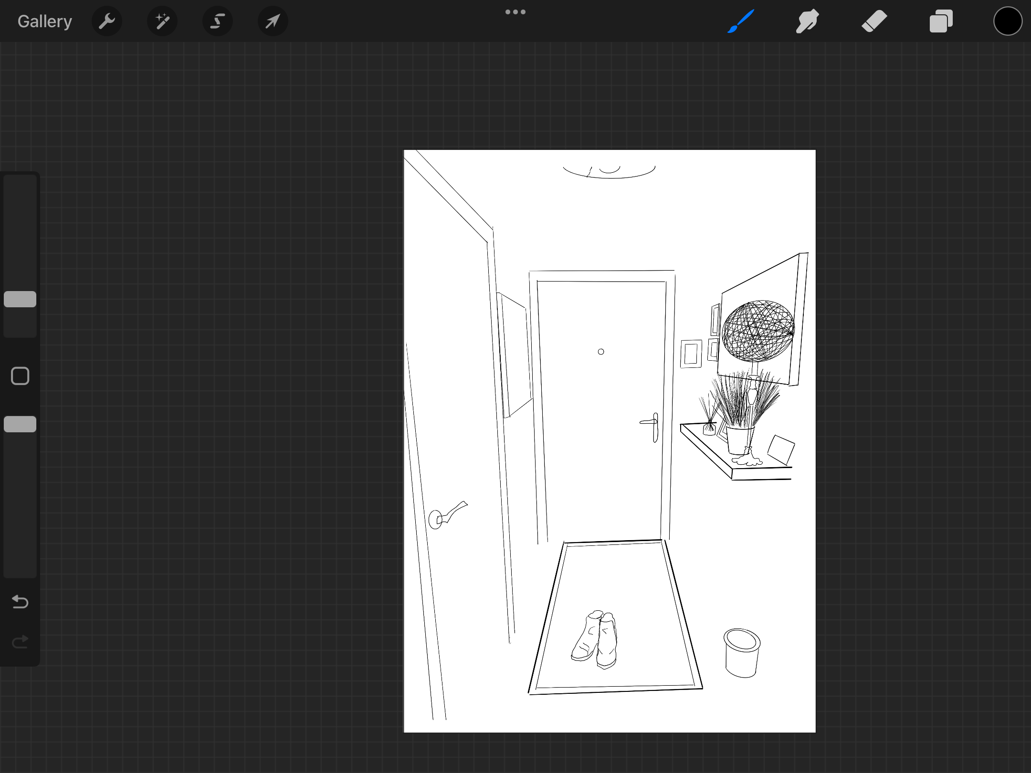
Now I need to draw a flat image of the hallway, so I am just going to draw part of the wall face on, which I think will work and make a flat image.

I needed to change the first few lines I made as they where on an angle, and showed a perspective so I needed to change that so it was flat on in front.

I did the picture drawing of the shelf in the hall face on, to include the painting on the wall, the lamp, a frame, the grass plant, and the cafe sign.

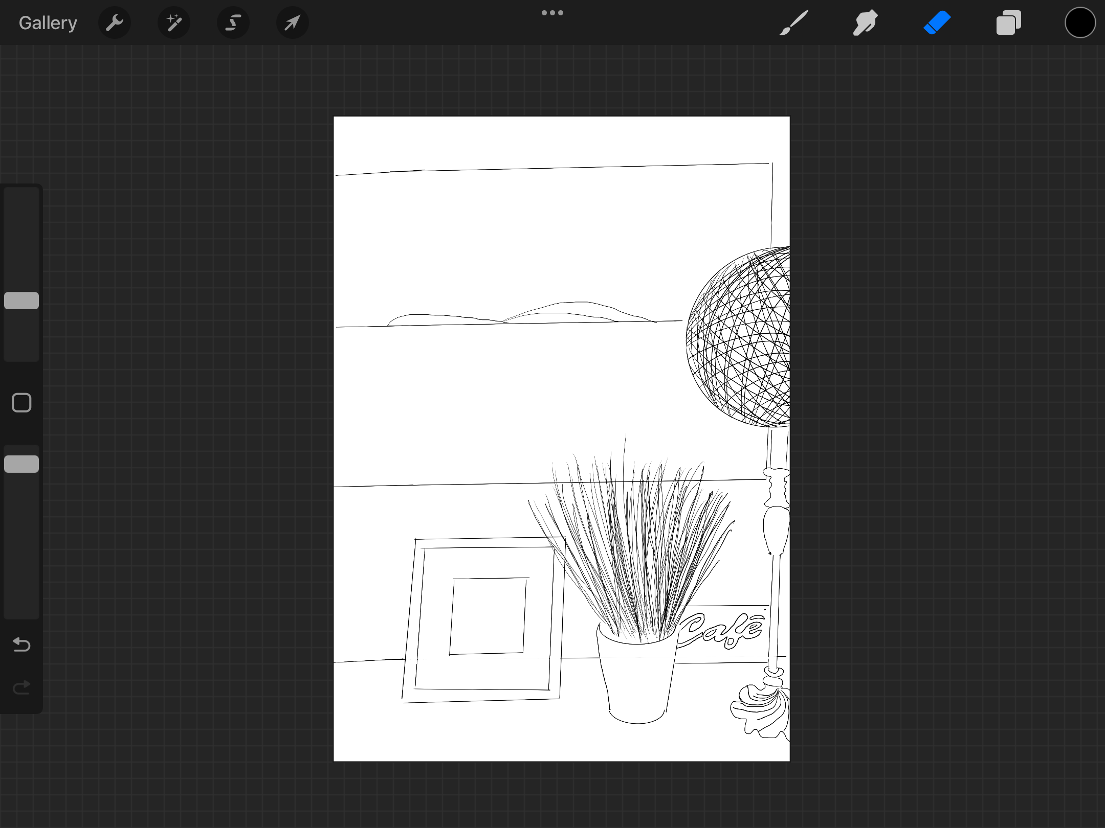
200 words on analysing how these different approaches affect the ‘meaning’ of the visual space being shown?

Drawing with a perspective point or vanishing point gives the viewer a sense of space and depth to a drawing, it puts the surrounding areas into perspective, a context. Having multiple vanishing points gives the drawing placement within the other areas of the drawing, it gives a larger space to view, and more communication to the viewer.

The isometric drawing gives a sense of structure, how the space is seen overall. It is a naive design, that does the job of putting across the building space and how it works in relation to the perspective drawings.

When you have a drawing that breaks rules like reportage illustration, it creates a sense of scene without the need of perspective, as its about what you see not necessarily putting that scene into a context.

The flat drawing just gives details that you may miss in the other view points, its a up close flat view point, that tells it like it is. It’s more abstract, you can add texture, but you don’t feel the sense of space.

Overall I would say the three point perspective gives the viewer the best view of the space, it gives the perspective needed, the sense of space and how the area works in relation to each other, you can then add as much detail as you would like to give texture, but the depth is already there.

Reflections

What went well

-I enjoyed using my iPad for this exercise, I found it easy to use on Procreate, as you can get straight lines without using a ruler, the app does it automatically, I found this helped my illustrations look more professional.

-I actually enjoyed this exercise overall, I really was not looking forward to it, as buildings and perspective is not a strong point, or something that I would have enjoyed doing. I was surprised how I got into the exercise and liked how my drawings turned out, I think working on the iPad helped with this.

_ I learnt a lot about the different kinds of perspective, and it has made me think more about the different views you can achieve by drawing these, each perspective gives a different feel to the drawing, some have more drama, like looking up or down, and some give a sense of space, like two point. It’s something to defiantly use going forward, and would help immensely when drawing illustrations for children books, which is something I’m interested in doing.

What I would do better or differently

-I looked at some research points as some of the perspective views were a little confusing for me, but I got the idea in the end. So spend a bit more time on research before completing the exercises going forward.

-I would maybe use colour as well next time, I didn’t this time as I wanted to just focus on the bare drawing to get the perspective points right first, but at least now I can then work on colour and texture going forward.

