Exercise 3

Less is more

So for this exercise I started by picking the letter of the alphabet I wanted to use, immediately I was looking at my kettle, so I chose K, I then chose Knife, Kiwi and Key, but it was difficult to come up with a fifth. I finally decided upon Knob, as I had a few decorative ones in my kitchen that would be interesting to draw.

So I had my list of items to draw:-
Kettle
Knife
Kiwi
Key
Knob

I then thought about what three colours I wanted to choose, it suggested a dark, medium and light colour. I wanted to try something different to use this exercise to experiment, so I thought about a navy (or dark blue) a lighter blue, then highlight with a contrasting colour like florescent yellow. I know when blue and yellow are put together they really make each other pop out!

But then I thought the exercise is asking me to use colours that work well together, more like harmoniously, and the exercise is less is more, so I started to sketch the five elements out in my sketchbook, so I had the basic shapes, I wanted to add some detail but not too much, it was just a sketch after all, then I would think about the colours afterwords.

I did rough sketches of the five elements, then I thought I would use my iPad and procreate, as I could swop and change the colours in and out easily to find 3 colours I liked the best.

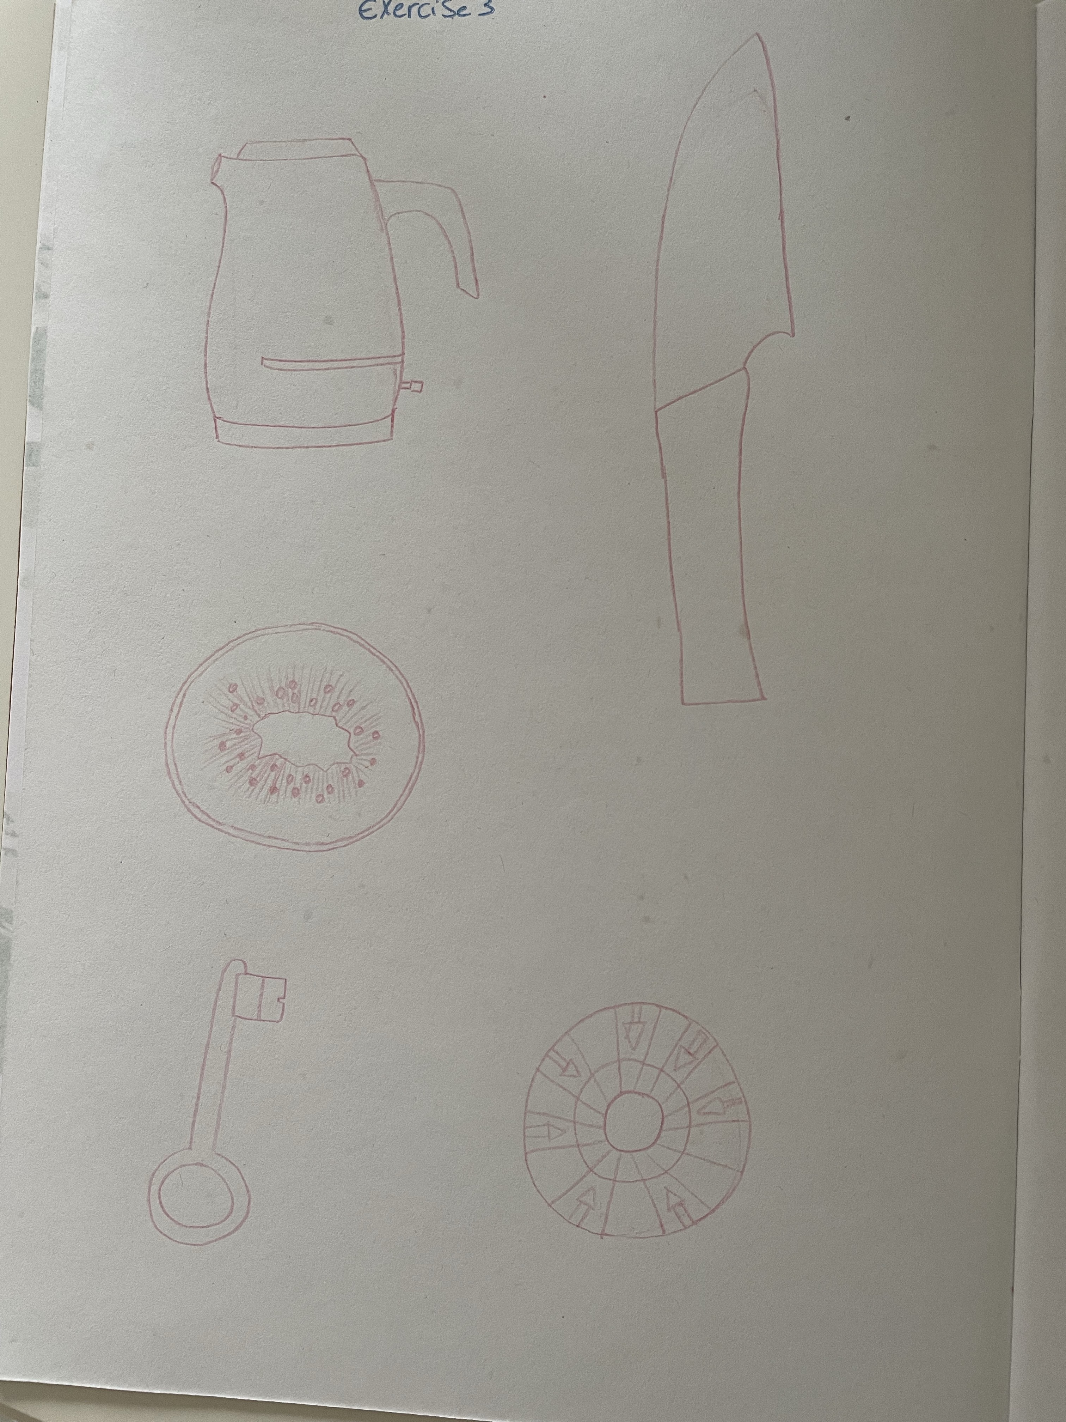
This would also be easier for the second part when trying out just two colours.

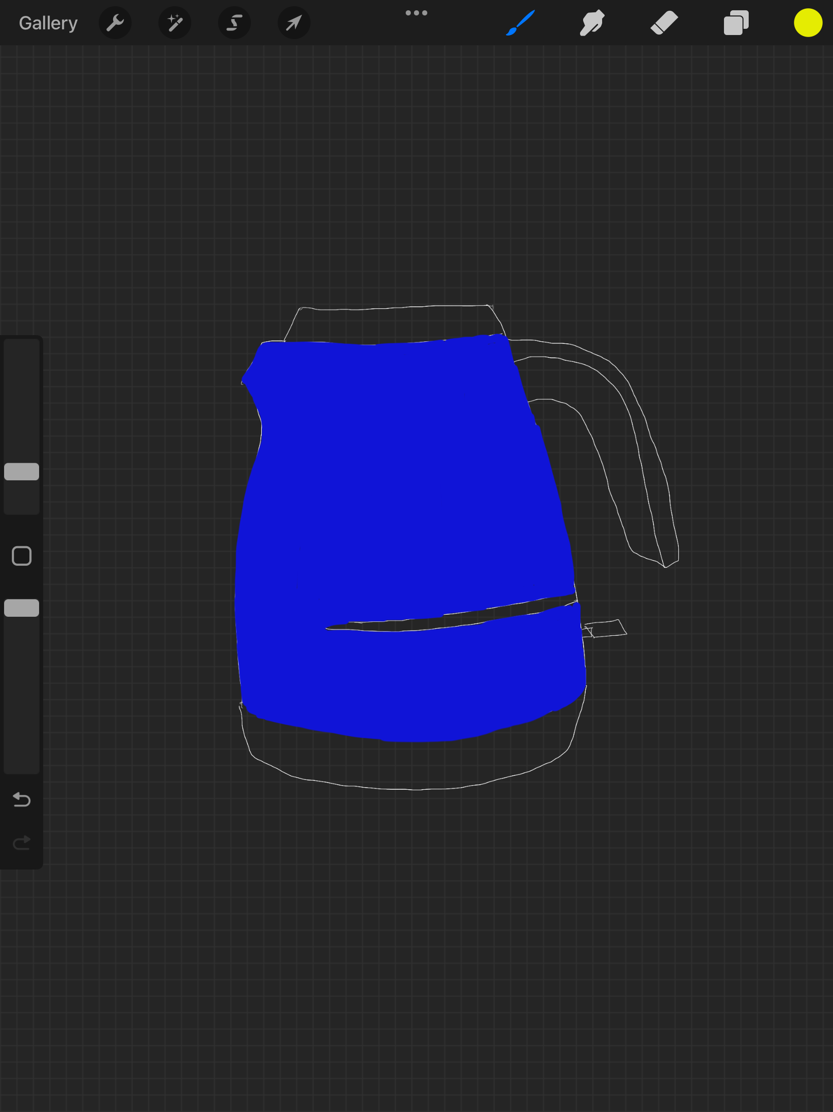
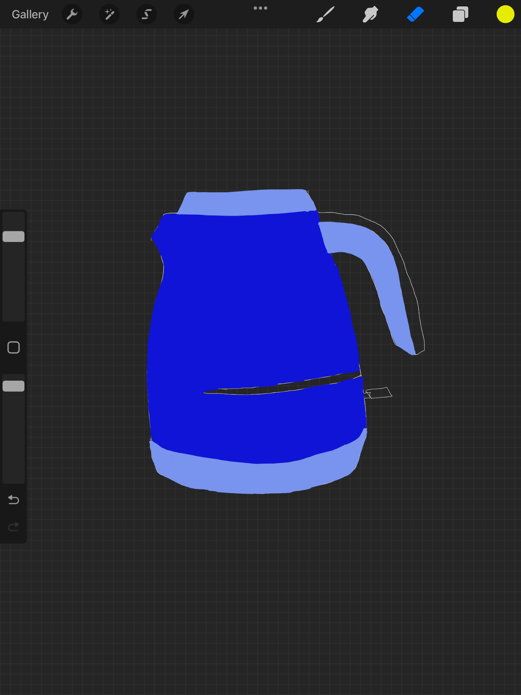
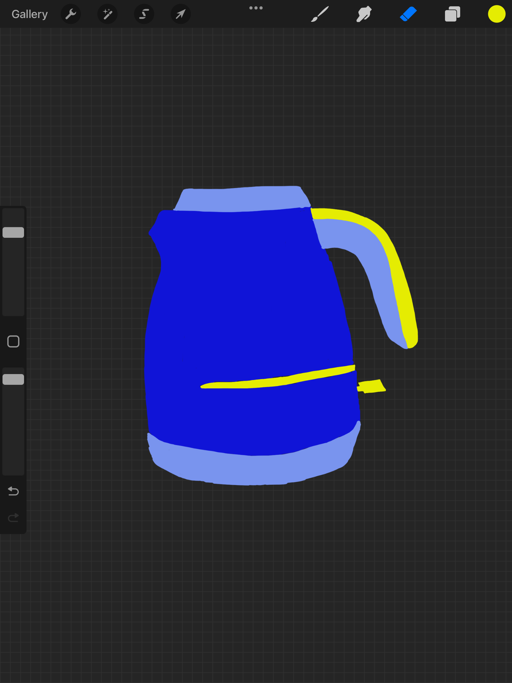
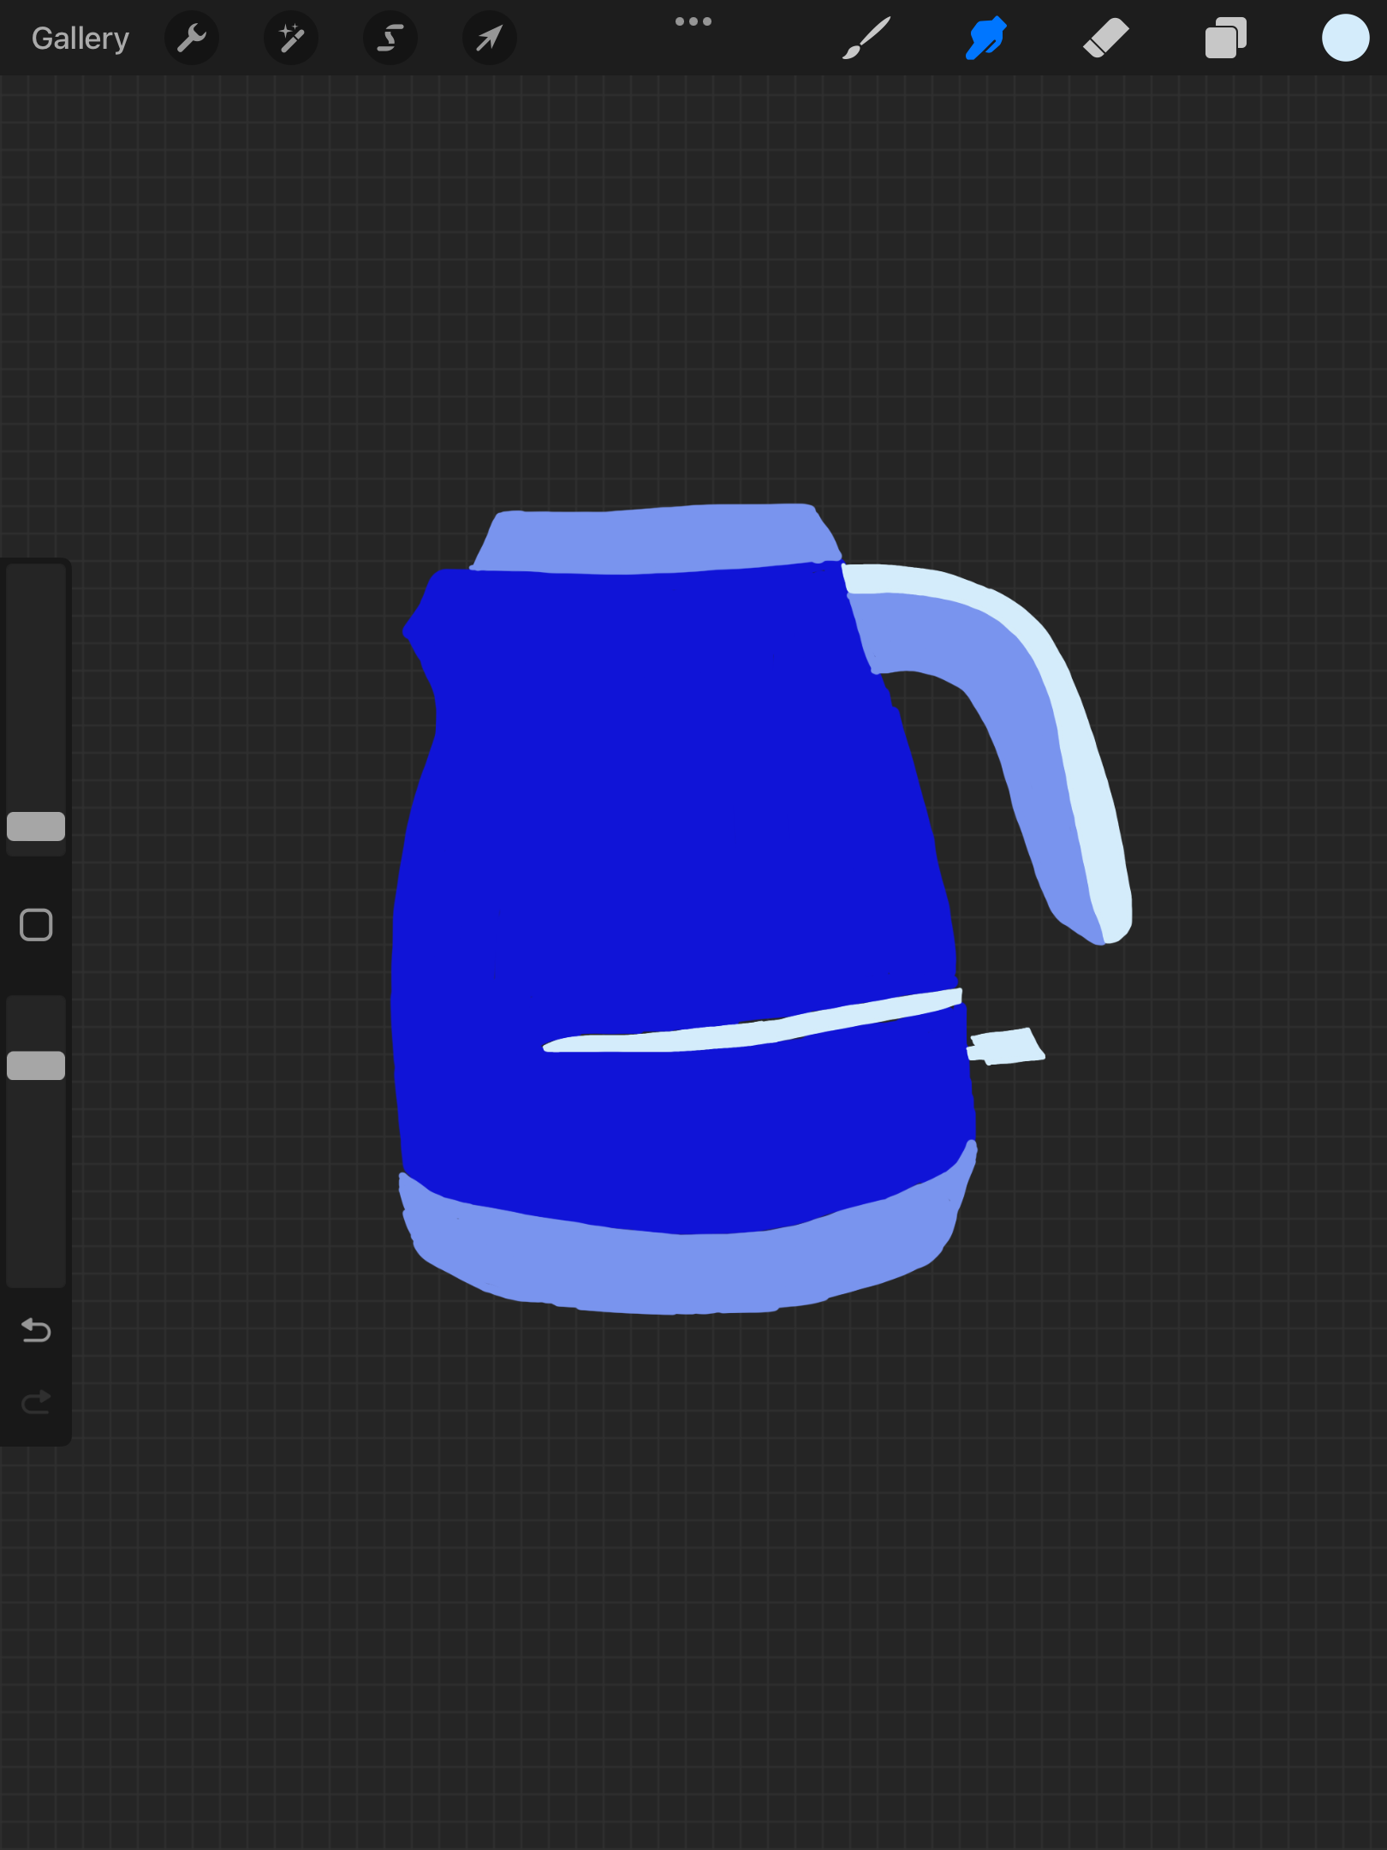
So I tried the design with the colours I thought of first, the navy, mid blue and florescent yellow, but then I tried it with a very pale blue to keep the hues the same, and yes this did work better. The very light blue almost loos white, but it is like a frosty white blue, but I think this does give a shading and highlight quality to the colouring.

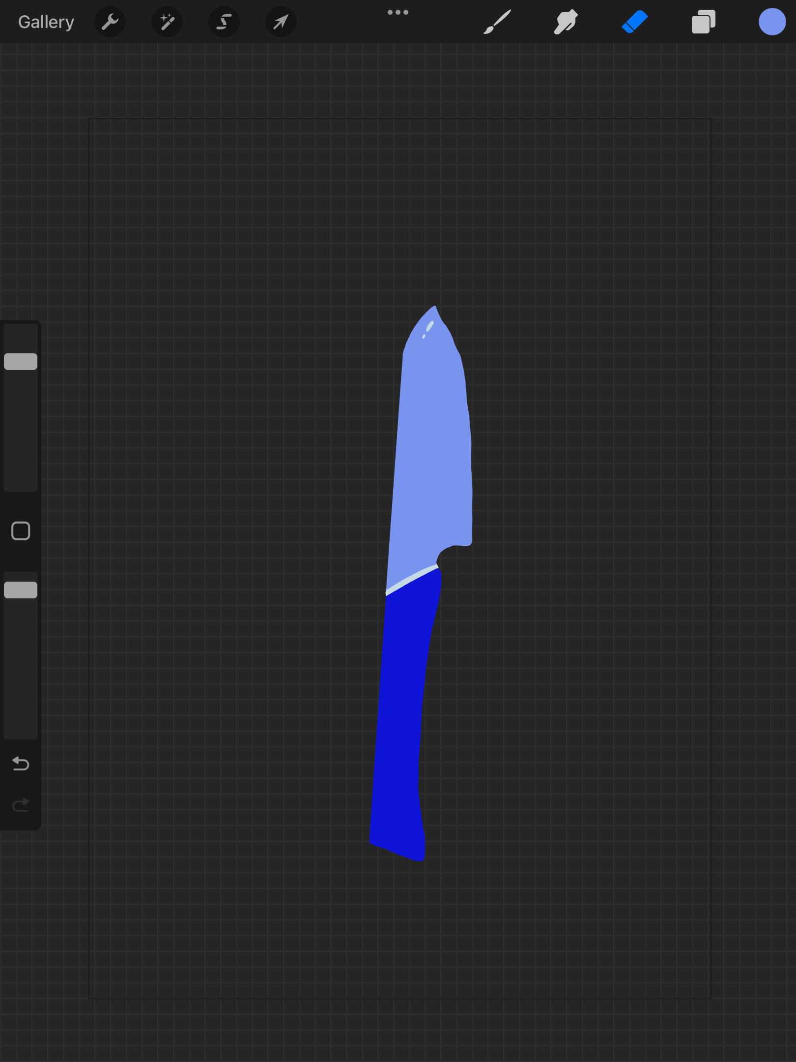
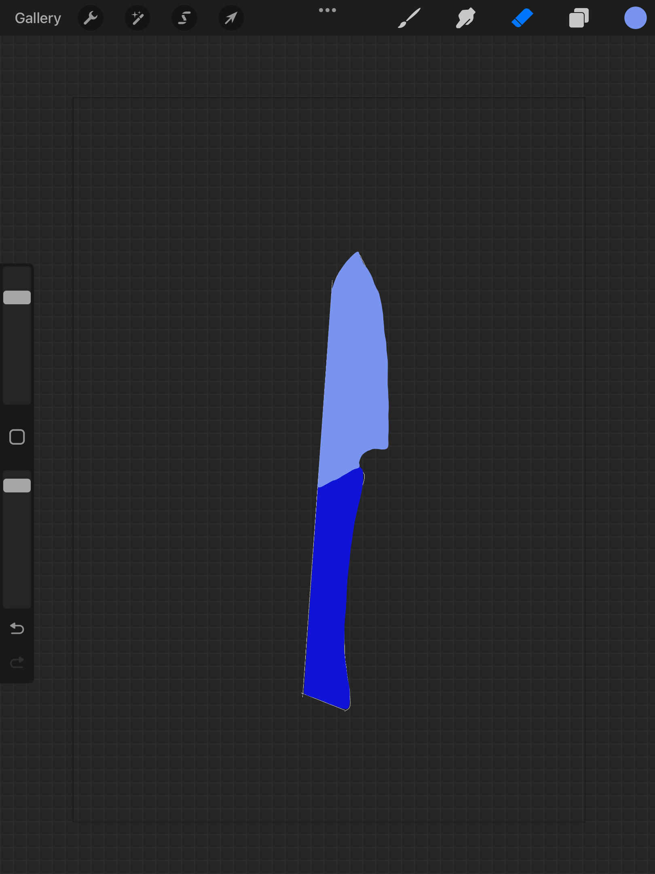

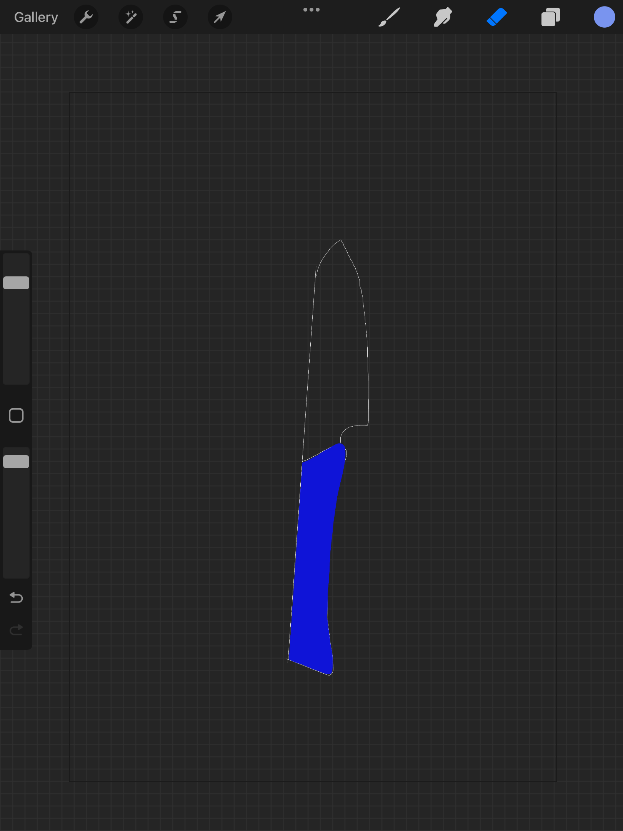
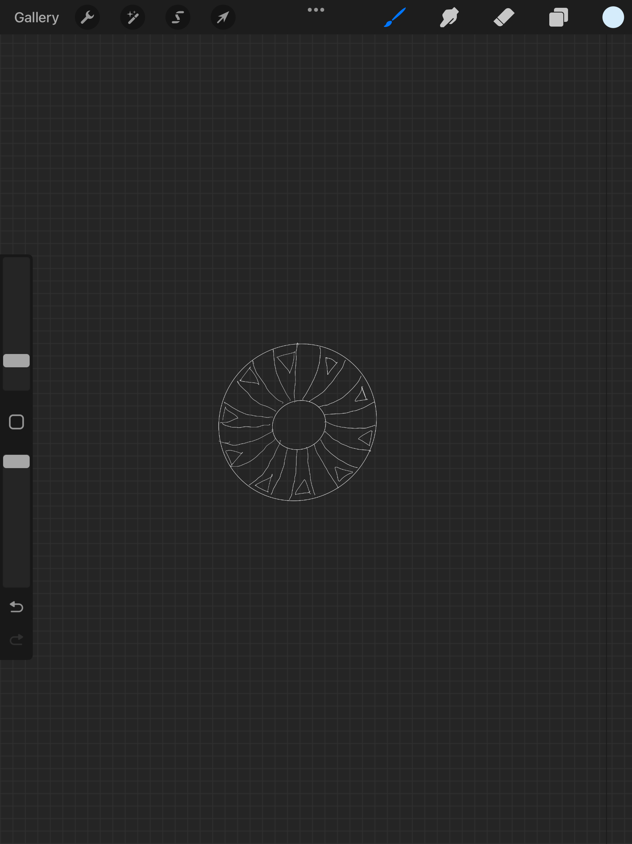

So after doing all five drawings and coloured them in the three hues of blue, I think they all turned out well.
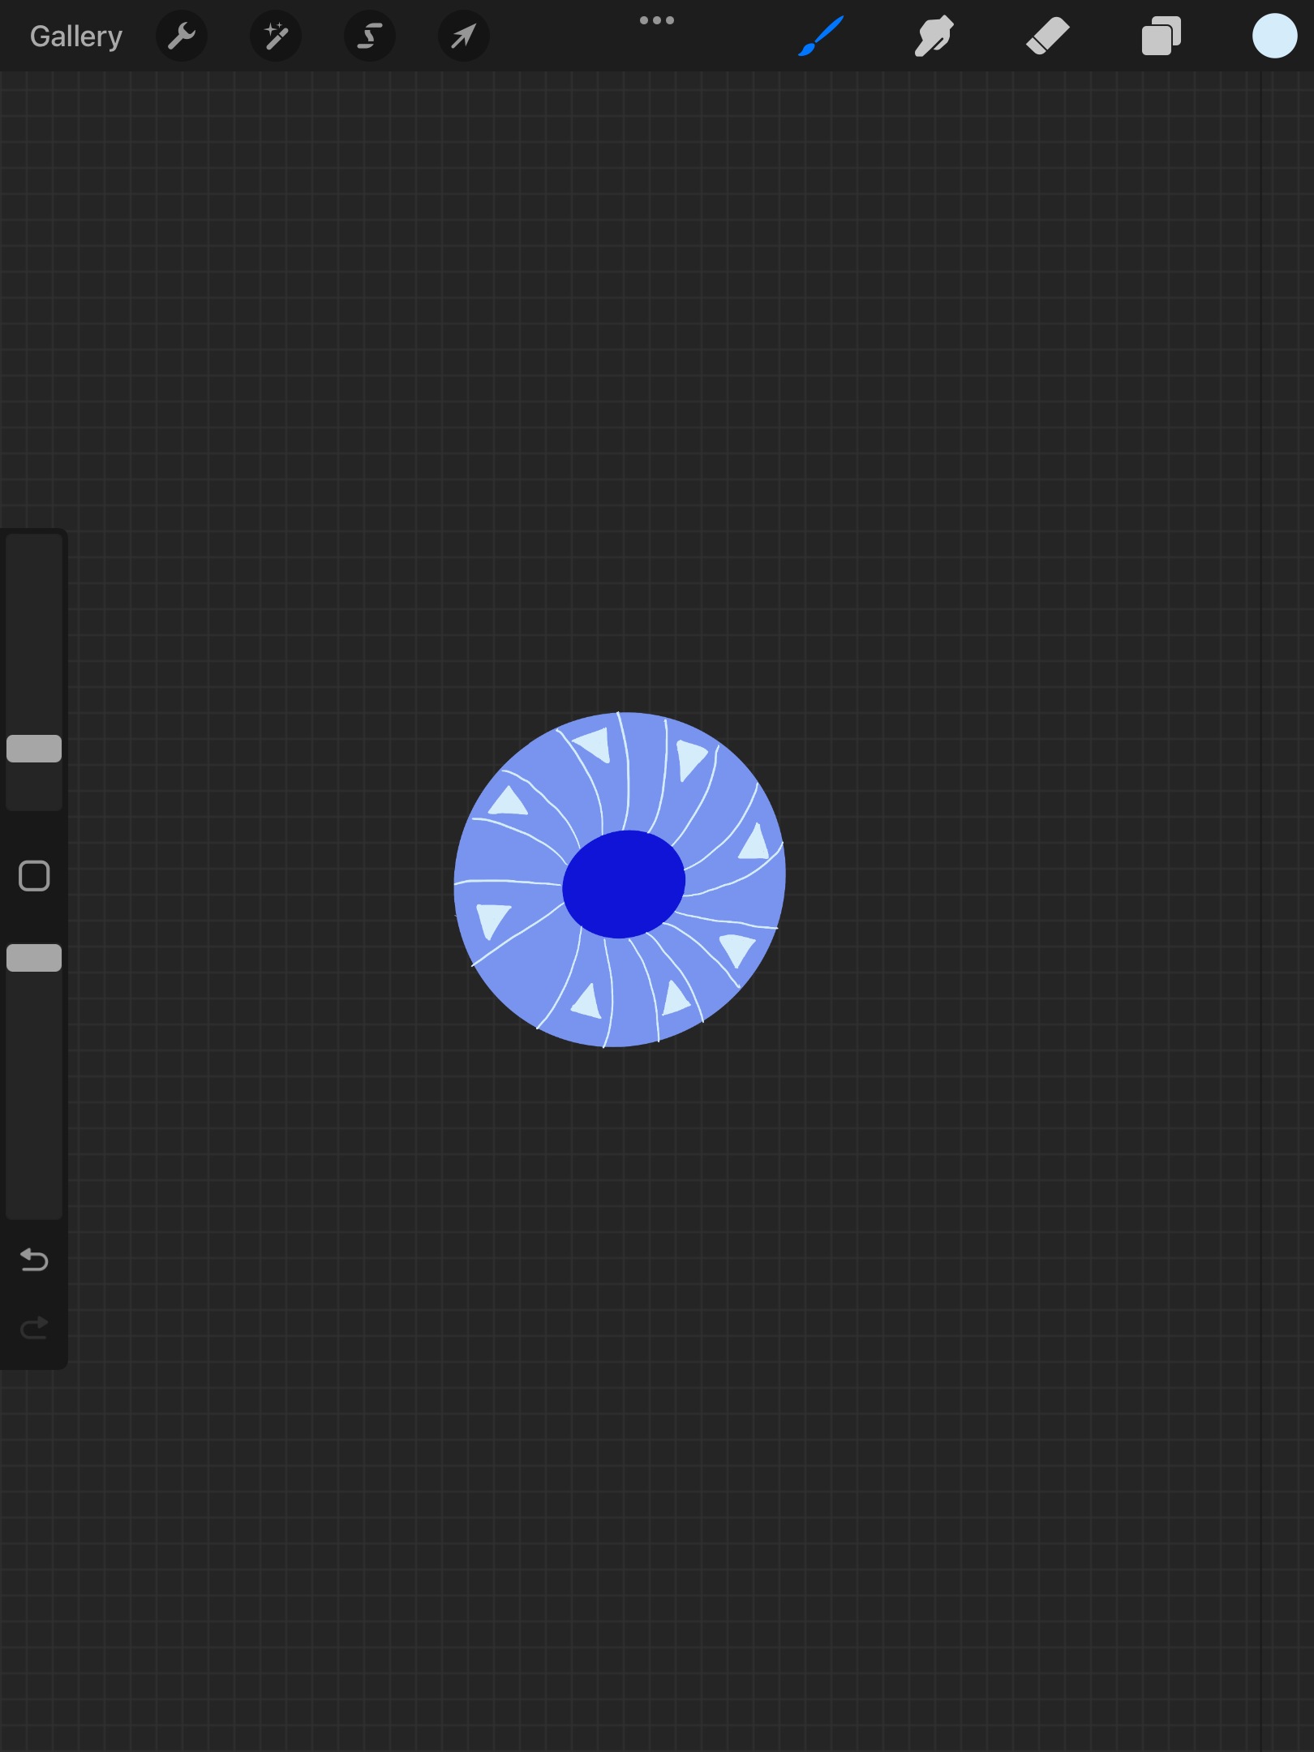
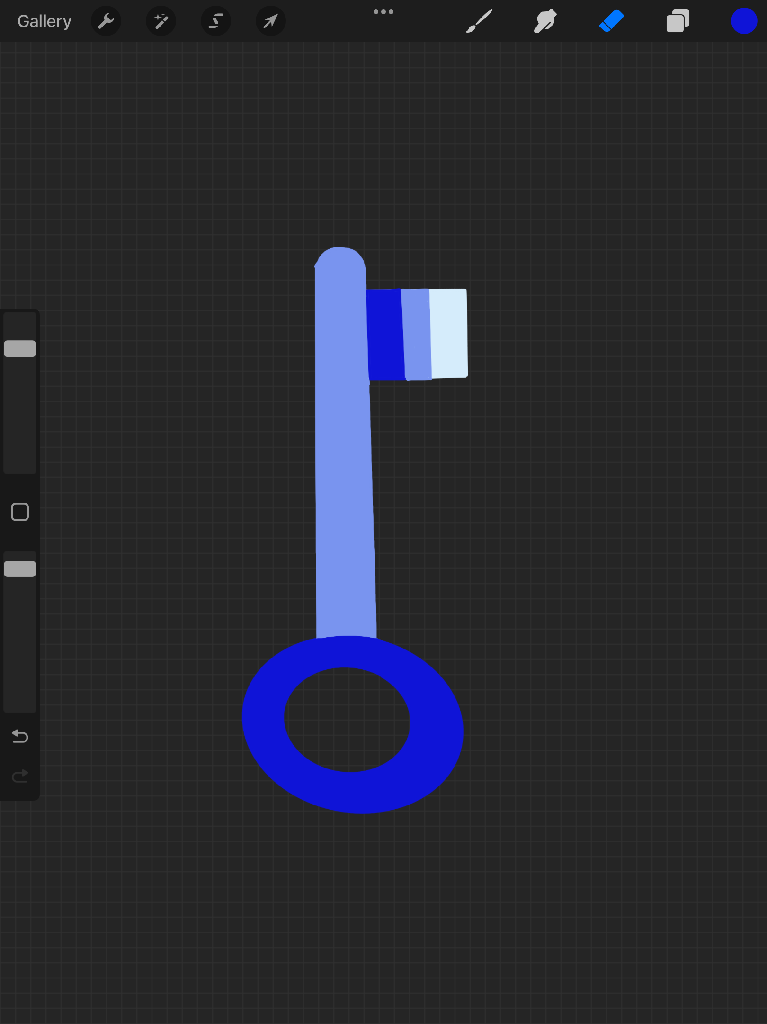
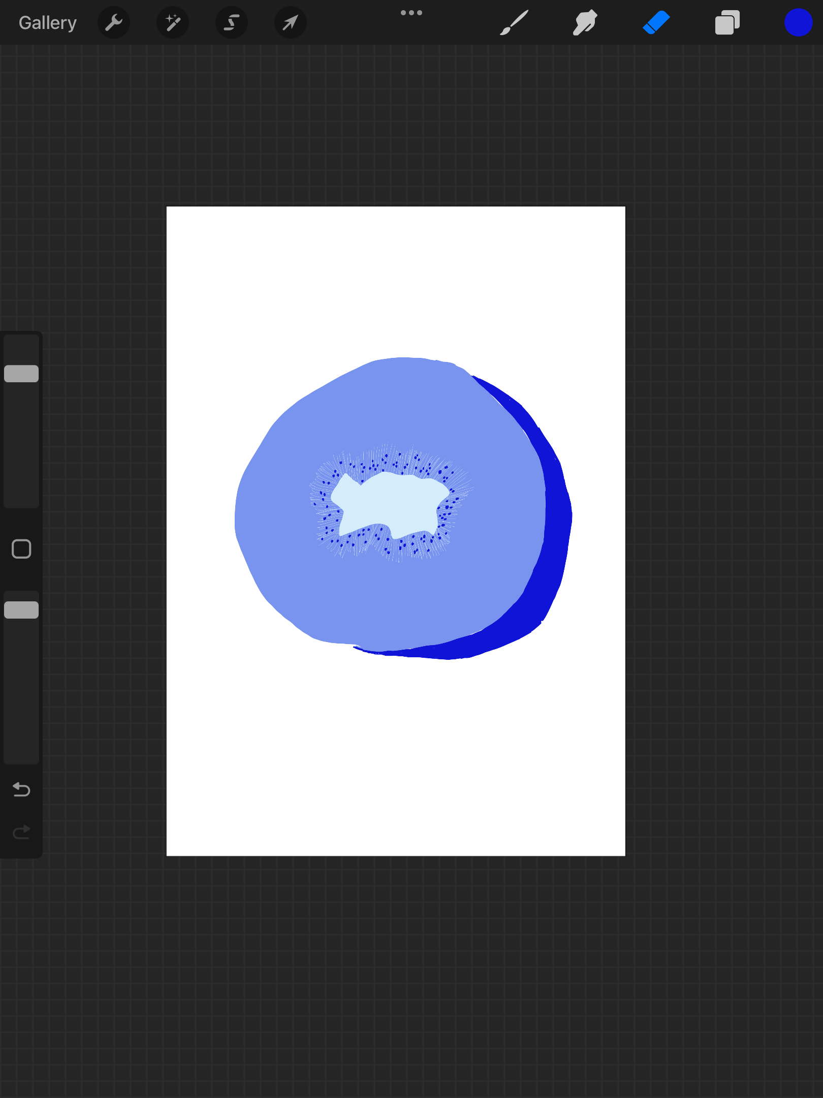
Now I want to move onto the second part and try another set of domestic items beginning with the letter ‘B’ the items I have decided to draw are:-
Bowl
Bread
Berry
Breakfast
Bacon

Now with these elements I only have two colours to choose, so actually I might choose two opposites for this one, two contrasting colours, two colours they make each other pop!
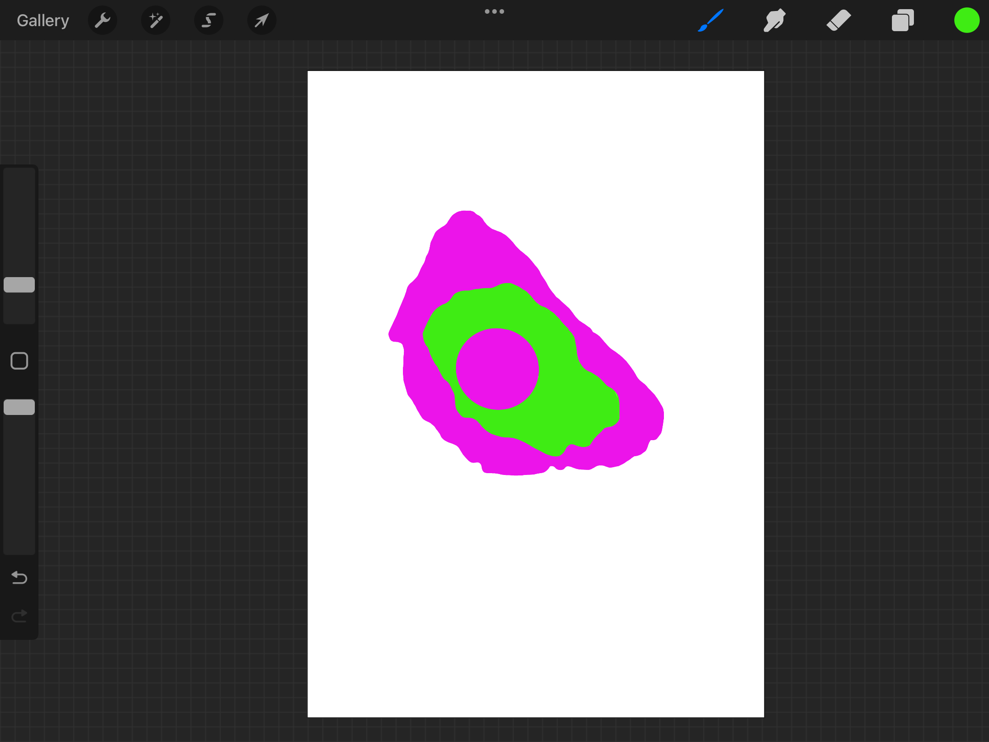
I will draw them on my iPad then experiment with colours, I think I’ll look at the colour wheel, and maybe choose two opposite each other first and see how that looks.
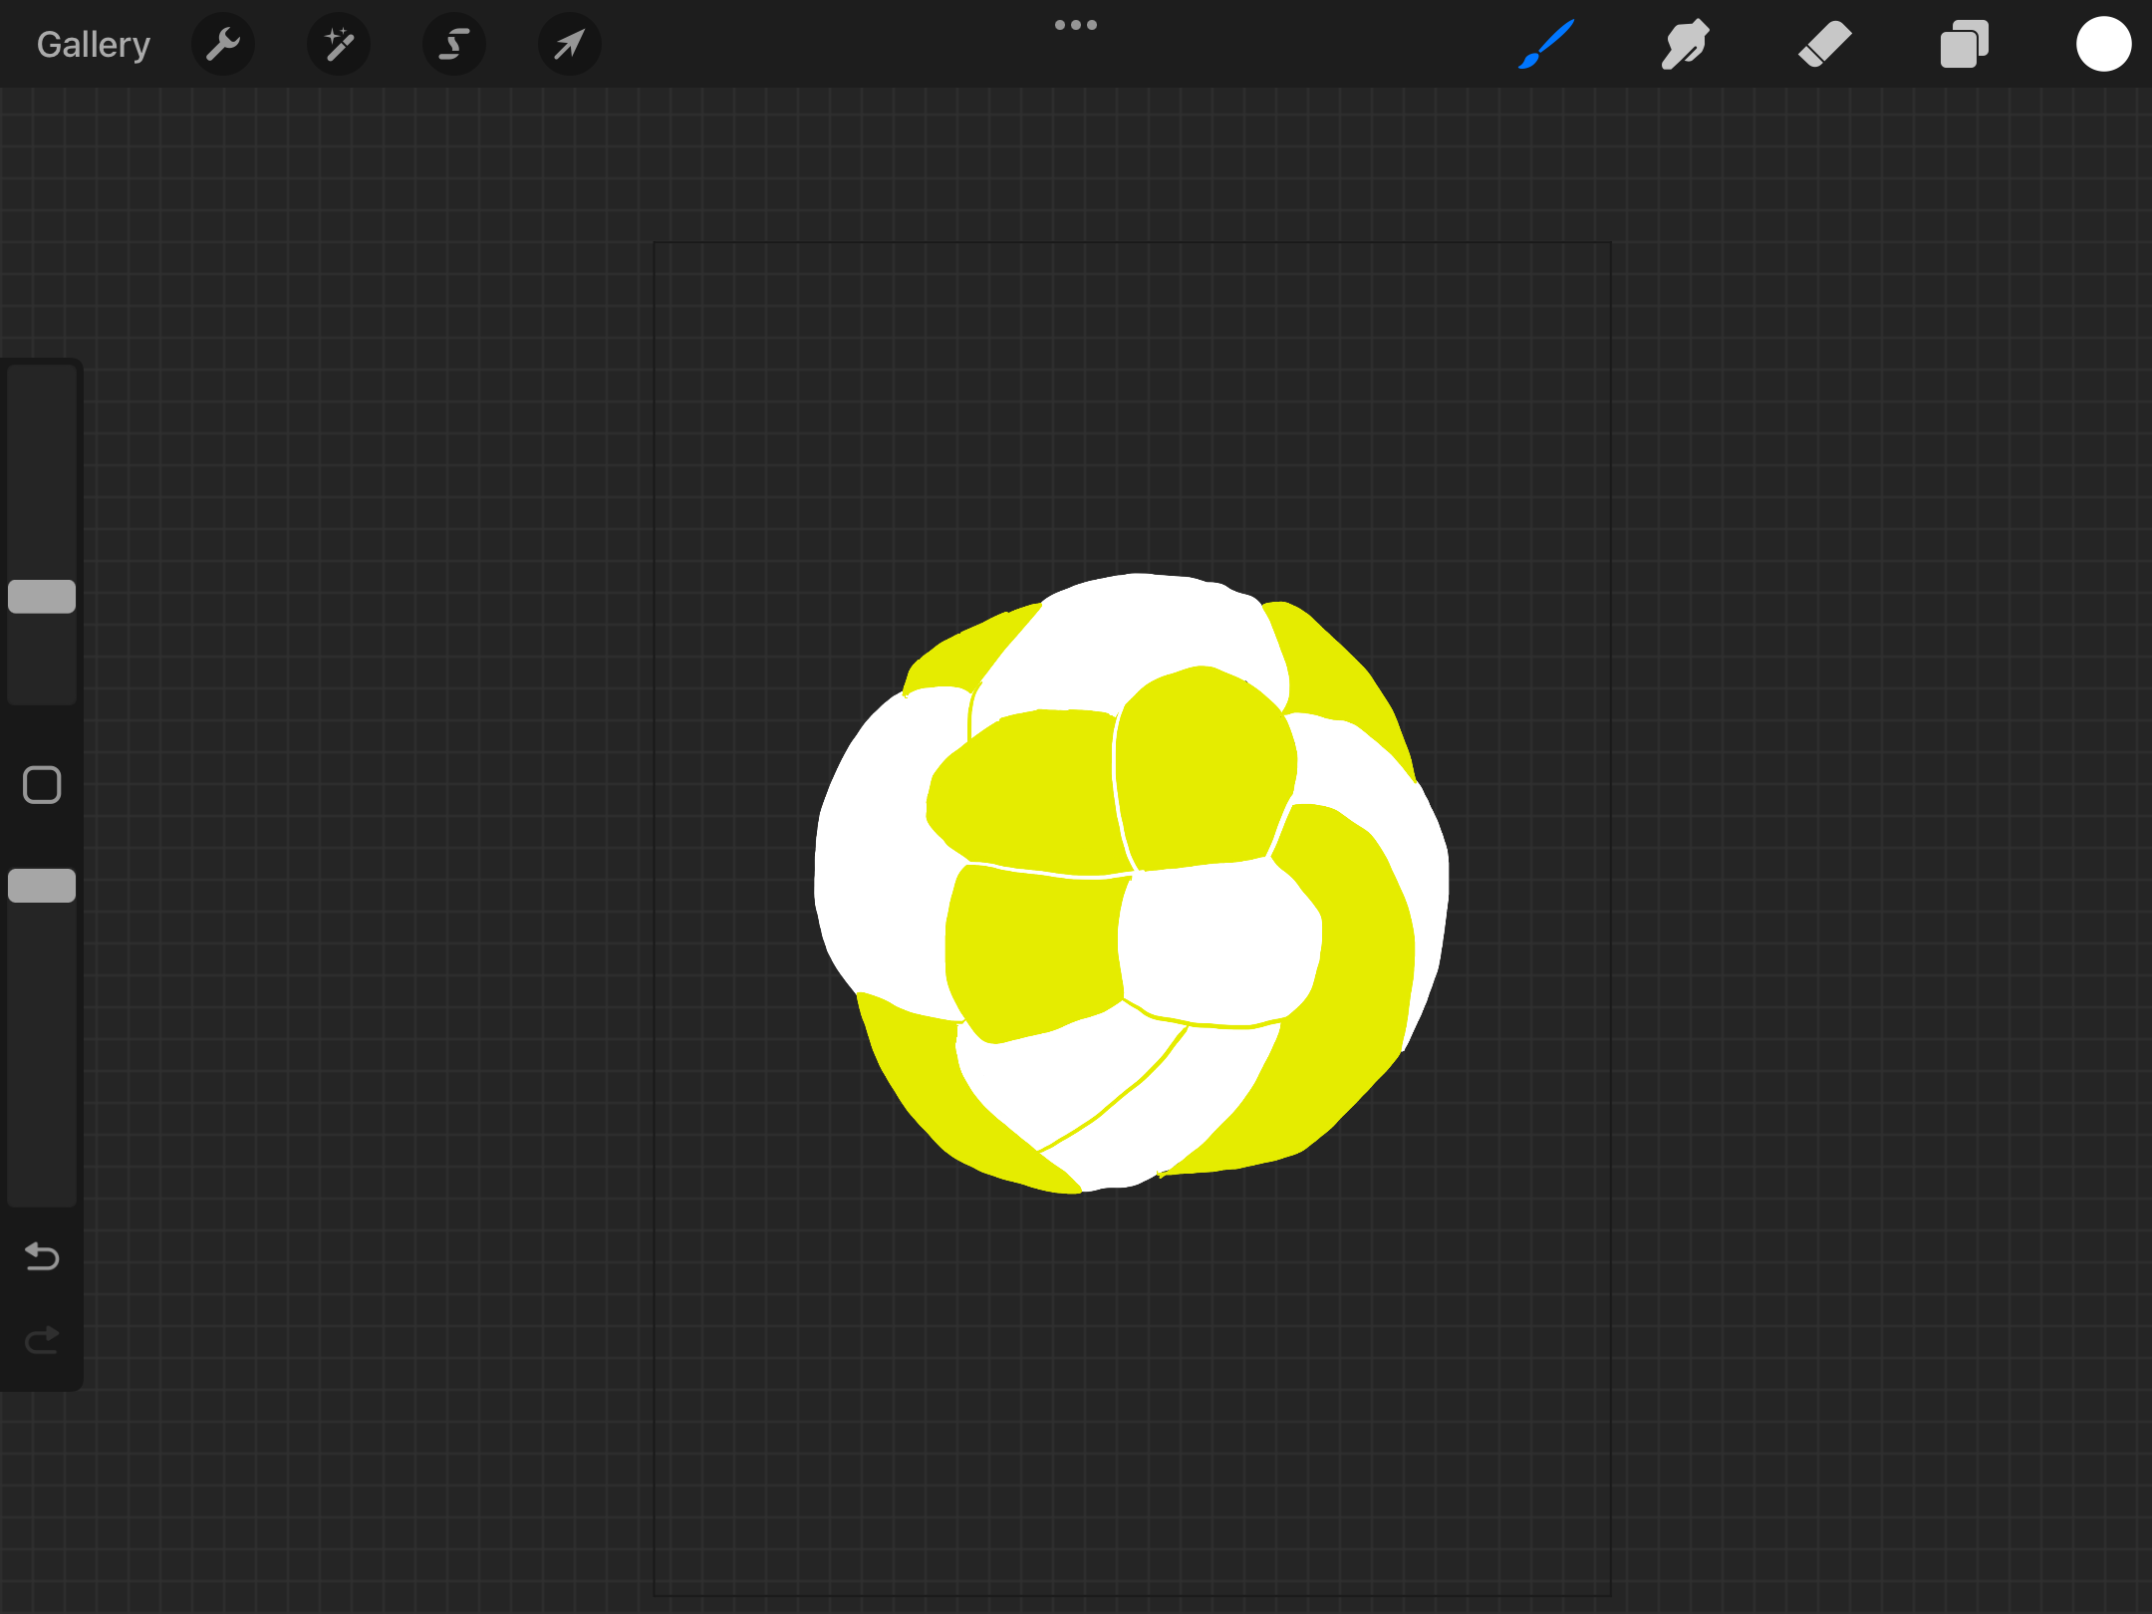
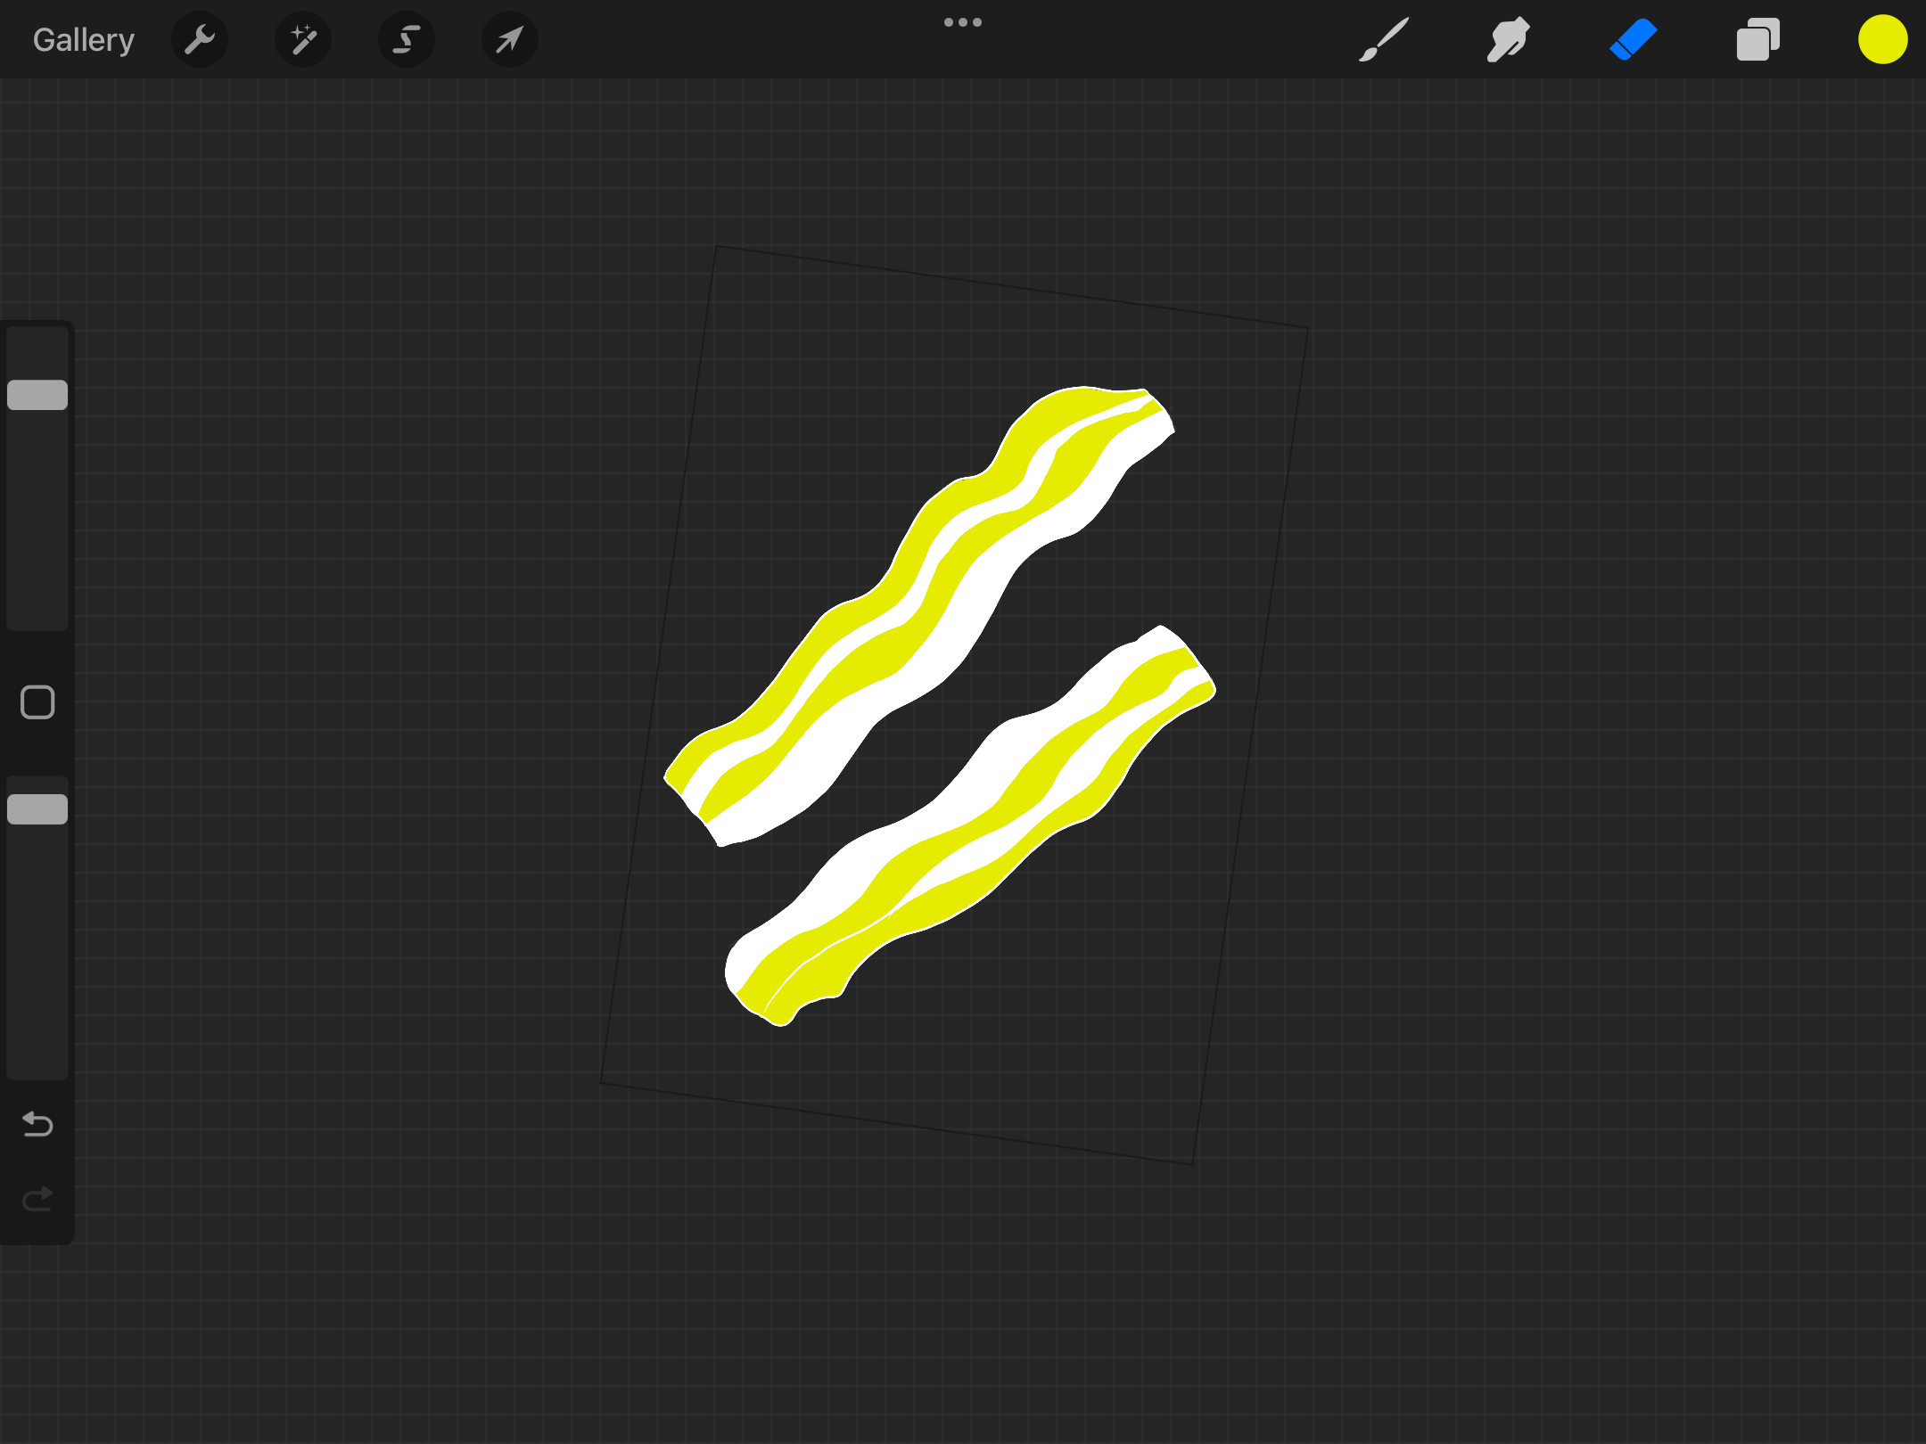
So I went for opposites on the colour wheel, but I feel as though this didn’t work well with the subject, the breakfast, and also rather than egg on toast it look like a psychedelic blob instead, so I decided to go for a white and yellow concept, these were still two different colours, they made each other pop, and they work well with all the element pieces.

I found the yellow and white colours worked with the bacon really well, with the berry, the egg on toast breakfast and the bread, there wasn’t so much of an impact on the bowl!

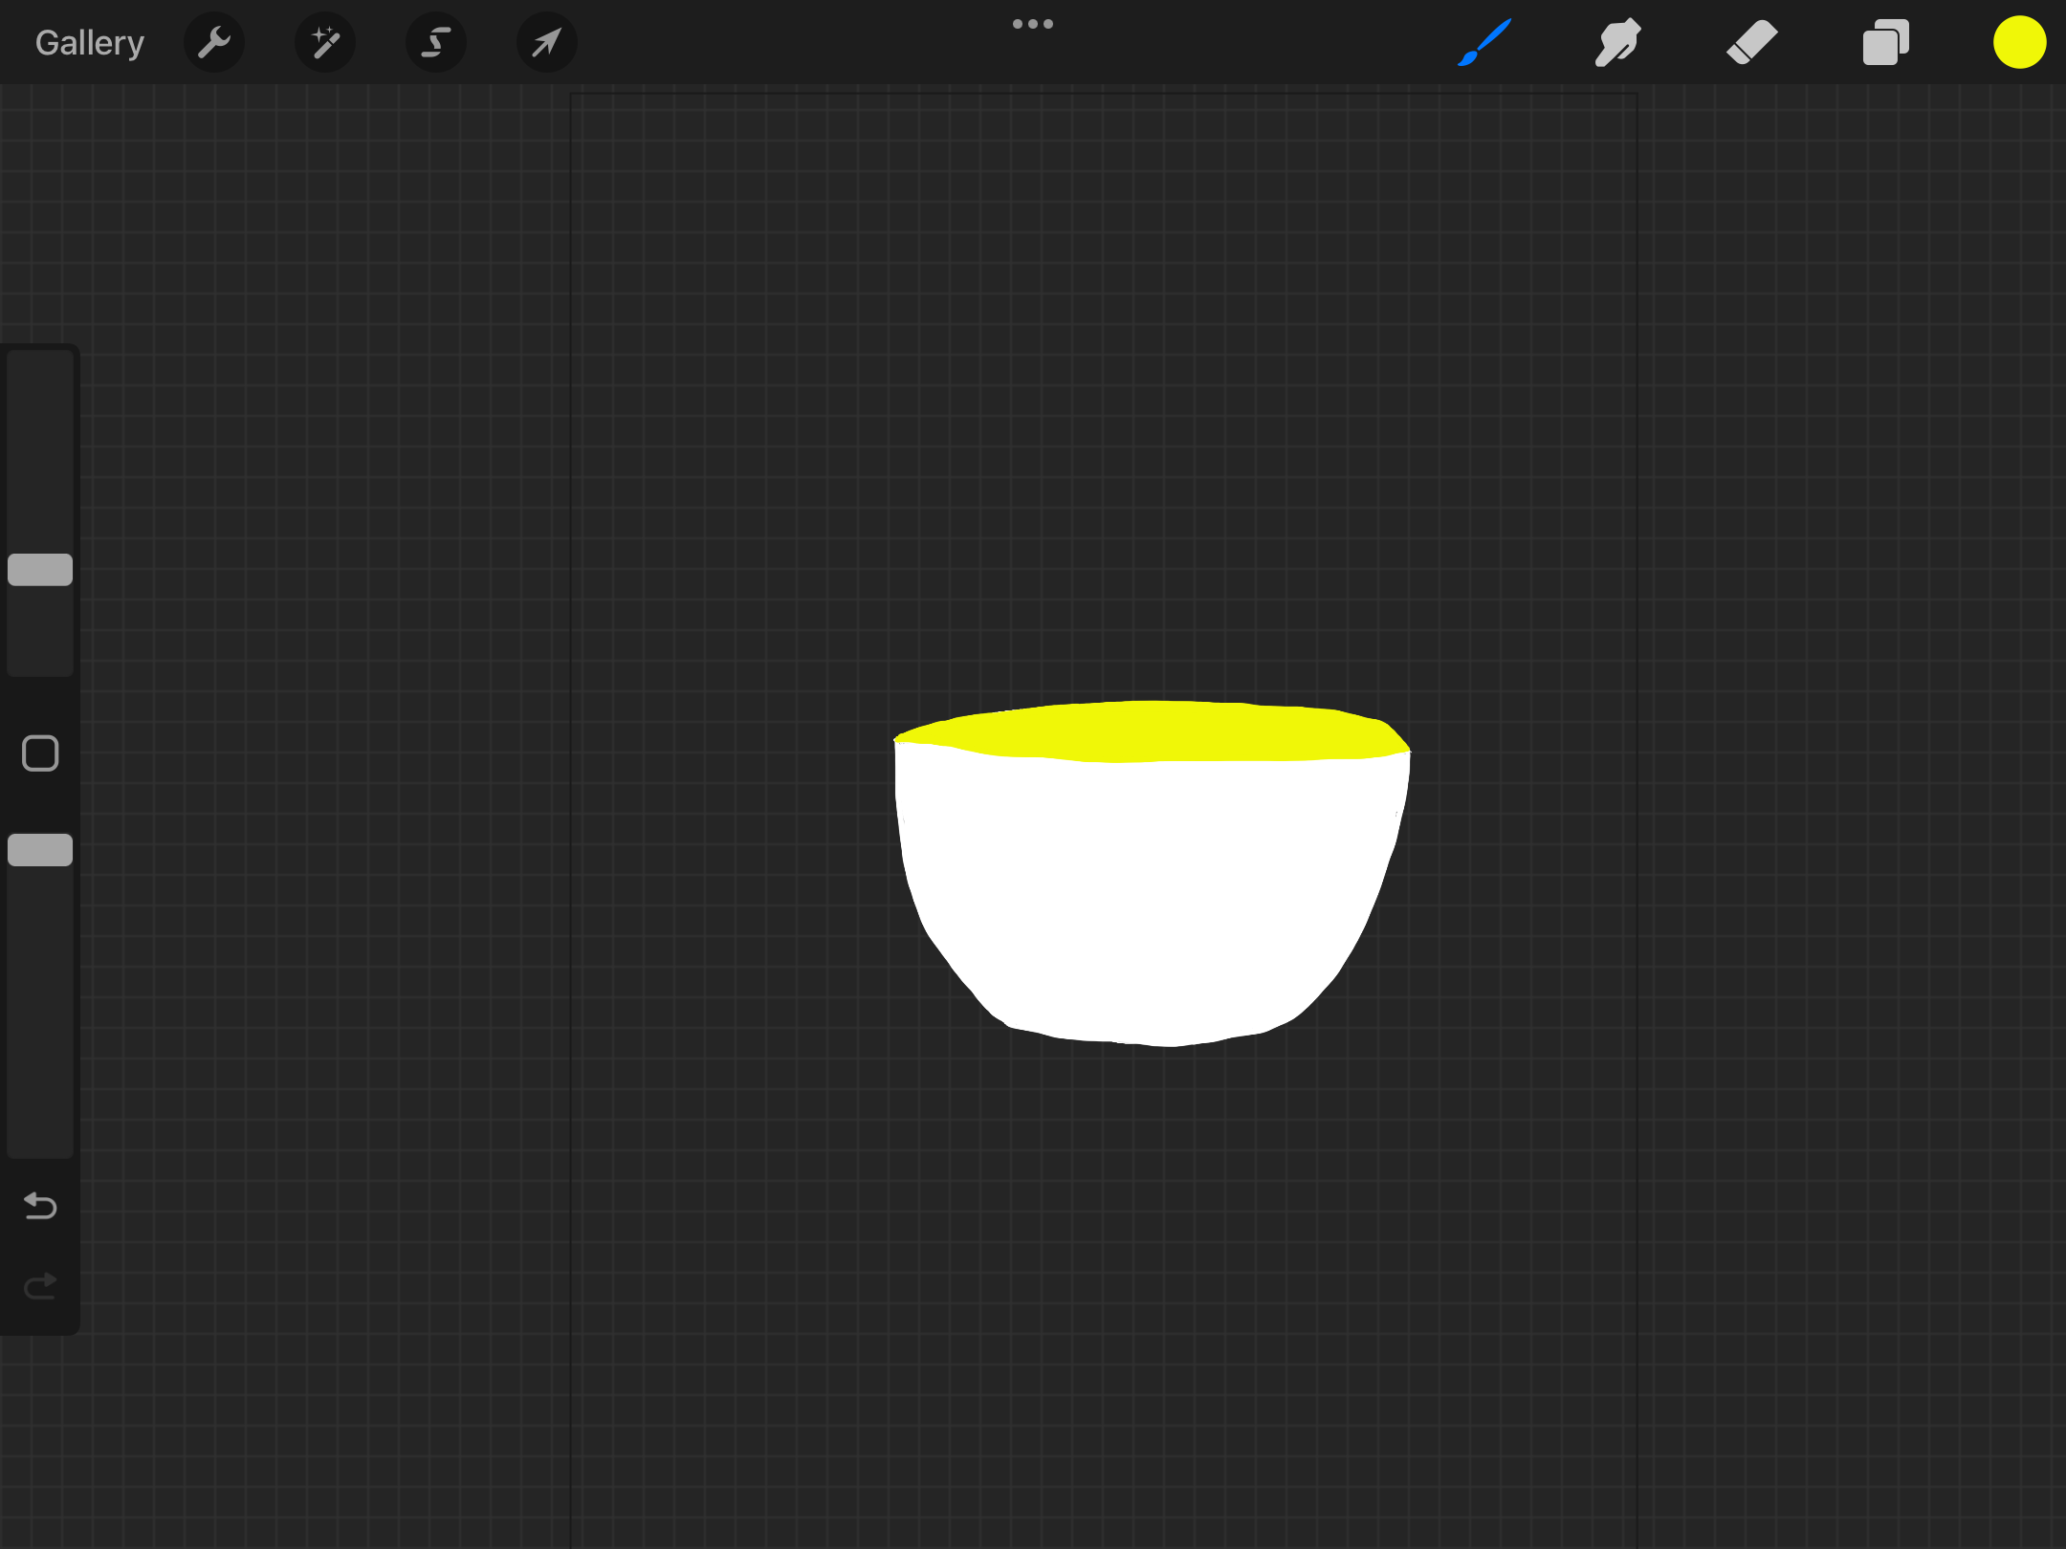
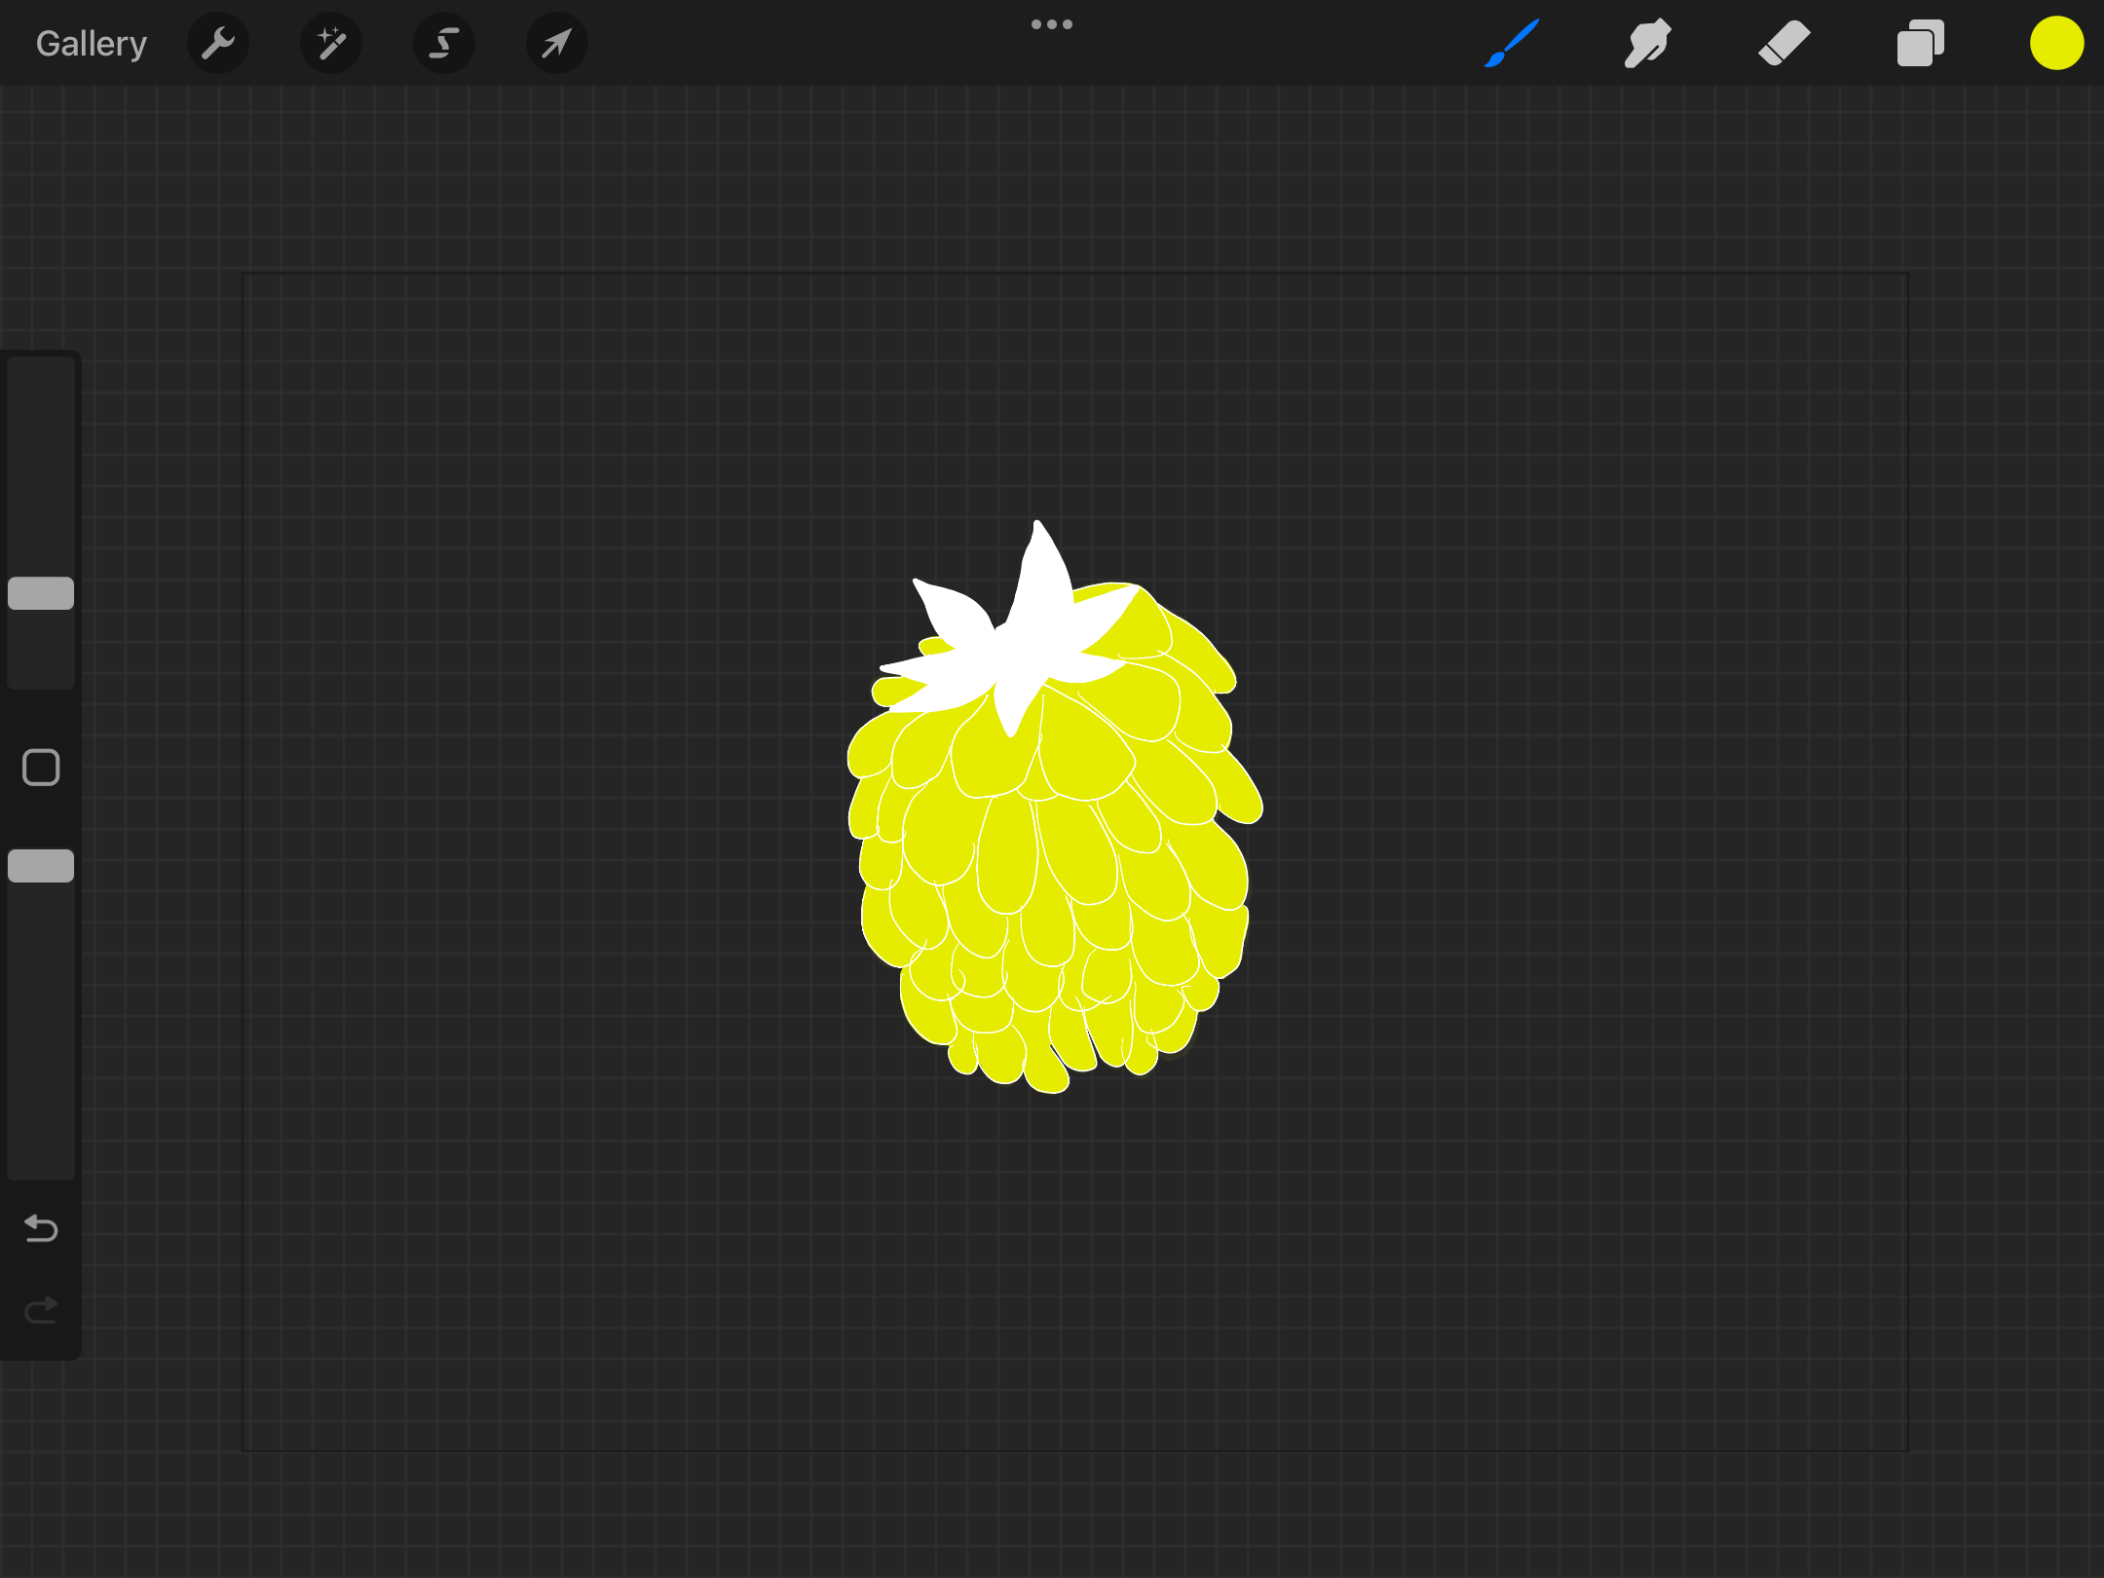
I enjoyed this experiment, but I found just the two colours more difficult that the three colours, I feel with the three, you can add depth of colour and highlights, whereas with the two it was hard to achieve it, it looked very flat.
