Exercise 2

Mixing and matching

So I started by thinking about the word Hybrid and I thought of cars, flowers, technology and animal. I went of course with hybrid flowers and found a tea rose reference photo from Pinterest, that I could sketch and use to scan into my computer. Now I didn’t know whether to use my computer (laptop) or my iPad for the scan to come through too. The computer I then have Photoshop and Illustrator to use to colour, or whether Procreate would be better to colour with?

I thought I would start with the computer then move to Procreate as a secondary trial after completing this exercise as written in the description.

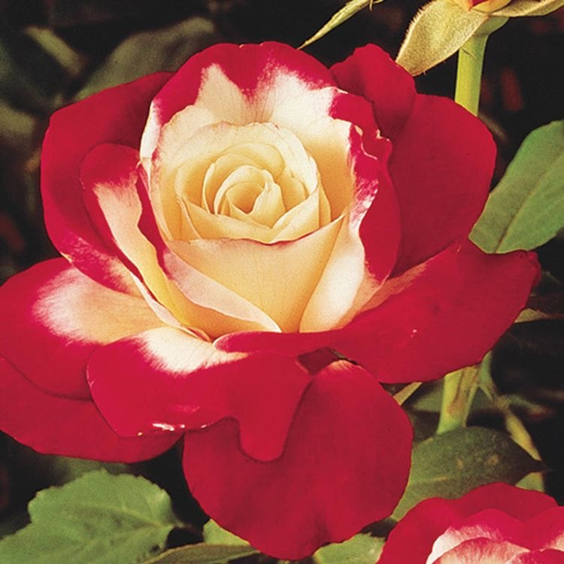
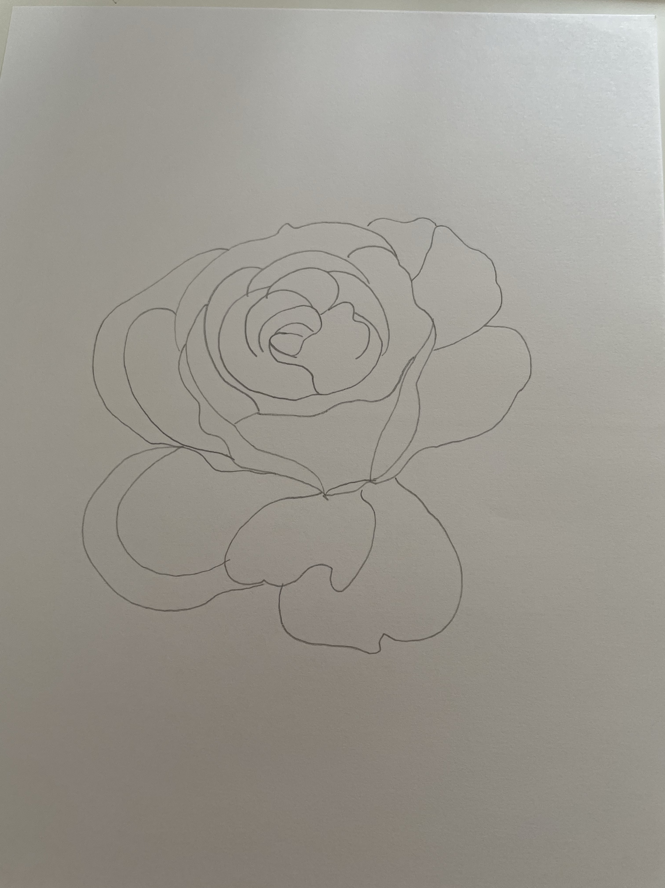
So I started by sketching the tea rose

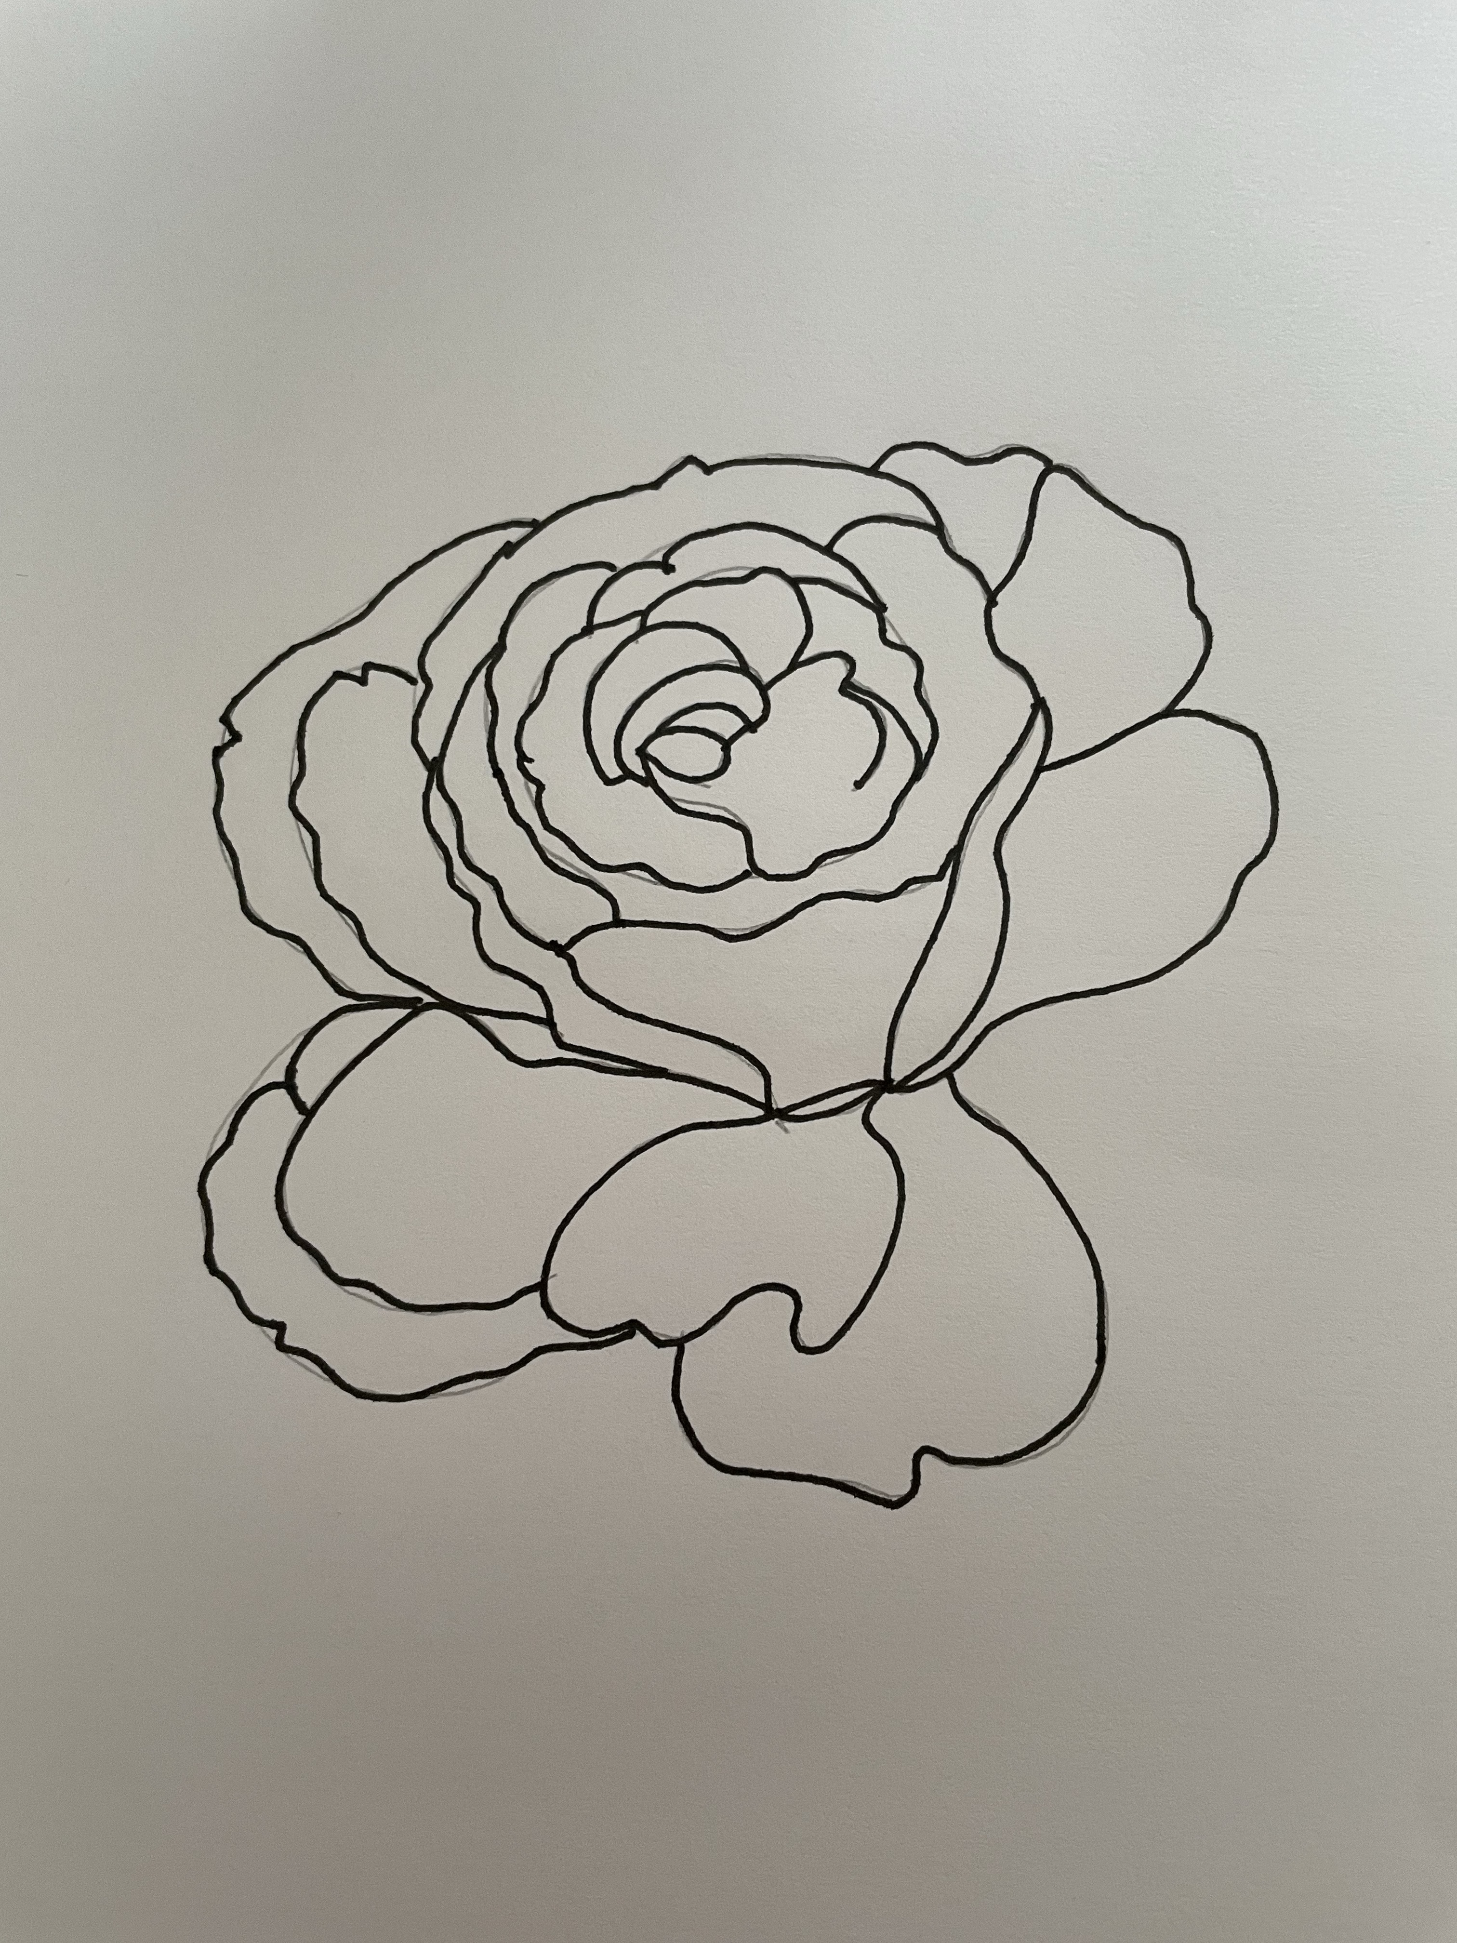

I sketched in pencil, but then went over this with black fine liner, I used a 0.8 so it was thick enough to see, as I find this picks up better through the scanning process.

I scanned the pen sketch into my computer, saved the scan and then Brough it up in Illustrator, I traced the outline then expanded the line, this meant I could colour the outline too.

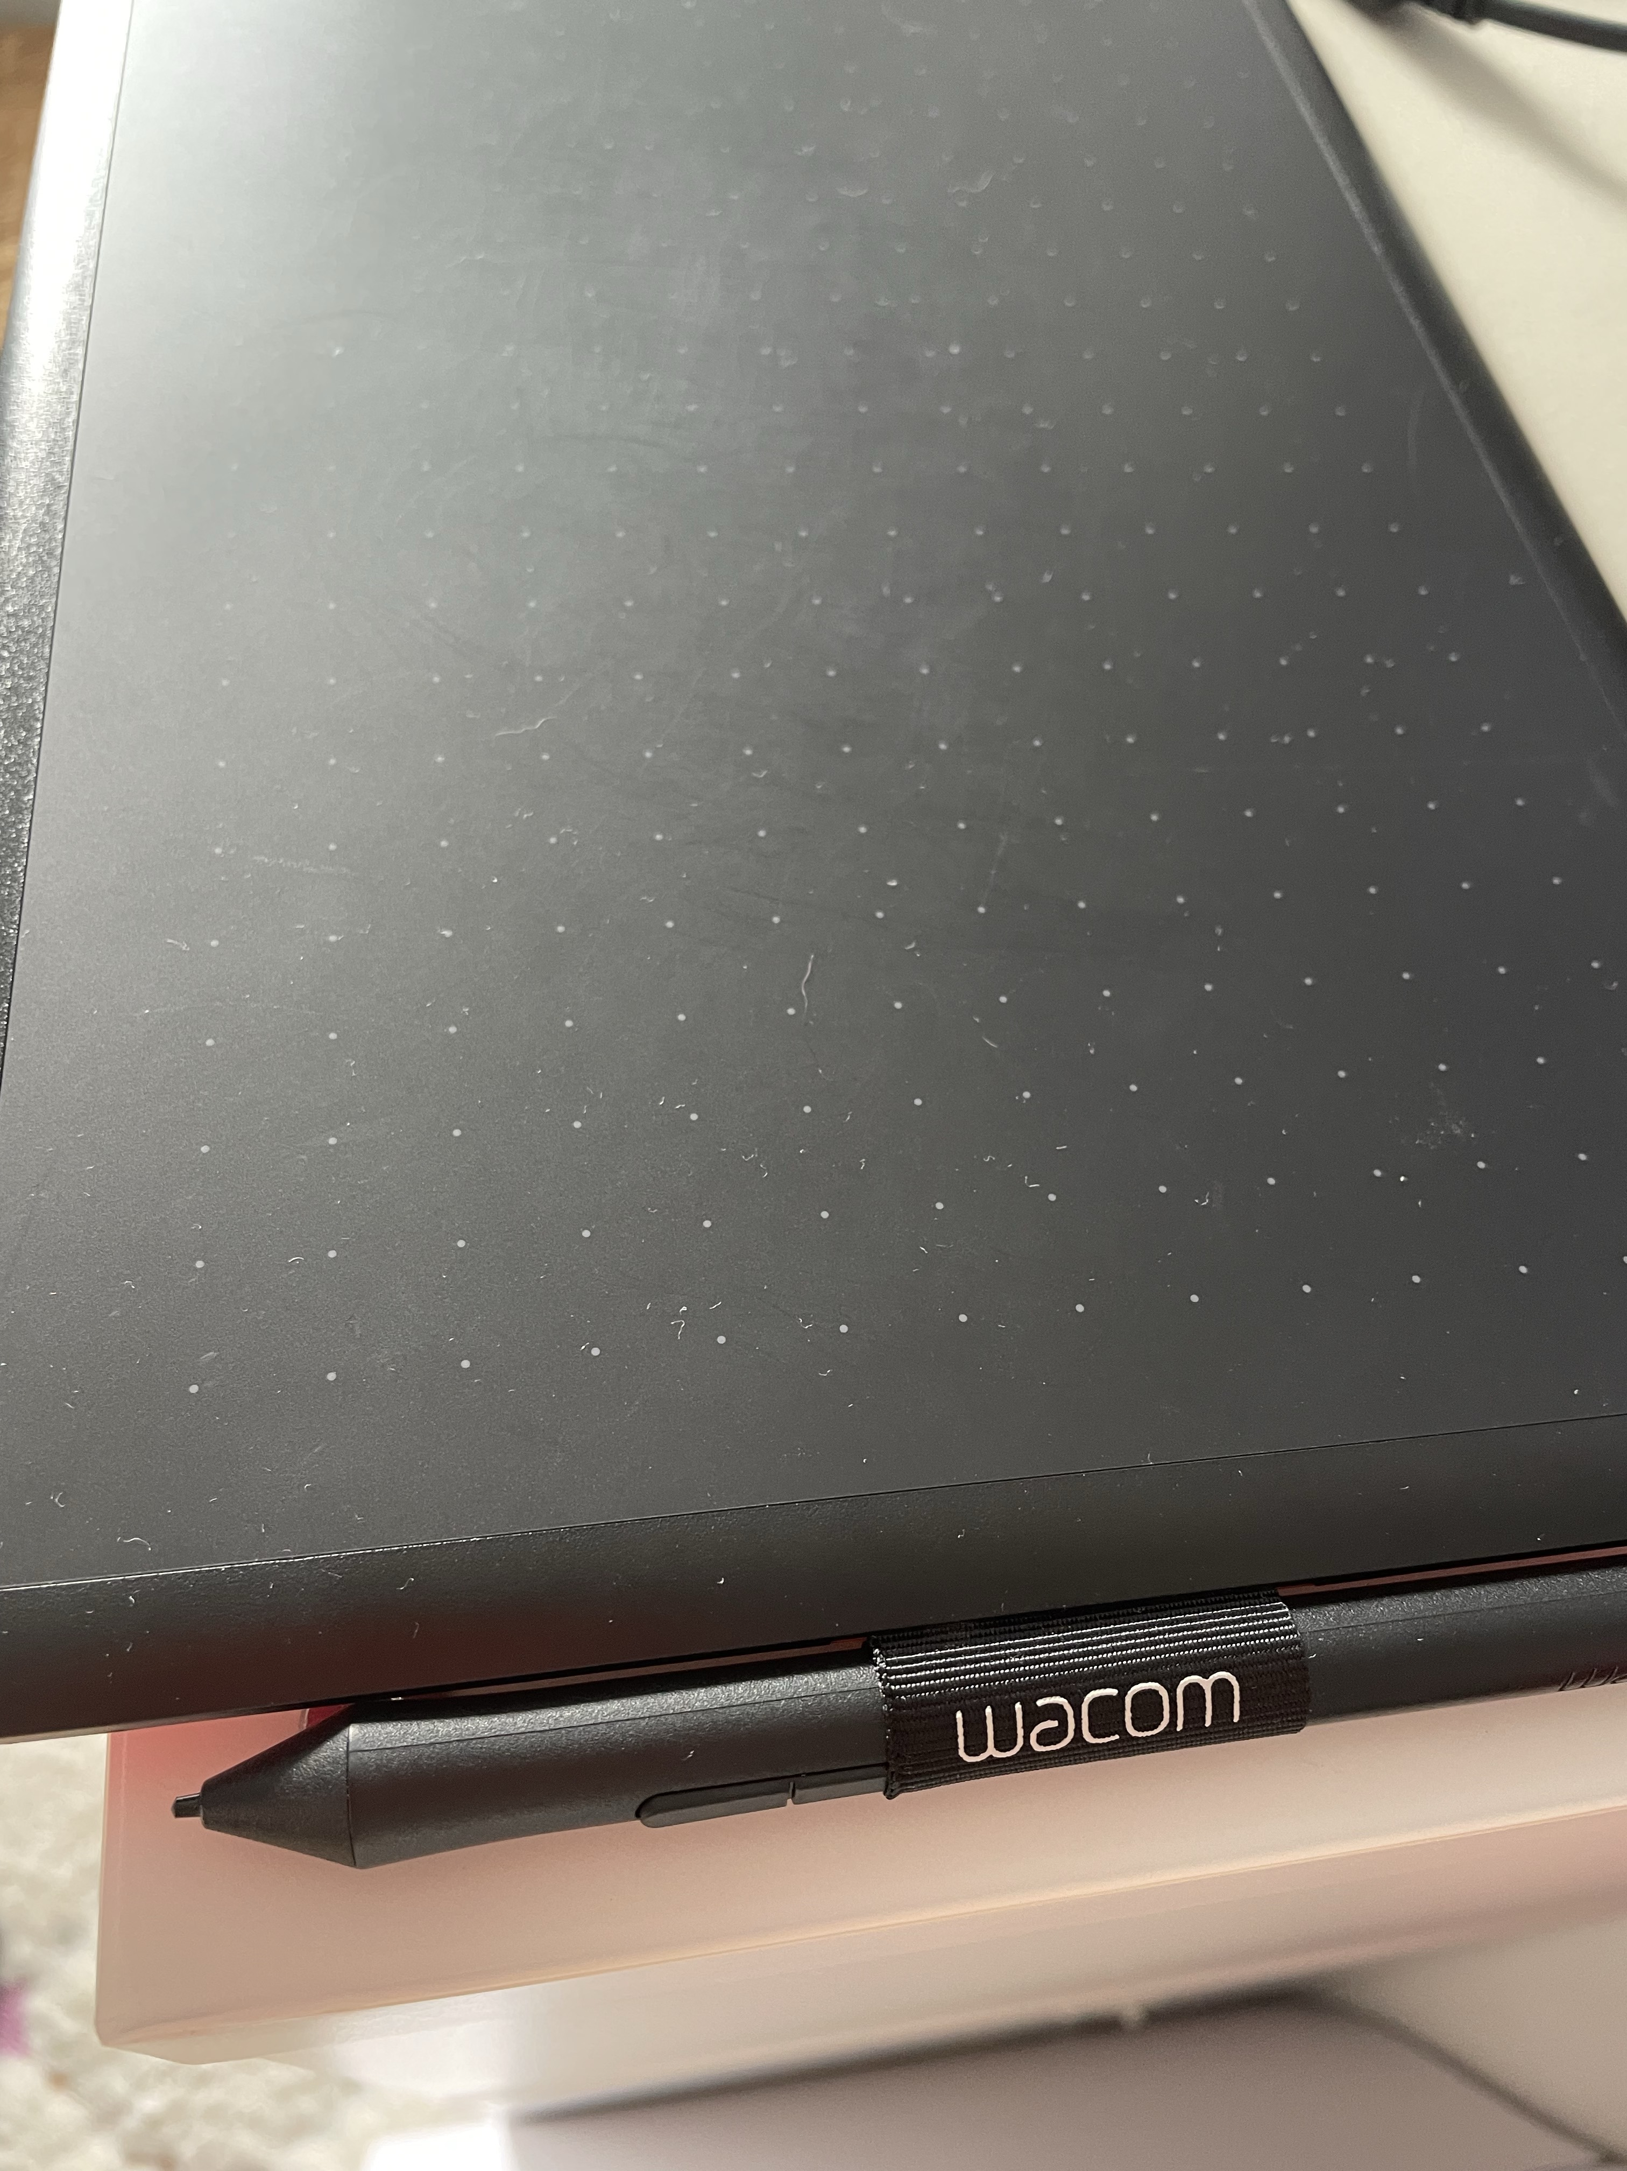
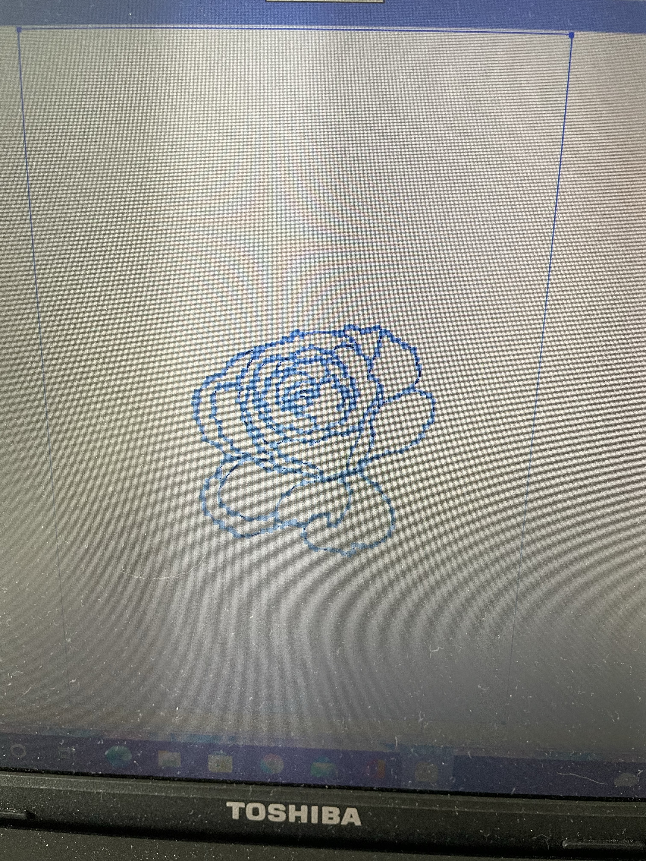

I then used my Wacom board to pencil paint in-between the lines, I used a paint palette from the Pantone swatch library’s, a red tone which moved through the pinks and lilacs too. This was a colour block style which was bold and pop art in style.
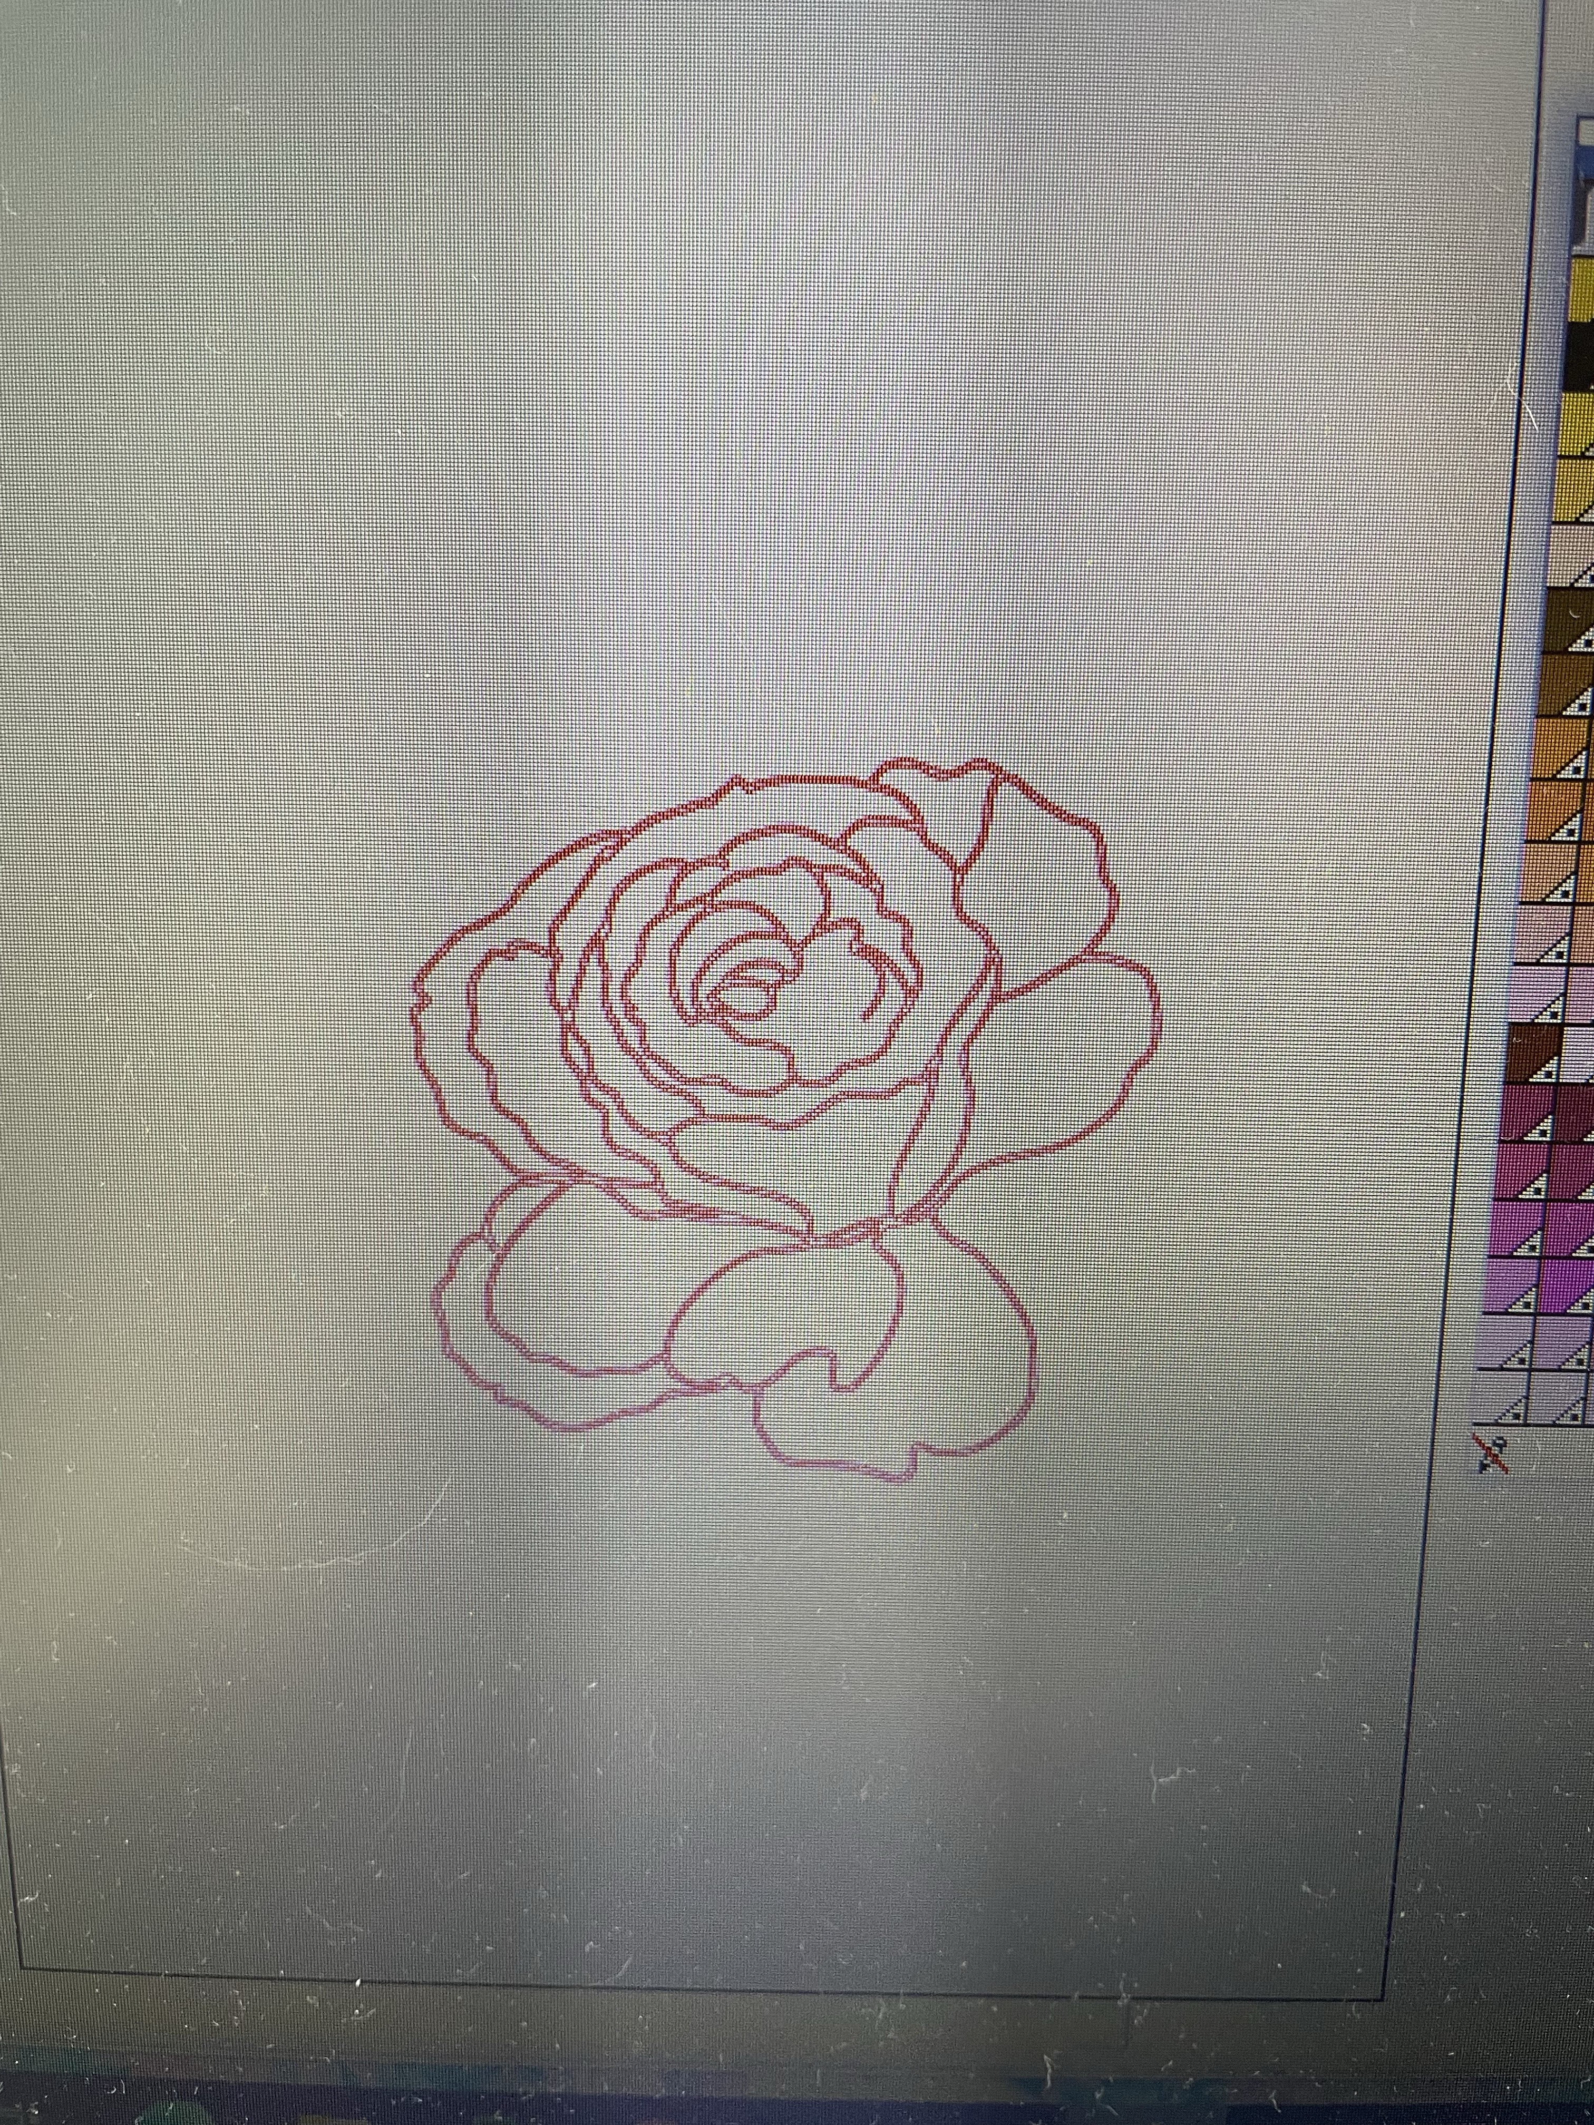
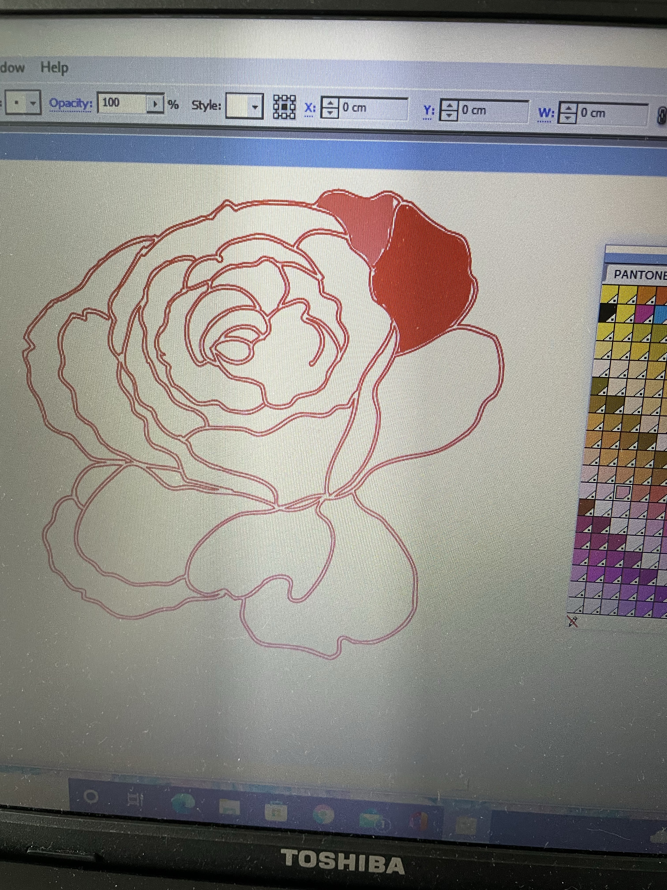
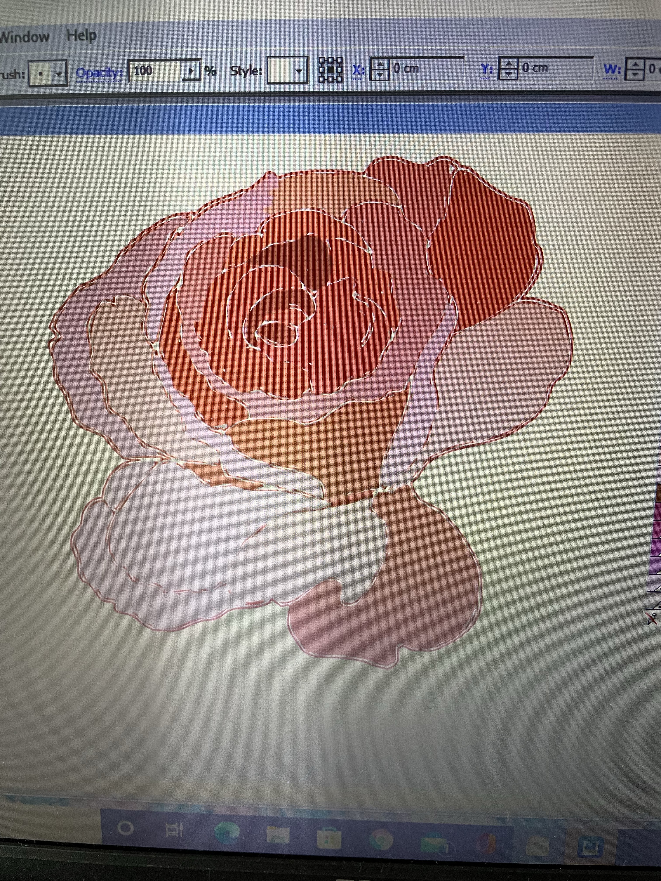

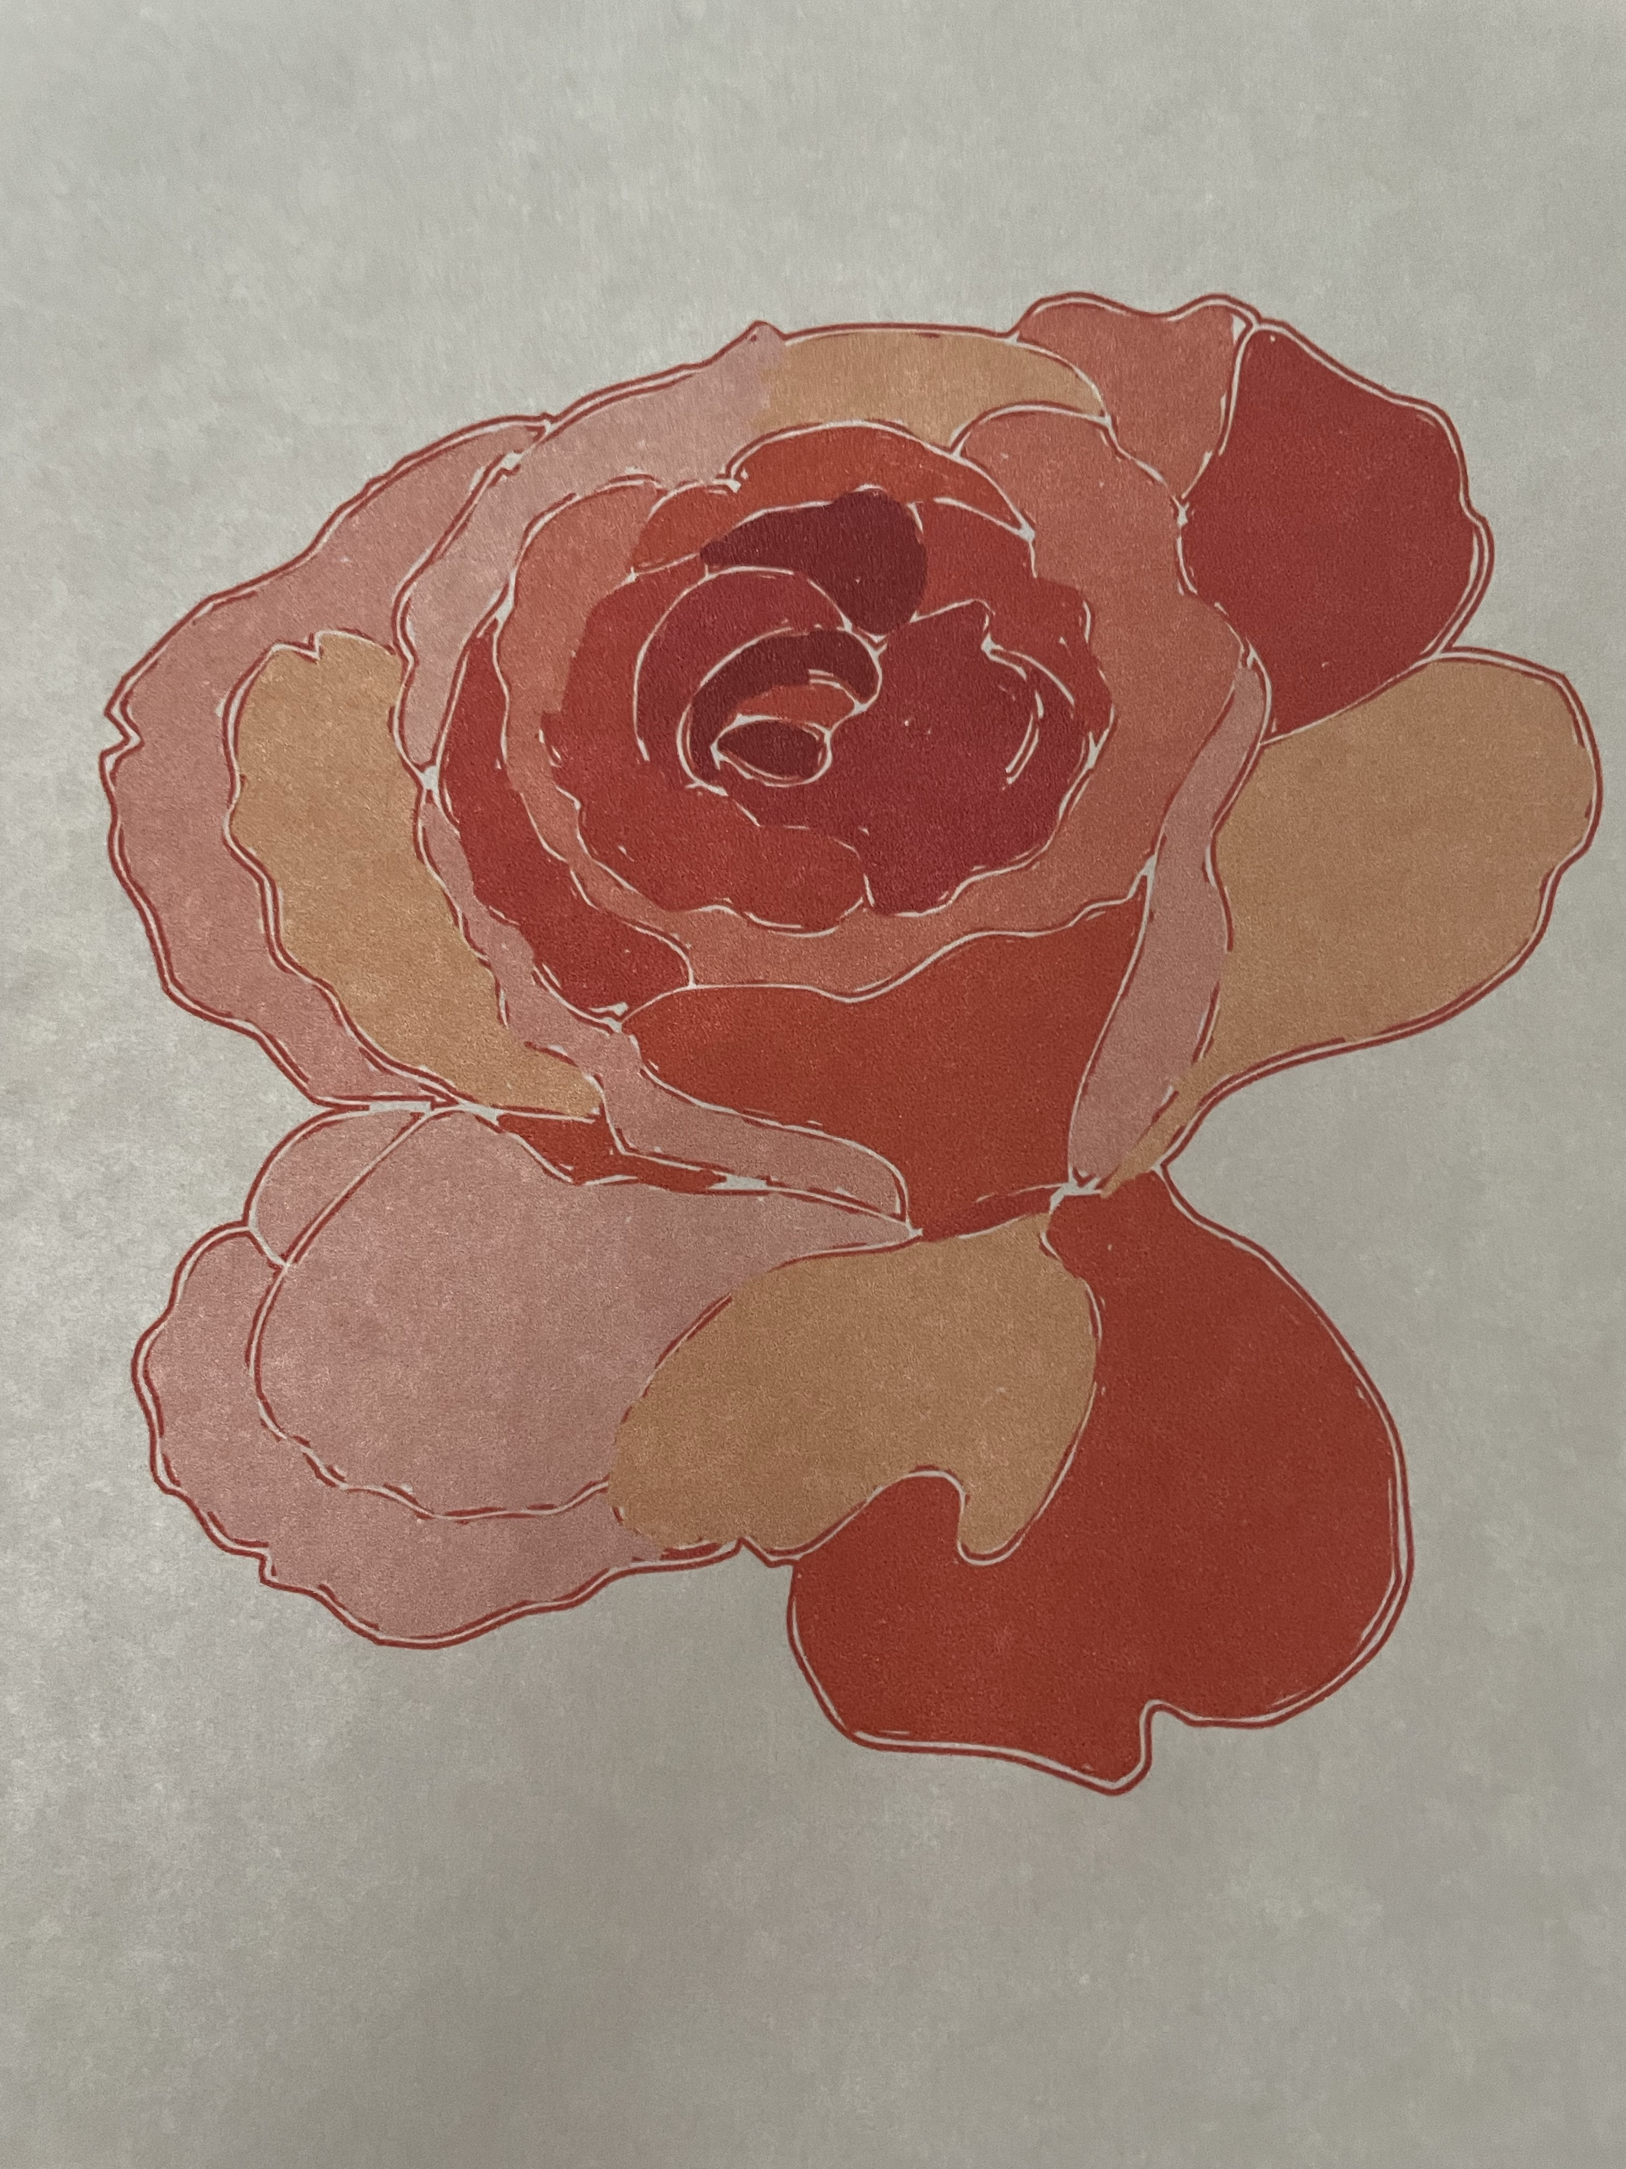
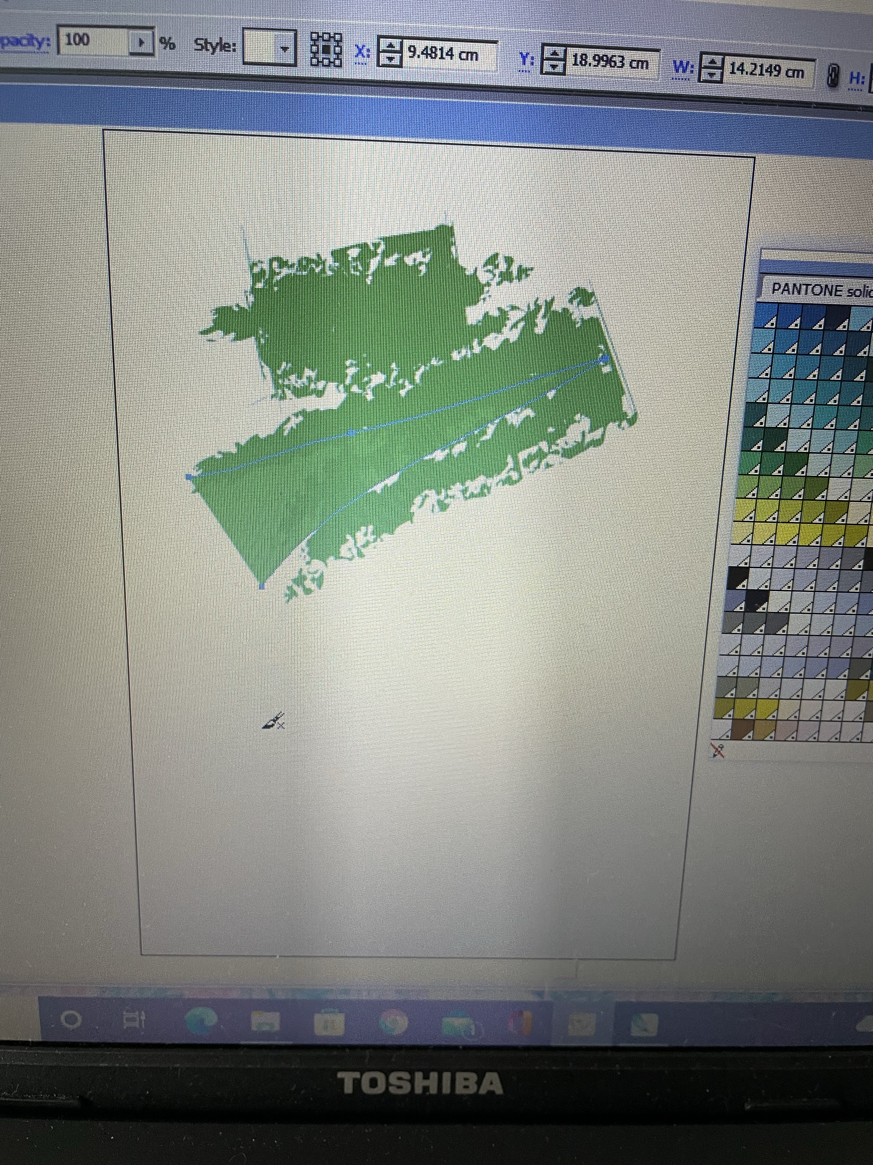
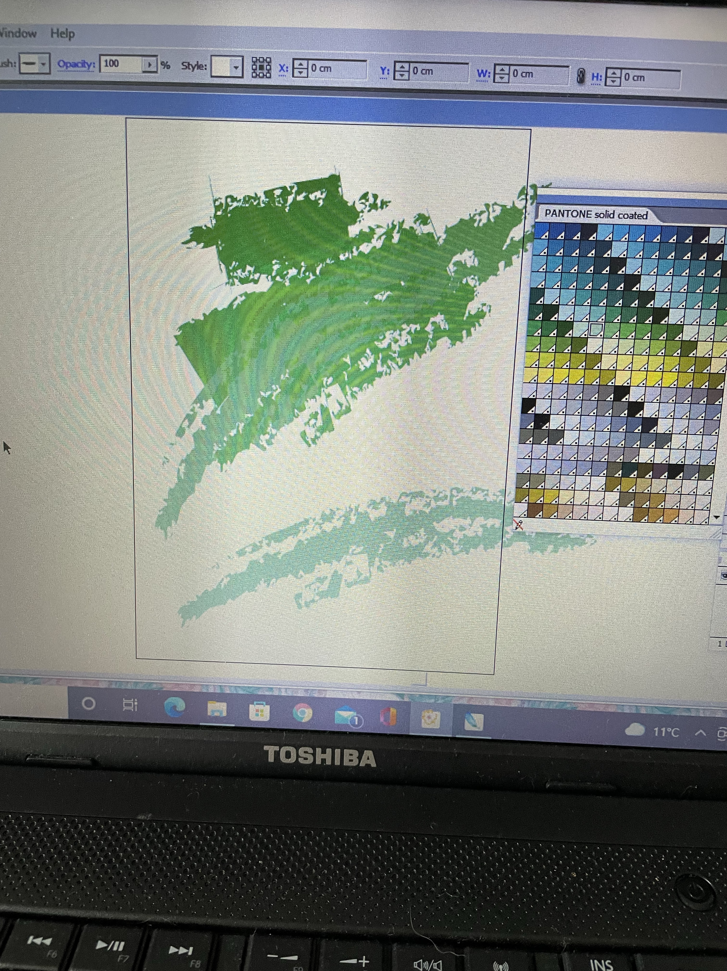
For the second experiment I started by colouring in part of a page on Illustrator, but this time I used a large brush with a textured stroke to it, I decided to use different hues of green from the swatch libraries.

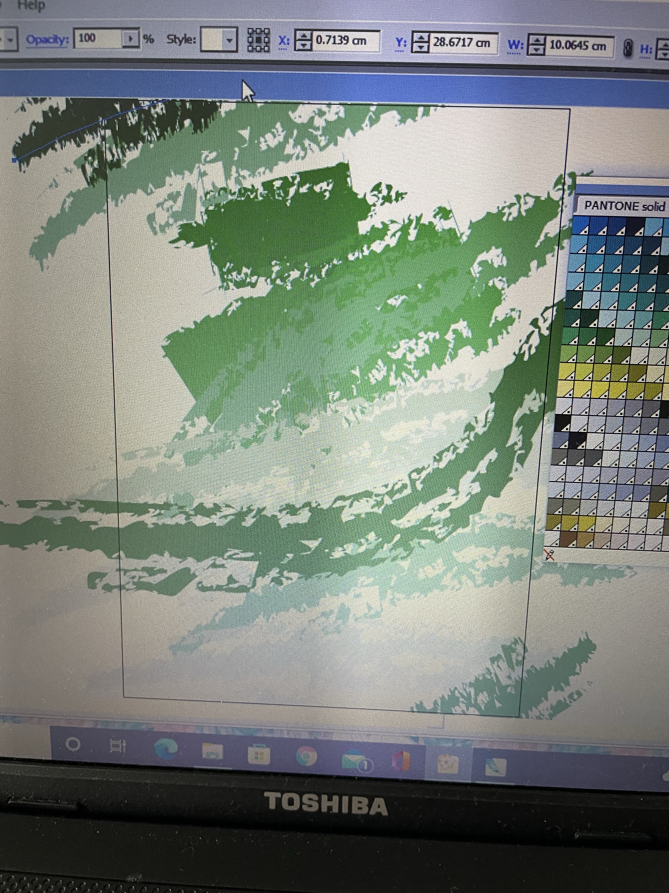
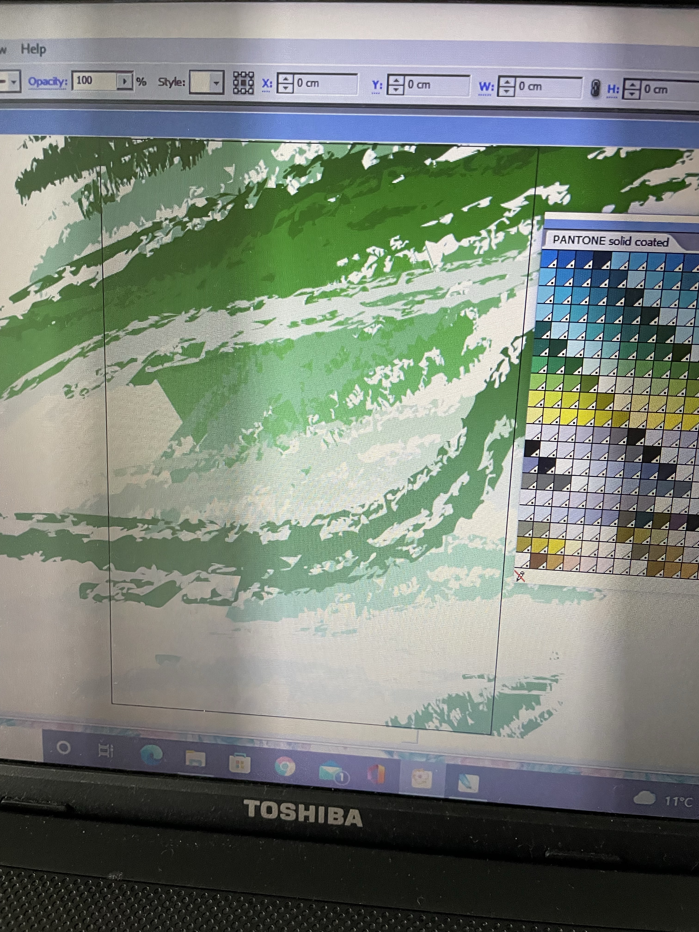
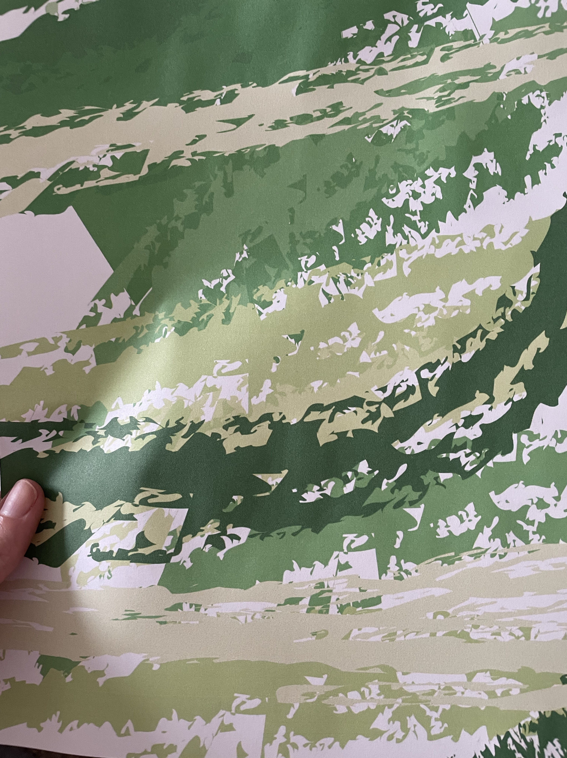
This is what the finished coloured page looked like once I had printed it off the computer.

Now it was just a case of drawing over the top, I decided to use some brush pens in black, and different green hues again, to create some foliage. This foliage will be a hybrid variety that is strong and out of control. The colours were:-
Parakeet green
Olive green
Crocodile green
Green tea
Seaweed green
Light green
Noir

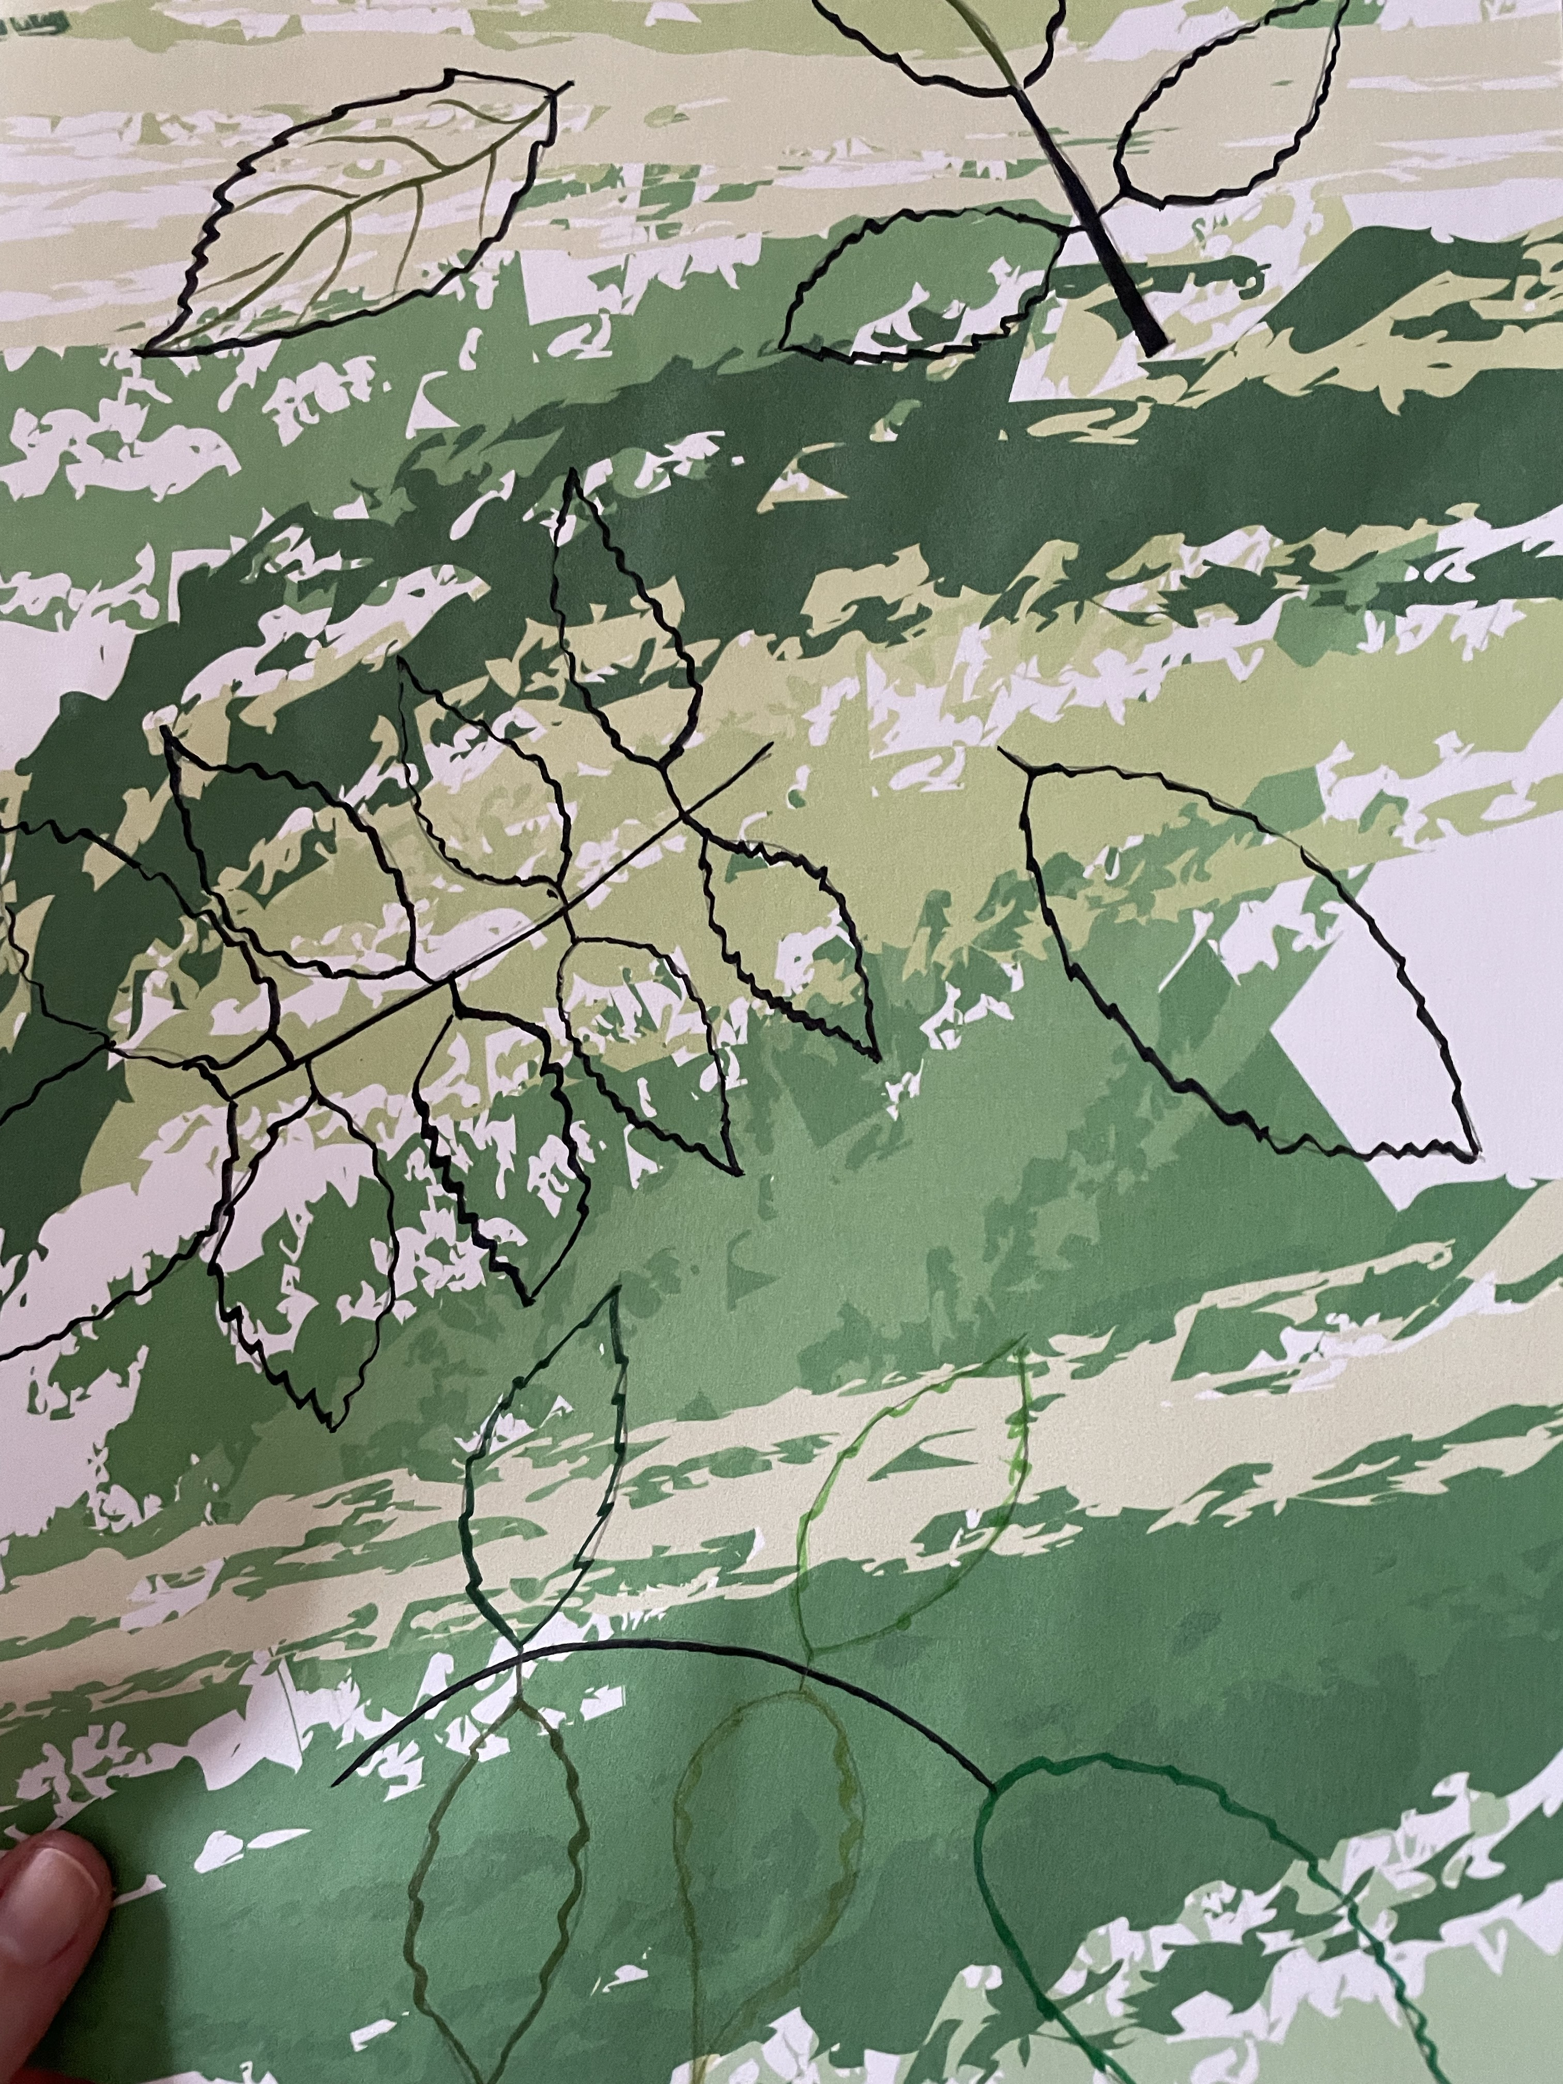
I found the foliage leaf for the tea rose hybrid above, so I decided to draw these in outline on top of the coloured paper. I started with just the black brush pen, but then thought what would it look like with the different green colours, so I did this towards the bottom.

I thought these leaves would look really good cut out to show the texture of the colours behind.
I thought of a few other ways you could add analogue and digital together, one would be to use a photo, so take one on your iPhone or iPad, then print that off and add texture over the top with paint.

The other one could be to paint over a sheet of paper, then scan that into Procreate on the iPad, then use the Apple Pencil to add drawings over the texture paint.

I really enjoyed this process of experimenting with the colouring and drawing, both analogue and digital, although I have done this before, I found that I was able to experiment easier, as this was trying it out, rather than having a definite outcome in mind.

I liked the idea at the end that I could cut out the leaves and the rose, and stick them onto another sheet of paper, and this would be a really interesting textured piece of collage. It would be very graphic, yet have many textures to it. It would be something I would try again, to experiment and try new things for my design work, it would be very unique.

