Exercise 1

Draw, draw and draw again

So for this exercise I was a bit daunted as it mentioned drawing a person in the description, I could have chosen something different but thought if I was going to improve my skills it had to be a person. I found a reference photo from Pintrest (see below), I started by drawing the body of the lady first to get the size correct before adding in the detail around her, and the window.
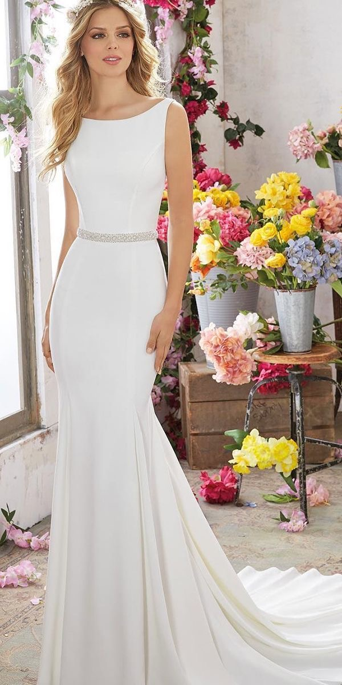

I was actually surprised at well I had done with this, I added in all the background flowers, vases and boxes, I didn’t add too much detail to the flowers, I just gave them a rough feel as though they were there, as I thought this was about sketching not proper drawings.

Again the second sketch was the same lady but with much less background, just a few flowers on the floor, and the garland at the window. I moved this sketch down the page slightly, as the first one I only just got her head in.

The third picture was the worst, I looked at the previous drawing only, and I was trying to do this sketch fast, and I completely lost the shape of the lady, and her face was Terrible.

The last sketch was the one where we could’t look at any reference or the previous sketch’s, but funnily enough, I found I concentrated on her shape more, and feel it’s well in proportion. The face is still not great, but better than the last one. I enjoyed the last drawing second from the best, and it was good to think about what was in your memory.

I found this exercise interesting, I found I could draw somethings better than I thought, and it has also made me realise that I need to work on faces too. I need to find a really thin pencil, I would imagine a technical pencil would be the best, then I could practise faces, and expressions.
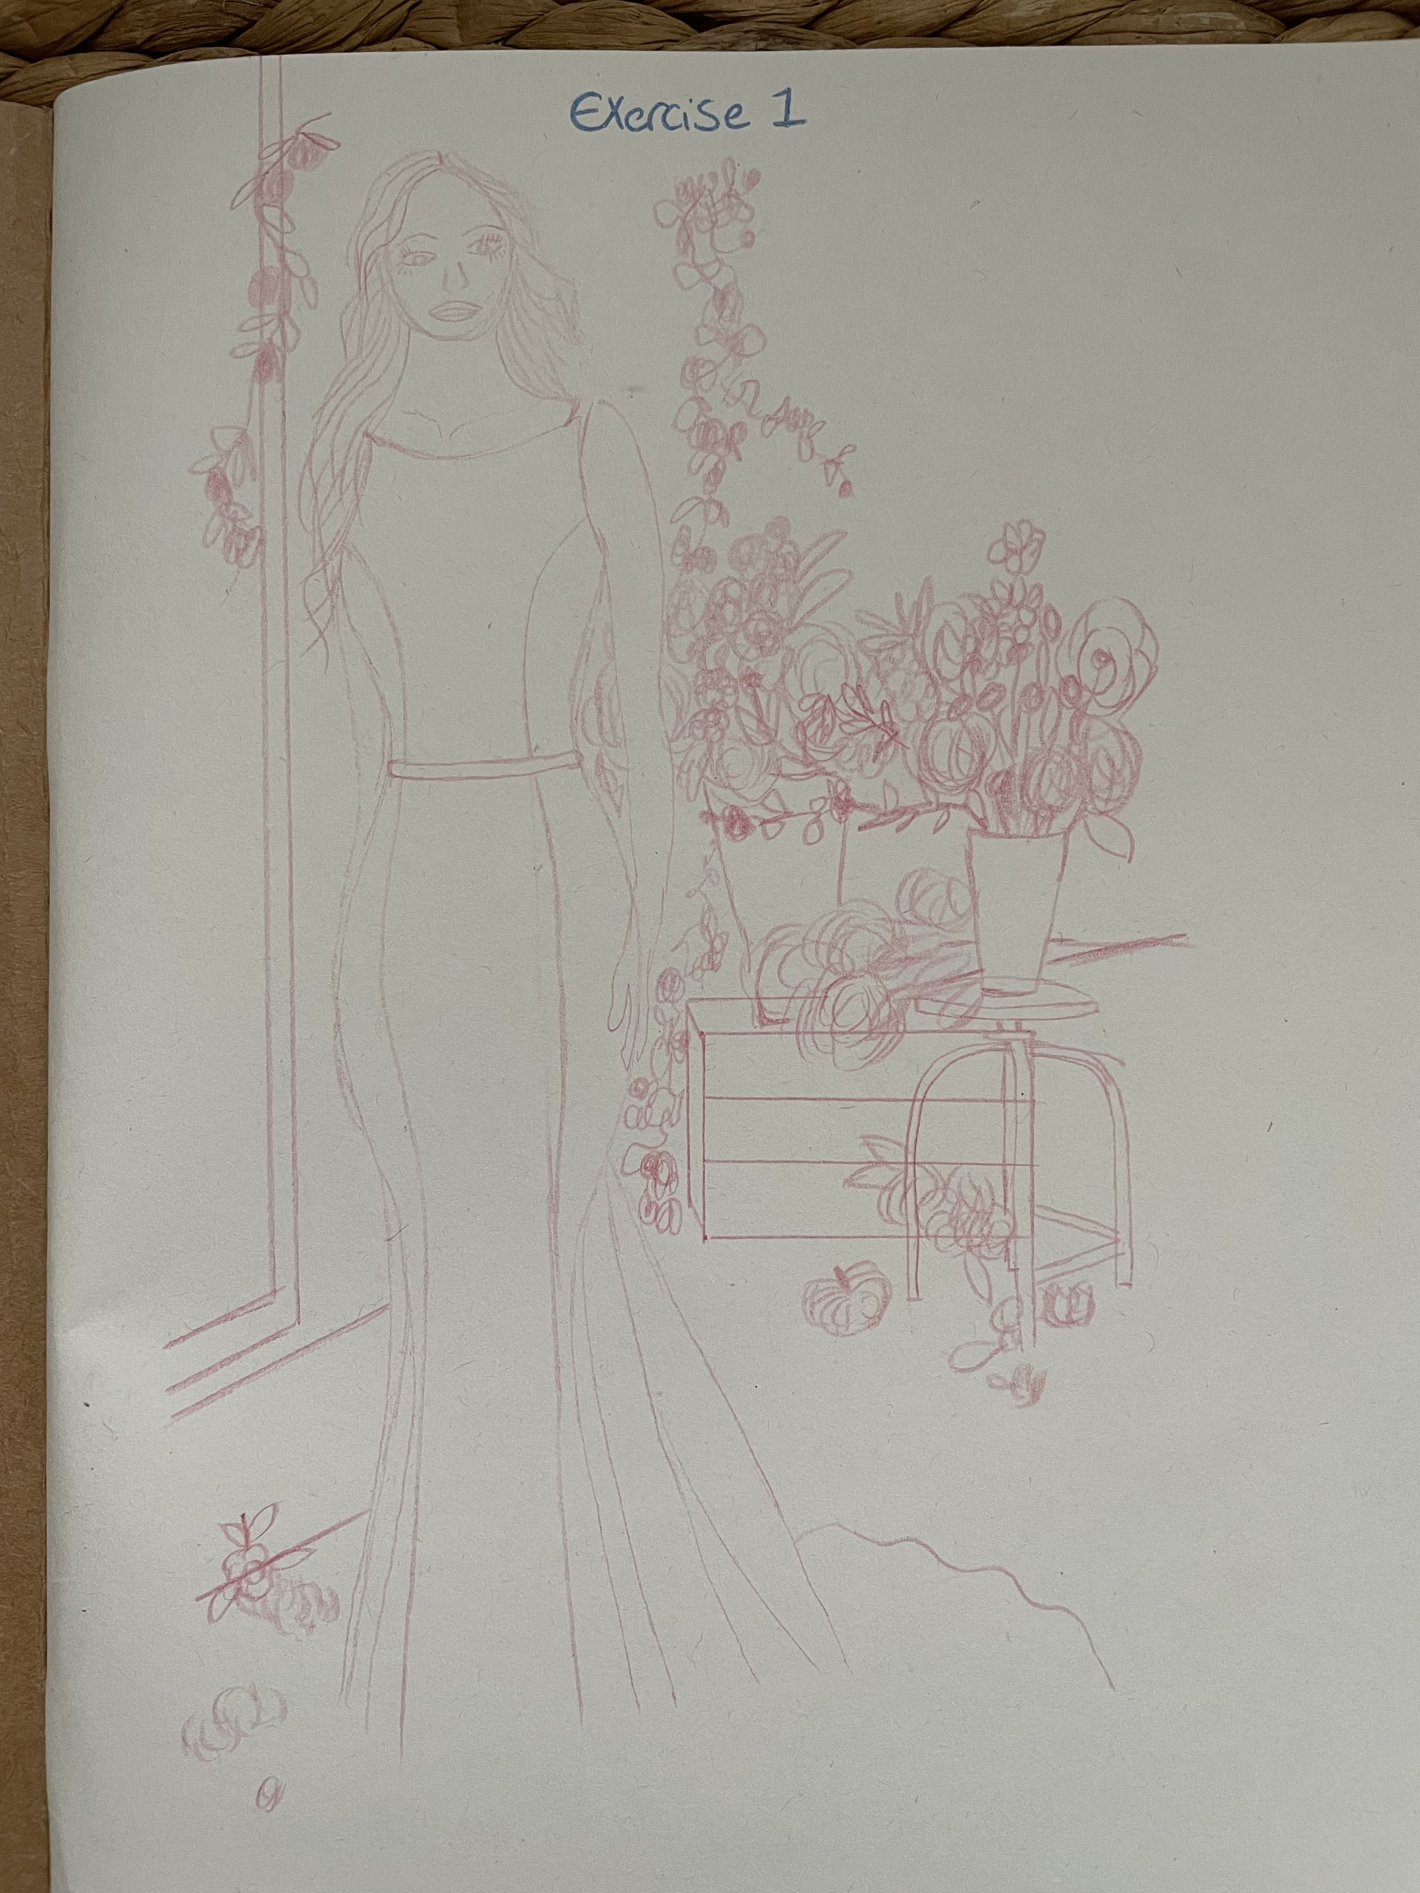
I’ve found I can work from memory, as long as I sketch the scene a few times first, which is some sort of progress.

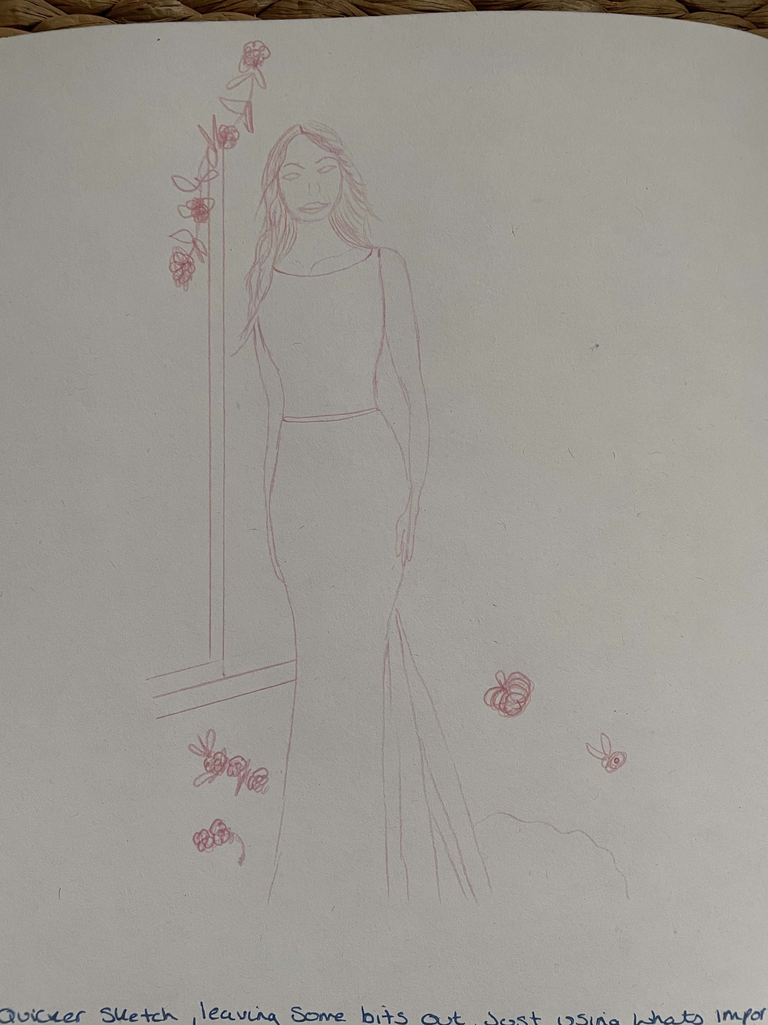
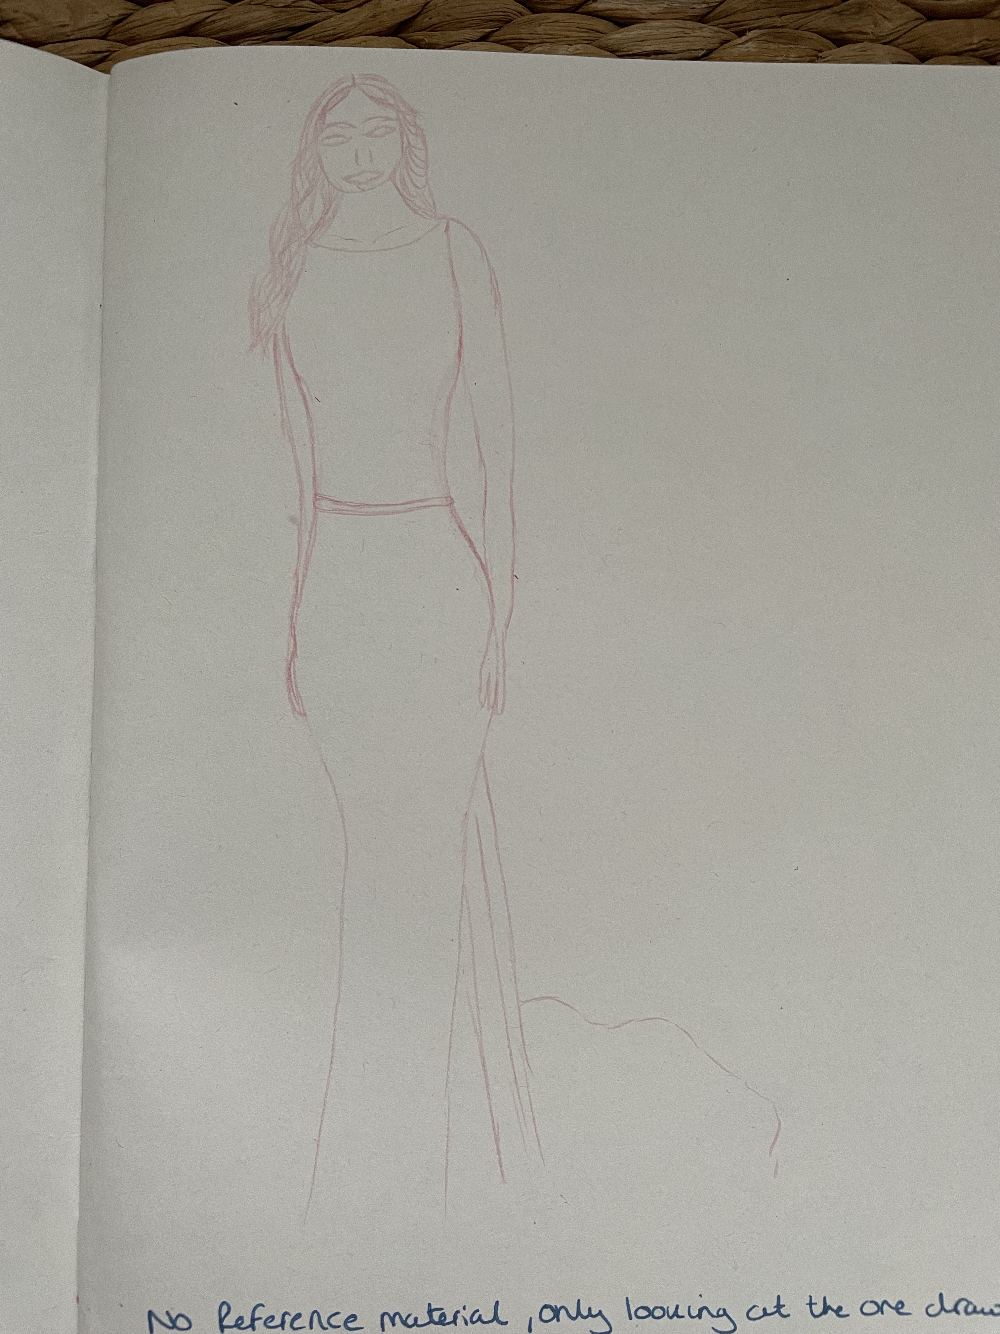
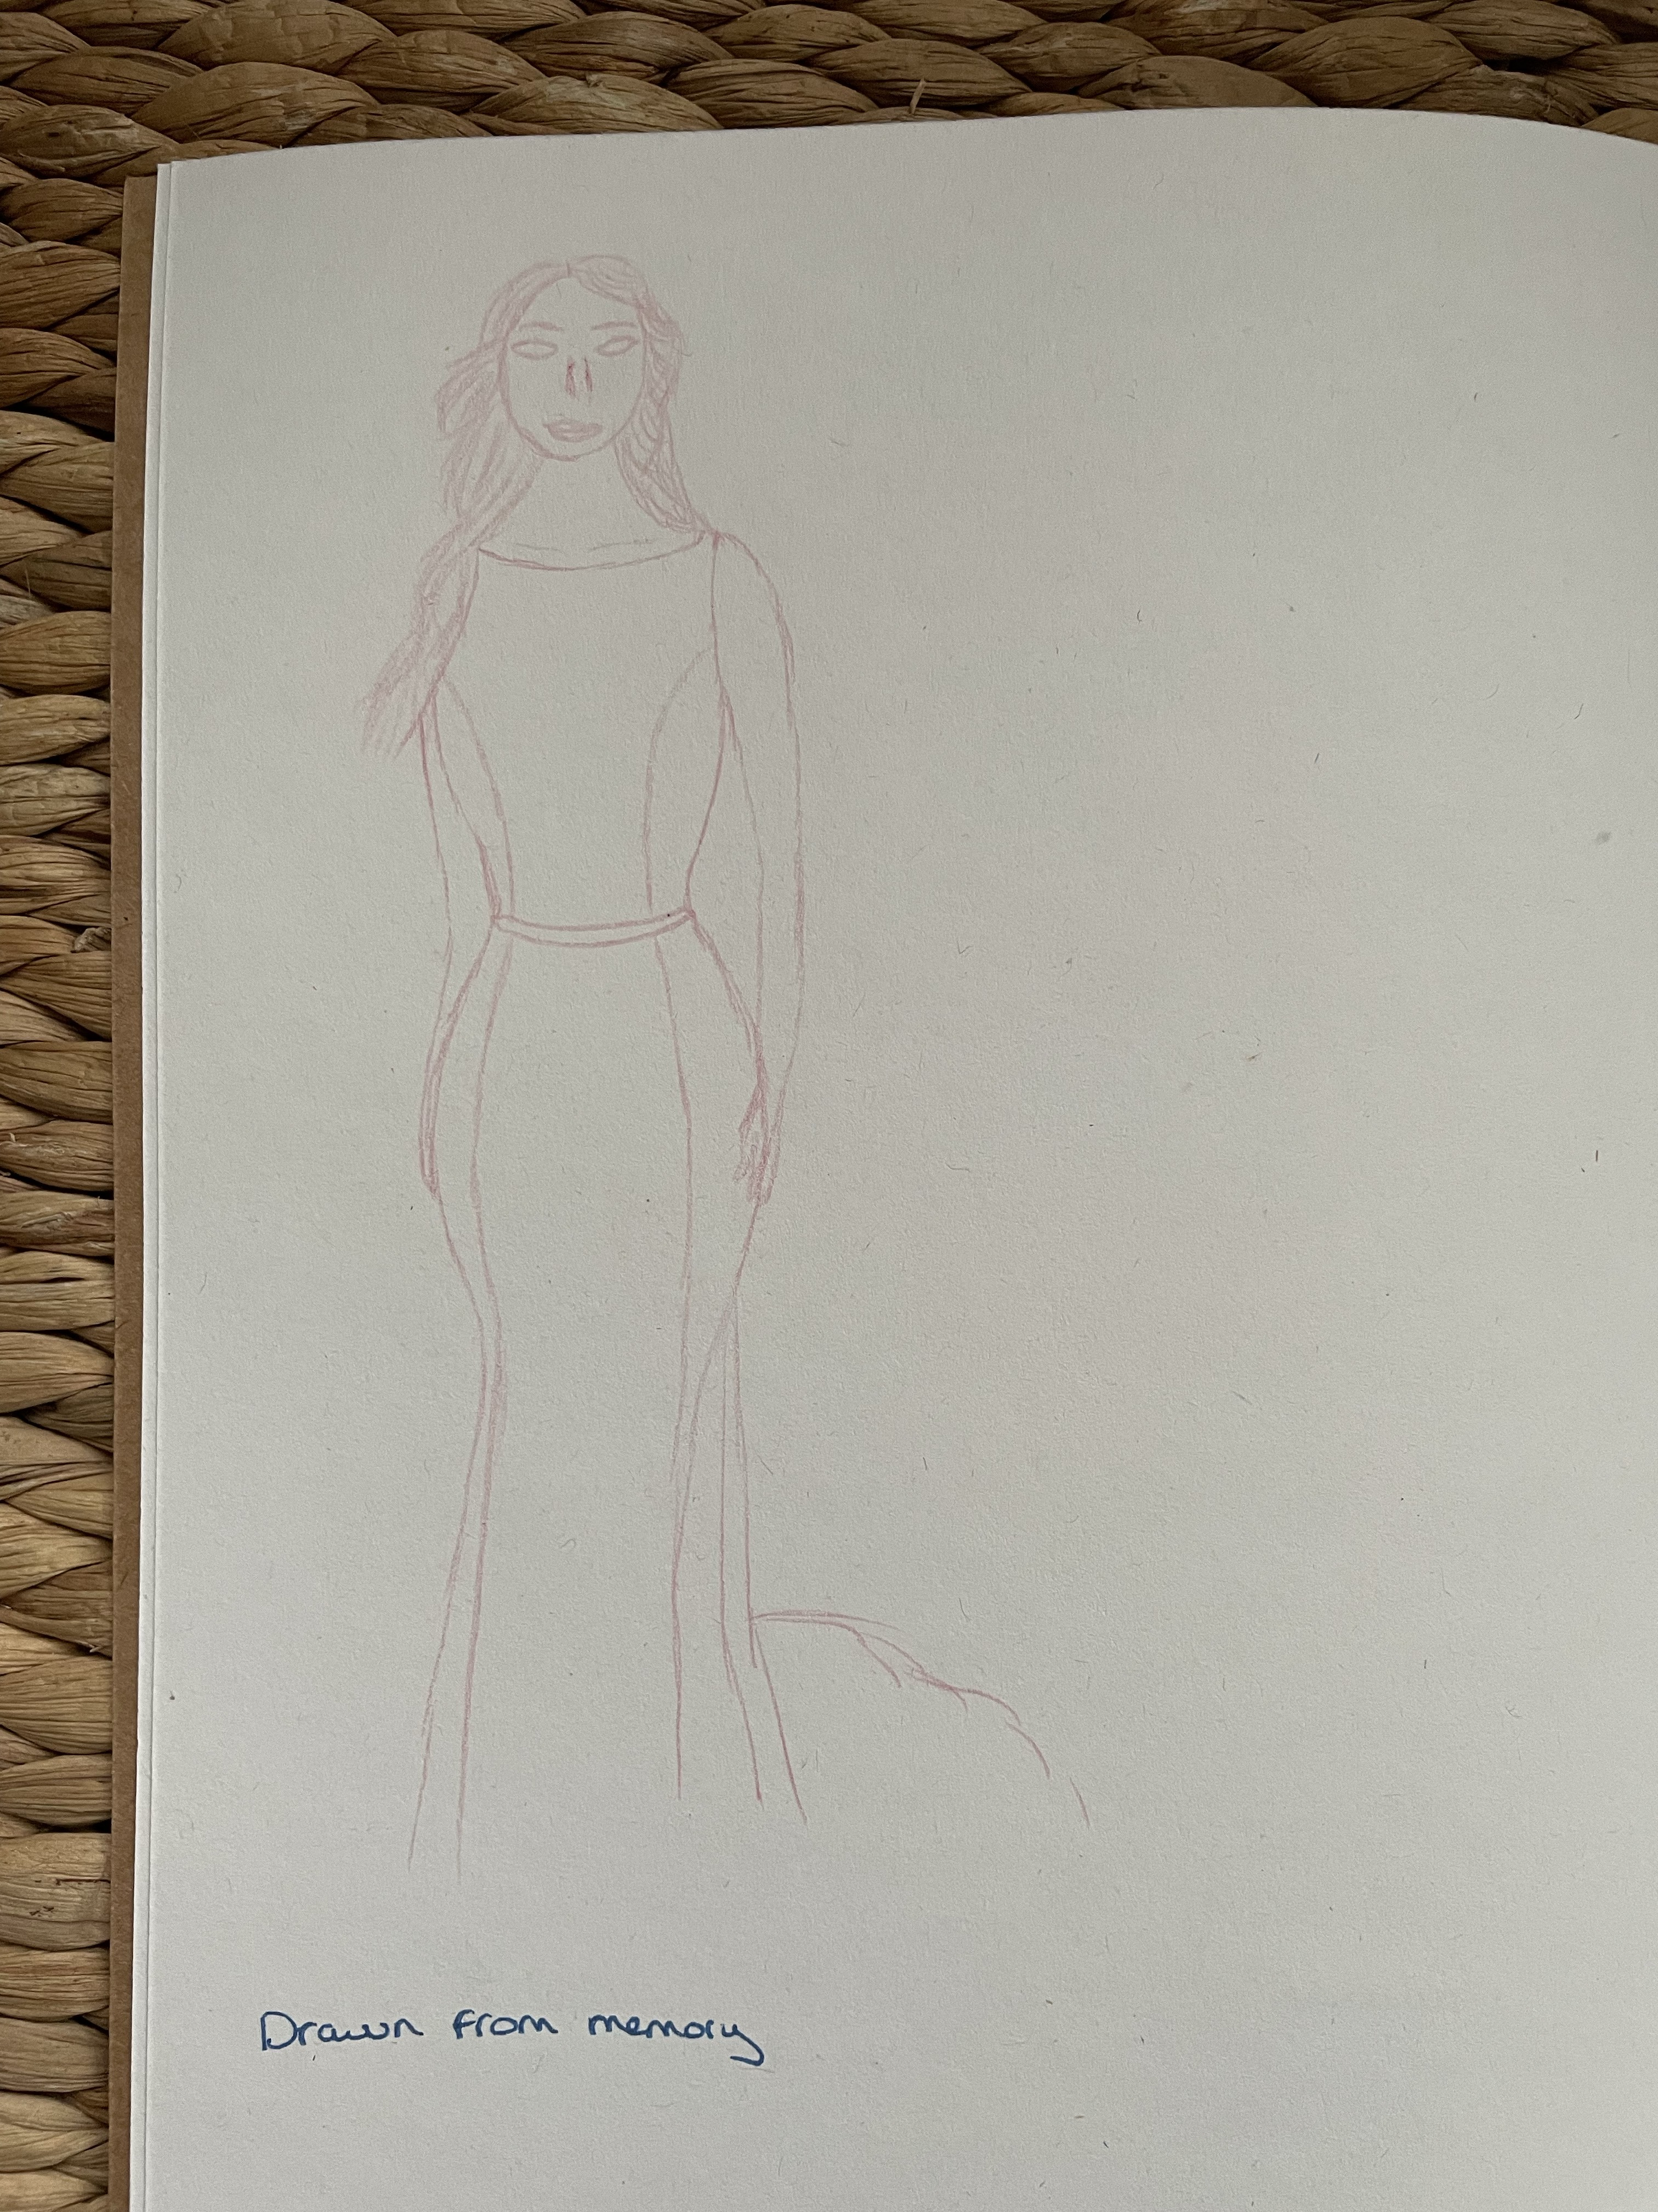
Overall I liked this exercise and would definitely do this exercise again, I would help my people drawing skills and how to get the perspectives right. I have also got work to do on faces which I can start in my own sketchbook also.

