Your choice
Your final assignment asks you to draw on all the skills, insight and experience you have gained so far, by designing and producing a book of your choice. Use the following options to as a starting point or alternatively identify your own project.
So this assignment brief is asking me to produce a book of my choice, either as a start from the three ideas below, or my own idea!
● Influential book designers Identify one or more book designers to present through your book. Find ways to develop your own creative responses to their ideas and visual approaches. Delve into their work, find suitable quotations, investigate their influences, and find ways of communicating this material, and your interpretation of it, to an audience through effective use of layout, narrative, and choices of material.
● Typography Extend your exploration of typography by continuing to develop creative approaches to how typography, layout and your material choices can help generate meaning. Develop a book that explores one aspect of typography in more detail, or combines a variety of approaches. Just because your project explores typography it doesn’t mean you can’t also include images, colour and narrative.
● Found and altered books Use an existing book as a creative starting point. This could be an extension of exploring altering books in some way, or as a research project into a specific book that will generate content and creative ideas for a new book. Find a physical book to work with or pick one of your influential books from Part One.
So carrying on from exercise 5 I have an idea, which works on from the first choice above, but with a lot of my own choice involved. Influential book designers, I am choosing Concrete poetry and sequencing images.
So I need to research concrete poetry in depth, after looking back into concrete poetry I wrote some thoughts down in my sketchbook:-
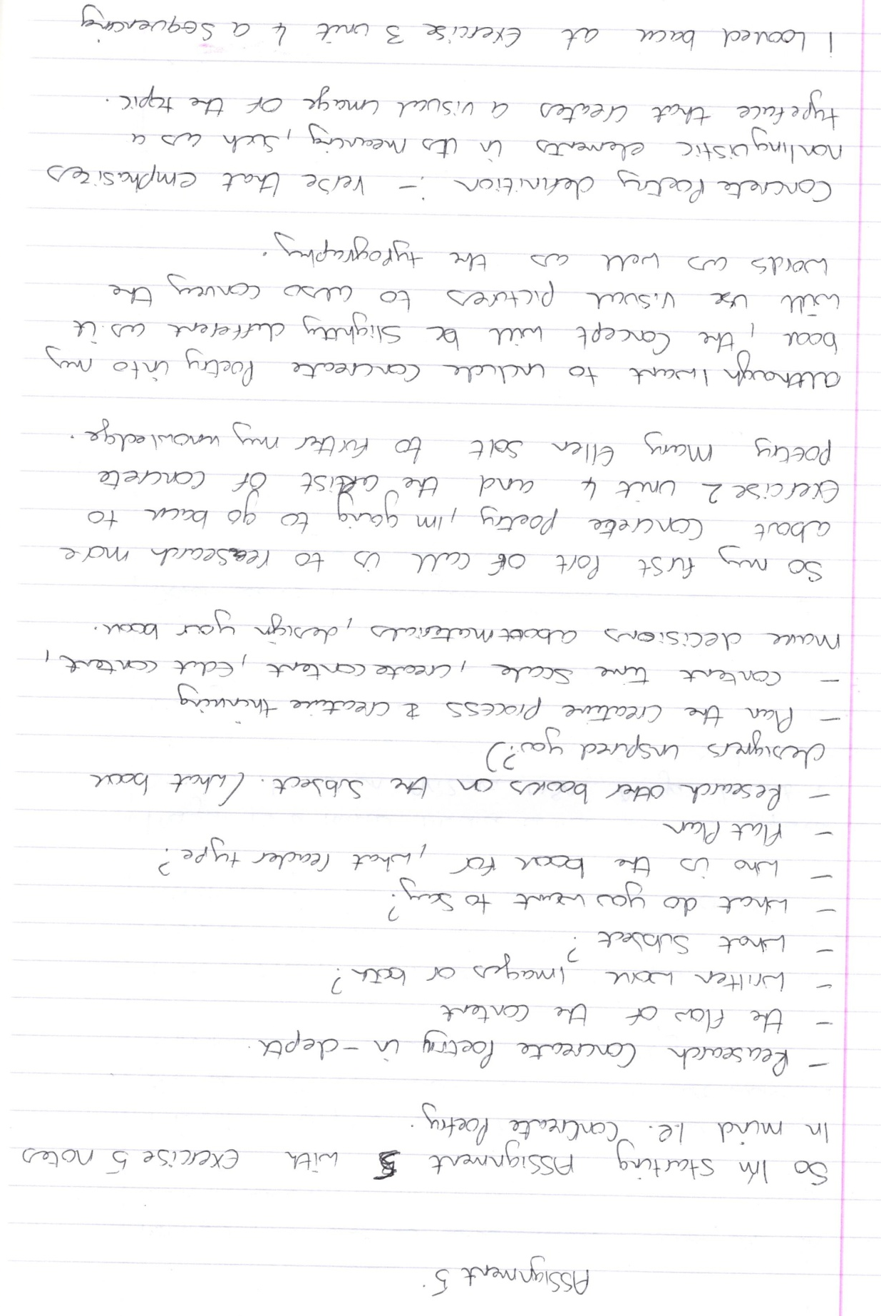
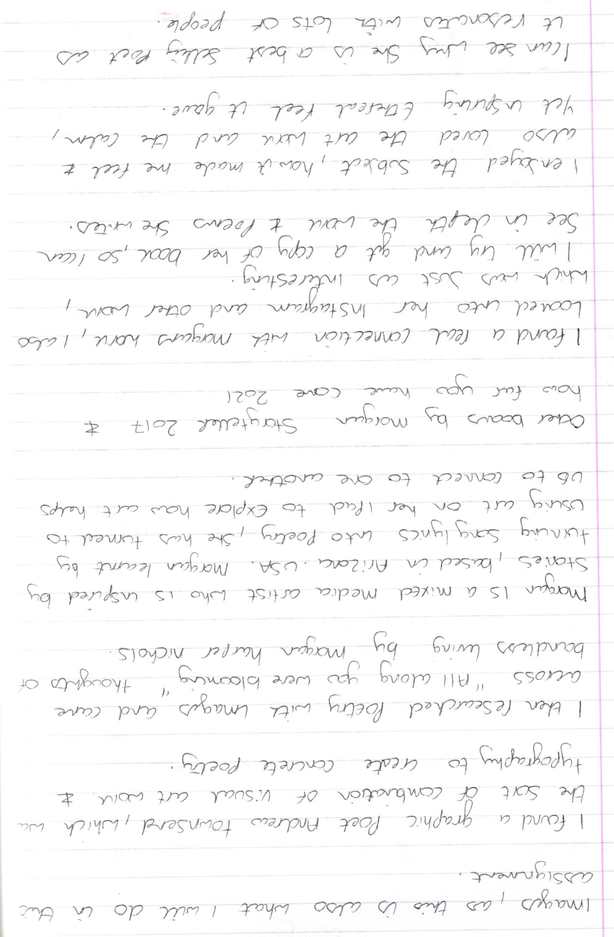

Andrew Townsend art work below:-
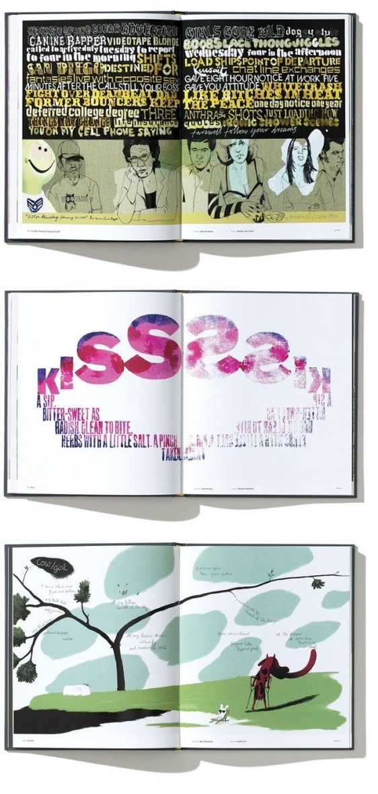
Morgan Harper Nichols book and art work below:-
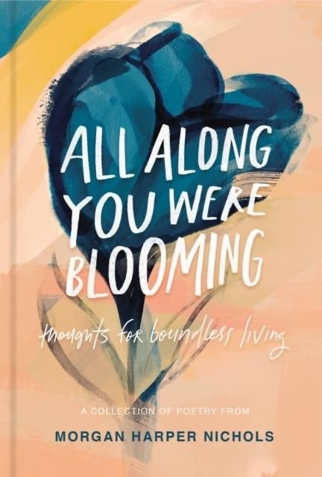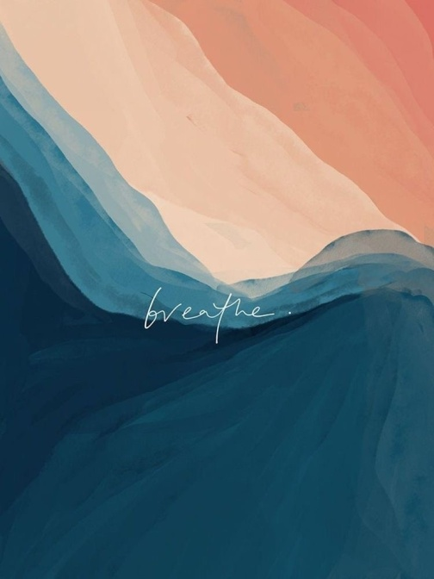
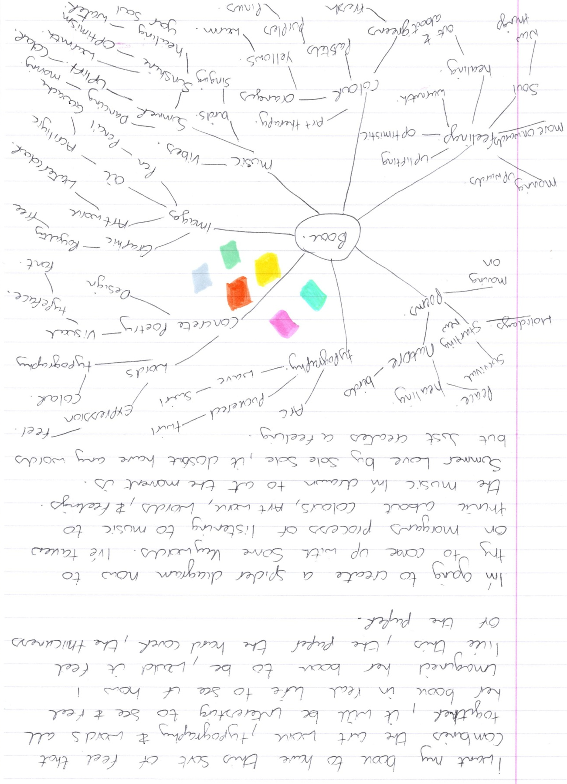
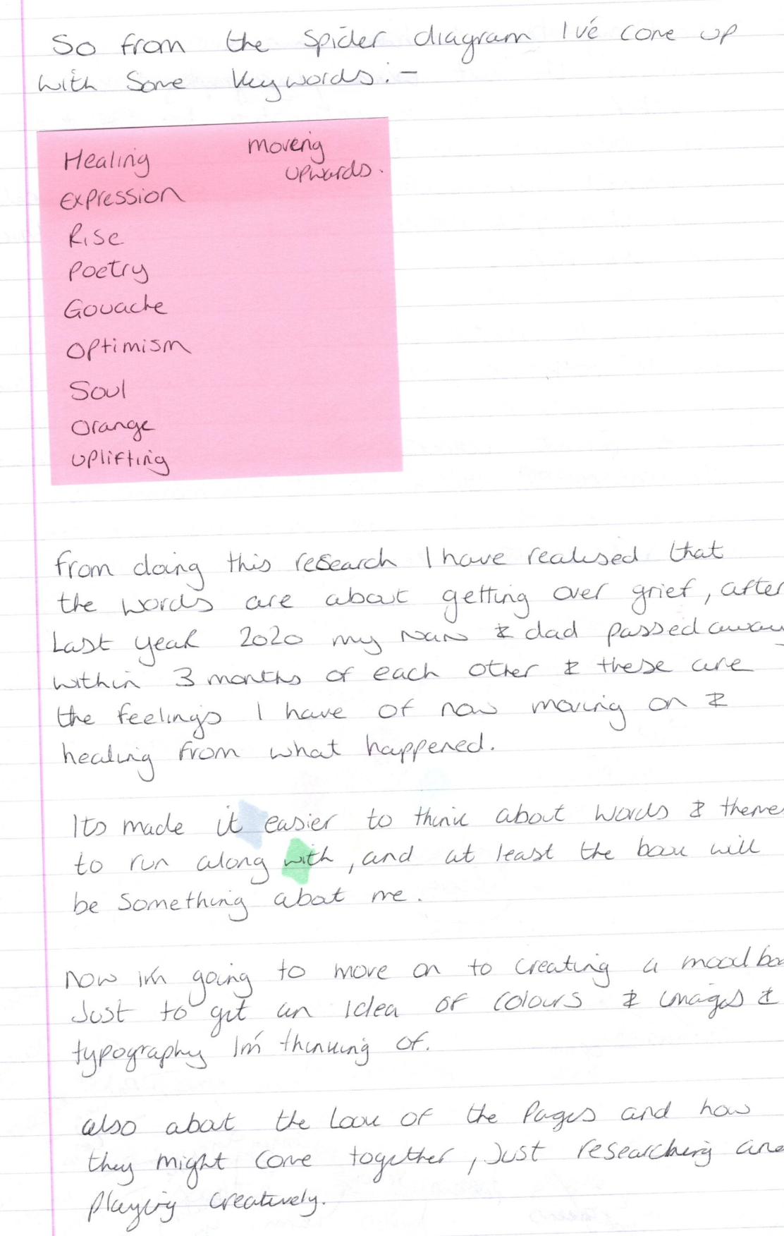

Mood board:-
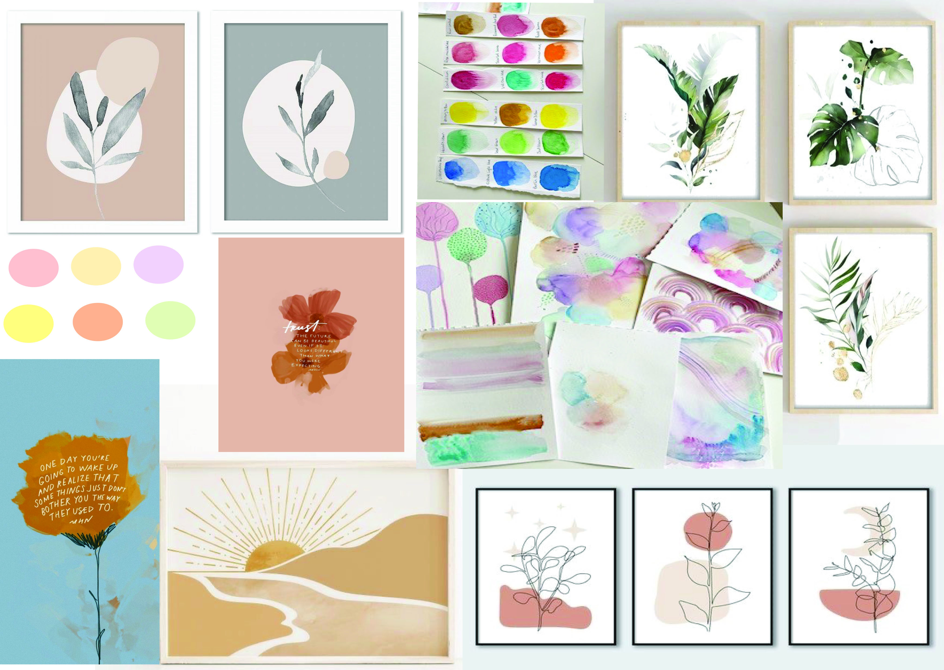

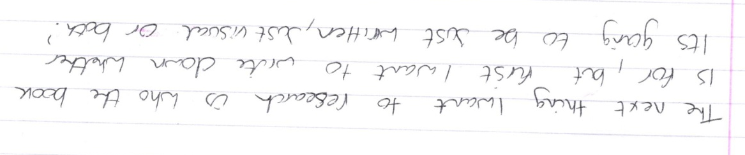
So from my previous written work, it’s probably obvious that I will be doing both written and visual images for this book. Although with the written work I’m not sure how much this will be!
The subject will be on grief, but not in an upsetting, depressing way, it’ll be more about when you get to the point where you can look forward again, and not feel guilty about it, the point when you want to move on, and the time when you feel more optimistic and you can see yourself moving forward again.
I started with playing around with my creativity and some watercolour explorations (I hadn’t received the book yet) I had previously done some watercolour explorations from my first unit in this degree pathway (Illustration 1, key steps) I have incorporated these into my moodboard above.
I started with just some watercolour work in my sketchbook:-
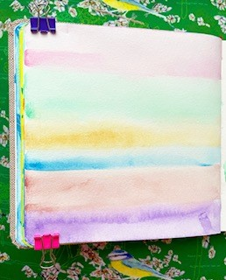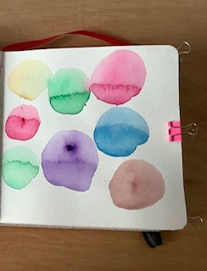
These are just some ideas I have in my head around the images that could work alongside my poem, the colours are just a test at this point, I think I want to go for more earthy colours maybe, and less pastel. I did some colour tests here too:-
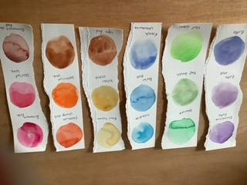
So the book finally came and I will write a bit about it below:-
So the book is a hard backed book it is ¾” thick and A5 in size, the pages are gathered into sections and bound by a saddle stitch, then glued onto the spine, head and tail band in blue webbing. The front cover is laminated and the title is embossed, the end papers are glued into place and are the same design either end. The paper is a thick natural, I would probably say recycled feel, I would say 140gsm, and it has a slight texture grain to it. The books pages and look has a eco earth feel to it but on a luxury edge, it has a satin ribbon book mark, it’s a heavy-ish book, but fits well with in your hand, and not too bulky to fit in a large handbag and take out with you. The look and feel of the book definitely adds to the subject and content (art work) of the book, it all works really well together.
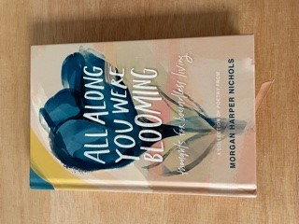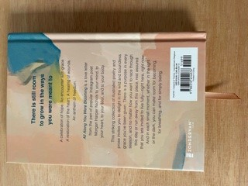
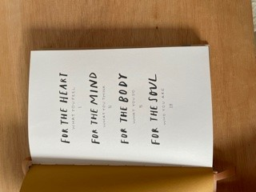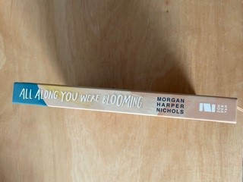
The art work inside has an expressionistic feel to it, the colour palette has an earthy feel, and the tones work well together and seem to be from the same hue and tone. The illustrations are simple and free, yet tie into the poem on the page, some are just paint techniques and some are line work illustrations, some are proper illustrations. The illustrations have a calming natural feel, which flows throughout the book; it has a natural rhythm to it.
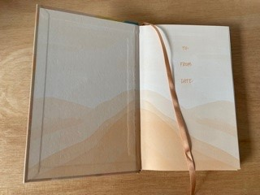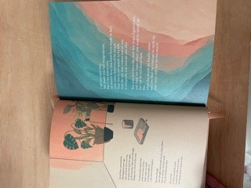
The typography ranges from hand drawn lettering, to a simple font like Times New Roman, but they all range different on each page, yet it ties in with the poem and the artwork. The typography comes in either black or white, but there are a few pages of coloured typography inside. The placement of the typography connects with the artwork, either by being involved with the art or above, below or on top of it.
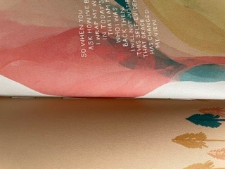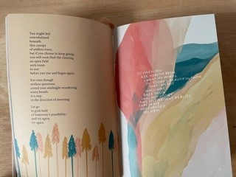
The poem book I want to create will be for people like my mum and also for me and my brother, who have gone through some kind of loss and grief, it doesn’t matter what kind, and it will be general.
I want it to show and say that you can now be optimistic and look forward again, you are allowed to be happy again, to go out and be free. That those moments of darkness now turn to light, that you can see colour in the world again, you look for the simple things first, the sound of the birds, the colours in nature, the sound of a stream and the taste of lovely home cooked food.
So obviously if I hadn’t gone through what we did last year, I would have researched grief and poems about grief and worked through this next stage in that way, but because it’s something that I am going through as well as my family, it will just be our personal thoughts on what we are feeling now that will be the research.
I think a lot of things that have helped us all are being out in nature, whether that be the garden, on walks in the woods, or country park, or further a field more recently to the coast and beaches.
I think this will be more of a process for me, so I will start thinking about a colour palette next, then the images (art work) then the words for the poem and typography. This may change as I’m going through it; I will just use my judgement and go with the flow but keeping to the creative process.
I did look at poem books for grief and loss, just to see what style and in what way they spoke about it through poems. (you can find this in research)
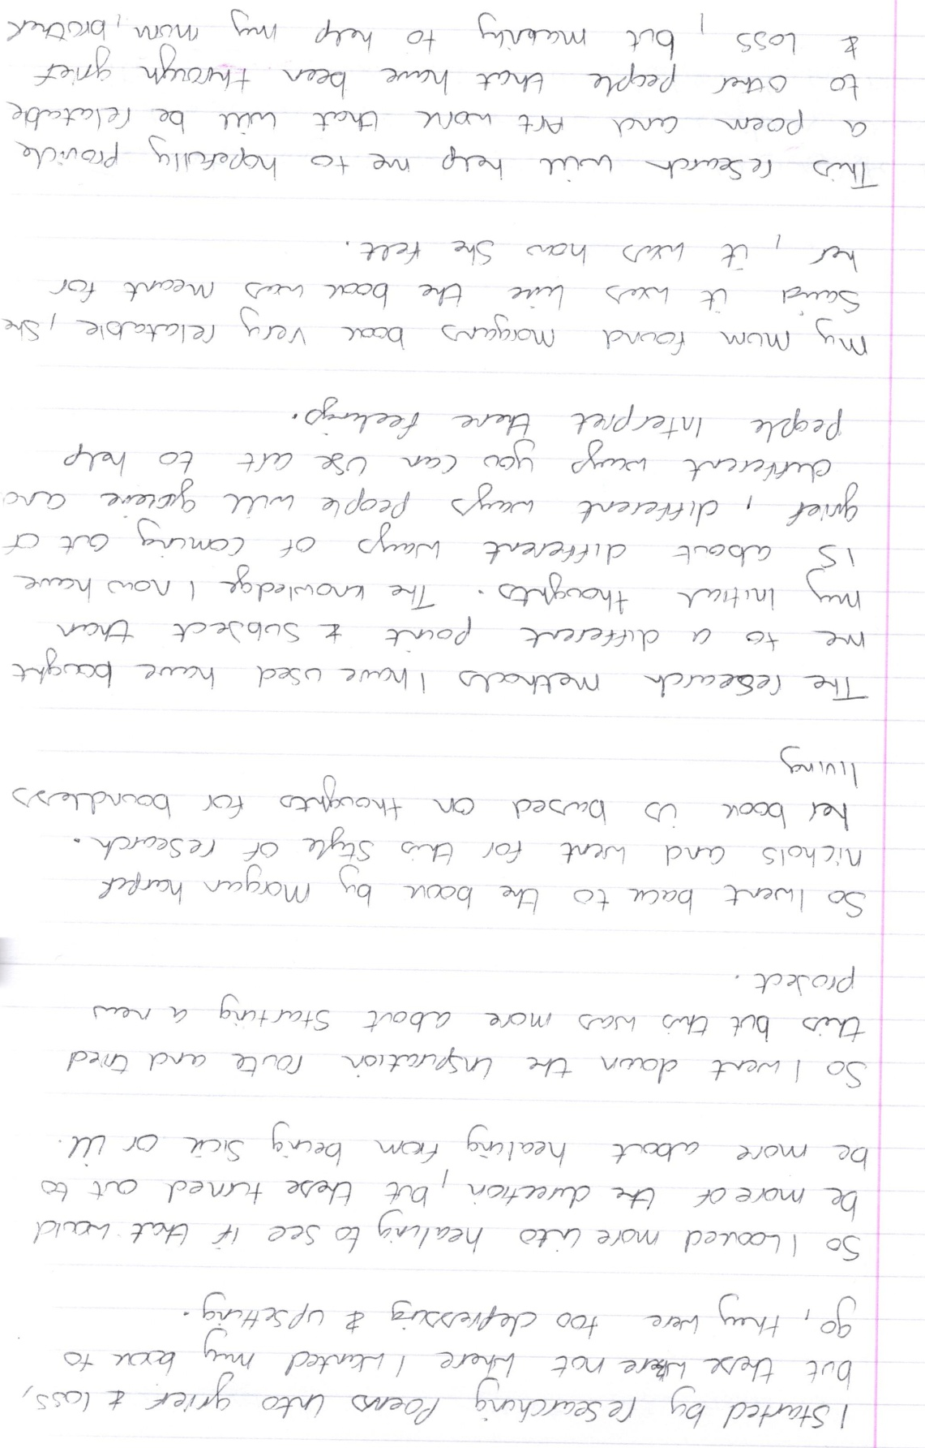
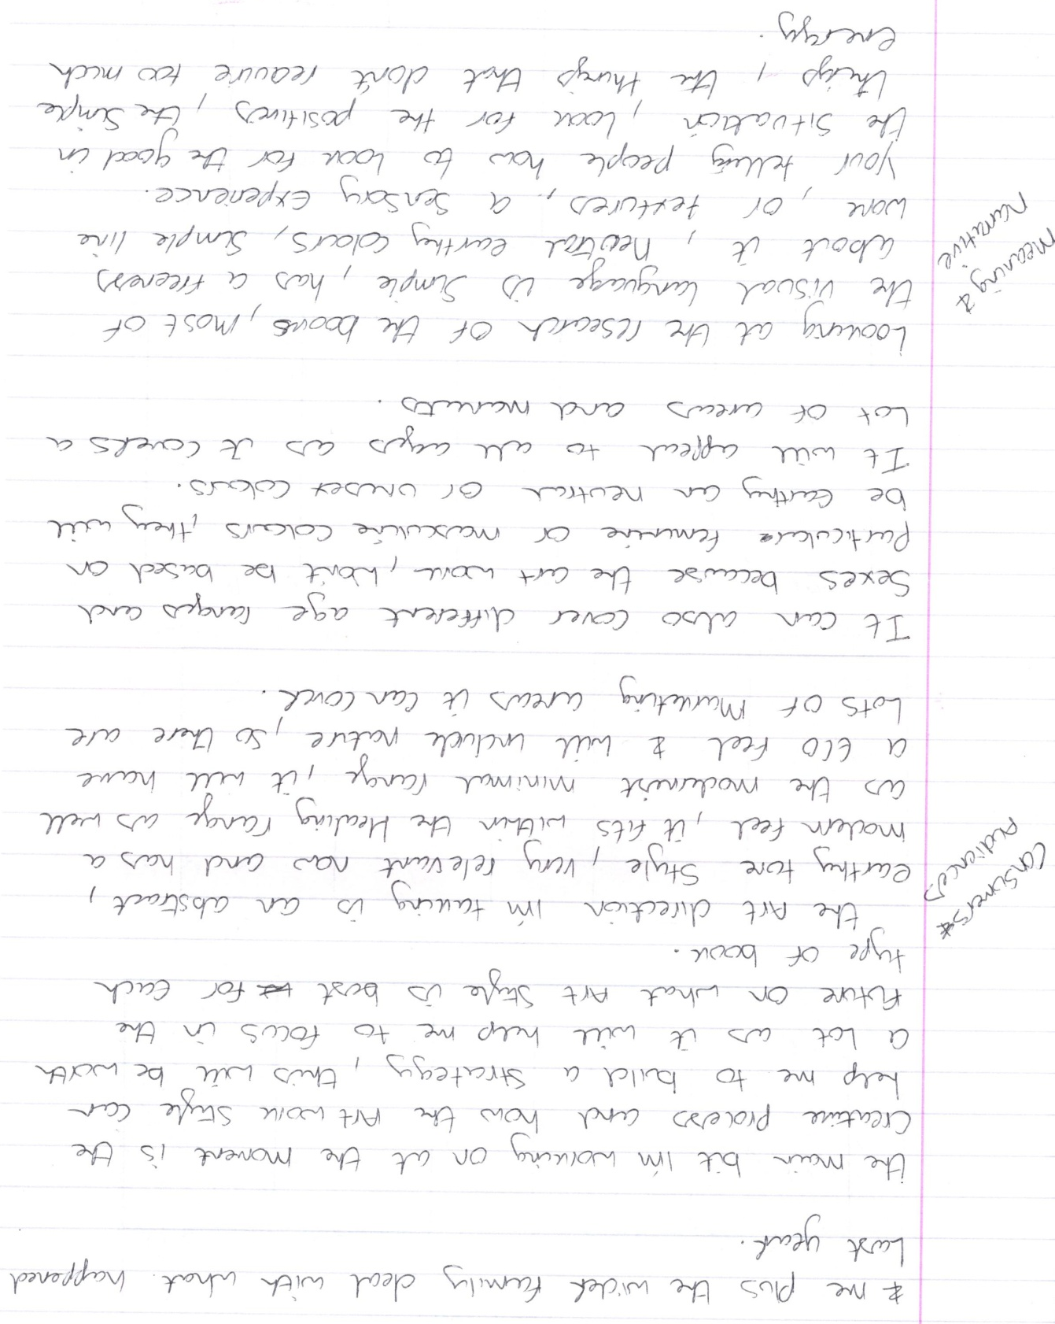
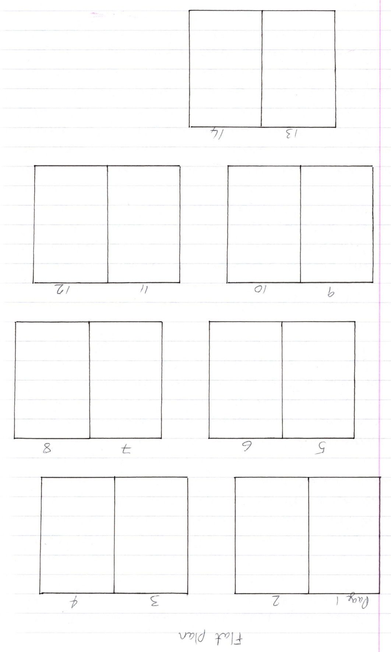
Although the flat plan is empty at the moment, it does have 14 pages and a front and back cover so 16 pages in total, I will add more if I need them, as after looking into the print on demand company I think the least pages you could get where 24-28, so it might need to be longer or add in a few other pages of content or pictures or foreword.
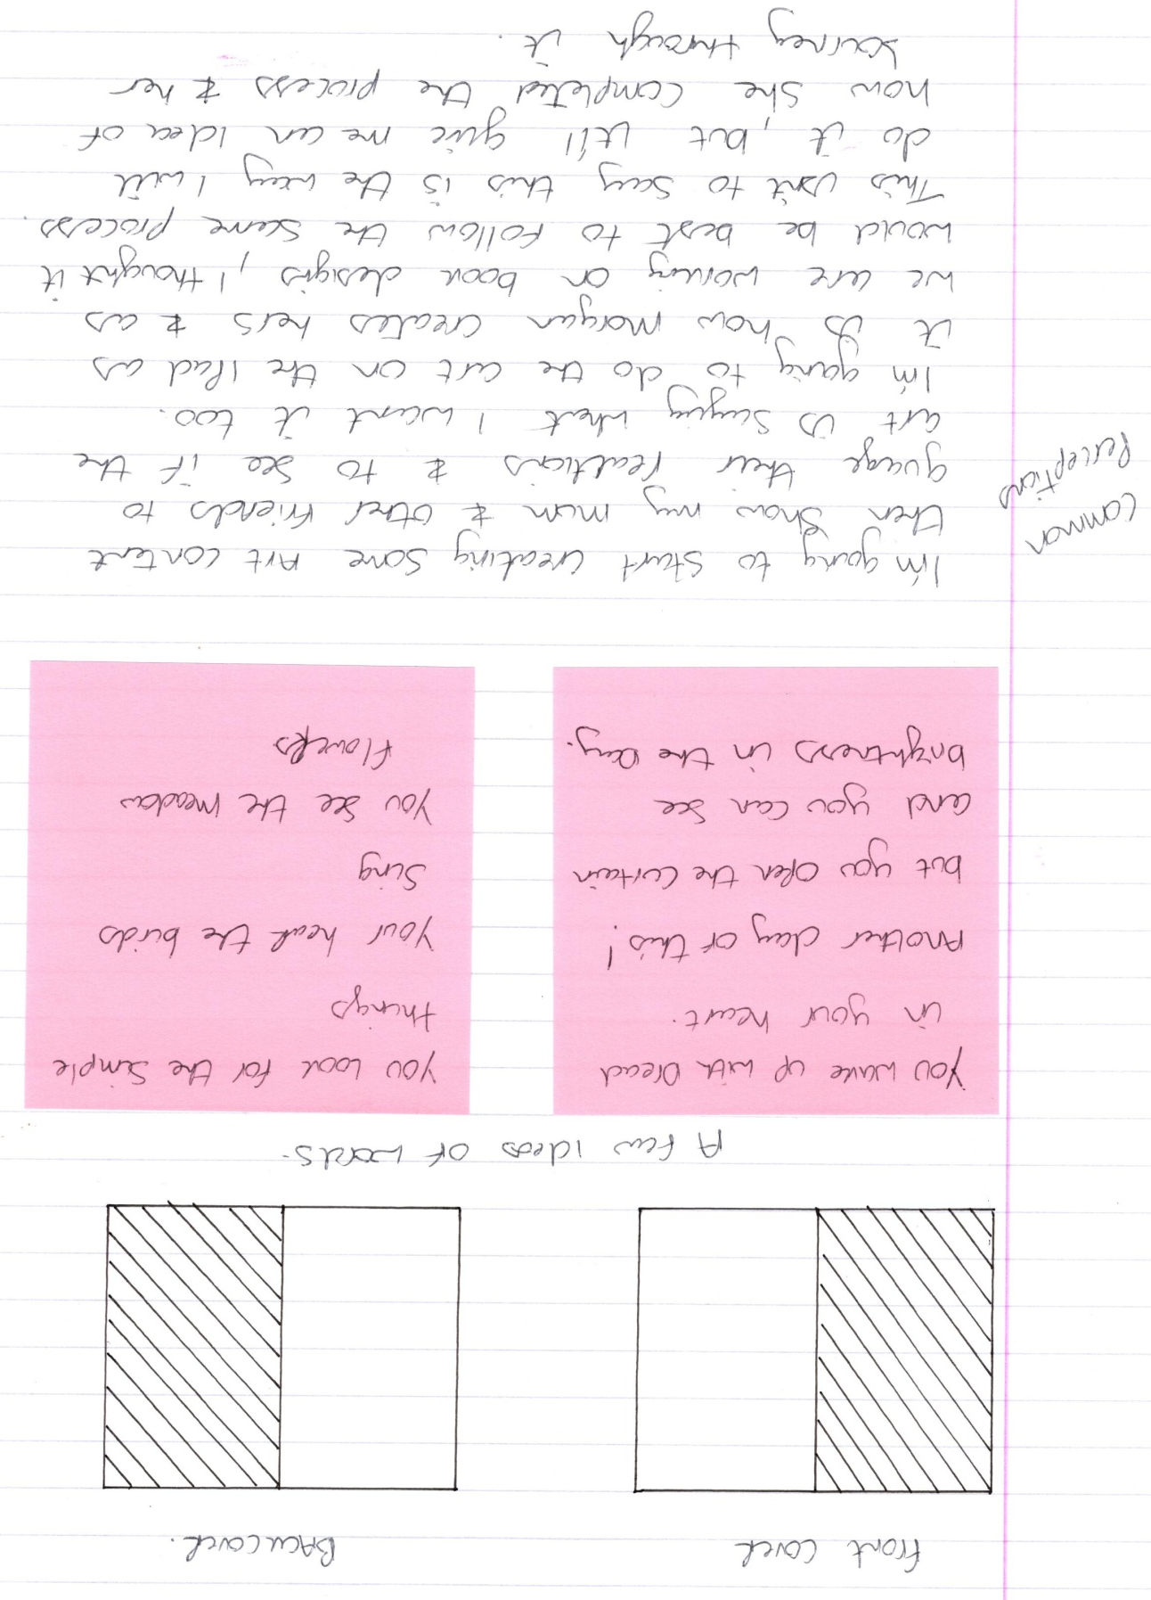
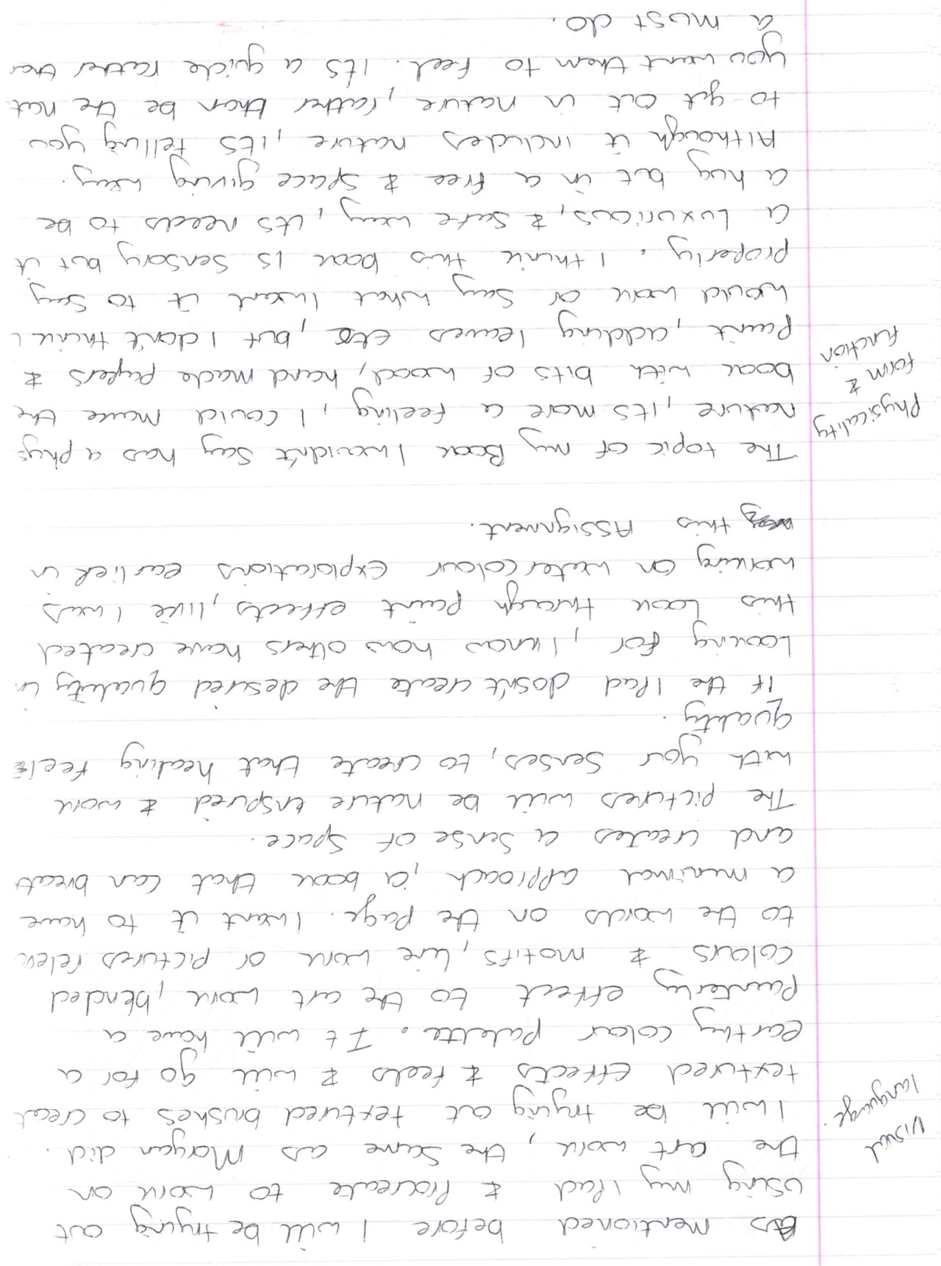
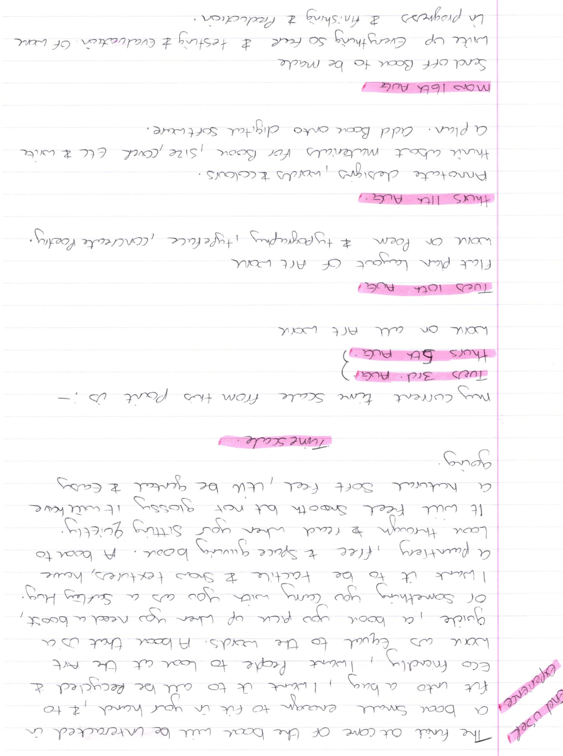
Creating Content
I then started to work on the art work for my book, I wasn’t sure whether I wanted to use watercolour explorations or digital art work on Procreate.
I started by picking a colour palette, as I had said before I wanted to emulate Morgan’s style, so I chose a earthy colour tone and palette.
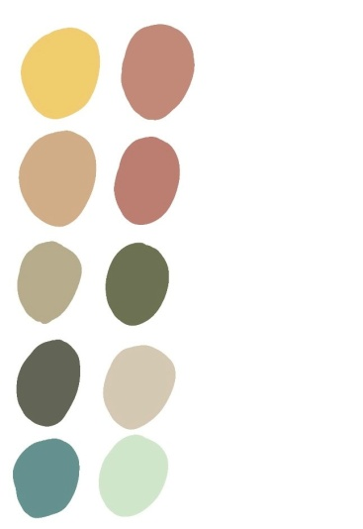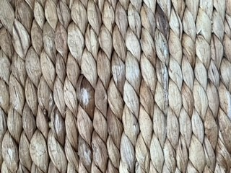
I also looked at some texture that I might be able to include, like this rattan basket weave, I thought this had a natural feel with neutral colours.
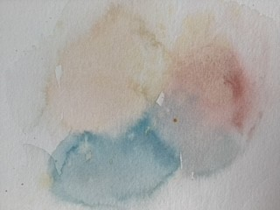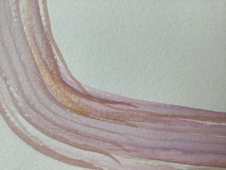

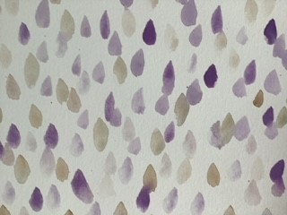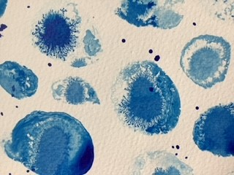
I did a few more watercolour explorations pieces, and then I decided to see what I could do on the Ipad digitally in Procreate.
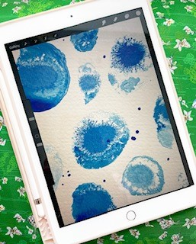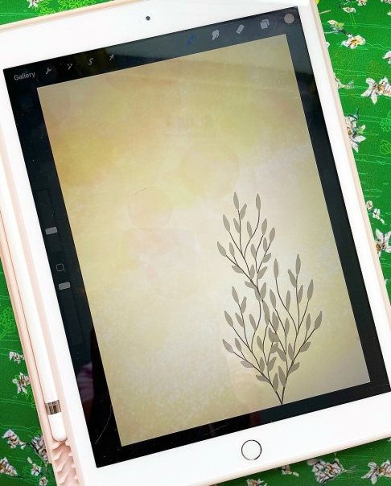
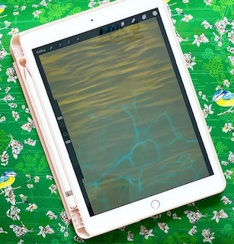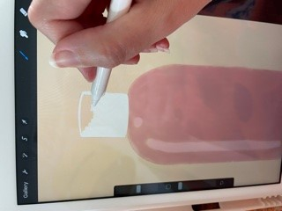
Some of the art work I was able to scan into the Ipad and use, like the watercolour explorations, and others I used brushes on Procreate to achieve the effects I wanted.
I had a rough idea of how I wanted the art work to be, I wanted the art to flow over all the pages but be connected in some way, not just separate images. I decided to use the poem as if it were a day in time, so I started with some of the lighter colours from my colour palette, and thought to myself in my head how has my days been? Thinking back to last year and how I felt when I woke up each morning, and how that differs to now.
I wrote down some words as though taking myself through a day, obviously all this was also when the Covid-19 pandemic was in full swing, so we couldn’t do too much!
I wrote down:-
Sun rise
Table and brolly
Coffee
Watering a pot plant
Sunflower
Cosy throw
Lion
Candle
Twinkle lights
Bunting
Bike
Bubble bath
These ware things I had done in a day, simple things that kept me busy, things that got me outside.
I then started on the poem and wrote out a rough idea of how I wanted it to be:-
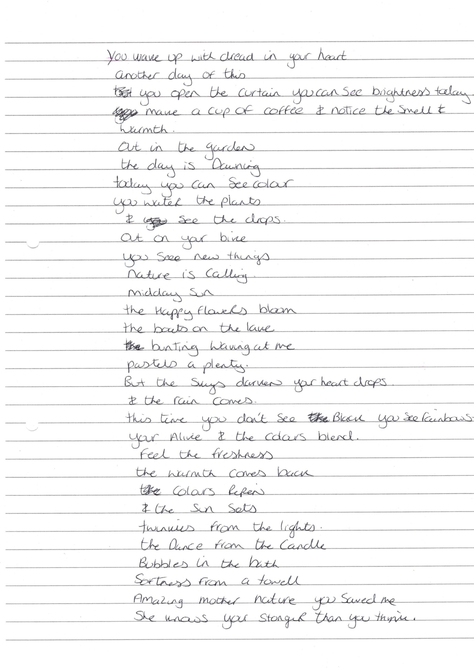

I then started on the art work and created some designs along these lines, they were not in any order yet, they were just simply textures, simple illustrations or line work and colours.
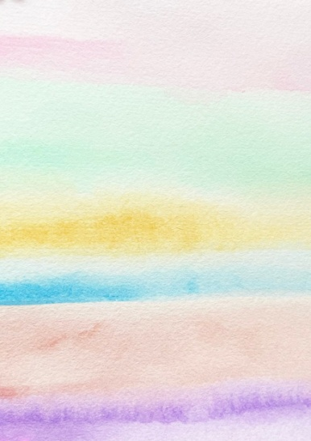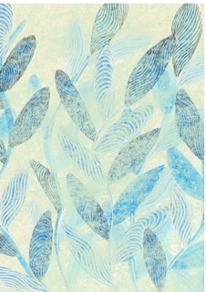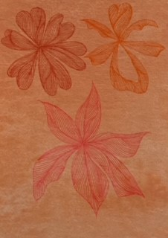

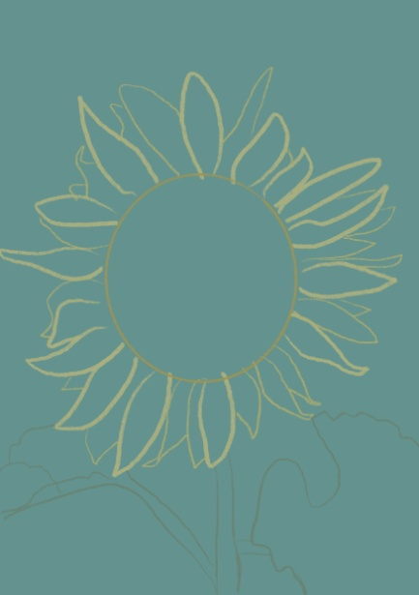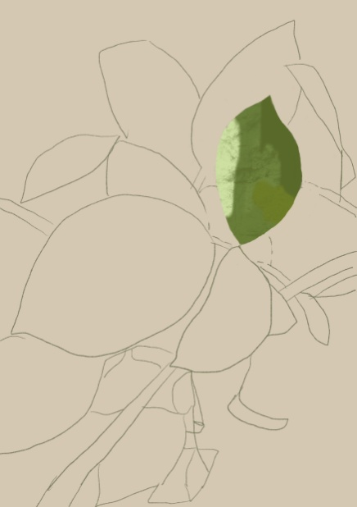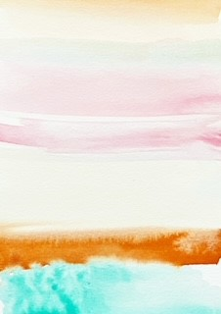

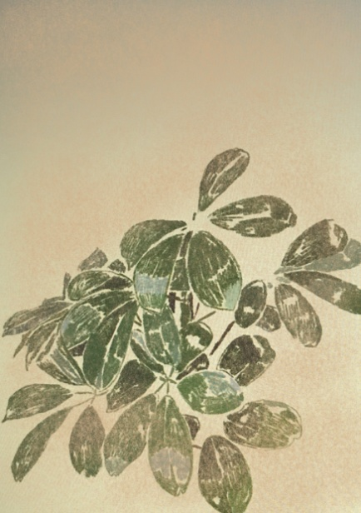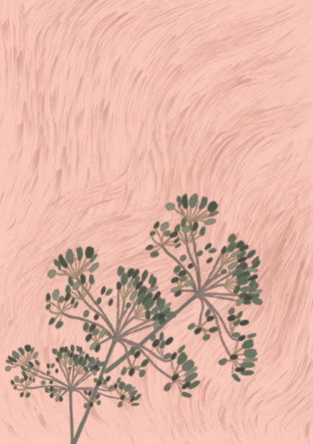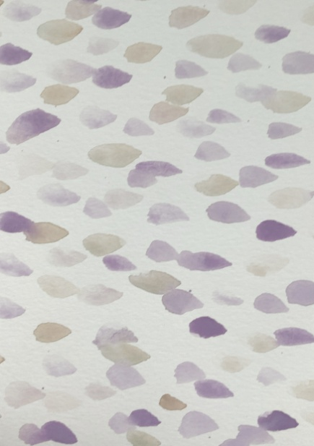
I then went on to create 30 art designs for the pages, but these will have to be whittled down for the final book, but I wanted more rather than less, so I could choose the best ones.
These are literally the background art works, then the typography will go on the top, and used in different ways like concrete poetry.
It still needs lots of work, but I feel I have a good idea in my mind now of how the pages will look in the end.
