Book Fairs
This task asked me to look at the list of links below at the book fairs, and research the artists books found exhibiting at the fairs.
Unfortunately most of the links provided didn’t work, so I had to find other ways to research this task.
But I did find that the Small publisher’s fair link worked, so most of my chosen artists were from this fair.
Off print London (link didn’t work and website unavailable)
The London book fair 10-13th Sept 2015
Free and open to the public, showcasing artist’s books, catalogues, zines, rare publications and brand new releases. At the Whitechapel Gallery, talks, workshops and book signings.
Small publishers fair
An annual gathering of small press publishers, writers, artists, poets and book designers, from the historic Conway Hall.
Antic-Ham (www.anticham.com)
Hyemee Kim lives in South Korea and Ireland; she makes artists books using photographs, collage drawings, silkscreen printing and writing.
This book is made up of 16 screen prints on various papers (found papers) old magazine, old accounting book, music book , notes and a map. It’s a hard backed copy.
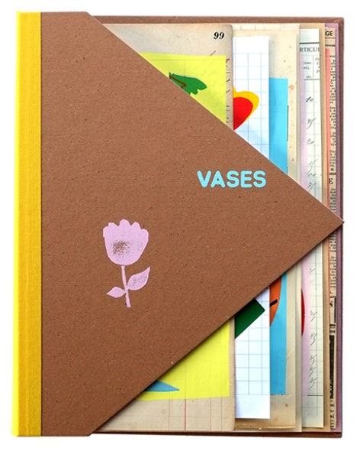
I was drawn to this book as it was colourful, had a mixture of different pages inside, and was unique in style and design. It had many folded pages which added interest and excitement; it was lovely to look through and simple in its representation.
Dizzy Pragnell (dizzypragnellprints.co.uk)
Print maker and book artist based near Ashford in Kent. Makes books using vegetable and fruit papyrus.
Dizzy wanted to find a new way of making paper based on the ancient Egypt version of papyrus, so she developed the ideas of layering fruits and vegetables as well as flowers, leaves and petals.
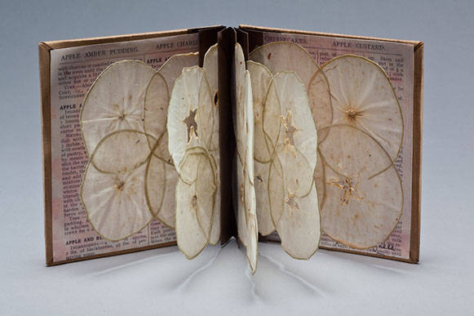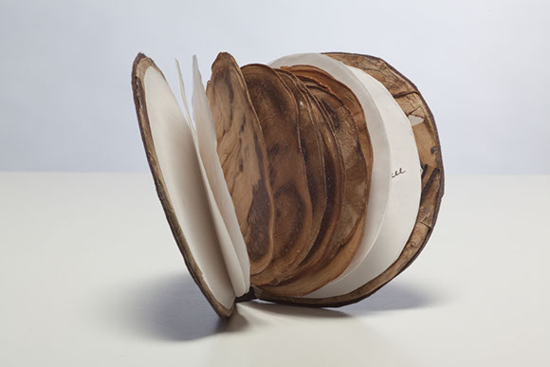
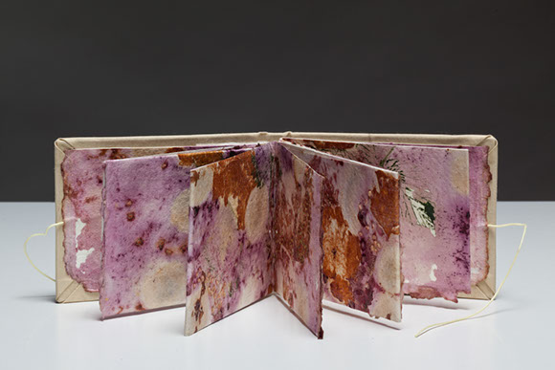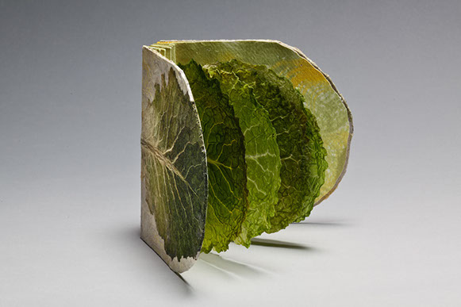
I liked these books because they focused on nature/ botanicals and re-using something we already had. I liked the colours and the textures it created, and the unique style and design created.
International contemporary artist book fair
The Tetley artists books, spotlight presentations, workshops and keynote talks.
The last fair was in 2019, but it doesn’t list any artist’s books.
The Sheffield international artists book prize, again the link didn’t work, so I researched it on Google.
Holly Serjeant
Holly did her degree in book binding and calligraphy. Holly restores treasured books. Holly uses decorative marbled papers, leathers and book cloth to create new bindings of various shapes and structures.
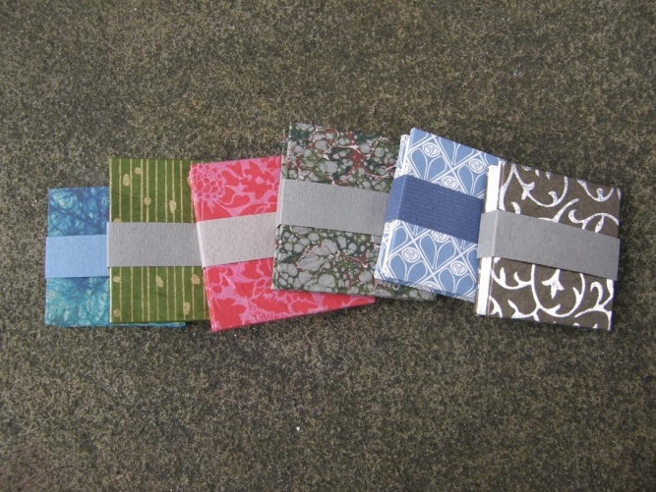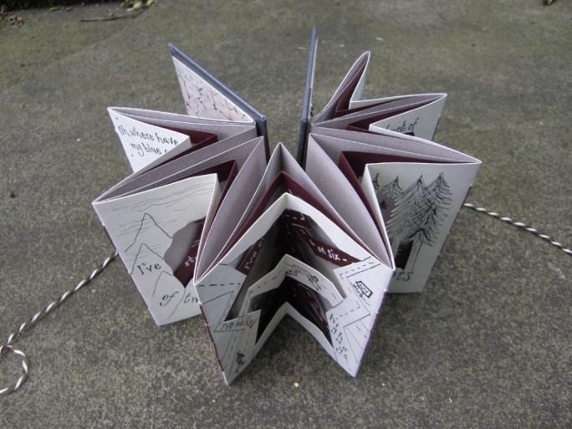
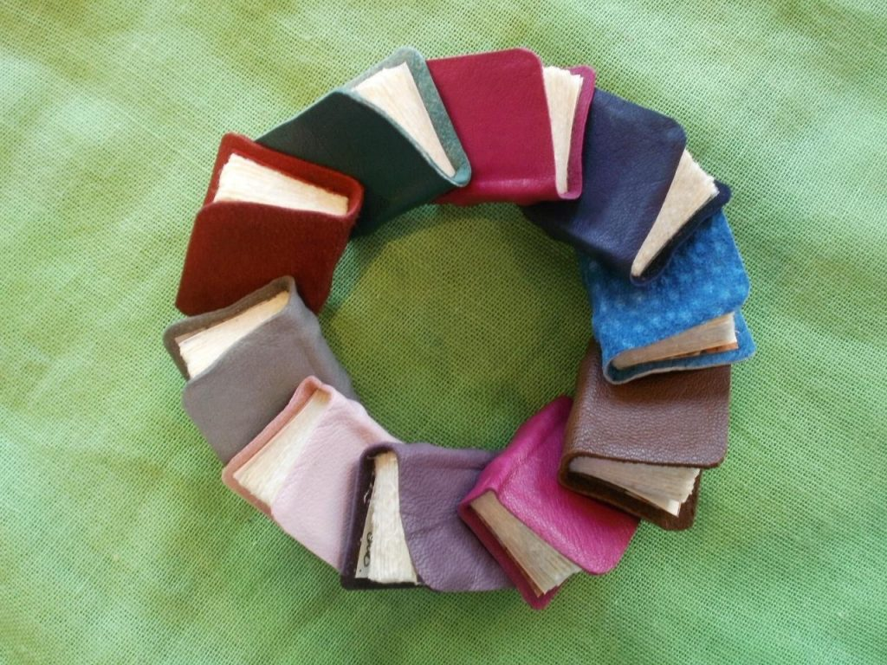
I was drawn to Holly’s books because of the textures and the materials she uses. I like the use of cloth for the covers and I like the idea of marbled papers in bright colours to give a unique style and design. Holly’s different was of binding are also interesting and gives you other ideas of what you could create.
Dublin art book fair
(Templebargallery.com) again was hard to find any artists books listed for the fairs.
BABE Bristol Artists book event, again it didn’t list any artists books, so I went back to look at the small publishers fair again, to find more artists books to research.
Analog Sea (analgsea.com)
Offline publisher of poetry books and The Analog Sea Review. Edited by writer and poet Jonathon Simons, who is based in Freiburg and Austin, Texas.
is a pocket-sized review which collects together poetry, essays, fiction, illustration and fine art for those 'wishing to maintain contemplative life in the digital age.
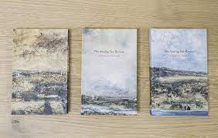
I was drawn to this book because of the cover colours and the nature of the themes, The sea and nature always catch my eye, and the painterly quality of the covers are very relaxing and calm. I love the idea of a compilation of works inside one book that take on the same theme, this would be a lovely little book to pick up every so often and flick through.
Bad Batty Press (badbettypress.com)
Publisher of new poetry, run by poets Amy Acre and Jake Wild Hall. Collections, anthologies, pamphlets and limited edition mini-pamphlet series, Bad Betty Shots. Rooted in live poetry, London based.
I like the idea of this company, I like the books and pamphlets style mini zines that they produce.

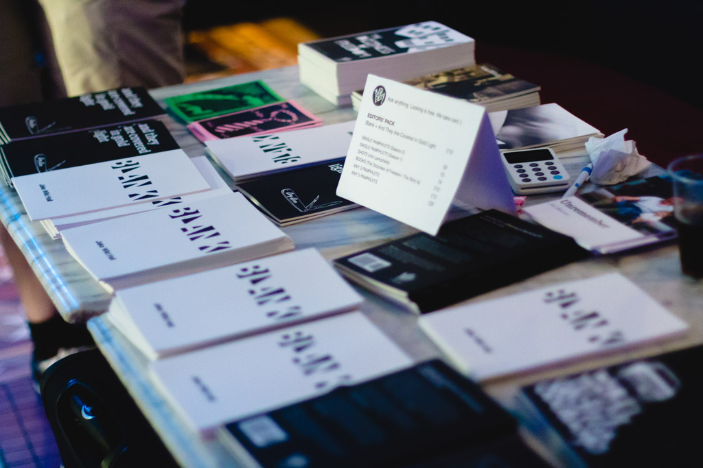
Below: Bad Betty Shots are limited-edition mini pamphlets, each containing a single long-form poem. Small but with plenty of bite, each Shot is a concentrated hit of the author’s voice.
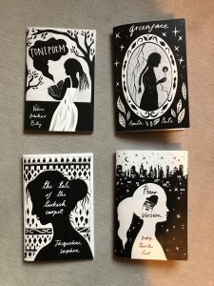
I like the idea of this design and style of book pamphlet or mini zine, having numerous poets creating a pamphlet each, using their take on the poem, and then selling them as little shots, is a great idea and something to take forward. I like the simplicity of the book style and the way it is laid out in A5 size, with simple binding.
This research has given me another snapshot of how you can produce books, pamphlets, mini zines and what kind of materials you could use, and how to come up with unusual bindings and different techniques.
I can see I am drawn to nature inspired designs and styles and also colour, I like things that are different and unique.

