Printing
In this exercise you can use any images created elsewhere in the course, to print onto the paper samples you collected earlier.
Active experimentation You are encouraged to be experimental in these exercises; it doesn’t matter if you make a mess or get things wrong in the images you make. It is important to reinforce this message at this point in the creative process, as often people tighten up when they think they are embarking on the final piece, and lose some of the fluidity and spontaneity of their original ideas. We want to keep the visual outcome of this exercise fresh and not stultified by perceived conventions of what is ‘right’. When you’re exploring visual ideas and processes, the outcomes may not always be what you thought they would be at the outset. You won’t always get it right the first time, and this is how it should be. By repeatedly trying out and experimenting with the materials and ideas at hand, you’ll discover new ways of working. Occasionally ‘mistakes’ turn into happy accidents and prompt a way of working, or technique, that you might choose to deliberately recreate and integrate into your next project. For example, one colour may bleed into another, or your coffee cup might leave a stain on your working paper. Instead of throwing these elements away, you could integrate them into your design process. Organising images When you’ve created a set of images, scan or photograph these to create digital files – JPEGS or TIFFs on your computer. Make sure the resolution is set at 300dpi. Having gathered all the images together in one folder, consider how you’re going to print them. What order will the images appear in? At what size? How will the image appear on the page? Which paper will you use for which image? Do you have a particular image in mind for a particular piece of paper? Will you try printing the same image on different sheets of paper? Draw a simple flatplan as a guide to working out how and where the image will be placed on the page, whether you will include any text, and to explore how the idea of ‘narrative’ might work. You might set up your page layout in DTP software, and work with your images digitally in this way, or you may simply print direct from your photo editing software onto the paper samples.
Creative Book Design Printing You may choose to use a desktop printer to output your images, or you may research other print methods such as screen-printing or etching. Print at least 16 pages using the images you’ve created on the paper samples you have collected.
So I started this exercise by writing down what I needed to do in bullet points:
-Experiment to create images from earlier units
-Come up with a process of order/ flatplan
-Print out on collected papers
-write about each paper and the print finish
I looked back over my sketchbooks to find some images to use for this exercise; I have added in two areas that I liked working on below:
I liked the warp, twirl and pucker effects on typography to get the words to work with images (in section 3 exercise 3)
I enjoyed the ephemera process, layering images that represent words (in section 4 exercise 3)
There wasn’t many images I had created throughout this unit that I felt would work together as a whole for this exercise, they were all very different, but I have added some of them below to see if I can come up with a connection with them.
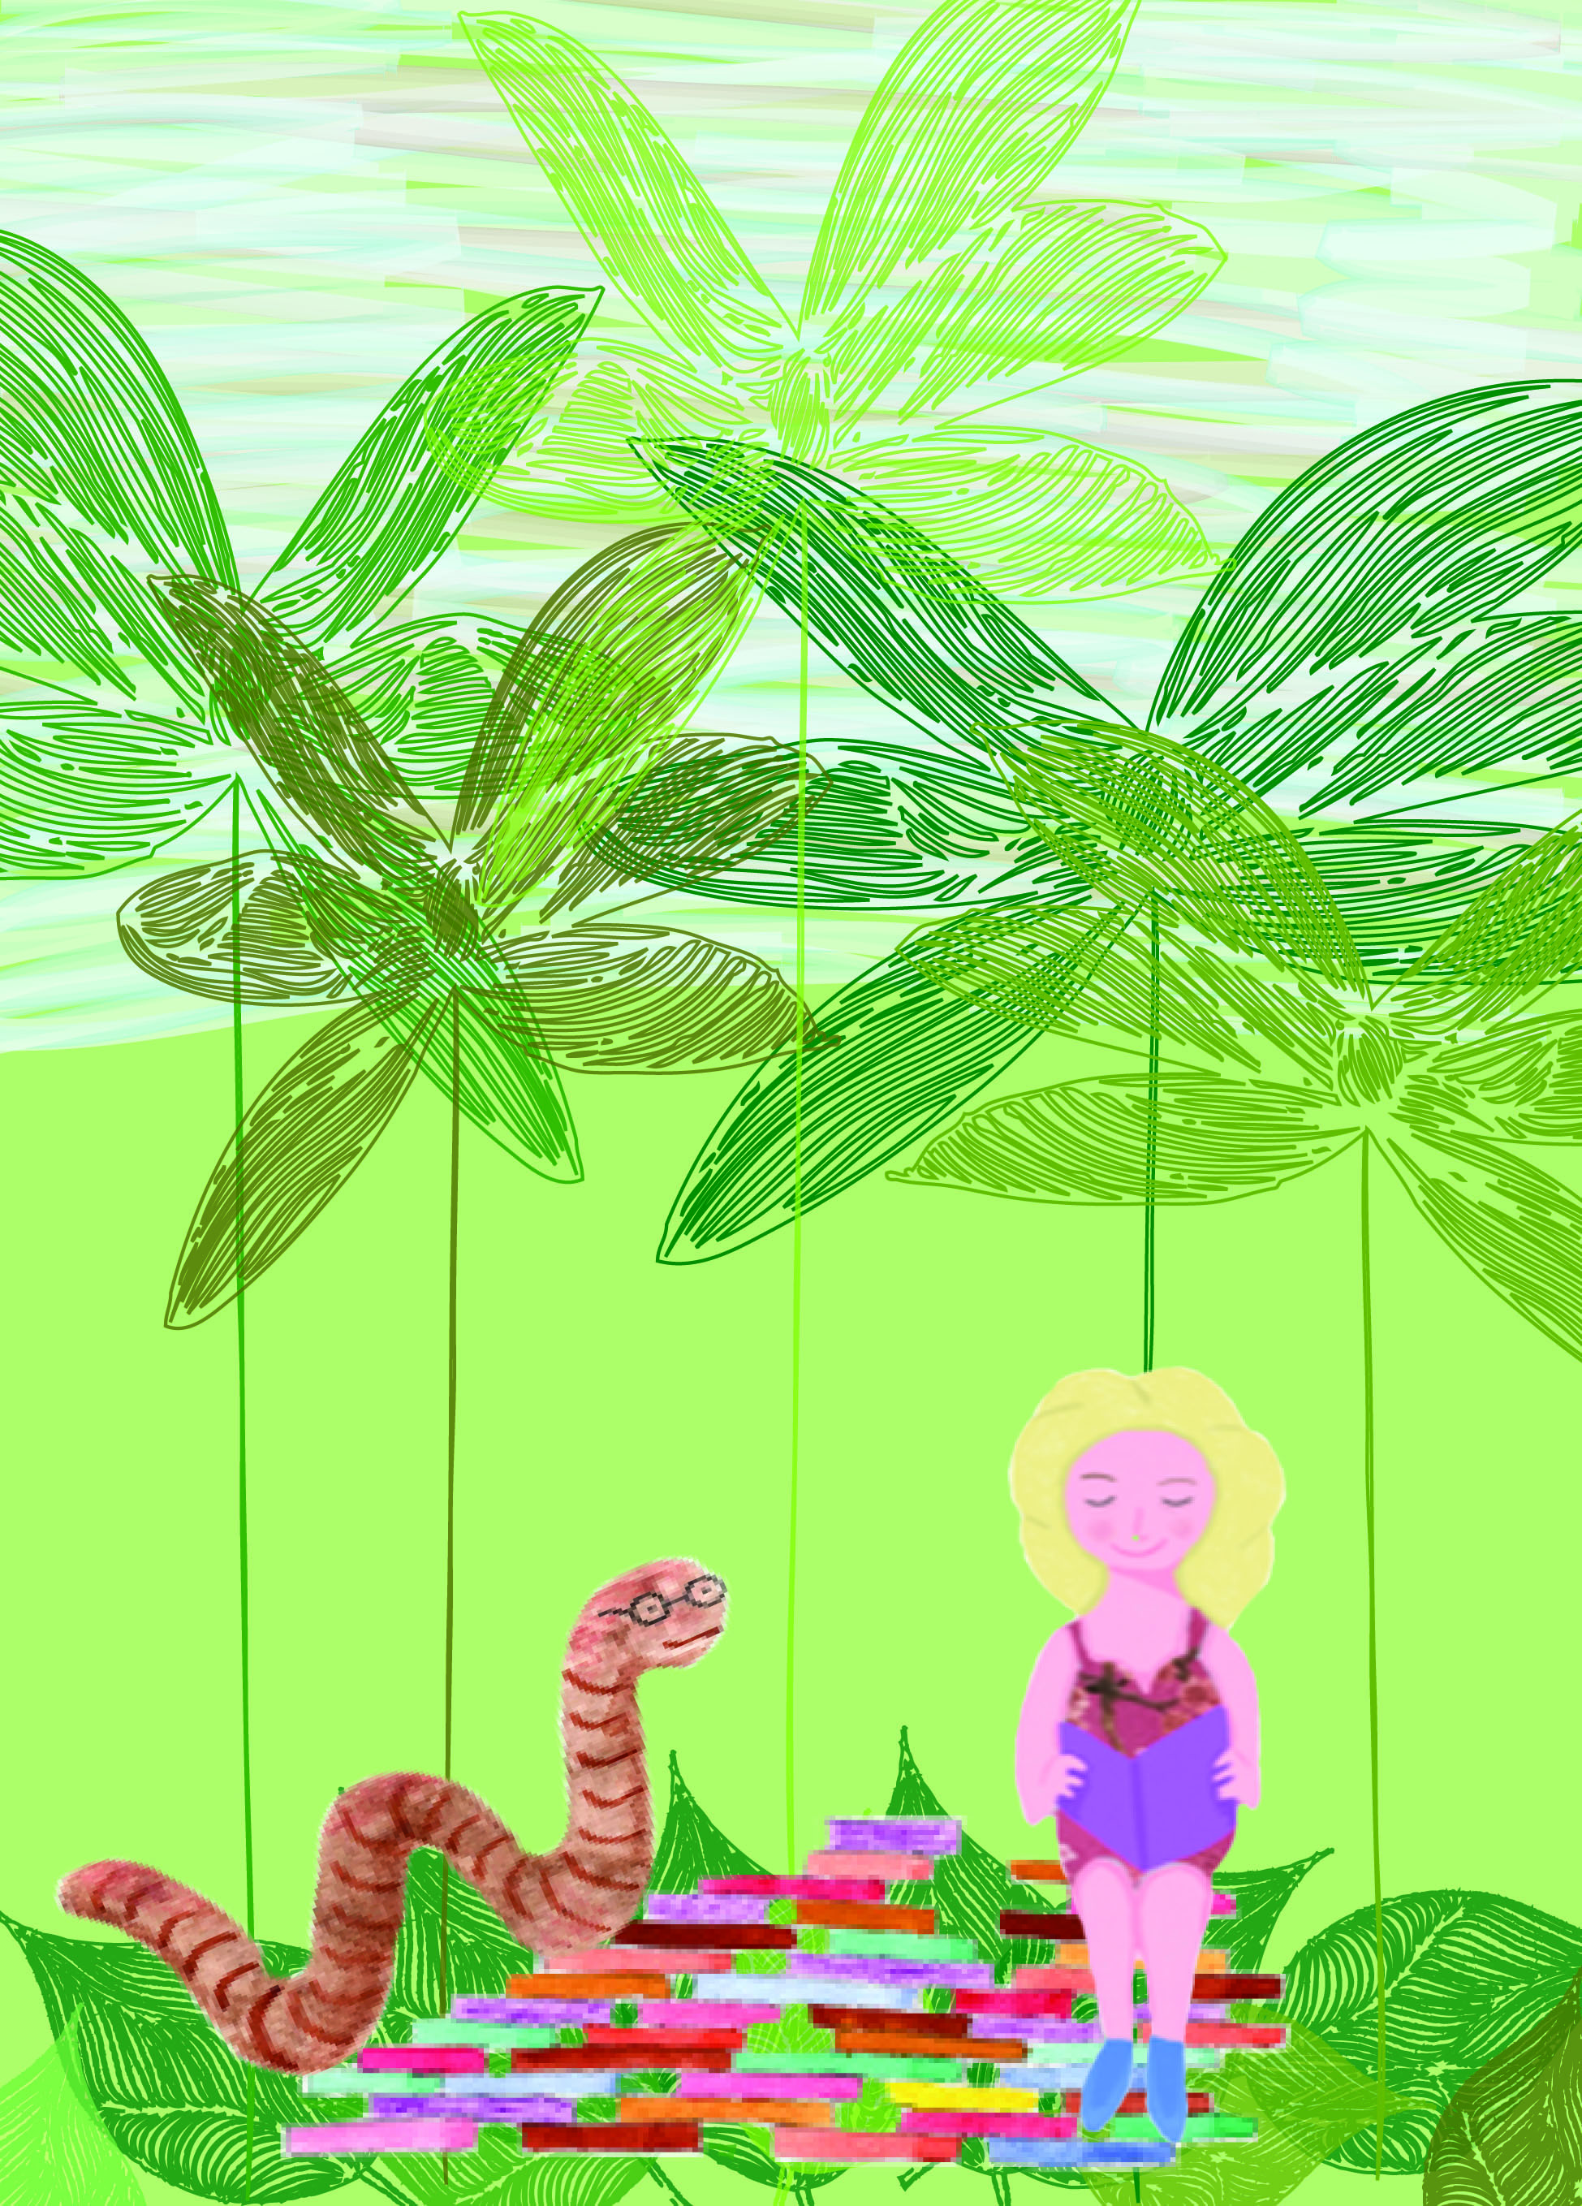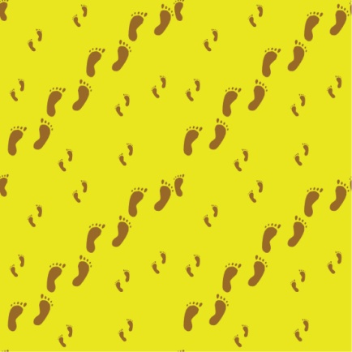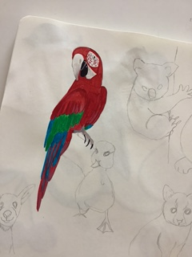
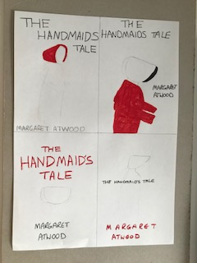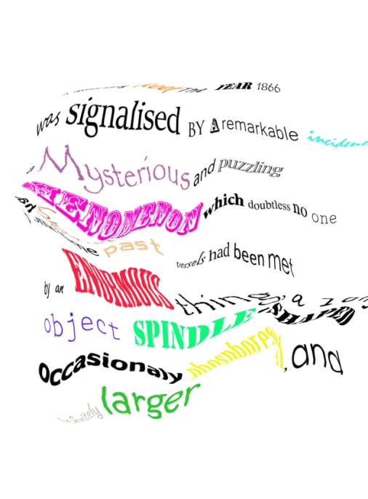
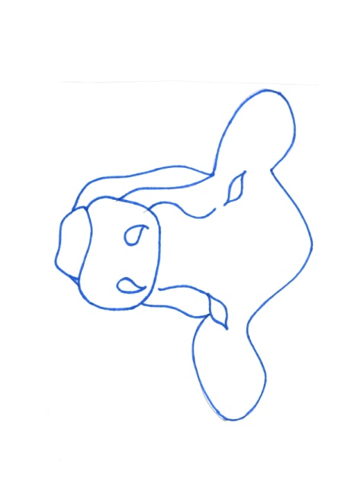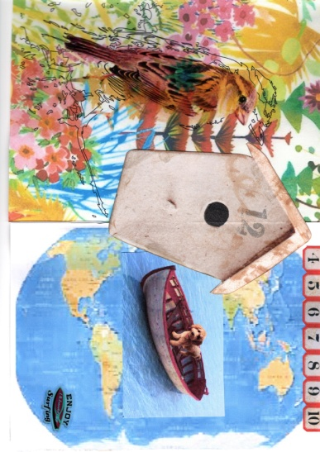
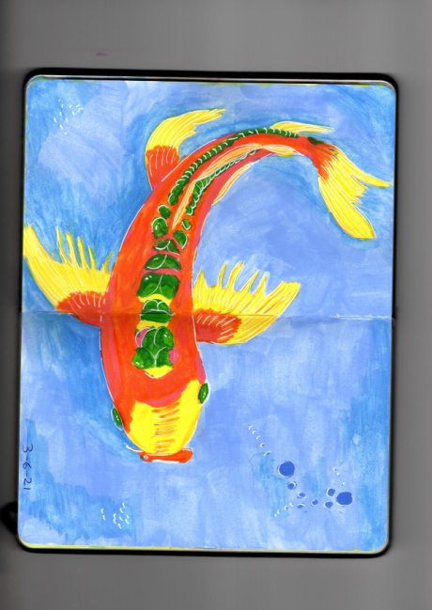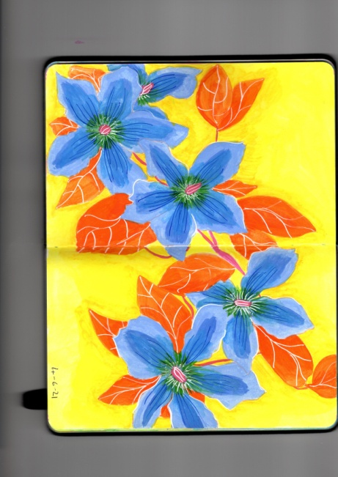
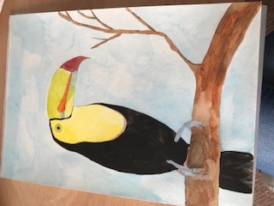
So Looking back over the images I have added above, actually I think I could pull something together using these. The only one I feel is out of place is the handmaid’s tale illustrations, so I will not include those. Assignment four was where most of the images come from, but I think adding in the others in between will work ok.
I made the images into a mood board, taking off the handmaid’s tale one.
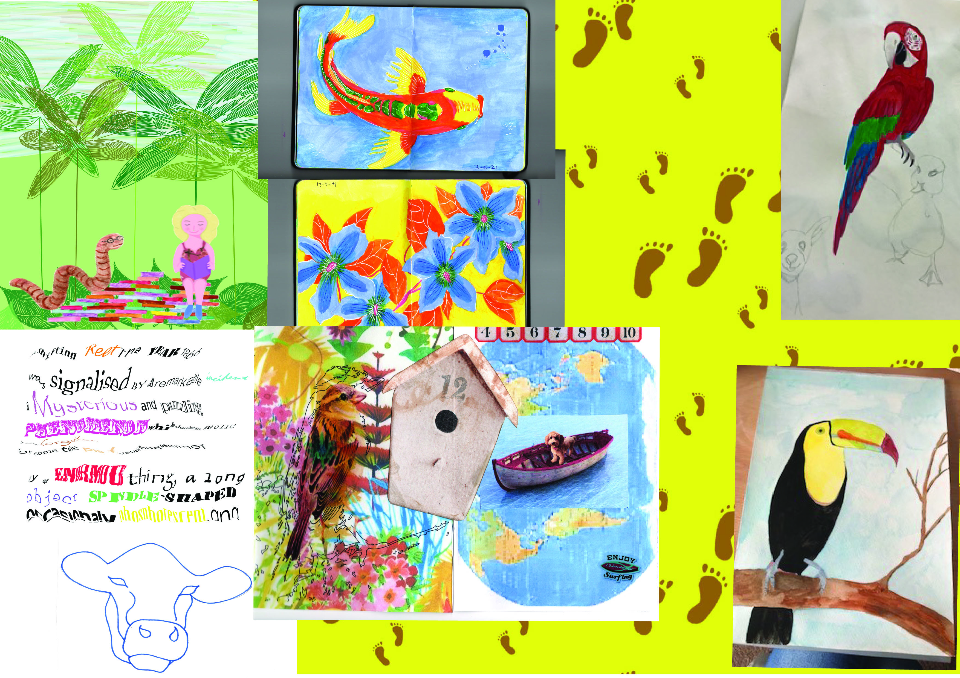
So after creating my moodboard of images I knew I would either have to add more images to this by creating new ones myself, but first I needed to know how this would come together!
So would I find a poem that would fit with my images?
I researched some poems about animals and nature, but I found it difficult to add my images into the words.
Or could I write a short story?
I felt a short story would be too involved for this exercise, I read back to the brief, and this is more about experimenting with the images and printing, rather than writing words.
Or could I come up with words myself that would help me to add these random visuals together?
The start to this exercise has really pushed my creative process as it’s not in the correct order that I usually work, so this is where I feel I’m stuck, but thinking about my creative process, I am going to create some key words from the images above, then put these into a spider diagram, then I will be back to my normal place in my creative process, and can work forward from there.
Keywords:
Bookworm
Koi
Clematis
Footprints
Parrot
Rippled typography
Cow
Birds
Dog sailing
Toucan
So those are the descriptions of the images I already have, now I will put these into a spider diagram, to come up with either other words that link them, or at least some colours, textures, or feelings from these.
Below is the spider diagram that I completed, I have now come up with another six words, these will be created into images which can slot in with the other 10 already chosen from the unit.
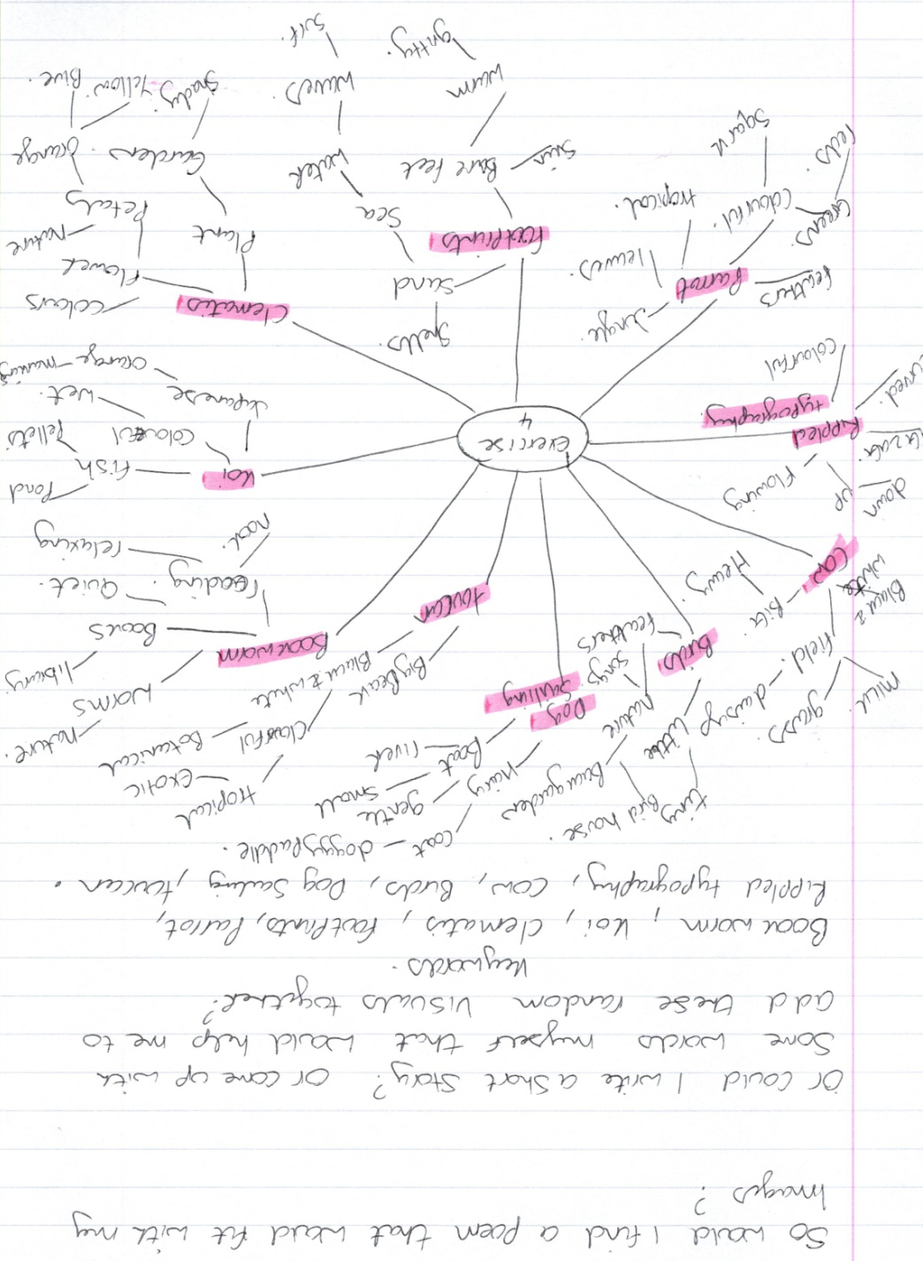
Shells
Tropical leaves
Colours (oranges and pinks)
Abstract lines and shapes
Tropical fruit
Field
After setting these other key words out, I went about drawing and painting some ideas for Illustrations, I used my sketchbooks for this:-
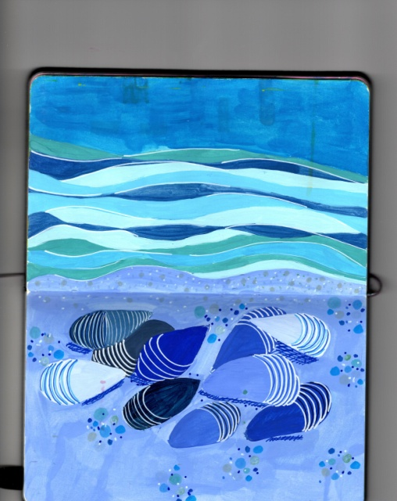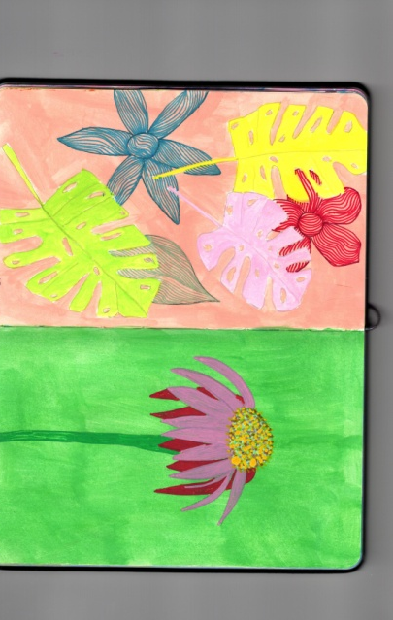
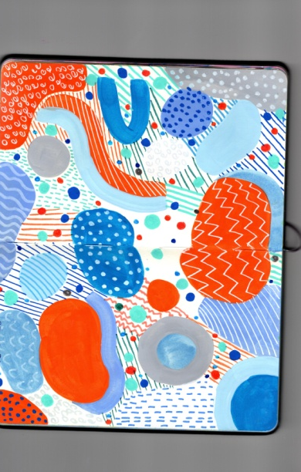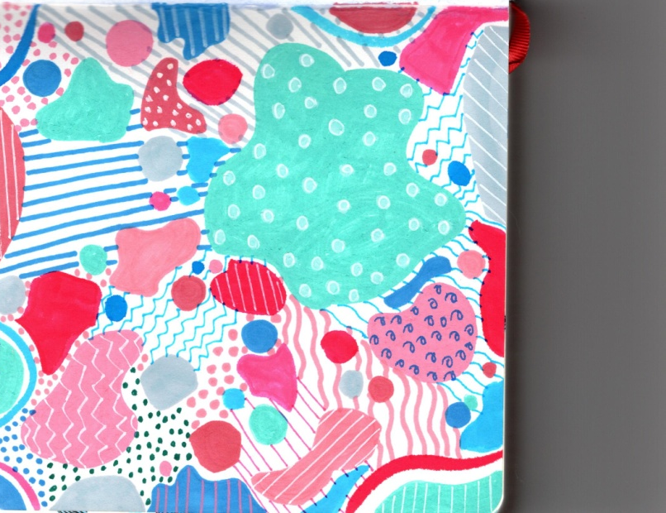
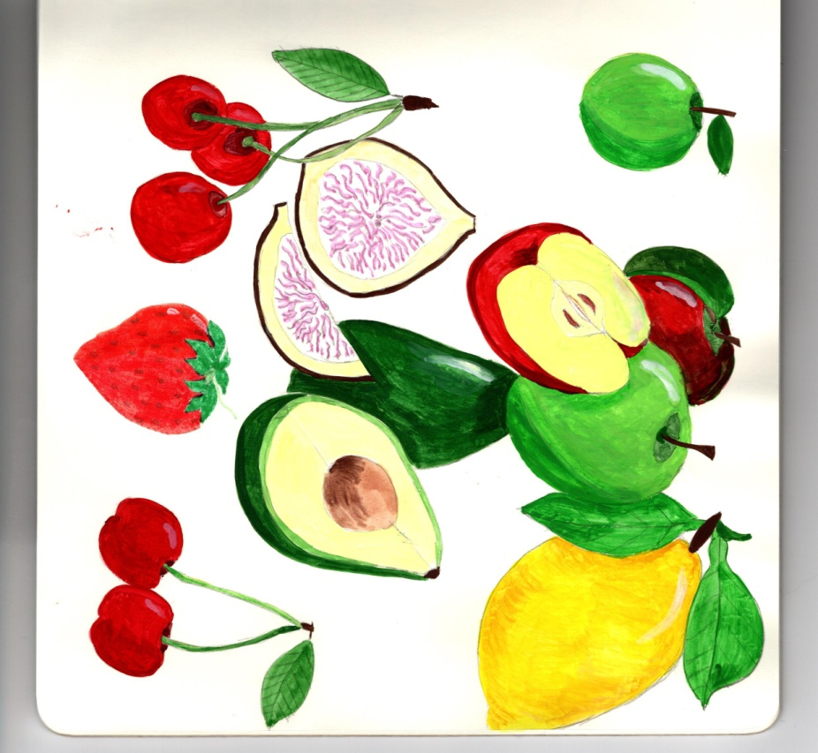

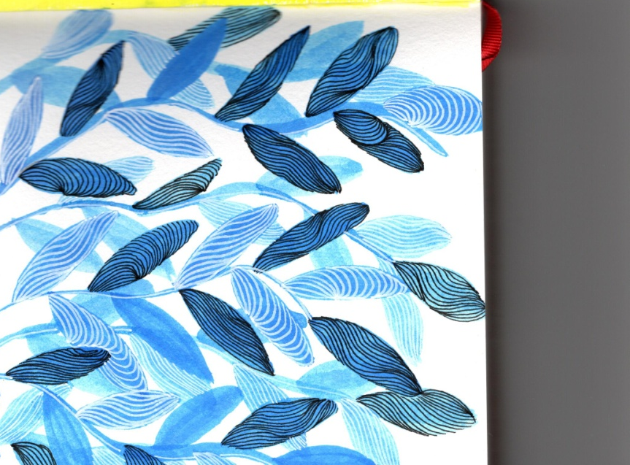
I am now going to print these out on just printer paper to see how they work, and so I can see them all together, and can then plan and move them around in orders.
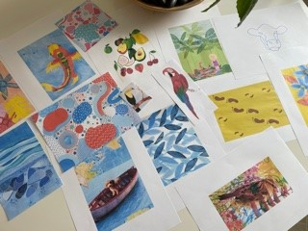

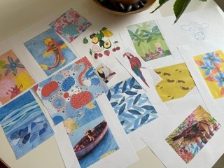
I then looked through the art work, and made up a short poem/ story, that compliments the images and subject matters.
I wrote this in my sketchbook, and also started to highlight the key words again from the poem, but would these be the same as before or different this time?
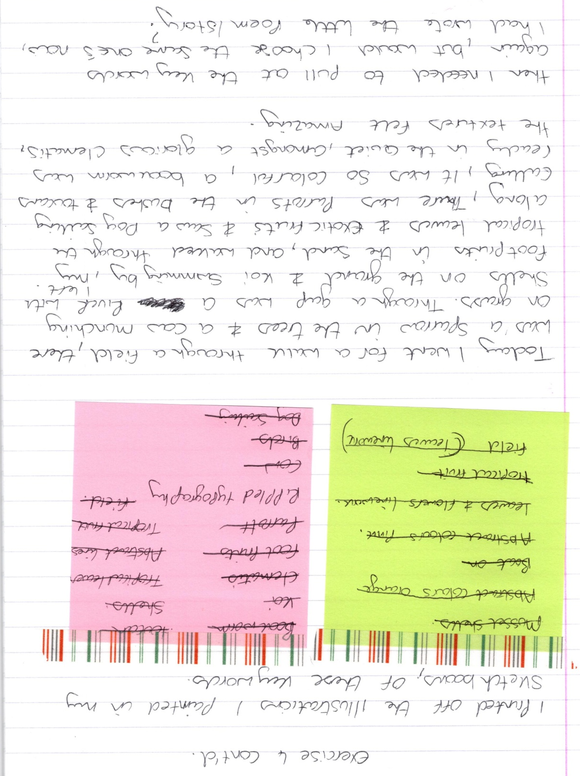
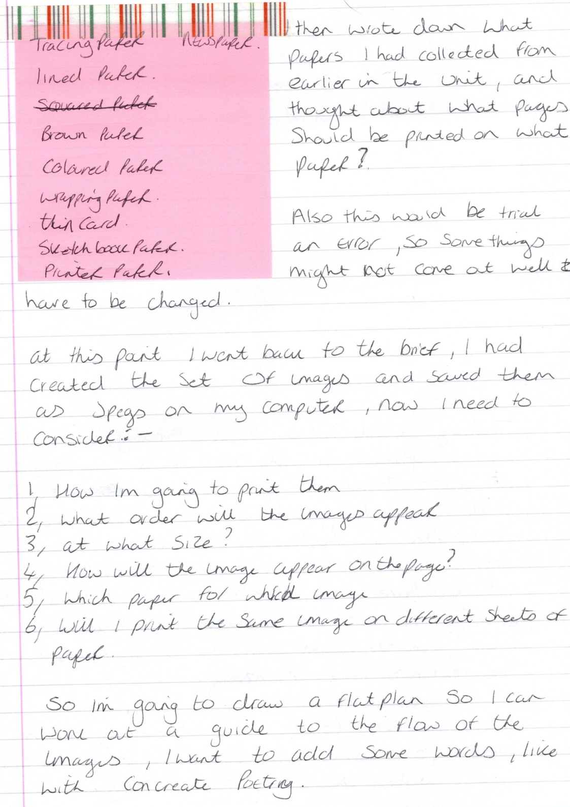
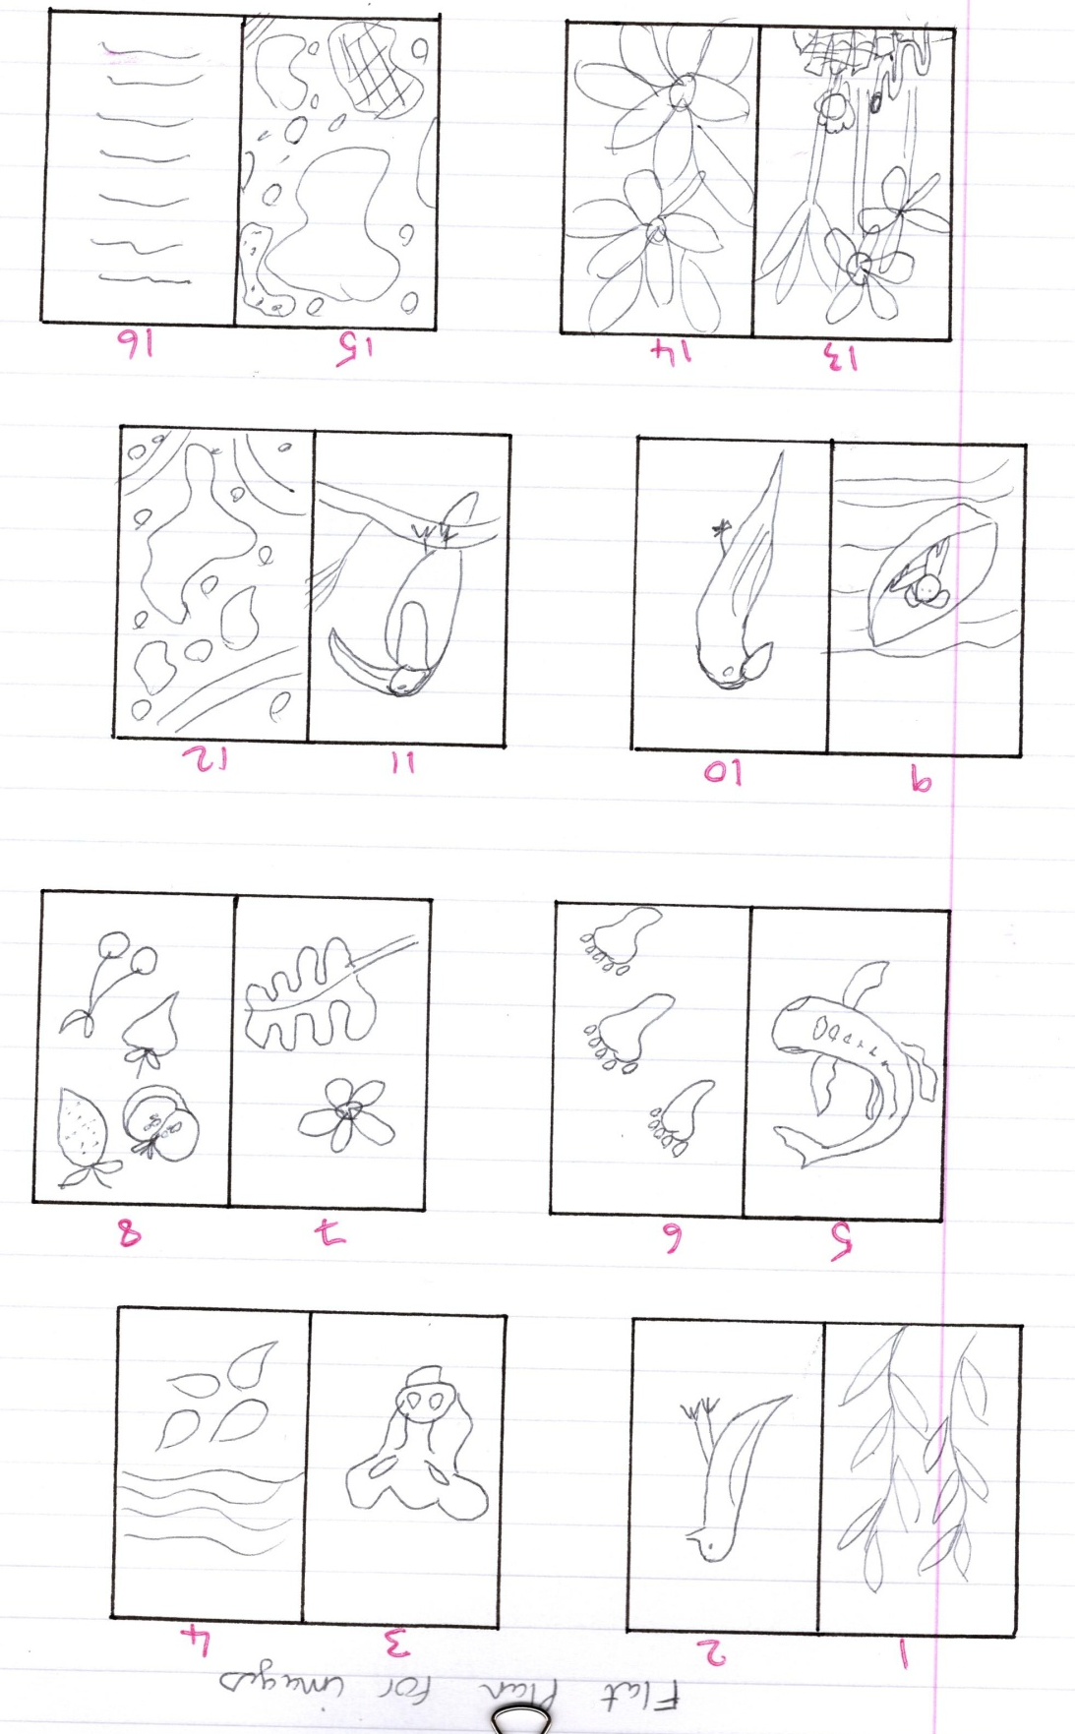

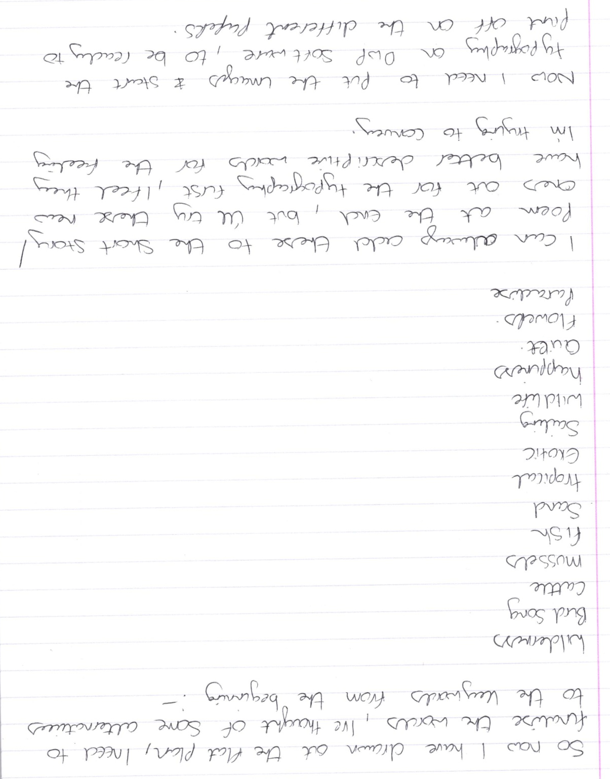

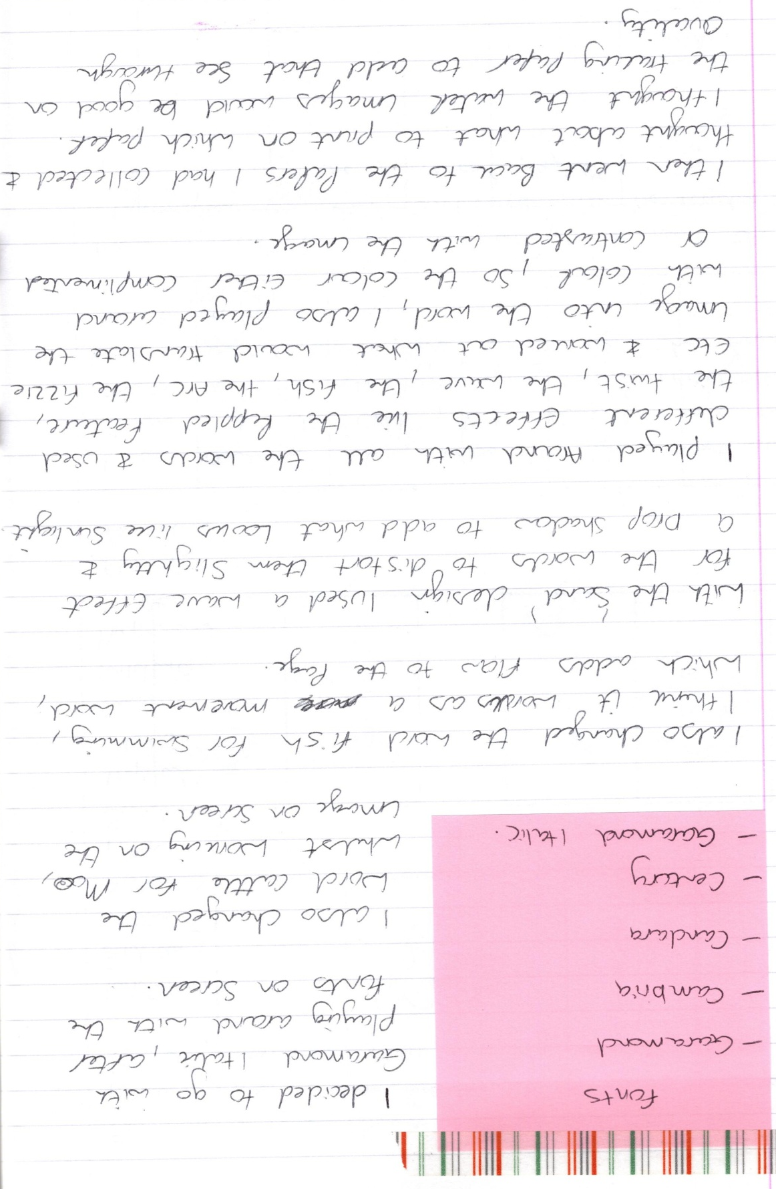
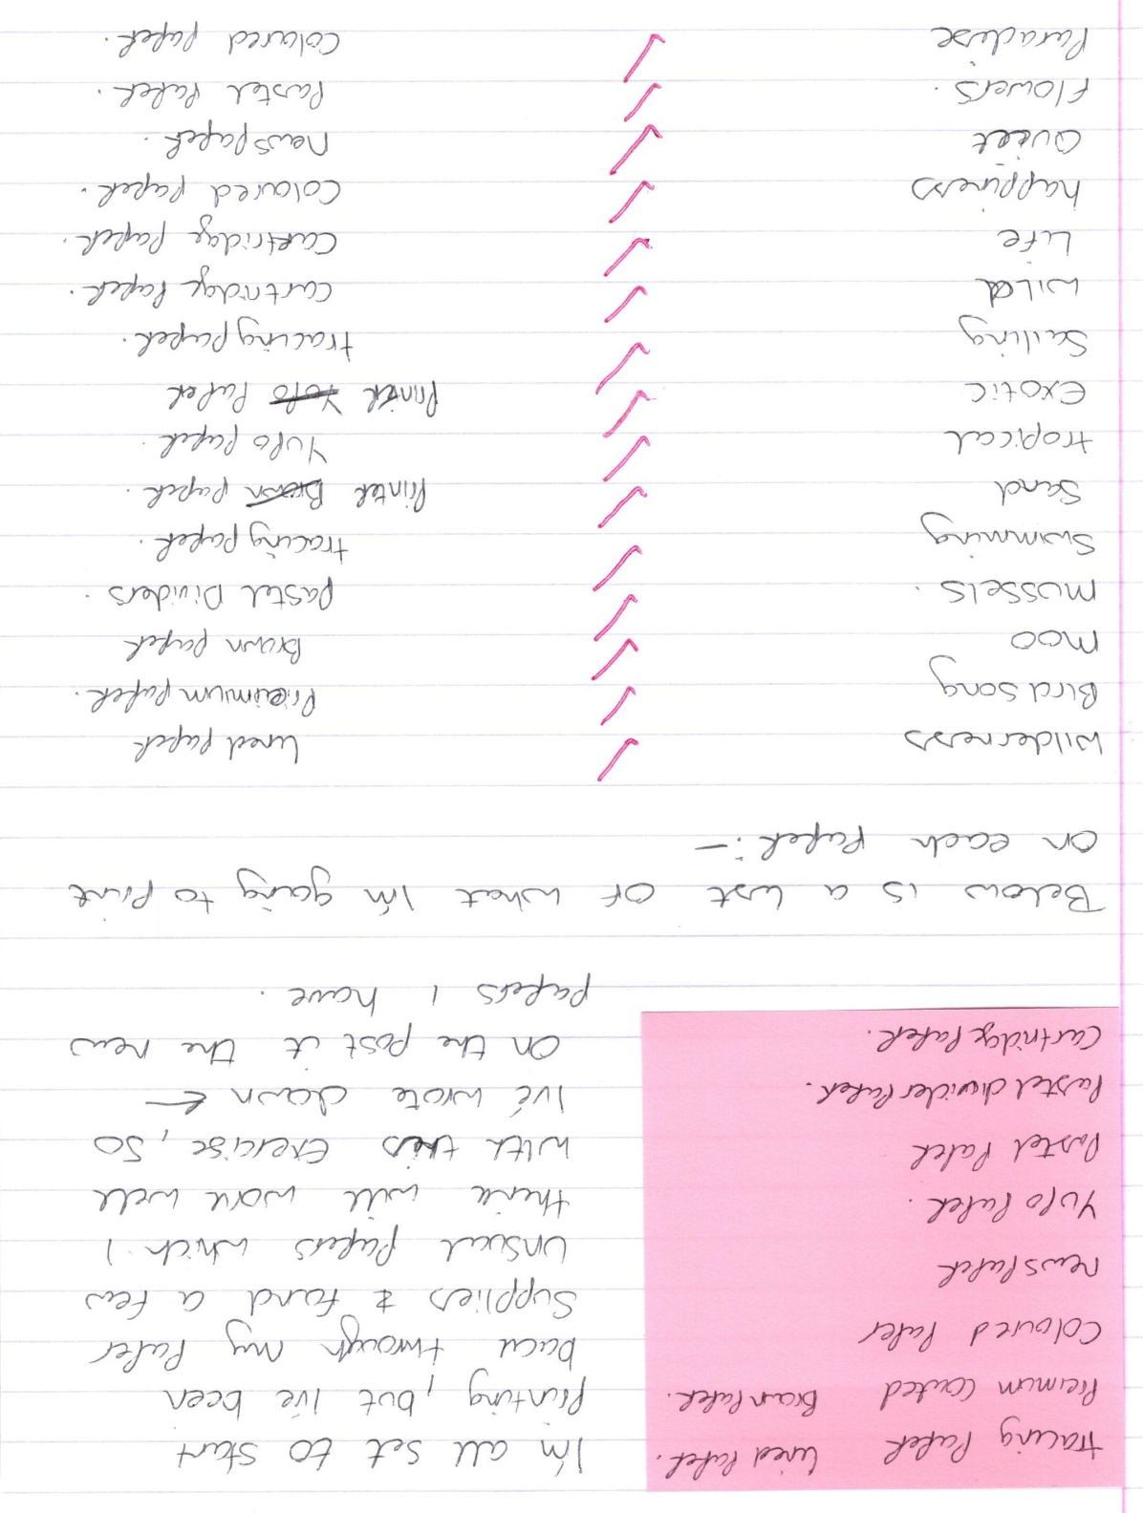
So I started by printing the Wilderness image, I used lined paper for this. I came out better than I thought it would, I used the A5 size for all of them, just so I could save ink on my computer.
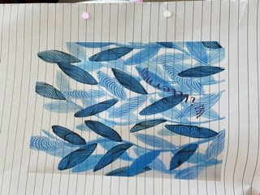
The next was the Birdsong on Premium paper, this again turned out better than I thought, the saturation is quite high here, but I like that quality to the image.
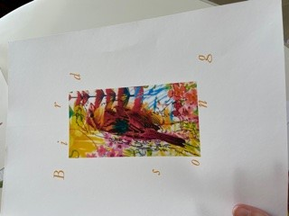
I had trouble with the Moo image, I had pastel paper ready in the printer, but it just kept running the paper through without printing, and saying there was no paper inside. I tried again with another sheet, but no luck, then I tried by sticking it to another sheet of printer paper, so the printer would recognise it, but again no luck, I changed setting but still nothing, so I’ll come back to this later.
Mussels was the next image and I decided to print this on the pastel paper covers (which is the paper in-between each pastel paper sheet to protect it) it’s very sheer and light and flimsy. The image came out ok, but the printer screwed the paper up, and some extra ink was blobbed on the image.
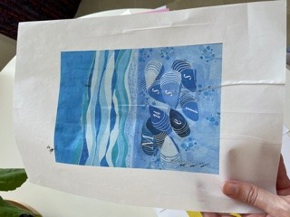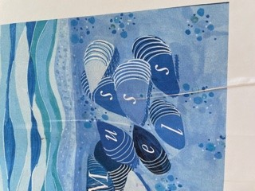
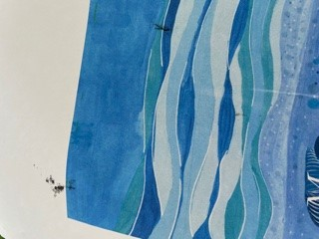
The next one was the swimming image with the koi fish, I was going to print it on tracing paper to give the idea of see through and water, but this didn’t work, the computer wouldn’t recognise the paper again! I used some textured paper instead which has a slight wave grain to it.
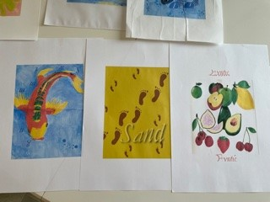
The sand image again was supposed to be the tracing paper, but I changed this to the printer paper, just so I could add the image to this exercise. The image came out well, and the typography words well with the image.
For the tropical image, I used Yupo paper, which is a very smooth, shinny paper, used for alcohol inks. Now this came out ok, the colours are very vibrant, but the ink had to dry, as it came out wet from the computer (the paper is not porous, the ink sits on top) I was concerned about my computer after, in case the ink had run inside, so I don’t think I’d ever try this again, it’s too risky to damage equipment. I wouldn’t recommend you do this!
The ink finally dried and did create a nice effect, that complimented the image, but again I would reiterate not to do this.
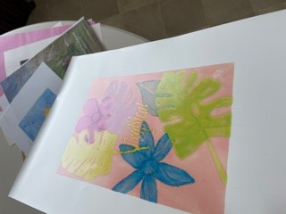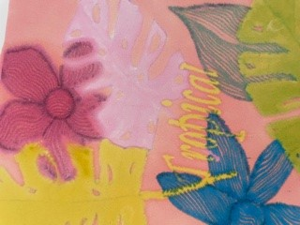
Exotic was the next image, I used printer paper again for this in the end, as it was supposed to be the previous paper Yupo, but I wouldn’t risk my computer again, so to add the image to this exercise I chose the printer paper, it came out well, the colours are vibrant, and the typography works well with the image.
Now Sailing was supposed to be on tracing paper as well, but it didn’t work on the other design, so this time I stuck the tracing paper to some printer paper, so the computer would recognise the paper, this did print, but again I wouldn’t risk my computer again, by doing this, the ink wasn’t as wet as the Yupo paper, but it was still wet! Although the tracing paper was stuck to printer paper, the tracing paper still gave that sheerness and translucency that worked well with the image.
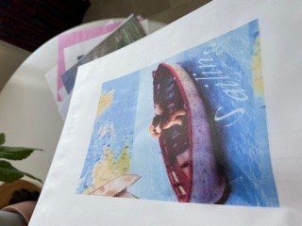
The Wild image was picked to go on cartridge paper, this had a slight textured grain, that was quite woody, which I thought would work, with the tropical birds and trees well; it had a slightly yellow colour too.
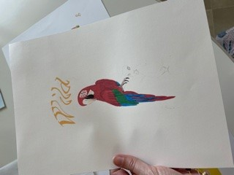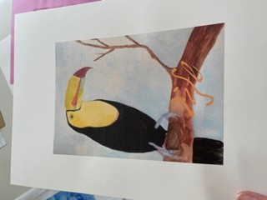
Happiness was to be printed on coloured paper; I chose blue coloured paper for this design, and also coloured paper for the Paradise image, which was pink. The paper was thin and had a texture to the colour, but not to the grain of the paper.
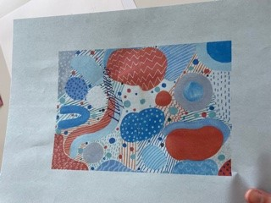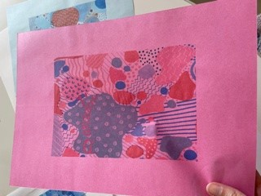
The Quiet image was the bookworm, I decided to print this on newspaper, as I thought it connects the image to the material, and also the word quiet, you can go somewhere quiet to read your newspaper. Now the piece of newspaper I chose was quite colourful already, and had a field and tress on it, so the printing didn’t come out that well, you can just about see the image. But in a way it does translate as quiet, as the printing is quiet too!
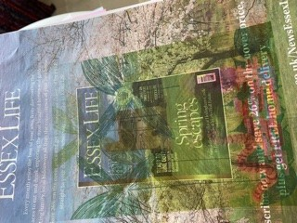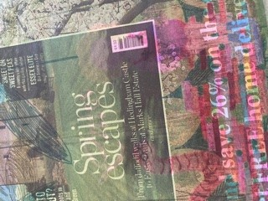
The last image was the flowers (Clematis) I decided to print this on some brown paper, the paper was quite textured with a grain, and the printing came out quite soft, but worked really well, with a wood natural feel.
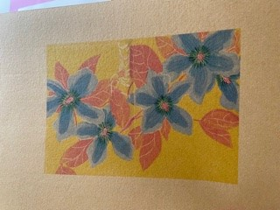

Tracing paper
I liked the translucent feel of this and the sheerness of the paper, holding the paper so the light can stream through is really nice, it’s a shame the printing didn’t work as I had wanted with this, it feels waxy and frosty, which is a nice feel.
Coloured Paper
The coloured paper worked well, and the colour texture was a nice addition to the image, sometimes the colour interfered with the colour on the image, but in some ways that makes for a happy mistake!
Brown paper
This worked really well with the flowers, and gave a natural and slightly Eco feel, which I really loved; I think this was my favourite outcome. The colours were more muted, but they seemed to blend in with the background colour more, which effect I really liked.
Printer paper
The printer paper worked really well, and gave a good contrast with the bright colours, the texture was smooth which complimented all the images, and the print was sharp.
Premium paper
The premium papers had a really good quality and feel to is, it made the colour come out quite saturated but I didn’t mind this, the texture was soft and fairly smooth, and the colour was a softer white, which added a luxury feel to it.
Cartridge paper
I really liked the cartridge paper, it gave a soft yet woody effect to the images, which worked really well with the nature vibe, and it had a softer cream feel, with a smooth yet fleck texture. I was really pleased how these turned out especially the Toucan picture.
Newspaper
The newspaper didn’t take the colour very well, due to the colour already on the sheet, which may have been my mistake for choosing that particular piece! But otherwise I like the hidden quality of how the printing came out, which in a roundabout way added to the image portrayal, which help put across the feeling of being in the woods quiet with a book reading. So in one way worked out well.
Lined paper
This paper surprised me, I liked the effect it gave to the image, and in one way you wouldn’t think it would work, but actually I think it did work, to me it gave a structure to the image, which was portraying a wilderness, so they were actually opposites, but I liked that contrast. I would definitely use lined paper again, it has a good texture and feel, yet an old feel too.
Pastel dividers
This was the thin paper usually to put over pastel paper so as not to smudge the pastel chalk; it’s a very thin paper, smooth and quite translucent. I really liked the quality of this paper it has a ethereal feel, I wanted this for my Mussel picture but it buckled in the printer and the ink smudged, it’s such a shame, but I really liked the feel it gave to the image.
Yupo paper
This was a good experiment, but maybe should have been thought through more to begin with, I really liked the idea of the extremely smooth and shinny paper, and thought it would lend itself to the Tropical image well. The outcome was good in that the effect it created was fun and really went with the tropical vibe, but I am still concerned that it may have damaged my printer, so not worth the experiment! The paper actually hasn’t dried; the ink can still be wiped off, so actually does not work at all.
I changed the story into a poem at the end, and added in the new words which were changed throughout the process:-
I walked through the wilderness
Where the bird song sung
A moo was heard
But mussel shells spied
As a koi went swimming by
I left my footprints in the sand
And walked through tropical leaves
Exotic fruits found
My mind wandered back
As a dog went sailing by
Wild life called
Like happiness all around
Quiet moments taken
While flowers surrounded me
In a surreal paradise

So overall I have learnt quite a lot for this exercise, I learnt about combining very different images to make a story/ poem. How to come up with keywords from images and use these to make a story up. How to choose particular papers that connect with the images to make the feeling come across to the reader.
Also about what not to do with printing on different papers, always check the papers not too smooth or shinny, so the ink stays wet and can damage the inside of your printer, or cause blobbing of excess ink after you have printed from it.
How to experiment and try different things, from image combinations, to papers, and to printing.
How to combine both images and typography, to get across the feeling of the piece, as well as choose the appropriate paper for the intended project.
I enjoyed this exercise as it’s practical and you can understand better through achieving and putting in practise something creative, I increased my awareness of choosing the right paper for the right images or project, and can communicate in itself a message that co exists with the image.

