On Press
Chapter Six - On Press (p.165 – 219) in Pipes, A. (2009) Production for Graphic Designers, 5th Edition, London: Laurence King Publishing, is available to you as a resource on the OCA student site.
Consider which aspects of the print process might feed into your creative decision making process. Where do the connections between artist and craftsperson sit within your work? Use your learning log to reflect on this. Identify your nearest local printer. If possible, introduce yourself with the aim of arranging a short tour of their production process, from computer through to finished article. Seeing the printers at work helps to put the theory into context and can clarify certain parts of the process you may be unsure of. If the printer you find does print books then so much the better, but any medium-sized printers will no doubt print flyers, brochures and similar material. They will certainly have machines for reproduction, printing, folding and binding, which would be relevant to your research into printing books. Don’t be shy about getting in touch. When you explain you’re a student, printers often enjoy taking time out of their regular schedule to show people ‘round the works’ – but be aware that they do have busy schedules, so take advantage of any time they offer you! Take your camera and ask permission to photograph the machinery and production line, as an aide-memoire. Similarly, take your notebook and document the visit – you can incorporate this research later into your learning log. Alternatively, you may want to concentrate on online options, such as PDFs or print on demand. Investigate these through internet research, documenting your key findings in your learning log. Any visit may provide valuable research material for you, and of course the printer may prove a good contact for you in the future.
After searching the OCA library for the Adrian Pipes book and specific chapter, unfortunately it didn’t seem to have it. So I tried Google instead, but that didn’t turn up anything either. So I decided to do my own research instead, I started with the main processes I will need to think about for my book printing process:
The size of the book i.e. A4, A5, A6, the format so Portrait, Landscape, or square.
The paper stock, GSM thickness.
To complete the book in colour or black and white.
How the book will be printed.
How the book will be bound.
The finishing, lamination, uncoated etc.
Production.
If I choose to have my book printed externally this will make my choices different to if I print the book myself, I would have more control if I printed the book myself, plus the costs would be less. If I printed externally I would have the choices above, but the rest would be out of my control.
I think because of costs I would choose a smaller size book, which again will impact the layout of the book, and also what I could put in it.
I would prefer the paper stock to be thicker, but again this would be controlled by the cost, and again would impact the type of book I finally decided to do.
I would prefer to print in colour of course, but I would then need to think about what inks I would choose, especially if I went for the uncoated finish, the colours would be less bright and would soak into the paper more.
I would probably choose digital printing, as this is the most affordable process, and the one that I am most used to.
How the book is bound would depend upon the choices I make for the rest of the book, If I choose to print on demand, it would then be a choice of a hardback or soft back, then that would be the decision of the binding.
If I printed the book myself, it would depend upon, again hard backed or soft backed, how I wanted the binding to work, and how it look.
Finishing again would be a choice made from decisions for the rest of the book first. Whether I went down the Eco friendly route, or the more luxurious route, again this would depend on cost also.
A lastly the production is ultimately the final decision, which works with all the previous decisions.
This process of research has given me a lot of things to think about when deciding which way to print my book, it will also help me decide in which route to consider the style and writing of the book.

Due to the Pandemic I was not allowed to go to the local printers, but I found a local printers website online, where they had some photos and information. Creative art LTD are a family run business started in 1999, they focus on canvas printing, but also print flyers, business cards, envelopes, stationery, banners, posters, stickers, labels and greetings cards. They specialise in light fast inks, and use Hewlett Packard machinery, and are a certified print centre for them.
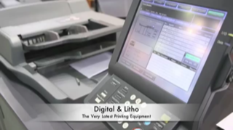

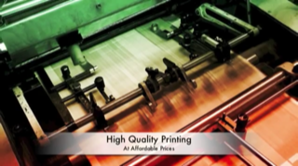

I contacted a printers based in Watford that was recommended to me by another student, which was Mixam printers, they are in-between a print on demand company and a traditional printers, I asked for a sample pack which I’ve just received. It would have been nice to receive samples of the book choices, but understand because of the costs involved. But there was one brochure type booklet that I thought could be suitable for my book, although I don’t know whether it would stand up to wear and tear enough!
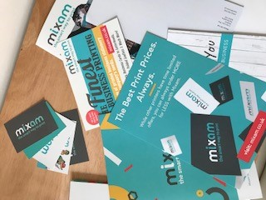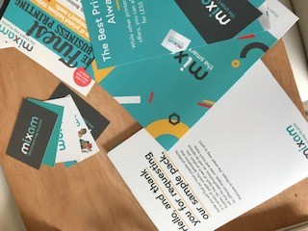

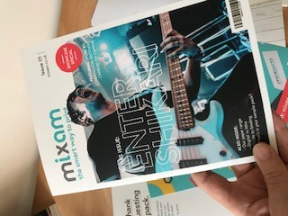

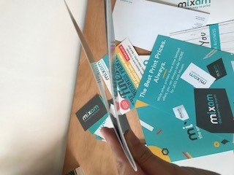
They gave me samples of matt laminate, uncoated, spot UV and soft touch laminate, my first thought would be to go for the uncoated, just because I am very Eco friendly and sustainable sensitive. The soft touch laminate is the most luxurious out of the four, and would be a great finish to the book. I didn’t like the spot UV it was printed on 300gsm silk, so was not very thick. The matt laminate was very similar to the soft touch, but slightly less soft! I will decide what finish I will use once the book is fully planned out, as I’m still not sure the external printing is the way forward yet.
I had a look on their website again, to find out more about costing and sizes, inks etc. I looked at both brochures and books to see how much they would cost.
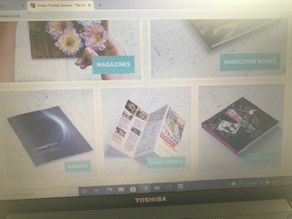
This was a square colour brochure, just one copy, which would cost £24, on recycled silk at 130gsm, with staple binding, in portrait.
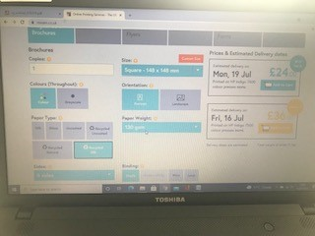
This was a book in A5 in portrait and colour, with silk paper at 200gsm, no sewing, and with no head and tail band, and 48 sides, one copy £43.
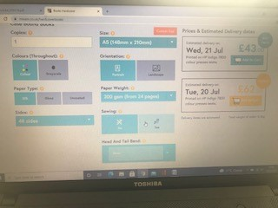
I then changed the book to landscape and with head and tail bands, with just 24 sides, and end papers in yellow, this come to £45 for one copy.
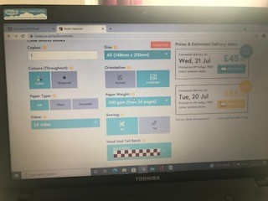

So I now have a good understanding of what processes I would need to employ when creating this book, there’s a lot to think about and decided upon. I have a few ideas now in my mind, it just depends which one will work out the best, and in which process I will finally choose.

