Collating and binding
Having printed your images from the previous exercise, take the opportunity to view all of the pages, reflect on them and evaluate before moving on to the next step of collating and binding the pages together. Which pages are successful? Which pages have not turned out as well as you had hoped? Are there any visual surprises, or happy accidents? Given the experimental and open-ended nature of this exercise, the answers may be quite subjective, but it is important you reflect on these and other questions, to sharpen your self-critical awareness and assessment of your own progress. You may want to re-work some of the images, and the printing process, and this is your opportunity to do that. You may end up with more and more pieces of printed paper.
Evaluate the strengths and weaknesses in your work and then begin a process of selecting up to 16 pages that work well together as a whole. Do these pages have images on each side of the page, or will the images appear on facing pages only? If you want to create back-to-back images you can work manually to cut and paste images and pages, using spray mount or similar. Equally, you can collage elements of printed ephemera onto and into the pages. Again, the brief is to be experimental, so work inventively with the process, cutting, gluing, pasting and arranging as you see fit. Collate these pages, putting them into a running order from beginning to end.
Drawing on your understanding of bookbinding so far, bind your 16 pages into a small book format. How will the pages be held together? Consider how the pages might be bound and experiment with solutions. Will you create a cover? Will the pages be stitched, sewn, glued, stapled or will you use another inventive approach?

I started this exercise by printing out all the pictures I had created in the last exercise, I had them all on the floor, they were printed smaller than the booklet as this was just a case of choosing and picking or re-working any images I wanted to take forward, so these didn’t need to be full size, as this would waste paper!
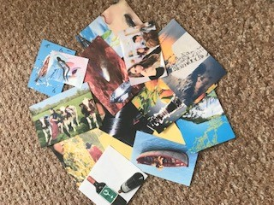
I looked at the images I had printed out and I put these in order of the poem on the floor, so I could see how they worked as a booklet. The first thing I noticed were the colours, they seemed to blend from blue to red. The second thing I noticed was the images moving from nature to people and sadness!
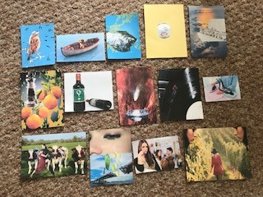
My first thought was to change the first image of the sparrow, I didn’t want the music notes on there, I found this distracting and I needed somewhere to put the typography.
The second image I wanted to change was the third from last, the ‘Build bridges with tears’. I wanted to remove the tears as they were green! And use another idea for tears instead.
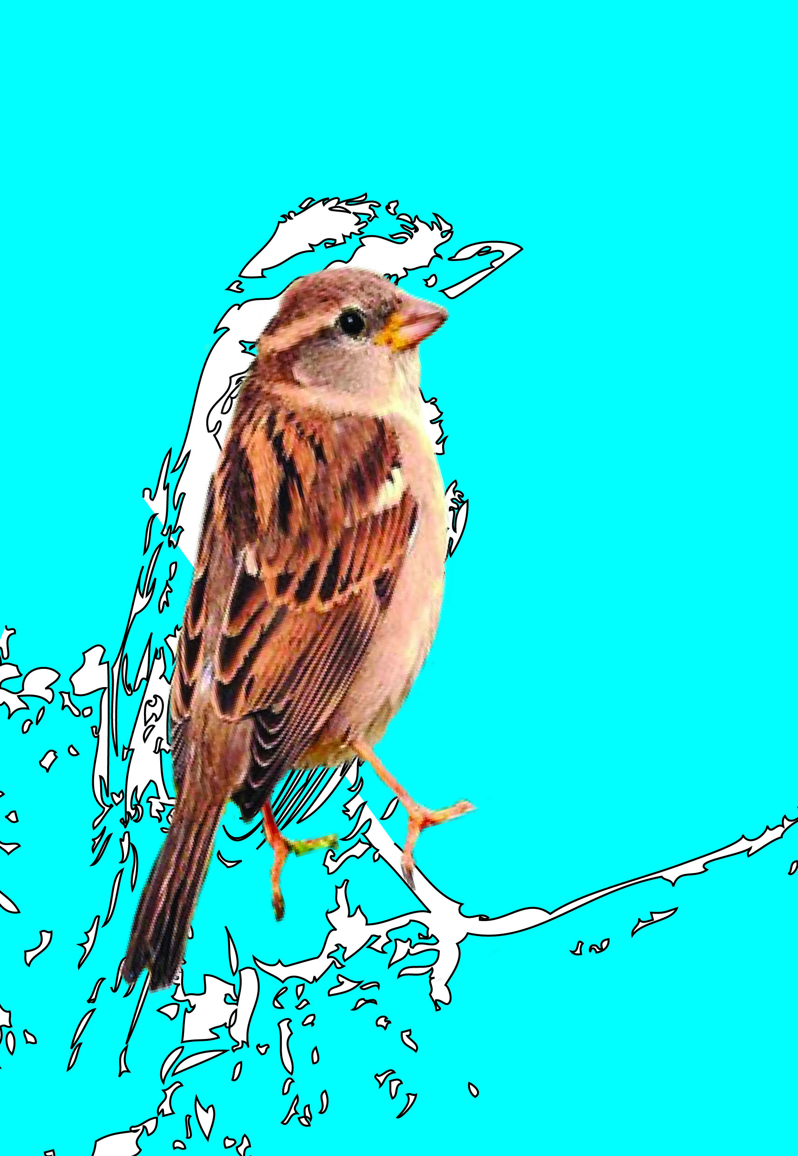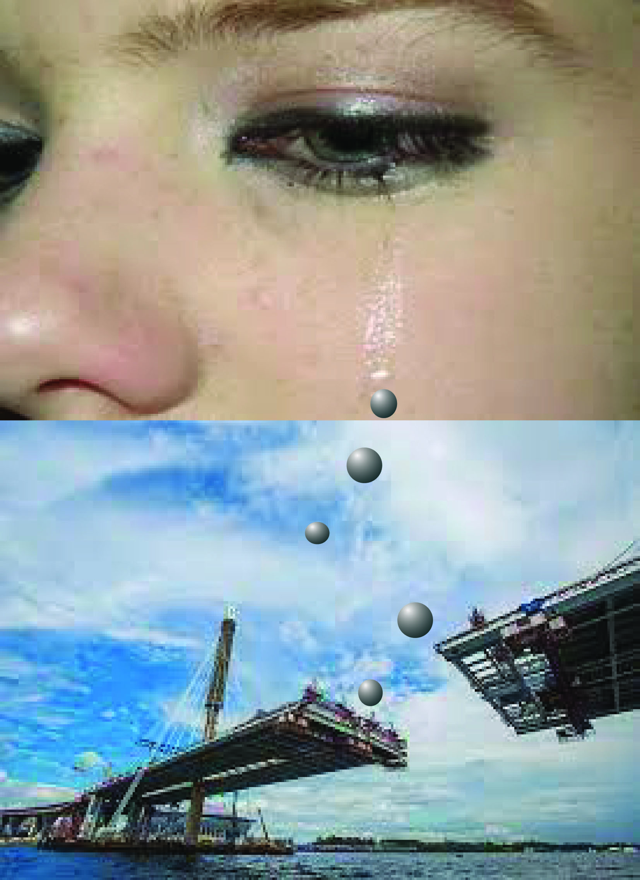
This is how they turned out, the sparrow is cleaner ready for some typography and the build bridges with tears looks much better and connects the two photos that are used in the image, I used a symbol tool of a bubble on Illustrator to create these tear like spheres. I think they look like concrete so work really well.
So my next step now is to look through my ephemera that I have collected and see if any of it works within any of my images.
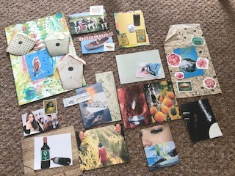
I found quite a lot that would fit with my images, but it would be a state of trial and error, to see if they would work or not. I started to lay out the images in order again to see how the flow would look with the added ephemera.

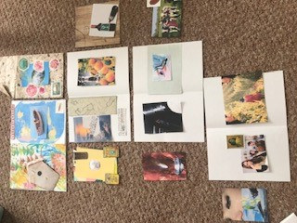
I found I had more ephemera for the first few images; it got harder the booklet went on.
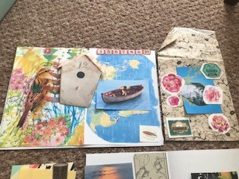
I printed off the sparrow onto this very spring like watercolour paper, which I think worked really well. I also added a coloured map to the background of the dog in the boat sailing; this was a nice bright colourful spread now.
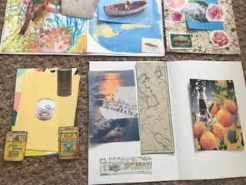
I found some images of old tin cans, so thought these would work well with the tinned mirth images.
And some added old maps and travel ephemera for the conqueror of the air image page.
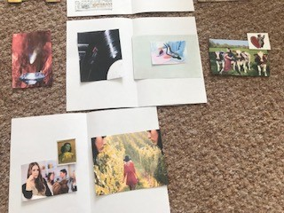
Things got a little thin on the ground towards the end, but I had a few ideas of what sort of images I wanted for these pages, so researched these some more.
This is how the first spread turned out, so this is pages 2 & 3 in the booklet, I still need to add some typography, but really liked the layered ephemera.
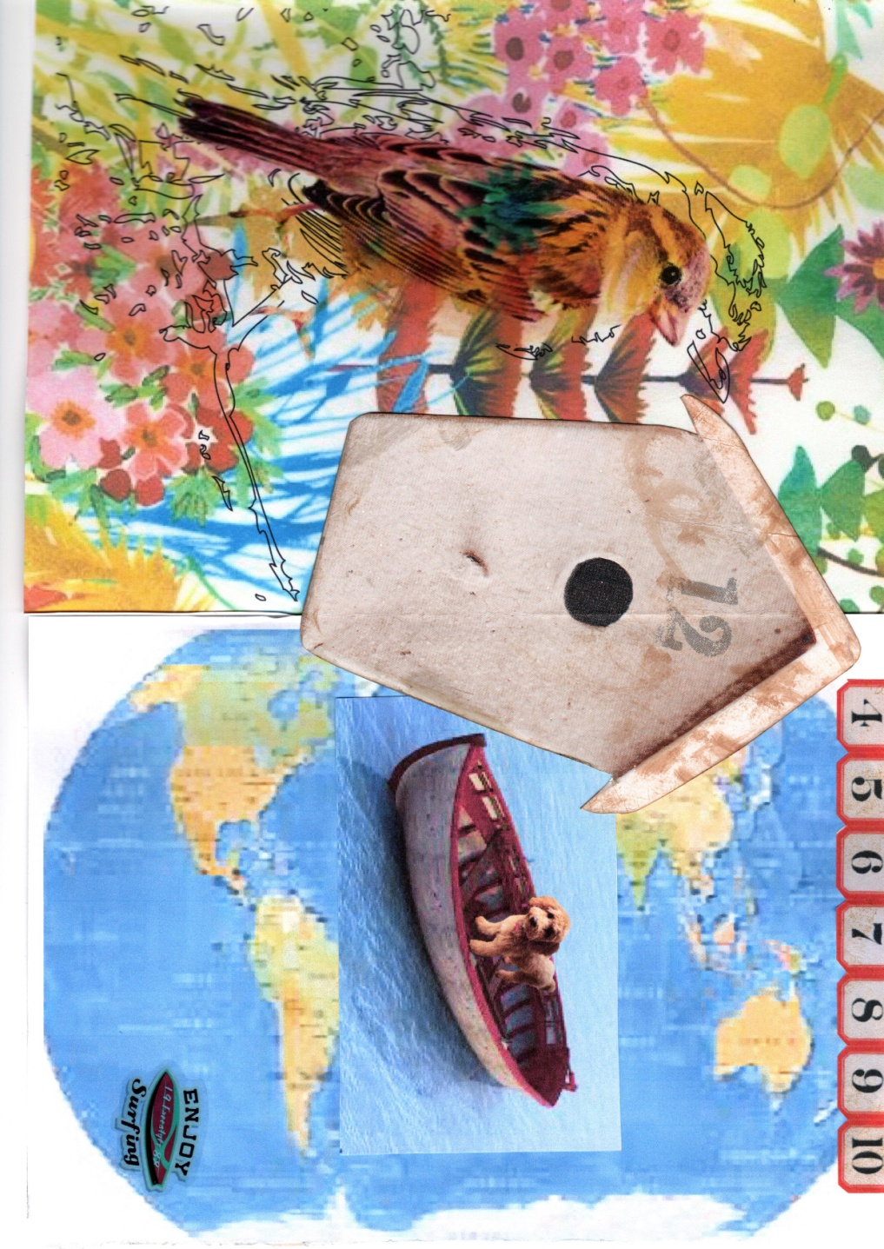
The front cover was going to be the image I completed for exercise 2; I just need to add the poem name to the front cover to finish it off.
The fourth page is the river in spring, here I used a old decorative paper bag as the background, layered my image on top, then added some clear stickers from my ephemera, to add that extra dimension.
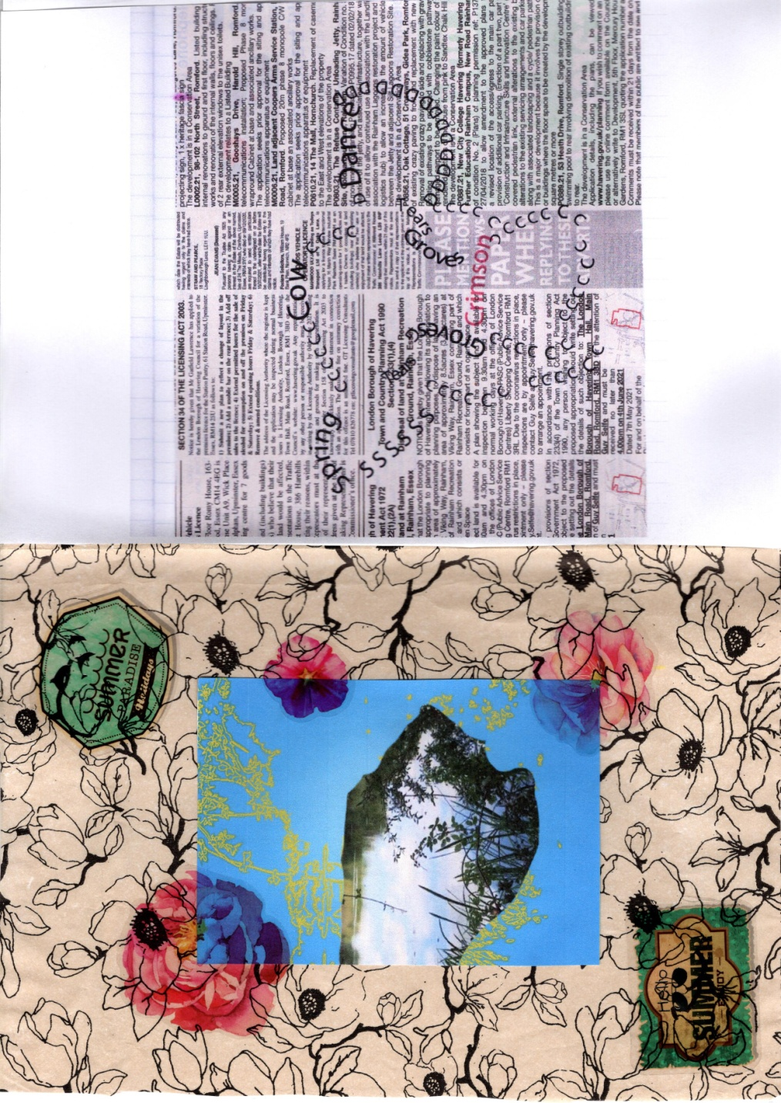
Pages 5 & 8:- For the drink a glass of wine, I found this wood effect paper that I thought looked like a old wine case, I still need to add the typography to the top and bottom, but thought this layered nicely with my images.
Page 8 :- tinned mirth, I used a graphic postcard I had in my ephemera and printed my tine and smile onto it, then layered on the tins I found in the ephemera packet I had bought. This layered nicely and gave a really good feel to it.
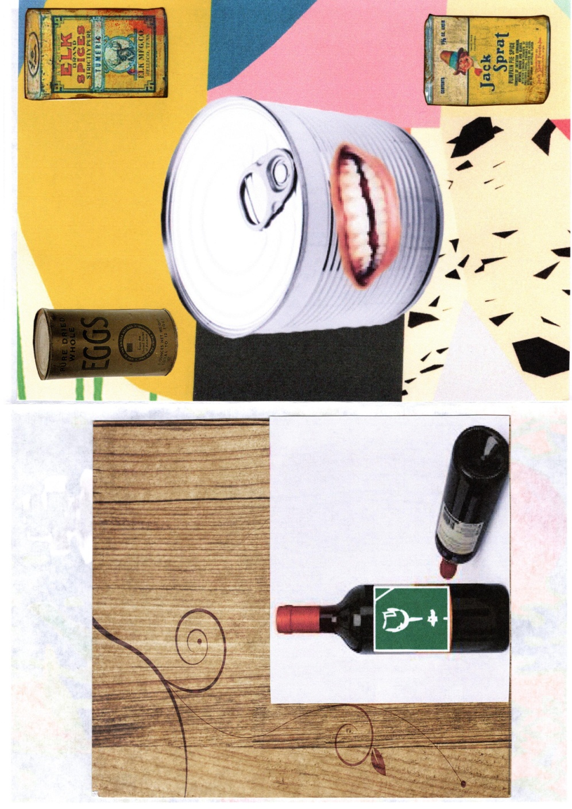
Pages 6 & 7:- were very much the same as they were before, I think they held their own already. The only thing I added to page 6 was a old map and old travel ephemera and layered these on top of the conquerors of air, I thought it gave extra depth to the images.
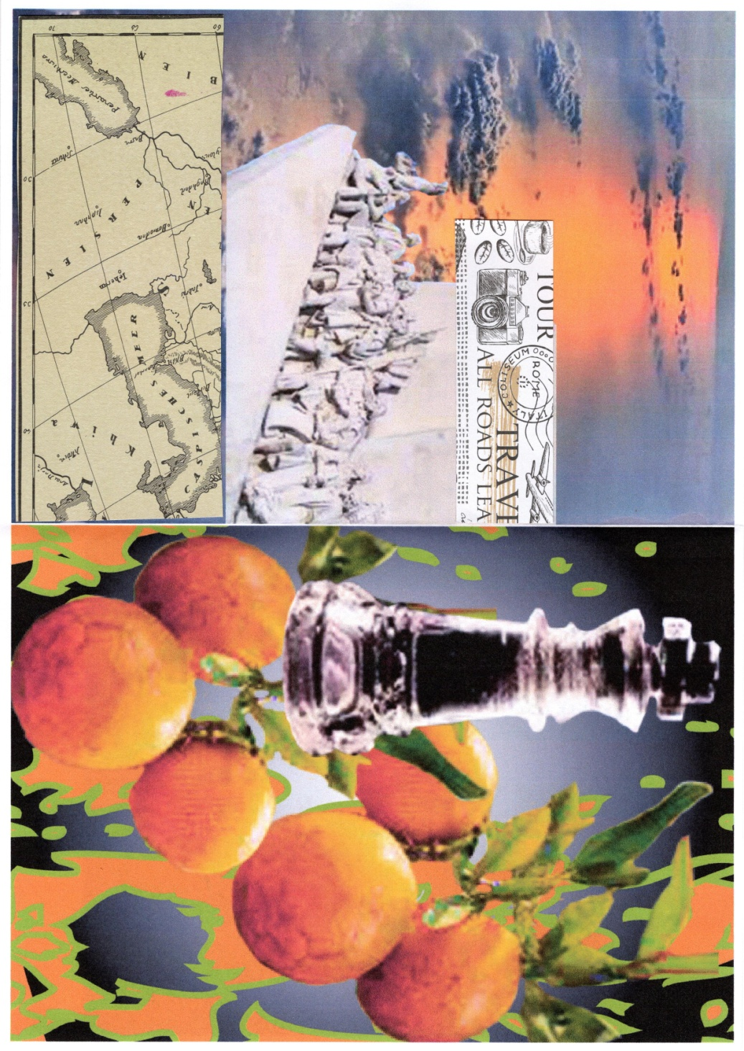
Again with pages 9 & 12 I kept most of the images the same, as again these were fairly strong already. The only extra I added was to extend the country view of the dance the tango with cows image, as it didn’t fit fully on the page, but I still need to add the typography so this might not stay anyway!
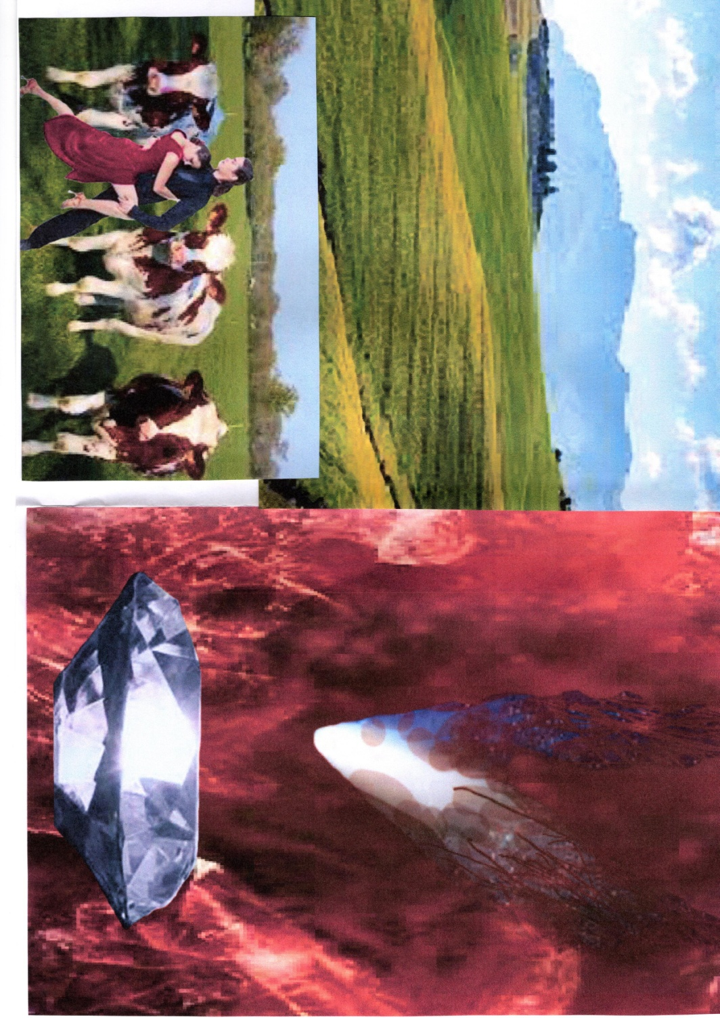
Pages 10 & 11: page 10 stayed the same as I feel I couldn’t add any more to it. Page 11 I added some more horns to the image I already have as this didn’t fit fully over the page, so I just layered more into it, but again this may not stay due to the typography.
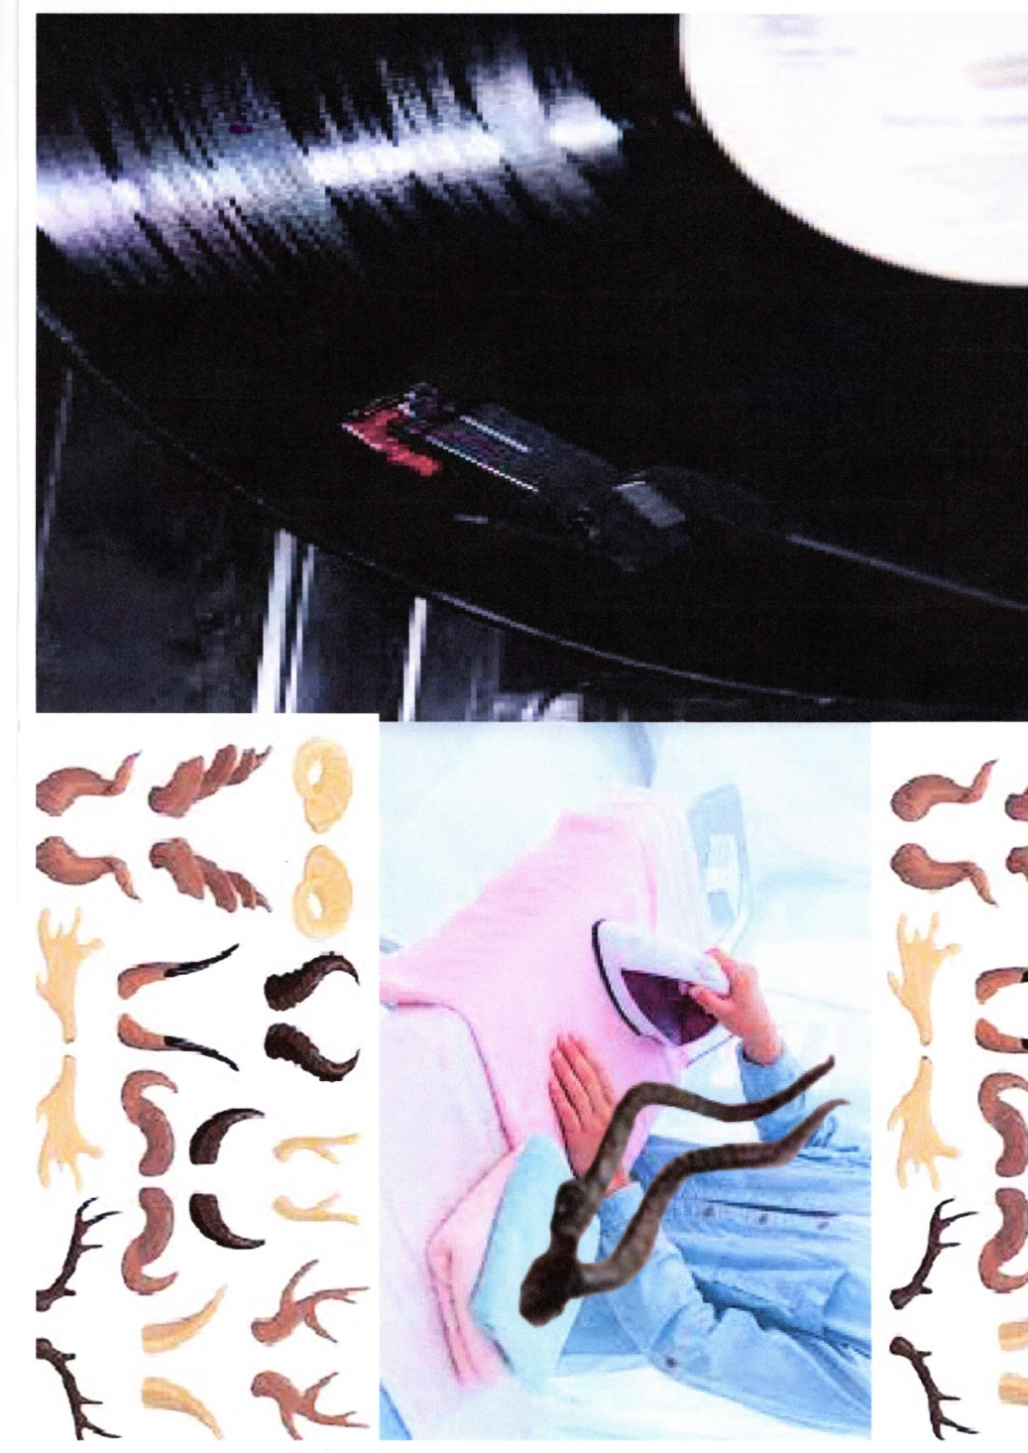
Pages 13 & 16:- Page 13 was the same as it was before, page 16 is the back cover, so I have just used the newspaper as the background and written the whole poem over the top in red, it looks a bit blurry on here but you can read it in real life. I wanted the writing in white but it didn’t show up on the news paper, I tried different ways but it just wouldn’t go, so I chose red instead to click with the front cover.
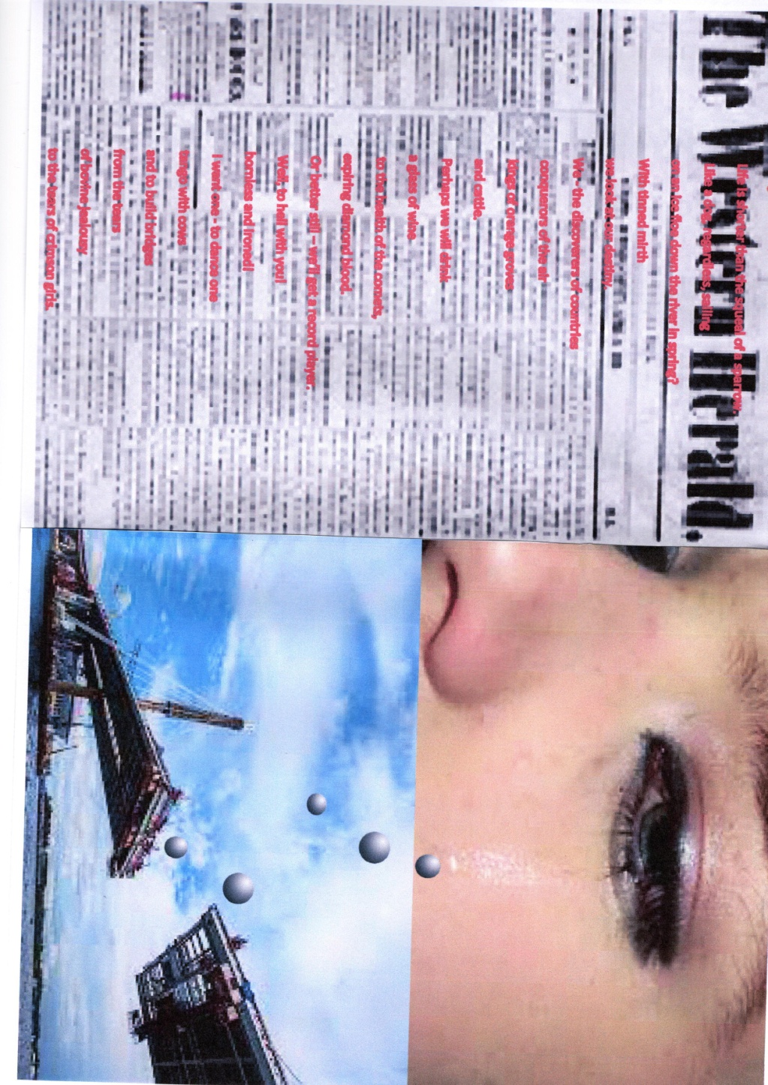
Pages 14 & 15:- Page 14 I just added the word jealousy, and added a background colour to match, then found a picture of a woman in my ephemera that looked like it fitted well, so layered this on top.
Page 15 was layered with the typography Crimson, and some crimson leaves, as well as a red background colour, just to add to the layered colour vibe.
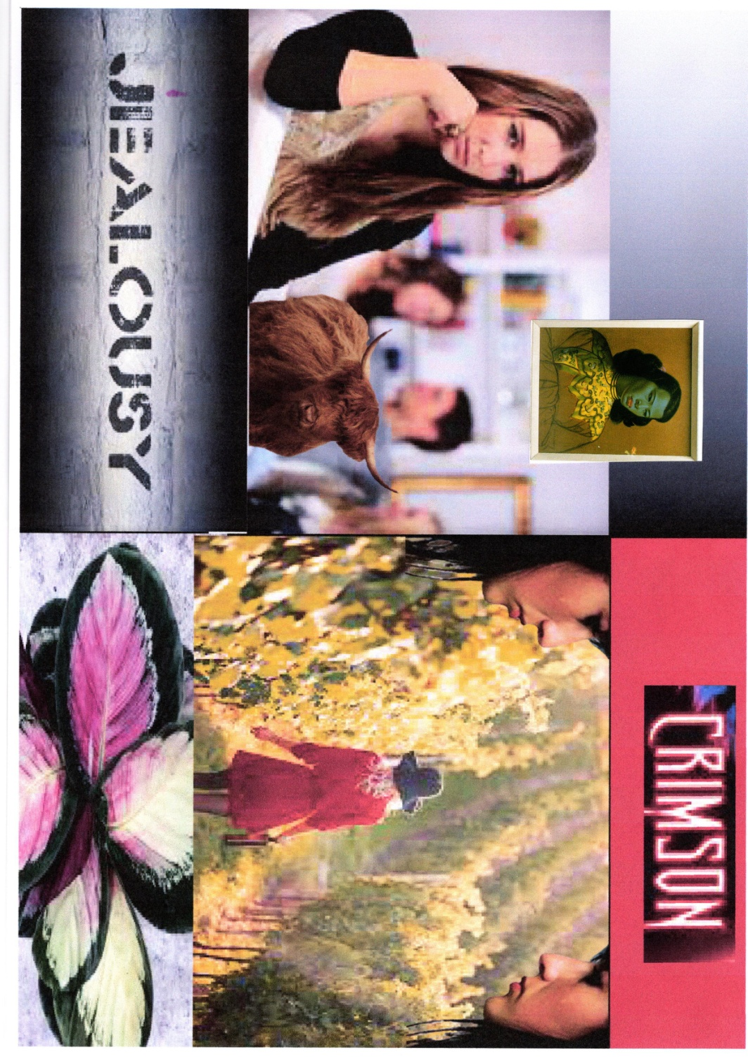
After completing this I needed to go back and think about the typography through the booklet now, some I had already added, so I just need to compliment that and make it flow through the booklet and gel it together.
I started with the front cover, and then worked my way through the booklet, here are the finished pages before I check them over and print them out.
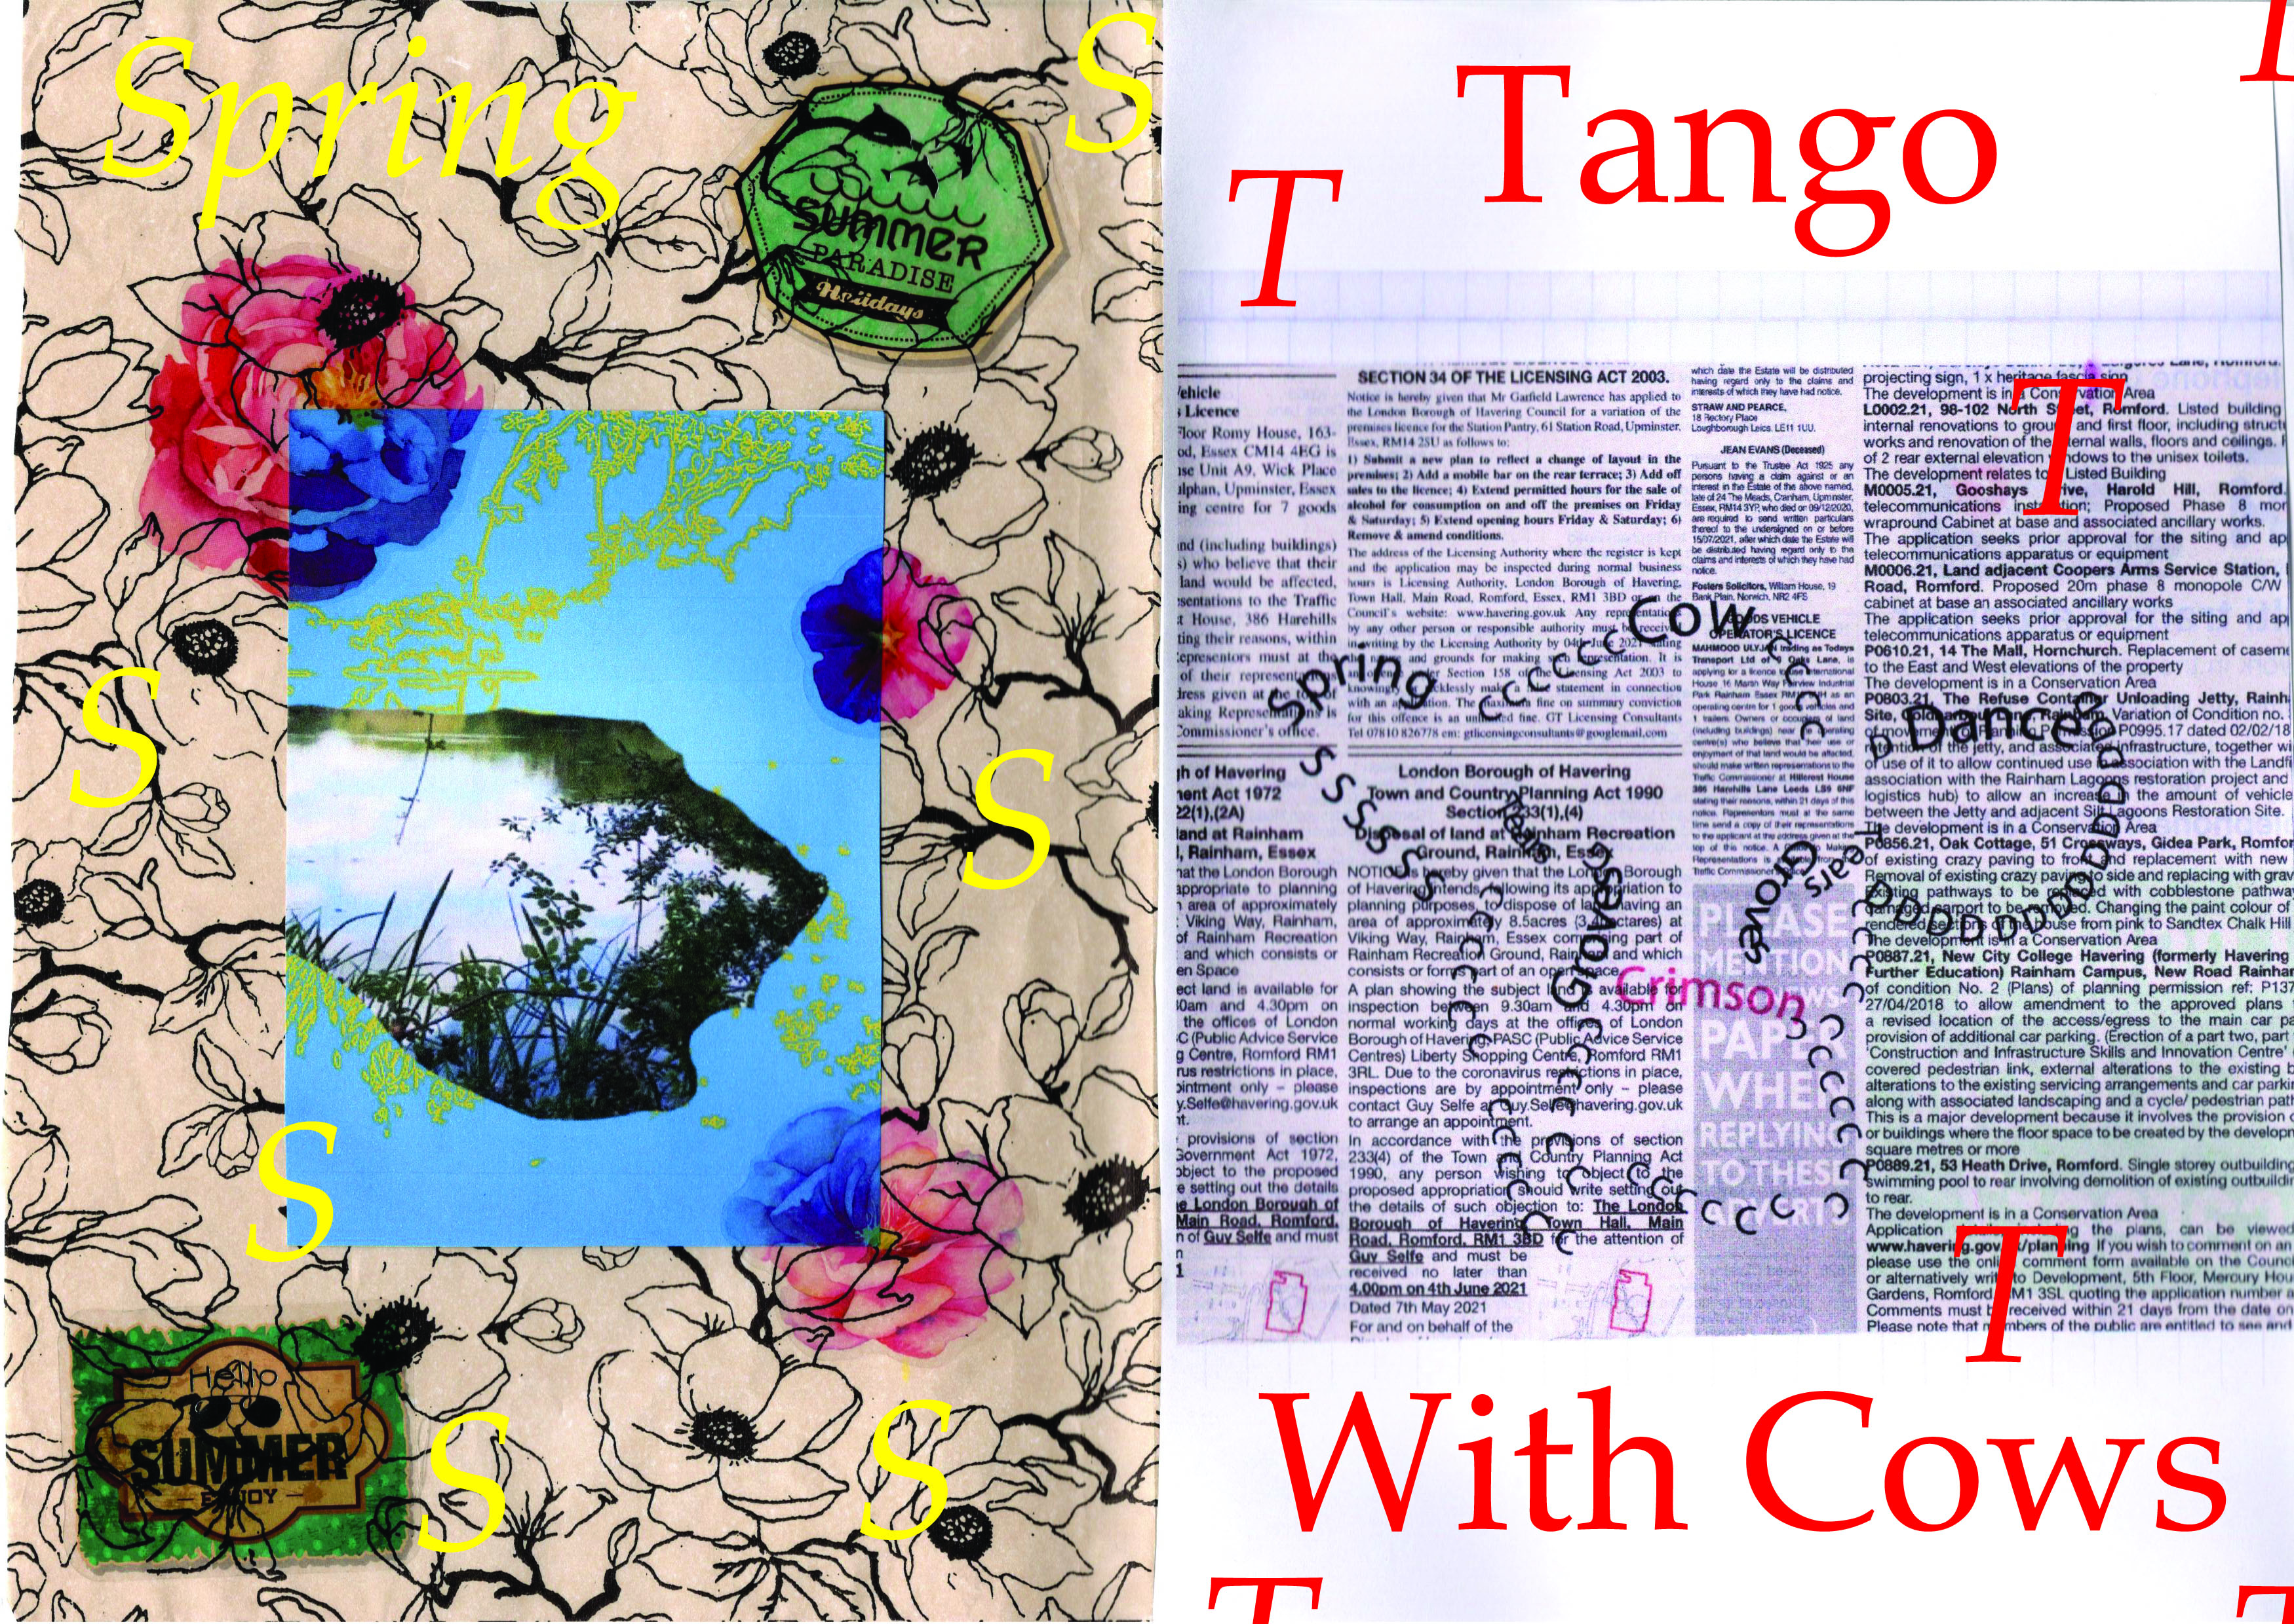

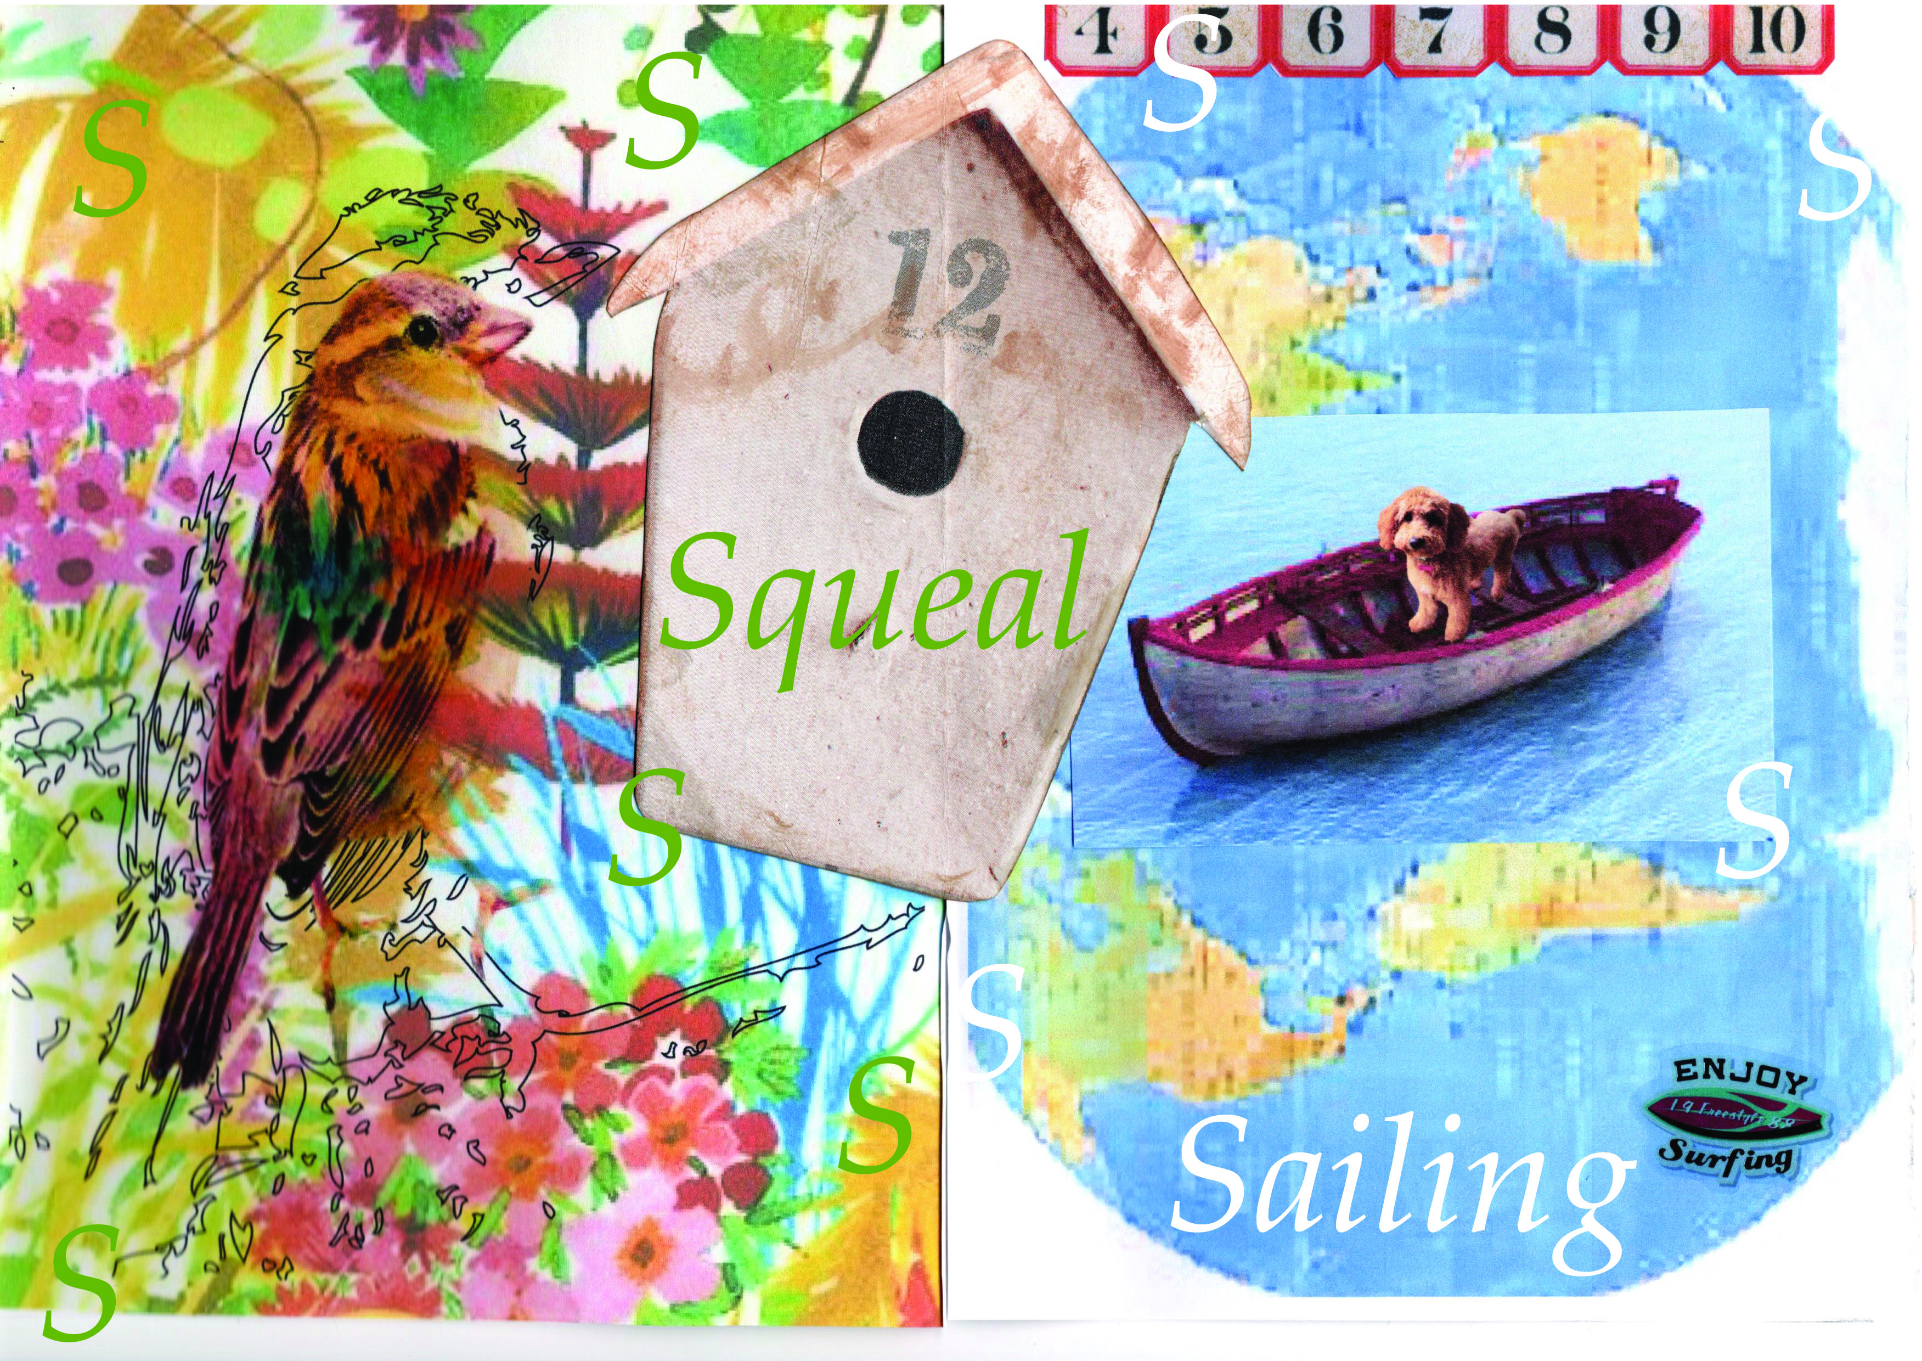
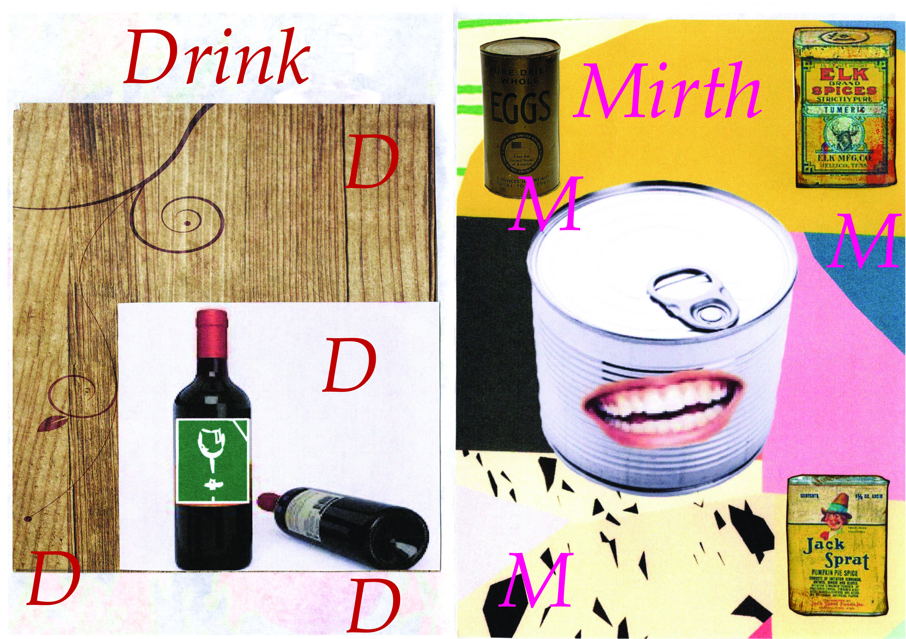
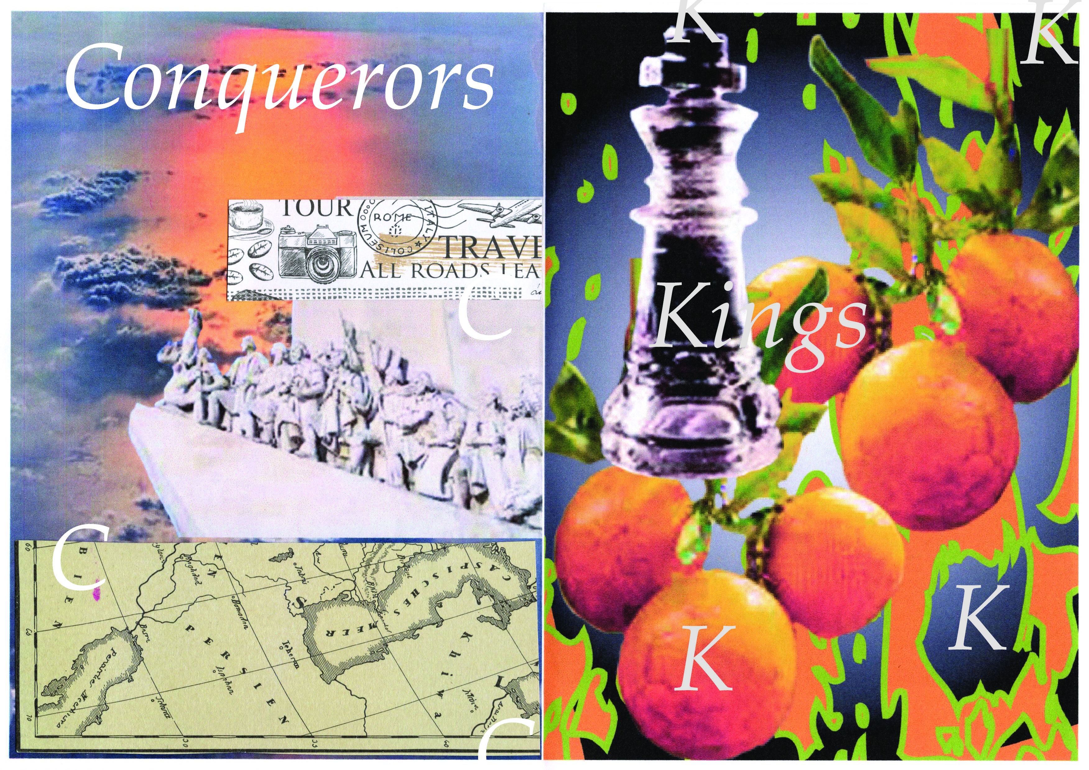
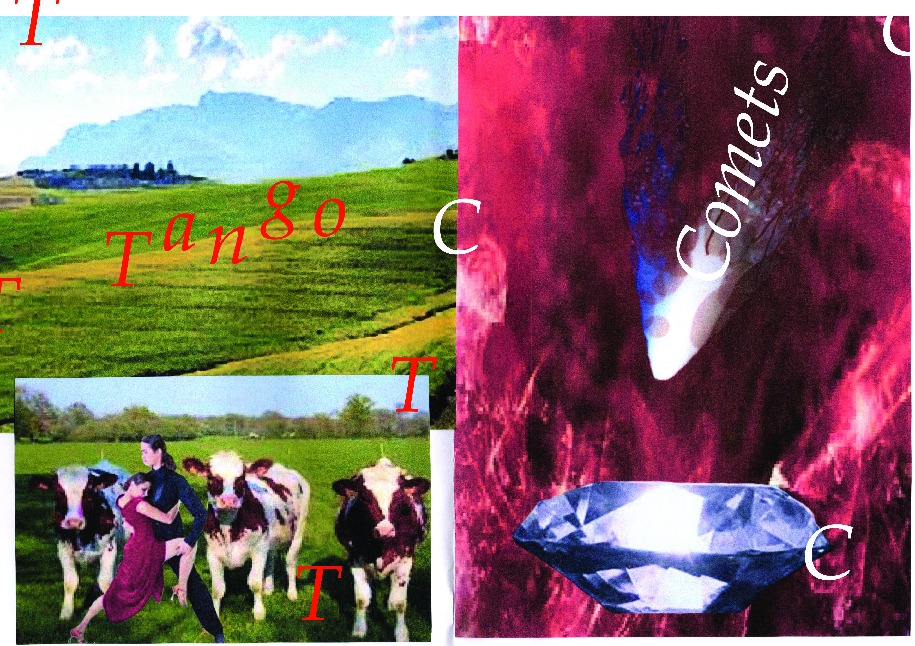
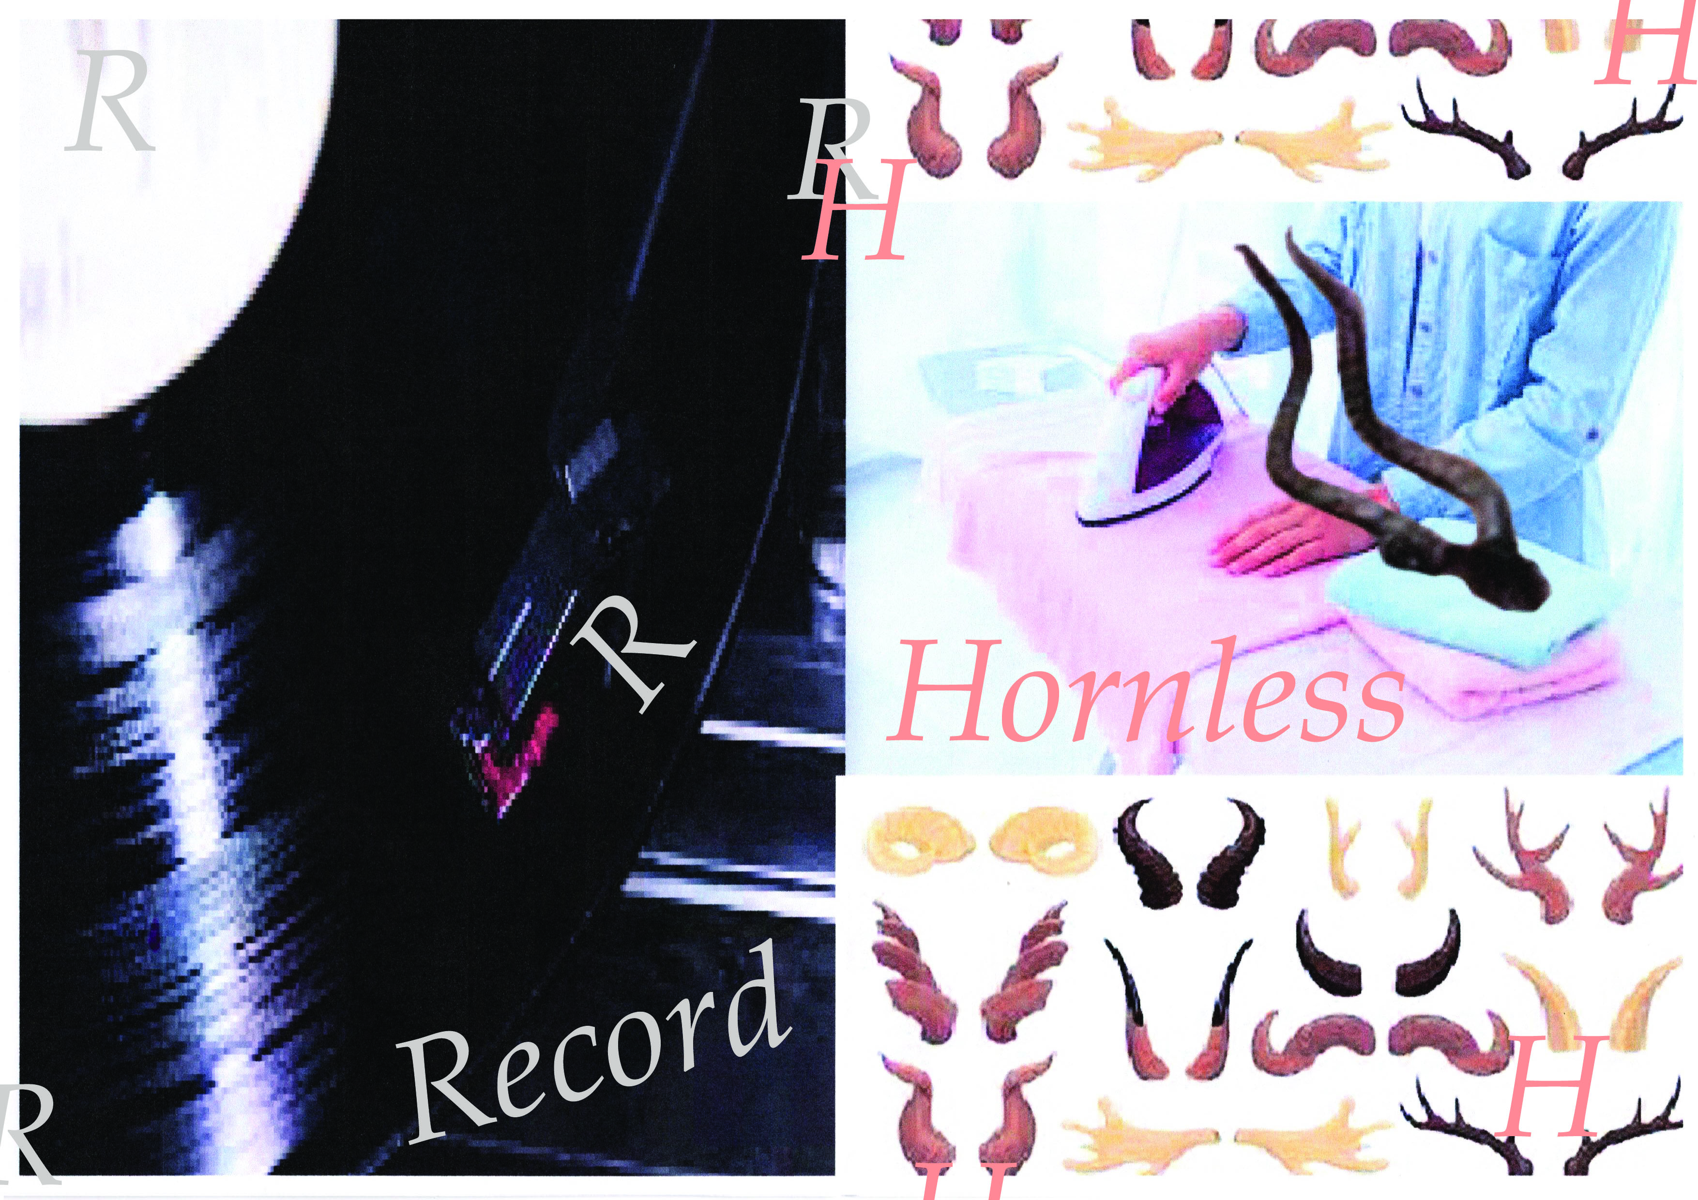
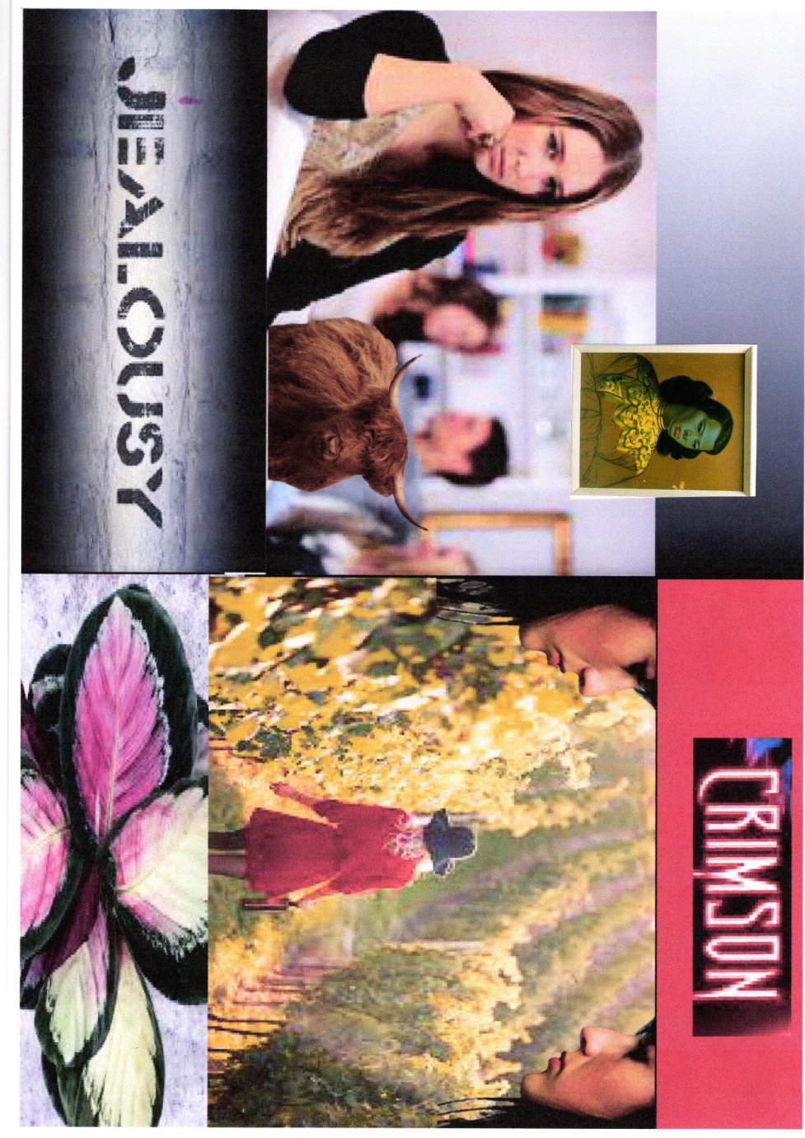
I used the same font as I did for the last exercise so the front covers were the same; I used the concrete poetry example of Mary Ellen Solt, of using the first letter of the descriptive work to add more of the typography to the image design. I did this by using a few of the capital letters in a random pattern, and coming off the page.
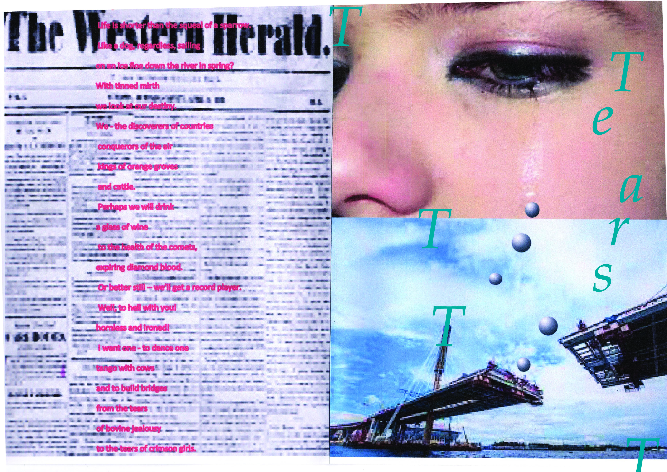
After printing this out on printer paper to check everything was ok, and I was happy with the images and arrangements, I then chose some 300gsm smooth card to print this out onto. I chose a smooth card as I thought this would carry the images better, and the quality of the ink came out stronger and brighter on this card. The card has a good weight and is stiff enough to create a really nice feel to the booklet, and makes it look and feel more luxury and makes it look more professional.
Once I printed these out I used my scoring board to create the professional folds in the booklet, and then folded in unison with each other, as I wanted a crisp finish.
I then used a large needle to put holes into each sheet of the booklet, then used silk corded thread, which is heavy duty and used for book binding, to sew and bind the book together. I used my own way of stitching as I felt this would work best for the style of booklet I chose to use, it fastened the book together better and stronger. See the photos below of how it turned out and the stitching and details used.
