Sequencing images
In this exercise you’re going to create images which you’ll then print onto the papers you collected in the first exercise. You have been working with the poem Tango With Cows in the exercise ‘Concrete Poetry’, to create an experimental text. Using your interpretation of the poem as a starting point, develop a set of images that you can sequence into a narrative. You can choose to create these images yourself or use existing images.
Idea generation Create a series of images which will build a narrative sequence over about 16 pages. Use keywords from the poem as a starting point. Work with images you have created before, developing and changing their contents, or use fresh new ideas and imagery related to the poem. Remind yourself of the creative design process. Explore the sequential narrative over the folds. Produce a folding document (2 sided) with the images you have created. Try one of the folding systems discussed in part two of the course, Form and Function: Paper folding.
Research and development A visual narrative is a way of communicating some form of ‘story’. It may be that you interpret ‘narrative’ in a conventional way, using chronological images of how your identity has changed over time, with a beginning, middle and an end. Or perhaps you’ll work in a less obvious way, exploring how your images can be exploited through abstraction and print processes, using the term ‘narrative’ as a vehicle on which to hang your concept of the poem. The purpose is to interpret the brief to create images that are meaningful to you, plus extend your understanding of image qualities. These images may be paintings, photographs, drawings, film stills – they can be at any scale, in any media and about whatever you want them to be, in the context of exploring the concept of the poem. This is your opportunity to explore some of the features of digital imaging software, such as Photoshop, to layer images, cut out images, experiment with opacity, filters, hue, brightness, contrast and halftone screens, among other things. For example, can we approach text as image? What happens if you ‘rasterize’ text, then begin to manipulate it, in the same way as you would montage image material. Be creative! Explore! Remember you have access to Bridgeman and Oxford art libraries online also, if you want to download images and work in this way, but originating your own images will make the project more personal to you.
I started this exercise off by writing myself a list of things I needed to achieve in this brief, and in what order, basically my creative process.
I also wrote down again the poem Tango with Cows, and also printed this off so I could highlight the words or sentences that I thought summed up the poem.

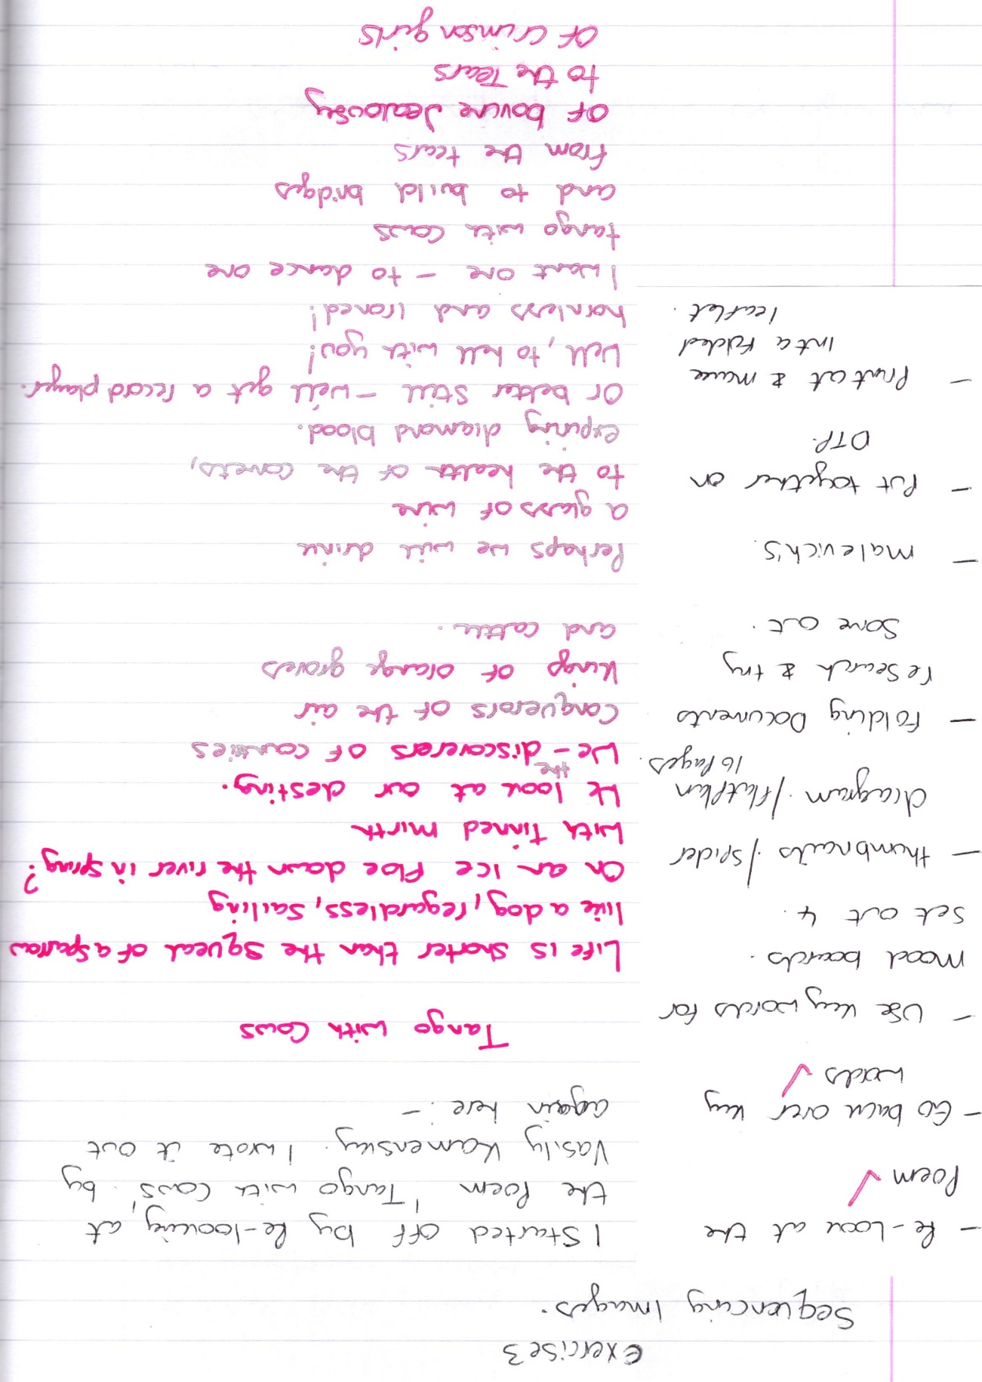

Unfortunately you cannot see the highlighted words from the scan of the sketchbook below!
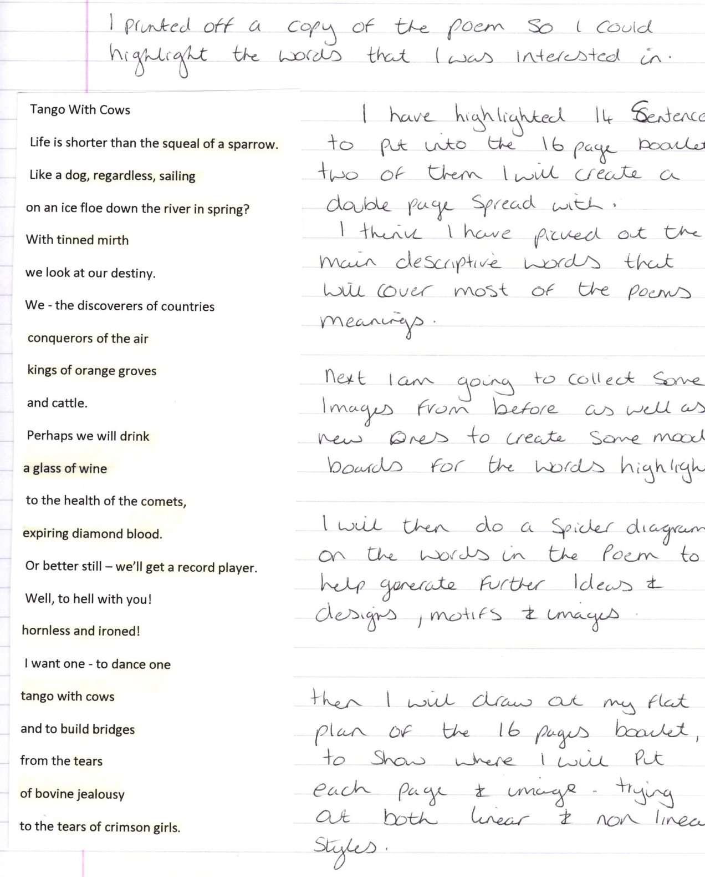
So I have written the words below:-
Squeal of a sparrow
Dog regardless sailing
River in spring
Tinned mirth
Conquerors of air
Kings of orange groves
Drink a glass of wine
Comets expiring diamond blood
We’ll get a record player
Hornless and ironed
Dance one tango with cows
Build bridges
Tears of bovine jealousy
Tears of crimson girls

I then created three mood boards based on the visual words above, most of them are quite literal, but I can use these in amore create way once in the booklet.
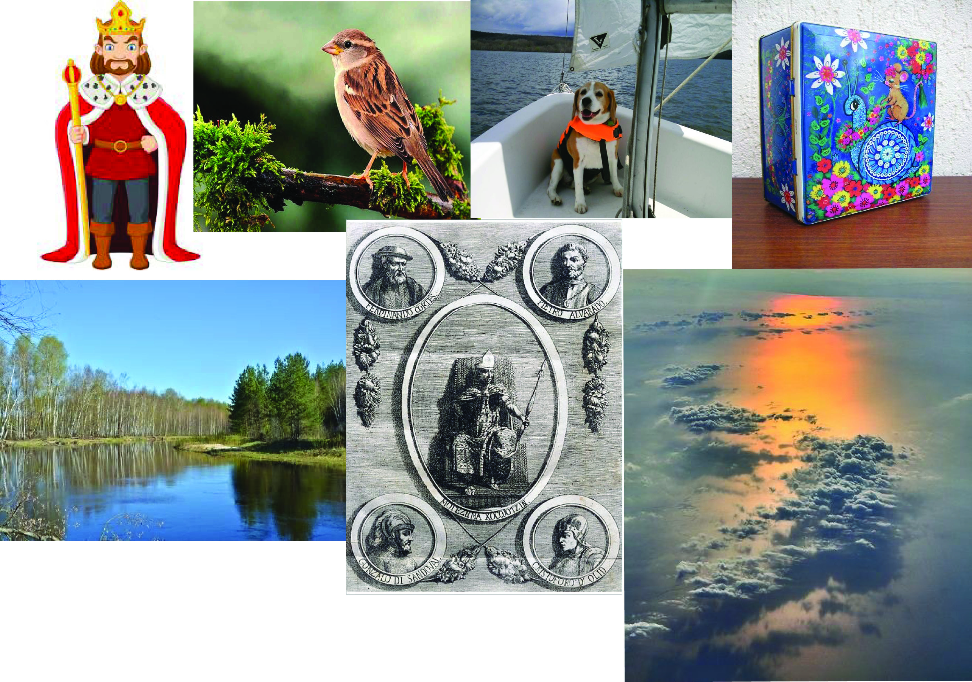
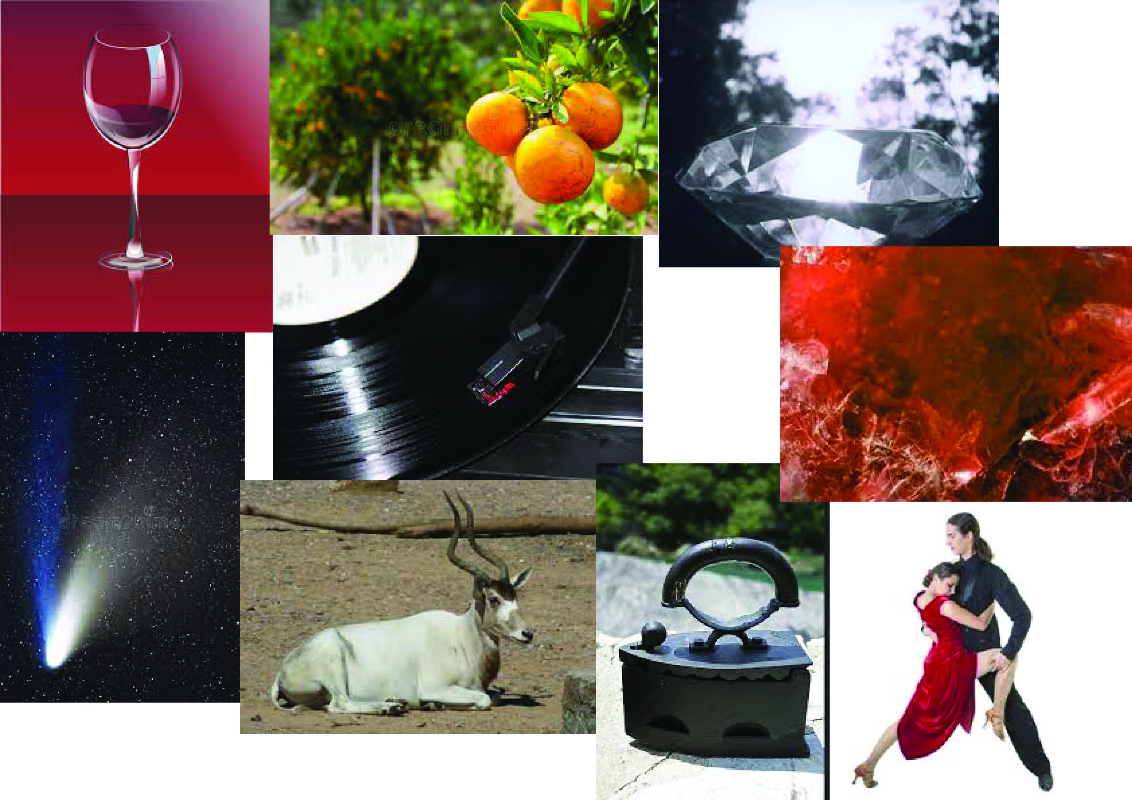
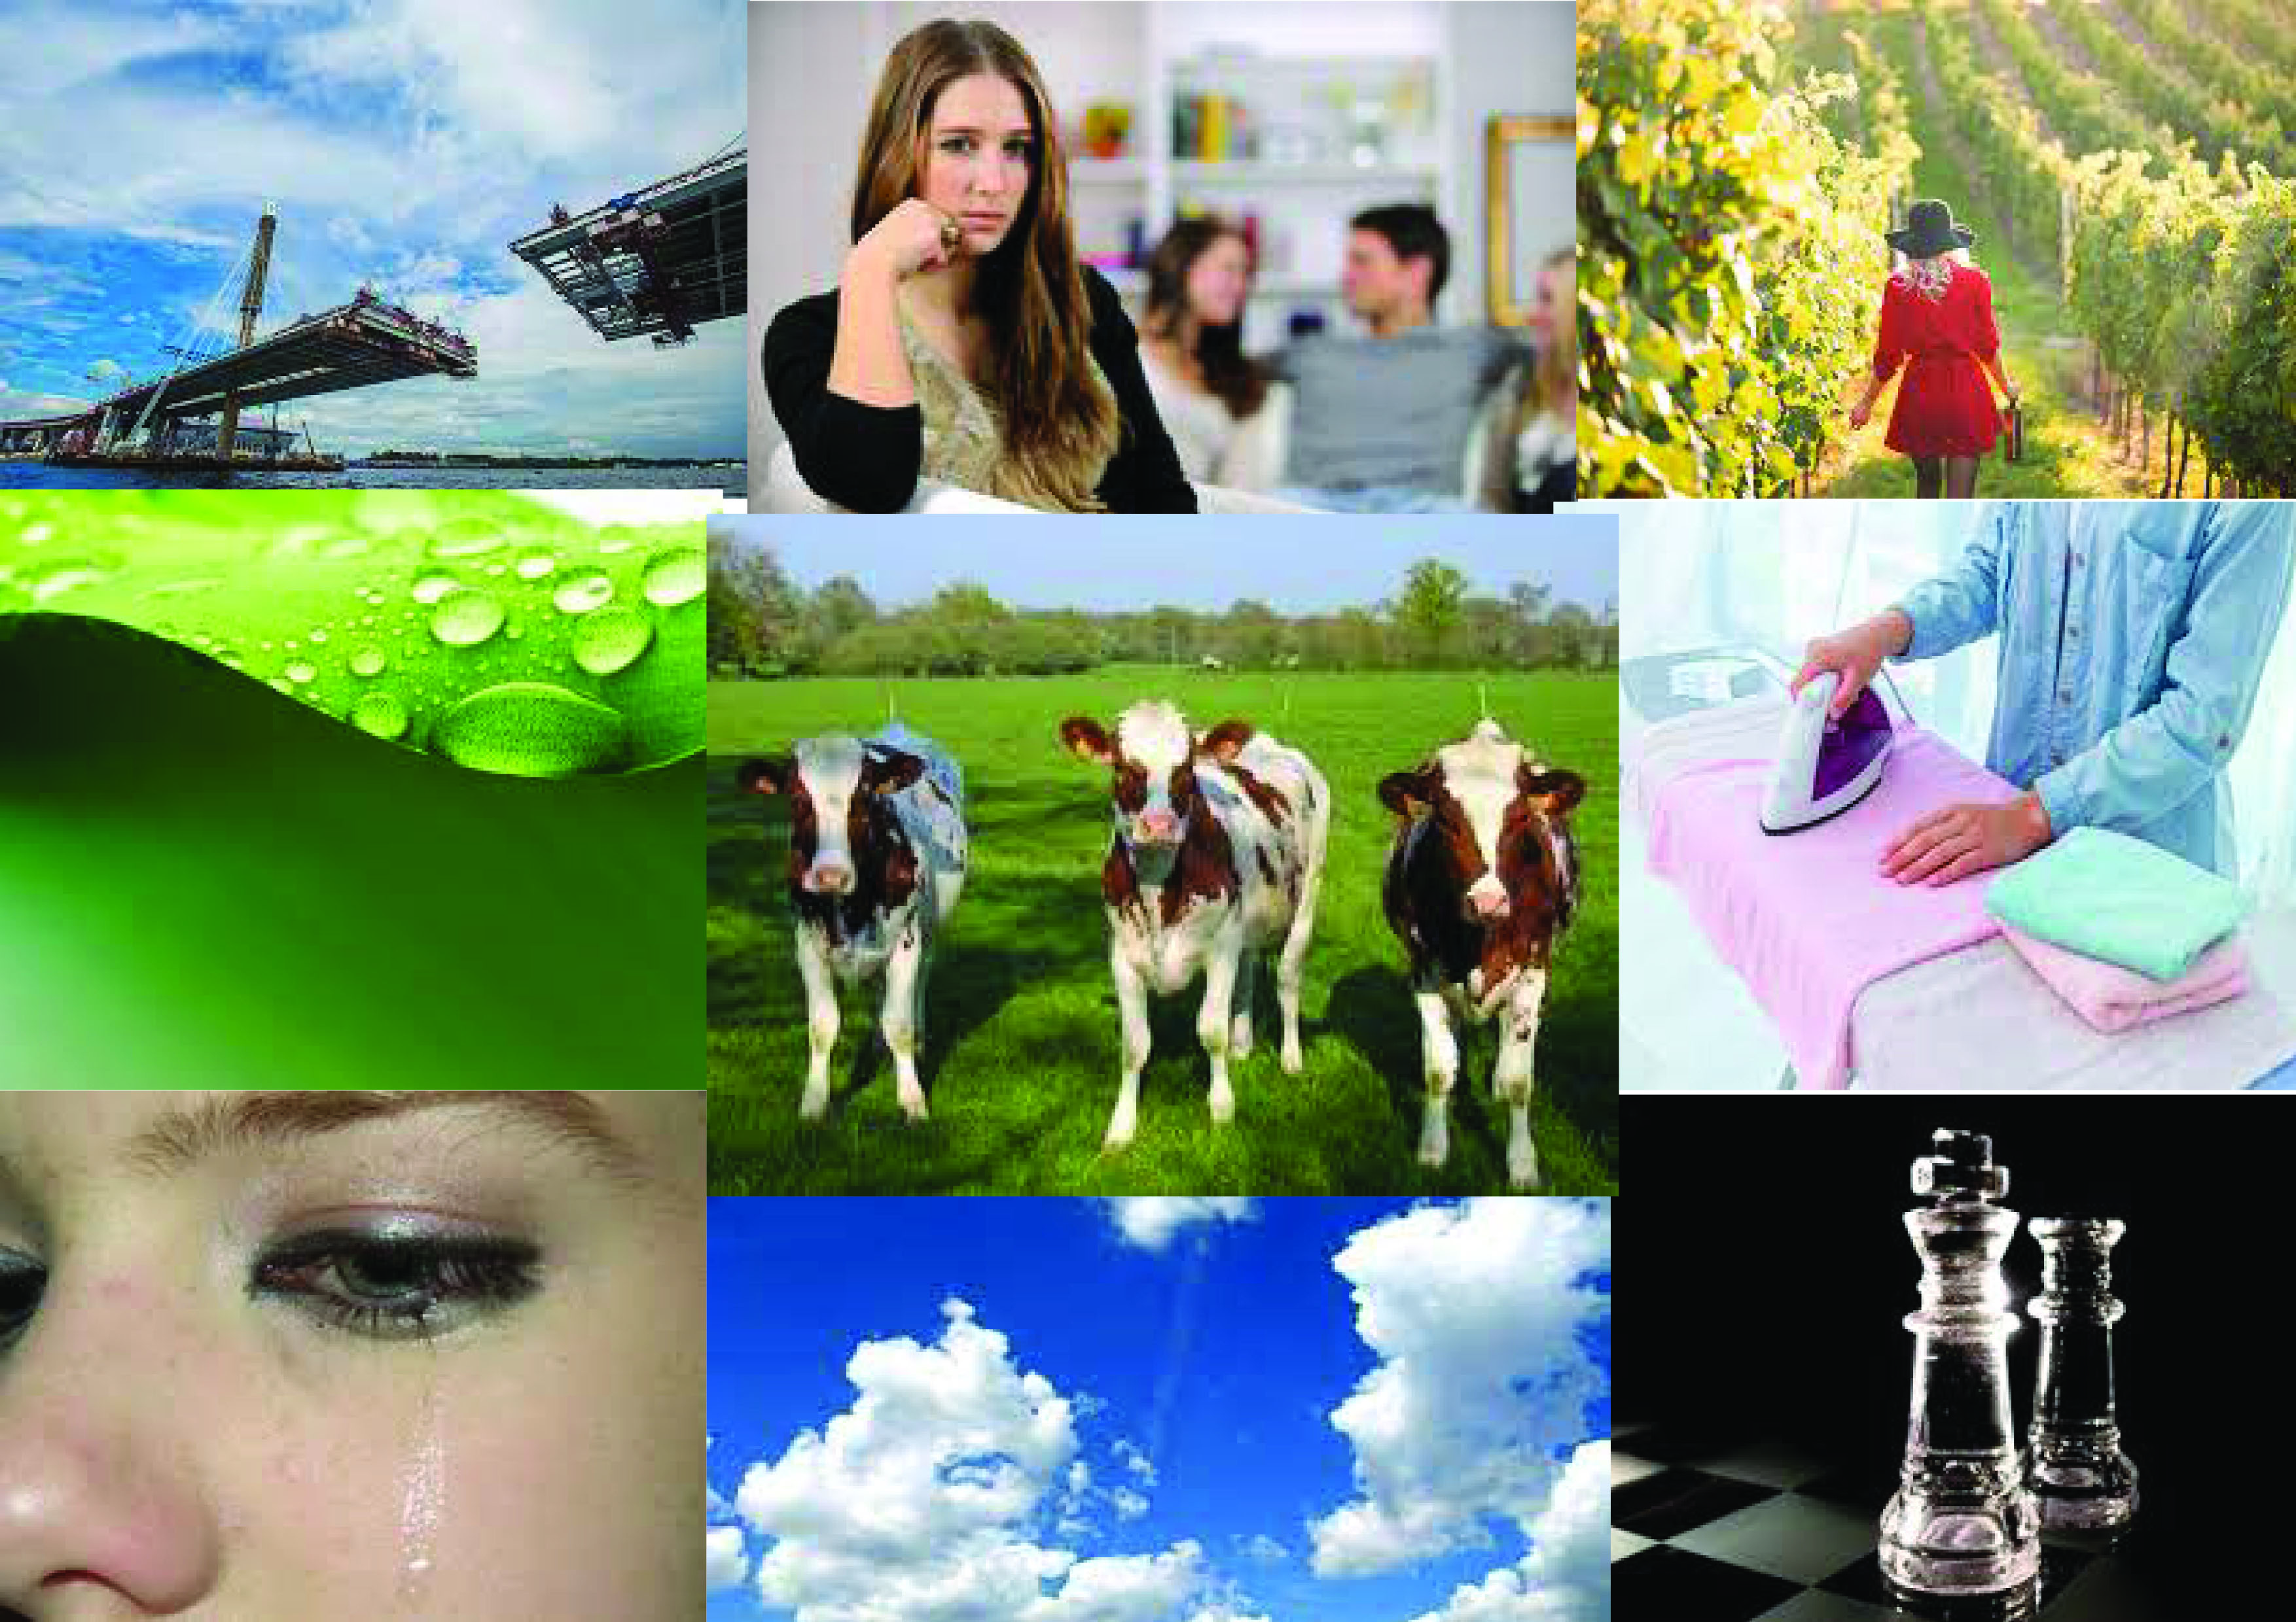
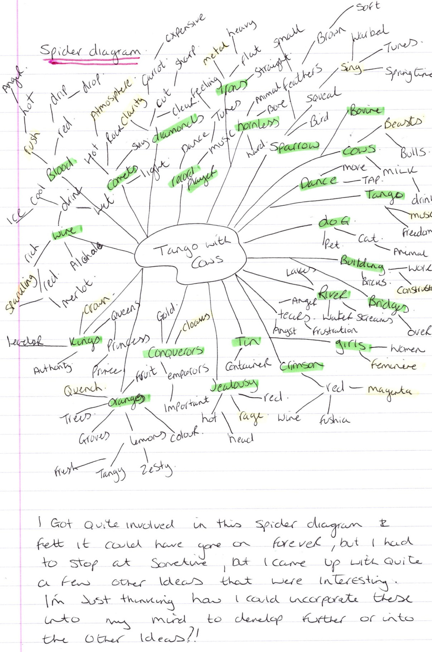

I then started working on my flat plan for the 16 pages booklet.
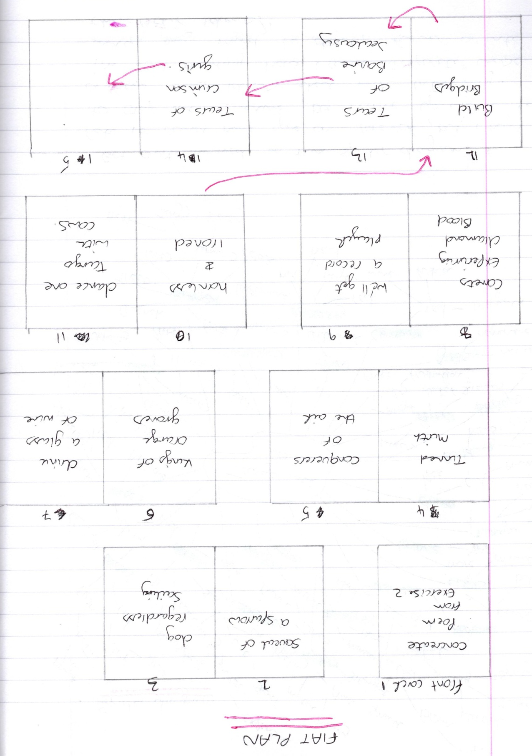
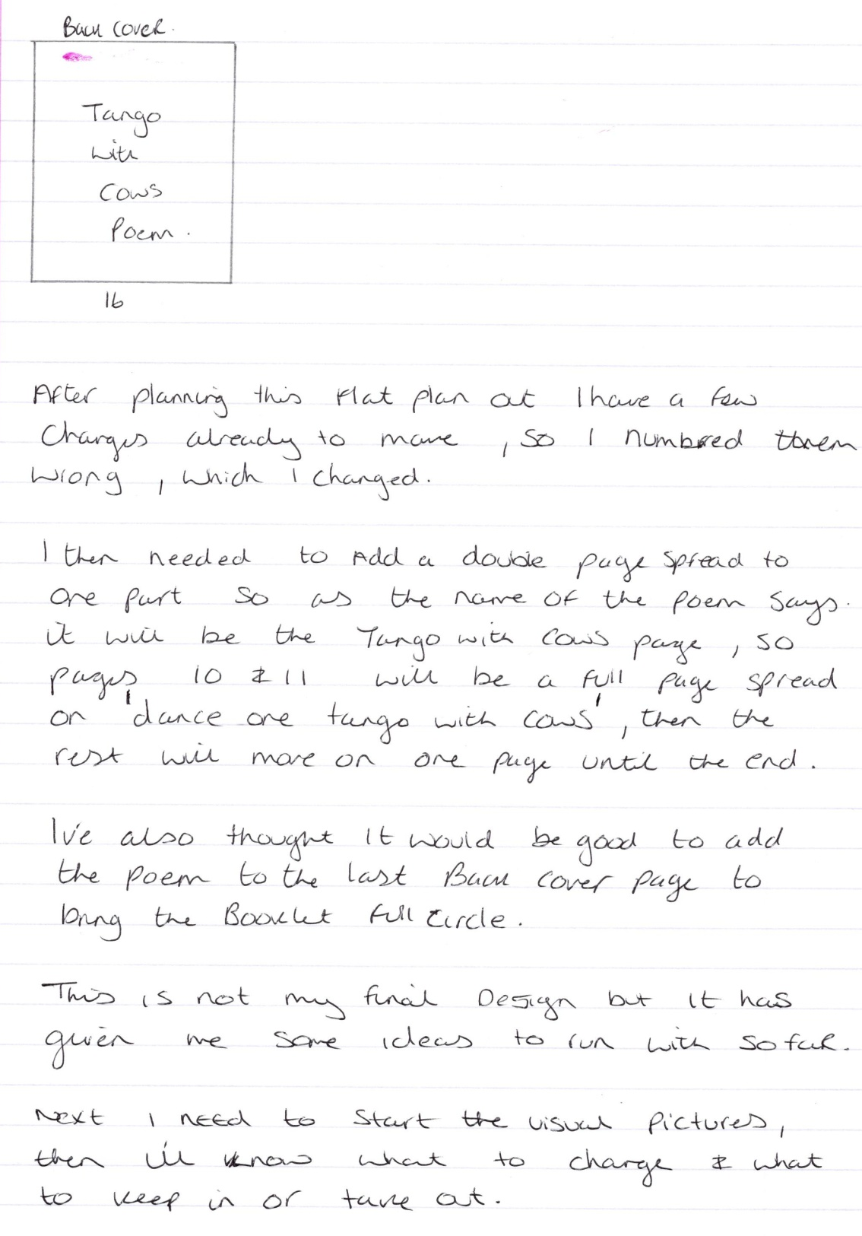

I then started to work on the thumbnail designs, I used the photos from my mood boards for inspiration, these will just start me off to get the visual look I am after, but they will be changed to a more abstract style through the annotation process.
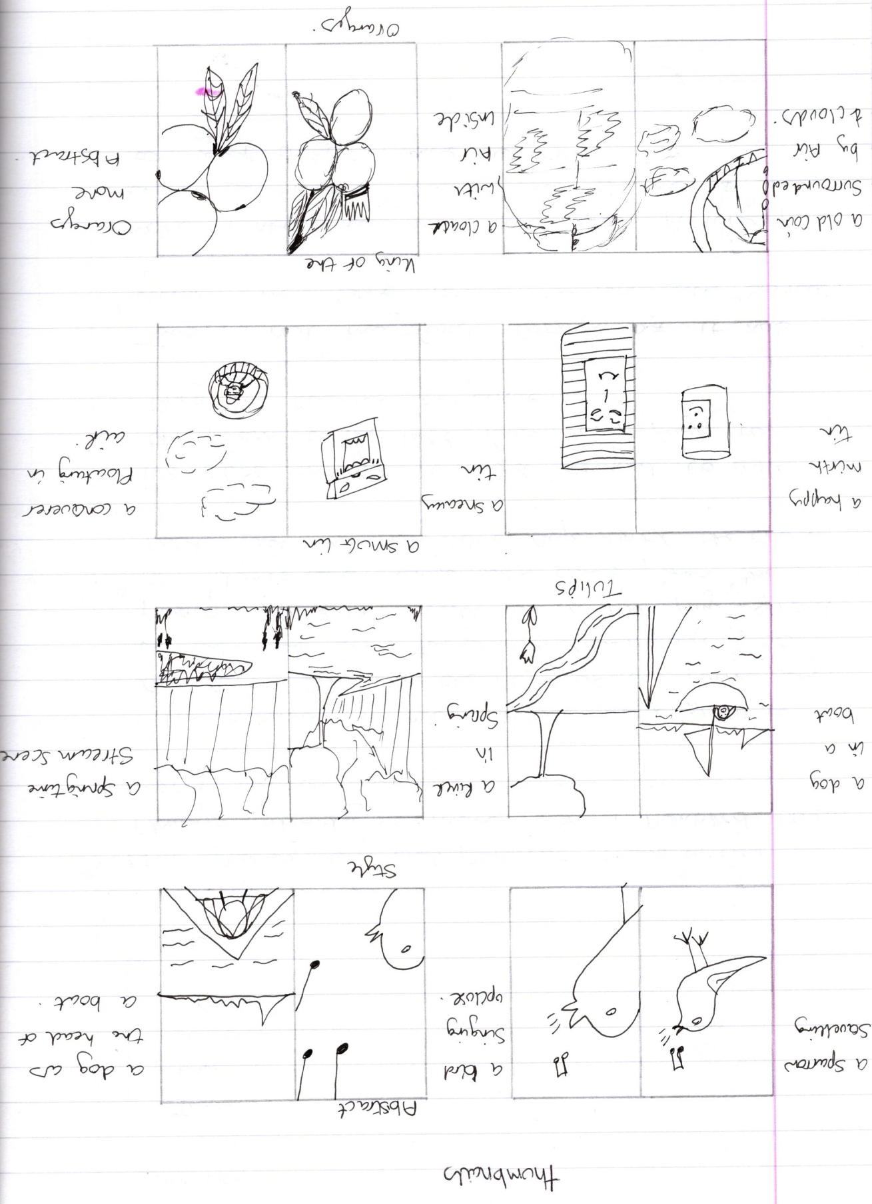
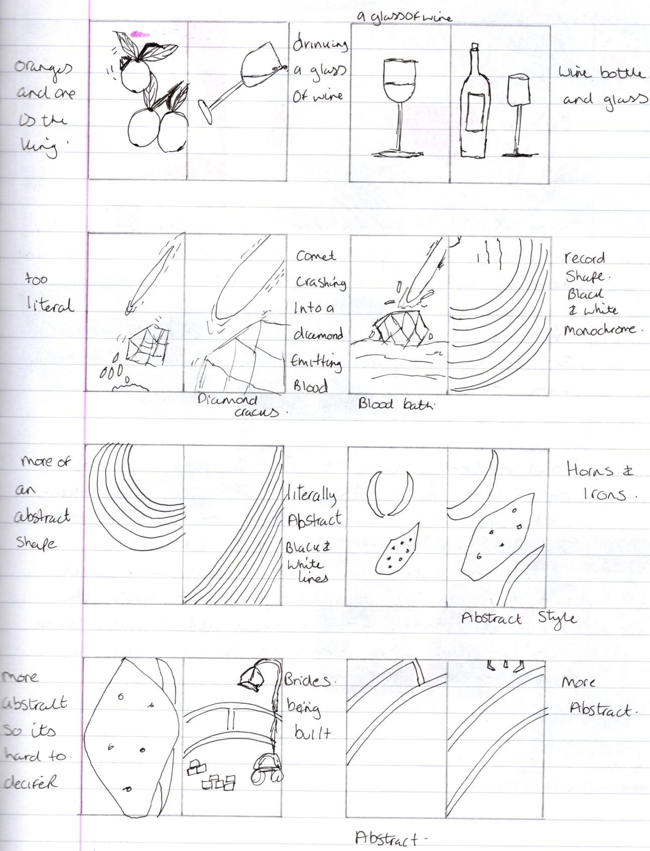
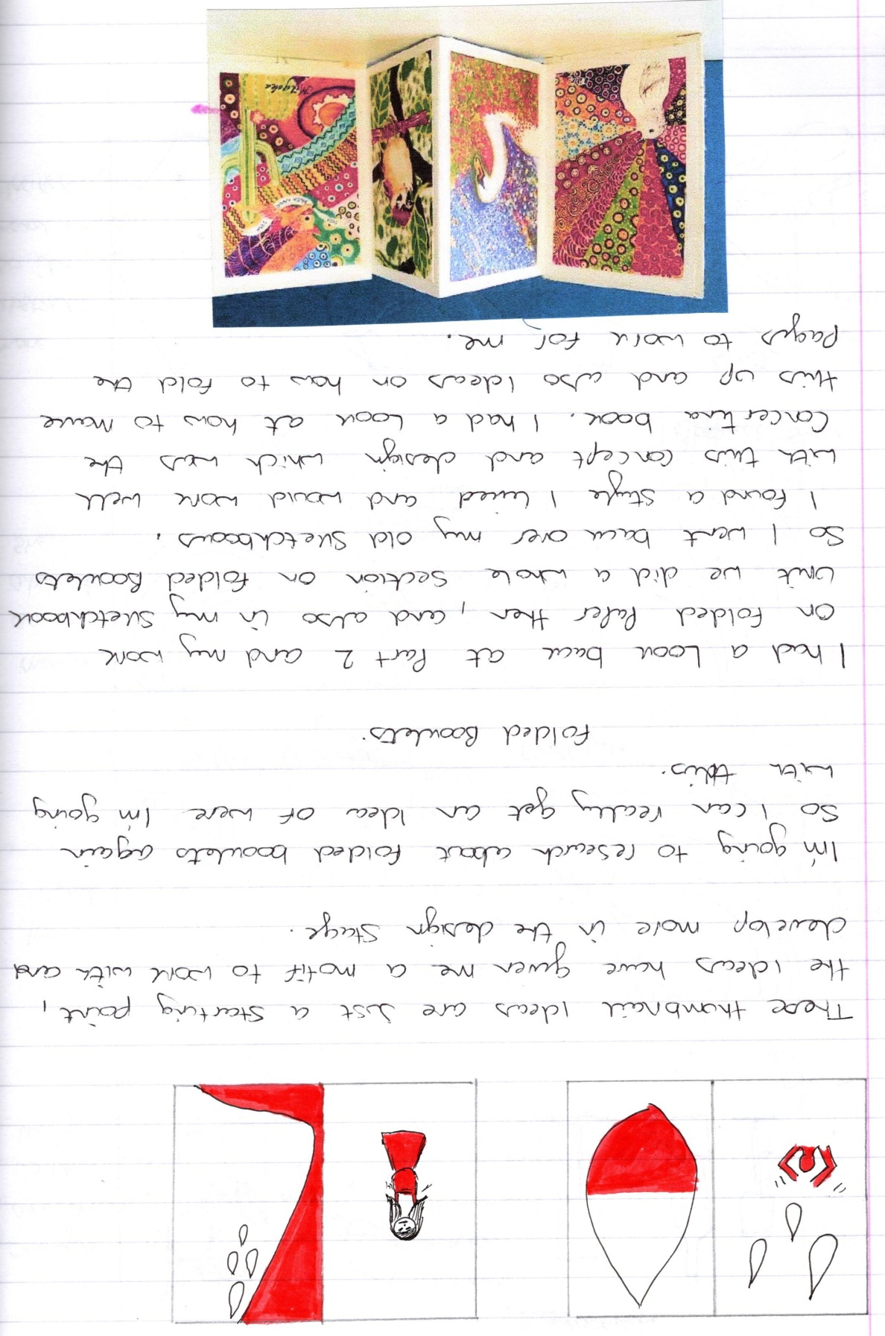
I then started to research about folded paper and booklets, I looked back at part two and the folded paper exercises, also I looked back through my Sketchbook unit as we did a whole section on folded booklets.
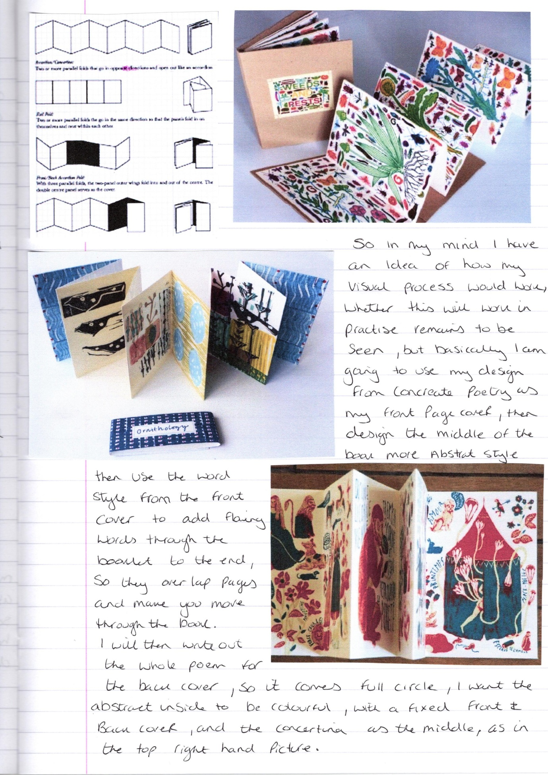
The next stage was to start the designing process on DTP, as stated before I will use the pictures as my starting point for the visual process and work through and change them in the annotation process.
Just before I started the designing, I made up a folded concertina booklet with 16 pages, but I realised I would have to change the pages slightly, and not have the hard cover front and back. I will draw out a new flat plan to work with this new concertina front and back booklet, and start the process again from there.
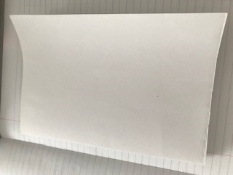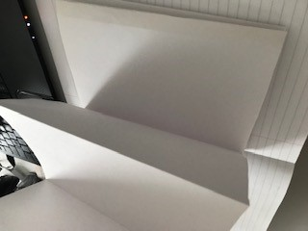

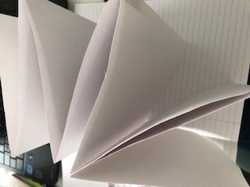
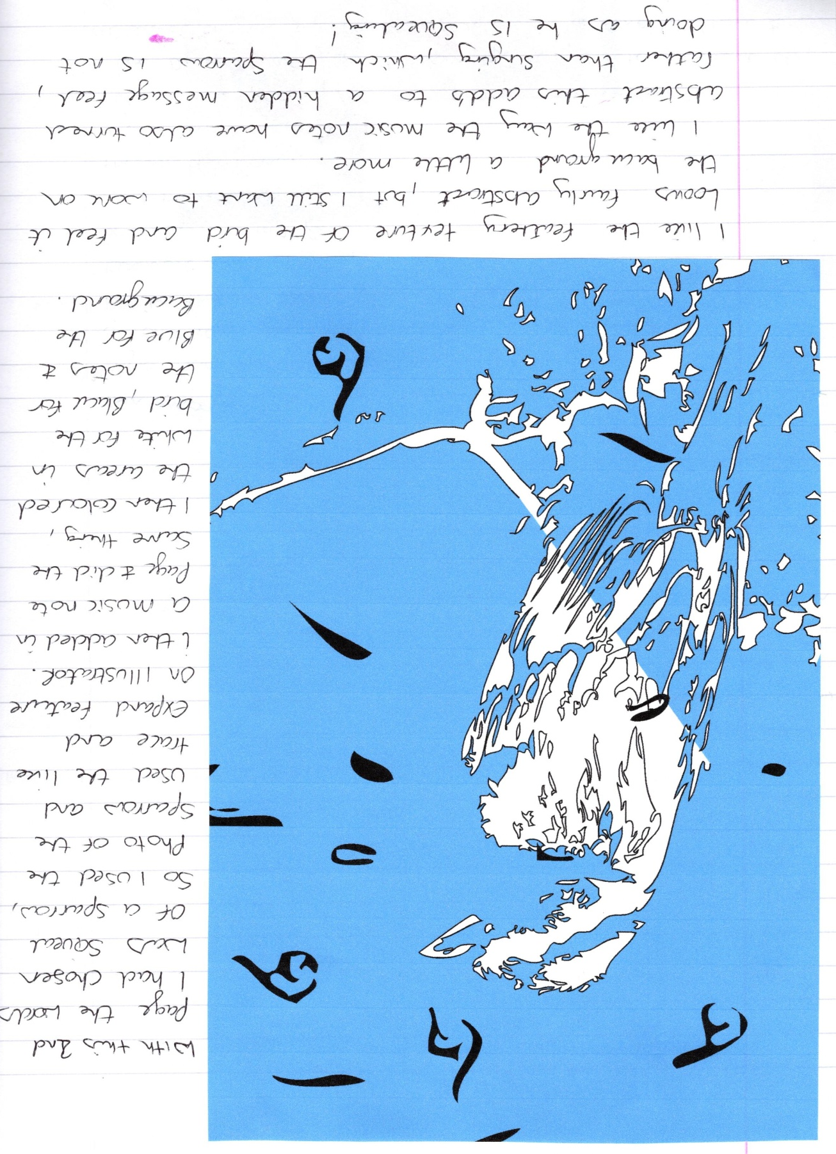
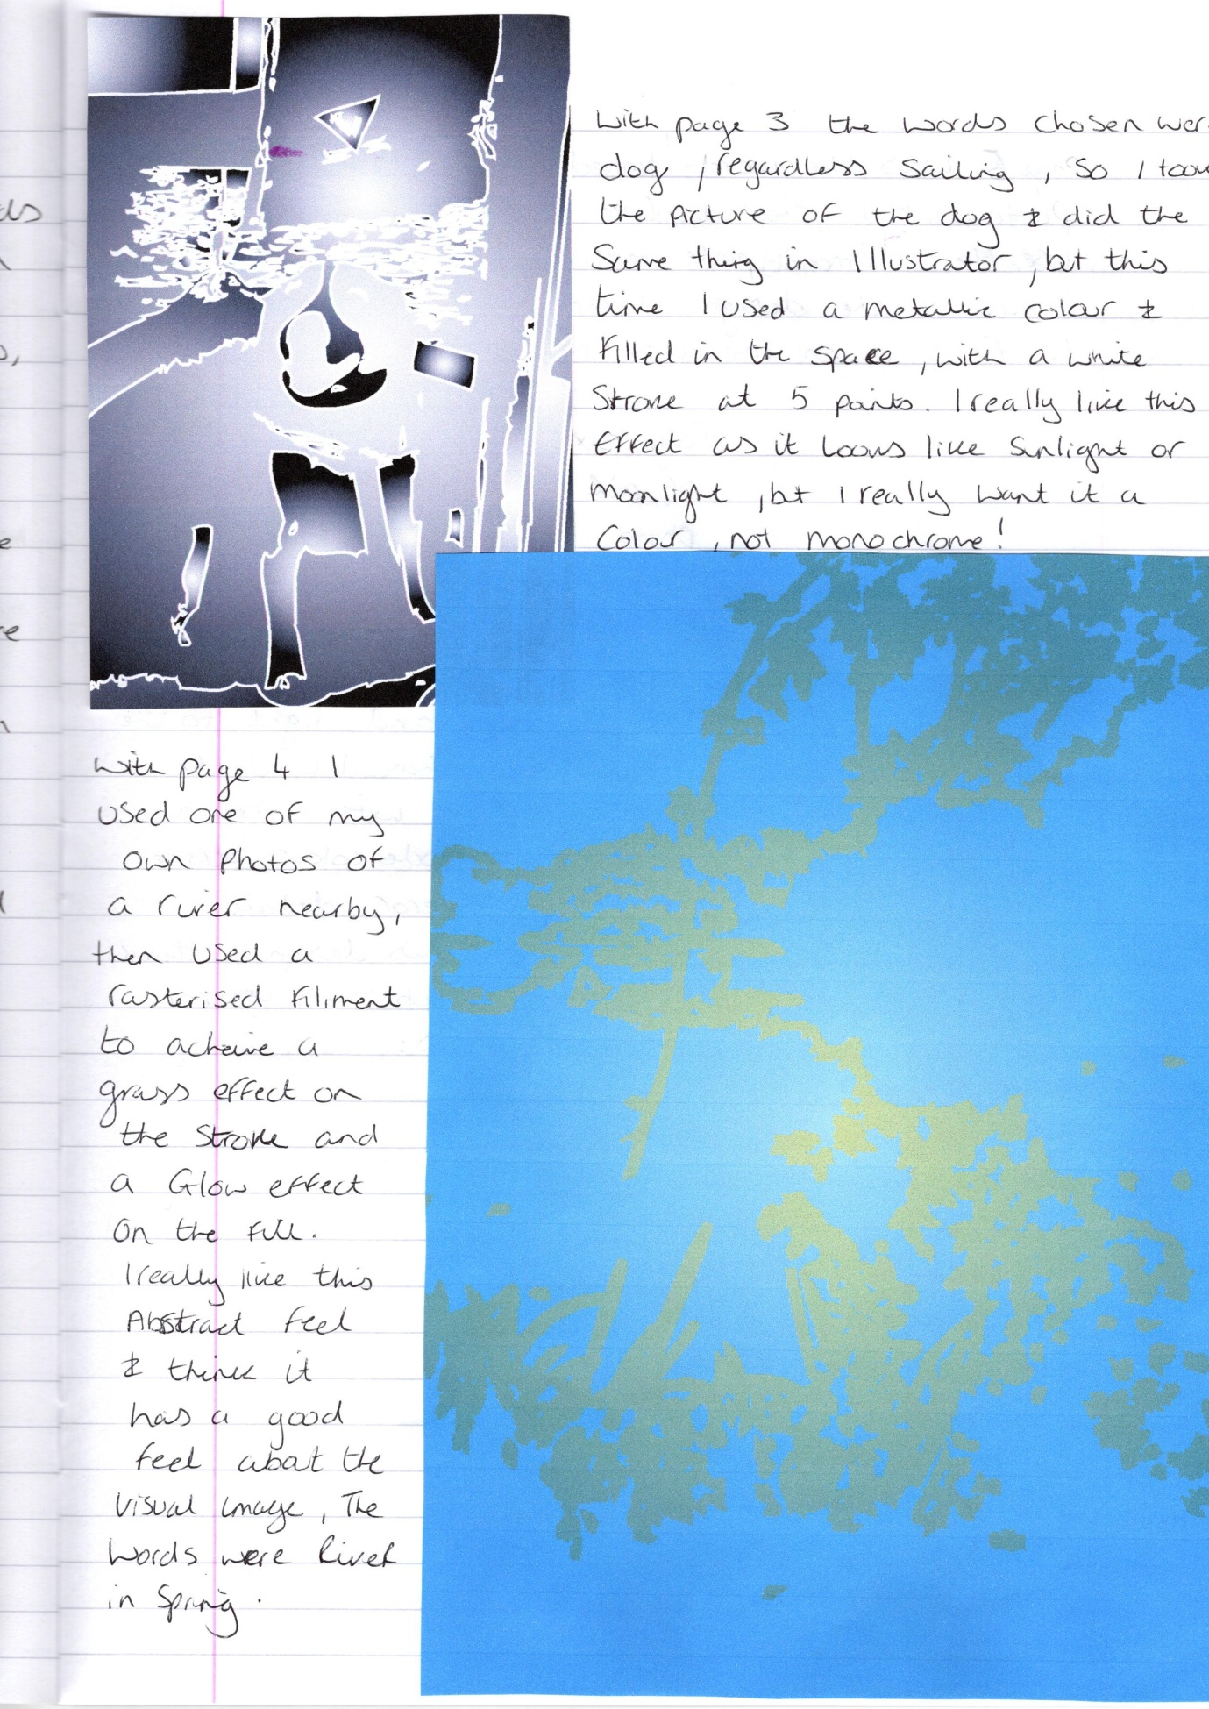
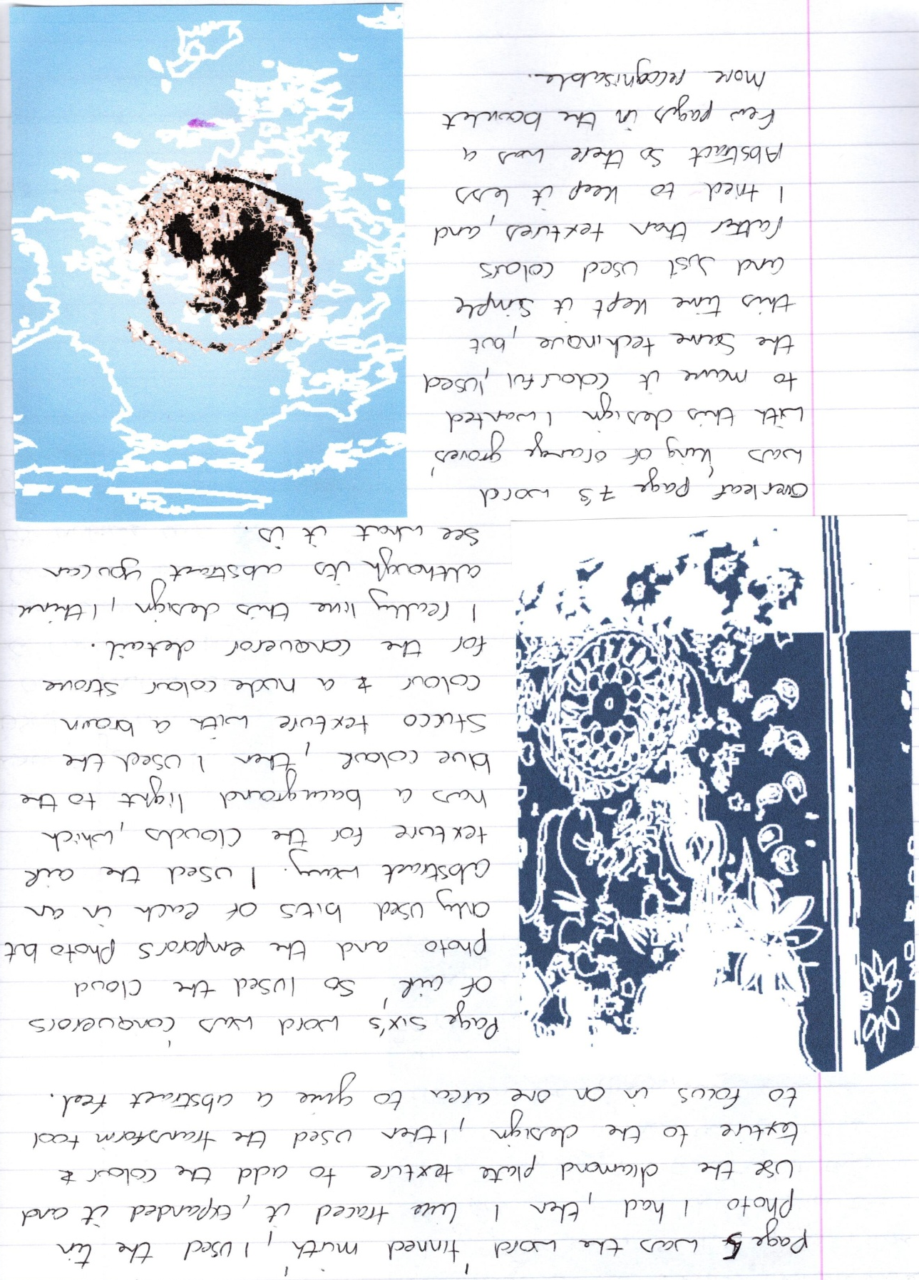
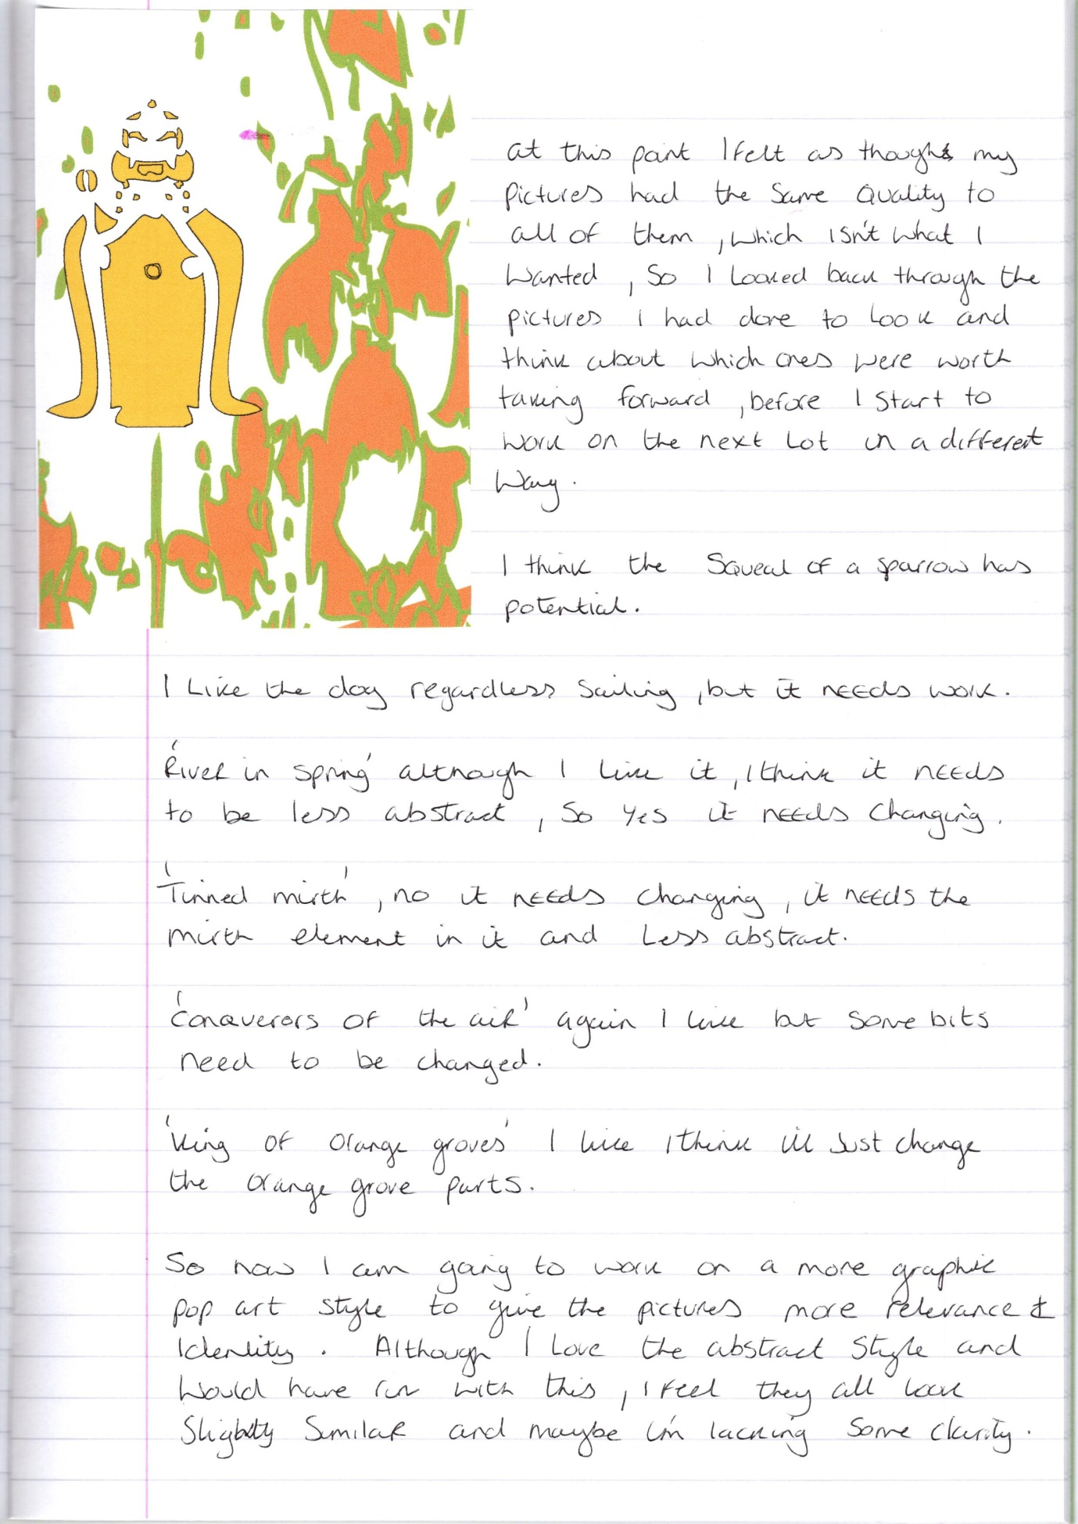
So I then started to work in a more graphic pop art style to give more impact and more identity to the visual image of the booklet. I changed the images more and added parts of the photograph’s in with the images I made, then I wrote some annotations of what I wanted to change next.
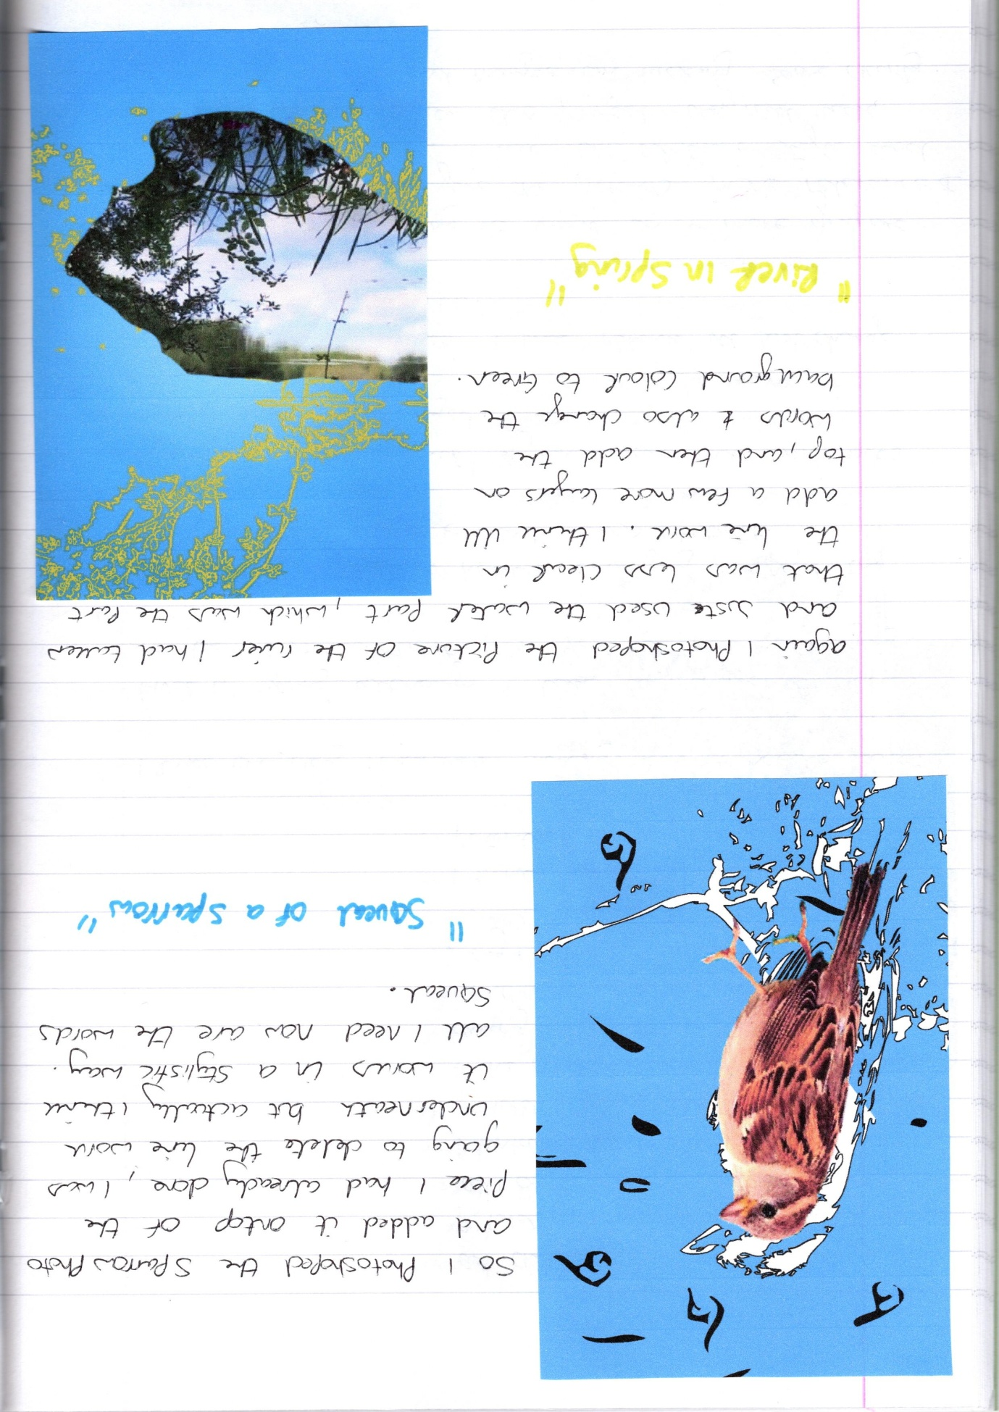
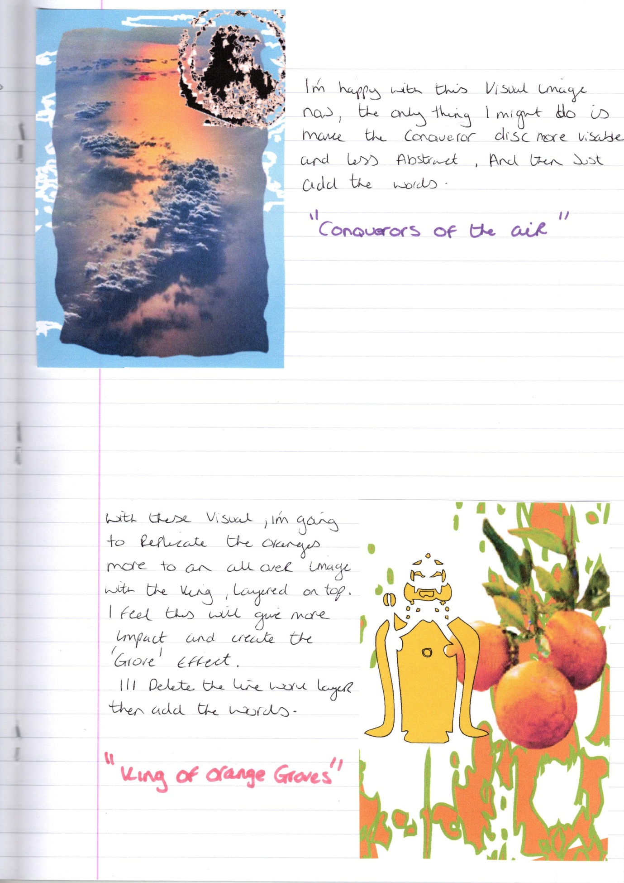

After a bit of a break for the bank holiday weekend I was not happy with the first four images, I feel as though I was trying too hard to make them interesting, when I should just be making them literally. So I have decided to carry on with the other 10 designs, then come back to these four and see how I feel about them then, or change them appropriately before finishing this exercise.
I also read forward onto the next exercise and realised that it was about changing or picking the best designs for that, so I will carry on as I was doing with the next 10 designs, then we can annotate and change them in the next exercise.
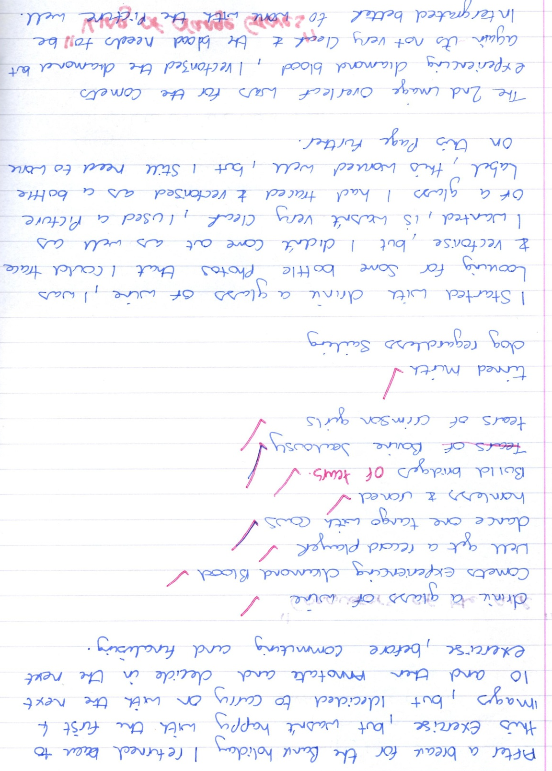
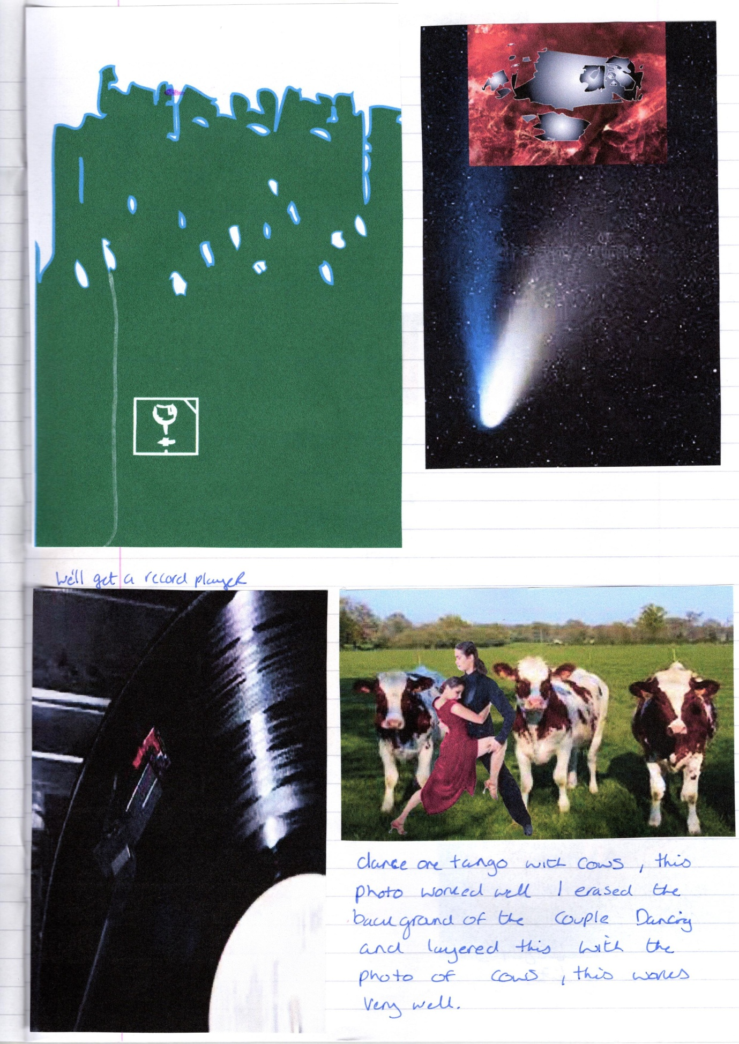
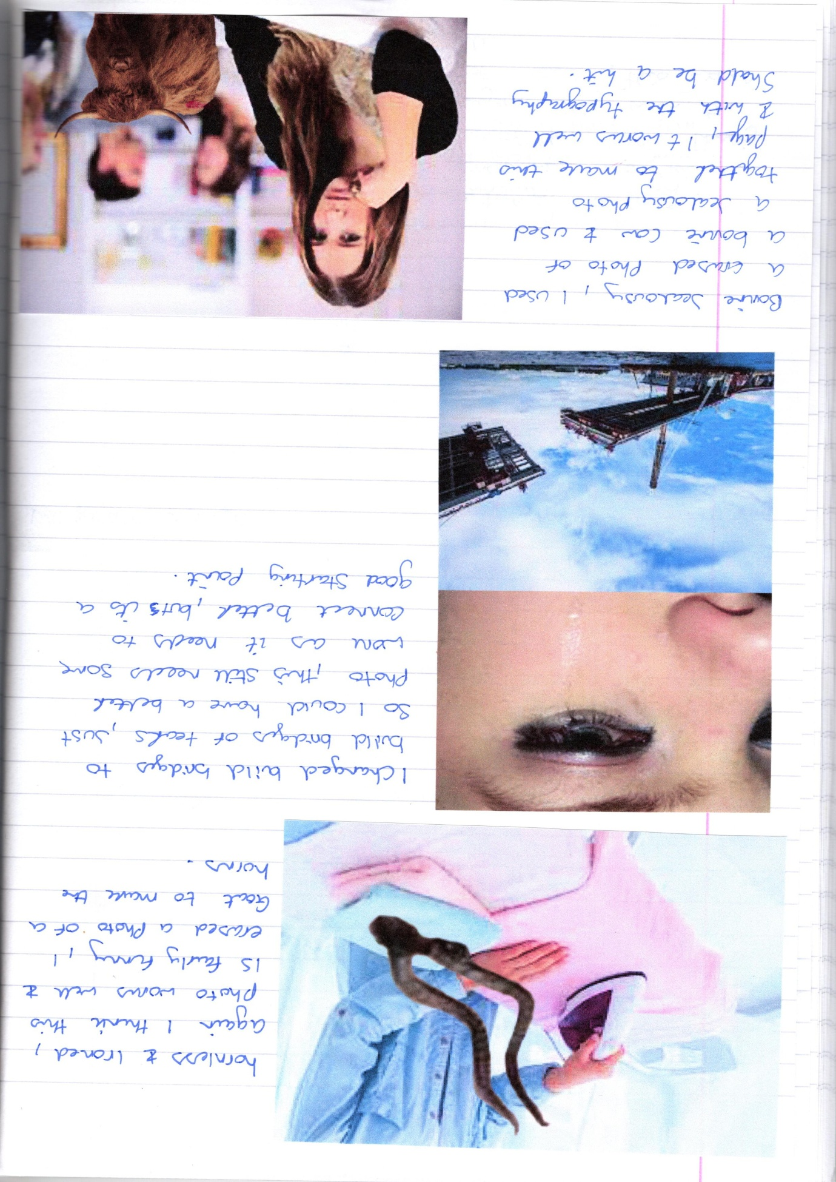
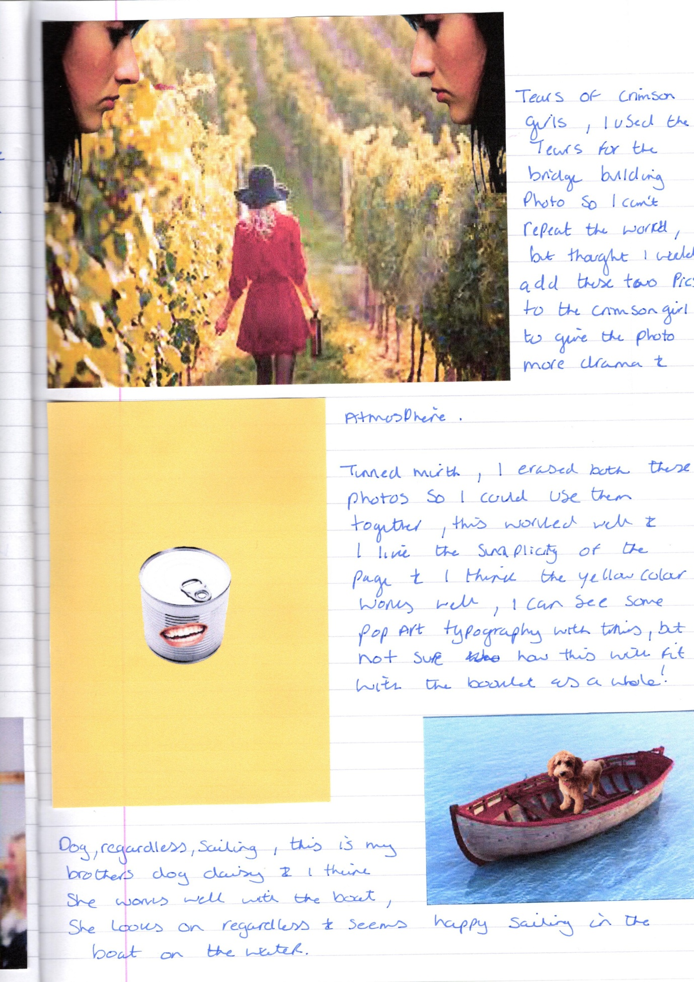
So after working on the 10 pages again, some I like and some still need some work to do, but I’ll list the images below in a sequence so you can see where I am going with this. The first four images as I’ve said before will need more work on them, but I think working through all 14 of the images, I have found a style that is working for me know.
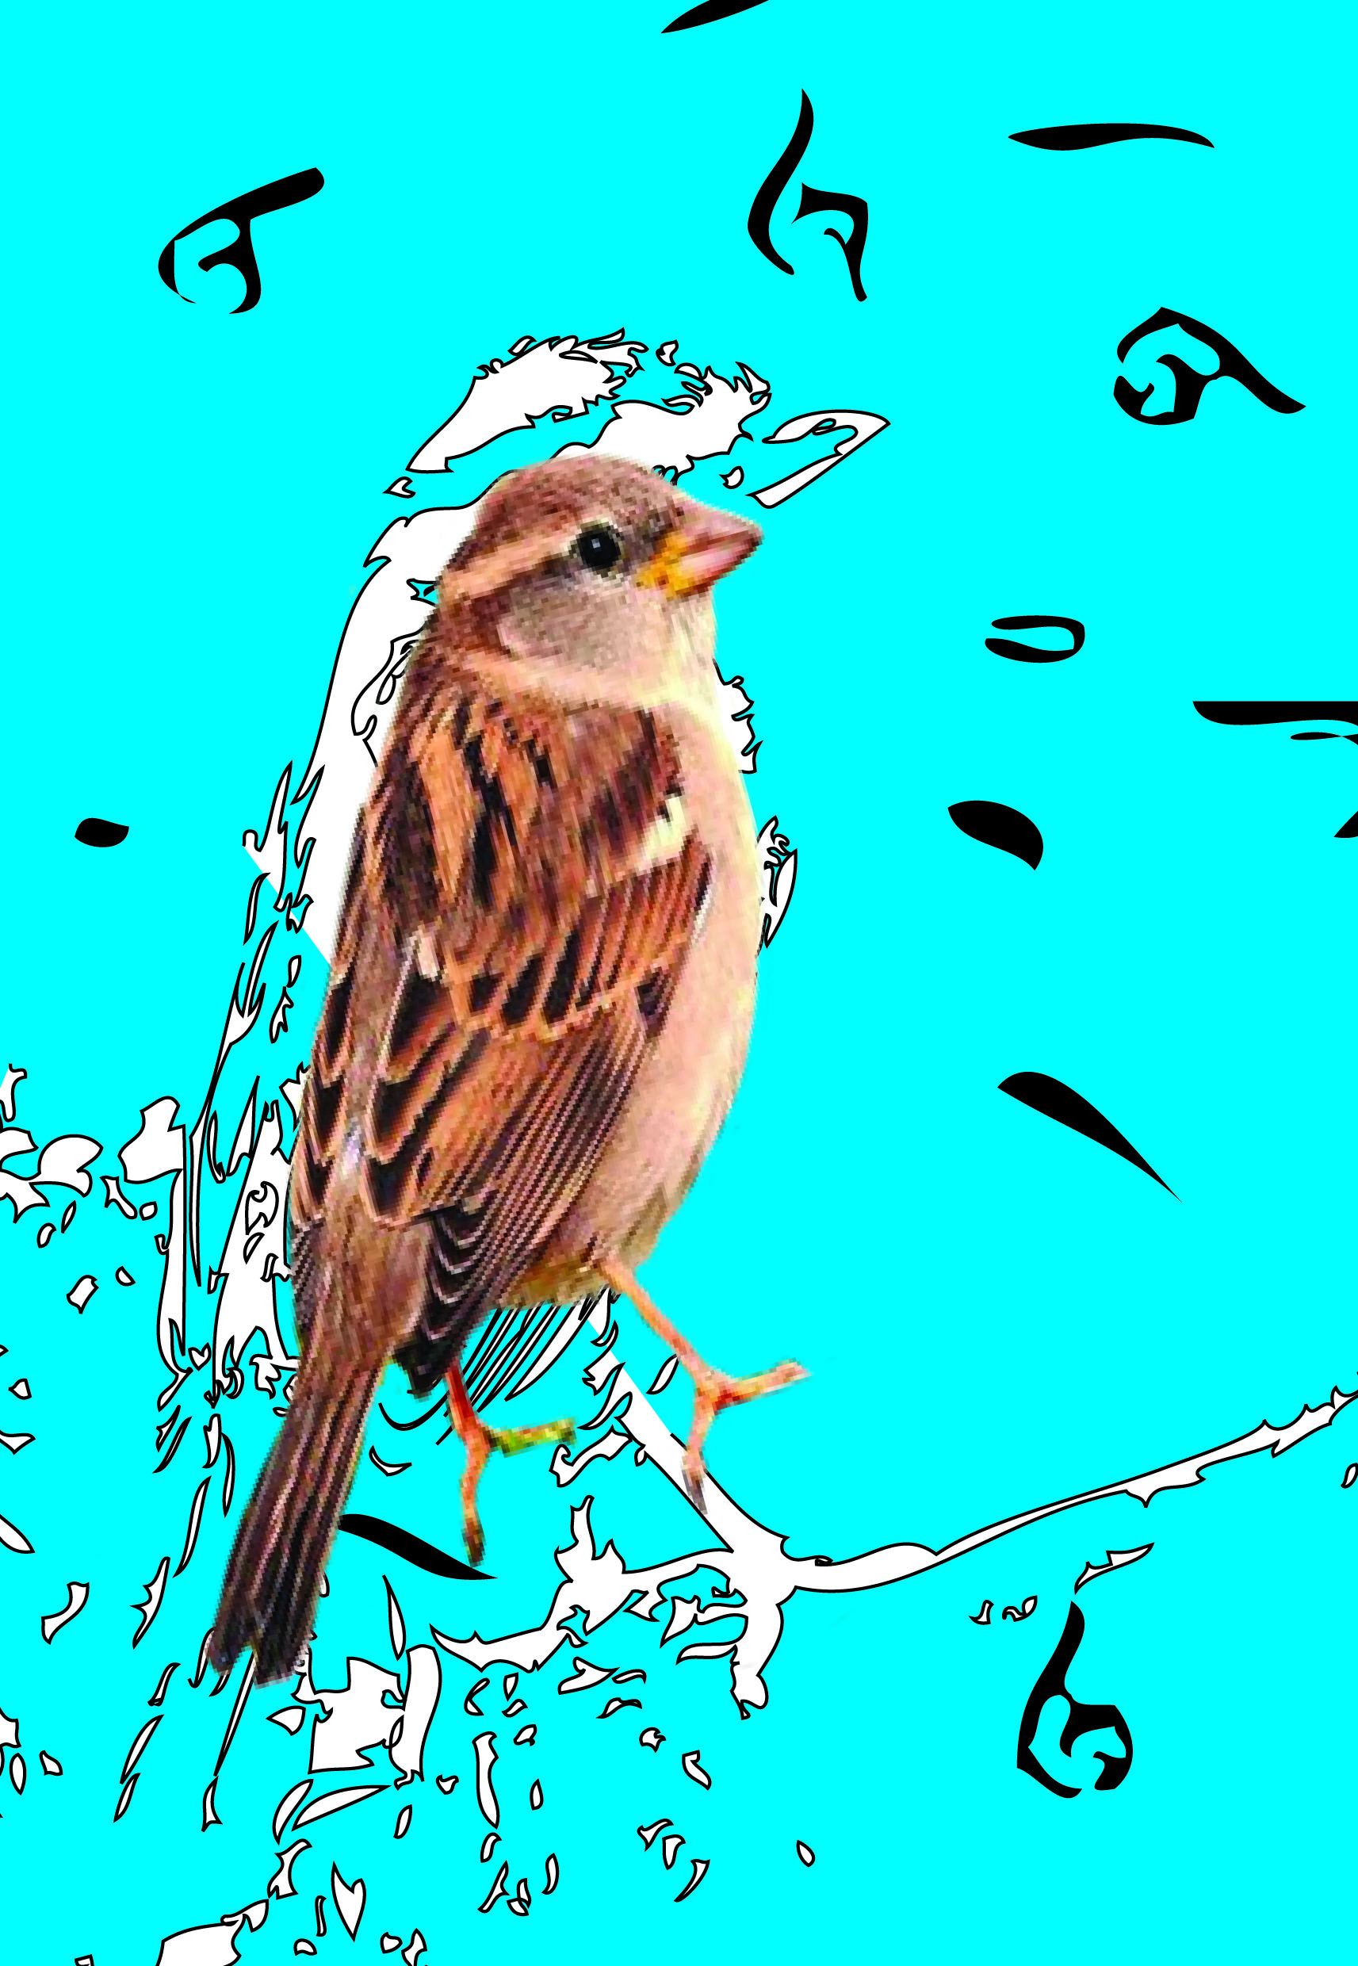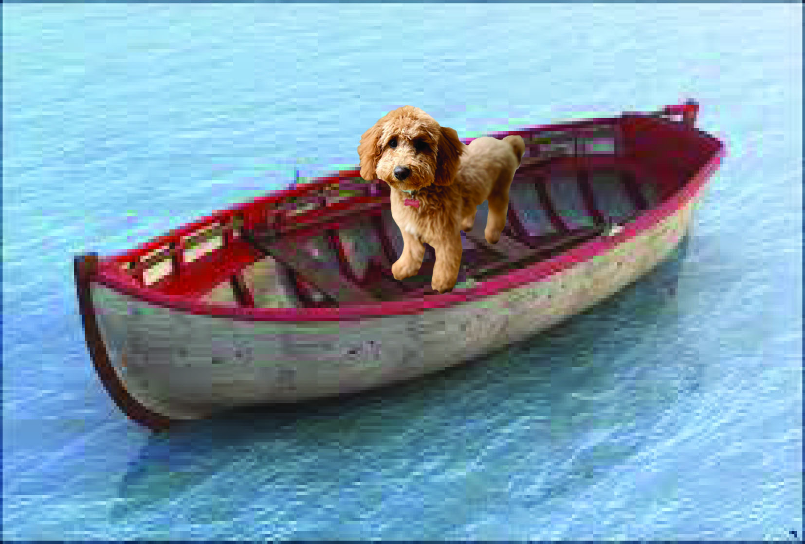
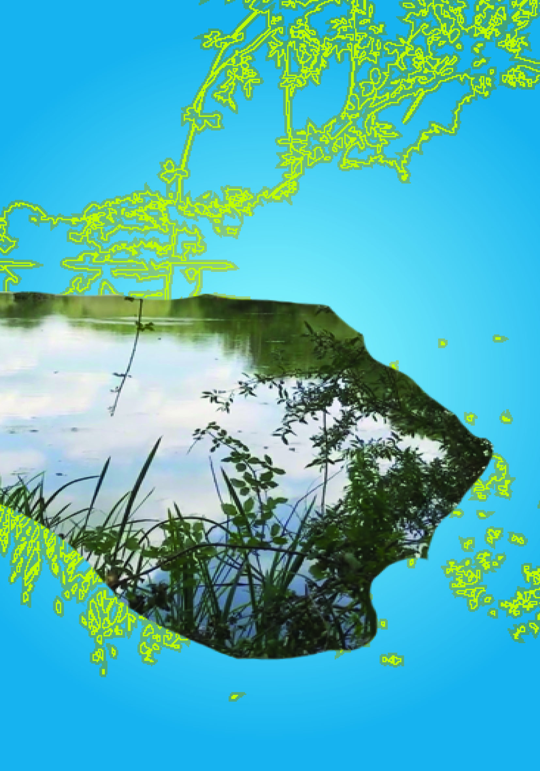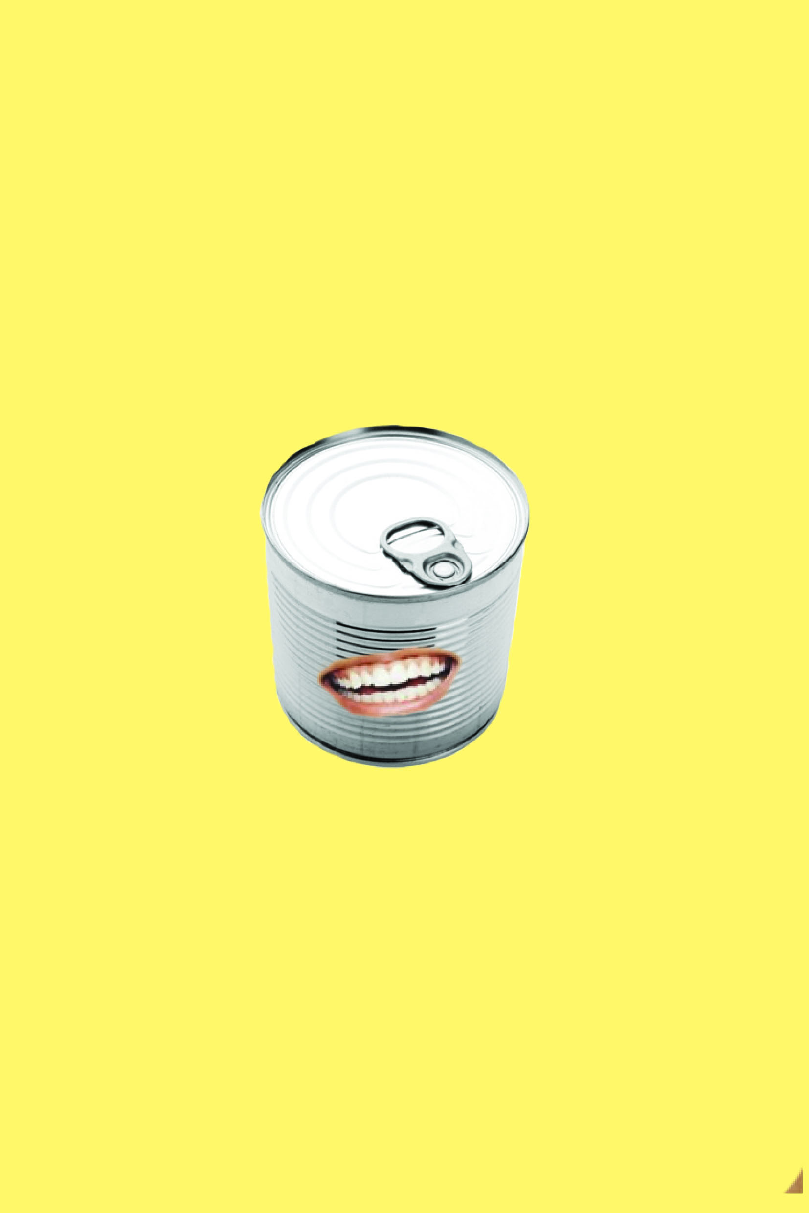

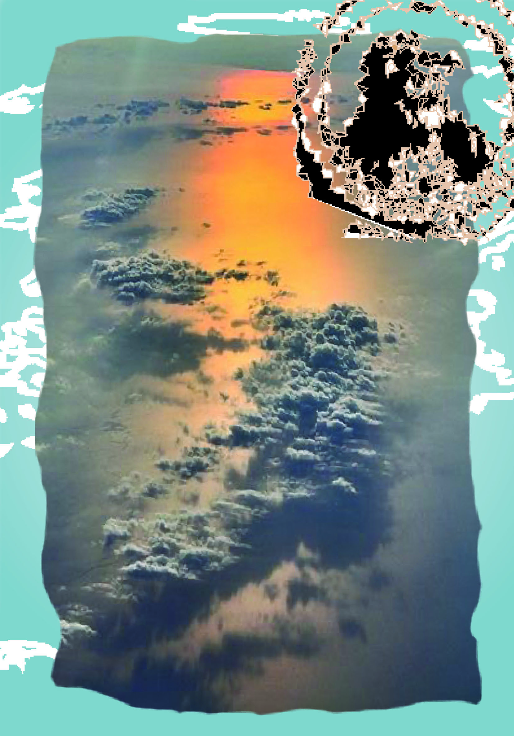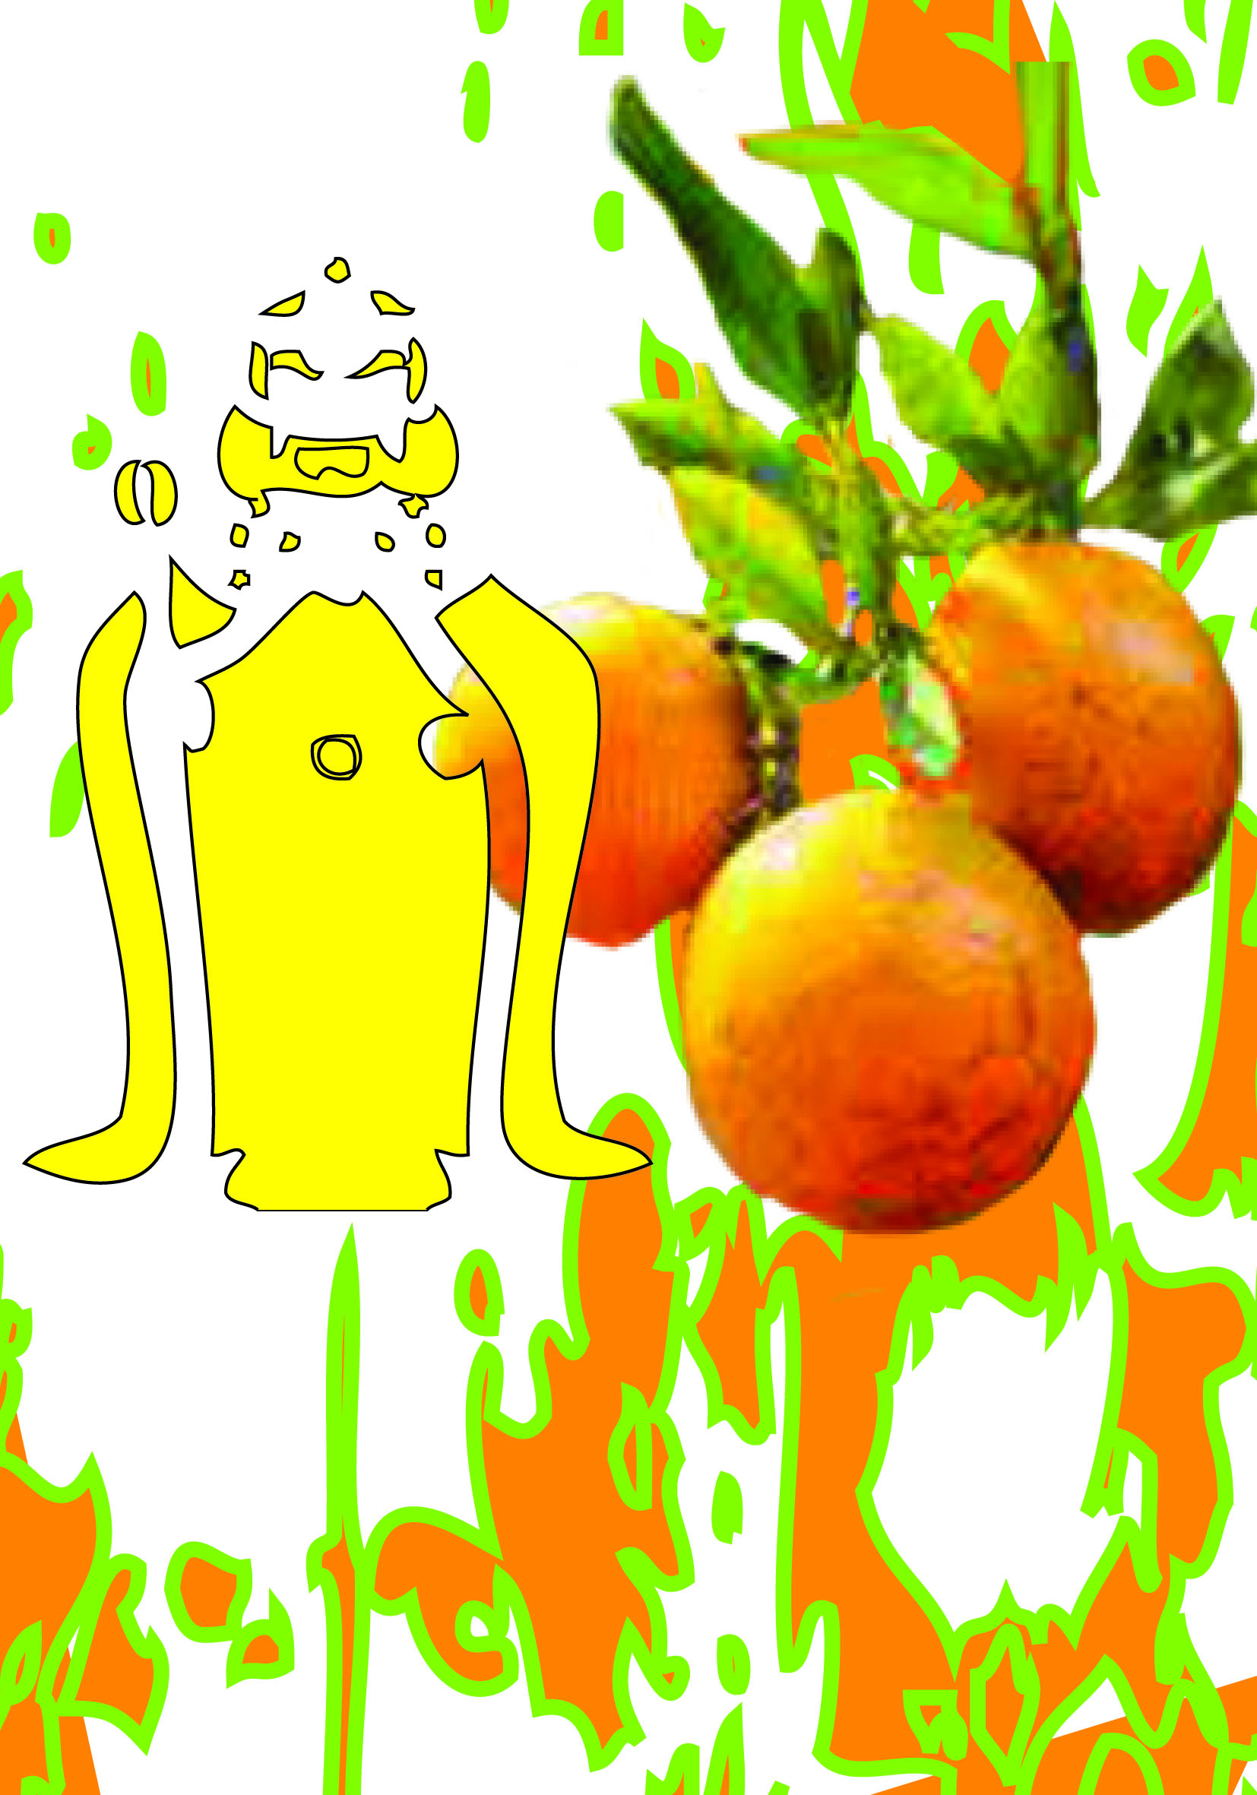

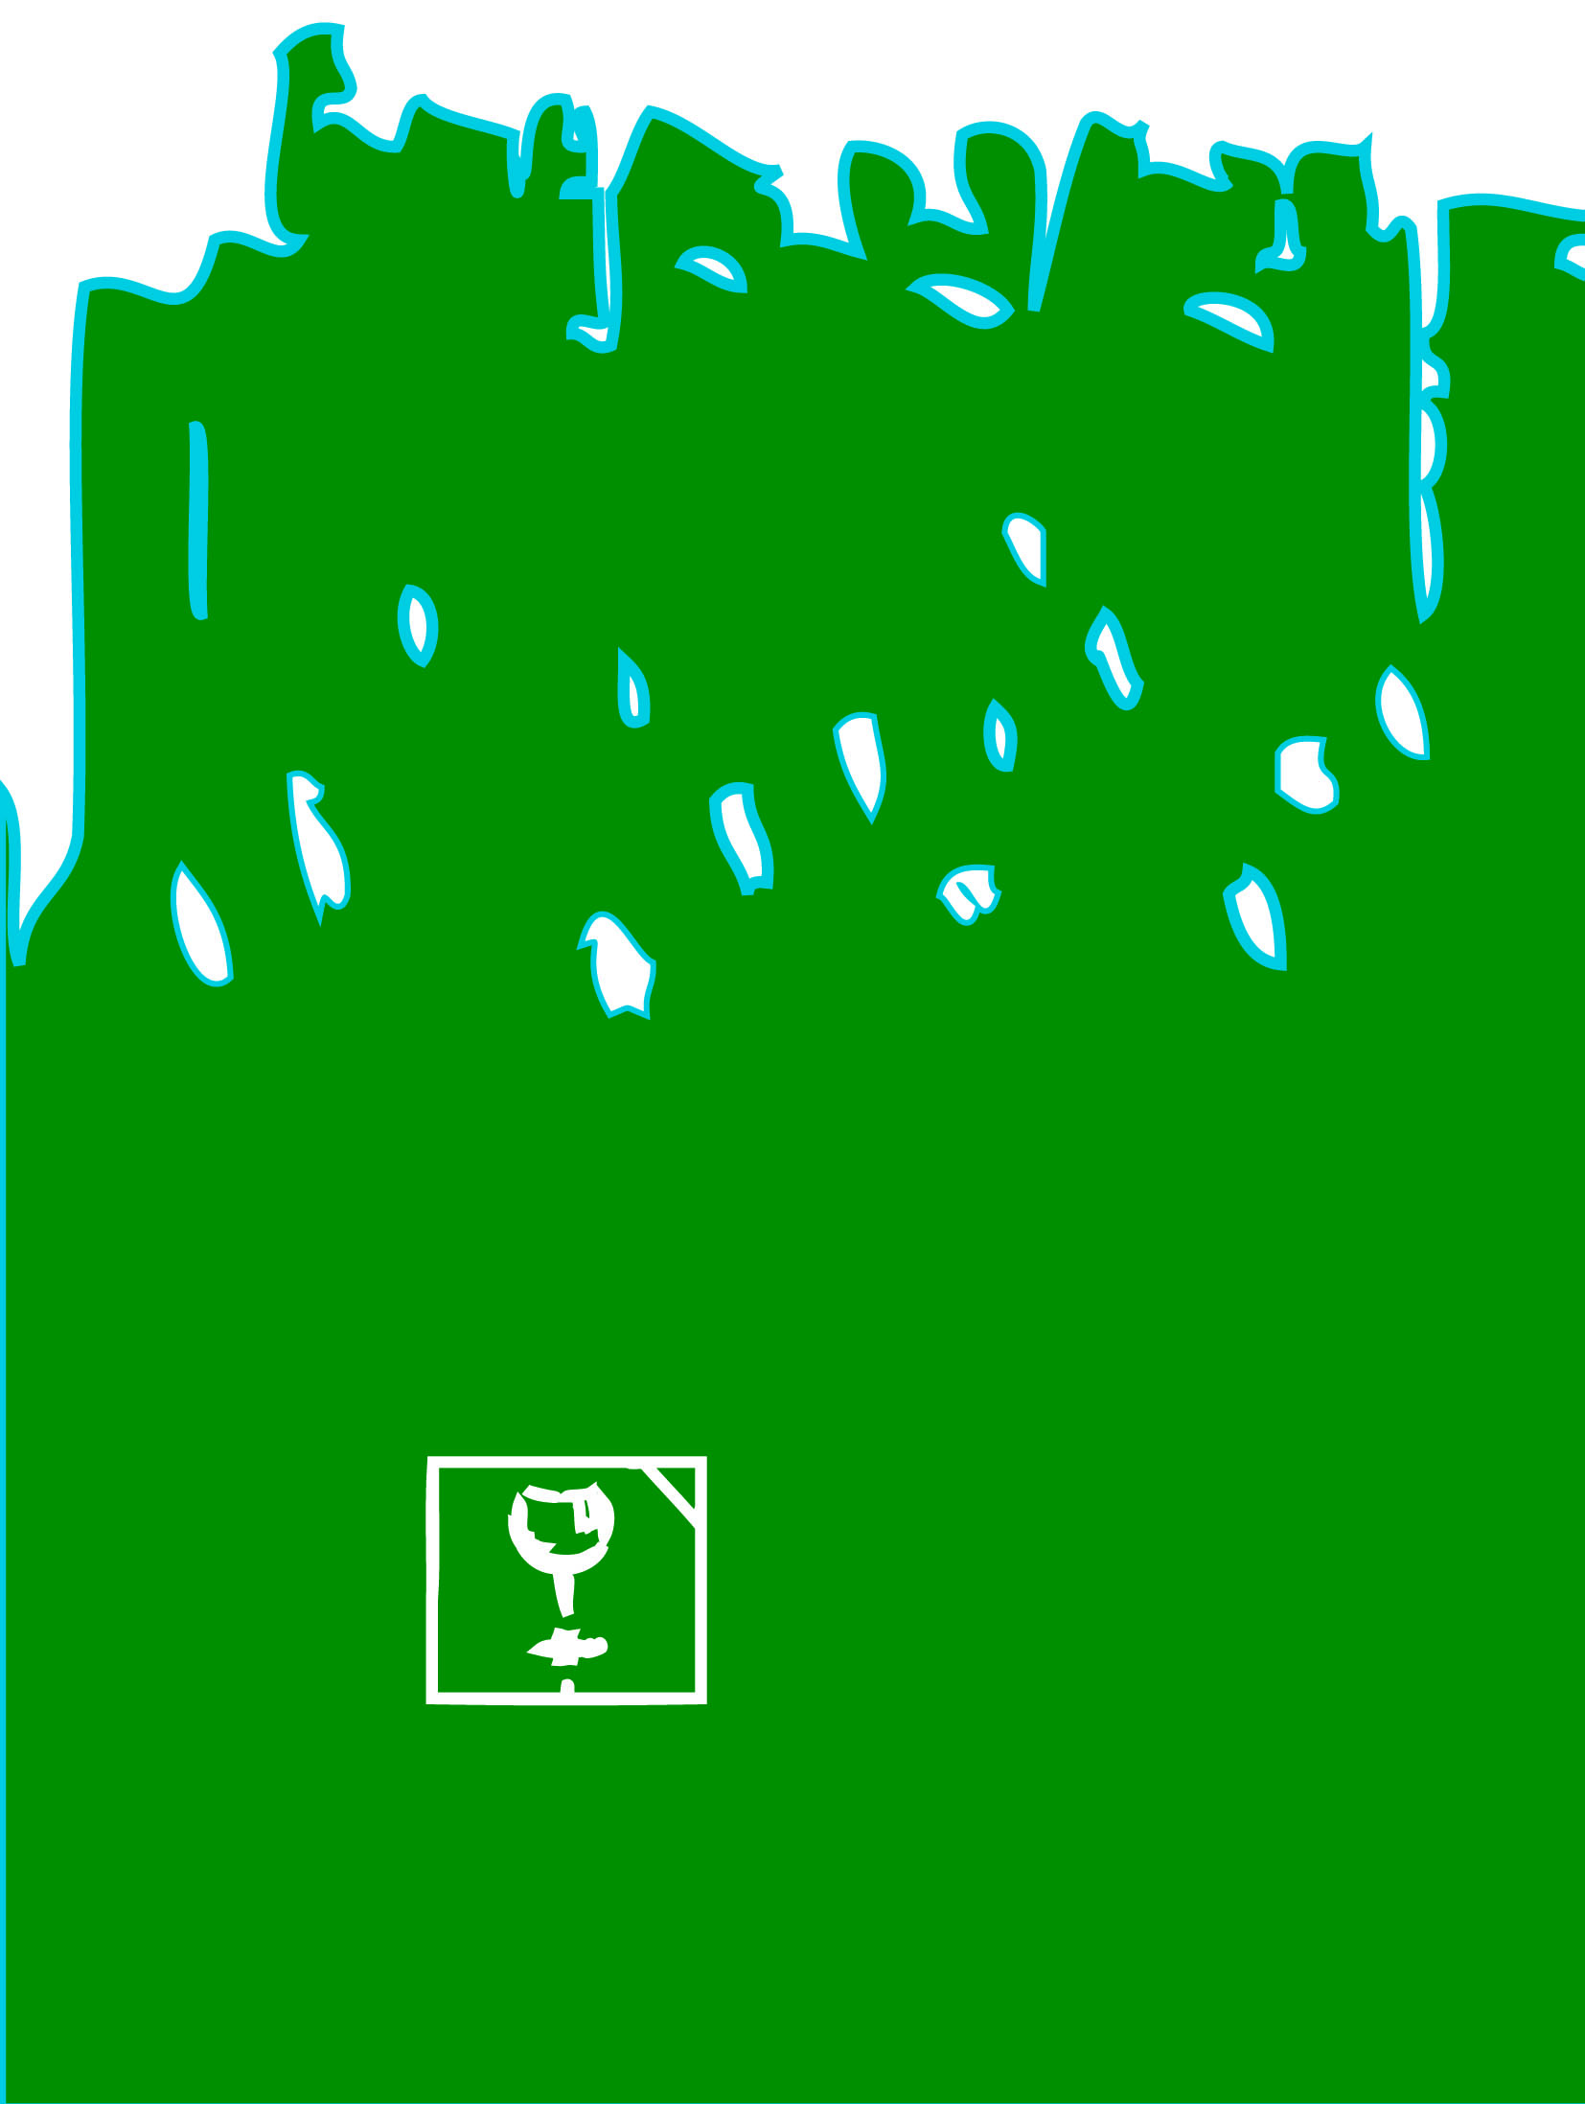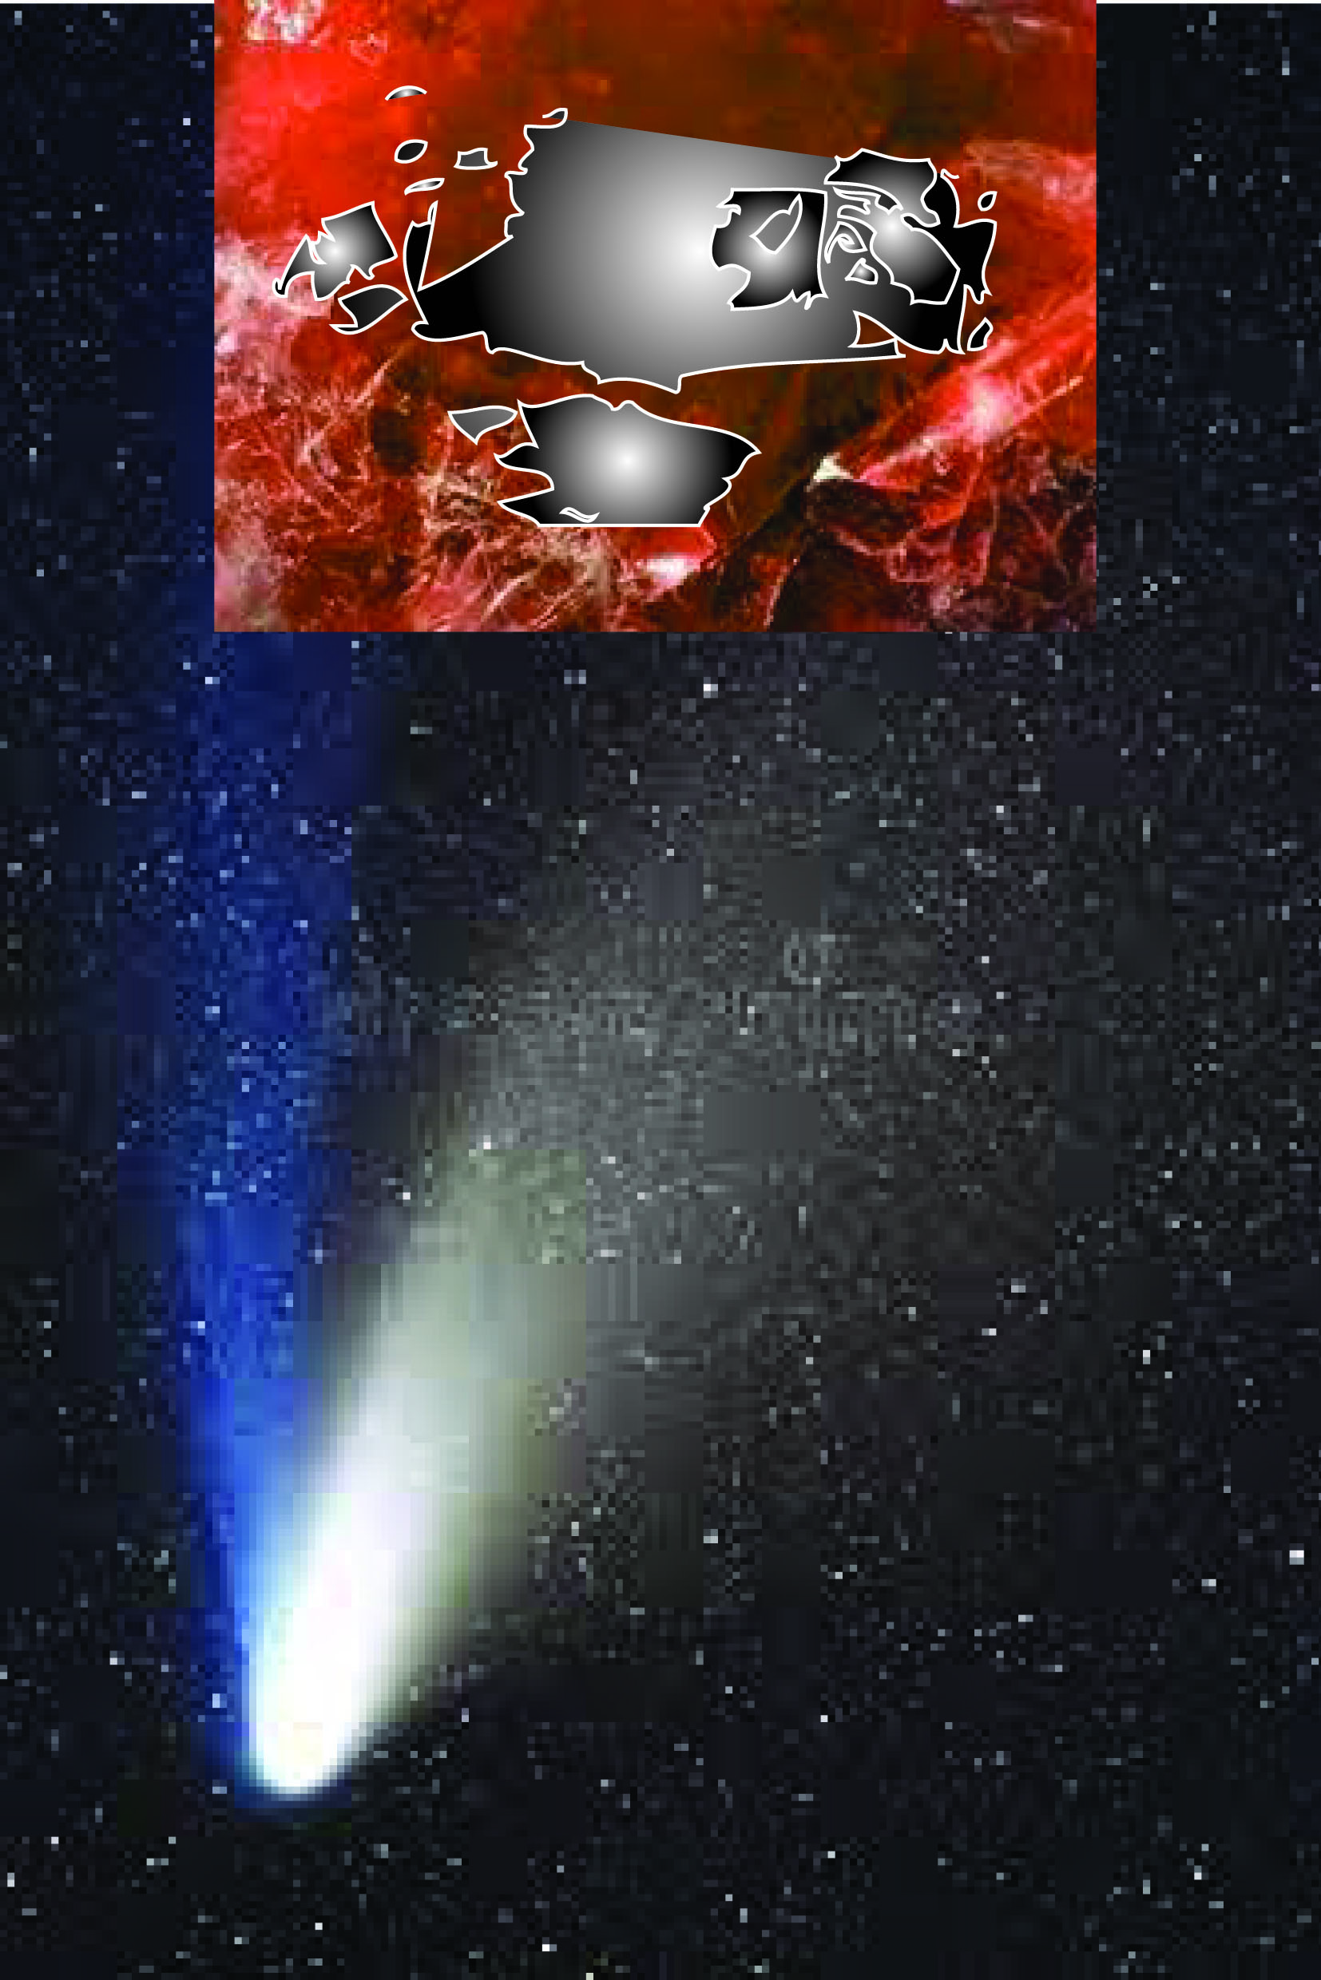

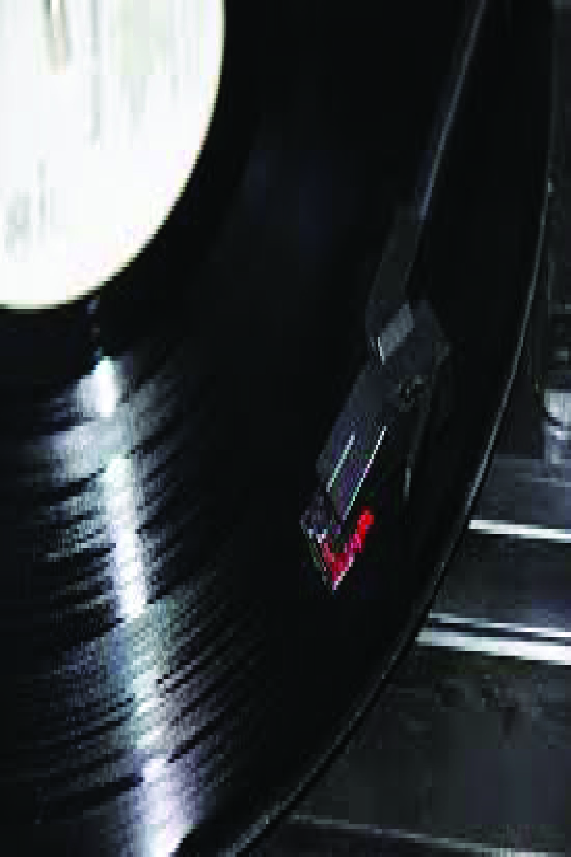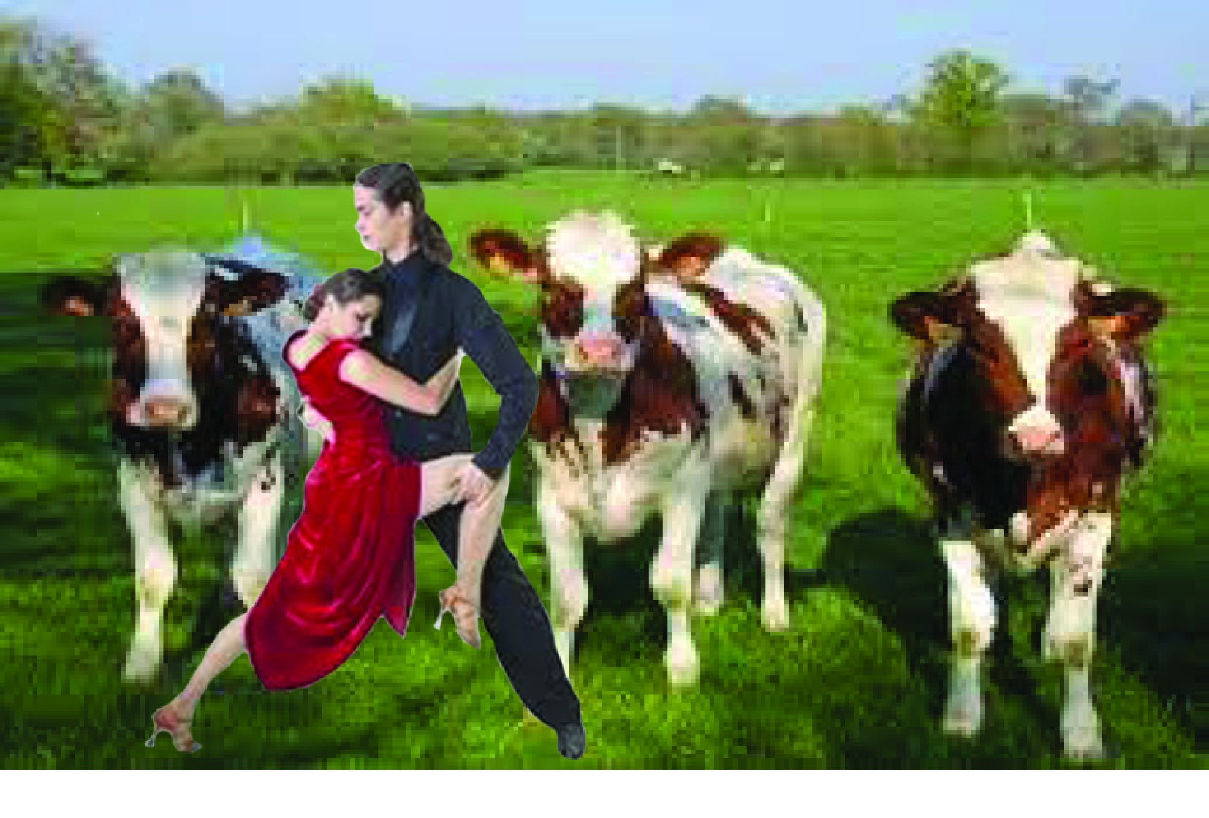

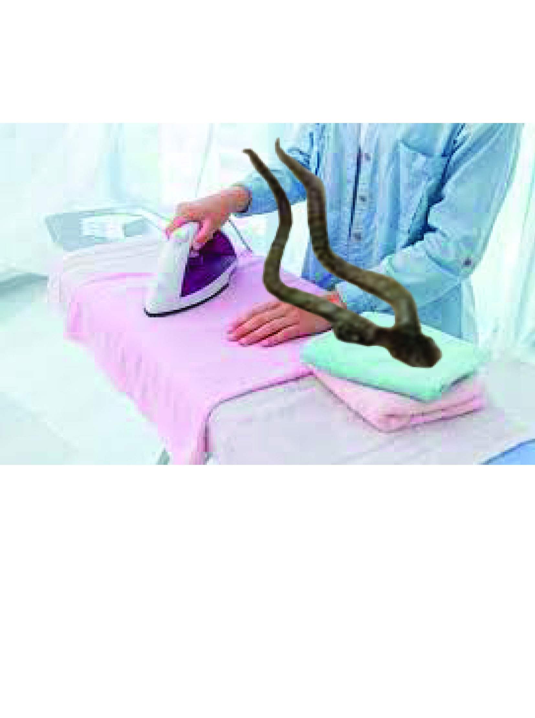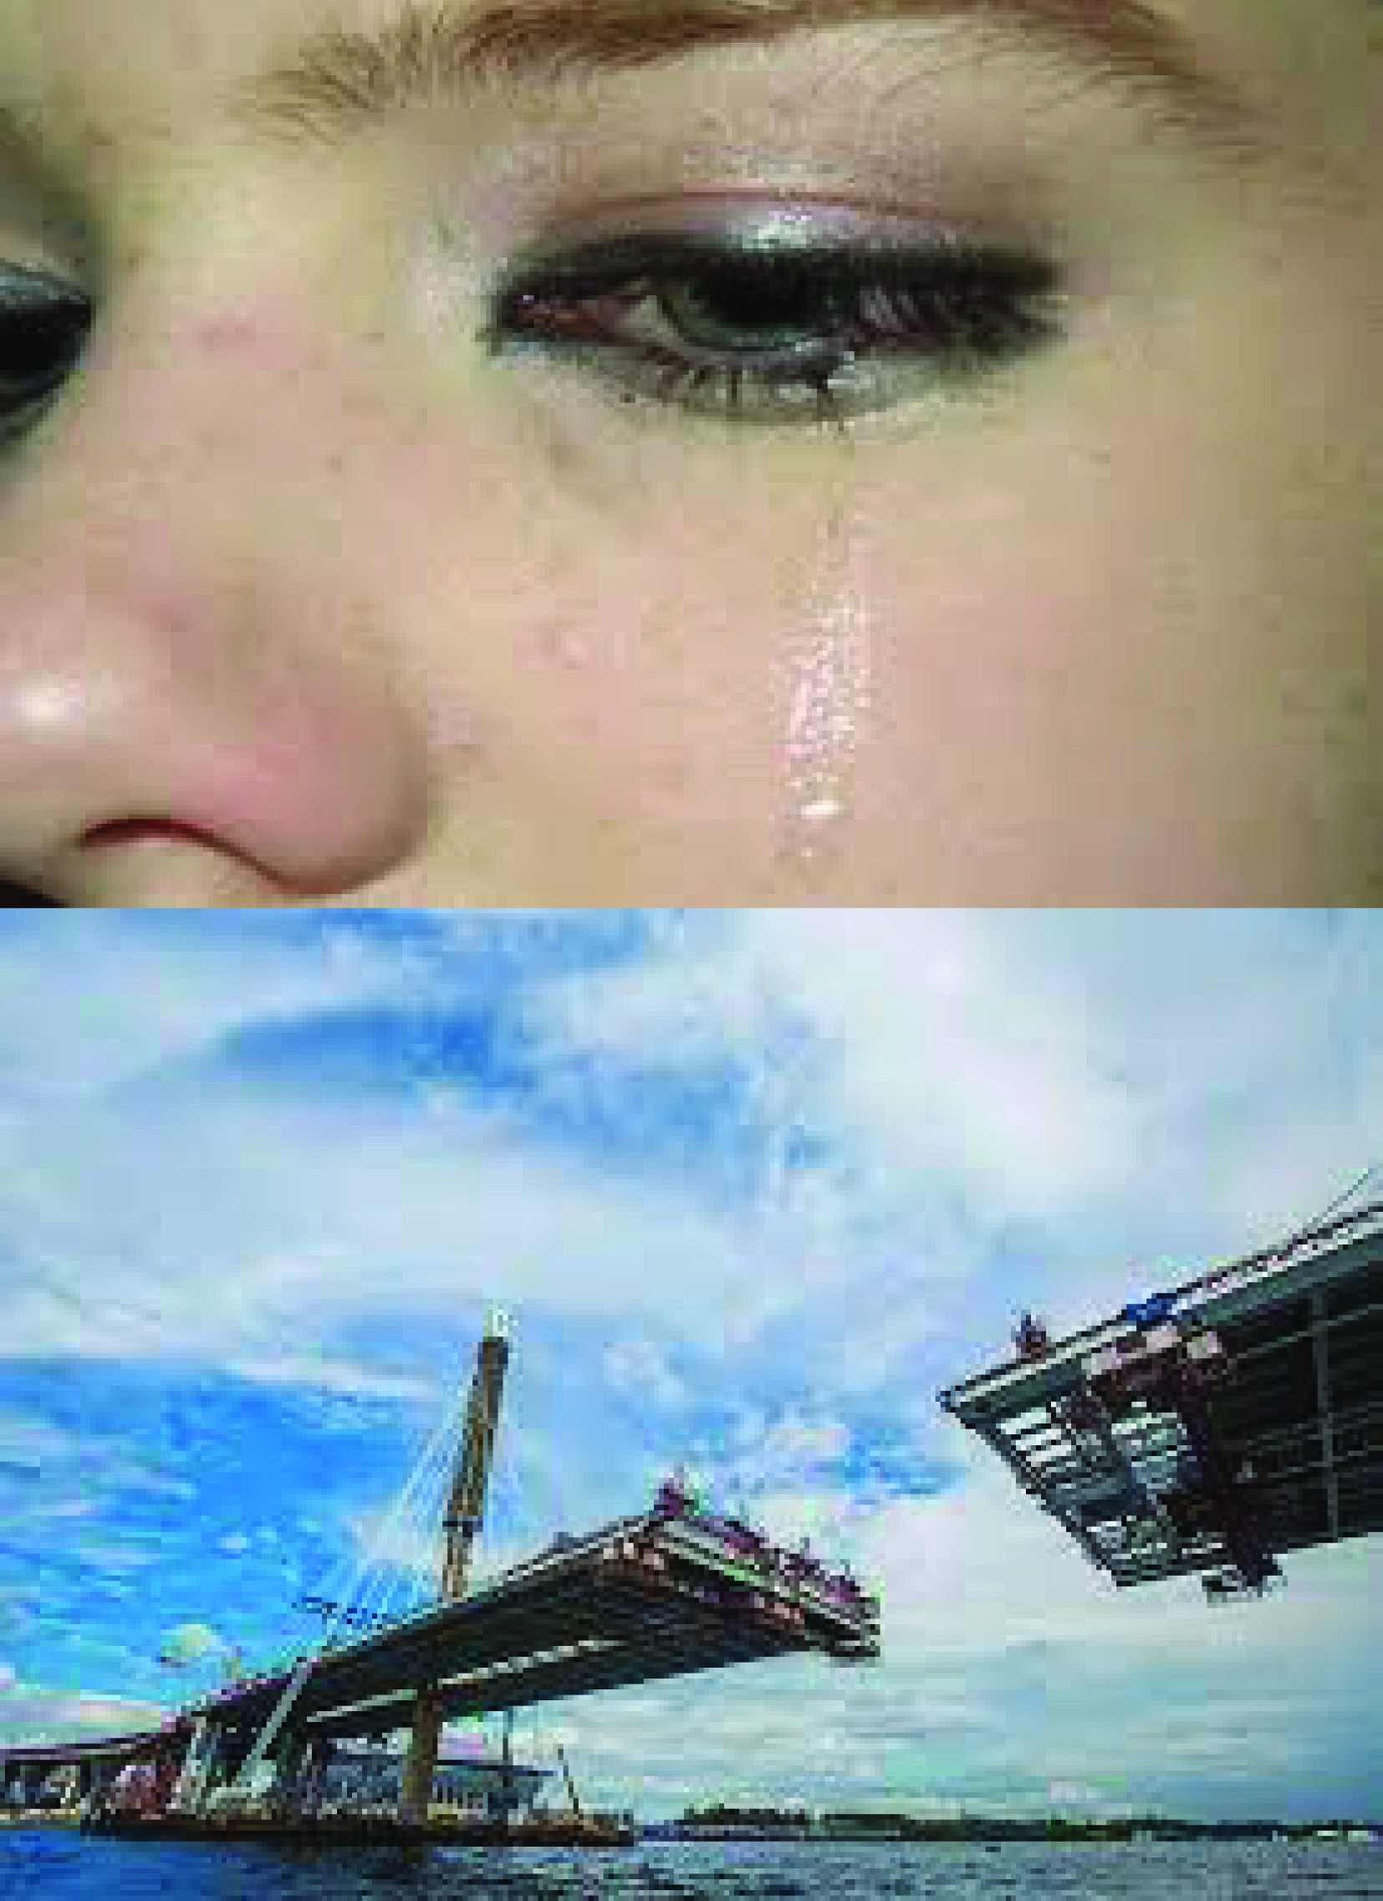

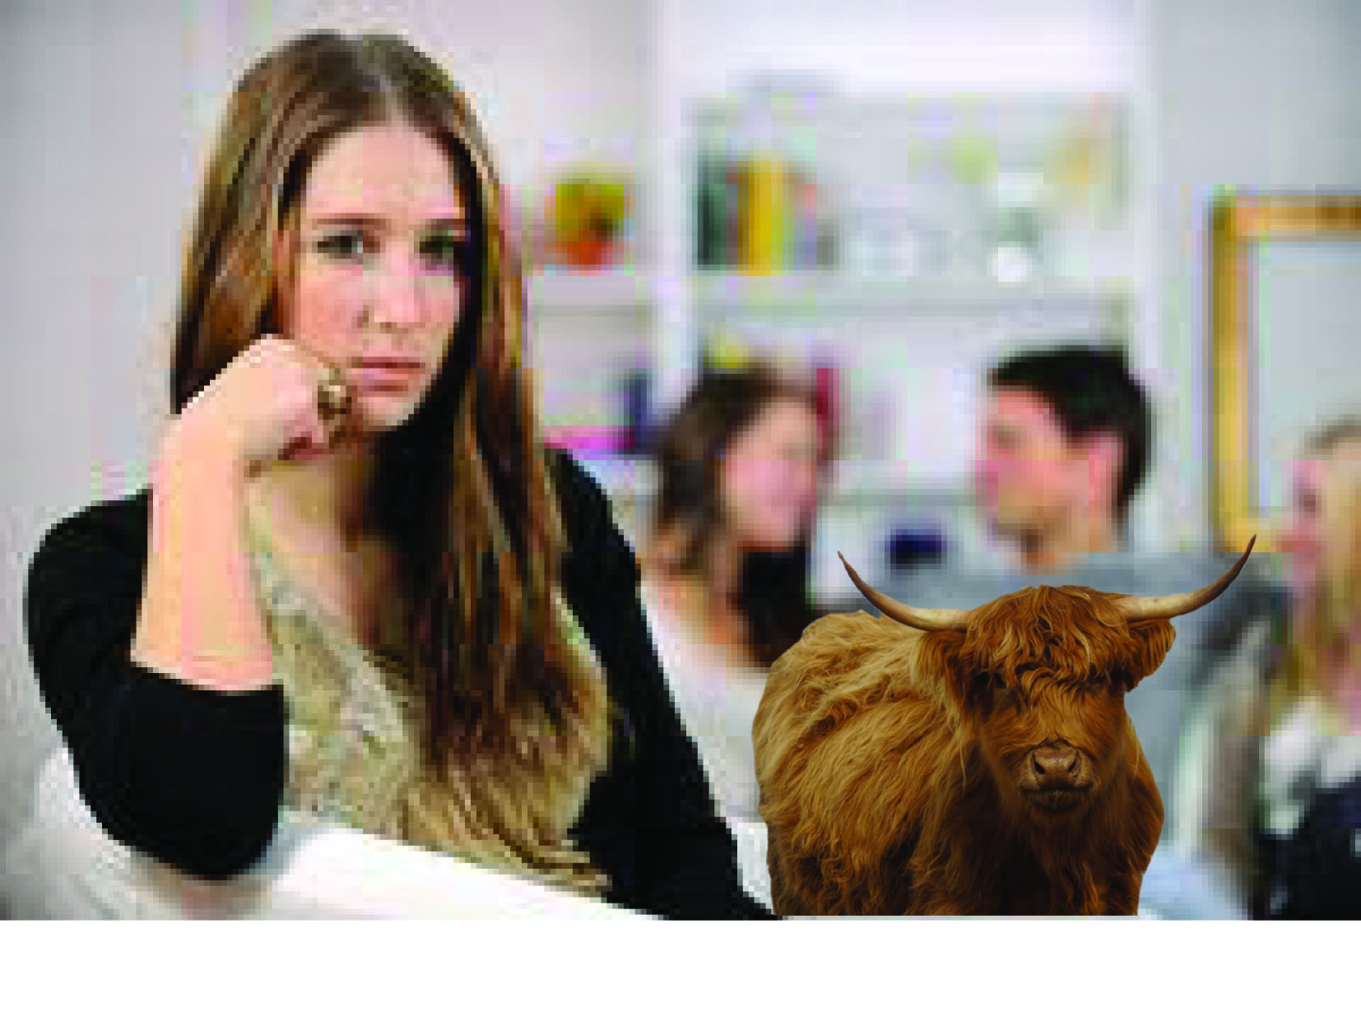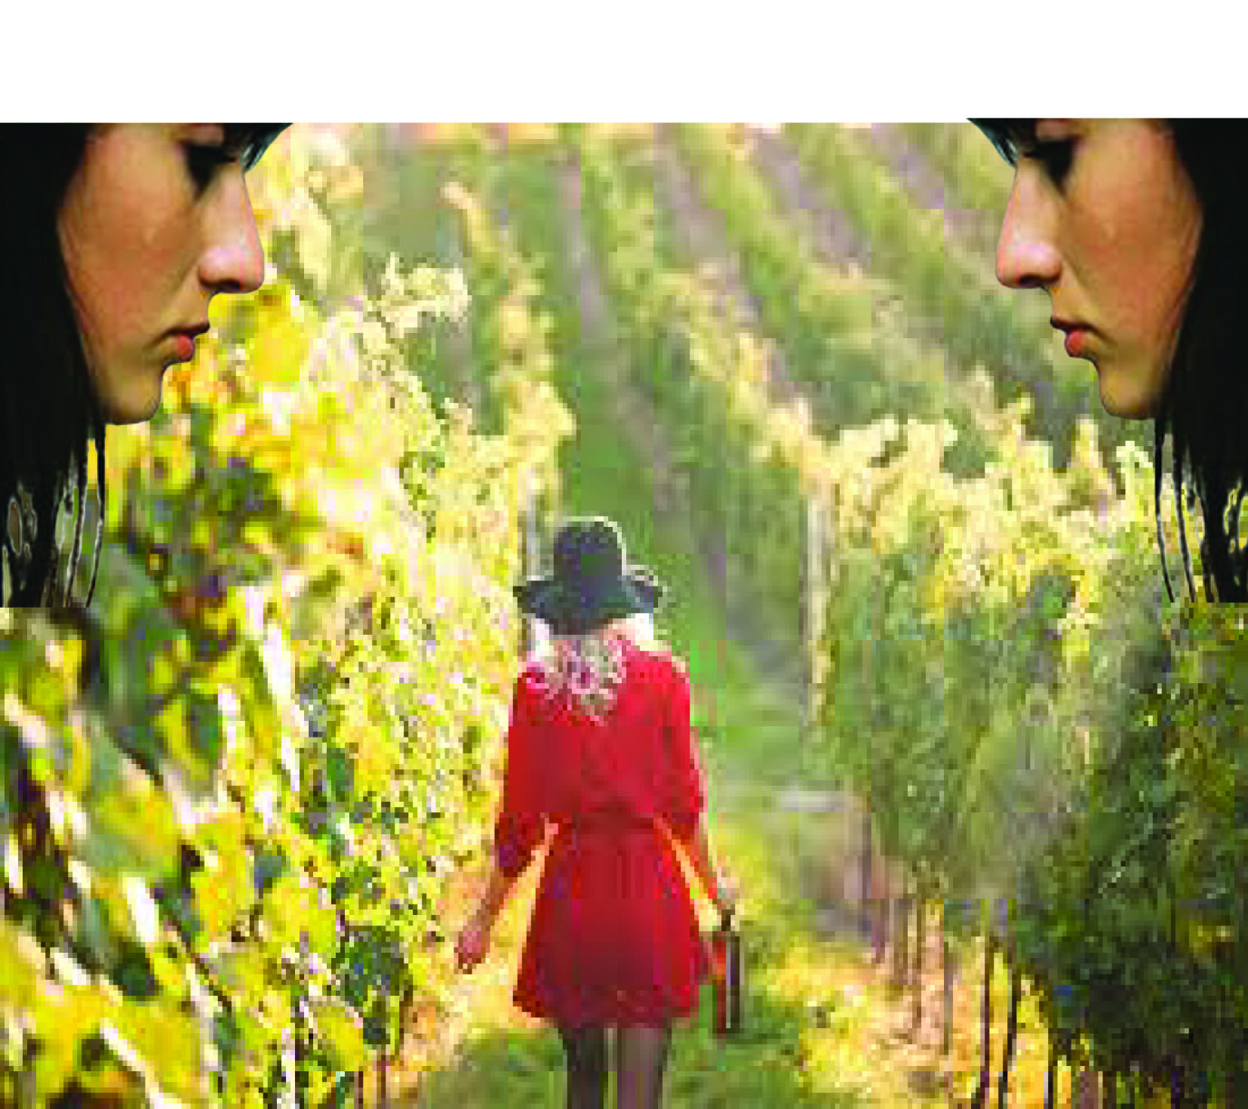
I then went back into five of the images and changed them, just so they were suitable to move forward with.
