Altered book
Using a found book, significantly alter the appearance of the pages to create a new volume that is personal to you. This can be any kind of book that is of interest to you. For example, a fiction book, a non-fiction book, a picture book or a photo book. Approach the found book in a very physical way, manipulating the pages and paper inventively. If you need to, stitch or glue a number of pages together to reduce the ground you need to cover. Decide what to remove from the book, and what to add. Use the found book as a source of ideas and inspiration – the existing text may inspire illustrative, conceptual images, collages or typography as image. Embed, overlay and integrate your work into the existing pages using whatever materials, media and processes you feel necessary. This may be digital, hand-rendered, photographic, textile, or a combination of all these and more. Think about the relationship between the content and the form, the design (text and images), the materials you use, such as papers. Perhaps you are creating a new sequence within the book? Change the book from its original form into a different form, altering the appearance and/or meaning. Apply an inventive, intuitive response to materials and how these can be exploited within the context of the altered book. Refer to your contextual research into artists and designers in the unit so far. Use elements of your research as inspiration and to inform your book-altering practice.
Reflection
Write a paragraph reflecting on the assignment and reflect on your process and decision making. Are you looking in a different way to meaning, materials, design and the form of the book?
So I started this assignment first with thinking about the type of book I wanted to alter?
I wanted to be a children’s illustrator, and I was already working in Surface Pattern design and stationery design, as well as being an artist, so I wanted to alter my chosen book with those elements in mind, as that is what I am about, and can bring to the altered book.
I thought about using an old children’s book, but I wanted it to be more specific, as I found these to be too broad in content and subject.
Then I found a children’s painting book, like a colouring book, but aimed at painting instead. I thought this would be perfect, as at the base of all my work is my painting and illustrations’, I also believe that painting is very good for children to express themselves, and believe that art therapy is very relevant in today’s society.
I already had many ideas in my mind just by looking at my chosen book to alter, but I needed to get these down into a more cohesive way, so that I could move forward with some of them.
The first thing I did was photography the book from different angles, and a few pages inside. This would help with before and after comparisons at the end of the assignment as well as showing you the book I chose.
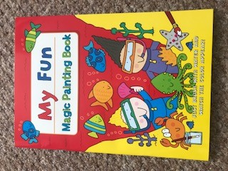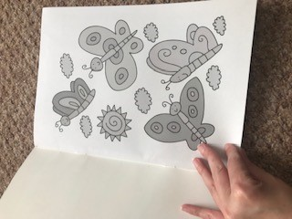

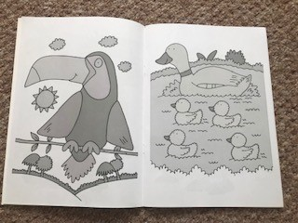

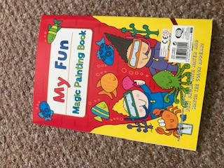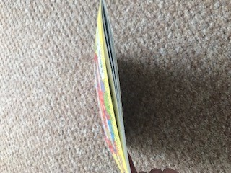

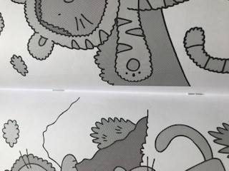
The book is soft covered, yet it has a harder front and back cover than the pages in the book, it is stapled together in the centre of the book, and is A4 in size. The pages are black and white with grey shading areas, there are 33 pages inside, plus the front and back cover.
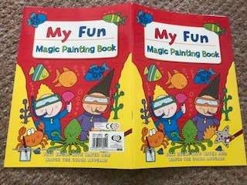
The next thing I did was un-staple the whole book, so I could look at what pages I wanted to discard or use again in a different way, and to think about what to do with the front and back covers?
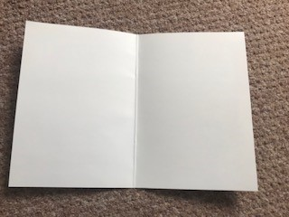

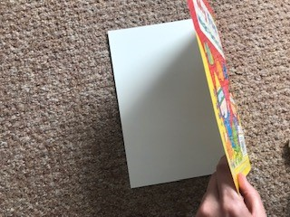
I then went through the pages I had taken out to decide what ones to discard, and what ones to re-use.
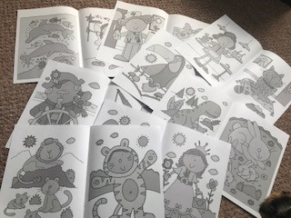
The first thing I had noticed about the pages was that most were animals or people, there were a few boats, plus the pages were double sided.
I decided to go with the theme of animals, so I kept most of the pages with animals on them.
This was one side, and then the other side below that. The pages with other things than animals on I would re-use or paint over or change in some way, they would be the backing or paper I would use.
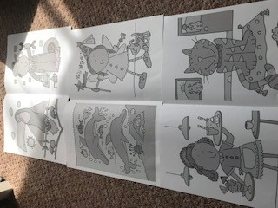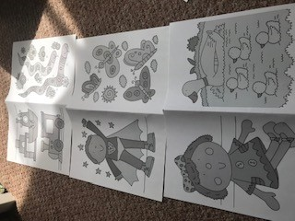

This page I decided to re-use in some way, so either collage, or cut up or cut out.etc.
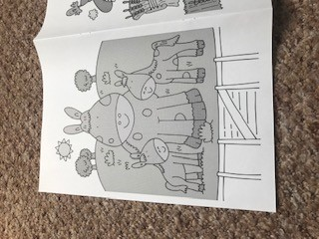
Then these were the pages I was going to discard, these were mainly people or boats, or animals that I didn’t want to use.
I wanted to use animals I had not painted or drawn before, that’s why some are in and some are not.
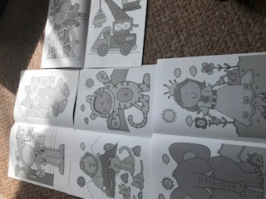
Then from this point I started to work on a spider diagram, to gain some ideas of what to do with the book, and also to write down the ideas I already had.
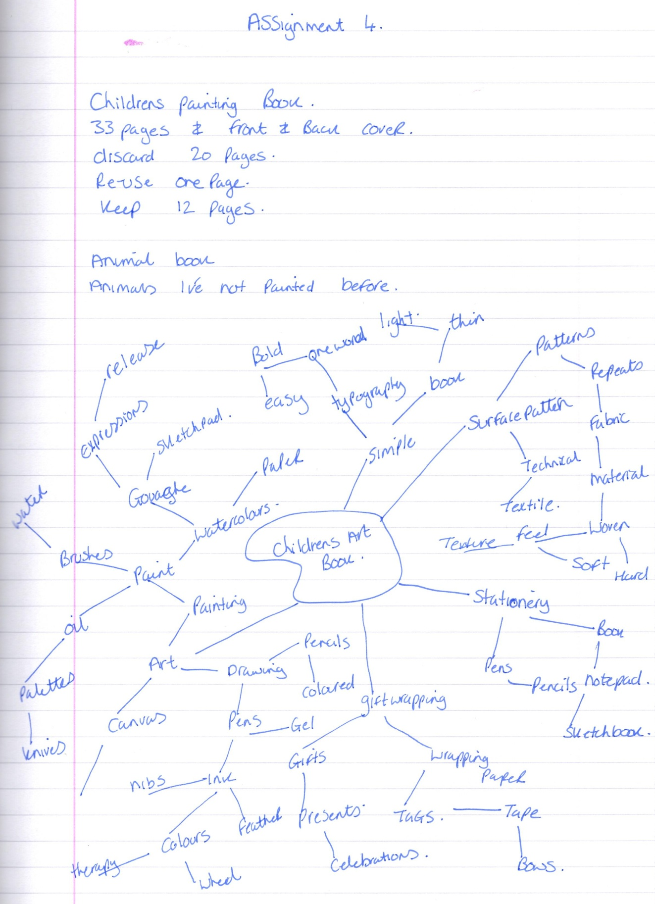
So from the spider diagram I wanted to highlight some keywords, which I could use to take my ideas forward.
In the meantime I had an idea about using some of the fabrics I had designed for my surface pattern to add to this book in some way. So I found some off cuts of the fabrics and took a photograph to show you what they looked like.
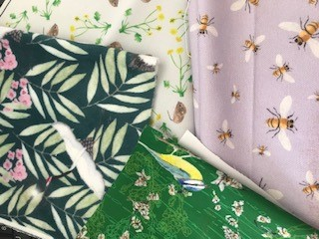
I then started to research altered books; I thought this would be the most apt time to do this, before I started with ideas.
I researched an artist who works in altered books her name is Jane Davenport and the info is below:-

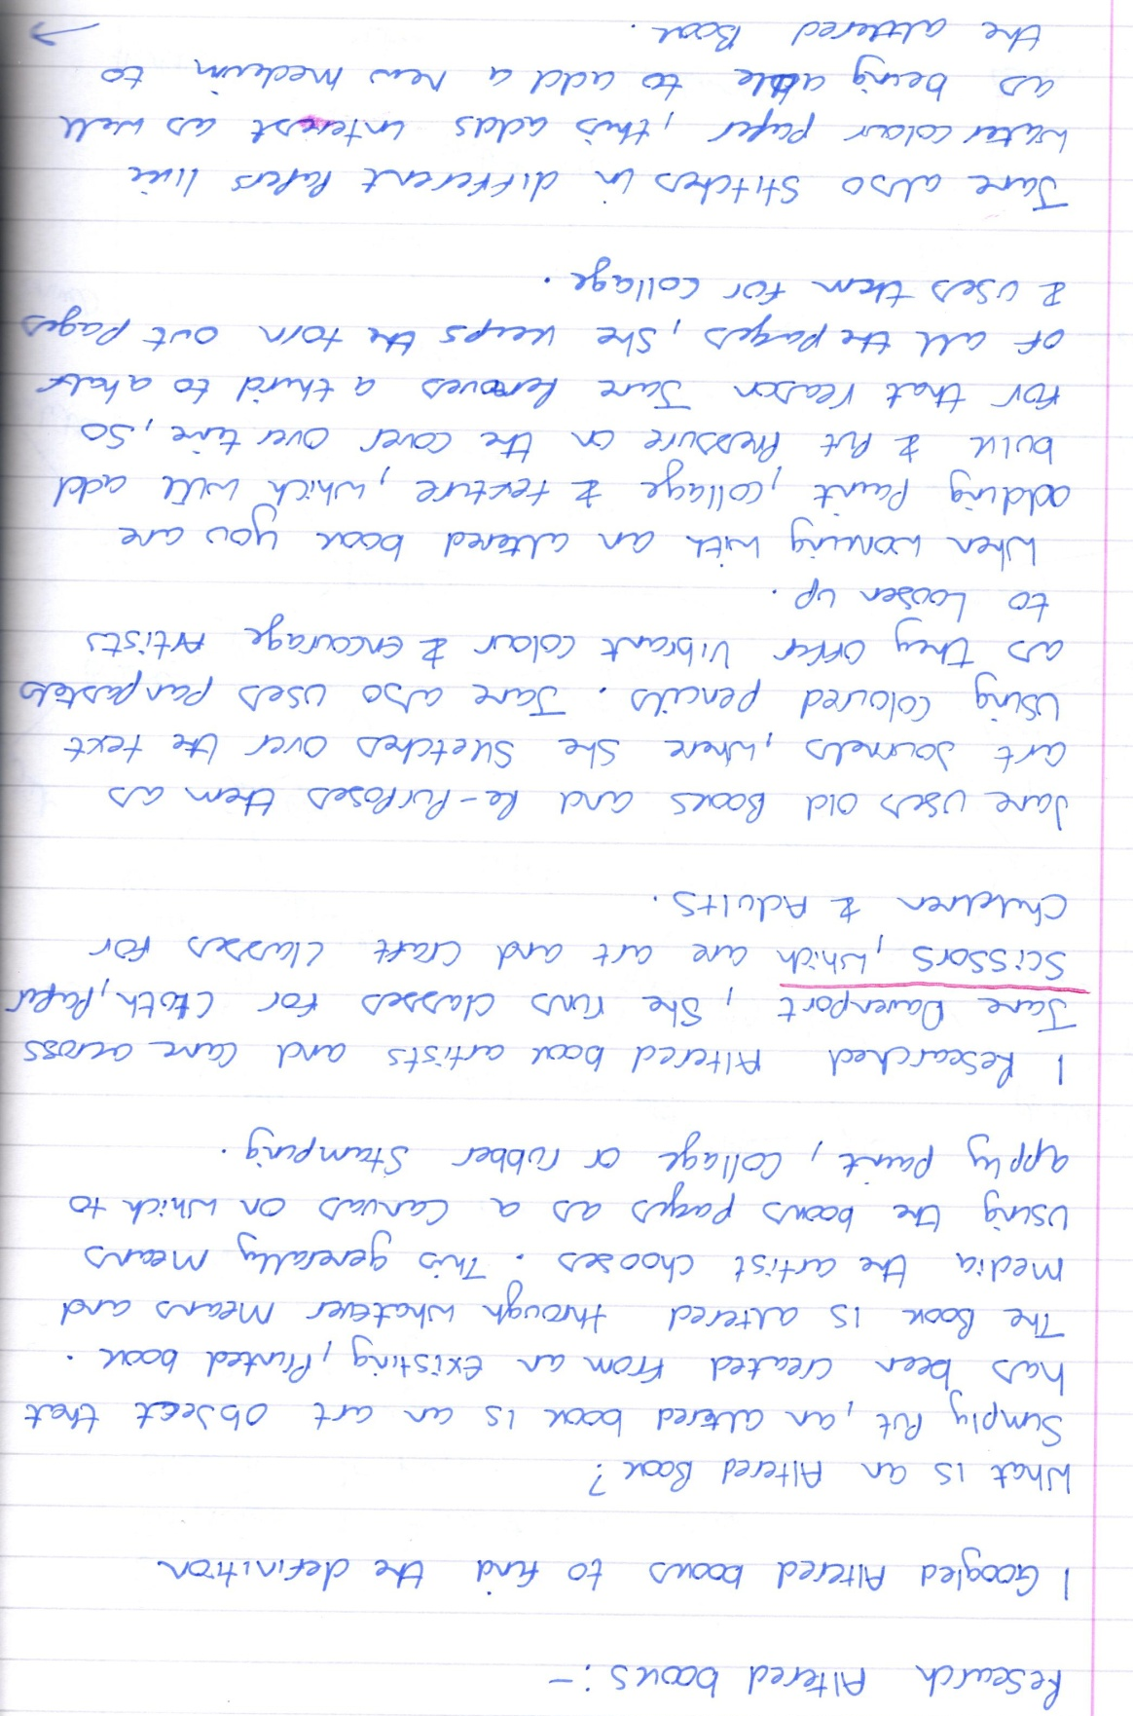
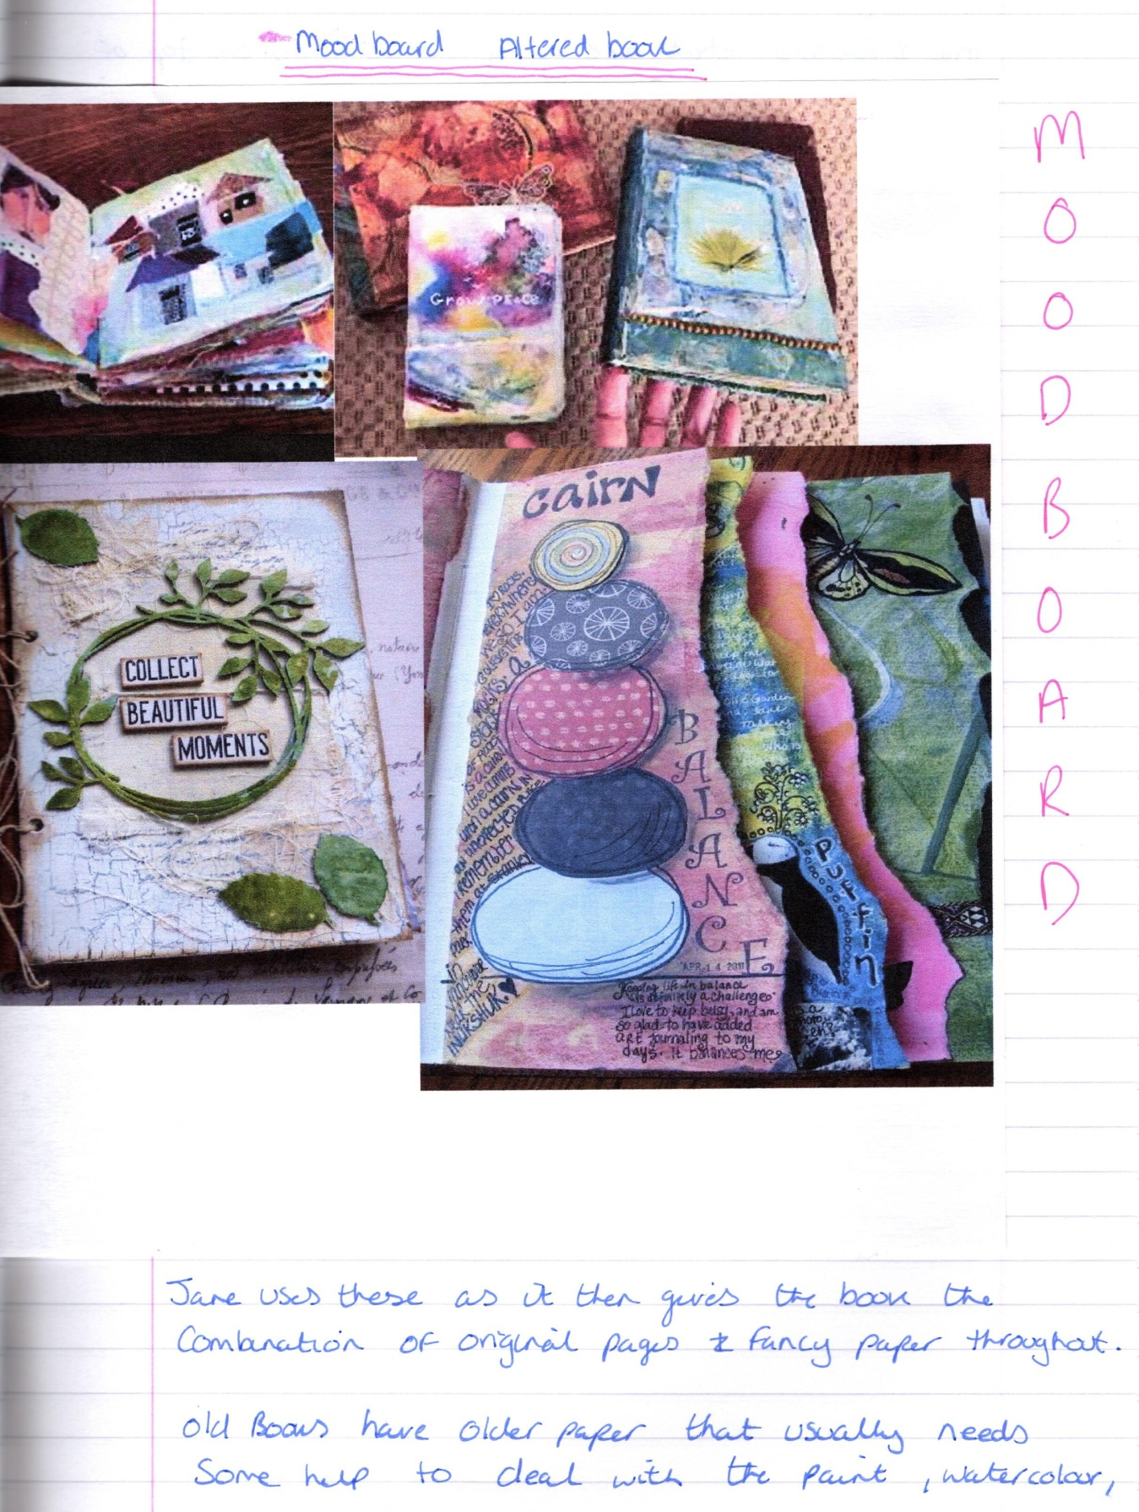
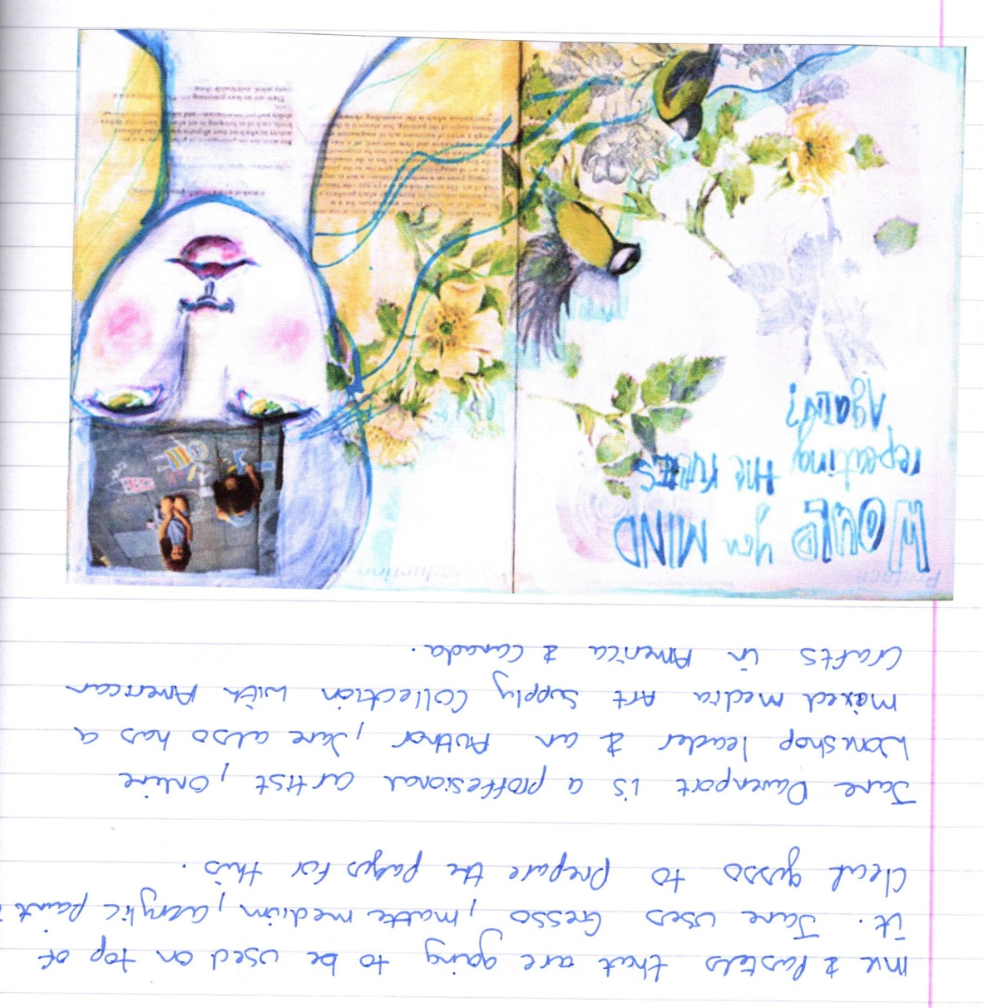
©Jane Davenport
The full mood board I created was this one, which showed me some ideas of altered books and what you could do with them, what paint you could use and how you could make them.
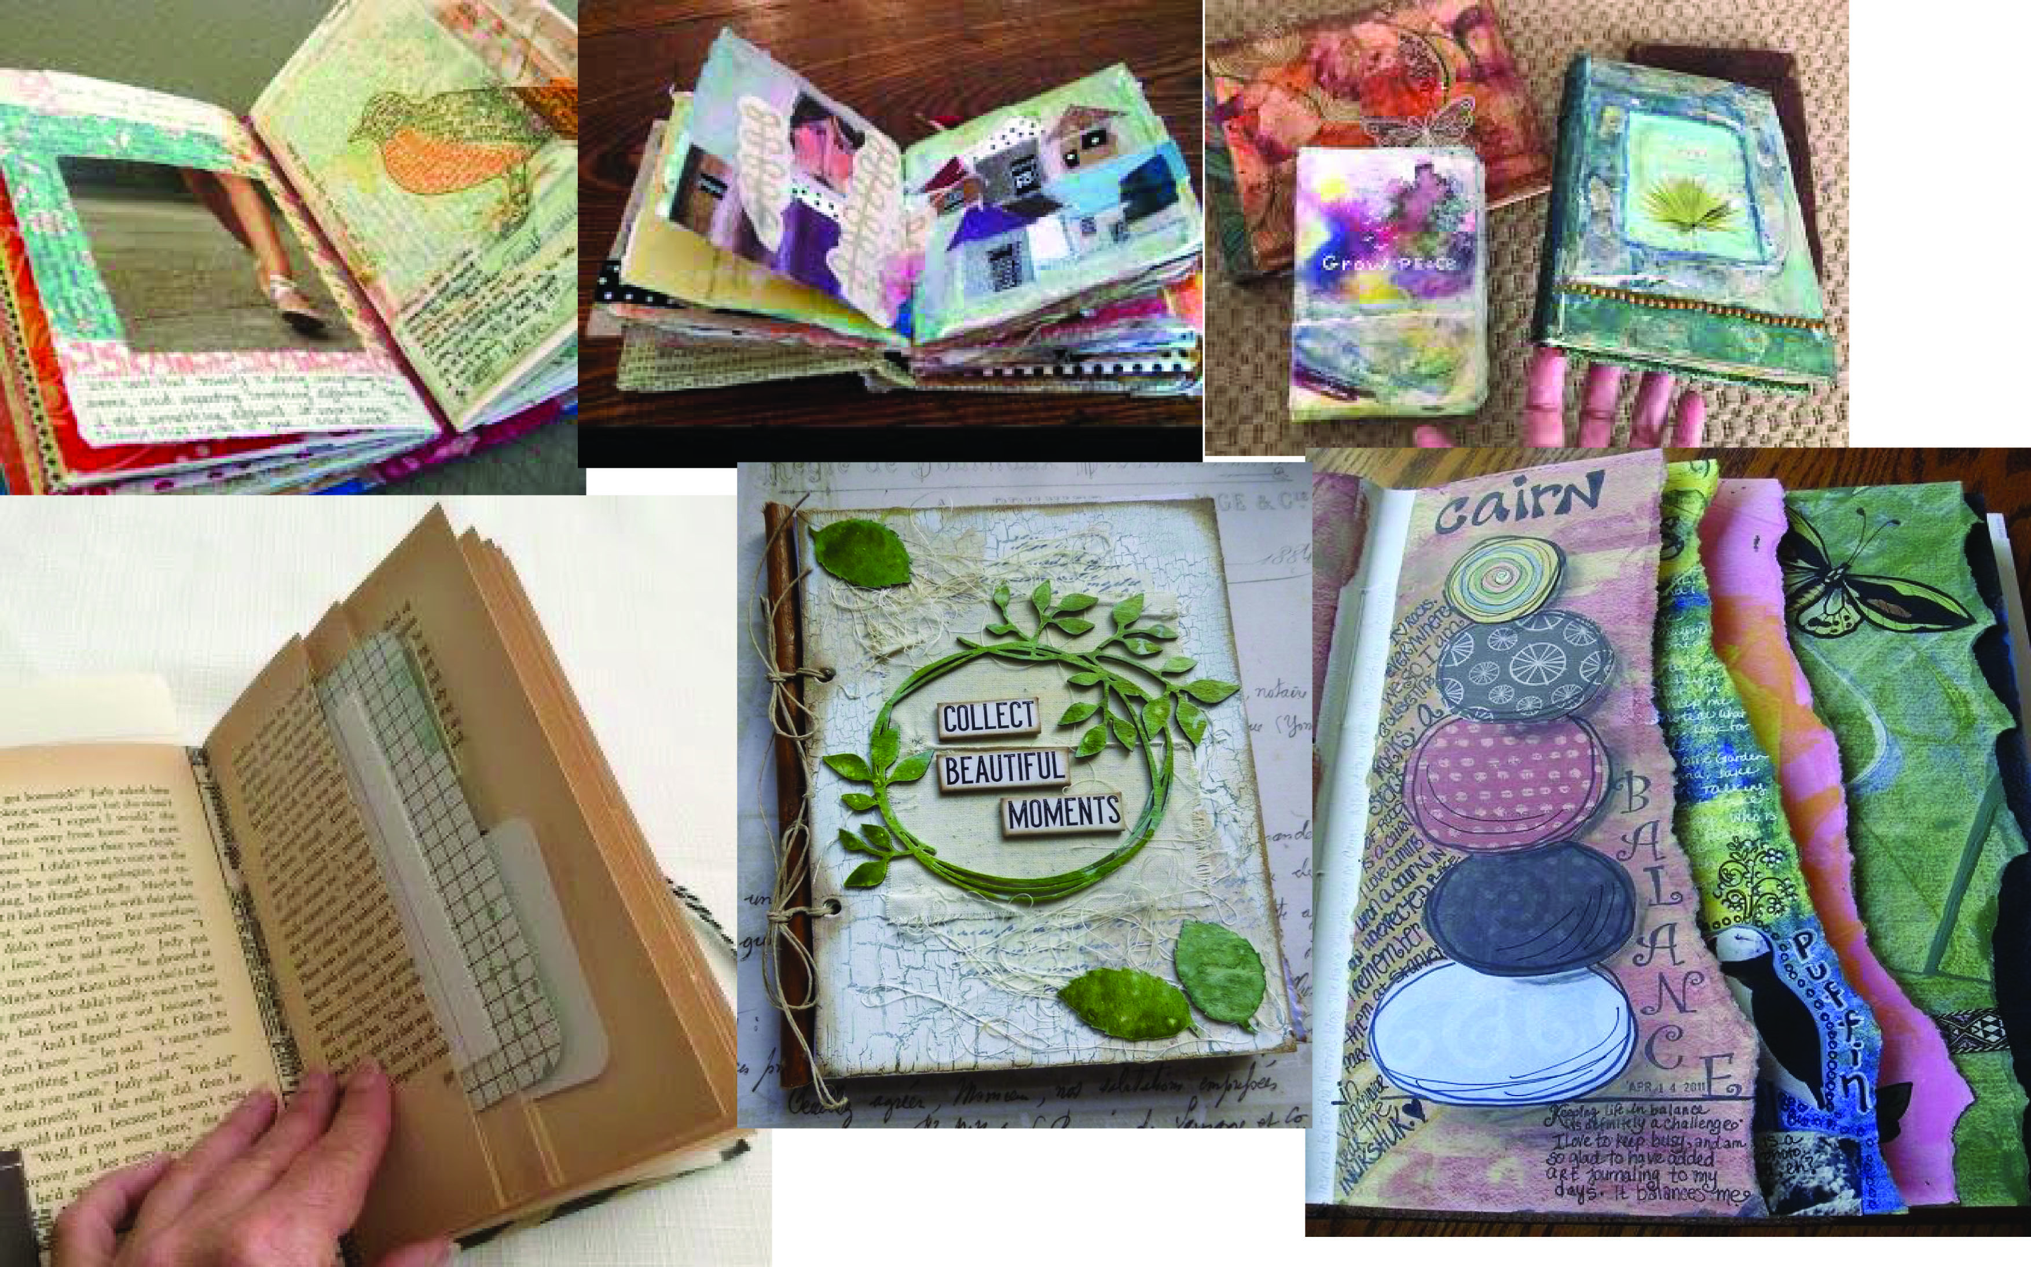
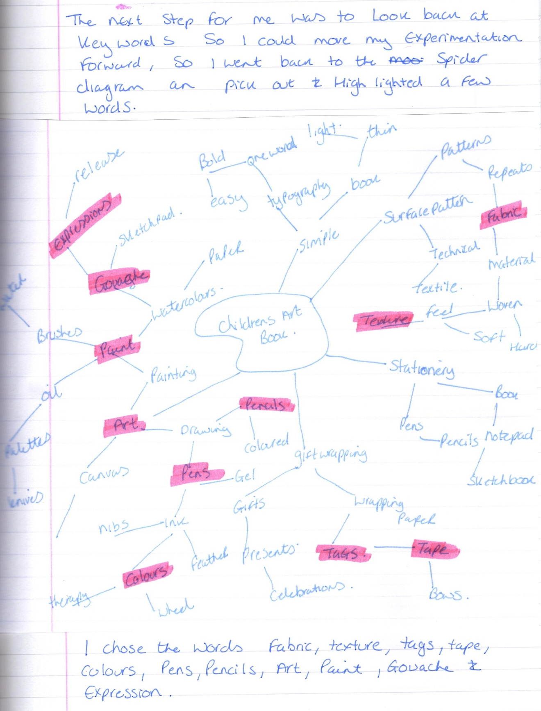
I decided from my key words to pull out the material and fabric from the spider diagram, and incorporate this into my altered book. The material off cuts that I had shown before were mainly small off cuts of material, but one design, the bee in flight was big enough to cover the cover of the book.
I started the next stage, the book cover design by choosing the fabric to go over the cover; I thought this would be a good idea to incorporate my surface pattern design and also to cover the bright glossy plastic cover that the book already had.
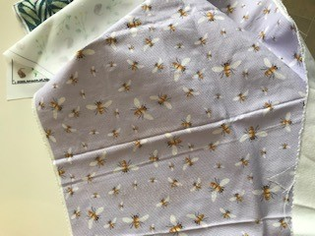
The fabric was a heavy duty linen which was great as a book cover, as linen is widely used in book covers, but I had the problem of not being able to get the creases out of the fabric, I had tried to iron it on a few occasions but it still had a major crease down the middle of the fabric, an no way of cutting the fabric could avoid this. I decided to go with the fabric still, and hopefully by the time I had finished the book, the crease might be a bit better.
I was going to cover the book as is, but the material was still see through enough for the bright red to show through, so I decided to turn the original book cover inside out, so the plain white side was showing through the fabric instead.
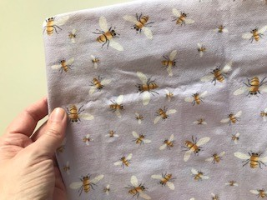
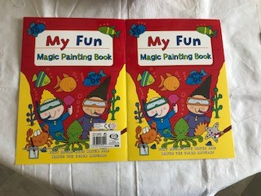
I used some pinking shears to cut the fabric, as this would stop the fraying of the edges.
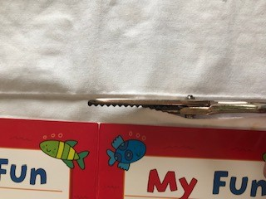
This creates a nice rounded zig zag pattern which is nice and neat for the edge of the material and will look good on the cover of the book.
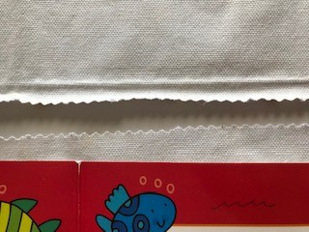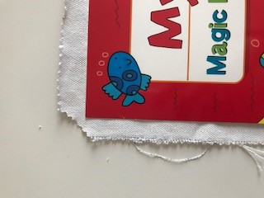
I then cut the corners off a bit, this stops the corners from being to bulky when you come to glue the edges to the cover.
I used a glue gun to stick the material to the cover; I chose this method as this would be more durable than PVA or a glue stick.
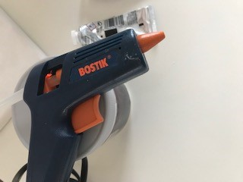
This worked really well and stuck the material hard to the cover, it was a bit messy but it was worth it.
After finishing the gluing of the material to the cover, I thought it would look good if I could make some end papers, this would cover the inside of the book cover (which was actually the right side!) and would make the edges even neater.
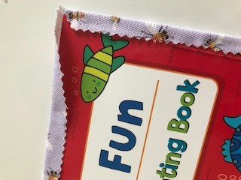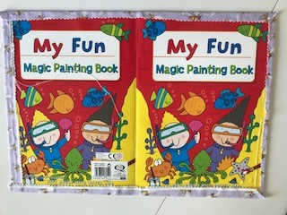
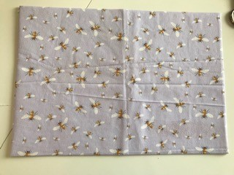
I had some wrapping paper which I had designed before, which would work with the subject matter, they were all hand painted illustrations, and I had some left over from my work.
The illustrations I used where some butterfly’s and a gerbera flower, it was on a plain white background, so stood out well, and also complimented the bee design on the front in fabric.
From the initial illustrations, these are the designs I had come up with:-
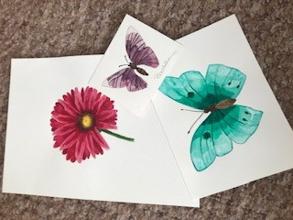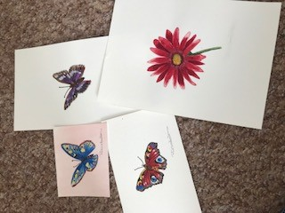
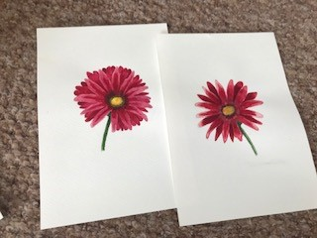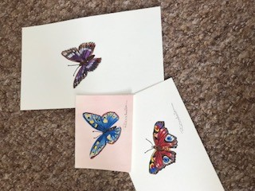
Then this is the wrapping paper printed out, again I cut this with the pinking shears to give continuity through the cover.
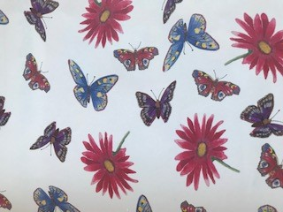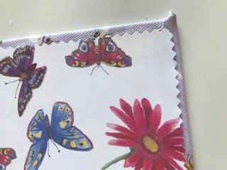
This is how it turned out, again I used the glue gun as I thought PVA would be too wet and crinkle the paper, and the glue stick would not be strong enough to stick to the fabric on the edge. The glue gun worked well again and gave a neat edge to the inside covers.
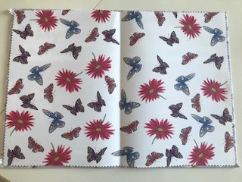
I was really pleased how this first stage had gone, and how well the fabric and paper worked on top of the original book cover. The coverage is really good and you cannot see any of the original through the designs now.
The next stage is to think about the first few pages in the book, I looked back at my key words, and the one’s I had chosen were:-
Fabric
Texture
Which we have already covered, then:-
Tags
Tape
Colours
Pens
Pencils
Art
Paint
Gouache
Expression
So it basically sums up some drawing and painting in different mediums to create colourful art, then there is the tape and tags.
I looked through my designs as a surface pattern designer and came across some seconds I had created but for some reason or another they had faults with them, so I found some tags were the colours were too dark when I printed them, so I thought I could use these in some way in the book.
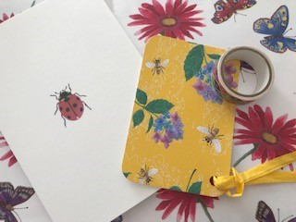
I also have a large collection of Washi tapes, which are paper tapes, usually decorative and or decorated these, are often used for journaling and scrap booking as well as in altered books.
I found one I thought would be suitable for in my altered book, and kept this to one side, until I can think were to use it.
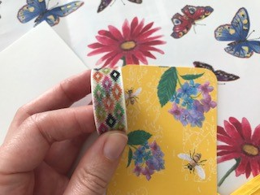
I then started with a flat plan of each page and the front and back covers, so I could plan what was going to go where.
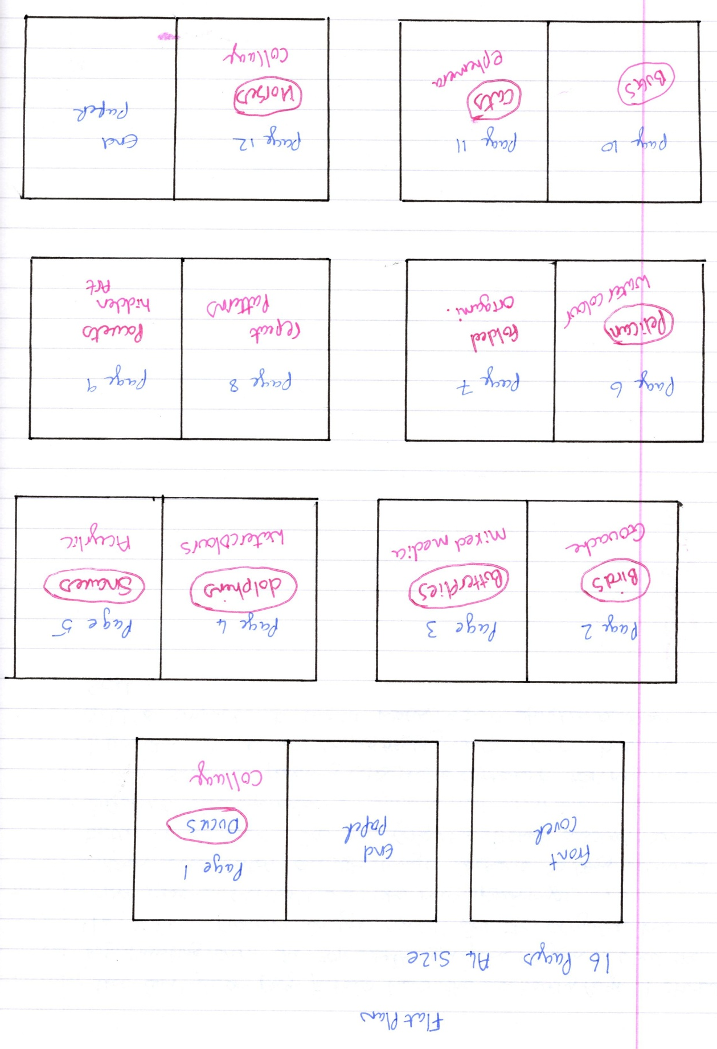
I then went onto think about things that I do and like, asa the altered book needs to be about me, I wrote a list of things like Surface pattern, Watercolour painting etc.
I then went back over to the flat plan and thats when I added what should be on each page, this was just some thoughts and a guide to begin with, it might change in the future as I go alng and complete the assignment.
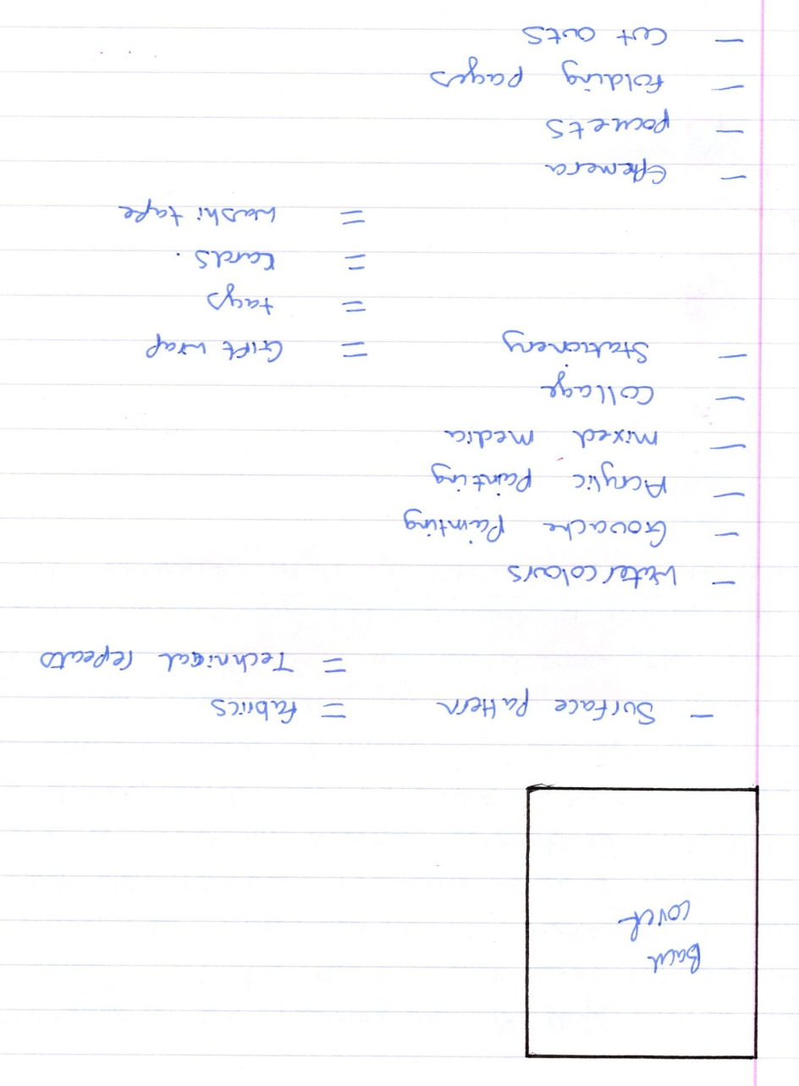

So I started on page 1, The ducks!
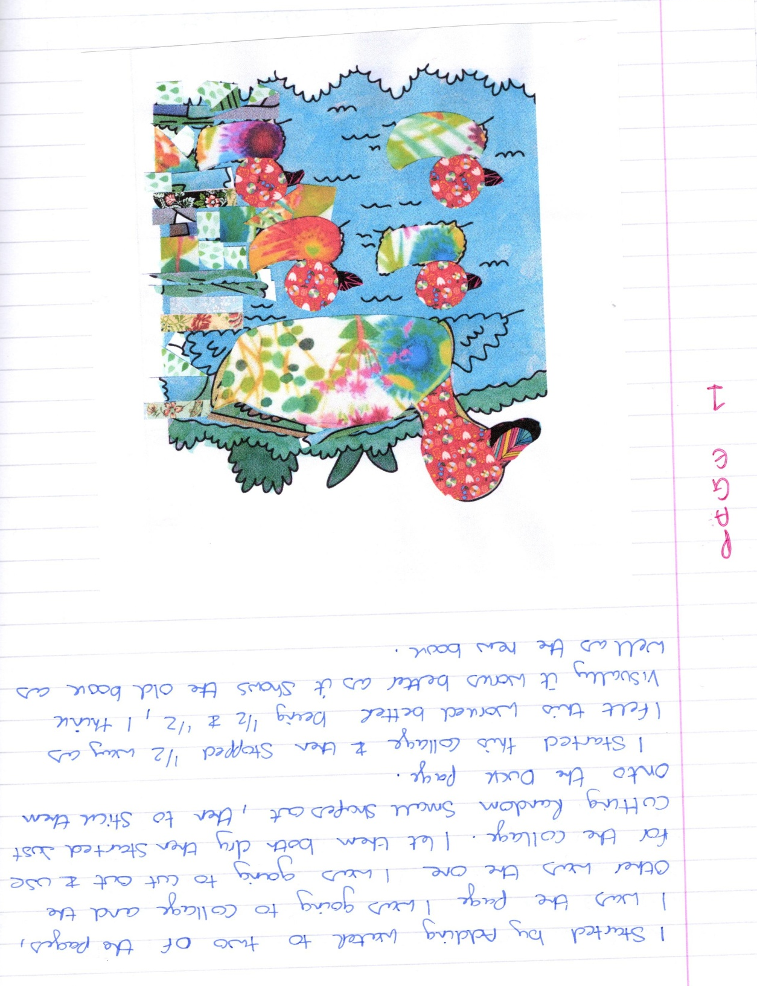
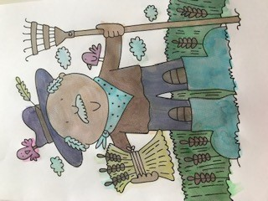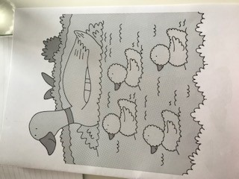
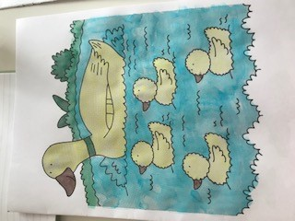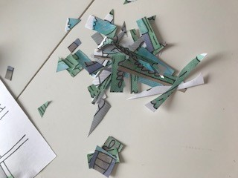
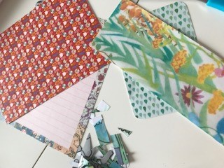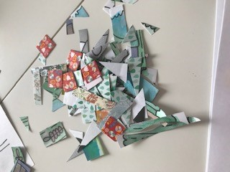

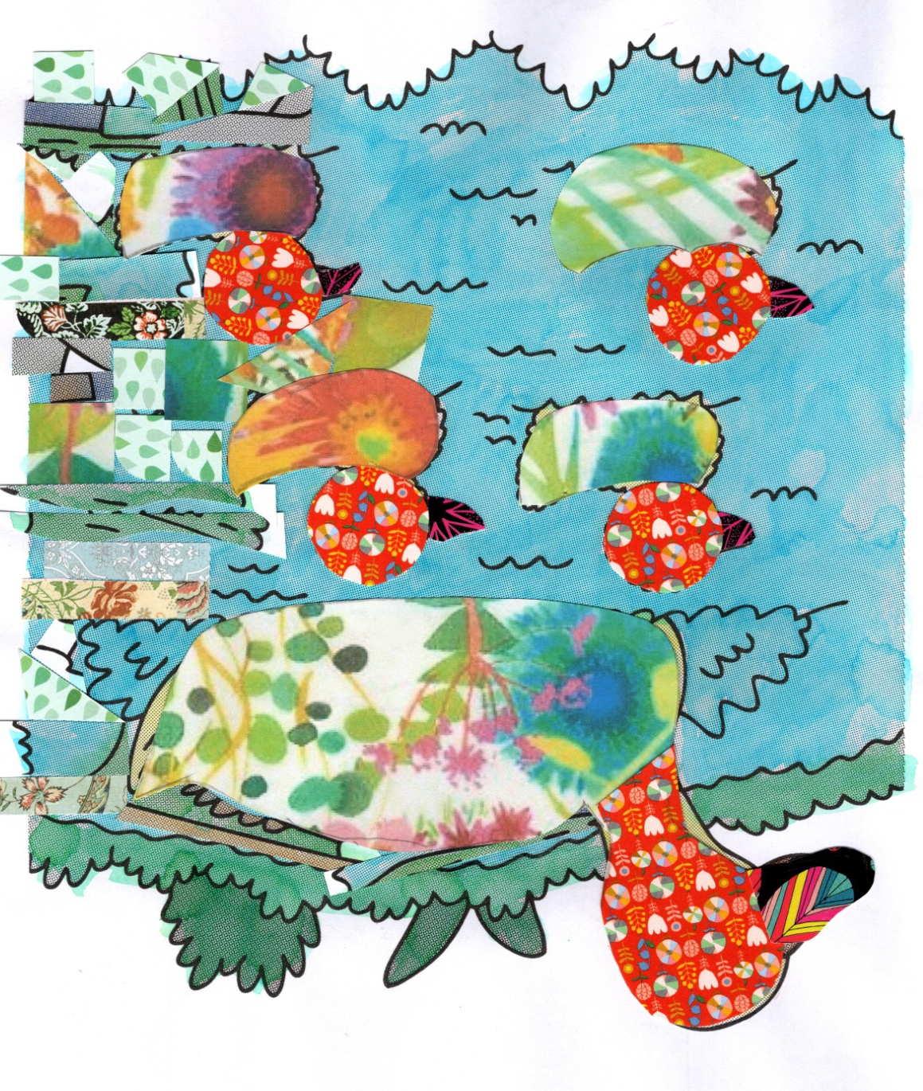
I then started on page 3 the butterflies.
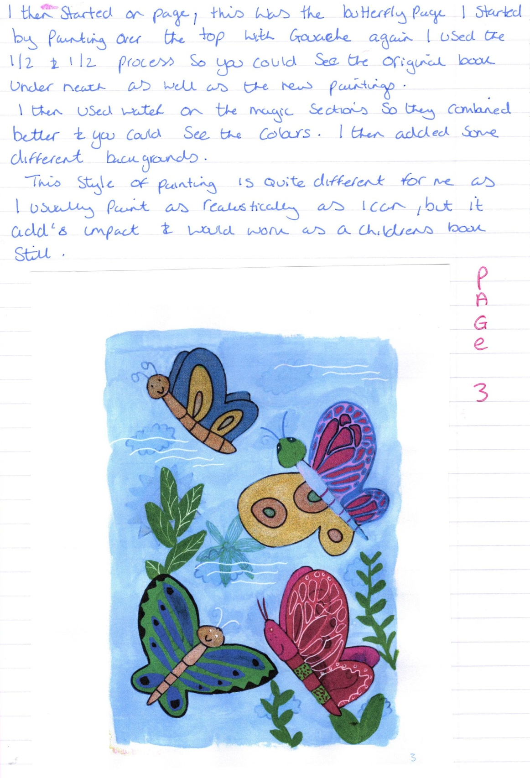
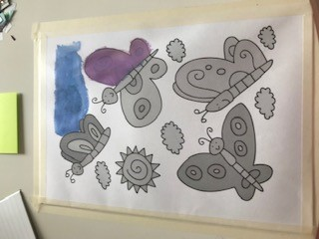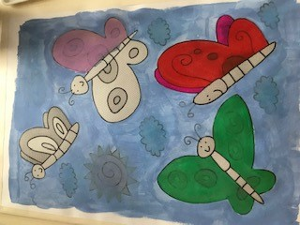

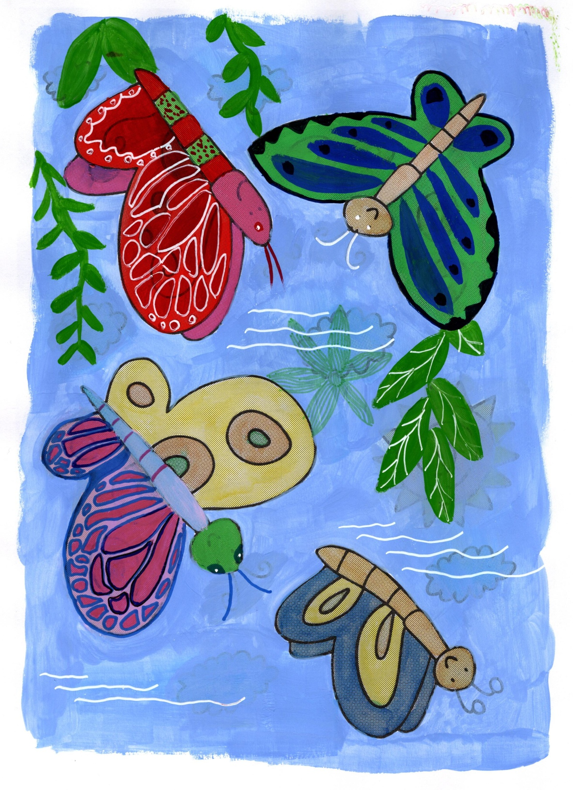
I started on page 2 by covering the page with Gouache paint.
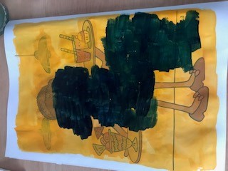
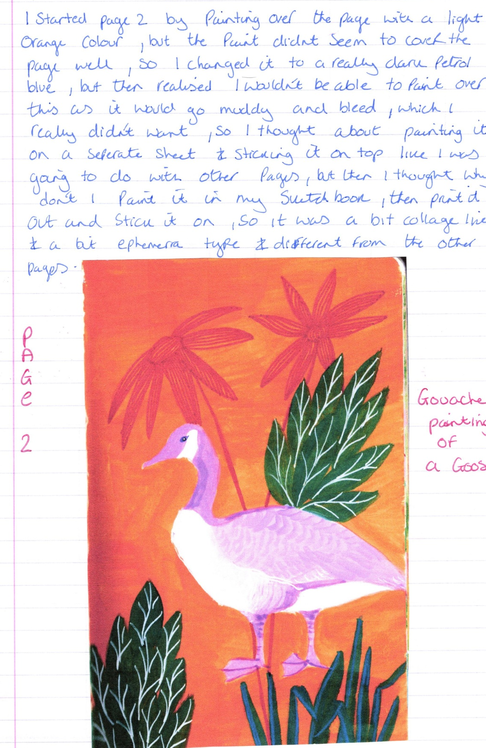
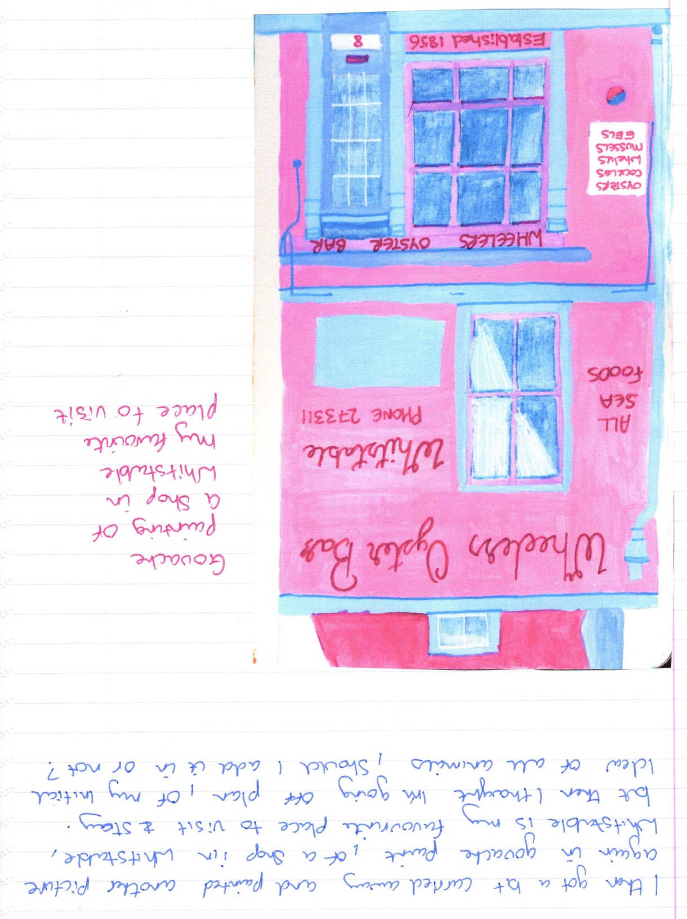
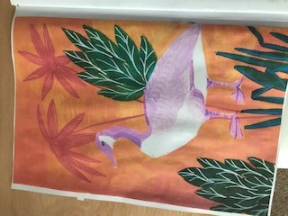

I then started on page 4 which was the dolphin painting, I started by getting a sheet of watercolour paper out, I then drew some dolphins and painted these in layers with watercolours, I added a bit of mixed media with watercolour and coloured pencils along with a black fine liner and white Posca paint pen.
I then added this sheet of watercolour paper with the paintings of the dolphins over the original page, now I didn’t know whether to use the Washi tape to stick it down with, or whether Pritstick would work, or something better would be more suitable?!
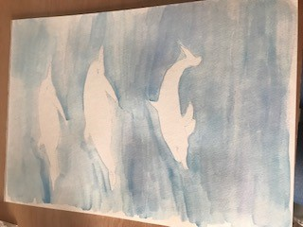
I decided to add the page at the end once I had completed the other pages, just encase I got paint on it, to be on the safe side.
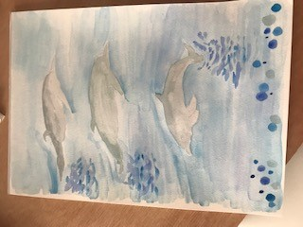
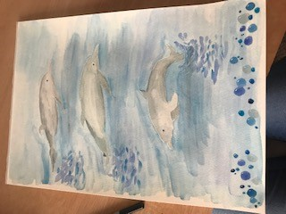

I then started on page 5 which was to be painted in acrylic this time, and I had to paint over the snake page. I decided to paint snakes on the top in my style, I haven’t painted snakes before so this would be out of my comfort zone.
I decided to try again covering the page with paint; I think acrylics cover better, so hopefully this works. I painted one coat and it seemed to coat better than the Gouache paint, so I did another coat just to be sure, and let that dry.
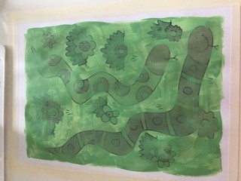
I then went onto page 9, which was where I needed to create some pockets out of the discarded pages that I could then put small paintings or fabrics or any little things inside really.
I started off by re-searching how to make pockets, but I soon realised I wasn’t any good, so I just made my own design up, which actually worked really well.
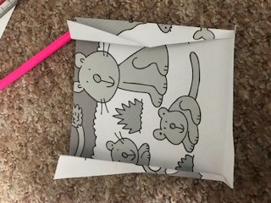
I tried to use the paper so the original animals were still showing, as I think I might just colour these in, I’m not sure yet?
This is the back, so you can see I just folded the edges over on either side, and then folded them back to make a concertina, this was for the sides, and then at the bottom I just folded it once.
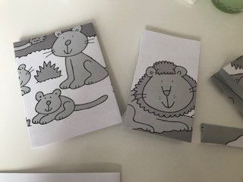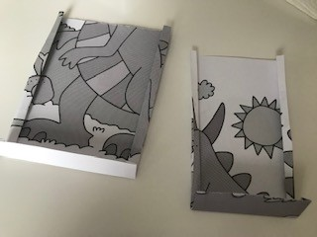

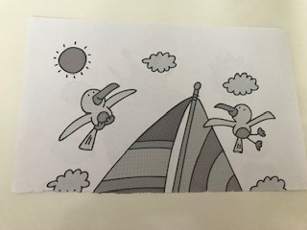
This is how they look like on the sheet, I have not stuck them down yet, as I’m still unsure of the colours and whether to keep the originals or not, maybe I should cover the background sheet in Ephemera, just to give a contrast?

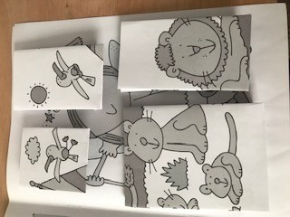

Page 10 Was going to be the page where I added extra bits, like tags and cards and different textures etc.
I found some ephemera that I thought would work well on this page and stuck these over the top of the original page, then added a gift tag which I had made, and printed off a card I had made too.
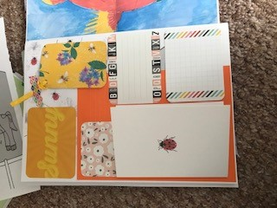
Inside the card I had another card which I had made, and underneath a watercolour of a rabbit, that was hidden. On the other side of the tag was blank, so you could add a drawing if you wanted too.
At this stage I did have to change a few of the pages from my original flat plan designs, purely because of the paint was making the paper too wet and rippled, the weight of some of the items made the pages to heavy, and something’s just didn’t work right with the feel of the book.
Page 11 changed to a gouache painting of a fish, I then scanned in the painting as I had done this in my sketchbook, and then printed it off on my computer, this made the picture easier to handle and was flatter when stuck down onto the original sheet.
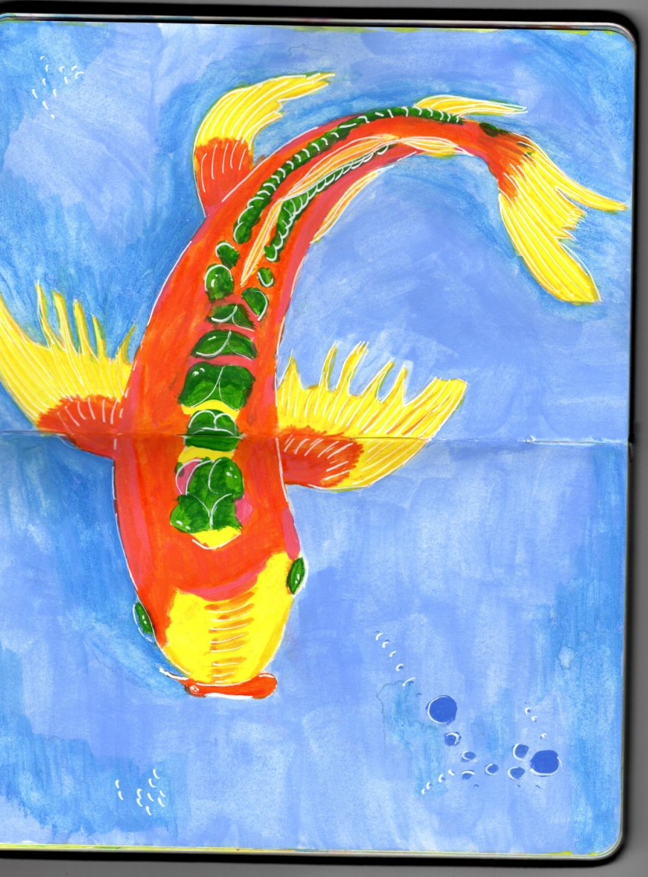
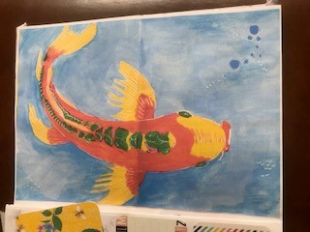
Page 12 was the last page this was the page where I wanted to re-use the donkey page from the original book in some way onto a new page. I went along the same lines as the page before and created a background scene with watercolours in my sketchbook, then scanned this into my computer and printed this out, then I cut out the donkeys and stuck them onto the page, so I used both the original page and made it new. I wanted to keep the donkeys black and white as this would be the original original page, rather than add water and it be coloured.
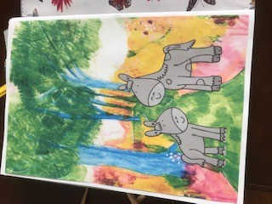
I then went back to the other pages that I had missed due to paint drying etc.
So we now go onto and back to page 5 the snake page, so I wanted to paint snakes again on this page but make them more into my style, I used acrylic paint for this.
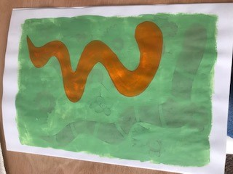
I tried to do different shape snakes and added an extra one on, as well as used different colours.
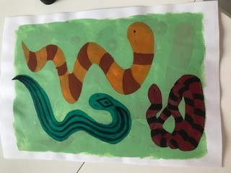
Page 6 was to paint the Toucan bird, for this one I used watercolours again, and painted the bird onto watercolour paper first then stuck that onto the original page.
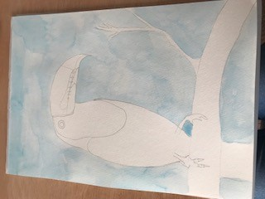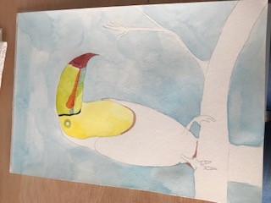

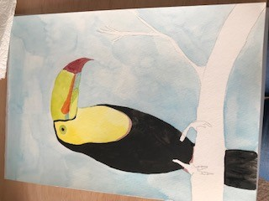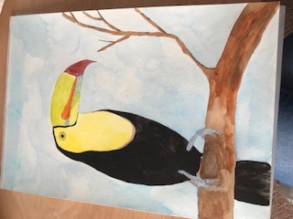

Then page 7 was a bit tricky, as I had changed the idea of origami into cutting out a shape from the page, but I was going to be using my Cricut machine for this, and it was going to be impossible to use the existing page from the book which I really wanted to use. In the end I cut the shapes out of blue and black coloured card and then made backgrounds for them to be stuck onto.
I had this design which I had painted so I photocopied it, and used a special sepia style edit on Illustrator to achieve this unusual tropical effect of the design, so I thought this would be great for the back ground of pages 7 and 8, I decided to use this for page 7, then I used the cut outs of the bear to stick onto the top.
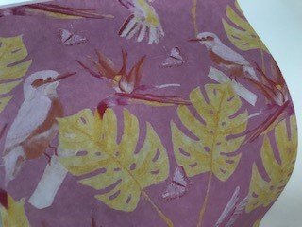
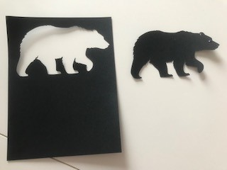
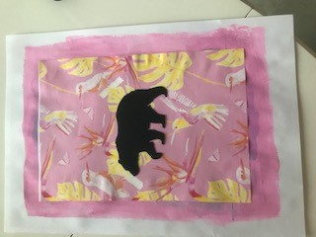
I painted this design in my sketchbook, as I thought this would be a nice colourful design and fitted in with the nature theme for page 8.
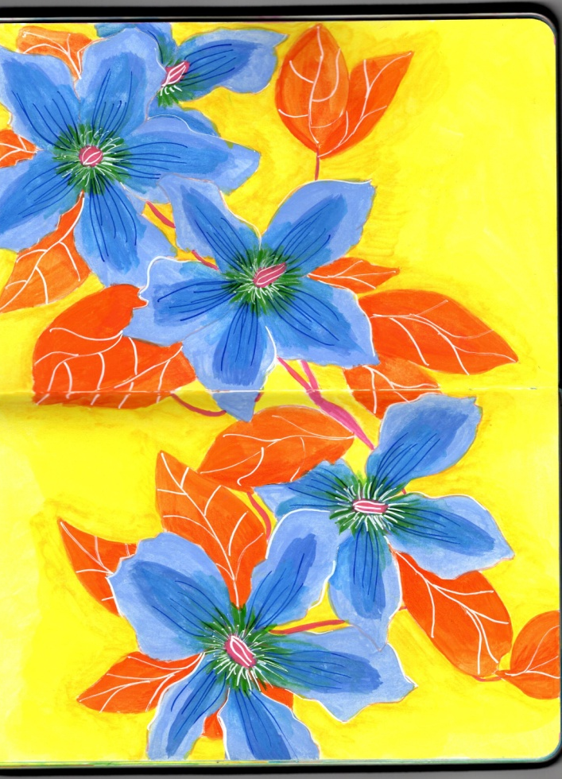
I then used the cut out card from the bears to add to the page, to create a negative space kind of design, a bit of ying and yang effect from the previous page.
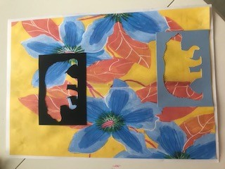

Then I went back to page 9 which was the pocket page, I painted the pockets using water, so the original colours would come out.
I then added some ephemera to the background page before I stuck the pockets onto the page. I found some nature and child friendly pieces, like the Beano comic picture.
I stuck the pockets on the top, then I added some little things to each pocket, the first one was some material I had had made from some of my illustrations, this gave a texture effect.
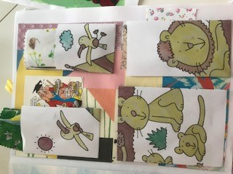
The second pocket had a little watercolour of a robin inside, the third one had some more material with my illustrations printed onto it, this was in a different fabric to the other, so a different texture experience. In the fourth pocket was the other cut out of the bear in blue.
I thought this page was a nice interactive page, with different textures, but still all my own illustrations and drawings.
So that then completed the book, the next stage I was going to think about was typography, but after thinking about it, I think I will not add typography! The original book didn’t have any words inside, the design of the book doesn’t need words, and I think it works better as a visual book, and that’s how I had thought in my mind how it would be anyway.
I then went on to think about binding, I knew binding by sewing or stapling would be difficult due the fabric covering. I looked back at the artists books I had researched and I really liked Mary Ellen Long’s design of her nature book. This then gave me the idea of not binding my book, and actually cutting the pages into individual pages so the viewer could decided in which order they wanted to look at the book. So I chose to add a middle tie to hold all the pages together in a kimono style way, and I chose raffia to secure it with, this was natural and would complement the book style and subject.
Also as a children’s book, it would add that extra special level of intrigue, as it’s different to books that they usually would look at.
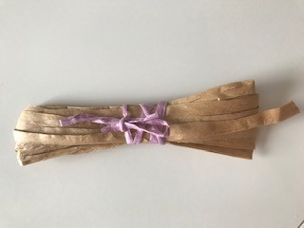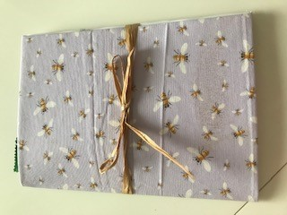

So these are the pictures of the pages in the order they were created for the book, although now they can be used and viewed in any order.
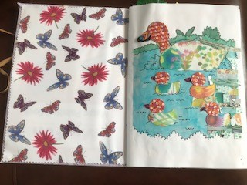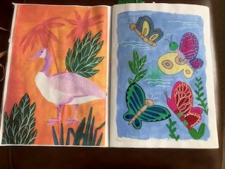

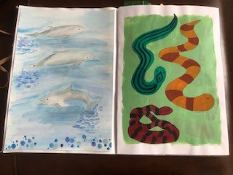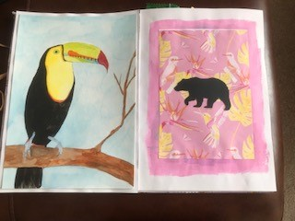
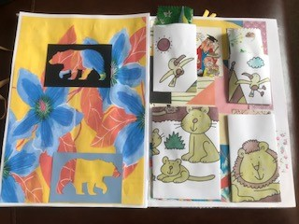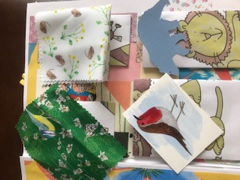

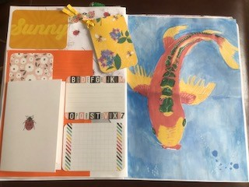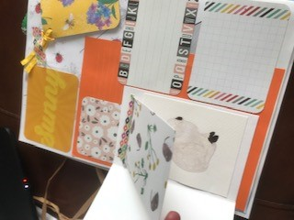

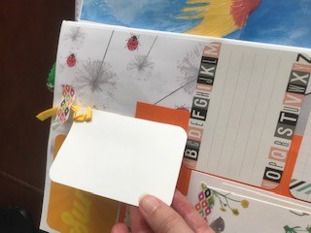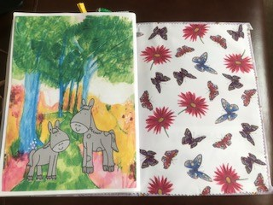

So after completing this assignment I thought about how the book has evolved and progressed through the process of my changing it. I wanted to create children’s art/ picture book from the original book, a book to show children that practising painting and drawing can lead to being a illustrator when they are older. The book now seems to represent my journey through my process of becoming a children’s book illustrator, using my skills as a surface pattern designer and painter to bring the books to life. My interest in nature and animals was at the forefront of the books subject, I wanted to keep it within animals and nature. I have used all the ideas I have of using my skills to develop a very colourful, fun and creative and texture rich illustrations for my books in the future. To have sensory elements to them, elements for the children to add their own things, write ideas down (page 9) and keep things hidden in the pockets on page 8.
I feel the process of doing this has also helped me to see in which direction I want to go into next with my degree, and how I can pull all my ideas together and create a style of my own. Although this book is not polished of finished to a high standard as it is using bits and pieces, it has helped me to cement what I wanted to know to take forward.
I enjoyed looking back through this section and using elements from artist I had researched and this gave me extra ideas and new ways to go, and to change directions, yet still come out to the right place again.
To me the form of a book is now very different to how I had perceived it before, it is now somewhere else I can be creative, it is how I can show everyone what I want them to see and learn. I enjoyed thinking about each page differently, and having the creative freedom to add what I wanted or to take away what I wanted.
I enjoyed the whole process of making this book; I am very much a practical learner and enjoy making things and being creative. I also like the fact that the reader/ viewer also has freedom to look through the book in any way they like, and when they put it down the next viewer will see it in another way as the pages will be left in a different order.

