Artist books
Find two artists’ books that you feel demonstrate an interesting relationship between their form and content through the materials that the artist has chosen to use. Reflect on these books in your learning log.
First of all I look at the link provided in the brief and had a look at the artist work there, the two I liked the best and had some affinity with was Mary Ellen Long and Kurt Allerslev’s both were actually the first two listed.
I then went on to research them further on their own websites, but the work on the website of Mary Ellen Long was not as interesting as the artist book that was written about in the link, so I used this piece of work to compare.
Also with Kurt Allerslev’s work, I found the booklet listed the most interesting, after having researched him more from his work.
I looked at the work of Mary Ellen Long “Site and Spirit” and also Kurt Allerslev’s “Hy.potenuse” artist’s books.
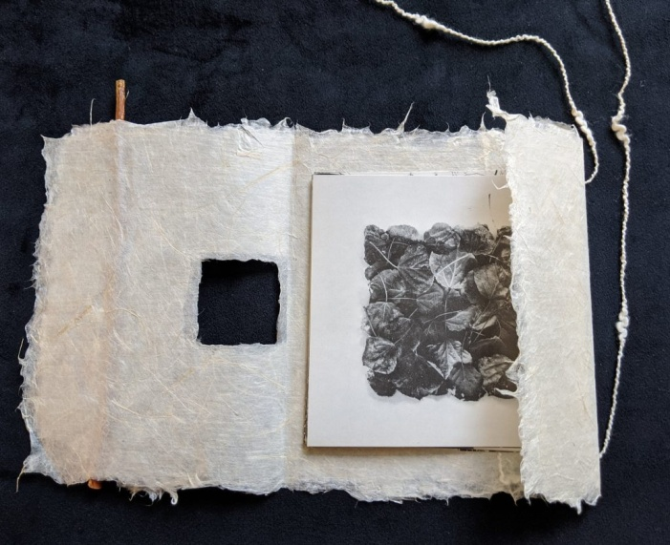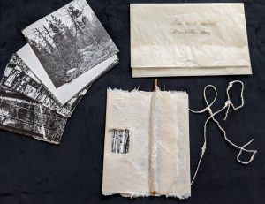
I found that Mary use’s nature and elements that are found outside, and around her home to create her books and work. I liked her idea of using a handmade cover with a twig to secure the loose cover, and natural products that would naturally decay.
I also liked her idea of leaving the pages (photographs) loose, so the reader (viewer) could choose which way to look through the pages and change the order they view them, as that would mean that everyone would view it differently.
I like that the front of the loose cover has a small hole in it so you can see a snippet of the work behind, this is also a nature study from her photographs, so this would work with the cover well, and link in that way too. Again dependent on what pages the last viewer left the photographs, this would or could be viewed differently by everybody else too.
I like the colour of the paper from the lose cover too, it’s very natural, soft and pure in the design and the way it would feel, seeing and feeling this with the twig catch would also be great for the natural connection.
The photographs inside would be smooth and may be glossy or matte, but the contrast would work well with the natural cover, the 14 photographs and artist statement inside would be left up to the reader in which way or order they would be read and seen, making the book a personal individual experience.
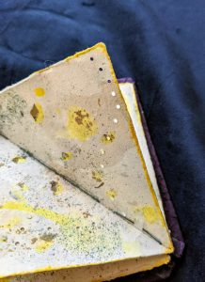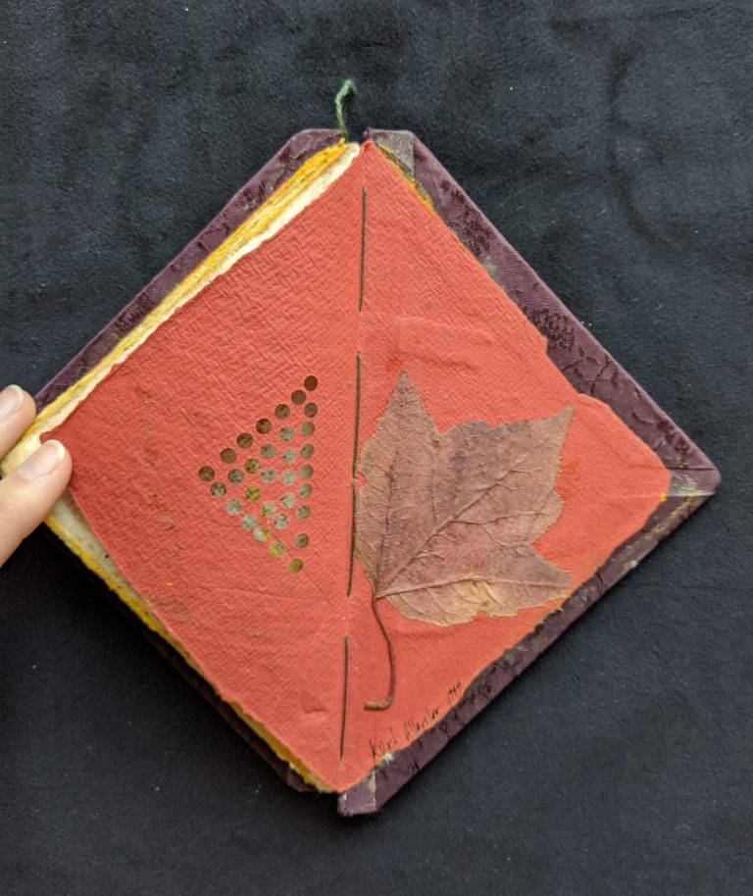
I found that Kurt’s work was different in that his work formed the pages; he used nature, juice, spices, flowers and seaweed to form the actual pages. I like his idea and use of textures in his book, and how each page is different, it feels and looks different.
I like the design and shape of his book too, it looks chunky and textured to touch, and you can see the textures visually as well as feel them in a sensory way.
The book was handmade and hand stitched, bound with natural papers, as well filled with natural papers. The colours were from nature using spices to colour the paper, found objects from nature leaves and flowers became part of the work, and it all linked together from his day job as a scientist.
The viewer would be able to understand more about the artist after looking through this book, and seeing their interpretations and views from their perspective.

