Concrete poetry
Identify an example of Concrete poetry and write a short critique of the content, design and relationship between content and form.
Look at the typography, layout and space to help generate meaning. Print out a copy of the poem add notes directly on the page, write a brief summary of thoughts, feelings and reflections on how Concrete poetry creates new meanings.
The first thing I did for this exercise was to look at the artists in the brief and find one I connected with the most to write about, and to also understand the concept behind Concrete poetry.
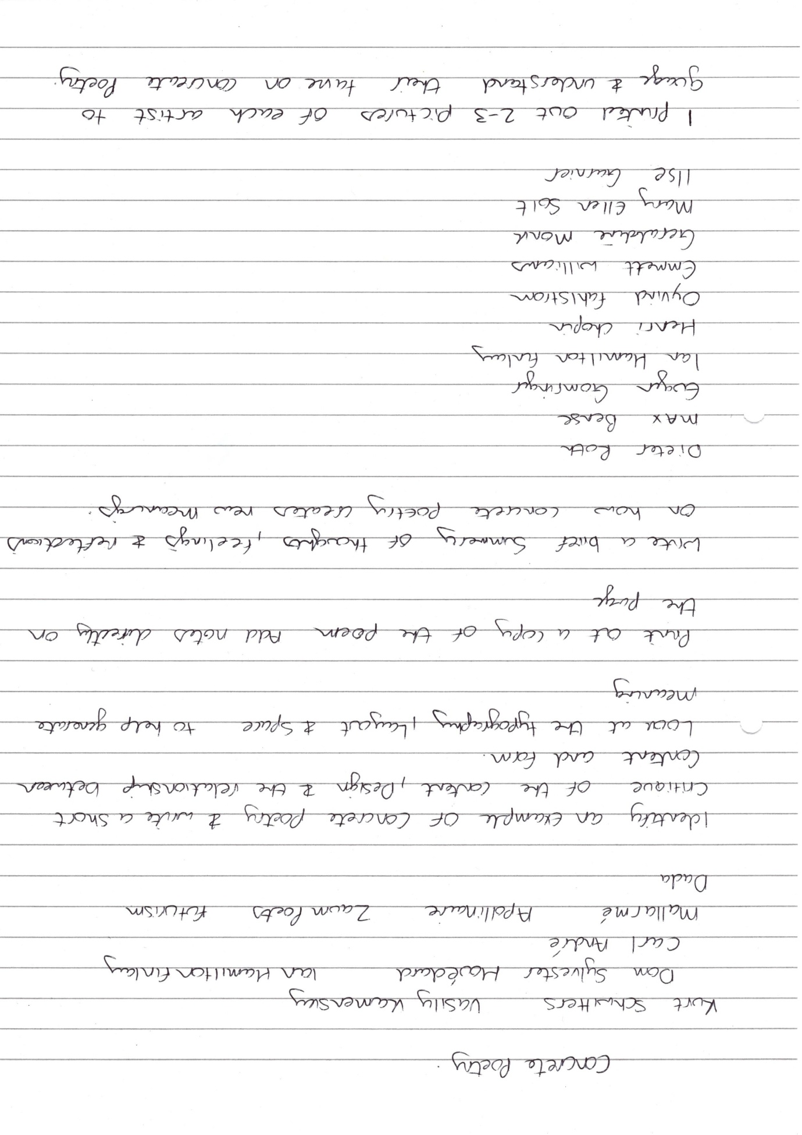
I actually looked through all the artists then decided to find some of their work, so that I could compile a few pages in my sketchbook, to show some of their work.
I researched Kurt Schwitters first as he was mentioned in the brief, I found some of his work and his collages and printed these off to place in my sketchbook.
I then decided to do this with the other entire 10 artist listed in the brief; I found this helped me to understand more about concrete poetry and art in general, and about the Dadaism movement.
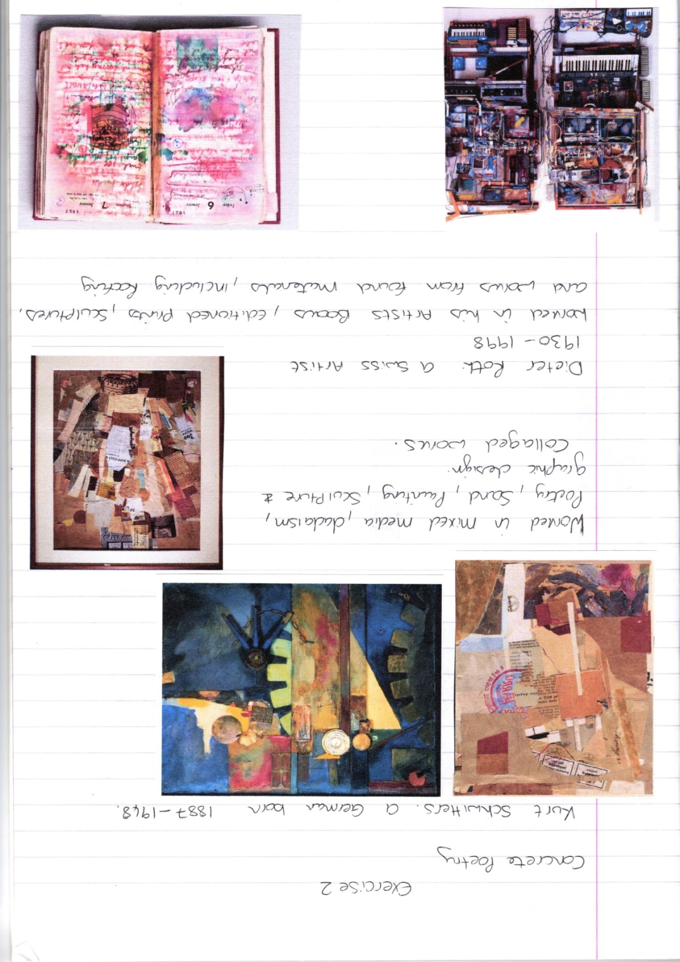

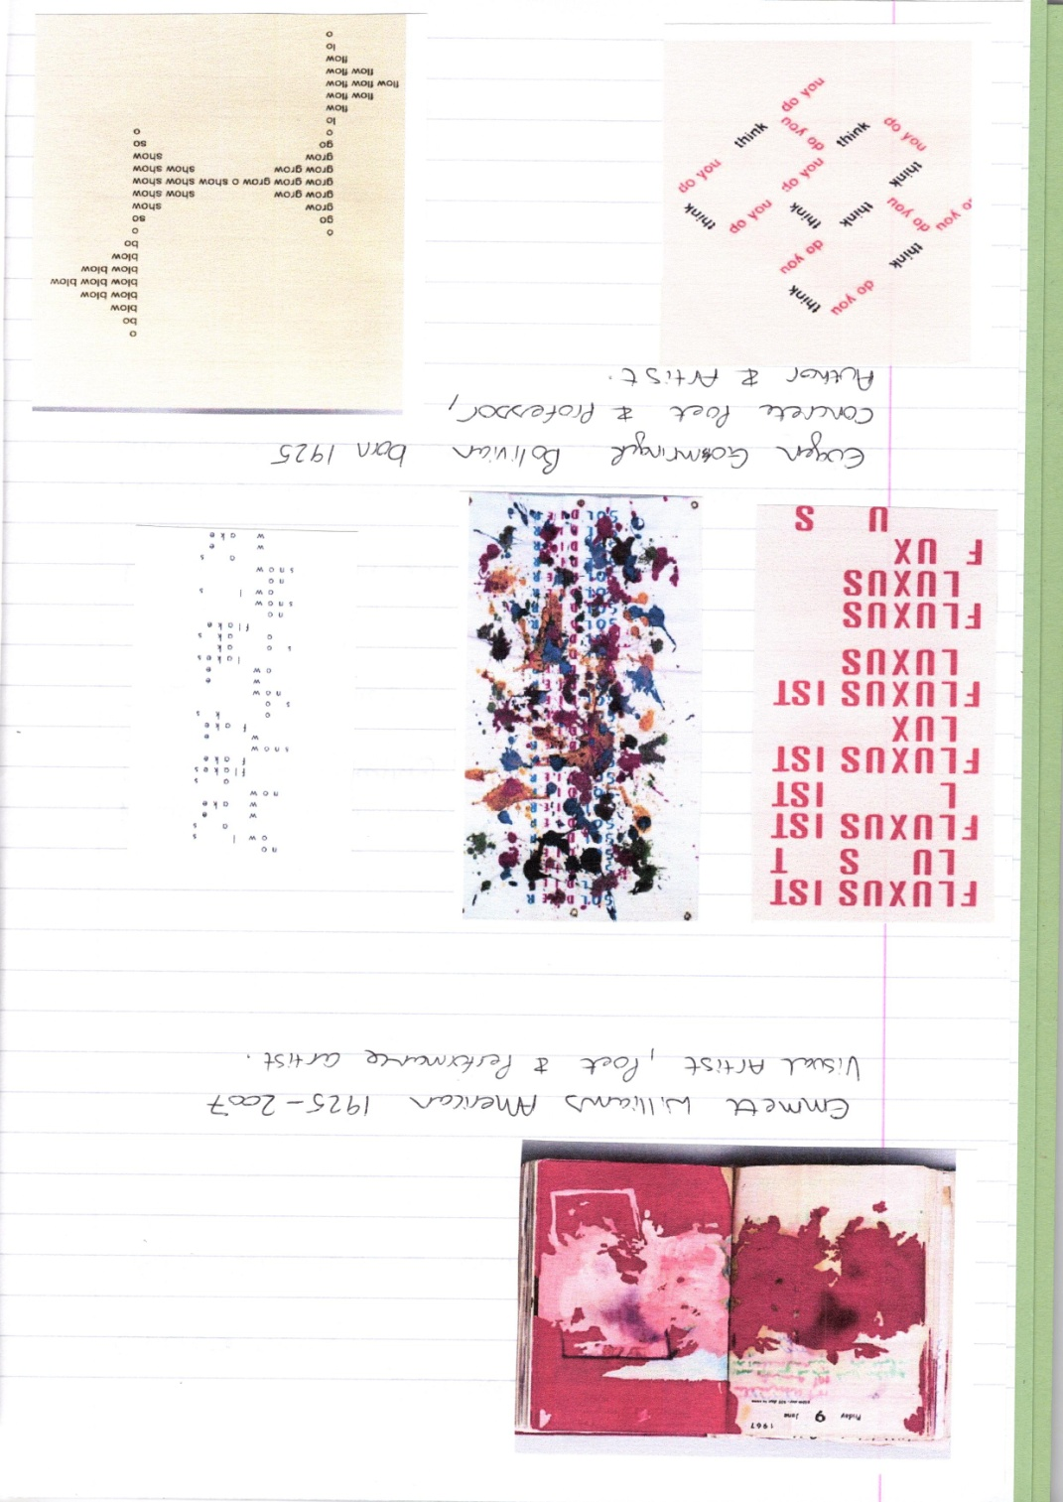

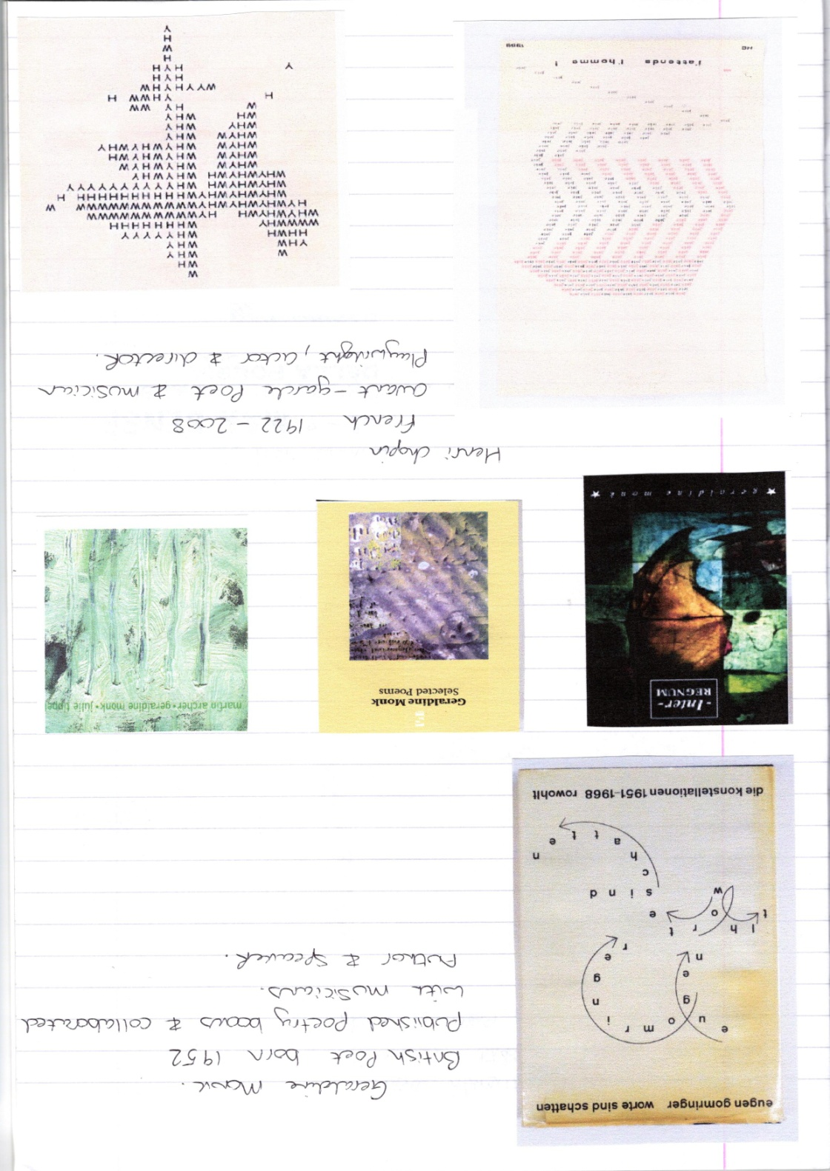

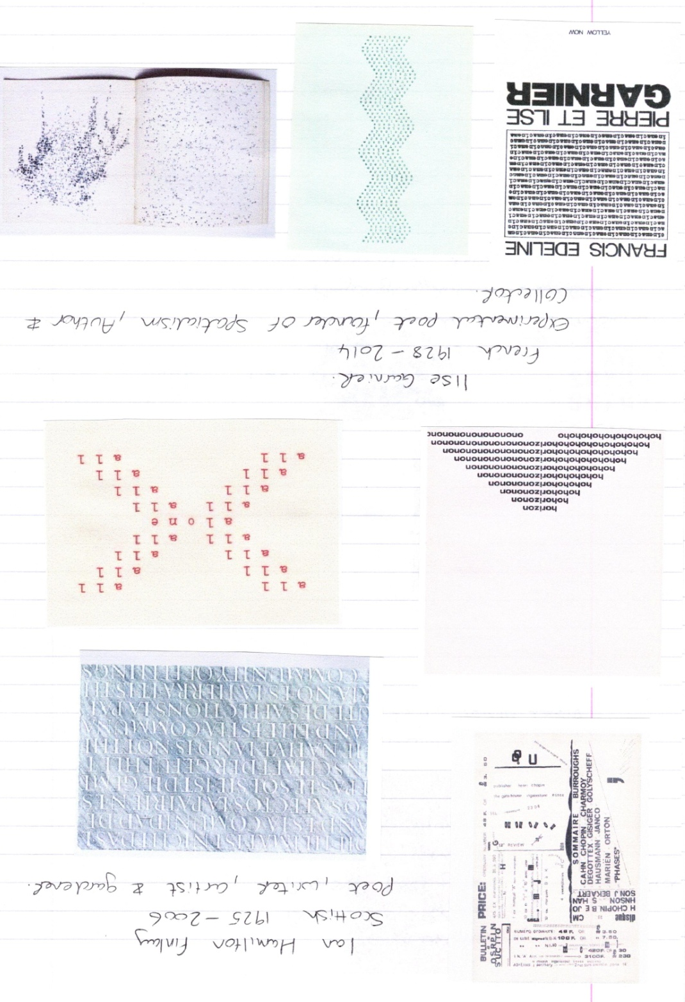

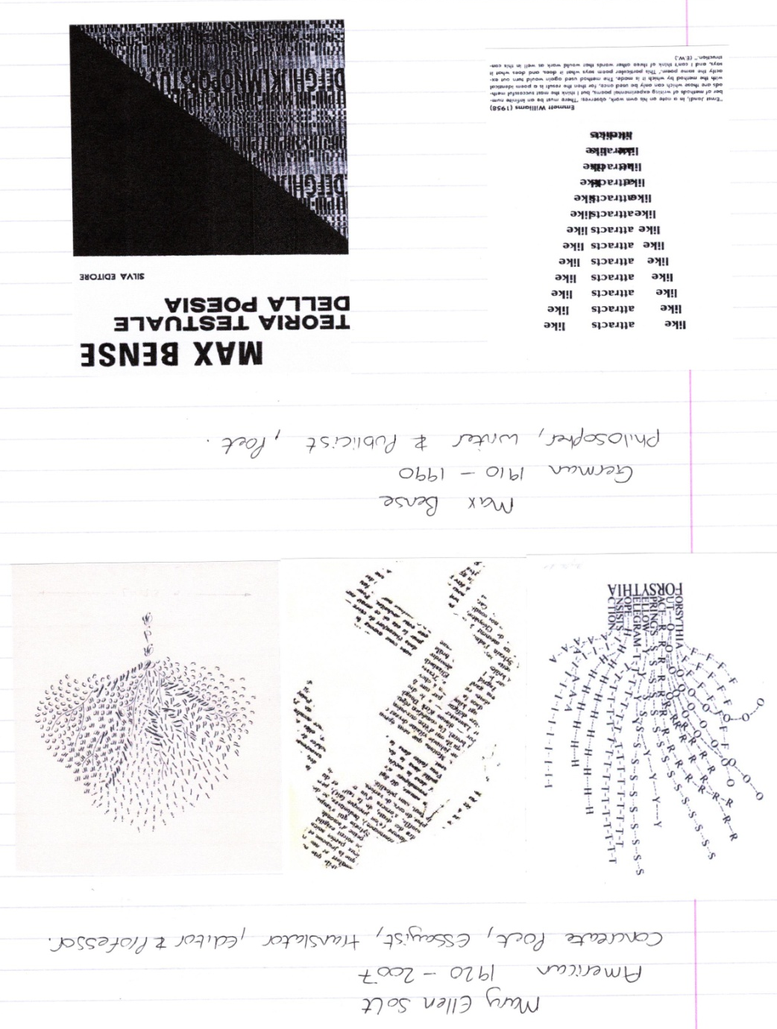

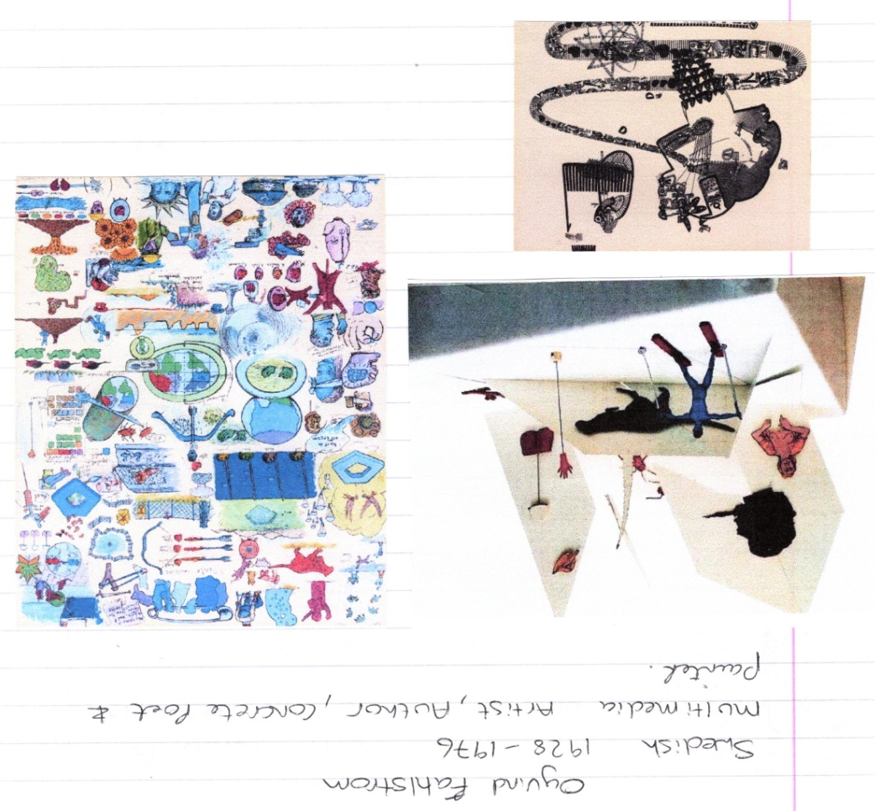
The artist who I had the most connection with was Mary Ellen Solt, particularly her book
‘Flowers in Concrete’, ‘Wild Crab’ poem.
Concrete poetry is an arrangement of linguistic elements in which the typographical effect is
more important in conveying meaning than verbal significance.
Verse that emphasizes non linguistic elements in its meaning, such as typeface that creates
a visual image of the topic.
I chose the ‘wild crab’ poem; the main words from the poem are used as the main branches
and trunk of the tree, the leaves, smaller branches or flowers are made up of individual
letters from the words, mainly the first letter of the word.
The typography is very decorative and has curls and flourishes and works well with the idea
of growth.
The space between the words are filled with spacious letters of the same kind, this shows a
consistency and the space between the individual letters get wider as the tree gets taller.
The design has a feel of movement, of swaying and wind, the design feels light and airy, yet
the words anchor the tree from the bottom.
I will need to continue to understand more about concrete poetry, but I can see how visual
representation creates new meanings from the words.
I think the visual space is just as important and also the type face chosen. I think colour is
also a good visual tool that could be used to good effect here. Having the words in brown to
represent the branches and trunk, and the individual letters could be in hues of green to
show the leaves.
Although I found it difficult to understand the relationship with the poem, I can see the
visual connection, and why the words were chosen.

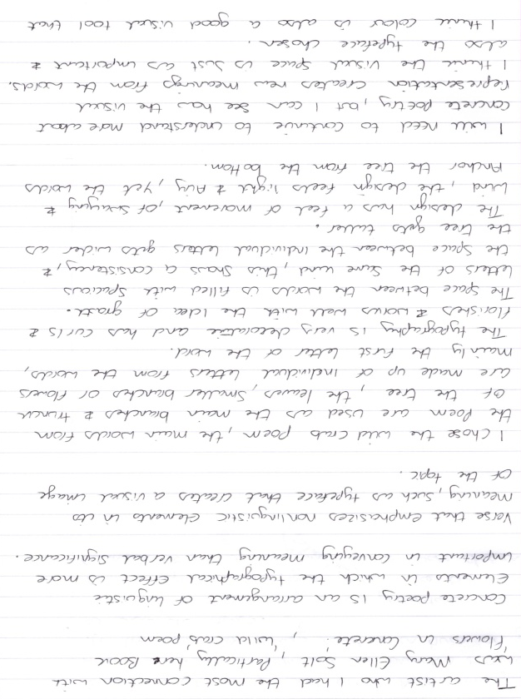
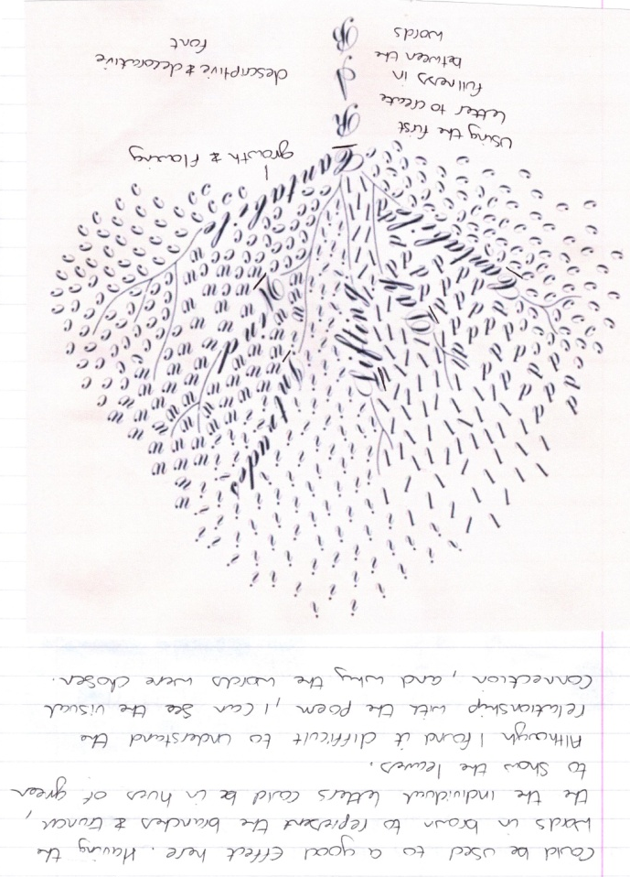
Visual task
The first thing I did for this task was look at Mary Ellen Solt’s a World view, just to understand better, how the concrete poetry process works, and how they came up with their ideas of using words and letters the way they did.
- Concentration upon the physical material from which the poem or text is made
- Words reduced to their elements of letters (to see) syllables (to hear)
- Some stay with whole words, others find fragments of letters or individual speech sounds more to their needs.
- Reduced language.

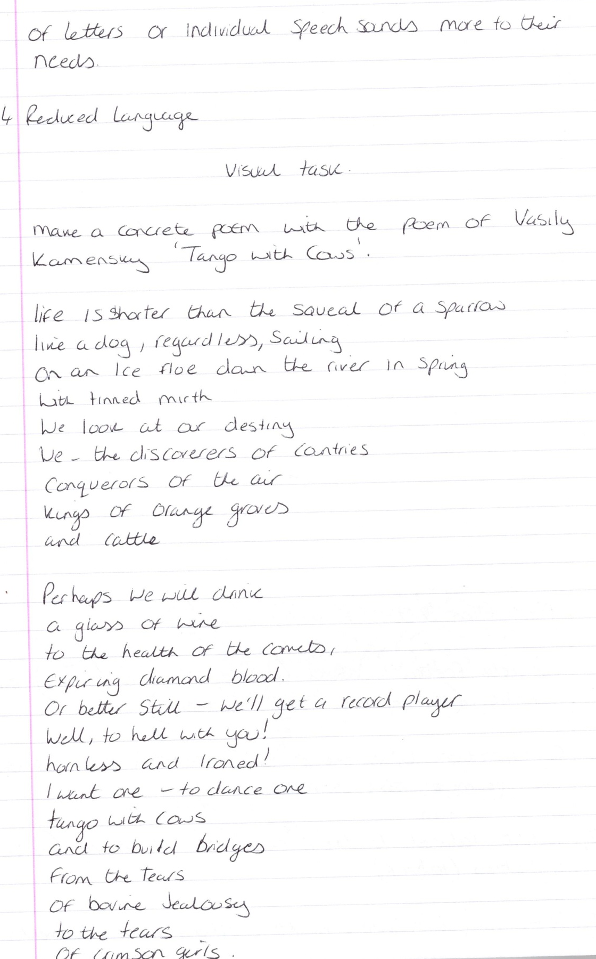

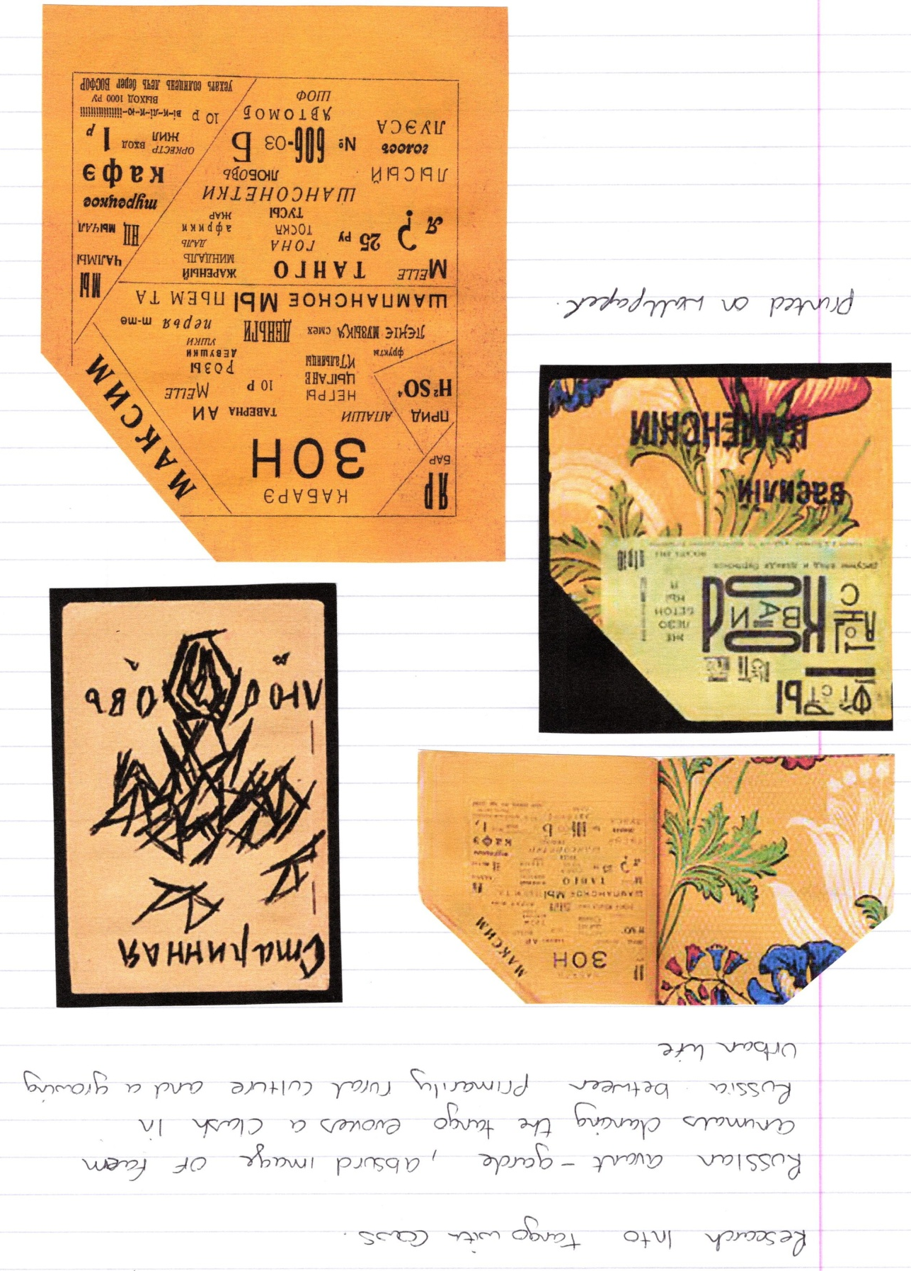

After the research I went back and read the Tango with Cows poem again, then I highlighted the words that I thought summed up the meaning of the poem in short.
The words that I chose were:-
Spring
Groves
Cattle
Dance
Cows
Crimson

I then thought about how this would work, then I went back and changed the word cattle for the word tears, because cattle is similar to cows and I felt that the tears were an important part of the meaning of the poem, so I swapped these two about.

Spring
Groves
Dance
Cows
Tears
Crimson

I then went onto draw a spider diagram to come up with some more ideas from the words above.
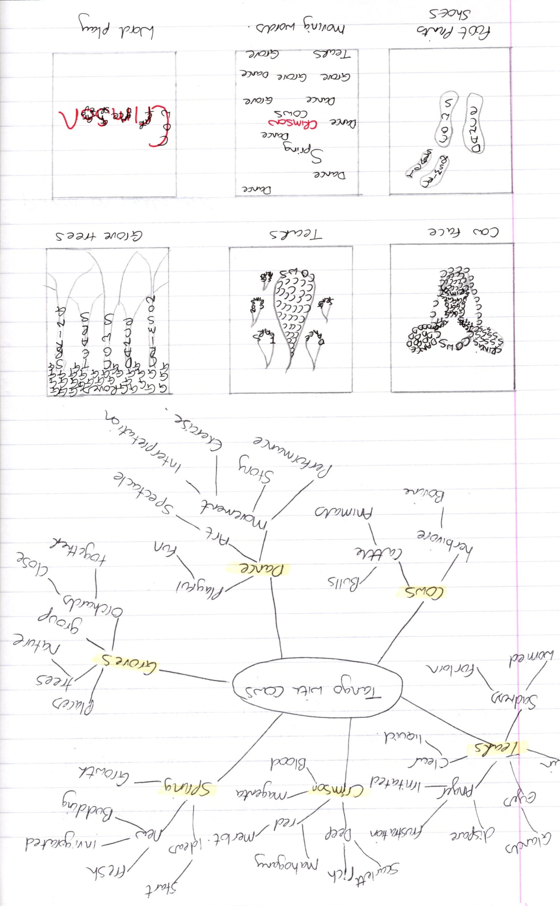
I then came up with six very different designs/ ideas in thumbnails for the style I was looking at. The first one was a cow’s face and then the words used on different areas, so for example the tears word would be on the eyes, with the letter T used to fill in the eye areas.
The second idea was for tear shapes, and then again the words used on the visual elements and filled in with the first letter of the word.
The third idea was to create a tree grove, then use the words as the trunks of the trees, but I felt this was very similar to Mary Ellen Solt’s ‘Wild Crab’ poem.
The fourth idea was to use the dance element visually and have shoe prints filled in with the words I had chosen.
The fifth idea was using the words sporadically across the page, like they were dancing around, with the ‘Crimson’ word in red.
Then the sixth and final design idea was a take further on the idea above, to use the word ‘Crimson’ in red again, but bigger this time, then the other words layer over each letter.

I then researched into typefaces and chose four different fonts’s to take further, to see if they would work with the designs.
I then decided to take one typeface further ‘Monotype Corsiva’, but then found another typeface to take further ‘InkFee’.
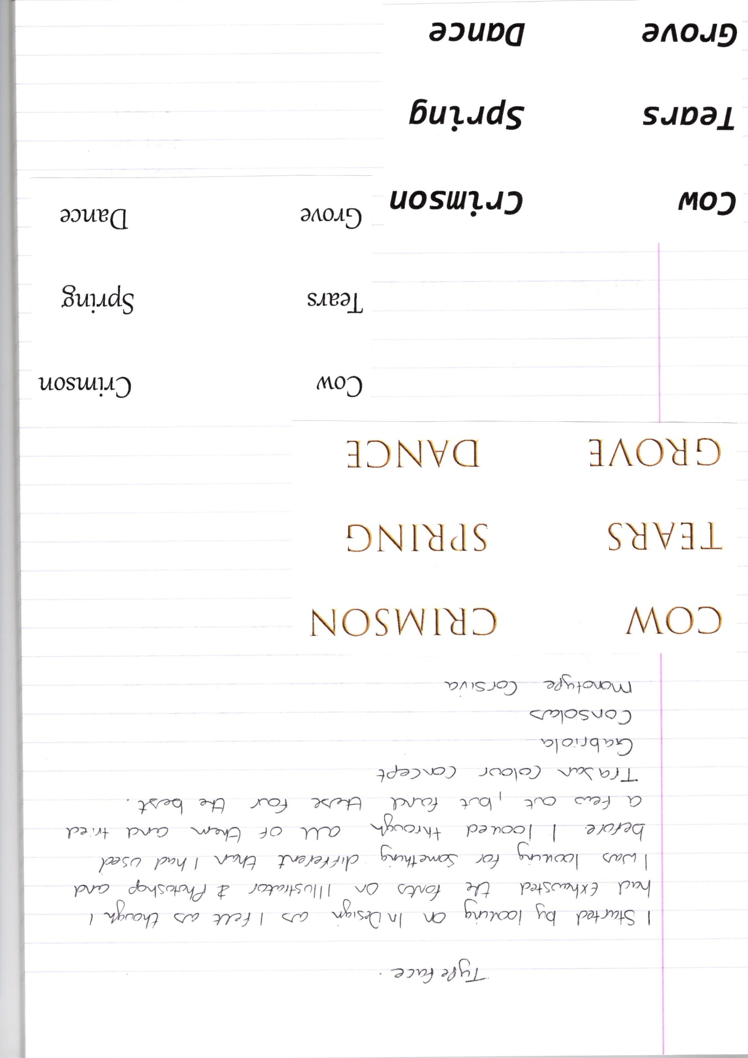

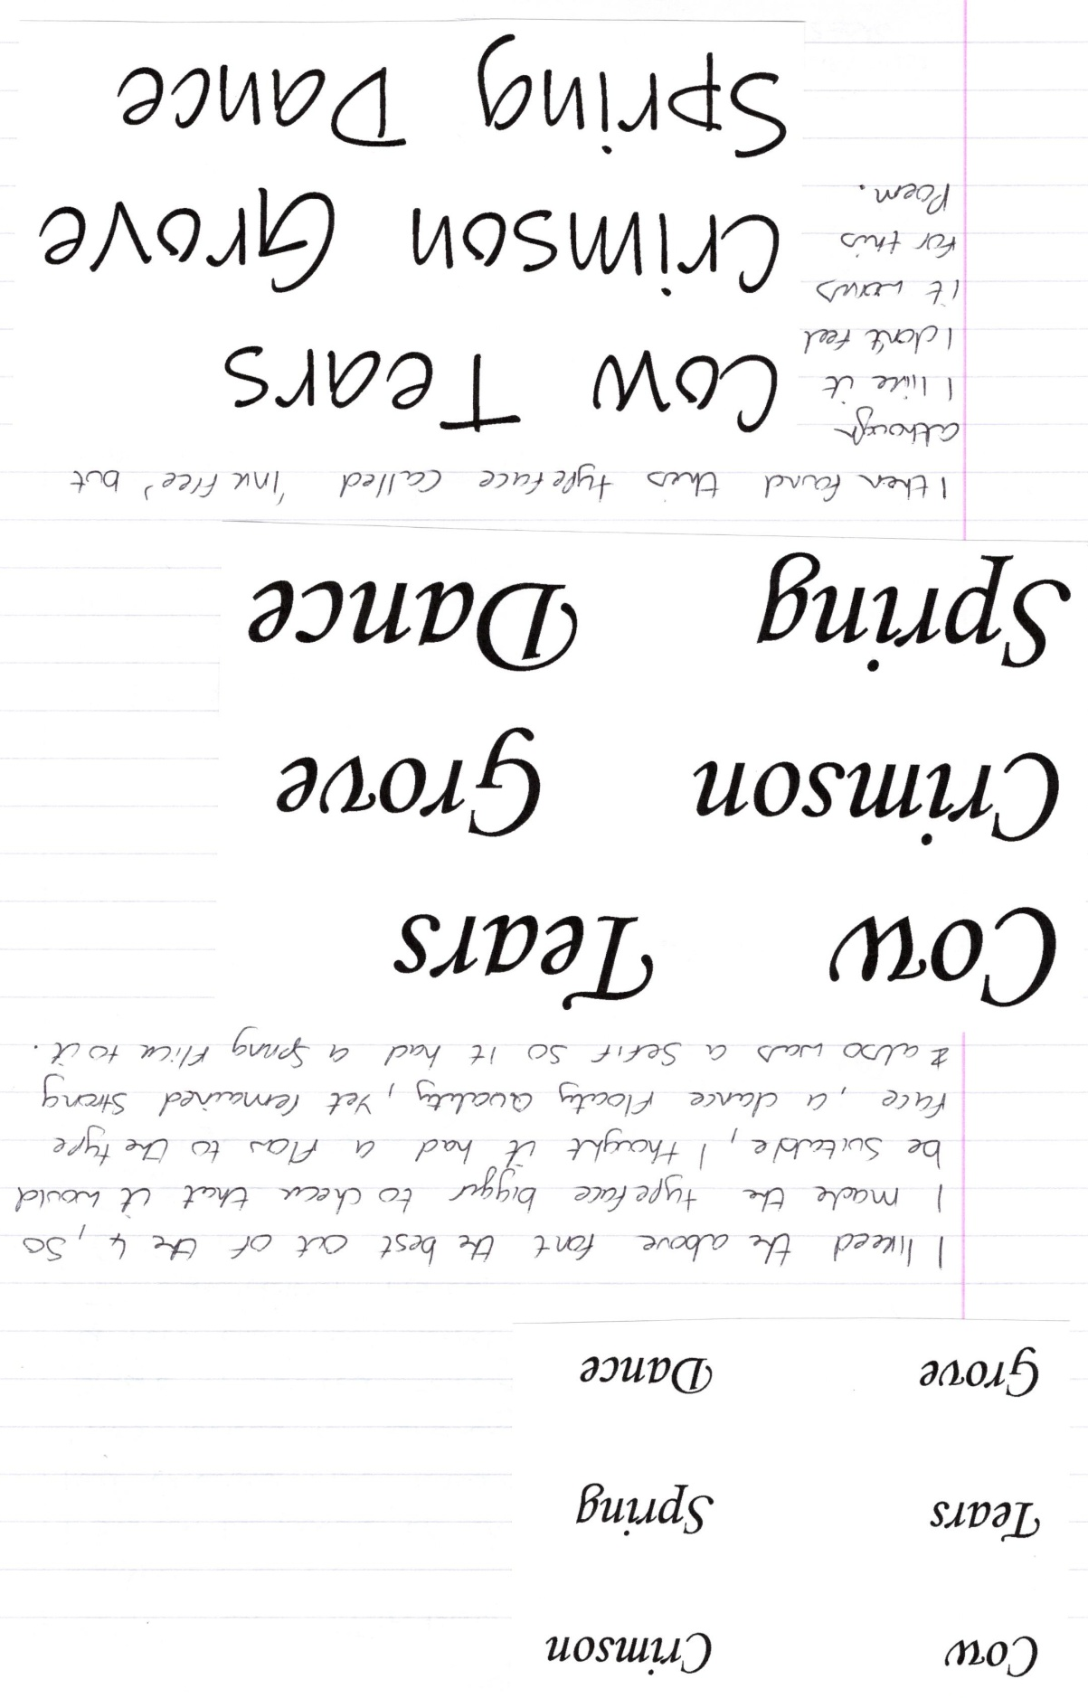

I started to think about my design ideas and what one to take further first, I liked the first one, second one, and sixth design.
So I started with the first one to see how this would look, as this was my favourite and I think it took the poem on well.
I did a rough simple sketch of a cow’s face, and then used that layer to build up the typeface on top.
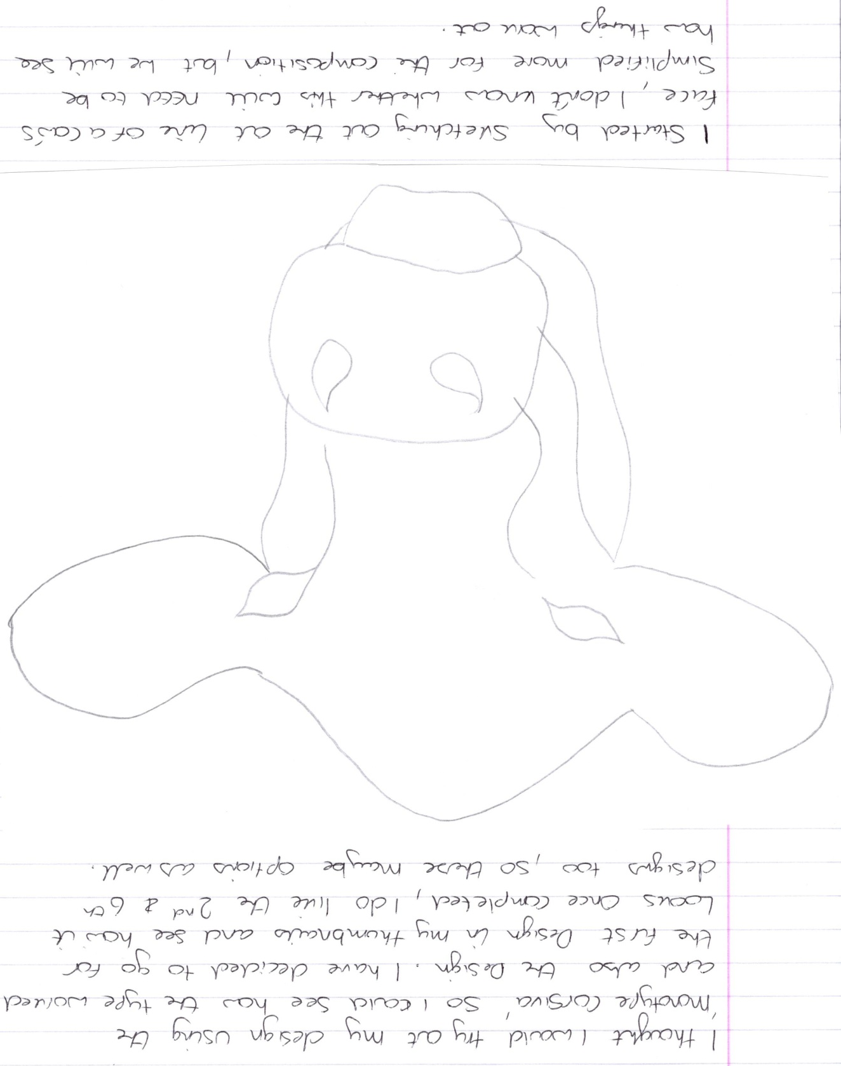
I started on In Design to create the outline of the cows face using the typeface font, it was a lot harder than I thought it was going to be to make the font go around the outline.
After an initial attempt, I then went into Illustrator and found this worked much better, to create this sort of design. I managed to hide the outline layer so the words just showed through; this made the design look much more like concrete poetry and professional.
I tried a few attempts at different designs and printed these out, in the end I chose to use two designs into one, but reduced the size or the design, and keep the typeface and letters simpler.
See my sketchbook pages for more in depth work.
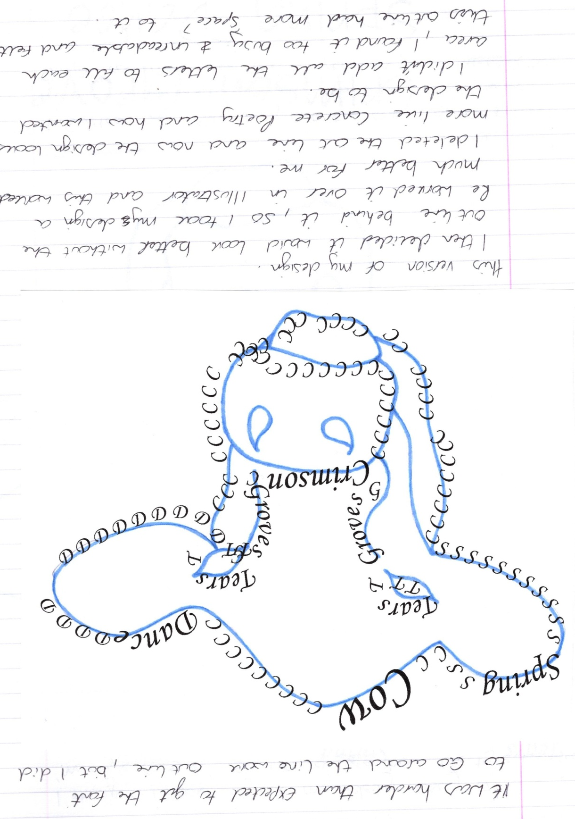

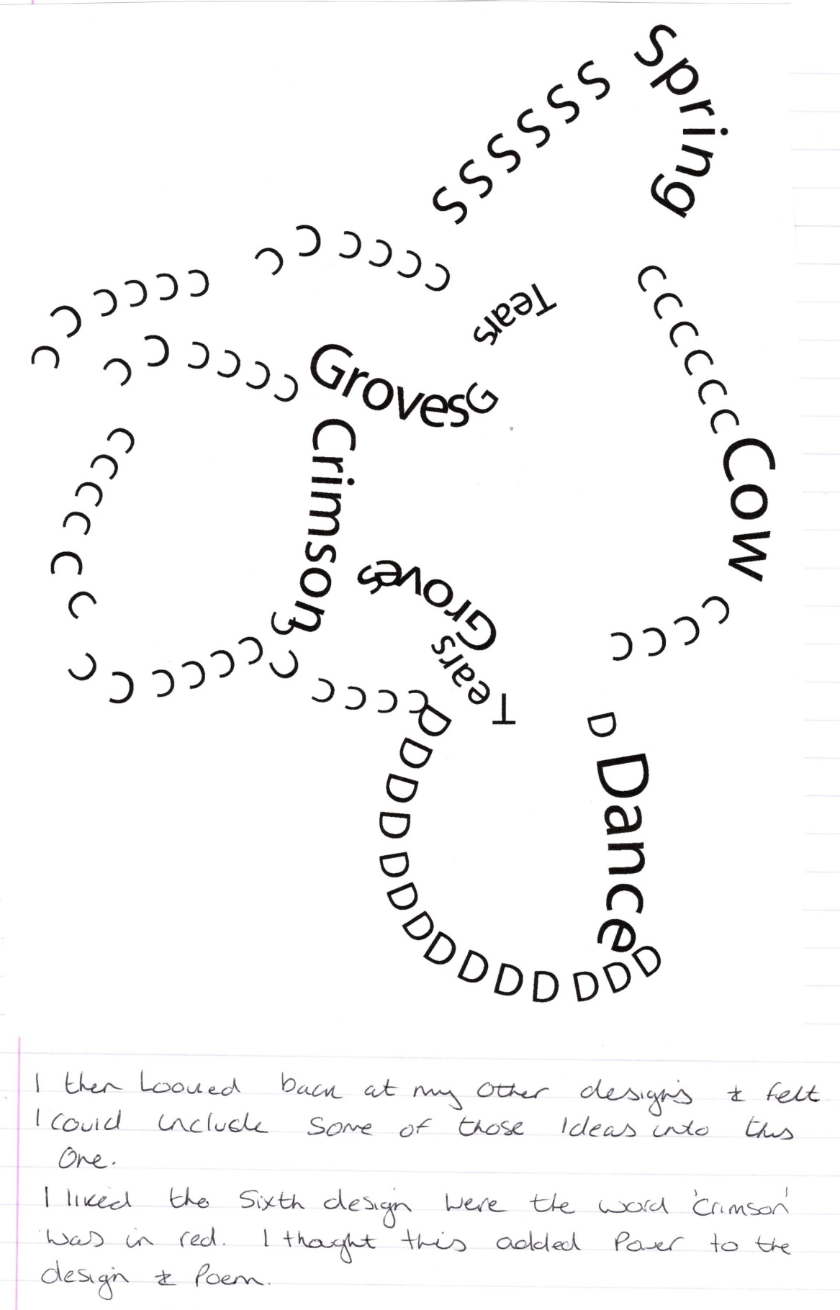

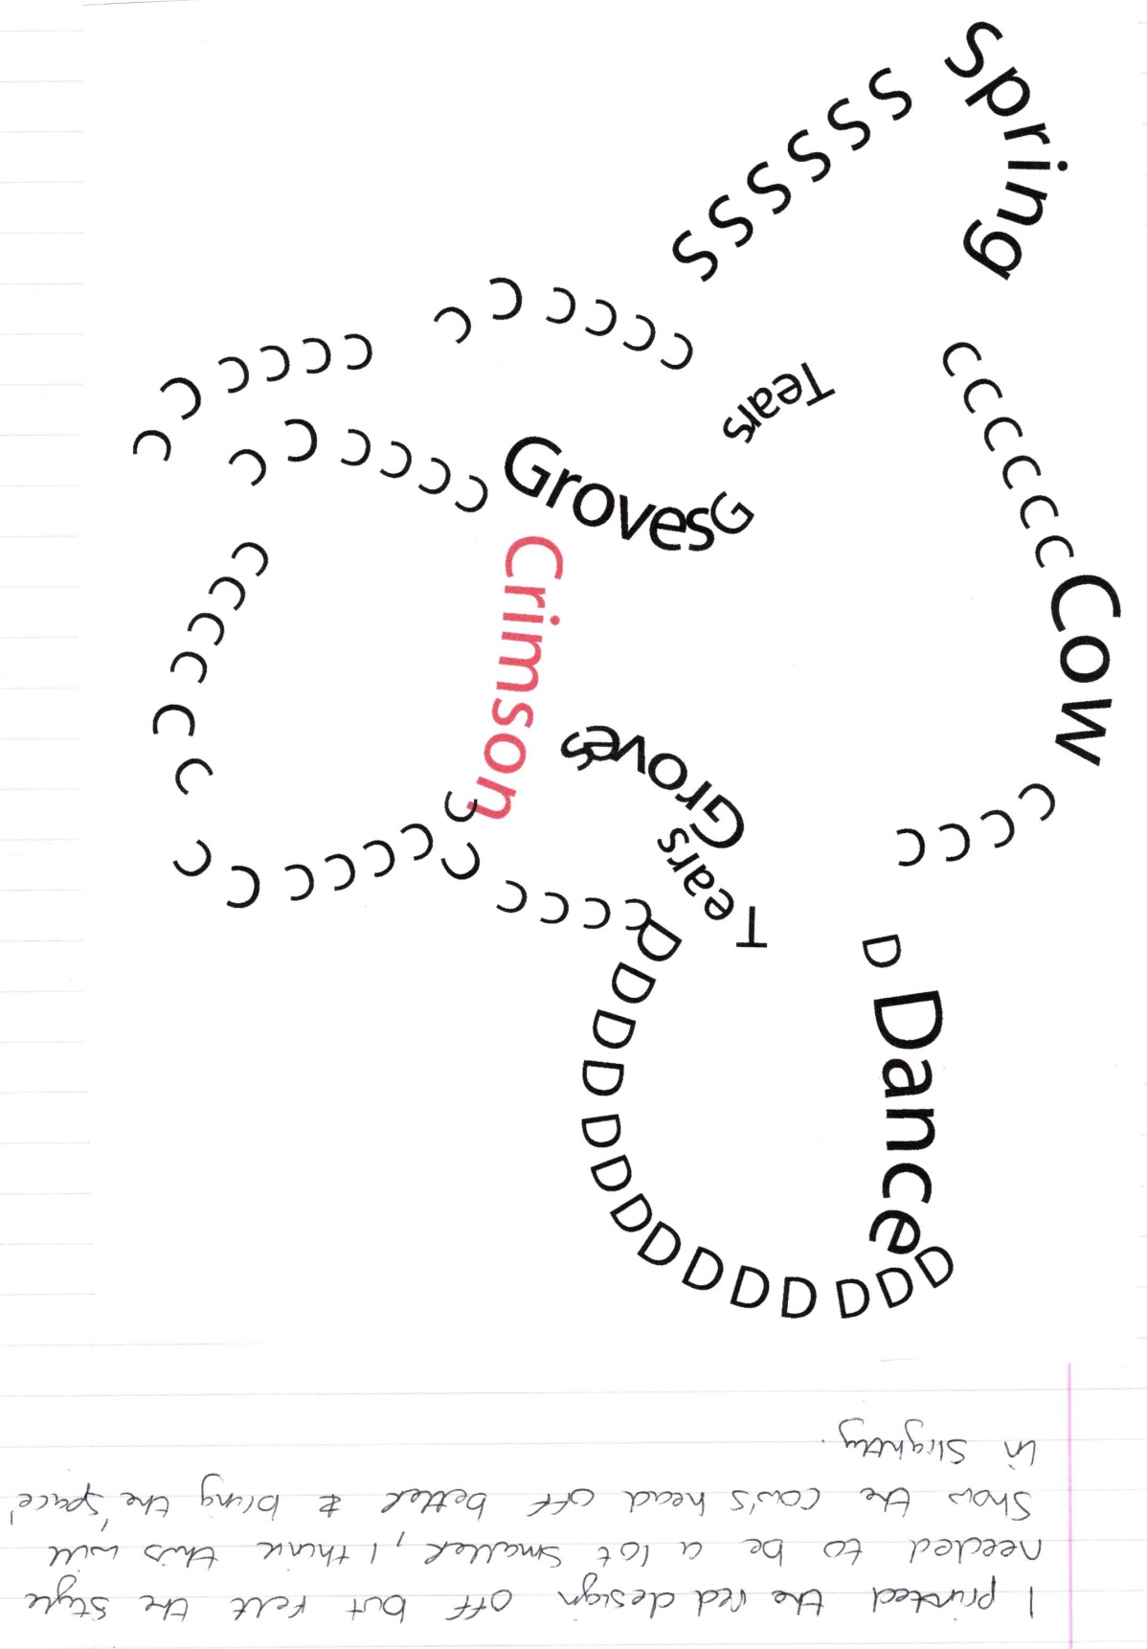

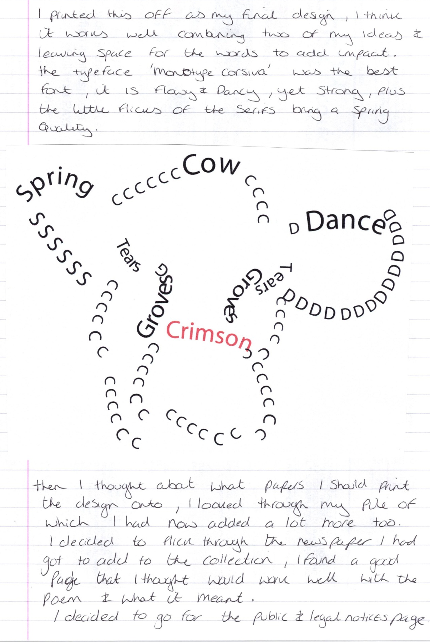

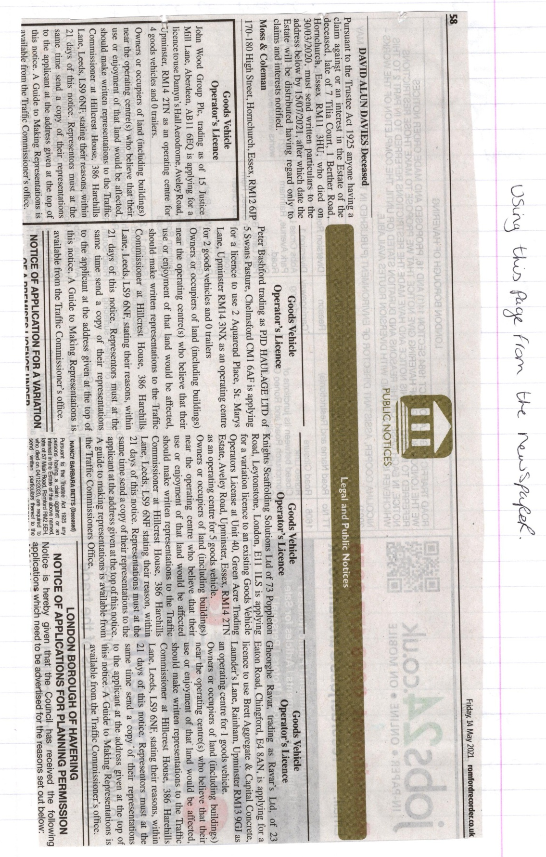

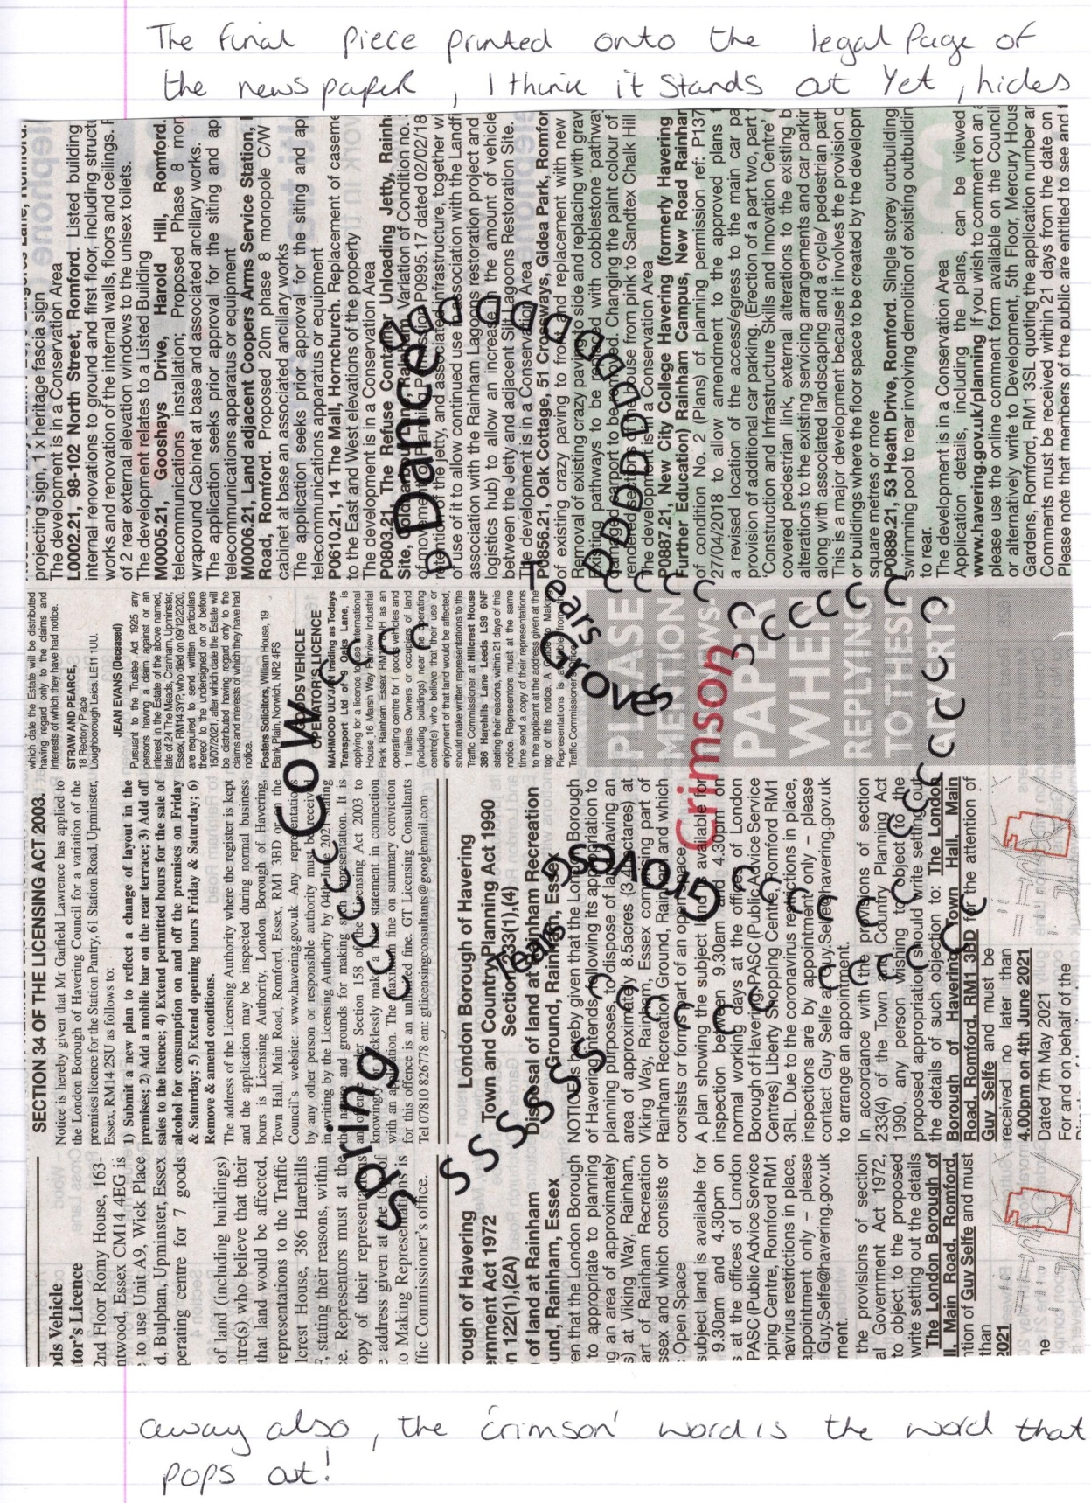

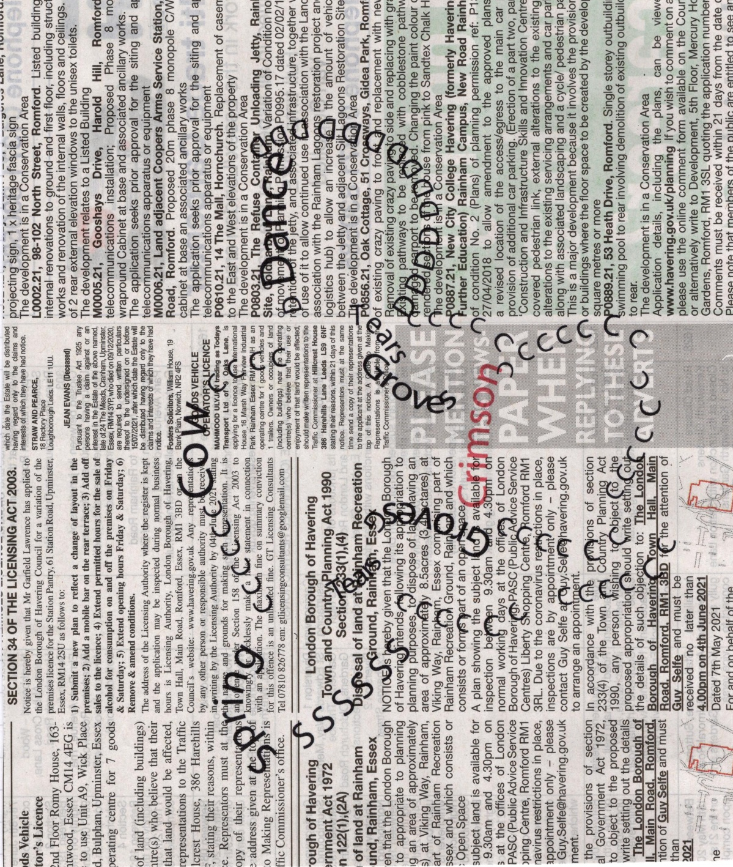
Write a short paragraph reflecting on the relationship between the form and content of your design in your learning log.
So the form of my design was to be the cow’s head outline, I thought this linked well with the poem as the words are about cows dancing the Tango, so it was one of the main motif’s I would say. I felt that the simplified outline worked better than the busier design, it had more impact. Using the colour red for the word ‘Crimson’ made this word become the top of the hierarchy in the design, I was not sure that this would work, but after researching and looking more in depth to the poem, this idea worked really well, as it touched on the anger.
Using the public and legal notices from the newspaper page I thought was a good linking idea, as the poem represented the rural and the urban differences, which this page sums up.

