Paper / Ephemera
So the brief asked me to collect a wide variety of papers and paper ephemera, which had different weights, textures and finishes to them. To build a collection and uses the varieties we collected from the last section.
Look at papers with special finishes like... metallic, embossed, shiny and matt, collect paper which is both light and heavy, but it needs to run through the home printer, so keep this in mind.
Also collect papers that I find interesting or that appeals to me in some way, this could be tickets, souvenirs from exhibitions, occasions and days out.
Create a stack to use for the next few exercises.
In your learning log, document some of these papers and their attributes. Use a reflective approach and simple, descriptive words. For example, it may be that a heavy, coarse coloured paper reminds you of primary school, or the particular smell and shine of a paper puts you in mind of glossy magazines, or the fish and chip shop. Document these associations, however bizarre, into your learning log and/or ongoing paper sample book – you may revisit the words and phrases you use here later on in this process.
So to start this brief I knew I wouldn’t have enough papers to have a stack, so I decided to collect what I could from home, then over the course of this unit I would collect more papers to add to this exercise. Because we are still in part of a lockdown and because of personal circumstances I am only starting to go out every so often, so I will get some more papers when I can.
I found some more decorative papers at home, I started with some tissue paper which was black, it was very light in weight, but I knew it would go through my printer so I chose this for my stack.
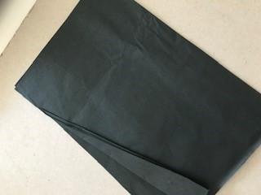
I also found some more black tissue paper, yet this had some gold foiling on it in decoration, so I thought this would be a good pick for my stack. This tissue had a slight sheen to it compared to the flat matt look of the one above; this made it feel more luxurious and special.
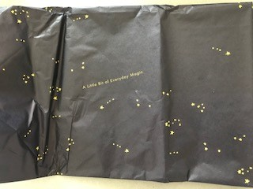
Then I found some stiff wrapping paper with decorative elements to it, although this was heavier in weight than normal wrapping paper (it was more like wallpaper) it would still go through my printer, so this went into my stack too. The paper was really thick and wouldn’t bend or fold very well, it had a rough feeling to it and raised parts like flocking to the designs.
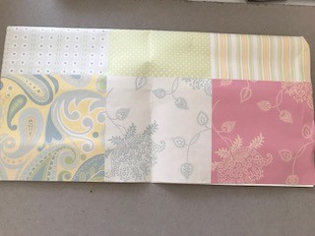
I then found a decorative paper bag from something I had bought years ago and kept this was light weight enough to go through the printer so again this went into my stack. This paper bag was thin and shiny and smooth, it had a luxurious feel to it, and the decoration felt expensive and exclusive.
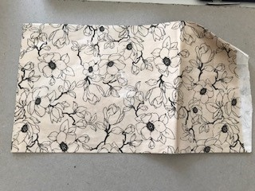
I then found an off cut of some wrapping paper I had designed, this was again slightly thicker than normal wrapping paper, it was 100gsm, but would still go through my printer ok, so this went into the stack. This paper is recycled and eco friendly, the paper is smooth but has a cardboard feel to it, which is the recycled quality and natural feel.
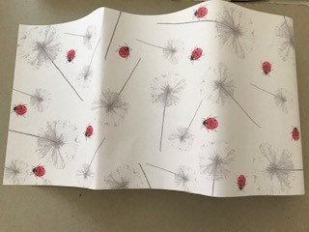
I then started to look at heavier papers, I found these cards which are pretty in decoration, and something I was drawn towards, these again would fit through my printer so these entered the stack. These were smooth but heavy and thick in weight, they reminded me of my Nan, and some of the decorations she had in her house when we were young.
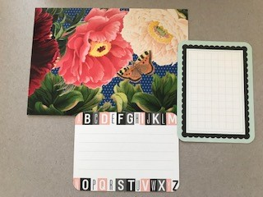
I then found some nice writing papers; these were colourful and had pretty designs which I liked so these went into my stack. The paper was really smooth and had a lovely finish to it, it reminded me of when I was young I used to love buying notebooks for school.
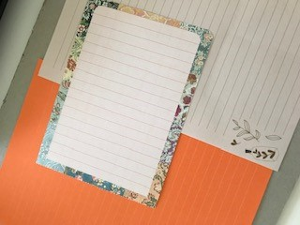
I have the standard printer paper, tracing paper, graph paper already in my stack from before. Plus I have a few variations of watercolour paper, sketch paper, Blotting paper and handmade papers, so I just added these to the new stack.
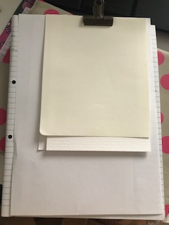
I will add some more paper to this exercise next week once I have been out.
So I went out and found some newspapers that I thought would be good for backgrounds and cutting out. The paper in very thin, and has a good monochrome text look.
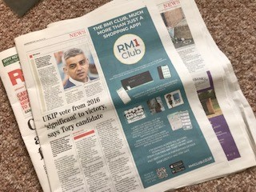
I then found some colourful botanical papers, so added these to my collection, the paper was again very thin, but I thought these would create interesting backgrounds and easy to cut out.
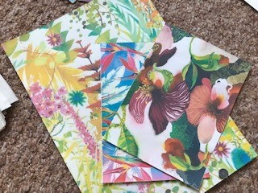
I found some postcards of texture and abstract designs which I thought would be colourful and graphic. The card was fairly thick, I reckon about 200gsm, but that would still go through my computer.
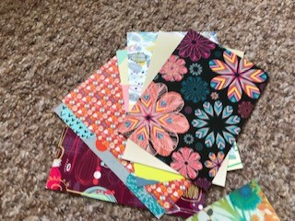
I had few off cuts of papers which I had kept from printing before, so I added these to my collection some were thin papers and some thicker, but both would go through the printer.
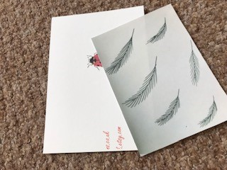
I then found a ephemera pack in the local craft shop, which had a mixture of everything, some older bits of card and papers, tickets, photos, wallpapers, stickers, card, calendars etc, just a big bundle, so I thought these might come in handy for the next few exercises.
