My Little Book of.....
The brief: Create two books explaining and exploring the typographic and layout principles you have researched in this section.
Book 1: My Little book of....Good Typography
Using the reference material that you’ve gathered throughout the exercises and research tasks in Part three, design a book which explores traditional ‘good practice’ in typography. What is readability and, as a designer, how can you aid it? Visually explain the typographic principles that we’ve touched on in Part Three, such as type size, leading and line length. For example, you could demonstrate kerning by creating a page which looks at letter combinations applying this principle. Equally, explore good layouts and use of grids to help support and frame your typography. This is an opportunity to develop carefully considered design layouts that feel easy and engaging to read, and look at. Be creative in how you do this, developing a range of options and possibilities. Show off your good typography skills as well as talking about what makes good typography in your text. To support this, find quotes and type rules by other typographers and designers - perhaps revisit your research into book designers from part two. Find examples of good typography within book design you can present and talk about. Your booklet should be a celebration of good typography, whatever you think that is.
Book 2: My Little Book of…Bad Typography
The rules surrounding what constitutes ‘good’ typography are entrenched in tradition and convention, as you demonstrated in Book 1. Having looked at ‘the rules’ surrounding readability and legibility, now is your opportunity to break them! Be inventive and experimental in how you explore what might constitute ‘bad’ typography. For example, negative leading, too-long line length and ‘inappropriate’ application of typographic principles may produce visually jarring and uncomfortable results. What does ‘bad typography’ mean to you and how might it manifest itself? Express your ideas in a visually imaginative way within your second book. This is an opportunity to be playful and push your design layouts, typography and ideas to the limits - celebrate bad typography through your designs and content. Again, find quotations you can work with or examples of bad typography to draw on.
So my first initial thoughts were to write down my initial thoughts in my sketch book, so I would start as I mean to go and share more of my thought process and other visual and written work.
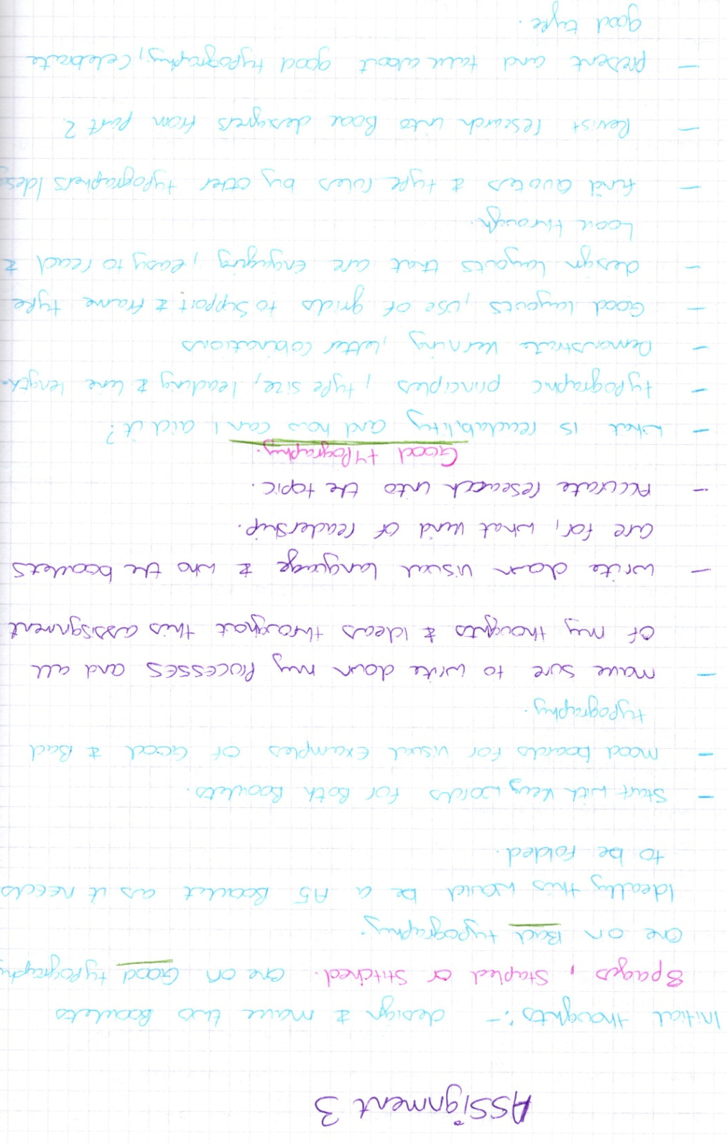

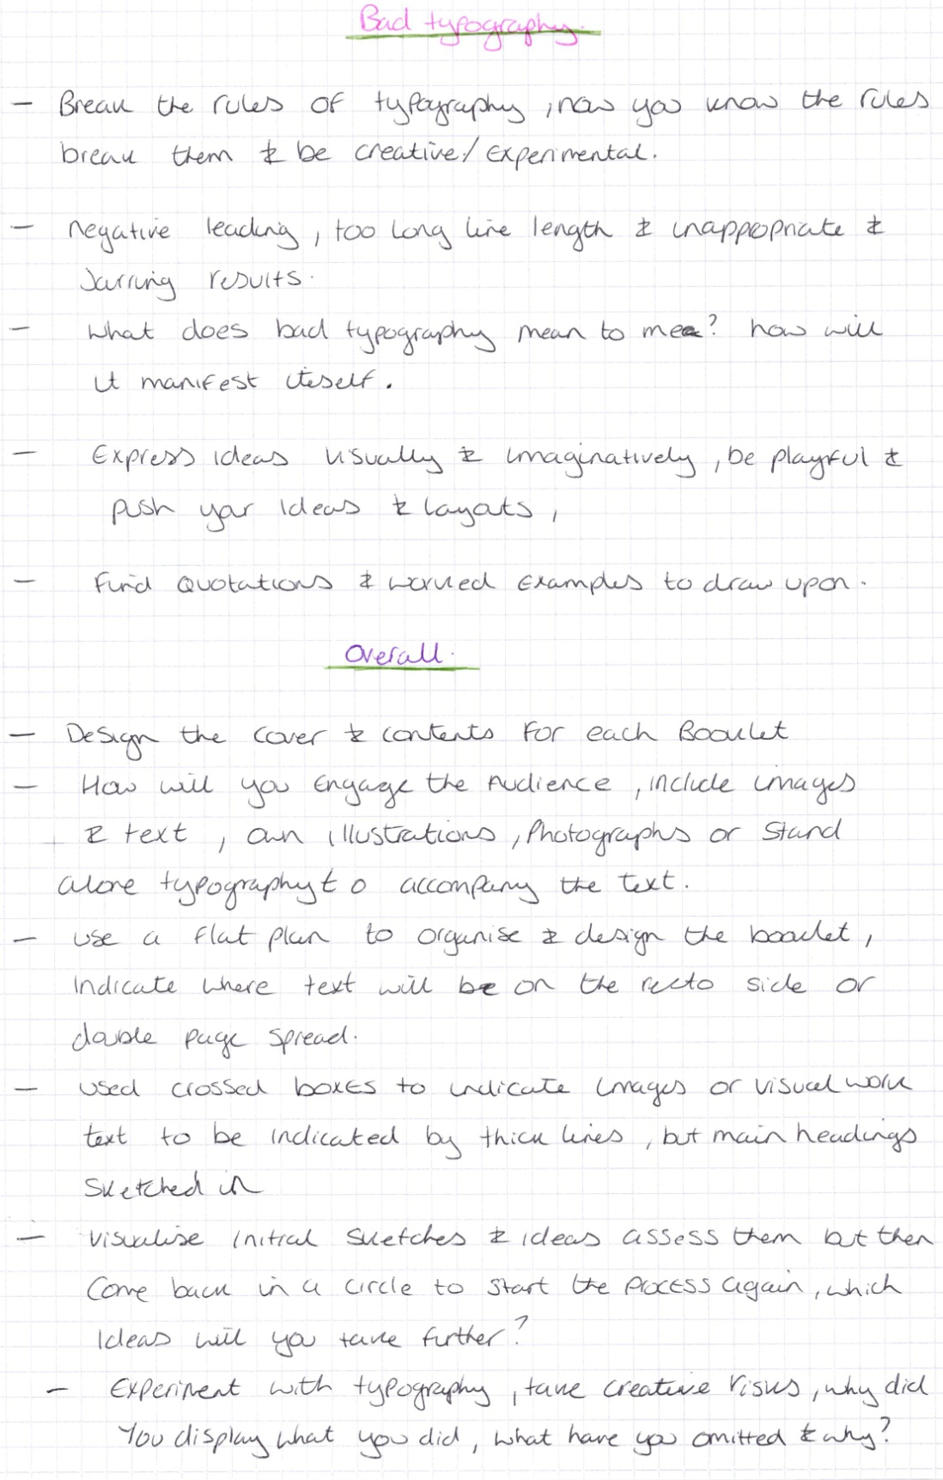
In then went on to write down what were the first steps I needed to take: Key words, Spider diagram for both booklets.
Basic flat plans for both to start me off with
Go back over all of section 3 to pick out all the elements I have learnt to make a list of words for good and bad typography.
Explain in brief what I want to say in the book, so I know where to start my thoughts from, for both books.
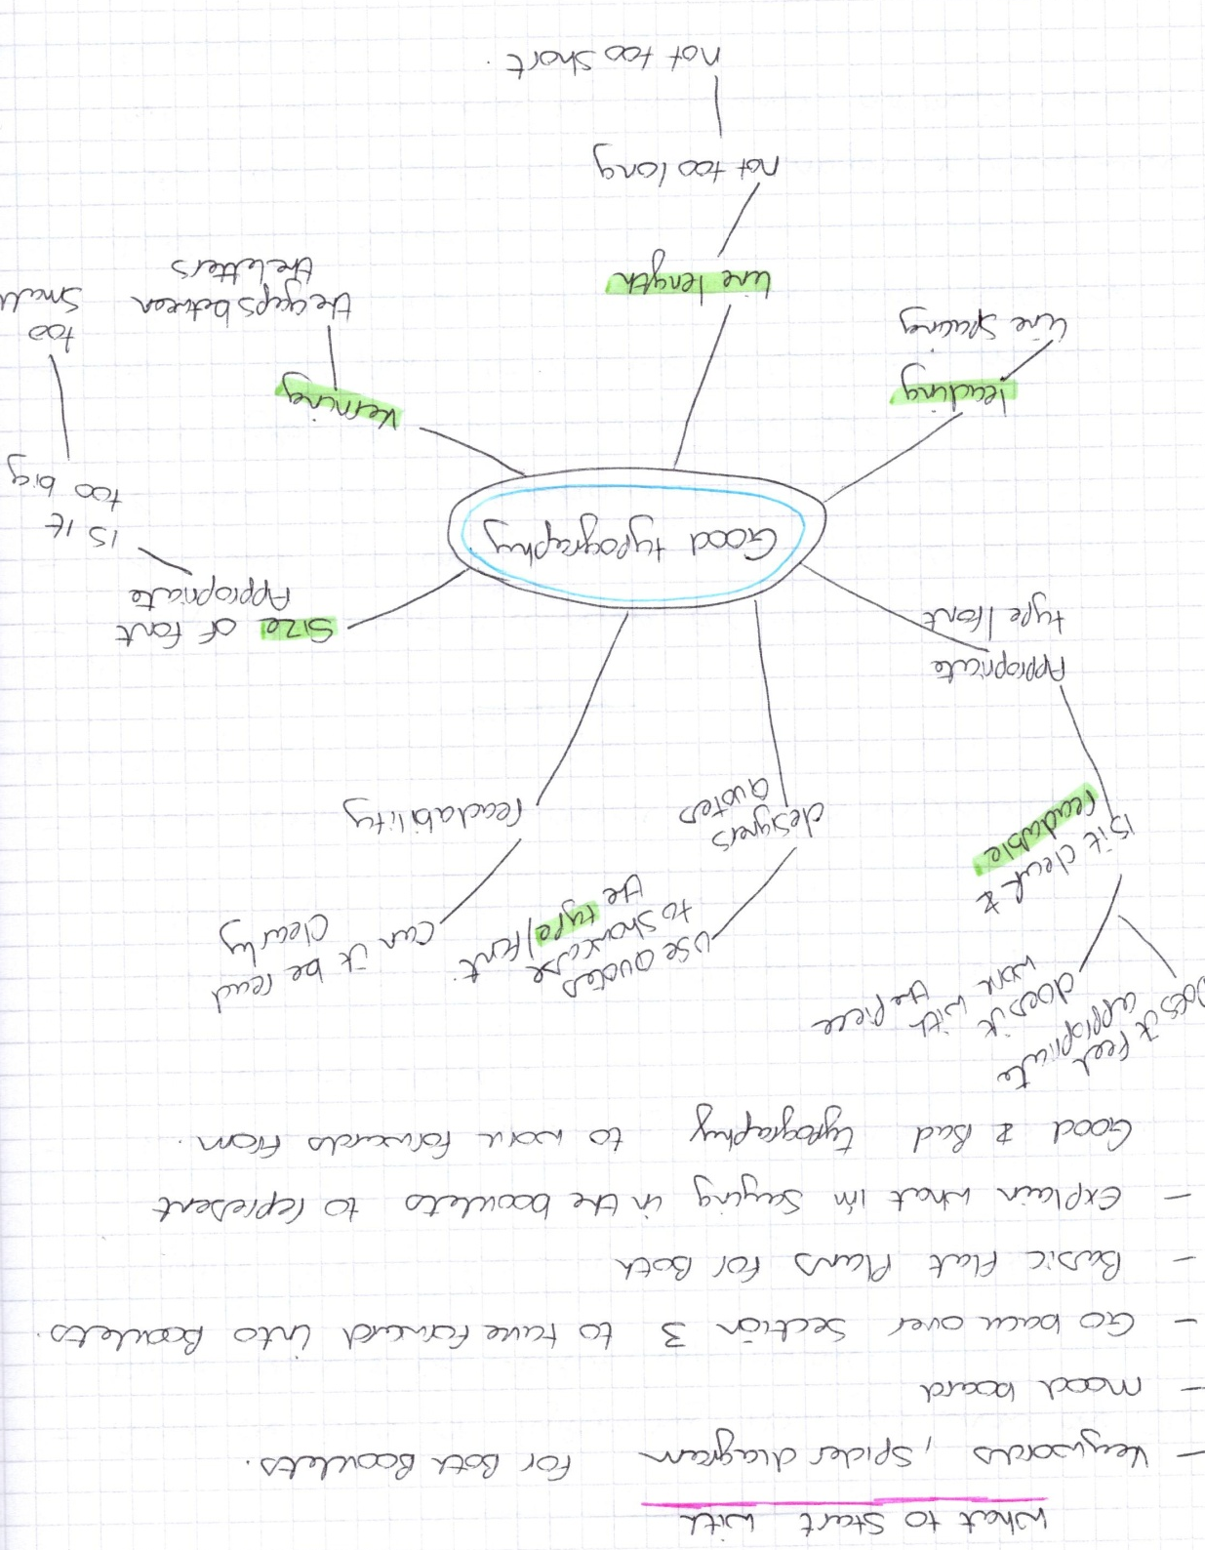

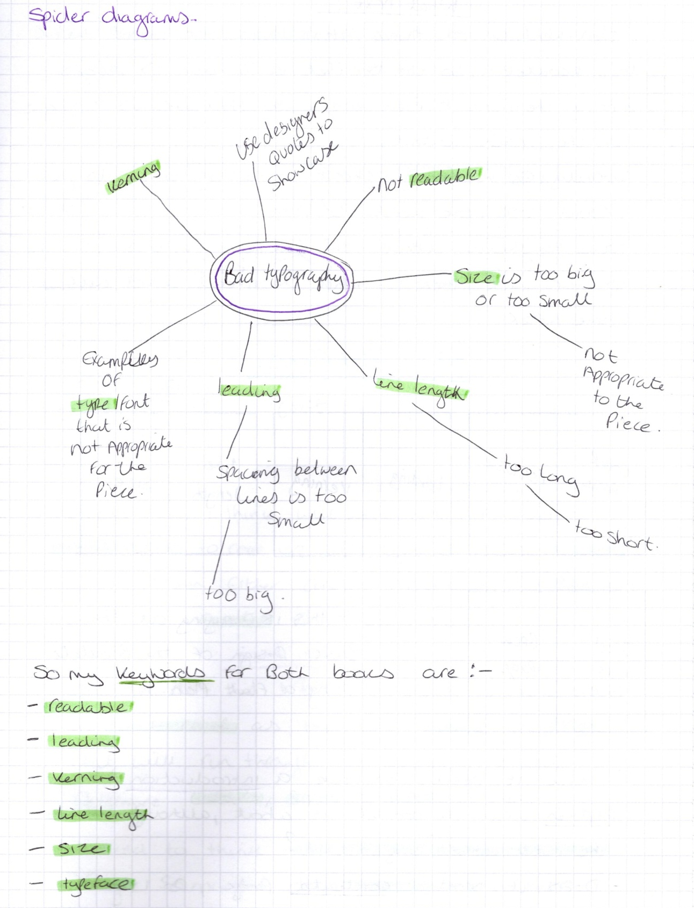

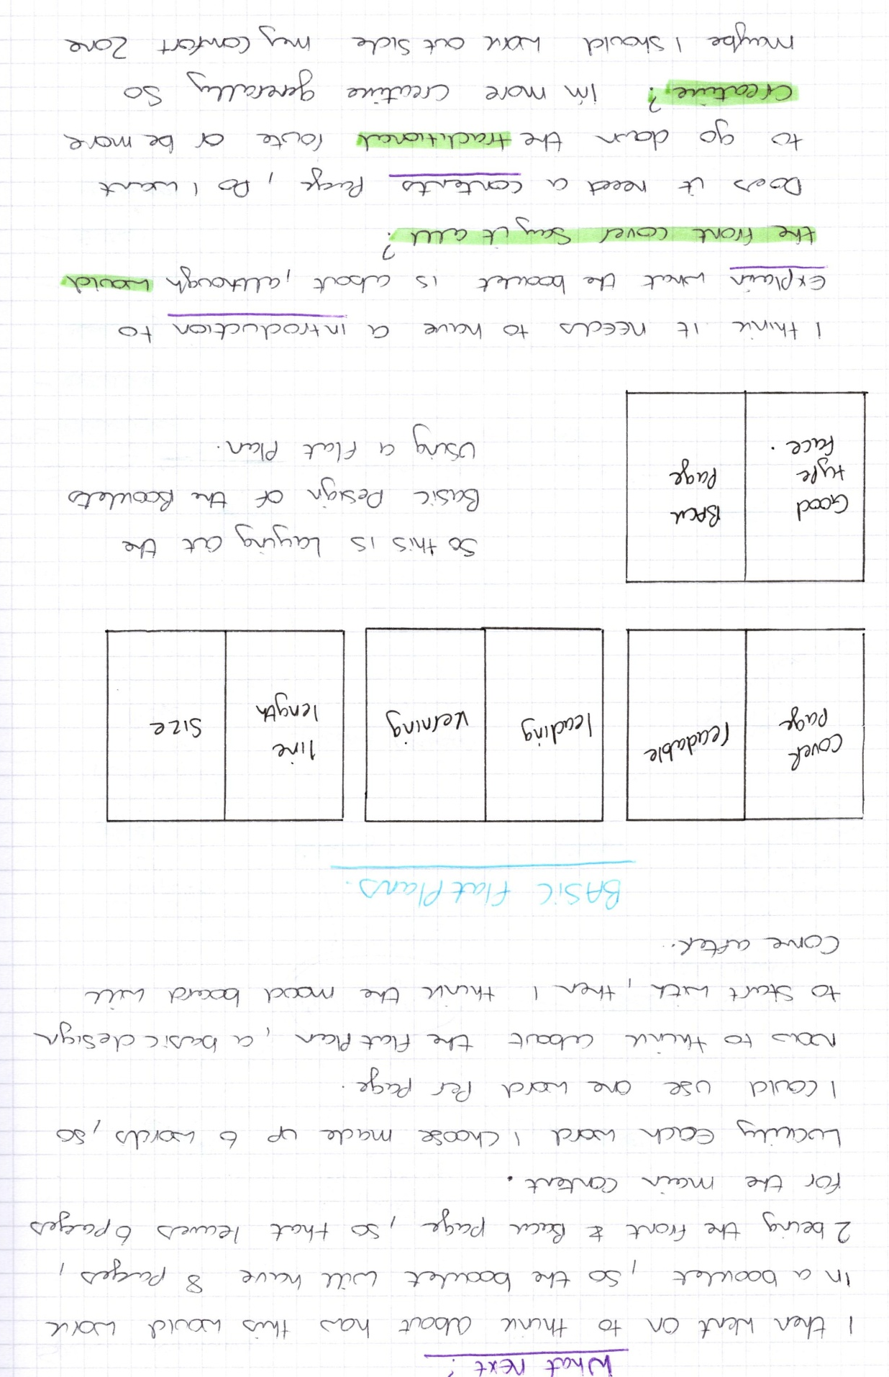

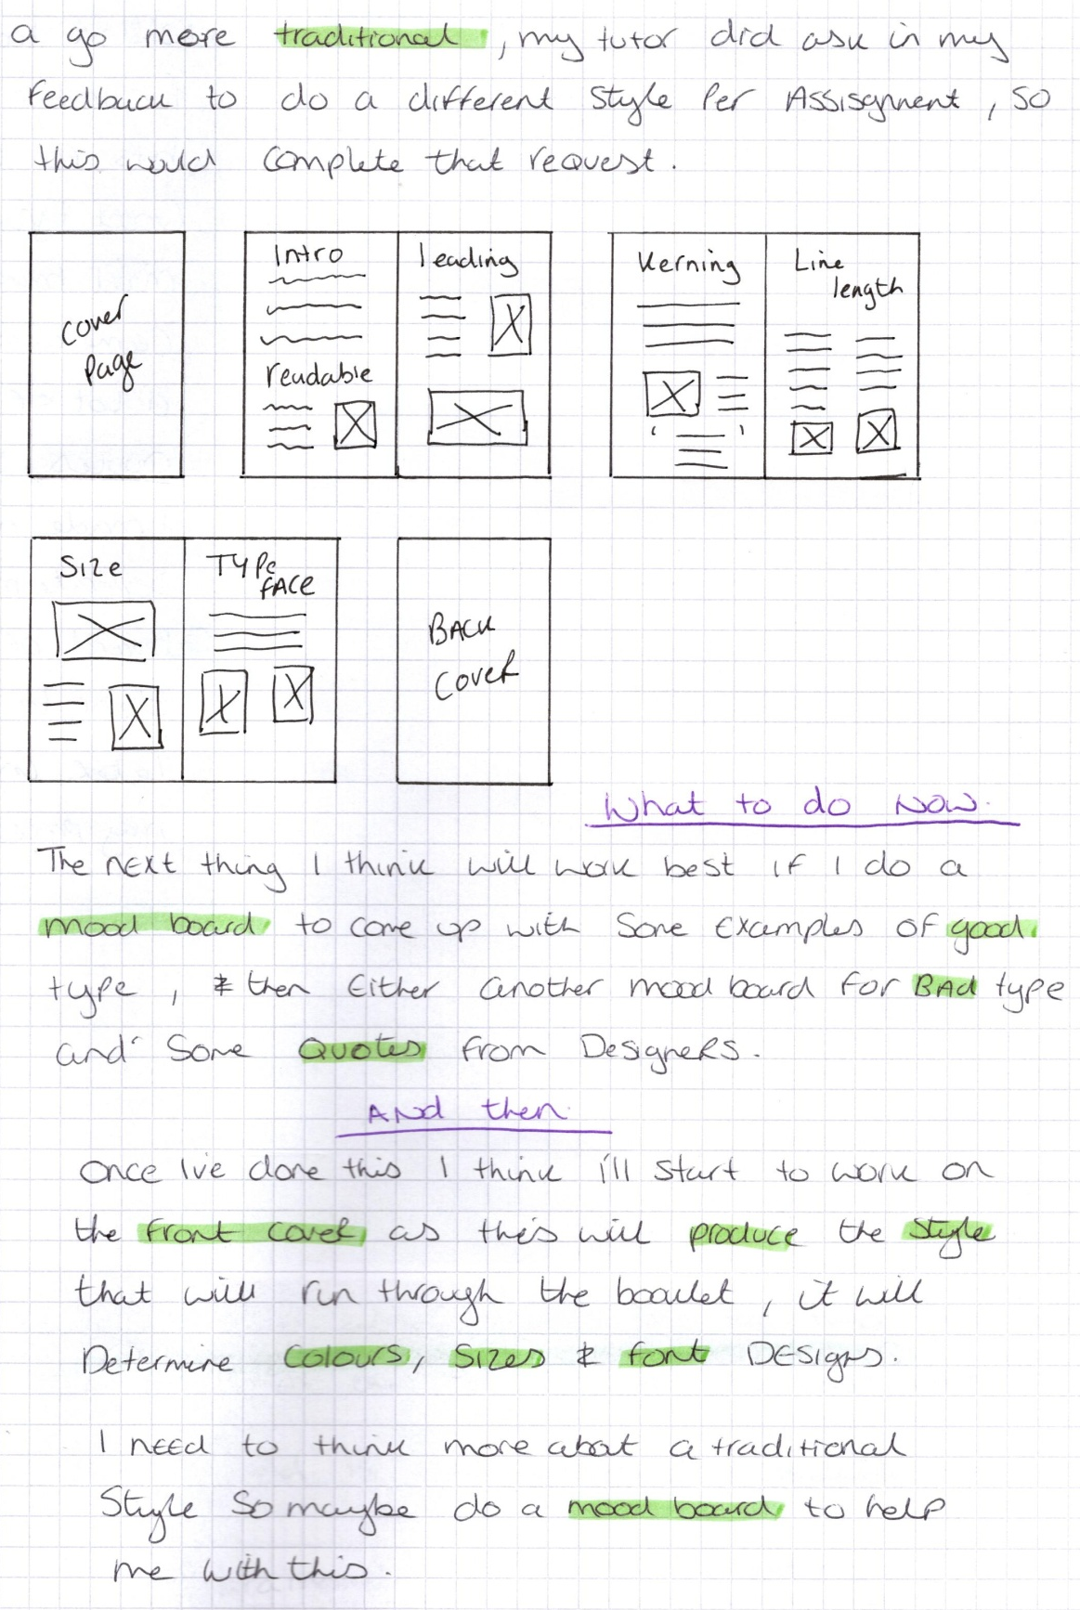

Whilst looking for images and bits for the good typography mood board, I came across a lot of quotes, so I made a separate mood board of these to use later in my process.
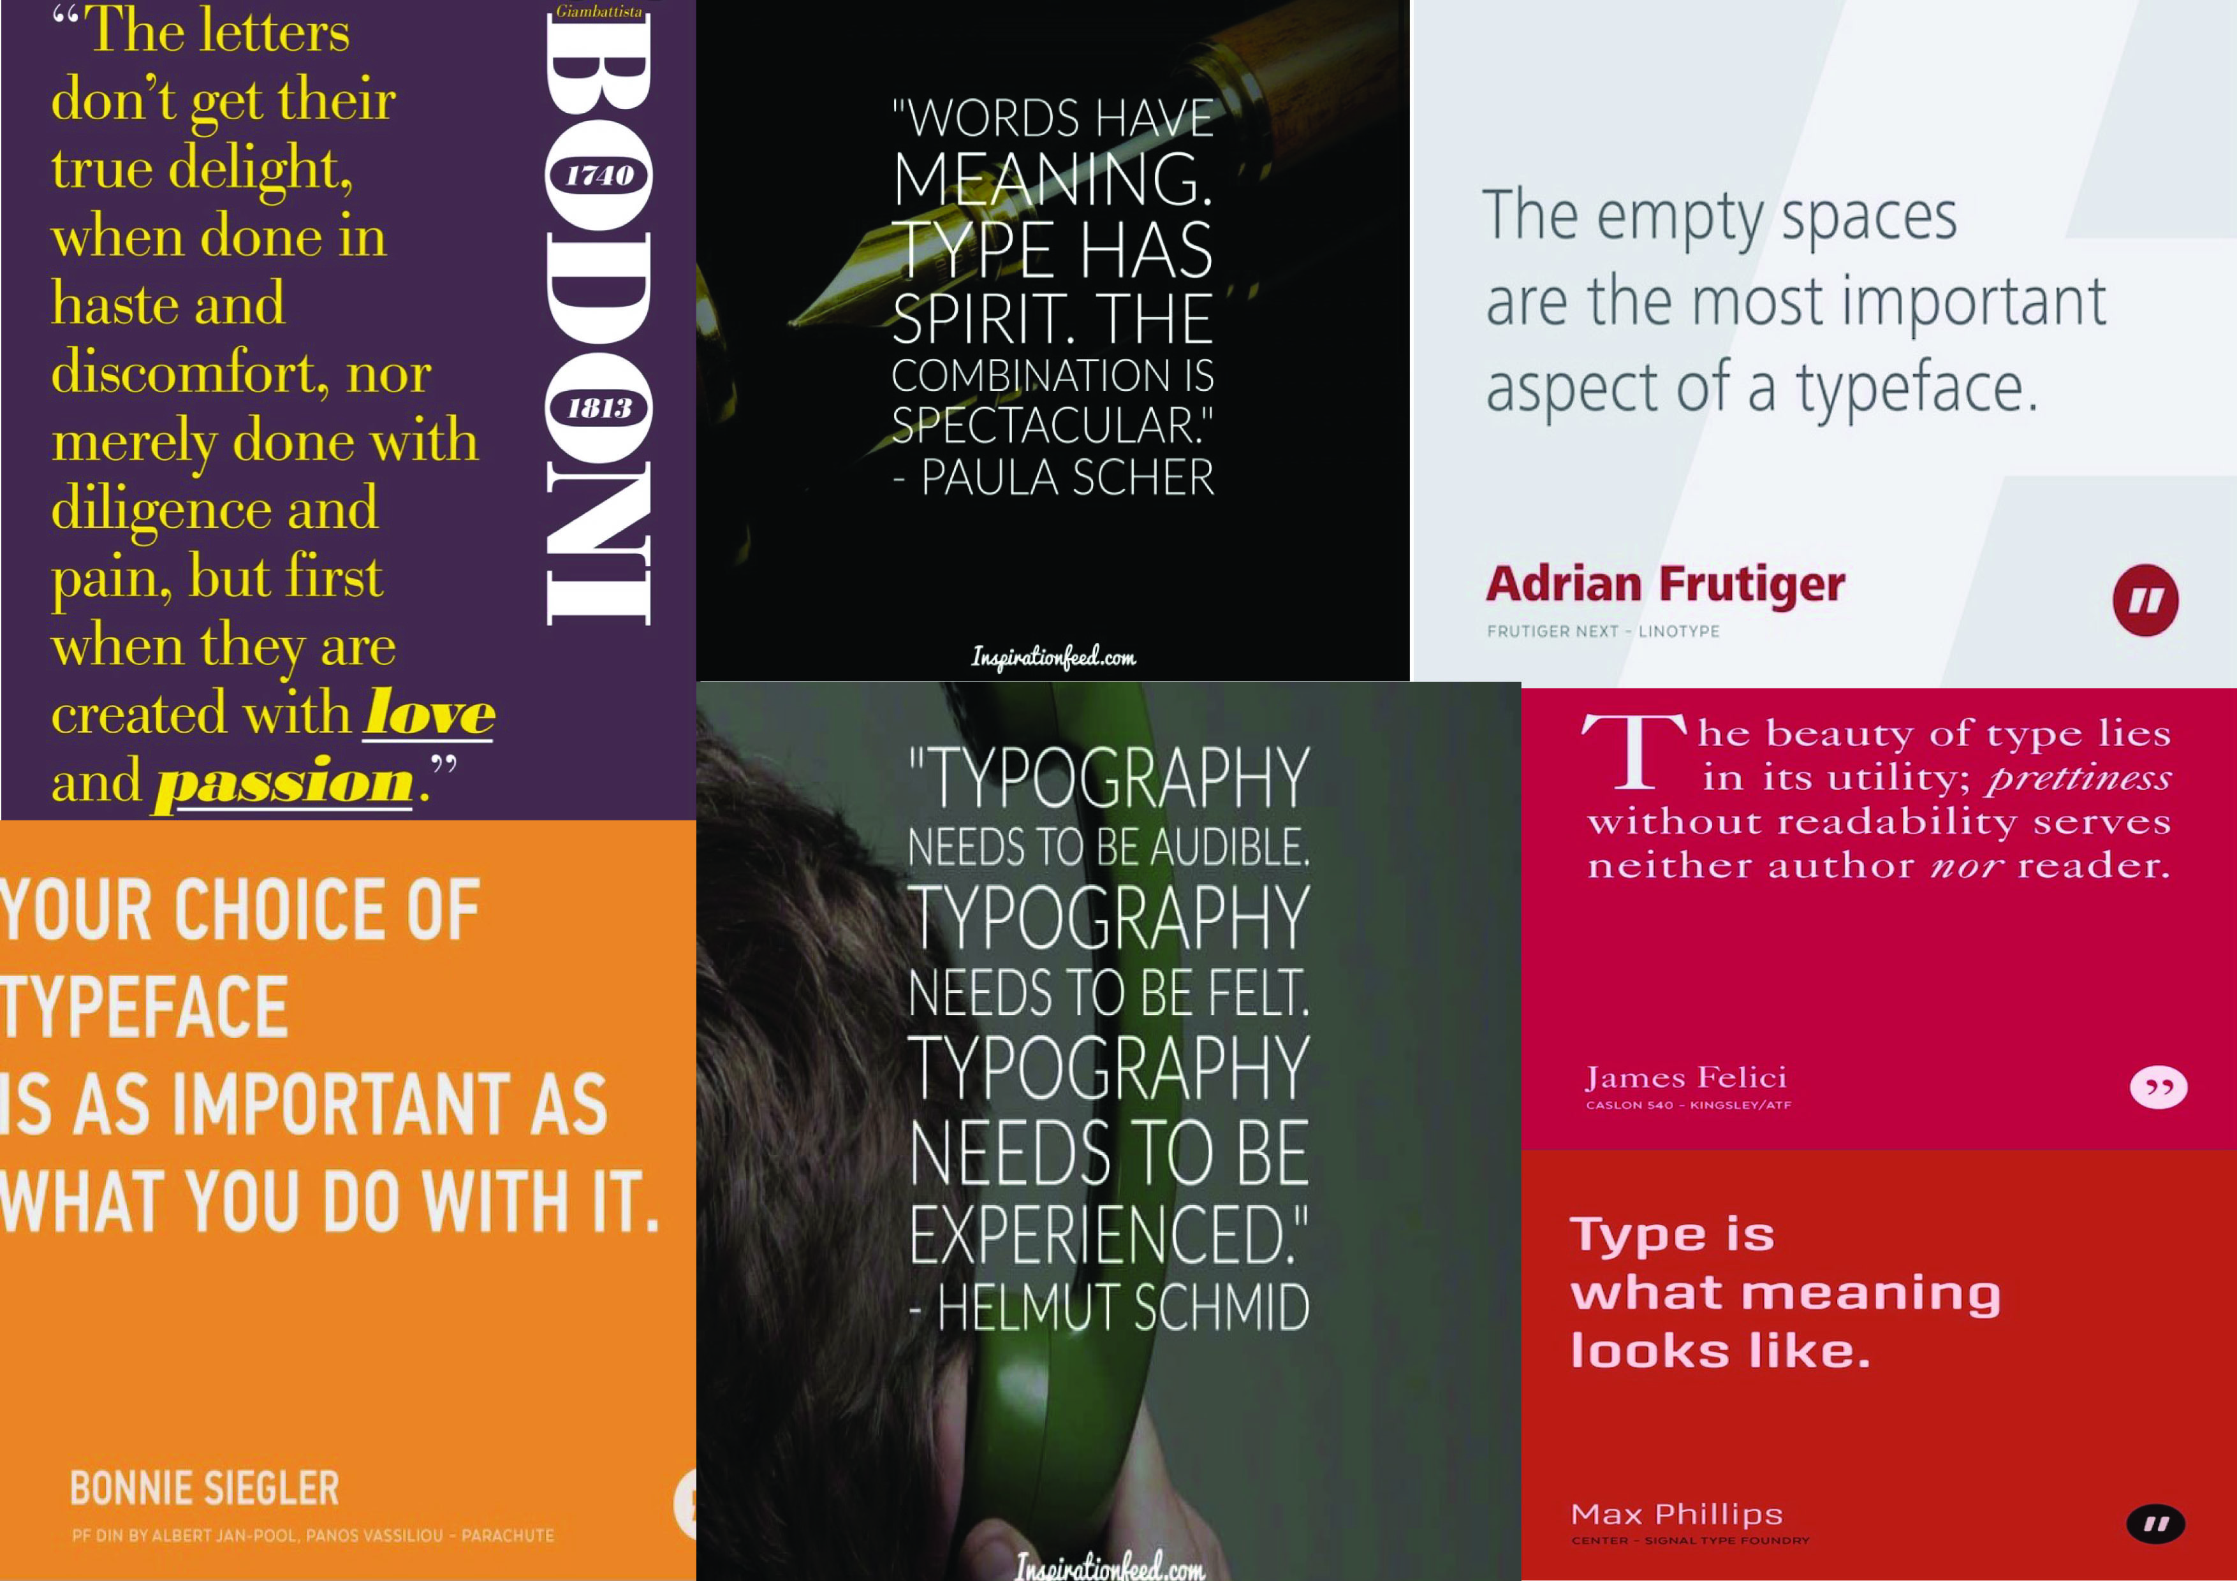

The Good typography mood board is made up of good signs that are clear and concise, some include good hierarchy too. Some have a visual image which works with the font and type face to show what the company is about.
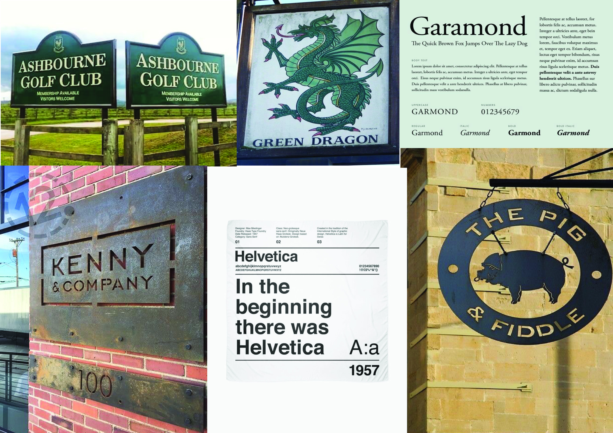
The mood board includes the top two typefaces that are used the most and work best with hierarchy and is bold yet clear and readable.
Garamond and Helvetica
The Bad typography mood board is made up of Comic Sans and Papyrus typefaces, which are the least favourite of book designers. How bad typography can look too busy, jumbled and hectic as well as un-readable.

Also some shop and company names can be considered un-readable or inappropriate, with mistakes of using different fonts for each letter and bad Kerning.
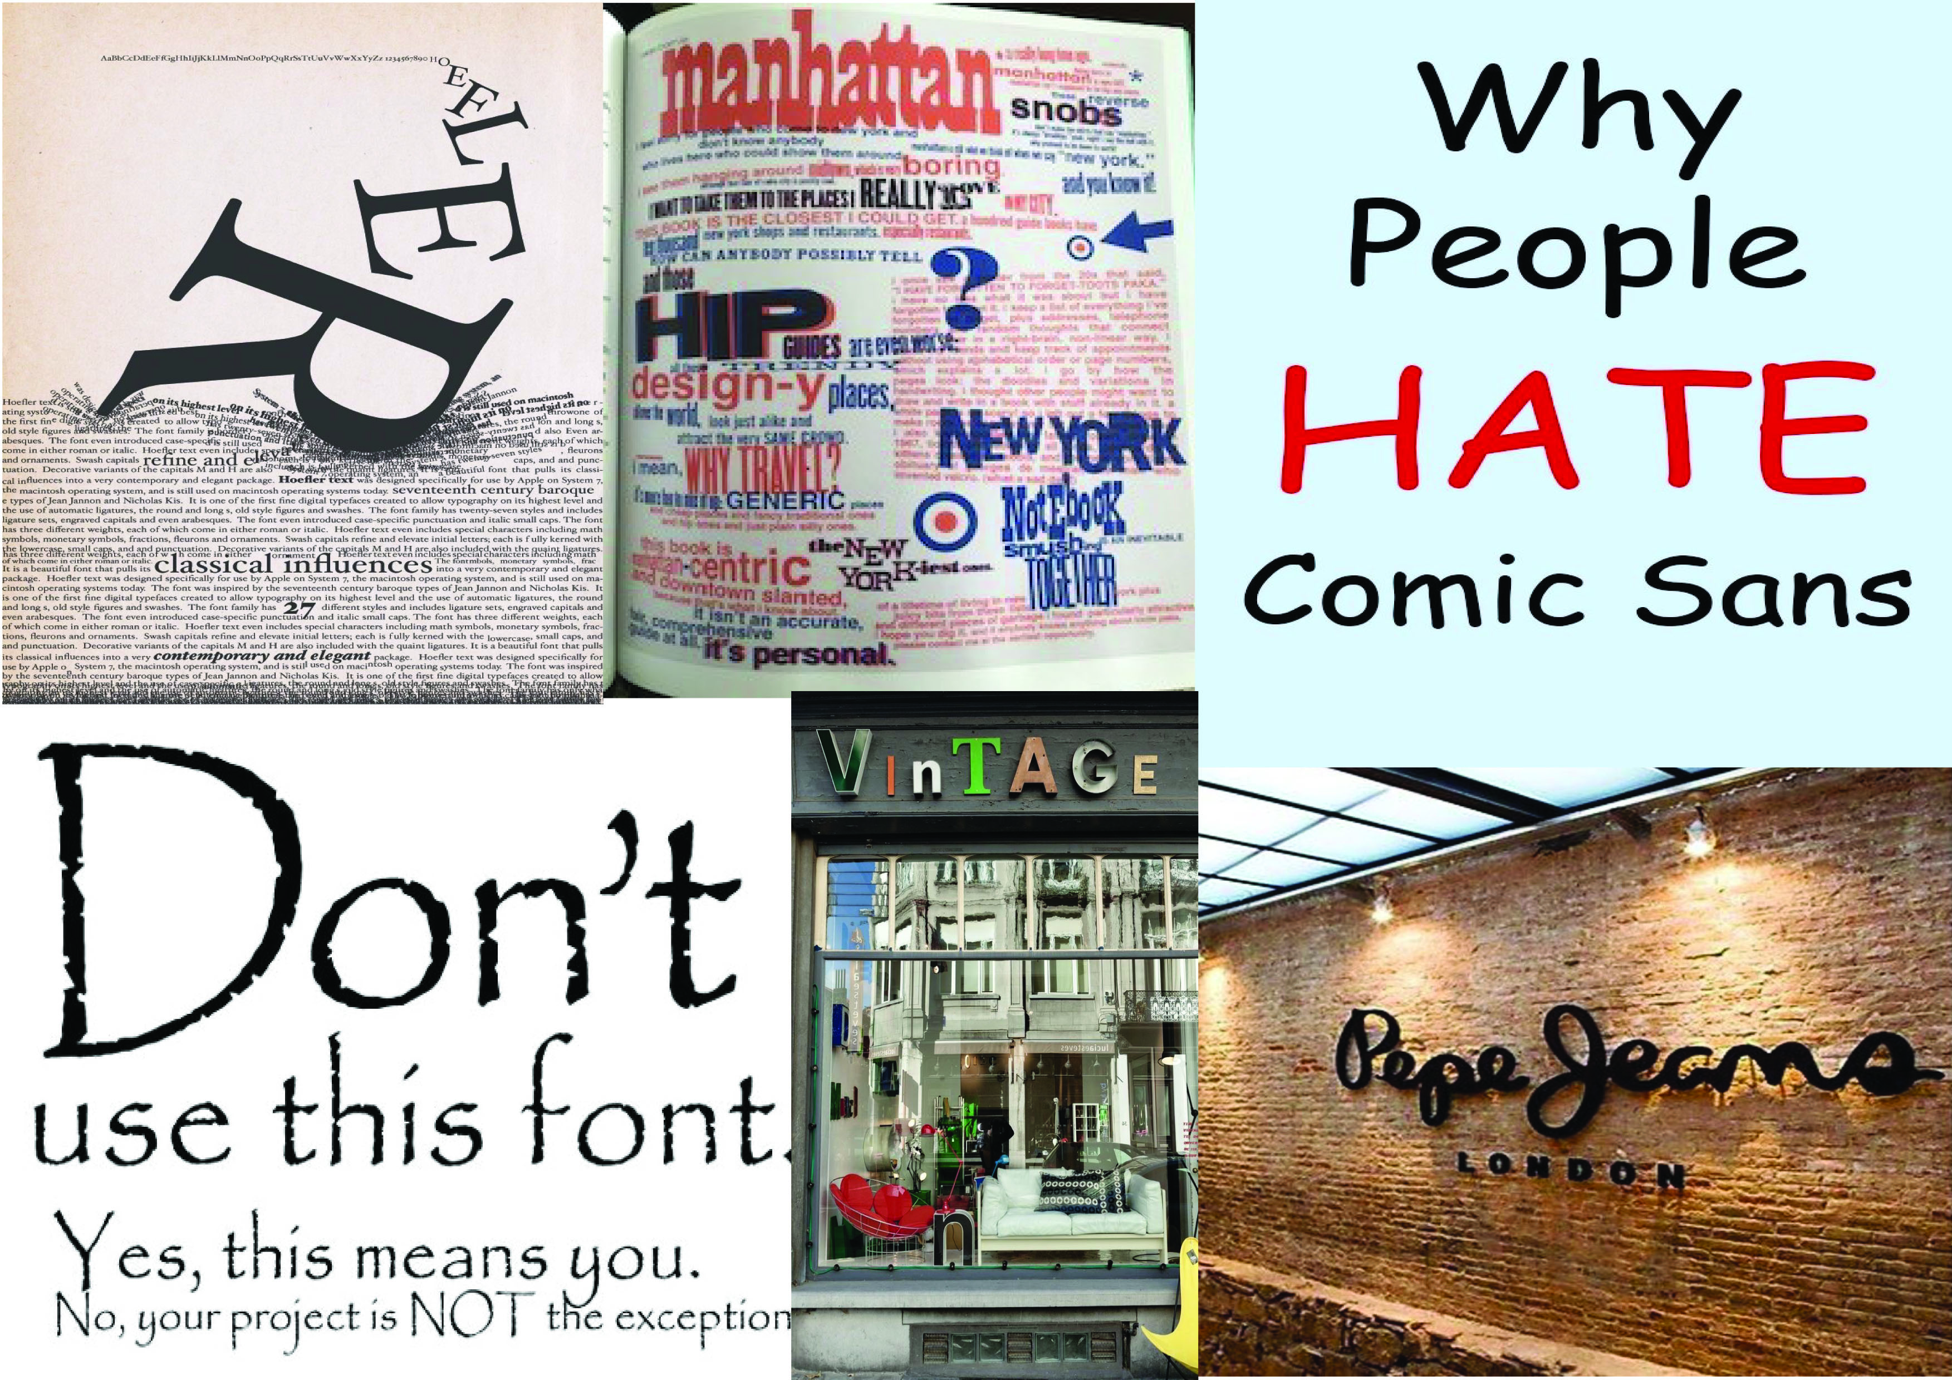

The next stage I started was thinking of some thumbnails for the front cover designs of the Good typography booklet. I chose to have lots of design that I drew in my sketch book, as the feedback from my tutor was to show all my thoughts in my sketchbook, so usually I just dwindle the designs down, so there is less to look at with my work, as this was feedback from my last tutor after assessment. I drew 22 designs, of which there were 7 styles of designs.
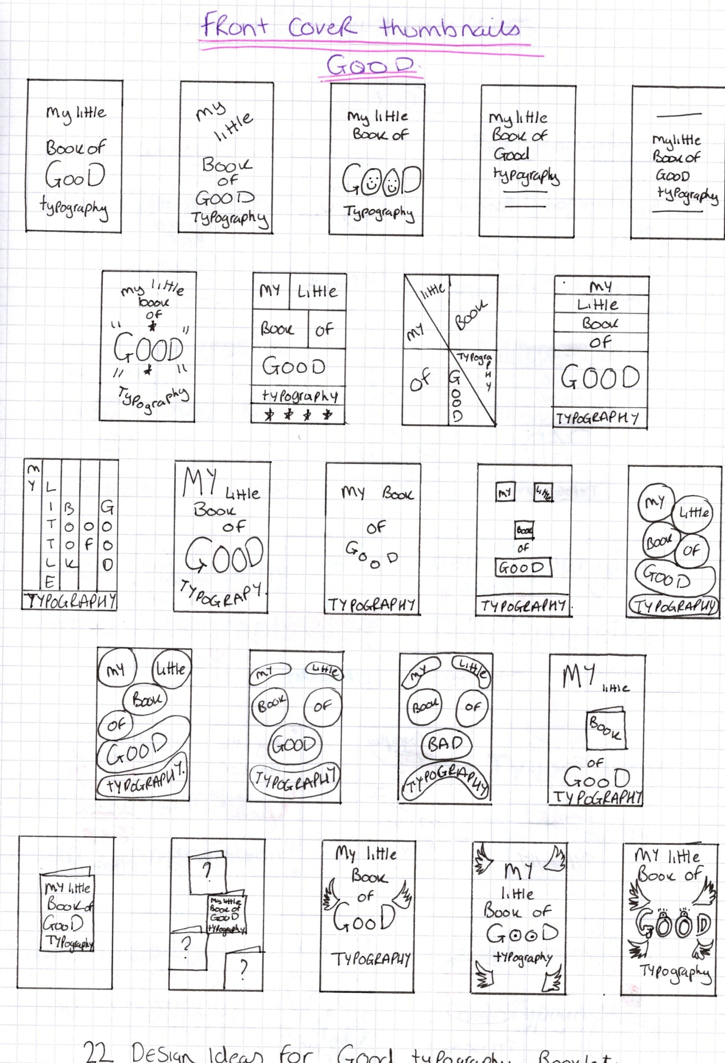

I then did the same in my sketch book for the bad typography front cover designs, but this time I had 20 designs and 10 styles of design. I found the bad typography ideas easier to come by then the good designs.
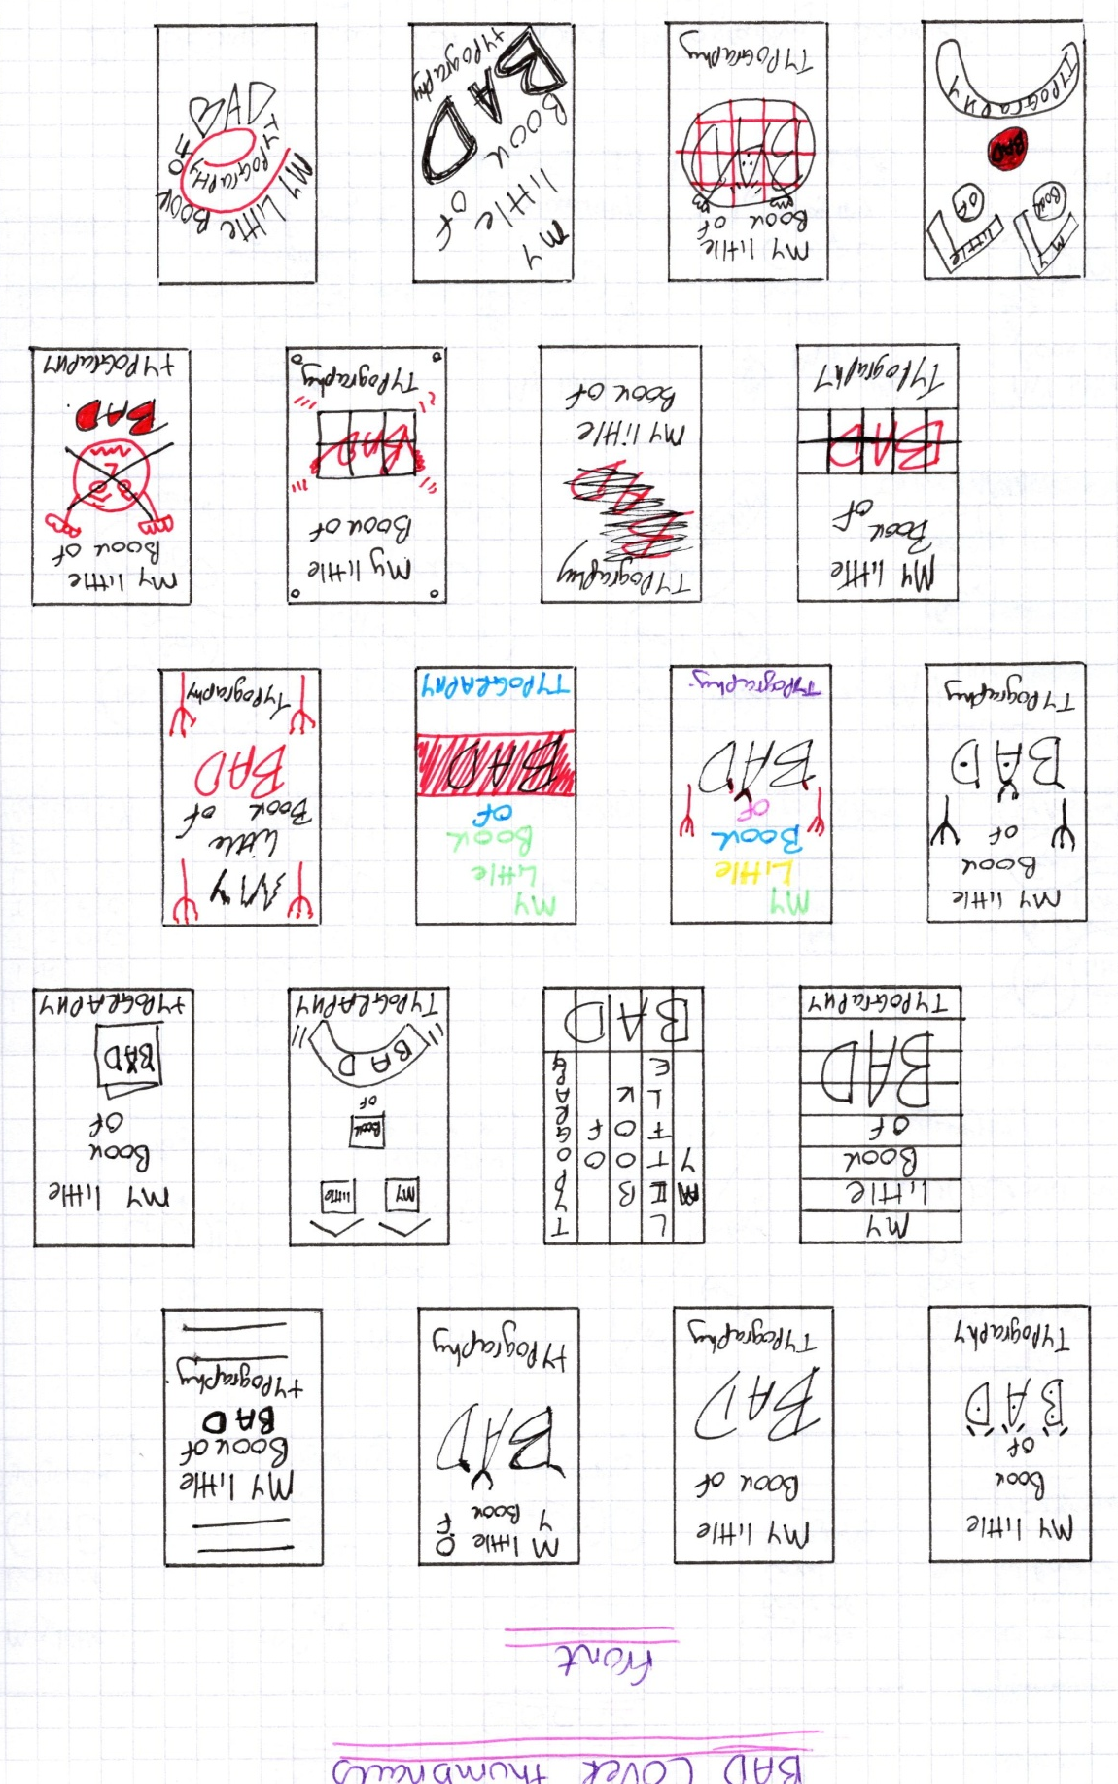

I then went on to explore the typefaces and font designs that we had looked at earlier in the section. I chose some good examples and some bad examples, and tested these out with the actual fonts and the words.
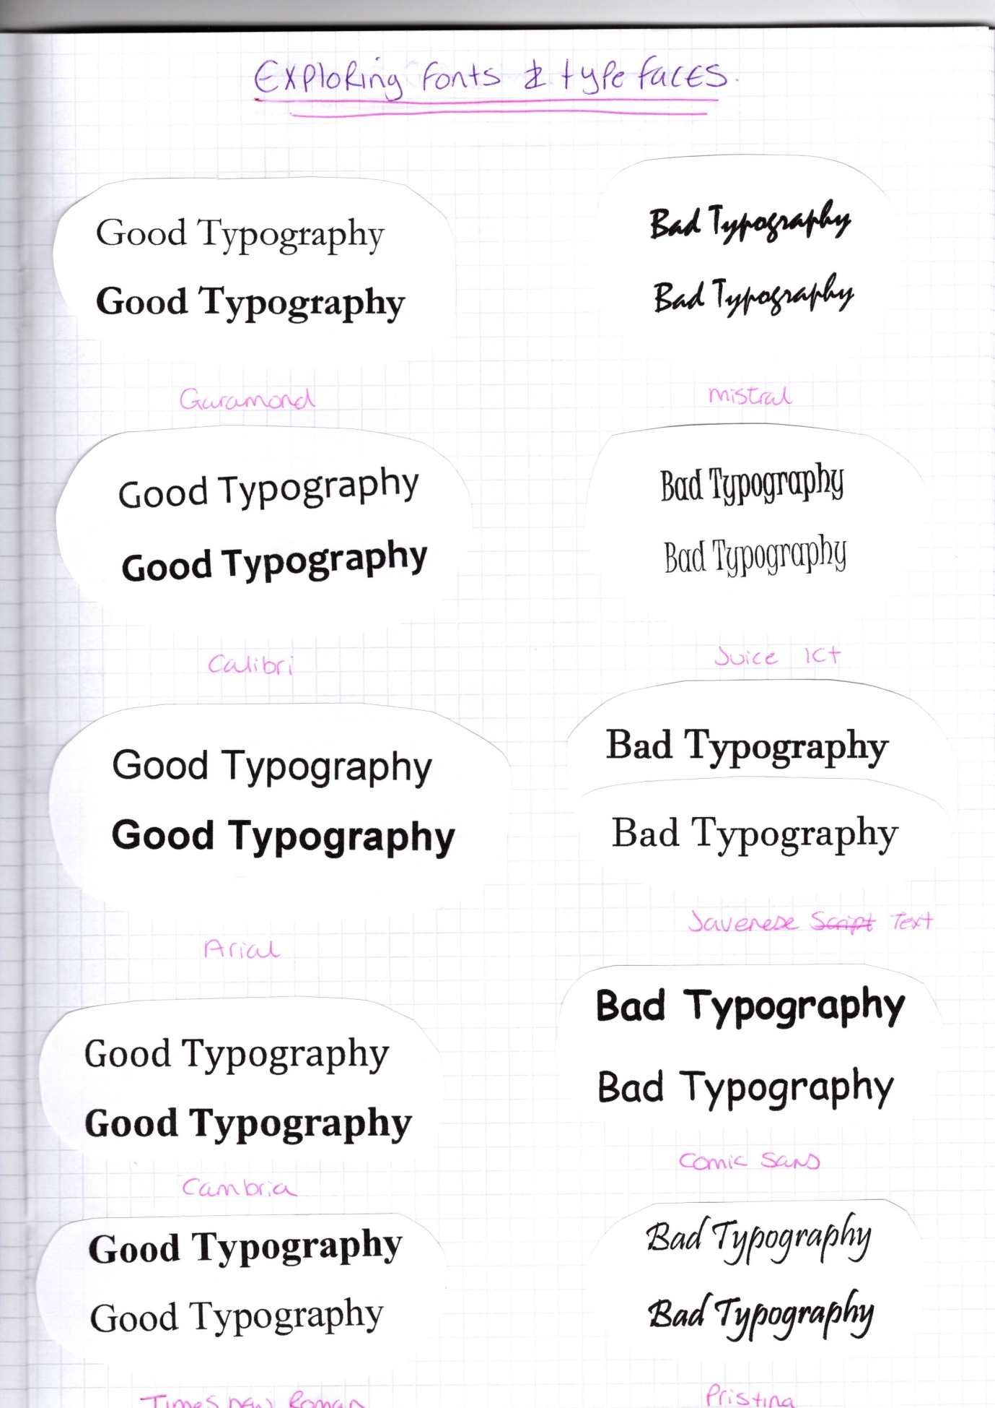

I was gradually whittling down the typefaces I like and worked with the good and bad designs. I then went onto use the quotes that I had researched earlier in this assignment, and used the typefaces and fonts to explore more about which ones would work on the front covers of the booklets.
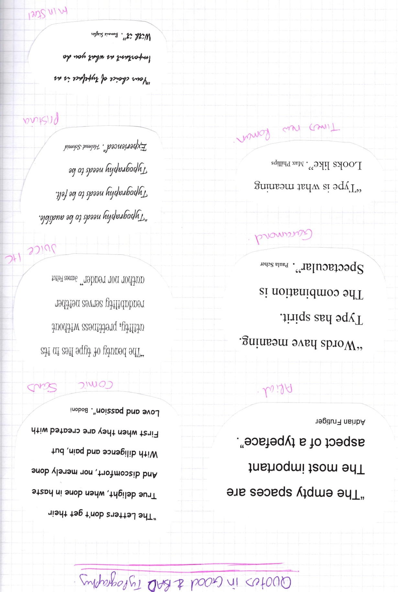

The typefaces that I liked the best so far for the good booklet were Garamond, Arial and Times New Roman.
For the bad designs it was still around 4 typefaces, Comic sans, Juice ITC, Pristina and Minstrel.
I then moved on to colour and colours that would suit the good and bad booklets, from my thumbnails for the bad typography booklet, Red was very much a part of the designs, as I felt it conveyed the feel of the font better, along with black. So this is what I wanted to explore more of, and in particular the good typography colours.
To do this I researched into colour therapy, and how certain colours make you feel things, and how this can have an effect on how you see and interpret designs.
This mood board was a collection of colours that would most probably work from, with both my booklets, I whittled them down from the basic primary colours that everybody knows.
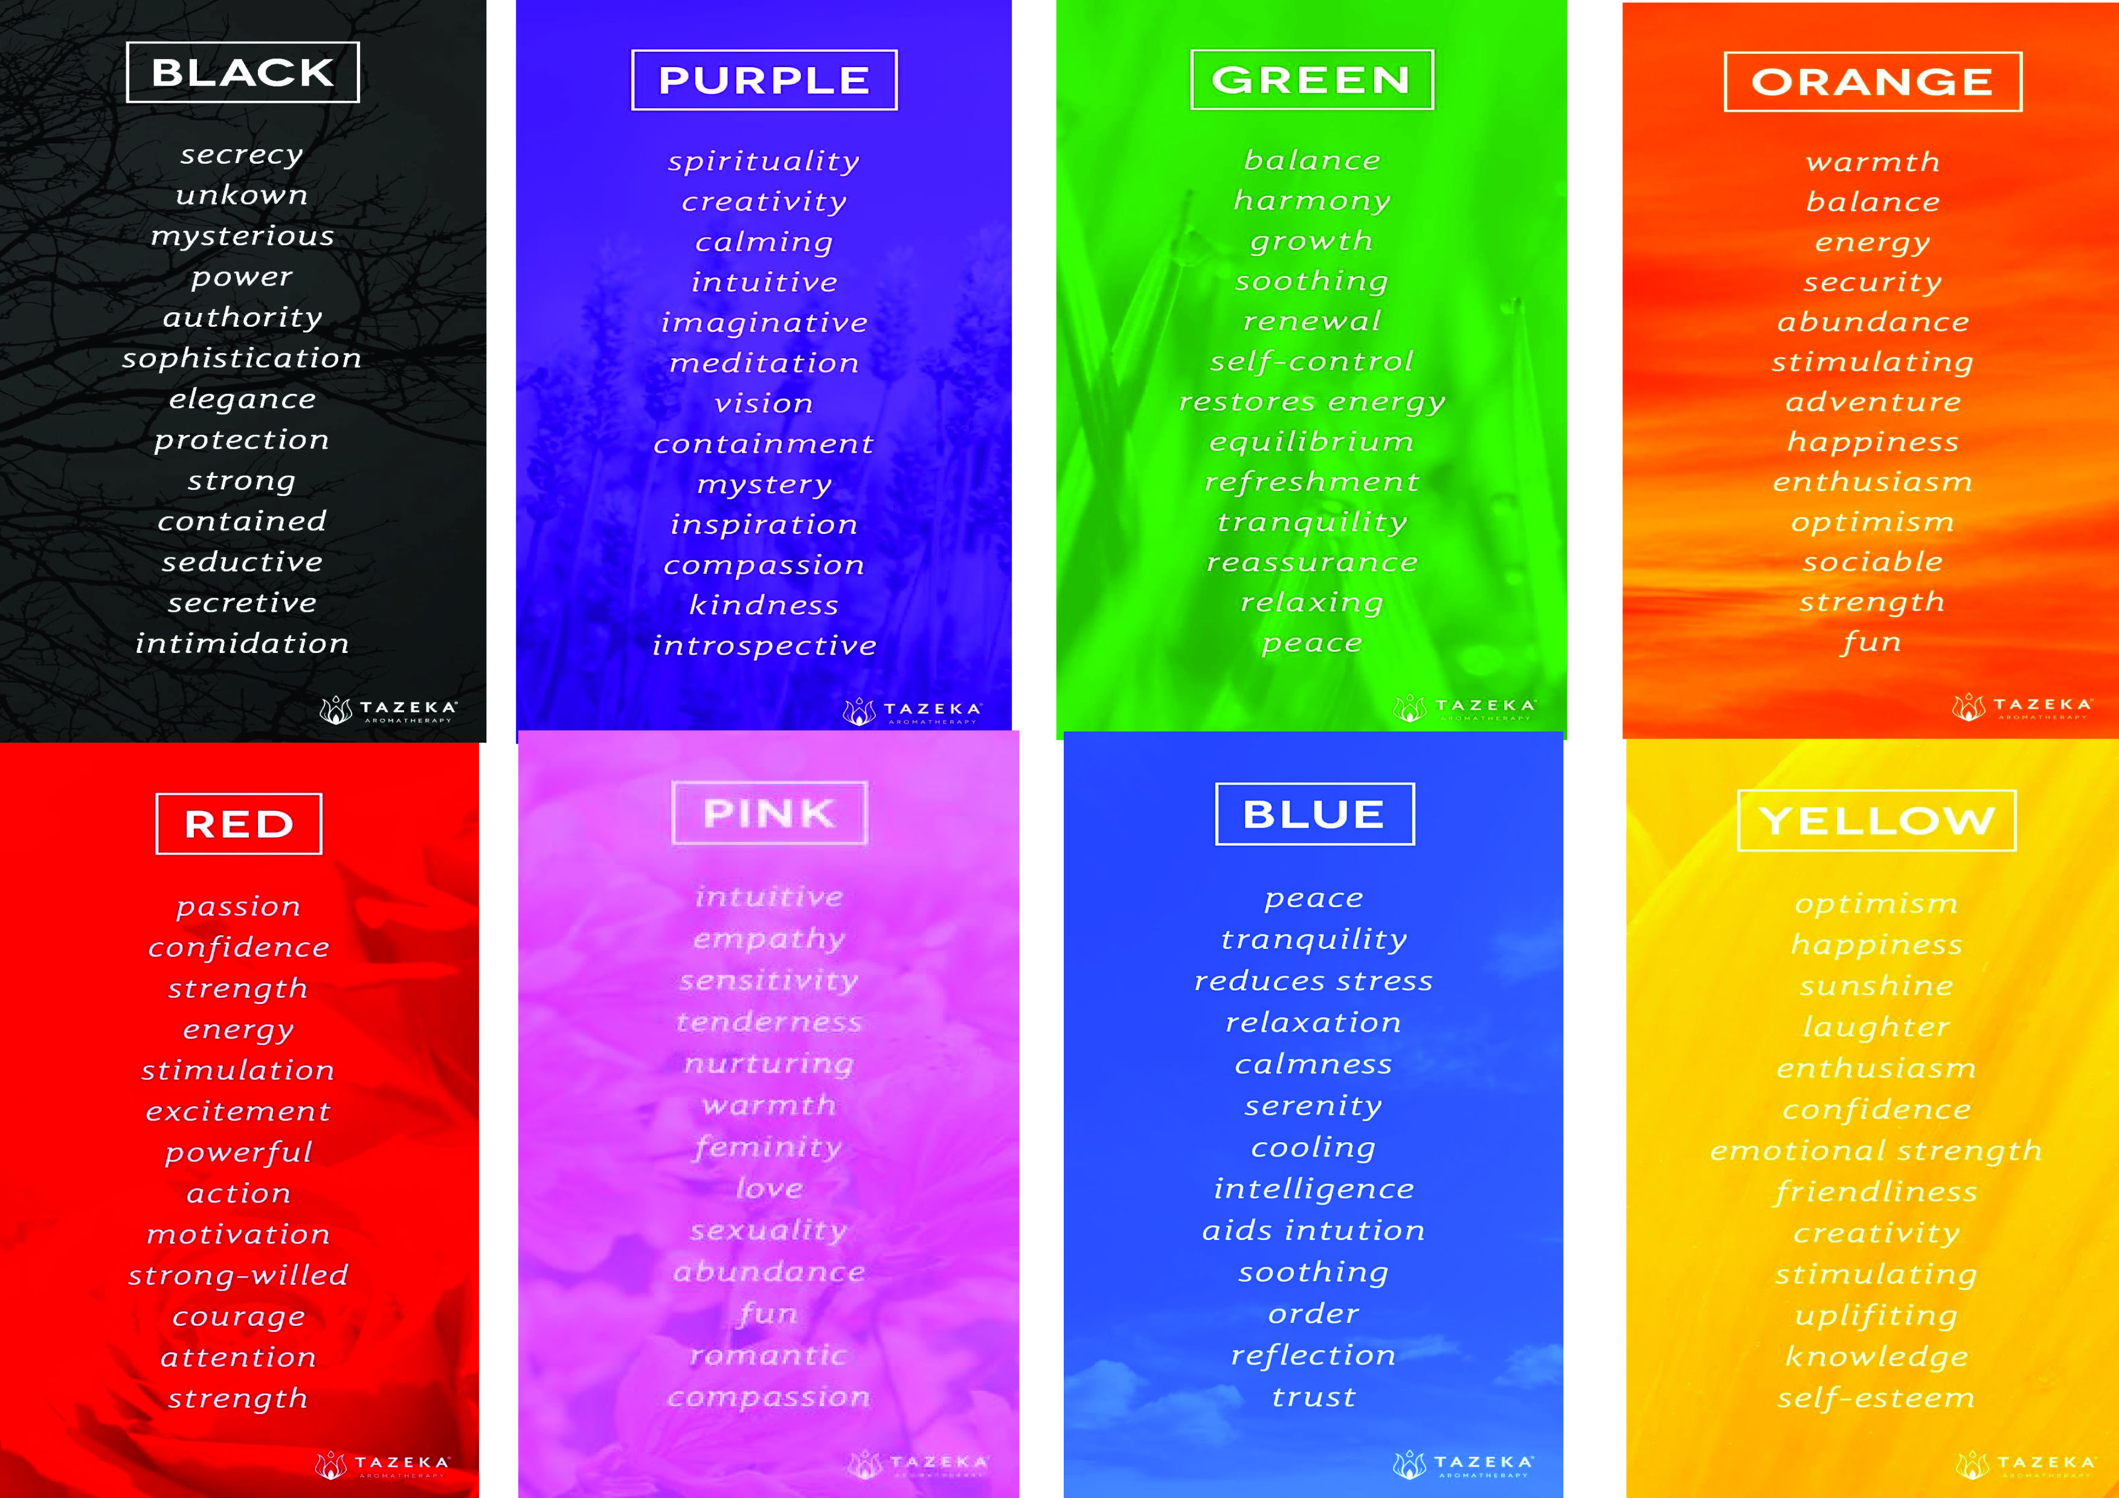

So now the next step would be to actually put some designs to the test, from my thumbnails sketches from earlier.
I chose a very simple design first off, and a ‘Good’ design too.
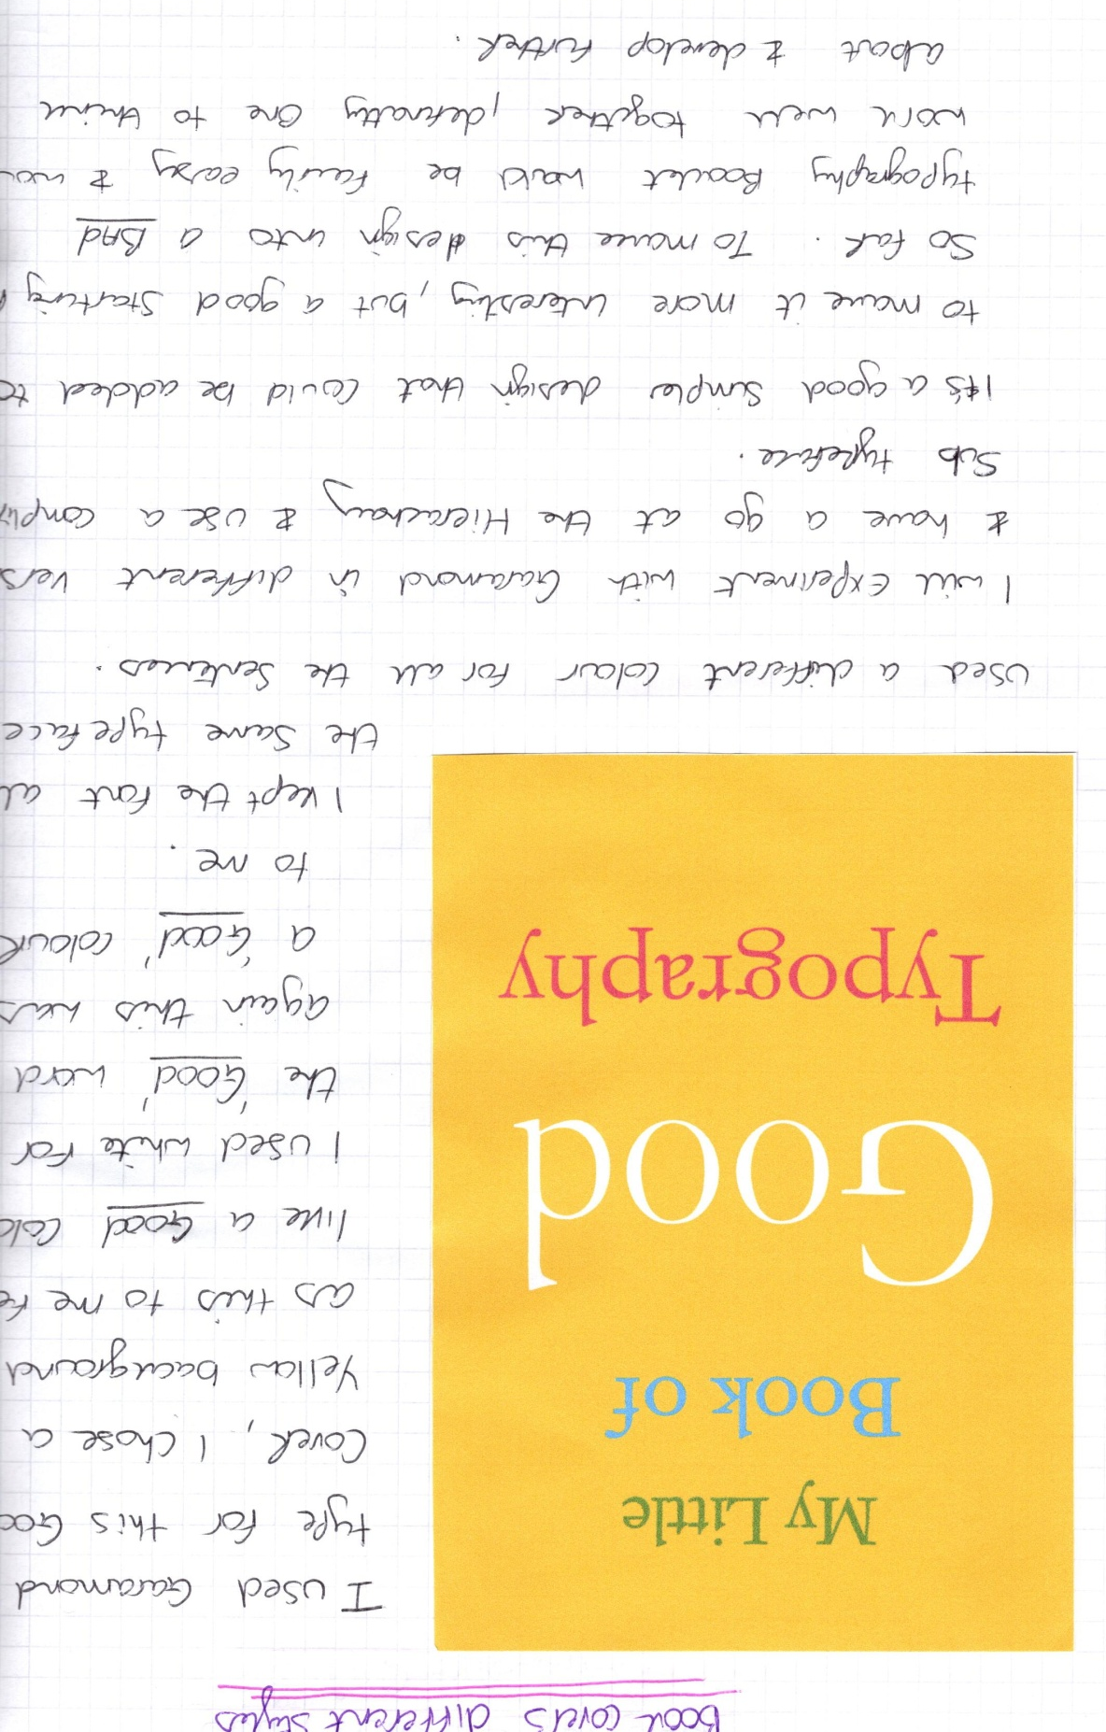

I then chose a ‘Bad’ design and another ‘Good’ design, to see how these would work out.
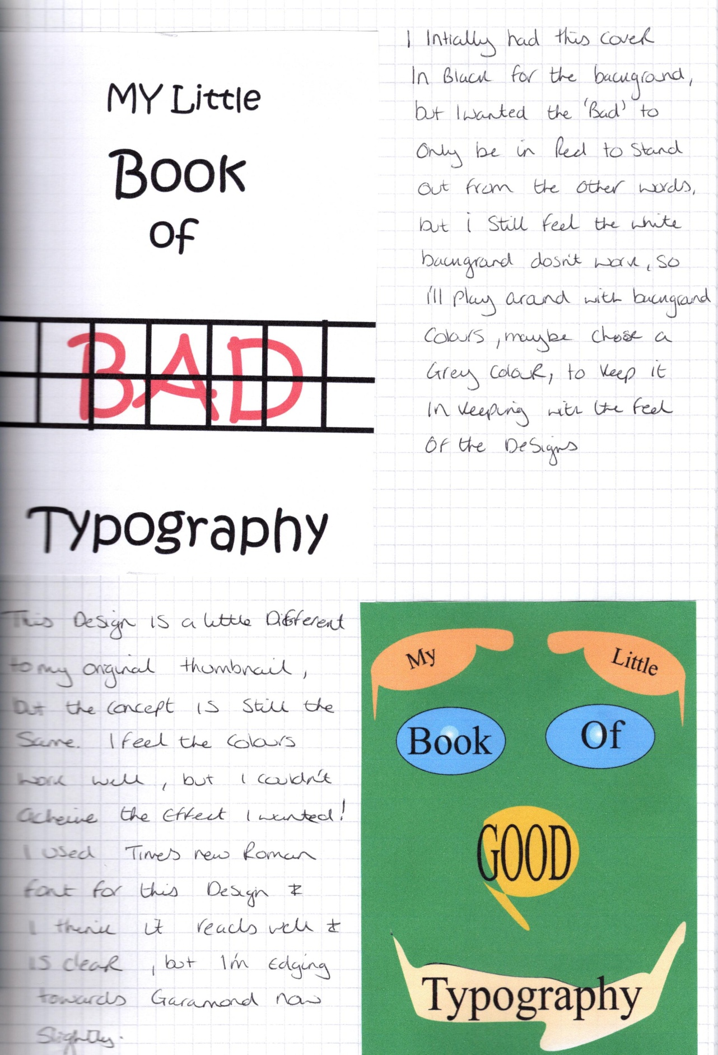

These initial designs helped me to decide a few things; I want my design to be more graphic in style this time, feedback from my tutor has been to try a different style with each of the assignments and to go outside your comfort zone. So I think I will try a more graphic, simple style, with limited colours for both the booklets, which is very different from my natural style.
I think I should defiantly choose a limited colour palette, I like the simple design of the bad cover above, I think I will work with this style and move this forward. I am still not convinced on either ‘Good’ design yet, so I will go back and work on a few more.
I worked on two more ‘Good’ designs and three more ‘Bad’ designs, I think I have some elements for each now that I can move forward.
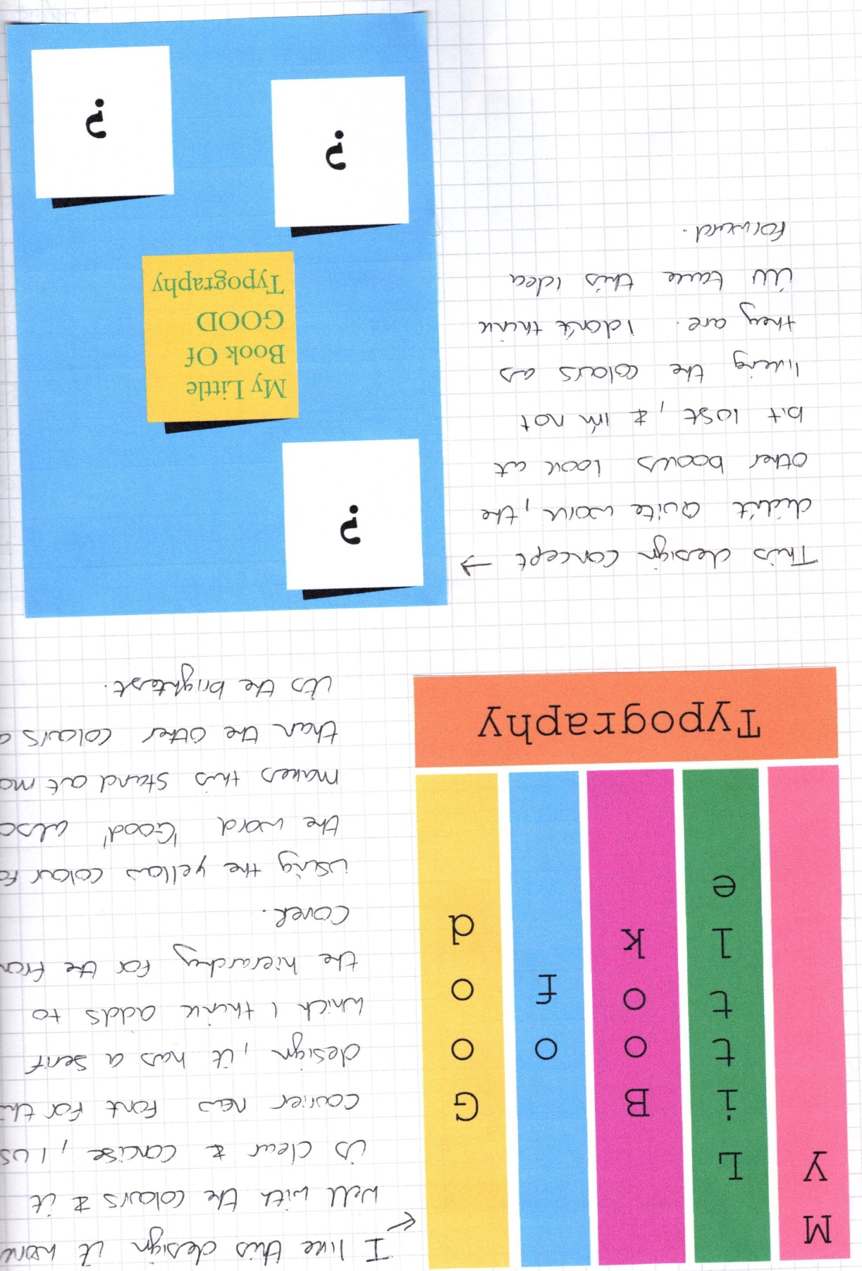

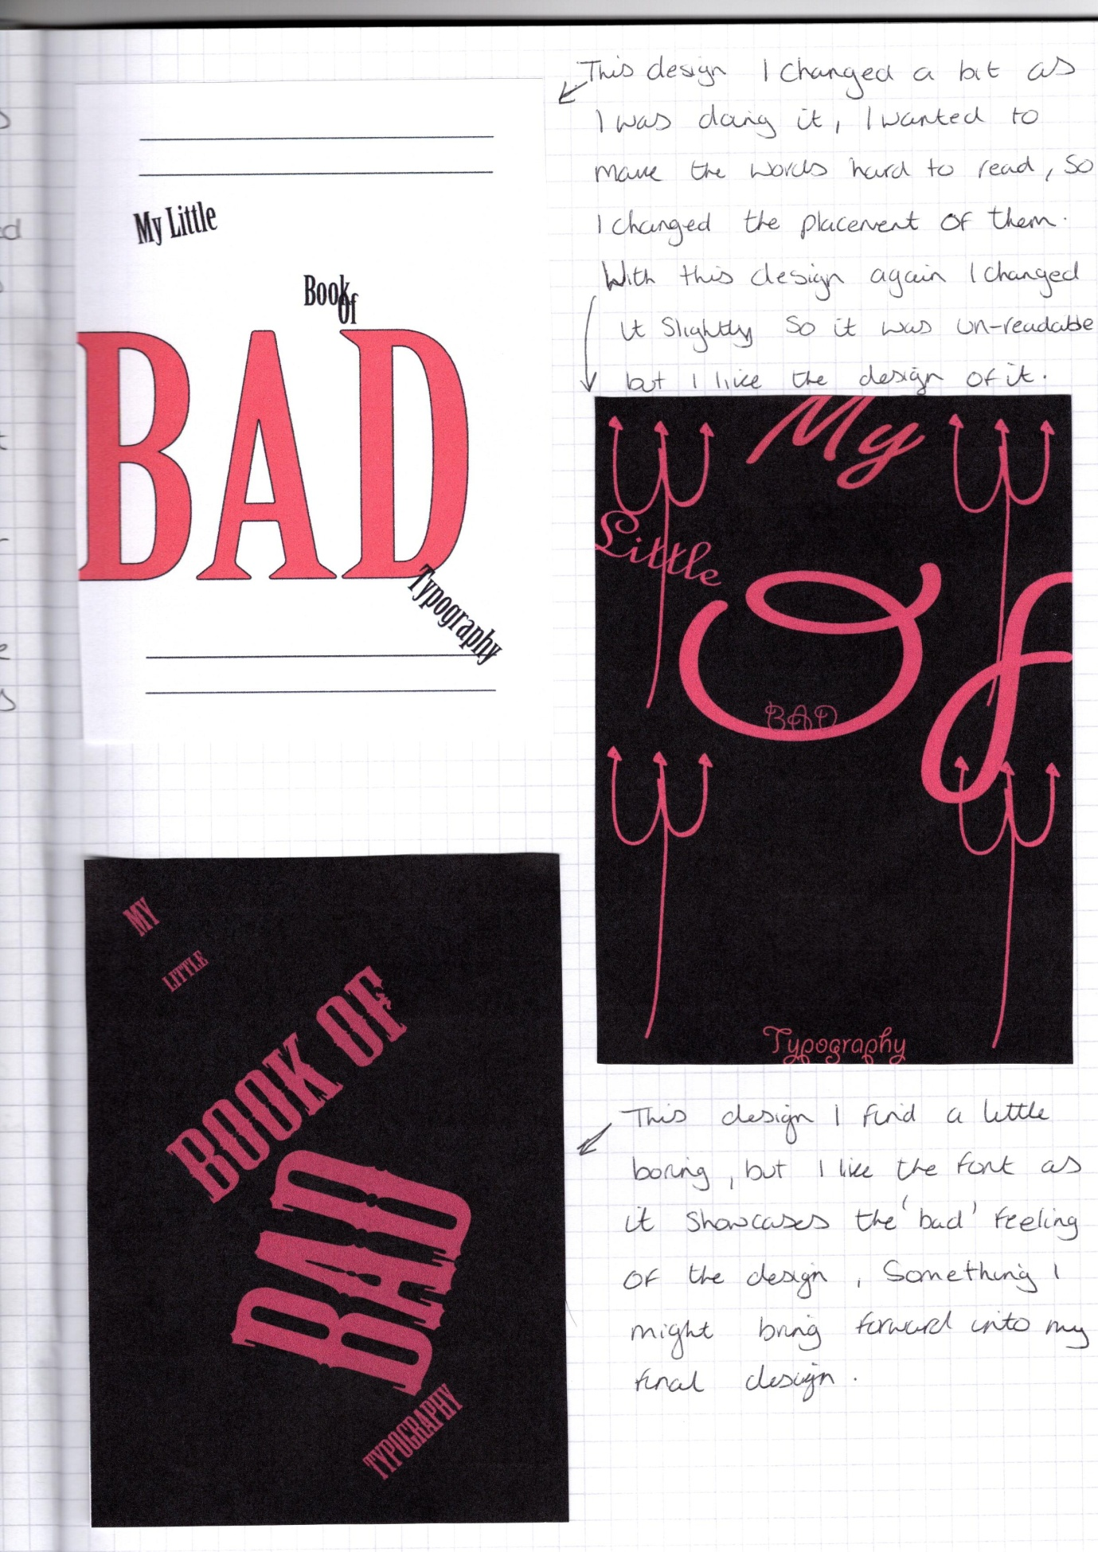

So I am going to think about this block colour design for the ‘Good’ booklet, I still needs some bits changing and tweaking, but I feel this design sums of what I am trying to achieve with this booklet.
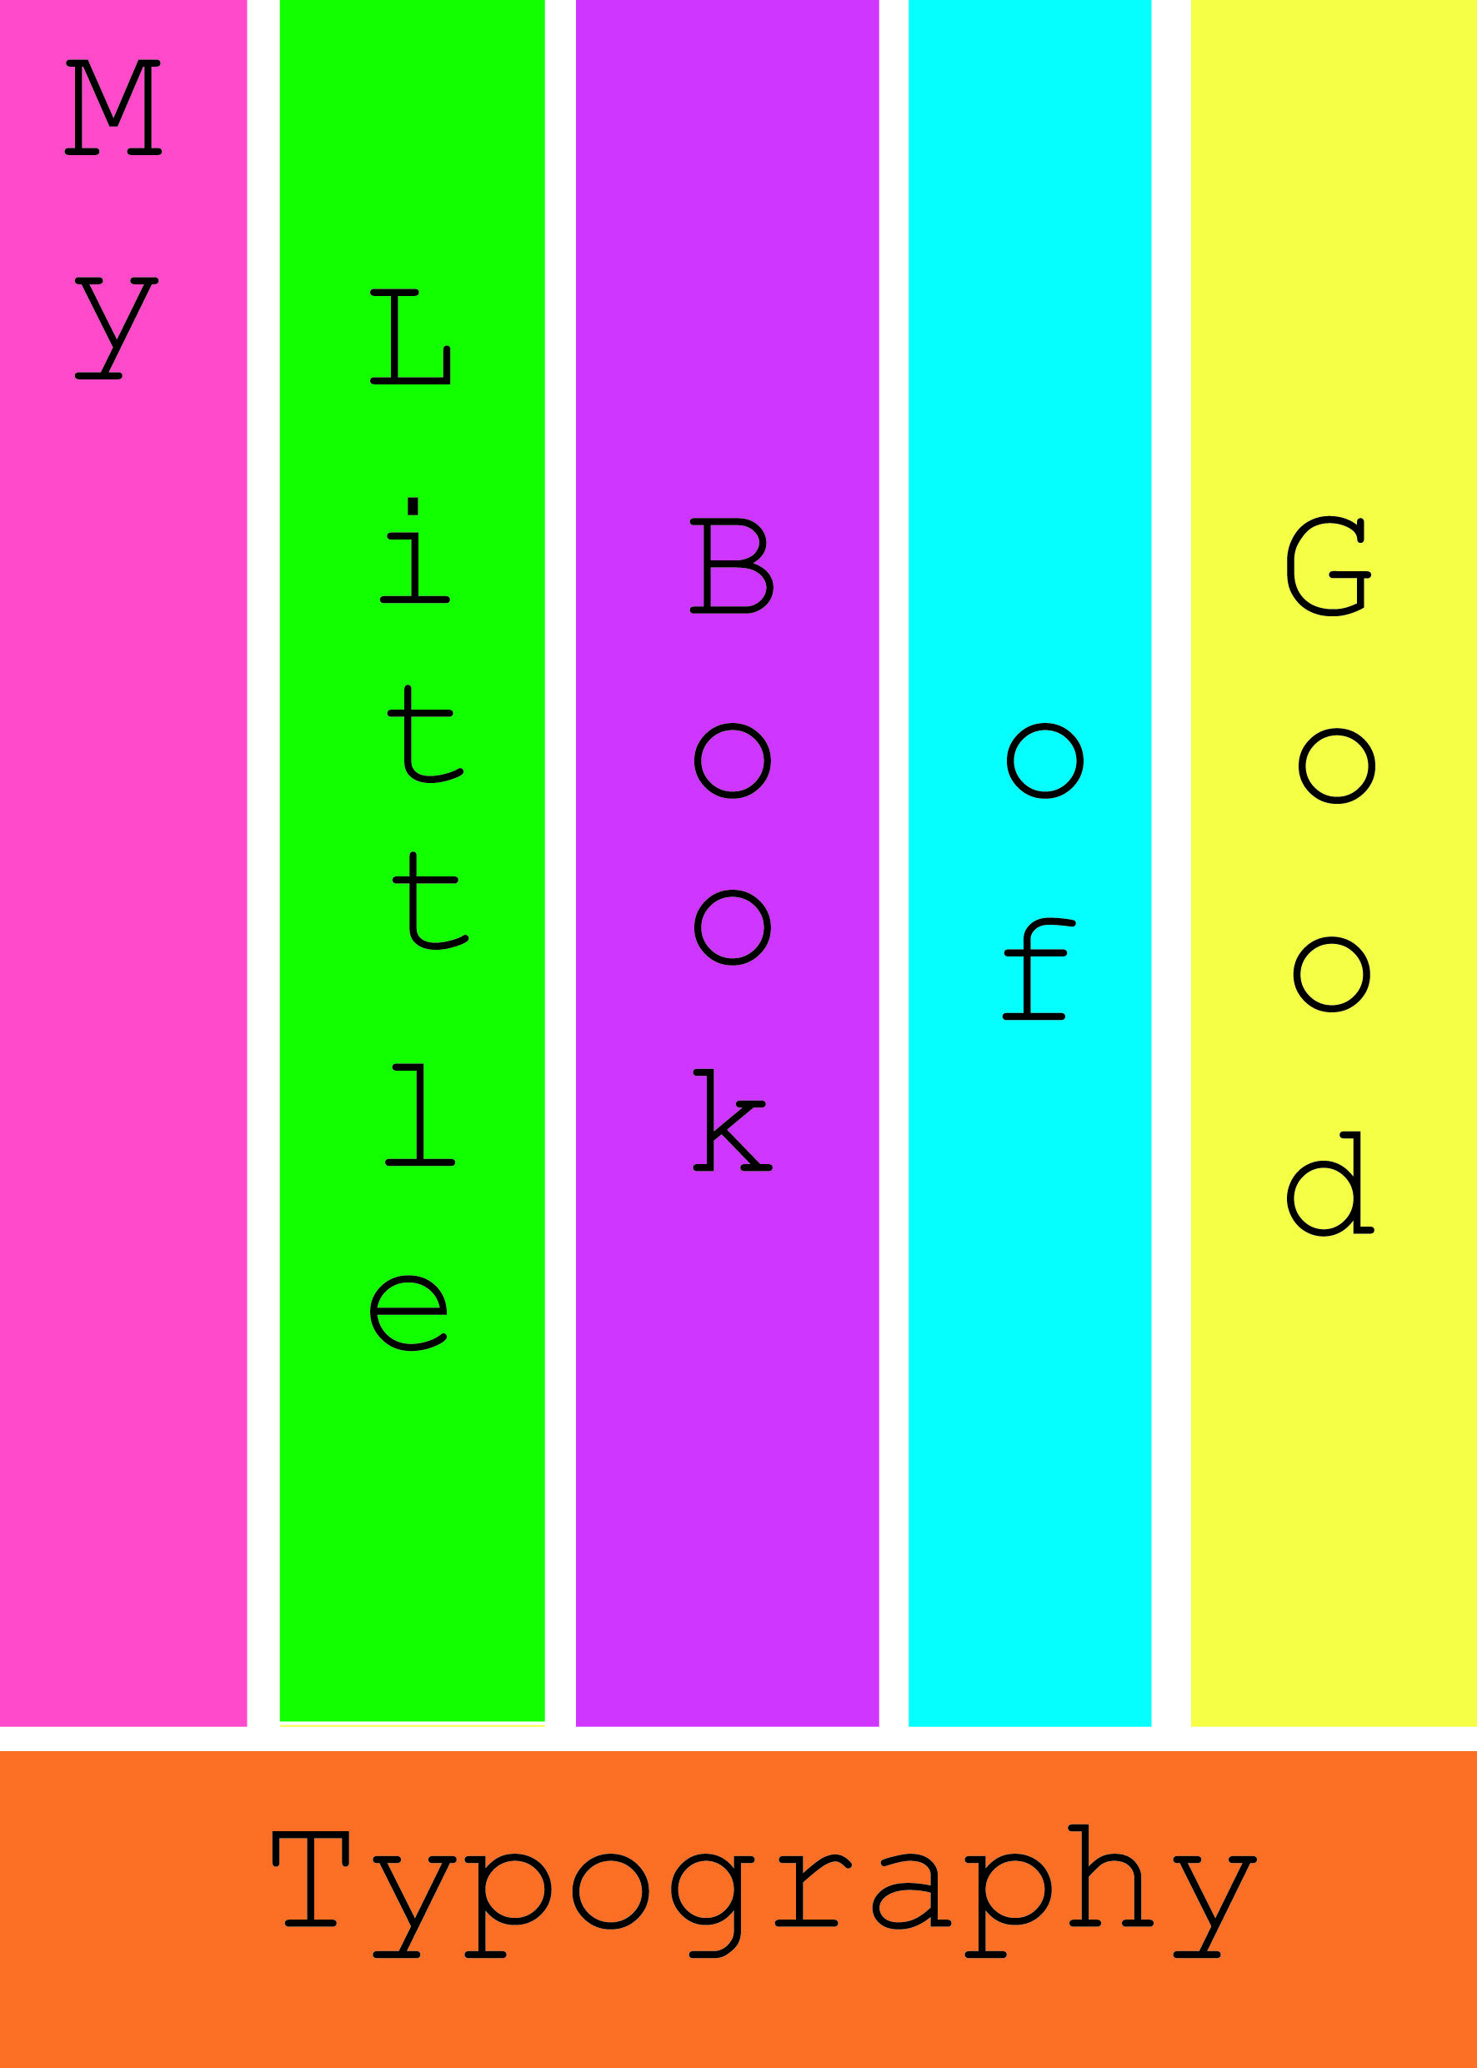
With the ‘Bad’ design I like this design, but it doesn’t fit in with the graphic style that I was going to focus on in this assignment, but I will use this and work on it further to see what it comes out like. I want to double check the brief to see if the booklets need to be the same or can be different in style or not?
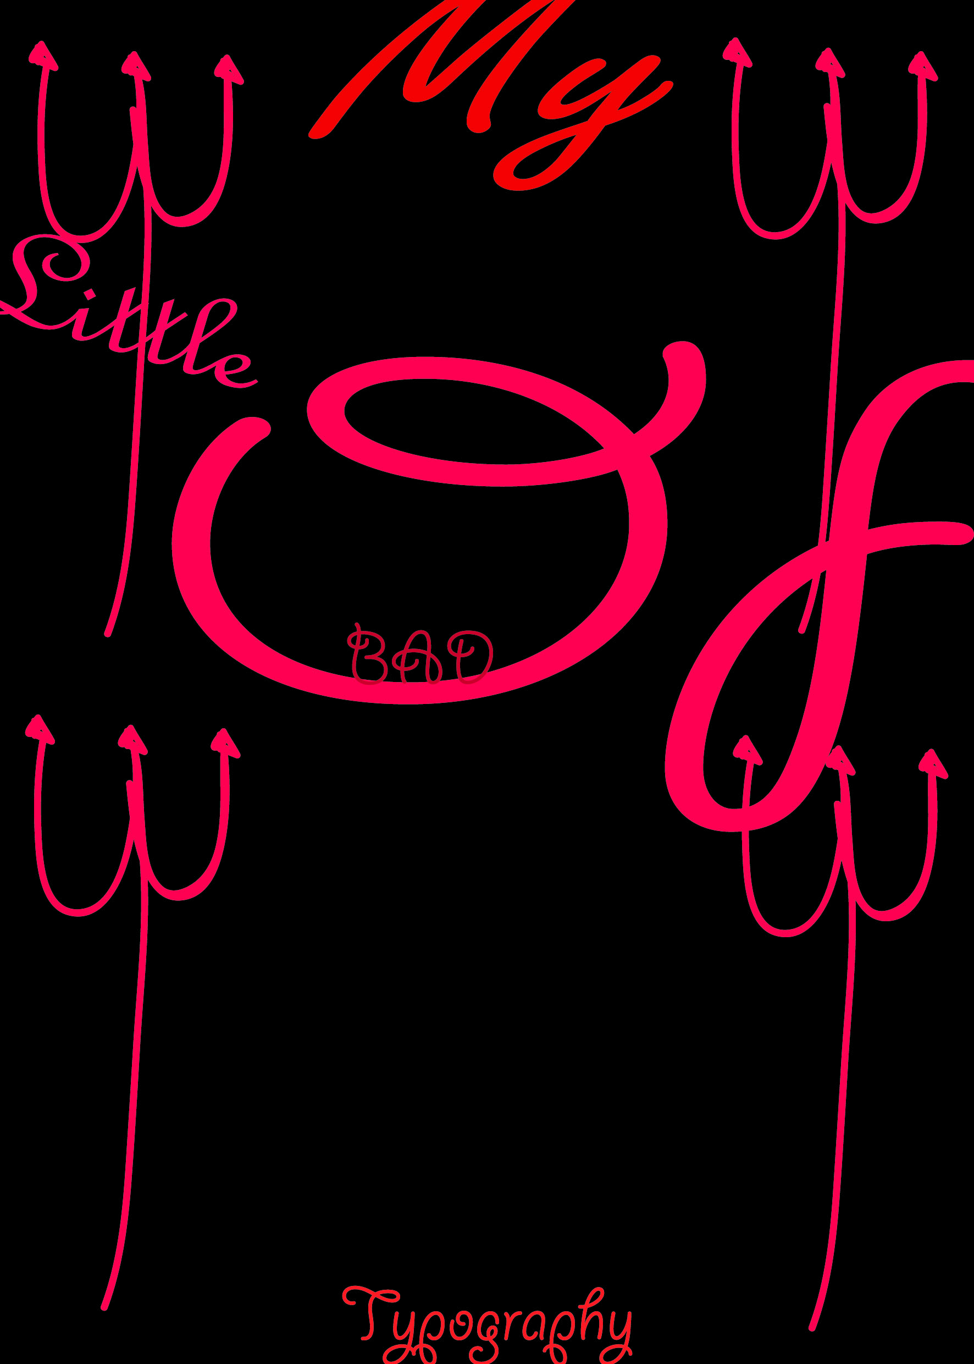
I am now going to start to get the booklet template up on In Design to start that process before I work on the covers again; it gives me some time to re-think to check I’m going down the right route.
I set up a template of an A5 booklet, with 8 pages and two columns, with a 1.25 margin both top, bottom and either side.
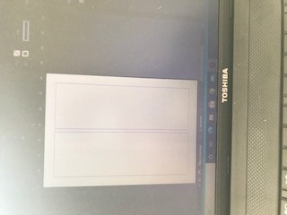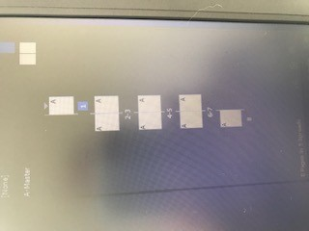

So that was all set up ready to start working on, now I just needed to work out what I was going to write for each page, so I went back to my sketchbook and wrote down in each section and heading for each page, a little something about each design feature.
This was just a brief sum up of what I wanted on each page, I will go over this and expand more once I’ve got everything together.

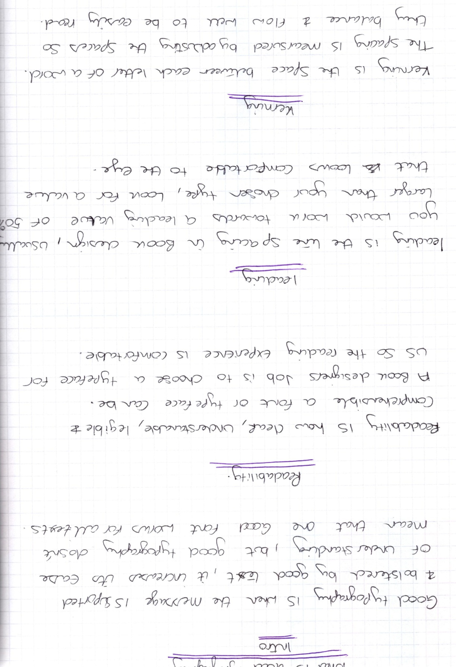
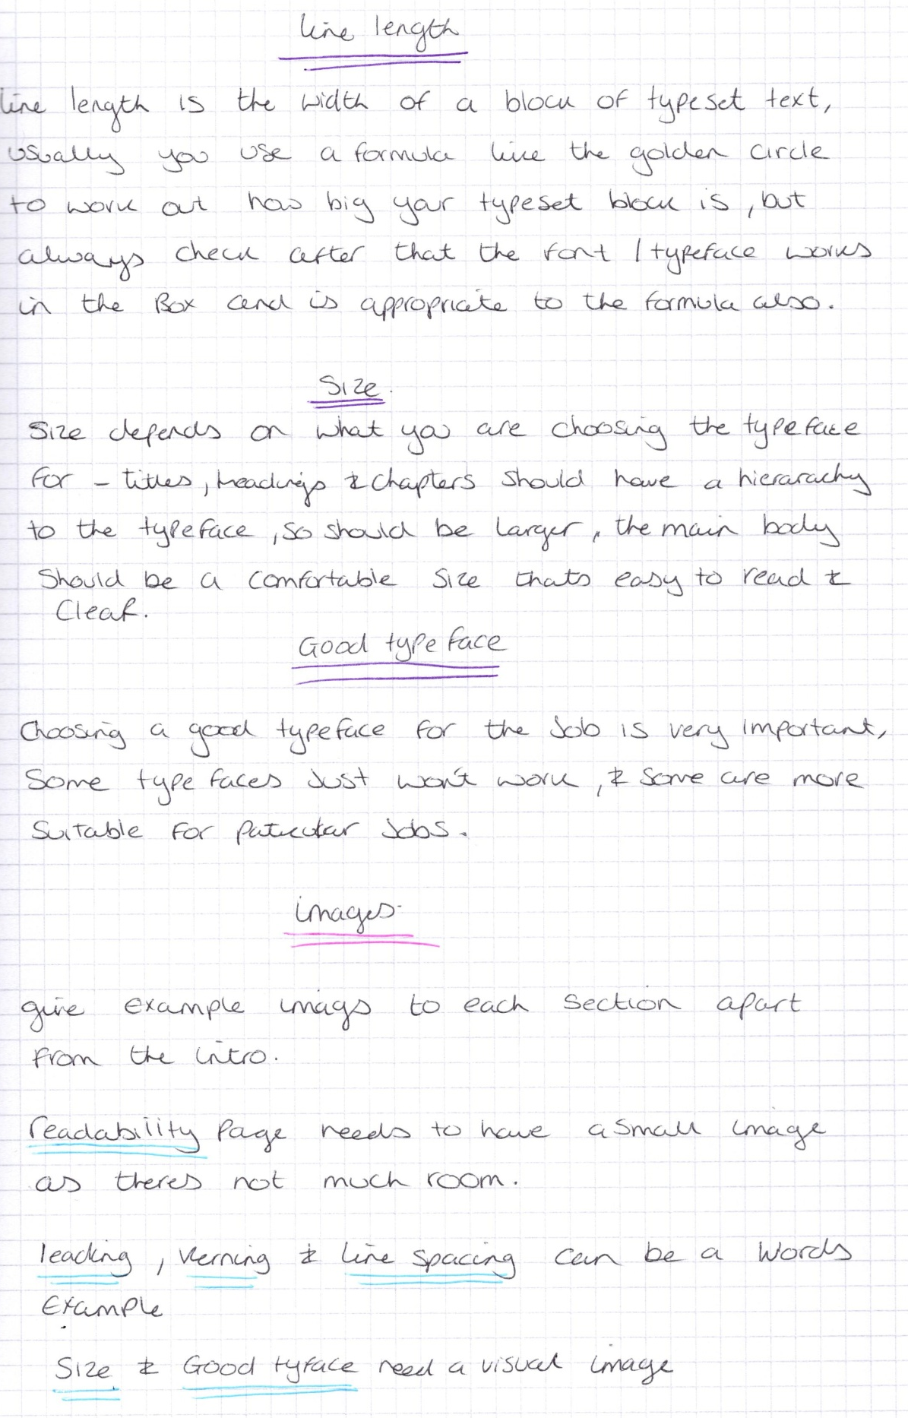

My next stage now is the plan out the layout of each page, of where the text boxes and image boxes will go, so I set up and drew a new flat plan for this.
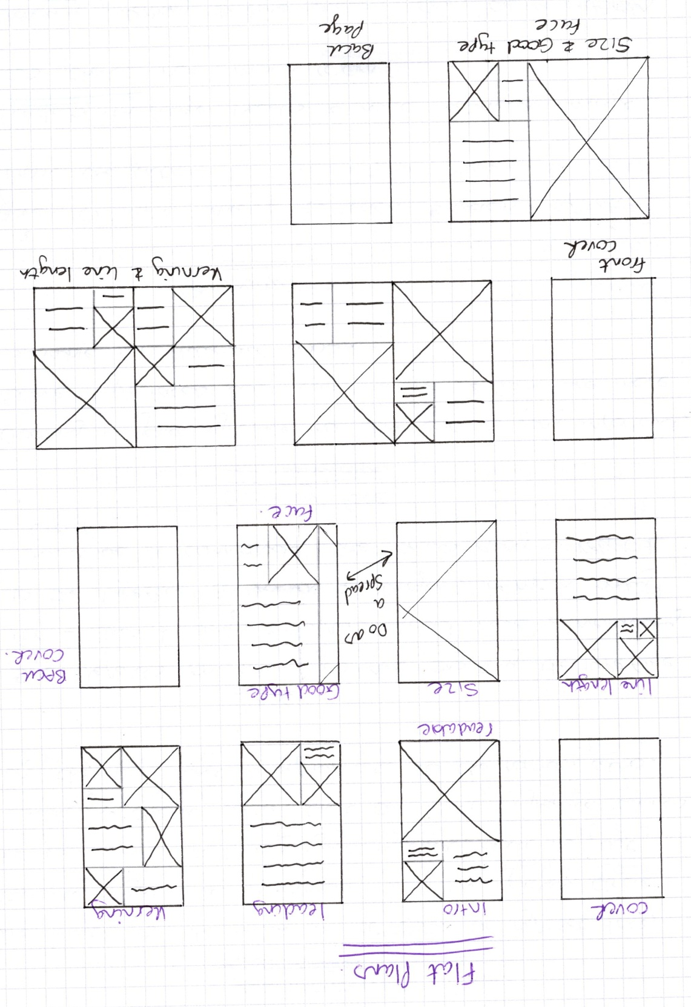

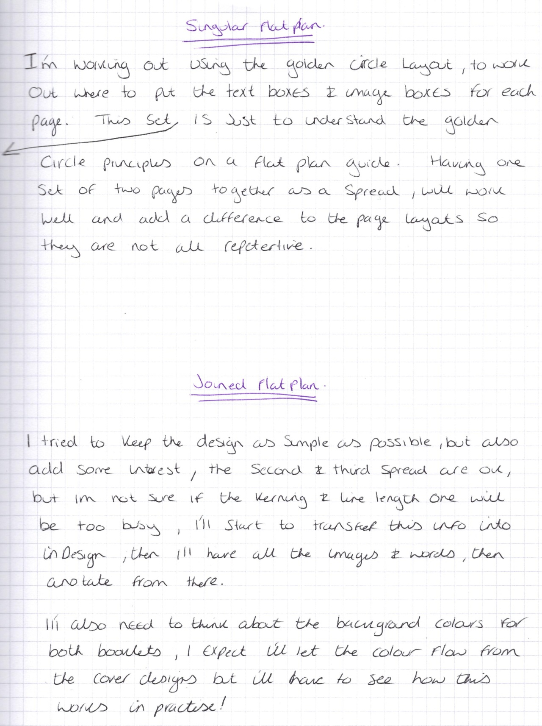

I then started to transfer the information over onto InDesign, I planned it out using 4 columns, I added in the text boxes using Garamond typeface for the time being.
I did all the pages and planned in the text boxes and used the words I had previously written in my sketchbook for each heading. I then printed these out and then annotated them, added where I wanted the pictures and also what the pictures would be. I also used this time to plan in the quote boxes and anything else I thought was relevant.
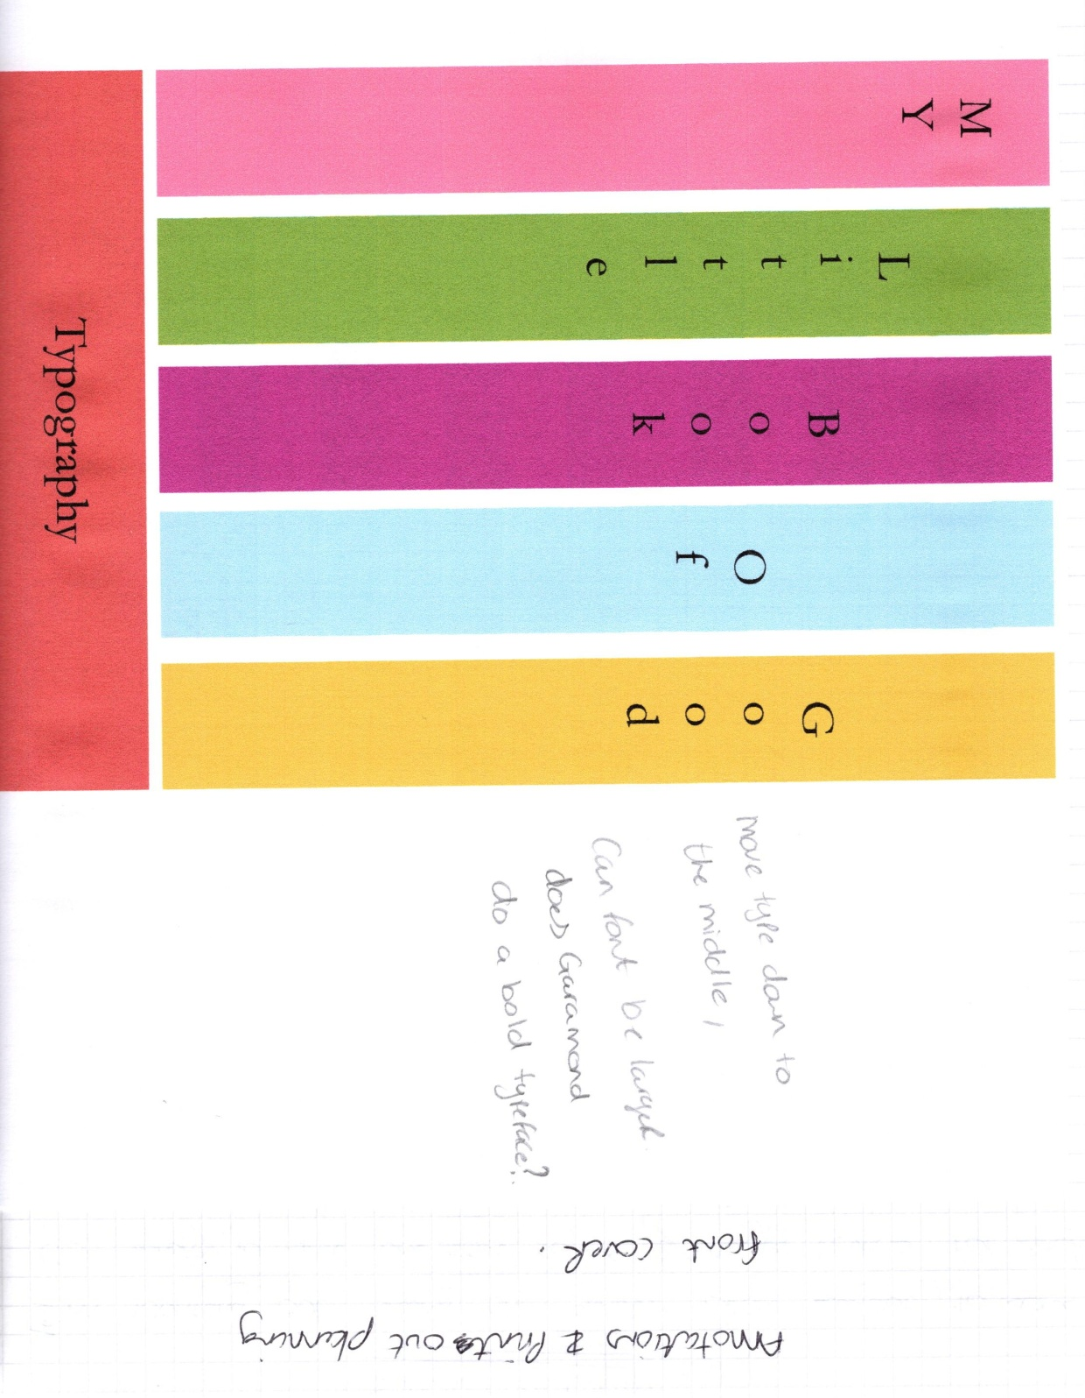
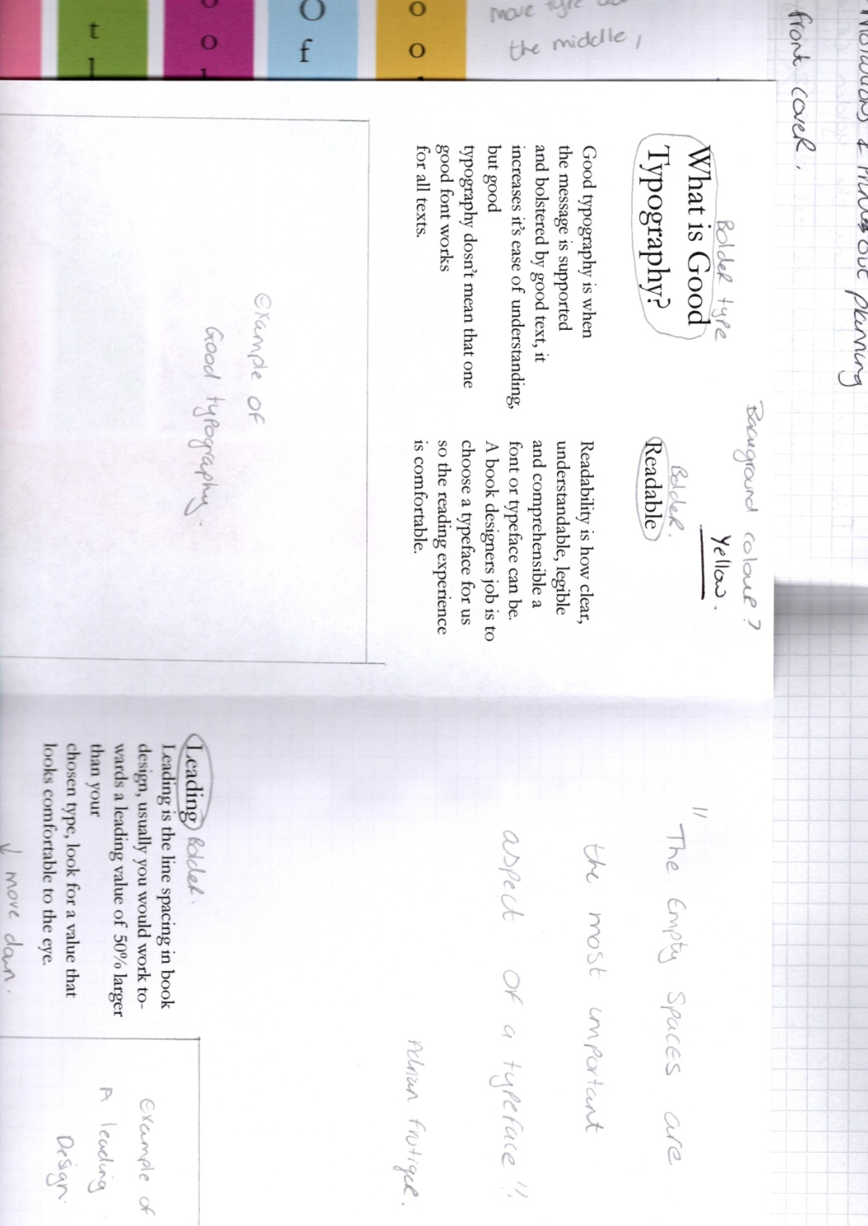
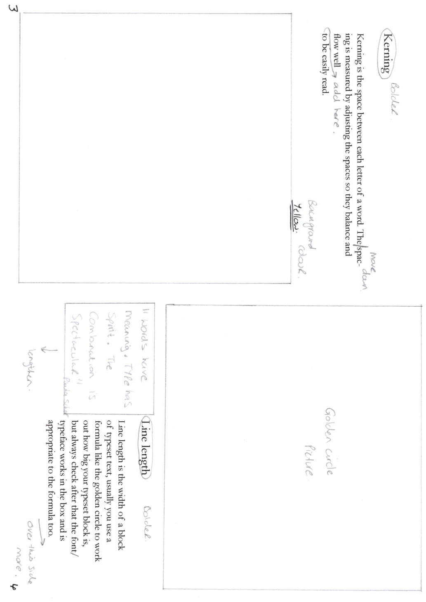

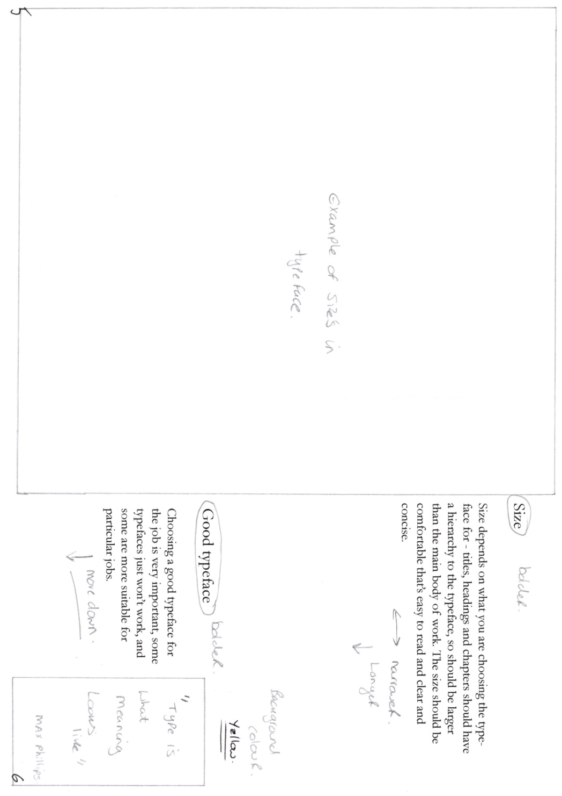
I then worked on the annotations from above, changed all the elements that I wanted too, then printed out another set of designs to see how much netter these were.
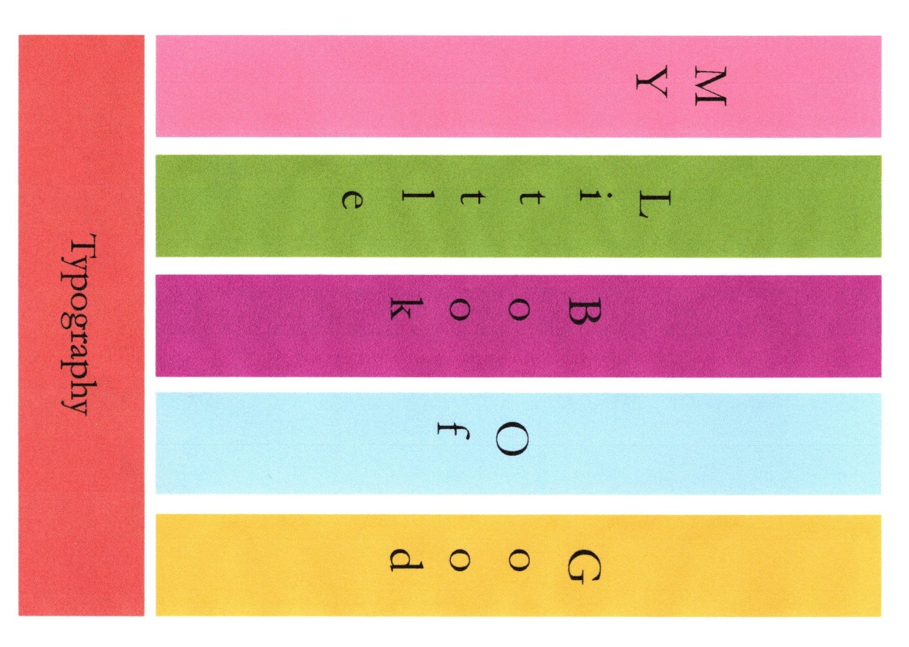

So with the front cover I moved the typography into the middle more, and changed the size larger.
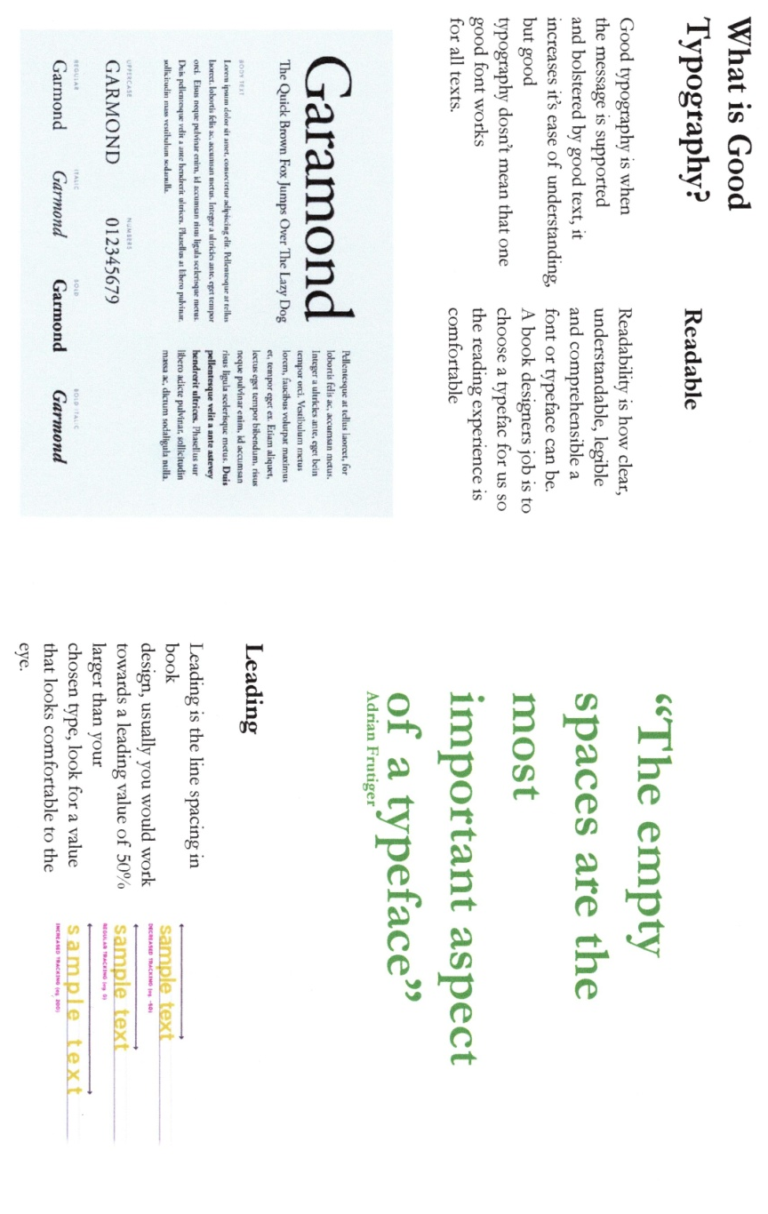
I then changed the headings to bold and made them larger, I added the example of good typography, and the quote, and an example of Leading.
I then changed page 4 and 5, again made the headings bolder and larger, added in a Kerning example, a golden circle picture, and also the quote, and moved some of the text boxes around to fit better.
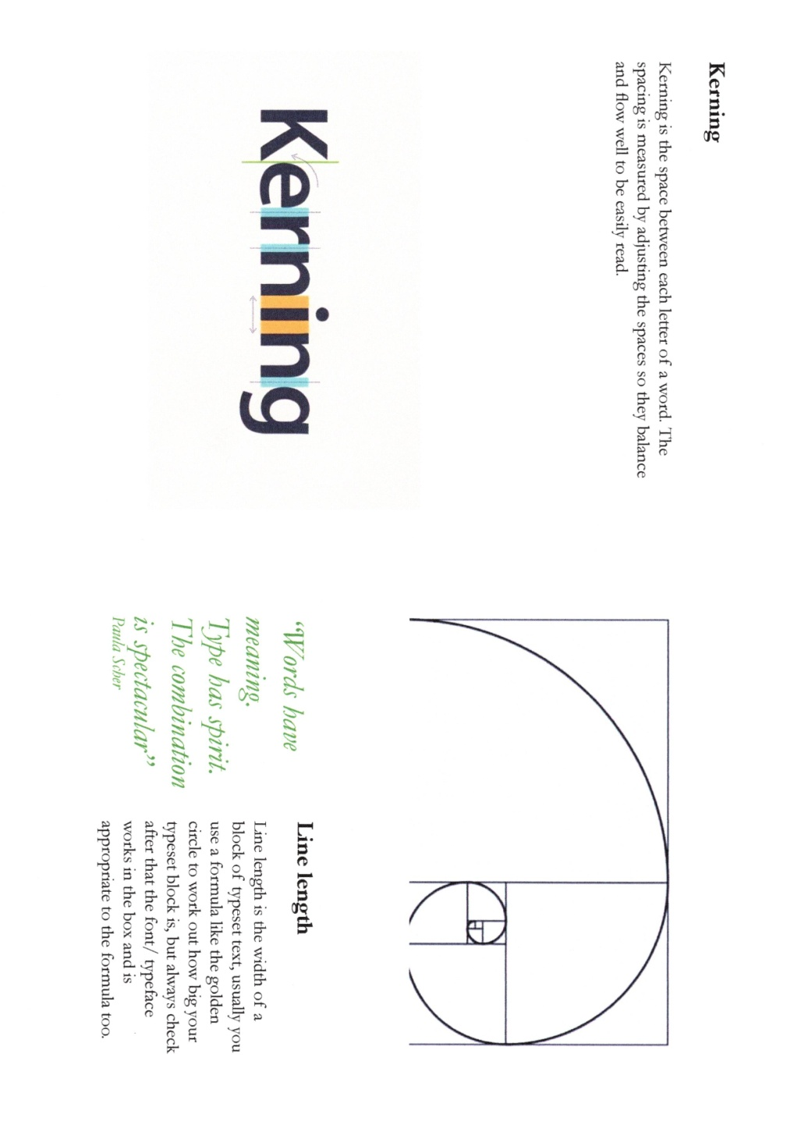
On pages 6 and 7 I again made the headings bolder and larger, added in an example of typefaces, the quote box and moved the text boxes around, so they sat better with the other elements.
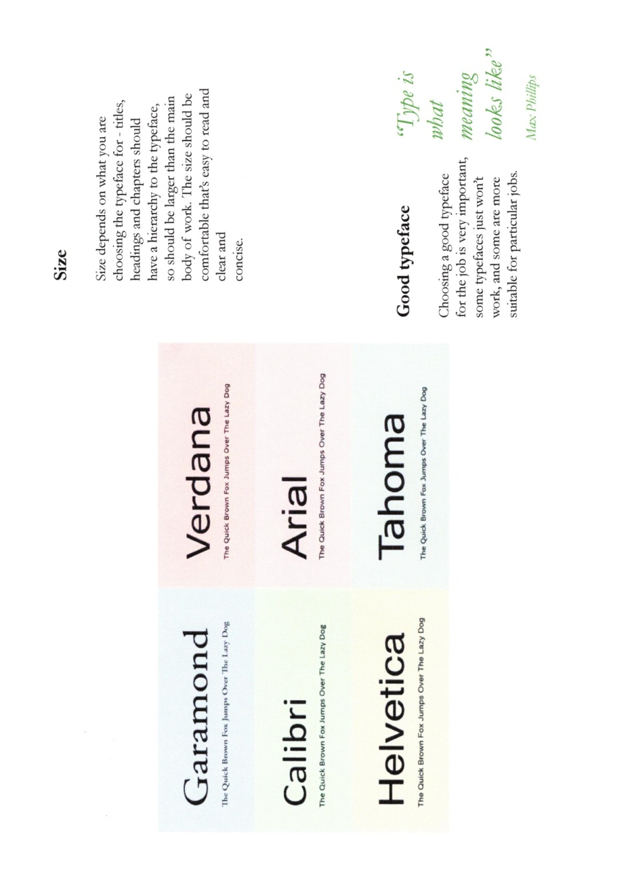
With the back page I just changed the colour to yellow, I need to think whether I need to add anything here or not?
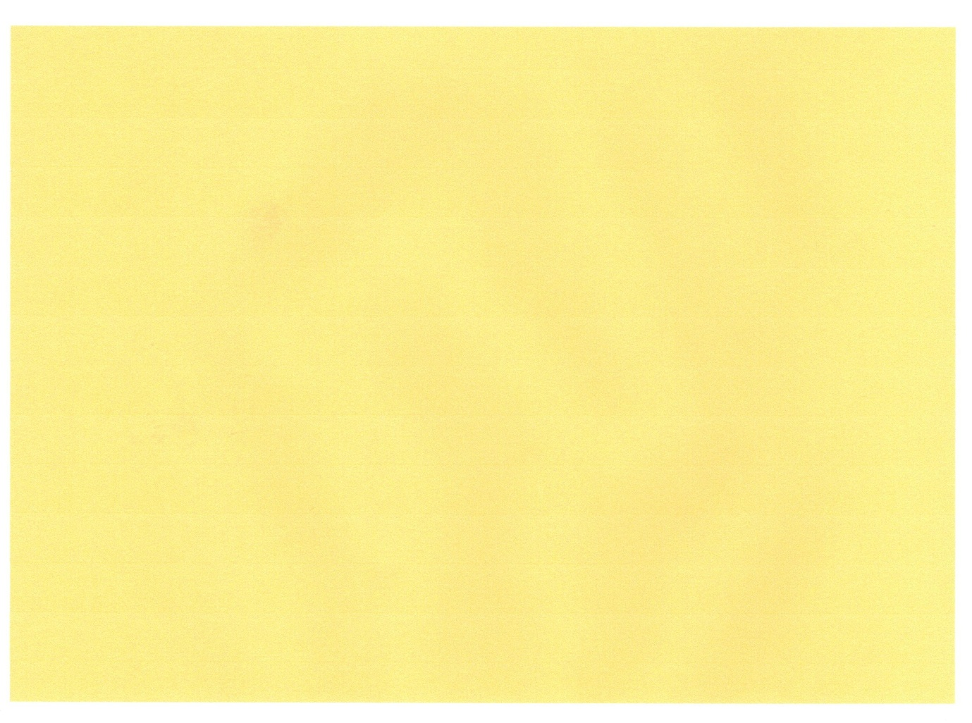
I then went on to annotate these pages to see if there was anything else I wanted or needed to change!
I printed these pages out too, and stuck them together roughly, to see how it would look in booklet form, before I finished annotating them.
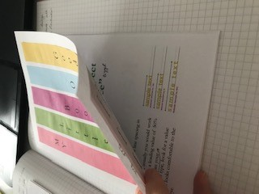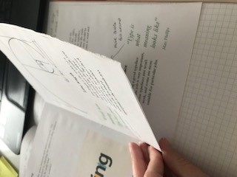

I then started on the Bad typography booklet; I started with the front cover, I decided to use the Pristina typeface for this booklet, as it was one of the bad fonts I had identified earlier.
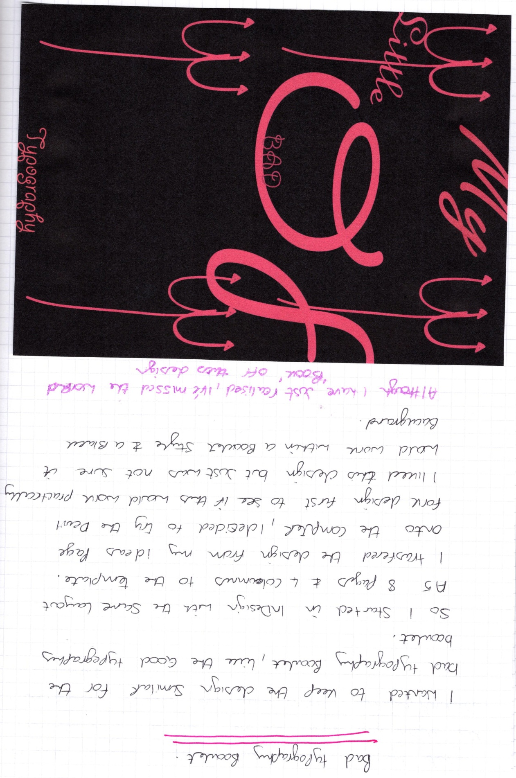
I changed the design ever so slightly, but included the word ‘book’ which I had missed out in the last design.
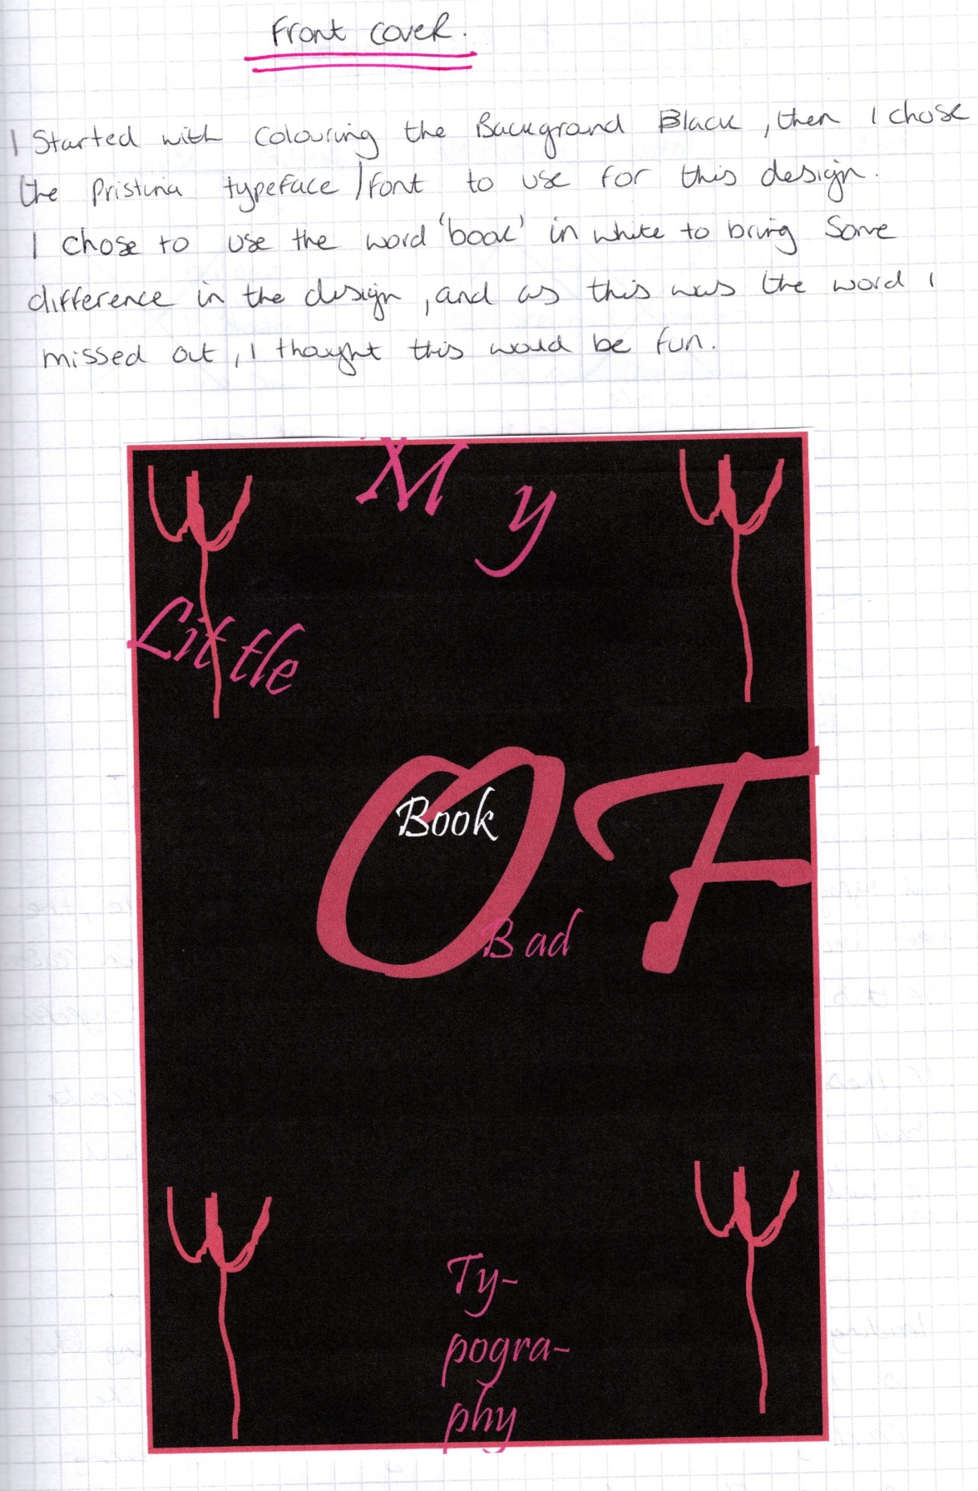

I then needed to think of a flat plan design for the booklet, so I drew out a rough idea of where I wanted the text and picture boxes to go, again using the golden circle as a guide of where to place things.

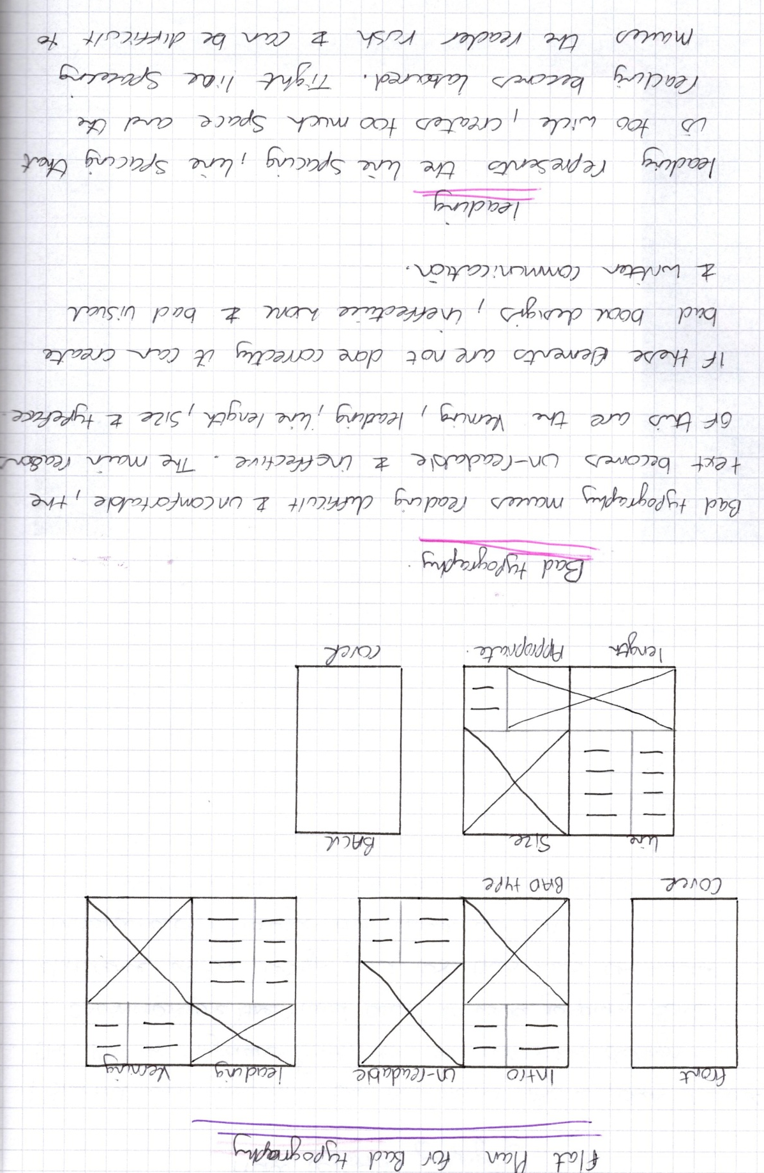
I then wrote a bit about each of my headings the same as what I did with the good typography booklet. So this gave me a rough plan of working on the template in InDesign.
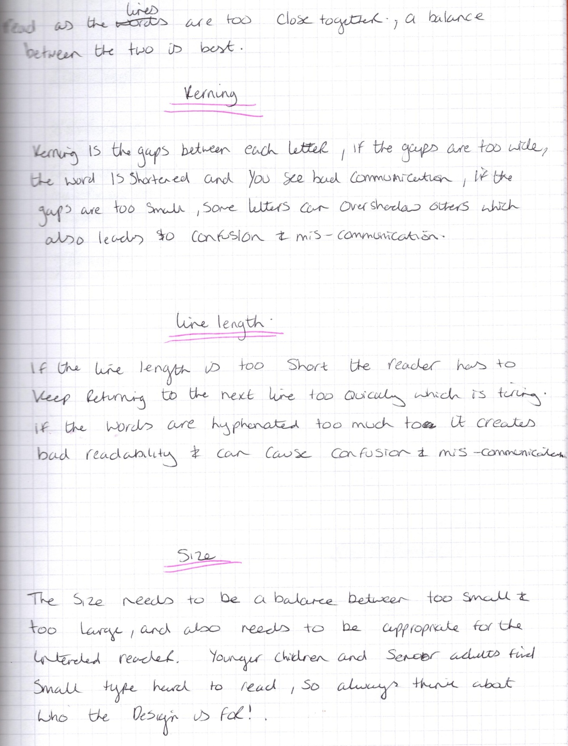
I wrote out the text boxes first, as I knew I needed to add in examples of bad typography into the writing, but I still needed it readable for the reader, so they understood the principles.
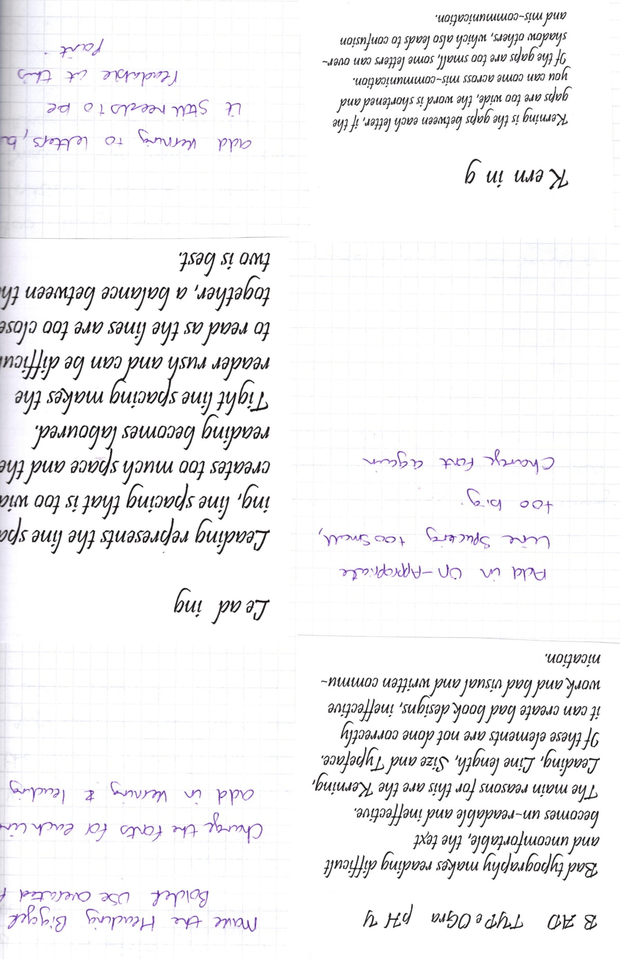

I annotated these also, as some aspects were not quite right, and I felt it needed to be really bad, so use more different typefaces, mix it up more, give more change in size, and change the kerning and leading. There would be a fine balance between really bad, and bad enough to still be readable for the reader!
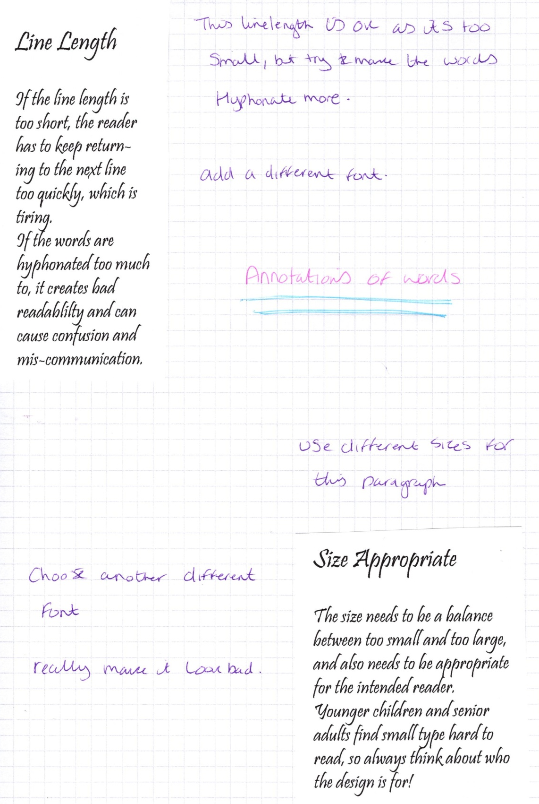

So I then started to transfer this information onto InDesign, I used the same template as before. I did all 3 spreads and then printed them out ready to annotate again.
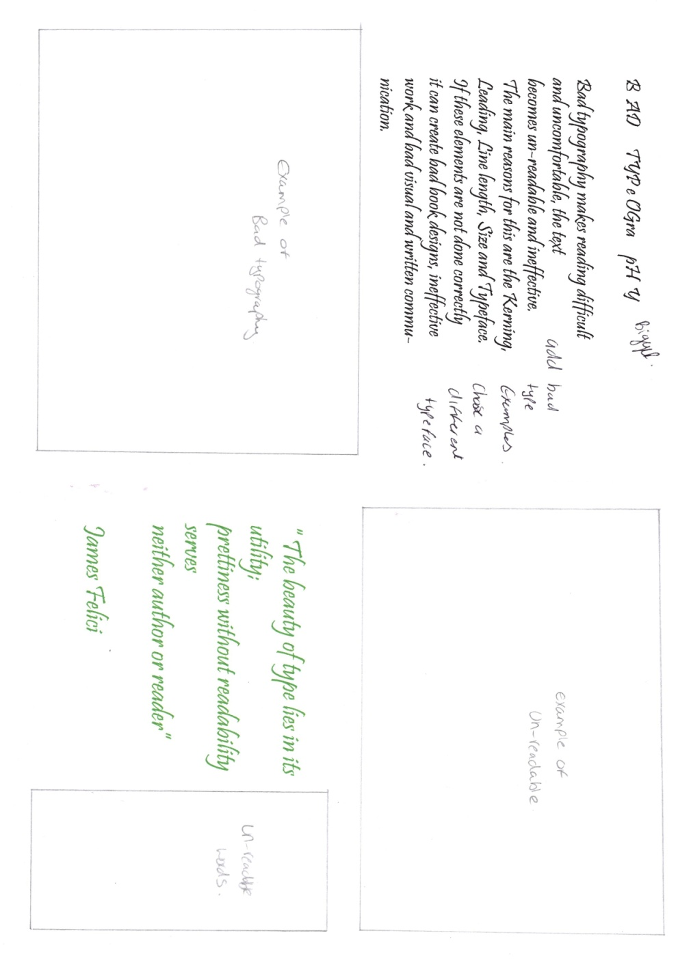
I added in boxes for the image designs that would fit in after; I added a few quotes, but also boxes where these would go too. Drawing on the print outs at this stage helps to plan the book better. I can add quotes that work best with that heading, and to know what size image I’m looking for.
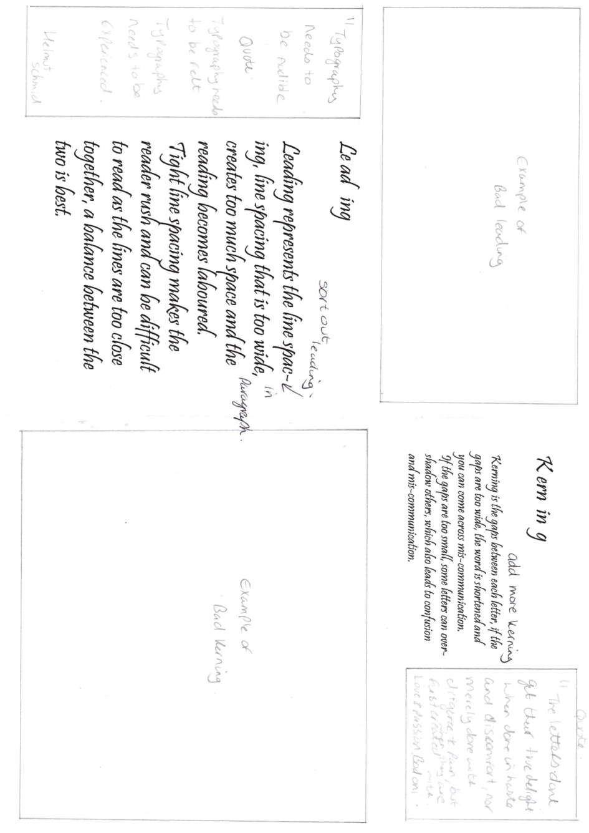
I added in my annotations of the writing in here too, so I knew what I needed to change on the next annotation.
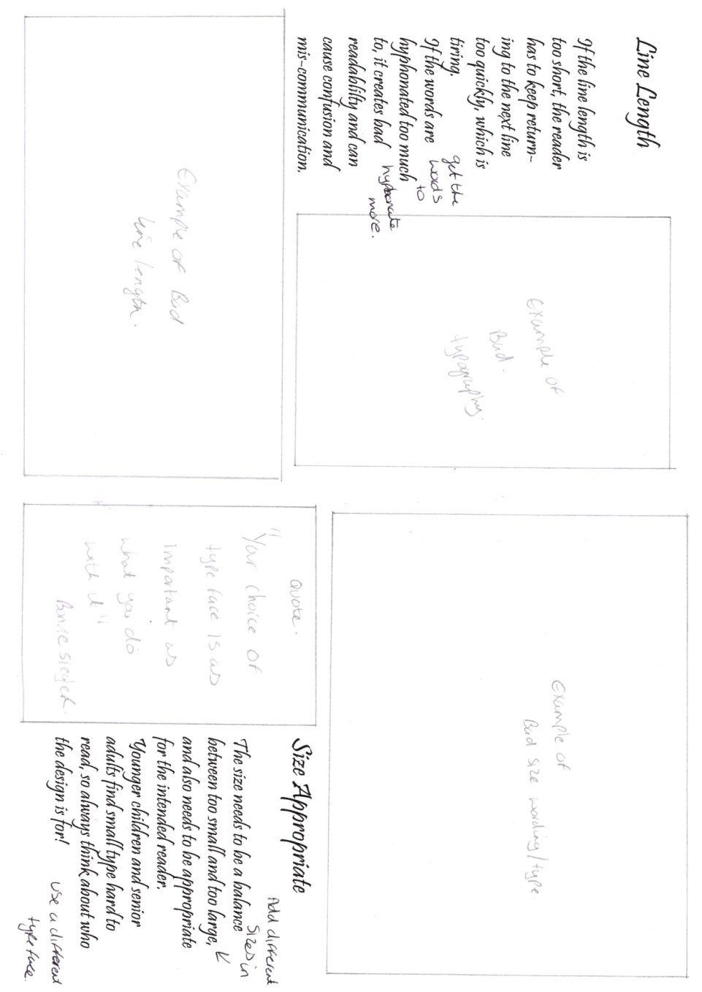
So then I went back onto InDesign to change the areas that needed changing, and to also add the rest of the quotes and images. I also change the fonts so there were more typefaces present. I changed the font sizes and the kerning and leading on some of the text boxes, to make it look really bad, yet still readable.
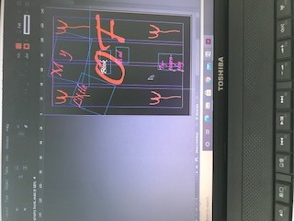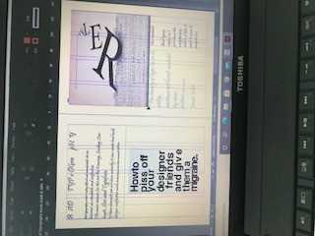

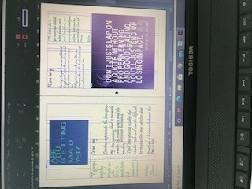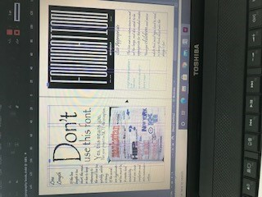

I then printed these off and checked to see if they needed any more annotation, there were some bits that over lapped, like a text box, but then I remembered that this was the bad typography book, so I didn’t need to change this, as this represented bad typography, so I just kept it as it is. The only thing that I would have added was reference boxes for the pictures I chose, but I’m not sure if this would constitute bad typography or not!?
I will add them to the good typography booklet, then think about and see. I am also not sure about the bad typography front cover, I’m thinking of using or trying one of the other designs.
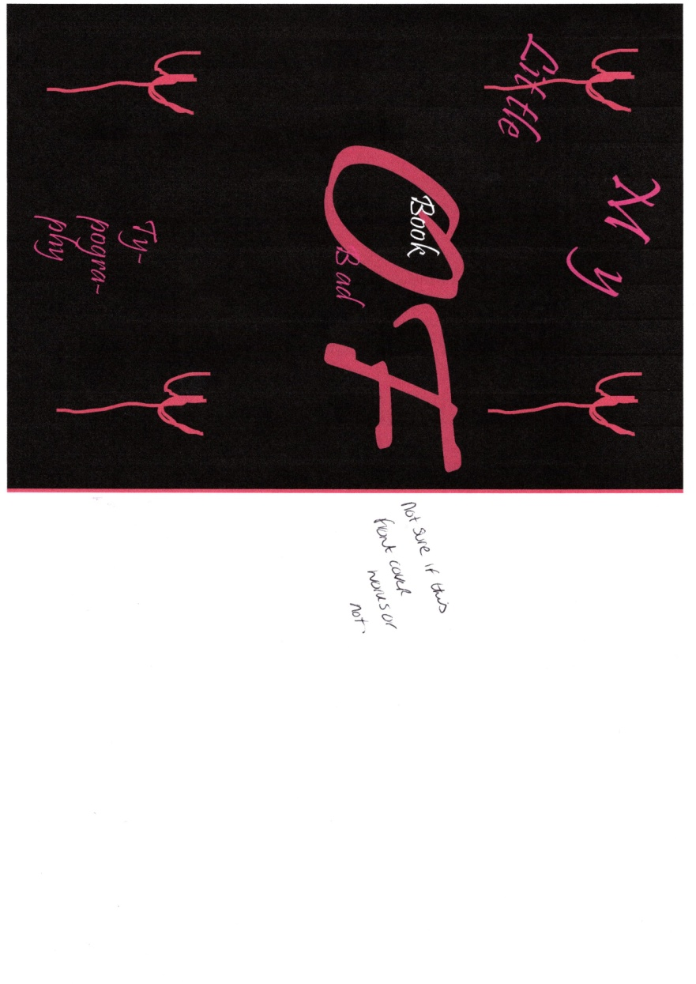
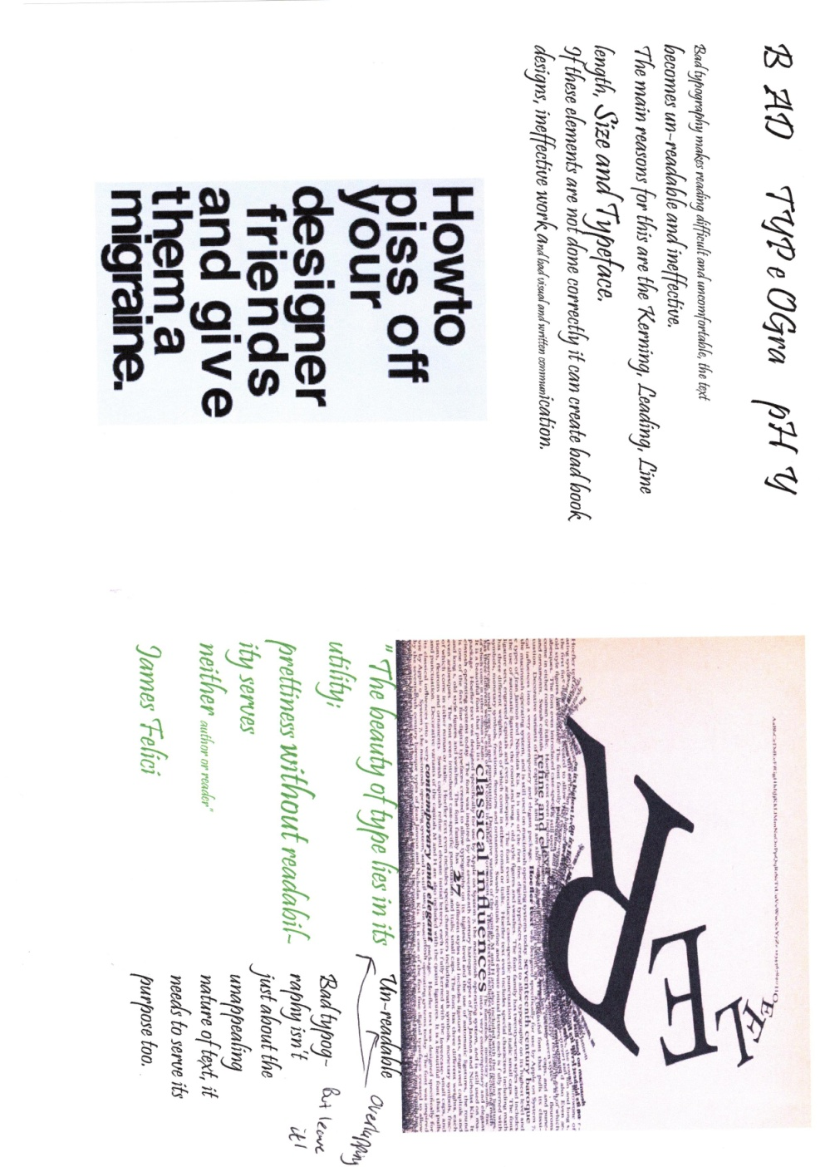
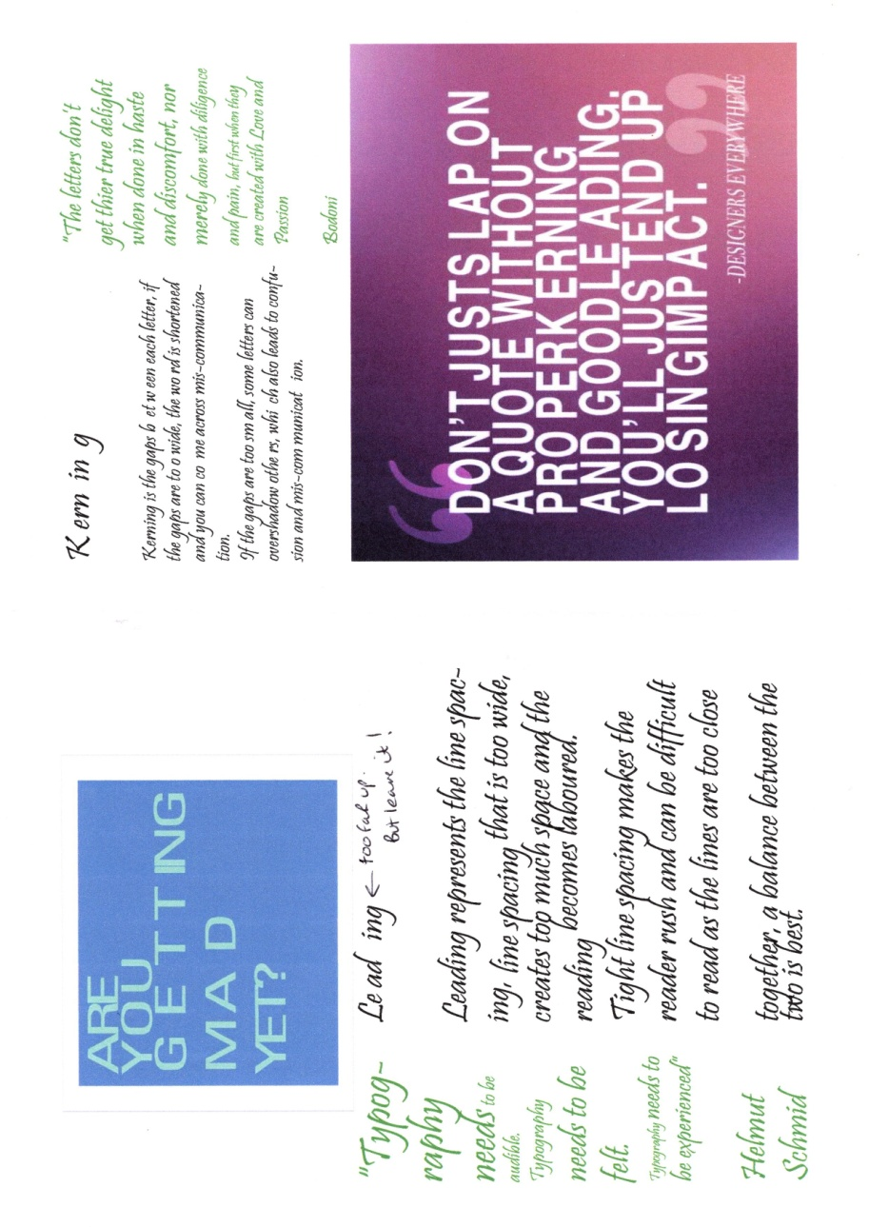
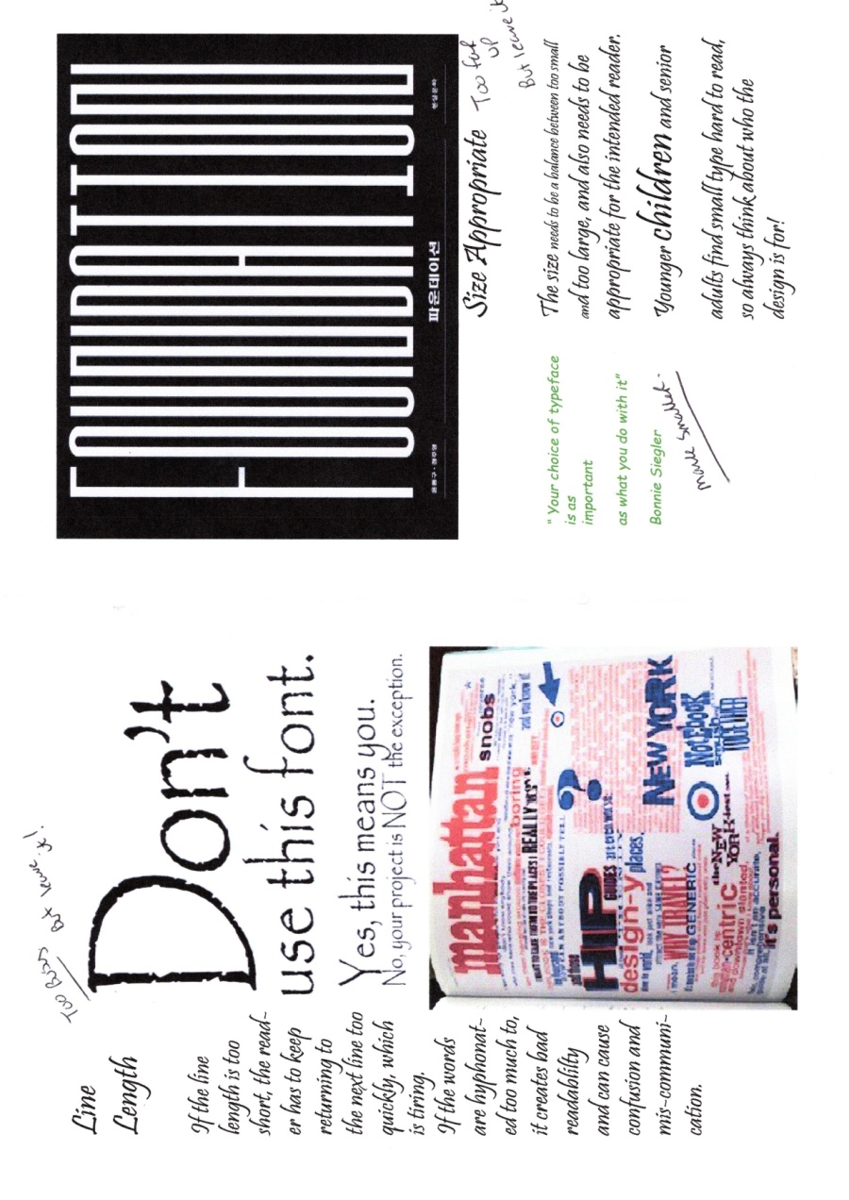
I then made this into a booklet, just by sticking the sheets together roughly, so I could see what the booklet looked like before I started to finish things up. I also wanted to test out the front cover to see how it looked in reality.
I printed off another copy and changed the front cover to the white one I designed before with the grid (like prison). I like the neatness of the white design, and thought it fitted well with the good typography booklet, as they were both neat and tidy and graphic in style.
But I like the confusion of the devil design and the black background, and think it represents the ‘bad’ vibes, and definitely has a devil may care feel to it. I think it represents all things bad in typography, so I think I will continue to use the ‘devil’ design.
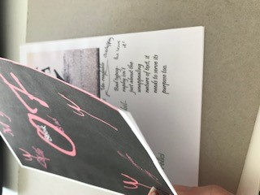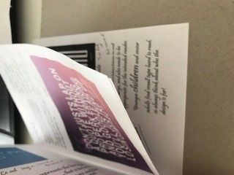

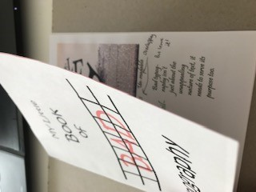

At this point I stopped and went back to the brief to double check I had completed everything it asked me to do. I went back through my sketchbook to tick off the pieces I had done and wrote down anything that I still needed to include.
The main thing that came out of this was writing down who I thought the booklet might be for! I had in my mind already gone through this earlier in the process, but realised that I had not written this information down, so as this was something my tutor had raised in the past, I got on and wrote a section about this in my sketchbook.
I also went back over the rough booklets I had created to think about how they flow, do they need more explanation, and have I ticked all the guidance in the brief?
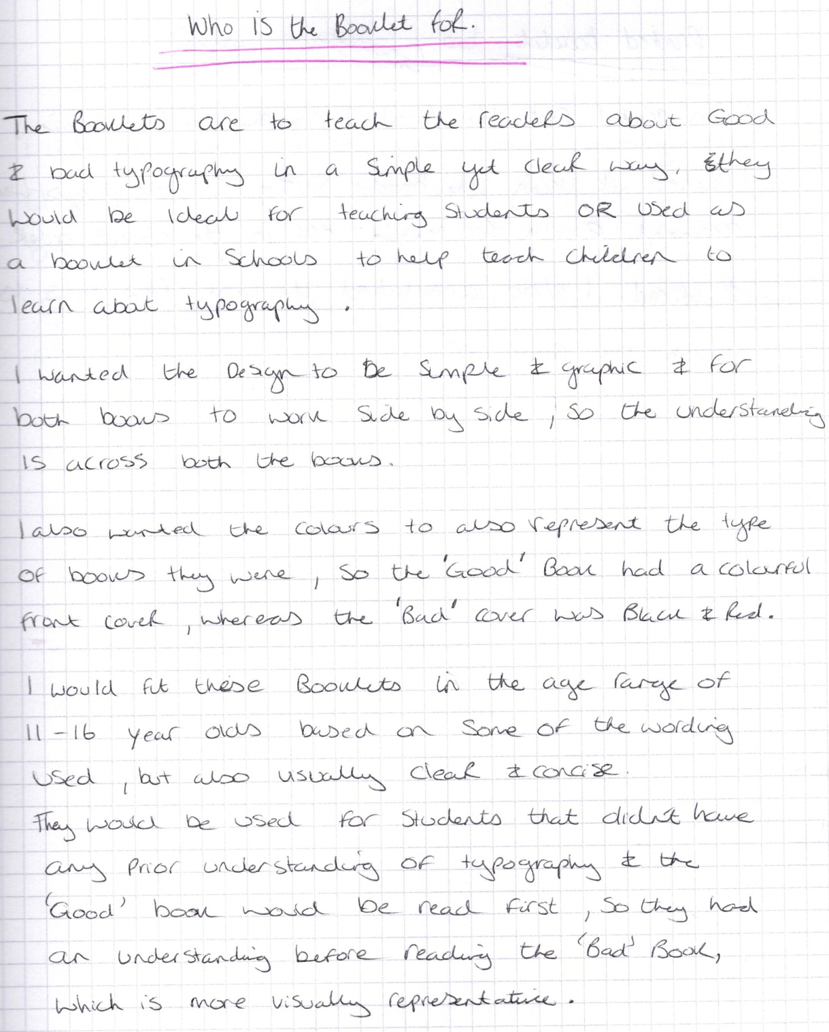

I then went on to print off the booklet again, I used the booklet setting on In design so the pages were arranged for printing in the correct order, I went on to annotate this booklet again, to make sure everything was right.
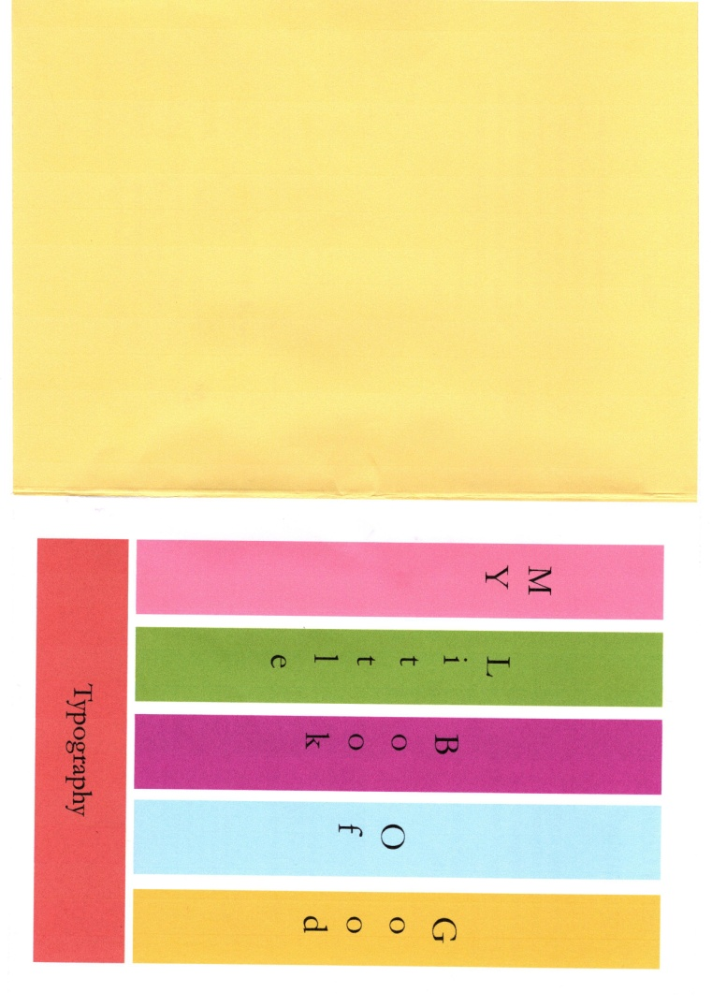
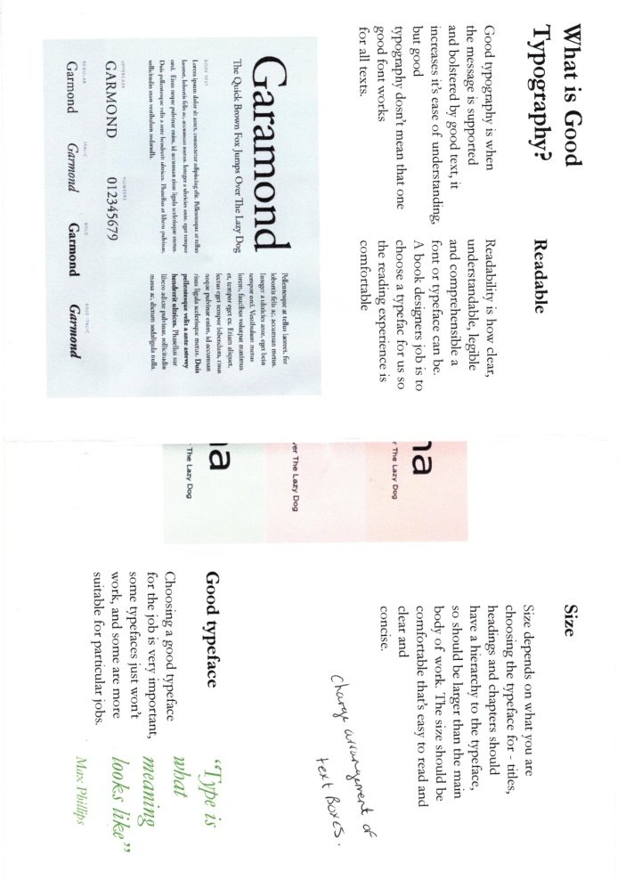
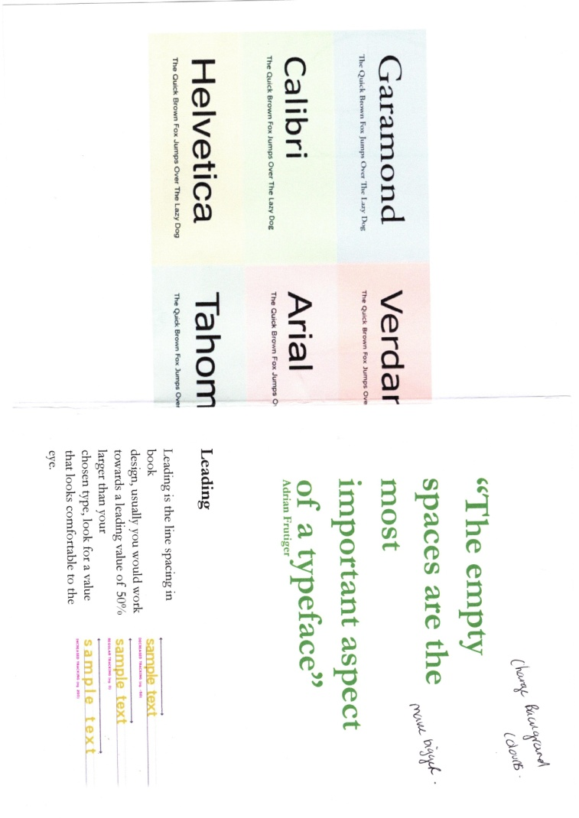
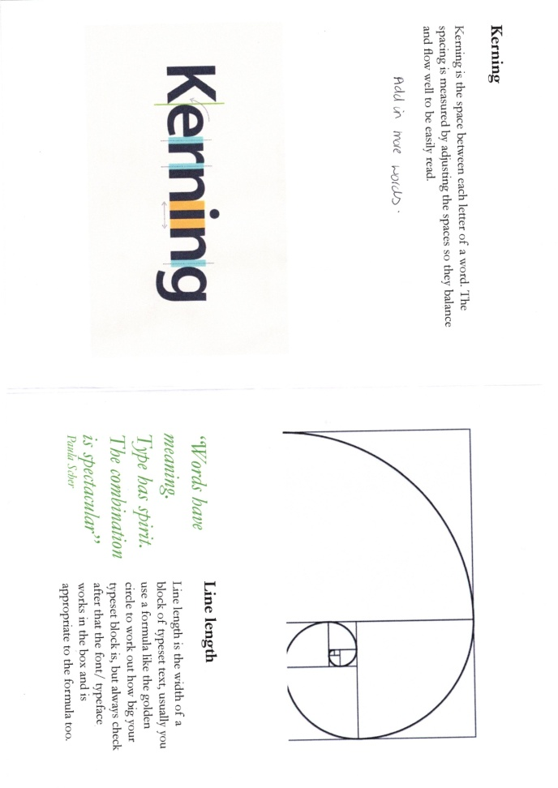
I did the same with the ‘Bad’ typography booklet, although after checking it didn’t need any more annotation on the written side, but I just needed to get some smoother paper and think about the colour of the pages.
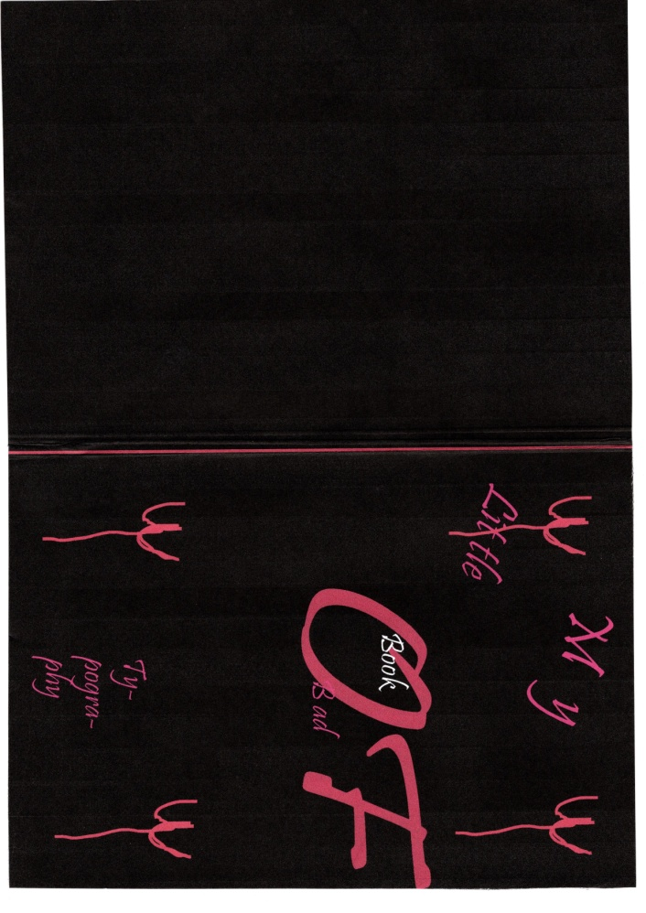
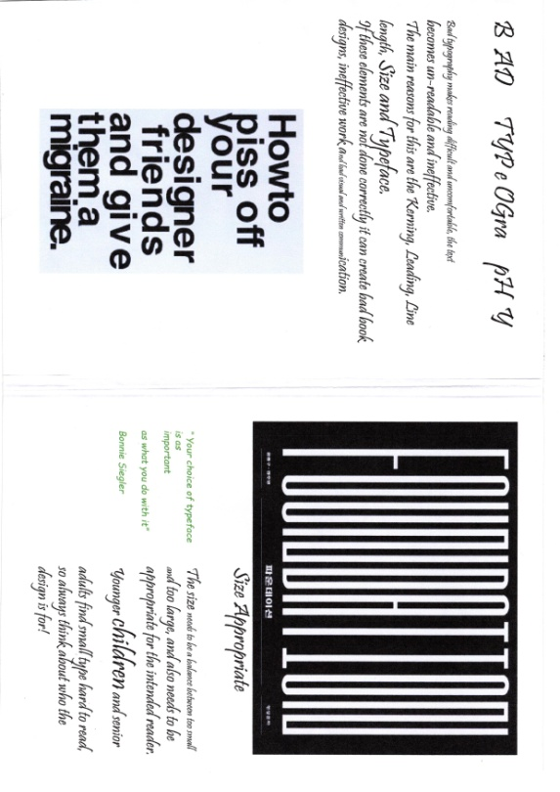
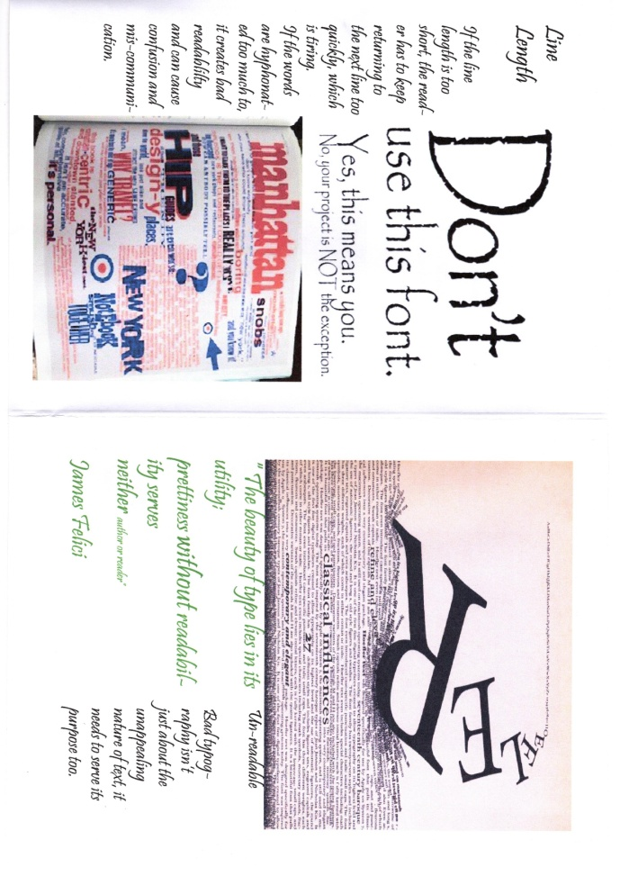
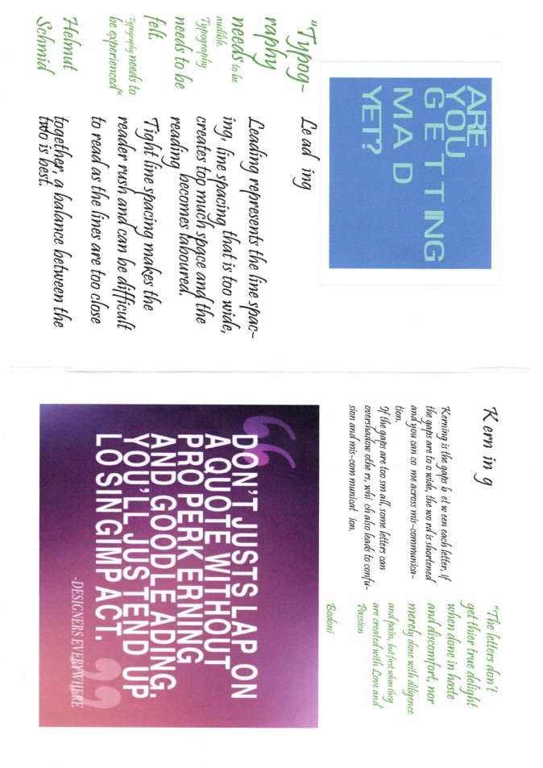
Annotation 3 for the ‘Good’ typography booklet, I changed the background colour of all the pages to a light yellow, and made the stripe or book (depending on how you see it) on the front cover a brighter yellow colour.
I added more words to the Kerning paragraph and changed the layout of the ‘size’ page.
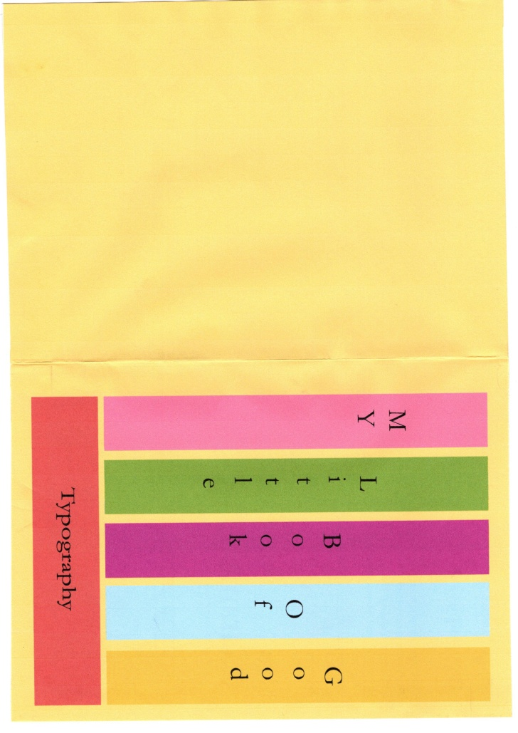
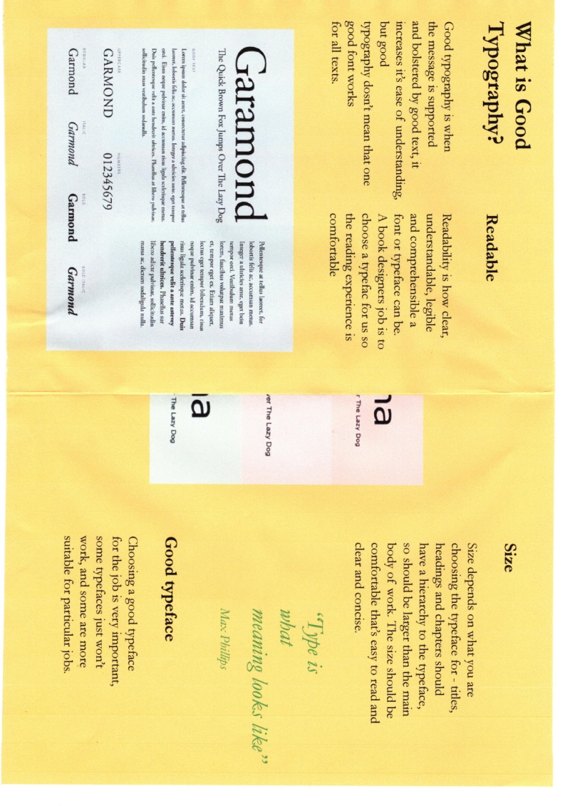
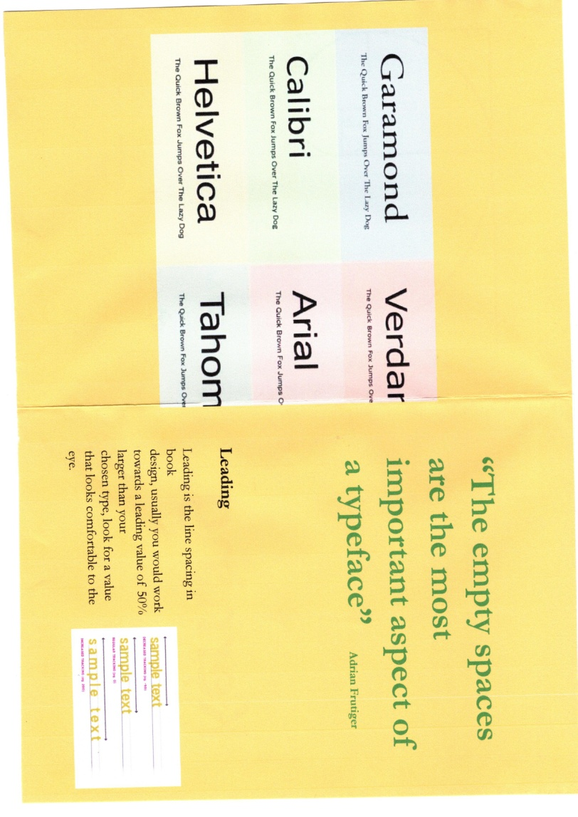
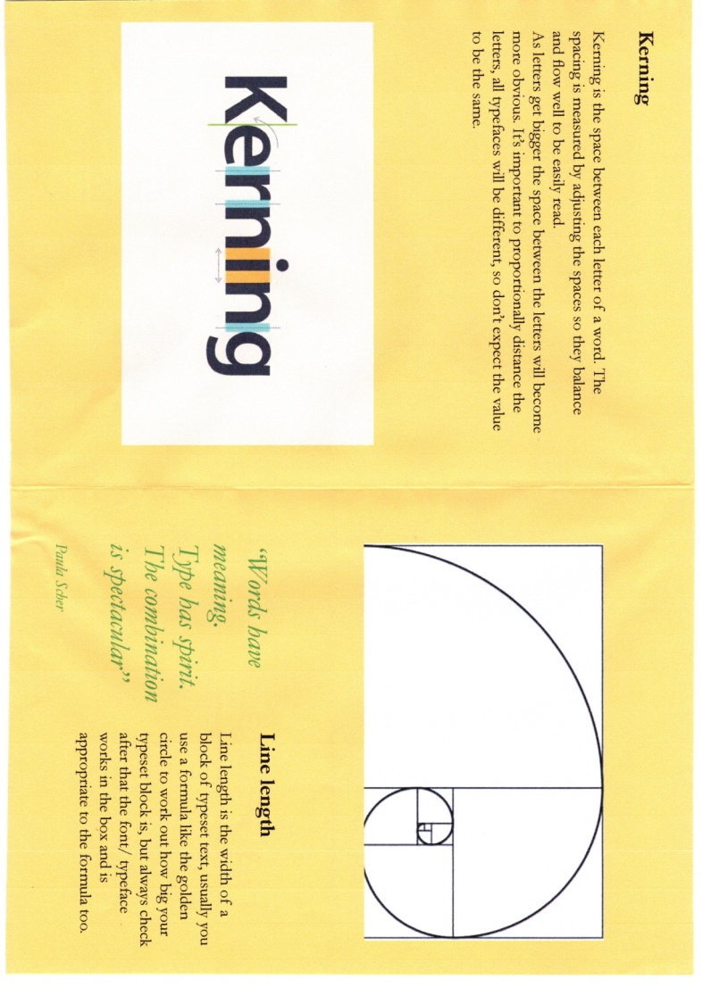
Final print out ‘Good’ typography booklet, I chose a smooth paper which actually made the colours brighter and more vibrant, which was a good choice, the paper was also thicker so it gave the booklet a more professional feel. I printed this off myself on my computer, as I have a good Epson printer, scoring board and paper cutter. I did have a few problems with the guillotine, as the paper got stuck, but I took out a few pages and just did a few at a time rather than the whole booklet, which worked better. The edges are not as crisp as I would like, but overall I am happy with how it turned out.
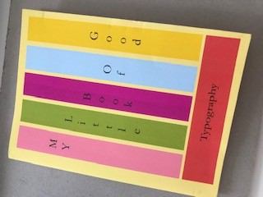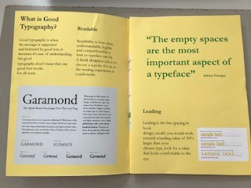

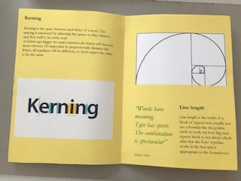

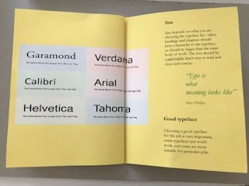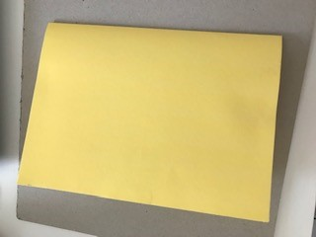

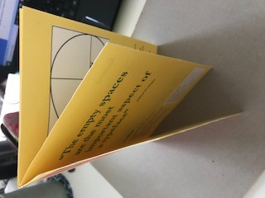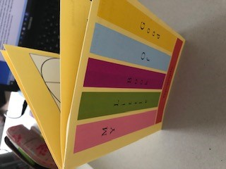

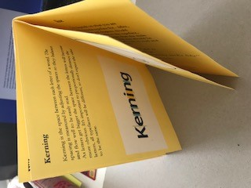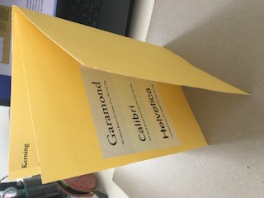

Final print out of ‘Bad’ typography booklet, I changed the colour to all inside pages to red, it was going to be black, but I found it too dark, so red was the next choice.
I did change a few of the text boxes that were overlapping as I thought; this would have been bad book design, rather than bad typography, so they are clearer now.
I printed the booklet onto the smooth paper like the ‘Good’ booklet; again the colours came out much better on this paper, so this really pleased me.
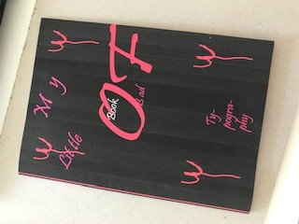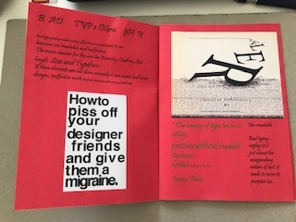

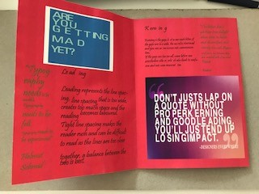

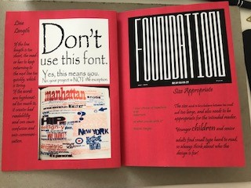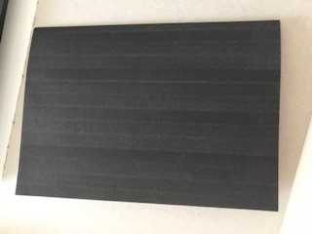

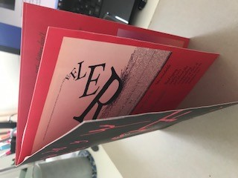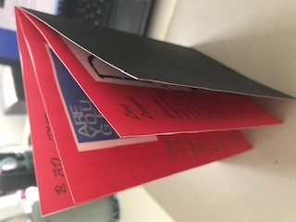

After having a few days break, I went back to start writing my critical analysis, I found that I wanted to change a few details on the ‘Bad’ typography booklet. The first one being to change the text box paragraphs to right alignment instead of left, I thought this would add to the bad typography feel.
The second detail was to change the front cover design back to the prison style one, but use the colours and typeface of the devil one, I thought this would look a lot neater and visually better, plus it would link more with the ‘good’ booklet as they are both now very neat and simple in design.
I kept the background colour black, then changed the typography to white as well as the bars, but kept the ‘BAD’ word in red, so it ended up being a mixture of the two designs in the end.
I also kept the typeface to Pristine to match the rest of the booklet, so it kept some consistency.

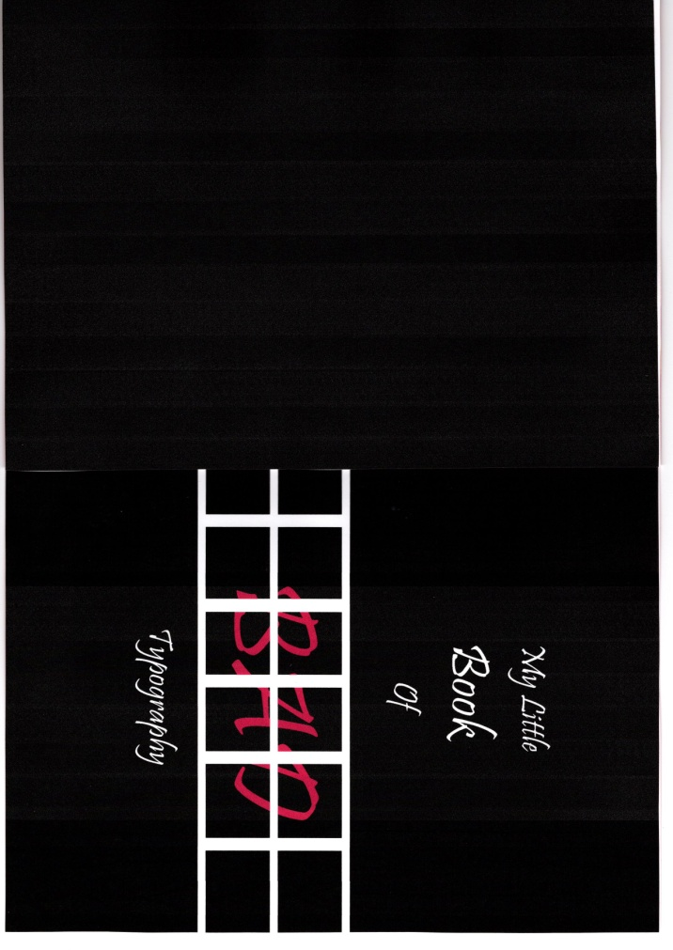
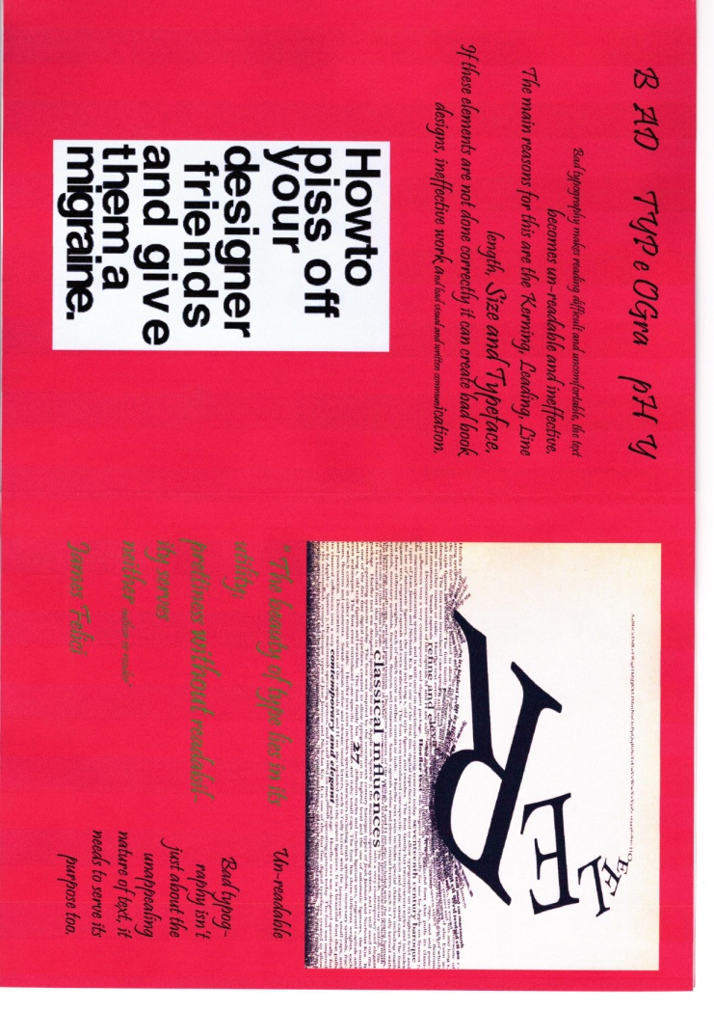
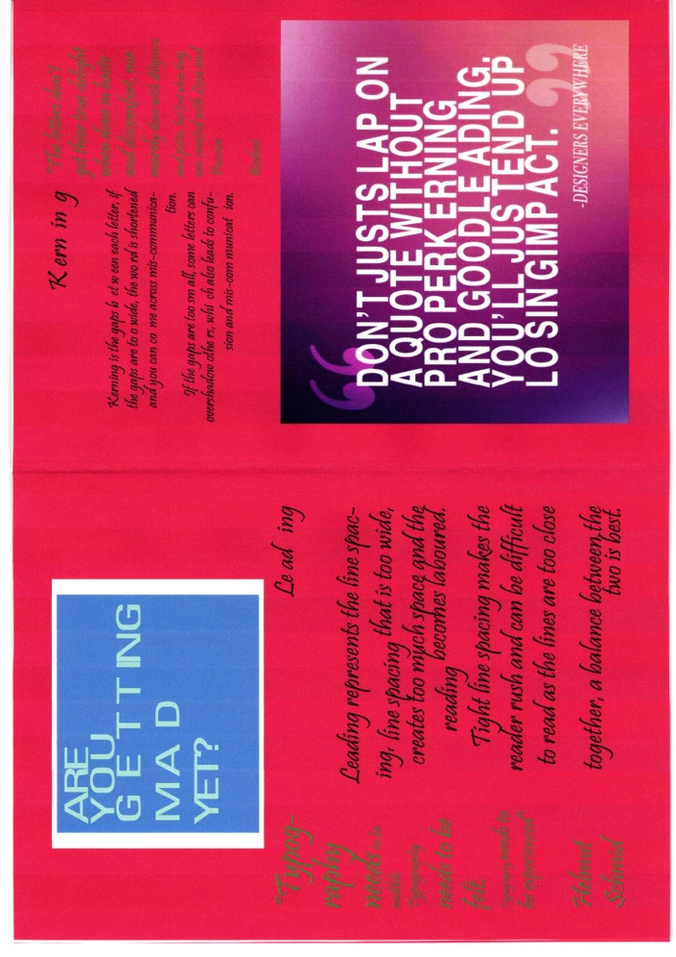
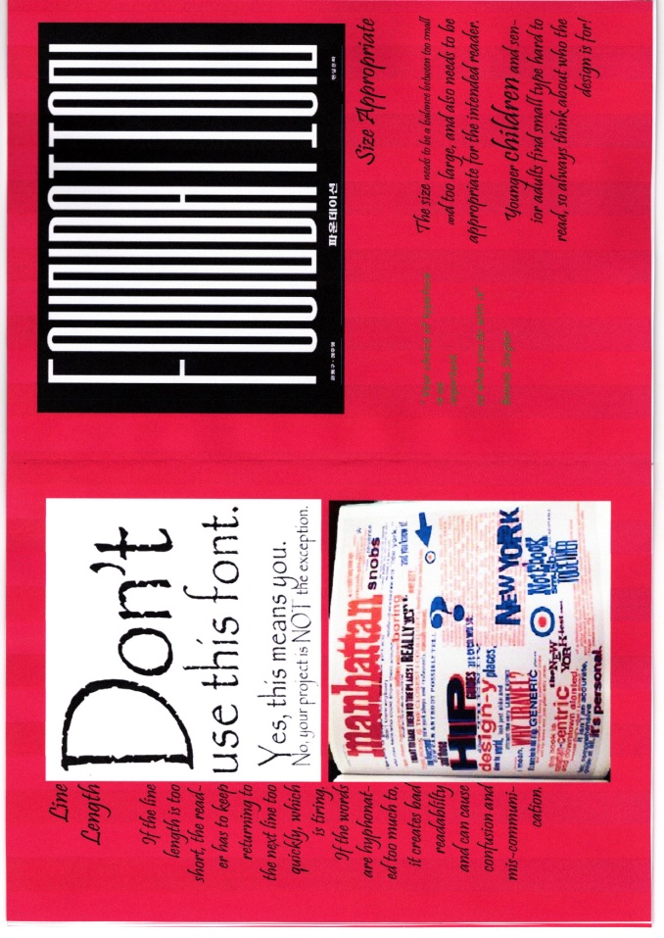
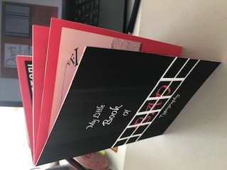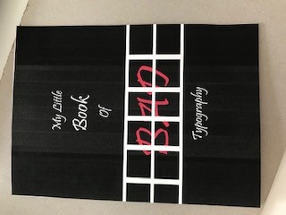

Reflection
After having completed assignment 3 I feel I have managed to pull together most things I have learnt so far in Creative book design, and hopefully it’s easier to follow and read. I have implemented a few strategies that I started in Illustration 1, in following a pattern of how I set out my work and use my sketchbook work more.
Both my little books have the golden circle as the main design element that works in the background of both the designs, using colour theory also helped me to choose the colours that I needed for both the booklets.
I tried to balance the type boxes with visual boxes and use appropriate quotes for each of the headings on the pages. I wanted these two books to be completely different to my usual style, my tutor mentioned in previous feedback, to use a different style with each assignment and to go out of your comfort zone. So here I have gone more graphic in style and simple in design.
I guess looking back over the designs there are still elements of my usual style in the designs, they are both colourful, they are both aimed at children or young adults and they both have a minimal theme behind them ‘Good’ (has a ‘book’ feel to the design, happy and positive) the ‘Bad’ (has a prison design, angry and bad).
I found I got on a lot better with In design this time, and learnt more about how to use the software. I didn’t have any problems with my computer this time so it was a lot more enjoyable to use, rather than panicking about getting the work done.
I still want to experiment more with typography, all my previous work has been hand drawn typography or calligraphy, so this design is much more graphic in style than I am used to.
I found the ‘Good’ typography booklet easier to complete than the ‘Bad’ typography booklet, with the ‘Bad’ booklet I had to think about making the elements bad, but then also make sure it’s still re-able and understandable to someone who might not know about typography. You are always looking and taking a step back, and thinking ‘will someone understand this’?
With the ‘Good’ typography booklet I played it very safe, having to work with a new design style as well as making sure everything was ‘Good’, I kept it very simple and readable.
Looking back at the brief I think I completed what the brief asked me to do, I created two A5 8 page booklets, one on ‘Good’ typography and one on ‘Bad’ typography.
I think the books work well together, but I think it’s best to read the ‘Good’ typography booklet first, to be able to understand the ‘Bad’ booklet.
I have chosen layouts that reflect the golden circle; I have hierarchy of size with my text choices, and kept the typeface to one design so it was easily readable. Looking back I could have chosen different typefaces that complimented each other in difference for the hierarchy, but as I am still knew to this, it’s something I will explore more in part 4.
I kept the layout the same on both booklets, so started with a small intro then readability, Leading, Kerning, Line length and size appropriate fonts. I felt this would work well across both books, and help the reader see the differences.
The covers on both designs are different, but since changing the ‘Bad’ design to the prison style, I feel they work better in style, even though they are still different. Using the same layouts inside and paper for the outside, I feel this matches them and makes them link more.
I feel as though there are distinctions between the ‘Good’ and ‘Bad’ typography booklets in design and style, but also similarities as mentioned above. Maybe the ‘Bad’ booklet could have been worse, as I still kept to the golden circle design, but I did this because of the readability, I think it can’t be too bad as then you wouldn’t understand it at all!
Overall I am happy with the outcome, I could definitely find and change a few more things, but on the whole I feel my understanding has come on a lot in this assignment.

