Designing a cover
Following on from the discussion of George Orwell’s novel 1984, look at the covers of Margaret Atwood’s equally dystopian novel The Handmaid’s Tale (1985), in which a woman finds herself surviving inside a harsh American fundamentalist society, that see’s women’s roles as subservient cooks, matrons, and mothers.
I started this exercise by looking up the books on the internet, and looking at the different book covers available. I was surprised at the older book covers and how modern they felt, the style and the shapes within them.
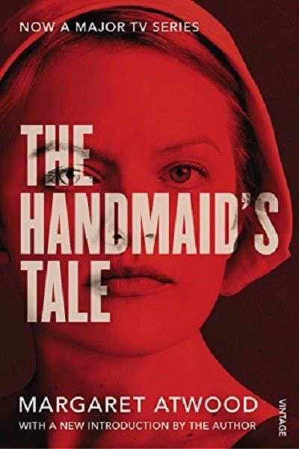
Image from dystopia books.com (April 1998)
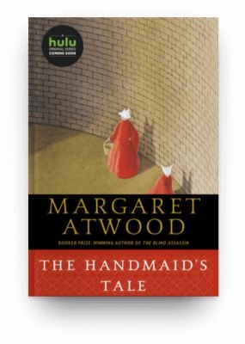
Image from theeverygirl.com (June 2020)

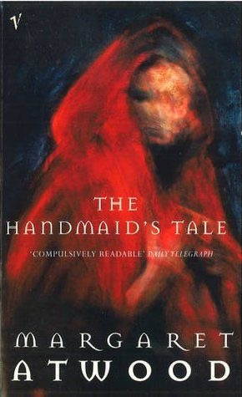
Image from goodreads.com (2016)
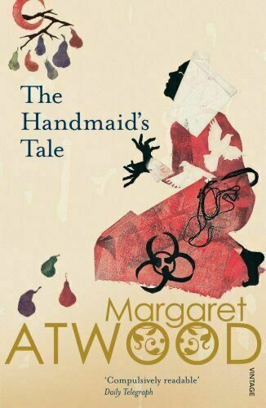
Image from goodreads.com (2017)

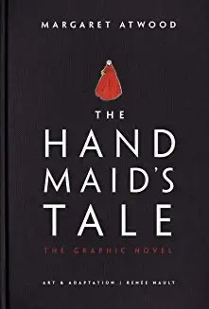
Image from target.com (2019)
From most of the book covers I have noticed the shapes the most that reoccur throughout all the covers. The shape of the hat seems to be the main symbol that connects them all!
It’s a very striking shape and one that is unique to this era and novel, also black and red seems to be the main colours chosen for this book on all the covers seen over the years.
Also the typography is very bold and simple in all of the cover designs, and seems to stand out against the image, it’s as though it has a joint balance with the type and the image.
So I went on to grid up some paper for thumbnails for this exercise, I just used plain printer paper, as it said this would be a quick exercise, I use pro marker pens, fine liners and a pencil. I chose to keep the hat shape as my main motif throughout the thumbnails, I kept a bold straight typography, and just used black and red colours, and the white colour came from the paper already.
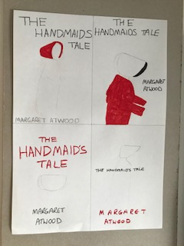
I liked the simpler designs; I found them more striking and bold. Obviously some of the pencil lines are harder to see, but they would just be outlined simply with a very thin line.
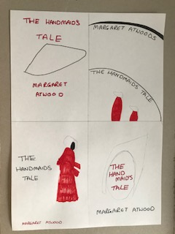
With the above set I tried more shapes within the hat shape to extend the ideas further; I tried the wall design, but made this very minimalist and very simple with just the colour and shapes as the dominant theme.
I then moved on in the next set to add two characters and see how that would look in the designs.
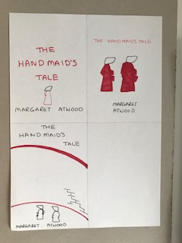
I think the three I like the best are the 2nd one, 9th one and 11th one. I feel these are the most bold yet simple, and I think most people would recognise the covers straightaway as The Handmaid’s Tale.
