Book Designers
Undertake a combination of library and internet research into the following designers, identifying a number of book cover designs for each. Reflect on their conceptual and / or expressive approaches to design. Write a very brief description of your selected cover designs and a brief overview of the designer- focus on key words.
Phil Baines
Coralie Bickford-Smith
Derek Birdsall
Kelly Blair
Irma Boom
Suzanne Dean
Julia Hastings
Linda Huang
Jost Huchuli
Ellen Lupton
Peter Mendelsund
Paul Rand
Paula Scher
Jan Tschichold
Wolfgang Weingart
I started looking at the book designer Phil Baines from the top of the list; I chose four book covers to make key words from.
Texture, colour, typography, Layout, Middle, background, foreground, photos,
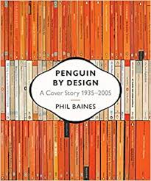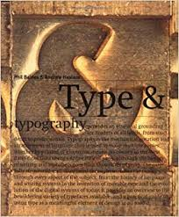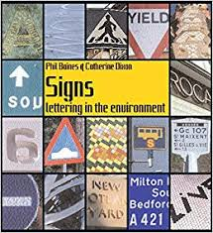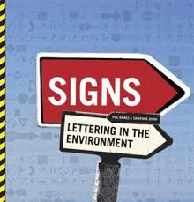
In then went on to the next designer on the list Coralie Bickford-Smith, chose four book covers of hers then wrote some keywords.
So Coralie’s books were very different from Peter Baines’s!
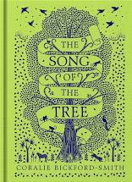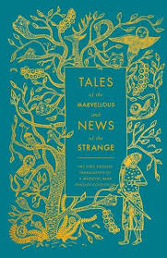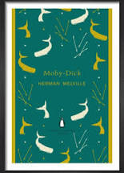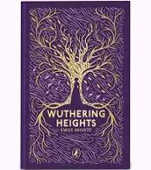
Line work, Detail, Central, nature, negative space, Jewel colours.
Up next is designer number three Derek Birdsall
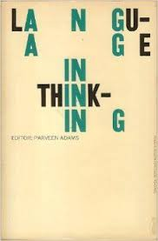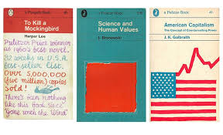
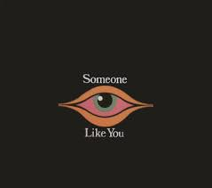

Keywords:- Graphic, Typography, minimalist, block colour, space.
Designer number four is Kelly Blair, the first thing I noticed with Kelly’s books were that they didn’t seem to have a style!
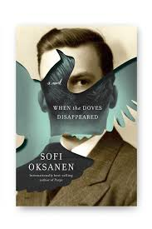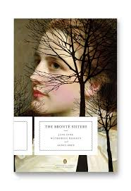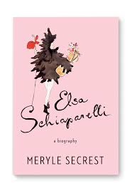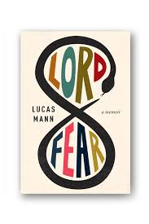
Keywords:- Eclectic, modern, old, contemporary, typography, feeling, atmosphere, middle.
Number five is Irma Boom in the list of designers
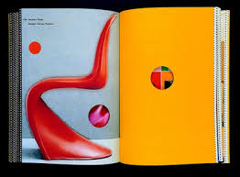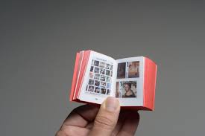
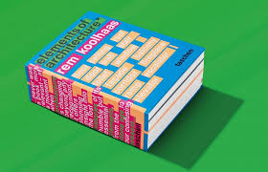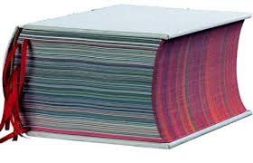
Keywords: - Literal, modern, architecture, engineered, thinking, texture, feel, design.
Suanne Dean is the sixth number on the list
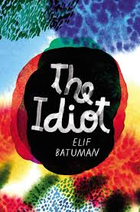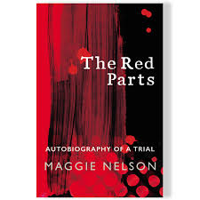
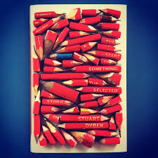
Keywords for Suzanne:- Colour, Feeling, therapy, typography, texture, art, two parts.
Number seven is Julia Hastings
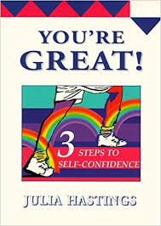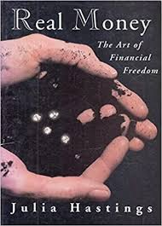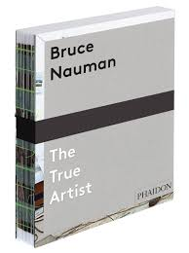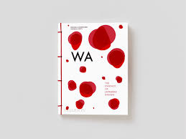
Graphic, Whole, Literal, Typography, font, binding.
Number eight is Linda Huang
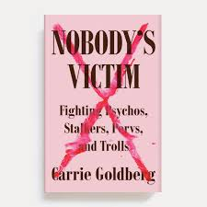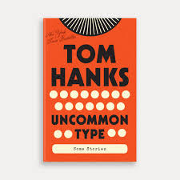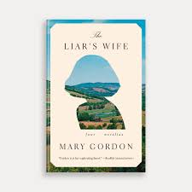
Keywords:- Whole, Typography, font, colour, graphic, stylised, block.
Number nine is Jost Huchuli
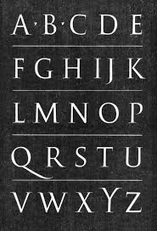
Jost Huchuli’s keywords of design:- Graphic, minimalist, font and type, block colours, space.
Ellen Lupton is number ten in the designers list to look at next
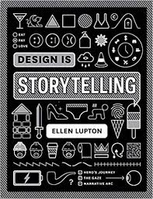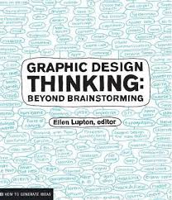
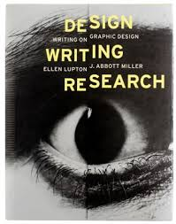
Keywords:- Design, whole page, type top half, texture, teach, photos.
Up next is number eleven Peter Mendelsund
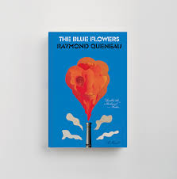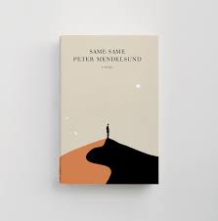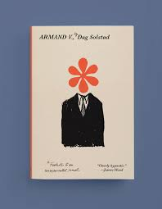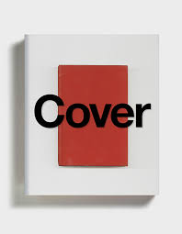
Keywords:- Graphic, Space, Typography, Colour block, Central.
Number twelve is Paul Rand
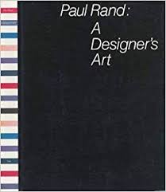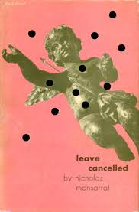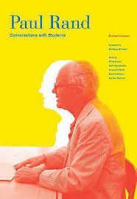
Keywords for Paul Rand are:- Graphic, Colour block, Photography, Effects, Design, top.
Number thirteen is Paula Scher
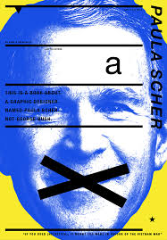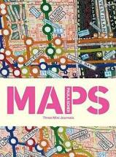
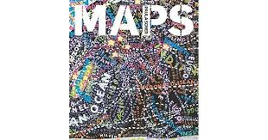
Keywords: - Graphic, Colourful, design, whole page, bold typography.
Jan Tschichold is at number fourteen
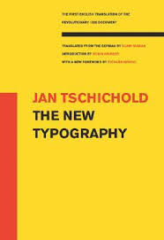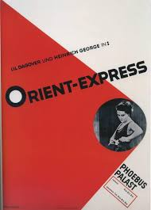
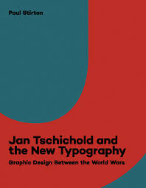
Keywords:- Very graphic, Colour block, typography, Middle, Space.
The last one is Wolfgang Weingart
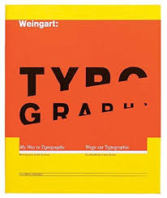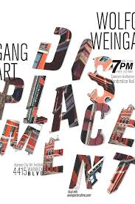
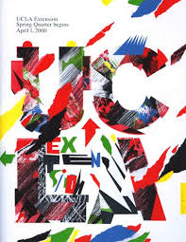
Keywords for Wolfgang weingart:- Graphic, Whole, Texture, Colour, Typography, Angles.
Compare and contrast some of the cover designs, make a drawing or sketch of the covers you’re comparing to help give you a better understanding of the imagery, typography and arrangement within the design. Which covers are the strongest and why?
I decided to compare Peter Mendelsunds books with Coralie Bickford-Smith’s, the main difference or the most striking is that Bickford-Smiths is more Illustrative than Mendelsunds more graphic style. I prefer the delicate detailed line work of Bickford-Smith’s the typography is very reminiscent of her style of work too, this is also incorporated into the pictures / illustrations, and she uses the main central part of the book cover for her visual work. With Mendelsunds his is more colour blocked, the typography I feel is second to the image in the centre, and it is more stylistic in design, I think the space around the images are also important or thought about by Mendelsund.
I also compared Kelly Blair’s books with Wolfgang Weingart. I found Blair’s books interesting as they were all very different from each other, I didn’t think she had her own style to begin with! But looking into more of her book covers I found her work was absorbed by the feeling of the book, so her styles would change according to the book, it was the same for the whole designs, so the typography, images and colours were the same, and they all corresponded to that book rather than her own style. Whereas Weingart has a very distinct style of his own, very graphic, working to angles, the colour blocking and texture styles are very much his own. I found Blair’s cover centralised the visuals down the centre, whereas Weingart used the whole of the page cover for his designs. Weingarts is very much typography heavy, whereas Blair’s is the opposite and the visual comes first to the type.

The book cover designers and or designs I found the most strongest were: I would have to say Kelly Blair’s, purely because she can changed her style according to the book and what the book is about, you would know straight away the genre, the time, the elements and the feeling of the book through the front covers design, which I think makes it the strongest.
The way she can adapt her style is amazing, but not only can her style change, but also the strength of that style is still present.

Now select three or more designers from the list that you are particularly drawn to, either because you like their work or because you don’t understand their approach, and research their design careers in more depth. Think about how they’ve responded to very different design challenges, whether they have underlying conceptual and / or expressive approach, and how their work has evolved over time.
I have chosen Coralie Bickford-Smith, Kelly Blair, Suzanne Dean, because I liked elements of their work. The other designers I was not keen on because their style is so graphic which does not appeal to me, but I have chosen Phil Baines to look at to understand more about his work.
Coralie Bickford-Smith was the only designer which I liked fully, I enjoyed her illustrative and expressive style, the way she has used line work and the way the typography is part of the image really appeals to me. I like her use of limited colours, and I like her use of the natural world to convey the book’s title. I like the use of negative space in the style and the way she uses the central part of the cover for all her designs.
Reading University, she works for Penguin books and has done numerous works for many top magazines and newspapers, her work with Penguin classics on the cloth bound series attracted worldwide attention, based on Victorian bindings. Coralie has published three of her own books with Penguin:-
The fox and the star
The worm and the bird
The song of the tree
Below are some note cards and envelopes designed on The fox and the star book, here you can still see her unique style, using a limited colour palette, having the typography in with the image, and the image centred down the middle of the front cover page.
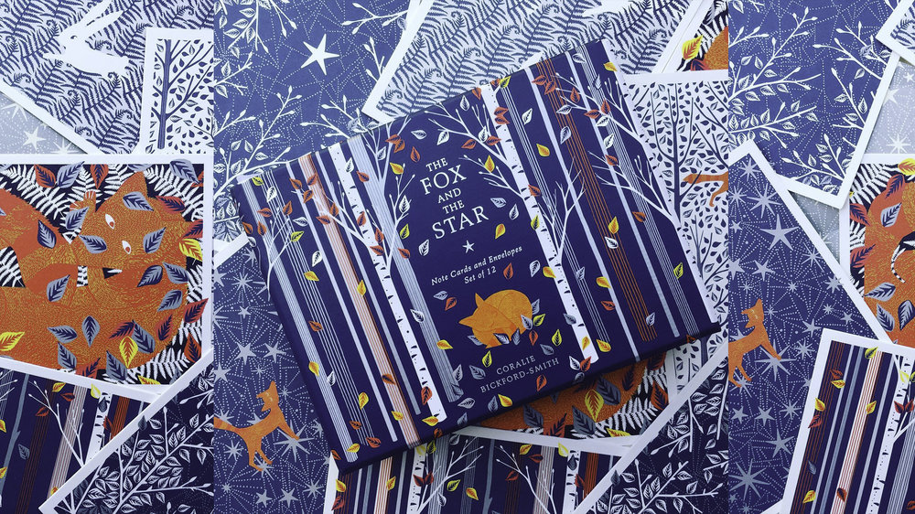
© Coralie Bickford-Smith cb-smith.com
Kelly Blair is an art director of pantheon books, also an associate art director at Knopf, and in her spare time a freelance Illustrator. I also looked at her Illustration work which is actually very graphic in style, I think this is where we see her own style more, rather than the work she does for book design or covers! Below are two examples of her Illustration work for newspapers.
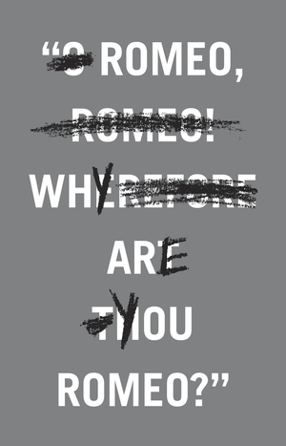
Book review/ The End Of Men The New York Times / Op-Ed
© Kelly Blair.com
I think Blair is an interesting book designer, I wasn’t really taken with her style, it isn’t something I like, but I liked the fact that she took the feeling of the book, or what the book is about, then made that feeling come across in her work of the book’s cover design. With old classics she used an old feel to the book, with classic colours, images and type, in a classic design. With more contemporary works she adapted her work to match the books nature; I think that is very clever for a designer to do. Blair has both a conceptual and expressive approach to her work, as it can be so varied, her work has evolved over time, and her own illustration work shows where her tastes lie with the graphic conceptual style. Below are two examples of this:-
Suzanne Dean is the next designer I sort of liked, the designs were not exactly something I like, but part of the materials she uses is! I enjoy how she uses art practises as the texture and expression backgrounds of her book cover designs, so we have some Surface pattern design, some inking and mark making, and some watercolour work. I also think her use of colour is fantastic, it really catches your eye and the books would defiantly appeal to me on a shops book shelf, they have a art therapy feeling to them! I like the way she uses the whole of the cover page for her designs, and the typography has the same feel as the cover, they complement each other well.
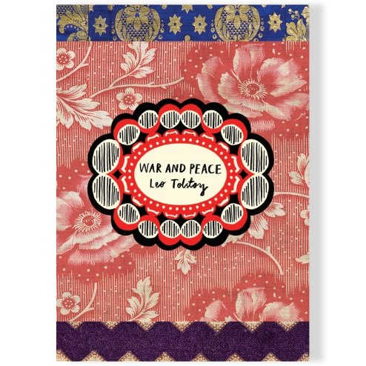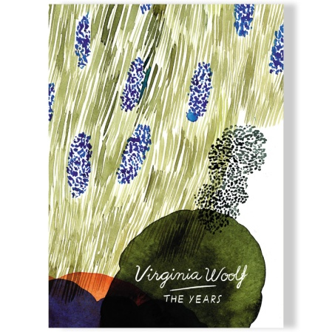
Suzanne Dean started out at Penguin books and also worked for Picador before becoming a creative director at Random House; she works across all publishing formats as a book designer.
Phil Baines graduated from The Royal College of Art in 1987, he currently works freelance as a graphic designer, and does some work for small publishers. He has self published some of his own books and has often produced Letterpress. He is also a typographic adviser for the Central Lettering project.
Baines’s work is mainly based upon his typographic skills and his lettering knowledge, you can see in his book covers that the type and fonts are as important to the front cover design as much if not more so than the visual images.
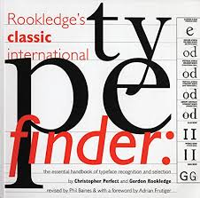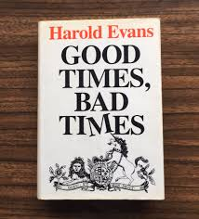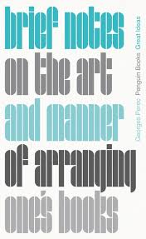
Baines again uses the entire page for his designs, but also focusing in on the middle section the most. The colours are block colours and he sometimes uses textures as a background to the type imagery. I would say Baines’s designs were more conceptual than expressive, and the words are also important like the type is.
Finally identify at least three different book designers you find visually engaging. Identify who designed these covers and find out more about them, is it to do with genre or their approach to design you like? What is it that captures you? What sort of imagery, if any, is used on the cover? How does the text relate to the image? What atmosphere does the cover evoke?
So I had quite a lot of trouble finding some book designers that I liked! The ones I did find were confusing as they had illustrators that drew the covers and illustrations inside the books, but also a book designer who chose things like the end papers, and how it was all set out. I then looked at illustrators but realised most of them worked on their own books, not other peoples, so I ended up a little confused about what designers I liked and what they contributed to the book’s cover!
So I thought I would concentrate on Lane Smith and Molly Leach, both are illustrators, but Molly is a book designer too. Lane creates the illustrations and molly decides where the type goes and so on and so forth.
Here is an exert from let’s talk picture books .com about Lane Smith and Molly Leach’s working practise:-
S: We work together, but separately. We go back and forth a lot but in separate studios. I’ll email her an illustration, and she has me adjust the composition to accommodate the type. Then I might come up with an idea where the type might fit better into the art, and she’ll top that with some other idea. It’s a constant process. Molly never gets her due. She does half of the work but most readers (and even some people in the business) have no idea what she does. I can’t imagine working in a traditional way where I do the entire book and hand it over to the publisher, and they lay the type in at the very end
©Lane Smith [let’s talk picture books.com]
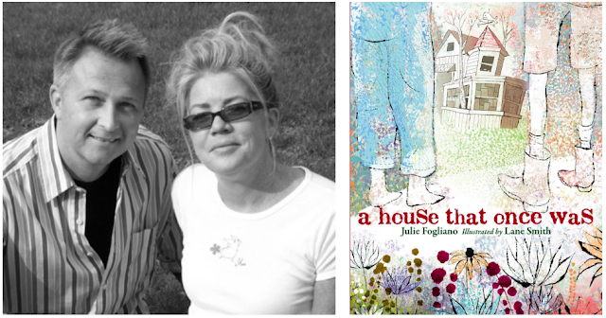
©Lane Smith [let’s talk picture books.com]
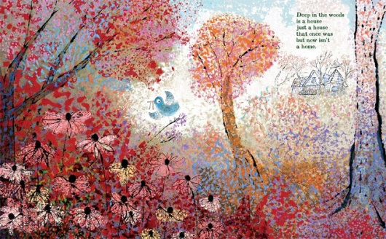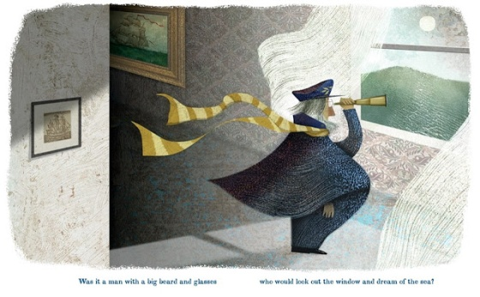
I guess with this book cover I liked the illustrations most and the style of the typography, but I have realised that the illustrations are done by Lane Smith the illustrator not Molly Leach the book designer, her input is more about the paper, the size, the costs, the typography and where it should be placed, whether it should be hard backed or soft backed, so it has made me think differently about what I like and why I like it with book design!
So the next person I have chosen is by thinking about things differently, so if this is the case that book designers are more about the paper, size, costs and layouts of the books, it’s harder to talk about the books without having them in your hands to touch and feel and look at. Because of the pandemic and not being able to go out, i have found this part of the exercise difficult, just by going on the front cover image.
But I have chosen the book designer Alison Forner, Alison is an art director or Avid Reader Press and also a co-art director of the Simon Schuster Imprint.
So with the book covers below I like the way the typography and font reflect what the book is about, so for example the school of psychics has a moon feel to it, the font it simple and easy to read, I like that the title is at the top of the cover and the author at the bottom, I think the size is a paperback which is what you would expect from a book of this type.
With the book cover on the bottom The Signature of All Things, it feels like this book might be about life, about nature or the meaning of life or a novel with that theme running through. Again the typography is quite classic, slightly upper class and proper in style and having it green adds to the nature theme seen on the cover.
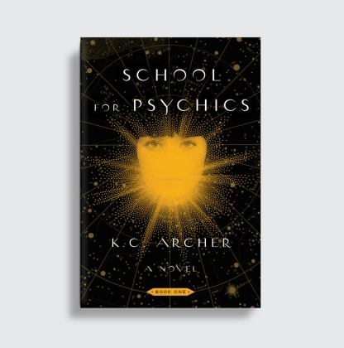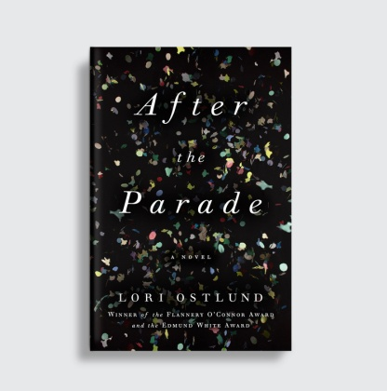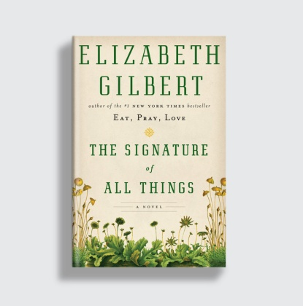
© Allison Forner .com

