Experimental typography
Below is an extract from Jules Verne’s 20,000 Leagues Under the Sea. Using a single typeface of your choice lay out the text in as inventive a way as possible. Experiment with the letters and words, using the typographic principles you researched in earlier exercises to significantly alter the arrangement of the text, its rhythm and readability. Think about design group Tomato’s definition of typography – ‘Sound as form’ – and how this concept might apply to your own work. Use the content of the text to inspire visual ideas. How might you experiment with the type to communicate something of the essence of the descriptive content? Think about how the designers you researched in the previous section, e.g. David Carson and El Lissitsky, would approach the text – or artists like Marinetti and Schwitters. It is important that you play with the text, with individual letters and words. How experimental can you be in making expressive typographic designs? Can you reveal something of the character and nature of the letterform by experimenting with scale and orientation, so a simple unassuming letter becomes a monumental, almost sculptural form?
So for my first part of this exercise I am going to read the following passage from 20,000 Leagues Under The Sea by Jules Verne, and I’m going to pick out descriptive words and words of motifs that I can use going forward.
20,000 Leagues Under the Sea, Jules Verne Chapter 1, A Shifting Reef The year 1866 was signalised by a remarkable incident, a mysterious and puzzling phenomenon, which doubtless no one has yet forgotten. Not to mention rumours which agitated the maritime population and excited the public mind, even in the interior of continents, seafaring men were particularly excited. Merchants, common sailors, captains of vessels, skippers, both of Europe and America, naval officers of all countries, and the Governments of several States on the two continents, were deeply interested in the matter. For some time past vessels had been met by “an enormous thing,” a long object, spindle-shaped, occasionally phosphorescent, and infinitely larger and more rapid in its movements than a whale. The facts relating to this apparition (entered in various log-books) agreed in most respects as to the shape of the object or creature in question, the untiring rapidity of its movements, its surprising power of locomotion, and the peculiar life with which it seemed endowed. If it was a whale, it surpassed in size all those hitherto classified in science.
So the main things I felt from the passage above, was that it was a sea/ ocean theme, with maritime and naval officers, talking about seeing a long creature from the ocean.
The words I had highlighted were:-
Maritime
Seafaring
Sailors
Captains
Naval officers
A long object
Creature
Whale
So I wanted to explore these words further by creating a mood board, to get the feeling of the scene.
For one of the images in the board I wanted to include a book of the story, but as I had not read the book just the passage above, there seemed to be a difference in the creature that I had in my mind from the description in the passage to the creature on all the book covers! I had a whale or a fantasy creature, whereas the books had an octopus!
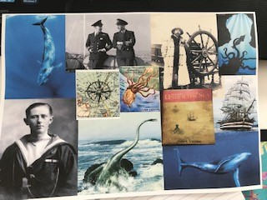

I then went on to research Tomato design studio to look at their work and the theme of ‘Sound as form’.
I found these two visual posters that somehow show them as using type in the form of the sound of the music, so for example this poster has the typeface designed in a graphic style of record, it looks like the old versions of Top of the Pops intro graphics on TV.
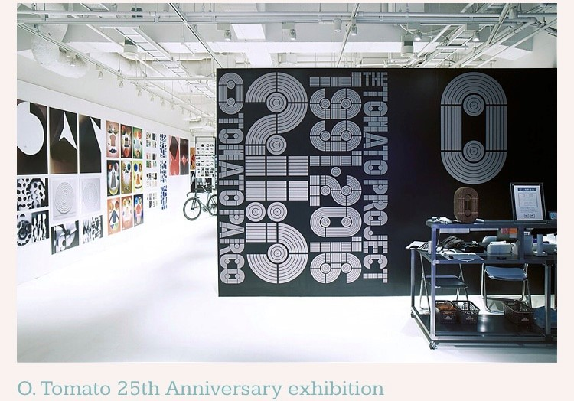
© tomato.co.uk

Also this poster shows s similar typeface with a different colour background, and set out in a different way.
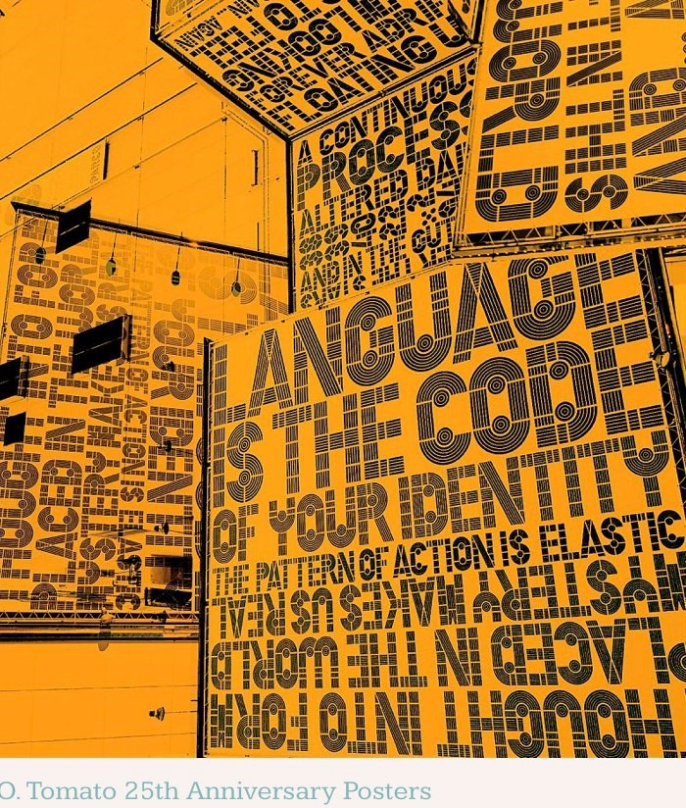
© tomato.co.uk.
I then went back over my previous work I did on typography and looked at the fonts from the collection I had pulled together. So for the paragraph I wanted something that was classic, yet un-complicated, and as it was for a novel I thought Garamond would be a good choice.
Then for the second paragraph I chose Century, this looked clearer and more spacious, but was a little bold and felt as though there was a tone difference from the font and the paper colour, than Garamond, which was softer on the eye.

GARAMOND
20,000 Leagues Under the Sea, Jules Verne Chapter 1, A Shifting Reef The year 1866 was signalised by a remarkable incident, a mysterious and puzzling phenomenon, which doubtless no one has yet forgotten. Not to mention rumours which agitated the maritime population and excited the public mind, even in the interior of continents, seafaring men were particularly excited. Merchants, common sailors, captains of vessels, skippers, both of Europe and America, naval officers of all countries, and the Governments of several States on the two continents, were deeply interested in the matter. For some time past vessels had been met by “an enormous thing,” a long object, spindle-shaped, occasionally phosphorescent, and infinitely larger and more rapid in its movements than a whale. The facts relating to this apparition (entered in various log-books) agreed in most respects as to the shape of the object or creature in question, the untiring rapidity of its movements, its surprising power of locomotion, and the peculiar life with which it seemed endowed. If it was a whale, it surpassed in size all those hitherto classified in science.

CENTURY
20,000 Leagues Under the Sea, Jules Verne Chapter 1, A Shifting Reef The year 1866 was signalised by a remarkable incident, a mysterious and puzzling phenomenon, which doubtless no one has yet forgotten. Not to mention rumours which agitated the maritime population and excited the public mind, even in the interior of continents, seafaring men were particularly excited. Merchants, common sailors, captains of vessels, skippers, both of Europe and America, naval officers of all countries, and the Governments of several States on the two continents, were deeply interested in the matter. For some time past vessels had been met by “an enormous thing,” a long object, spindle-shaped, occasionally phosphorescent, and infinitely larger and more rapid in its movements than a whale. The facts relating to this apparition (entered in various log-books) agreed in most respects as to the shape of the object or creature in question, the untiring rapidity of its movements, it’s surprising power of locomotion, and the peculiar life with which it seemed endowed. If it was a whale, it surpassed in size all those hitherto classified in science.

Then I went on to research David Carson to get some ideas for un-conventional ways of displaying text and choosing fonts, and making expressive typographic designs.
I found some really interesting designs of Carson’s and how he had experimented with fonts and typefaces, some are collaged and some are manipulated into designs.
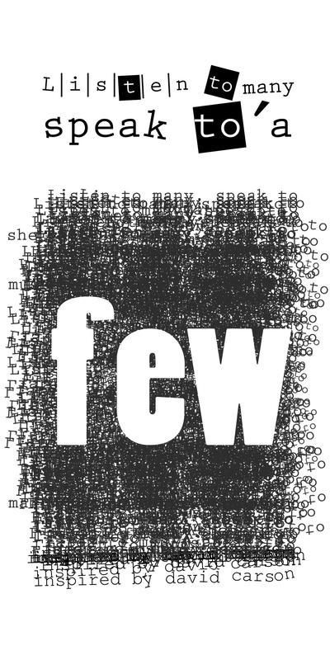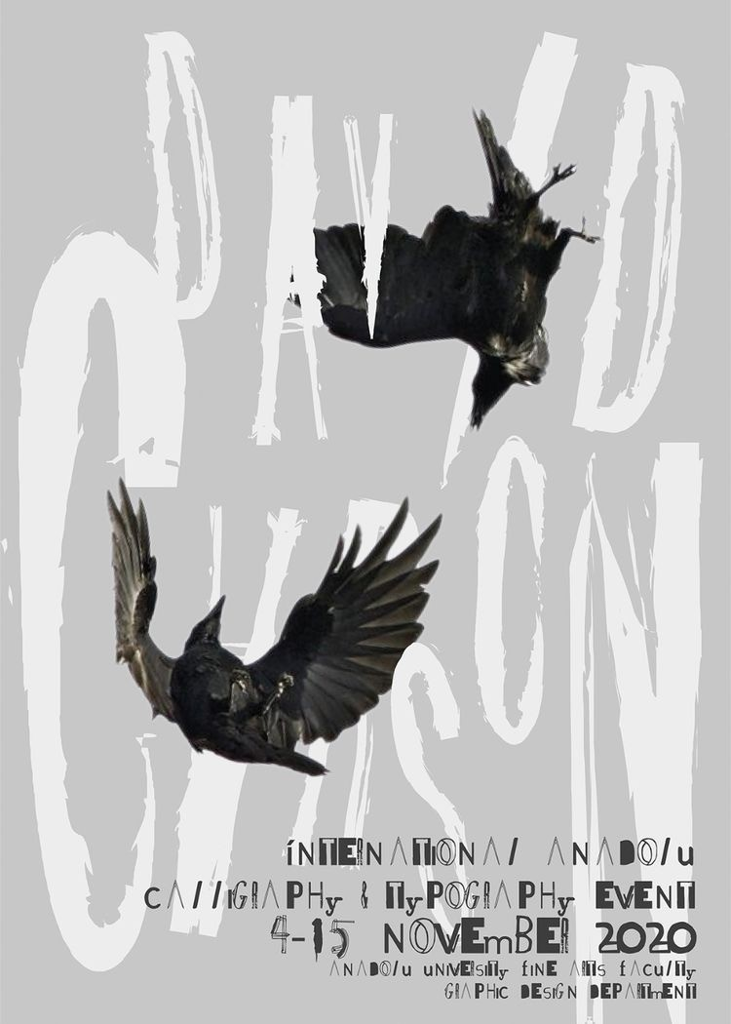

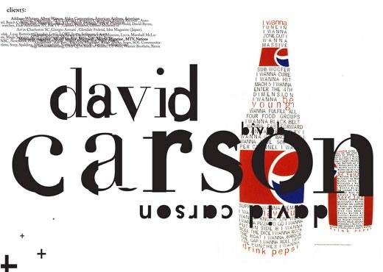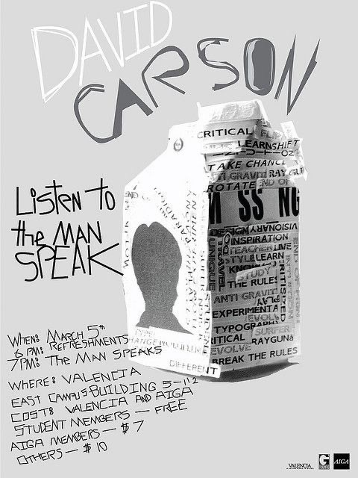

I really liked the design above, the one with the coke bottle made of words, I thought this was really unusual and was very experimental.
This gave me some good ideas to play around with in my sketchbook, so I created some thumbnails of rough sketch designs. First off I drew some of the motifs that had sprung from the passage from the book, so I rough sketched these.
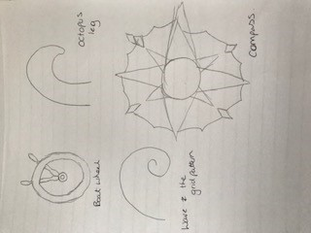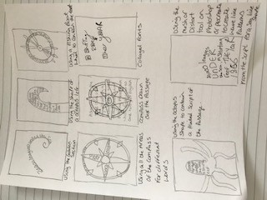

I then went onto sketch out some thumbnails for some different ideas, the first one was to create the passage type along the golden section wave graph, I thought this would be good as the wave design also links to the seafaring book.
The second design was to collage some type into the shape of a octopus leg, again I thought this would link the book into the design, and in the passage description it was all about the creature I thought this linked well.
It was similar with the third design, except I would use a sea boat wheel for the design, then similar for the fourth design; I would use a compass shape to encase the collaged type.
The fifth design was different again, this time I would use experimental type on a sheet of paper then draw over the top a compass motif, but maybe this is too simple, although if I really experimented with the type it could work?!
The sixth design was to collage each different letter in a different style of font, to create a script style look to the design.
The seventh design was to encompass the type in a whole octopus shape, and experiment of where to put certain parts of the passage on the octopus, so for example use the 1866 as one of the arms, so to use hierarchy in the type and passage to differentiate between the important words first.
Then the eighth design was to use the typography in different sizes, again to bring in hierarchy, but then use a warp tool or the mesh tool to distort the words into a wave style pattern.
So I started off by printing off the passage from the book in different types from my computer, so I had some type to work with and collage. I used the font’s Freestyle script, Kristen ITC, Pristina for this page; they all worked really well with the feeling of the book and the passage of writing.
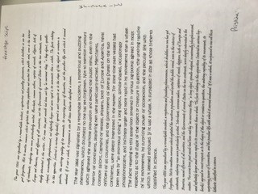

I then used Segoe script and Tempus Sans ITC for this page; again they worked well with the passage from the book, but were different enough to create some excitement and experimentation.
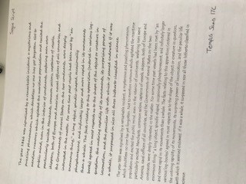

I decided to pick a certain part of the passage which summed up the book in cut down version, to use this for my experiments, this made more sense to me rather than trying to use the whole passage.
A Shifting Reef The year 1866 was signalised by a remarkable incident, a mysterious and puzzling phenomenon, which doubtless no one has yet forgotten.
For some time past vessels had been met by “an enormous thing,” a long object, spindle-shaped, occasionally phosphorescent, and infinitely larger

I started with the idea of the passage with the compass on the top, so with this font I decided to choose the Segoe script, as I thought this would read easily and would also fit in with the feel of the book.
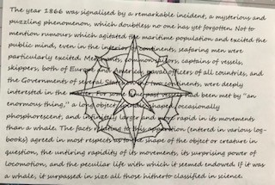
This was my least adventurous design, but I still think it would work maybe for the back of the book, where it shows a snippet of what’s inside.

Next was the golden section wave design, so I used collage for this one, and used a different font for each letter, to give a varied and un-expected design.
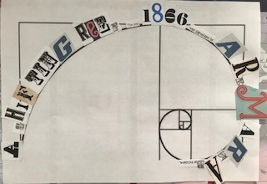
This was a creative exercise and it got me cutting and sticking the letters, I tried to create hierarchy in the design, by using the most vibrant fonts for the descriptive words and planner fonts for the in-between words.

Then I went onto create the octopus leg, this is where I changed the design slightly, so I used different fonts for each WORD now rather than letter, this again was used by thinking about hierarchy for each word.
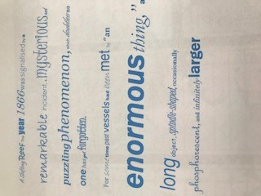
I could not fit all the shortened passage in the design, as I wanted some rather large words, especially ENORMOUS! I used more everyday fonts for this design which were on my computer, I think the word mysterious came out well I used Juice ITC for this one, and I think it captured the feeling of the word.
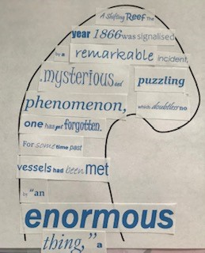
I think if I went on and transferred this onto the computer it would relate better, but using collage made it a bit difficult to arrange the words as I wanted, but it’s given me some good ideas to follow up on and develop further throughout the rest of the unit.
I went onto the computer and InDesign to try some of the typography words I used above with the typefaces and fonts I used, and to see if I could come up with a design that was more digital, that had risen from my creative work above. So I started with the passage and used different font’s again on the descriptive words.
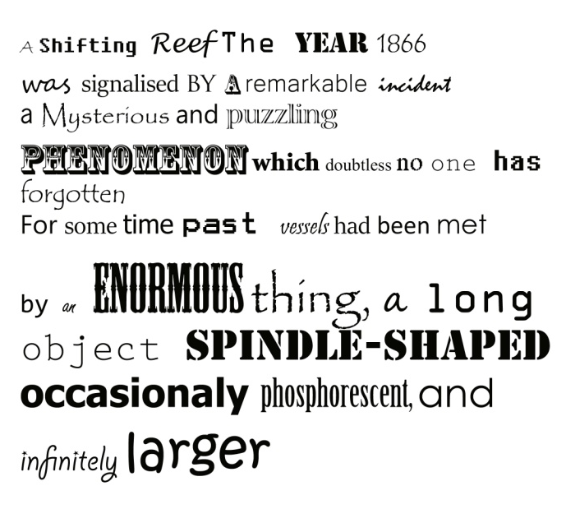
I then used the warp tool to start to experiment with making waves or sea like shapes through the words to distort them.
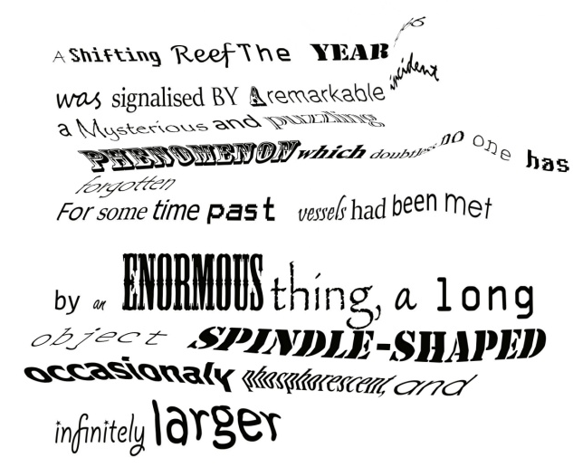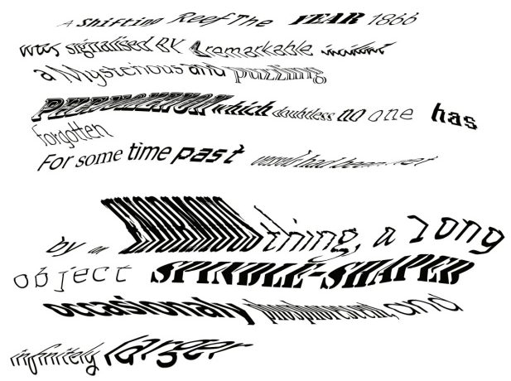
So after two goes I was getting the hang of it, and then tried this design, to get a really wibbly effect!
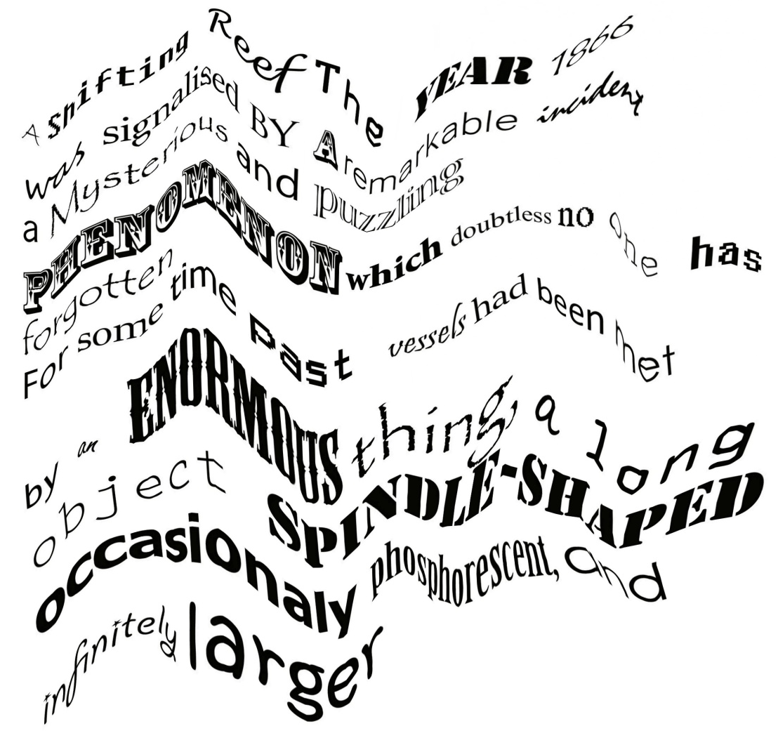
I then thought it would be good to add colour to the descriptive words as well, so they came alive more, this would also help the hierarchy and the feel of the words.
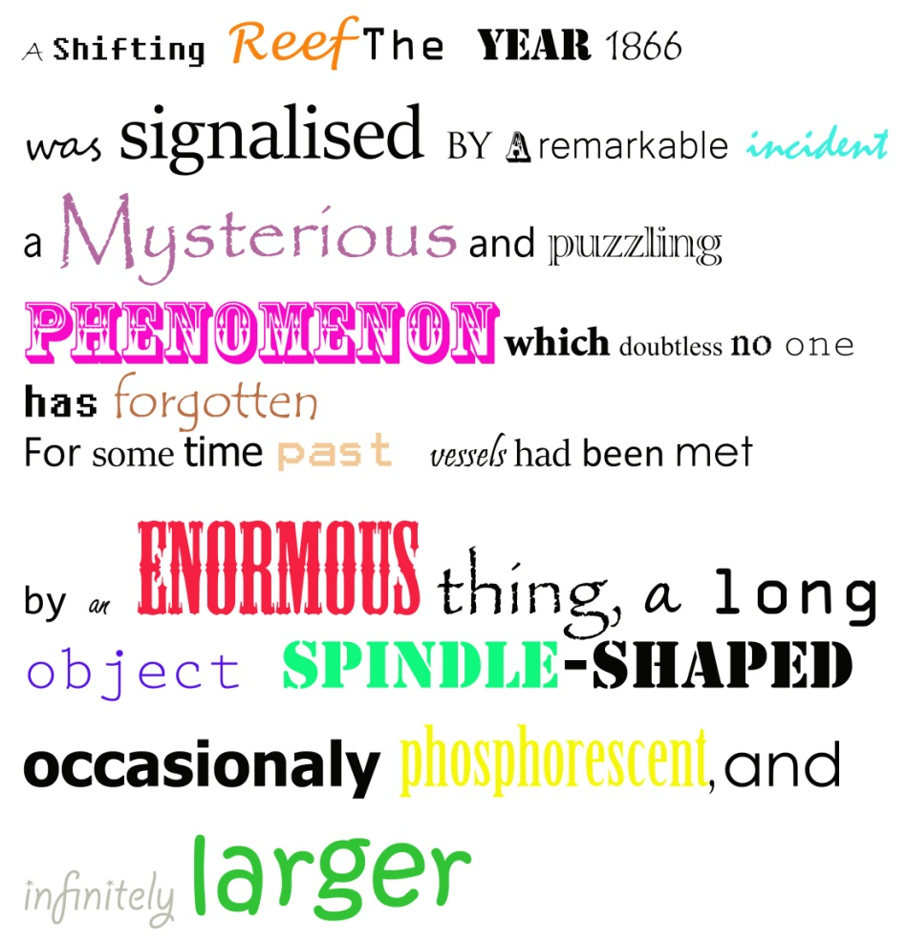
I then used the warp tool again to get the wave effect, and to see if the colour changed the feel of the design or words.

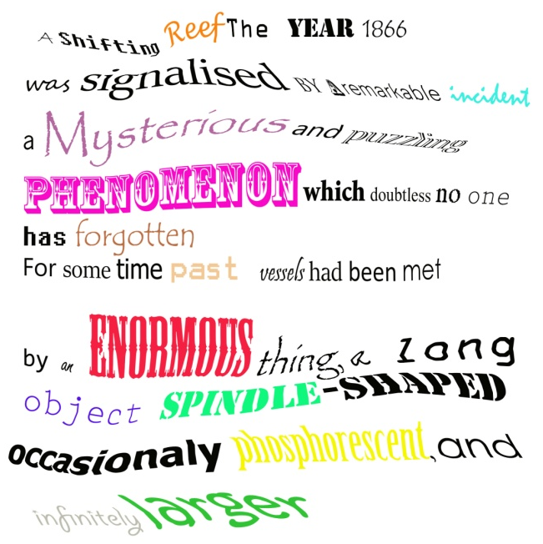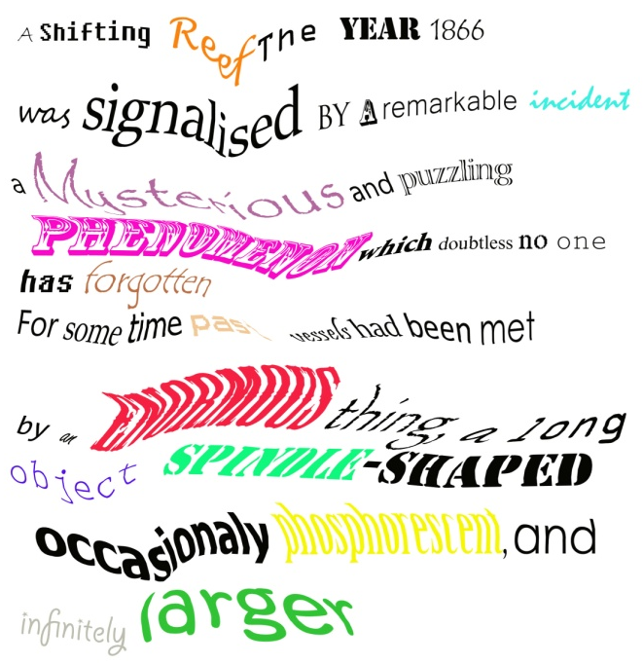
Again I got the hang of it more and made the warp bigger to add more impact and difference.
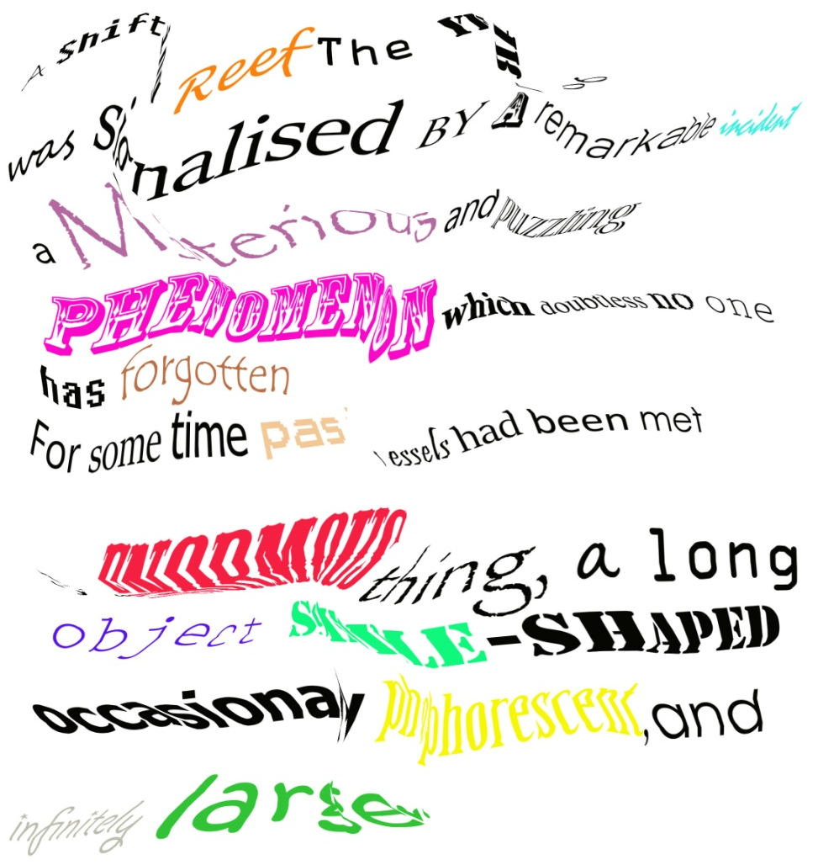
I then found the twirl tool and decided to give this ago, to see if I could get any more unusual effects and differences.
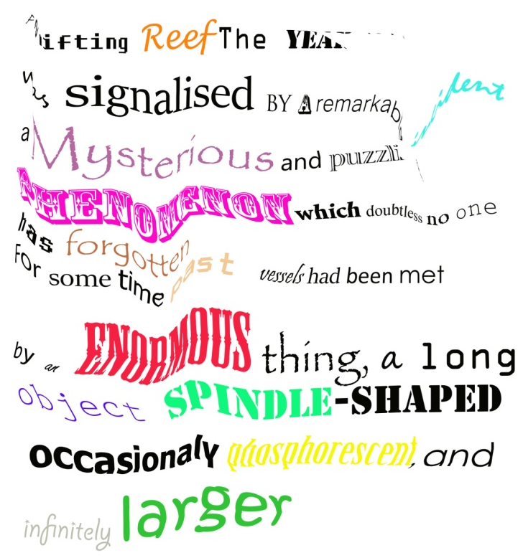

I then went on to find the scallop tool!
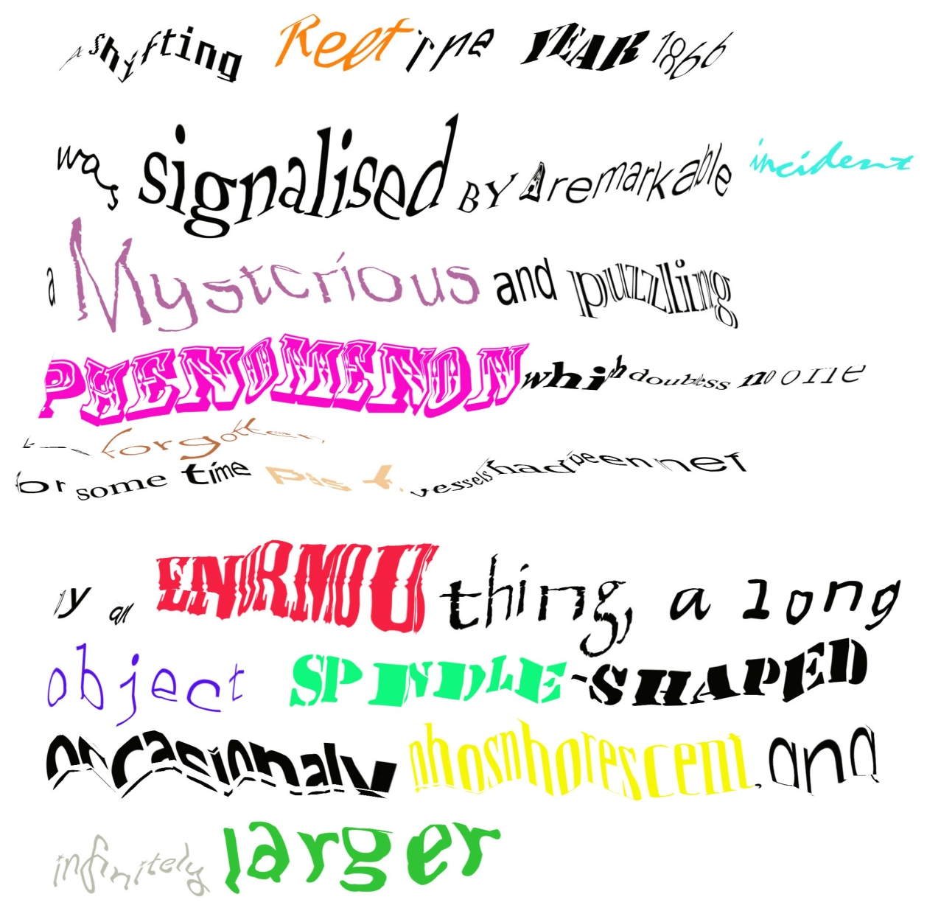

This was a good tool to use, it had a bigger effect but it was jagged than I expected and didn’t flow as well, to give a wave scene.
Then I went on to find the pucker tool, which again had a good effect, but some of the words got lost or flattened, which was not the effect I wanted, as the passage wouldn’t read then.

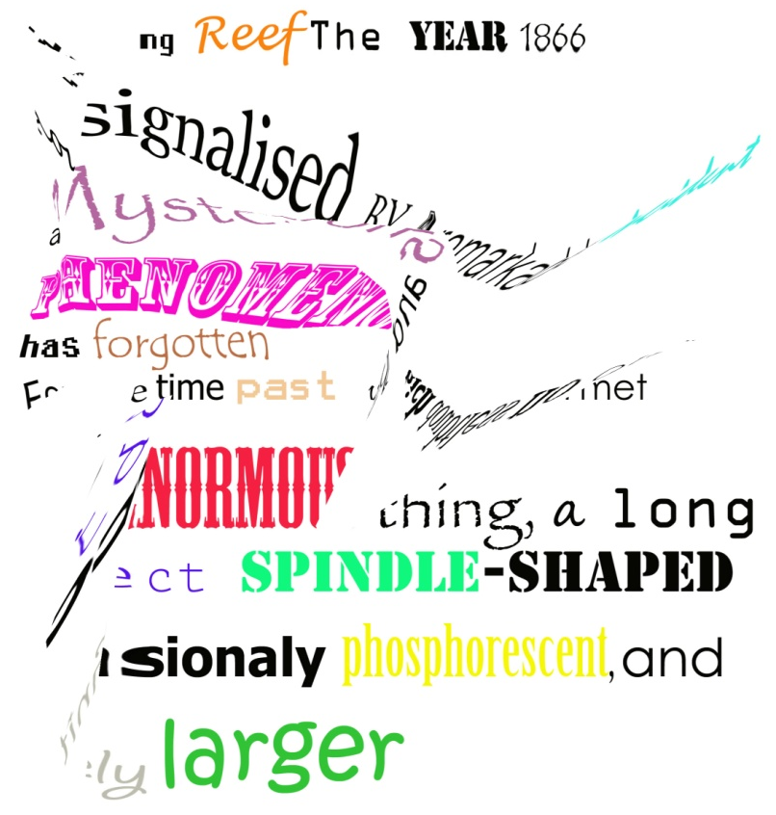

This next design had a nice feel to it, again it was using the pucker tool, but I used it in a slower swaying way, to give this undulating design, which I think looks like water.
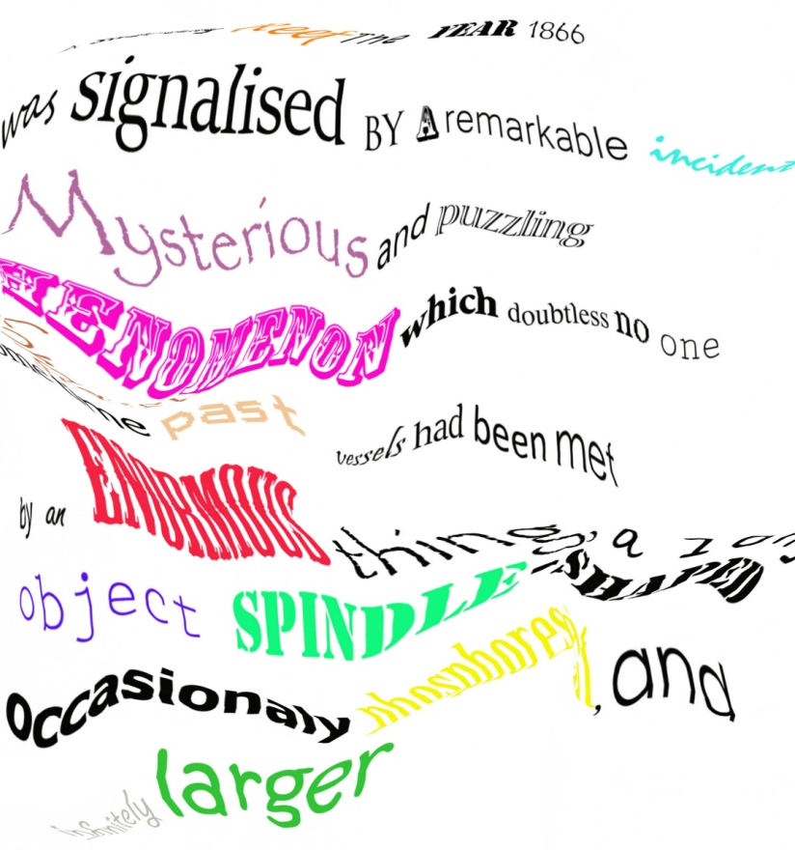
I think I like this design the best, it has the nicest sway and gentle motion to the distortion, which I think reflects the octopuses legs movement from the book, so works well as a concept.
I still like the idea of using a shape to contain the words, but think this is a good final piece to leave this exercise on, it has everything in it that I wanted to show.

