Paper and Book Binding
I read the pages listed 165-180 On Press by Alan Pipes, although it was fairly hard to find on the OCA website, and then it wasn’t in the format that I was expecting it was pages 1-55.
I then went on to compile my paper stock, first of all I wasn’t sure if I had any, it’s a little difficult at the moment if you don’t have anything at home, as you can’t go out due to the lockdown and Pandemic.
I had some printer paper, some card stock from my business and I found some different paper styles from different sketchbooks I had. I guess it’s a starting point of where I can build it up over time. I’ve contacted a few printer companies to see if I can get some samples sent to me through the post, I’ll up-date this once they arrive.
I’ve kept the papers in a bull dog clip, so I can easily add to them, I have listed the papers below.
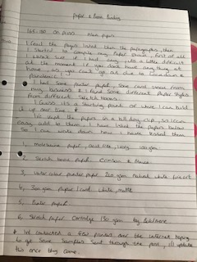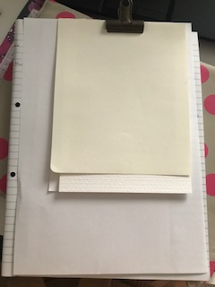

- Moleskine paper, acid free, ivory 100gsm
- Sketchbook paper Crimson and Blake
- Watercolour fine art paper 240gsm natural white
- White paper/ card matte 300gsm
- Printer paper 80gsm white
- Sketch paper Cartridge 130gsm Boldmere

So I came back to this exercise after I had received some samples from a printer, I only managed to get one lot as most of the printers I contacted wanted some kind of payment for the samples, and didn’t quite understand what I wanted.
Very kindly I was sent some by Kestrel Print ltd in Essex, the samples were not quite what I had asked for, but they seem to be general printers rather than a specific book or magazine printers. So I was sent a bundle of paper goods that were printed on different papers and card.
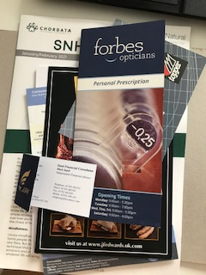

So I don’t really know what type of papers these are e.g. a name for them but basically here they are:-
So this business card was un-coated the type printed well as was clear, also the front had a metallic motif on it, which was embossed well and added that extra touch.
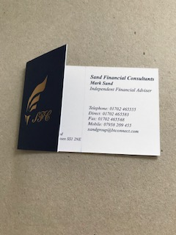
This notepad was fairly thin and had a flexible cardboard backing, the paper was pure white and the printing was clear and the colours bright. I would have chosen a thicker backing board and more pages if this was my notepad.
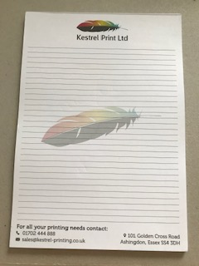

This was a opticians appointment card, which was printed on stiff card, it was a smooth card that had a yellow finish to it, which made it look a bit old and discoloured. I think I would have chosen a pure white card or changed the printing to a white colour.

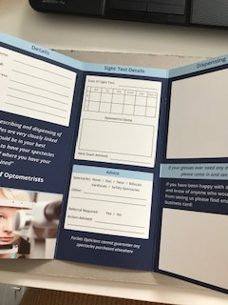

The next business card was printed onto a ridged card, but it wasn’t thick, it had a smooth texture and the printing was very clear and bright, the design on the front had a overlay of gloss on the logo, which added a elevated feel.
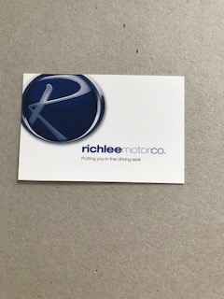

The next business card was made from what looked like recycled card or actually paper as it was quite thin. I didn’t like this much at all, it looked cheap and not very good quality, I really love recycled products and paper but this was not good. Although the type was clear and printed well, it did feel a bit like parchment paper, so maybe that’s why they chose it.

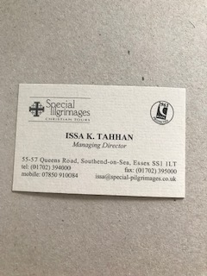

This next little flyer was really nicely made, it was a smooth card, but it had a very nice coating on the top that was glossy but it felt warm, it suited the business it was promoting and defiantly had a feel good feel to it!
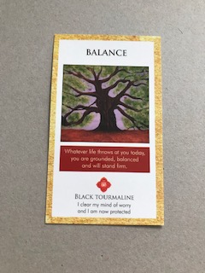
This next item was for the tops of packaged products a hanger board, it had a gloss coating on the front side, but matt on the back, and the design and type printed well and was very clear.
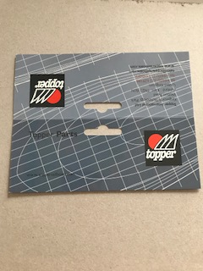

The next flyer was for a butchers, that I assume from the design was a more premium brand of butcher, the card was thick and smooth, but not glossy it had a shine on it though. The print was good the colour looked really good and the black was deep and rich in colour. The card looked like it cut well too, so that was a bonus.

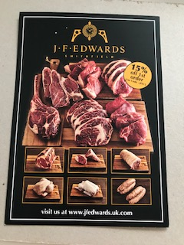

This next flyer was very flimsy and could easily tear, it was like paper, it did have smooth feel but it was a bit grainy too. The colour seemed basic, and it didnt look as bright as some of the others, although I did like the pure white background colour.
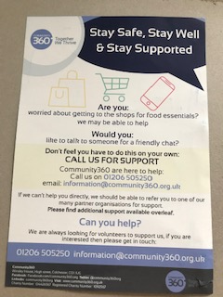

This next business card was actually the printer’s card, it was nice having the rounded corners that made the card feel different, and it was fairly thick and had a smooth, yet un-coated surface. The colour was really vibrant and the type was crisp. The only thing I didn’t like about it was, as you touch the back it had a rim around the edge as though it wasn’t cut very well. I don’t know if this was a second that he sent, or this was his normal cards, but I wasn’t keen on that.

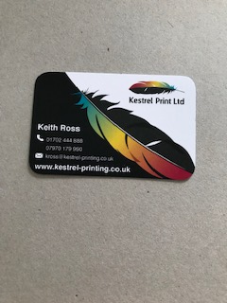

Again this one was a medical card, i was thick yet flexible, which was good because of the use of the card, you need to keep this in your pocket or close to you. It was smooth, yet didnt have a coating as you needed to write on it. The colours was muted because that was the design, but it was crisp and clear.
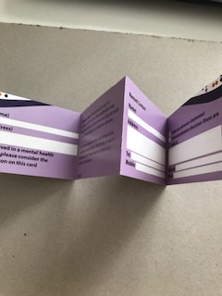

The last one was a large news letter style flyer, the paper was flexible so easy to handle, yet it had a stiffness to it so it didn’t tear easily. The colour was bright and clear, helped by being printed on crisp white. It had smoothness to it yet it was un-coated, it had a nice feel to it and suited the wellness aspect of the business.

