Double-page spread
This exercise asks to understand the relationship between typography, the grid layout, and the format of the page, more in depth by looking at and analysing layouts and creating new ones.
Understanding layouts
Research into book layouts you find interesting, and then into more complex layouts that balance images, type and other content across the columns.
So I started this exercise by looking at some of my books I enjoy, now most of them are children’s books, as I want to be a children’s book illustrator, but I do have some that relate to that, but are design books. Here are a few that I have to choose from:-
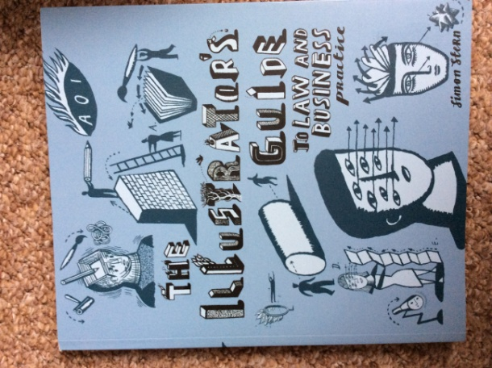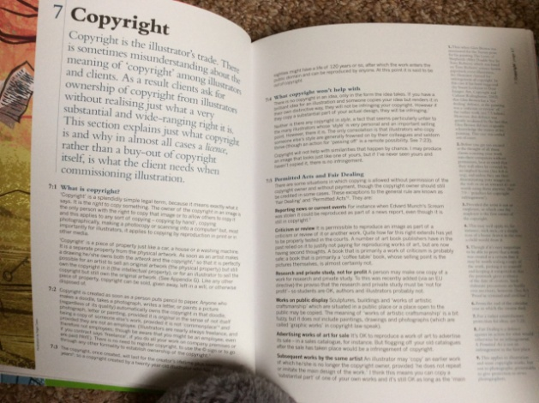

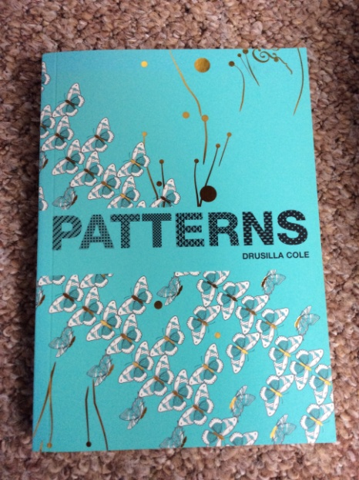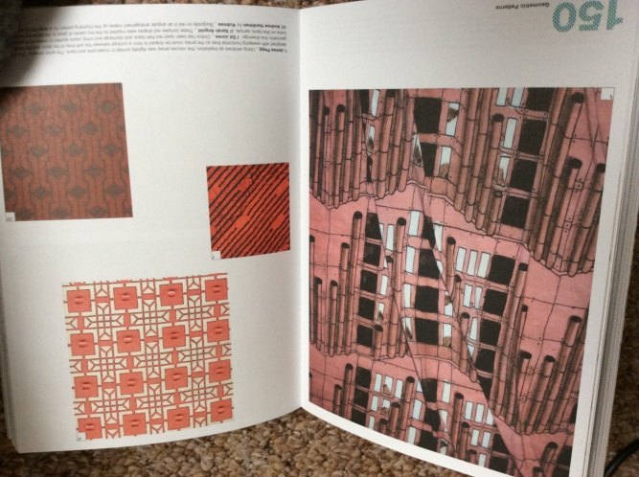
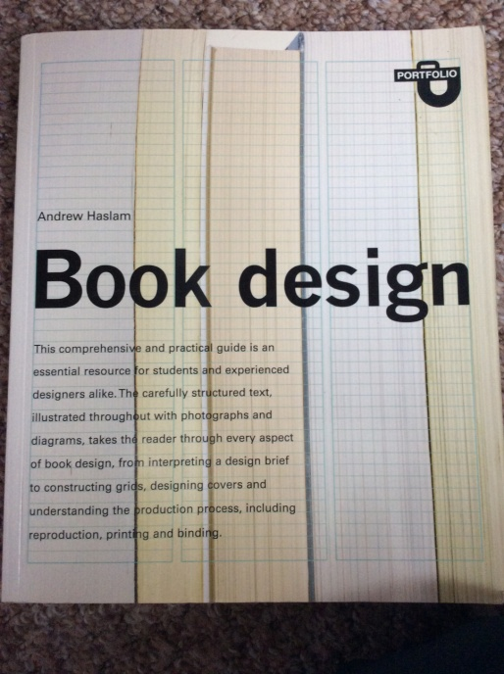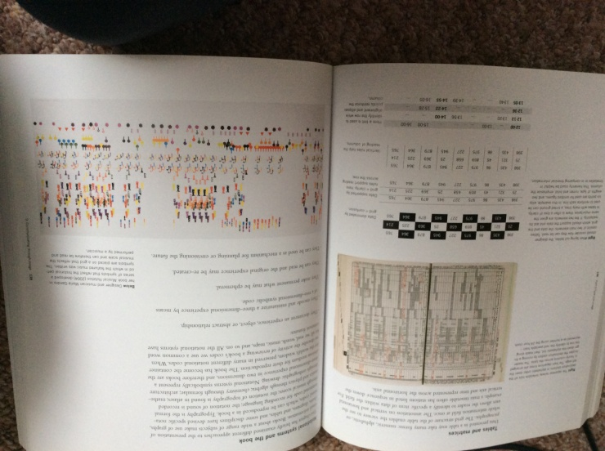

So the book I chose was ‘Children’s Picture books’ the art of visual storytelling by Martin Salisbury and Morag Styles.
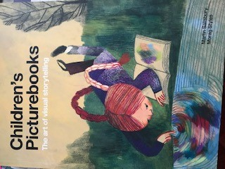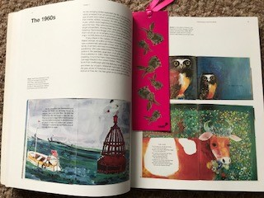

I had a browse through the book and looked at the layouts inside, how the pages differed or where the same, how much text was on each page, or the size and placements of the images.
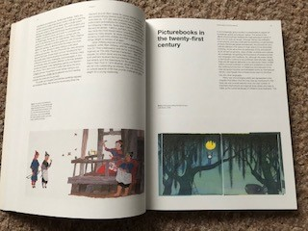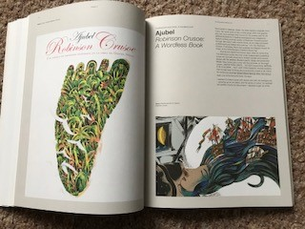
I decided upon this page to get me started on tracing the layout, and then I would work on from there.
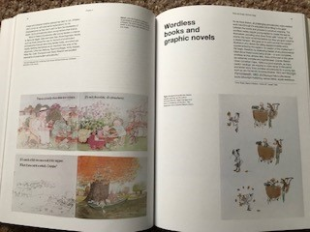

Here is the traced layout; I had to use two sheets as I only had A4 tracing paper. I added in all the sizes of each box and column, also the size of the margins from the top, bottom and each side. Also the width and height in-between each box.
I had a look in the book to see how this layout compared to other pages, they all had the same margin sizes and similar layouts, some were image heavy and some were text heavy.
They all had a certain balance to them, either two images or one image and a sketch. I did see a grid system to the layouts, similar to the Golden section. They all had a large square within the spread, then smaller ones that measured the correct ratio.
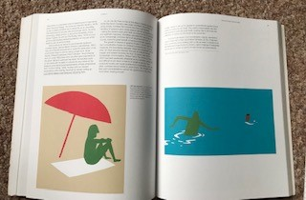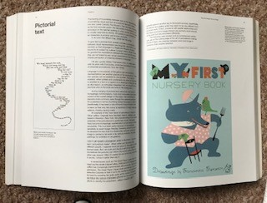

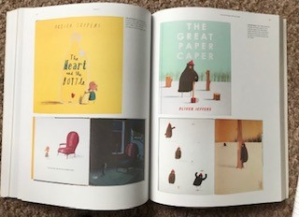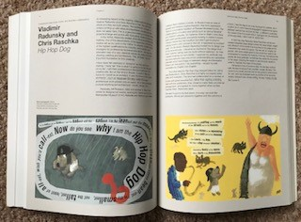

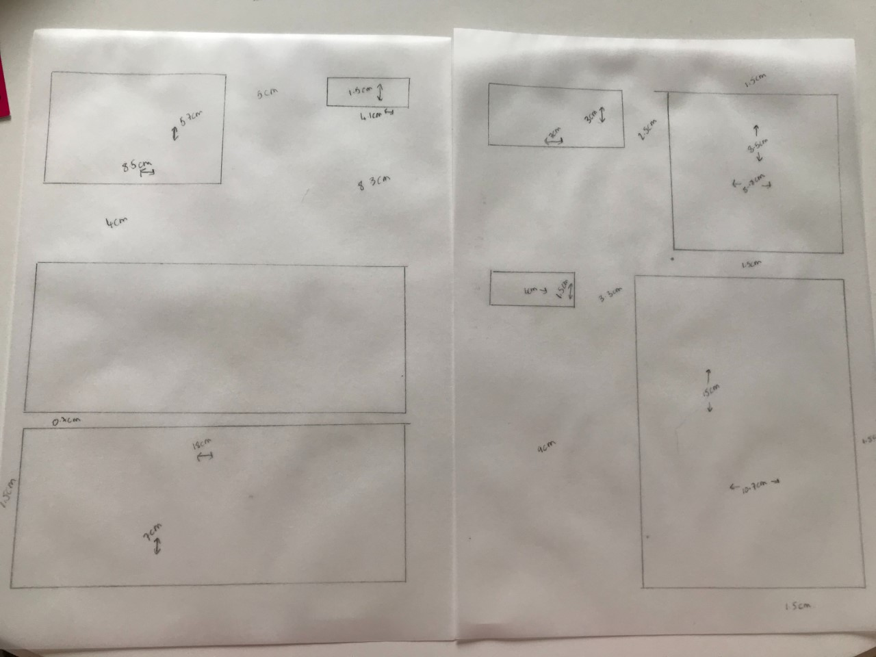

I then went on to transfer all this information into InDesign and a flat spread layout, the size of the book was 44cm x 28cm and the margin was 1.5cm all the way around. I used the gradient at 10% shading for the image squares, and the text boxes I left empty until I could find the correct font.
I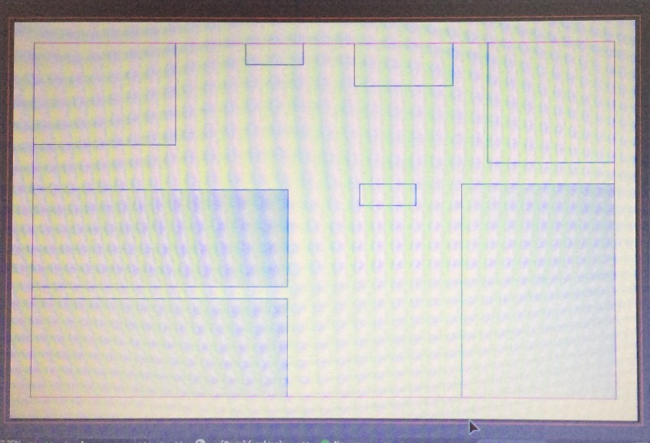

I used a plain sans serif font, as the one in the book was very plain and simple, i couldn’t find the exact one, but went for one very similar. I used my own words for the examples in the text boxes, this made it look more realistic.
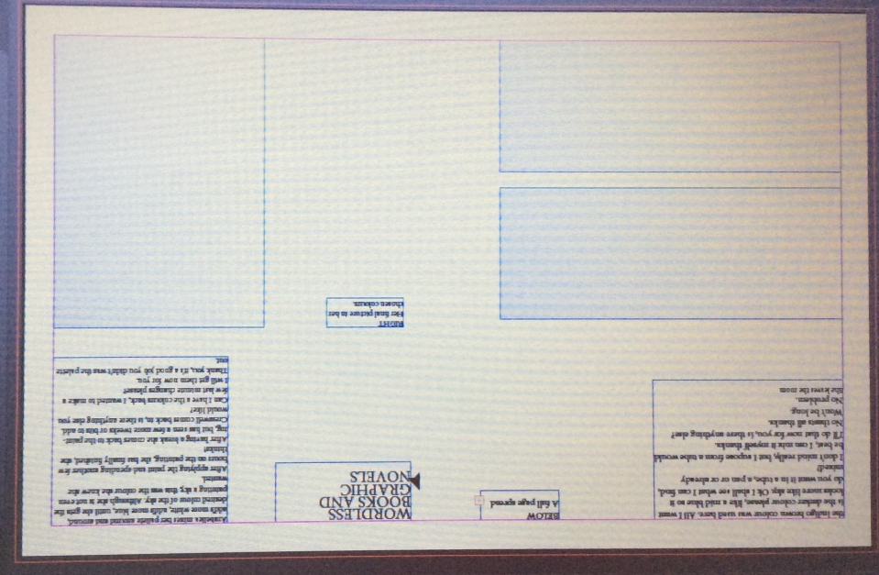

After I had saved this document to my computer, I then went on to look at some other layouts that would really experiment with the spread and radically change it. I came up with 3 thumbnail spreads that were very different from the example one’s and sketched these out onto paper, then stuck these in my sketchbook. The first one was using the full page spread as one, rather than two separate pages. I used one of the images to cross over each page, so it was bang in the middle of the spread. I did notice this in on another page in the book, but they had used the image slightly off balance than I did.
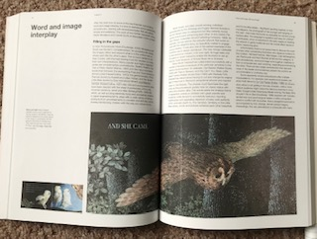
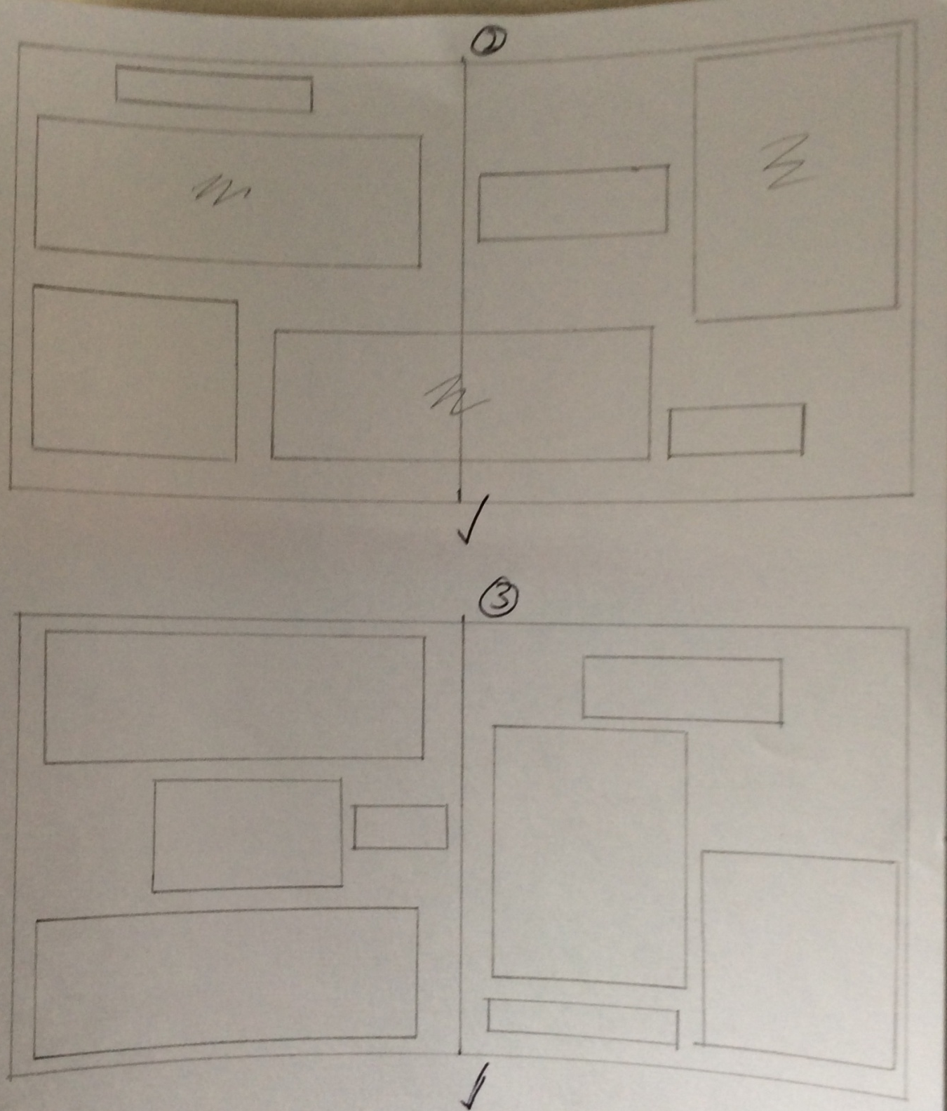

So I then transferred the sizes and boxes over to InDesign and created another spread layout page.
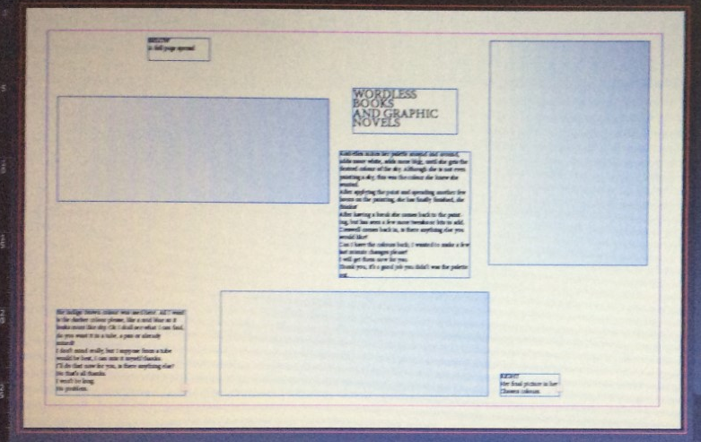

The 2nd design was to split up the two images boxes on the left side and then to still create a balance on the right side. All the sizes of the boxes I kept the same as the original, but moved them about, whereas in my 3rd design I also changed the sizes of the text boxes to completely change it up.
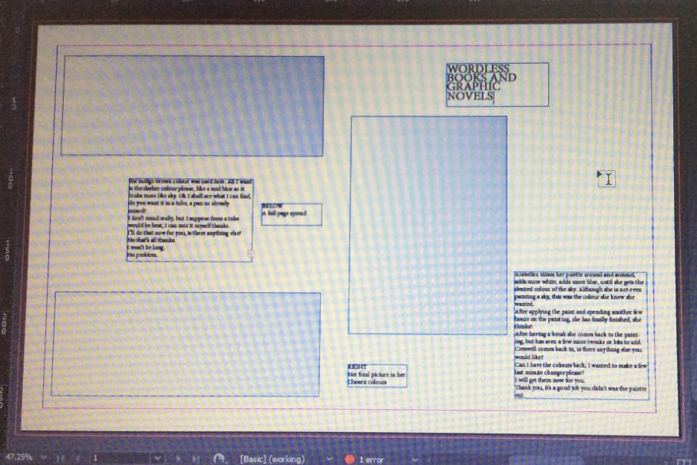
The third layout I wanted to use the image box in the centre of the right hand page, and then I worked the text boxes around this, and then tried to create a balance on the left hand page, so the spread look even. I changed the size of the font on the chapter title on the right hand page to make it bigger, so this has a hierarchy against the other designs and the other text.
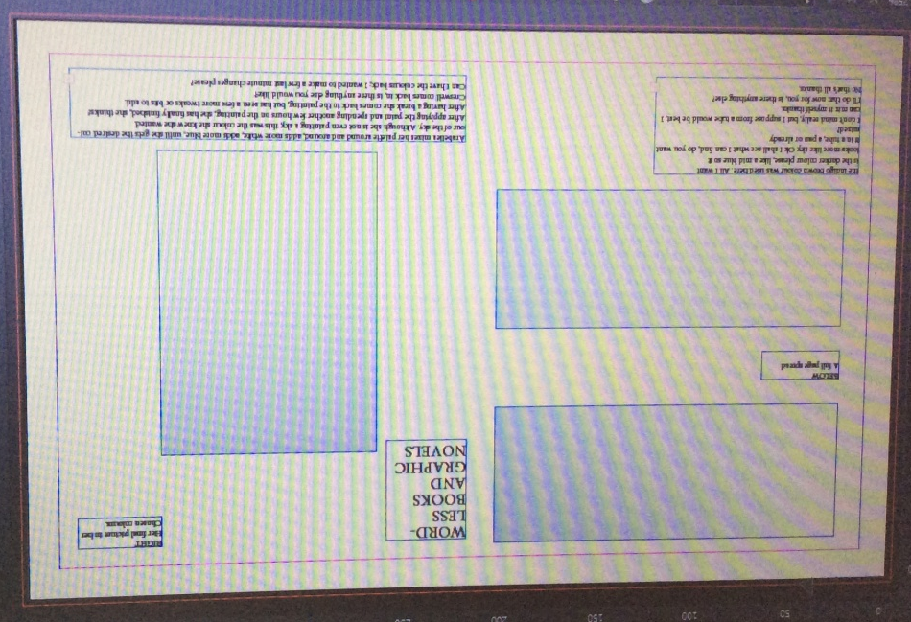

I found that changing the layout around you could make it more interesting, a bit different which I think works well for the book description, but I still felt it was important to create a balance across the whole page spread. Looking over my layouts I can still see some grid systems going on, that I didn’t even think about, the only one that does not show this to my eye is the last layout, layout 3.

