I have identified 6 books at present that I will be looking at for this exercise. The 6 books are all different from each other; I have a ‘Making Fine Chocolate’ cook book.
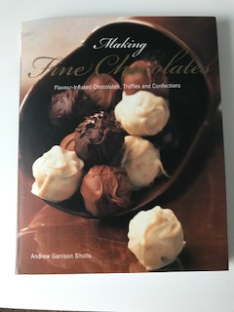

A artists book ‘Hockney’
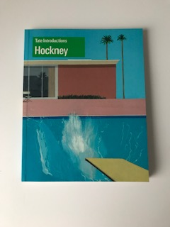

A chic lit novel ‘Wish Upon A Star’
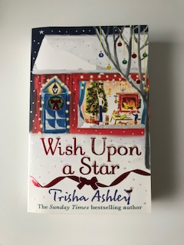

A self help book ‘Crystal Healing’
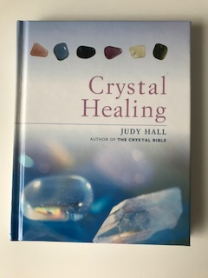

A travel guide to ‘Paris’
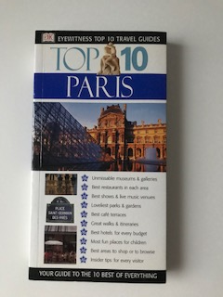

And lastly a botanical book from Kew gardens ‘Welcome To The Museum Of Botanicum’
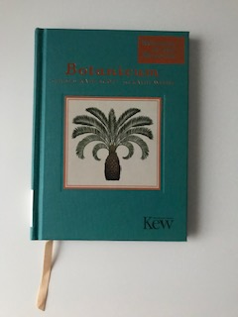

The first book ‘Making Fine Chocolates’ by Andrew Garrison Shotts is a book of 21cm x 26cm x 0.5cm in size, it is just short of A4 in Length, it is a soft backed book and has a very smooth cover, which feels as though it could be wipe clean! The texture of the cover is smooth, it feels luxurious and the feel matches the subject of the book.
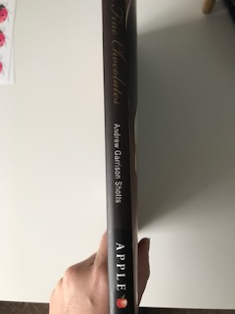
It has a photograph on the front of what look like chocolates or truffles, it looks decadent and makes your mouth water. The colour palette is browns, lattes and chocolate colours, dark, milk and white, it looks velvety and rich in colour.
The type on the front cover is a French script style and the word ‘fine chocolates’ is coloured in gold metallic lettering to really enhance the luxury rich feel.
The ‘making’ and ‘flavour-infused chocolates, truffles and confections words are written in white, this makes it stand out from the dark chocolate coloured backgrounds of the photography.
The authors name is also in white to show consistency, and the spine of the book is coloured in a rich dark brown, the type is the same as the front cover.
The back of the book is split into two sections in two different colours. The milk chocolate colour tells you about the book, the dark chocolate colour breaks down what is inside the book by bullet points. There are two photos from images inside the book, all this gives the reader a glimpse of what’s inside, at the bottom of the cover is a review by USA today.
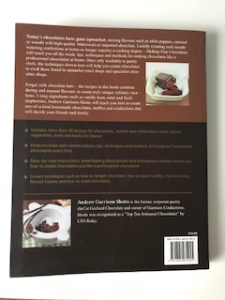
Inside the book you can view quickly its function is a cook book, it has recipes and step by step photos of how to create the confectionary. There are 176 pages inside and to me who doesn’t use cook books much, this seems big! It’s fairly heavy for a soft backed book, but the quality of the pages feels high. The pages are very smooth, brilliant white in colour and it smells like good paper. Inside the book it starts with a publication page, then a dedication page. A contents page, the foreword and introduction pages, it then starts with the basics, like selecting ingredients, techniques and then ‘how to’s’ on basic ganache’s.
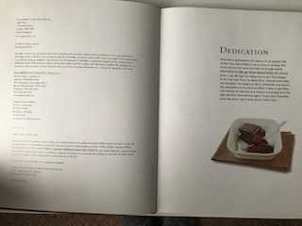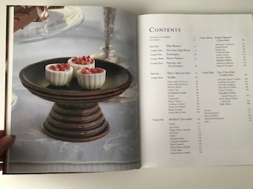

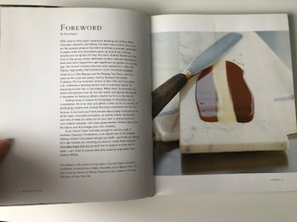
From here it goes into the recipes which consist of a photograph on the left page, then the written recipe on the right page, this fills up most of the book and is kept consistent with the style of photo and the type for the written work. In between there are some how to guides, which are step by step guides on making something, these consist of a few photos showing the steps and written words underneath so you can follow what is going on. Again the photos are similar in style, the lighting on them is the same, and the type again is consistent with the rest of the book.
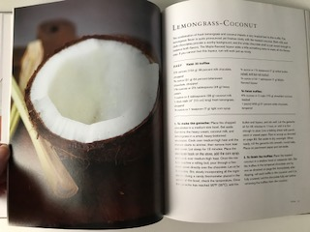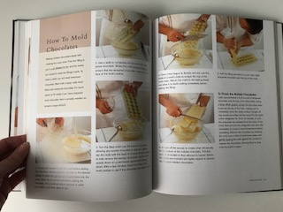
At the back of the book we have a ‘Sources’ page, and the acknowledgments page, followed by an about page for the author and the same for the photographer. Then we come to the index pages which are four pages long. The front and end pages are just plain brown, but the paper is more rough, it feels like recycled paper, and you can see a slight grain in it too.
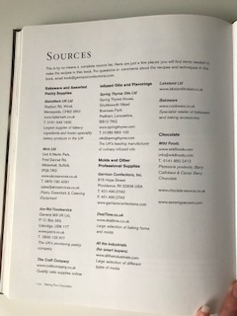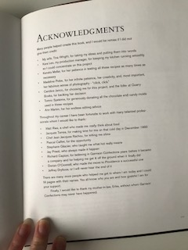

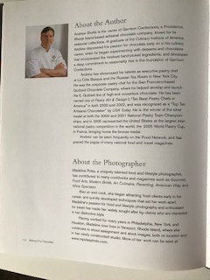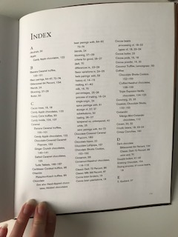

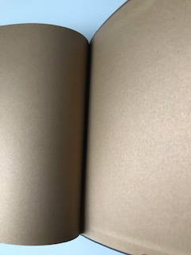

The second book is the art book on ‘Hockney’ this is a again a soft backed cover, the size is 16.8cm x 21cm x 0.8cm it’s a little larger in width than a A5 size.
The front cover is a picture of Hockney’s art ‘The Spalsh’ it has a small green rectangle with Tate Introductions written on it then in bigger font ‘Hockney’ this is in white and the type is quite a modern style, it is very boxy and square.
The back of the book is in plain green with white writing telling the reader about David Hockney, it has a small logo of the Tate in the bottom right hand corner again in white, and then the barcode on the bottom left. It’s a very sleek simple cover and reflects the modernist feel and style of Hockneys work.
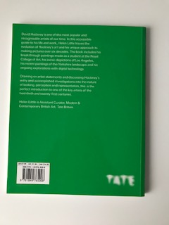
Inside the book the first double page spread has on the left another one of David’s paintings and on the right the title and introduction of the book, again it is using the same type that is on the front cover, the boxy square modern style.

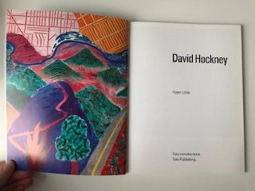
Then as we get into the book we have a few double page spreads about David Hockney and his life, as well as photographs of him and about his life. These are usually spot photographs, so the written paragraphs are either below or above these pictures.
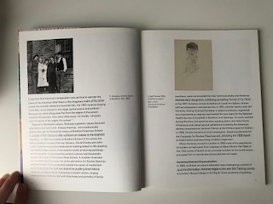
We then move on to the main body of the book, which is filled with Hockney’s paintings, the references are again either just above the picture or just below. This theme runs throughout the book and keeps the consistency running through.

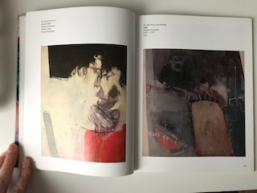
All the photographs and painting are square in this book; again this is something that runs throughout the book. The weight of the book is no too heavy and it’s a flexible book, so easy to flick through. The paper quality is again lovely and smooth and a rich white in colour, the paper is a bit thinner than the last book, and I don’t get that luxury feel I did before.
Towards the end of the book we come across a notes page, which is full of text, again the type is the same boxy square font it was throughout.
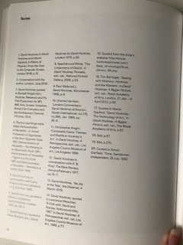
We then have our index pages which again are four in total.

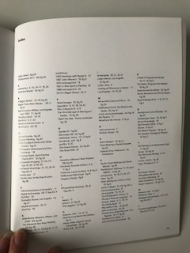

Inside the front and back covers, we have a plain blue front inside cover, but the back end inside cover has a selection of books that Tate promotes. They just use the imagery, but all of the artists are modern in style, so it keeps it consistent.
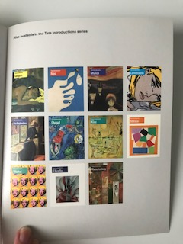

The third book is ‘Wish Upon A Star’ by Trisha Ashley it is a chic lit novel, the book is 13cm x 19.8cm x 3cm in size, it is your typical novel paperback size that you would take on holiday, or just read when you have a moment. Although it’s a thick book it doesn’t feel heavy and it’s very flexible to handle in one hand. The front cover is embossed, that’s the first thing you feel about it, it has a illustrated front cover of a Christmas scene, a small house, a tree and snow, most of the embossed features are metallic, mainly red, silver and gold in colour.
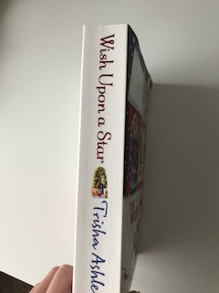
The type of the words is fairly curly, it has a romantic feel and quite feminine, the authors name is in a different type, it looks more like a hand written type, maybe her own handwriting!
The name of the book and author are also down the spine of the book, again in the same type as the front. The back of the book has some decorative illustrations on the top, to make it feel Christmassy too, and the bottom of the book shows other books in the range. It feels quite a busy back cover, the middle section has a synopsis written in the same font as the pages in the book, so the outside gives off the feel of what the book is like from the inside when reading it.
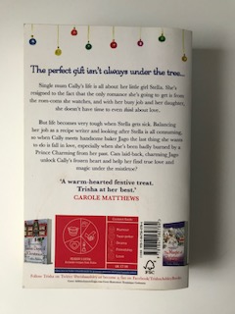

Inside the book the first few pages are very sparse and bare; the first page has a small description of the book, just to small paragraphs long.

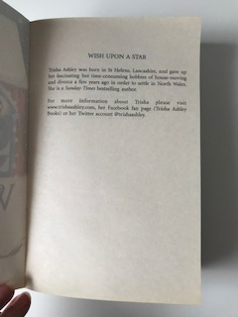
Then we have a list of other titles of books the author has written, on the left page. On the right is just the title of the book again, and the authors name.
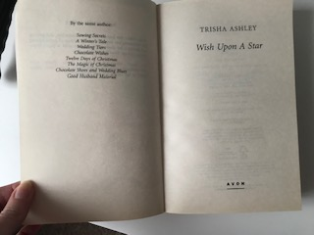
Then we have the publishing details on the next page on the left side, the right side shows a personal dedication for the book.

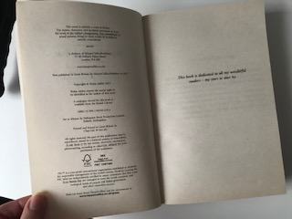
The paper is very thin and quite rough, it feels like cheap paper, and it’s very see through, you can see the writing on the next page through it. The weight of the book is lighter than you would expect for the thickness, so maybe this is why the paper is thinner, it counteracts each other out.
So of the writing is very small, but the type font remains the same throughout, There are no pictures or photographs throughout the book it is literally a whole written novel, the only colour and decoration is on the front, back and side covers.
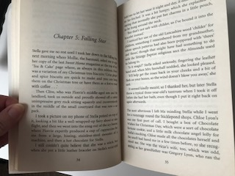
There are 469 pages in the book, and the last page is made up on the left hand side of a promotion picture and words in black and white of another book, the right hand page is blank.

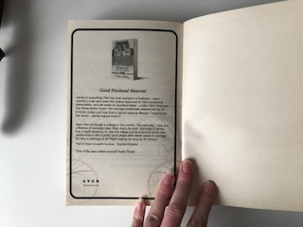

Book four is ‘Crystal Healing’ by Judy Hall it is a small hard backed book 13.5cm x 17cm x 1.5cm in size, It’s quite a heavy book, but the small size makes it easy to handle.
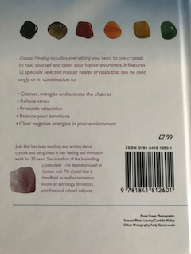

The front cover has a photograph of some gems and a stone in a close up design, the top of the book has a two tone gradual colour gradient, which gives a natural ethereal look. There are 6 stones at the top, and the type and fonts are thin but clear and concise. Using the light purple/ pink colour for the font, gives a healing magical feel.
The back of the book has the same gradient colouring as the front, with again six stones at the top, it then has the same font in the purple/ pink colour but smaller for the words that are placed in the centre section of the back cover, along with the barcode and some publishing words in black type.
Inside the front cover are plain almost eco feeling pages in the same purple/ pink colour as the font, this makes the book feel consistent and flows well.
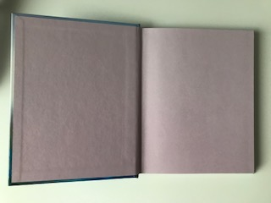
The next pages are made up of smooth, thick glossy paper, which has a nice look and feel to it.
The right hand page has a title and some stones in a ring around it, it is a simple design and makes you feel as though the book will be easy to read and learn.
We then come to the first spread and again it is a title page, which also shows a photograph of a hand with gem stones inside, again this is a simple photo, so this style is flowing into the book.
The font and type also matches the front cover, so this is consistent throughout.
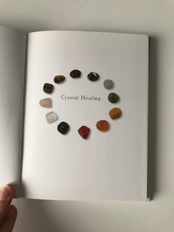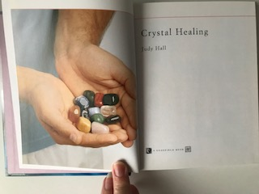
The second double page spread is the publishing page and the contents page, the stones appear here too, but this time down the sides, not at the top and bottom, but still again flows through the book, the type and font are also the same but here they are in black.

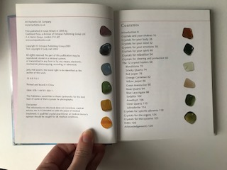
We then reach the introduction page, where we have this title and line underneath; this style carries on throughout the book and creates a streamlined effect. We have a few cameo spot photographs, and again this carries on over most of the pages in the book, sometimes the placement is different, but the style is the same.
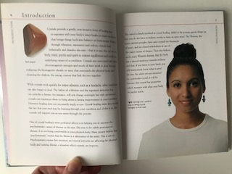
We then have a ‘how crystals work’ page, in this page it’s like a ‘how to style’, so the words with the pink square behind represent the ‘how to’ part, but you have the same title and line at the top of the page, the font and type are the same, and the cameo photos are similar in style and placement.
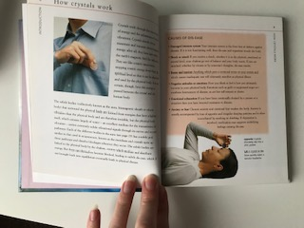
We then have a few pages that are like reference pages, so you can return back to these pages for quick reference. It shows the crystal and what they are good for, but again the page layout is the same, the font and type are the same, but these pages have a background colour of light purple, so you can see them clearly from the side of the book, so you can quickly turn to these pages.
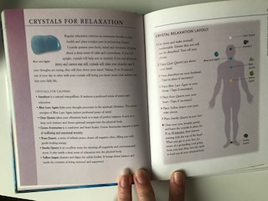
To follow on from these pages we have a grid like page, so you can see on the graph, what works with what stone.

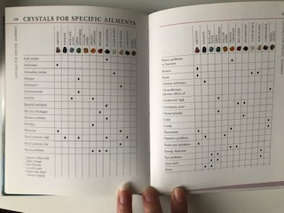
We end with the index pages, which also follow the same page layout.

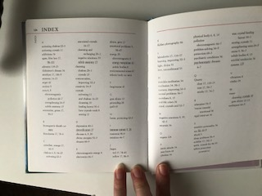
The last page is the acknowledgments page.
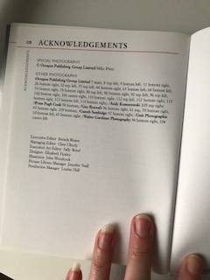

I felt this book had the most consistency throughout the design, it flowed really well and worked as a whole as well as individual page. The function was well thought out and the reference pages and ‘how to’ squares worked quick and easy. The cameo images were distributed well throughout the book, having mainly two on each page, it was well balanced.

Book 5 a travel book ‘Top 10 Paris’ is the smallest book out of this collection 10.2cm x 19cm x 1.2cm in size, it should fit neatly into a pocket, or small hand bag, and be easy to take out and about with you. It is fairly thick, but it is a flexible book and lightweight in design.
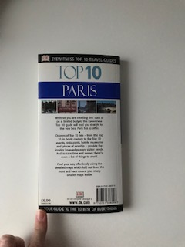
The front cover is broken into sections, the top is the title, then you have a photograph of the Louvre, then below a bullet point list of what’s inside. The font and type are clear and bold, but each word is in a different type, thickness and colour, but it does make it stand out!
The back cover is partitioned into sections similar to the front cover so this shows consistency; the black, white and blue colours are bold and striking against each other.
The indie page is a pull out map of the centre of Paris, which is a great idea, and folds very well back in place. The right hand page is just another title page, but the photo looks older and because it’s in black and white looks slightly different and not consistent with the cover.
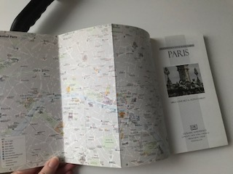
The next full page spread is the contents page, here again you can see the page broken into sections, the photographs along the top, then the contents listed into boxes, and more photos in boxes at the bottom right hand side. It also has a coloured panel down each vertical side; these are on all the pages but in different colours so you can reach pages and section easily and quickly.
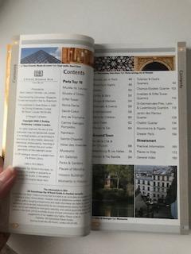
The next page shows the next section and what’s in it; this is a good way to show sections by using colours and having a contents list inside this as well. So all the pages following this page are blue on the vertical stripe down both side and it shows the Paris highlights.
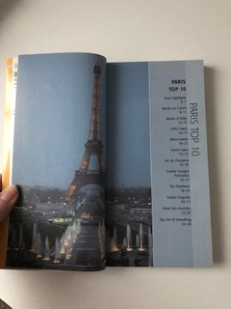
The following page after this is designed like this: - with Illustrations, photos and maps, with a small amount of information for each, it points each picture to an area on the map where you can find it. It’s an easy reference book on a small scale. The type and font flow throughout the book and the colour remains in black.
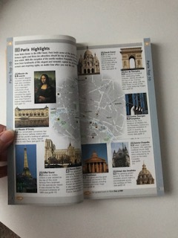
The next section was ‘Around town’ and this was coloured pale blue and helped you to quickly find it. Having the book laid out this way, would be helpful when you are a tourist and out and about, its quick access and easy design really works well here.

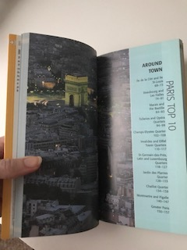
The next section of pages were bordered with yellow to show the; Street Smart’ section, again it’s done like this for easy reference and to quickly flick to the right pages when your out and about.
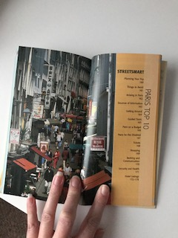
The pages were smooth and didn’t seem see through, because there was a lot of detail and imagery on every page, this was good that the paper wasn’t see through! The cover was a soft backed book, but again it felt like a wipe clean cover, it was very glossy. The cover felt thicker due to the maps folded up underneath the cover, so this added thickness and made it sturdier.
We then get to the index page, these were again designed in the same way and colour coded.
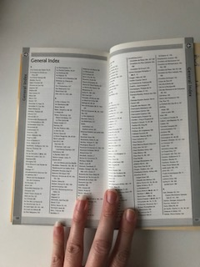

This was the back page map, which was of a particular area of Paris; it also had a train map too, so that was helpful. The function of this book is to help you find your way around Paris, see some well known sights and places, give recommendations of cafes, or places to eat, places to stay, and places to visit. It needs to be practical, easy to use and have quick wins throughout.
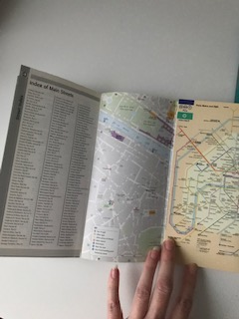

The last book in the 6 is the Kew Gardens Museum book ‘Botanicum’ by Katie Scott and Kathy Willis.
It’s a small sized book 13cm x 17.5cm x 1cm, it is a hard backed book and fairly light in weight.
The cover has a rough texture to it, I think it is supposed to look old, it has a classic botanical old feel to it, the colour is amazing, it’s a lovely rich turquoise green colour and feels very retro.
The typography is very botanical and luxurious; it has gold metallic colours, the authors names are in a more simple type that’s easy to read.
The function of the book is to reference and bring together an especially curetted set of illustrations and information to immerse yourself in the museum and galleries.
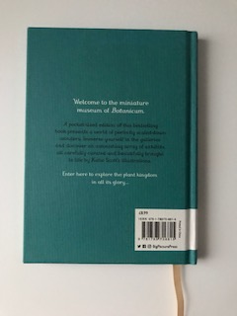
The paper quality is smooth, yet it has a water feel to it, you can see lines and the paper texture; it’s a nice thick good quality paper, it feels and smells nice.
Inside the front cover is a gorgeous pattern of old illustrations of botanicals, in a lovely rich jewel green colour, it feels majestic and old in a wealthy way.
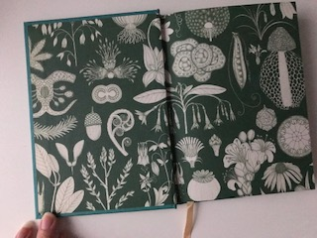
The first page is laid out like the entrance to a museum or gallery, so it has a paragraph and introduction to the book on the right hand side page.
The left hand side of the page shows a illustration of a flower, the paper is slightly yellowed to achieve the old effect, even though it’s a new book. It’s designed and laid out simply, yet its effective in giving that 1920’s retro feel.
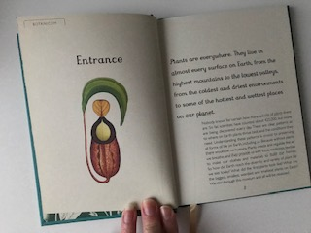
Each page after is then designed like this: - it has the name of the botanical on the left side with a description about it, the measurements and Latin names. On the right side are the hand drawn illustrations of the botanicals, in all the details. This runs throughout the rest of the book.
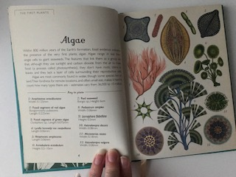
The second from last page is this double page spread, which shows mangrove forests, again it is designed and laid out in the same way, the type and fonts are the same and it flows through the book.

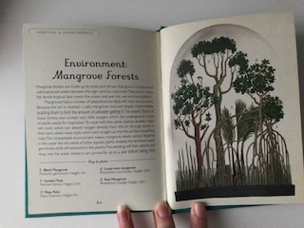
The last page is on the left side, which shows the publishing details, again it’s in the same font and type and has the same old retro feeling.
There are 63 pages to this book, the images are evenly distributed over all the pages inside, with the same amount on each page, the front and end pages are lovely with the retro old pattern designs. The book doesn’t have many other pages apart from the publishing page, there is no index or contents pages. It is a simple book, simply designed, but with an amazing retro feel, which I think makes the book.
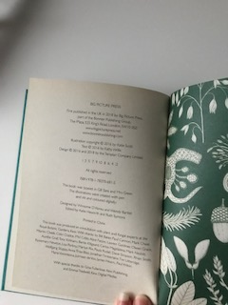

I can now see more about the design of the books than I could do before, I now realise there are many pages as well as the actual book pages included, like the contents, publishing, index, reference, dedication, etc pages.
I can see that it’s good to be consistent on each page the layout the type and the font, so it flows well. If you have reference pages or ‘how to’ pages these should be colour coded for easy access or to quickly flick to these points, or have step by step pictures.
I think the size, weight and feel of the books are important too, I prefer small books that are not too heavy, that you can easily carry around with you, I like a good quality paper and a thick cover is important.
The type needs to reflect the style and subject of the book; this can also help with the books age or simulated age. Colour is also important for the front cover, it sets the scene for what’s inside the book and gives off the feeling of what you will be reading.
There’s a lot more to think about than you realise, but doing this exercise has made me see what involved and the things to implement going forward.

