Type Samples
I had a look online and I found examples of all the typography fonts used in the example mentioned in the exercise, I printed these off and made a booklet of them.
Old style :- Garamond and Caslon
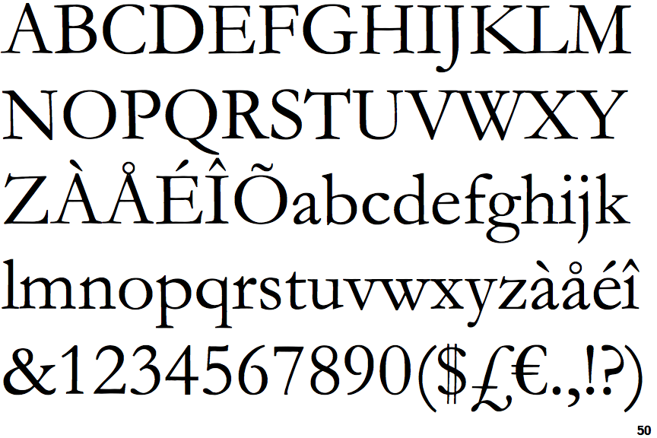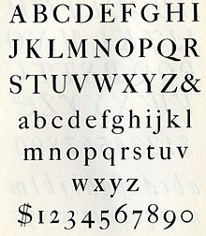

Modern:- Times Roman, Bodoni and Didot.
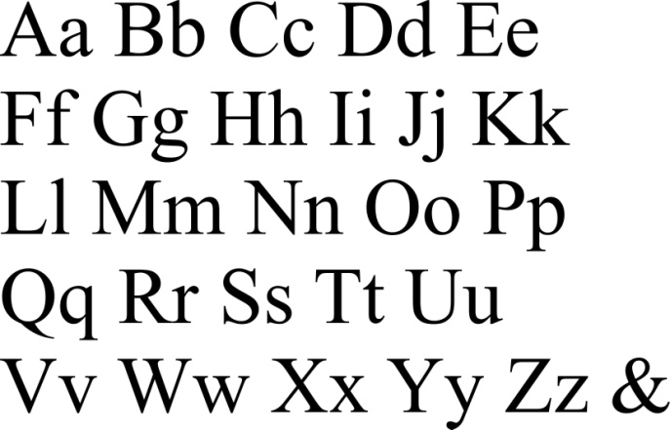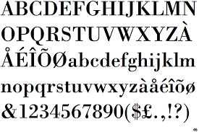

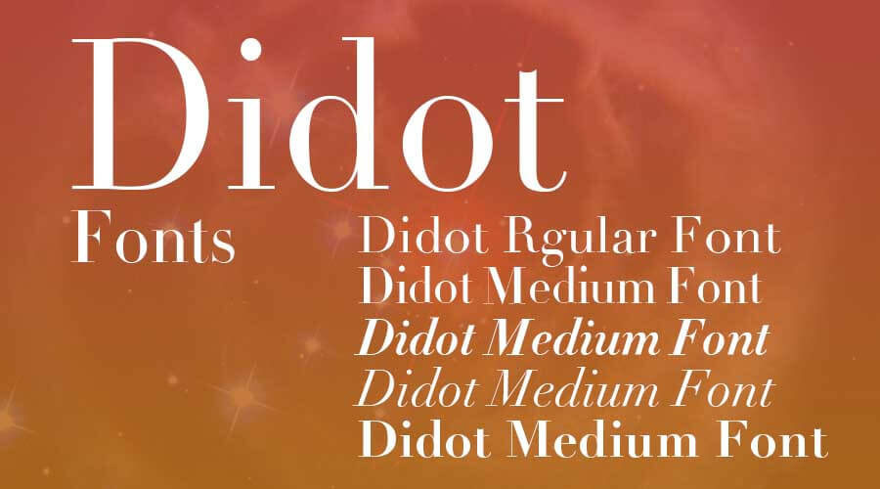

Sqaure Serif:- Claredon, Stymie and Lubalin graph.
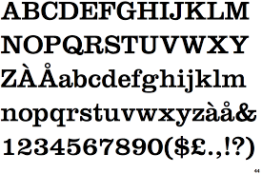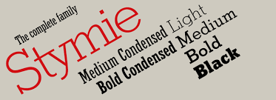
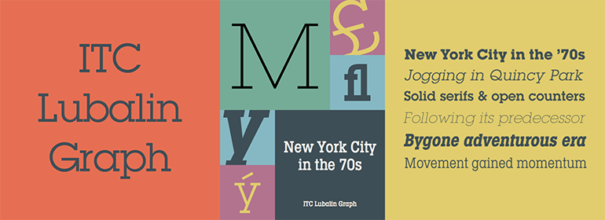

Sans Serif:- Helcetica, News Gothic and Futura.
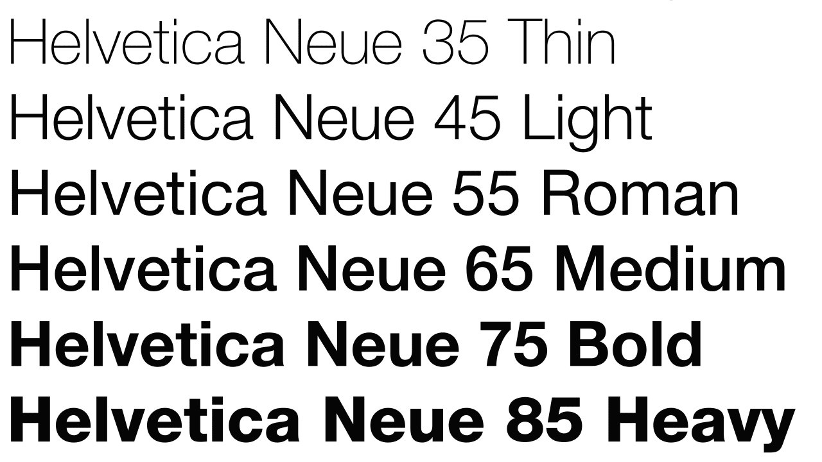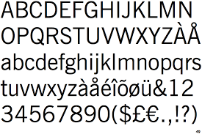

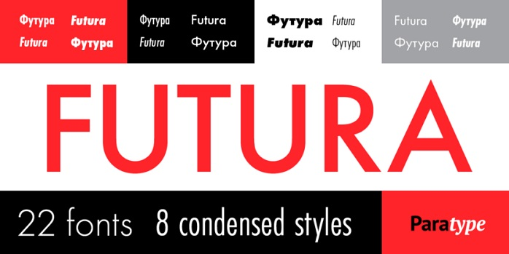
Script:- Commercial script and Zapf Chancery.
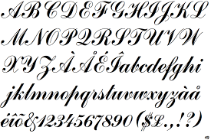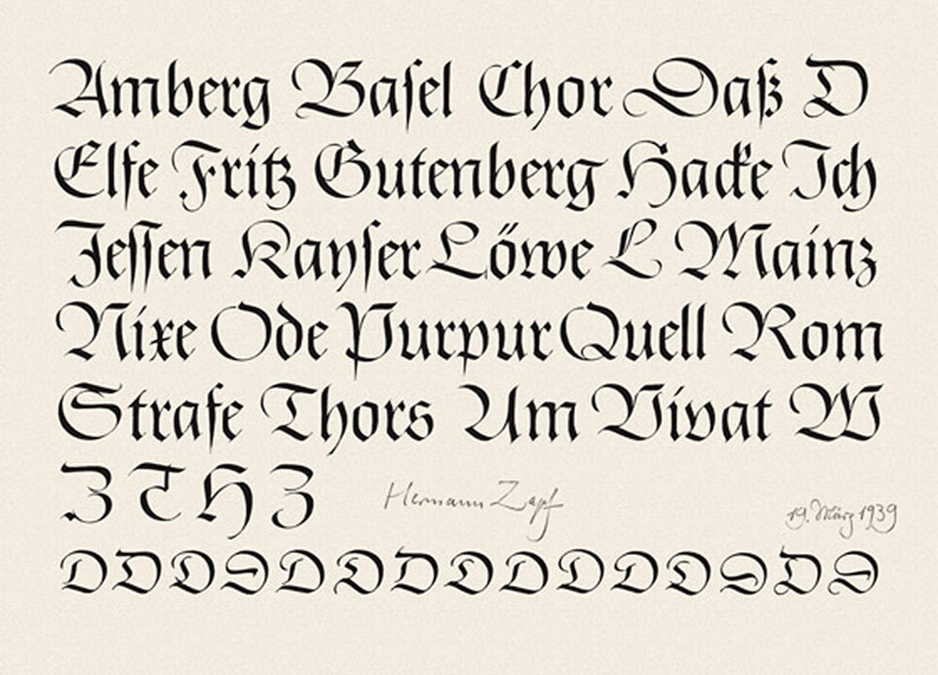

Text letters:- Old English and Engravers text.
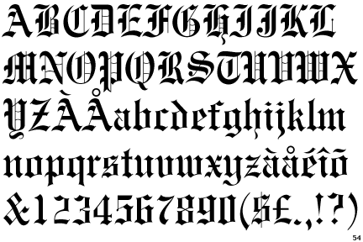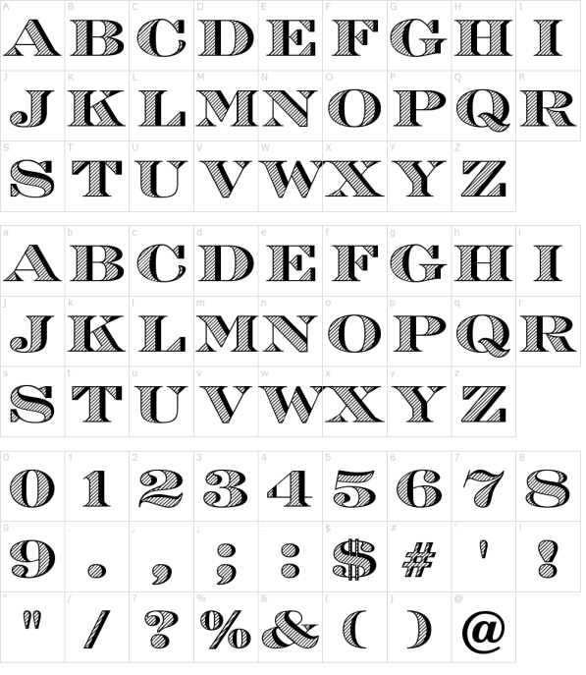

Decorative types:- Comstock.
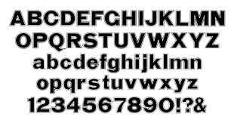
I then went on to find examples of fonts in books, newspapers and magazines, to print off and collate into my collection.
I had lots of books to hand, but no newspapers or magazines due to lockdown.
I had this book on hand lettering which I bought last year; it has some great examples of serif and sans serif fonts and how to create them yourself. But I actually liked the fonts on the front cover and the mixture used to show the consumer what might be inside.
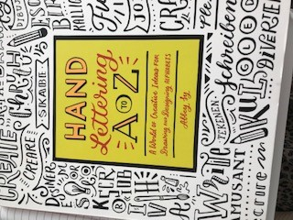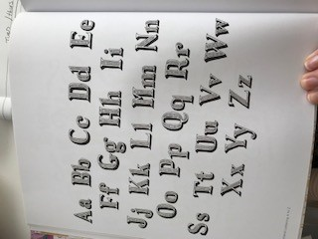

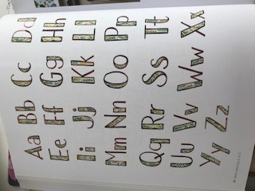

I also had this book on patterns, and I liked the way the bold words had a different pattern in each letter.
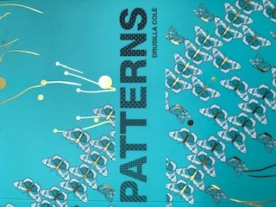
This book by Lorna Scobie is great as it uses hand lettering with traditional modern type.

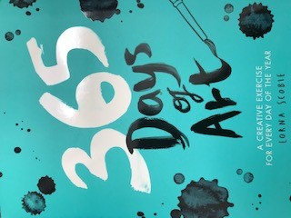
This Botanica book has a great font for the title a modern clear serif.
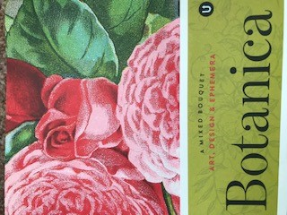
Again another book with a decorative font style, which is hand drawn.
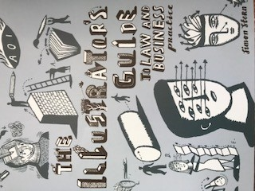
This Botanicum book has a old style serif font and yet it looks modern and bold.
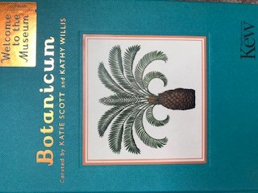
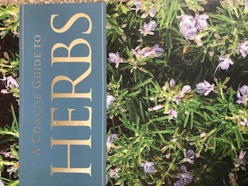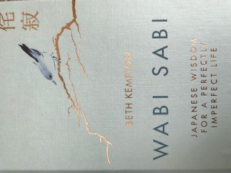
This Wabi Sabi book has a great font it’s modern and clean and works well bigger as well as smaller, and the simpleness works with the books style and the nature of the book itself, about living a simple life.
I picked out some fonts from my computer and put them in similar styles to the ones shown in the exercise. I would say that the Arial font would work in both magazines, newspapers and as well as a science book, because the font is clear and simple and modern, it can look bold as well as thin, and it would work for both titles and reading material.
I think the Candara light would work for a book the best as it’s easy to read, simple and light and easy on the eye for periods of time.
I think the Bookman old style would work on a newspaper its bold eye catching and great for titles.
And as I’ve said before the Arial would work well in a science book, as its modern simple and easy to read.

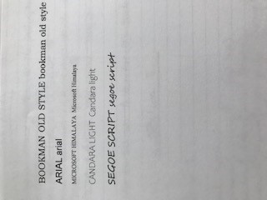
Looking at font’s where the use of them is ugly or wrong, I came up with these ideas:-
I thought this font would not work well for a science book; it would be too distracting, too colourful and not appropriate.
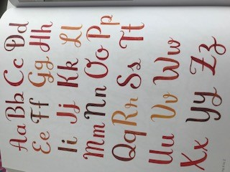
This font would not work for a novel as it’s too big, too busy and could be hard to read for long periods of time.
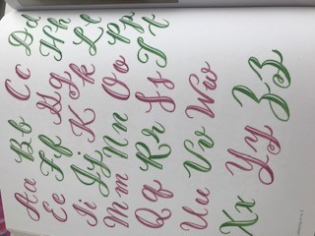
This font would not work for a newspaper as its too big, you would hardly get any words on the page, it’s too bold and too stark having the black boldness against off white paper.
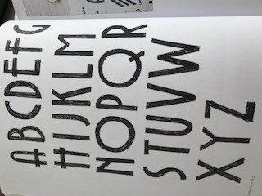

This font would not look right on a magazine, its too complicated and not for easy lightweight reading, and it would not fit within some themes or topics, it wouldn’t be appropriate.
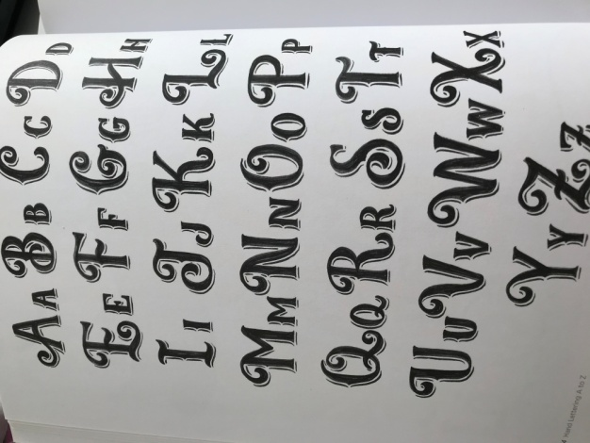
I thought this font below would be really un-appropriate on a newspaper, it’s too colourful, too busy and quite young, it would be ugly and not suitable, but funny!

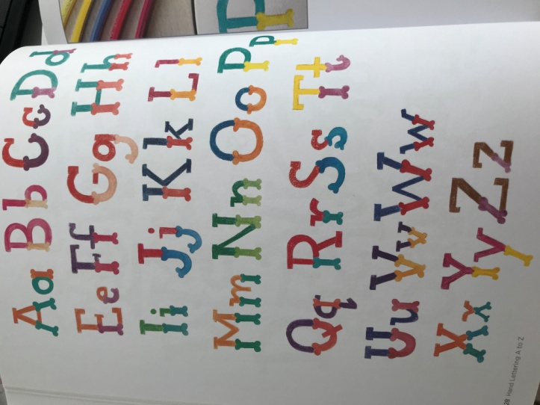

I went back over all the fonts I printed out and annotated them all with descriptive words:-
Clean, bold and serif
Clear, Concise and classic.
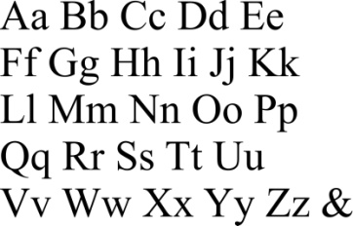
Modern, Bold, Simple and serif.
Classic/ modern, serif and thick/thin.
Serif, opposites and a 20’s edge.
Sq serif, bold and rounded.
Thin, sq serif, whiled, condensed and curvy.
Serif, easy and arrowed.
Sans serif, clear, spacious and Swedish.
Sans serif, clear, easy and square.
Bold, graphic, sans serif and underground.
Old classic, flourishes, curls, decorative, linked, think/thick and serif.
Pointy, thin/thick, jagged, old, German and serif.
Grids, distinct, angular, doubled and serif.
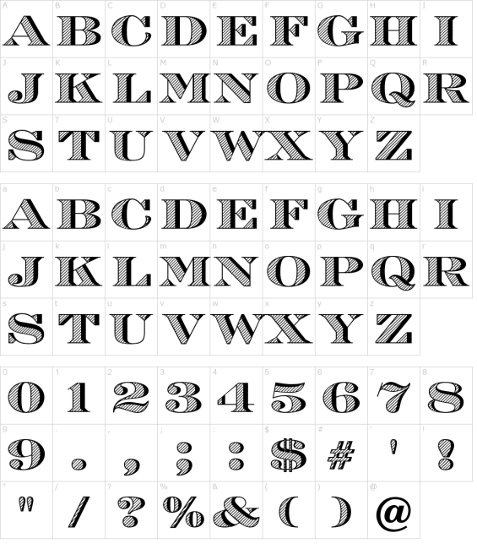
Serif, busy, fat/thin, lines and edges.
Bold, clear, squared and sans serif.

I then started working on tracing some unusual font designs, then transferring them to clean paper and colouring in with a HB pencil.
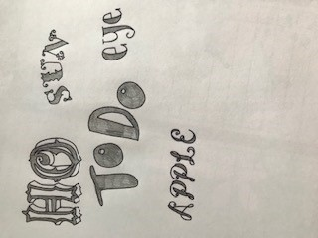

Looking at creatively developing the typography I have created and collated in this exercise, I’m looking at art works of typography to help me with this, like the picture below.
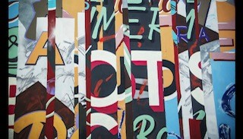
The history of typography and its journey through art. © Widewalls

