Assignment 2: Form and Function
So to start this assignment off I read what I had to do that was given in the text;
Design the book format and cover artwork for two different versions of Daniel Defoe’s classic 1719 novel Robinson Crusoe. The publishers, Viking Press, have decided to re-release this title as a new pocket edition for readers on the move that reflects the adventurous nature of the story within a contemporary setting. This paperback version should have a modern visual feel that can compete with new titles in the bookshop. They also want a deluxe edition for armchair readers and classic book collectors that reference the historical nature of the story and its associations. Produce book design ideas and cover artwork to reflect the content of the story across both formats and contexts. Be creative and inventive with both the look and format of these books.
As a side project to accompany the re-release of Robinson Crusoe, Viking Press has also asked you to design a new book called Washed ashore: The ultimate guide to surviving on a desert island by Rik Bennett. This is a ‘how to’ guide that should reflect not only the practical advice it offers, but something of the adventure of being a castaway.
I then went on to create my own brief with the template I have learnt through this degree, this helps me to see clearly what needs to be done.
The Brief
Overview
Three book covers based on the novel Robinson Crusoe
What type of Illustration?
Book covers
What type of project?
- Pocket edition that reflects the adventurous nature of the story within a contemporary setting, Paperback, modern to compete with new titles
- Deluxe edition for armchair readers and classic book collectors, historical aspect
- Washed ashore; The Ultimate Guide to Surviving on a Desert Island.
Project description
Create front, back, spine and flaps of the covers traditional or alternative binding. Generate illustrations, photography or artwork for covers or purely typographic covers.
Mock up each book and cover by presenting the overall spec
Layout the jacket using DTP software text and image, design a range of versions to choose from, print the jacket designs and make a mock up.
Vision of the project
The pocket edition needs to celebrate the functionality of the book as a lightweight, transportable, travel and survival themes, contemporary
The deluxe edition needs to be larger, finer, luxurious or expanded, and reflect the history of the book.
The shipwrecked guide needs to be a separate genre, but piggy back the Robinson Crusoe book.
All part of a series; adapt to fit all three, look at scale, stock and binding
Target Audience
New and existing readers
Skill’s I’m looking for
Traditional Illustrator or digital
Deadline
11th March
From this I went on to read some of the book Robinson Crusoe, I have a knowledge of what the book is about, even though I have not read it, but I wanted to create some key words to then help me to start a spider diagram.
So my keywords are:-
Trained talking parrot
Isolation
Spiritual/ Religion
Footprint
Palms
I then went on to start my spider diagram, I usually collect my keywords after I have done my spider diagram, but because I needed to know more about the book first, before completing this, I thought it would be better the other way around this time.
So this is my spider diagram:-
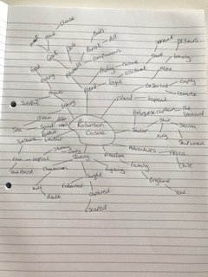
The words I found that came out of this were:-
Friday
Cannibalism
Goat
Awakening
Shipwrecked
Adventure
Remote
28 years
From this I then collected some pictures for a mood board for the feel of the book.
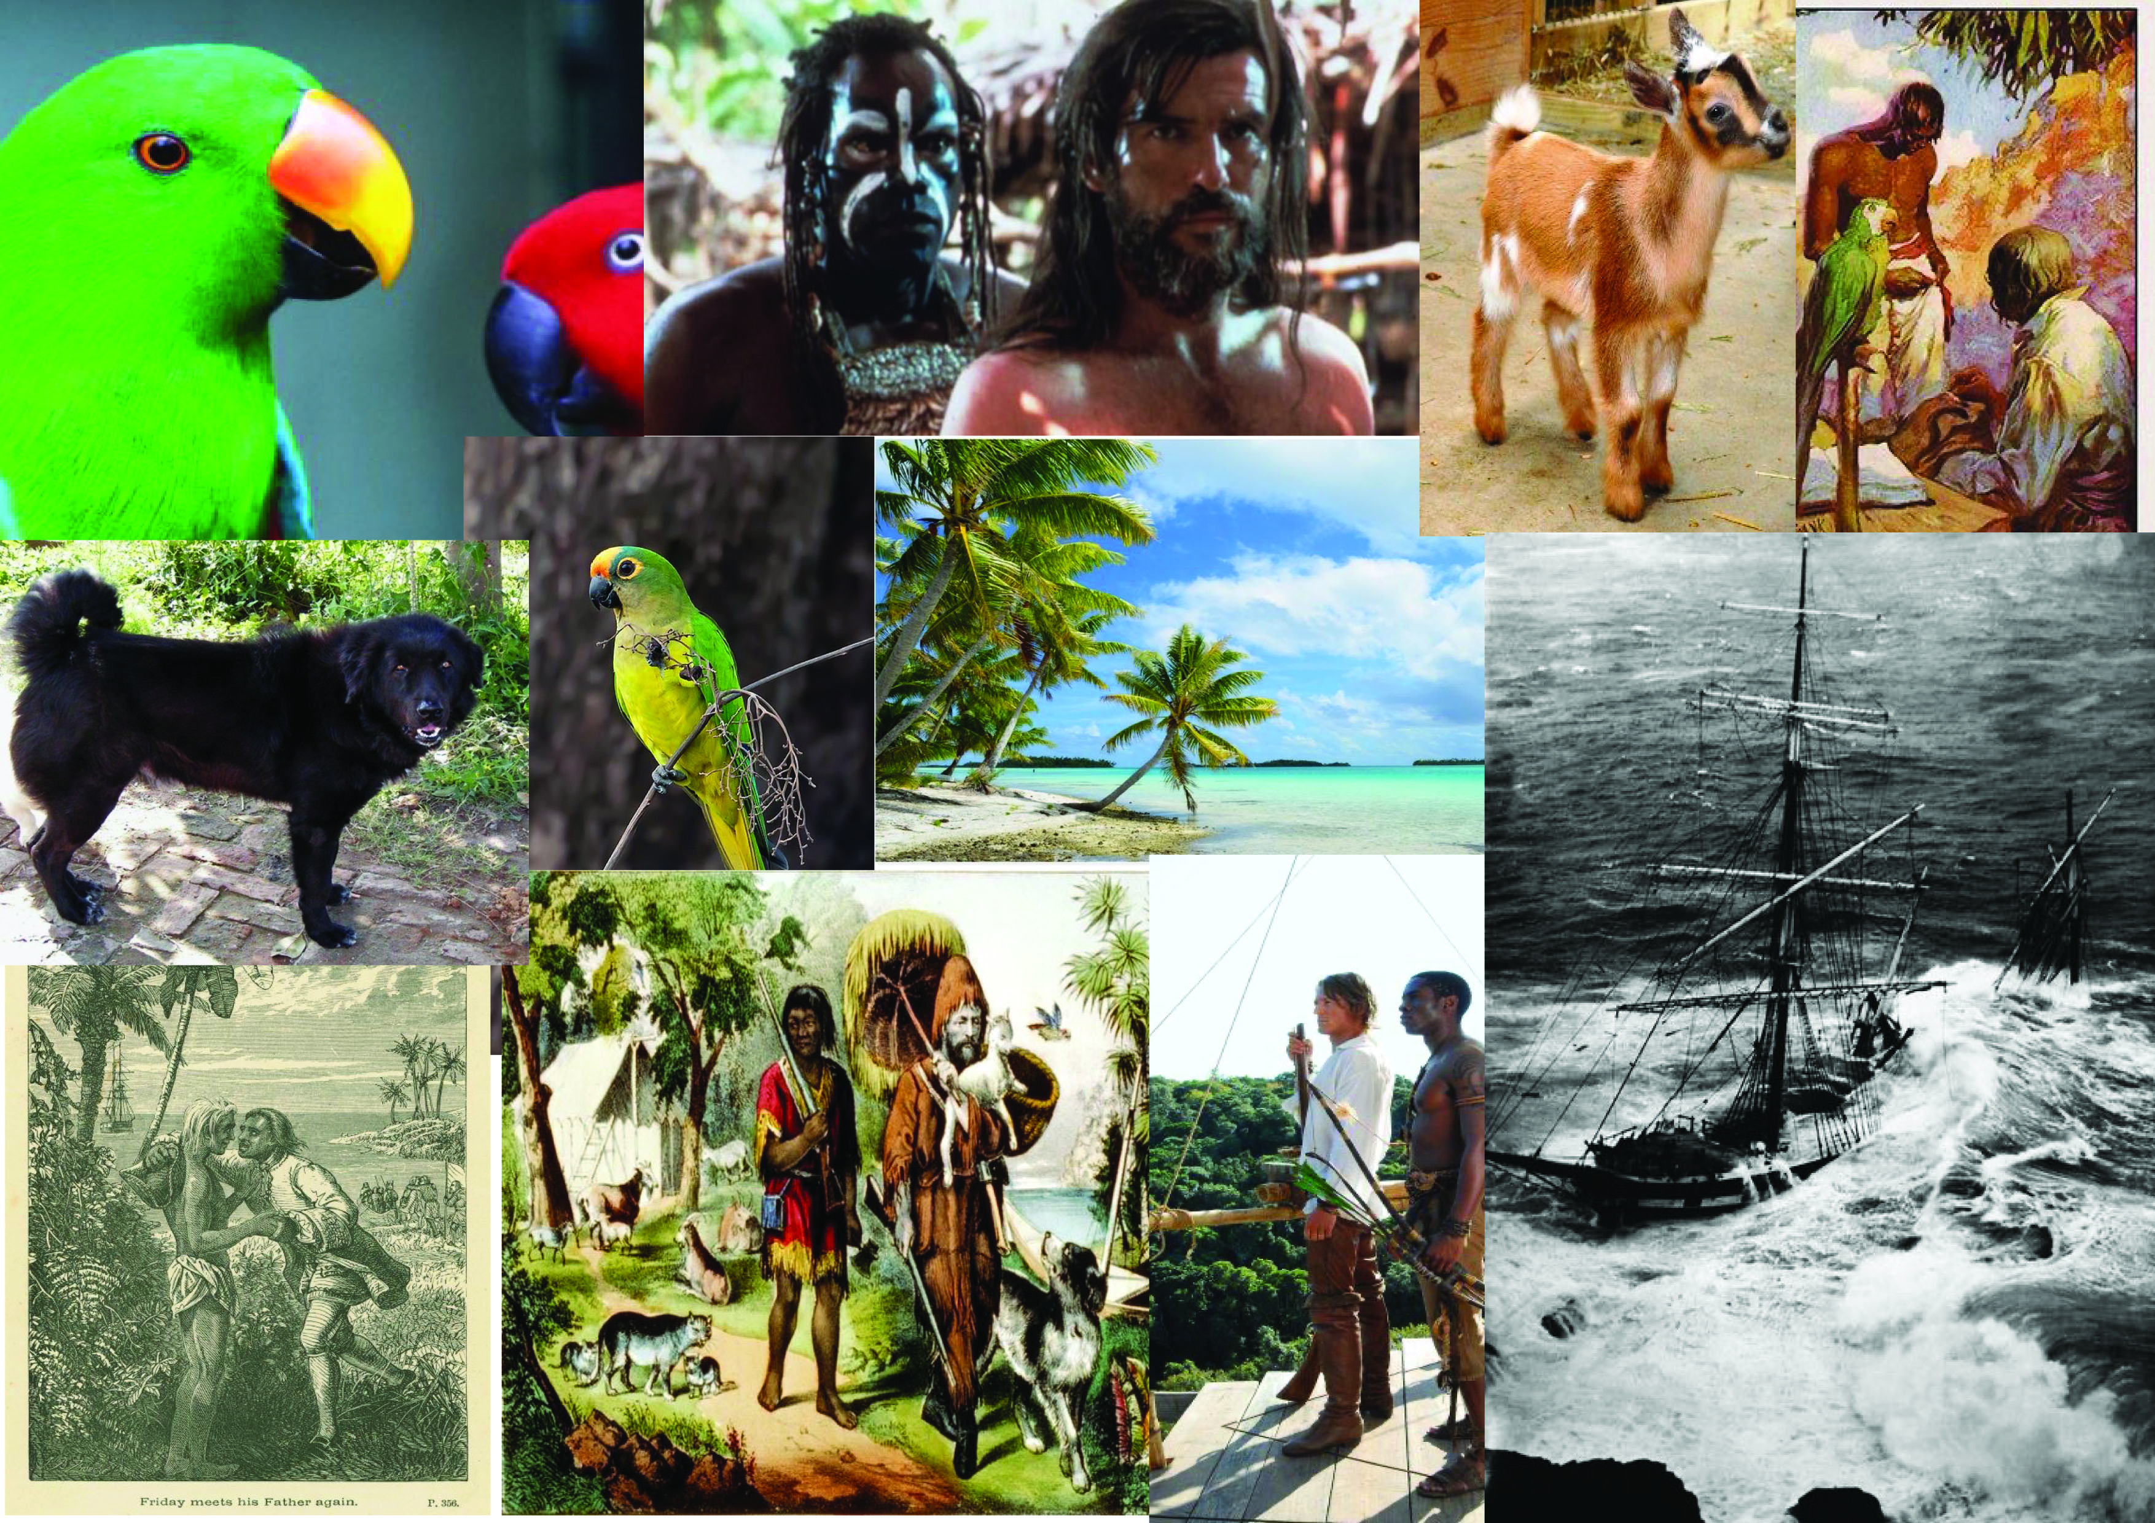

I felt as though this was a good beginning and now I felt as though I knew more about the book and how the design would come about, I wanted to look at old book covers of Robinson Crusoe to get a feel of how they achieved the front cover design and what elements that put in theirs.
I decided to then put the books into another mood board, I like mood boards they really help me to see visually all the different aspects involved, from colour, to fonts, to typography, to placements, to style and beyond.
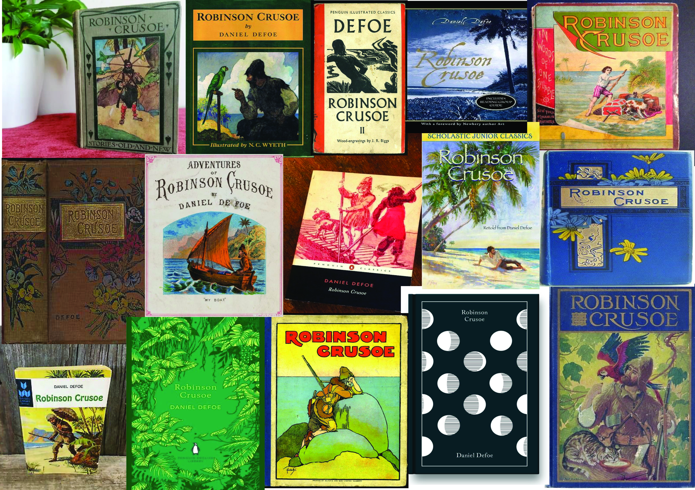

I particularly liked this book from the mood board, for some reason it really captured me, so I then decided to look at book covers that caught my eye, not necessarily of Robinson Crusoe, although I will add some of these in there. So again I created another set of book covers and designs I liked.
The second book below is fun and more aimed at children or teenagers, but I like the use of colour and the detail included. The third book below, I like the use of a limited colour palette and the texture in the illustration, also the feeling of remoteness.
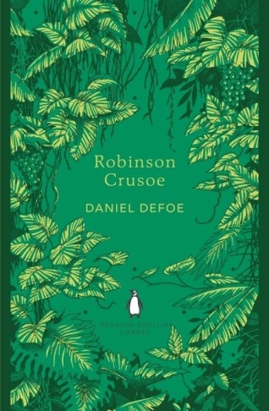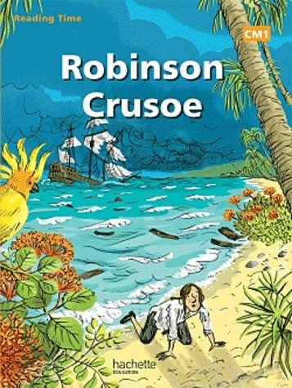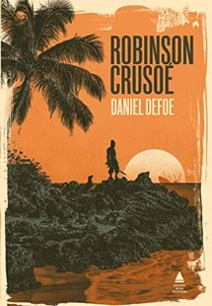

Below are more books I liked, the first one I liked the graphic quality of the cover and the feeling of space. The second book below, I really loved the textures in the sea, which created a rough feeling.
The third book below, I liked the simple design, the feeling of looking from above and the limited colour palette again.
Then the final book below I liked, but I think this would suit the third book we have to design for the survival guide.
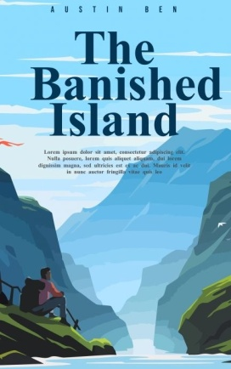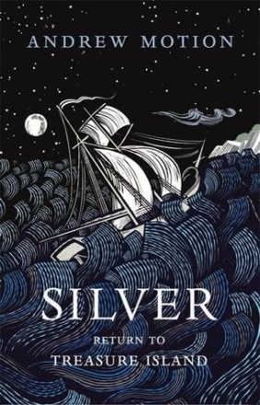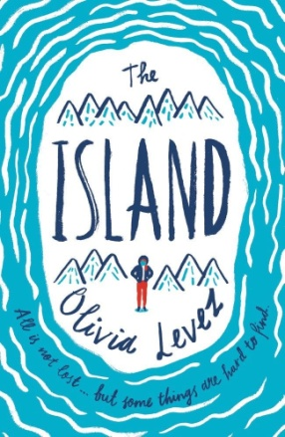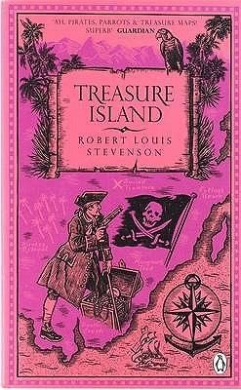
So the next part is to research pocket books, I want to find some ideas for the pocket book, some front covers and ways to plan this out.
I decided to do another mood board for this, I find this the easiest way to look at everything altogether. There wasn’t actually that much out there of pocket book design, unless you where looking for handmade books or more travel books, which I think, will relate a lot more to the third book we need to design.
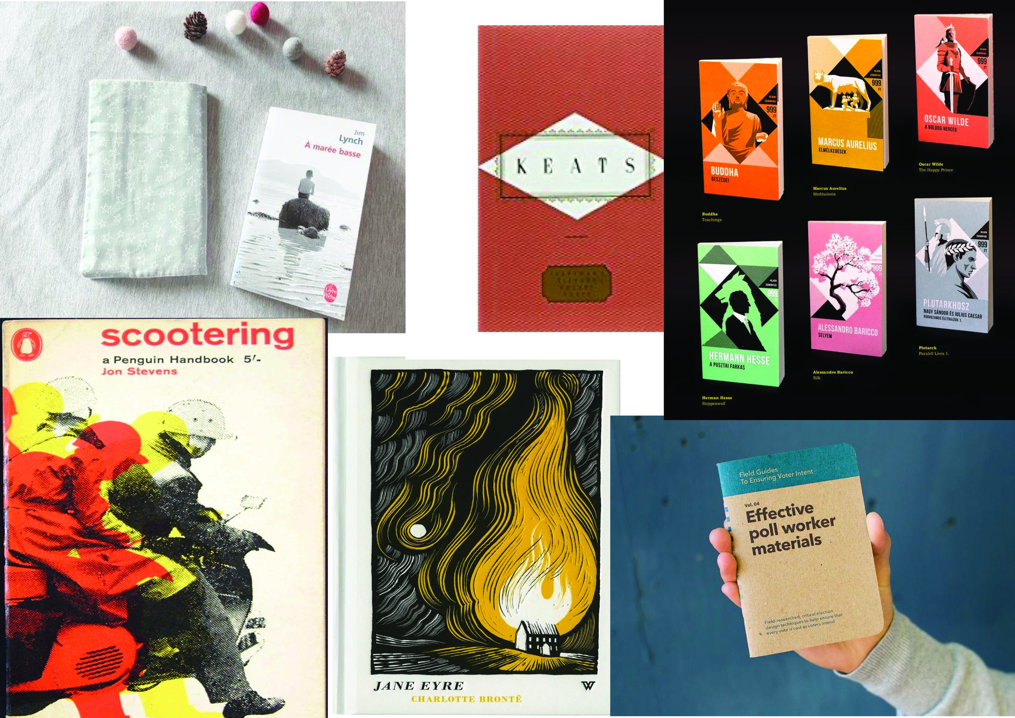

I found that with pocket books are mainly just smaller versions of the bigger books, especially books that are in a series. They are easy to put in your pocket or handbag, easy to hold and handle, usually always paper backed and flexible. The designs seem to be simpler in the cover designs, and more graphic in layout and style, so I guess because they are smaller they need to have a bigger impact, like colour blocking etc.
I then went on to research deluxe books, luxury books that are more expensive or exclusive in their design. Again I compiled a mood board for this.
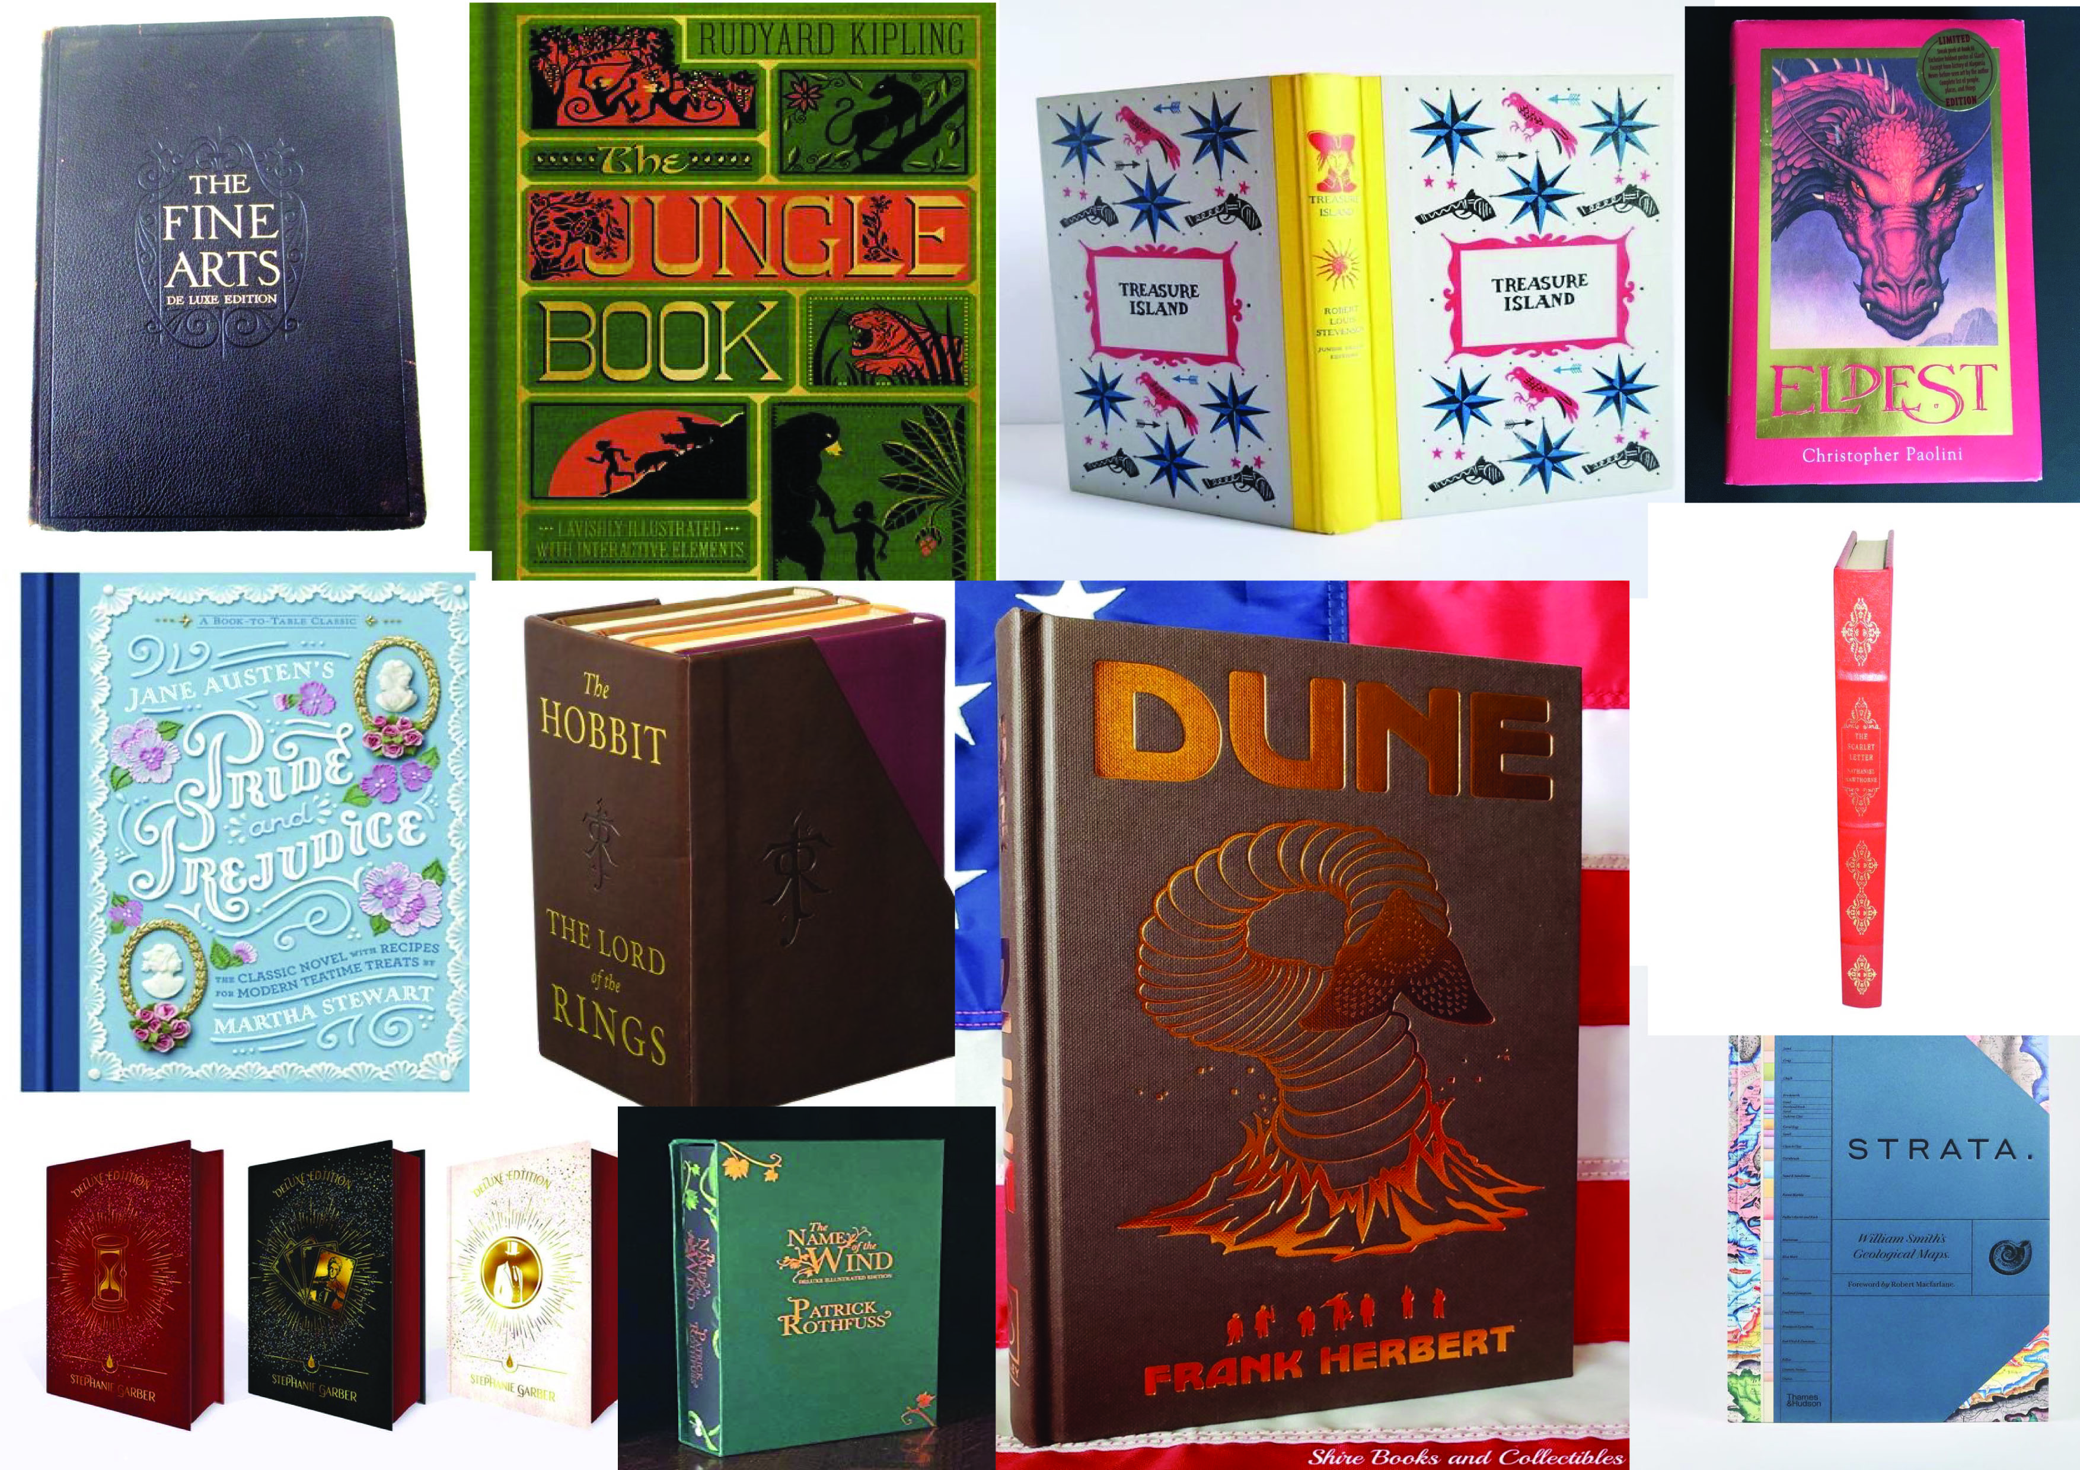

The main things I found out about deluxe books were that they were usually hard backed, had some gold lettering or motif on them, usually had excellent quality paper and covers, sometimes leather, were either very minimalist or very detailed with hand painted illustrations etc, and usually quite thick.
I have lots of information now to get me started on the sketches and thumbnails of the three designs, I will start with the pocket design first and create some rough images and see where it goes from there.
I started with some rough thumbnail sketches, I created nine different designs and I liked three of them, which I have ticked. I then went onto create these three thumbnails that I liked bigger, and with slightly more detail.
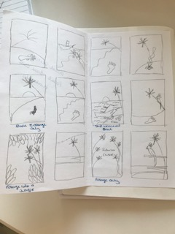

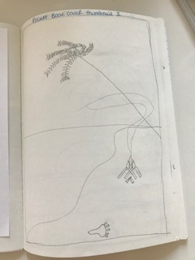
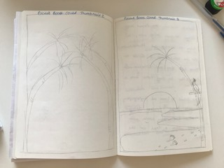
I did the same process with the deluxe book cover, I created nine rough thumbnail sketches, then three better ones from the three that I liked the best and ticked.
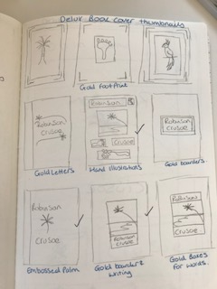

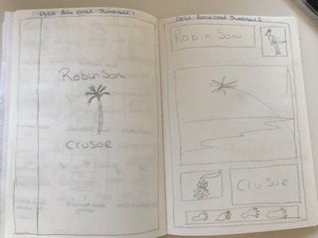

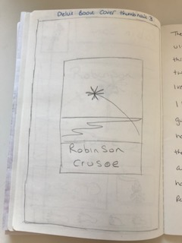

I then wanted to do the same for the ultimate guide book cover, but before I started on the rough thumbnails I had a look at one of my pocket travel books to Dublin, to see what things I needed to add to the cover, that makes it look like a guide.
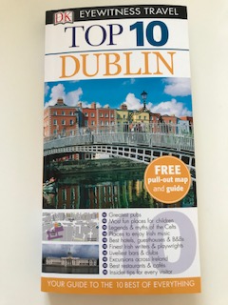
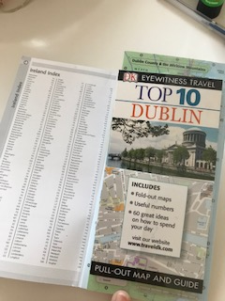

The main things I found were that there was more information on the front cover of the book; the first main thing was that the guide books were usually pocket in size and or small. The second thing was there were usually bullet points on the front of things you could find inside, the third thing was they had tips or maps inside too. The front covers where usually in block formats/ sections and usually had two or three main colours.
So I then went on to sketch the rough thumbnails and then picked three designs out that I liked then created three better larger thumbnails of these designs.
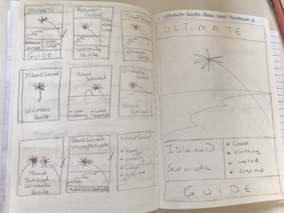

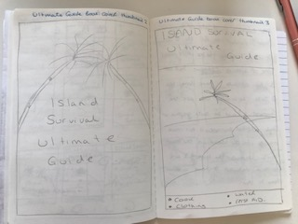

After completing the three sets of thumbnails I decided to pull the three designs of each together, to see if I could come up with a cohesive set of three, so I did rough sketches of the three sets in thumbnails. The middle set are the simplest and would be quite graphic in nature, the top three are a bit more intricate with the island as the main focus. The bottom set is the most detailed and have block colours to them, which unites the set.
I will leave them here at this point and move on to the typography, just in case the type moves my ideas in another direction.
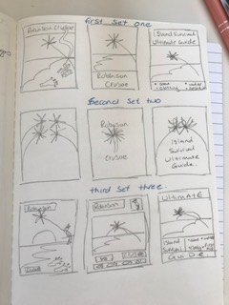

I worked on my computer to find a few sets of fonts that would work well with the island life I wanted to create.
I was searching for a font that would make the words feel like you were on a deserted island, they needed to be a bit rough around the edges, a little bit italic and or as though they felt as though they were from another country, somewhere abroad or exotic, I came up with these ten that I found to be the best.
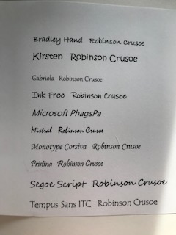

The next part I decided to take on was the art work; I drew some sketches of the motifs I was looking to put into the cover, the main ones were the Parrot, the camp fire, the footprints and a palm tree, these ideas came from the highlighted words in the first part of this assignment and from the spider diagram, I painted these in Gouache paints, and the illustrations are below.
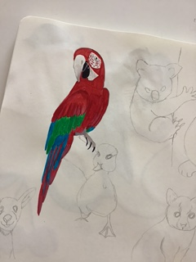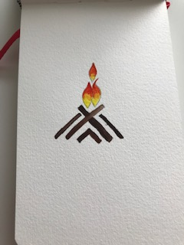

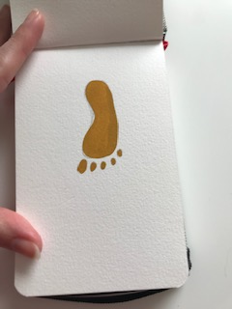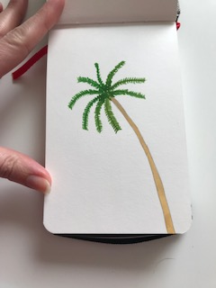

Now after I had painted these I got a new Ipad for my business which I was able to put Procreate onto and use my Apple Pencil with, I thought about how I could make these book covers as a digital piece of art work, the style that I was wanting to achieve, was quite a colour block simple style. So actually this would lend itself to digital drawing well.
I had a play around with Procreate and learnt a few tutorials to get the hang of the basics. I then went on to create this design.
This was the first design in the set of 9 that I whittled down to using for my design, I found this a bit too simple, although I liked the typography and font used.
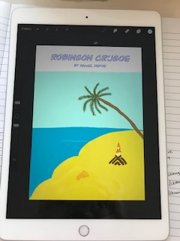

So I then went back to the set of 9 design ideas and decided to make the art work for the bottom three designs, I thought this was a good compromise between the 9 designs, and would work well as digital drawings.

I started with the pocket design and came up with this design, I still need to annotate this design as it’s still not quite right, but it’s a good starting point.
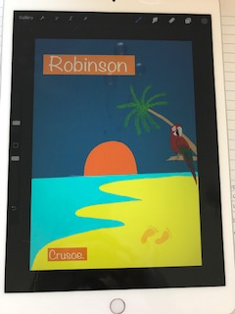
I feel the colours are bolder and more striking which will attract attention and the colour block style is very bold yet simple.
The second book cover I created was the deluxe edition; I took my inspiration from one of the book designs in the mood boards, which has a lot of rectangles which are illustrated.
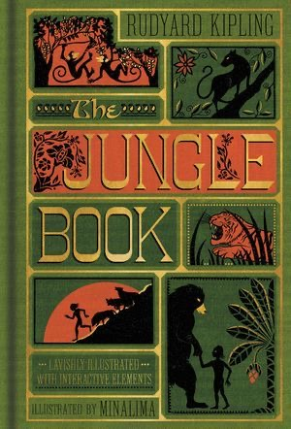
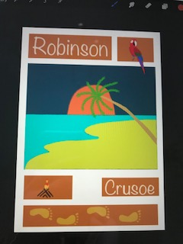
Again it’s only the first piece of art work for this design, so again it will need to be annotated, but I kept most of the details the same, but put them in a different design format.
The third design was for the survival guide, so this is the art work for that. Again a few bits need changing but overall it works well.
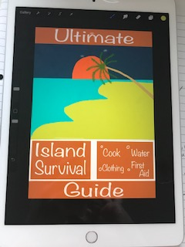

I then went on to pull the three together just to see how they worked together and I could see them next to each other.
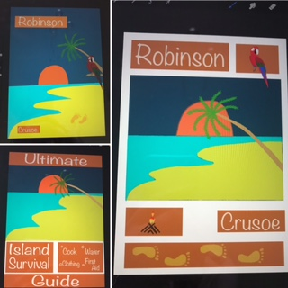

I then went on to add a few small details, so extra shading and depth to the palm tree and the shadows on the sand.
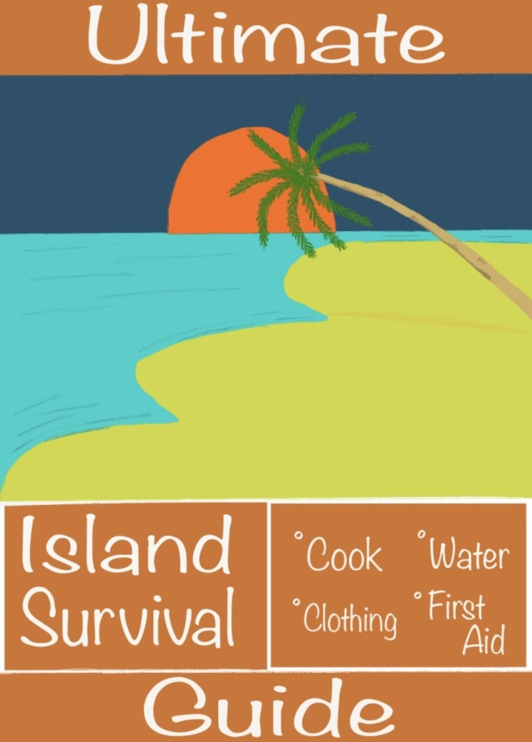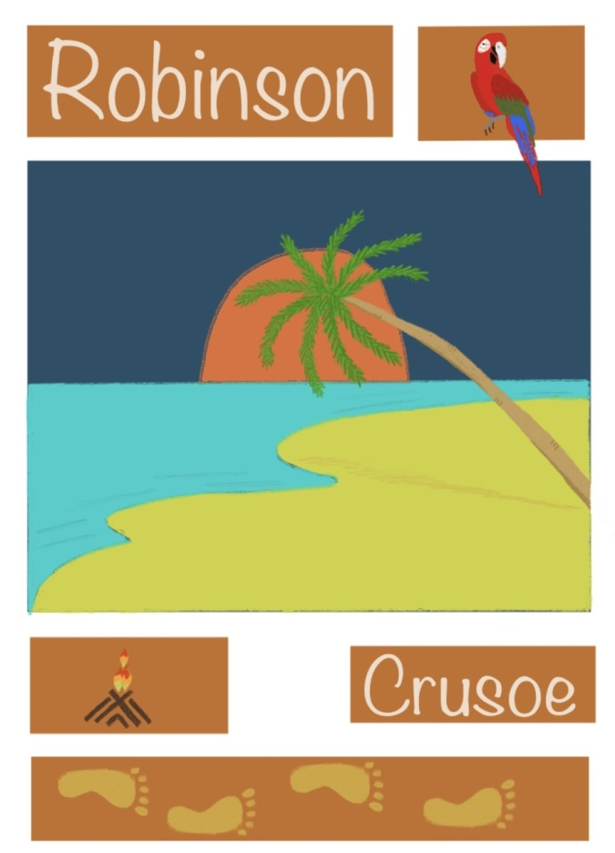
Although these are only slight changes I feel the original look is good, but these small extras give the depth and light that’s needed. I want to change the box sizes on some, or two of the designs, and maybe change the font back to the first design I created.
It’s just trial and error for the next few bits of art work, until I get it just right.
So these are the next versions after two annotations, I have changed the box placements on all three designs, added the authors name on the deluxe cover, and re-arranged the ultimate guide bottom section. I’m rather happy with the two first covers the pocket book and deluxe book, but I’m still not happy with the ultimate guide.
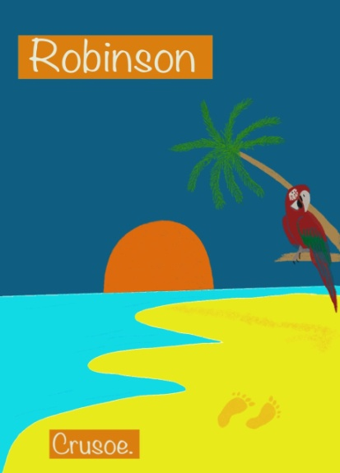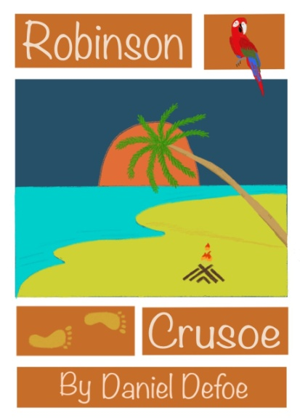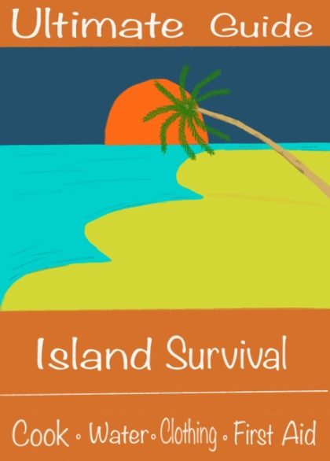
But what I think I’m going to do is, re-search book sizes and find some digital mock ups, then place the designs on these mock up’s, to see if standing back and seeing them as a proper book, I might be able to find out how to change the guide cover to fit better.
I have done the books in a group just to see how they work together, and see if I can see any other changes I want to make!?
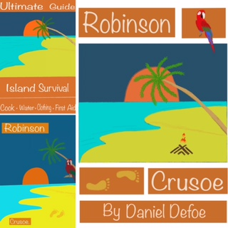

I started to look at book sizes and what the standards are for publishing, I found a reference chart that seemed to be a basic idea and is found on most searches.
For your reference, the standard book sizes in inches are:
- Fiction: 4.25 x 6.87, 5 x 8, 5.25 x 8, 5.5 x 8.5, 6 x 9
- Novella: 5 x 8
- Children’s: 7.5 x 7.5, 7 x 10, 10 x 8
- Textbooks: 6 x 9, 7 x 10, 8.5 x 11
- Non-fiction: 5.5 x 8.5, 6 x 9, 7 x 10"
- Memoir: 5.25 x 8, 5.5 x 8.5
- Photography: Whatever you see fit!

So the standard sizes for fiction seem to be 4.25 – 6.87”, a hard backed is 6 x 9” or 8.5 x 11” in size, and pocket 5.5 x 8.5”.
So I think I’ll go for an A5 hardback size for the deluxe version, an A6 craft version for the Ultimate guide, and a standard paperback size for the pocket version.
I found some free mock up’s of these sizes so hopefully I’ll be able to get the art work onto these for the presentation.

I then went on to print off the artwork I had created digitally, this helped me better to see what I needed to change, I annotated these and wrote on them what I wanted to change, then made a start on this. So on this one I wanted to move the water level up higher, along with the sunset, so I could move the palm tree lower, so it sits in the sunset, like in the other two covers. I wanted to make the foot prints darker, as you can’t see them that well, and also add the author’s name.
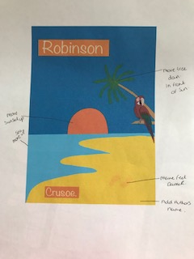
With this design, I added a picture instead of words as I had a better idea if I drew it down, so I will be trying the format out like this instead.
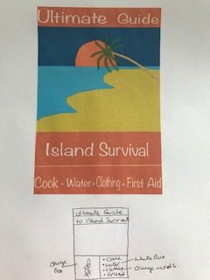
After this I went back onto the IPad to re-look at the annotations and changes that needed to be made.

I then went back over the ‘How To’ guide as the working was wrong when I re-looked at the brief to double check I was fulfilling the entire brief. I added the correct title and the author’s name, and re-arranged the layout slightly to get it to look more like a pocket guide.
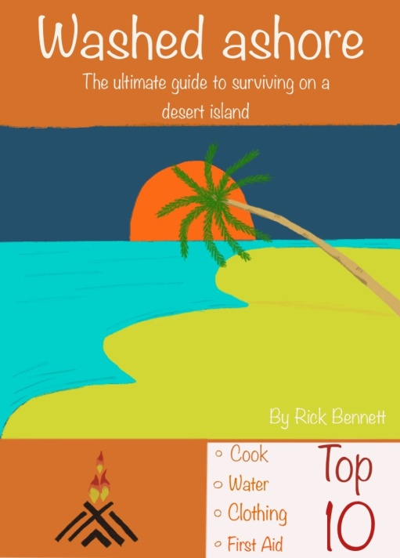
I then went on to re-look at the deluxe cover, I wanted to make the cover look more expensive, so I came up with the idea of adding a leather texture to the art work, which is very subtle but does make it look more deluxe, I’m not sure if you can see it here in this graphic, but I’m hoping when I print it out you will be able to see it.
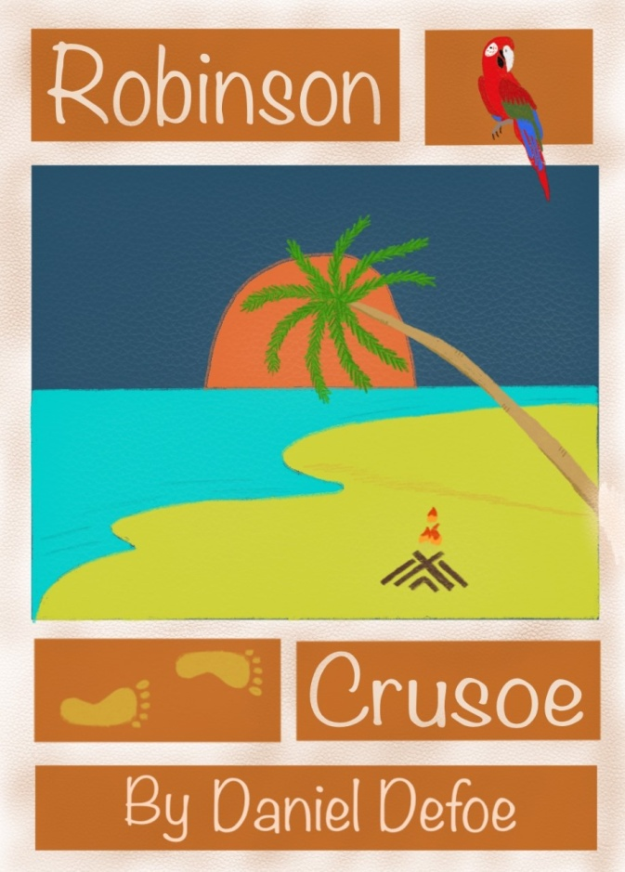
The pocket paperback version hasn’t changed much; here is the artwork for that.
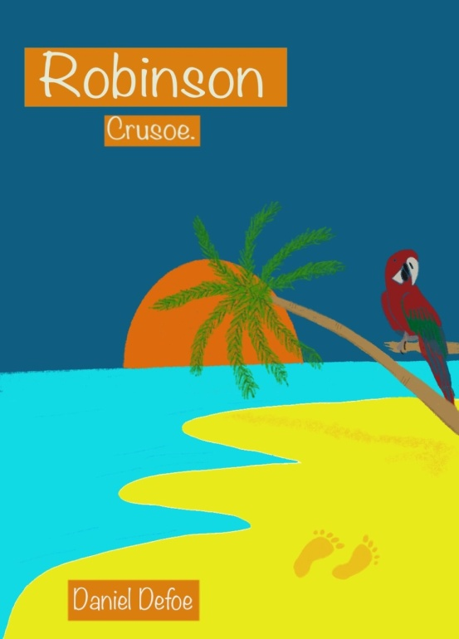

I then started with flatplan sketches of all three books, plus the end papers of the deluxe book. I did this on graph paper as I found this easier, it helped with sizes and how they would be printed out, and in what order, and it helped to remind me of the including the spine, and width’s etc.
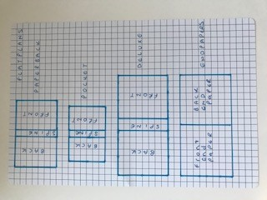
The next step I need to take is to create some mock up’s and see how these turn out, unfortunately I have run into a problem with Photoshop and the mock up’s. So I decided to start on the InDesign work first, and hopefully come back to this stage after, if not I will print off the images and create a physical mock up if I can and photograph.

Then I started to look at putting the art work onto InDesign, I started with thinking about the spine width as this is dependent on the number of pages in the book and the thickness of the paper. I went for a template size of 6 x 9 inches, which is fairly correct for a paperback size of book. I then looked at the template so I could use it in two ways, one to send to a print company, so a spread with all three sections together (the front cover, the spine and the back cover). Then another way to separate the three sections for promotional use.
So my template was 6 x 9 inches
Margins at 0.5 inches
Bleed at 0.125 inches
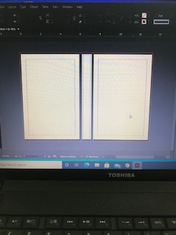

I then started to create the art work for the back and the spines for all three books, which I also did on Procreate to keep the consistency of the colours and art work style.
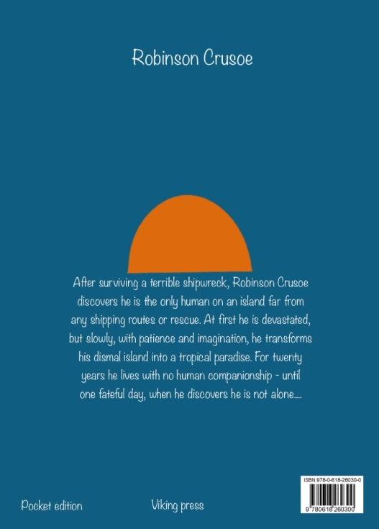
I decided to keep the back and spine quite simple in style, and used one of the motifs to follow on to the back (here it is the sunset). I added a mock up barcode and added the publisher’s name, as well as a short description of the book; the spine just had the books name and the authors.
With book 2 the Delux edition, it was slightly harder to create the deluxe feel in a mock up! I used the same technique as before and used a leather texture to put over the art work to make it look more expensive. I would have liked to have embossed the lettering, but I couldn’t find out how to do this on the art work to make it look like that. So I used a different effect on the same typography to show a slightly higher end feel.
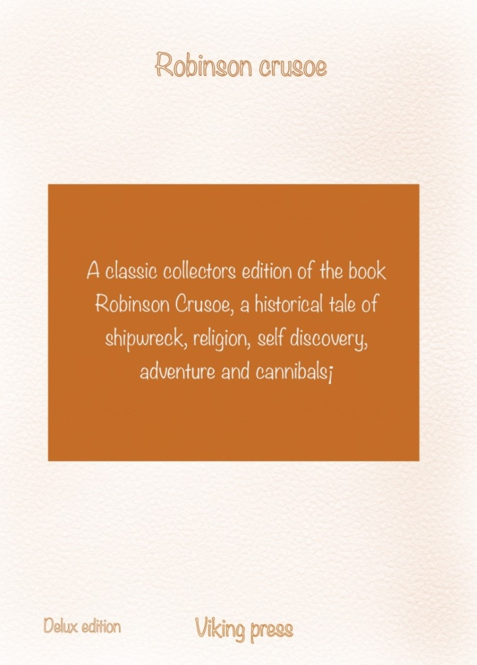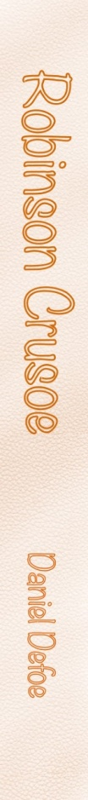

The pocket guide: I used a similar style as book 1, but picked different colours and a motif to link the three book designs. The main difference you will see of the first two books to the pocket guide would be the paper and size of the book. I want to have the pocket guide in a recycled paper, with a texture, and it will be small enough to fit in your pocket.
The paperback and deluxe guides are both smooth papers!
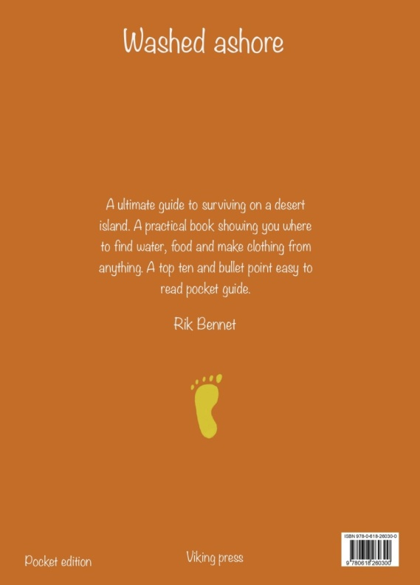

The next stage was to put all the art work pieces onto the InDesign template, hopefully to then print them off and create physical mock ups with them. I started with book one the paperback design, this was mainly blue in colour with white typography, I used the Noteworthy Font which I feel has an old parchment feel to it.
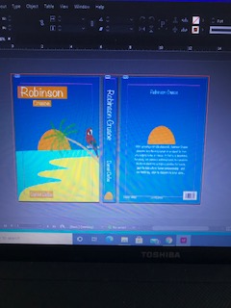
This was the deluxe edition, the book would be covered in a leather or imitation leather, with embossed lettering, although this looks fairly bright, I still think it works well as a deluxe edition. The typography was still the Noteworthy font.
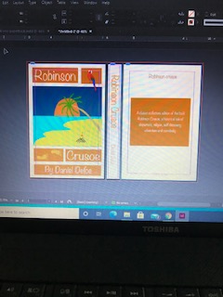

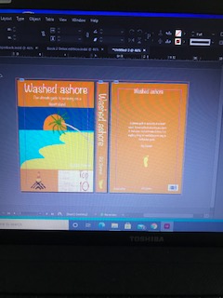

The pocket guide is in the orange colour from the set of colours I chose for these books, I think using a restricted colour palette helps to make all three feel joined, and as part of a family.

I changed the size of the books in InDesign, as I found these to be too large when I printed them out, so I changed them back down to 5” x 7.5”, this seemed to be more the size of a paperback.
I then went onto look at and research the papers and covers of the book, the layout on all three books would be similar, but just different sizes and materials used.
For the paperback (pocket edition) I would use a 300gsm paper with a gloss finish/ lamination, to give the book some durability whilst being handled a lot. The pages would be 100gsm; this would keep the thickness down, without compromising quality, and would also cost less. The book would be glued using cost effective glue, as the print run would be large on the paperback.
For the Hardback (Deluxe) edition the board (Binders board) would be covered in a leather look material (buckram) I have researched that buckram can be embossed, so this is what I would choose to do, to get the effect I wanted. This will cost more, but I have chosen not to include a dust jacket or box for the deluxe book to go in, so this is where I would save the costs. The end papers would be 150gsm bond paper and would be matt, this would look and feel better than a satin or gloss finish, which is not really used for these papers. I would add a white satin ribbon to be case bound into the cover, and the pages inside would be printed on 140gsm paper.

For the How to Guide (pocket) edition I would use a 240gsm gloss coated paper for the front cover, as I want it flexible enough to keep in a pocket, and hard wearing with durability, for taking out and about with you. The pages would be 80gsm recycled bond paper, so thinner than the paperback, so the size and thickness is less and reduces the book size down. I want a pocket in the inside back cover, to keep notes or bits you find on your journey. The centre of the book would have a fold out map, that can be taken completely out and put in the pocket at the back if you wanted too, this would be in the same 80gsm paper as the books pages, so it folds easily and isn’t bulky.

The end paper design for the deluxe book I based on the foot print motif and just repeated this pattern across the page. I used Illustrator to create a technical repeat pattern for this, and then added this to the books image.
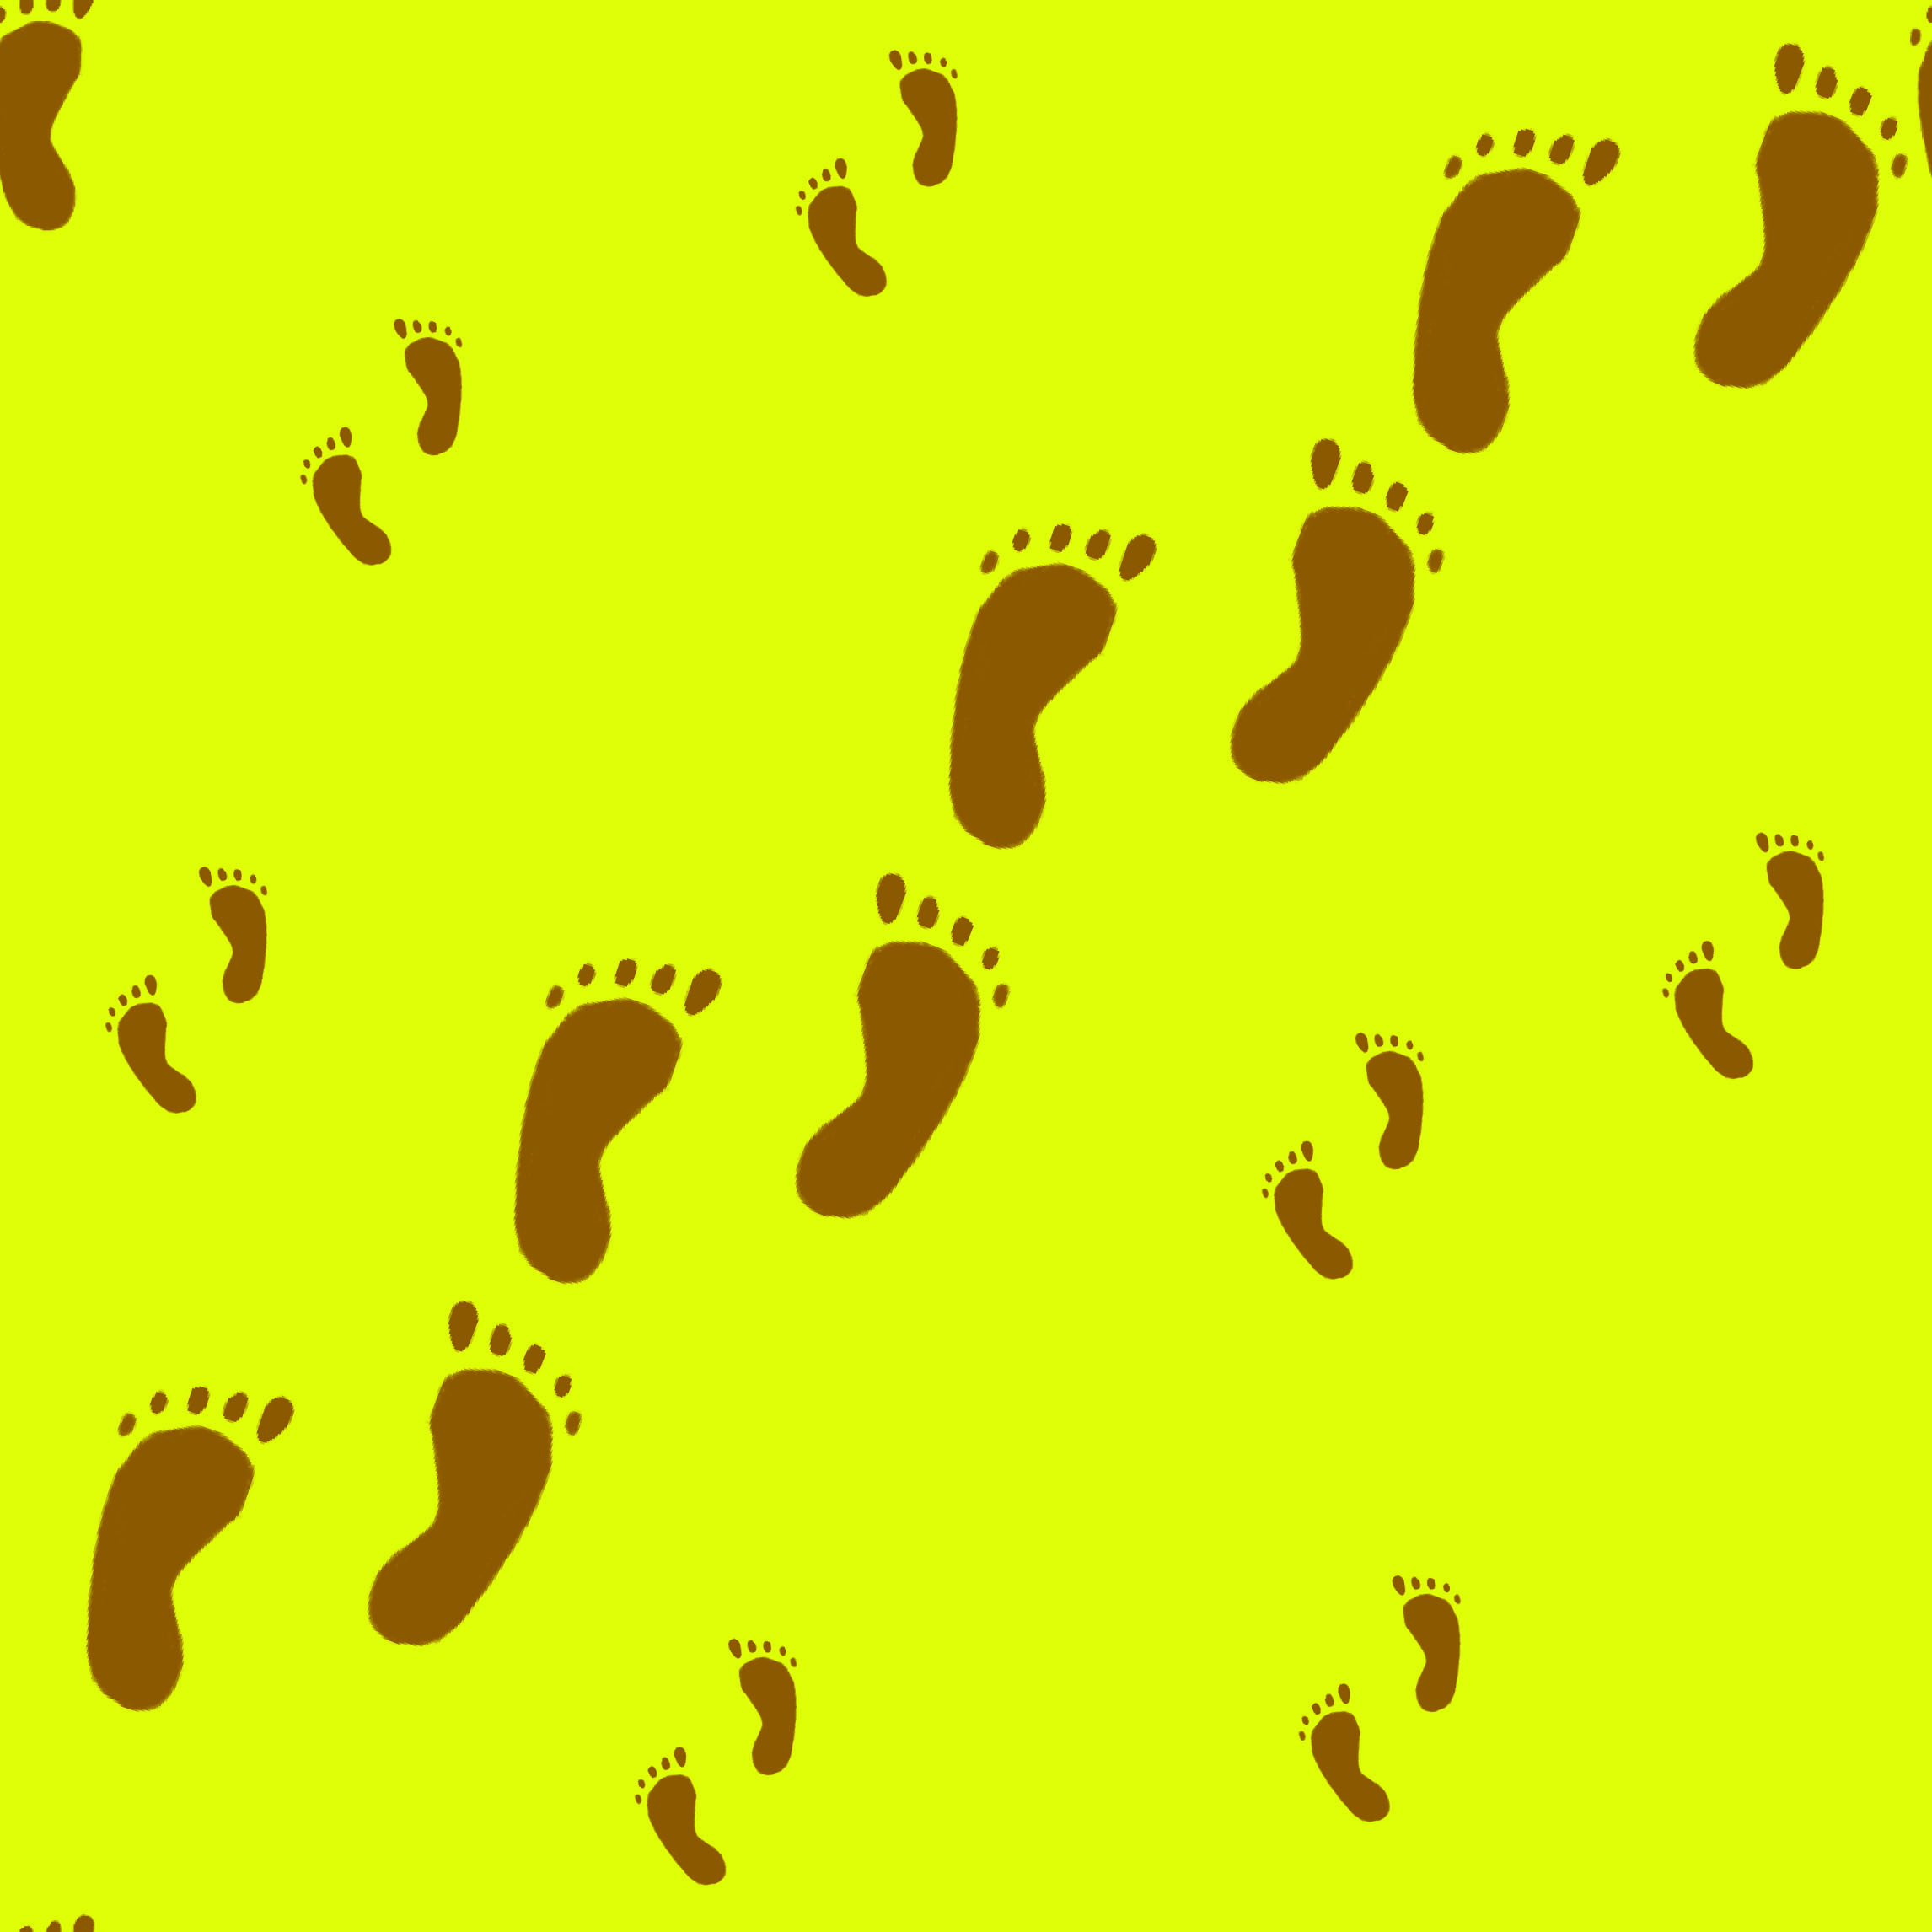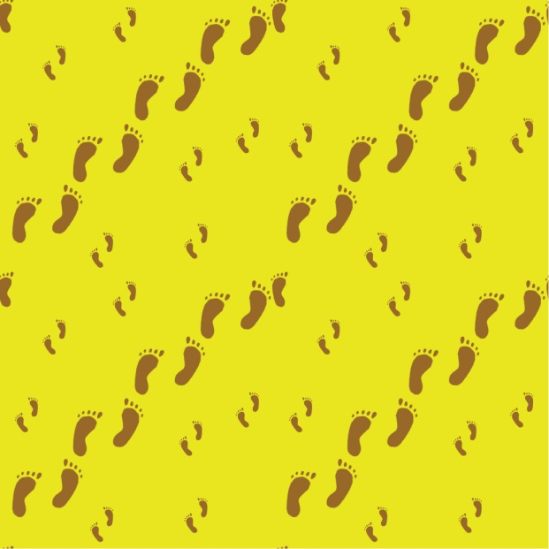

I had trouble again with Photoshop and creating the mock up’s, every time I opened a mock up the software would crash, so it’s something I need to look into and contact someone that can help me for the future. So in the meantime I created some physical mock ups and took photographs of these.
Obviously these are not exactly how the books would be, as this does not show the correct paper and finish, but it gives you an idea of how it will look once finished.
So this is the paperback edition:-
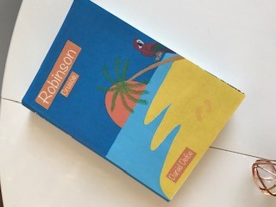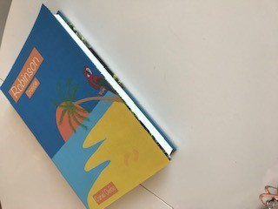

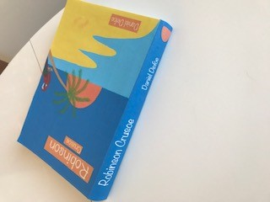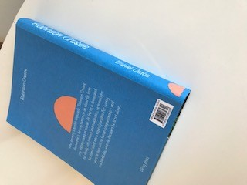

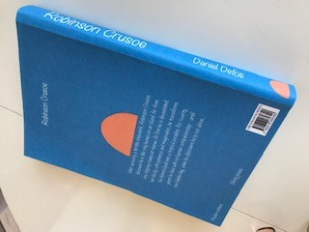

This is the deluxe edition:-
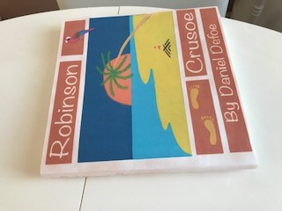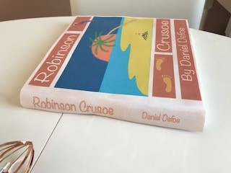

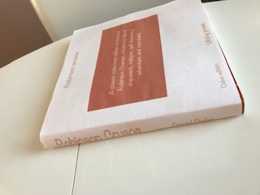
Plus the end paper designs;-
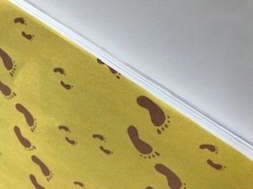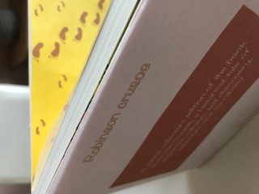

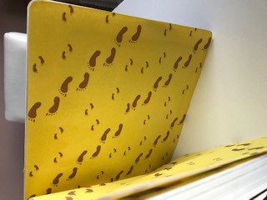

This is the How to guide (pocket edition):-
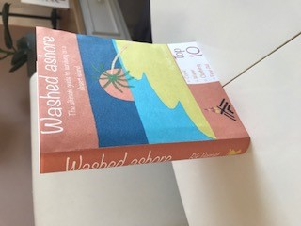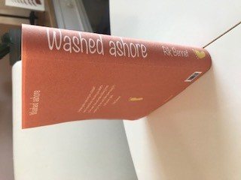

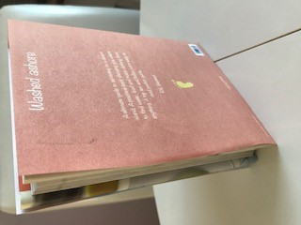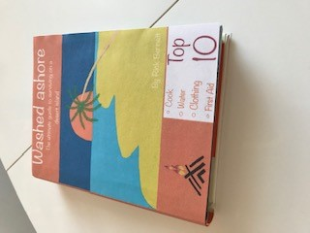

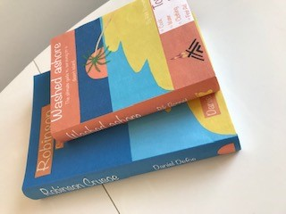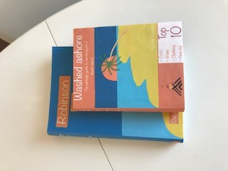

Then all three books together:-
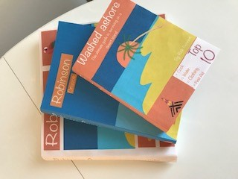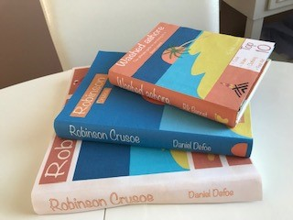

So now I am finished, looking back through my assignment work I am pleased with how the books have turned out, I feel they are a family and sit well together. I feel as though the ‘how to’ guide is different enough to differentiate it against the other two books, because of the size, the style and the materials used, yet it sits together because of the colours used.
I feel as though my creative process is a full one, I made a chart when I was doing Illustration 1 of all the steps to take whilst completing a brief, and I have used that for this assignment too. I used my sketchbook more to complete thumbnails and created more of them, to come up with many ideas, which helped narrow down a design, to then work across all three books. I want to create a similar step by step check list for this unit, so I have a process to use when creating book designs, I will add these steps each time I finish an assignment, and will show the guide at the end of the course.
I am now getting to know more about InDesign, which is helping with this unit, I have watched many tutorials and You Tube videos to help me with this, but I am gaining confidence.
This was the first time I have used digital drawing for my degree work, I always use traditional drawing and painting in my previous units, so this was really new for me, and out of my comfort zone. I was pleased how well I got on with the IPad and Procreate, and designing and drawing the book covers, back and spines in the software.
I have read more of Andrew Haslam’s Book Design book and have researched more about flat plans; I am creating a separate section on my blog for my own creative research, Typefaces and sketchbook work, where I have added these points for the end of this unit and assessment.
I made sure I researched a lot more areas in this assignment and wrote down every step that I took; hopefully this is more organised and easier to read.
I feel as though this assignment was arranged more systematically and has more of a step by step approach to it, I definitely feel as though I am getting into more of a rhythm with the way this unit works, and hopefully after each assignment this gets better, and comes together by the end and ready for assessment.

