Book Terminology
I found some book terminology and a graphic example of where the parts were on the book. There seems to be some differences in the terminology of some parts, as I found a few different image examples with different headings.
Board
Case cloth or case side
Joint
Case liner
Headband
Liner
Super
End papers
Shoulders
Signature
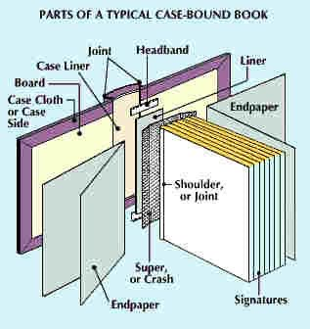
Ferdinando.org.uk
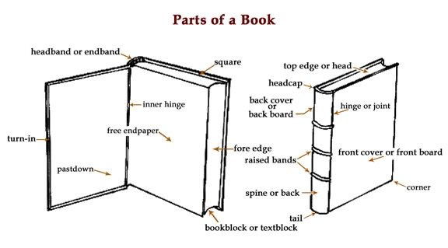
Cardinal of London
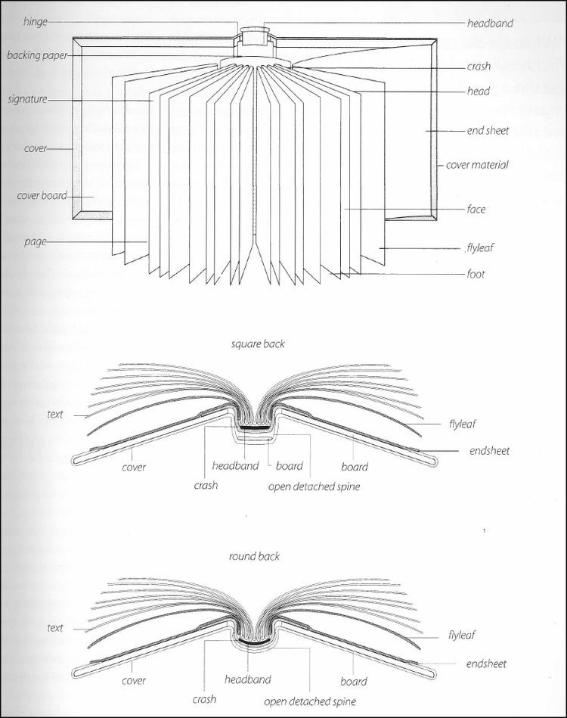
Tania Cunha
The board could be made thicker or thinner depending on whether the book is a hard or soft backed book.
The case cloth or case side is where the decoration or illustrations are put; sometimes this is just a plain fabric or board ready for a jacket that will go over the top. You can obviously change this depending on what type of book you are going for, the more expensive book could have a lovely cloth, then a jacket on top. The more inexpensive book would have the book design and cover printed onto this case then just stuck onto the boards of the book.
The joint needs to be ridged yet flexible so the pages can move, you could decorate this area to be really decorative for elaborate book, or simple for the more economic books.
This is where the majority of the strain will occur, so it needs to be solid and made well for all books. This could also show whether the book is made well or not by how this joint section stands up to the wear and tear.
The case liner is the board behind the case cloth and with the joints, so this needs to be strong as I said before its where most of the strain will be, it needs to be flush and flat too. Again the more expensive the book, the thicker or better quality this might be! Although sometimes even the inexpensive books might spend more money on these parts rather than others to achieve the strength needed.
The headband is a small piece of board or cloth that sticks to the case liner and the liner, there is one at the top edge of the book and also at the bottom edge which is called the tail band, these used to be made from small pieces of vellum, catgut, or cord wrapped or braided with silk, although now they are just made from ribbon.
The liner is a strip of paper, cloth or thin board which is attached to the headband and the crash; this is to keep the pages flat, secure and strong. Again all these elements are dependent on the budget of the book, and how well made the book will be.
The crash or super is a small sheet of webbing or support that connects to the liner and the pages to keep everything together, flat and secure. This also adds the flexibility to the pages and the books spine, so this needs to be good quality as this is how the book functions.
End papers these are the plain or decorative pages just inside the front or back cover, I love these pages and think they really contribute to the feel of the book and what you can expect. I think with more expensive or luxury books you can really push these pages to boundaries, so you could have flocked fabric, a linen fabric, or a flocked paper, hand illustrated papers etc. If you want to keep it clean and simple you can then just choose a colour that would sit well with the books design.
Shoulders or joints are where the pages are kept together, these need to be super strong and sticky or thick to keep the pages together and have that crisps strong edge that fixes into the books crash section.
The last things are the signatures, which are the amount of pages wrapped in one page of a book, there are many signatures in a book, and all the amounts should be the same and equal. You can also find that the very ends of these pages can now sometimes be gold, which gives off a really expensive luxury feeling; it makes the book special and rich. It’s also good to have really crisp edges to these and also to be cut well and precisely.

