Visualising, Editing and critiquing
I started this exercise off by looking through what I had already done for this project so far, I went back over my sketch book and all the work I had written, so I knew where I needed to go further with it.
I then spent 2 and ½ hours doing a tutorial on ‘In Design’ so I could understand more about it, and how printing off a Zine would work. I have printed off greetings cards as templates before for my business, so working on two pages on one sheet is similar to this, so I think I will be ok with that.
I am hoping to create my Zine on In Design and print it off myself. I worked on stitching books together on my Sketchbook unit, so again I think I will be ok with this.
I am intending to work on an A4 format and printing two pages off at once, in a flat portrait style, so the zine is A5 once folded. I have recently bought a guillotine and a scoring board for my business, so these will come in handy for this Zine too.
I started by looking at some Typography and font designs for my first page, which will say HI.
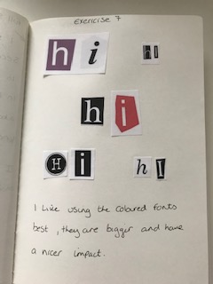
I want to find a few colours that will run through the Zine which will work cohesively together. I have decided to use the more colourful font designs, as this is more of how I work, all of my work is very colourful and colour is what represents me.
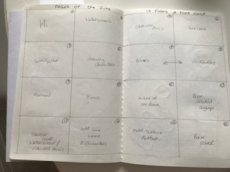
Now looking at the page layout I drew out roughly, if I’m working on the first page I will also need to print off the back page also on the same sheet of A4, so it folds into A5.
The back page is something I’m struggling with so far, how to end the zine!?
I went back and researched back covers of Zines, and this is what I found.
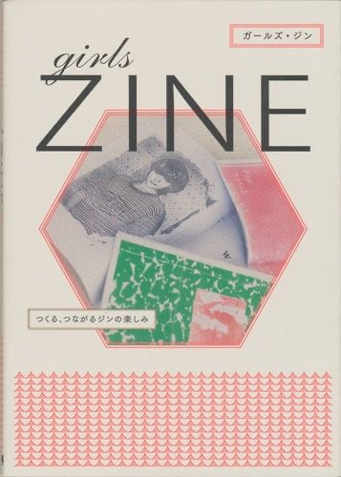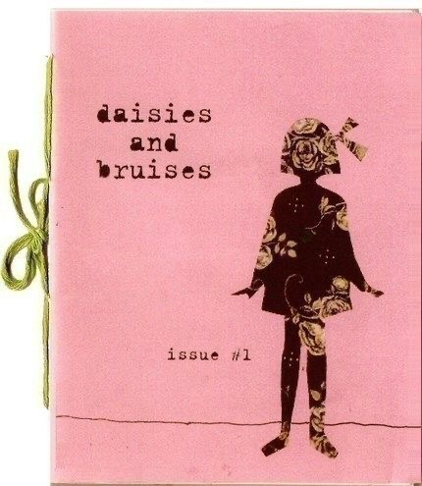

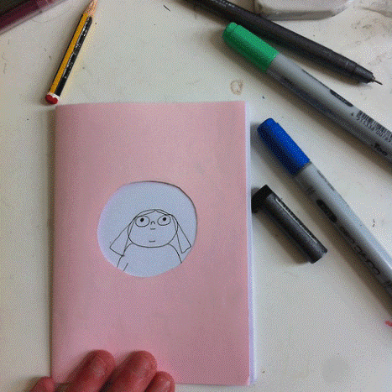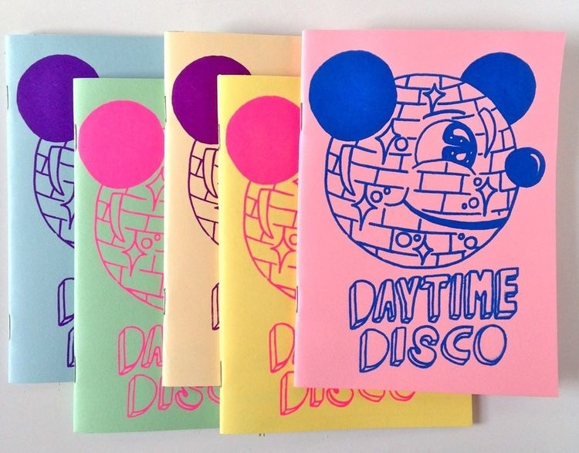

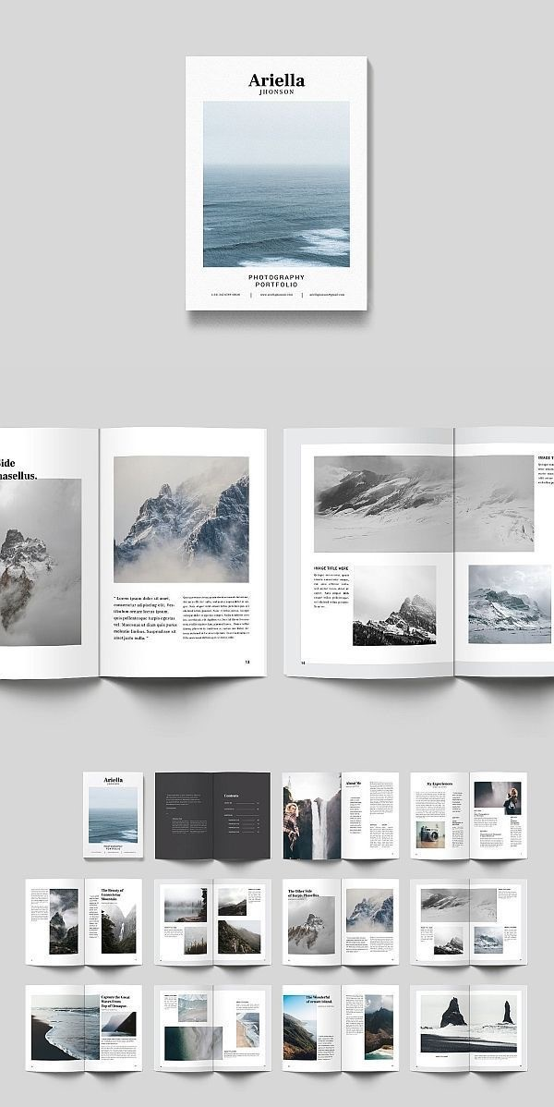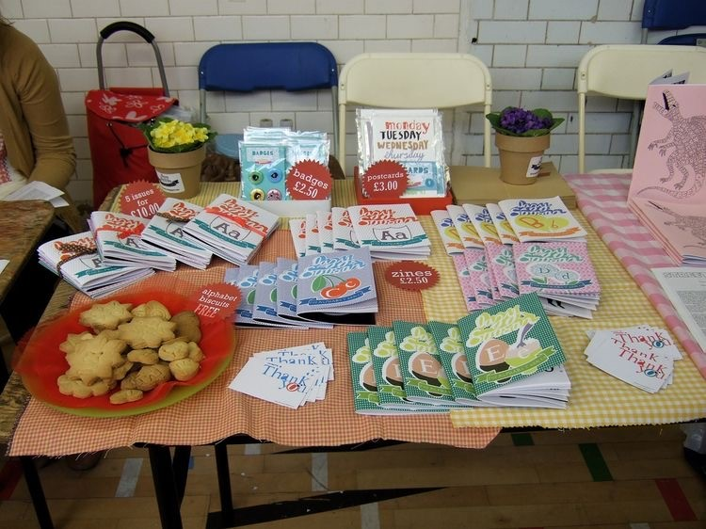
So I couldn’t exactly find anything to do with back covers, most of the work that I have seen is where the front cover just travels around the back, so it just extends along. So I think this is how I will work mine, I thought I would just add more nature details around the back. Maybe a small description of the Zine too.
I then found that most Zines are in one colour for the front and back cover, with some simple illustrations on. So most of the backs are actually plain, so this is something to think about when finally putting together.
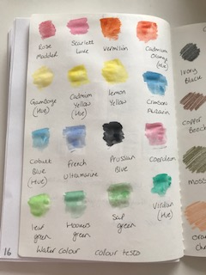

I then went on to try out some more with watercolours, I want lots of textures in my front cover, and mark making and watercolours is a big part of my creative process, and my chosen medium of choice, so I want to do a page of this in my Zine. Looking again at my layout design, page two will be printed with page 15 which is adding Surface pattern designs to my Characters.

The next set of pages are page 3 and page 14, so page 3 is using coloured pencils in my creative process and page 14 is adding line work and characters to my Illustrations.
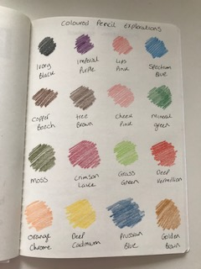
Pages 4,5,6,7 and 8 are to add in line work, surface pattern designs, characters, my books and my illustrations into the pages, so I have a good idea in my head of how these will look.
I have some examples of my work that I can add into these pages, I can scale them up and down to add more interest and variation so it looks more dynamic.
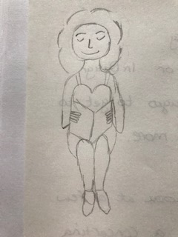
I went back over my lady character for the book, and I changed the proportions of her top half so it matched the bottom half, so this is a better sketch of how I want her to be, for the front cover.
I’m going to go back over the Frannerd section that I wrote about to condense it down a bit and take out and edit what I would like in my Zine. This will be page 9 in the Zine.
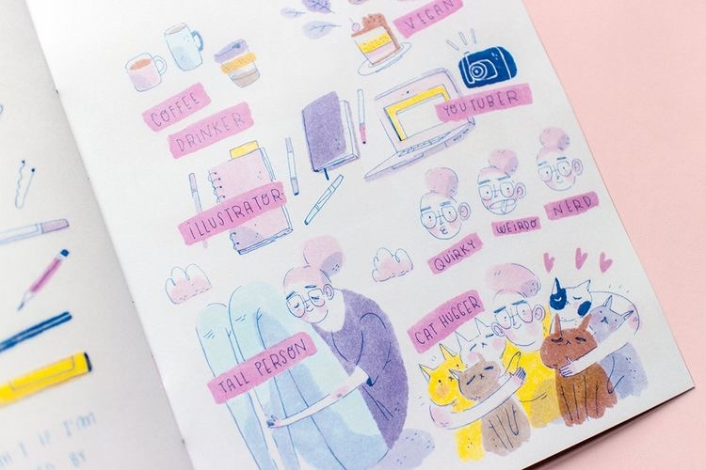
Frannerd has inspired me with Illustrating and creating things yourself, small zines are a great way to get your illustrating out there, and to say things that are close to your heart, or things you just want to express.
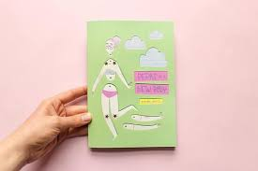
I really like the idea of creating a small Zine all about myself and how I work, I think this will show my process to others and help them understand better. It will help to develop my illustrating, and pull everything together that I have learnt so far with my degree. I think printing it myself If I can, will be a great way to showcase my other ideas and areas for exploration, like In Design, book creation, plans and layouts, stitching and binding and also creating a finished Zine.
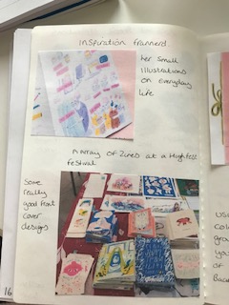

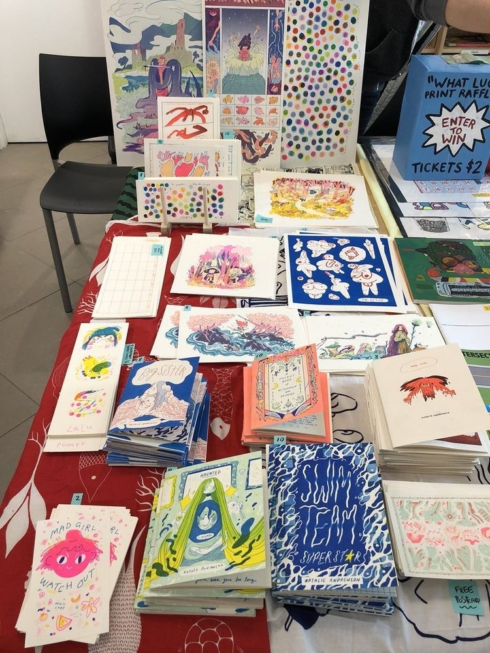
So These other pictures have given me more ideas about my Zine, I noticed on the ones above, that they have the makers name on the front in a white box, the Illustrations are quite busy on the front, so this helps differentiate the name from the art work, which I thought was a good idea.
Since starting this unit my idea of book design has not changed as much yet, but I did do quite a lot of research beforehand. So I knew roughly what you could design and how to design some of them. I know that now I am actually creating a Zine, there is more that you have to think about, and get your head around first. Thinking what pages need to be printed with others, and will you print on the backs of these pages too, and what way up will the print out be!
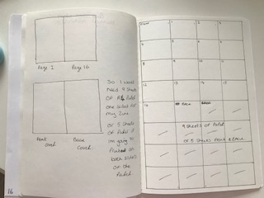
The way I intend to build the Zine up is by adding something on each page, so by the end of the Zine the page is full. I want to use a limited colour palette to be cohesive and also have the same type/ font running through.
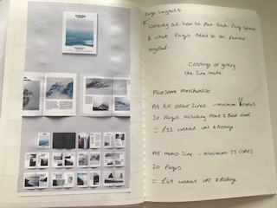
I researched prices for the Zine, and found the cheapest was Awesome Merch where you could get a minimum of 25 copies, with 20 pages of 1 design, for £51 without VAT and postage.
But I have decided to still print my own as I don’t need that many Zines, and it is quite expense for a project.
I am either planning to stitch Zine myself, down the centre, or I will use staples, but I will put these in myself with a hammer. It depends on what paper or card I use and how thick the Zine becomes at the end.
I have 3 different paper/ card types that I could use for this Zine, The first being some 210gsm white card, which is not too thick, yet has some strength to it.
Then I have some 300gsm thicker card, but I think this might just be best for the front and back covers, to give it some body and differentiate from the pages.
I am thinking of printing 5 copies, 1 for my Degree work, 1 for me to keep and three spare for anybody else that might like one. I can always save the file and print more off if needed.
Since working out the pages for the zine in this editing section, I have found that the front and back page will need to be printed together on one sheet, and then page 1 will be printed with page 16. I would need 9 sheets of A4 paper if I print on one side. If I print on both sides of the page I would need only 5 pages. So this is something I need to think about, and also how the printer will print the other side, will I have to put the page back through the printers upside down or back to front.
So these are the things I need to explore further for the Assignment.
Overall there have been a few things that I have had to change for the Zine, mostly adding more bits into it, rather than taking bits out. I have managed to work out how many pages I will need and what pages will be printed together, and that I will be using In Design and my other resources to print this off myself.
I have a Epson Eco tank printer, so I know the ink will be ok to print these Zines and should be fairly cheap to make and process.

