Folding and mocking up your book
So I started this exercise by reading through what needed to be done, then I started mocking up the first small mock up design.
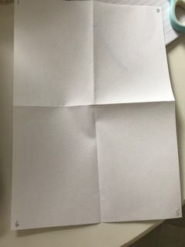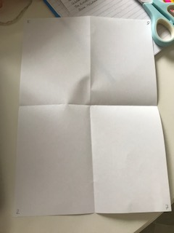

I numbered the pages and here you can see how they worked out after and looking back on how the pages lay out.
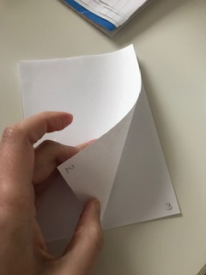
I then cut through the folds and this is how the pages worked. I then put this in a envelope to keep in my sketchbook.

I then started the next full size mock up and folded the four sheets of paper in half, I numbered them and then stitched down the middle to secure the pages.
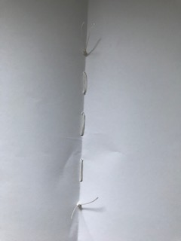

I then went on to have a look on In Design, I finally managed to get it on my computer, so this was the first time I had seen it.
I had a play around and tried a few bits out, just to get the hang of the layout and things. I did one of the tutorials as well, so that helped.

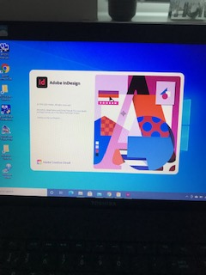

I went on to have a look at other designs, like a concertina booklet / Zine layout. I found some ideas on Pintrest and have showed them below.
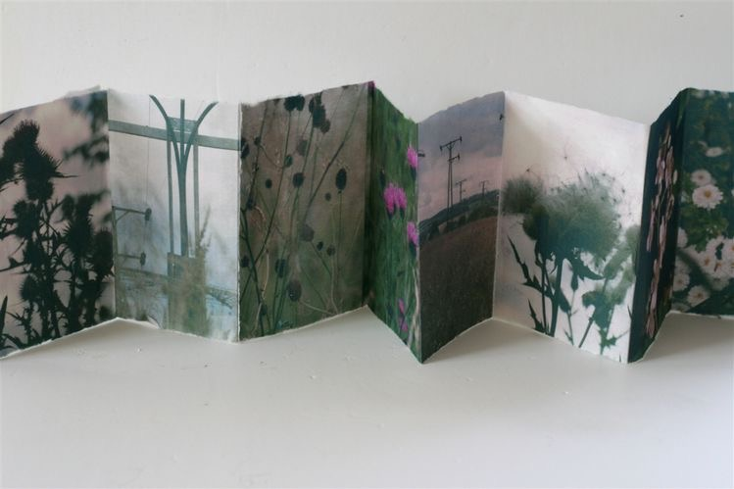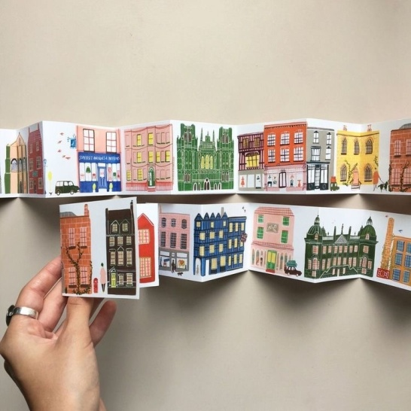

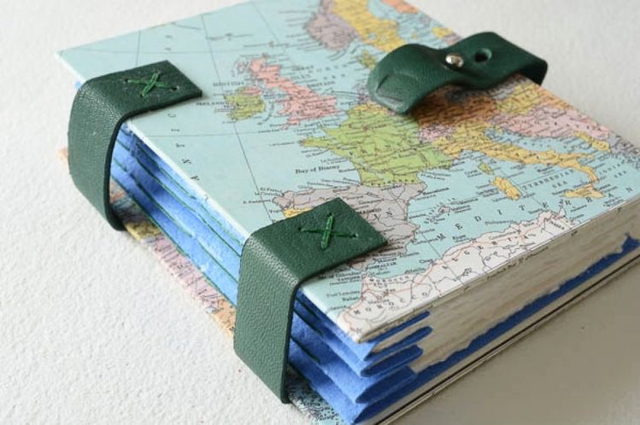

I then had a go at mocking up a concertina zine, I used a thicker card for this so the concertina stayed in place better.
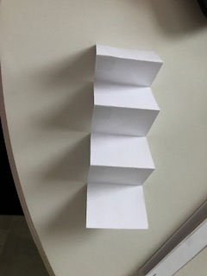

I then also had a look at this style of Zine layout design, it’s like a concertina but you cut down two folds. I remember doing this in my Sketchbook unit, and thought this might work for this research too. I used a slightly thicker card again for this mock up too.
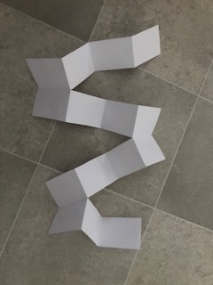

For the small section of critiquing and editing on this exercise, I decided to go back to my The future of the book section, as I felt that I didn’t quite know in what direction I was going to go with this. I felt I need to edit what was already written and critique sections to move forward with it.
So having looked back at what I had written for this, I personally still believe in THE BOOK, so I will be having some visual pictures in my Zine of things I enjoy, like hard backed books, Journaling, book binding and creating my own books one day. I will add pictures of my own books and have these in varying scales across the page, I will use similar type and typography throughout the zine to keep it consistent, and this will hopefully tie the pages together. I’m also thinking of a colour scheme to run throughout also to make it flow and work together.
Just going back and doing this small amount of editing has made me be able to move forward with this section, I can now see in my head how it will come together.

