Research and development
Looking back at the two ideas I chose to develop further: I found it easier to find ideas for ‘Book worm’.
‘In someone’s good/ bad books was really hard to find and research for. I looked into metaphors to see if this would help, but there was none at all!
So I came up with ideas that were based on a couple and tried these in different formats.
I think I will develop the book worm idea further for exercise 5, I think as I am interested in nature, this comes more easily to me, and working more for children is a added interest, so this made sense to me.
I like most of the thumbnails I created for Book worm, but I think I will develop the first thumbnail. So a design in nature, but I think it needs a human character, so I will use the girl in thumbnails 7 and 8. I also think I have a worm character so he is dressed up like thumbnails 3,5 and 6, with a little hat or something.
I then went on to create another mood board based on these ideas that I have thought about and defined further:
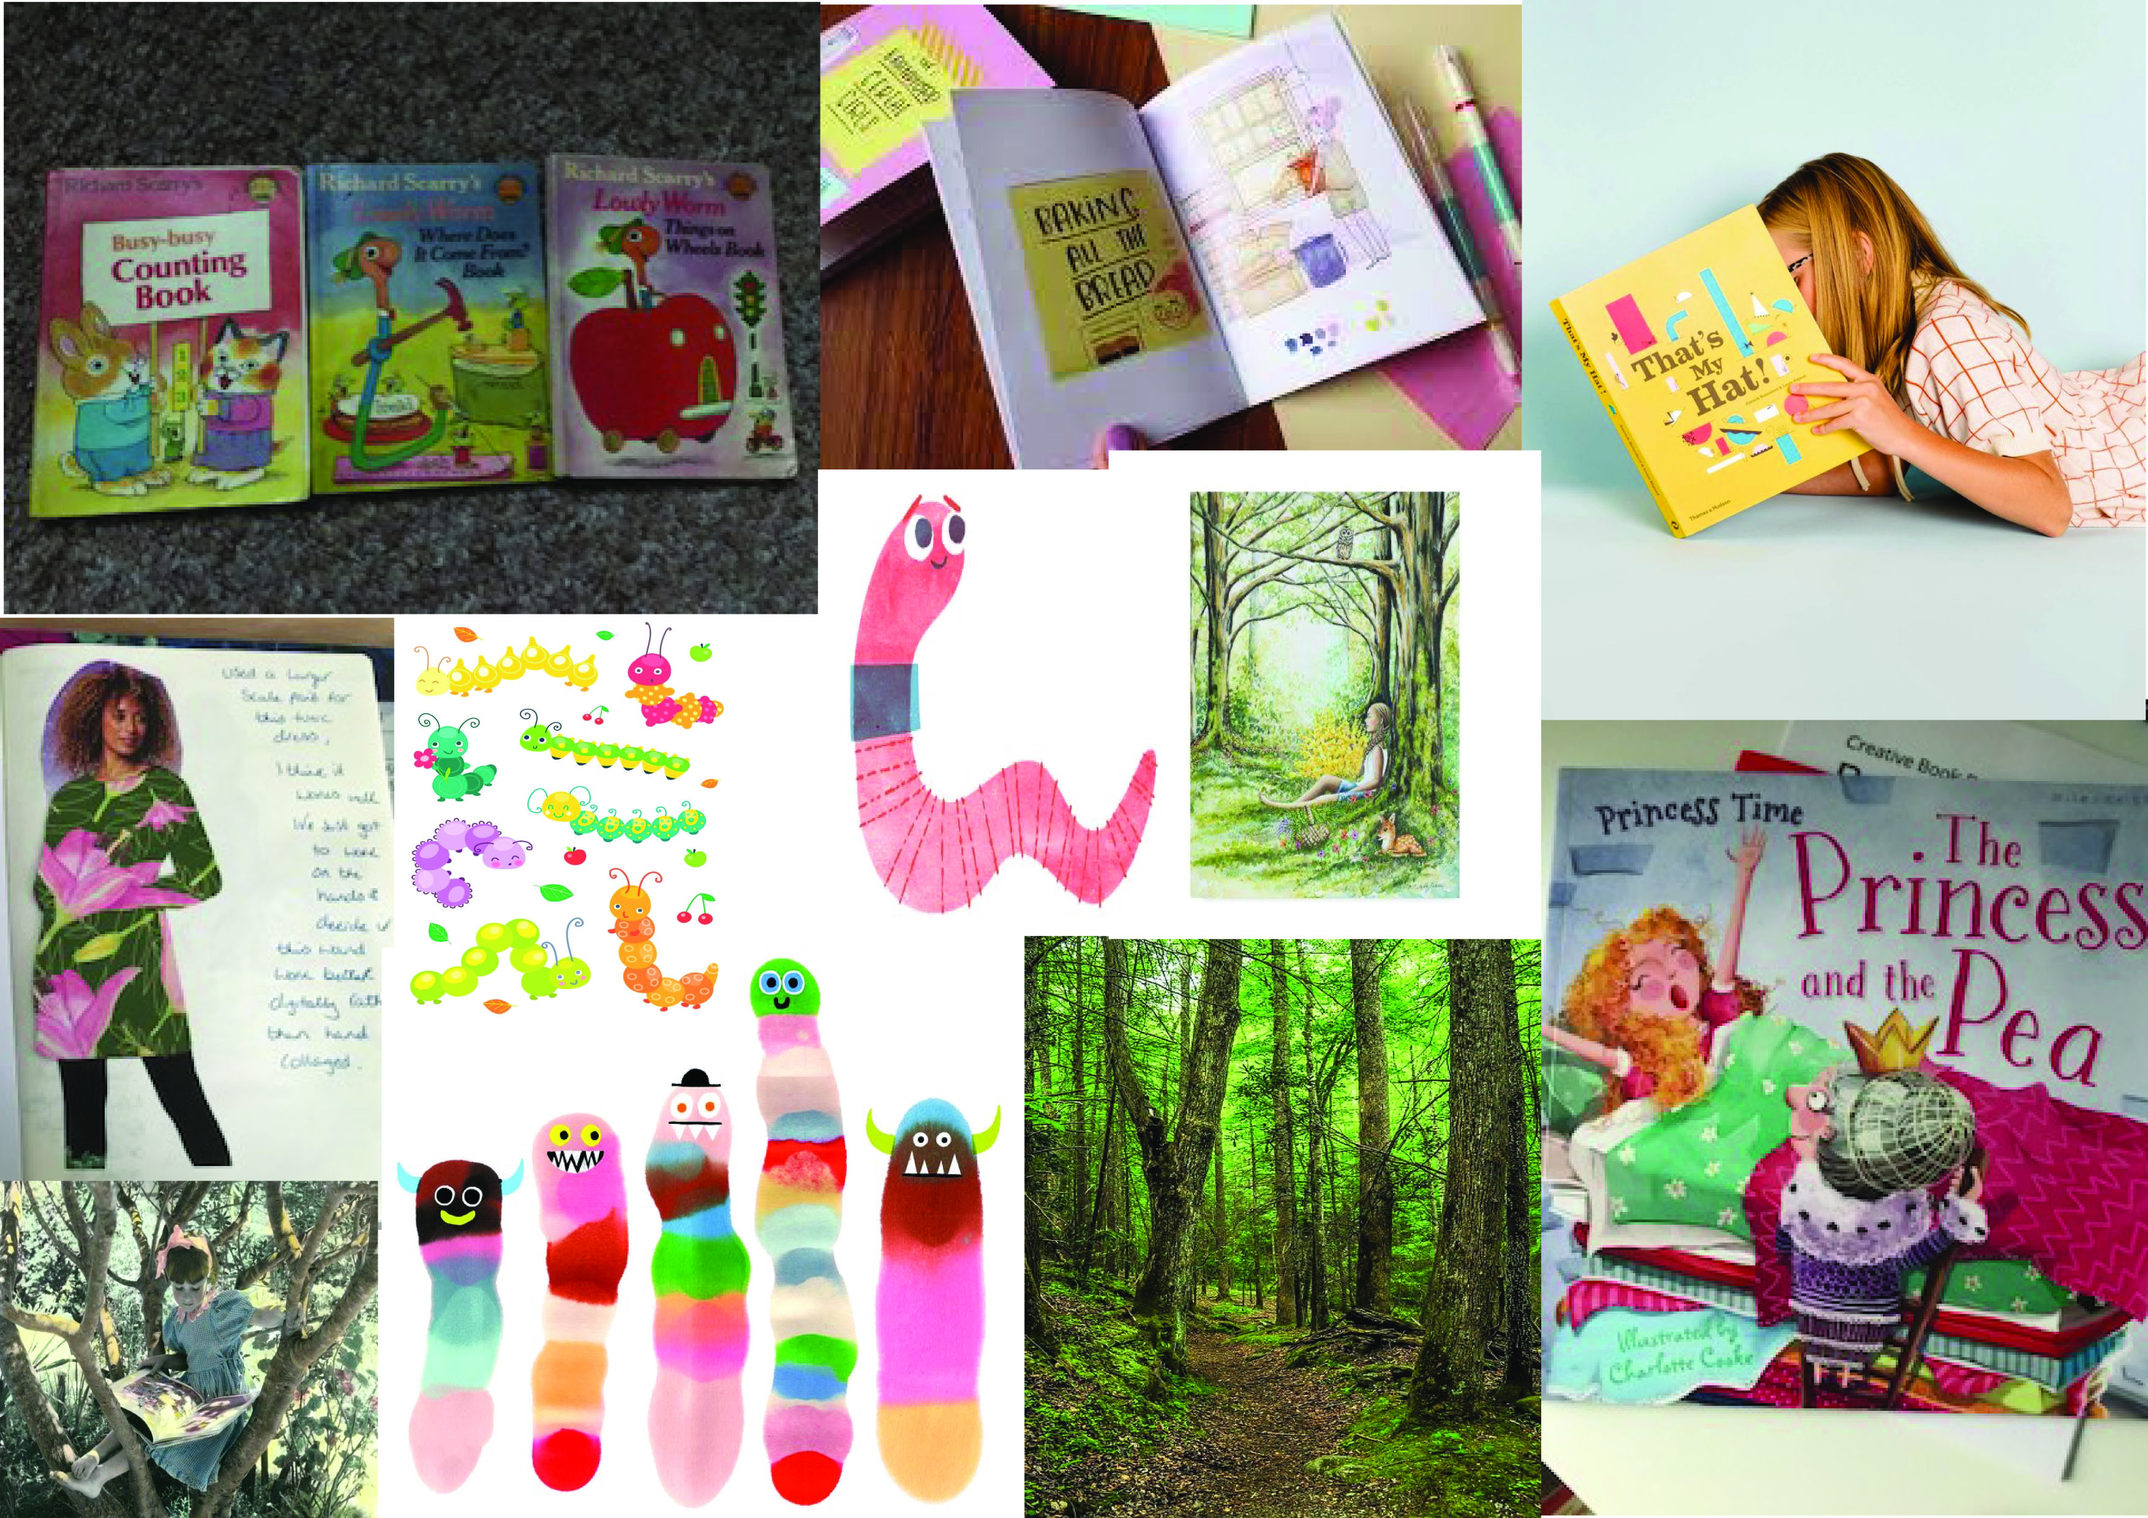

So after doing the mood board I had a rough idea of how the larger thumbnails would look, so I’m going to create a sketch with a girl character, a worm character, in a wood or garden scene, with a book, the girl will have a surface pattern design as her outfit.
So I rough sketched out some ideas on thumbnails but just a bit larger, and slightly more detailed.
I came up with four designs:
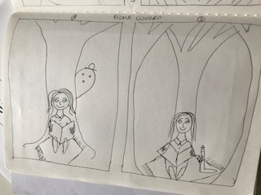

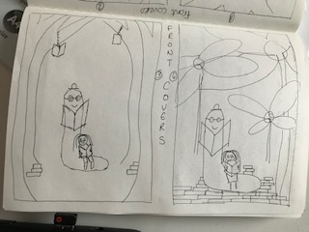

I then went on to create some line work flowers, which I wanted to incorporate into the cover. I use this style of drawing to add some texture and movement into my illustratrations.
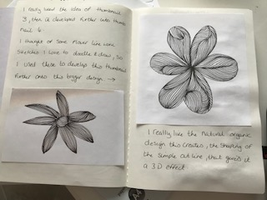
Then I started some mark making for the worm character, I used a sponge with some acrylic paint in a circle design, then I tried the back of a spoon, but that was a bit messy and would need some pen detail to shape it into the right shape!

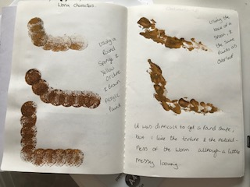
I then wrote down in my sketchbook, the headings of the process ill be using to make up the zine.
So I will introduce myself:
I was thinking of using different typography in cut and paste design, maybe having different ‘Hi’ in different languages.
Then I will show my create process:
So I will do something with watercolour, coloured pencils, line work (like the flowers) some mark making, character drawings, then some surface pattern designs and illustrations.

Look at book:
So show my book collection from around my home, having a few books larger so you can see the front cover designs.

Global influence:
So the influence of Frannerd, who I researched for my Zine.

Future of the book:
So the work I collected on the books future, from my view.

Book related sayings:
Basically the whole process of this zine, will be based on this quote.

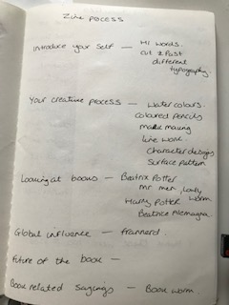
I then went on to draw some girl characters, not particularly based on me, although they could be. I was thinking more about the person who would read my Zine instead.
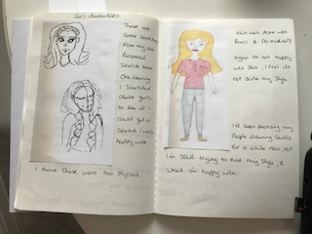
I did a few sketches but I couldn’t get the style I wanted for this zine, the sketches on the left were too stylised. The sketch on the right was not good enough.
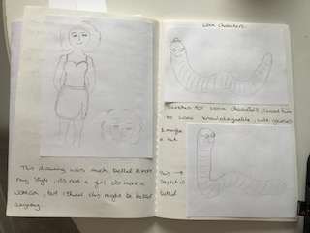
This lady was a better drawing and in the style I wanted to achieve, but she’s not a girl she’s a woman, so I guess it could be based on me now.
I then went on to design some worm characters, with some rough sketches. The first two were good but not quite right.
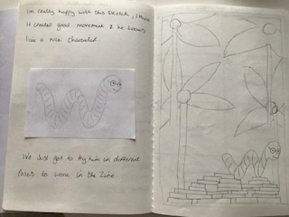
This worm character was much better, I like the movement in the drawing and the character seems more friendly.
To the right is a bigger thumbnail of the front cover design I was thinking of. It still needs the lady in it, but I need to sketch her sitting down and reading her book.
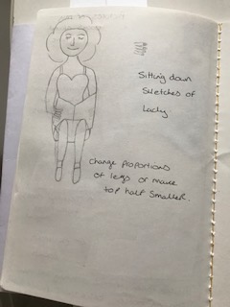
This was her sitting down reading, but the proportions are not quite right, so I will come back to this and sketch a better drawing.
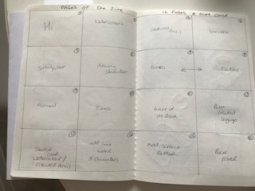
Above are the 16 squares of the Zine pages, I have not included the front cover. I have written out where I will be having each page and the flow of the pages.
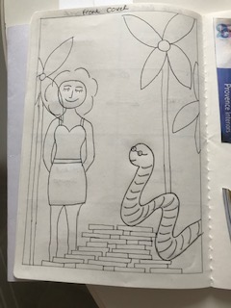
This is another front cover large thumbnail including the lady this time, I like the way the worm is slithering over the book sand looking at her, so I will keep this section in the final design. I just need the lady sitting and reading still. But it is coming together now.
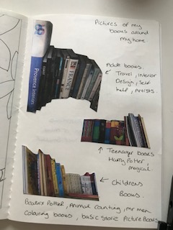
Here are the books around my home, in the sections that I keep them in and by ages. So the top books are in my lounge and are older books, so travel books, interior design, artists books, self help books etc.
Then below are teenager books which are in the spare room, Harry potter, Shakespeare and magical stories.
Then at the bottom children’s, kids and babies books, Beatrix potter, Mr Men, Lowly Worm, babies picture books, colouring books.

