Generating Ideas
So for the start of this exercise I looked at the options given for the ideas:
Bookworms
A closed/ open book
The oldest trick in the book
You can’t judge a book by its cover
In someone’s good/ bad books
By the book
I chose to work on Bookworms just because I immediately had ideas in my mind of what I could do! Then I thought about the others individually and decided to look into ‘In someone’s good/ bad books’.
I then started by generating ideas using a spider diagram
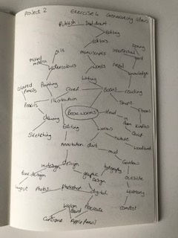
Then I went on to do the same for ‘In someone’s good/ bad books’
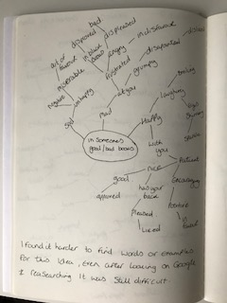
I had more trouble with this one, I found it hard to come up with words for the diagram, so I did some more research and Google the subject, but nothing much extra came up. I then went on to look at bad books and or good books to see if that generated anything more or different.
I decided to move forward with the next generation of ideas, which were mood boards. So I found lots of visual elements that I could use in a mood board for ‘Book worms’ this is the mood board:-
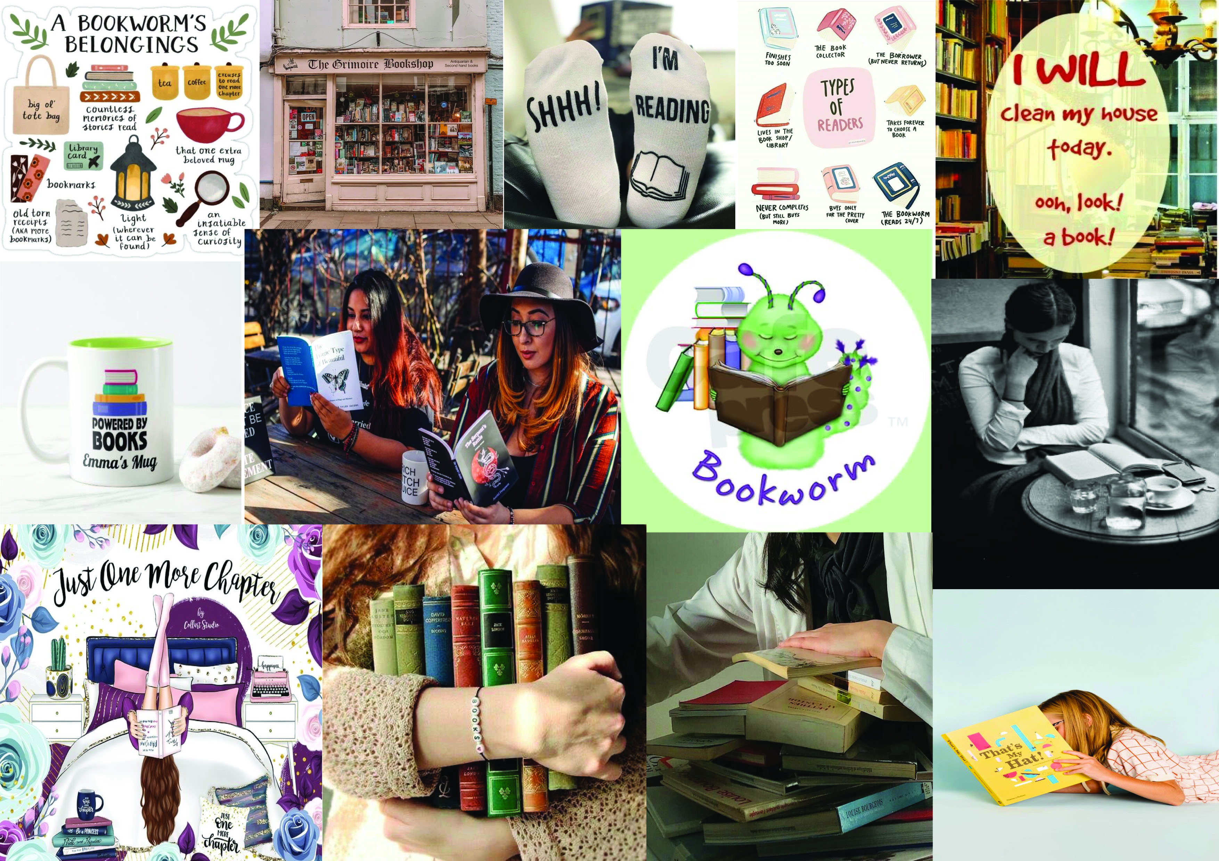
Again I had trouble finding visual images for ‘In someone good/ bad books’ so I decided to break it down into elements and photographs and motifs, and then hopefully build it from there.
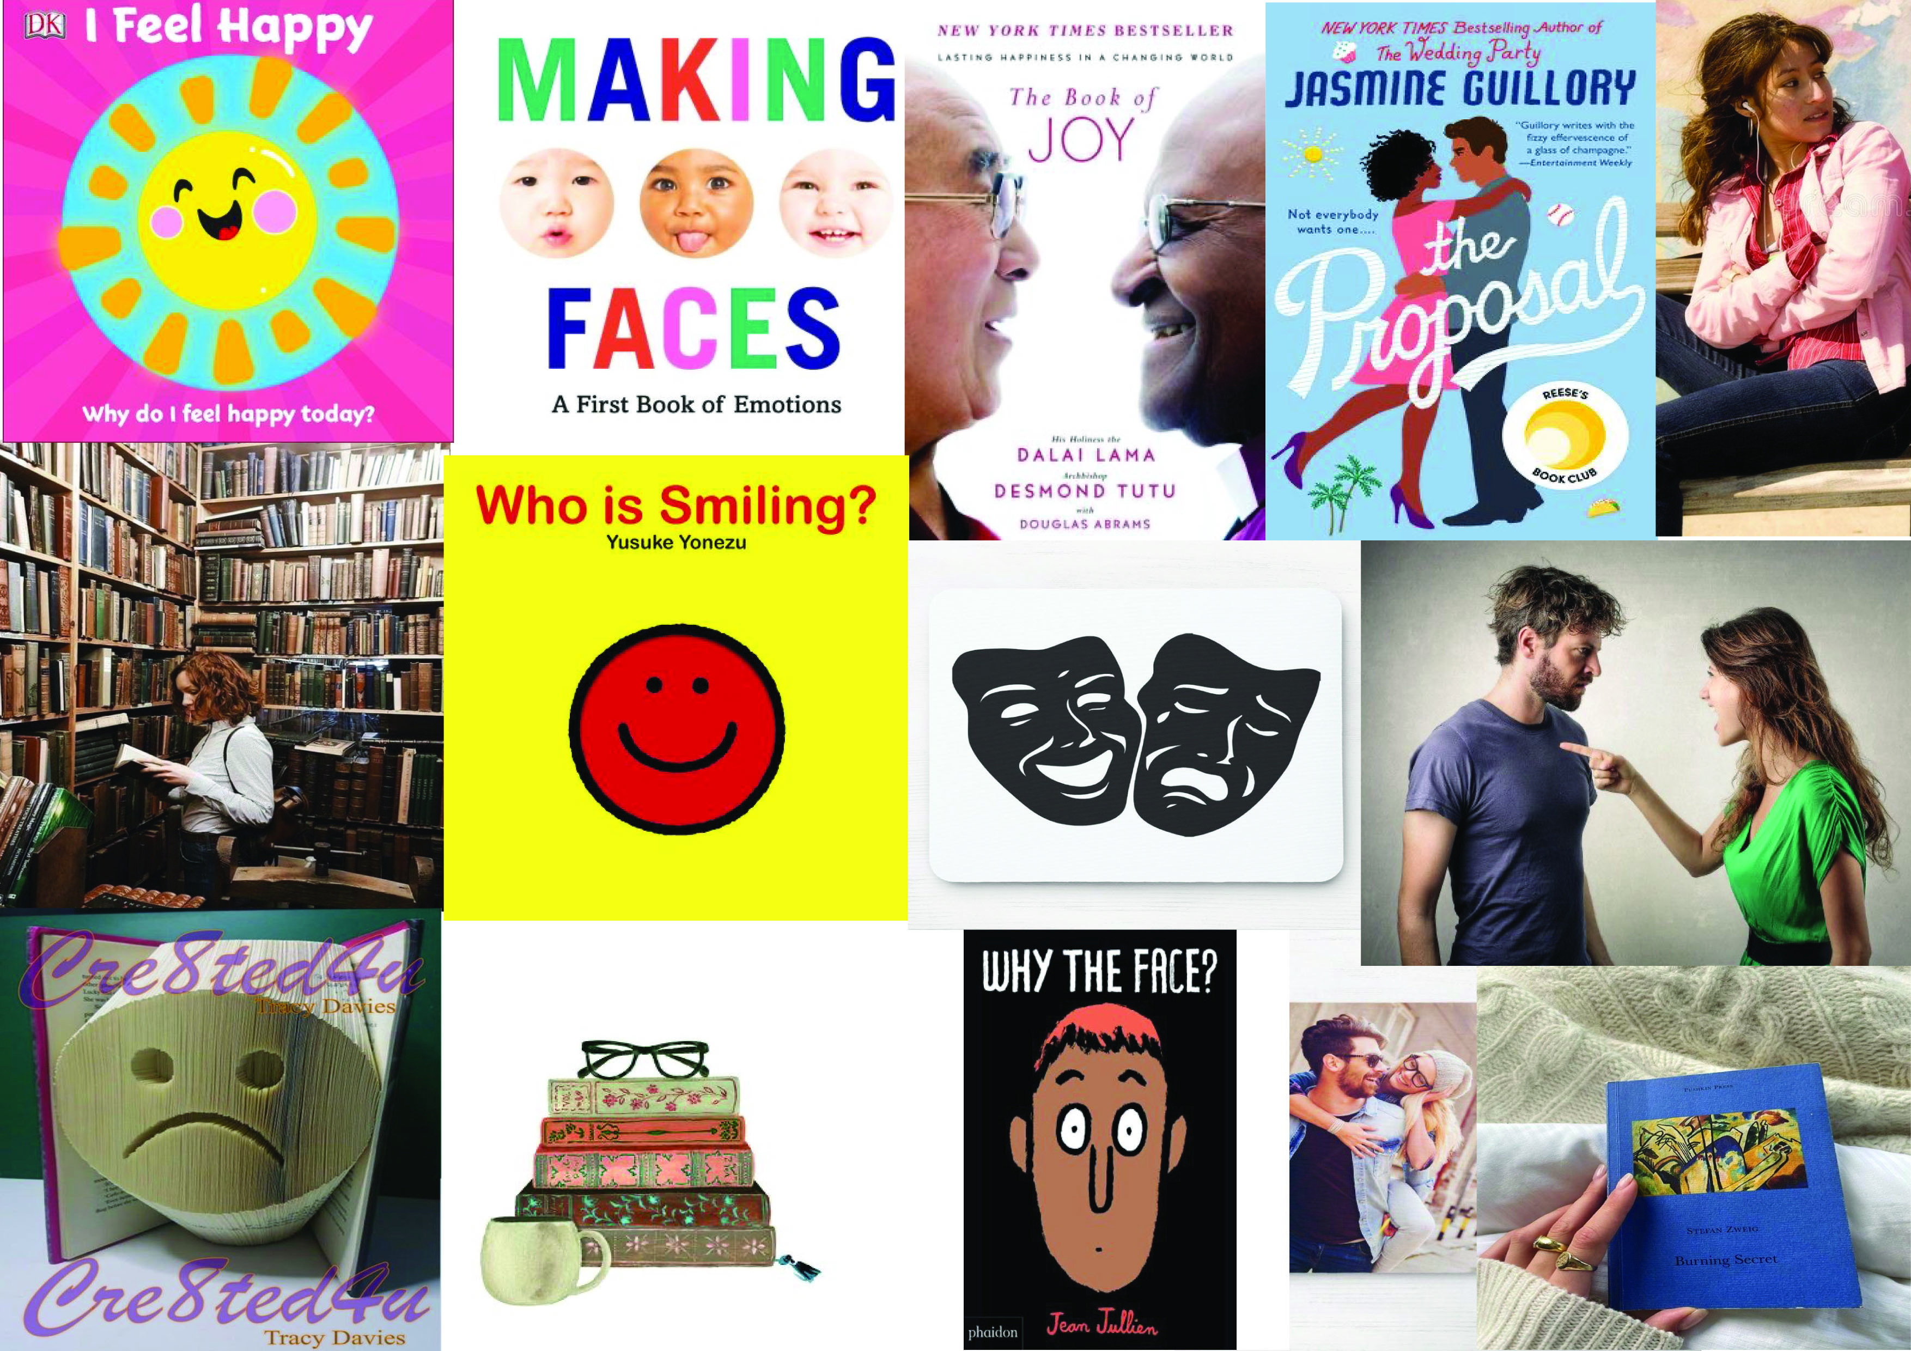

I then started on some basic small thumbnails, first with ‘Book worm’.
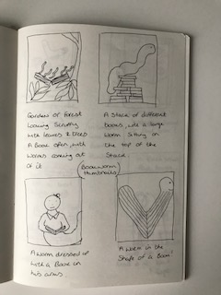
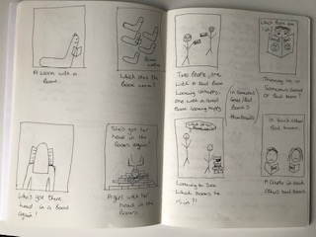

And then with ‘In someone’s good/ bad books.
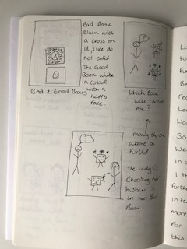
I enjoyed drawing the rough sketches, and found the ideas flowed easily with the ‘Book worm’ as I said before, but less so with ‘In someone’s good/ bad books.

