Alternative Publications
I had researched into artists’ books and fanzines, now I had to use a cut and paste style to explore my own ideas of Zine’s and how I might develop further.
I started by thinking about what type of Zine I would look at, I looked at Pintrest and came across a few different styles, which I made one up from, as like a mini mock up.
Then I started to think about how I could fill it, and what I wanted in my zine. I wasn’t going to make a zine, like it said in the description, just play about.
So I printed off some of my Surface pattern designs, as that it a third of what I do, then I thought about how I could incorporate these in to a zine style book.
I then thought about cutting out some people in a magazine, and then put my patterns onto them like clothes. I suppose a bit like Frannerd’s style of zine the dress up doll, but my interpretation, as mine would be more like a children’s story, than a journal style.
I had a play in my sketchbook and here are the pages from that.
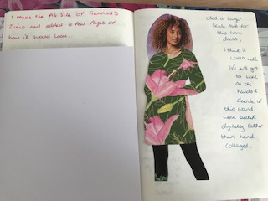
I made up an actual zine style book, just with plain paper and card, just to see the size and set up of how the zine might look.
I then went on to cut out some models from a magazine I had, and then I cut out from my printed surface pattern designs, some clothes. It gave a collaged effect, and I changed the size of the patterns to see which ones would work best.
I like this Lily pattern as a tunic for this woman. I think it might work better digitally, so using a clipping mask, you could show the hands better, rather than drawing over the top of the pattern.
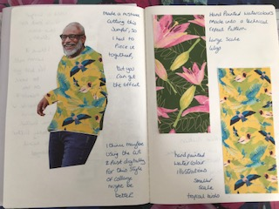
Here I made a mistake and cut the jumper for this man wrong, but I collaged it back together in a patch work effect, but it seemed to work ok. This pattern was slightly smaller in size, which I think worked better as you could see the pattern visually more.
Although it is quite as graphic as the Lily design. I have added the swatches of patterns I’ve used, so you can see the scale better.
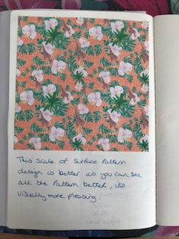
I printed this pattern design off, as I think this size and scale would be better for a collaged outfit, this would be great for a man’s shirt, it’s quite Hawaiian in style, with a safari twist.
I really enjoyed this exercise; I found that thinking of working towards a zine, has made me come up with some unusual ideas about collage and digital work. Putting background work into new work and giving it a refresh, as well as learning what style of zine I would like to design and create going forward.
It’s just the starting point, but from the research in the exercises before hand, it’s given me a direction to go in.

