The Future of the Book
Research task: The future of the book
Having read through the chapter and 15 pages as suggested.
The future of the book is an interesting one, where as nowadays most people have a Kindle or E Reader and or read online. Students do most of their work on digital devices now, and people read their magazines and newspapers online too, there doesn’t seem to be much need for the traditional book anymore!
Yet most people that I have asked about this always say, yes but you can’t beat a good book in paperback or hand back, having the book physically in your hand, nothing beats this!
I myself am one of these people, every now and again, I’ll buy myself a good book, and nothing beats that feeling, it’s like a little treat now. You give them as gifts still, for Christmas and Birthdays, and they are still very well received and looked forward too.
I’ve also noticed an increase in small cottage industries bringing back old processes, like bindery, there is a plethora of new courses on book binding, on creating special books, whether they are a specific subject, or just decorative notebooks.
There’s also been a big resurgence in America which has now taken over Europe and England, ‘journaling’, which again brings back the old ideas of having books, although these might be travel journals or personal ones, I feel this resurgence is gradually bringing back ‘THE BOOK’, and will also lead back to publishing and written books, everything that goes around comes around, and back again, full circle!
Although I’m very much for having books, I am also excited to: in the future self publish some books, I already have ideas for these, I think as someone who is interested in this, and it’s something that is now more accessible. You can then sell your books online with Amazon or other places like Blurb and Snapfish.
It gives us small people the opportunity to get published and have our thoughts and interests out there. I myself think there is room for both, why should it be one or the other? They can both work side by side. The time we are in at the moment is surely a mid time of when both publishing houses who create traditional books and online places like Amazon with their Kindles that can share the market.
I think the future of the book; will be aspects of both or all four areas of change that were mentioned in the research piece.
I think people like Frannerd, Who is a Chilean Illustrator living in New York, she is a new digital Illustrator, yet she uses old processes of publishing her own mini zine books to sell in her online shop. So here we have a good example of working in the digital age, yet using old processes, they can work easily side by side. This for me is where I see the future of the book going, and I think it is a really good way to move forward.
I visited William Blake’s exhibition at Tate Britain earlier this year, looking at Typography and his small books.
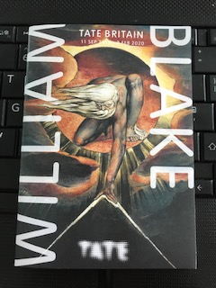
Tate Britain Exhibition flyer
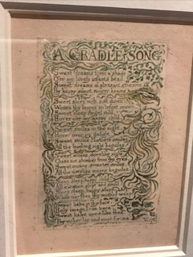
Blake W (1789) a cradle song part of the book ‘Songs of Innocence’ [Relief etching and hand colouring]

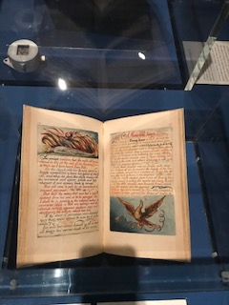
The Marridge of heaven and hell (copy H) (c1790) Book 27 plates on 15 leaves [Relief etching with hand colouring]
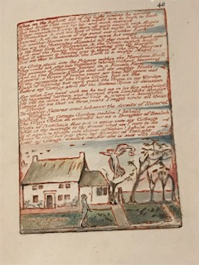
Milton, a poem in 12 [i.e.2] books (copy D)
1804-18 book 50 plates on 50 leaves [Relief etching printed in orange and hand coloured]
William Blake started this book and it takes on his journey of spiritual self discovery of the poet John Milton who returns from heaven. This plate shows the cottage where he lived with Catherine his wife.

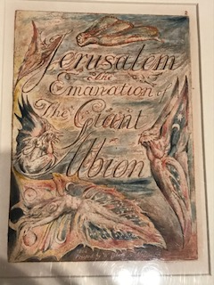
Blake W (1804-20) Plate 2 Title page, copy E [Relief etching and hand colouring] Yale centre for British Art, Paul Mellon Collection.
I loved looking at his books he had made from plate etchings then hand coloured himself, from the poems to the full books and the gorgeous hand drawn typography.
The way the Illustrations reacted with the written words, how one complemented the other and bought the words to life. How one wouldn’t work without the other, and the attention to detail and the way you felt after reading them.

Research task: Artists’ books and fanzines
Browse the American based Smithsonian Libraries’ Artist Book archive to identify books that you find interesting or questions the notion of the book in some way.
I tried to look on this website and browse the books, but you couldn’t look at the books to read or look at them to find them interesting, so I found some books of a similar type i.e Art books.
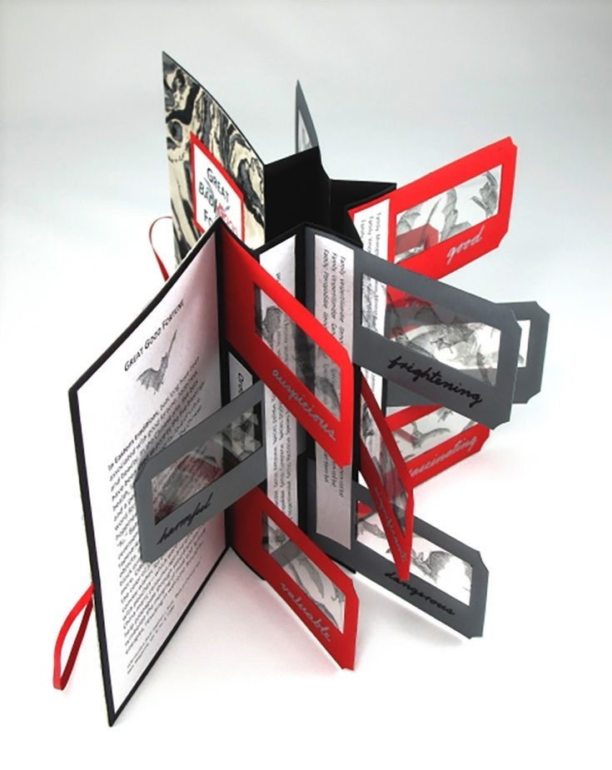
Sharp S (2014) Flag book [print and paper] Flag book gallery
Flag books are a great way to display photography, imagery in new and unusual ways.
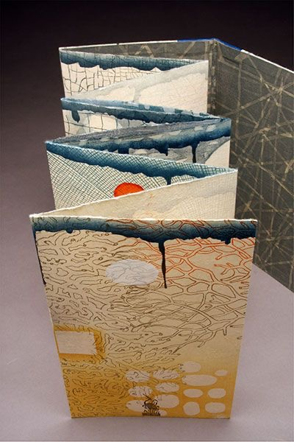
Kunc K (2009) Ephemera [Wood cut, letterpress, polmer relief] Poems by Robert Pinsky 10” x 6” folded artist book.
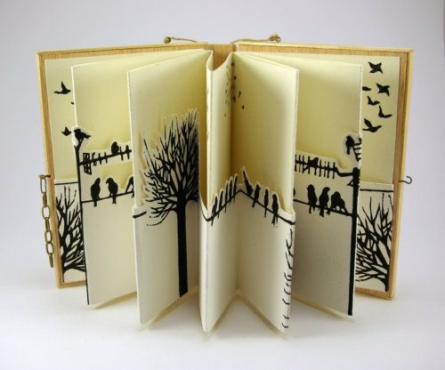
Fernandez C (2012) Among Humans [Linoleum cuts printed by hand on paper, wood] Artists book edition of two opens into a carrousel and hung with string.
I found these three artists books interesting as they used the art work as a display unit; the book just helps you to see the art within it, a bit like a frame would do for a normal painting.

I read Teal Trigg’s chapter Definitions and early days (pages 6–43) from her book Fanzines: A do-it-yourself revolution (2010).
As mentioned before I have research the Illustrator Frannerd, and she has created some Fanzine’s which she sold at High Fest, the Illustration festival at Hastings each year. Frannerd also sells her zines on her online shops, she has created a few now, and some of the examples are below.
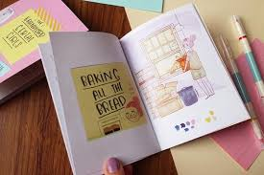
Meneses F (2016) the Brandford Cereal Girls

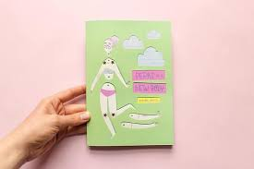
Meneses F (2016) perks of a new body

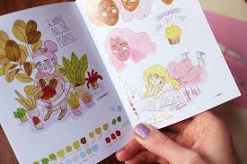
Meneses F (2016) the Brandford Cereal Girls

I really like these little A5 Fanzines by Frannerd (whose real name is Fran Meneses) The Perks of a new body was when Fran turned 30, and couldn’t decide how she felt about this, excited yet scared, so she started journaling, this is the brief summary of that journal, with pictures of course!
The zine prints in full colour, 300gsm matte laminated cover, 120gsm uncoated 100% recycled paper inside, 36 ages.
I like the handmade style of the front cover, of a toy that Fran used to play as a child, dressing up paper dolls. The visual quality of the front cover has a retro feel because of this link back to her favourite toy.
The colours she uses are mainly pastels and mainly ink and watercolour or Copic markers, her Illustration style is comic in style, yet not overly stylised, it’s more natural.

