Influential books

The books I used to read when I was a child were:-
The Magic Bus
The Mr Men books
Lowly Worm
Beatrix Potter’s the tales of Benjamin Button series
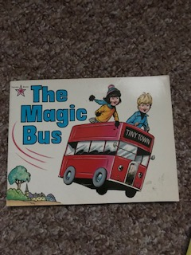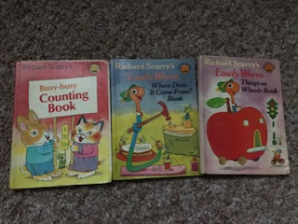

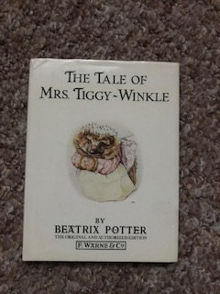
More recently and in later years:-
The Harry Potter
Oliver Jeffers books
And up-dated Illustrations for Classics, like The Princess and The Pea.
Roald Dahl
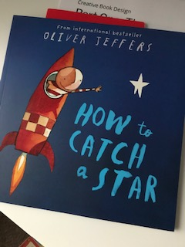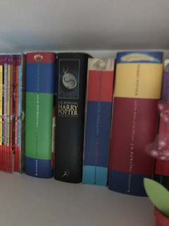

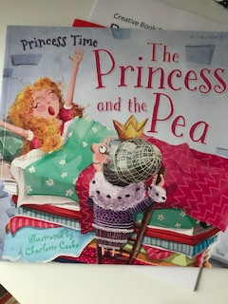
The reason I think I like all these books is that they take you off to another world which is created just for these characters, the books are very colourful to look at, very detailed and have a connection with the mediums used.
I looked further into these books, about how the authors were influenced and how they influenced other generations themselves.
So if we take Beatrix Potter, she was influenced by the likes of Randolph Caldecott, John Everett Millais and John Tenniel.
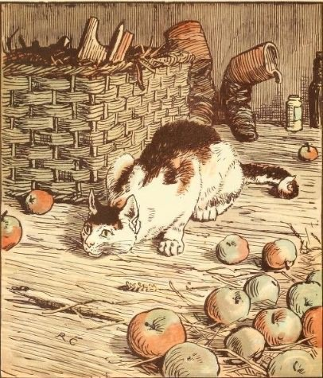
Caldecott J (1846) The House That Jack Built [Ink on paper] Frederick Warne and Co.
As you can see in Caldecott’s work, it is illustrated in a similar way to Potter’s, Using ink and paint, also featuring animals.
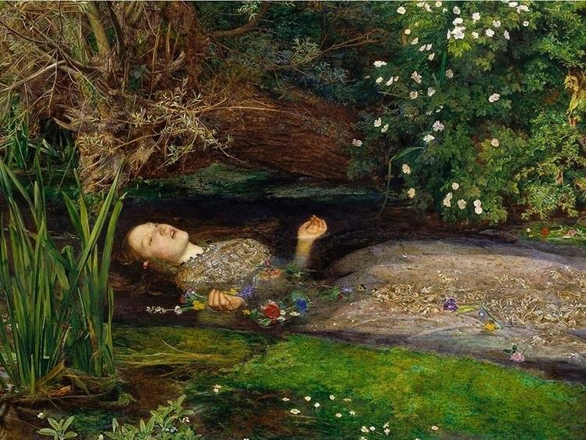
Everett Millais J (1851) Ophelia [Oil on canvas] Pre-Raphaelite Brotherhood, Tate Britain.
Beatrix was also influenced by John Everett Millais, especially his painting Ophelia, The natural scene, the detailed art work and the connection to Shakespeare’s play Hamlet, so it all inter connects with words and pictures.
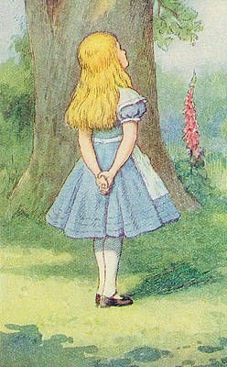
Tenniel J (1865) Alice in Wonderland [ink and watercolour] Lewis Carroll.
Also a real connection with John Tenniel’s Illustrations for Lewis Carroll’s book Alice in Wonder Land and later on Through the Looking Glass, and What Alice found There.
Again the style with drawing in ink and then using watercolours show the connection to Potter, as well as the colourful yet soft feeling of the way they both paint.
Carroll’s writing also links these by creating another whole world of where Alice goes.
You can also connect John Tenniel’s work he was influenced by, which was his Punch cartoons, representing the national and international situations, his social influence of the weekly publishing of the political cartoons.

Using one of my later collection of books I really enjoyed reading ‘Harry Potter’, you can take JK Rowlings influences, her as a child when she had measles at the age of 4, she loved and was later influenced by this story which stuck with her from that early memory, The wind In The Willows by Kenneth Grahame and Illustrated by Arthur Rackham.
With this it’s not so much the illustrations that connect, but more the worlds that the authors created, which Rackham and Thomas Taylor had to create Illustrations for. Actually when you put the illustrations together though, there is a similarity in how they are painted and the media used.
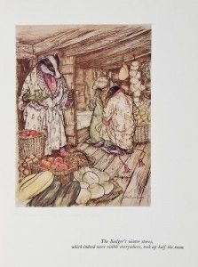
Rackham A (1940) The Wind in the Willows [Pencil, Pen, Ink and watercolour]

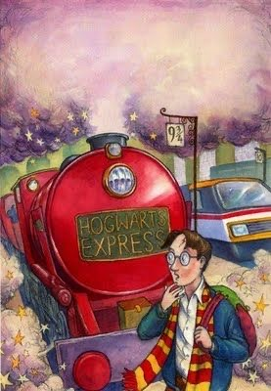
Taylor T (2014) Harry Potter and the Philosophers stone [Watercolour]

