Fill it up – FAST!
So for this exercise it was a bit tricky to find somewhere to go, because of the Covid situation still, but I found that I could go to the local small garden centre and gardens, and just sit at the side and observe and sketch people quietly, whilst socially distancing. There were not that many people there or staff for that matter, but it was the best I could do under the circumstances, as I could not go to a gallery, a musical, a public talk, an indoor market or with lots of family and friends.
I made a mini zine first of a few pages like the brief suggested, one of these pages I folded into 8 squares to create the collage / vignette scenes.
The size of my mini zine was A5 as I just folded in half a A4 size piece of paper and card, I had 6 pages in total.
I took with me a slightly larger kit, as I wanted to experiment with different media and as it was going to be for a few hours, I thought this was the best idea. So I went along with my usual watercolours, but I took my larger palette instead of my travel size. I also took a few brush pens and fine liners in different colours too. On the whole the rest of the kit was my usual bits.
My first page was a bit of a montage of a section of the gardens that I was sitting in. The lady gardener was what I was trying to focus on and draw whilst she was digging and gardening. I added a few bits of what I could see around me.
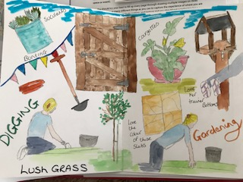
The second page (on the right) was the same scene, but just from a different view, which was next to the cafe (which was closed) Again it was made up of things I liked and saw around me
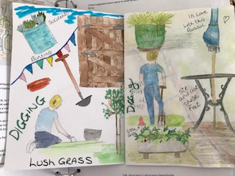
The third page was of a scene as I was looking down upon it, from some stairs by the side which I was sitting on sketching. We were not allowed to tread on the grass, so it was the only way I could view that section. I really liked the paving stones; they were a lovely warm yellow colour. The fourth page was where I folded the page into 8 smaller squares; here you can see the back of 4 of them, because of the way it’s folded.
I chose to add in these little squares just bits I saw and liked, or just snippets I saw and drew.
So here is a pot with a frame in it, which I thought was a good idea for growing things up, the second was a pear tree I saw, the third some Verbena plants which I loved, and the fourth was a large shinny black pot, which I thought was great to plant things in, as the shinny side showed reflections in.
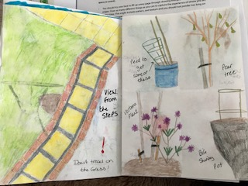
With the next page, which was the middle page was the whole page of the 8 small squares, so here is a lovely wind chime I heard, a gorgeous old bird bath, which had gone verdigris, a rubbing of some screws in the gate I painted in the first page, I liked the effect it gave.
Then I bought some strawberries for a snack so drew one of these, the next side was the handmade signs that I saw, which I thought was a good idea, a Chimnea which would be great to keep warm by, like a fire pit does. The other two squares were just some plants I saw, but couldn’t find the names of, so I drew them to remember what they looked like.
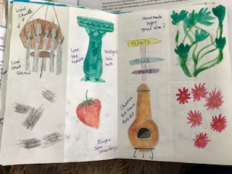
The page overleaf was the next, which was my monochrome page, where I drew a sketch of an arbour, which I thought was a fab idea for a garden, it was made up of two bench’s, a table and trellis down either side, as well as wooden slats above. The page on the right was a rubbing of the table in page two, which I thought was lovely to see the pattern of.
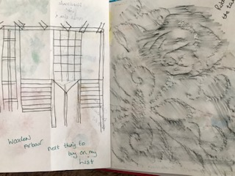
The second from last page was a sketch and painting I did of a vegetable area in the gardens, I loved the set up of it and it gave me lots of ideas. I liked the bird scarer, which was made of metal, with two birds that swung around in the wind.
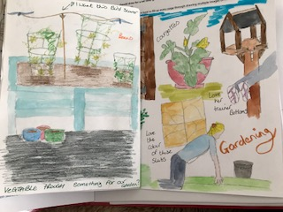
The last page, the back cover was a sign I saw in the gardens at the back, and thought it was a cute idea for children.
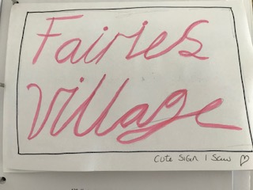

Then when I got home I just added the front cover and drew the words gardens and flowers to create a sense of place, then coloured these in with coloured fine liners.
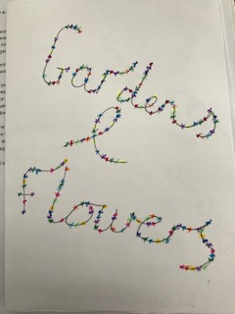

So the new media approaches I used were to use more pens for this outing, I knew I would be adding words or thoughts so I wanted something other than paint and coloured pencils for this. I had my black fine liner, but I also like colour, so took my brush pens and coloured fine liners too.
At first I found it easy to work fast along the same theme, but once I got past the middle page, it was harder to look for things that were different from the rest, but I think just moving to a different position adds a different perspective to similar things.
The day I went was sunny, but also cloudy with a risk of rain, so I don’t think going another day would change anything according to the weather. Trying it in a different environment will make it difference, I think it’s best to think about where you’re going first (at least to begin with) so you can take the bits you think you will need the most.
I think when things start to get busier as the Covid situation eases, it will be more difficult in one way, as places will be busier with more people, and the sketches will be more detailed due to this.
I found this exercise very good to get me to start using my sketch book out and about more, I think keeping to a few pages is a good idea to begin with; it makes it easier to not feel daunted you have to fill up too much. I liked sketching fast, although I tried to add more detail than I had done in previous exercises, as this was something I needed to do.
I will defiantly be using little zines again, when I go out for the day or on holiday or a break away, it’s a nice way to create memories and ideas on many subjects.
I liked making notes, I think this adds to the sense of place and it helps to take you back to that place, and it gives you a feeling of texture, smell or sound.
After feedback from my tutor
He mentioned that it would have been good to fill the middle page spread as one big picture. I had seen this in the brief, but after working quickly at the gardens and garden centre, the spread turned out to be the inside of the front and back covers! But I went back to the garden centre and because the restrictions are a little less ridged now I was able to sit in the actual centre part, so was able to sketch this scene out. I didn’t paint the scene at the garden centre as you still had to keep your distance and I was getting in the way a bit. I finished the painting at home, the background is just a quick wash, but I did manage to get a bit more detail in the foreground.
I think this has turned out well, I like the depth in the picture and it was nice as it wasn’t too busy and I could capture the shapes I needed before it got busy. I think this works well now as a middle page spread and one whole picture to fulfil the brief better.
