Building stories
So I started this assignment by reading through the brief then writing myself a plan of how to complete it by stages.
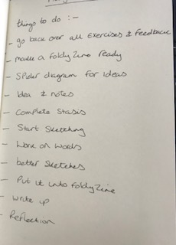
Then went back over my sketch books and feedback from this whole unit to establish what my good points are, and what I need to work on, as well as looking for 3 initial ideas to follow on from for this assignment.
So the illustrations and exercises I enjoyed the most and seemed to have better feedback on were the Pareidolia exercise on characters from exercise 2.6 and Assignment 2.
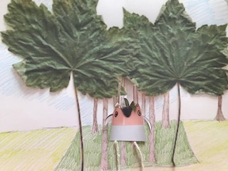
I really enjoyed this exercise then Assignment, I found the character cute and funny, and really enjoyed the whole process and the creativity behind it. I was surprised how you could easily come up with ideas for characters in this way, and felt this was a starting point for me for the future.
Then from exercise 3.4 suppose we make it different, putting unusual illustrations together.
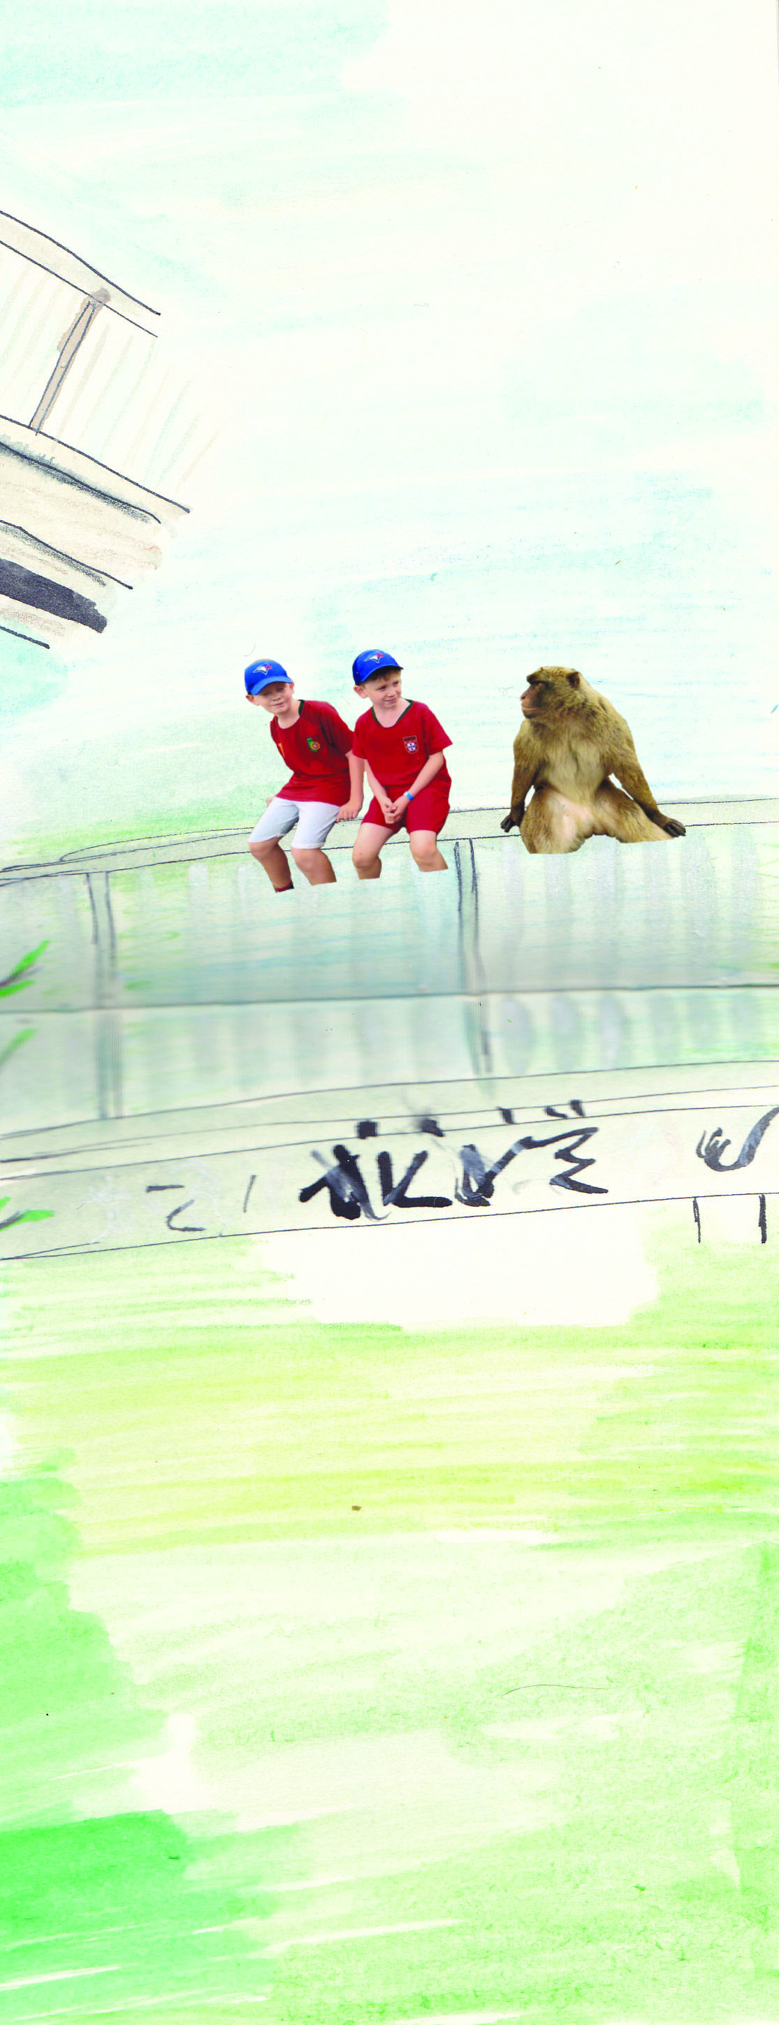
I liked the way you could literally put anything together in sketches and create a story from these, it was an unusual way of looking at things, but was enjoyable and again something to take forward for the future, it really gets your inspiration and imagination going.
Then Assignment 3, the illustrations from ‘Strictly Come Dancing’, the more loose sketches and drawings of the dancers.
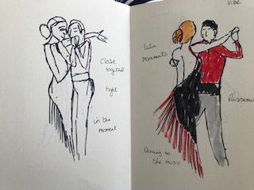
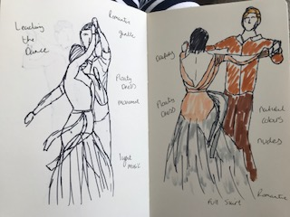
I have never really sketched in this way before, but I’m finding that this way is really good for me, my sketches are much looser, but also much better than the others. I think have less time makes me look for the actions more than the static elements, which I didn’t know I had in me, so this is a revelation and something to defiantly work on. Drawing figures has been a trouble for a long time, but I can see a bit of light and how I can beat this going forward.
Then also the sketches I did for exercise 4.2 storyboarding, where I drew frames from the movie ‘Miss Potter, again I felt my sketching was looser and more instant.

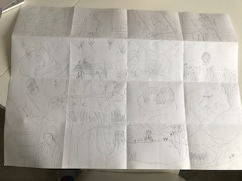
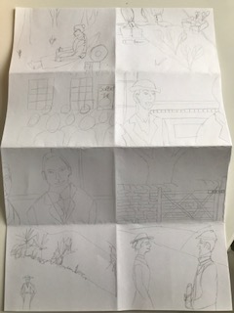
Although a few of the sketches were not great, I was quite surprised by how well I sketched most of them, and some of the people looked good! I defiantly think sketching rapidly especially with drawing people is defiantly what I should work more on going forward.
So the things I need to work on are thoroughly exploring all ideas, especially ones that are working well, try not to stop and keep going.
So the next thing I need to do is create my foldy zine, now I need to have 8 pages in the book, so should I include those 8 as the front and back cover too, or add these on separate?
I think I’ll have 8 pages just to begin with, then I’ll see if I need to add a front and back cover at the end.
I want to use some card I have that I know will be able to take paint as well as sketching, I will fold these in half to create a A5 size, then at the end I want to sew the middle to create a book bind.
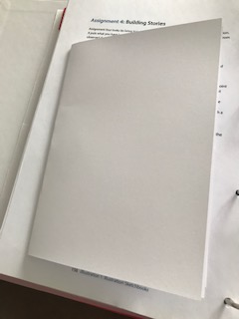
I really enjoy creating these little zine style sketchbooks now, and have started to use these in my own work too.

The next thing to do is to create a spider diagram to come up with some ideas for this 8 page book; I’ll base them on the 4 best bits from above and see where we end up.
So I started with the last one which was the sketches I created for exercise 4.2 and then I used one of the sketches for 4.3, its these sketches that I’m thinking of using for this Assignment.
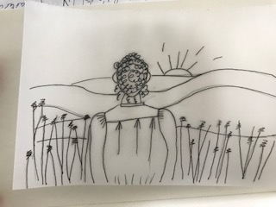
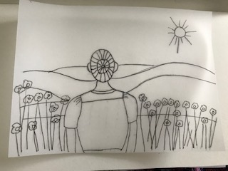
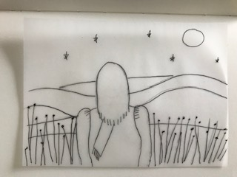
I then went back and re- read the brief, then I realised that we had to use sketches from this unit, so therefore this narrows the idea down to one, which are these sketches, as the others come from earlier in the course.
So now I have to do a spider diagram on these sketches, so I thought of ‘The Seasons’, and did a diagram on this.
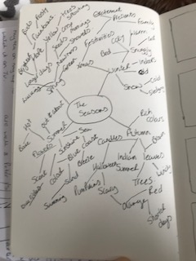
Although this gave me some great ideas to add into the pictures, it didn’t give my any idea of a story or how to push this forward, so I then went onto the story structure section.
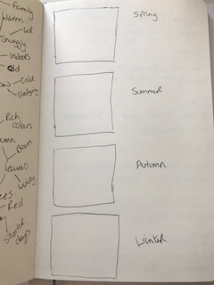
So I wrote down the list of story structures in my sketchbook, and filled in the spaces, to create a focus and idea.
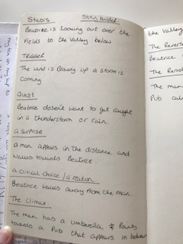

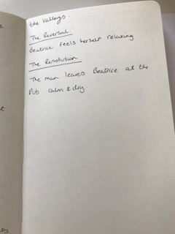
So it’s a fairly basic story, but I didn’t want too many words and wanted to keep it simple, as I wanted the illustrations to tell most of the story.
So it’s about a lady called Beatrice looking out over the fields to the valley below, the wind is blowing up, a storm is coming!
Beatrice doesn’t wan to get caught in the thunderstorm or rain, a man appears in the distance and walks towards Beatrice. Beatrice walks away from the man, she looks back and see’s the man holding an umbrella and points towards what looks like a inn that appears in-between the valleys.
Beatrice feels herself relaxing; the man leaves Beatrice at the door of the inn, calm and dry.
I then went on to sketching very quickly thumbnails to see what to put in each frame, and how the story flows.
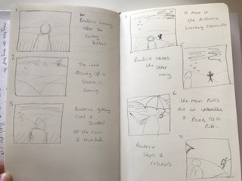
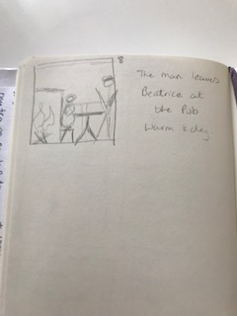

The next stage was to sketch the individual frames better with more detail. So I started with the same sketch I used previously for frame 1, then I used a similar sketch but changed the sky to look dark and cloudy.
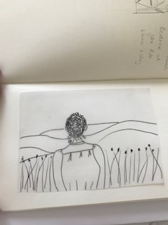

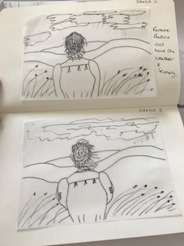
Then in the third sketch I had Beatrice looking windswept and the flowers blowing in the wind.
Looking back over the last three sketches, I think they look too much the same, so in the second one, I’m going to take out Beatrice and just have the weather and scenery.
Then in frame four was the landscape valley picture, with the man in the distance. The sketch of the man was really rough and I will need to go back to sketch it better. I think maybe even going back and looking at the movie, might be a good idea, so I can capture the man in motion.
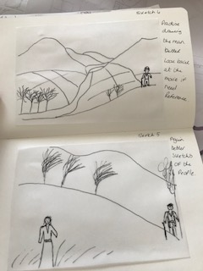
In frame five I had Beatrice walking away, with the man in the distance, but again I will need to re-sketch the people, I defiantly need to sketch whilst they are moving, I capture the sense of the person better.
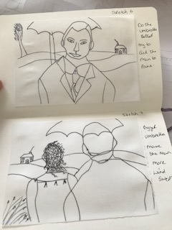
In frame 6 it’s a close up of the man, I think he needs to be a bit more windswept and the umbrella needs to be drawn better.
I like frame 7, but the umbrella needs work again and like above the man needs to be more windswept.
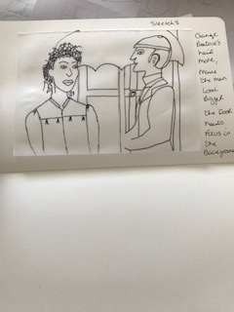
In frame 8 they are both outside the Inn at the door, I need to re-look at Beatrice’s hair, she looks better drawn, but her hair looks a bit afro rather than windswept!
The man needs to be bigger, or in proportion more, and the door needs to be a focus so it represents the Inn.
Done the sketches but still only rough and a few bits to sort out before putting and drawing them on the zine.
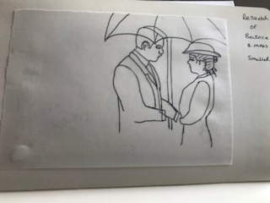
I then went on to make a mock up of the booklet (zine) to then start sketching to better sketches and move forward with how the overall look will be.
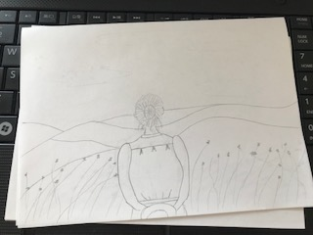

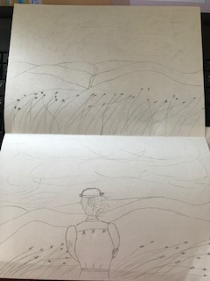

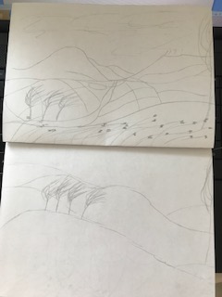

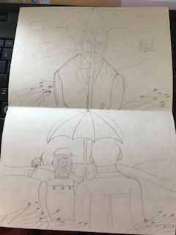
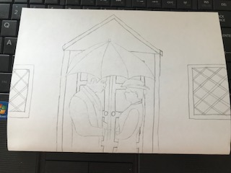

I’m really pleased with how this are looking so far, the sketches of the Beatrice and the man are looking better, and the story flows nicely from each frame.
I just need to think about where the words will be placed, I will research this a bit and also how the zine will work.
I looked through the ‘Foldy zine’ section at the beginning of the course and realised I had got the wrong type ready, so then I went back to my sketchbook and sketched out how the new zine would work.
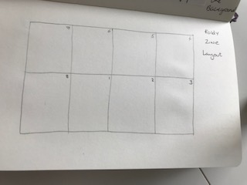
I’ve gone for the simplest design; I’ve just got to work out how to fold it so that it works properly.
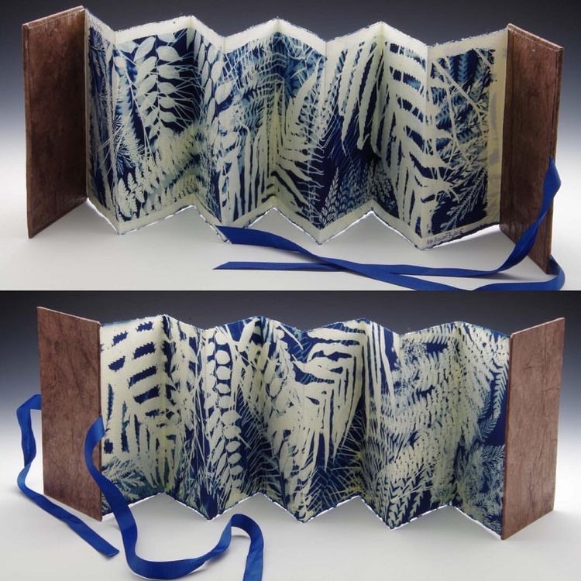
Mollie Bosworth
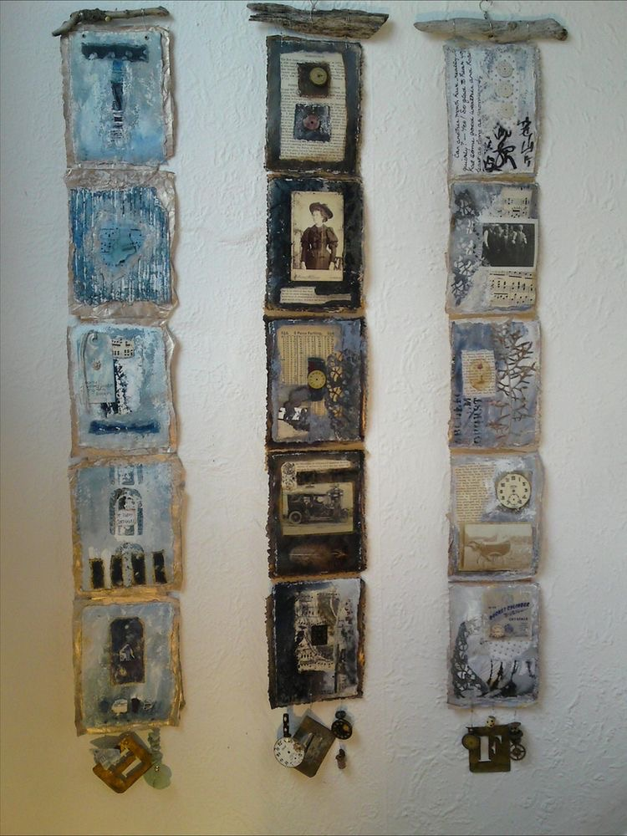
Sally McCabe
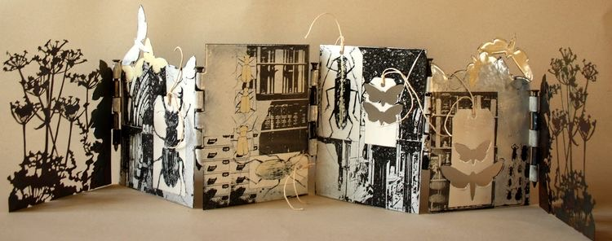
Sue Brown
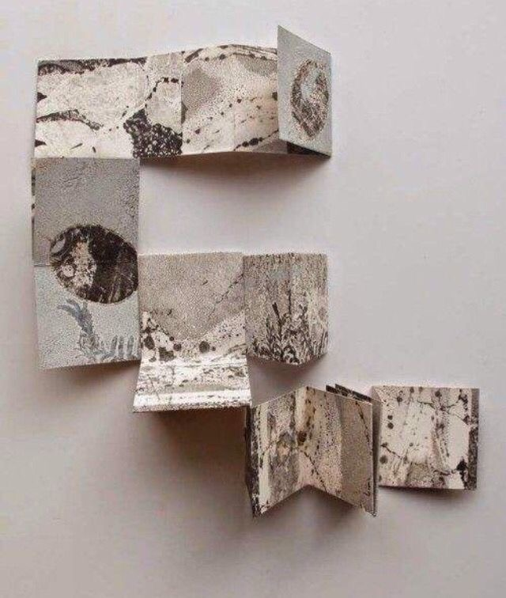
Stef Mitchell
So I’ve folded it like this, but it will work as a booklet in the end, I’ve now just got to plot out the sketches then colour and add the words.
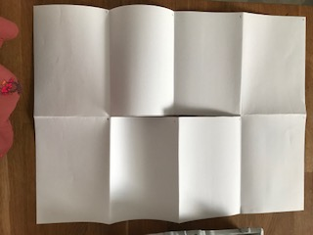
But first I’m just going to plot the words onto the mock up, so I know where they look best and should go.
I research some designs of love story comic books, although this is not really the style I was going for, I liked the idea of the layout of the word in this way. I thought I could incorporate this design into my style, but make it sit well.
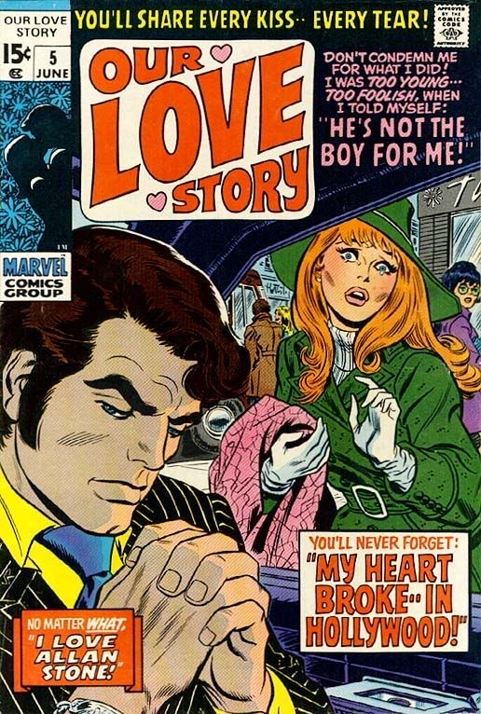
Jim Steranko
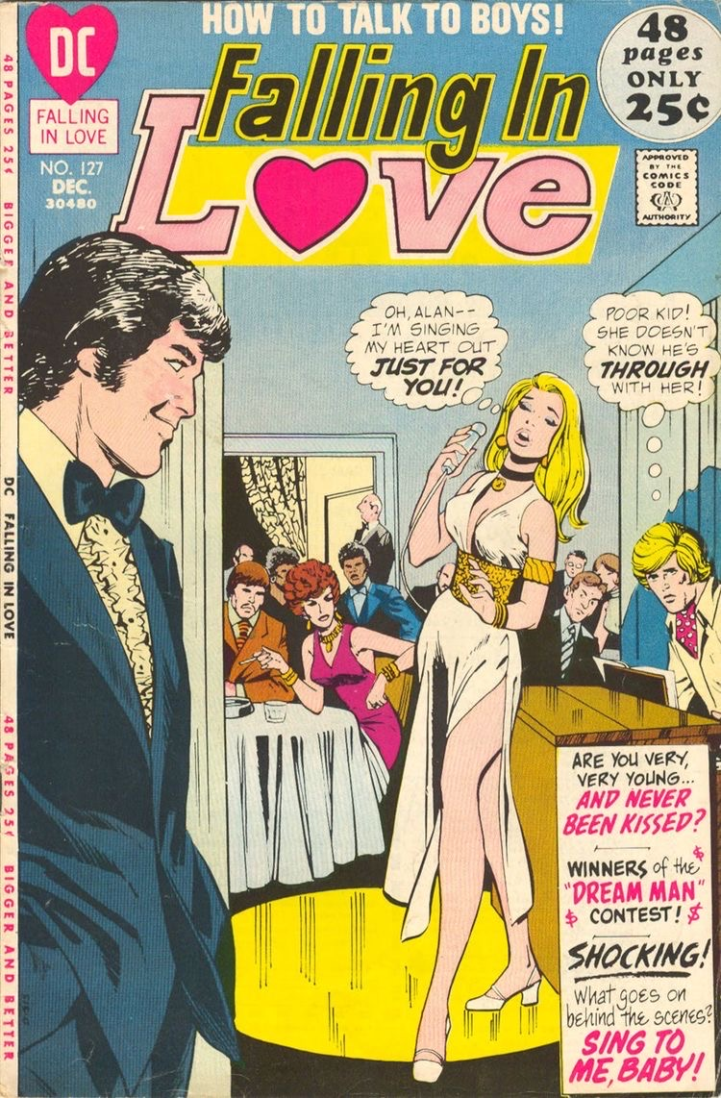
A Moon, a Girl, Romance
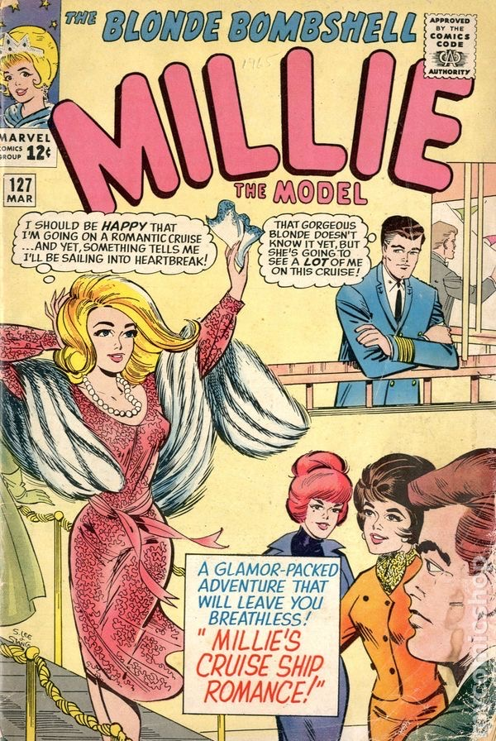
Millie the model 1946 comic books
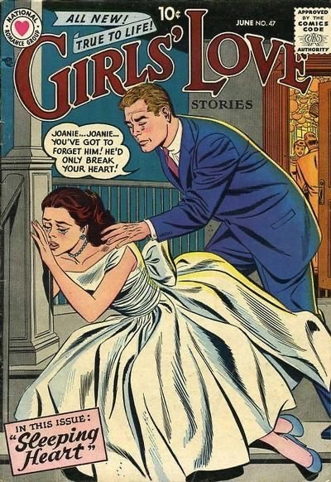
GCD cover Girls love stories #47
So I started on my mock up with the words:-
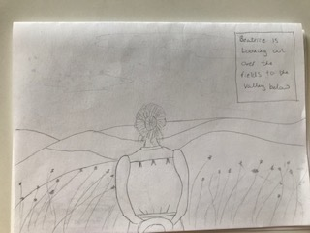

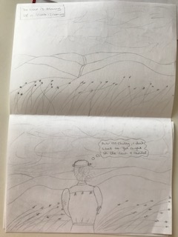

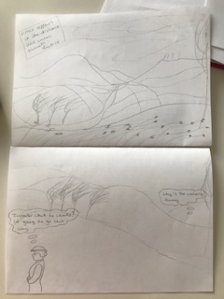

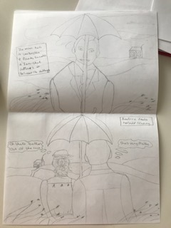
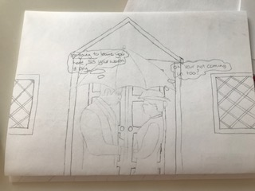
So I have roughly placed the words where I think they will work best, but I think until I set it out in the proper finished zine, I won’t know for definite, so I’m going to get started with that now.
So I sketched all the panels out onto my zine paper, and got them to work in the proper order, so when it folded it worked.
I then started on painting the sections, I used watercolours and water colour pencils and just ordinary coloured pencils. This is my style of painting using these mediums so I carried on using these as this makes me me.
It took at longer than expected to paint the whole zine, I ended up having to do it in two parts and carry on again another day as I ran out of time.
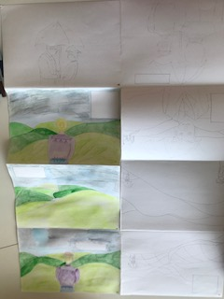

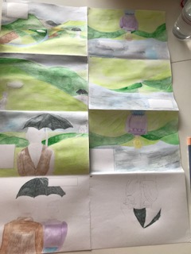

But I got there in the end, and this is all the painting finished.
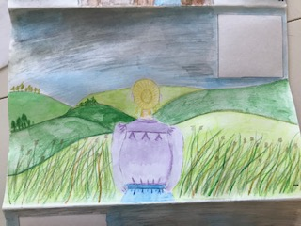
I have left the boxes clear for the writing as I didn’t want any illustration on them or paint. I used square and oblong boxes for descriptive writing, then speech bubbles for speaking or thoughts of the characters.
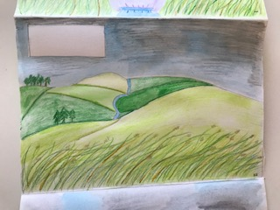
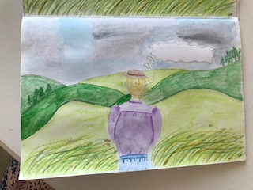
I tried to keep similar things in some of the frames, so the story could be seen as being in the same place; I tried to add movement to the grass and Beatrice’s hair to give the feeling of wind.
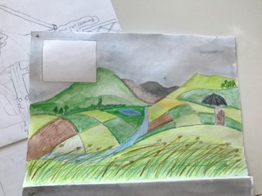
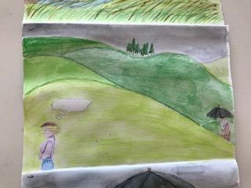
I found it hard to draw the characters in proportion to the surrounding landscape, but hopefully it looks ok and not too bad.
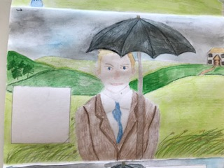
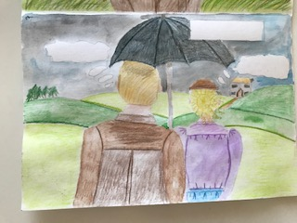
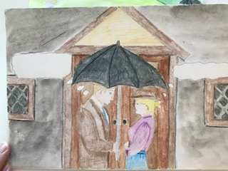
I added more black and grey to the sky as each frame went along, but ended on the last frame in front of the Inn, which was quite dull in colour and I think adds to the windy, rain and thunder feeling.
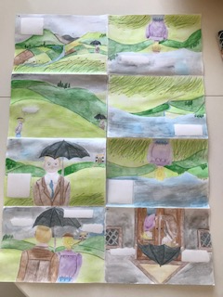
So this is how it looks laid out flat from one end, and here is the other end.
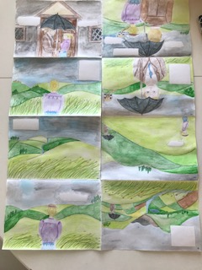
I then went back over each frame and wrote the words in the boxes and speech bubbles, I hand wrote these in black fine liner because I thought it added to the hand painted feel. I was going to scan the images through Photoshop and add typography then, but thought it would look out of place for this sketchbook.
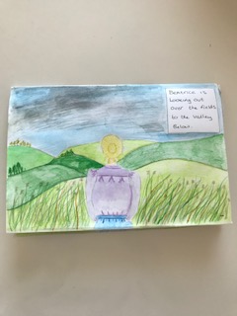
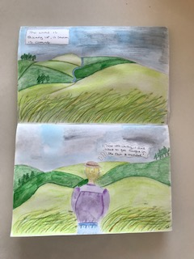

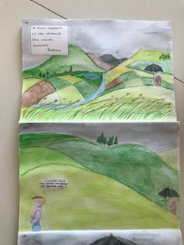
So of the boxes ended up too big and some of the speech bubbles were not big enough, so although I practised these on the mock up, I think I should have planned the boxes and sizes better.
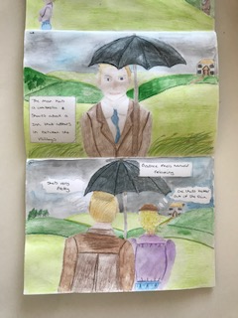
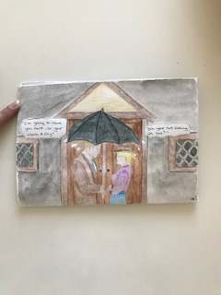

I took some photos of the zine pulled out like a concertina, but the images are on the side as the zine works landscape rather than portrait, but I did this just to show the zine.
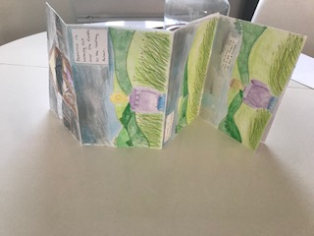
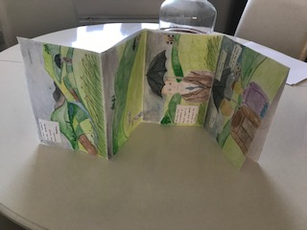
So overall I think I would have used watercolour paper for the final zine, I had to use a large sketch book sheet instead, which didn’t’ hold the paint well, and became too soft and a bit muddy. I would also re-look at the typography and see if I could improve this too.
I did really enjoy this assignment and found my drawing of people is getting much better, and I’m surprised at how I can now draw characters too.
I have found that drawing quickly with people really works for me much better, as long as they stay still for a while!!
I enjoyed looking at comic strips and the process of working in frames really interesting, I was not really interested in this style of illustration before, but I was surprised by how much I enjoyed it and working in this style and laying the frames out.
I think the turning point was when I drew from the film Miss Potter; I really seemed to grasp the idea from then on.
I found using basic narrative structure really helpful and also the story structures research point, both of these and the storyboarding exercise was where I really got into this section. I will take those ideas away with me and hope to use in section 5.
I found writing alongside my illustrations good; I felt the zine needed some words to it to give the illustrations more depth. I looked at the illustrations without words and thought it could be a bit boring, but I think by adding the few words I did it has given more depth, and also a climax on the last frame, will he go in too, or will he walk away?
The only thing I would re-look at as I stated above was the typography; I think this would need looking into more.
I found changing into fictional characters easier, I have always had a good imagination so coming up with characters has never been a problem, I think letting them evolve as you go along helps to make them organic. I find fiction easier than descriptive drawings; because anything goes you’re not restricted.
The Illustrator that I had the most dialogue with was Lizzy Stewart, I did find Oliver Jeffers and Laurent Moreau in a close second as I have an affinity with bits of all three, but overall it would be Lizzy, because her style is very similar to mine, we both use watercolours and coloured pencils for texture and a certain feel, and also the way her style is very naive is similar in some ways to mine. I think her children’s books are really charming and this is something I would like to get into, so I feel our styles are similar, we both like the little details that add so much to an illustration, and our use of colour is very bright and colourful, which is great for children.
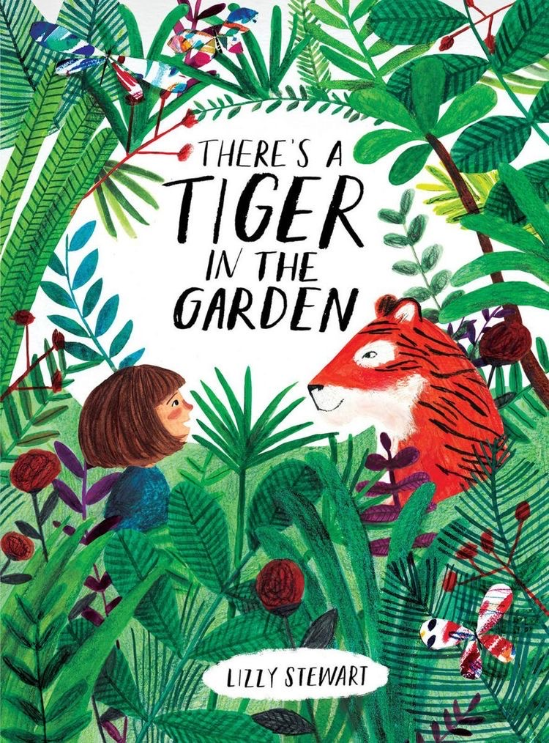

After feedback from my tutor:-
My tutor was pleased with the overall look and feel of the assignment and said ‘it was a well completed assignment’.
I have still gone back over a few recommendations that he suggested which was to include more Characters or animals and interiors in the pictures, and to try and move the frames on quicker, to speed them up and have the narrative cross over the pages.
So I have decided to do a quick sketch out on paper of how I could put these elements in place over the zine content.
So I got a sheet of paper and just sketched out the same style look, then I started to think about how I could change the story so it made it quicken up.
I re-worked the story in my sketchbook and cut out two of the frames, so I could add extra frames to the end, which speeds up the first few frames quicker (and the story)!
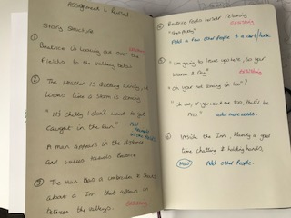
So I kept frame one, frame two I added some horses into the fields to add more to the scenery, frame three was the existing frame, frame four was the existing frame but I added a horse and cart and people inside, to add extra characters.
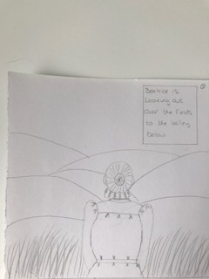

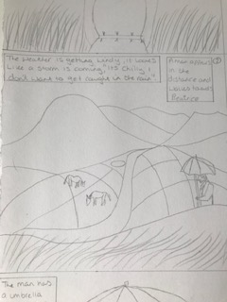
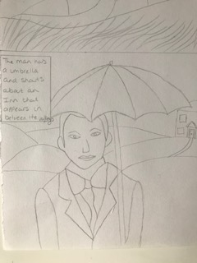

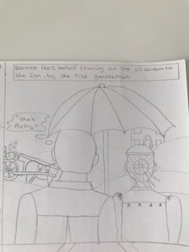
Then frame five was an excising frame, but I added more words to change the flow of the story, as this was the original end to the zine.
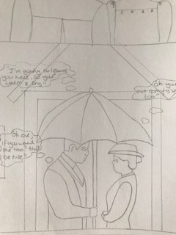
Then frame six was a complete new picture, I added the inside of the Inn, plus a few other characters to the pub, I also added more to the story so it ended nicely and could be considered a short story zine now, rather than an introduction to a longer piece or movie/ book.
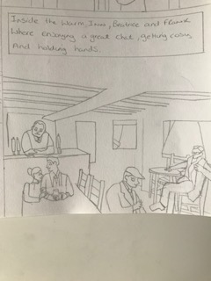

My people drawing skills in this frame took a back step, but at least I’m trying new poses and different types of people, it’s another starting point for me.
I feel the story now works better as a whole and could be a finished complete small short story, ideal for a storyboard or mini zine. I hope this has developed this more to what my tutor was thinking.
I agree the story and pictures move on quicker now, and there’s less dragging on the scenery frames.
This is the finished whole sheet, hopefully you can see it as it’s in pencil, I’ll film the work anyway for assessment so you will be able to see it better then.
