Happy Accidents

So to start me off on this assignment I started by looking back on the last exercise Pareidolia, I went back to the photos I had taken of the faces I found in objects.
I decided to pick out two of them to develop further, one would me male and one would be female.
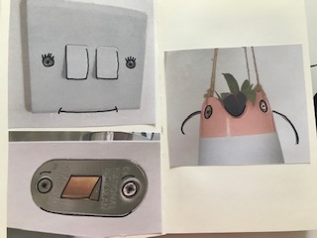
I decided to go with the two characters above, the little hanging pot plant and the door lock; I think they both have great faces and the ability to grow the characters more.
With the hanging pot plant I followed through with the string of the hanging handles and made some simple legs using some string I had around the house.
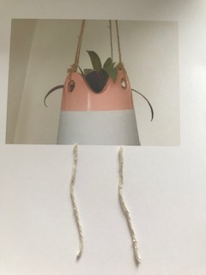
I then took a picture of this and printed it out to put into my sketchbook; I then drew it as a sketch on the next page as a proper little character.
Using the natural string to follow through from the hanging bits really completes the feeling of this little character, as she is a pot plant holder using nature throughout and natural materials really completes her look.
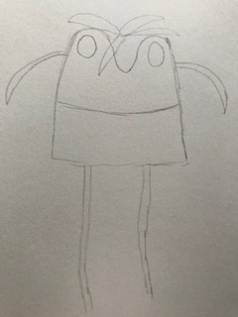
I then did the same with the door lock guy, but this time I decided to look in my screw box for some hair, body and arms.
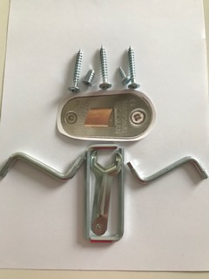
I then sketched him as a little character in pencil in my sketchbook to create him more as a free hand character.
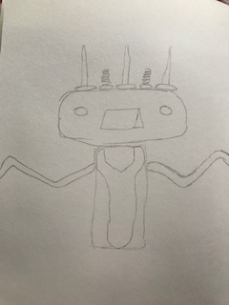
I think using the metal for the rest of his body works well with the overall feel of the little character; he looks quite robot- ish due to the square shapes of his body and head, and the shinny surface follows through to complete him.
I then went on to start point 2, so I went back through my sketchbook and used my view finder to help look at areas of the designs. I found 8 designs I liked for the backgrounds, I want to whittle these down to 4 so I’ve got 2 for each character, then decided on the final ones after that.
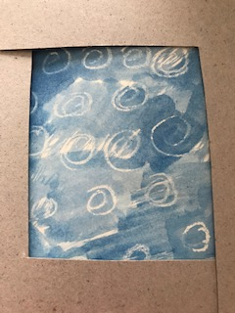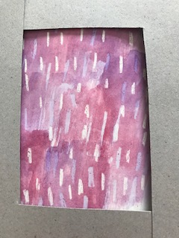

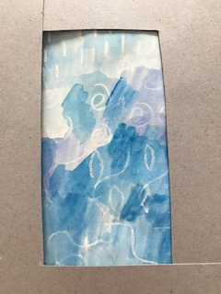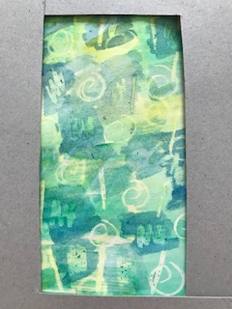

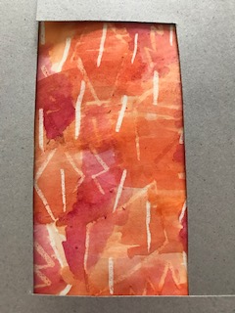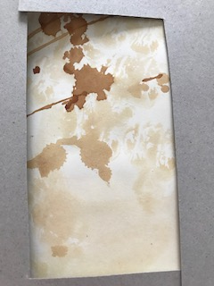

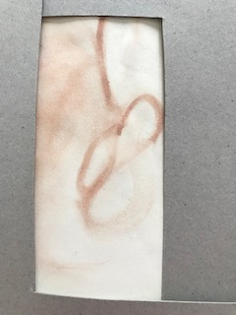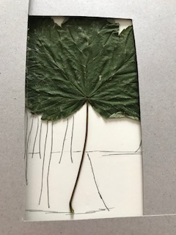

I think these two would work well with the little plant pot character as they are both natural looking and feeling backgrounds.

With the little metal lock guy I was not sure which backgrounds would work well, I think these are the ones I like the best.
With this one I like the blue colours as they are cool colours and work well with metal, I like the textures and the swirls within the paint.
The little guy reminds me of a robot, so this next background it looks quite robot –ish, there are square shapes within the paint and the colours are good for robots.

I then went on to print out these designs again in full, on paper, the I laid or cut out the characters on the top, to see how these would work before I decided upon a definite background design.
The little robot guy I think works best on the green and yellow design background, the shapes and the busyness works really well with the character.
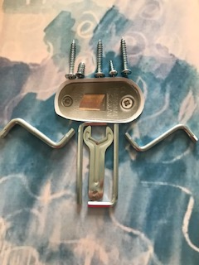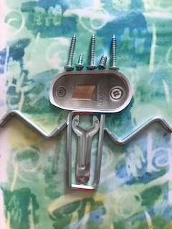
The little plant pot lady I think works best with the leaf trees; it looks like an actual scene or world that she lives in. I think overall out of the two characters and backgrounds this is the one that works the best, so I’m going to push this one forward and work on it a little more.
I want to make the character a little bit smaller so it fits better within the scene and colour some of the scene more to add more background colour.
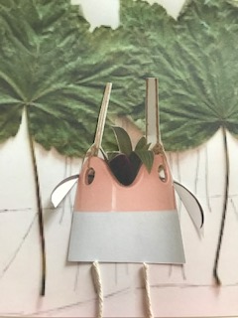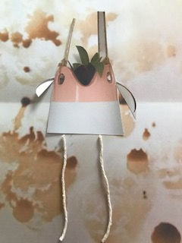
So I went back and printed out another character but smaller and cut her out, then I took the print out of the background scene and coloured in more of the areas.
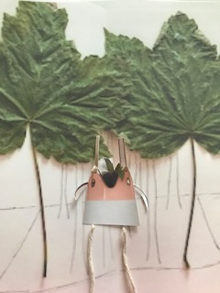
Smaller character to fit her in properly into the background.
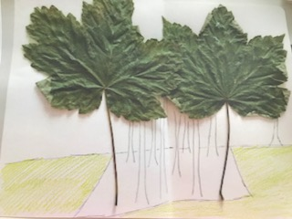
Coloured in the grass
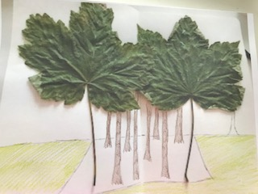
Coloured in the tree trunks.
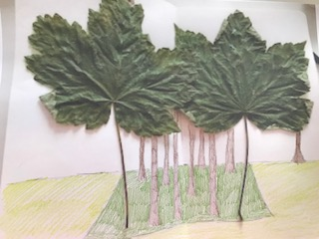
Coloured in the meadow below the trees.
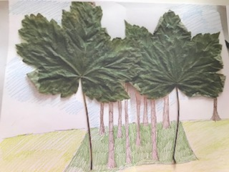
Colure in some of the sky
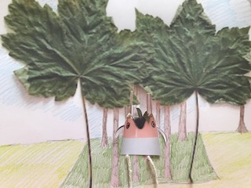
Finished little character in her background world.
I really enjoyed this assignment; I found putting all the elements together from the last few exercises enlightening. I really enjoyed creating characters and found this a great way to develop my drawing skills and a way to develop character ideas.
I liked the idea of creating worlds for your characters and how you can come up with colours or textures or objects that fit within that world or are a part of that world.
The main challenges I came across when working with unusual drawing techniques was thinking of different ways to draw with the paint or medium that I had chosen, but I think once you find a different way to do this initially, you then get the idea and find lots of ways to do this and they come flooding in. I had a look on Pintrest, which gives good ideas and boards on this subject, you can then find similar items around the house and then you can work on this.
The techniques and the materials I might use more in my next sketchbook would be the makeup, I was surprised I had not thought of this before, but there was quite a lot of options and different outcomes with the makeup I had chosen. The techniques would be to just think outside the box, research and look online for technique ideas and to just try it out and not worry about the outcome. ‘Happy accidents’
I really enjoyed moving from observed drawing to imaginative drawing, I find my imagination is a good place to be and can come up with good ideas. I think being interested in children’s book this is a lot easier for me and something I find inspiring and would defiantly continue to do this more and develop it further.
I have learnt to draw quickly and found that it’s easier than I thought; I have learnt not to worry about what you draw and how it turns out. To try and stay loose and just go with it really.
I think when I start drawing people in part 4 it will be easier to just get the outlines down first quickly and then build them up from there.
I liked the illustrations of Lucy Austin and Keith Larsen the best, I can’t choose between them as they are both good in different ways. I really liked Lucy’s textures, colours and paint styles as they were abstract, free flowing and more about how you feel. I liked Keith Larsen’s work because it gave me a real insight of how to build up quirky characters easily from any objects and how you can create a little world for them too. They have both really sparked my imagination and given me a feeling of a starting point going forward.
I have joined a sketchbook circle and there is a separate section for this on my blog, we are already on round two of sharing our work, so please look at that section on my blog for updates.

