Constructing a visual journey
I started this exercise by reading the brief, but I must admit I found it a bit confusing of what it was asking me to do?!
I had a look at other students work and looked back over my unit so far, so I decided that it needed to be a journey of some kind. I started by finding the booklet I had made for the last assignment but then changed it at the last minute, so I had this mini zine spare. I needed to add a few more pages as there was only 4 pages in this one, I added another 3 so there was 7 in total and these were full page spreads, as well as a front and back cover. I used a thicker card this time encase I wanted to paint in it, it would hold up better.
I then started to sketch in my sketchbook a plan of the pages, so I simply did the 7 pages then wrote the page numbers next to it, so this was my starting point.
I then went back over my action plan and the words I had wrote down from the last 2 exercises, I decided I was going to print the list of words out from my computer using different fonts that I felt went well with the word. I then looked back at the last exercise where I used my favourite pieces to create a picture; I then printed these pictures off again to add to my sketchbook.
In the brief it mentioned using all your pieces of work you have created over the last few months, but these are already in my sketchbook, so I was unsure what other bits I should have had. That’s why I decided to print them out again and use these.
I then added the pictures to the pages in chronological order that I had completed them in the unit, in my sketches. Then I added the word of that action I was going to take, so for example on page one, it was handmade sketchbooks so I had a print out of that word for the page and then I was going to add a envelope to hide something in, and show the process in pictures of me creating this handmade sketchbook, with sewn edges.
I did this for all the other pictures I had printed off and the words too, so this gave me a good structure to my book, so I knew what each page was going to be about.
Page 1. Handmade sketchbook – being creative
Page 2. Textures – Being more relaxed and loose
Page 3. Pareidolia, happy accidents – being imaginative/ characters
Page 4. Making it different/ scamper – being inventive
Page 5. Drawing people – quick and rapid drawing
Page 6. Story boarding – working in sequence
Page 7. Story structures - words
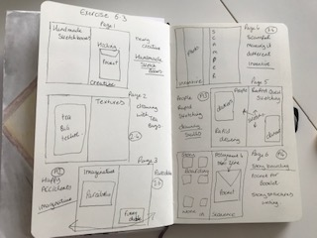

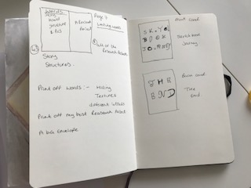
I then started to add all these elements into my sketchbook and cut them out and stick them down, this helped me to see what I needed to do next with each page.
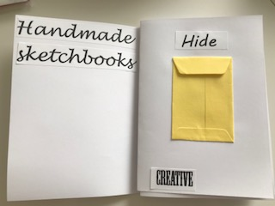
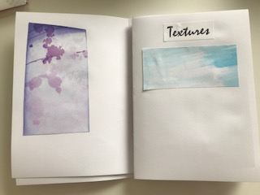
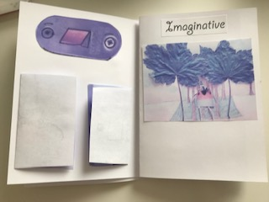
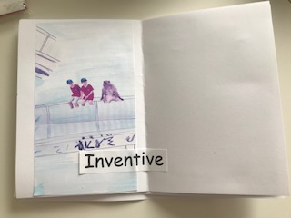
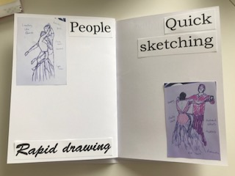
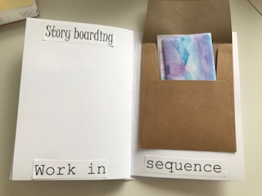
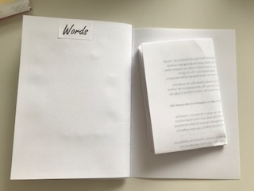
I added more little pockets throughout the booklet and also added words throughout the booklet, so these are things that carry all the way through the sketchbook.
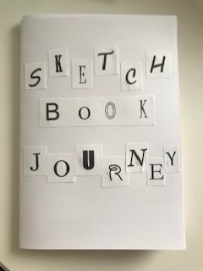
I started to make up the front cover with the different fonts and cut these out and stuck them on, then I coloured them in with brush pens.
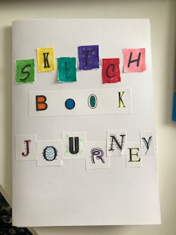
The brush pens had soaked up in the paper a bit, so it wasn’t as neat as I had wanted! But it is a sketchbook after all, and mistakes happen.
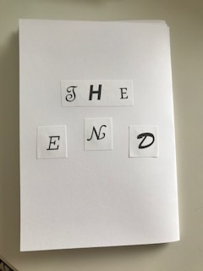
I did the same with the back as well.
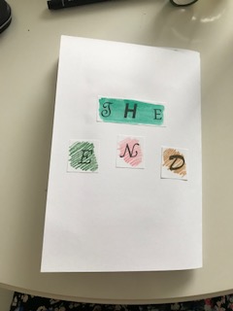
I then started on page 1 and started to draw some sewing bits, as at the end of making this book, I’ll be sewing the spine so it keeps it together, and I get to learn more about handmade sketchbooks to finish them off.
I then added my words from my action plan and also, working on hiding a small handmade sketchbook, which is in the pocket.
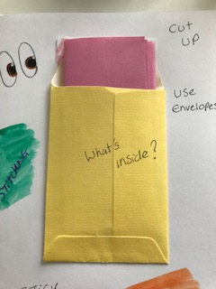
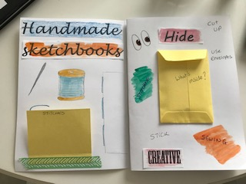
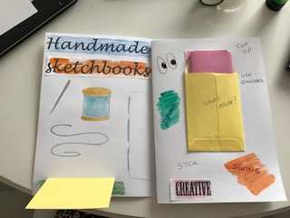
I then started on page two which was about exploring textures and using unusual things to create effects and mark making, so I had a two images which I printed out from my work, then I created some more textures, using a fork, a cotton bud, a pen top and a scrunched up kitchen towel.
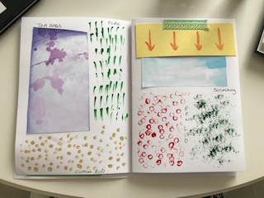
I added a flap, to hide a small bit and put some arrows on these to show you should lift it up.
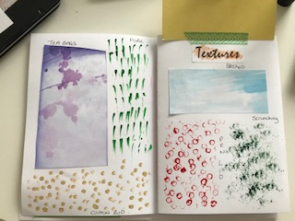
Then it was page three which was the imaginative and Pareidolia page, I really enjoyed doing this page as it was full of characters. I used my best character from Assignment 3 and added in the Parediolia characters from 2.6.
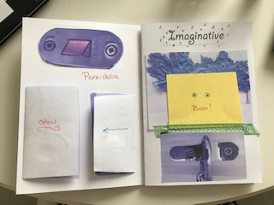
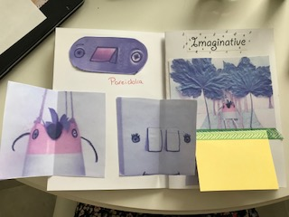
I added a screen to put my best character behind with the word BOO on the front and I folded two of the others so you had to open them to see them.
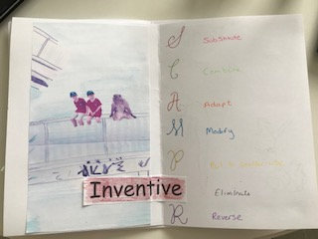
Page four was less images and more words; I added my favourite picture from 3.4 and the SCAMPER words and meanings as I found this a good element to take forward.
I chose some script writing which I used for the first letters and incorporated the INVENTIVE word into it with the letter ‘E’.
Next was page five which was all about drawing people and my work to strengthen these skills further, I have found out I draw people quicker and more rapidly, which helps me to capture them better. I incorporated 2 images of my dancers from strictly, and then I drew another 3 people rapidly to fill the page.
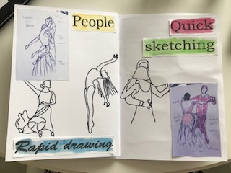
Then it was page 6 which was about storyboarding and working in sequence, so I drew and painted a decorative storyboard, with the frames, which helps me to remember to think of frames when I sketch a storyboard. I then added a large envelope and printed off my mini zine from assignment 4 which I really enjoyed and folded this up and popped it in to the envelope.
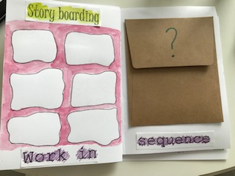
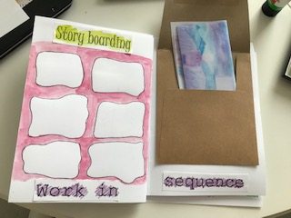
Then came page seven the last page, this one was about story structures which I enjoyed learning about, and again would be something useful to take forward with me, It would help a lot. I wrote out the concept so it was something I could look back on. I then added on the last half of the page, my best written piece of research work, which I got good feedback on from my tutor. I printed this out and folded it into four so it would sit on the page, then stuck it down.
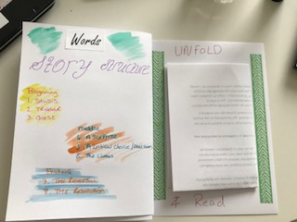
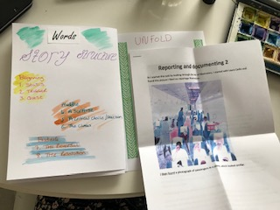
So I have now finished the sketchbook, I just need to get some cotton and a needle to sew the spine up together, to keep it all neatly.
I have not used loads of works or sentences for this sketchbook, as I like the idea of remembering what I had done from the pictures I have drawn inside and the print outs. I like the words I have chosen and the ones from my action plan as it tells me what’s next.
I enjoyed the creativity side of this exercise and found myself really looking for inventive ways to make it feel more interesting and interactive. I think I have put some of the elements I have chosen for my action plan all the way through the book, which I feel brings it together more.

