Making Connections
I started this next exercise with reading through the brief and thinking about what sketches I had done in my sketchbook, which I would like to include in this exercise.
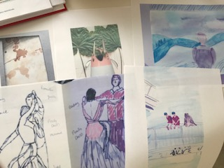
These are the sketches I liked the best from this whole unit, I also compared them to the list I had made in my sketchbook, for the last exercise and this includes, quick sketching which I did with my dancers that you can see here.
I also had using my imagination, so I did this with my sketch with my nephews and the monkey, and making things different.
I also wanted to include my little parediollia character ‘Mr Plant pot’, which was also using my imagination.
Then I wanted to develop my drawing of people, so I included my drawing from the last section = 4, and also use my creativity in experimenting with different textures and the ‘Tea’ bag background.
I cut out and bought together my sketches in to a design roughly on my table; I was piecing together my collage, and wanted to use the SCAMPER process, and to ‘make it different’ too.

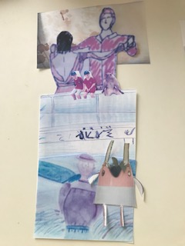

I tried different ways of arranging the collage to see what worked best, I think the one above was better, I just need to get the positing better.
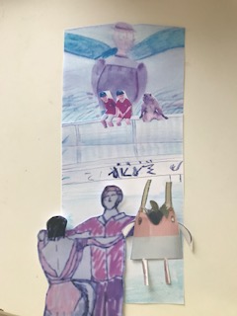

This is nearly how I want it, but the background ‘Tea’ texture was too small, the bit I printed off, so I need to make this A4 size so it fits behind the design better.

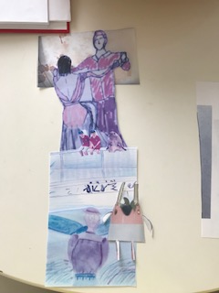

This is how it turned out after the re-size of the background texture, I tried to make the layers work to give perspective and depth to the design, and to also make it different!
I took off the top section (the sky) from the last image, I took the background out of the second image, and I made the 4th image a lot bigger than the others to make the dancers look giant!
I think the design has an exciting look about it, and it would make a great story! I think this design shows all the aspects I wanted into one design, to move forward with.
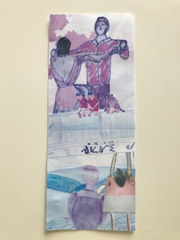
So the images that I used from my sketchbooks where the following:-
1.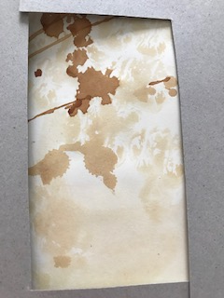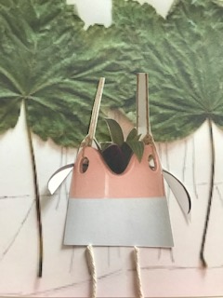2.
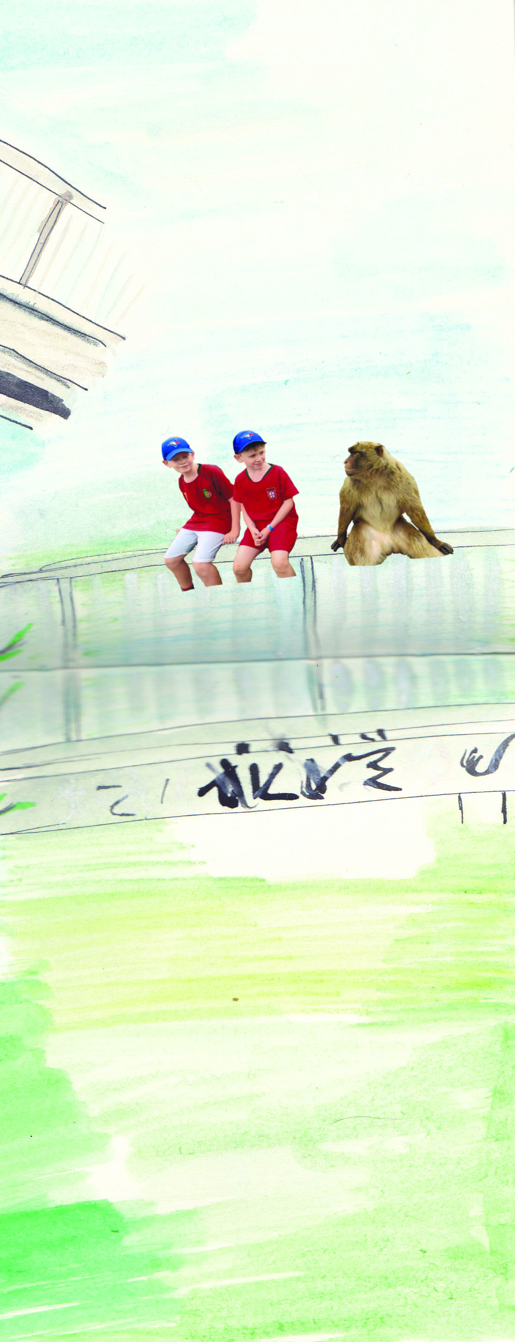 3.
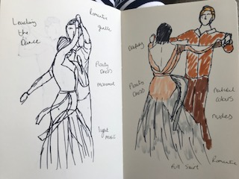 4.
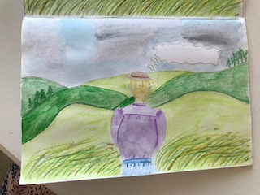 5.
I think they all connect as they are all people or characters and they are in a rural setting, there are some fast sketching included, and some textures, sketches where I used my imagination more. I think they all work well as they link with each other but also work individually.

