Taking Stock
To start this exercise I went and grabbed all my sketchbook’s I have used whilst completing this unit.
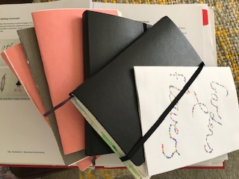
I have six in total, four are small made booklets and two are Moleskine A5 size plain art sketchbooks. I started to look through them and back at all the work I had done for this unit.
The first handmade sketchbook was for the exercises in part 1, where we had to make foldy zines and working on the idea of hiding work as well as showing work.
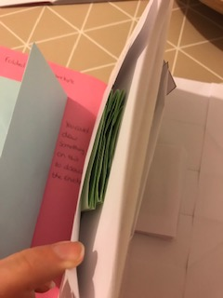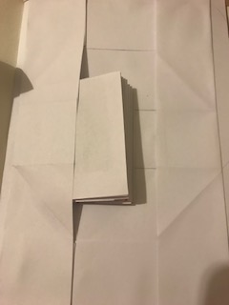
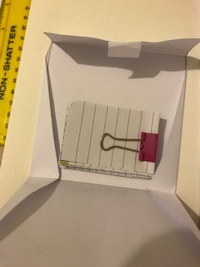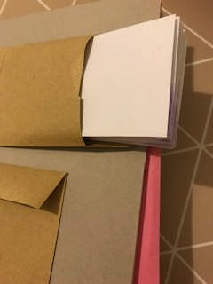
I really enjoyed the creative side of these exercises and do continue to use some of these ideas in my own sketchbooks. I find it helps to store bigger pieces of work, by folding them up and hiding them or just storing them in my sketchbooks.
The second mini sketchbook was for what I use my sketchbooks for, so this was some watercolour experiments I had done, working on texture and mark making.
My sketchbook for the first Assignment and was a handmade A5 booklet with a general day to day diary type sketchbook, with many different things in it.
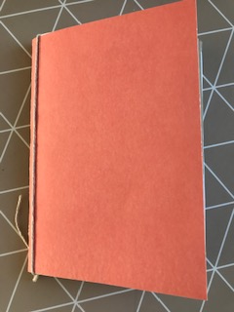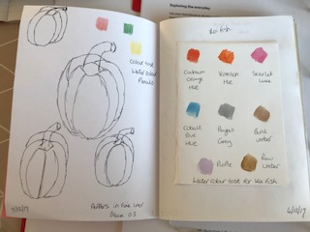
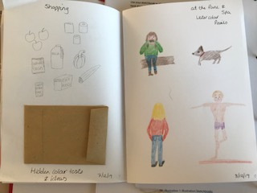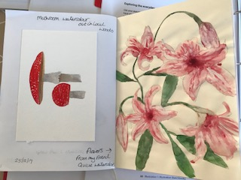
My people drawing skills were not very good here, and the sketches were quite small and detailed and looking back now feels quite restricted.
With this first unit I became more aware of the creativity of a sketchbook, and how it shouldn’t be restrictive. As well as new ideas of how to show or hide work, and leaving mistakes in as well as better sketches, I was beginning to feel freer and had loosed up with regards to the relationship I was having with my sketchbook.
In my feedback it mentions that I have a lot of variety in my sketchbook for assignment 1, which I think is a positive, it makes it less repetitive, and shows the variety or work I am interested in.
My figure work needed more work, but it was something I tried to focus on in this unit.
Section two was more about sketching styles; I started in my Moleskine A5 sketchbook for this section. I tried out rapid sketching, limited line drawings, investigating processes and blind contour drawing. I found all these were to draw more liberating, and I was beginning to see and experiment with other ways to sketch.
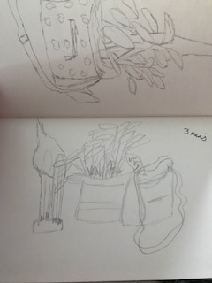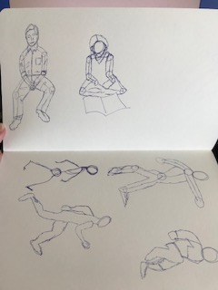
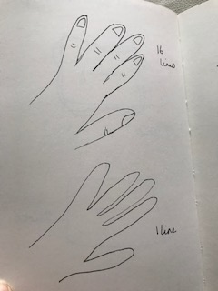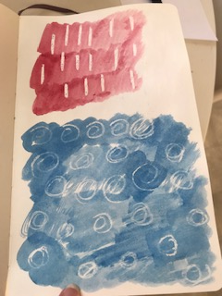
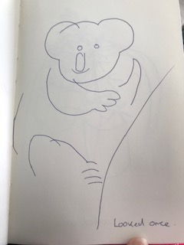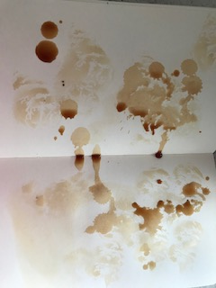
Pareidolia was the next exercise which I really enjoyed; this was a creative piece which really caught my imagination. I loved looking for little characters in everyday objects and really enjoyed the assignment that came after where you had to add your characters into backgrounds.
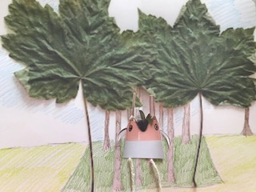
I think at this point I realised that literally anything goes in a sketchbook, the creativity is limitless!
I found in my feedback for section two that I seemed to get better comments for the quick sketches I had done, my style felt freer and I got the better results from this type of sketch work.
I had feedback on my written work as well, which was that I had expressed myself well with the written work and comparing Illustrators and talking about their work.
My Pareidolia work was successful and my characters were well received, I was told my image in the landscape was funny, charming and well developed, bringing together all of the aspects of the section well.
I think having sections that can engage my creativity is something I work well with and having a freer hand when sketching quickly see’s better results.
For part three I carried on in my Moleskine A5 sketchbook, people and place were the things we would learn in part three, which I was looking forward to as people was something I really wanted to get better at drawing.
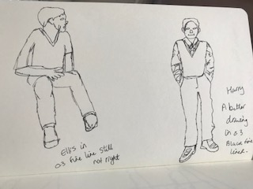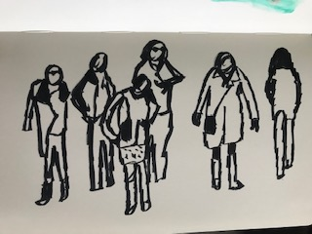
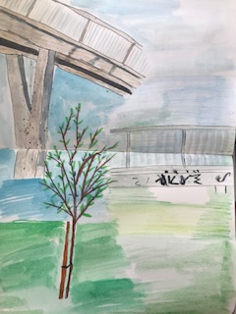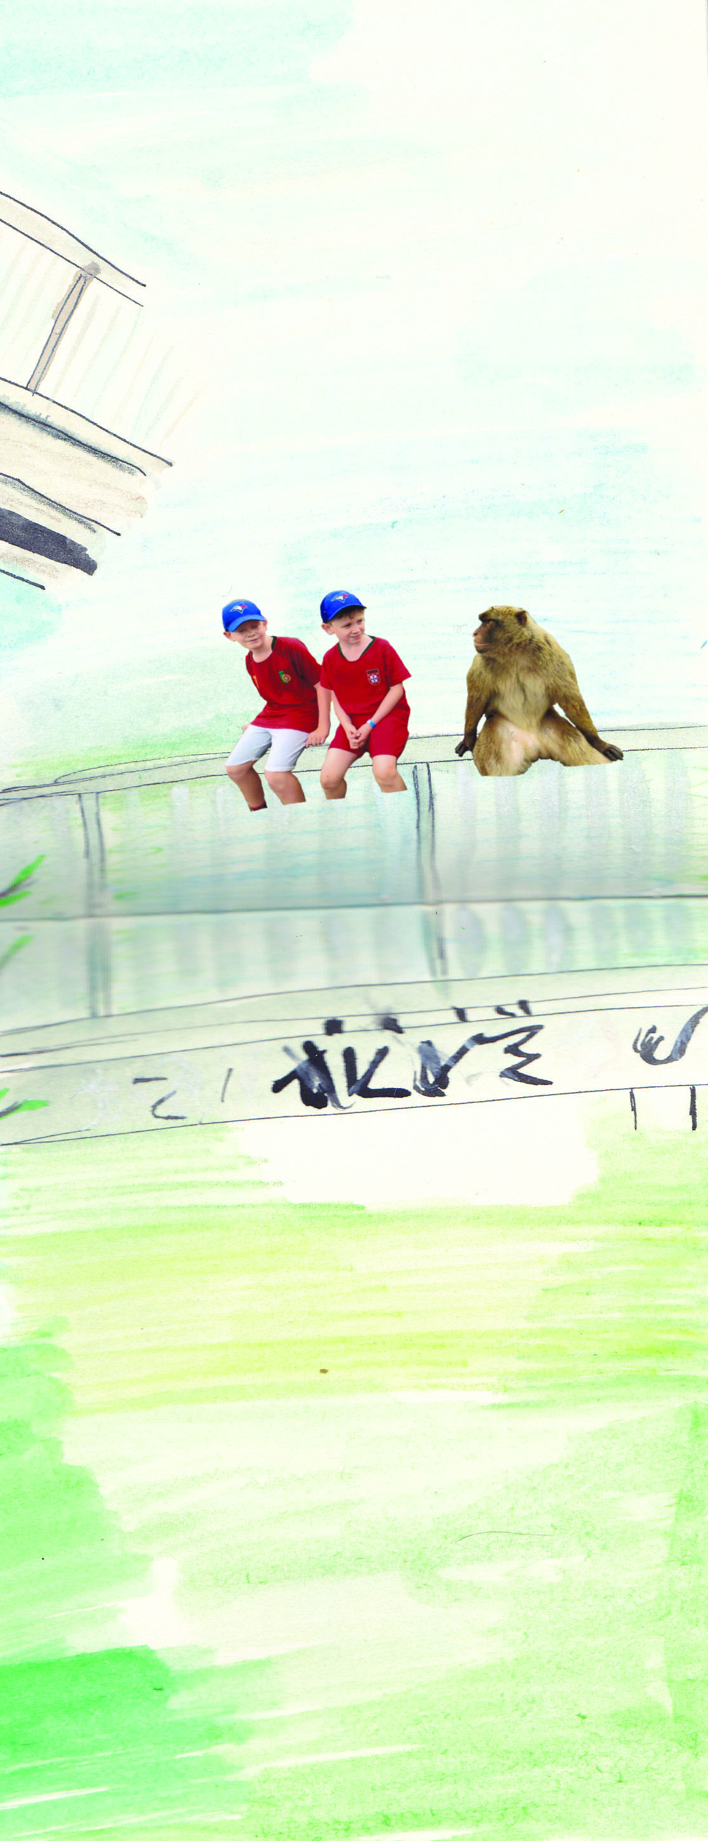
I found some exercises harder than others in this section, I was beginning to become more confident in drawing people, and using the quick sketch style was helping, although my feedback was that it was a little unresolved in places. In exercise 3.3 Illustrative drawings the feedback I was given was that my work really improves in this exercise.
Again the feedback on the written pieces was good and I had been told I had considered the different approaches of illustrators well.
Assignment 3 was a mixed bag, I feel that this was the point that I really got the hang of and understood more about drawing people, I felt my sketches of Mick Hucknell and the dancers from strictly really turned a corner, they were quick sketches, a lot freer and had movement in them. I surprisingly really enjoyed this assignment; it bought together a lot of different people that I think were quite well drawn.
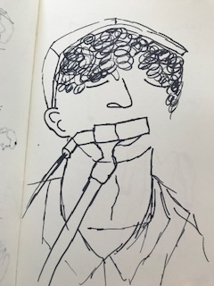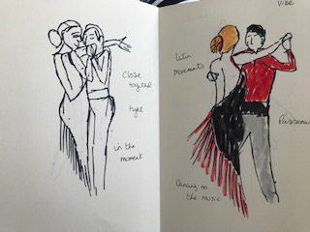
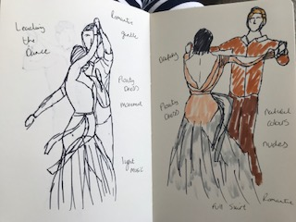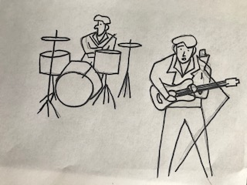
The feedback was good; it said that I understand the essence of a figure or expression better than if was working from reference.
The feedback mentioned the poster could do with more work to look less flat, as all the figures are the same size and the contrast between the colours could be better. I will re-look at this before assessment, but overall happy with the breakthrough I had with the sketching of people.
With part four I was now into my second Moleskine A5 sketchbook, this part was about sequence and narrative.
I really enjoyed the first exercise of ‘fill it up fast’, and again hand made a sketchbook for this exercise.
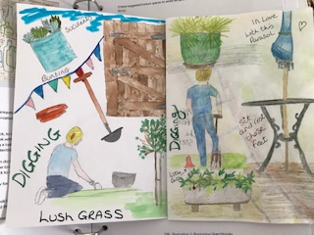
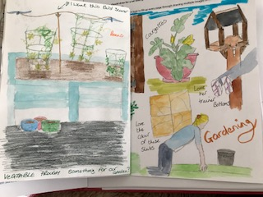
I enjoyed trying to fill all of the pages in this book, and used lots of colour. I did find drawing the gardener quite hard, as she kept moving away and coming back again, so it was difficult to even sketch quickly. It’s something I will work on going forward, so I get the essence quicker, and then I can work from there.
Again it was tricky because of lockdown, but it was nice to go somewhere and finally draw someone else.
Again I found exercise 4.1 tricky and a bit restrictive again, but I enjoyed the written work to accompany the drawing.
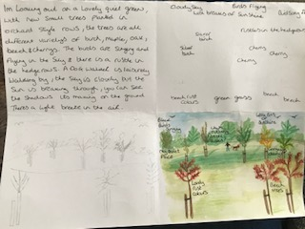
I was daunted at first with exercise 4.2, as I didn’t know how this would turn out, but again I was surprised how much I enjoyed this, and again how much my drawing had become better, especially of the characters.
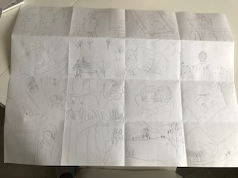
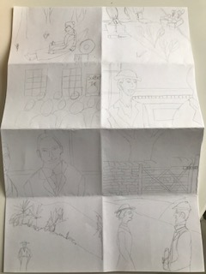
Some of the frames needed extra work, but overall this was a great exercise and something I understood well.
I was not too keen on exercise 4.3, but I enjoyed using my imagination with the letter and the story, I thought I was inventive with the pictures used and how I combined these into the letter.

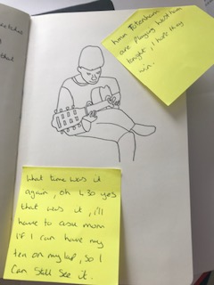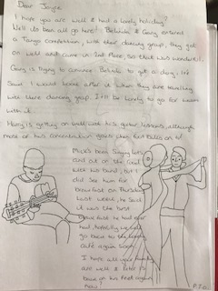
Again with exercise 4.4 I enjoyed this piece and got into the feel of the idea, I liked the sketches of all of the drawings, they are basic yet effective.
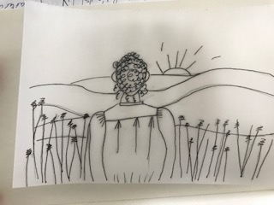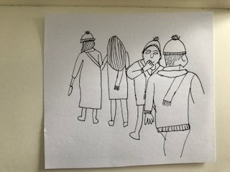
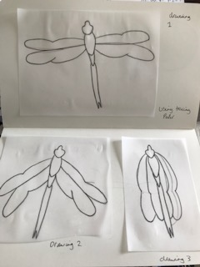
Then we got to assignment 4, where I had a good couple of day’s not really sure where to go with this! But after re-reading the brief and looking back on what I had done, I picked the one I enjoyed the most and worked from there.
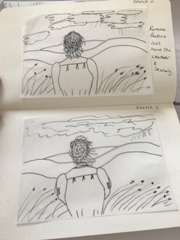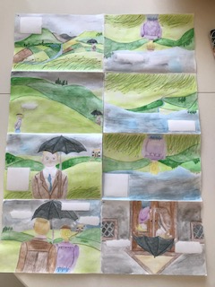

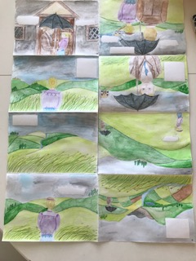
I think the combination of the unit came together in this last piece, and I think the characters have developed well, again it’s still not finished to a high quality, but as it is just a sketchbook style, I think it works well.
I have definitely enjoyed and become a fan of frame sketches and comic style books, I think having a limited amount of writing works well for this piece, but overall I can see how writing can add to illustrations to give an overall feel of the story.
Answering the questions in the brief:-
What did you connect with most?
-Handmade sketchbooks and hiding work
-Creative exercises
-All the written exercises
-Rapid sketching (especially people)
-Characters and Pareidolia
-Understanding how words interact with illustrations
-Storyboarding and sketching frames.

List what you enjoyed least:-
-Journey style sketch booking
-Reportage drawing
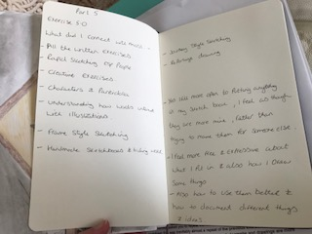

Have your opinions and thoughts changed about how you keep a sketchbook?
-Yes I feel more open to putting anything in my sketchbook, I feel as though they are more mine, rather than trying to make them for someone else.
-I feel more free and expressive about what I put in and also how I draw some things.
-Also how to use them better and how to document different things and ideas.
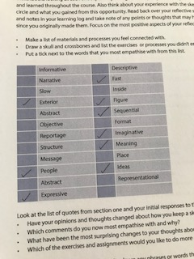
I empathise with the following comments:-
-Exterior
-People
-Expressive
-Fast
-Figure
-Sequential
-Imaginative
-Meaning
-Ideas
What have been the most surprising changes to your thoughts about sketchbooks?
I would probably say the more imaginative side of using sketchbooks, being more creative and how to develop characters and using your sketchbooks in different ways, like story boarding and reportage. I would probably use my sketchbooks more for taking on holidays or days out and report on what I see and do (including people). I would also use my sketchbooks now on developing short stories, through storyboarding and story structures, as well as developing characters through Pareidolia. I would also have pockets in my sketchbooks now, for collecting things or hiding things.
Which of the exercises and assignments would you like to do more of or return to?
There are a few: - I loved the Pareidolia assignment and also the Illustrating people and places assignment, but I would have to say, because it was my aim from first starting this unit would be the storyboarding assignment from section 4, just because I want to continue to develop my people drawing skills and this was the one I was the most surprised how much I enjoyed.

