Assignment 5
Application and Context
I started by reading through the brief and looking at what I needed to do, I read through the 3 options it gave you for your final assignment. I had already had a little look through and I was torn between option 2 People and Place and option 3 Everyday stories. The reason why I decided to choose option 3 in the end was because option 2 you had to produce a poster, wall mural, tote bag or backdrop, and when I did my poster for Assignment 3 the feedback was not as good as Assignment 4 which was a storyboard.
Option 3 asked for a storyboard on the everyday (my everyday) so I wanted to keep to my strengths and produce another storyboard.
I wanted to also include my people drawing skills, so what better place than to start with drawing myself!
The first steps I made were to write down a plan of action for the work, to work out what I needed to do first. So I started with the actual sketchbook, and thought about a handmade design that would take my sketchbook making to the next level. So I researched handmade sketchbook and bookbinding.
I found some help in Pintrest and printed off some ideas that I wanted to explore and add into my sketchbook.
My initial thought was to sew the book together, but then I found some others that were more inventive using rubber bands and pieces of wood, or pencils.
I left this at this point as I wanted to mull it over and see what I could pull together, I then moved onto making a spider diagram of ‘my everyday’.
After this I started to pull some sheets of paper together for my sketchbook, I used some thick white card, some tracing paper, some paper I had washed with watercolour paint. I had some patterned paper so I added that too and some envelopes. I wanted to create a really handmade feel to this sketchbook and make it really creative.
I folded all the paper up into an A5 booklet, then I washed the paper both sides with watercolours, to give some texture and it’s what I work with most, so added this as a background.
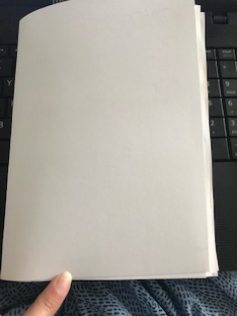
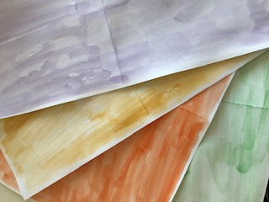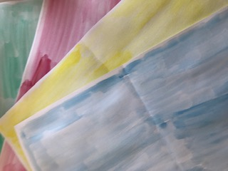

I also found some scrap paper that I wanted to use as the cover; it has a handmade feel and has patterns in it too, so I thought it would represent me well.
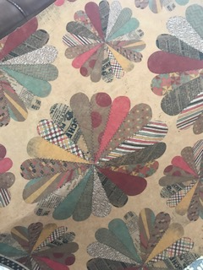
I started in my sketchbook and added a list of everyday things that I do, I must admit my ‘everyday’ like I suppose most people has changed quite a lot over the last few months with the Coronavirus. I wanted to have this as a background feature to my sketchbook, but not make it about the Coroavirus. I’m getting to grips with my ‘normal’ everyday, not only because of the Coronavirus, being made redundant, but also losing my Nan in March and my dad in June. So literally my everyday will never go back to the way it was, so this sketchbook is about my ‘new normal’, I’m making it a positive thing and something that is good to document.
So my new list is about working from home and becoming self employed, spending lots of time with my mum and helping her get through what has happened.
I highlighted the words that are going to become the basis of the story, it’ll be a basic story based on a time in my every day, it could be part of a film or storyboard for a book.
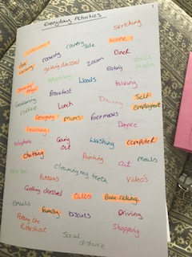

The words I highlighted were Walking, dog walking, work, designing, learning, mum, self employment, chatting, computer, calls, family, bike riding, and cat.
I then added in my action plan from the last exercise of what I wanted to use in my sketchbook and also words that will describe what I’m trying to achieve.
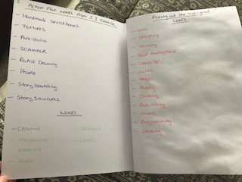
I then went on to look at everyday textures, which was textures with tea and this time I also used coffee granules. Then I looked at what I used each day, and kept some packaging from these items and added them to my sketchbook, like toothpaste, milk, porridge, tuna for my cat and dark chocolate.
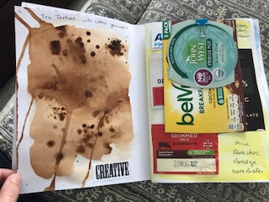
I then went onto look at binding for sketchbooks, sewing them and what stitches to use. I filled a double page with ideas and also some extra pages with actual stitches and sketches of stitches and ideas.
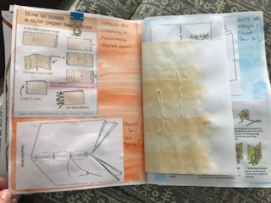
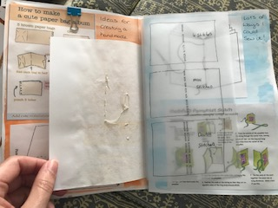
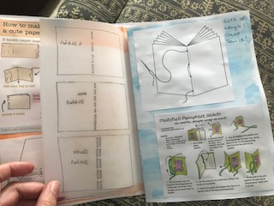
From this I thought about being more imaginative, so I decided to forget the stitches idea as I had used this for the last exercise, then I looked into creative ways to use a rubber band.
So the next page is full of ideas about rubber band fastenings
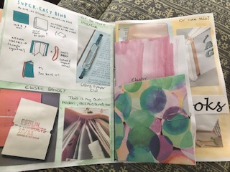
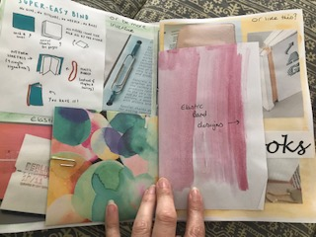
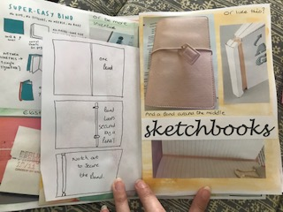
I then stopped at this point as I had already run out of pages, so I added some more and then did a plan of how this would work in a booklet and how many pages I would need. I worked out I would need 24 pages, this would include the final storyboard design, the front and back cover are extra.
I then drew this plan out and wrote in each page and what it would include, so I could gauge some sort of strategy and intention to keep the sketchbook on track.
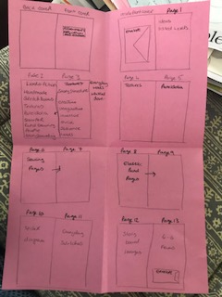
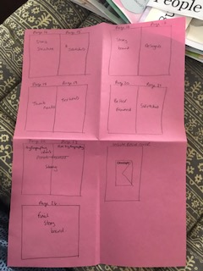
My next page included the spider diagram I created earlier and a page of my everyday, so I did a sketch portrait of myself on the phone, I also created some smaller sketches on everyday items or things I did. Put I added a little pocket envelop to add in some pattern work I had been working on.
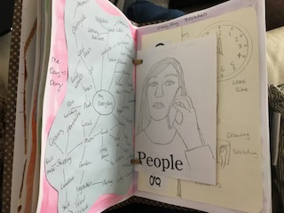
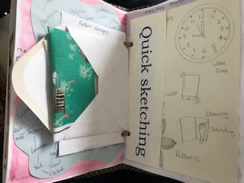
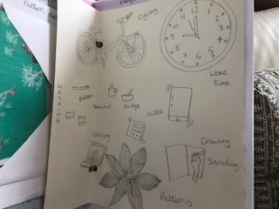
I have found I have become more creative with this assignment and have found things clicking into place with sketchbooks. I have really enjoyed pulling this design together and have been inspired by what I have learnt so far.
The next page was the story board designs I had fund on Pintrest and also some designs for short story’s which are just 4 or 6 frames long. I liked to look at the designs of how they made them more creative and set them out decoratively.
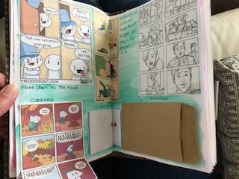
Again I added a little pocket where I put my favourite one’s so they are slightly hidden.
I then added a page on the story structure, now this changed a little once I had moved onto the final story board design, but the essence of the story is still there. I also did a quick sketch thumbnail page just to start to pull together ideas quickly on paper.
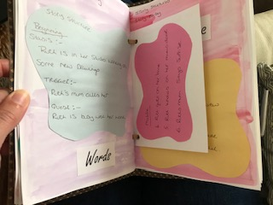
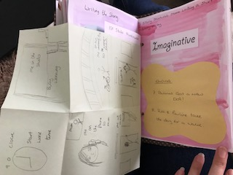
Then I did a page on designing my own storyboard designs, I mainly kept them simple but I found these most effective for very short stories. I had a little pocket in the patterned paper, where I again added my favourite designs so they were hidden.
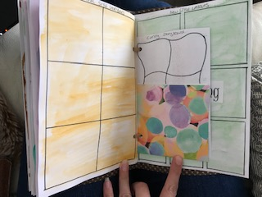
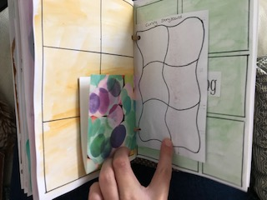
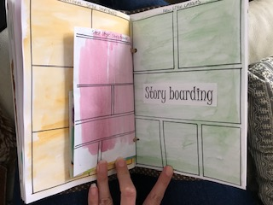
Then I started the Pareidolia page, I used my character from Assignment 2 to turn into a dog character for this story, but I used the outline of the pareidolia guy and slowly by each pencil drawing turned him into a dog.
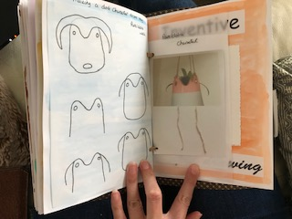
You can see here how step by step I changed the flower pot guy into a dog.
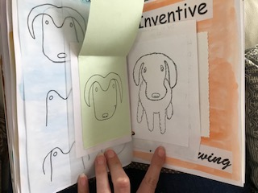
I then went on to draw him and paint him in watercolours.
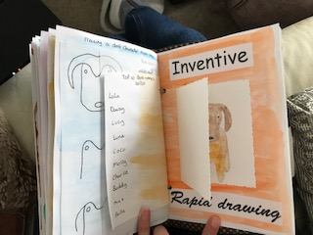
I also made a list of the top 10 dog’s names for 2020. I think he ended up being quite a cute character, and it has also shown me how I can turn other images or work into something new, and also how Pareidolia can help develop new characters.
Then I started to pull things together and did a proper storyboard style and worked out some sketches for each frame, I tried a few ideas for this, but it helped by looking at it properly in sequence and how I could move it forward and what bits I needed to change.
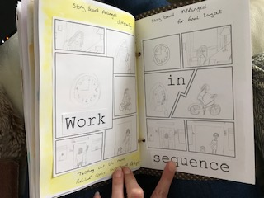
On the final page I started looking at works and how I could make them decorative, I was not sure if I could or would use this in my final storyboard, it would depend on space and style, but I enjoyed looking into words and decorating anyway.
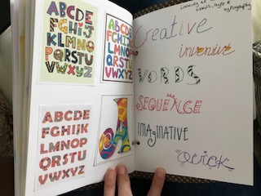
I then hole punched each page and small inserts, so I could thread with the elastic band, then secure with the pencil on the front.
So this is the final sketchbook and cover, I really like the design and pencil idea it really compliments the sketchbook and what it’s used for. The design on the cover is also very appropriate for what’s inside and also my everyday life.
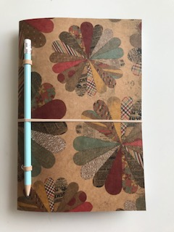
So from all of this I then went on to design my final story board, I used watercolour paper for this, as I knew I would be painting the design in watercolours, so knew from experience to use the proper paper to get the best result.
Now although it is not a finished piece, I still wanted to make it look as good as possible, so tried to use the right paints, paper, brushes, pencils and designs to achieve this.
From the ideas I had gathered in my sketchbook, I had decided on a simple story board design, but I chose to add interest by choosing irregular sized frames instead.
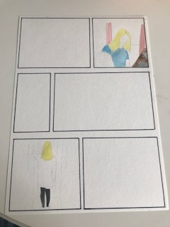
I the sketched in the two frames I knew I wanted in the design and painted these in.
I then added a clock to frame one as I felt this would be a good introduction, and set the scene, I wanted this story to move quicker as suggested by my tutor for Assignment 4 and concentrated more on the people and figures than the background scenes.
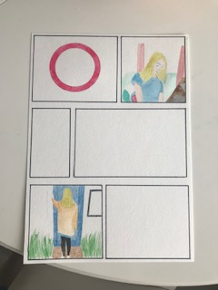
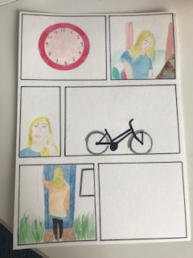
I then worked on another two frames and made them close ups and more distance images to ad variety to the pictures.
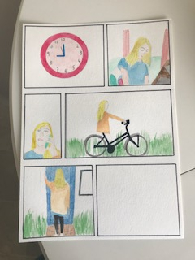
Once I had got these frames in, I just needed to add my mum into two of the frames and also the dog character to the last. I used watercolours and watercolour pencils for the painting; I tried to keep to a limited colour palette through the story, and also added a highlight of the pink to run through the frames to give it some consistency.
I finished the painting, then I started working on the words, now there was not enough room to add decorative fonts and type here now, so I chose to use black fine liner in the boxes.
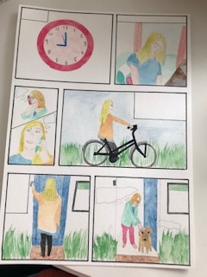
I also used coloured fine liners for mine and my mum’s speech bubbles. Now the drawings of my mum were not quite how I wanted them to be, they got a bit stiff and lost; I think the speech bubbles help.
I did also want to add in a background texture on some or all of the frames of the tea and coffee granules, probably mainly the clock one to show it was morning.
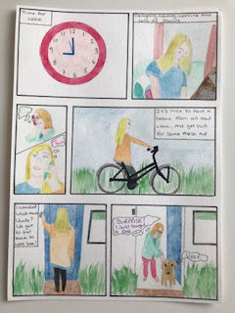
Overall I am pleased how the sketchbook turned out, I think it has grown in creativity and pulling everything together over this unit, I think it includes some break through moments and things I have loved doing.
I am also pleased with the story board, as it is an un-finished piece, there are definitely things I would add in and change in the future, but as it is I am happy with it.
This is the video of the sketchbook and how all the pockets and elements work.

