Your own work
So I started this exercise by looking back through all my sketchbooks from this unit so far, I currently have 14 sketchbooks from this, so a lot to look through!
I have marked the sketches or artwork I liked the best, I picked out 7 to start with.
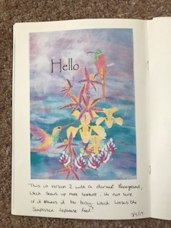
Starting from right back at the beginning of the unit for assignment 1, I created this piece of artwork, it wasn’t the final piece I chose for the assignment but I just love all the elements, the hand painted watercolours, the use of oil painting texture in the background and the colourful feel of the illustration.
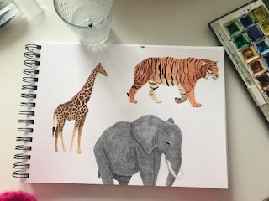
This was number 2 this was some watercolour illustrations I created for exercise 2.3, I loved the idea of ‘wild’ behind these illustrations and thought this would be a great idea to put into some sort of illustration. I liked the colours and the animal pattern on the animals that I painted.
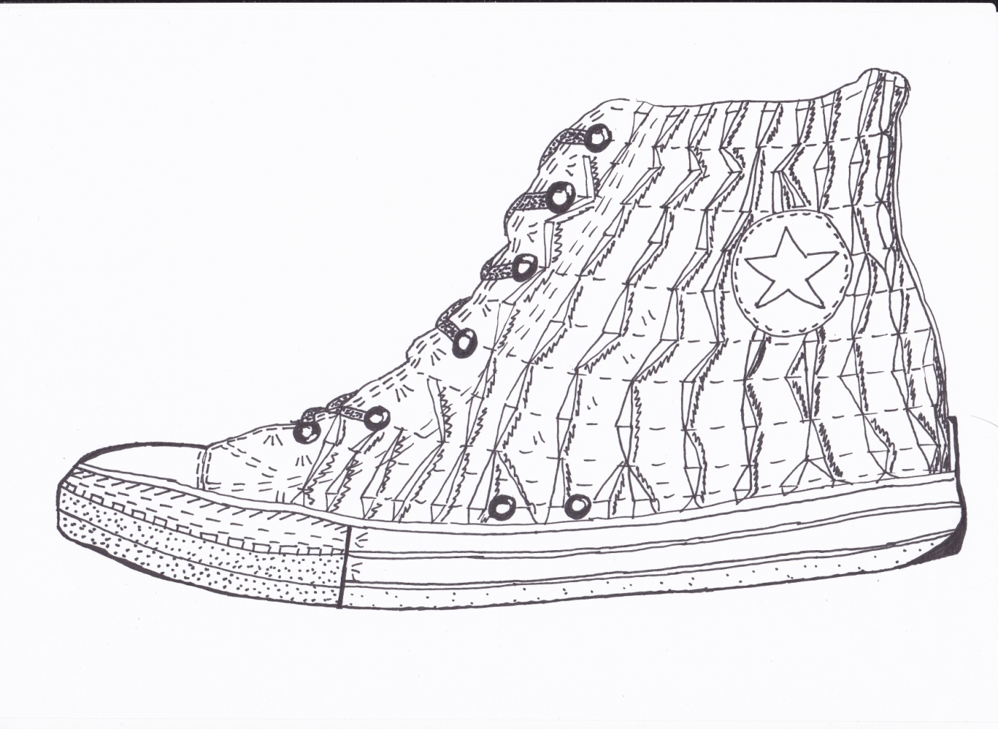
My next illustration was this shoe from exercise 2.7, I really enjoyed drawing my converse trainer and thought this would be a good starting point for a illustration for a magazine or newspaper, or maybe some advertising for shopping? I like the texture of the shoe and how I have drawn this and the fact it is in black and white yet its obvious what the make and design is.
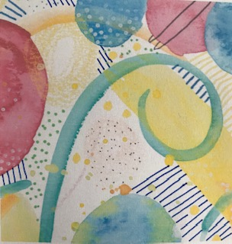
This illustration was from exercise 3.4 I just love how I created this from music, I love the textures, mark making, colours and use of fine liners, all the things I love to create with. I thought this might work as fabric or as the exercise was about music an album cover.
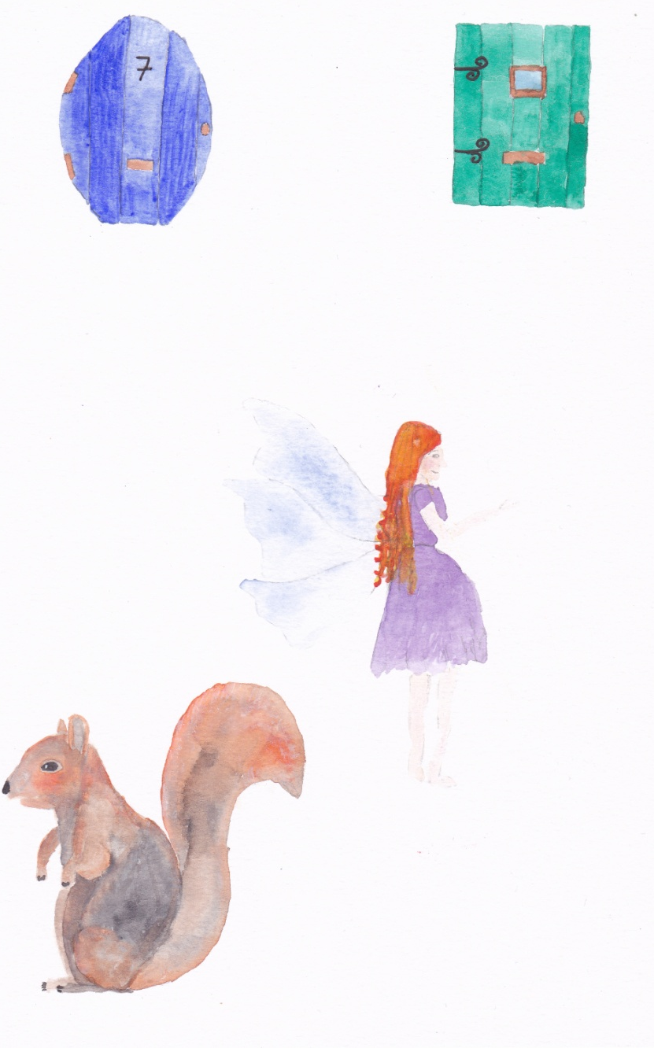
This was my next choice the watercolour illustrations I created for exercise 3.8, I think these little characters (the fairy and squirrel) would be great for a little story or a short story in a magazine?
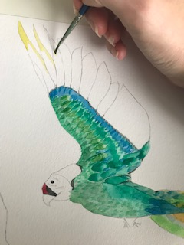
I really liked this bird character I created for exercise 4.2, I loved painting him and I used watercolour pencils and ordinary pencils along with my watercolours to draw him. I love all his colours and the details on his feathers. He really is an easy character to create an illustration from for a book or magazine/comic.
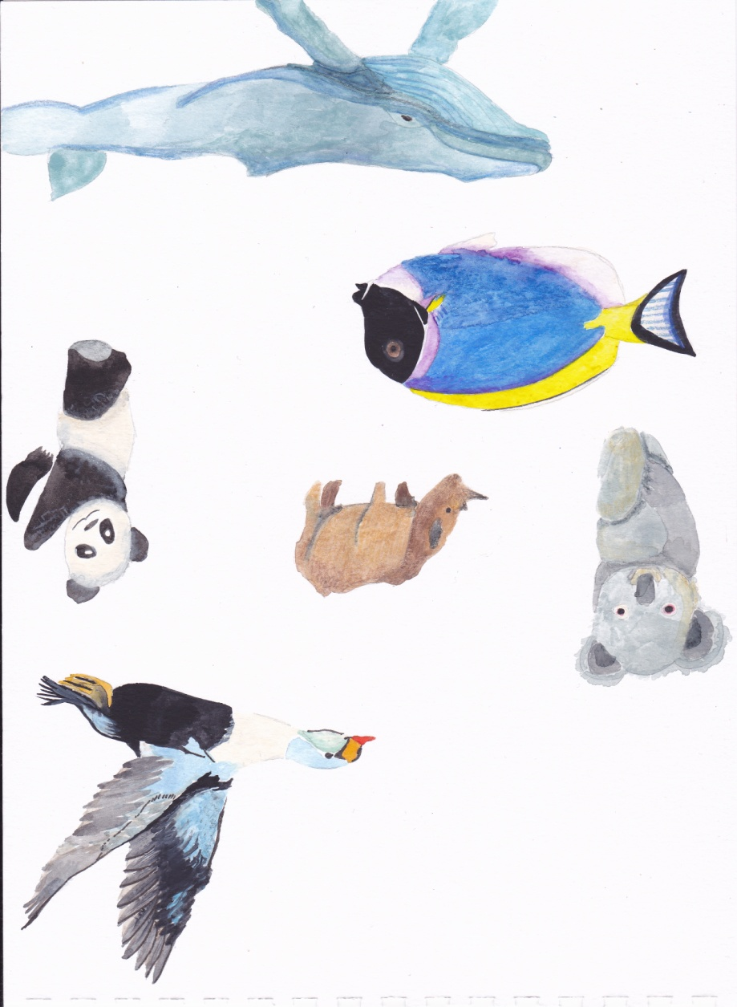
The final ones I looked at where these watercolour illustrations of these different animals, but I really liked the little panda the best and thought he would make a great character, or maybe a design for children’s clothes, accessories or bedding?
After looking back through all my sketchbooks, I couldn’t believe how much work I have created and how many little sketches or designs I had drawn.
Having thought about all of them, I wanted to create a mood board so I could see them all side by side and see what feeling I got from them.
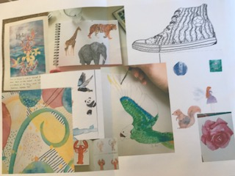
From this I decided upon 2 illustrations I liked the best, the first one was the first illustration of the hummingbirds and orchids etc, I chose this one as it has a nice feeling about it, I like the colours and the textures and I feel it represents me. The second one was the giraffe in the set of wild things illustrations, I chose this illustration as I like the markings on the giraffe and I just like giraffe’s.
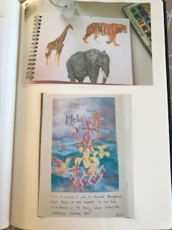
From this I started to think about what sort of authorial practise I wanted to choose and would work with the illustration I had chosen. I wrote down a list of how I thought I could use each illustration and how they would work on each authorial practise.
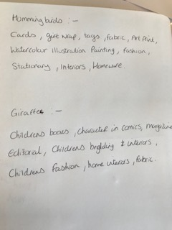
From this I decided that the hummingbird illustration was more complimented towards stationary design, which could be used on wrapping paper, cards, tags, notebooks and diaries, and the giraffe was more suitable for fabric, which then could be used for children’s bedding, clothes or interior designs
So from this I needed to create a surface pattern design, I started to look into costs of each of these items to see which one was more cost effective.
I found that wrapping paper was the most cost effective, so I decided to go for the hummingbird pattern.
I started with putting the hummingbirds and orchids and plants into Photoshop to clear the backgrounds and save them as a PSD file so I could then import them into Illustrator.
I then started in Illustrator and put the hummingbirds on the art board first.
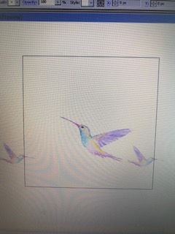
I then added the orchids I used these in multiple and changed the sizes and reflected them too.
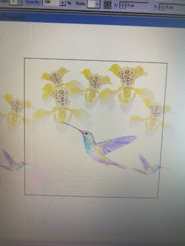
My art board was a classic 550 x 550 pixels wide which is a standard size in surface pattern.
I then added the tropical flower buds, which gives it some texture and vibrancy.
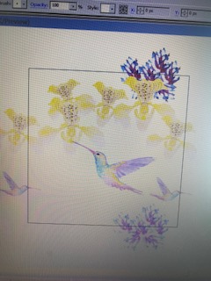
I wanted to keep the textures, colours and feeling of the original artwork, but I had to break it down and build it up again in layers to create the technical repeat pattern in surface design.
I then added the tiger plant; again I used different sizes and reflected the image to give a variety and depth to the pattern.
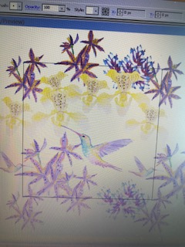
I was pleased how this was coming together, it was looking like the pattern was creating a stripe design, but this was not obvious and I was hoping this would still look good when it repeated. I decided to try out some different back ground colours, I initially used the same background as the original illustration but this looked too busy and was hard to create a technical repeat with. So I decided to go for a plain background colour but would maybe use a texture from my sketchbook.
I tried yellow, pink, blue, green, orange, but in the end a bright turquoise seemed to work the best.

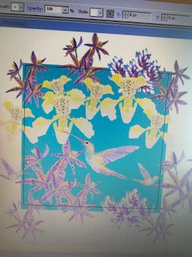
I looked through my little mark making sketchbook from my degree and found some water droplets, I thought these might work as a background texture; it would be in keeping with the tropical paradise theme.
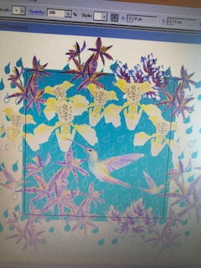
I had to change the transparency on the background texture as it was too much as it was, but now its blended more into the background but still gives a textured effect.
Now to test to see if it repeats! Yes it does, I’m really pleased with how it looks, it still keeps the look and feel of the original illustration but it has made it look more professional and feasible as a finish piece. I think this will work really well as some wrapping paper; it would work well on a tag also.
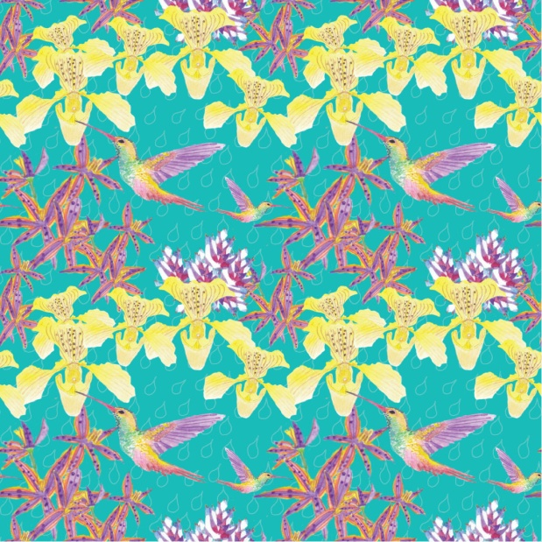
So from this I decided to order the wrapping paper, I found a company called Fashion Formula which I had got a quote from earlier. They do a wrapping paper in a high gloss style which I think will make the colours pop with this design.
I will wait until it comes to write up how it looks and feels.
So the wrapping paper was delivered and I haven’t yet opened it up, so let’s see what it looks like!
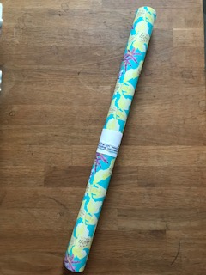

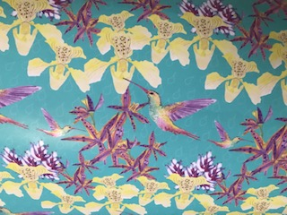
I was surprised at how good it looked, having it made in the gloss paper really made it look professional and like proper wrapping paper you buy from a shop. The colours have turned out very bright and punchy and the detail was still there to see.
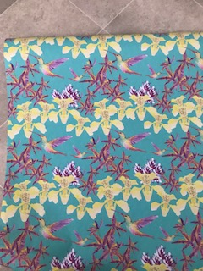
You can see the stripe detail here of the orchids, but I think this works well with the design and the concept of the birds and tropical plants.
I think this wrapping paper could be used for many occasions, not just birthdays, but general celebrations, thank you gifts, anniversary’s, weddings and Mothers day.
You could also make matching items to coordinate with this paper like a cute little tag with one of the hummingbirds on it. You could make a matching gift bag and tissue paper, also some blank cards or work on some typography and do birthday cards or Mothers day cards.
To explore it even further you could also do a stationary range like diaries, notebooks, pens, pencils, pencil cases, to do lists and jotters.

What did you think of this exercise?
I was a little apprehensive about this exercise as I had read through it in advance and was unsure what I would do! But once I started to look back at all my sketchbooks and decided upon one that I wanted to expand on, I found the exercise really great. I really liked thinking about what I could use my drawings or designs for, how they would work on different authorial practises and what would be the most suitable for that design.

What have you gained from doing this?
I have gained a better understanding of how you can turn even just little sketches or ideas into something tangible and professional. I think working through this process for this exercise gives you a good idea of how to explore further one particular idea and work on it as a professional piece.

Are there any materials or ideas you would like to explore and what will they be?
I would think more about what I could use my illustrations for in a professional sense after creating them for the exercises. It would give me more confidence to see and expand my work further; I will look into other authorial practises to see which ones fitted within some other work from this unit.

After the feedback from my tutor:-
She suggested that I add the quotes that I got from the company’s I looked at before I ordered the wrapping paper.
Also how much would I consider selling this sheet for? And how much would I make?
Also to take photos of the samples I received from the different printers.
And to look into Illustrators who use their surface pattern designs in products, I chose the Illustrator Boccachini Meadows, who I have looked into before and follow on Instagram and Pintrest.
So the printers that I looked into where Fashion Formula and Spoonflower, I have enquired at local printers, but they didn’t just print one sheet, which is what I needed for this exercise. The minimum I could get was 25 from the printer ‘Printed.com’ which was £26 for the 25 sheets, plus delivery. This was the best quote I received but of course didn’t need 25 for this exercise so I had to go for a more expensive print on demand site like Fashion formula or Spoonflower.
The samples I received are below, the Fashion Formula one was High gloss when I got it, but on the sample it says ‘satin’. The price was for one sheet 50 x 70 cm which was £4.50 without postage costs.
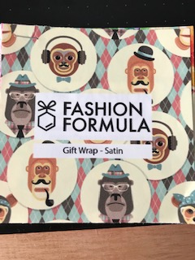
The Spoonflower one was thicker, but didn’t have a very nice shine to it. The cost was for a A2 sheet, which was £6 without delivery.
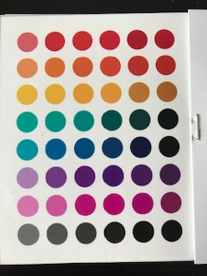
I decided to go with the Fashion Formula store one, because it was the cheapest out of the two that could print just one sheet, and the quality was better than the Spoonflower one.
So in total the cost was £5.50 with delivery included by second class royal mail, now this is quite expensive for one sheet of wrapping paper, and I wouldn’t sell this for that price. I would have ordered a sample form the printers that could supply 25 sheets for £26, £30 with postage costs, which would work out at £1.20 per sheet to make it, I would sell these for £4 per sheet.
I looked at Etsy, Paperchase, Clintons and a local boutique gift shop, and the prices for this type of wrapping paper was between £2 and £4.99, I would market it as luxury gloss wrapping paper. So per sheet I would make £2.80, which I think it a really good profit.

Sara Boccaccini Meadows is a illustrator and print designer who lives in New York, but originally from the Peak District in England. Sara graduated from university with a 1st class honours degree in Textiles and Surface pattern, she takes inspiration from nature and details in her everyday living to create unique designs.
Her media is Watercolours, Gouache and ink pen, and has worked for many high profile company’s like Hewlett Packard and Bentley to name but a few.
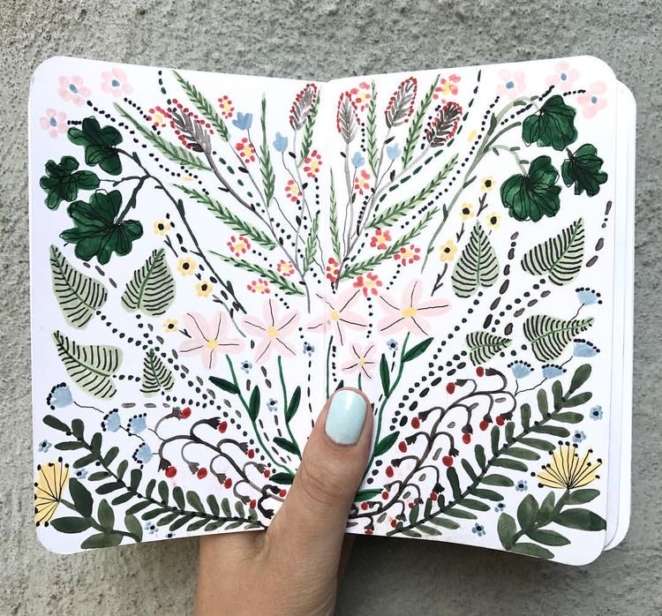

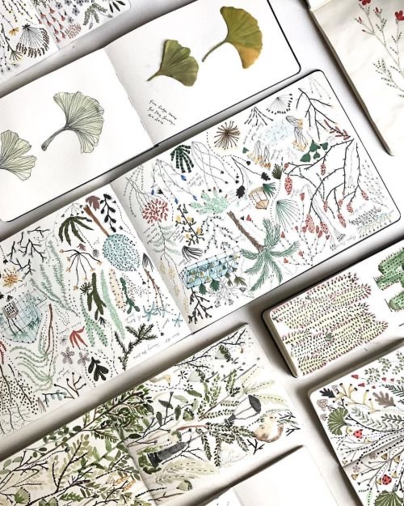

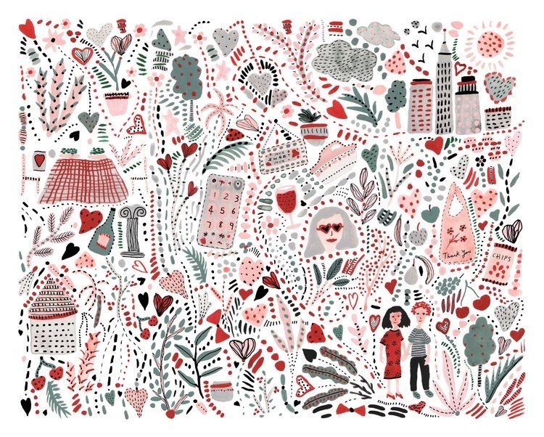

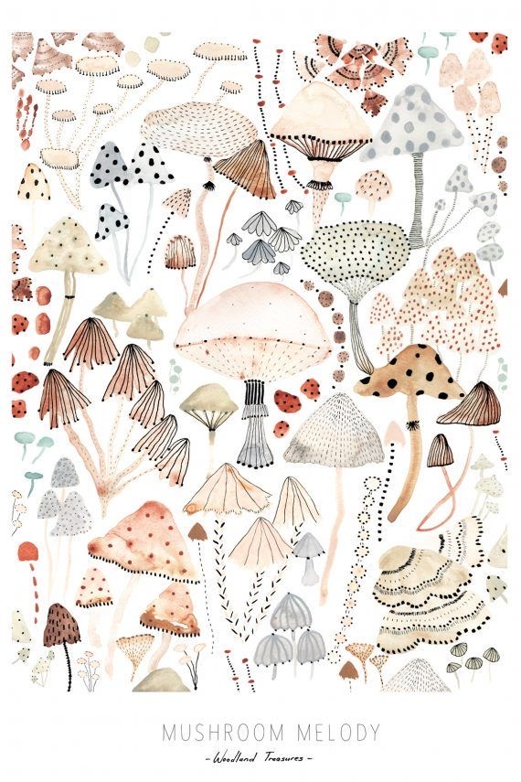
You can see by Sara’s illustrations and sketchbooks that she paints gorgeous illustrations of nature, being outside, or fun quirky people. Sara uses these illustrations to create surface pattern designs, which can then be transferred onto almost any kind of product like: fabric, home wares, like cushions, bedding, also clothing like women’s dresses t-shirts, or children’s rompers.
Her designs transfer very well by doing this and it is something she has developed over her career to get to her successful designer status now.
Sara uses lots of small details in her illustrations, there are lots of stripes, dots and mark making that she uses in shapes, along with the transparency of the watercolour layers and washes this creates a lovely feeling to the illustrations, that will then be passed onto the surface pattern and then to the product.
The way she draws people is quite naive and child like, but I really love this quality to her work and shows the designs can be used of all ages. The people are simple in the way they are drawn, yet you can instantly see they are women and men and boys and girls. Sara also adds the tiniest details to these characters also, like the stripe jumper or the pattern on the lady’s dress, which again gives texture and adds those special details which make them so cute.

