A menu card
I started this exercise by researching some logos of fish restaurants; I wanted quite simple designs so they would stand out and be suitable for all manner of things that would represent the business.
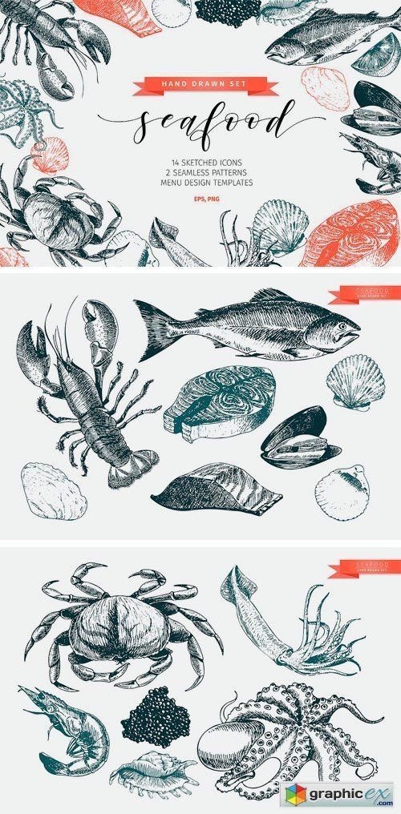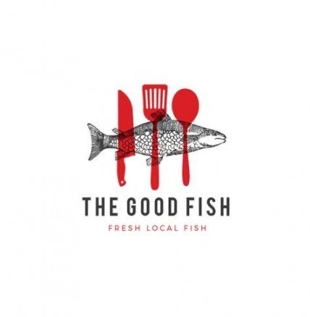
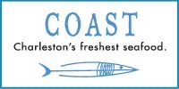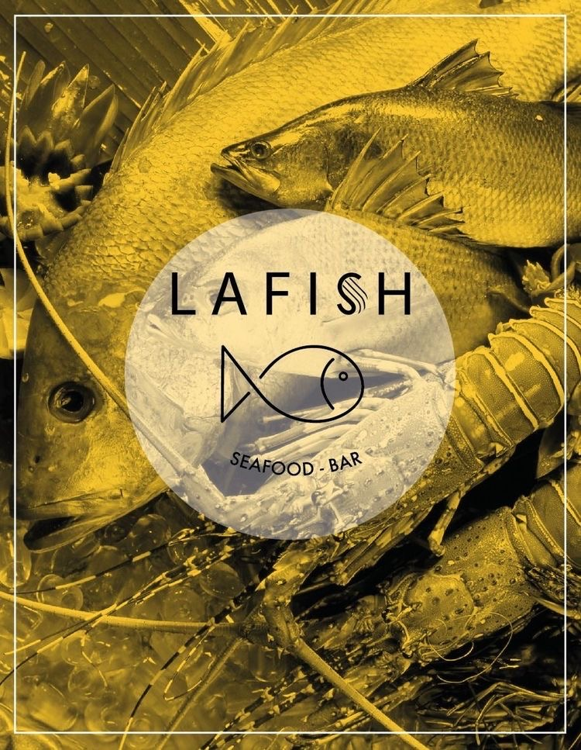
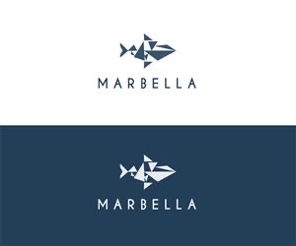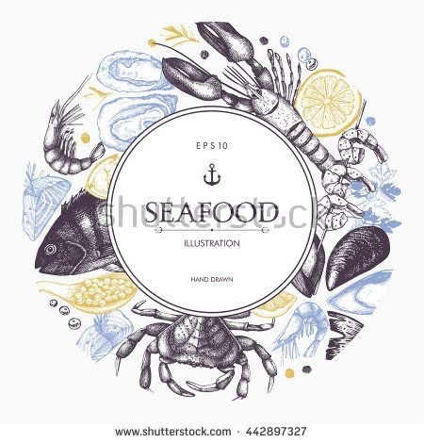
I liked all of the above designs, but thought would it be better to look at even more simpler ones?
So I then look at logo designers that just worked on the logo.
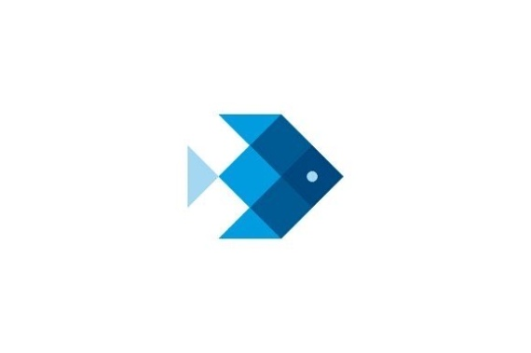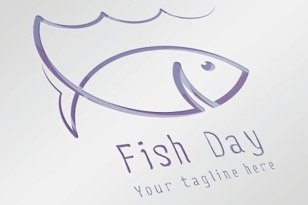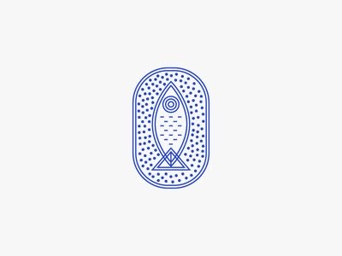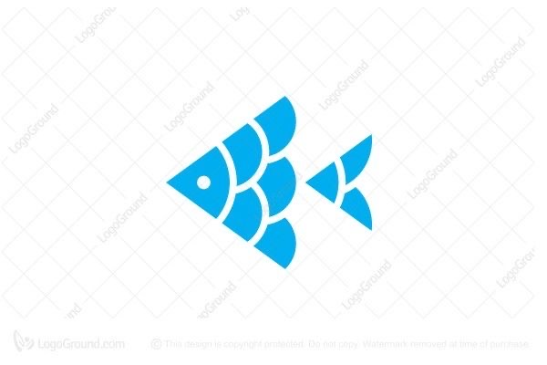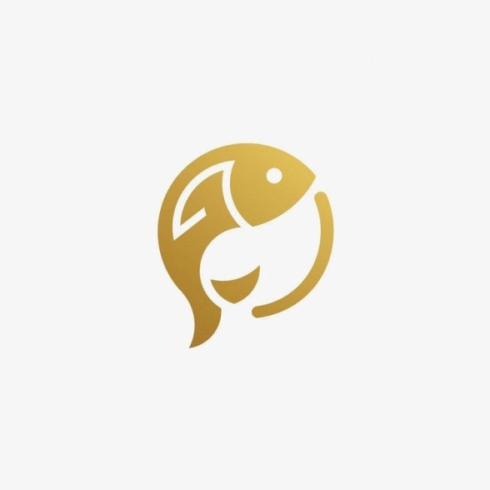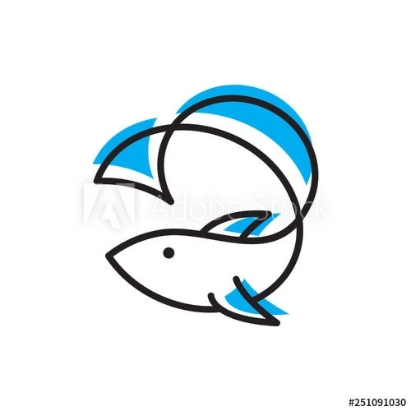
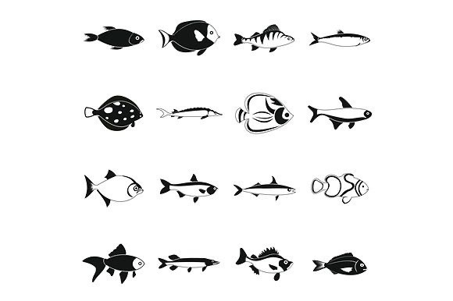
These were much simpler and I thought eye catching, I then decided to look into illustrators that worked on logo designs or really simple designs. I found the illustrator Steven Noble: Steven has been an illustrator for 25 years now and has been highly recognised as an illustrator with a wide variety of award winning designs. Since graduating from California University Steven has a developed a wide range of mediums including scratch board and has been successful all over the world.
His range of medium includes woodcut, pen and ink, engraving and steel engraving. His line work technique is extremely disciplined and complex. Over the course of the years he has created many recognised logos and ad campaigns, which include Mercedes-Benz. Stevens’s subject matter includes food, portraits, animals, maps, architecture and corporate images.
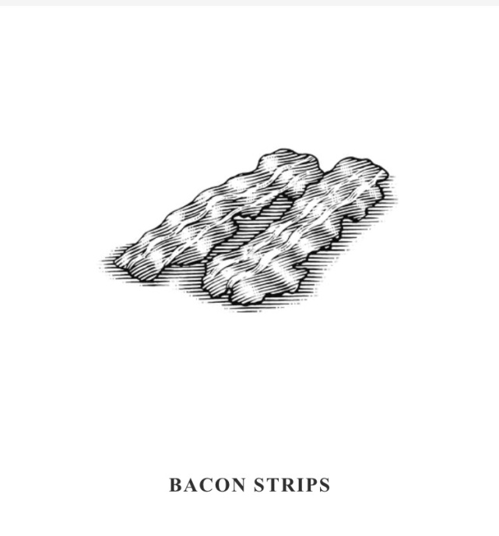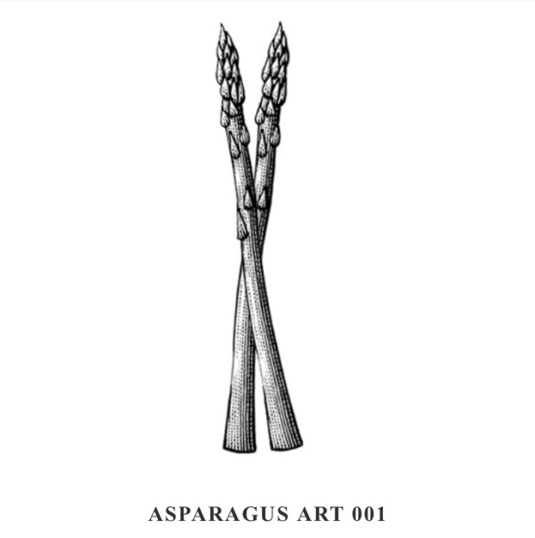
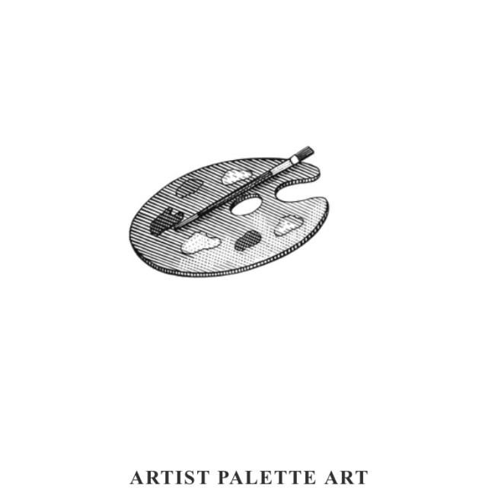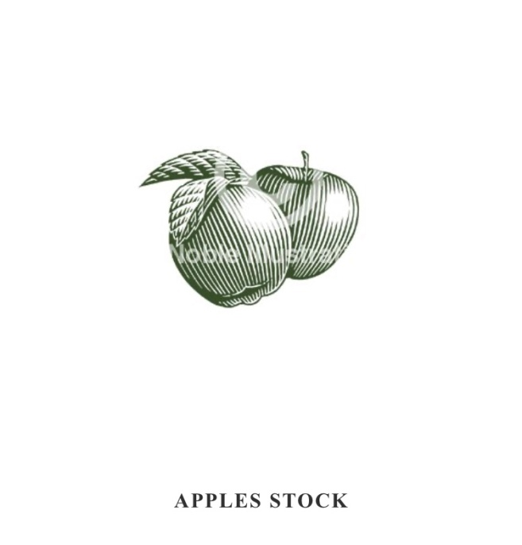
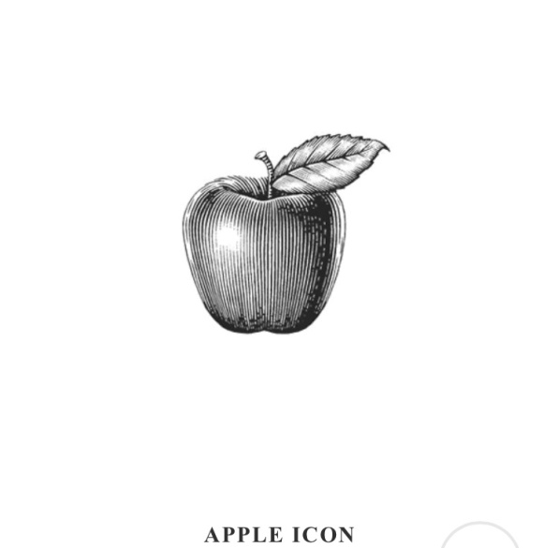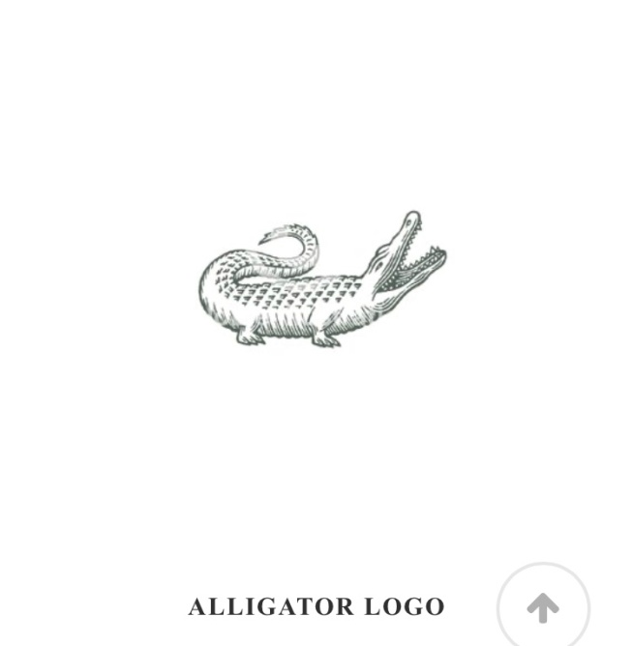

I like the simple-ness of Stevens work, the way the line work is so exact and detailed, you can see why the logos are good as they stand out and look great from a distance, put they are immediately recognisable. I like the way he has used pen and ink in some of them, having them in black and white also is very striking and something to think about with my design.
From this research and looking into designers and illustrators I went on to create a spider diagram from the words ‘Fish restaurant menu card’ I came up with some ideas for different fish and a small section of the atmosphere and style.
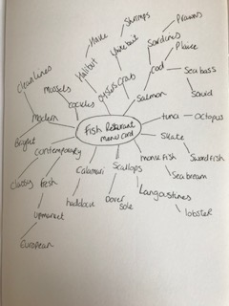

From this I then pulled together a catalogue of images of fish meals and recipes, which I then condensed down into a mood board.
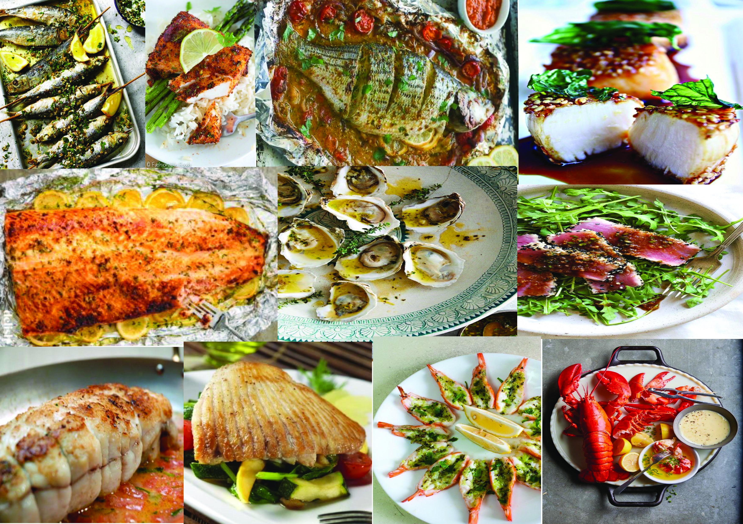

I then started to do some sketching of 4 of the images I liked the best from the spider diagram ideas words. I chose Crab, Salmon, Oyster and Lobster, I thought all of these were classic and sophisticated and would represent good quality.
I started with some quick sketches, and then went on to more detailed sketches that I took more time over.
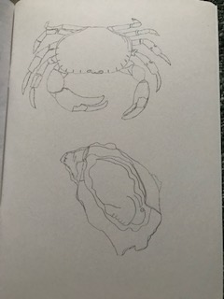
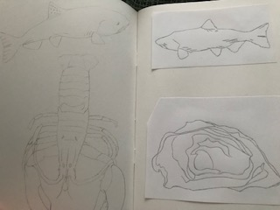
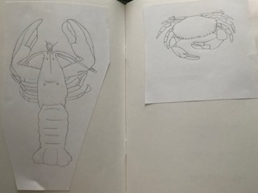

I then went on to do some colour tests; the image I decided I wanted to try was the lobster. After thinking about which ones would look best, I thought the oyster would be really hard to make look appetising as they look really bad. The Salmon I thought might cause problems as I researched Salmons there are many different kinds and colours depending on if they are wild or farmed or fresh etc. So it was between the crab and the lobster, I thought the crab looked less appetising than the lobster, as a crab would be naturally dressed before serving, whereas a lobster can just be served as it is.
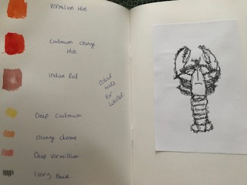
I then went on to the computer and scanned in my original sketch of the lobster, then put it into Illustrator, I then played around for a while with the effects as I still wasn’t sure whether I wanted a more graphic image for this exercise. This one is called zig zag and gives a jagged effect a bit like wire it was very clever and something I could use at another point but not for this exercise.

This one (on the left below) is an effect called feathering, which is great and something I can use in the future, this would be great for birds. This was not right for this exercise as it didn’t make it look appetising.
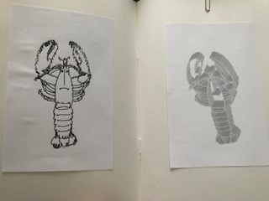
The effect on the right above was something I didn’t realise I had pressed so I’m not sure what it’s called, but it looks great. I love the way it has changed the original sketch, it looks like metal now. Fab but not for this idea.
So I went back to my colour tests and then started to draw the lobster again and then use watercolours, coloured pencils and watercolour pencils to create this painted illustration of a cooked lobster. It was difficult to create it to look really appetising as the tones were nearly all the same, but using subtle differences and shading I’m hoping it looks realistic and yummy!

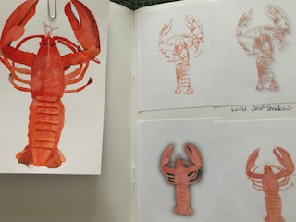
I then went on to scan the illustration into my computer and into Illustrator again, I decided to have a play again and see if I could create anything more realistic with effects. The top left is it traced and expanded, which gives a great effect, but again not ideal for this, I then used a drop shadow to see if this would change it anymore, but not enough to look great.
The bottom left was the original scanned illustration but with the effect of an ‘outer glow’, this made it look more realistic but I’m not sure if it was more appetising!
The bottom right was with the effect of an ‘inner glow’ this I liked it was a subtle difference but I thought it added a shine to the shell which made it more appetising, so I kept this effect.
Next I wasn’t sure whether the logo required typography so I had a little go in my sketchbook to test out some fonts.
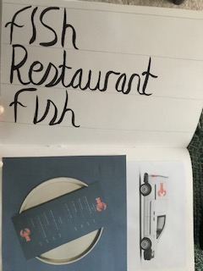
I re-read the brief from the exercise and realised it didn’t require any typography, it stated just a logo.
From this I went back onto the computer and started to look at mock ups, I found a menu, a van, a shop sign and a poster sign. I decided to put the lobster on these to see how they look and to see if I needed to anything more.
I decided it did need something more as it was fairly simple, I thought about what the restaurant represented, sophisticated, modern and fresh, so I went with the fresh idea. I decided to look at lemons as I thought this would add that fresh element, it’s a side element to the lobster dish and it would make your taste buds water for the tang.
I decided to create a graphic image for the lemon, so I created one in Illustrator using the circle tool and adding some texture to the middle. The thing I had trouble the most was getting the colours right, but after about an hour I managed to get the balance right between the darker and lighter tones
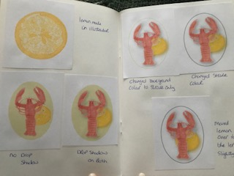
I then used this lemon behind the lobster to poke out one side, like a slice of lemon. I changed the logo into an oval shape and added a background colour in fresh lime. This looked great but looked flat, so I decided to try the drop shadows again, I used it on both the lemon and the lobster which worked well now.
I was not sure about the background lime colour, I wasn’t sure if it was sophisticated enough, so I tried the logo with just the stroke in a colour, first I chose the lime colour again, but this was not right. Then I tried a grey colour, but this didn’t work either. So then I tried a black which was to stark but I changed the opacity to 50% and this worked well, I double the size of the stroke so it stood out more. I then moved the lemon over to the left more, so the logo was balanced within the oval shape.
After this I put them back on the mock ups and these look good, I think the poster style sign is the best, having a white background really makes the logo stand out and makes it look the most realistic and appetising.

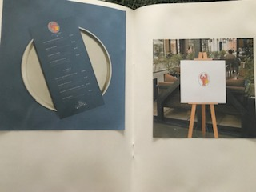
When I did the black sign below, the logo had an opaque oval around it, so I had to change this back in illustrator so the background was clear. Which is what the last picture is?
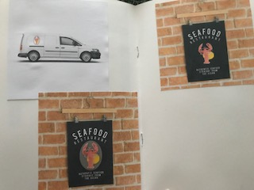
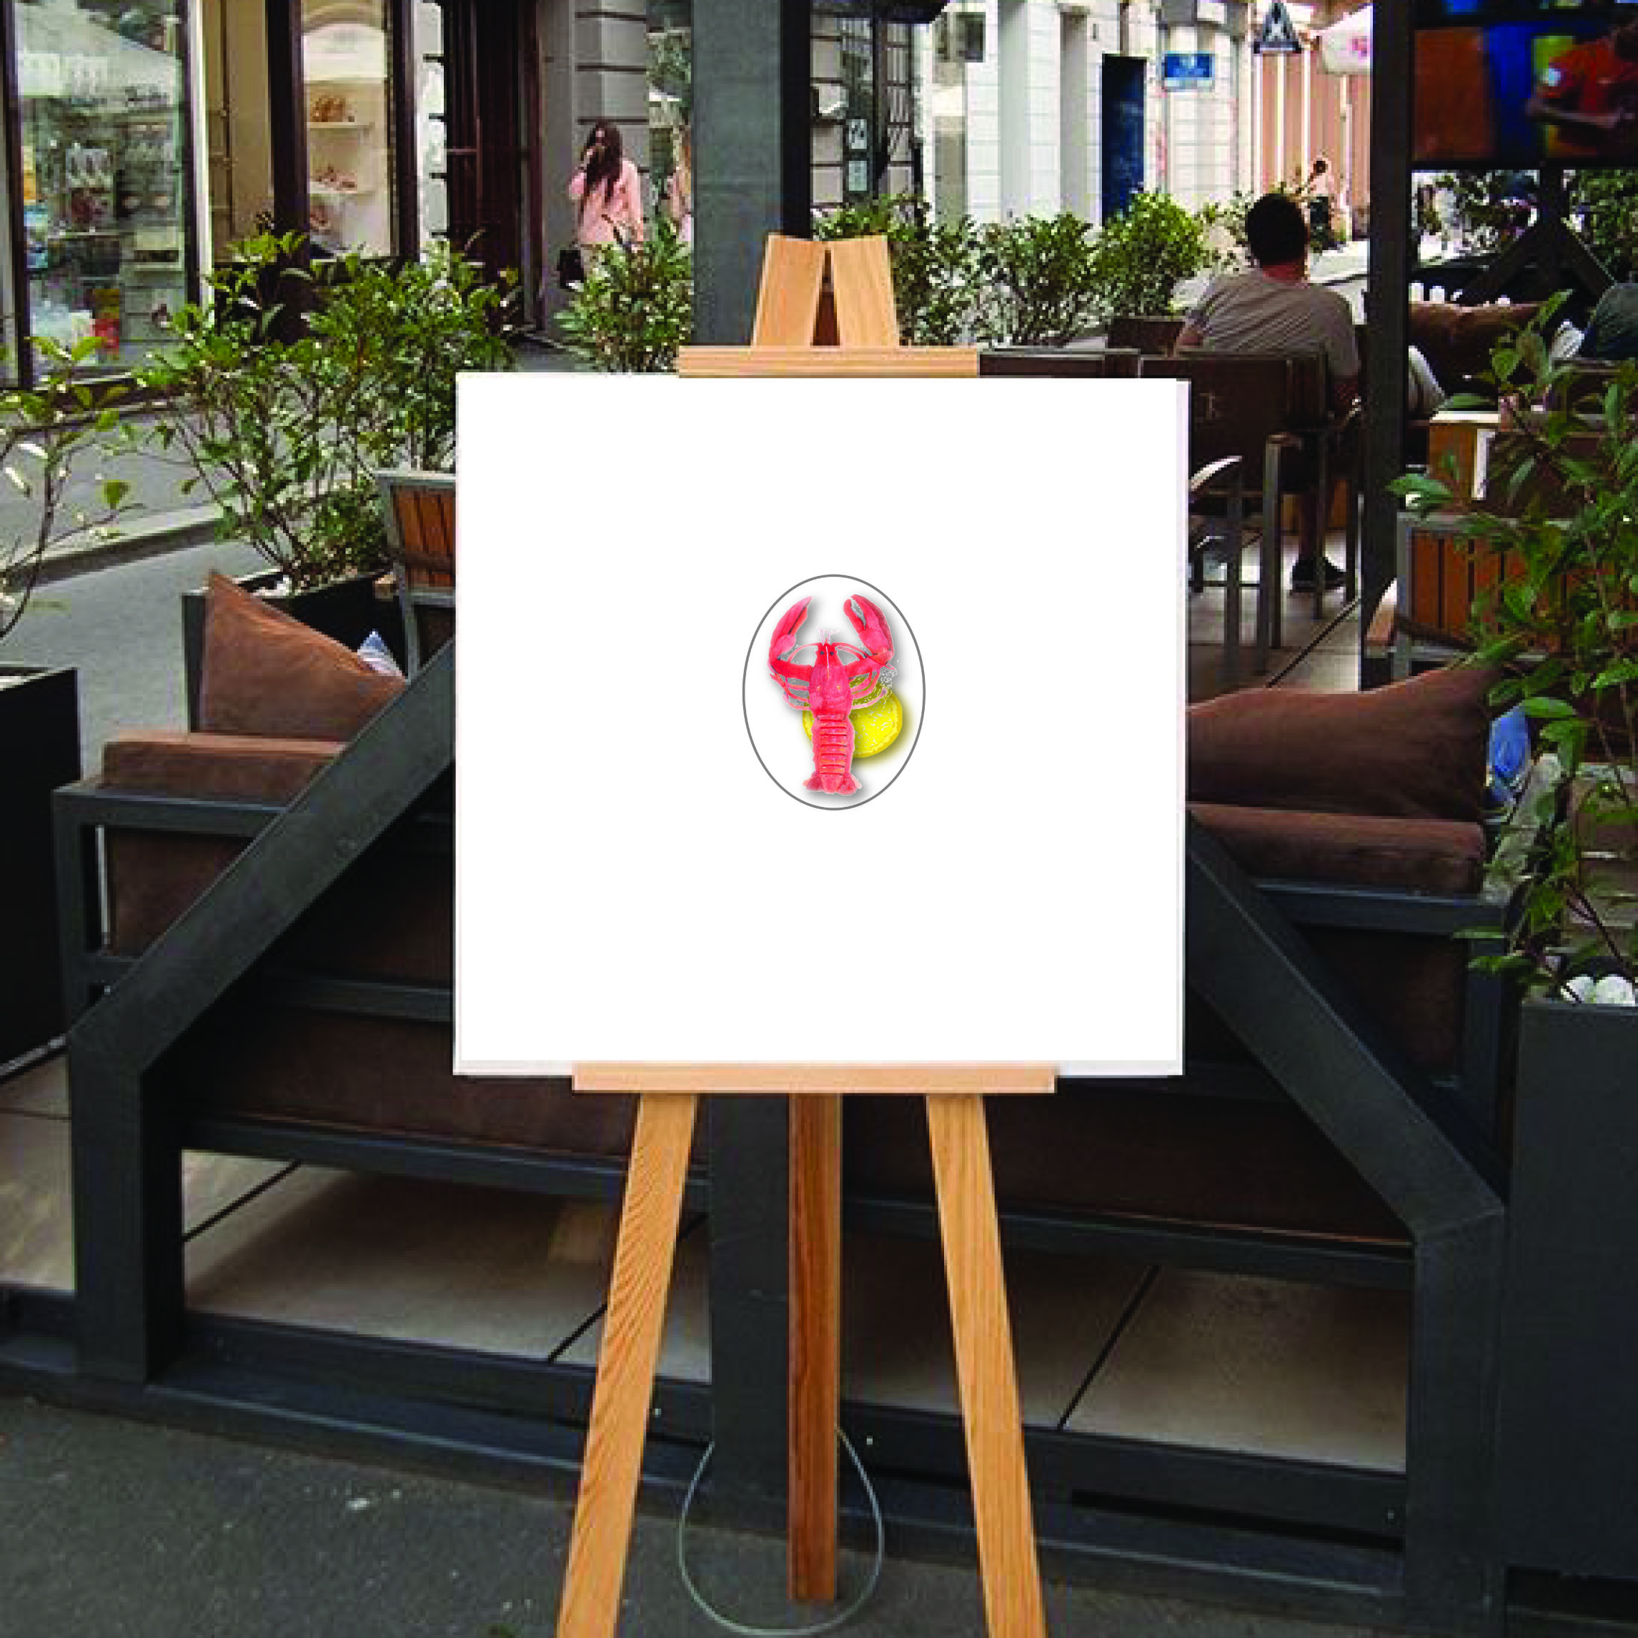
This one makes the logo really pop and looks realistic and appetising; I like the clean white background which adds to the ‘fresh’ idea. I’m really pleased with the way this one looks.
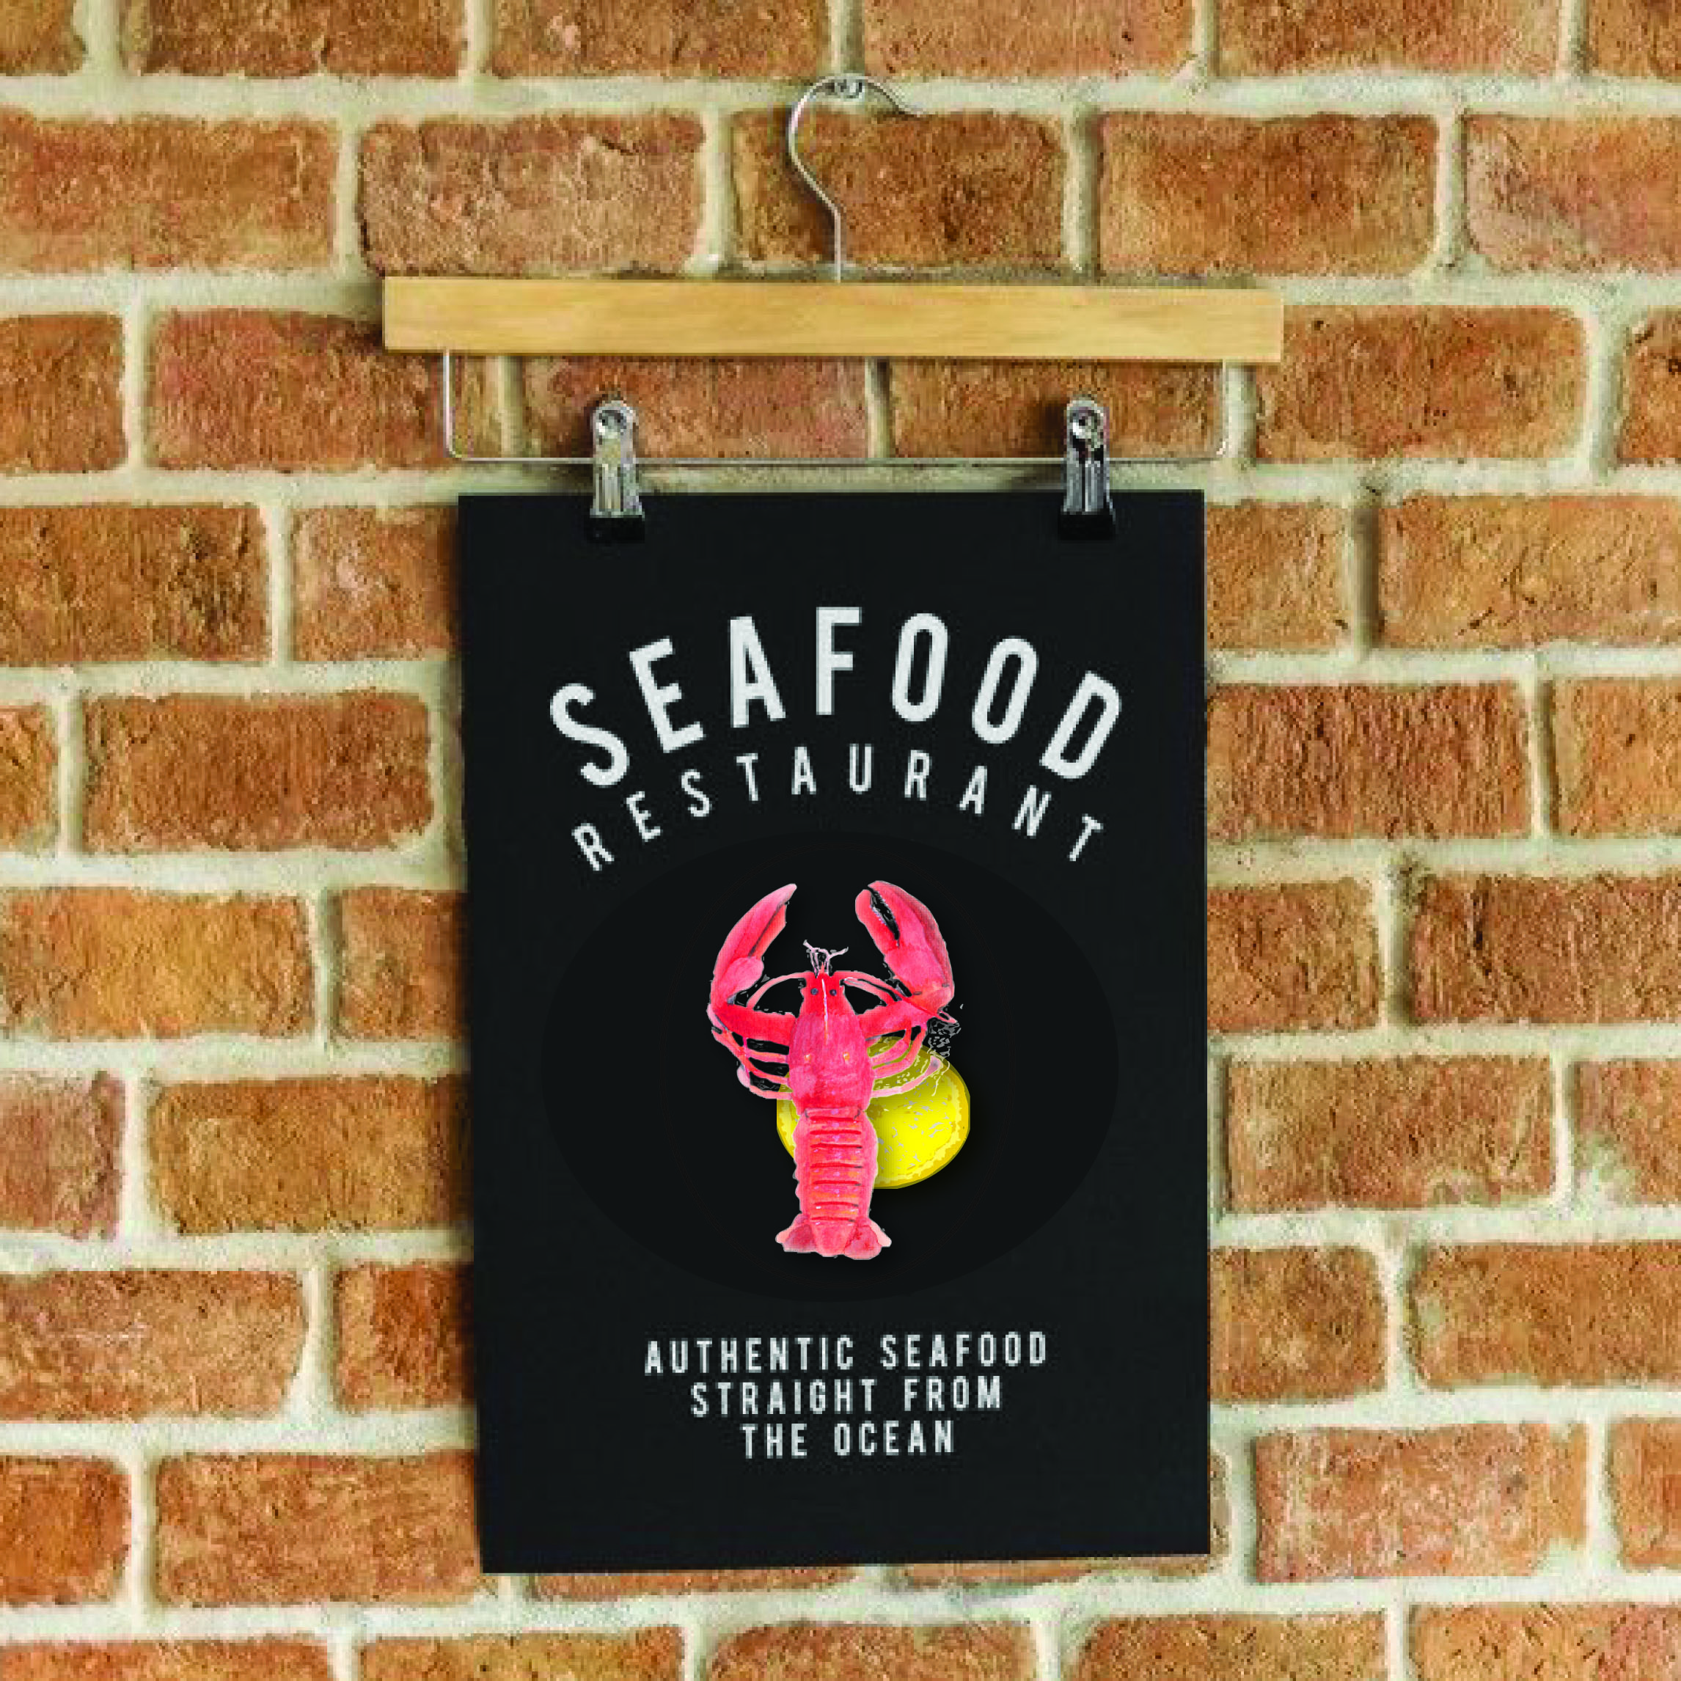
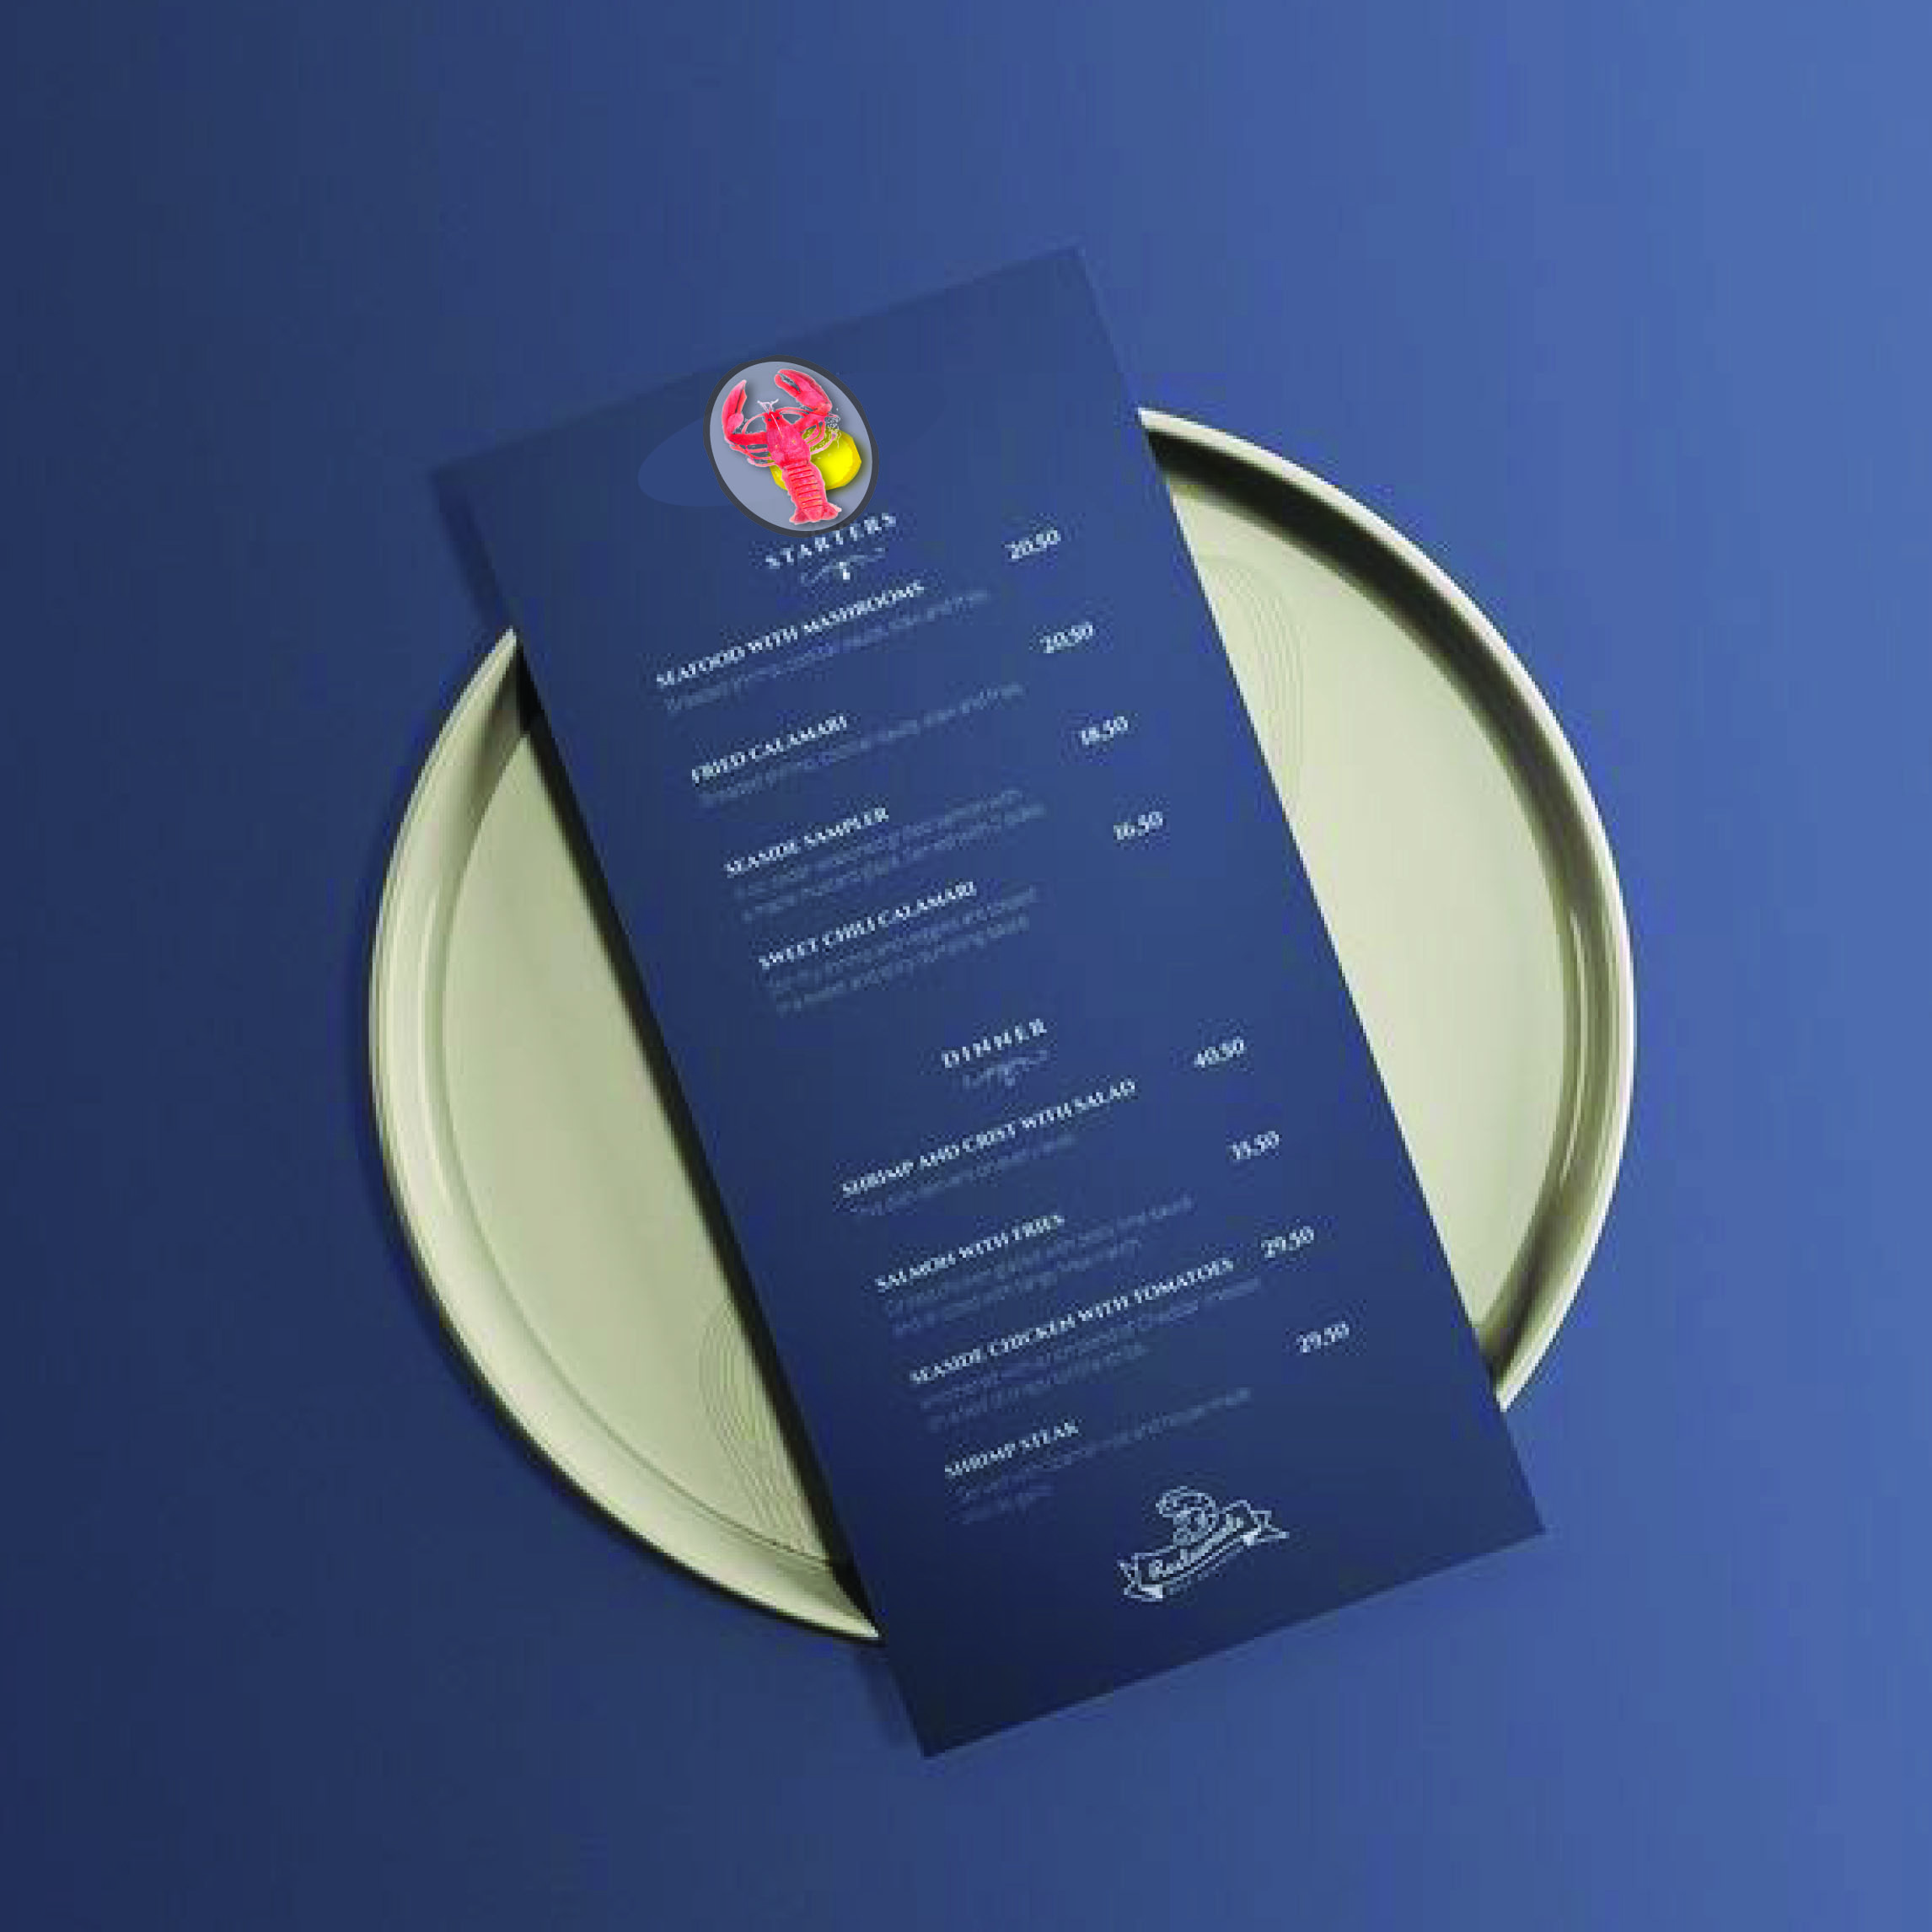
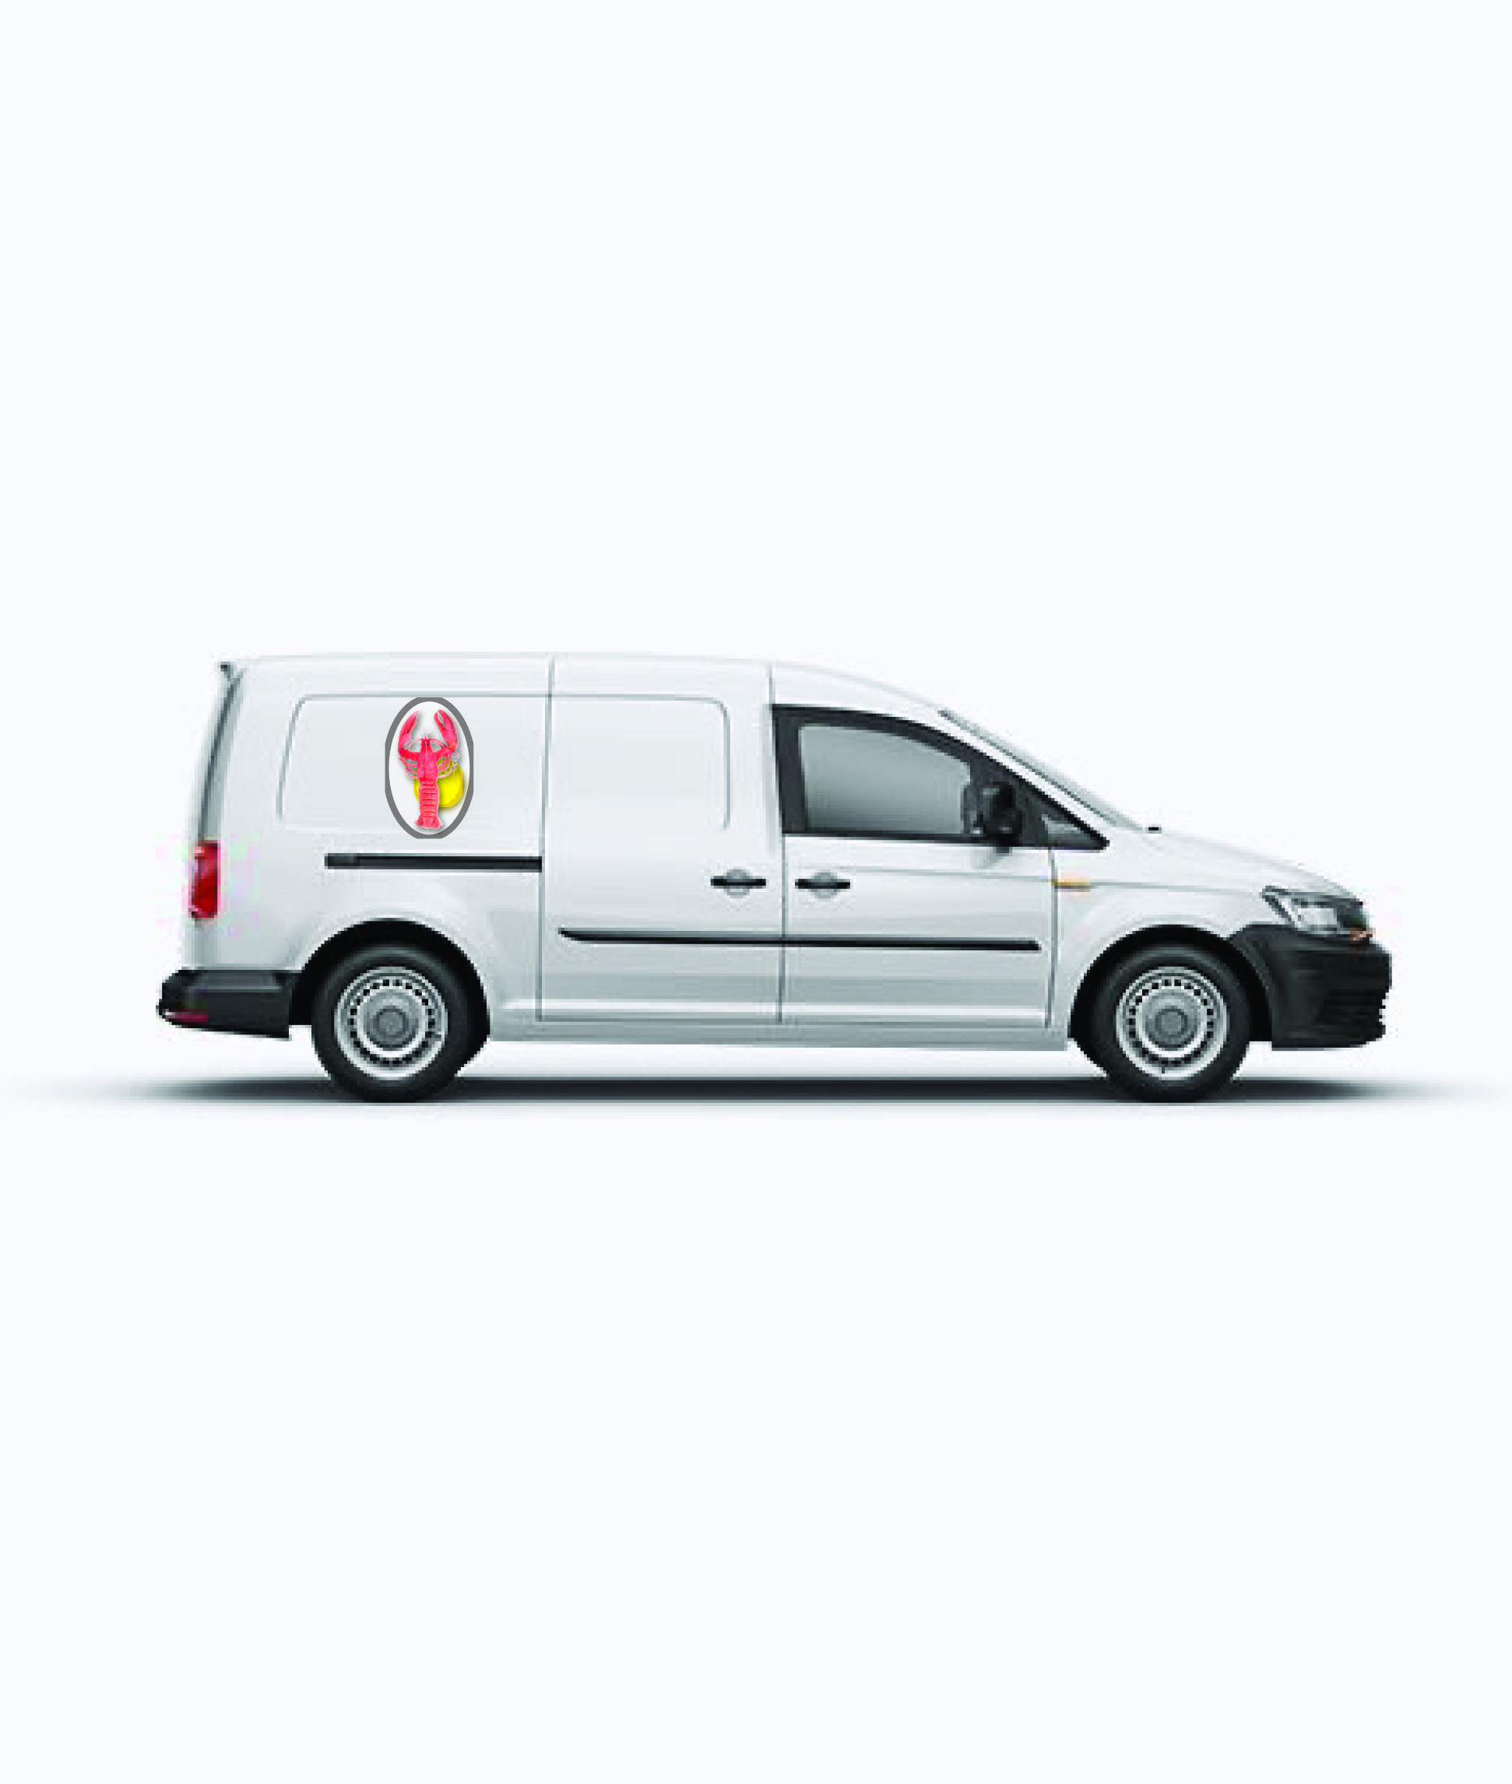
What did you like most about this exercise?
I was not sure about this exercise as I not particularly great on the graphic side of illustrating, but once I got onto the computer and had a play around with different things i found it really enjoyable and learnt some new effects.
What have you gained from doing this exercise?
I have gained more experience and confidence with Illustrator and trying out new graphic techniques and effects. I have learnt more about thinking of the little details in the brief that you can pick up on like the ‘Fresh’ idea. More confidence in my painting abilities for making things looks appetising.
Are there any ideas or materials you would like to explore? What will you do?
I will continue playing around with the Illustrator software and looking into more graphic techniques to enhance my illustrations or original watercolours.

After feedback from my tutor:
What’s the difference between the white and the black backgrounds?
Look again at the graphic shadows on the white backgrounds.
Re-look at the logo’s in the research of your work and see the cleaner backgrounds, this suggests more sophistication, which is what you are going for.
So from this I went back over my work and looked at the difference between the works I produced on the white back grounds compared to the black backgrounds.
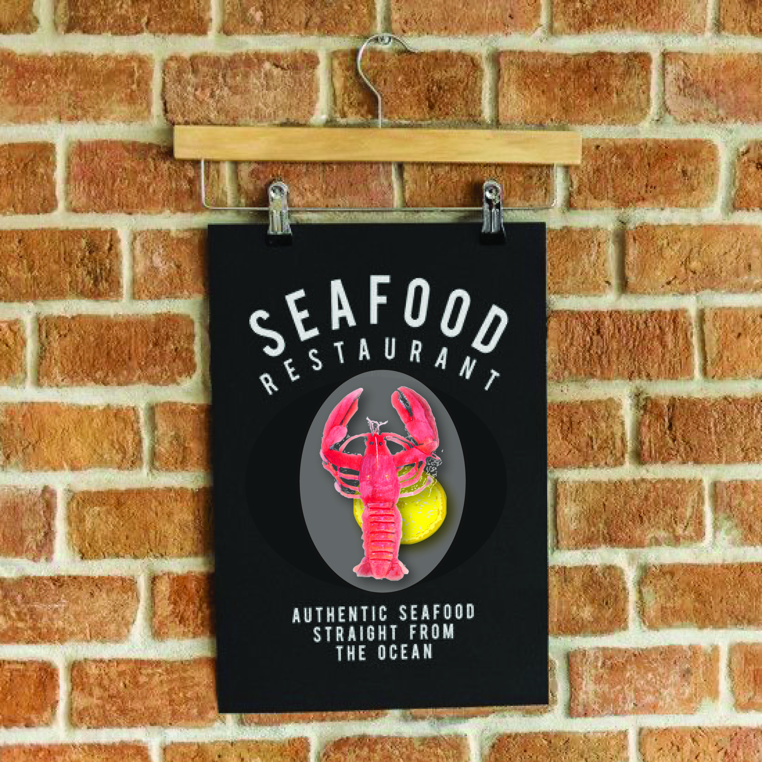
So for me the black background was more relaxed and friendly in the feel you got from the black background, this I think is because of the dark colour, and it anchors the picture. This is helped by the mock up, with the natural brick wall behind and the detail in the writing; all this put together helps that feeling of informal dinning.
The white background is more fresh and contemporary, and has a feeling of simplicity, again the mock up gives a more modern back drop, and it looks slightly higher class, more expensive and exclusive.
I think if you swapped these two signs around, they would confuse the customer as the settings behind would feel wrong.
So because of the brief wanted a sophisticated look, I would choose the white design, but would just add a modern simple typography, that said ‘Fish Restaurant’ I think the look and feel of the sign would tell the customer what kind of place it was.
The graphic shadows behind the design was to make the design pop out, so I went back to the design and took off the shadows to see how that looked. I looked back at the logo research I did and yes none of the designs had this feature.
I changed the design so the lobster and lemon had no shadows behind them, I also added the typography to finish off the sign, I used the same colour for the font as the logo’s oval shape, and I used a modern font, but chose not to fill with colour, I just used the stroke as the colour, I felt this looked more modern and sophisticated.
Overall the design looks much fresher now and the shadows didn’t really add to the design, so it looks fine now. I think the typography finishes off the sign and makes it complete and compliments the logo design.
