A children’s book cover

I started this exercise by completing a spider diagram on the words ‘Animals around the world’ I used Google more for this diagram than I have for any other as I wanted to make sure I got the right animals in the right countries.
I found lots of animals that I didn’t know about and ones I didn’t know came from certain countries!
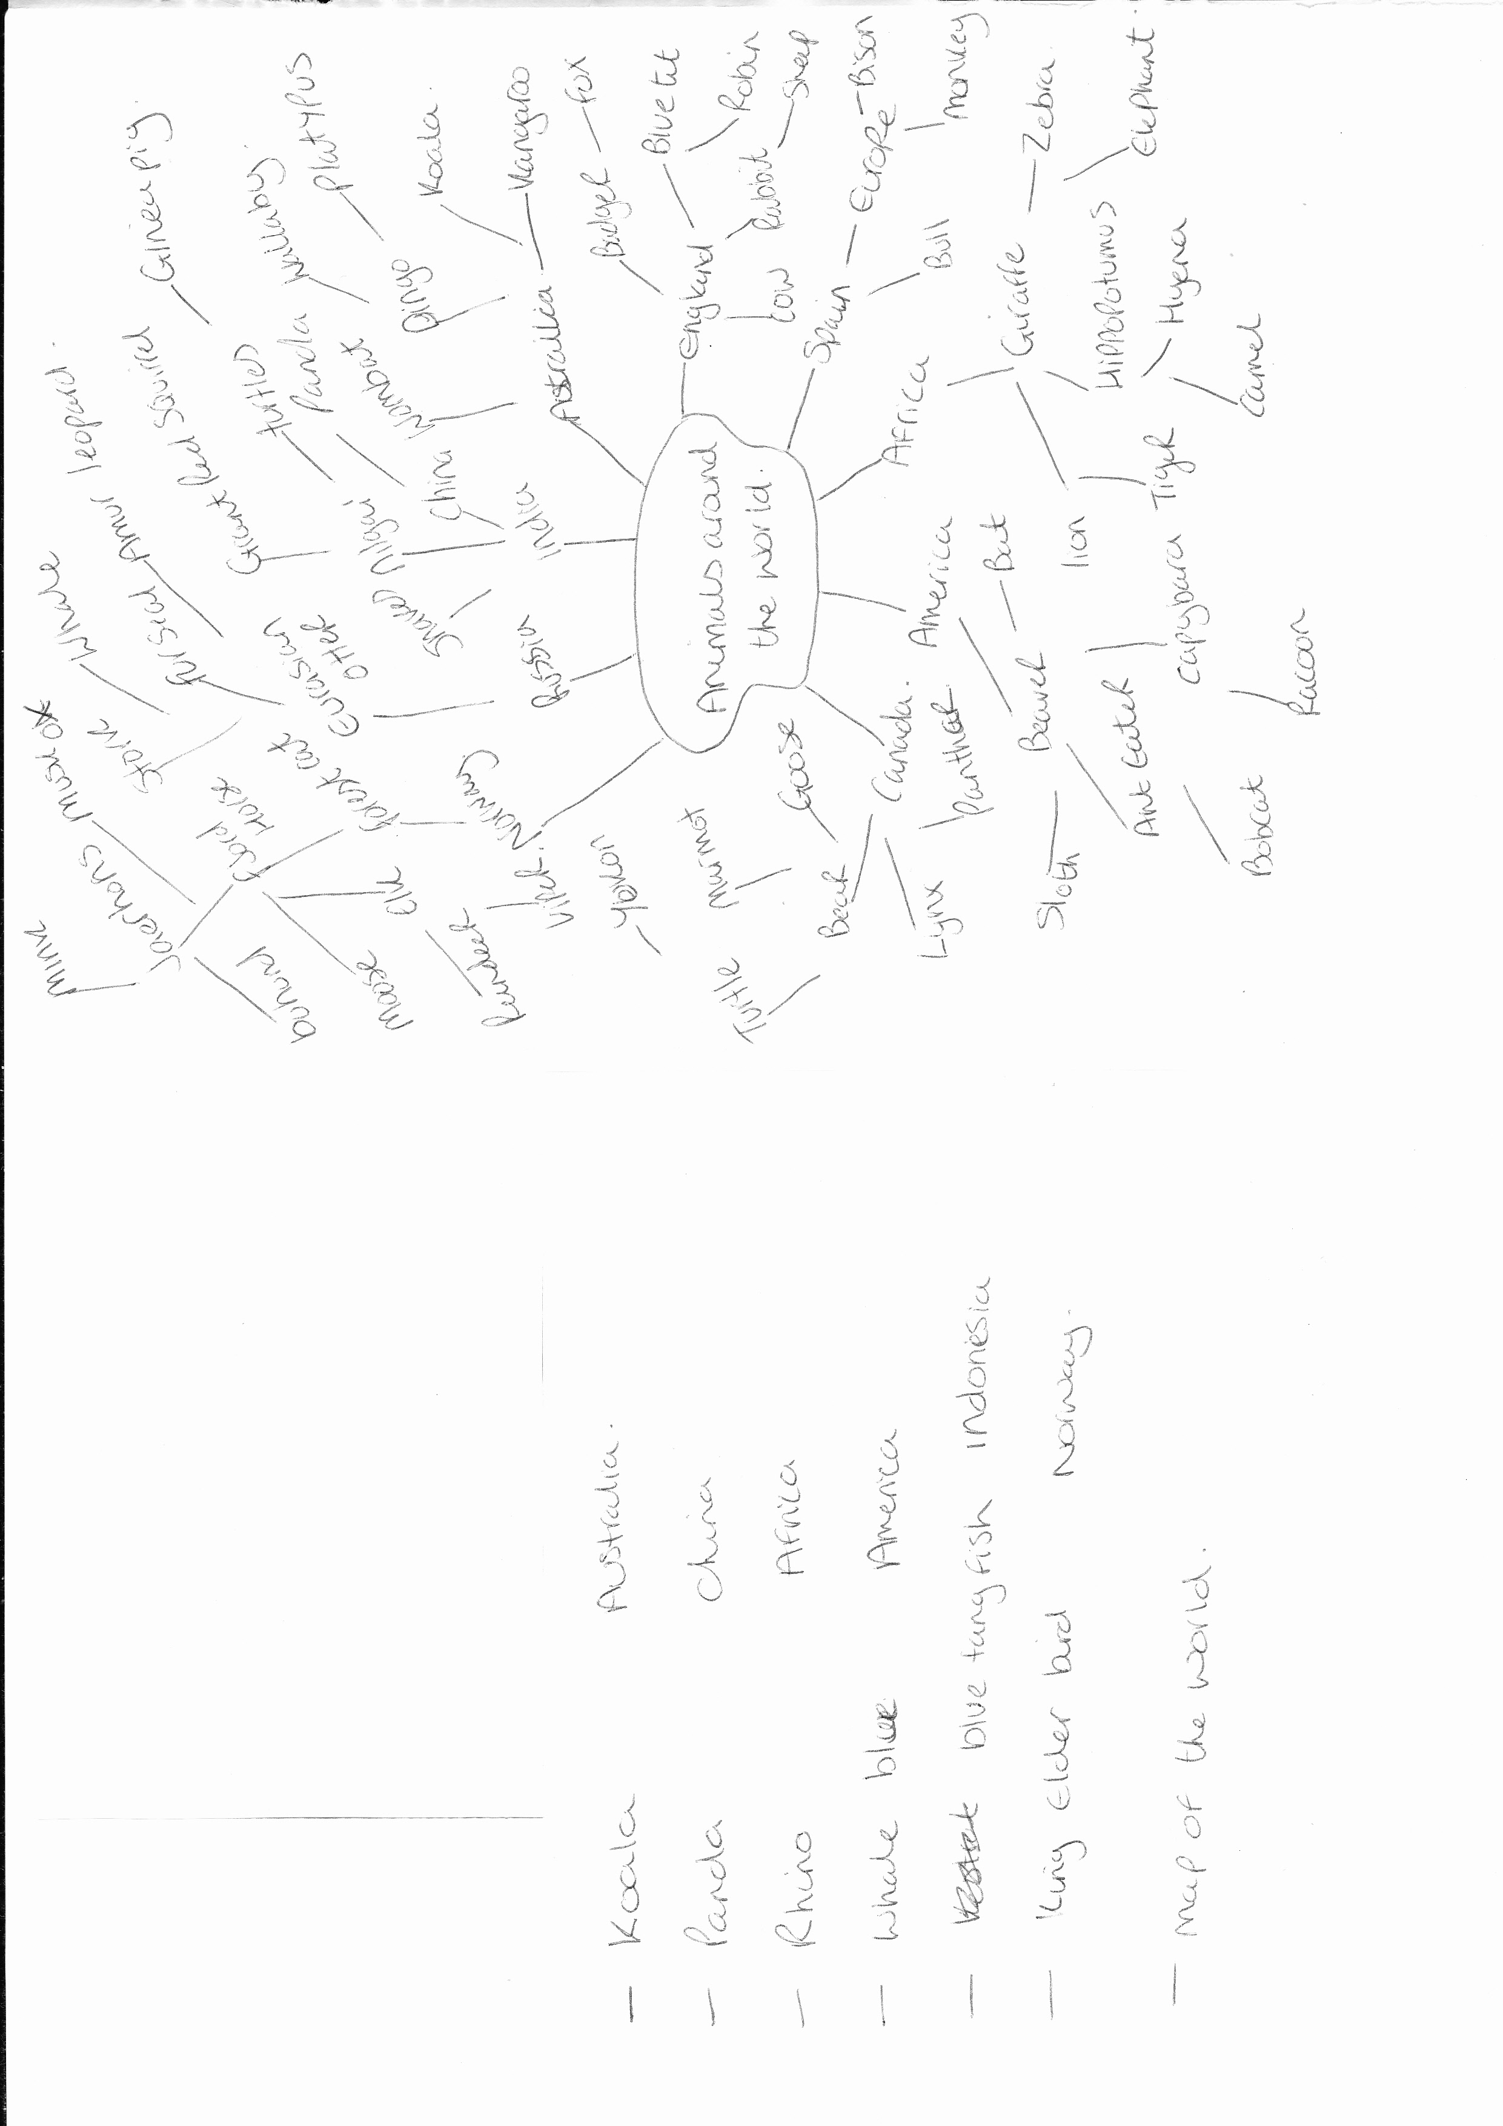
I then went on from this and picked an animal from the 6 areas of the world that are the most known, and some animals that are popular and some that are les known.
So the areas were Australia, China, Africa, America, Indonesia and Norway.
The animals I chose were Koala, Panda, Rhino, Blue whale, Blue tang fish and the King Elder bird.
I then created a mood board on the animals, so I could see all the images together and work onwards from there.
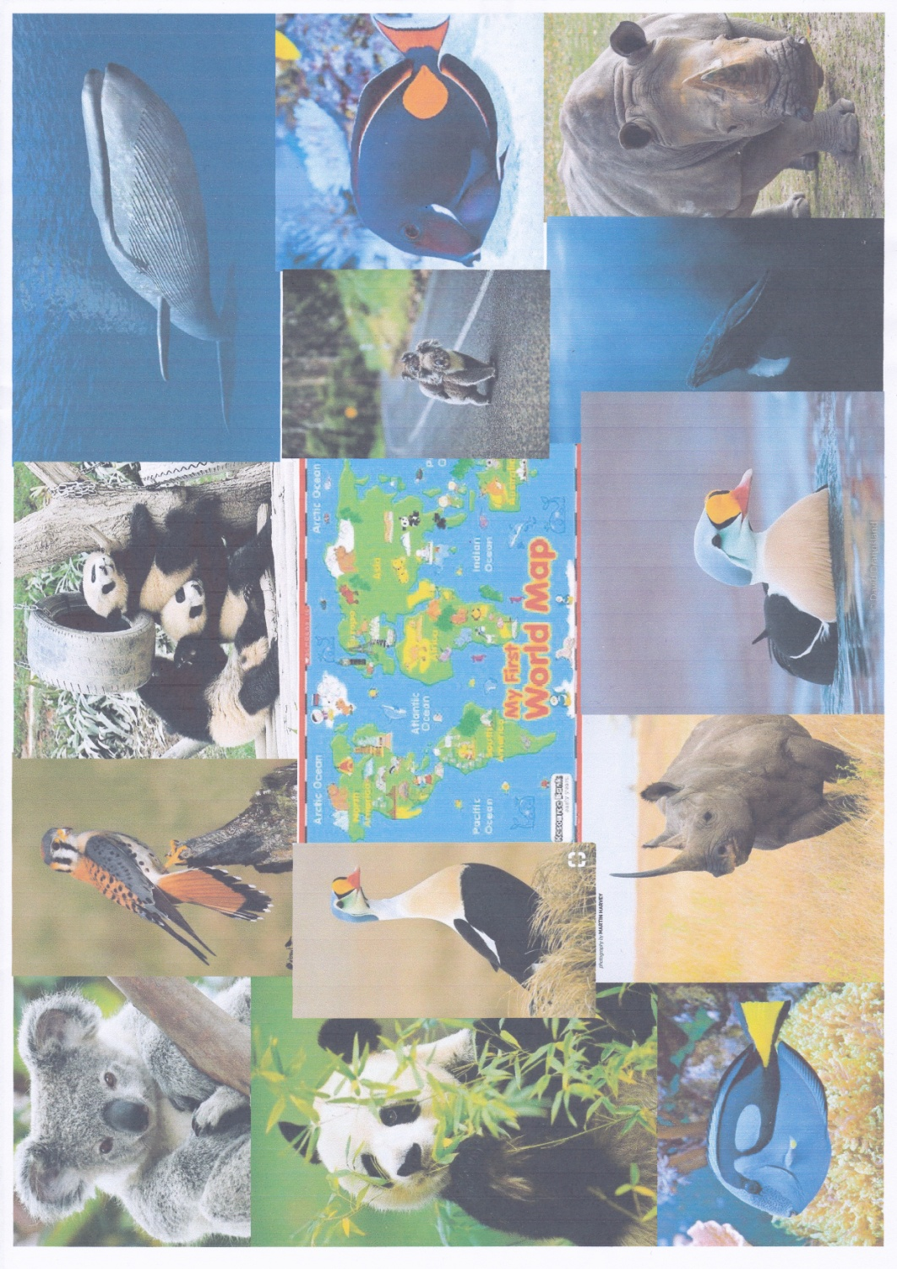
I then researched animal reference books from years ago to see how much has changed and how to modernise the design in a new way.
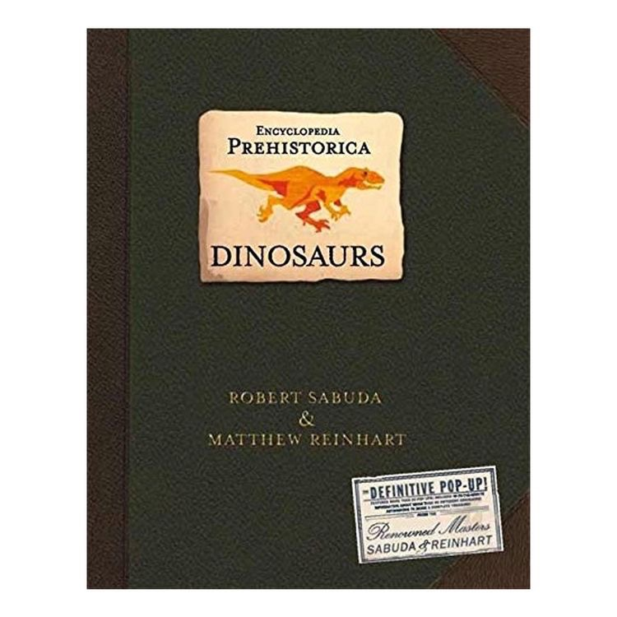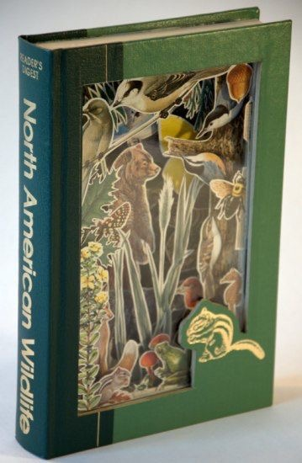
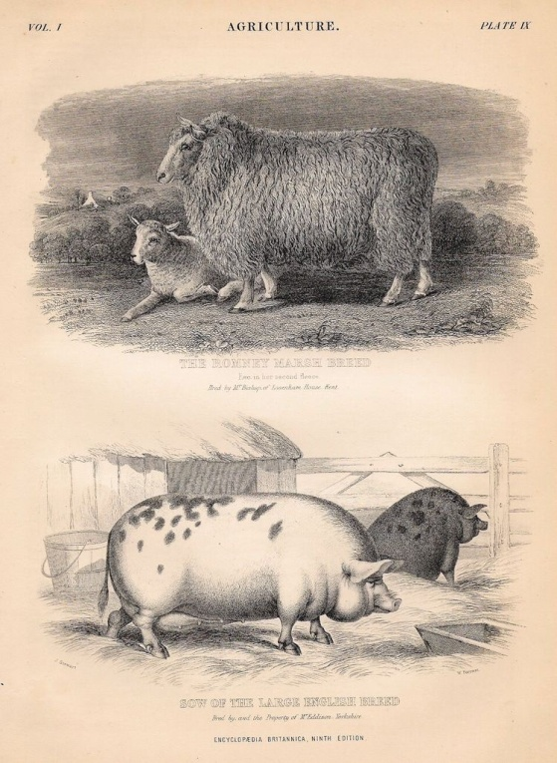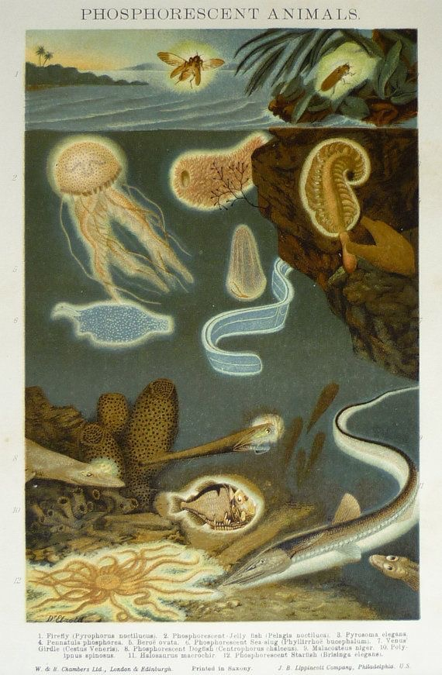
I then looked into an illustrator that illustrates for animal reference books, I found the illustrator Nikki Dyson.
Nikki grew up in a small village called Shrivenham in Oxfordshire. Niki studied for an illustration degree at Swindon uni, after graduating Niki now illustrates books for children including the book 1000 Animals and 1000 things to eat.
Niki spent her childhood drawing and reading, she loves creating characters for stories and is inspired by animation and concept artists.
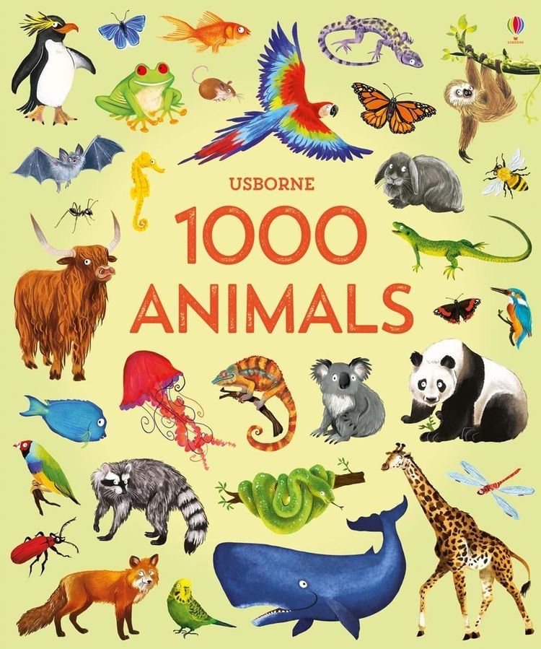
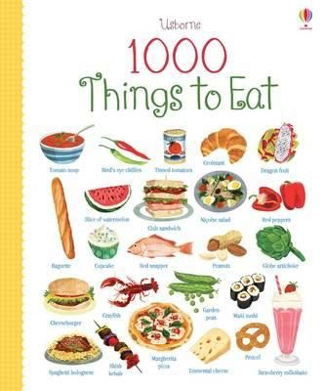
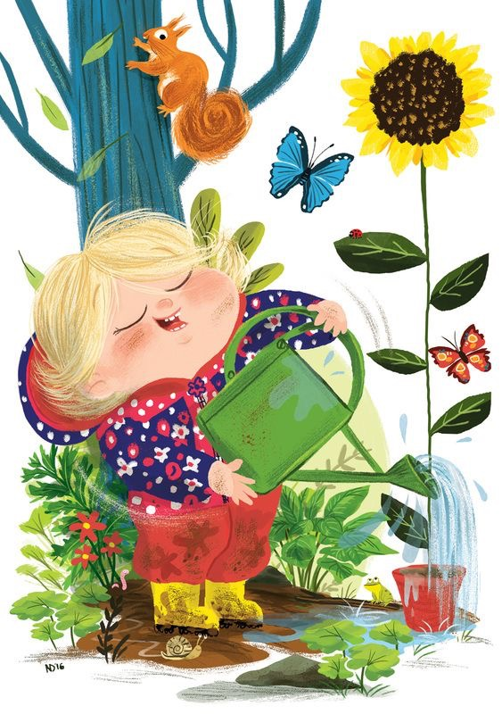
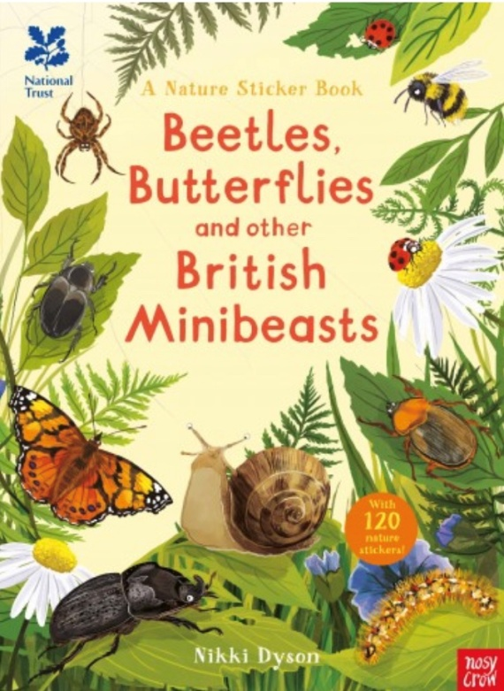
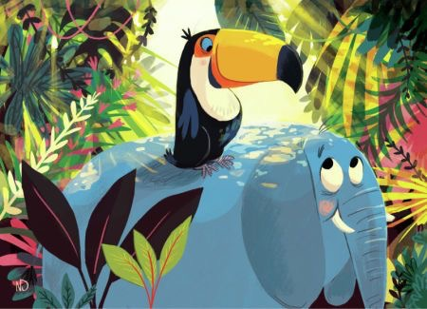
From what I can tell of Nikki’s illustrations, she use paint and pencils for her illustrations, plus software like procreate to create her illustrations. She has a great use of colour and uses realistic animals but adds expression to make characters come alive.
Creating ideas for modern audiences, we need to relate it to the present time, present decade or present century; I think using bright bold colours can help with this, using textures and new concepts would also bring it up to date.
Below are some more modern versions of reference books for children.
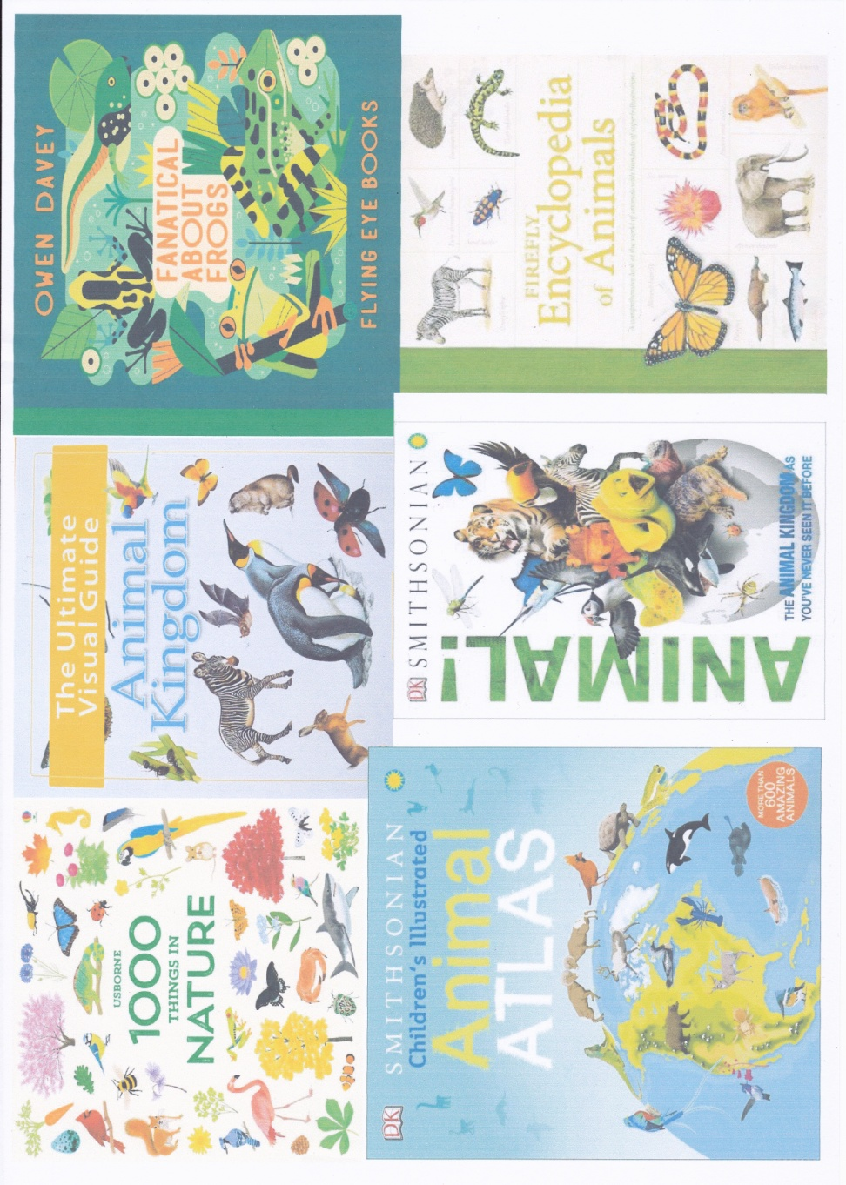
After this I started on my thumbnails, I started with the idea of using the world map in the centre of the page, but not using the rounded style of the world, using a flat image so you can see the countries like a map. I then sketched the animals on top of the map on the countries they came from.
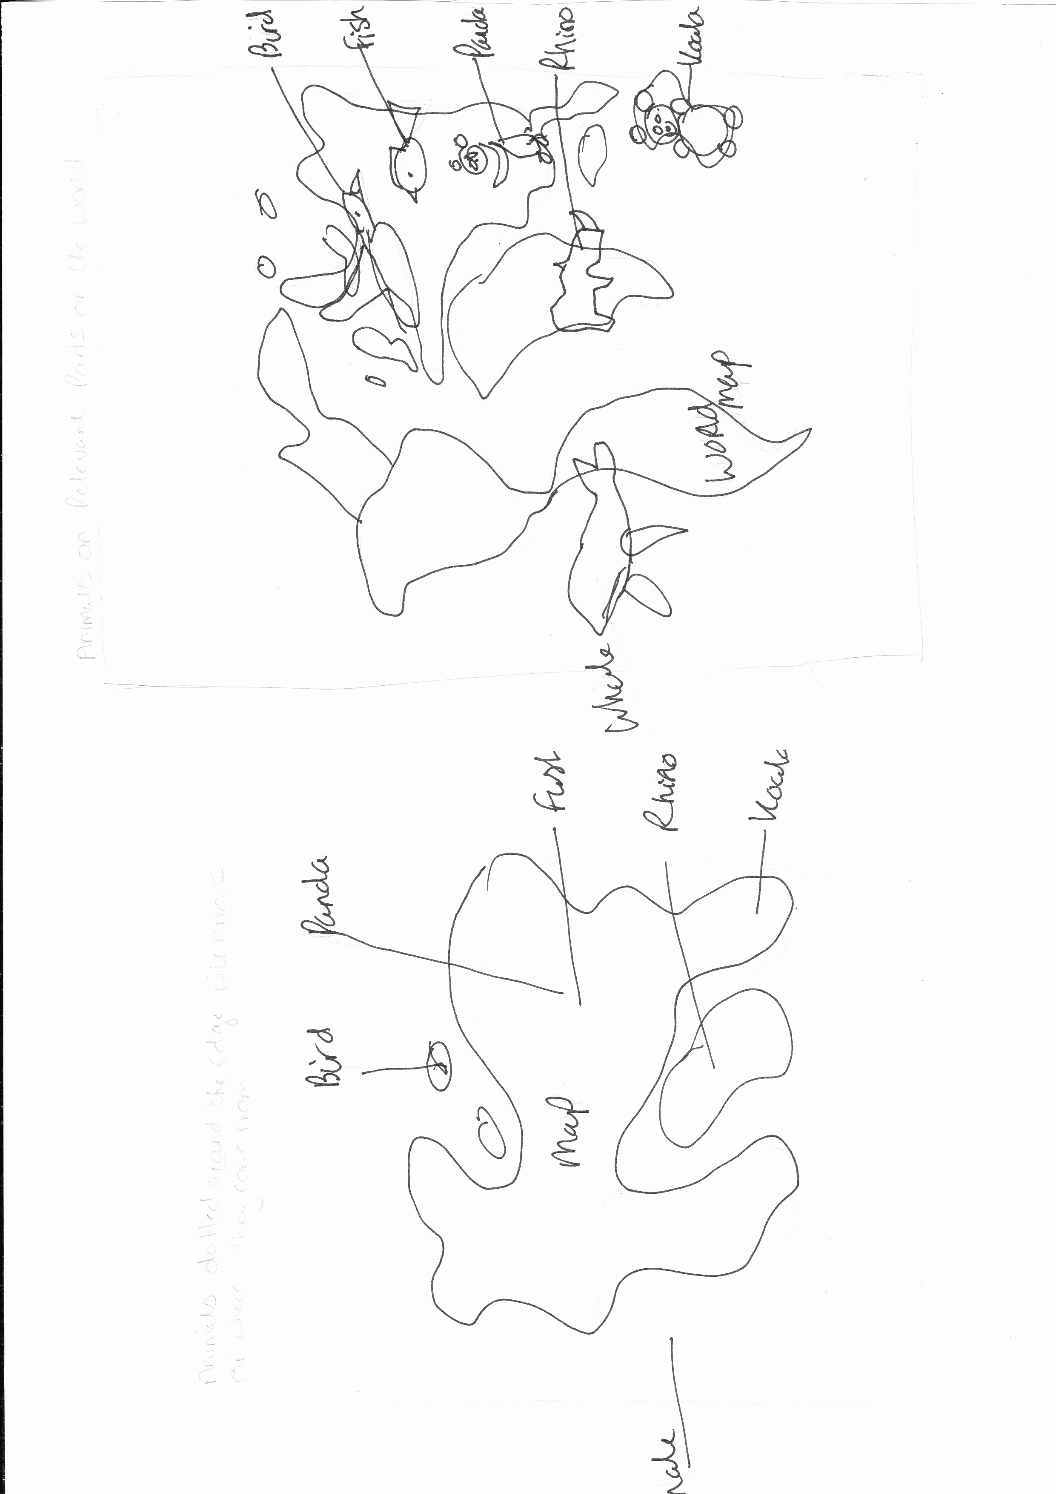
My second idea was using the map the same way, but having the animals all the way around the edge like clock numbers then having arrows to the relevant animals.
The thirds idea is again using the map in the same way, but have 3 animals at the top and three at the bottom of the design.
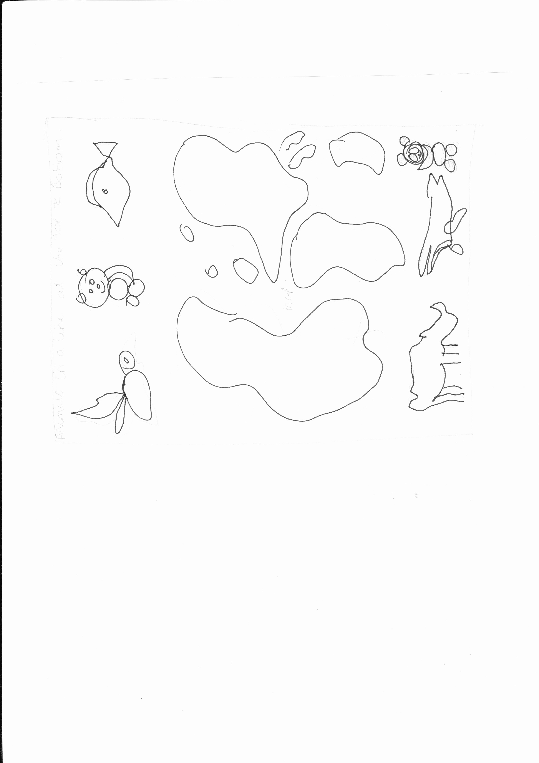
The next 3 ideas were using the map of the world in a round way like a globe but ‘big’, again placing the illustrations of the animals on top of their relevant countries.
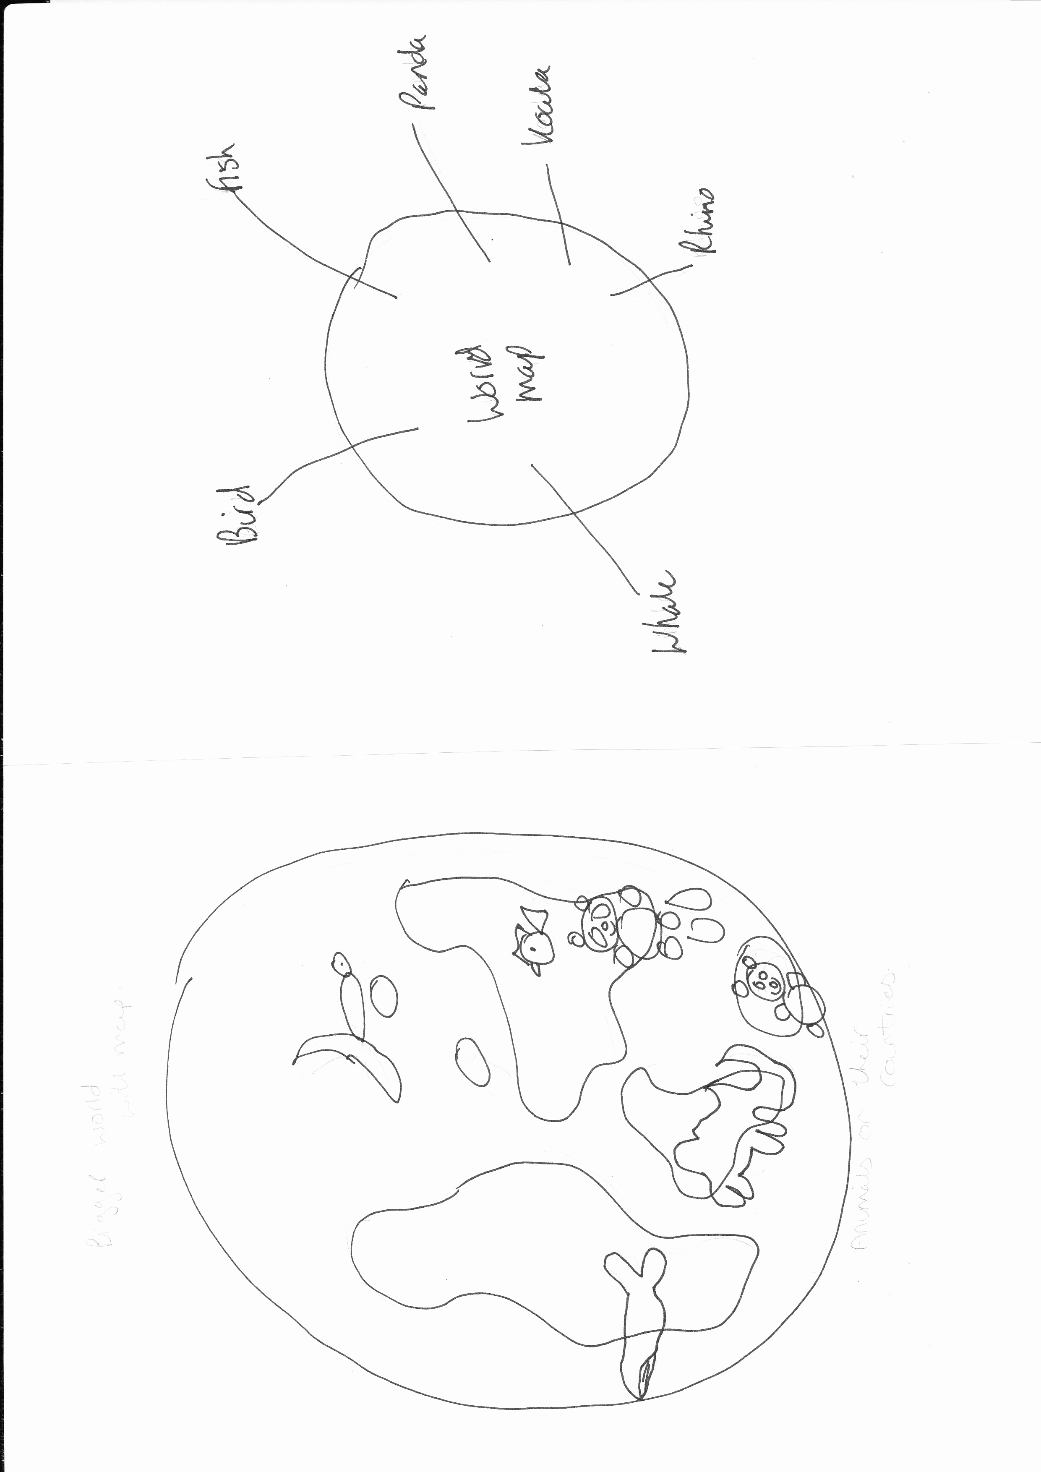
The second of idea of this set was again using the globe but having the arrows pointing outwards around it to the animals.
The third idea was to use the globe again, but to have the animals in a group above the globe as though they are bursting out of the top.
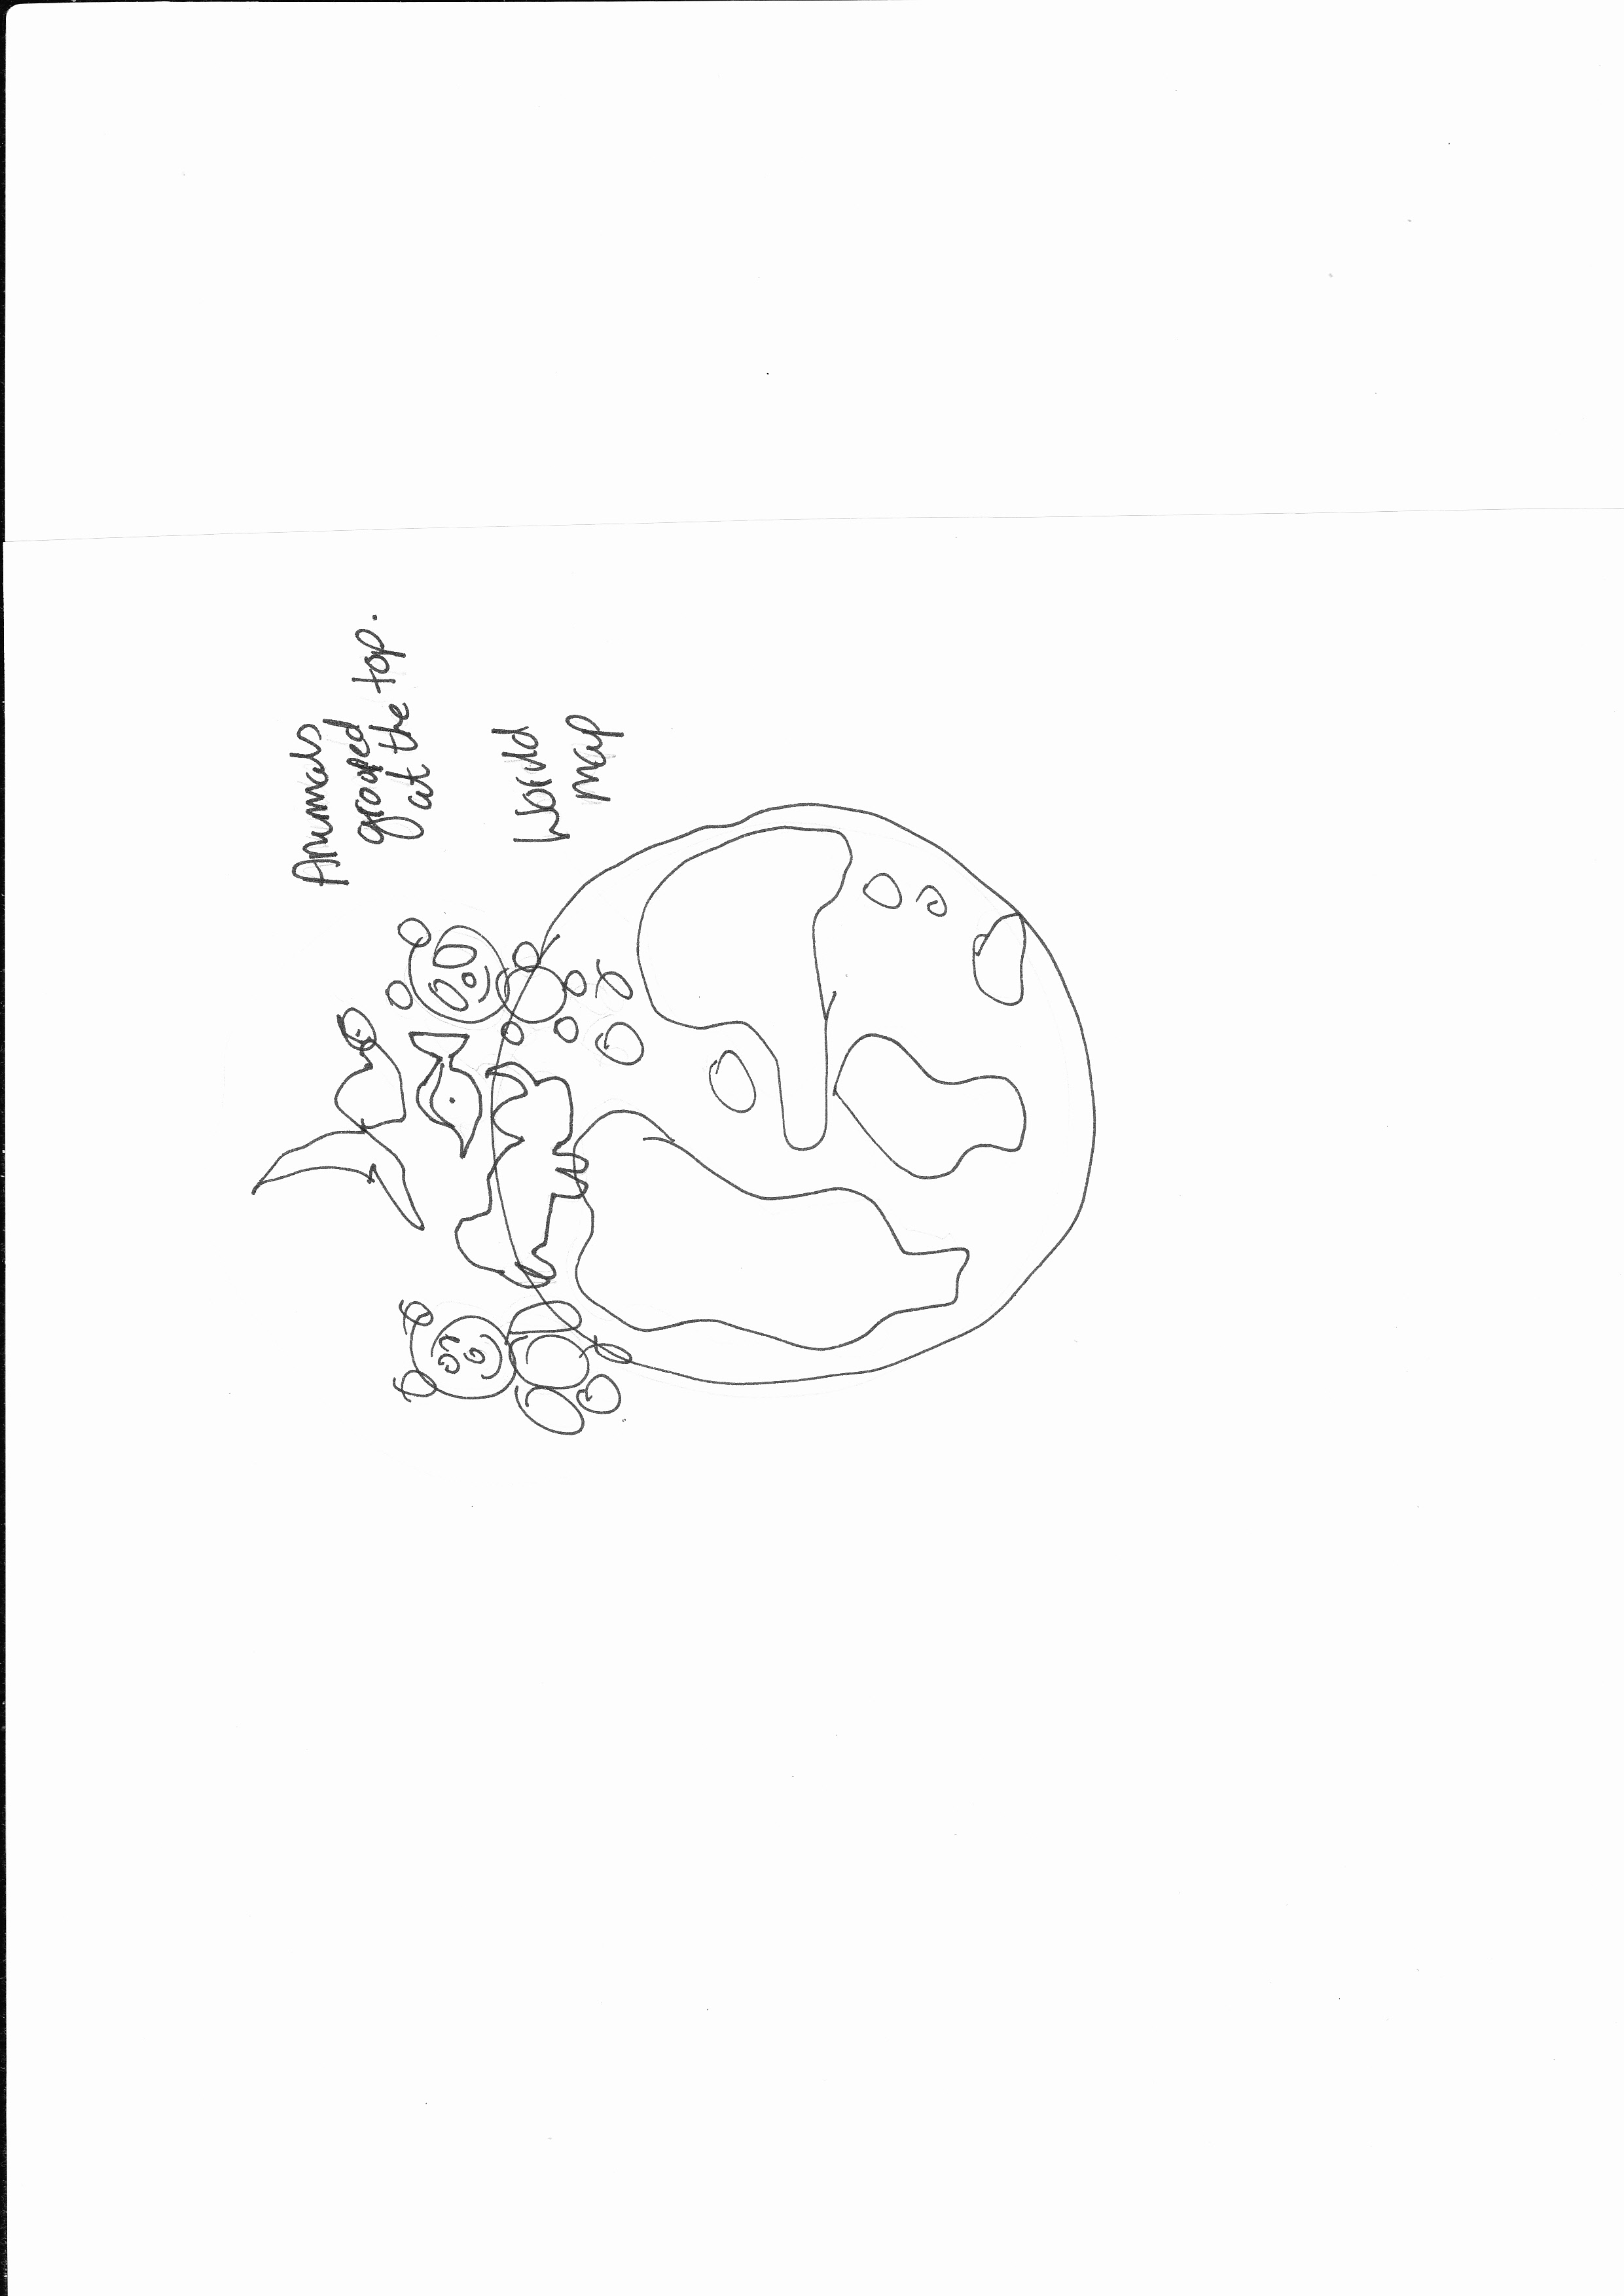
The third set of three I used the flat map of the world again, but this time have the animals grouped at the top, some of them in their natural habitats i.e. the panda with bamboo but with one of the illustrations bigger than the others with an arrow to their country, to focus on one.
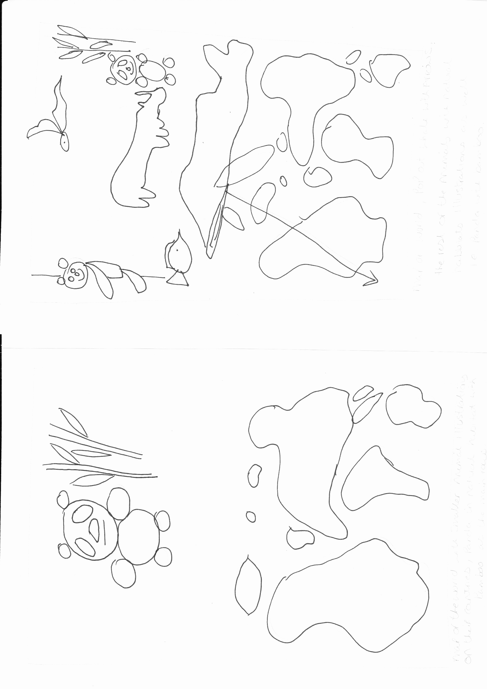
The second idea is to again have the flat map, the animals above the map in an illustration style with the whale and fish at the bottom like they are in the sea, the panda, koala and rhino on the land and the bird in the sky.
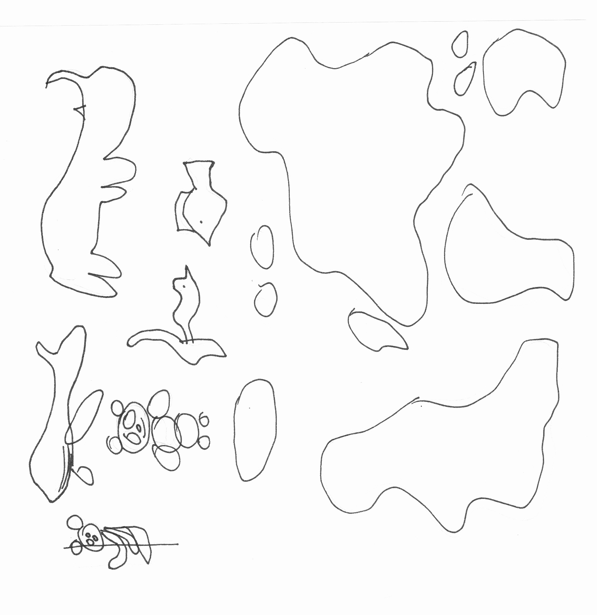

The last idea was again the flat map, with the panda and his natural habitat of bamboo, with the world below him, the other animals on the respective countries.

After these thumbnails I decided to start sketching some animals, I used some of the photographs I had taken at the Natural History Museum as reference material.
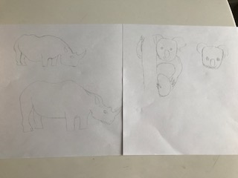
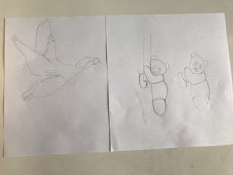
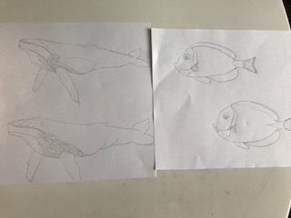
After sketching these out I decided to start some watercolour painting, some of the animals were mixed media where I used coloured pencils and some ink mixed in with the paint to give brighter colours.
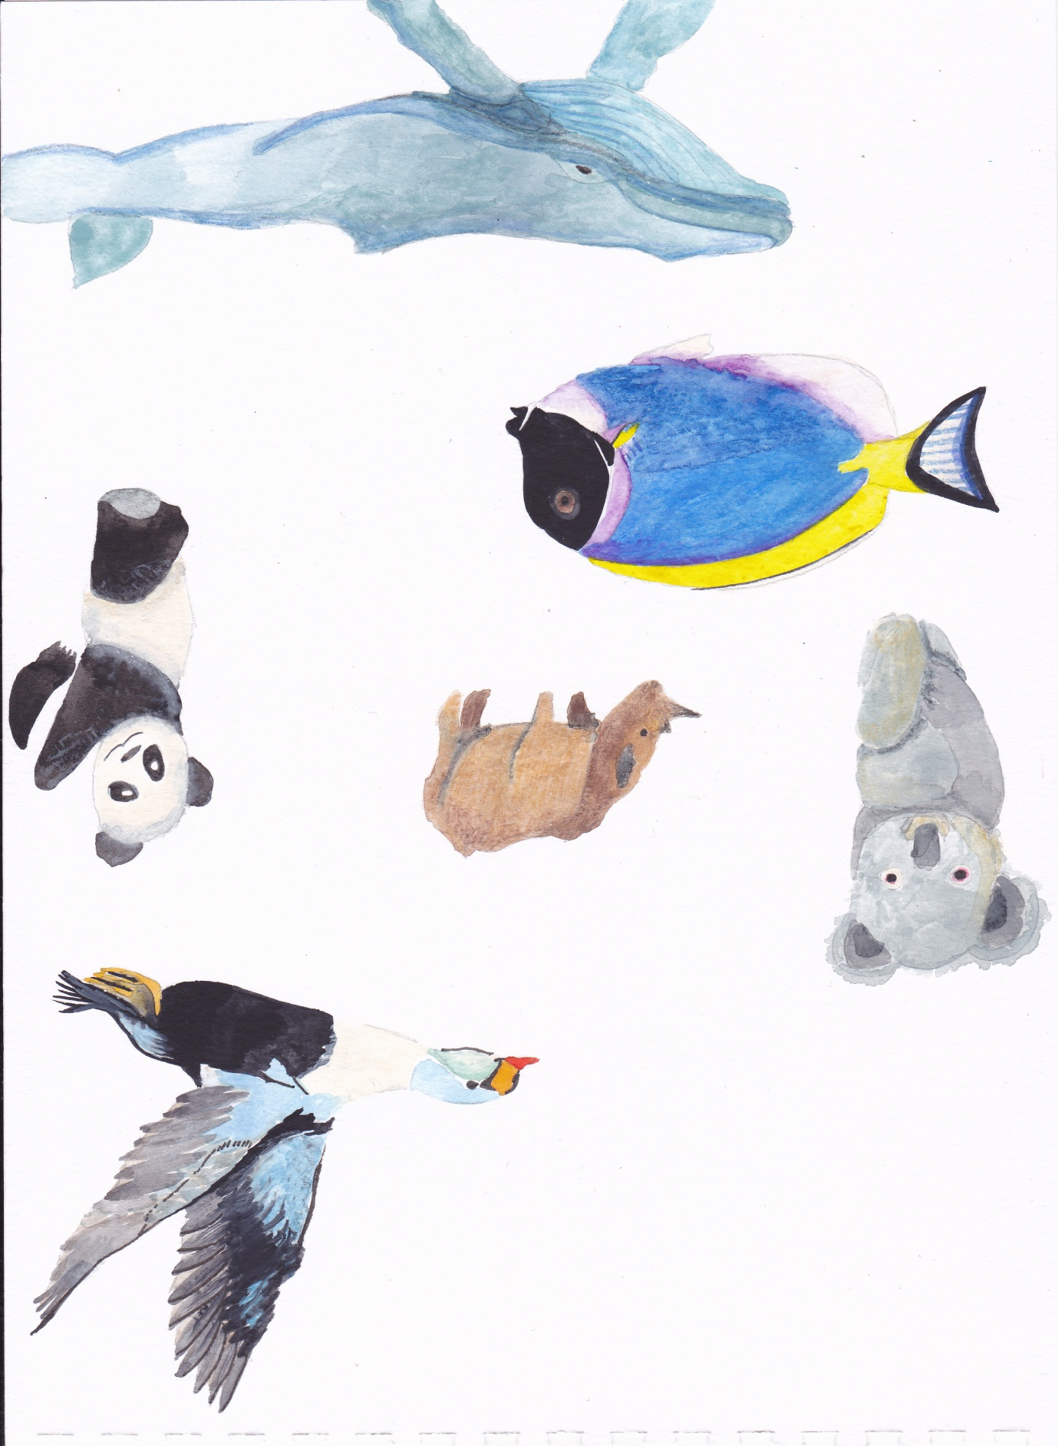

I also looked at things I could pick out from their natural habitats, so for example bamboo for the panda, I sketched some bamboo and also painted these in watercolours. I also found some reference material to be able to sketch a world globe.
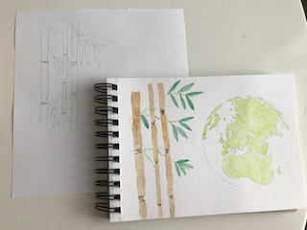
The globe is as technically accurate as I could get it; it was hard as it was supposed to be on a rounded globe!
I also did a flat map to help illustrate one of my thumbnail ideas. I chose to do this in a very light watercolour wash so I could get some difference in colour from the more lush areas to the more hot areas, again it’s a technically accurate as I could get it!
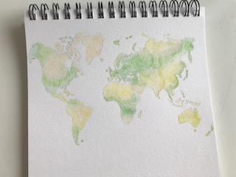
I started by putting these illustrations through Photoshop to erase the backgrounds and around the edges, so I could easily place these in layers on my pictures, backgrounds and textures.
Once I had done that using my Wacom board, I saved these as PSD files. I then started on composition 1 which was the Flat map with animals around it. This is the thumbnail of it:
I chose to start with a blue background as I thought this would represent the water around the land.
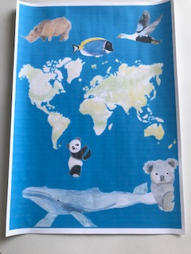
From this I printed it out smaller and started to annotate it to add some variations.
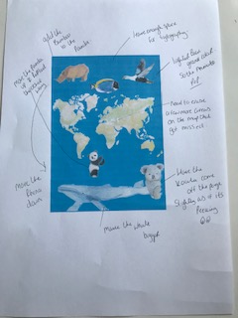
The main things I wanted to change where:-
Add the bamboo to the panda
Move the panda up and reflect the image the other way
Leave enough space at the top for the typography
Try a lighter background colour
Need to erase a few more areas on the map that I missed
Have the Koala come off the page
Make the whale bigger
Move the Rhino down
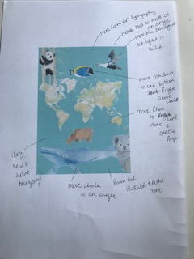
I then printed this off and annotated again:
Move the bird to more of an angle
The lighter background is better but its more green than blue. Change it to blue
Move the fish down to the bottom right above the whale
Move the rhino to the left and off the page
Room for the illustrator’s name
Move the whale to an angle
Does it need texture in the background?
Don’t forget room for the typography
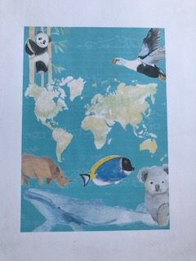
This is what I have come up with for now.
I then move on to composition 2, which was the globe world with animals on top. This was the thumbnail:
So I started with a green background colour, but I thought straight off with this one, its needs texture as there is a lot of space around the image. I looked through my texture sketchbook and found this acrylic blended texture painting I did as a trial, I thought this would be good as it had blues and greens that could represent the foliage and sea.
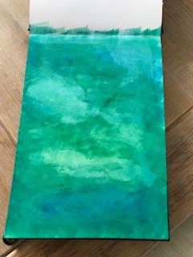
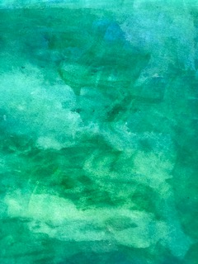
I then placed the illustrations on top, and then printed this off to annotate it.
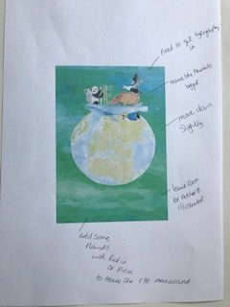
My annotations where:-
Need room for the typography
Make the animals bigger
Move the globe down slightly
Leave room at the bottom for the illustrator’s name
Add some flowers with red or pink to move the eye around the picture and create flow
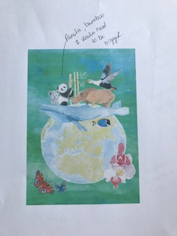
I printed this out and annotated again, which was just to make the Panda, Bamboo and Koala bigger.
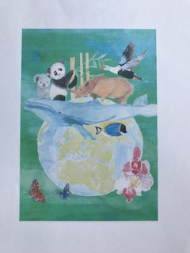
This was ok for now, so I moved onto the third composition. This is the thumbnail:-
Again I started with a background colour, this time I chose a dark teal, to make the illustrations pop. I again printed this out and annotated it:-
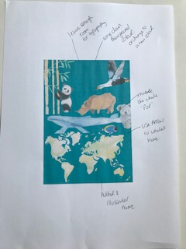
Leave enough room for the typography
Tone down the background colour or change to a new colour
Make the whale pop!
Use an arrow to show the whale’s home
Author and illustrator name at the bottom
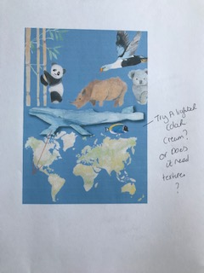
I printed this out and was pleased with it, but the colour was wrong still, I tried many versions:-
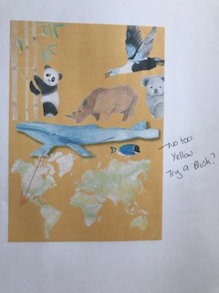
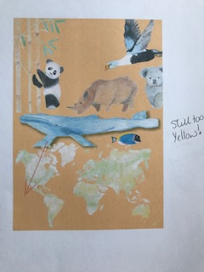
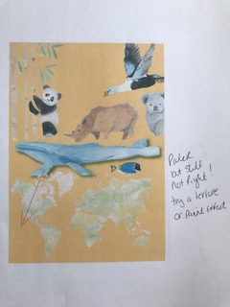
I decided on this one that it did need some sort of texture behind.
I again found in my texture sketchbook a blended acrylic piece which I licked as it had like a forest feel.
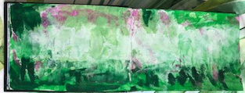
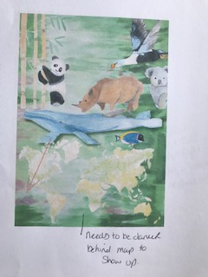
I liked this but the bit behind the map was too light, it didn’t show it up, so I turned the picture around and this worked better.
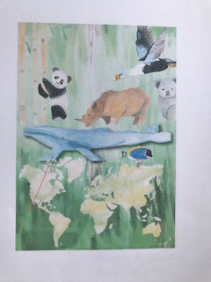
To make the whale pop, I used a drop shadow which I found in Illustrator, I had never used this before so I was really pleased how it looked.
So after I had got an image for each of the 3 book covers, I started to look into typography. I really wanted to draw my own type this time, as in previous exercises I had run out of time to fully get into this. I started with a A5 sketchbook to start doodling in.
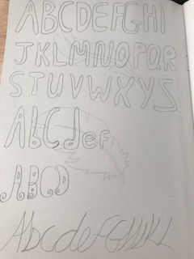
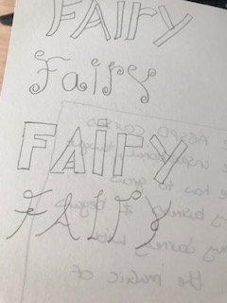
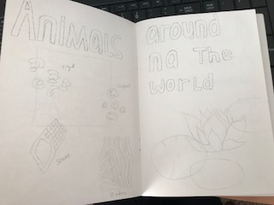
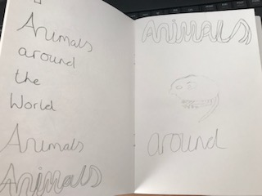
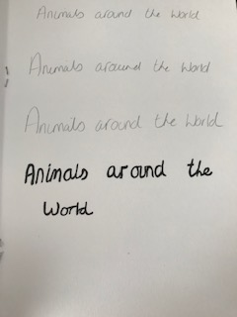
From these I came up with 3 fonts:-
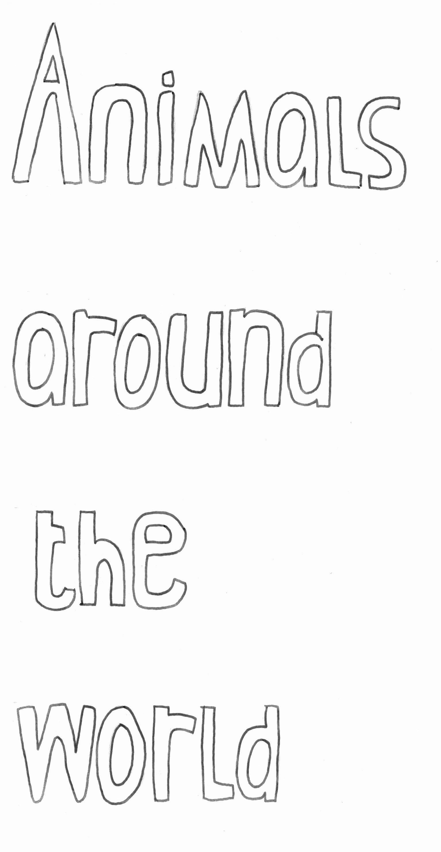
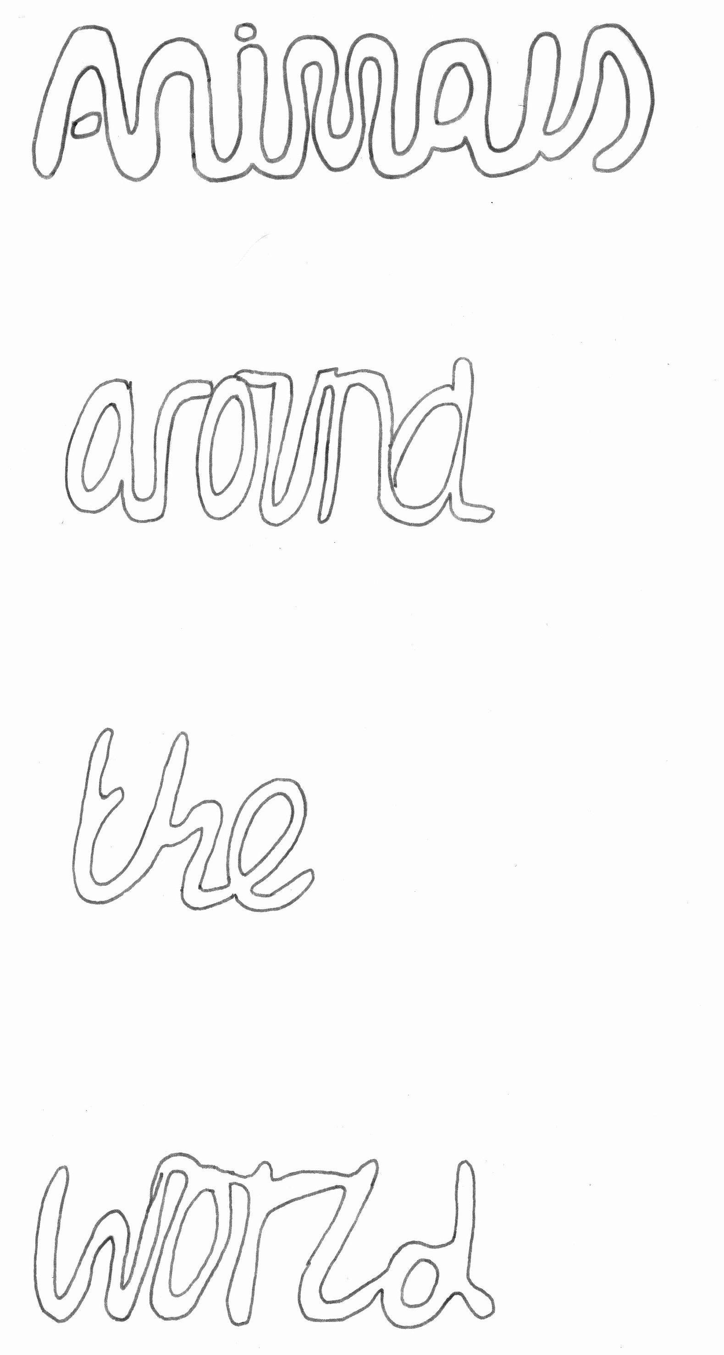

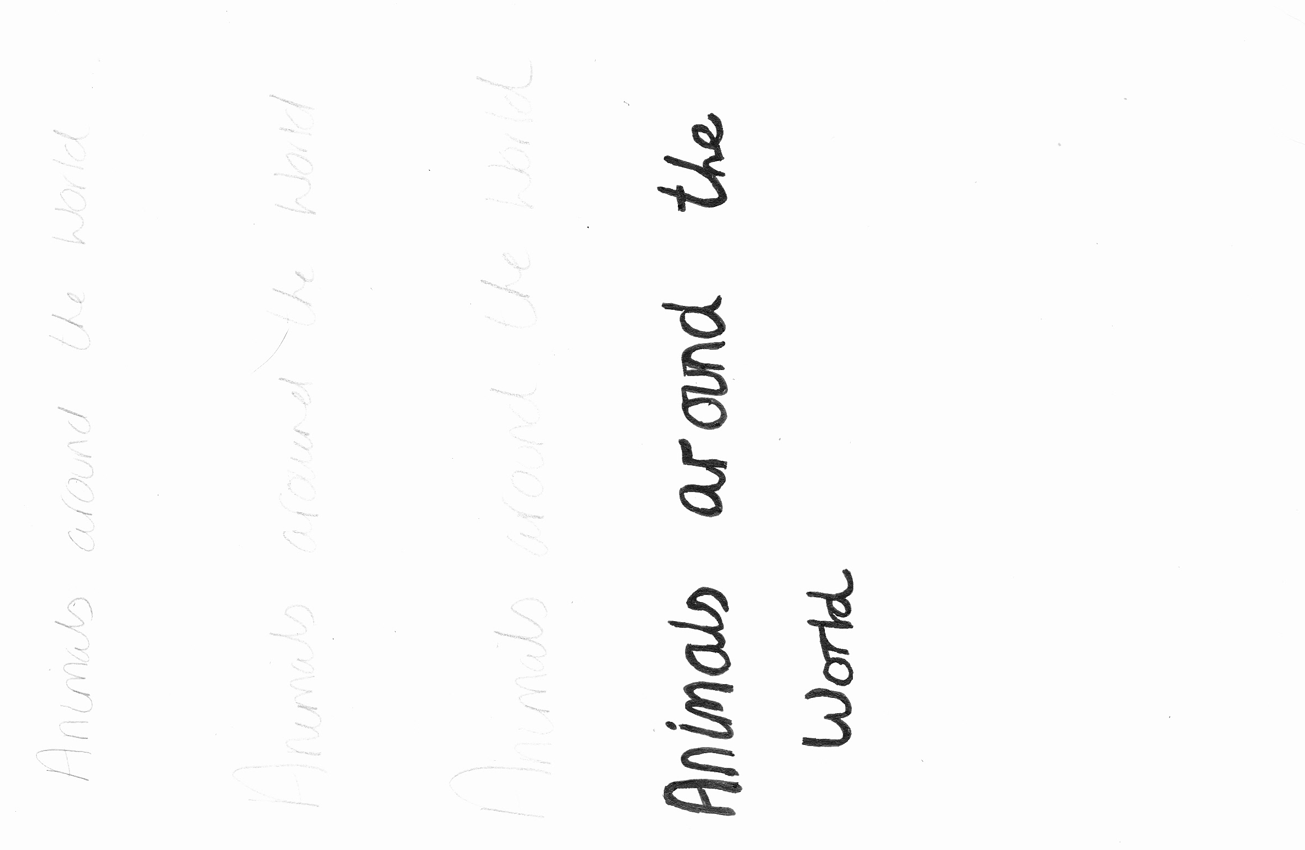
I had the idea of creating some animal patterns to make a clipping mask with for the fonts, so the actual letters were a different animal design.
I started by finding some reference material:
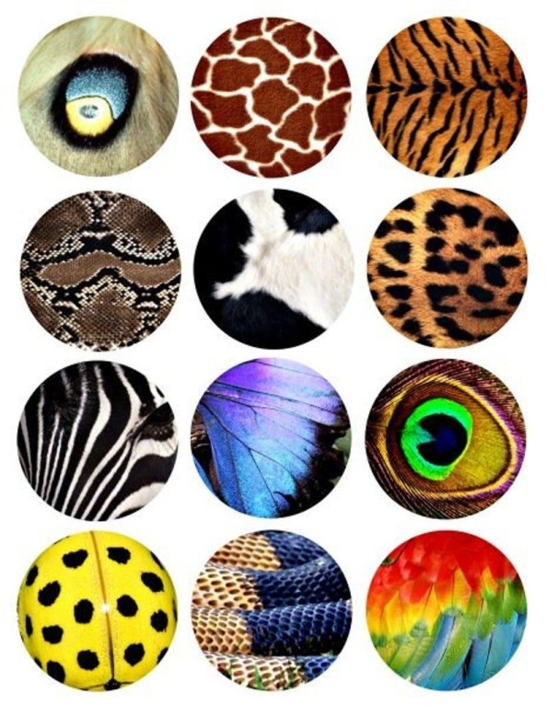
From this I created some watercolours to recreate the patterns;
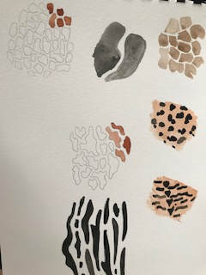
I then put the first font through Illustrator and tried to create the clipping mask, but unfortunately after a few hours it still wouldn’t let me do it, it kept saying the font was to complex.
So I had to change tack, so I concentrated on the other two compositions with their fonts first and come back to this later.
The second font was to go with the globe cover:
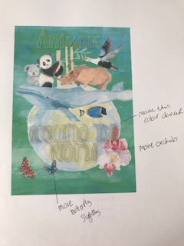
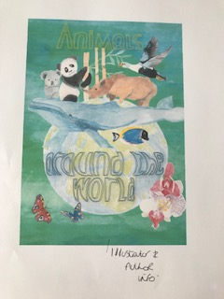
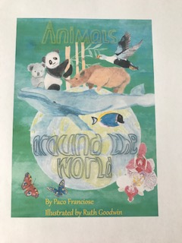
The third font was using my own handwriting; I wanted the book to have writing as though a child had written it, so I purposely did quite a naive style.
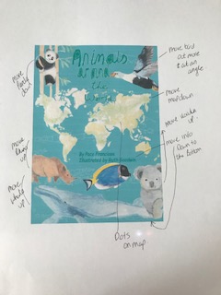
I did this, but then felt with the type it look too busy, so I re-arrange and annotated a print out again.
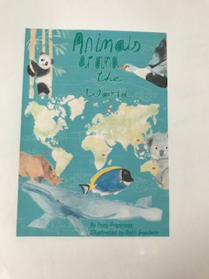
I then went back to the type I was having trouble with; I decided to use a type on the computer as it was simpler and would work with the animal patterns.
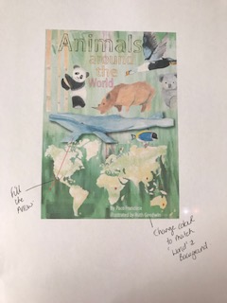
It didn’t show up as much as I had hoped, but using a colour that went with the animal pattern I chose for each word helped bring out the pattern. I then just annotated a few more points and then finished.
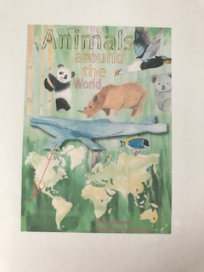
From this I then did a mock up of each of the book covers, and then changed the contrasts and saturations to make the colours come out more.
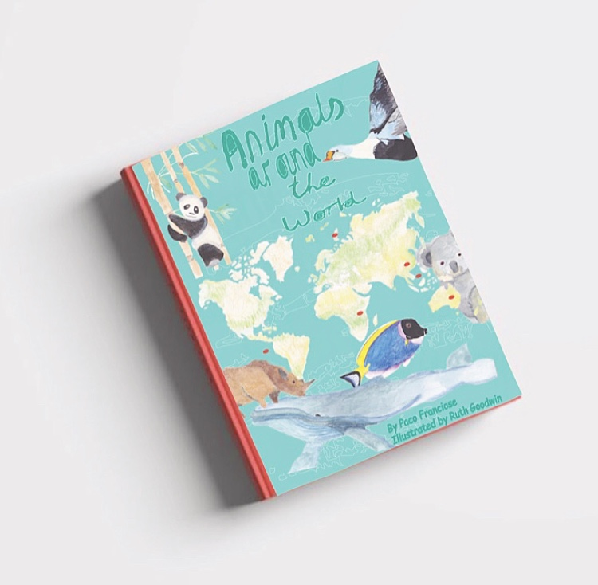
I feel this design is more unisex and would appeal to both boys and girls of the age range 7-11, the illustrations are not babyish or child like, but are still cute for the younger 7 year olds.
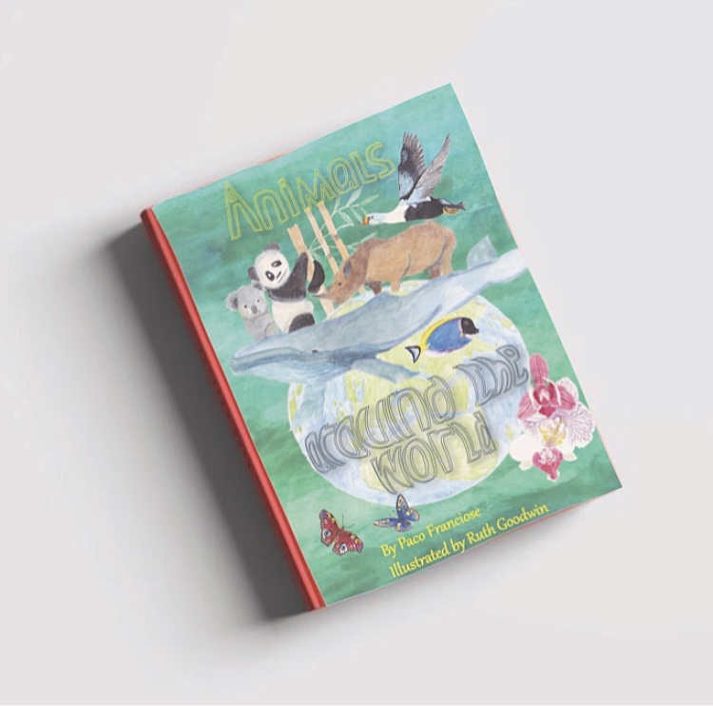
This one I feel appeals more to girls, purely because of the colours used and the butterflies and orchids on the cover, it’s prettier. Again it is good for the age range 7-11 it’s not too young but not too old either.
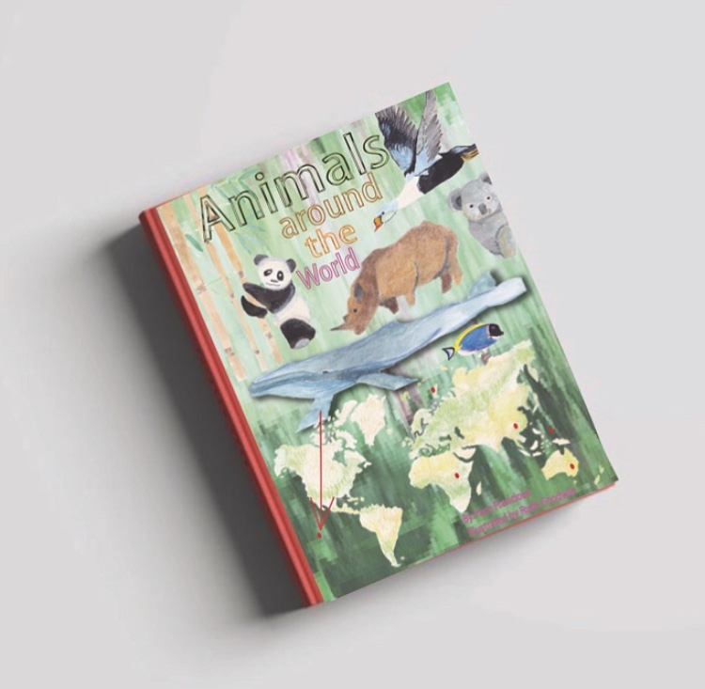
This one I feel would appeal to more boys than girls and this one has a slightly older feel, its more textured and more knowledge looking.

What did you think of this exercise?
I was really looking forward to this exercise as this is something I’m extremely interested in doing. The title of the book was also up my street and animals are something I love drawing and illustrating.
I really wanted to concentrate on this exercise so I gave myself double the time of the exercises in the previous sections.
What have you gained from doing this?
I have gained overall to be more thorough and to take the time you need to complete the exercise the best you can. I have also gained more experience of Illustrator and just by playing around I have found a few new things which will help me going forward.
I have spent more time on typography which was a focus for me, and I have really got to grips with annotation and composition.
Are there any materials or ideas you would like to explore? What will you do?
I want to continue looking into typography; I will continue my little A5 sketchbook with this. I will continue to play around with both Photoshop and Illustrator, to learn any new bits within the software.
I will look more into keeping the brightness and colour in my designs, working out how to keep the colours I originally paint with, which seem to get lost in the software and printing process.

Over all I really liked this exercise, I really enjoyed doing all aspects of it and found myself becoming more confident in all the aspects of it.
Up-dated 23/10/2019
I showed my designs to a group of friends and colleagues as I wanted to get some feedback on the 3 designs, whether they thought it matched the age range? Which design they liked the best and why? Do the words work? Is it eye catching?
The feedback I received was:-
Out of the 20 asked 14 liked the globe design the best (1.)
2 liked the blue design best (2.)
4 liked the green design the best (3.)
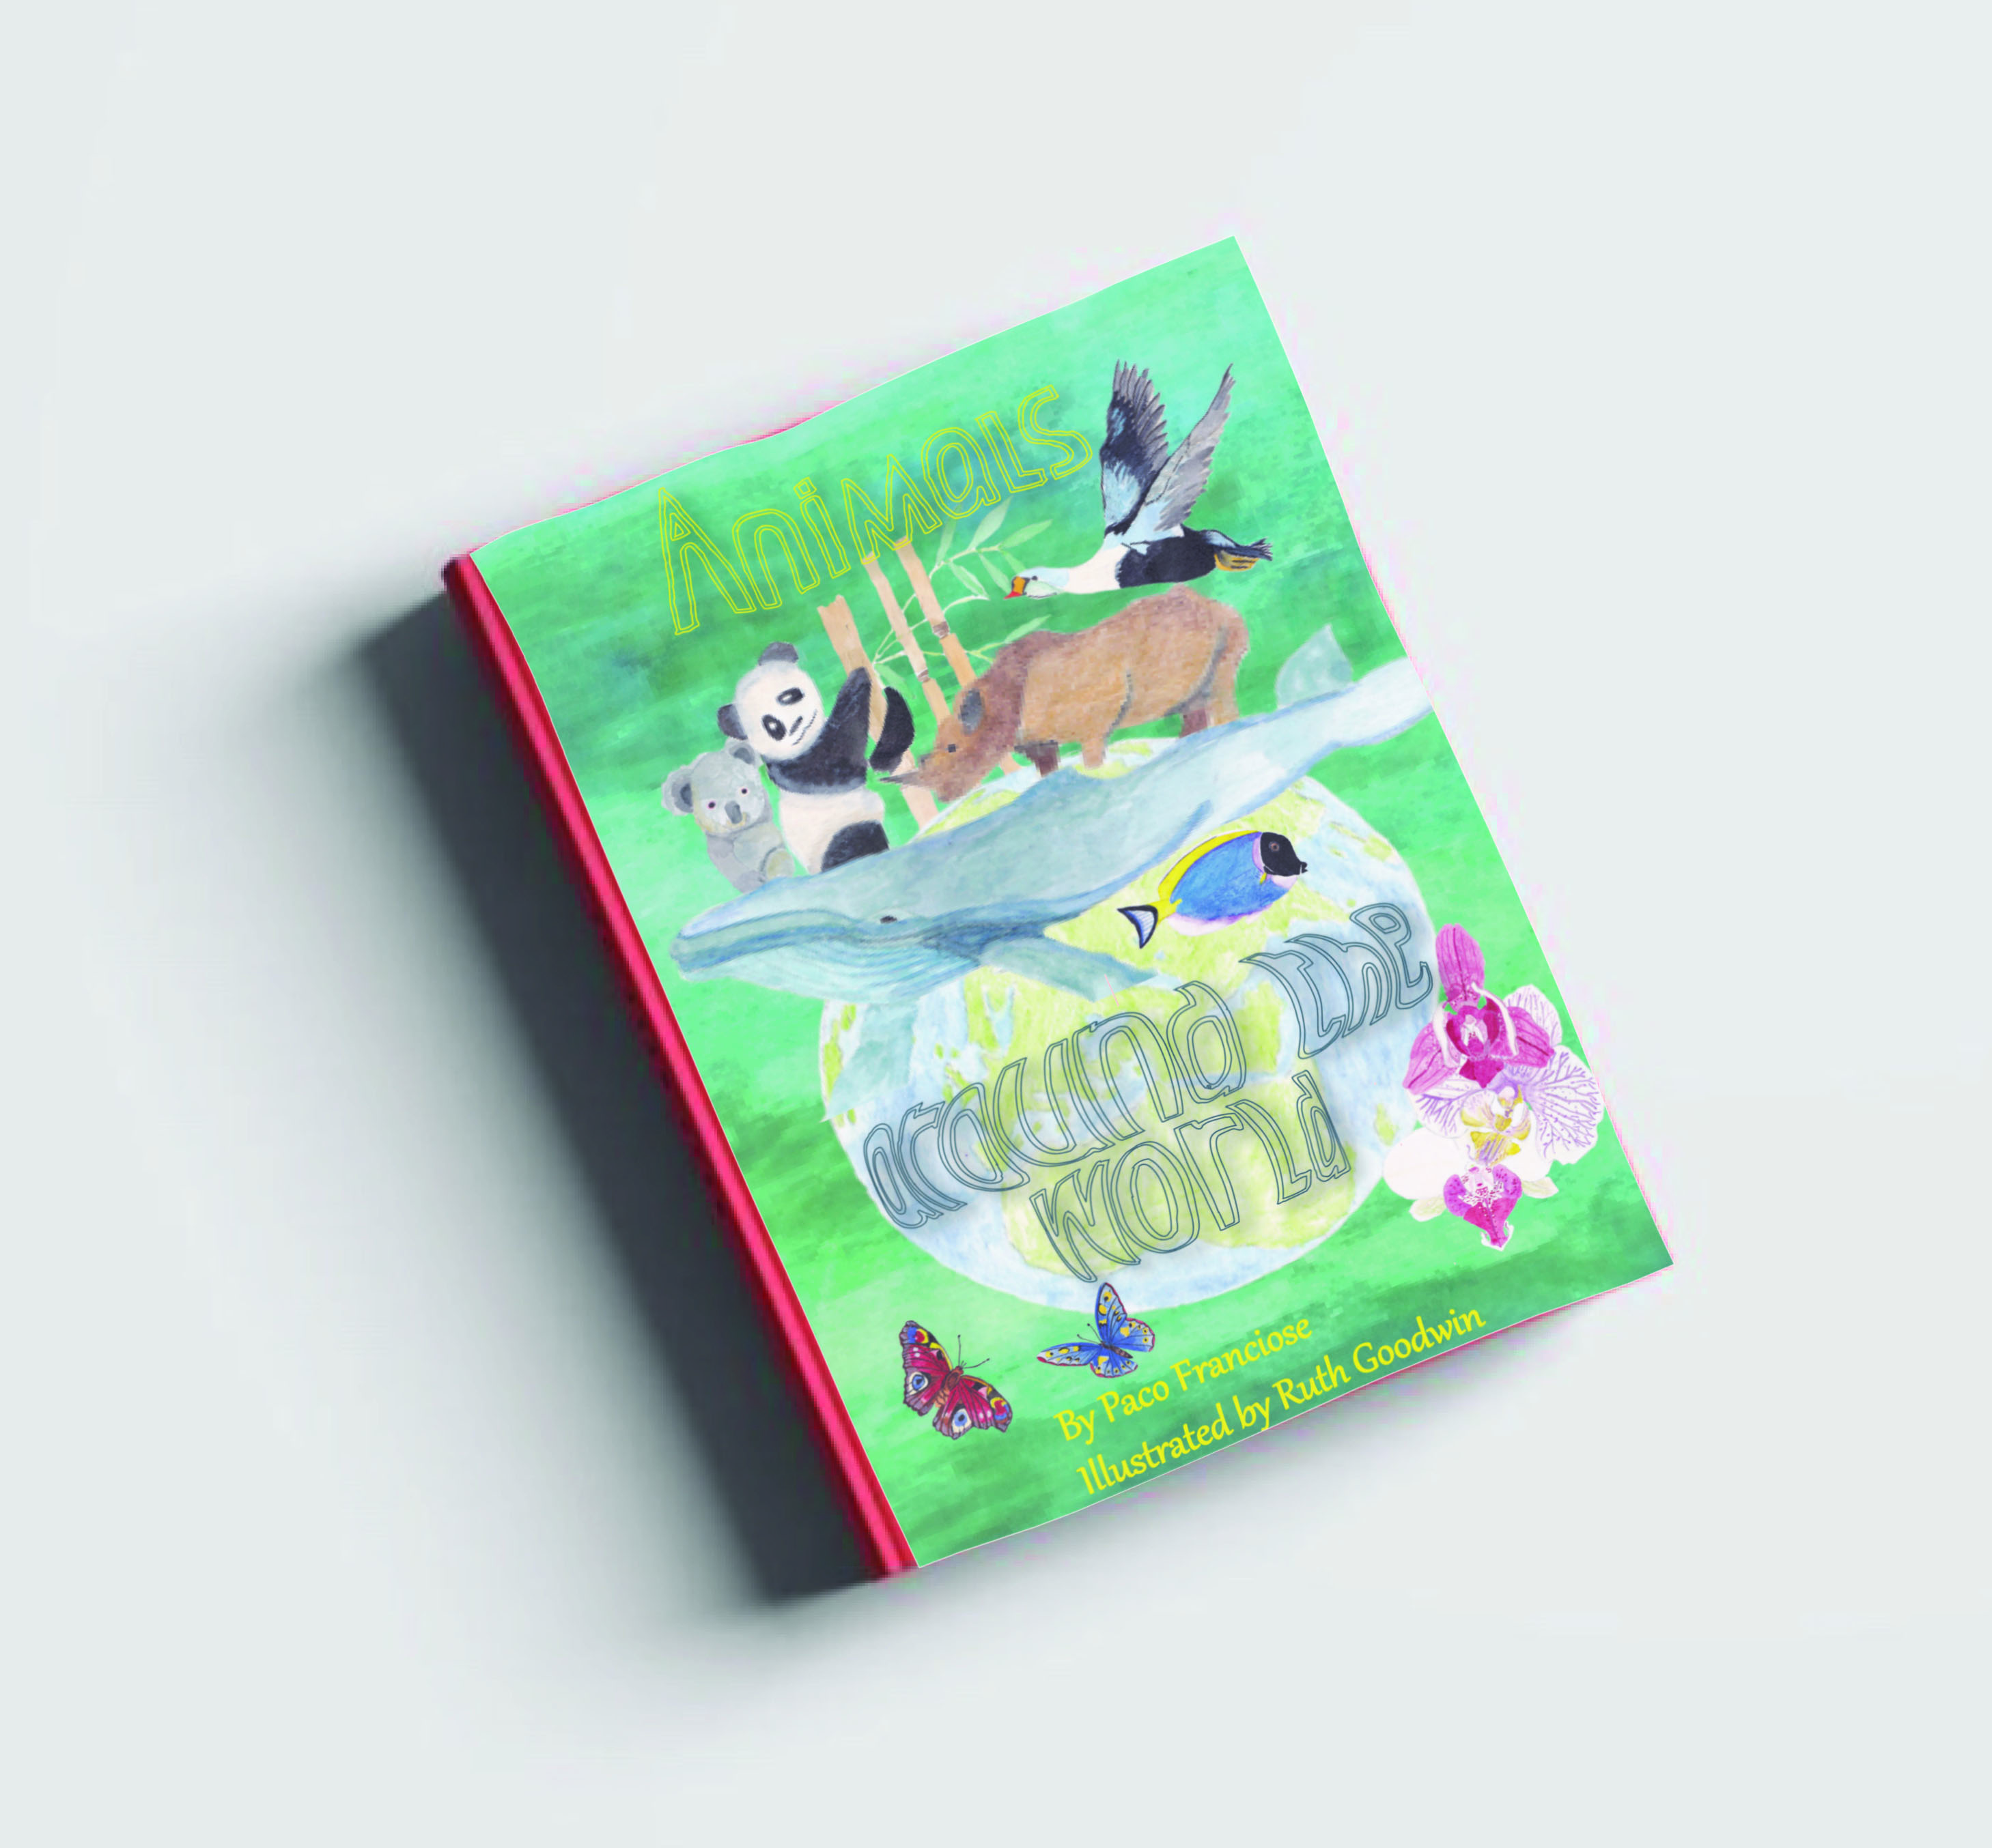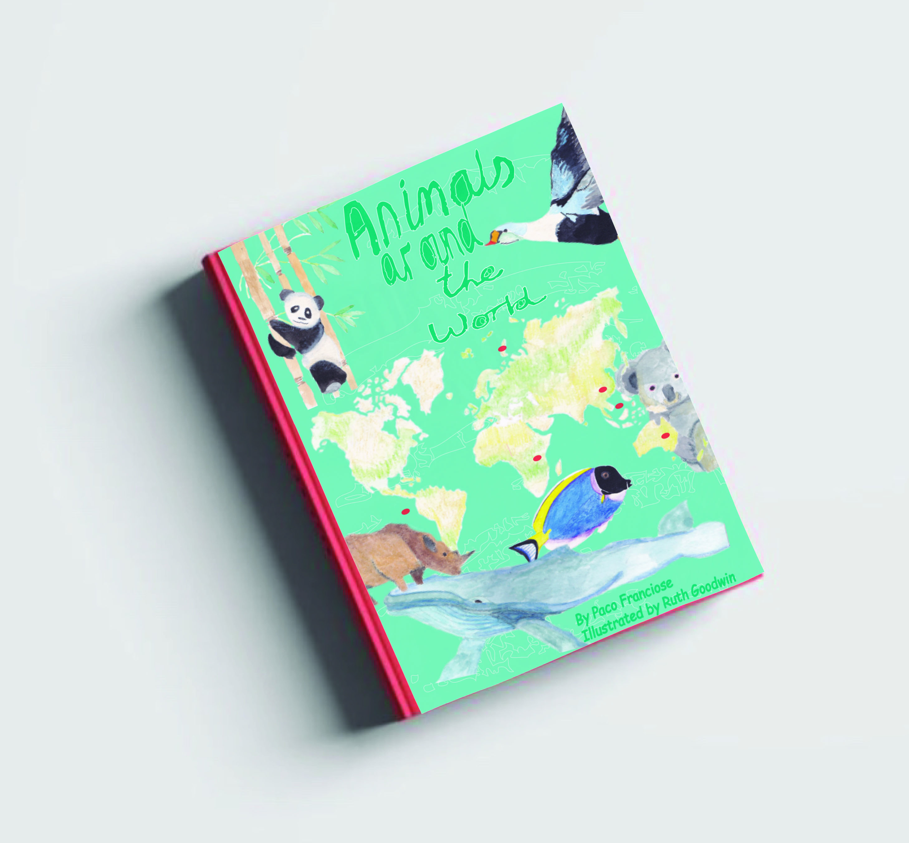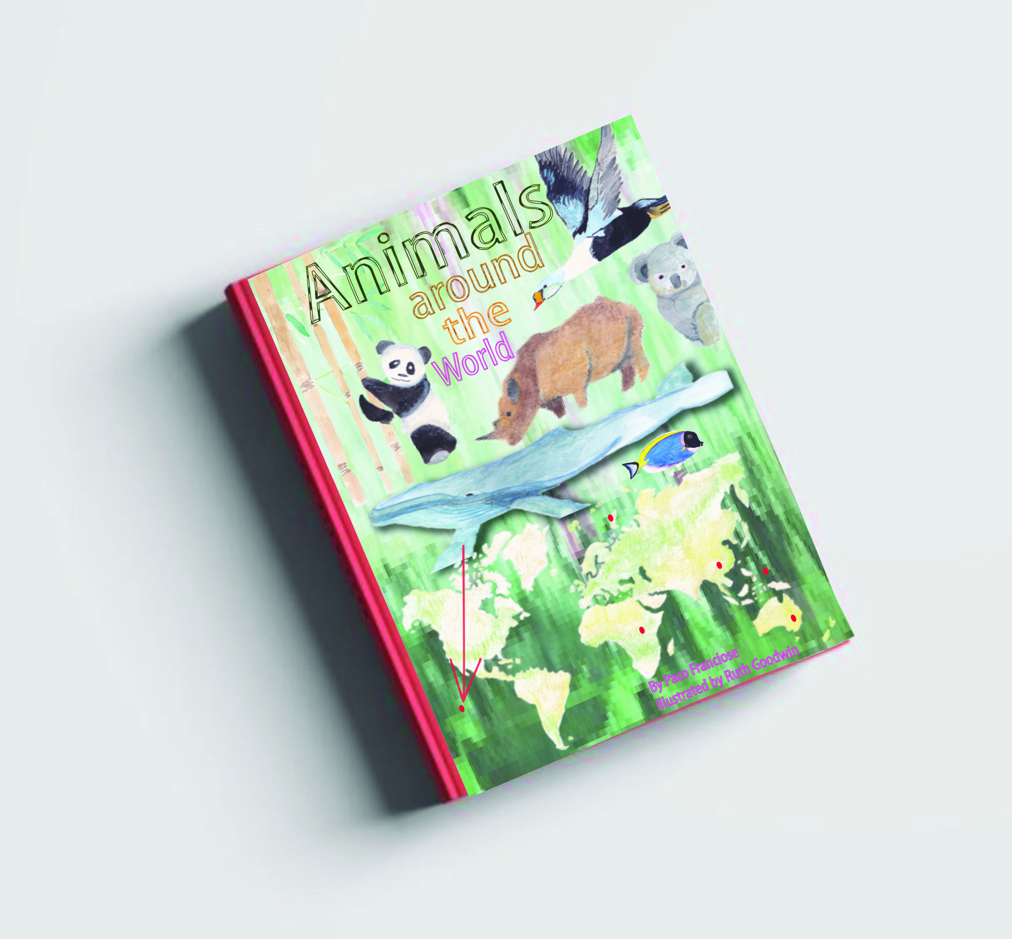
Mostly all of the people asked preferred the typography of the green design (3.)
All of the people asked thought all the designs were appropriate to the age range given.
The 14 people that liked the (1.) design said it was because of the globe; it represented the entire world and was visually better to represent that using the globe. They liked the typography style and placement, although a few mentioned it could be bolder.
Some people thought the green design (3.) was about the rain forest due to the texture in the background.
Some thought the green one (3.) didn’t have anything on the bottom half, they couldn’t see the map.
The 4 people that voted for the green design (3.) thought it was colourful and eye catching.
After feedback from my tutor, she suggested to go into more detail about the book design of each one, the size of the book, the format of the books, why I chose the colours I did, the characters and composition and shapes.
The intend size of the books would be A5, I think anything bigger would feel oversized, The illustration I have completed is for the front cover only, I think I would use the background colour and texture for the back cover, with just the barcode and details of the publishers, along with a short bio of what the book is about.
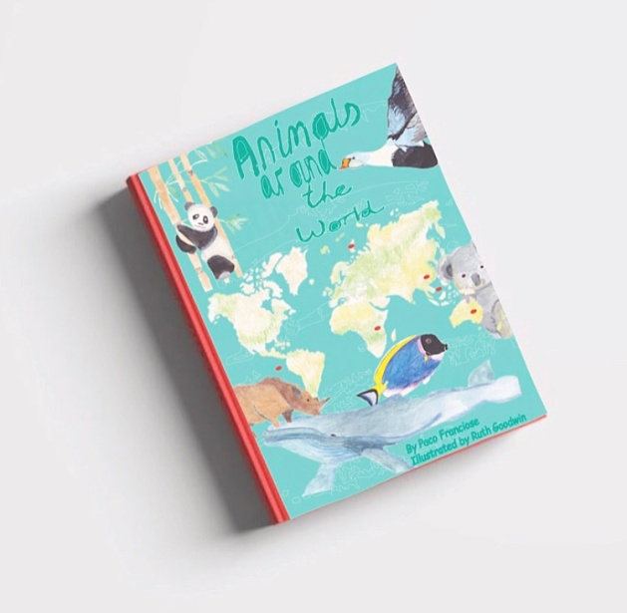
I chose the colours for the first one (above) because it was based on the background being the sea, which contrasts the map which is in a lighter green and brown. I added the small amount of lined texture in the background to give the effect of the sea and to give it some interest. I chose the colour of the typography to compliment the background colour and tie the two together. I used the composition on this book, to make the bird come in from the right side and also the Koala, then the same with the Rhino on the left. I think this makes the reader want to open the book to see what’s on the other side. The animals or characters I chose for all three covers was because I thought I would have a variety of different animals to represent animals from around the world, so I tried to pick ones that were different and some that were recognisable.
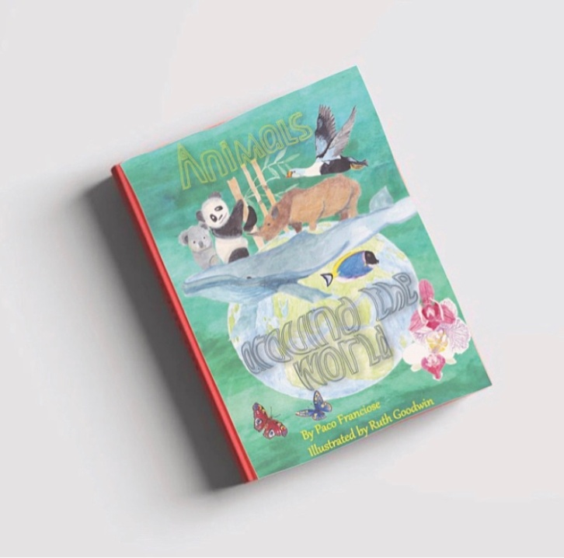
For the second book cover (above) it would also be in A5 and the format would be the same, this illustration is for the front cover and the back cover would just be the background colour and texture, along with the publisher’s details and a short bio on what the books about.
I chose this composition because I wanted the shape of the round world (globe) to be the main focus. I wanted the animals to leap out of the top, but because of the scale of the whale to the other animals; I had to change that idea slightly to fit them all on the top. I decided to add the orchids and butterflies to give more colour and a slightly feminine feel to this book cover.
The typography I think works really well, and I chose to place it in these places because I wanted the words to show the roundness of the globe, and make the book pop. The typography at the top is to frame the illustration. I learnt how to make the fonts curve on the computer, which I think really adds a great dimension to the typography.
The colour of the words could still work better and be bolder, I had another look at this and tried a few colours out, I finally came to the decision that orange looked better, it popped more and brought another colour into the picture.
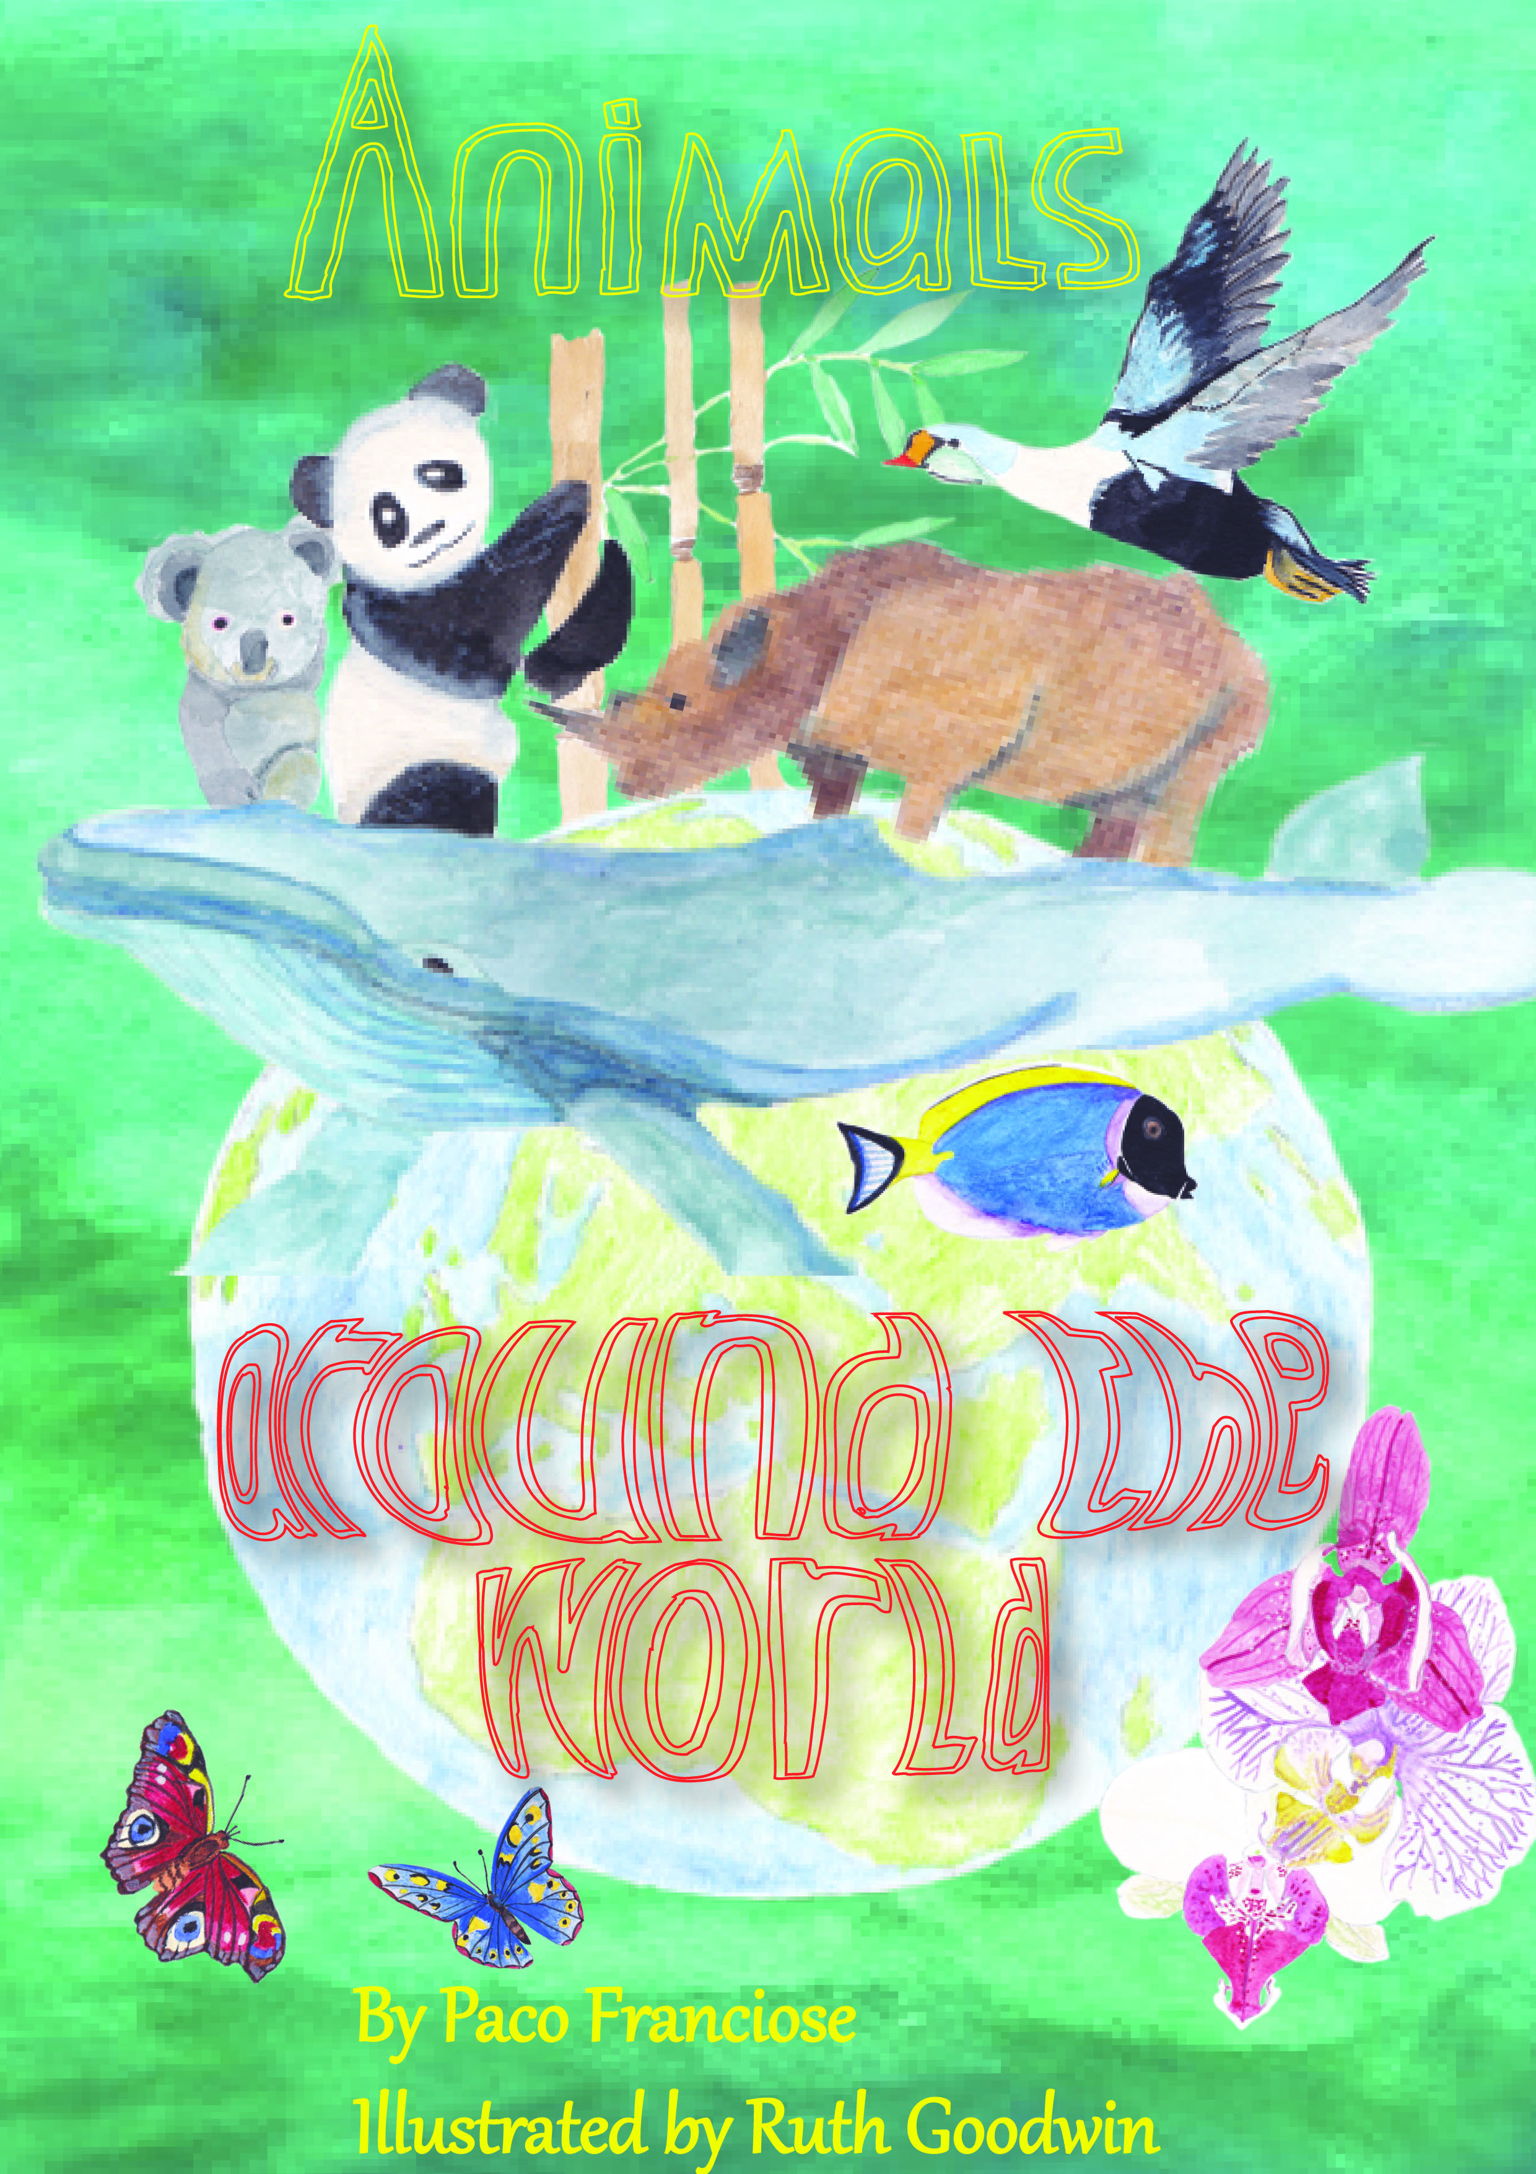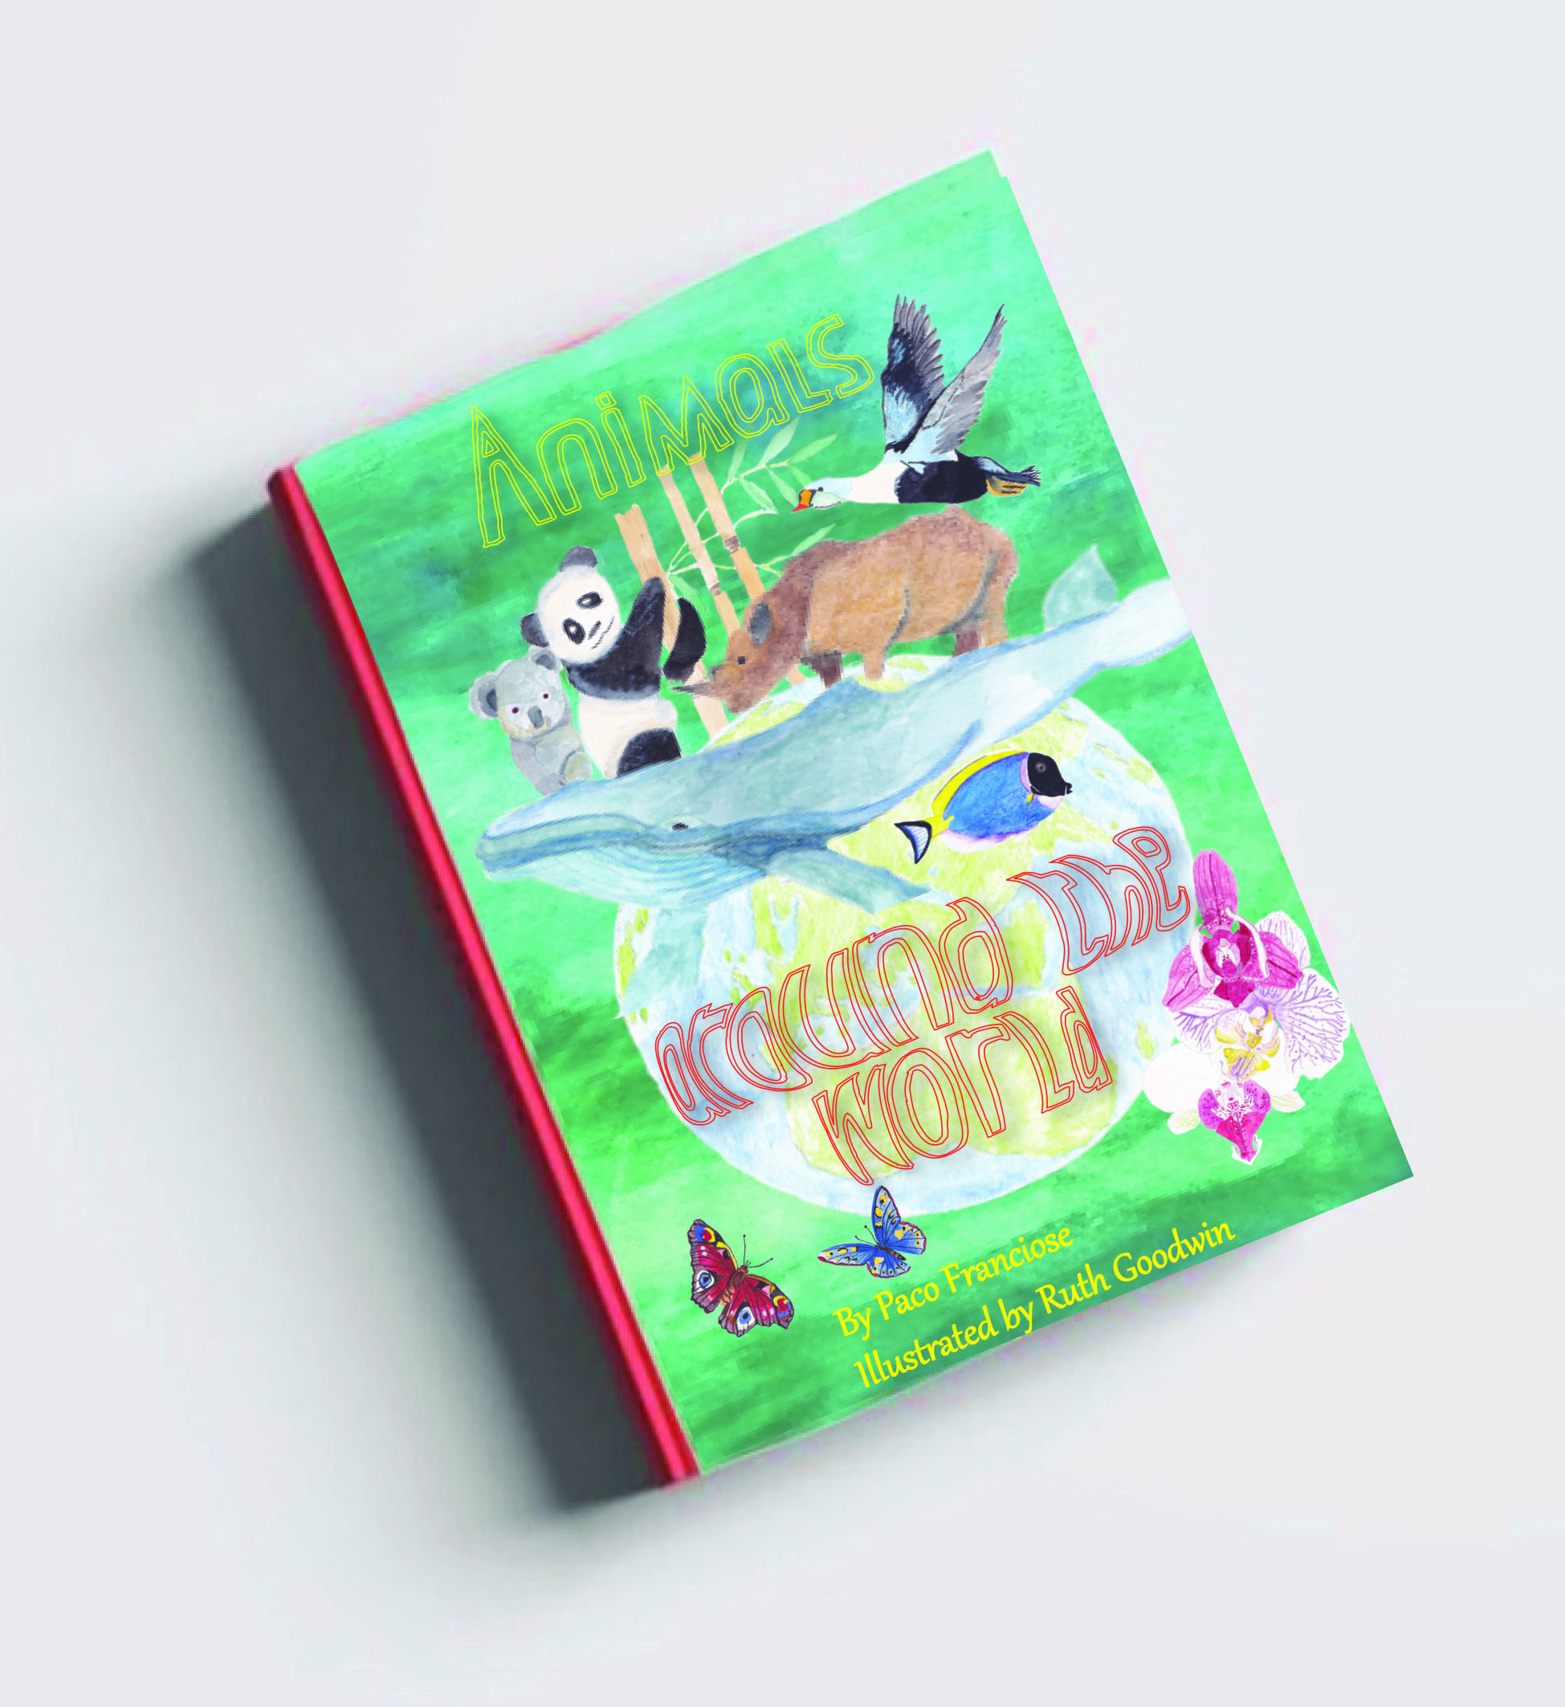
With book cover three (above) I again chose the A5 size along with this illustration being the front cover, and the back just the background colour and texture.
I wanted the map on the design to be separate from the animals, that’s why I chose to separate the top and bottom into sections for the map and animals. I chose to use the bird and Koala again to come in from the right side, but have the other animals in the middle, I think the bamboo balances the illustration out.
I chose to colour my typography here in different colours for each word, I chose the colours in the background to highlight this. I think this draws out the background more and ties it altogether; the colours really work here as it looks like texture from the animal kingdom, foliage and grass etc.

