Museum posters
Before I started this exercise I read through the brief, and then went out for the day to the Natural History Museum in London, to get all the photos I needed and research and soak up the atmosphere, as this was the museum I was going to design the posters for.
I started to look at illustrators that have done posters for museums too; I found Nina Cosford and researched into her and her illustrations.
I found these illustrations that Nina did for 3 different museums, but she has done them in the same style so they are a family of posters.
This first one was for Leighton house museum, it depicts Leighton house at the bottom, and then like a speech bubble or idea bubble, she has illustrated some of the things you would find at the museum. The style is very simple, yet it is bold and striking, it’s all images with no words apart from the name at the bottom, so she lets the visual speak for itself.
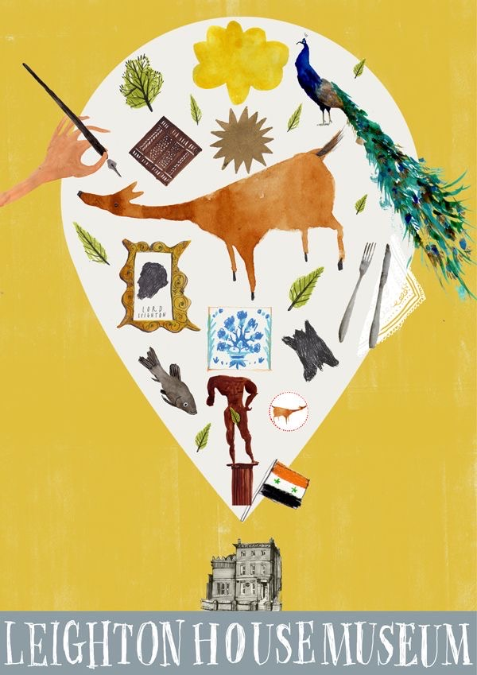
The second one is for The Museum of London, again it is in the exact same style as the first one, and the visual is all encompassing.
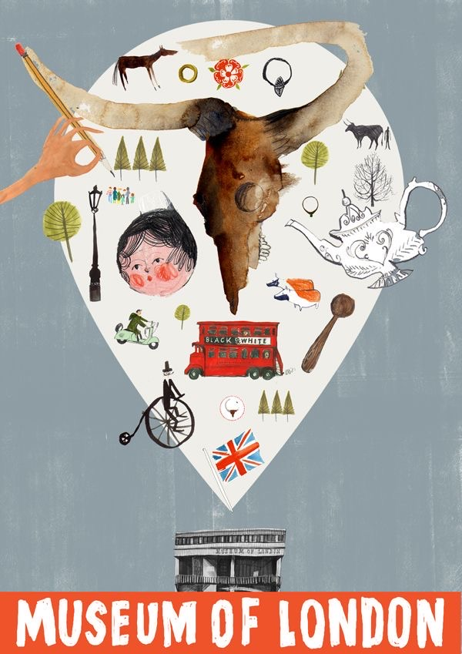
The third design poster is for an exhibition of Japan at the V & A Museum, This one I like the best, it is very bold and colourful, lots of Japanese elements like the blossom. I like the fact that although the posters are for different museums, she has kept the designs as a family. I think this is interesting as an illustrator; it would keep your style consistent.
Below are little leaflets that Nina designed for children who attended the exhibitions and museums that they could interact with whilst walking around.
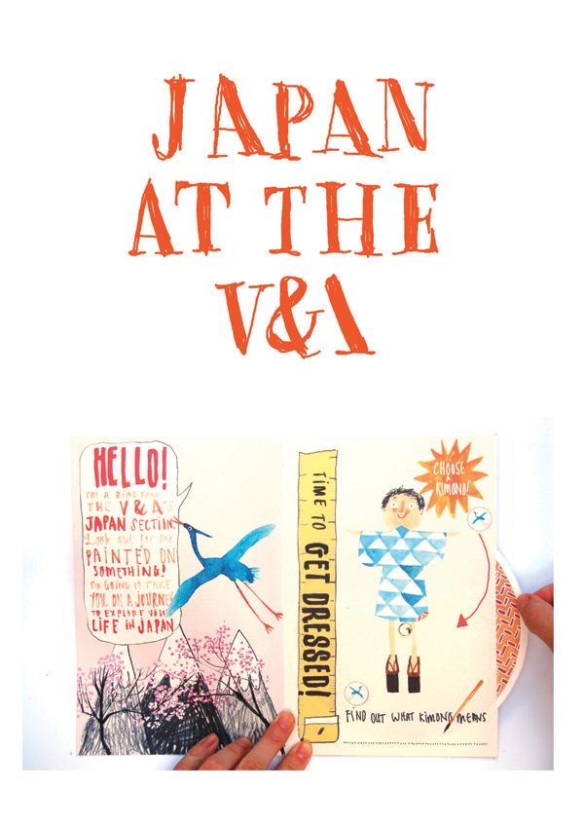
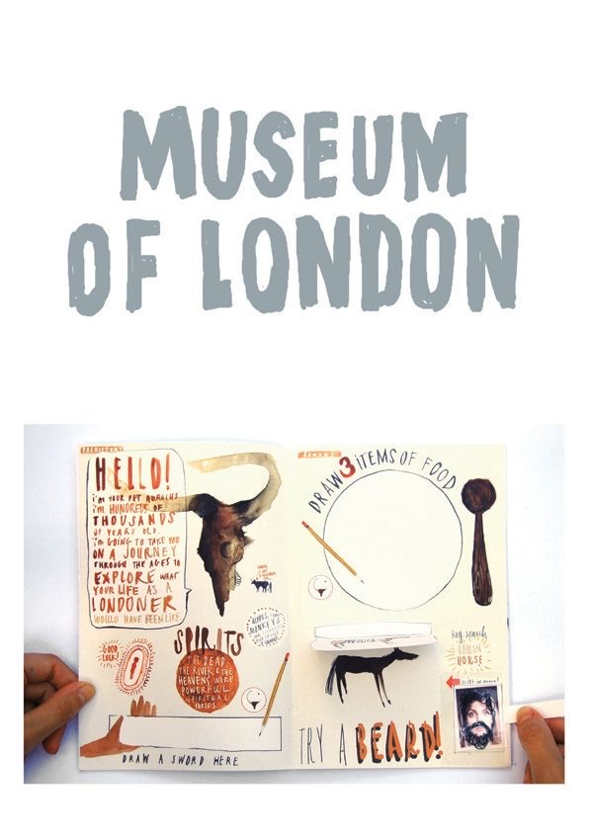
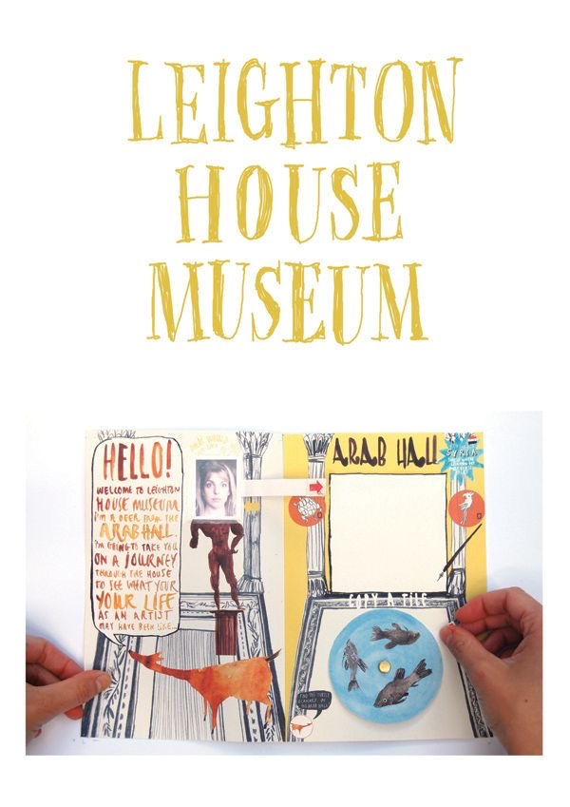
~Plus a few more illustrations of Nina’s, that is posters from around the world.
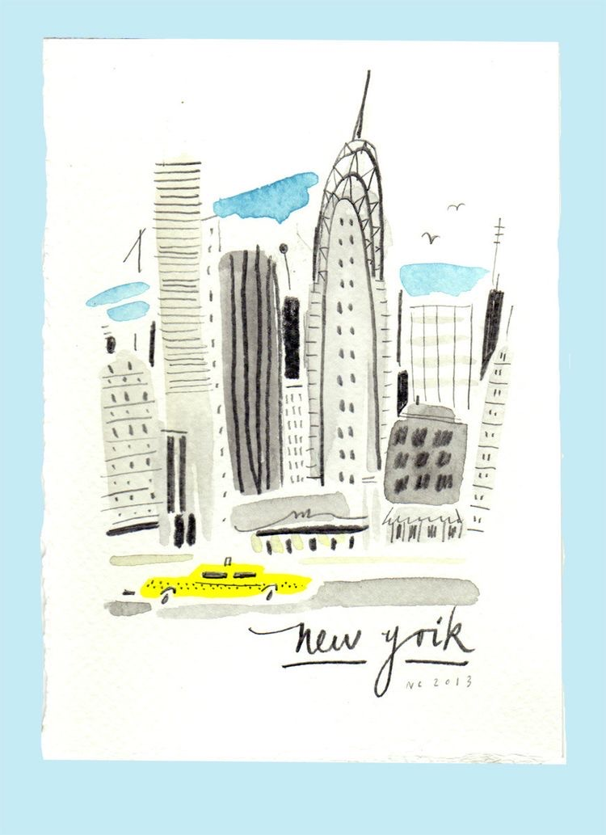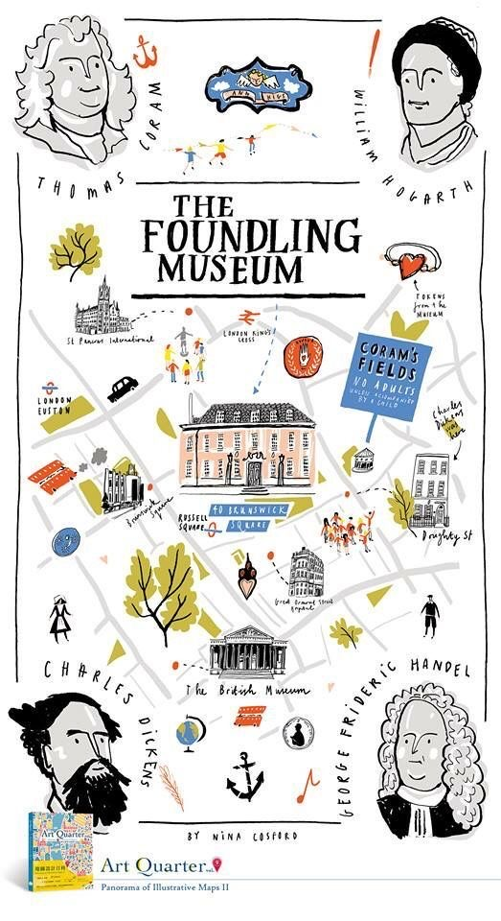
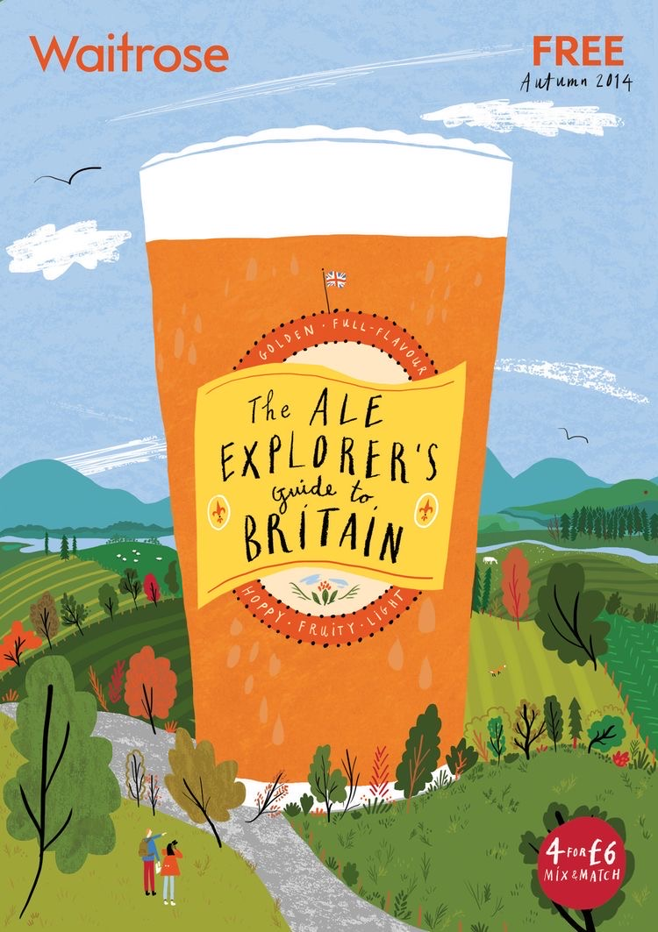
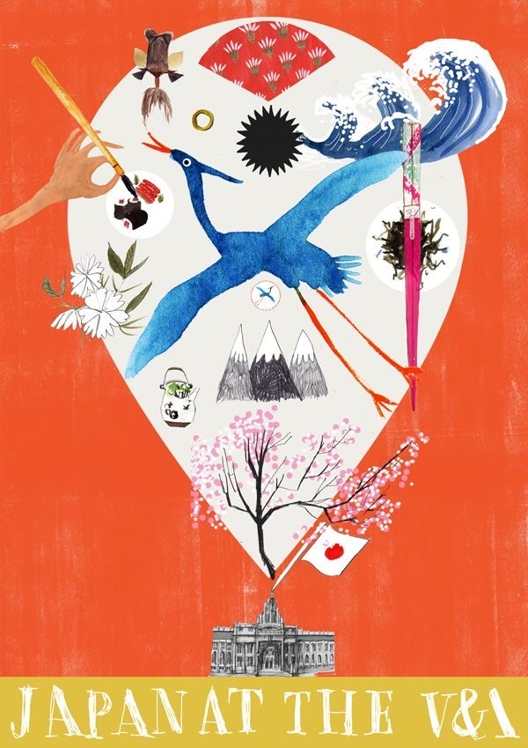

After this I researched museum poster for children, I found some good designs on Pintrest and made up a board of different designs.
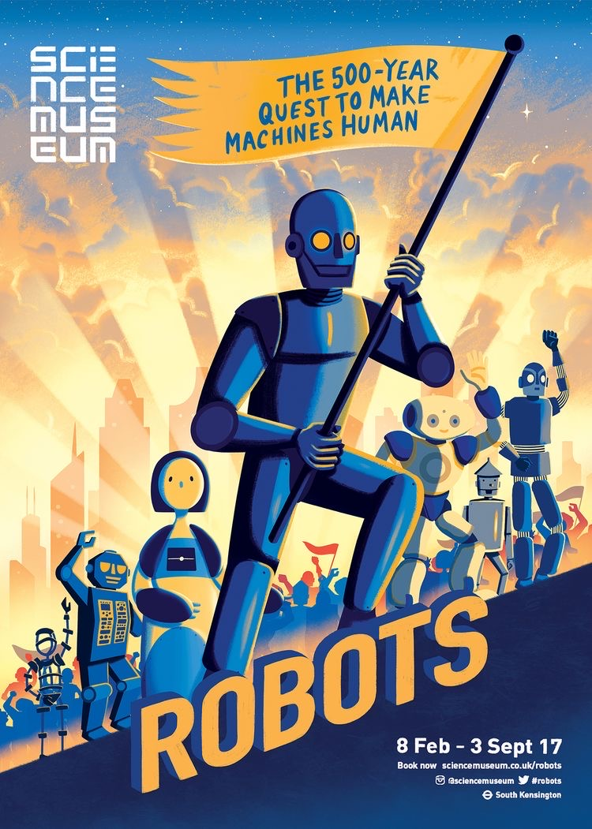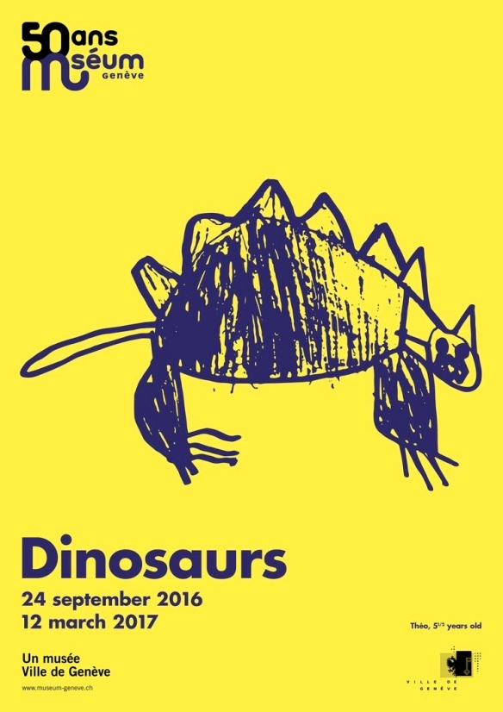
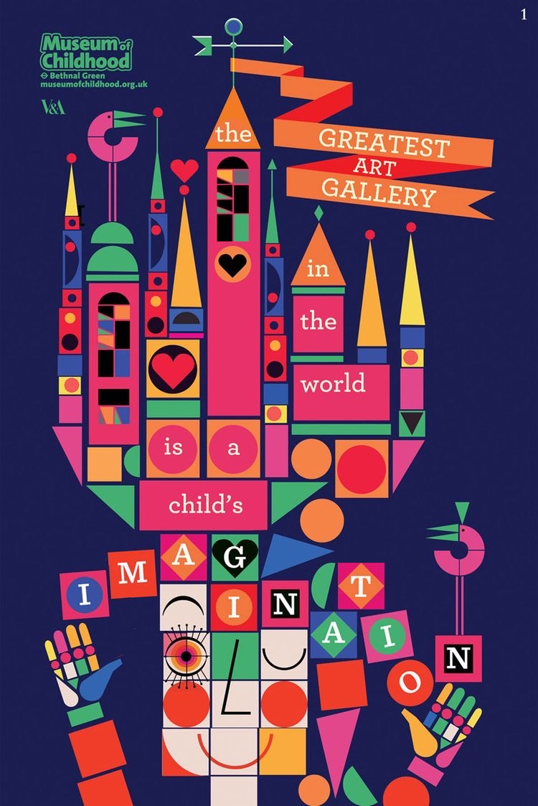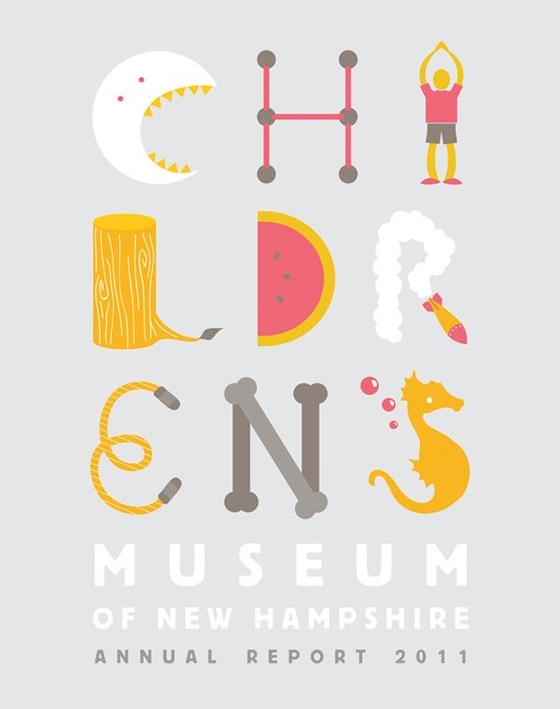

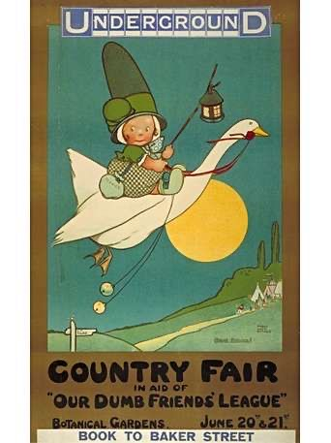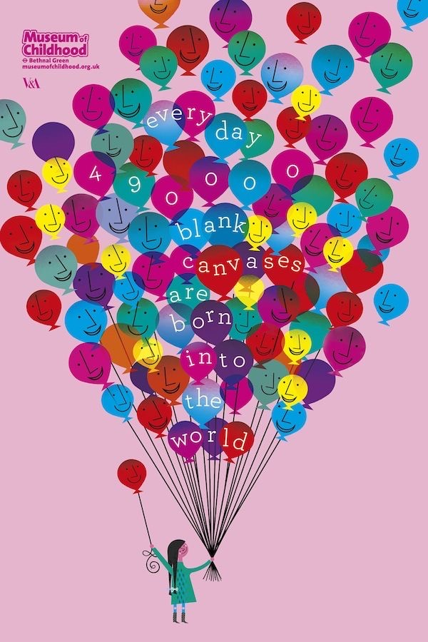
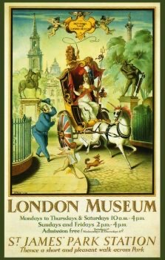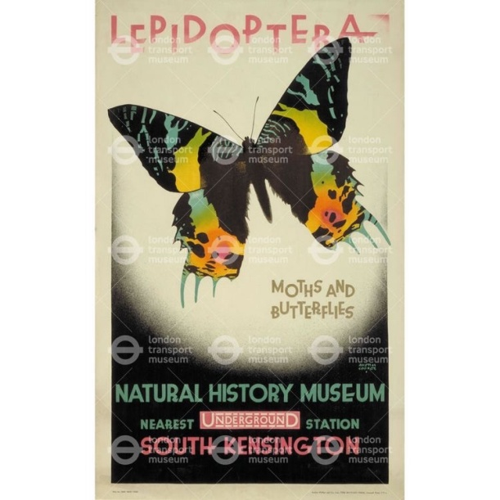
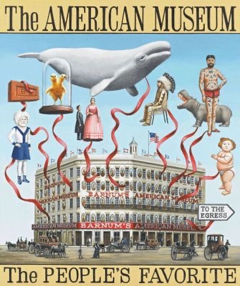

From my photos of the museum I made three mood boards for the different ages that the posters are for, I used the photos that I thought were relevant to that age group.
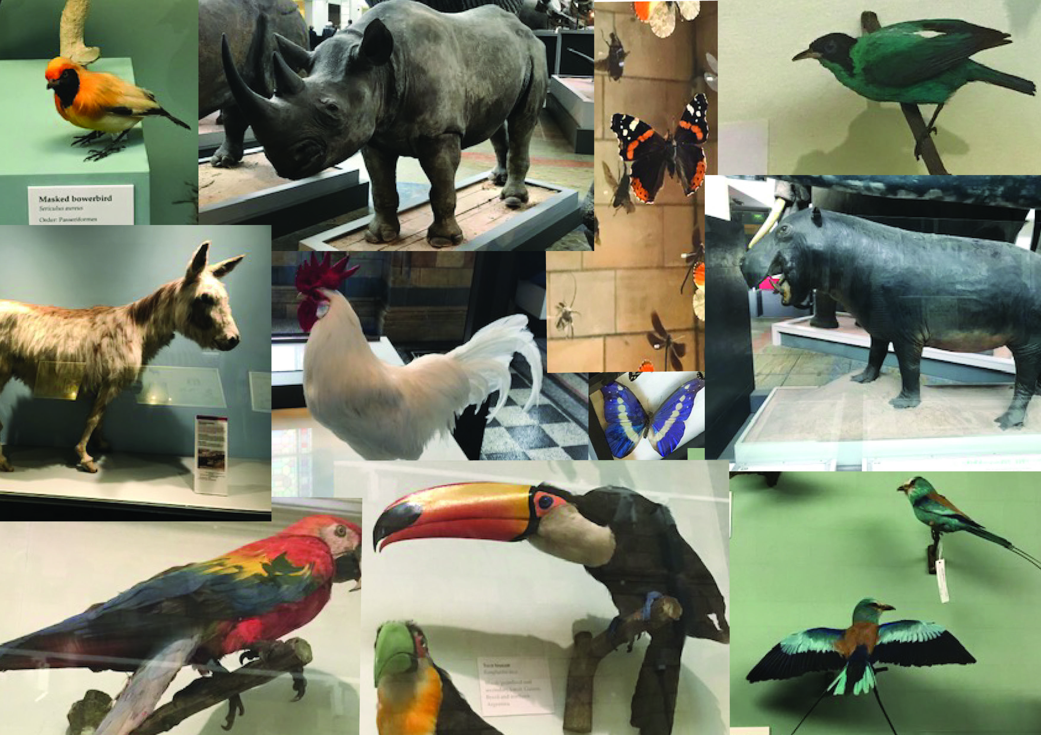
Above was the kid’s board, I added the animals, colourful birds and butterflies to this mood board.
Next was the teenager’s board, here I added all the dinosaurs and the moon exhibition that was going on at present. I thought teenagers would like the scariness of the dinosaurs and might be interested in the moon. Whilst at the Natural history museum, I found a lot of secondary schools were in these locations for these exhibits, whereas the families with young children were more with the animals and birds.

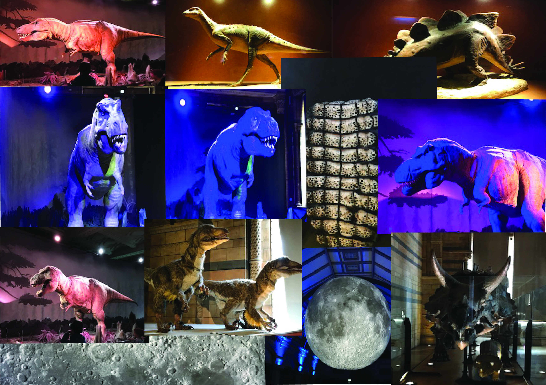
Then I did the adults board, I decided to use all the gem stones, crystals and minerals plus the illustration sketch books and paintings for this mood board.
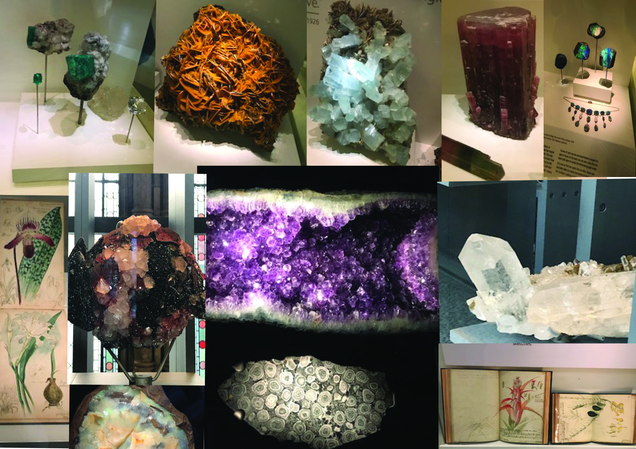
I wanted to showcase in the posters elements that are not well known for the Natural History Museum, apart from the dinosaurs. I was surprised when I went how much more there is to the museum that I didn’t know about. Having been in the last 3 years with my nephews and a few times when I was young, there was much more to look at and see.
I found up the stairs around the landing wonderful hanging, flying birds of a tropical nature, the display was colourful and interesting and fab to look at, I wanted to re-create that into my poster, incorporating the butterfly’s too.
I was also surprised by the second floor rooms of gemmology, I didn’t know that this existed, there were so many great and interesting things to look at, all the gemstones, marble, and granite and learn how they grow and form. This would be great for the adult’s poster as it something that is current in today’s life as gemstones have made a real come back in fashion jewellery.
From these mood boards I created 3 spider diagrams for each age range, photos and ideas I had of the posters.
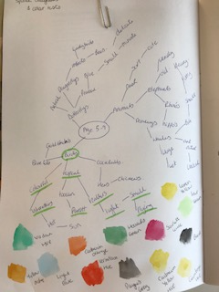
I also did some colour tests as well onto the diagram, I thought this was a good way to add colour and feelings too. Above is the kid’s spider diagram and below is the teenager’s one.
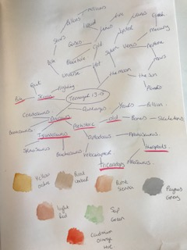
Below is the adult’s diagram and colour test.
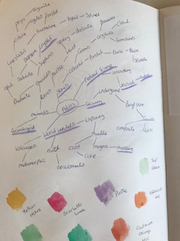
I also started to make and experiment with mark making ideas for the posters.
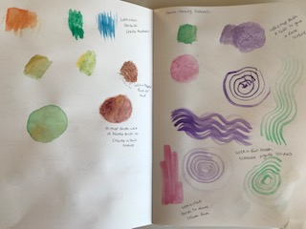
I then added in some sketches I did at the museum of some of the displays and exhibitions.
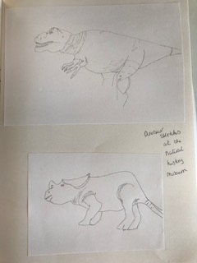
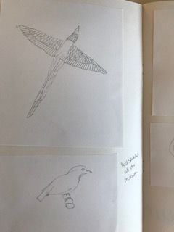
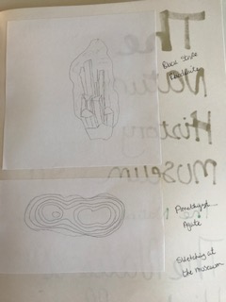
I then started on some typography ideas and experiments of font and designs, I used different pens to see how I could change the look and feel of the type.
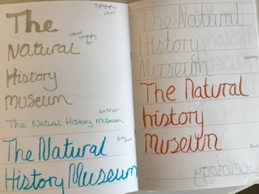
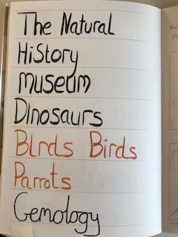
I then started on some ideas of thumbnails of how the posters could look; I started with the kid’s one and used some ideas from my mood board of birds.
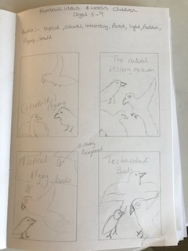
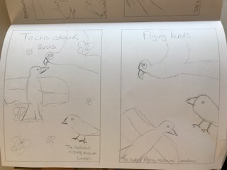
I liked the idea of the words Technicolor and flying birds so I did some more typography with these words using a brush pen.
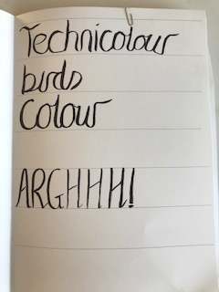
I started by drawing some illustrations of birds on watercolour paper, to then paint after and add mixed media to get some texture and detail of the feathers.
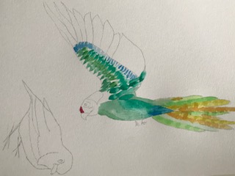
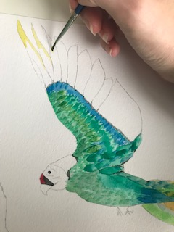
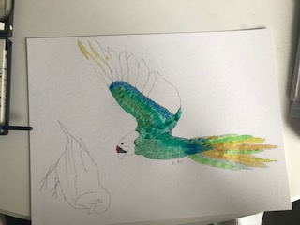
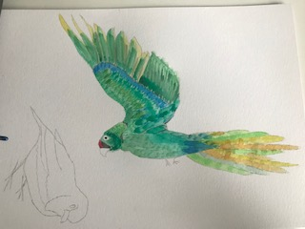
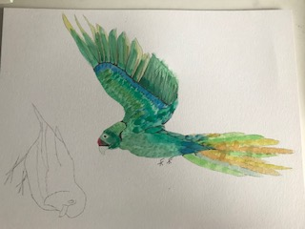
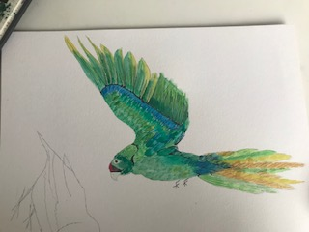
I did this also for two more birds and 3 different dinosaurs; I used watercolour paint, coloured pencils, black finer liner, and brush pens and watercolours pencils, to create the illustrations.
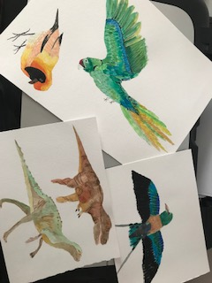
I then started on thumbnails for the teenagers posters; these were based on the dinosaurs.
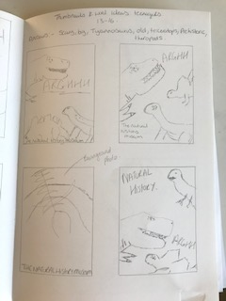
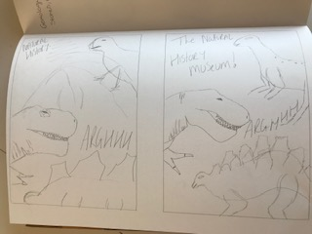
I then went back to the typography and started on a new design for the kids type, which I used the Technicolor birds words, in a flowing quite naive style.
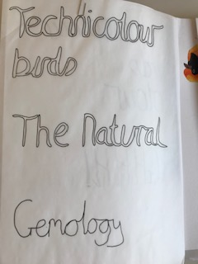
I then put all the watercolour illustrations through Photoshop to erase the background so I was left with a PSD file of each one.
I then started to pull together the kids poster onto Illustrator on the computer, I started with an idea I had of using one of my photographs of the butterflies as the back ground to my poster, I then layered on top the bird illustrations I did, then printed this off to annotate.
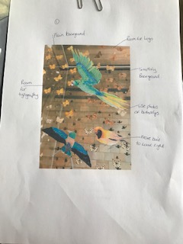
I decided this didn’t look right for a poster; it was too busy and not direct enough. From a distance it would be hard to fathom what it was or what it was about.
I decided to keep the concept though but to simplify it, so I erased the background of another picture I had taken of the butterflies and used these on a plain background, so I got the effect I wanted but in a more direct way. I then layered the illustrations over the top again, printed off and annotated.
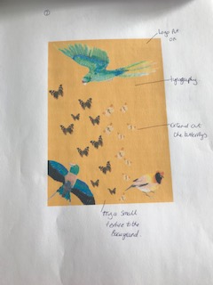
I liked this much better; it still needed the logo of the museum on it, the typography and, maybe a texture in the background.
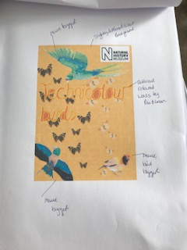
This was good enough so far, so I wanted to move onto the teenagers one next.
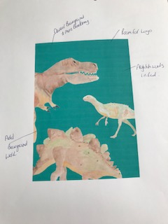
I decided I wanted most of the dinosaurs coming off the page, and to be fairly big on the design, I put these elements into Illustrator and this was my first print out that I then annotated.
I then wanted to have quite a dynamic background which added some atmosphere to this poster, to really catch the attention of the teenagers, as I think these are the hardest audience of this group. I used a photo I had taken of the inside of the museum, and went over some of the lines in black pen, to define them more. I then put this through Illustrator traced it then expanded it and added this to the background of my next annotation, layered with the illustrations on top.
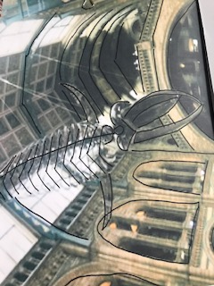
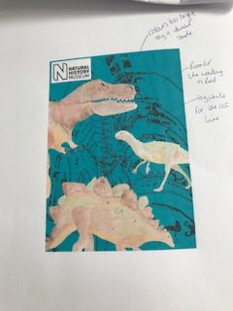
I really liked this but felt the colours needed sorting out, so I went bluer on the background colour and changed the background detail to white instead.
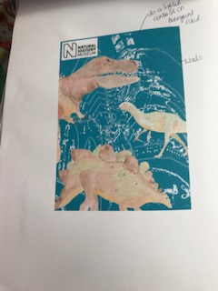
This I felt was much better and I thought I would leave it there for now and move onto the adult’s one.
After painting the illustrations of the gemstones, I then drew some thumbnails to help me decided what direction to go in.
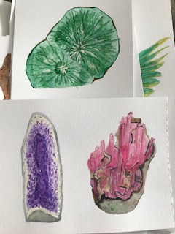
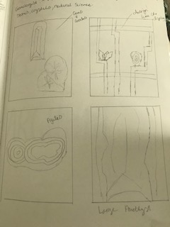
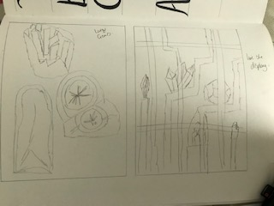

Then I did what I did with the others and put them through Photoshop to erase the backgrounds and save them as a PSD file individually.

I then started to layer these up in illustrator with a plain background, I wanted quite a dark background so the colours showed up well and made the gems twinkle and look precious.
I printed off my first design and annotated this. I used a photograph I had taken of a close up of the amethyst gem stone rock and traced and expanded this in illustrator and used this as my background texture, I thought it look like rock pieces and worked well with the geology theme and gems.
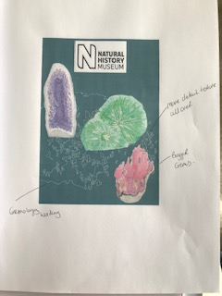
My second design was to have more of the texture detail in the background all over, make the gems bigger and have the words gemmology on the poster from the typography designs I had done earlier.
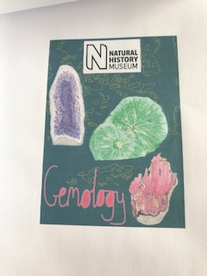
I also changed the colour of the background texture to yellow so it would stand out more on the dark background.
After doing these I was fairly happy with the poster designs, they just needed refining and finishing off.
With the kids poster I used a feather texture detail I had in one of my texture sketch books to add detail to the back ground but in a subtle way. I also changed the colour of the background to a bright purple/ pink to really make the colours pop on the birds and butterflies. As this was for the youngest generation I really wanted it to be colourful and bright and eye catching to the public.

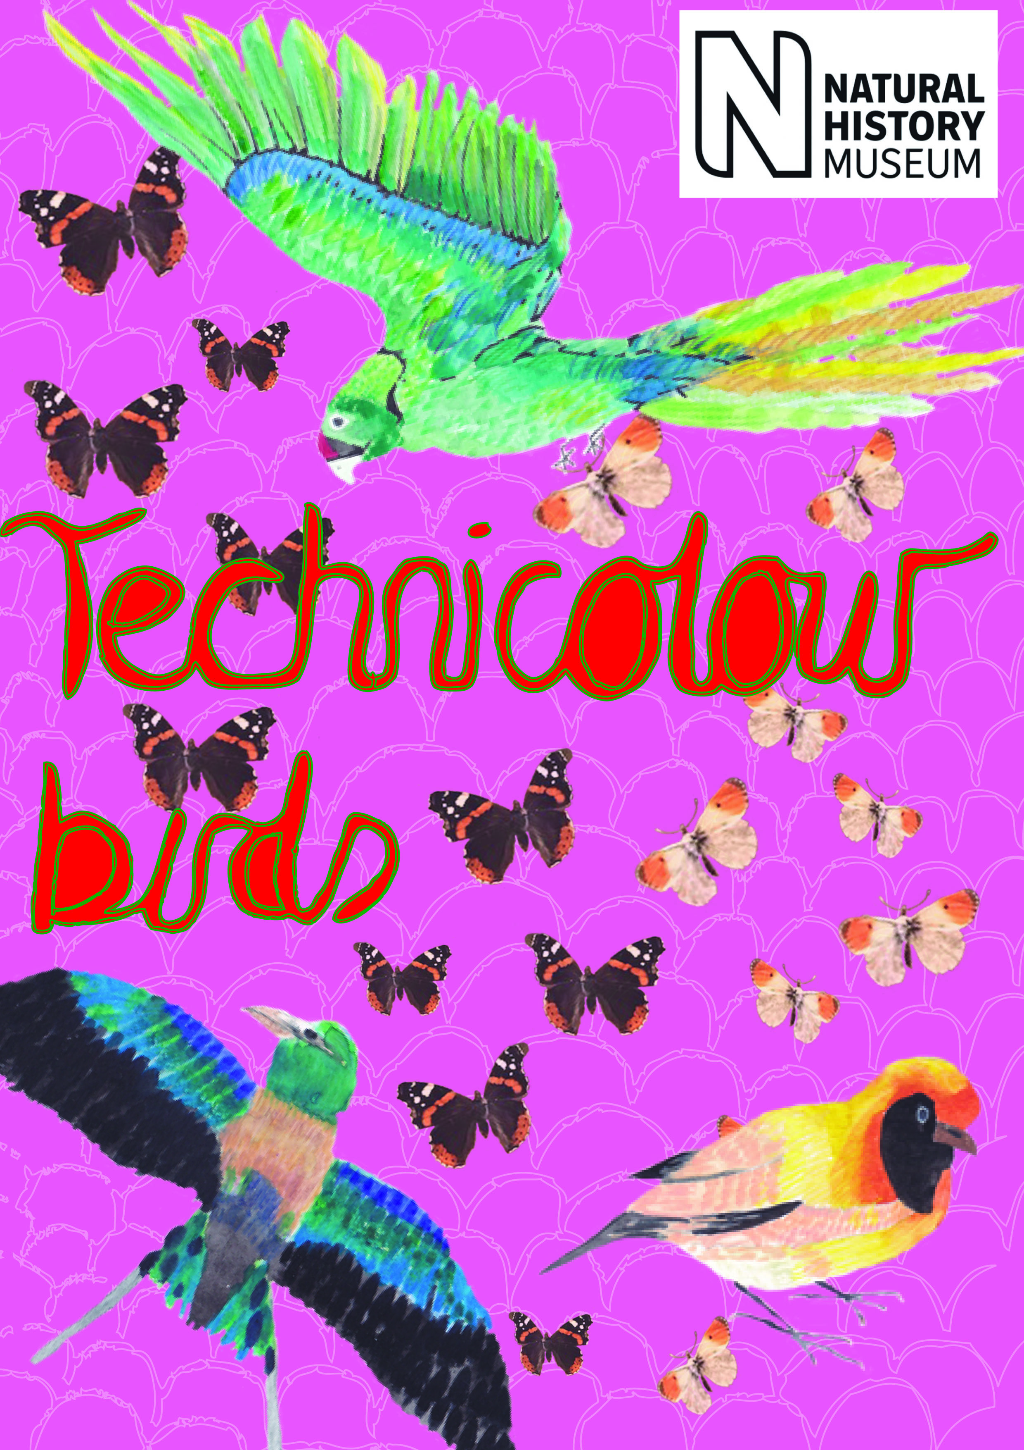
With the teenager’s design all I did was add some typography ‘Arghhh’ which I thought would be good for the subject, I used red to colour this type in so it stood out. I still really like the effect of the background texture in this poster; it gives it a historical feel and brings the actual museum into focus too.
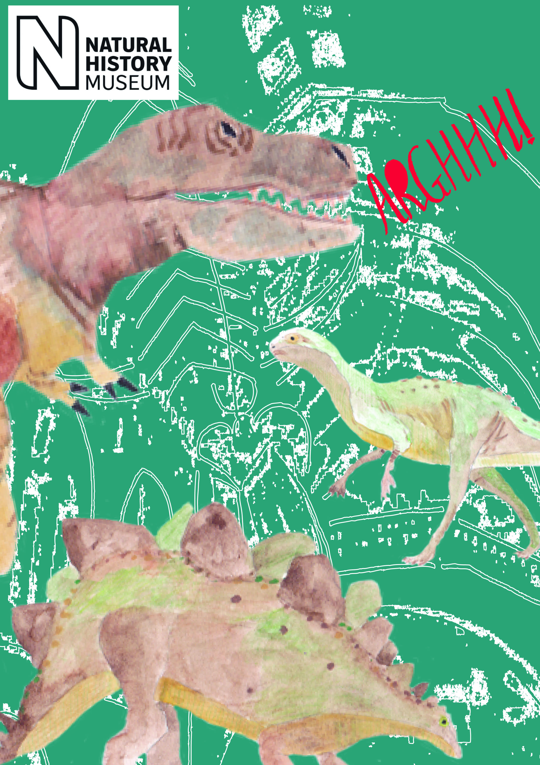
In the adults one the only thing I changed was the outline stroke of the typography to a blue colour, I felt this made it stand out more and show the detail in the type. This is the simplest poster, but actually I think it’s the most striking, the illustrations really stand out, and from a distance it looks great too.
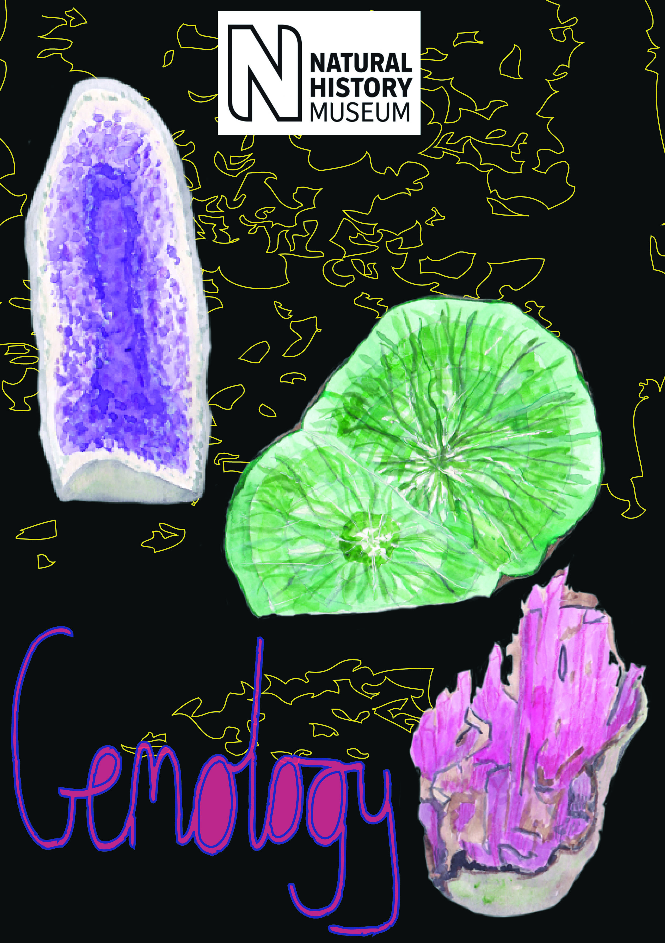
I put all three designs on to a mock up of a poster, to really get the effect and to see how they would look in real life.
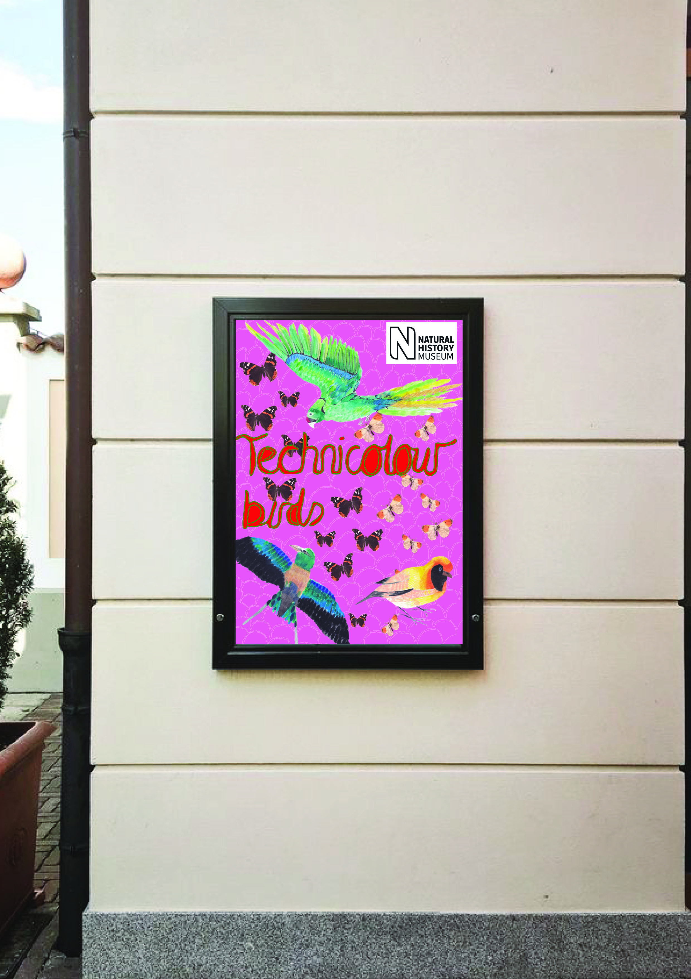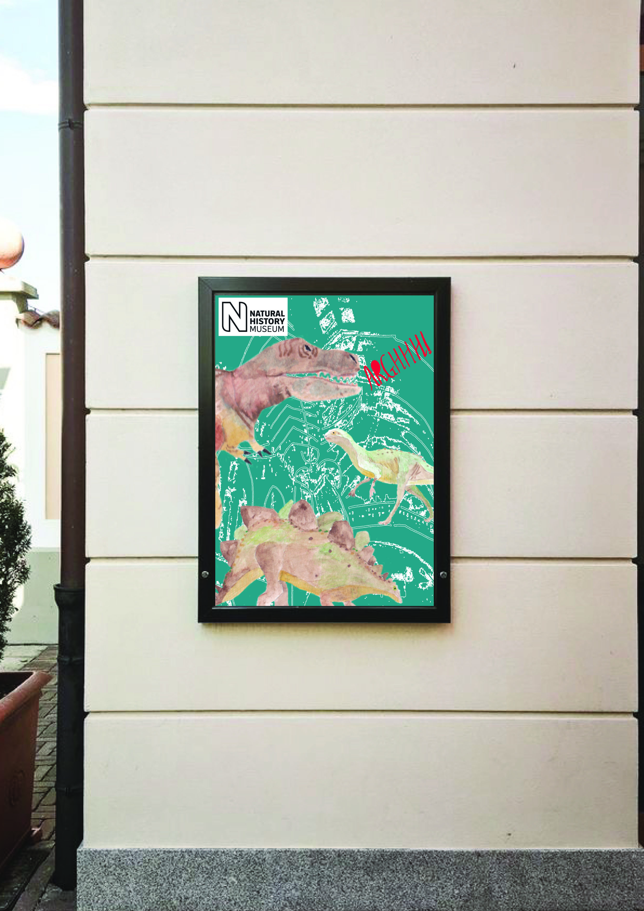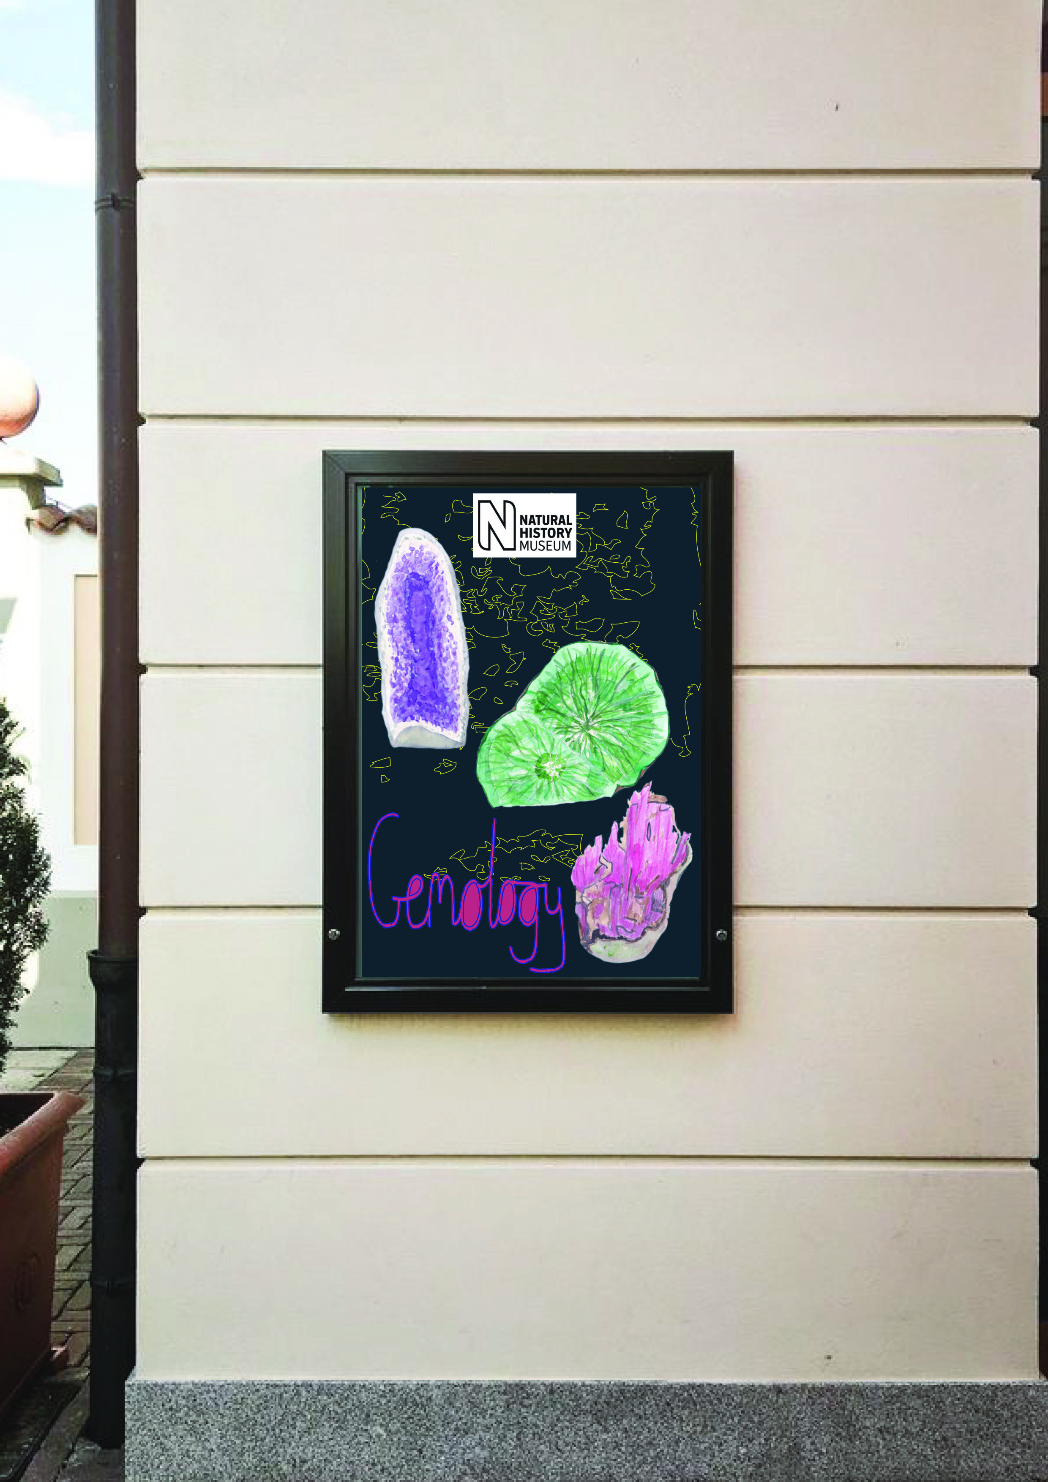
Although they are all different in style, I hope to think that they do look like a family of posters by my style, medium, elements used and by the placement of the museum logo.
I got some feedback from my nephews age 7 & 10 and from some friends, my nephews thought that the kids one was lovely and colourful, they liked the birds and could easily read the typography, they thought it could be for any age range and any gender.
The second poster they liked the best, they could identify the background texture as the bones and outline of the museum, they liked the blue background colour and they thought again it could be for any age range. They liked it the best as they knew instantly it was for the Natural History Museum.
The adults one, they again liked very much, they liked the colours the best and thought the black background was cool. They could tell me what the illustrations were and thought this one stood out the most from a distance. They didn’t know about the gems in the museum.
The feedback I got from my friends was:-
‘I’d say number one for the 5-9 age range as its eye catching with all the colours and unisex, number 2 for the teenagers and maybe more for boys as their understanding of dinosaurs would have evolved and number 3 for the adults and unisex.’
‘Number 1 for the kids, the colours stand out and there is variety of animals, though I would overlap it with number 2 as the same age range because the dinosaurs are instantly recognisable and synonymous with the Natural History Museum. Number 2 could work for all ages that are my favourite because I wouldn’t need to ask what it represents. I can see number 3 working for adults because there is more to explore at the museum than just the dinosaurs, so it raises interest outside of the predictable. Overall my eye is drawn to number 2 due to its combo of colours and illustrations, though I can see why you chose a darker background for the last image, because otherwise the illustrations would disappear.’
‘Number 1 and 2 could be used for all the age groups, everyone is fascinated by dinosaurs, and colours are just perfect’
‘Dinosaurs number 1 for the kid’s age range, my son was obsessed with them! The birds are eye catching for teenagers, and the rock crystals appeal to the older generation’
‘I like the 2nd one as it would entice me to see the dinosaurs and it’s colourful’
‘I like number 2 the best, I think it would appeal to the kid’s age range; I like the background colour too.’
I would say number 1 for the kids, number 2 for the teenagers, I really like it and the colours are super eye catching and appealing. I really like number 3, I think this would be for teenagers or adults, If I saw this poster I would defiantly go to the museum to see the gems!.’
What did you think of this exercise?
I was really looking forward to this exercise, I had planned to go to the museum so I could gauge the atmosphere and look at all the exhibitions. I collected a lot of photos and information, it was nice to really experience what you were going to illustrate, it was extremely beneficial to go and make the visit. It was the hardest exercise so far and the most work needed as we had to create 3 illustrations for 3 posters, so it did take longer than expected and because of that, there was a moment in the middle that was difficult to keep going and plod on.
What have you gained from doing this?
I have gained a better understanding of why its god to try and go and experience what you will illustrate and do your research first, I feel you get into the exercise or brief fully if you do this. I have more experience of typography this time and have really enjoyed practising my brush work and hand writing techniques. I also enjoy getting feedback from people and how you can use this to your benefit.
Are there any materials or ideas you would like to explore further? What will you do?
I am going to continue with my typography sketch book and learning more about that and sketching my own designs and hand writing styles.
I will continue to try and explore or visit experiences that connect with the briefs and exercises I’m working on.
I thought I got a better colour saturation on these posters, so I will continue to explore this more and learn more about that on the computer with Illustrator.
After feedback from my tutor:
Go into more depth about the designs of Nina Cosford, look at colour, type of font and why, how do the leaflets engage with children and how do they compliment the posters?
Explain why the designs are good, talk about colour, shape, content, type, characters and layouts. How do the designs differ from age ranges?
Bring the font away from the edges of the posters; weave in and out of the butterflies.
Contrast on the dinosaur poster
Contrast on the gem poster too
Go back to the brief and talk about how you have met the requirements, discuss the appeal to different age groups and the effectiveness.
I went back into look at Nina Cosford’s work that I had picked as research for this exercise, I preferred the background colour of the first poster, compared to the second poster, I thought the yellow background was more bold and bright and eye catching, it seemed to show up the illustrations better. The typography looked hand drawn, but it also looked very professional so it could have been already made. The font had a spooky feel to it with the slight scratchy texture and the serifs. Both the illustrations and font worked well together on this poster. The second poster because of the grey background seemed more subdued, and the font was more childlike, and simple.
The leaflets compliment the posters because they have the same illustrations on them; the type is very similar, childlike and simple. They have activities on them, which help to engage the children; some of these activities are drawing, which adds that extra element. One of the leaflets is interactive, the wheel turns around, and so that’s interesting and playful for children.
The posters and leaflets work well together and interact with each other in font and style; you can see they are both from the museum and the same illustrator.
I like my designs and thought the colour of the kid’s poster was vibrant and colourful, I thought it would catch the eye of children, it felt playful, yet young enough to appeal to the youngest age range, i think butterflies and birds was the best choice for the kids poster. I chose a typography that was simple and child like, I hand drew this myself and used bold primary colours to make this stand out.
I chose this layout as I thought it would look, eye catching, I think having the parrot at the top looks bold and looks like he is flying down, and then having the other two birds at the bottom balances this out. The butterflies in between, flying upwards leads your eye from the bottom to the top of the poster. I think having the pale yellow butterflies on the same side as the yellow bird works well and gels the birds and butterflies together.
I chose to use red in the typography to get your eye to look straight at that first, like the hierarchy in the poster.
With poster two (teenagers) I chose to use a dark green as the background colour, which I think makes the poster look and feel a bit dark and menacing, the texture and line of the inside of the museum, helps to connect the museum with the posters, as well as give a background and death to the vision, it’s like the dinosaurs have come to life in the museum!
I chose to have the largest dinosaur at the top right as he looked the scariest and I wanted him to be the main feature. The other characters I also chose for them to come in from the side and below, to make it look like they were walking about. I changed the scale of these so it added more interest and looked visually stronger. Again I chose to use red for the typography, especially with these words, as they are scary!
I chose this content as I thought it would catch the sense of drama with teenagers, I thought it would appeal to both sexes as it is the most well known element of the Natural History Museum. I wanted to use part of the museum as well, and thought of using the photograph in this way to show texture was a good idea, I think it works and adds the depth the poster needs. It was defiantly something my friends picked up on, and was an element that stood out to them, which connected the posters to the museum.
With the third poster (adults) I chose the dark black background to add that sense of richness, of preciousness. The black really shows up the gem colours of the agates, stones and crystals, this has really helped make the illustrations pop. I chose to use these three gemstones illustrations because, they were all different colours, bold and the actual shapes and textures of the stones were all different from each other, it added variety.
I chose the set of three as I think odd numbers work well for this; it gives it an unbalance, but then if you add in the typography I feel this words and balances out the layout and content on the poster. I think having the long amethyst on the left, then the green agate and pink stone on the right works well as a format, it’s like a step in stone style.
The typography here was also hand drawn, I think it echoes the roundness of the gem shapes, and the loopiness makes it look natural and organic, which I think works with the natural nature of the stones.

So I went back to the Technicolor bird poster and looked at the font and how I could interweave this into the butterflies more. I moved the type into the middle of the poster more and away from the edges, then I moved the type layer behind some of the butterflies to make it look like it was interweaving in them.
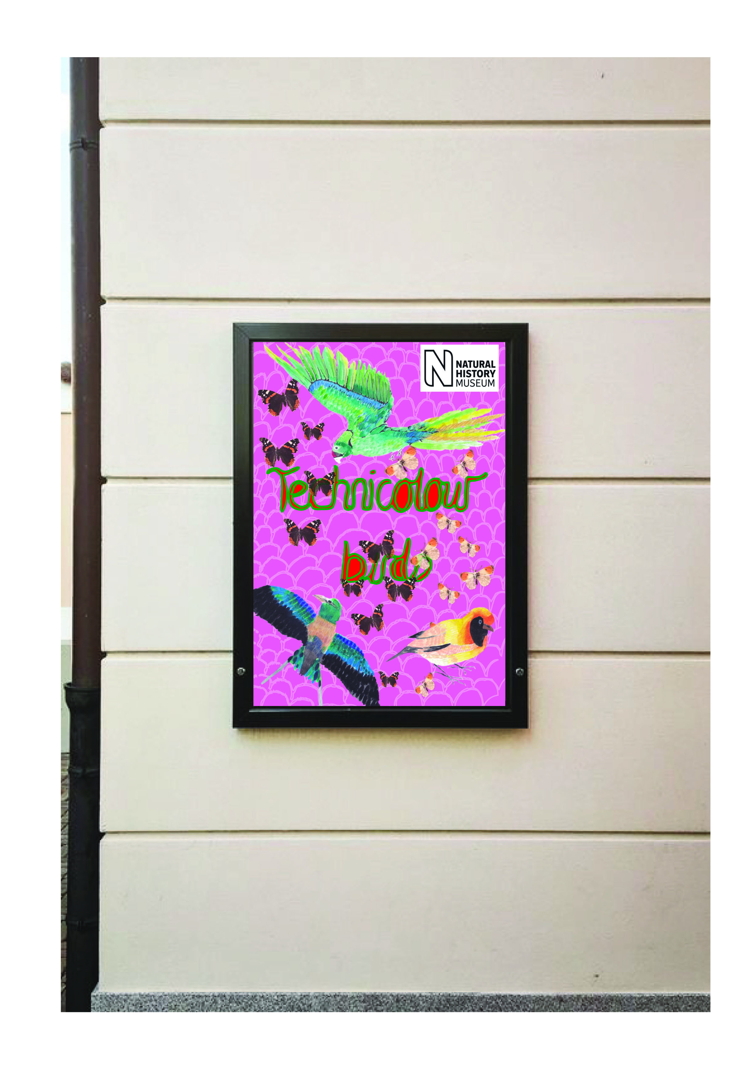
I went back to the dinosaur poster and looked at the contrast of the dinosaurs with the background and tried to make this more prominent. I changed the background colour so it was slightly darker and more of a greener tone, I changed the contrast on the dinosaurs slightly which I think has helped a lot. I have also pushed back the colour of the back ground texture, from a cream colour to a lighter tone of the background colour, I think this helps push the background back and brings the dinosaurs out more.
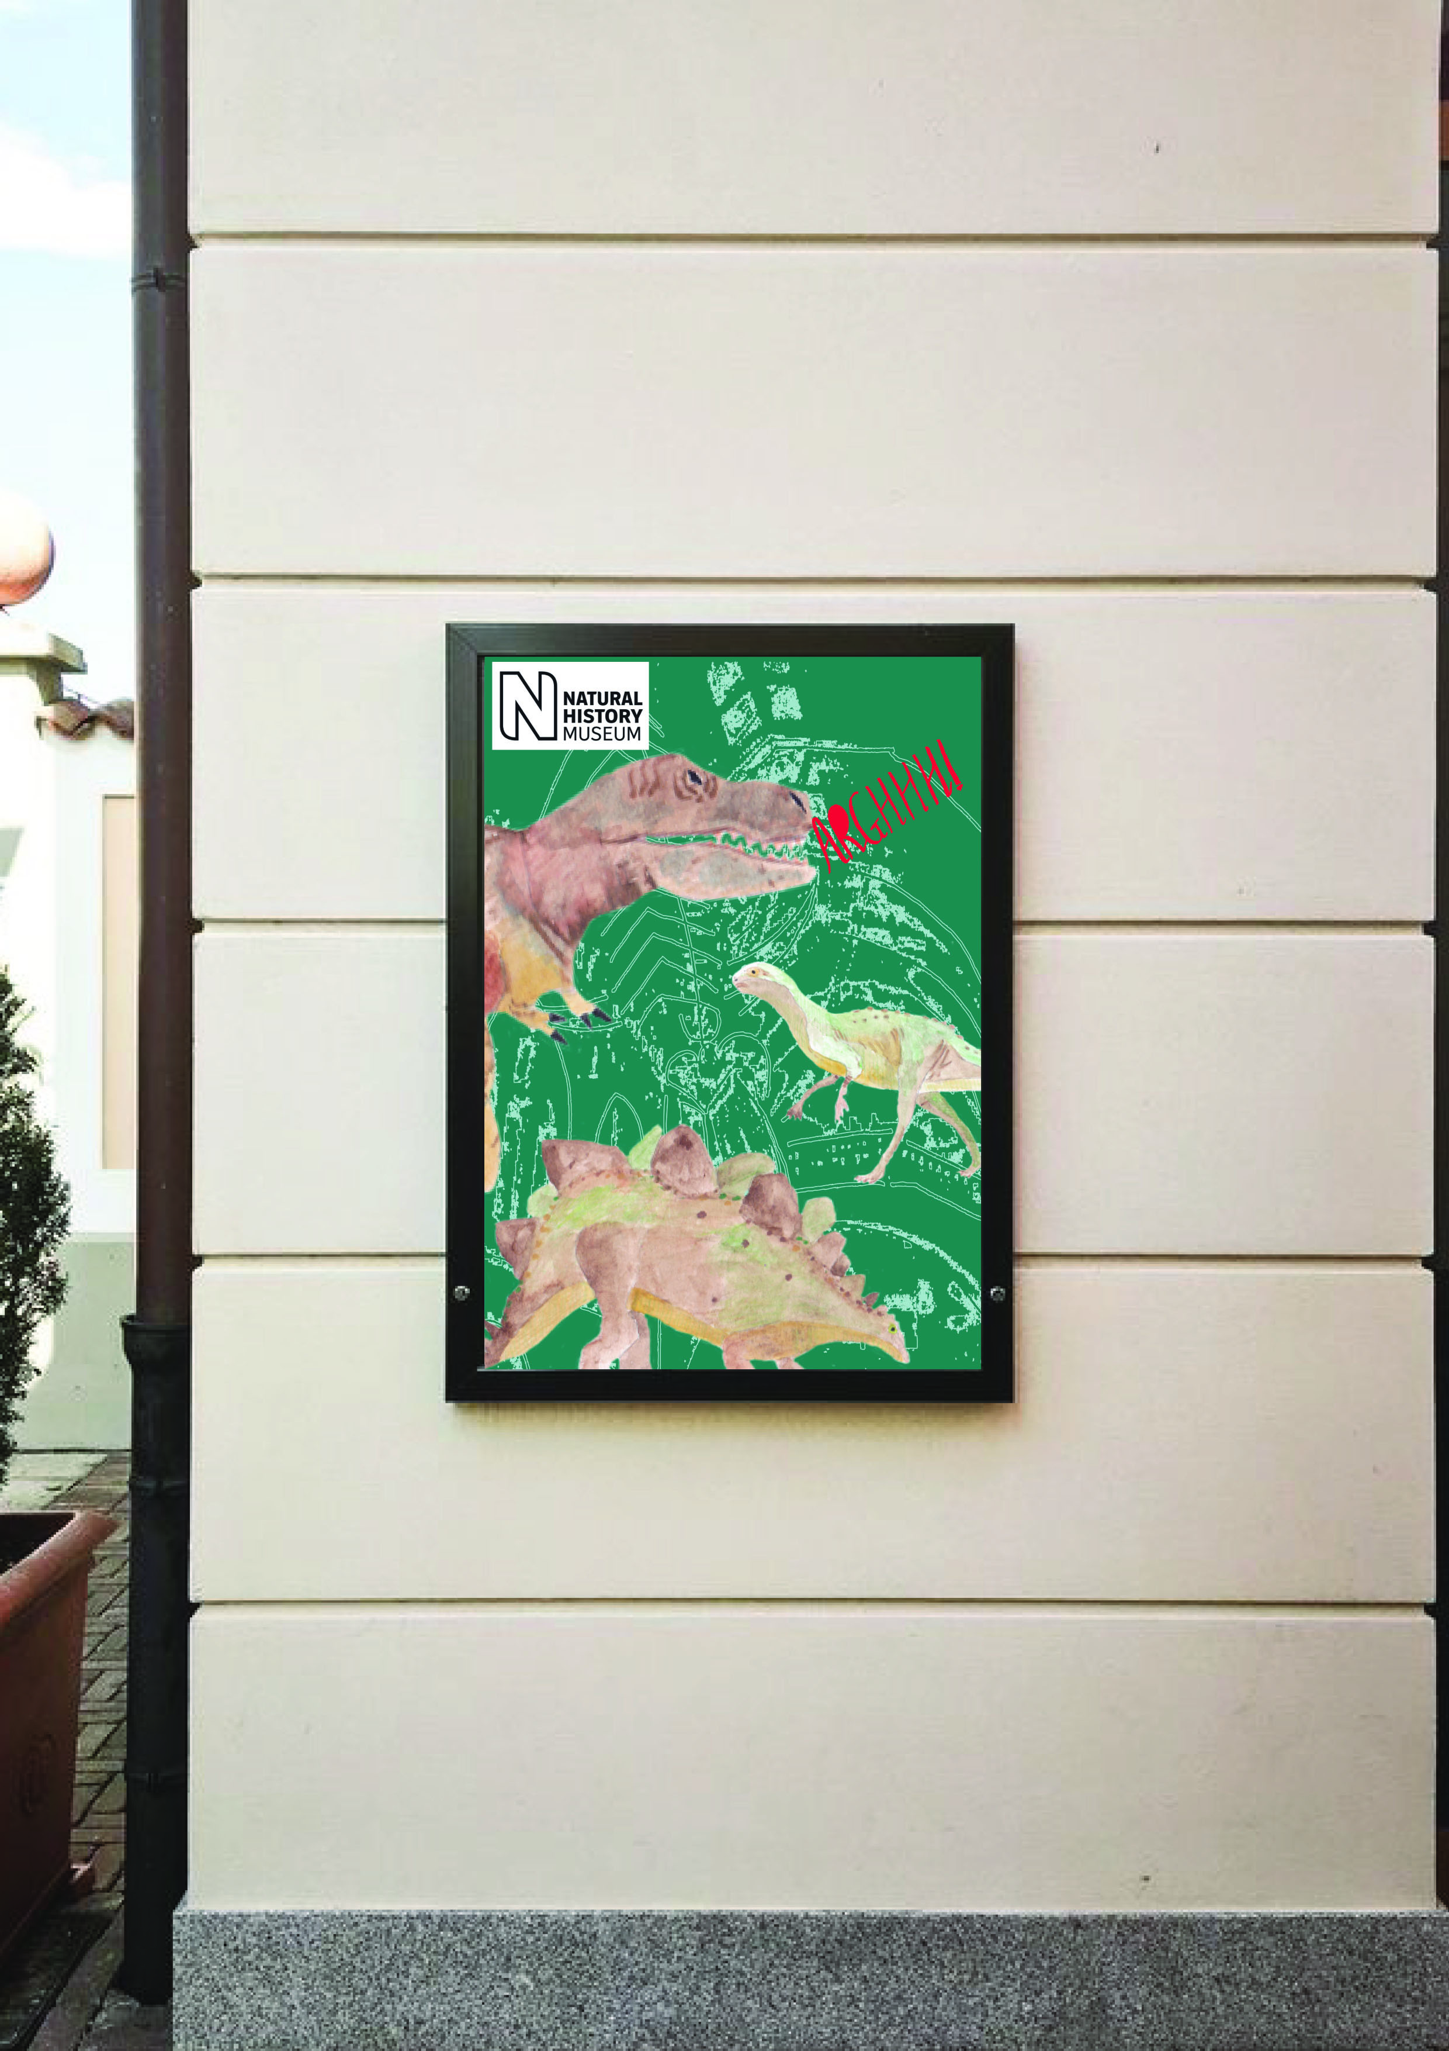
I then went back to the gem poster and looked at the contrast on that one; I changed the background colour to pure black, to make the gems pop more. Then I changed the background texture from yellow to cream to again get the gems to pop more. I changed the contrast on all three gems and added some extra detail in, using my Wacom board and the paint brush and pencil element. I drew some details in the inside of the Amethyst to add depth, I added more contrast in lines on the green agate, and I added more detail and texture to the pink gem. I think the gems really look life like now, and they seem to have more depth. I also changed the colour of the typography and made it slightly smaller and moved it in from the edges, I think this stands out more also.

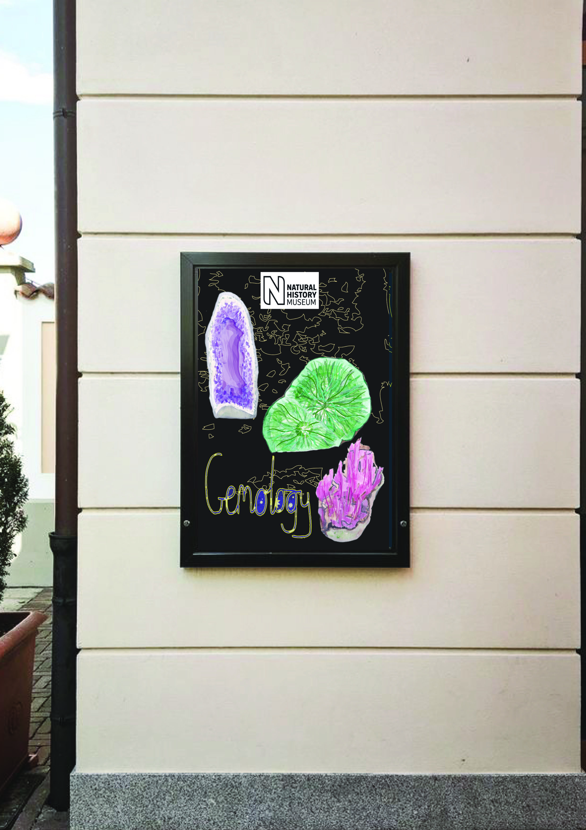
So once I had made these changes from the feedback, I then went on to look back at the brief to see if I had met all the criteria.
So In the brief it asks for one object to use in each of the posters, so you would think you needed 3 objects, but in the next paragraph it asks for three illustrations for three posters, so I chose to do this, I chose three objects, three illustrations for each of the three posters. I am not sure if that was right but that is how I interpreted it, and I also checked with other students and that’s how they had read that too.
I think the posters look like a family, with in the style and mock ups I used, the placement and consistency of the museums logo all add to this. But if some people can’t see the connection, I don’t think it would matter, as long as it helps to attract customers to the museum, would that matter?!
I think I have chosen to use the objects I found in the museum to help entice the customers into the museum, it wasn’t to promote the historic setting, it wasn’t to use a character, it wasn’t to be decorative, or diagrammatic. It was purely for advertising reasons that I chose to complete my posters in the way I did, I think coming from a retail management background, this is something that is instilled in me to entice customers in.
I don’t think I have made generalisations in my choices, the youngest poster is not too young that it would not appeal to older people too, and the same with the teenagers and adult posters too, I think that they are appropriate for the audience yet ok for all.

