Making a mock up
I started this exercise by looking through my books I have at home; I found a few books I thought about re-designing the covers for. In the end I remembered how much I loved the Enid Blyton books when I was a child; I researched some of the illustrated book covers and noticed how old the books were! That gave me the idea of making a modern interpretation of this for this exercise.
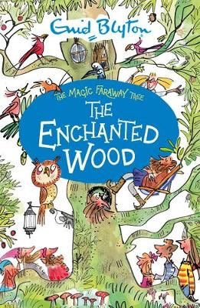
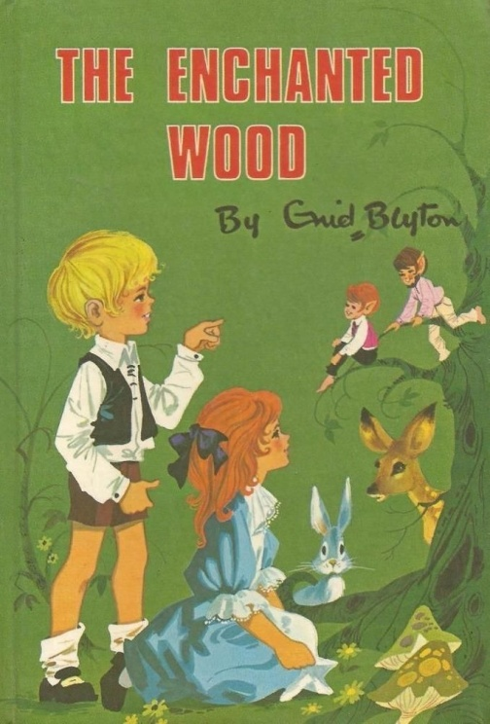
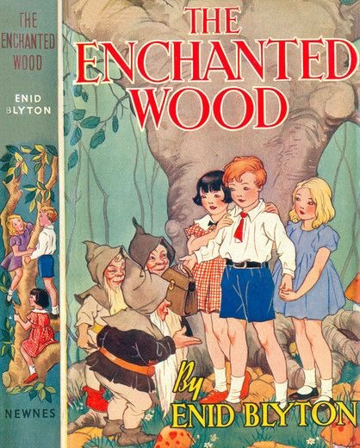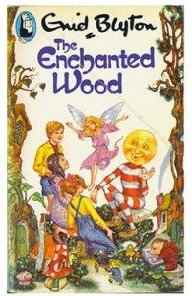
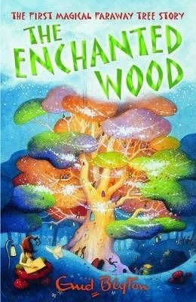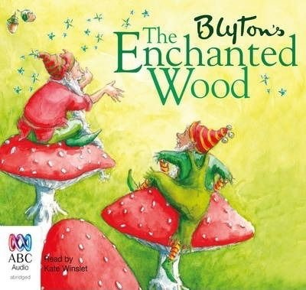
I then looked at a illustrator that I’ve been researching of late Eleanor Taylor, I found her illustrations similar to the way I wanted this book cover to look, there are certain elements I’m interested to explore.
Eleanor Taylor was bought up in Scotland, she studied Architecture at university but then worked as a designer for a few years in Spain and then at Harrods in London. Eleanor has created over forty children’s books of which she won an award in 2001 for the best illustrated book for 4-11 year olds. Eleanor also created the crest of Hogwarts for JK Rowling.
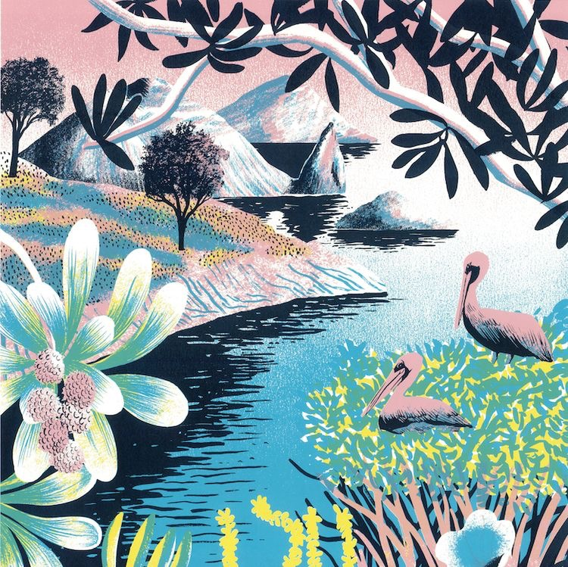
Eleanor’s illustrations are a process of drawing sketches, etchings and monoprint, she layers these all together in the software program to create the finished article. In this particular illustration I really liked the composition, I like the fact that some elements are off the page, or you only see part of the illustration. Again I love all the texture and mark making look, plus the parts of black, which add a photographic look, I think this is where the monoprint comes through. Eleanor makes the illustration look really modern by the colours she chooses, the slightly 50’s pastel colours, but the up-to date version of these make elements pop!
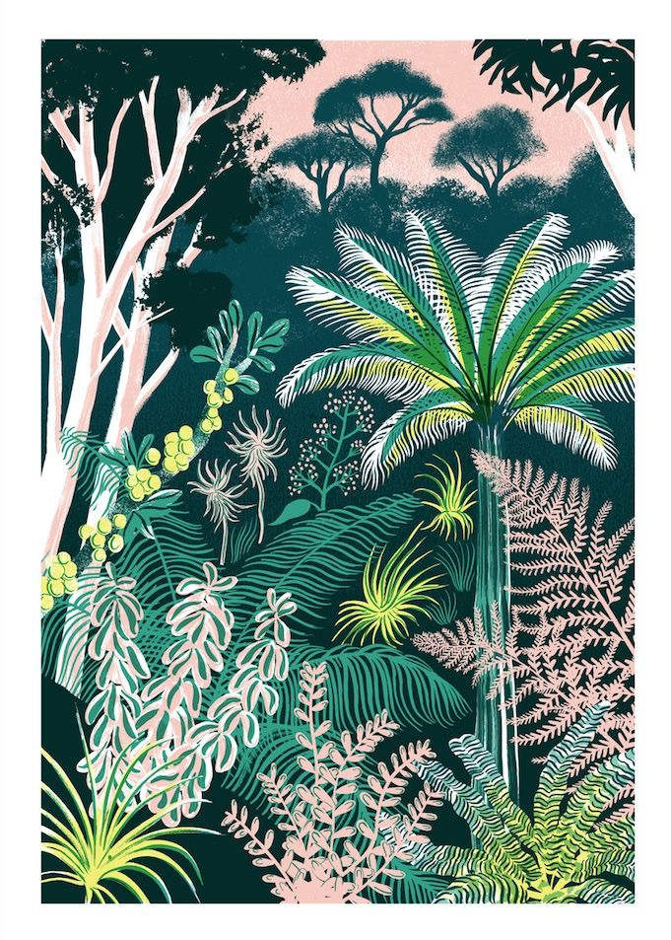
The trees in this illustration are done through etchings, which I think gives the feathery effect that gives the texture a soft look. I like the way she has used line work to pick out some of the foliage and plants, the soft pink in this illustration, makes quite a harsh and dark illustration feel more feminine and soft.
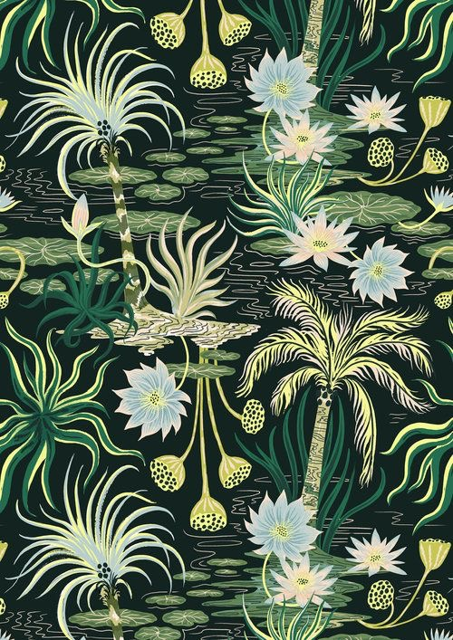
This illustration is less busy and has more of the plain black background colour that comes through. This feels more delicate as there are smaller motifs used and more of a flowy pattern emerging. It feels very organic and has pretty details of the lily pads and water mark lines.
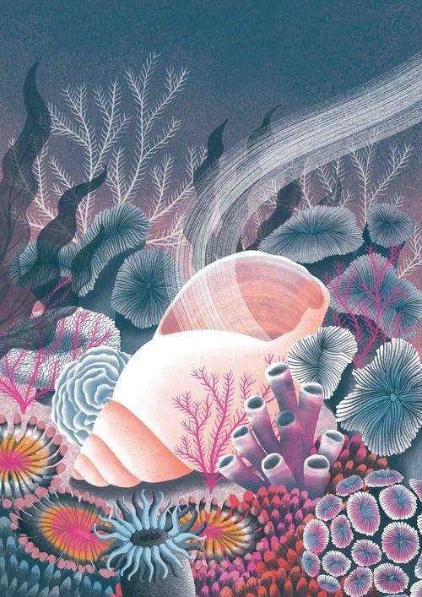
This illustration has a different feel to it, but the colours are lovely, they work really well together and have the same hue to them, which makes it connect together.
There are very delicate details, mark making and texture elements, which really make you look in depth into the drawing as you see something different all the time. The top part of the illustration is calmer, with just the floaty plants then the plain section, I think this is a nice composition and has a real natural feel to it.

I started the exercise by using the word ‘Enchanted wood’ for a spider diagram, I came up with the words:- Woodland, Moon, Stars, Fairy, little doors, Animals, Bark lines, Fluidity, Mushrooms, magic.

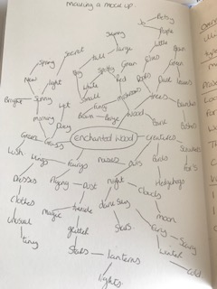
I then made a mood board from these words:
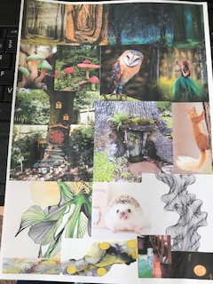

From this I then wrote myself a brief of what the direction would be for me;
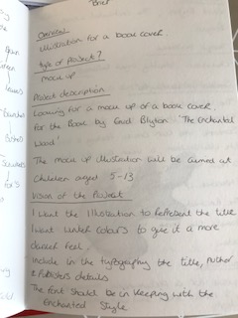

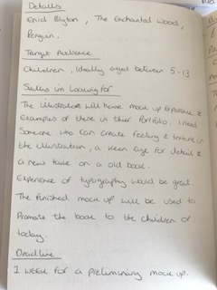
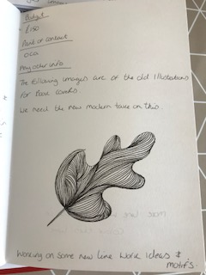

Doing this really helped me to get an idea of the direction I was going in and what I had to complete to get this done.
I started to look at textures for the illustration, I had recently been doing some line work in my line work sketch book, and I had organically come up with these elements that I really liked. I decided to explore these more and did a few more objects as well as leaves and flowers to see how these turned out.
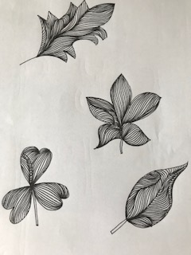
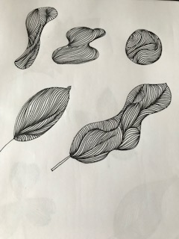
I then thought this would be great as bark for my woodland trees, a bit like this picture I had taken of a Eucalyptus tree bark at Kew gardens.
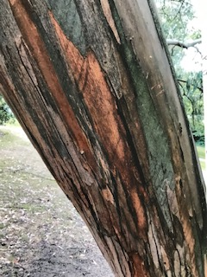
I then used the same technique to draw some trees, and tree bark.
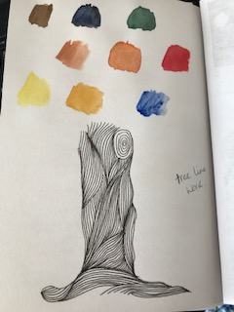
I also did some colour tests for this idea, I came up with mainly autumn colours, which I think will work with the theme well.
I then did a few drawings of some of the elements from the mood board, I drew 2 little doors a fairy and a squirrel.
I painted these in watercolours and put these through Photoshop to get them ready for the first compilation of the illustration.
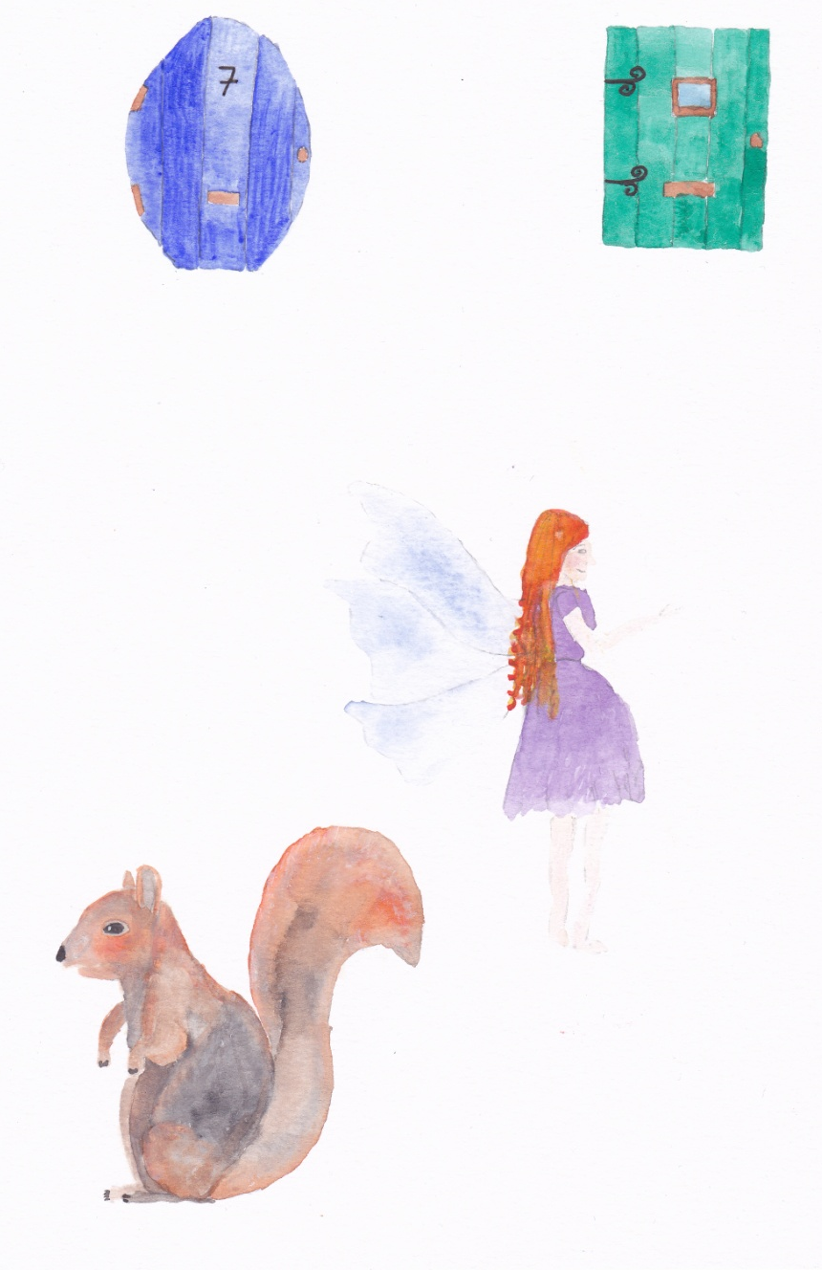

I then started to draw some thumbnails on a scale similar to the book cover size, to see how these would look. I had a few ideas of how I wanted the book and which elements I would add in, but needed some idea of composition and placement.
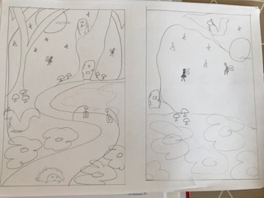
So the idea on the left was a path that led your eye through the picture, surrounded by trees and woodland, with a main tree at the back, with a little door in it. (The book I chose is part of a set called the magic faraway tree, so the big tree is that tree) I added in some animals, squirrel, hedgehog and owl. Made the theme at night as I thought it would add more sparkle and magic and mystery to the illustration.
The idea on the right was the main magic faraway tree, but a bigger foreground where I wanted to add a green, mossy, leafy and flower area, with mushrooms, that was all quite textural. Add some fairies flying in the night sky with stars and a moon. More simple and airy, which a composition that bought your around clockwise.
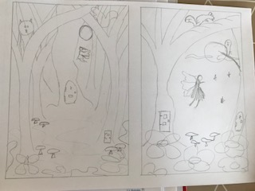
The third and forth ideas were, the one on the left was looking through a wood, to the main faraway tree, with the little door, surrounded by smaller trees in a path way style. With the mossy grass and woodland floor in textural elements, with the mushrooms. Another little door in a tree and some fairies flying around. The moon in the background and animals peering out from areas.
The one on the right was again the main faraway tree but with the focus on a fairy in the centre with all the other elements around it.
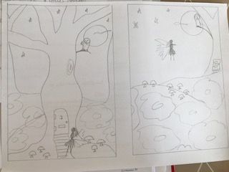
The final set was the one on the left, really focusing in on the faraway tree and the little door and fairy, with all the other elements in the background.
The one on the right was a hill type idea, with the foreground focussed on the texture in the leaves, flowers and mushrooms. A main fairy and the main tree in the top half, again this one is simpler and more airy.
I liked two the best and the where numbers 1 & 3, mainly because they gave more of a feel of the enchanted WOOD than the others, it focuses on the wood and gives a more eerie yet magical feel to the composition.

I started to look into textures for my forest woodland floor, having been experimenting with tracing paper and ink and watercolour recently I have discovered alcohol ink; I have embarked on some experiments with this ink style.
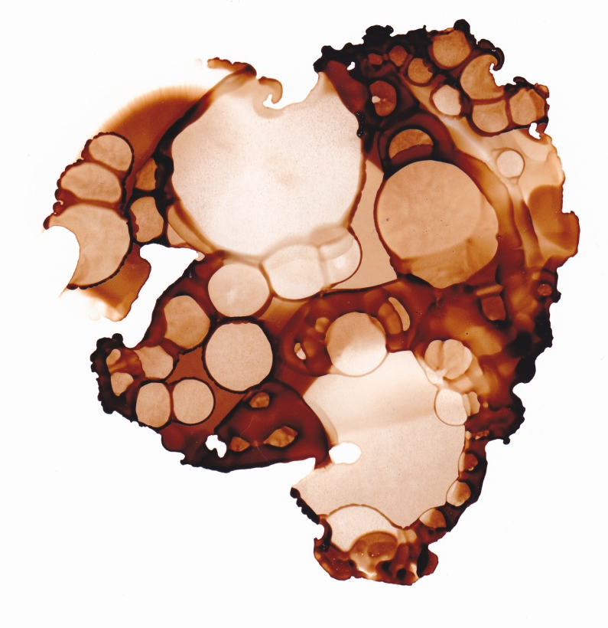
This was my first attempt at it; I love the different shades of colour within it and the circle dotty texture it reveals. I think this would look great as wood effects or bark or wet leaf texture, quite muddy looking.
I tried again with a green colour this time, I tried to do it bigger and have darker areas and lighter areas within it.
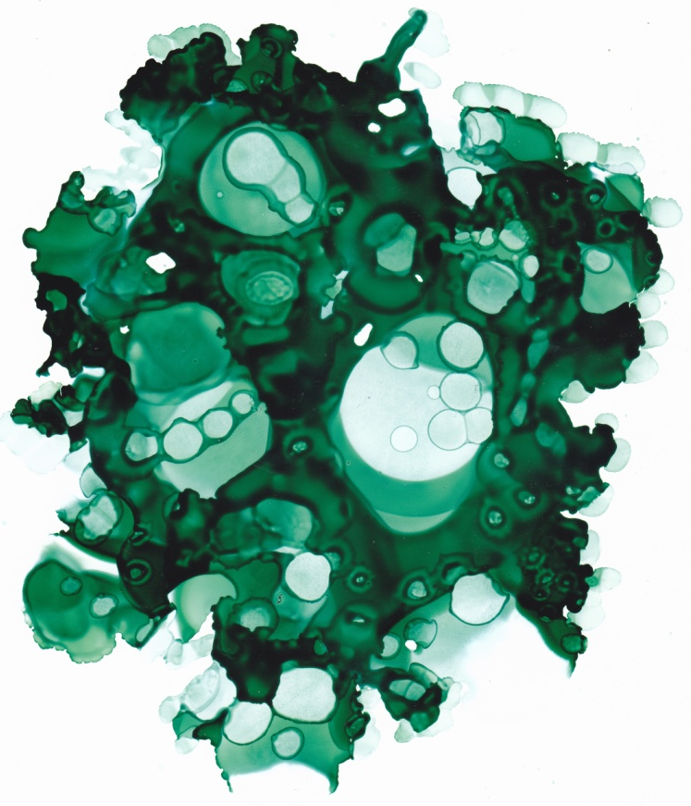
Again this turned out well, it has the texture I was after, and it has a mossy organic feel to it. It has lighter areas and deep dark areas, again the circle spotty look is really unusual, it adds a modern feel to the textures.
I started to draw my line work shapes for my illustration; I did a flower which looks really organic and then an orchid flower, plus the tree shapes I wanted.
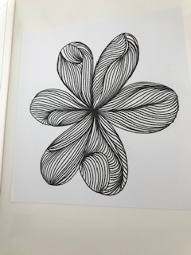

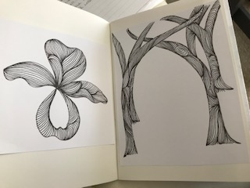

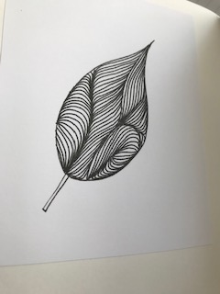

I was pleased how well these turned out, I then started to paint some more water colours of some elements.
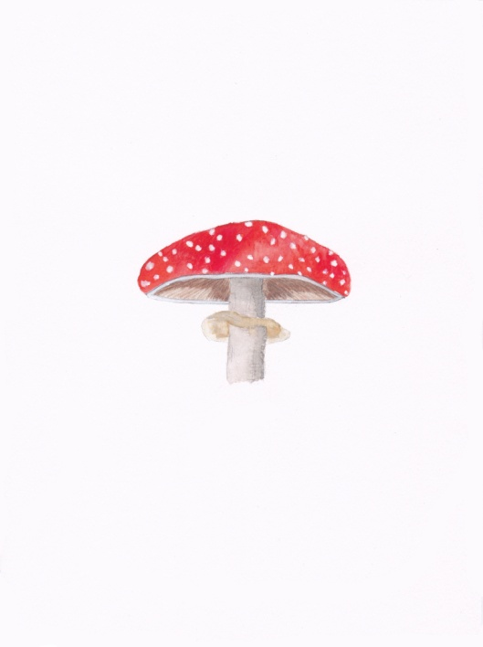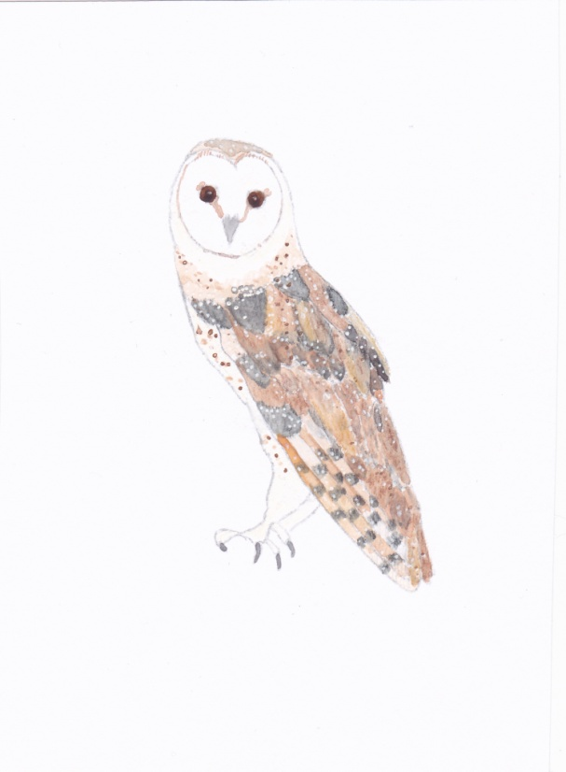
I then started to compile the elements into Illustrator, This is the first picture I did, I then printed this off and did some annotations of what I what to change, take out or develop further.
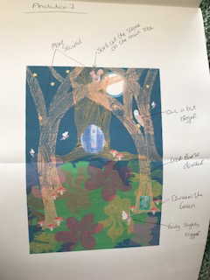

After going back onto the computer I change these bits and printed off a copy again.
This is the second annotation I did for this illustration.
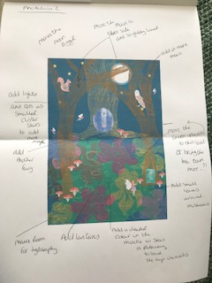
After this one I changed these onto the computer and printed this off too.
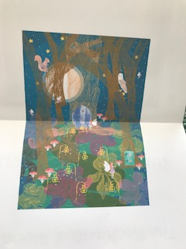
After this one I decided to leave it for a bit while I mulled over whether it needed more or anything changing.
I started to look into typography and fonts for my illustration.
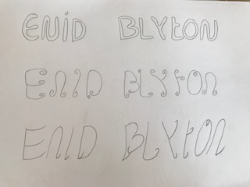
I started with some hand drawn fonts, then tried out different themes to the type’s
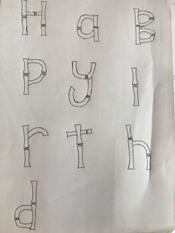
I think these are good but will need a lot more work to them to create some of my on fonts and typography styles.
I looked on the computer for some fonts that I thought might complement the illustration, I found these 6 to start with:
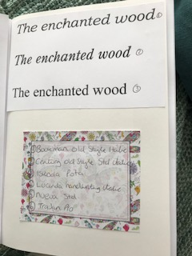

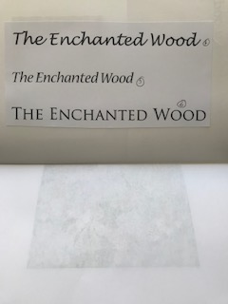
I like the 4th and 6th font’s the best. I decided to mock these up onto the illustration to see how they would look.
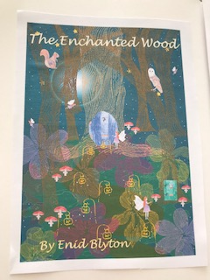
I liked this one it has a nice flow to the type and in the italic mode it works well with the illustration, it does have that feeling of enchantment and cuteness.
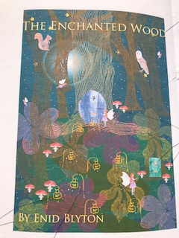
This was the 6th one; it goes really well with the illustration and has a fairytale feel to it but a bit more grown up than the last one.
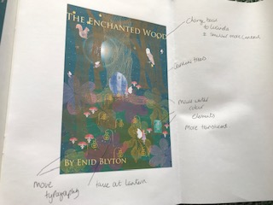
With this one I printed the picture out, as whilst doing the typography I noticed a few things I wanted to change again on the illustration, so I annotated this too.
I decided I liked the first typography the best; the illustration has a young feel to it, so I thought this one had a better connection with the art work. I do feel this illustration leans more to young girls than boys, because of the fairy theme but I thought you could do another cover with pixies or gnomes in it for boys, or combine the two!?
I chose to colour the typography with a stroke of yellow and then filled with white, I thought this gave a sparkle to it and made it look magical.
I also decided to crop the image inwards slightly as I feel some of the outside could be more direct. I used my cut out view finder to work out a good composition.
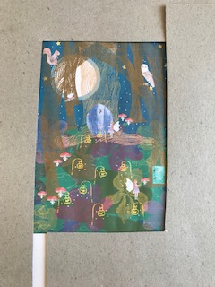

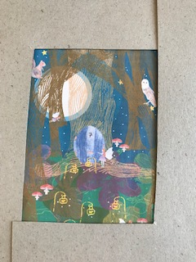

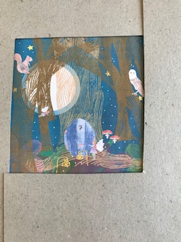
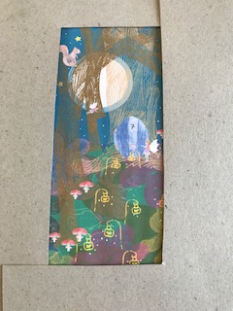
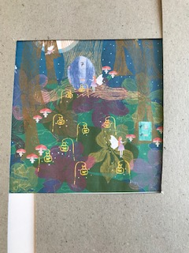
I liked the second composition the best, I then cropped this on the computer and added in the typography again and played around with the placement and size.
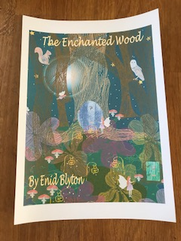
This is the final composition, cropped and with the typography, I’ve just got to put this on a mock up now. I printed this out on a white card which had a very smooth feeling to it, which I feel adds to the feeling of the book cover.
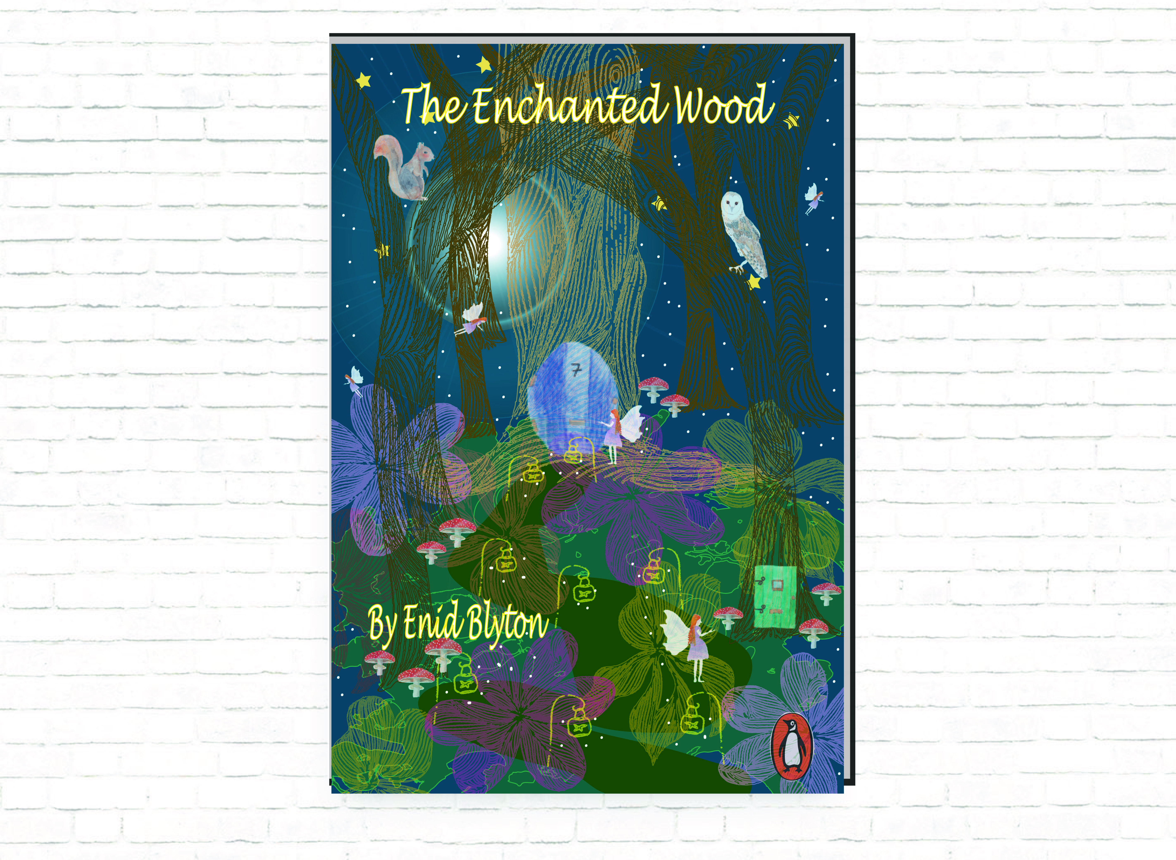
This is the final design mock up of the Enid Blyton book The Enchanted Wood.
What did you think of this exercise?
I was looking forward to this exercise as I love books; I enjoyed looking into which book to re-design the cover for. I thought this exercise was a good one as it was to show you how to implement all the exercise in this section and how to roll them all into this one to practise all the elements.
What have you gained from doing this?
I have gained and practised how to put all the elements together, it has helped me understand how to use all the steps and build up to a final illustration and knowing what works and doesn’t and trialling different options, before settling on the final piece.
Are there any materials or ideas you would like to explore further? What will you do?
I will continue to use all these steps going forward into the next section and into the next assignment which will follow. I’m going to write down each step so I make a check list of the steps which will help me with the next exercises.
17/09/19
I came back to this after I had completed assignment 3, due to having looked into better mock ups, I found a free book mock up so I tried this with my finished illustration.
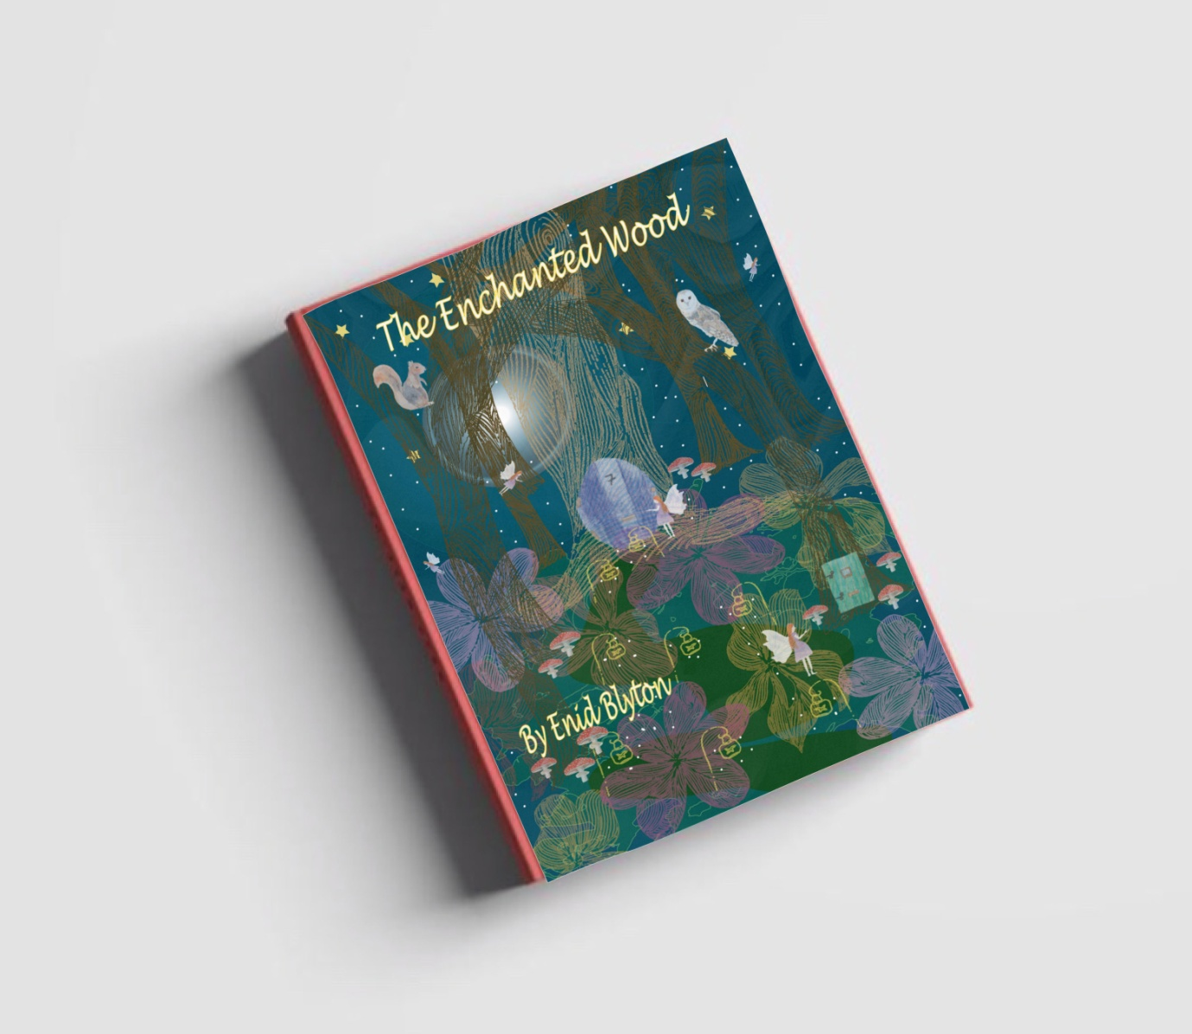
After feedback from my tutor:-
Which was to try to add more contrast between the elements like the trees, try to make them darker. Look at the focal point; try to get the eye to move around the image, using colour and scale.
So I went back into my saved Illustrator file and had a go at making the trees darker.
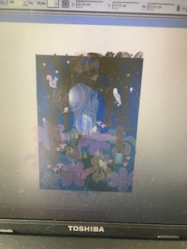

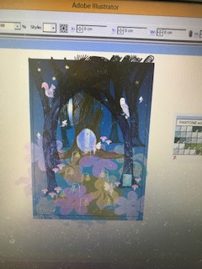
I also changed the colour of the path to slightly brighter, so your eye would move through the picture with the path.
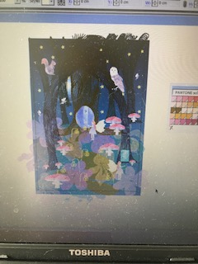
I made the mushrooms larger in some areas to get your eye to move around the picture, the red of the mushrooms helps to do this. I also made the two main fairies slightly larger, as when the mushrooms were larger they looked too small and blended more into the background.
This is the mock after the changes I made, it does make your eye move through the illustration more and the whole picture looks brighter and colourful. The reason I did the colouring before was that I wanted it to look secret and magical, but I do think this looks better, it would grab people more, and the eye defiantly travels around the picture more.
