Abstract illustration
I started by looking at some abstract illustrators, I found Lyubov Popova.
Lyubov Popova was born in Russia in 1889, Popova travelled extensively to learn and investigate from a wide diverse range of painting, but it was the paintings of Giotto and the 15th and 16th century Italian painters and Russian icons that interested her the most.
In 1912-13 she studied art in Paris; in 1914 she travelled to Italy at the development of Cubism and Futurism.
After exploring impressionism in 1913 and compositions with figures, she went on to develop a fusion of cubo-futurism from France and Italy. Popova was one of the first female pioneers in this style.
Her paintings The Violin of 1914, shows her new painterly architectonics series this defined her new style by the distinct abstract trajectory of form.
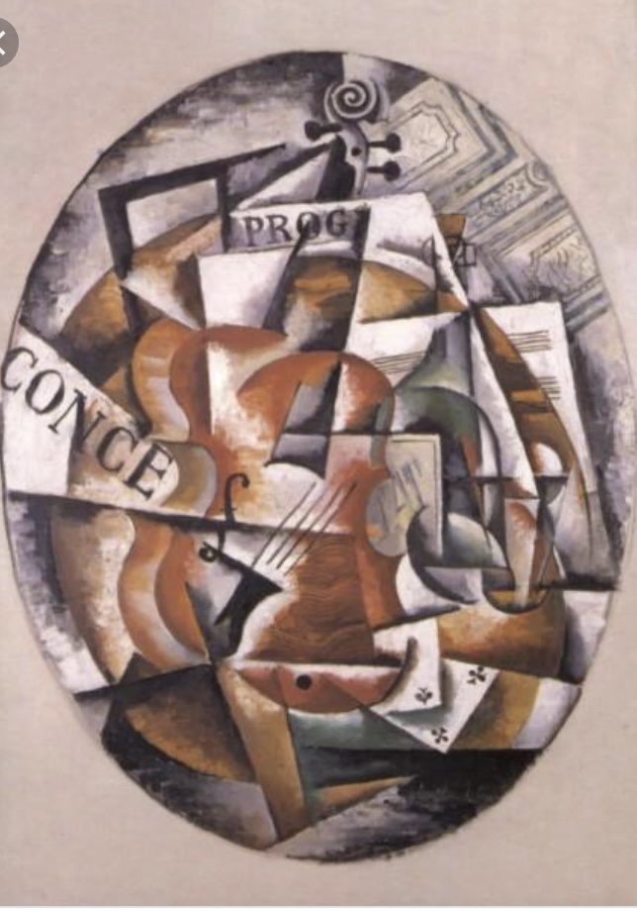
Popova Lyubov, (1915) violin [Oil paint] Public domain.
The focus on colour largely draws the shapes together; the whole surface of the picture is a interlocking series of forms in an abstract nature. Angular movement and a constant state of energy being released, like tectonic plates of the earth.
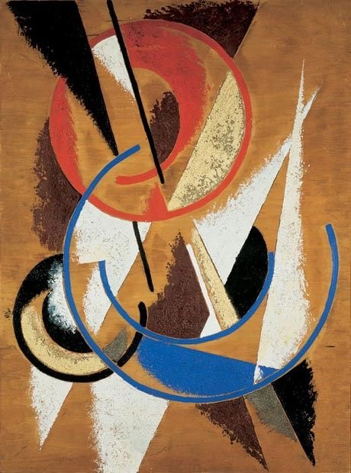
Popova Lyubov, (1921) Space-force construction [oil paint] State tretiakov gallery Moscow.
This piece shows how shapes, texture and lines can interlock and create an abstract piece of an object.
I like the texture in this piece, it’s like she’s used a dry roller to roller paint over, you can feel the texture this has created, and you could liken it to concrete or brick.
I like the use of curved lines and straight lines it gives a balance to the picture.
The colour red at the top brings your eye here first, and then to the blue, then to the soft yellow, so your eye explores every piece and moves around the composition.

To start this exercise I had a listen to all the musicians listed, but I decided to go with Miles Davies. I felt I had the best connection with his music, I started to listen to his music, I decided to pick a random 6 pieces and see which one I felt the most from. I’ve listed the songs below:-
- Concierto de aranjuez adagio
- Tasty pudding
- Sorcerer
- Blue haze
- Out of nowhere
- Kind of blue
The one I had the best connection and got feelings from was Tasty pudding, I initially got these colours ready from after listening to it, these were the ones I was drawn too.
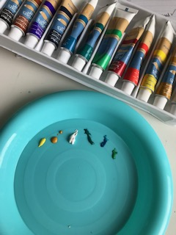
I then had the song on repeat and did a few marks in my sketchbook, I decided to use and start with Gouache paint.
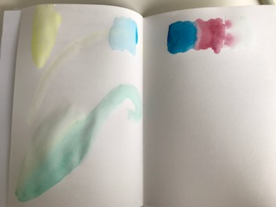
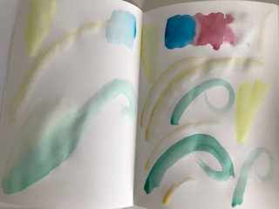
I then moved onto a small watercolour pad as the paper was thicker and buckled less, so I could get a clearer idea of the marks I was making.
I then let this dry and then added a few more marks, so it became layered.
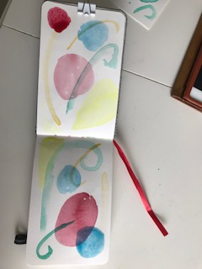
I then wanted to add some texture with the paint so did some dry brush marks in my sketch book. All the time I’m doing this I have the song playing.
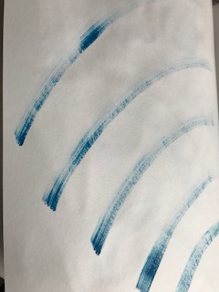
I then used my sketch book and washed the colours I had used over a page, I wanted to add marks, so then went with these marks, which I felt whilst listening.
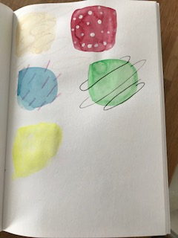
After this I felt I had some elements that I could work with, so I culminated these onto a larger sheet of watercolour paper,
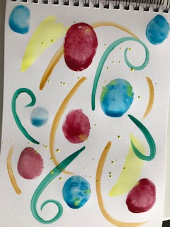
I waited for the first layer to dry, and then I added some more colour and marks on top, to get the layered feeling I was after, and then added the mark making on the top. I continued to listen to the music and made sure that I wanted or not to add anything else.
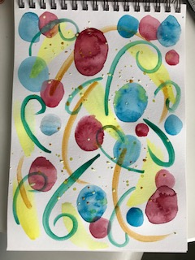
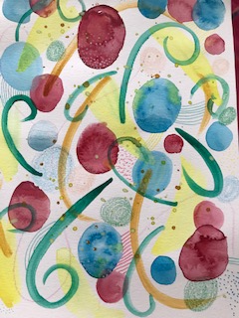

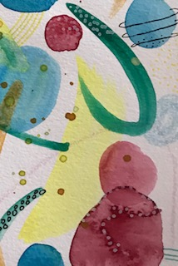
This is the section I liked most from the painting; this is cropped from the image, so it focuses on certain aspects of the mark making and textures.
I then decided to do a spider diagram of this picture, as I was not sure what word I would describe this as. I think generating words this way; I might come up with something different or unusual.
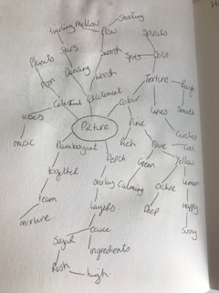
So from this spider diagram I came up with the words: - High, Mixture, Vibes and star.
I listened to the music again, and I felt that the big picture was ‘High’, I decided to use the square cardboard to help with the composition as I felt the cropped area I had chosen needed more in it.
I added more texture and mark making to the picture, I focused on 6 areas. I have cropped 6 versions to see which ones I liked and felt right, whilst continuing to listen to the music.
So this was number one, I didn’t really like this once I cropped it, it didn’t feel right with the music.
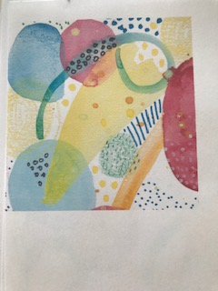
Number 2
This felt better, I think cropping the circles in half helps the composition as it adds drama and the un-expected.
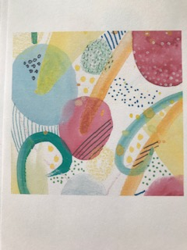
Number 3
I focused on areas with the most mark making and textures, this I felt was much better.
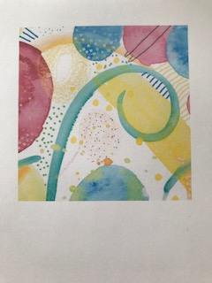
Number 4
Had nice patterns and splashes of colour which I felt went well with the music.
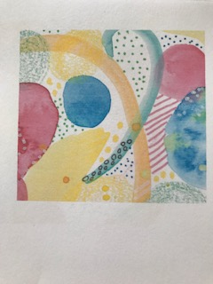
Number 5
I really liked this crop, It had good mark making, went well with the music and having less pink colour within it made it feel fresher.
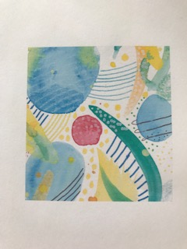
Number 6
I cropped number 1 differently and came up with number 6, I still liked the textures in number 1, but felt cropping it so that the circles were half off the paper help the composition.
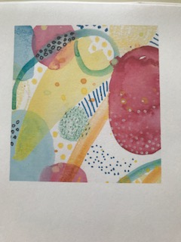
I listened to the music again at this point to determine which one fitted the sounds best.
I felt that number 3 was the best in the abstraction of the piece, the cymbal of the drums represented by the dots, gave it a glitter feel. I felt that the trumpets were represented by the swirls and whooshes, whether the trumpet note was long or short. The piano was represented by the stripe lines, although I added a few more, as there was more piano playing at the end of the song.
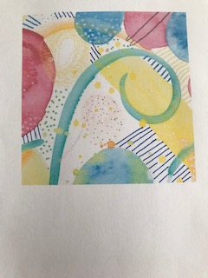
I think this would look lovely as a CD cover for the song as a single or as the album cover, I think its eye catching, the colours flow well and the mark making and textures represent the music well. As an abstract piece I think it conveys what it does well.
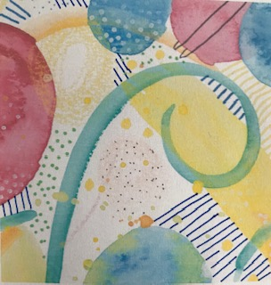

What did you think of this exercise?
I really liked this exercise, I have done canvas paintings before based on feelings, so this was fairly easy for me to understand and go with the flow of the music. I liked the fact that this was what you felt with music this time, and I had never listened to Miles Davies before so that was nice too.
What have you gained from doing this?
I have gained a better understanding of abstract work, how you can capture a section/ composition of an image and use this to make a new abstract piece. I have also learnt more about mark making and layering colour with paint, also on how to interpret music into something I believe comes from the feelings you feel when you listen to it.
Are there any materials or ideas you would like to explore? What will you do?
I am looking into some abstract watercolour and Gouache work, or sketchbook work, using layers.
Also adding mark making to this, to create textures, layers and unusual patterns.
I would also do another exercise like this as I found it quite therapeutic and fun.
After my tutors feedback :-
My tutor liked my design, but just suggested putting the design on a CD mock up, so here is my final design picture.
