Turning words into pictures

I started off by looking at all the words individually; I wanted something that would take me out of my comfort zone slightly, so I would sketch different subjects. I decided to choose ‘Wild’ as my word.
I then decided to start a spider diagram to get all the wild words out to see what I could come up with.
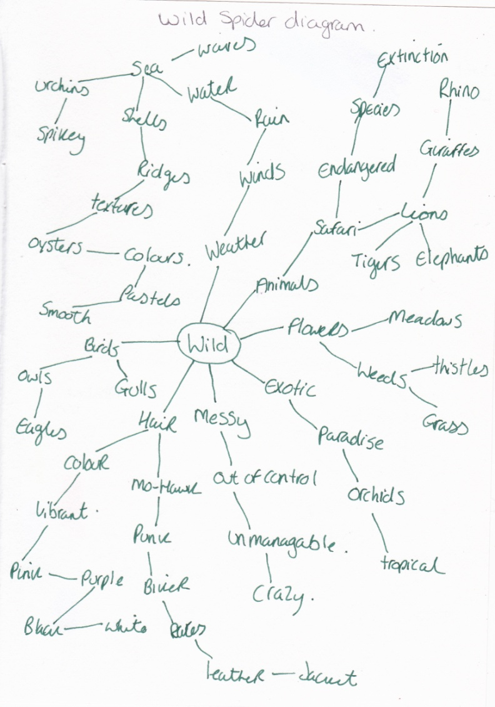
I did quite well on this diagram and came up with lots of ideas, some I was surprised by, for example ‘weather’. I found I got a real sense of the word and then started to sketch some pictures of the words I found.
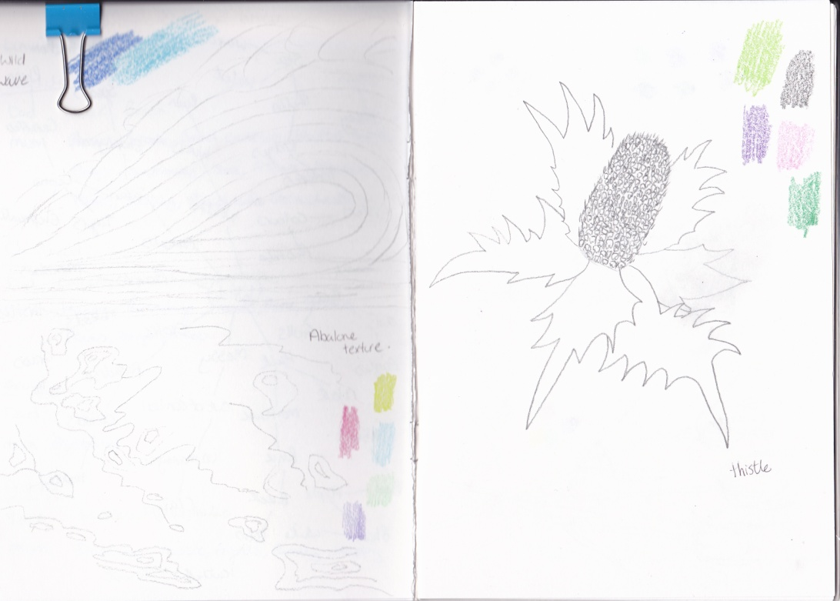
I started with the weather and the sea and drew a large wave to depict how the sea and weather can be wild together. I then drew a texture, which was from the diagram, which leads from the sea which was shells and abalone.
The second page I drew a wild flower which was a thistle, which I thought represented a spiky wild looking flower with foliage.
I added colours to both the pages with colour swatches, to bring out the colour of the wildness too.
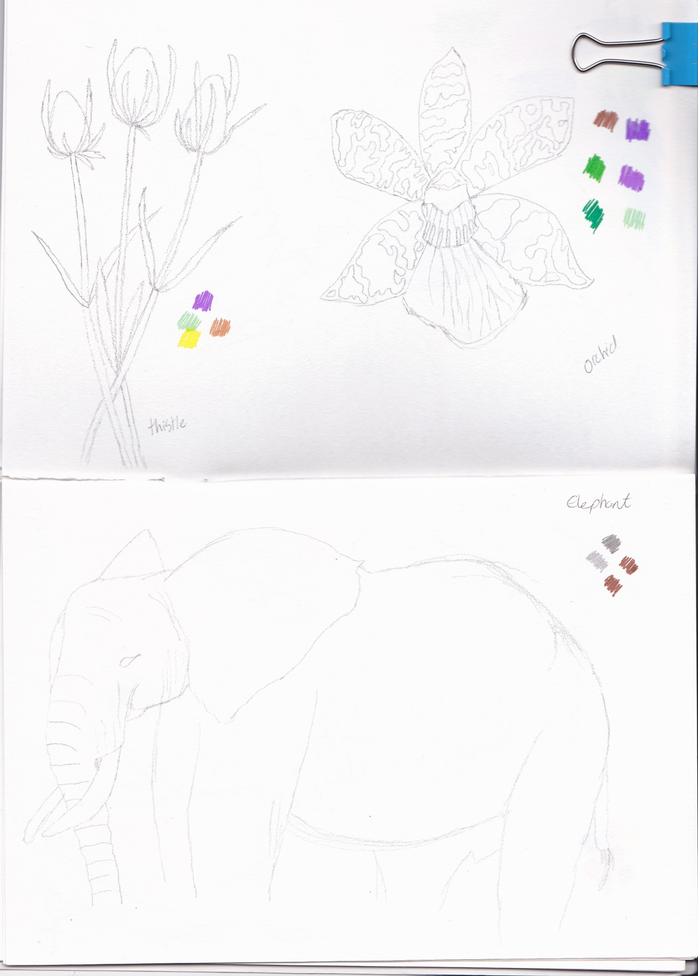
I then went on to page 3 of my sketch book and drew some wild flowers, one which was a type of thistle, which had gone to seed and was starting to turn brown, it felt very wild, spiky, old, and messy.
The second was wild in the sense it was exotic, tropical and from paradise. A fab looking orchid with amazing markings, which you would say add some wild textures.
Again adding the colours to the pages in swatches, to give the colour feeling.
The fourth page of my sketchbook shows a drawing of an elephant I did which says wild in the sense, of safari and endangered. Again I added the colour to the page and some sketching to show the texture of the skin of the elephant, which could also be classed as wild too.
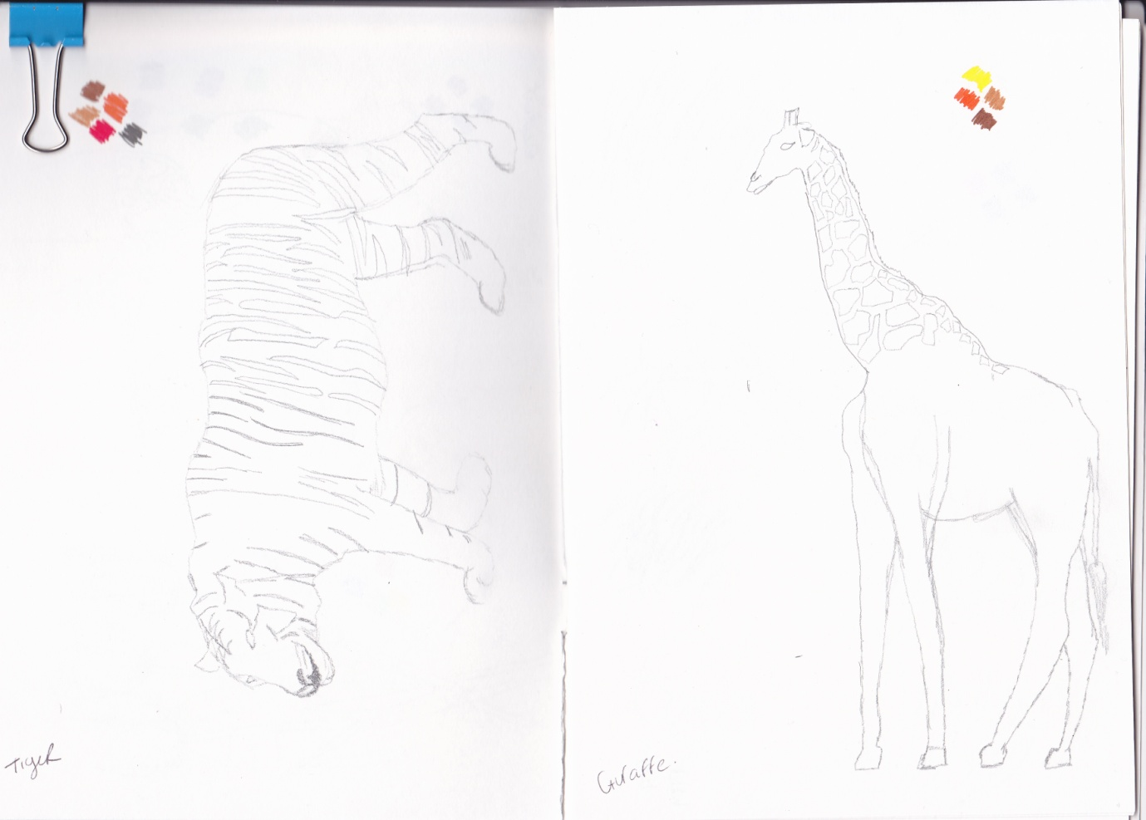
The 5th and 6th page show some more wild animals from the safari, a tiger and giraffe, both of the markings on these animals could also be classed as wild as in textures and colours.
The more I sketched the more I thought about the textures, colours and the sketches and how they can all represent the word ‘wild’.
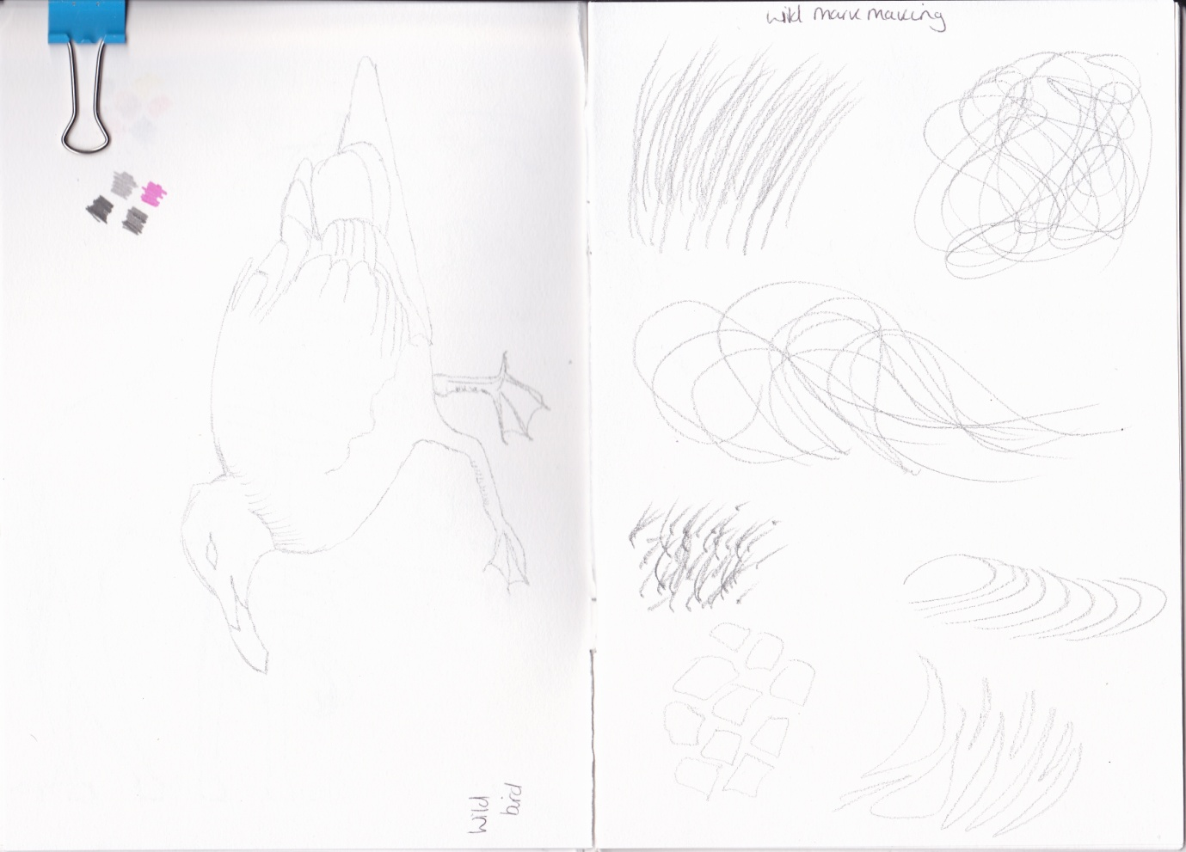
The 7th page shows a wild bird/duck, which looked slightly pre-historic, both in colour and look. I then moved this forward and thought more about what could make all the sketches more ‘wild’ other than colour and texture, and I thought of mark making which could feel like ‘wild’ so I then sketched some mark making techniques I thought felt like ‘wild’, I used the drawings I had sketched to think about the marks to create.
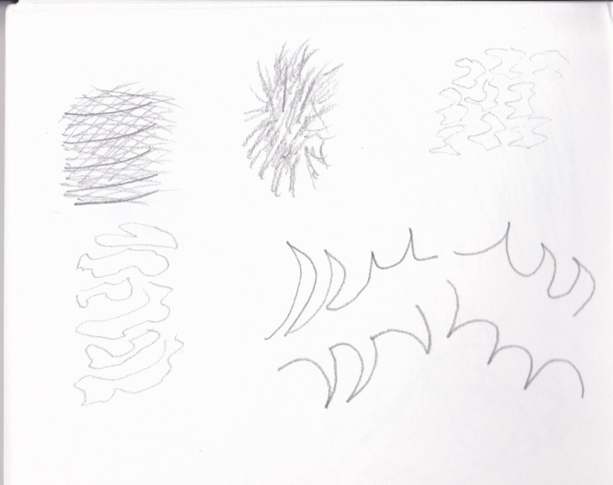
What did you think of this exercise?
I was a bit dubious at first as I was un-sure of how to draw ‘wild’ the word I had chosen, but once I had completed the spider diagram I was well on my way and found it easy to come up with sketches and then colours, which then moved on to textures and mark making. I really enjoyed this at the end and was surprised at how quickly the thoughts came to me.
What have you gained from doing this?
I have gained a good basis of how to start ideas off, how to add in more ideas. E.g. Textures, colours and mark making to give more of the feeling you need to have a rounded idea or sketch.
Are there any materials or ideas you would like to explore?
I am still exploring mark making techniques and textures, but will use this exercise to add those techniques to feel and colour too, atmosphere is something I’m gaining more info on doing these exercises.
What will you do?
When drawing an object or word I will maybe do another spider diagram for texture and feeling as well, which I think will help with background ideas of illustrations.
I went in to this further with a design challenge I came across for ‘Safari’ as the title. I used a few of my pictures that I had created for ‘Wild’ and turned these into some watercolour illustrations.
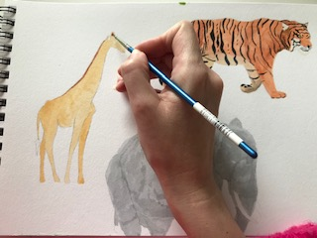
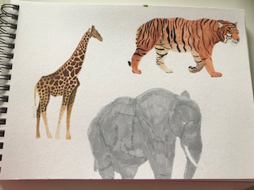
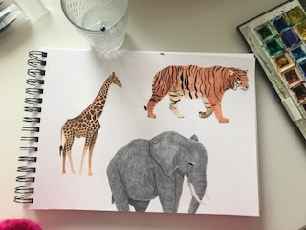
I then did some mark making in my sketch book of the patterns from the markings on the animals.
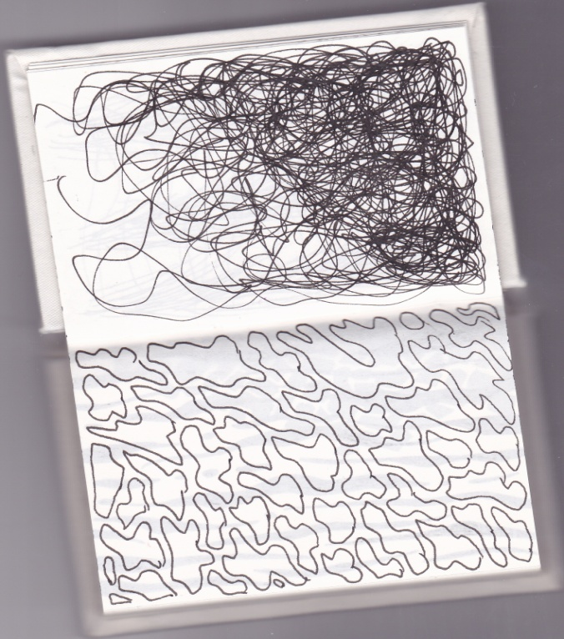
I then created a pattern with these elements. I chose to use the animal markings as a background texture. The elephant and tiger were my main characters and I also did a watercolour illustration of a tree and some foliage/ scrub land.
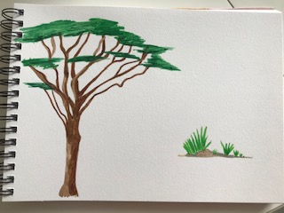
I then put all the elements into Photoshop and Illustrator and created this pattern.
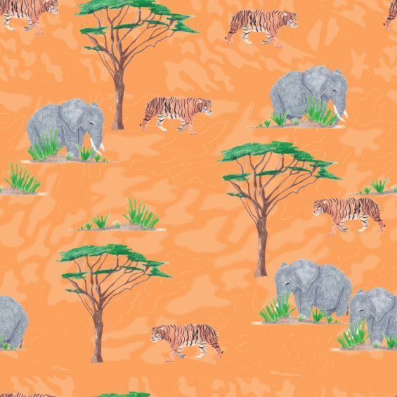
I then created a technical repeat to check the repeated the pattern.
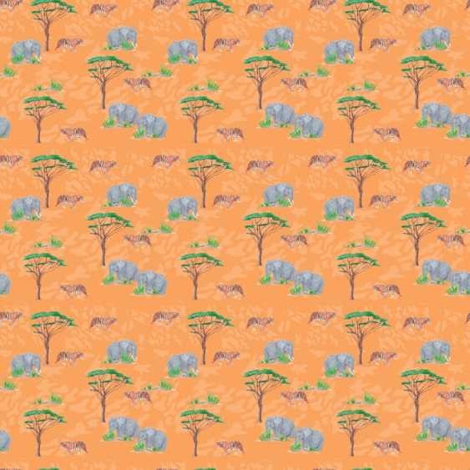
I really liked this design, but I felt there was something not quite right about it, but I could not put my finger on it. So I slept on the idea over night.
I came back to it the next day and thought about what my main aim was for the design challenge and pattern. Basically I wanted the pattern to be more of an illustration and to tell a story as that is what I am trying to learn with this Degree.
I liked the texture to the background and I liked the watercolour illustrations, so I liked all the elements. I then looked at conversational prints on Pintrest and saw a running theme through them which was little groupings of illustrations. The patterns were mainly from children’s pattern designs.
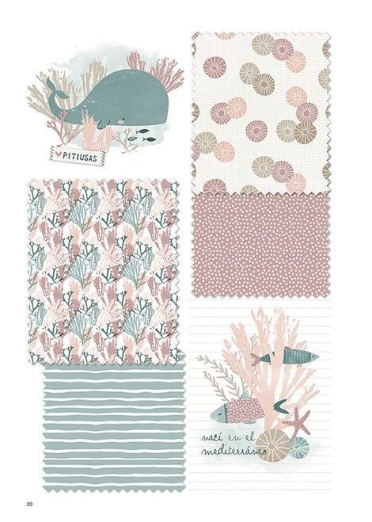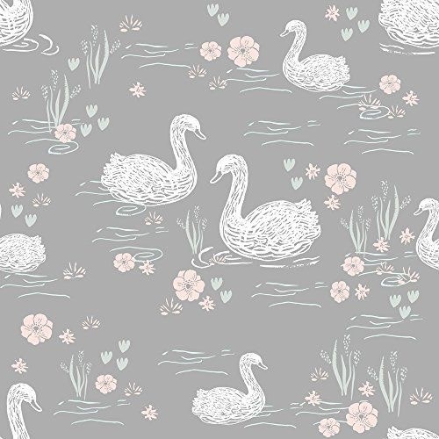
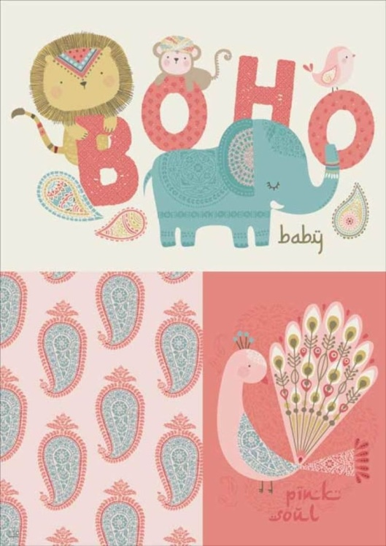
So I changed the pattern slightly and moved the characters in together more, and added a smaller baby elephant, which I feel gives a little story to the illustration. I changed the background colour and changed the stroke of the background texture to an outline rather than a fill colour. Then added a sun which again I feel creates atmosphere to the illustration pattern.
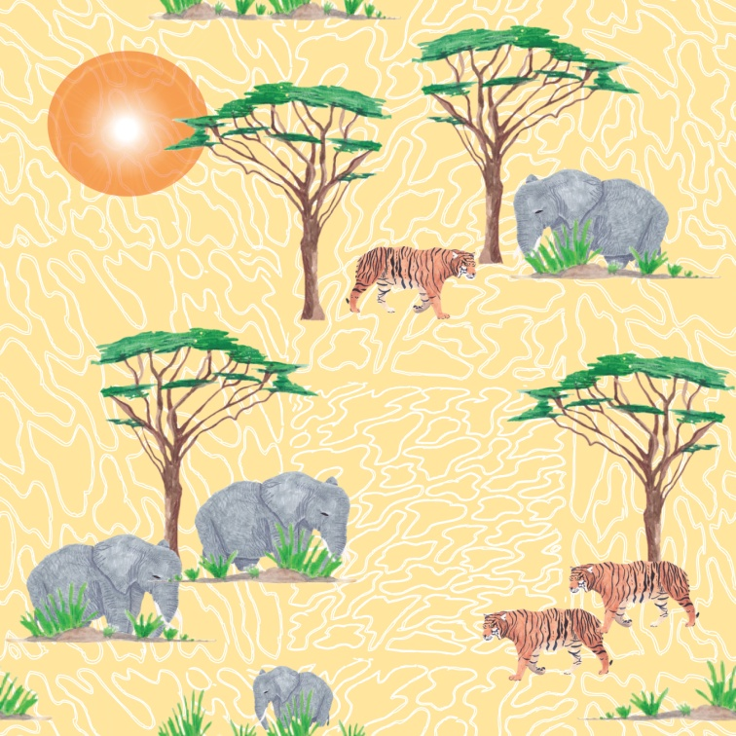
Once again I created a technical repeat and checked it repeated ok.
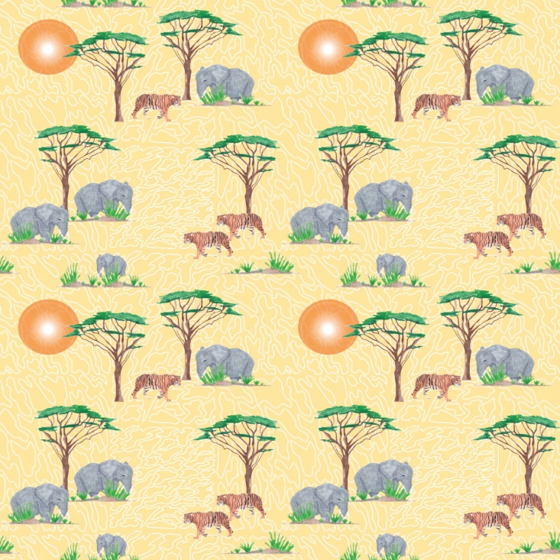
I then entered this into the design challenge and created some mock ups to show the design in use.
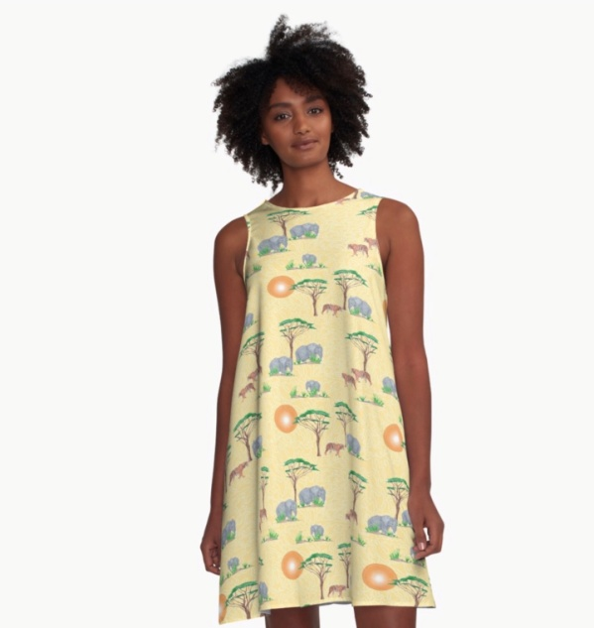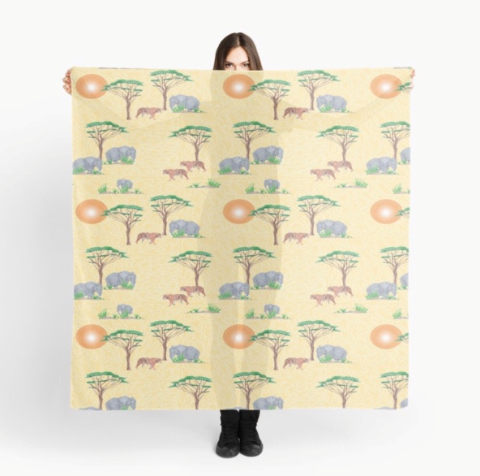
I then received an email to say I had won the design challenge! I was so pleased, I had called the design ‘Hot sun safari’ which I think sums up the design and atmosphere. They also put the design on more mock up’s to promote it.
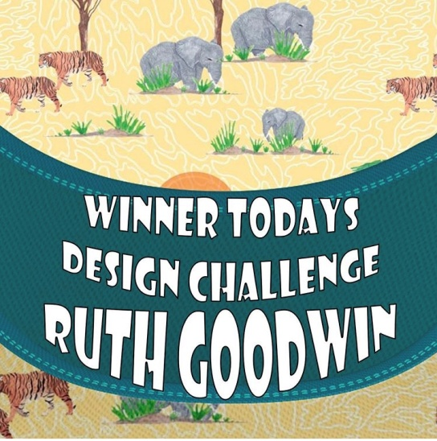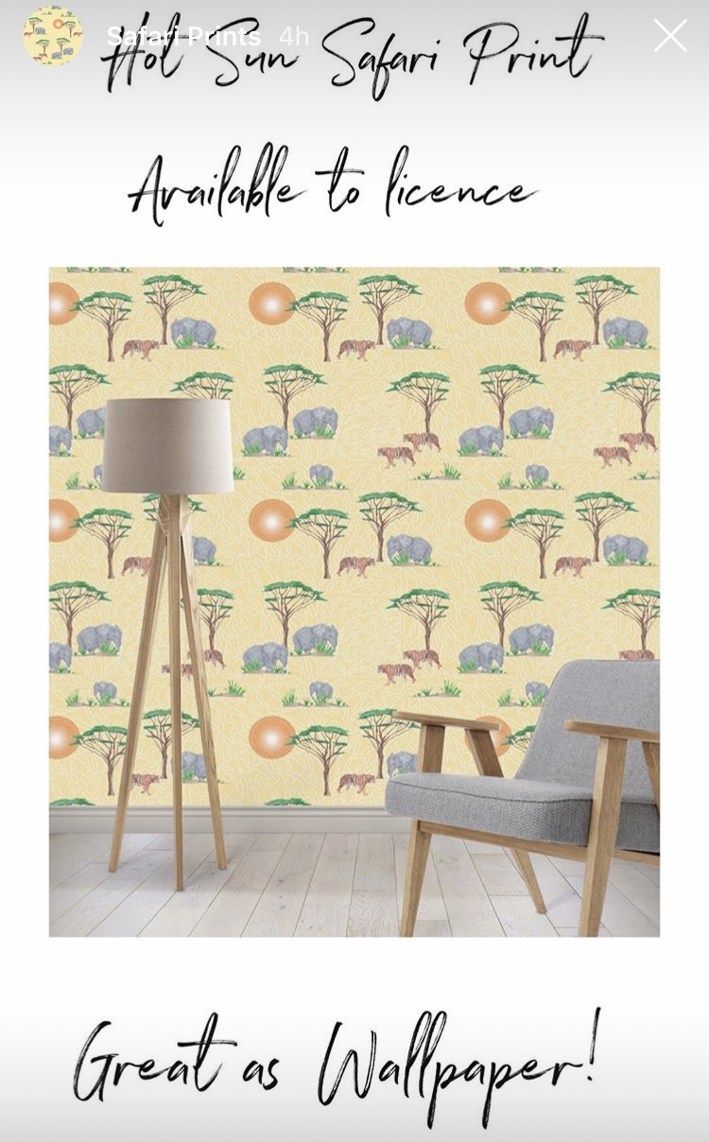
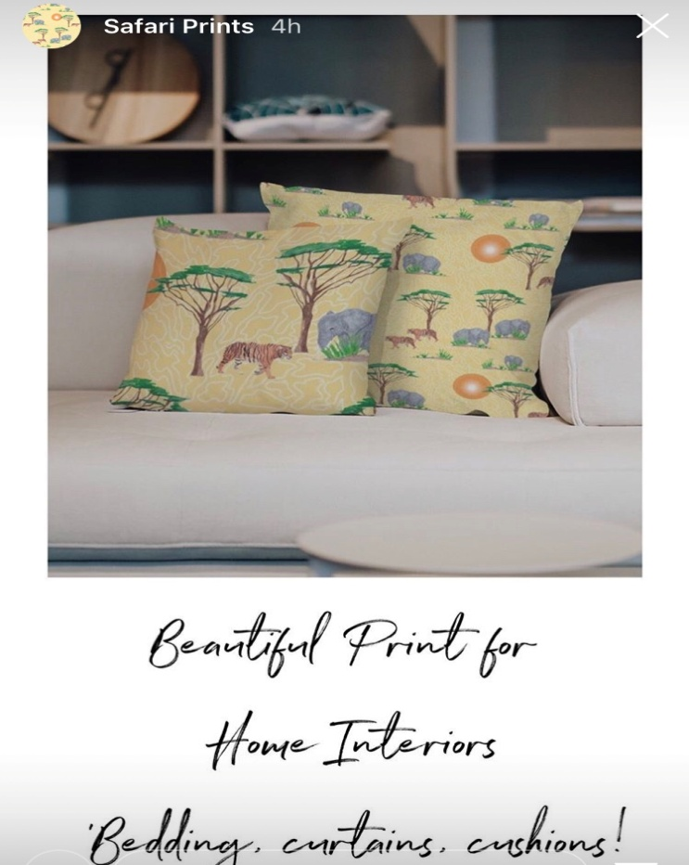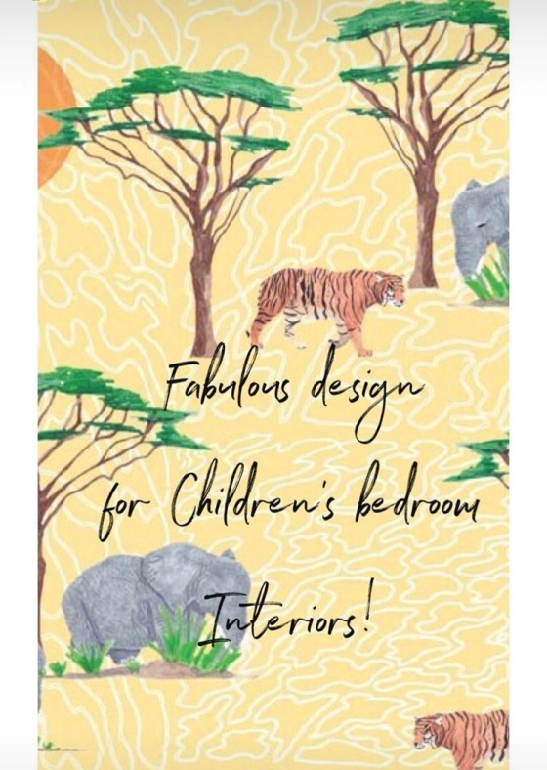
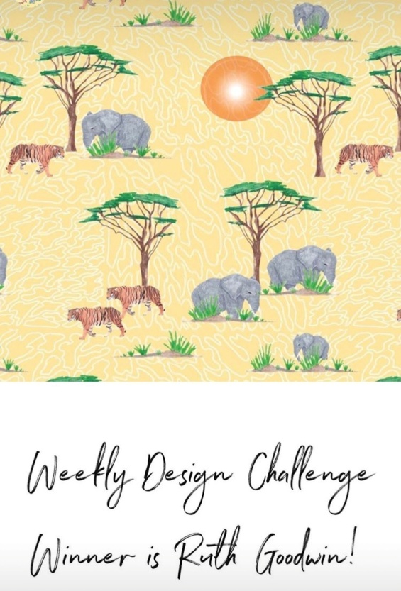
So from this one exercise I feel as though I have learnt a great deal, I will really work on these elements to develop my illustrations to give them texture, atmosphere and feeling.
After feedback from my tutor:-
She suggested going further in responding abstractly with the media and try black in for its fluid quality’s, and oil pastels as well as coloured lines.
So I went back to my sketchbook and created some colour tests and textures from oil pastels, soluble pastels, brush ink pen and blue ink (I didn’t have any black)
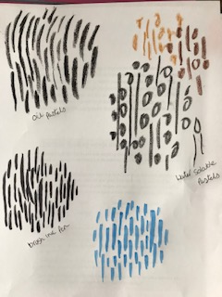
I did find that the oil pastels especially did create a really good texture and would be great for a Zebra print or the rough skin of a Rhino, it’s something I will use in the future. The ink was more fluid and would work with more smooth surfaces, and the thin coloured pens would be great for details on bird’s feathers or the smaller details. I really enjoyed this little experiment and have made me think and see more about the relation of the media to the description of a animal foe example.
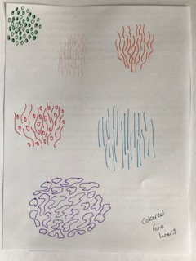
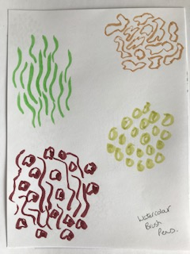
I found the watercolour brush pens above the compromise between the two thicker textures at the top and the thin coloured pens in the middle. I think these would be good for giraffes or snakes, because of the way the lines vary between thicker and thin and have a slightly smoother texture.
The second part of my tutor’s feedback was to set myself a few more pattern design projects, which I have done. I carried on the theme of ‘wild’ into this other pattern, this one was a bit more different, but I think has a lot of texture in it.
I kept with the theme and used the Giraffe I had painted for the exercise but didn’t use in the end. I then was thinking what other things are wild? I came up with the idea of wild flowers, so I used some inspiration I had of the Kew Gardens orchid festival pictures I had, and picked 4 orchids that I thought looked wild and painted these in watercolour and coloured pencils.
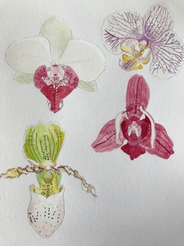
I chose one of these orchids that had the most markings on it, as this added texture to the design. I then painted a palm tree, using these strokes to create a feather effect for the palm leaves, and a leaf with was tropical in nature. I wanted quite a maximalist pattern that was busy and full of content, which gave lots of interest and texture.
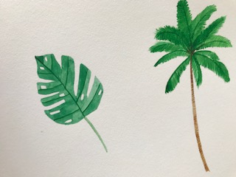
With all these elements I created a 550 x 550 Pixel frame for a layered Illustrator file, to create a seamless repeat pattern. I then added a background using some of the textures I had created in my texture sketchbook and layered this onto the pattern as the bottom layer.
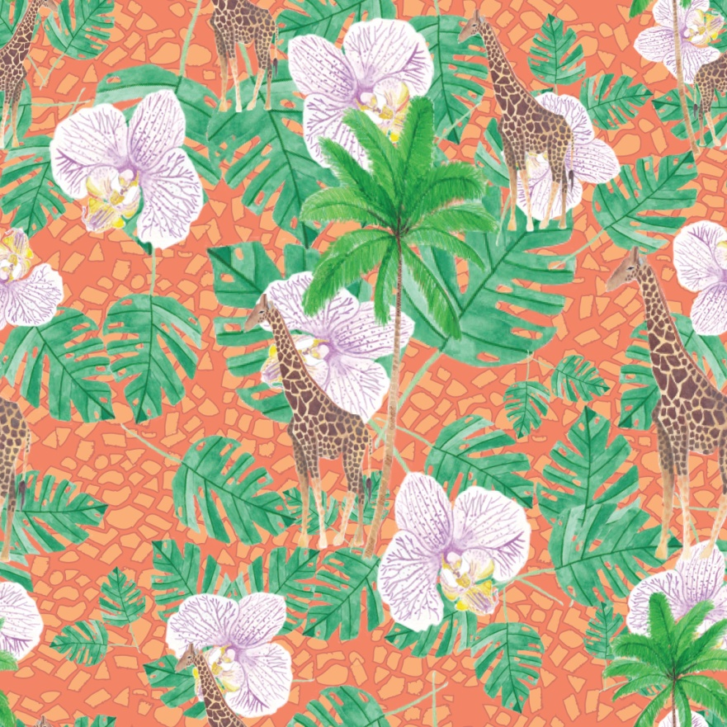
This is the 550 x 550 pixel frame, and then I repeated the pattern to check the repeat was correct.
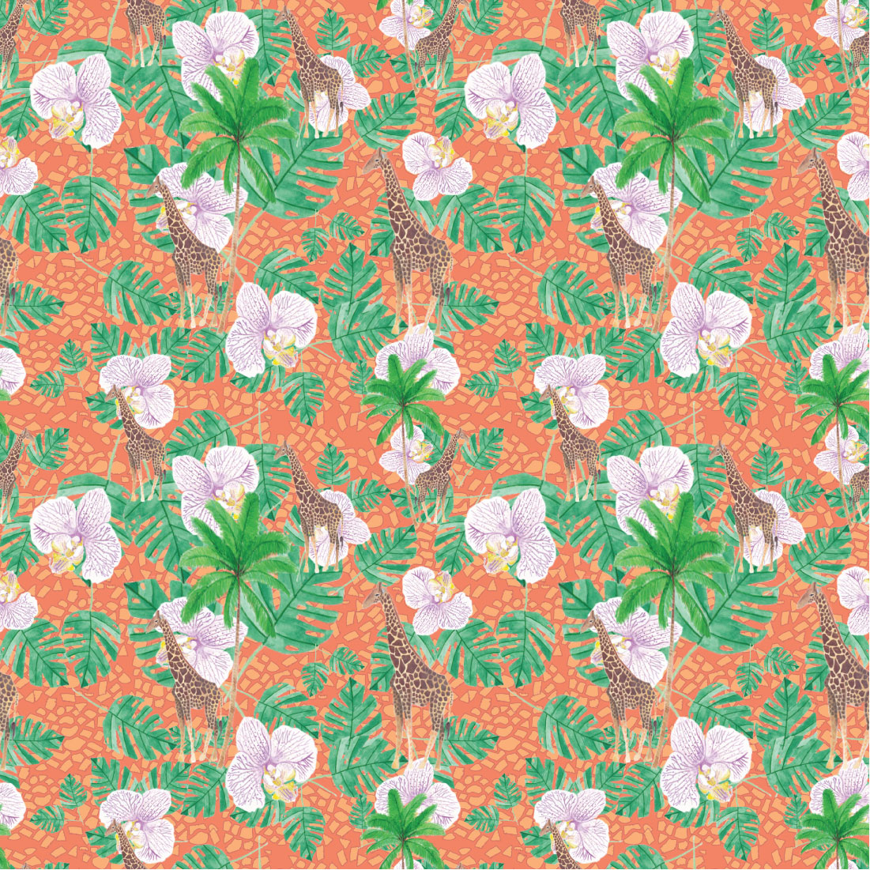
I like the textures in this pattern from the bigger background animal print, to the smaller print on the giraffe himself, and then the lines on the orchid.
Overall i am really pleased with how this turned out, it is very busy, but I think it works as the more you look the more you see. I think the colours work well, I like the orange background colours and the lighter orchid, but then the giraffe blends the colours together to create a harmony.
I think this would look good as a Hawaiian style shirt for a man, it has that feel about it, but wilder.

