Assignment 4: A Magazine Illustration
I started by reading through the brief, I looked at the four words available for the topics; I was first drawn to the word ‘Discovery’ as it seemed the only positive word in the group. So I started with some words in my sketchbook that would represent this topic, I used a Thesaurus to help me out a little. The words that I had written down were:-
Encounter, Exploration, Revelation, Experimentation, Exposure, Identification, Invention, Learning, Locating, Perception, Ascertainment, Unearthing.
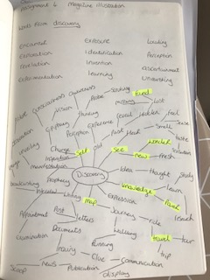
From these words I started a spider diagram also, as I wanted less direct words, feelings and just to see where this would take me.
From the spider diagram (above) I highlighted 9 words I liked and that I felt were thinking about ‘Discovery’ in different ways.
The words I decided to highlight were:-
Found
Self
See
New
Wonder
Knowledge
Power
Map
Travel
From these words I looked up some pictures and images and created a mood board from these words.
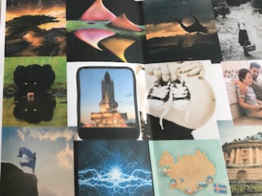
From this mood board I whittled the words down to just two to explore further, they were ‘See and Self’
From these words I had two ideas forming, the first one for ‘See’ was to discover something through looking through something else, like a pair of binoculars for example.
The second one was for ‘Self’ and the idea I had from that was discovering yourself.
After this I started to look at Illustrators that either used illustrations about discovering themselves or something new about them or for the first one looking through something to find something else.
I found the Illustrator Tara Jacoby who is an Illustrator and art director from New York, after working as an illustrator and deputy art director for a few companies, Tara is now a freelance Illustrator. Tara is now living in Philadelphia where she is freelancing and teaching at The University of the Arts.
Tara used Digital media to create her illustrations; I have found her illustrations very interesting and have ‘Discovered’ a new way of thinking about illustrations to convey a word.
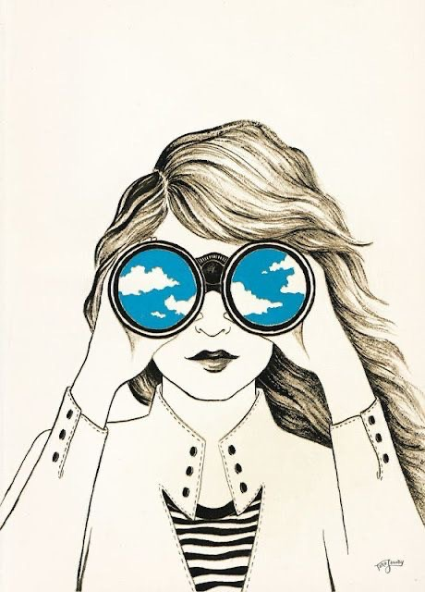
This one above is effective in that the main illustration of the girl is in black and white, yet what she is seeing is in colour, she’s obviously also discovering something through the binoculars too. It looks like this has been completed on an I pad or through Photoshop, the texture of the hair is good and gives the picture a softness.
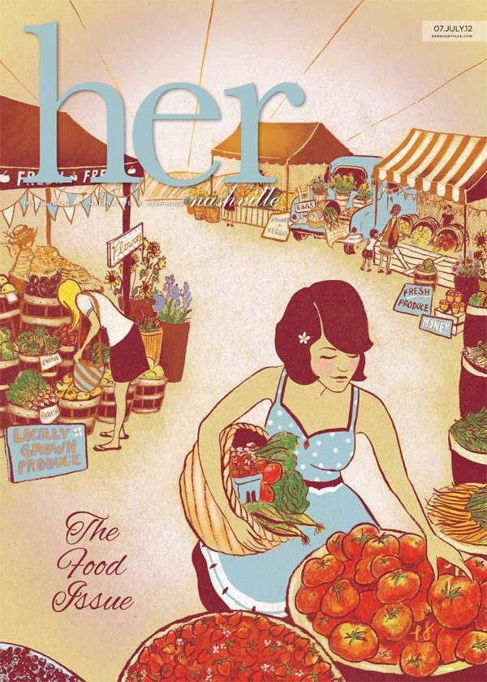
This is another illustration by Tara but this one is very different from her others, this again looks like it was created on a digital device, but this one has more texture within it. This one was for ‘Her’ magazine and I thought this was good for ‘self’ it shows a typical group of ladies doing womanly chores like shopping and cooking and looking after children.

Below are a few of Tara’s illustration, they all vary quite a lot and some are very political.
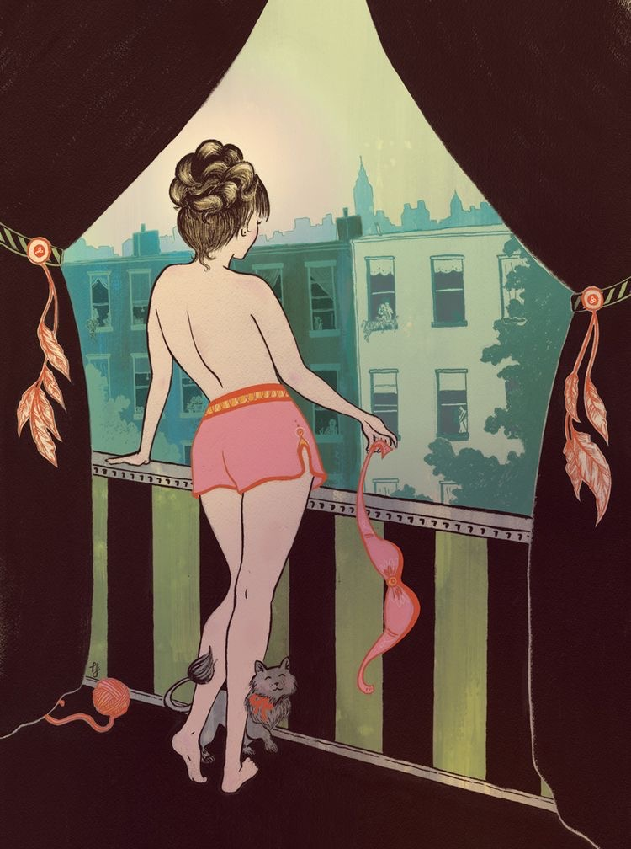
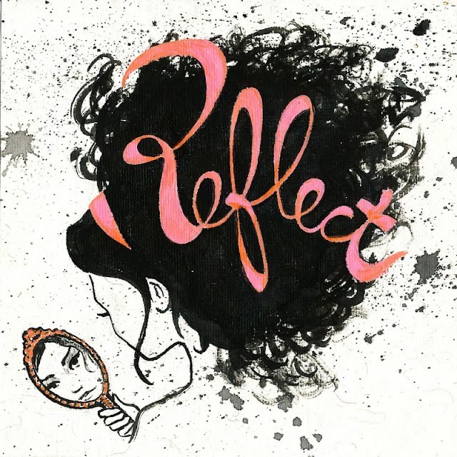
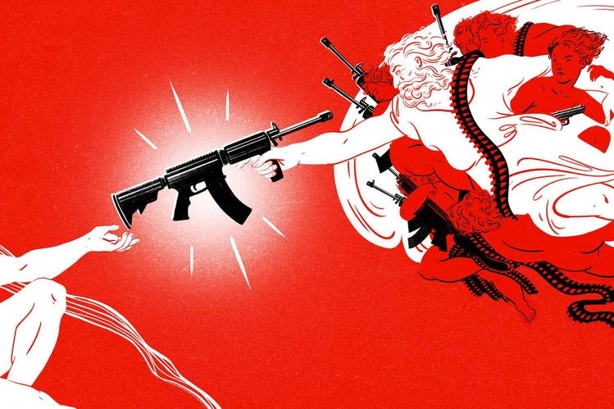
© All images Tara Jacoby website
So from this research I had a good few ideas of where to go to next, so I started to pull together some objects for my still life arrangements.
I started with the word ‘See’ and took some photos of my dad’s telescope, his binoculars and my mum’s glasses, it was difficult to arrange a still life composition due to the telescope being so much larger than the other items, but I took some pictures anyway, thinking I might be able to sketch them better together myself.
From this I started to sketch some thumb nails, at this point I wasn’t really sure where this was going to lead, but I went with it anyway.
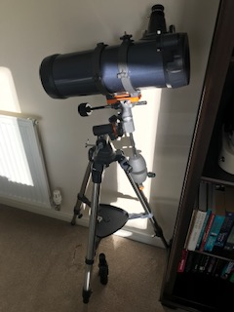
Here are my thumbnails of the different compositions I thought of, I then went on to sketch two of them larger and better to see how these would look.
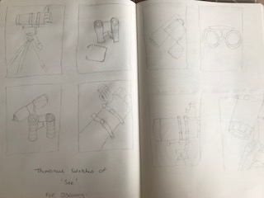
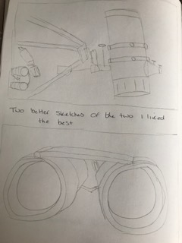
I preferred the big sketch of the binoculars best, but is this considered a still life, even though its only one object?
From this I went on to compose my still life for ‘Self’ so my idea for this was more advanced than the ‘See’ one, so my idea was to do self discovery based on a character that has discovered things about themselves.
My still life was based around a mirror and the person looking in the mirror and the reflection back. I wanted to make a contrast within the picture from black and white to colour, so the best thing I thought of was paint. My still life has paint, pencils and colourful objects in it to make this happen at a later stage. Although I have an idea I still don’t know how to achieve this so I’m working on ideas as I go.
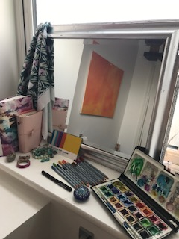
My thumbnails show different perspectives of this idea.
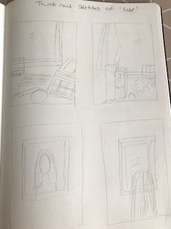
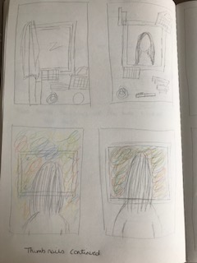
From these I decided upon two of my favourite sketches and made them larger and slightly more detailed.
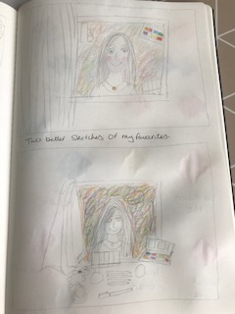
After these ideas and sketches I decided to think about colours and mediums to use, I stuck with my usual watercolour paint and coloured pencils as this has become my signature style. I created some colour tests for each of the two words.
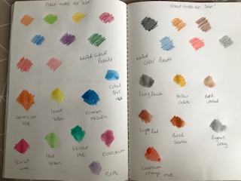
The tests on the right are for the word ‘Self’ as this will involve loads of different colours, the one on the left is for ‘See’ which is more tonal and darker colours due to the objects chosen.
My thoughts at this point are to go with the idea of ‘Self’ discovery, I have a better and more advanced idea for this already and I feel as though I know which direction this is going in, but I will continue to the next stage anyway with both and decide finally from there.
So my next direction was to draw a line visual of the composition I like the best, I did this in my sketch book as a sketch, then I thought I could scan this into Illustrator and work on the line from there.
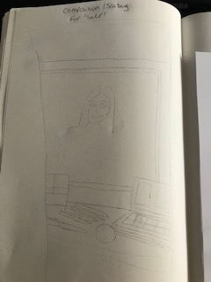
This is where I put it through Illustrator.

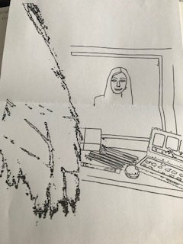
I took out some of the lines but also added others; I wanted it to look like the person was standing in front of the mirror to one side, so you can see their hair then the reflection of them in the mirror.
After this I did this with the other word ‘See’ I sketched the line visual in my sketch book then put this through Illustrator and added or took out lines to make it look better.
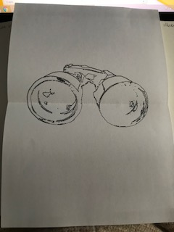
From this I started on some mark making in my sketch book for both ideas, the ‘See’ was more for landscapes and the ‘Self’ was more watercolour experiments. I have also completed a watercolour exploration sketchbook (which you can find in the sketchbook section on my blog)
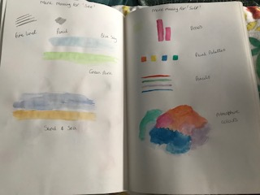
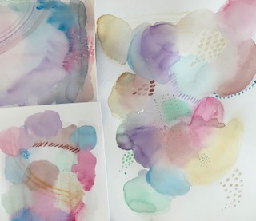
After this I started to think about the typography, I didn’t know whether the magazine illustration would require some type or not, but as it has been a focus of mine of late, I thought I would look into this now and early on in this assignment so I can think of the typography first along with the images.
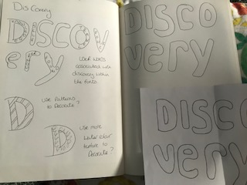
I came up with the idea of using the word ‘Discovery’ but with type inside to describe different ways that could be. I didn’t know whether to use some patterns in the fonts or watercolours to match the main idea?
I sketched a hand drawn type for the word in very simple bubble style writing.
I then started to pull together all the ideas I had so far and see how these looked, this was my first annotation. This was ok but it needed some tidying up, the font needed to be larger, I needed to add some drop shadows to make the character stand out; make the mirror look more lifelike. I decided to use some of my own pictures which I put through Photoshop to distort the image in the mirror slightly and have a collage effect.
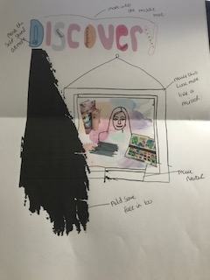
My second annotation was using collage to make the mirror look more shinny; I tried some foil, but didn’t know how this would translate into the computer!?
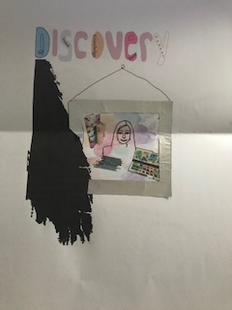

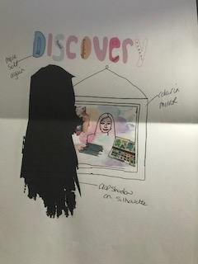
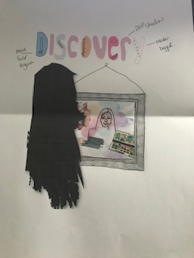
I then completed a line visual to simplify the image to see how that would work; I liked the simplicity of it, but missed the typography which I feel adds to the piece.
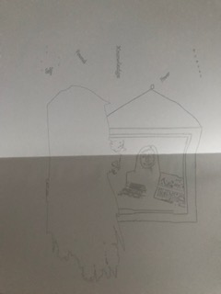
Then I printed off a tonal annotation to see how this would look, it was quite faint and less vibrant but looked ok.
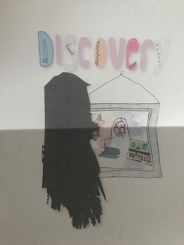
I then did a black and white tone with simple line work, to see how this read as an image.
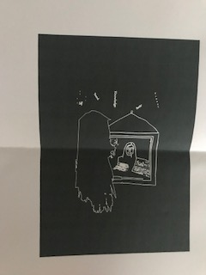
At this point I was not sure if this was saying what I wanted it to, it’s hard when you know your idea, but is it translating in the image? I decided to go back to the original image as I felt this was stronger with the type added too. I mocked this up on a magazine style mock up, I think this reads well like this, and alongside a written piece I think this would be good.
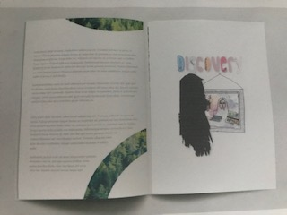
It was beginning to come together now and was looking ok; at this point I decided to go back over the brief and double check what I was doing.
After doing this I realised that maybe I had made a mistake somewhere, as my images were not Objective! I decided to think about what I had done and how I could change this to be more objective, I returned to the ‘See’ idea and looked to see how I could make this objective. I started to pull together some pieces, but I kept the typography, I used a different character and did a line visual of her. I used the binoculars as my starting point and worked around those, I used my watercolour experiments as the ‘See’ idea.
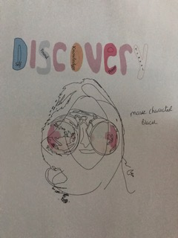
The thought I had was, about ‘Self discovery, finding out something you didn’t know about yourself and seeing it in you for the first time. I wanted the colours to pop, so I wanted the character to be black.
This is very similar to the other design, but I feel this is more simple and less about feeling more about discovery.
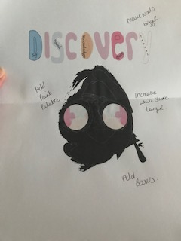
I wanted the detail of the lines to been seen still though, and I wanted to add the other elements I had of the still life, the books and paint palette.
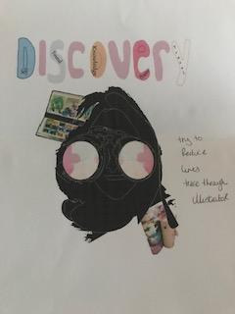
This is the line work and tonal annotation for this design, I liked that it looked more simple in black and white, but I feel lacked the ‘Discovery’ element.
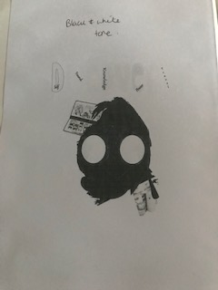
I tried this look but with a texture fill from Illustrator and used a coloured pattern stroke for the details; this was beginning to look better.

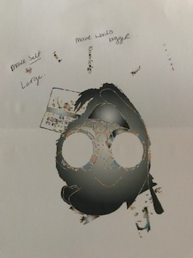
I wanted the words to be bigger so you could read them and the ‘Self’ word to be the biggest; also I wanted to use a bright pink to make this the hierarchy image of the piece.
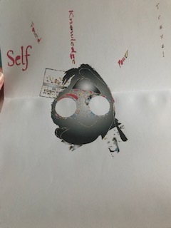
I then added this onto a mock up of a magazine to see how this would look in real life.
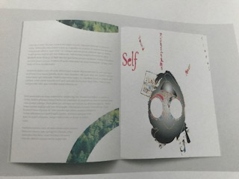
I think from a distance it’s not easy to see what this image is supposed to be, but I think when you read the words and look at the image you can see what its meant to be, I feel it’s a piece that would make you think.
1. What have you enjoyed and why? How might I expand my knowledge in this area?
I found this assignment slightly tricky, due to the word ‘Objective’ I always try and put some feeling into my images or at least understand and feel what the brief is about, so for me it was hard to be objective. I think through the process of annotation I have made this possible as it takes away a lot of the unnecessary ‘bits’, and lets you get to the point.
I enjoyed thinking of words differently and finding other meanings to words to expand on ideas. I think it would be interesting to use words in my sketchbook to come up with new ideas, (a bit of an archive for words and meanings)
2. What are the strengths and weaknesses of this image? How might I tackle any weaknesses?
I think the strengths are the use of colour and the simplified image with keeping the word ‘Discovery’ in mind. The weaknesses are the placement of the typography and the white circles of the binoculars, I don’t know whether these should be coloured?
The typography just needs to be re-looked at and placement improved, these are things I will try and see how they look.
3. It can be useful to return to your brief, check you are meeting the criteria (are the colours, character, feel of the image communicating the right idea?
I returned to the brief after the first completed image, so yes it was useful, maybe I should have done it sooner! I have checked again now and feel as though everything is ticked that I’ve completed for this brief, in my mind it does communicate the idea, but I think it’s always good to get some feedback anyway to see how others relate to this too.
4. What have you learnt in this exercise and how might I use it in future projects?
I have learnt to not be afraid of really simplifying an image, sometimes it can get rid of a lot of unnecessary elements that just make it messy or distract from what you are trying to say, sometimes less is more.
I have learnt to not be afraid of distorting an image to help you say what you need to, be more confident in being different. Using texture, paint techniques and digital elements to add something different and unique in future exercises.
The use of hand written or designed typography and fonts and how this can add to an image and make the communication stronger. Keep my type sketchbook going and use this as much as possible and practise on future exercises.
5. Has this inspired me to go on and delve into any new research?
I am continuing with my digital experiments, looking at Illustrator and Photoshop more and playing about with different techniques, I am learning as I’m going along with this.
Character development is something I’m hoping to focus on; I have a new sketchbook to help me along with this, which I’ve started. I am hoping to just sketch people in basic form and gain confidence in doing this and hoping my style and technique which is really bad at the moment will gradually improve.
After feedback from my tutor:-
She suggested with ‘Girl in the mirror’ to change the hair colour of the girl in the mirror to dark hair like the girl looking in the mirror and maybe to also have a full figure of the girl looking in the mirror to show more context, or to have the illustration as a full page spread for the mock up.
She also said that the image I finally decided upon looked like the research picture I had chosen to talk about, so because of this I went back to my initial design of ‘Girl in the mirror’ and work more on this as my final design. I also thought this maybe had a better connection with the word discovery rather than ‘see’, I do think that when you stop and take time out to think about things, you see them in a different light, and I think this is the better option to go for.
So I went back to the illustration and changed the hair colour of the girl in the mirror to match the girl looking in the mirror, so they are seen as the same person. I decided to go with brown hair instead, as I thought this looked less harsh and more realistic to connect the two images to make one.
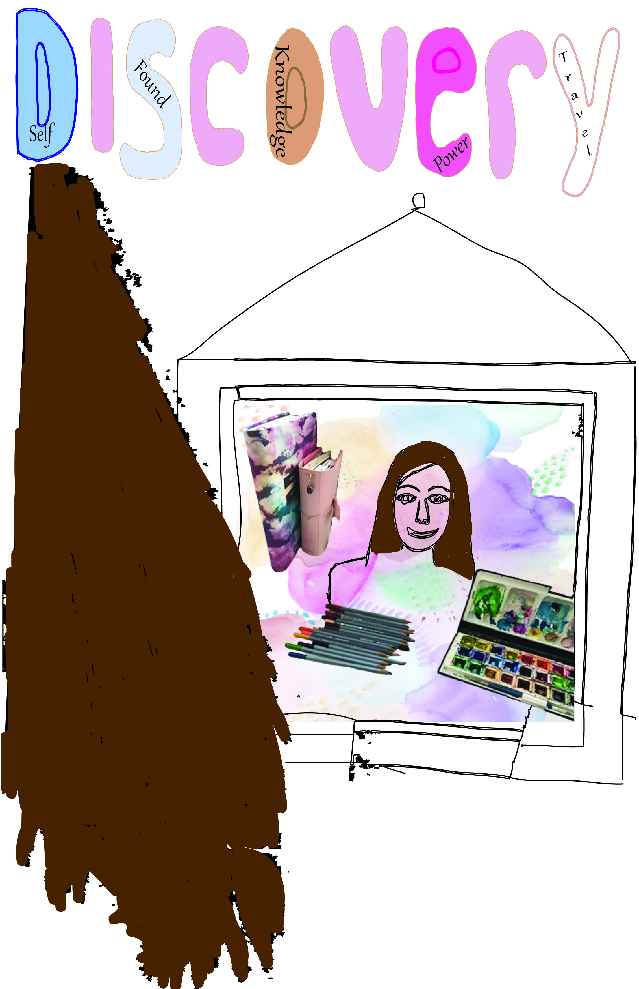

I changed the scale on the mock up so it was a full page spread, it looks like it has more impact and you can see more of the details now.
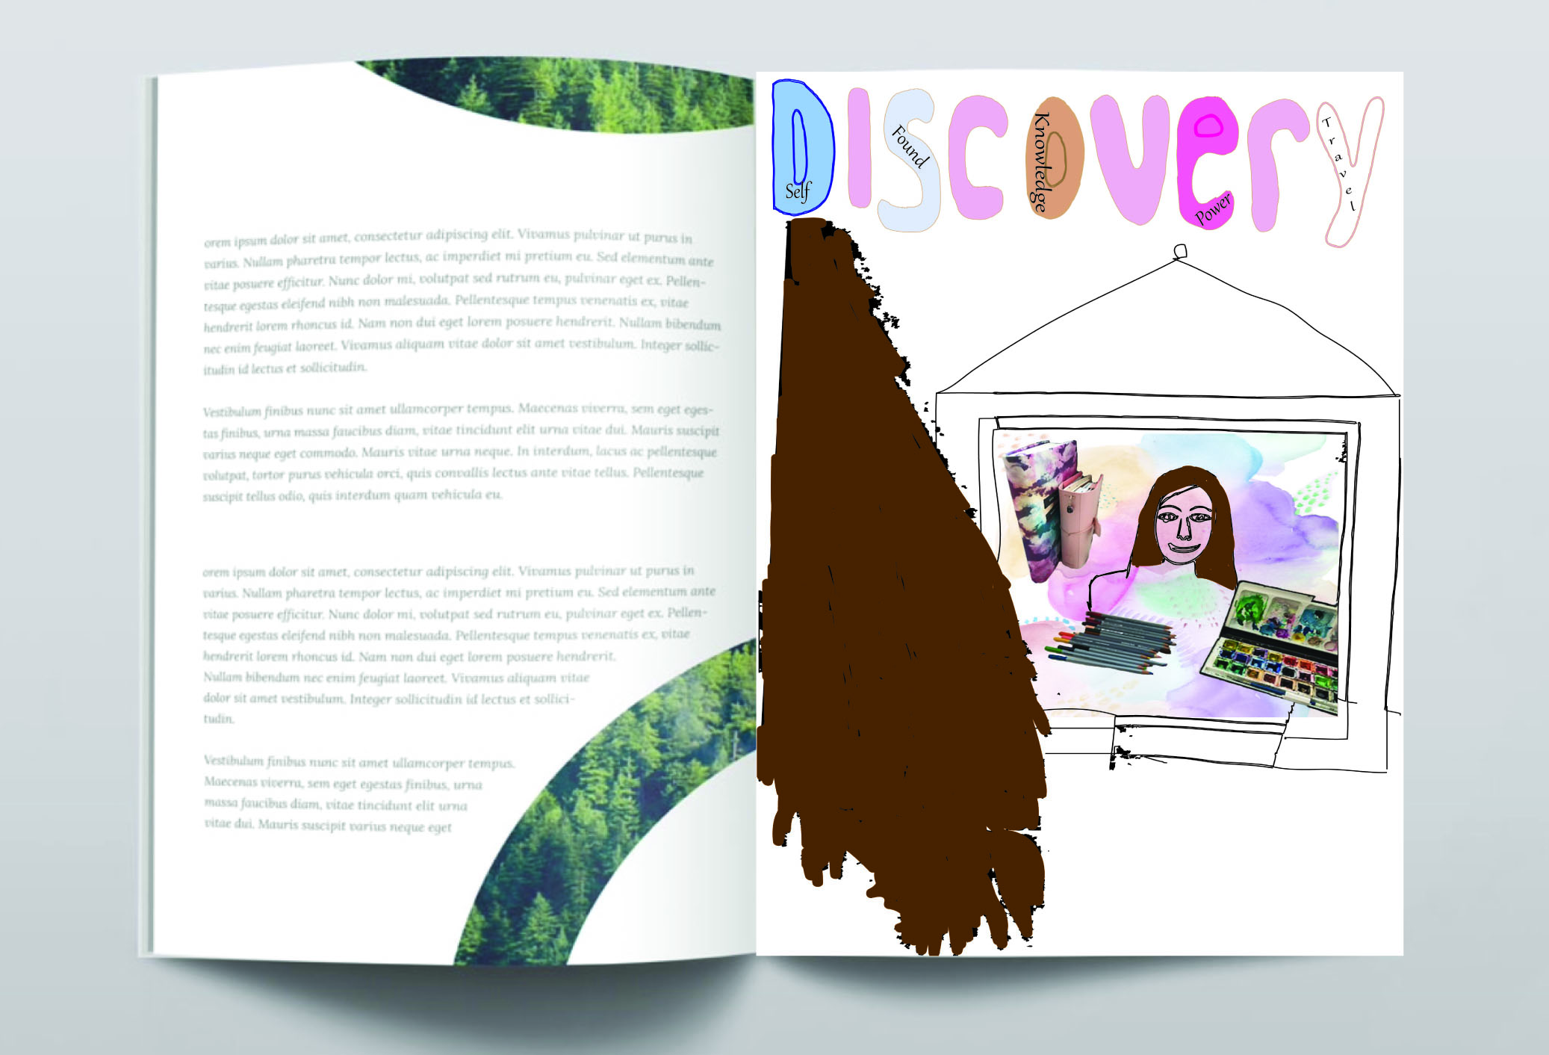
I think having the hair the same colour does link the images and I think it looks like you would assume the person is looking in a mirror.
I then went on to look at editorial illustration and research some different styles and designs and how these are set out.
I found four different editorial designs which I found interesting, the first one I liked that the pictures kind of framed the writing, and how the title connected the two images together. Having a limited colour palette has made the images bolder and striking.
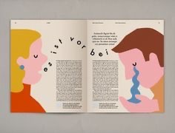
The second one was very visual having the tonal colour, with the words in a slither down the middle is very impactful.
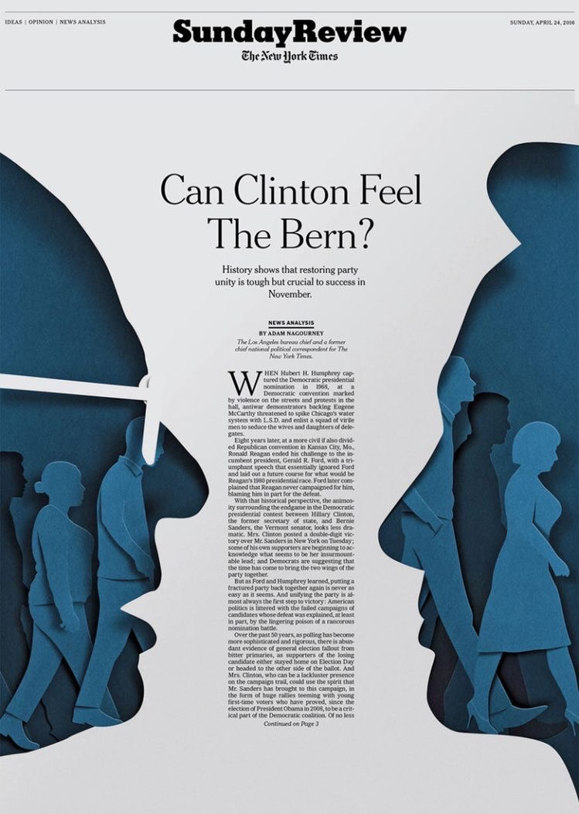
The third design is more classical, which is the style I went for. In this design I like the way the reflection in the illustration is ‘reflected’ in the typogrpahy, the way they have reflected the words. They have also chose the same colour from the water with the reflection word ‘grief’. It’s very clever the way its thought out.
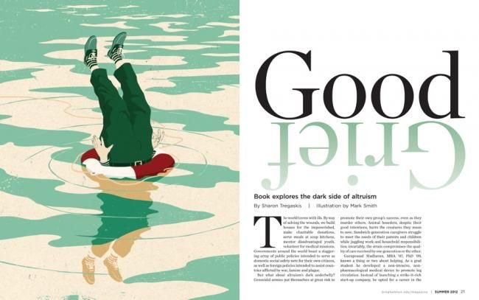
The fourth design is more about the visual; this takes up most of the page, whereas the writing is only a short space at the bottom. The style of the illustration the pretty pink colours and the floral style is echoed again in the typography, the font is very feminine and floaty in its style; it connects the two together very well.

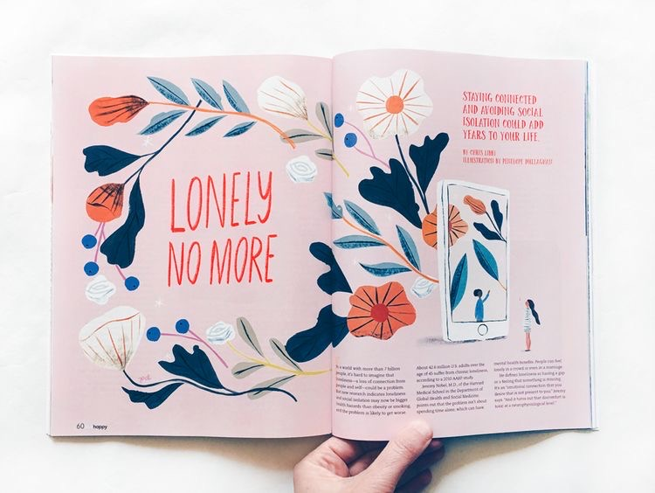

I went back to look at my illustration so I then decided to try to replicate the reflection of my girl in the mirror with the typography to continue the theme, but with my reflection style it was a mirror not water, so I needed to think how a reflection works in a mirror. I reflected the typography and then changed the first set back to brown again to echo the rest of the illustration, I then carried this theme onto the page before to change the trees into a brown stripe and a colourful strip, I thought this would cement the whole illustration and editorial design.
