Assignment 3
A Poster
I started this assignment by listening to jazz music again, whilst compiling a spider diagram on the word Jazz evening.
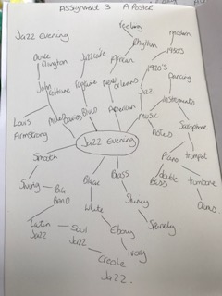
I then decided to create a brief to see what I needed to come up with to move forwards.
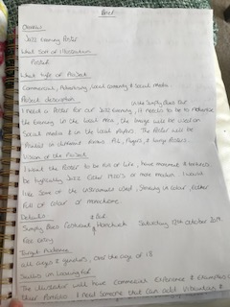
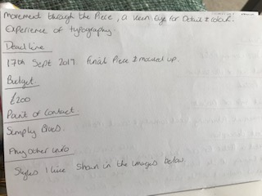
The brief was:
Overview
Jazz evening
What sort of illustration?
Poster
What type of project?
Commercial, advertising, local community and social media.
Project description
We need a poster for our jazz evening in the Simply Blues bar Hornchurch Essex; it needs to be to advertise the evening in the local area. The image will be used on social media and in local papers and on small advertising boards around the town. The poster will be printed in different forms A4, flyers and large posters.
Vision of the project
We want the poster to be full of life, have movement and textures. We want it to be typically jazz either 1920’s or more modern. We would like some of the instruments used, striking in colour, either full of colour or monochrome.
Details
Simply Blues bar and restaurant Hornchurch, Saturday 12th October 2019, free entry.
Target audience
All ages over the age of 18 and genders.
Skills we want
The illustrator will have commercial experience and examples of their portfolio. I need someone that can add vibrancy and movement through the piece, a keen eye for detail and colour. Experience with typography.
Deadline
17th Sept 2019, final piece mocked up.
Budget
£200
Point of contact
Simply Blues
Any other info
Styles we like shown in the images below

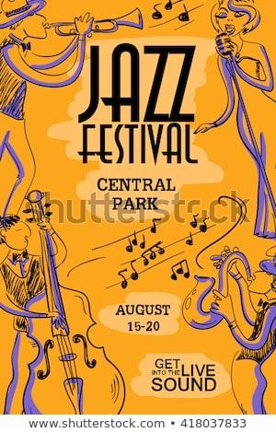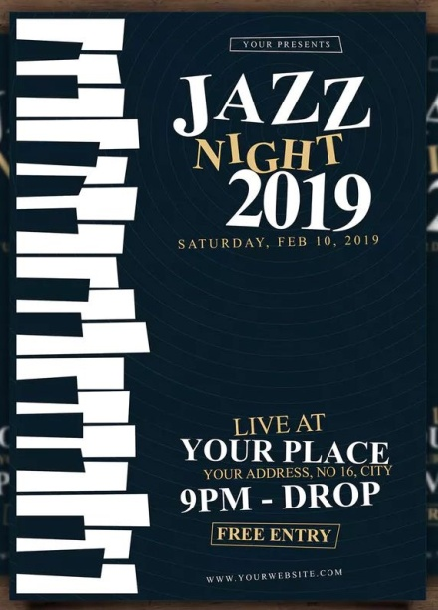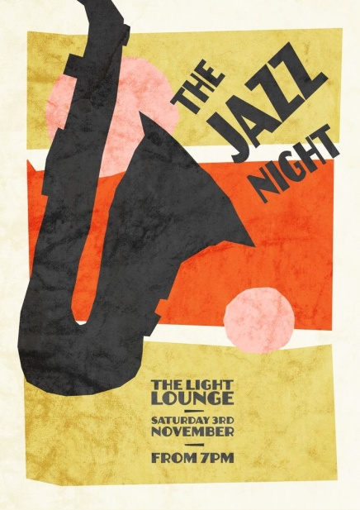

From this I created a mood board to look for colours, typography, styles, shapes and the general feeling, some of the poster ideas from the brief.
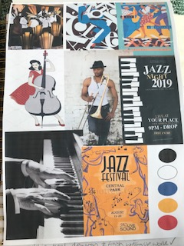

I then stopped and started to look at some illustrators that I thought might help my thoughts and look into different styles that might be useful in this assignment.
The illustrators/ studio I looked into was Atelier Bingo, the studio of Maxime Prou and Adele Favreau a pair that illustrate, create graphic design and surface patterns from their studio in France.
The duo specialise in making screen printed posters, using not only different artistic techniques but also collage, gouache, pens, inks etc.
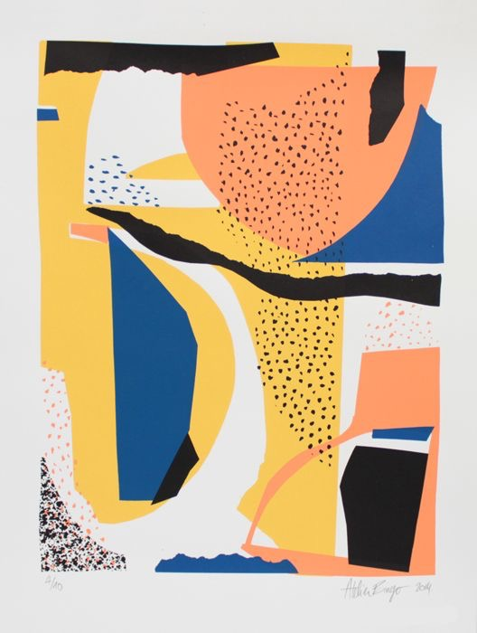
I like this poster, the peach and the yellow colours are the same hue so work well together, the blue gives it a pop of deep colour which makes it stand out. I like the gentle light marks made, and they way they have been positioned on the poster, the composition is in harmony together. The shapes are organic, like torn paper, to me the poster represents a sunset and the sea, it feels very holiday like, fresh with the white background, quite modern yet Mediterranean.

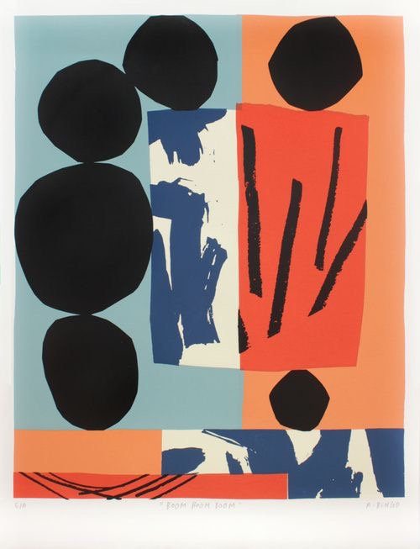
This poster to me looks like a window, the square is the window, the blue is the cool inside and the orange is the hot outside, again it has a holiday feel to it. I think this would be a lovely and different beach towel!
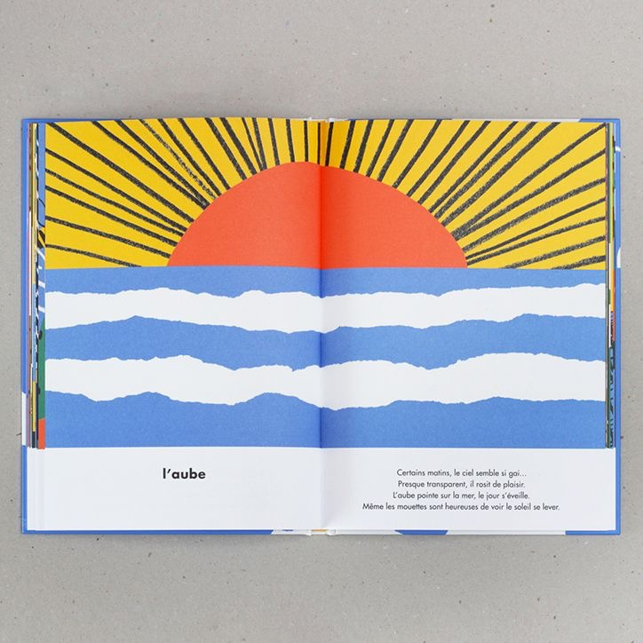
This is like torn paper, the jagged edges of the blue and white to make the water and the waves. I like the sun’s rays in black it is a stark contrast against the yellow.
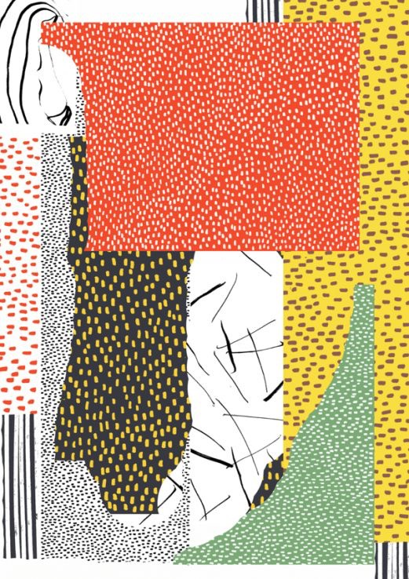
This one is full of mark making, dots, lines, threads, stripes, seeds. They look like bits of different fabrics pulled together onto a piece of paper. This one has a more natural feel to it, the colours are earthier, still bright but with the dark brown and black it anchors it.
From looking at Atelier Bingo I have found a way of using some organic torn shapes I could draw to represent the instruments in my Jazz poster, the look is very similar to this poster of a Jazz festival.
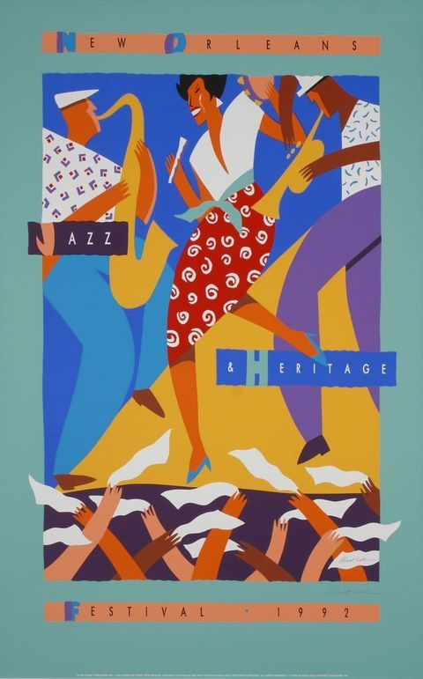
I started to draw some thumbnails to work out compositions and placement; I started with a simple saxophone, surround by organic shapes and music notes.
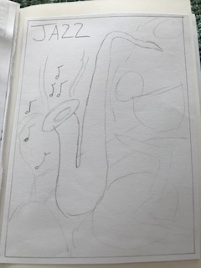

Then I added part of a piano at the bottom in an abstract way and moved the saxophone upwards on the thumbnail, again with some organic shapes behind and music notes, I roughly placed in where some typography could go.
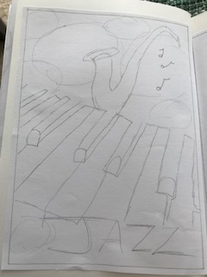

Then I made the saxophone larger, which a trombone again in an abstract style, plus some keys at the bottom. I’m not keen on the piano keys at the bottom, but I like the abstract trombone and saxophone.
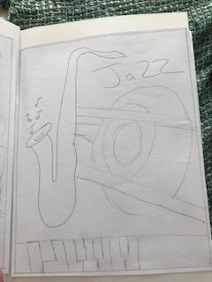

The 4th thumbnail I went back to the abstract piano I did in thumbnail 2 and added the saxophone and trombone from thumbnail 3, this is looking stronger, I’ve placed the wording down one side.
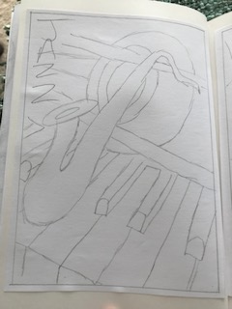

I wanted to try a more organic style, so I was listening to the Jazz music of Oilix- no stress, summer trip. And I came up with this thumbnail, which was more about the shapes following from the music.
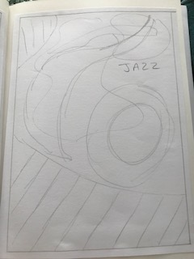
I really like this organic flow effect, which the shapes representing the instruments.

From this one I tried another thumbnail again with a slightly organic flow feel, but more with music notes and shapes instead.
After drawing these thumbnails I went on to draw stronger images of some of the instrument shapes to make them into identifiable pieces.

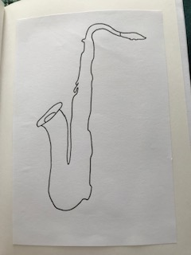
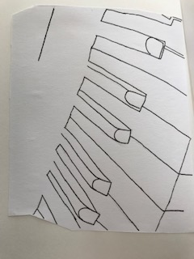

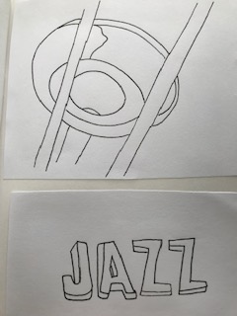

I then did a line work drawing of the saxophone; I find the saxophone very textural, because of all the parts of the instrument, which are displayed on the outside. The main body of the saxophone is very shinny, smooth and made of brass, buts it’s covered in these other elements which make it very detailed.
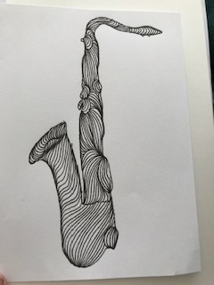
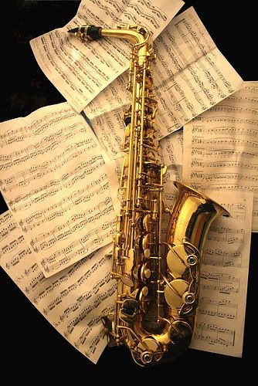
I then started the two line visuals of my two favourite thumbnail drawings; I decided to choose thumbnail 4 and 5. Number 4 had the strong abstract instruments of the piano and trombone. Number 5 was the organic and flowing style whilst listening to Oilix.
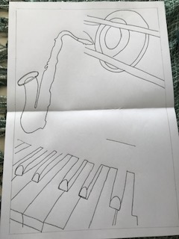
This is number 4 in the line visual.
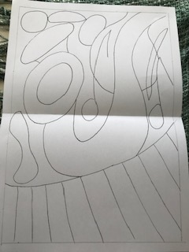
This is number 5 in the line visual.
I then drew the piano image onto watercolour paper and painted in the black keys.
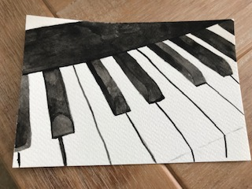
I thought I would start to mock up number 4, but Pick a few elements out from number 5 into the background to add a more organic feel to the strong abstract instruments.
Basically to combine the two as I liked them both so much, Before I did this I decided to colour in my trombone drawing with coloured pencil and use slightly light mark making to add some roundness and texture.
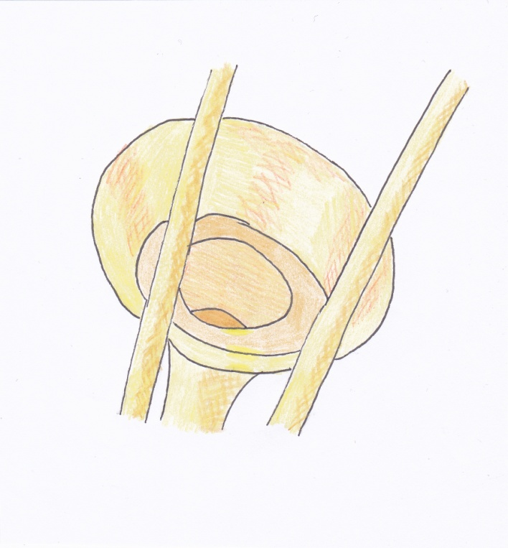
So then I got started on layering in Illustrator, this was my first annotation.
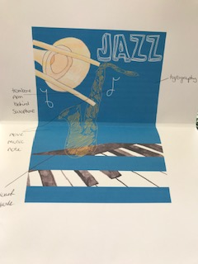
I started by building the back ground layer which was the rich blue colour, I thought this would be good as it would link to Simply Blue’s the bar. I used the trombone and the line work saxophone, with my hand drawn Jazz typography. When printing this out for some reason I have a stripe across the piano!
I started to look at typography for the rest of the writing, I wanted to differentiate against the jazz, to make that more bold. I chose 6 different fonts I liked, but decided upon the first one ‘Myriad std sketch’, I thought this worked well with the jazz typography as well as being simpler so it can be read quickly.
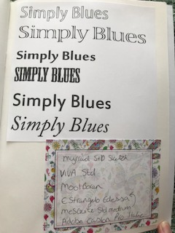

Annotation 2 was to move the trombone behind the saxophone, move the music note over to the other one, and make the stroke thicker on the saxophone and trial the typography.
I started to listen to the jazz music again of Oilix and drew on the computer some organic shapes and marks, I added these into the next print out to annotate.
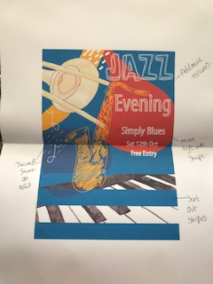
The annotation from this one is to add more textures to the coloured shapes, with the inspiration from Atelier Bingo, move the typography into the red shape. Sort out the stripes again on the piano (as what I tried didn’t work), and lastly a thicker stroke on the music notes.
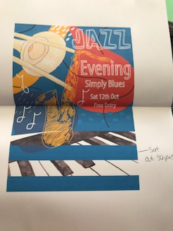
After doing all these bits, I was still getting the stripes on the piano, I thought maybe because it was I was printing directly from Illustrator, so I decided to save it and bring it back into Photoshop and save again and then print. This worked this time and the stripes were gone.

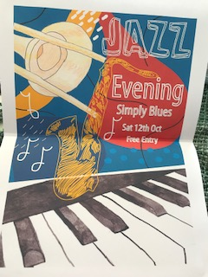
I printed this out onto a smooth thick paper, which would be similar to the A4 graphics and flyers for the brief.
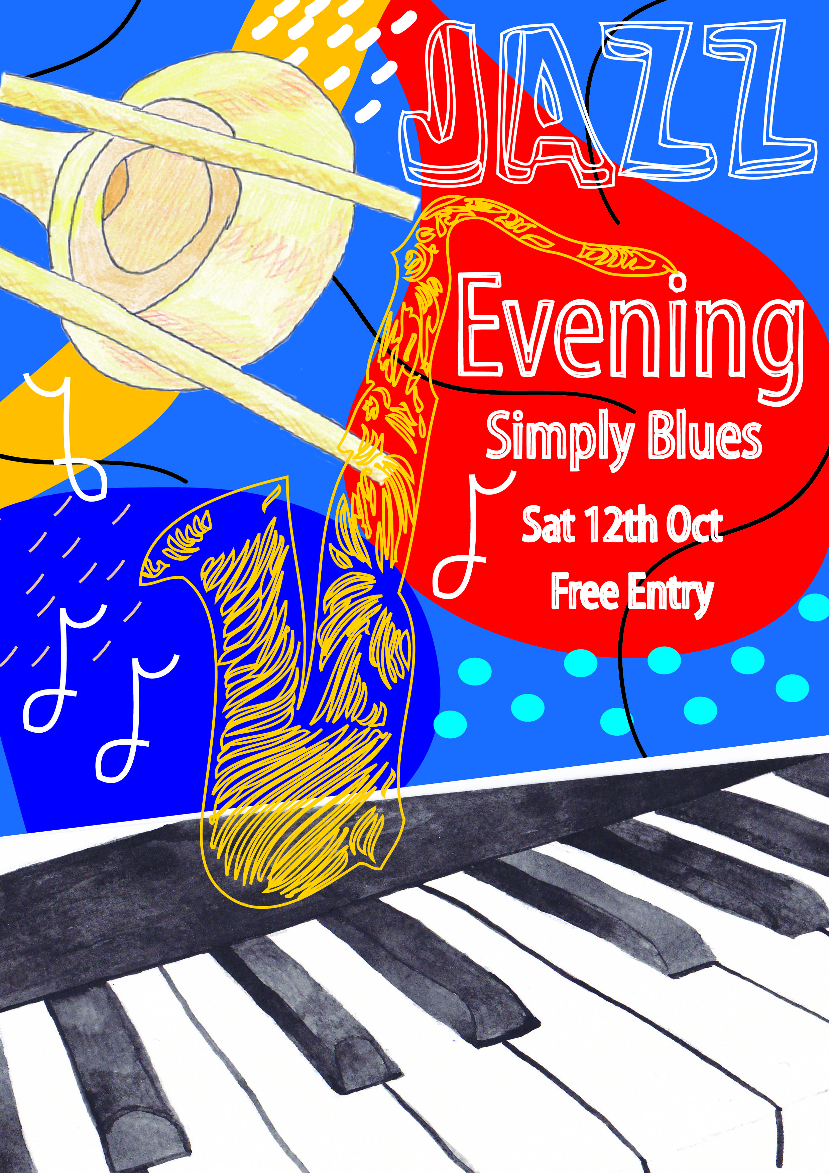

I also mocked this up onto a clip up poster.
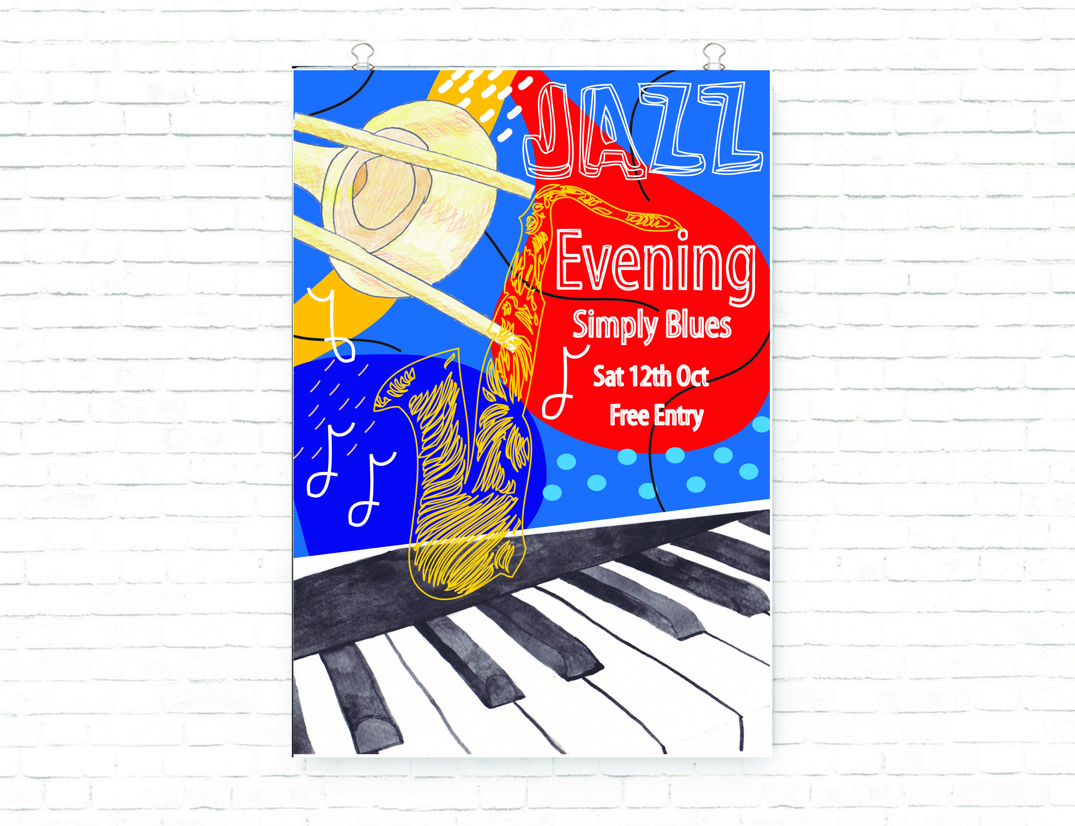
And then onto a mock up of a outdoor wall poster for advertising.
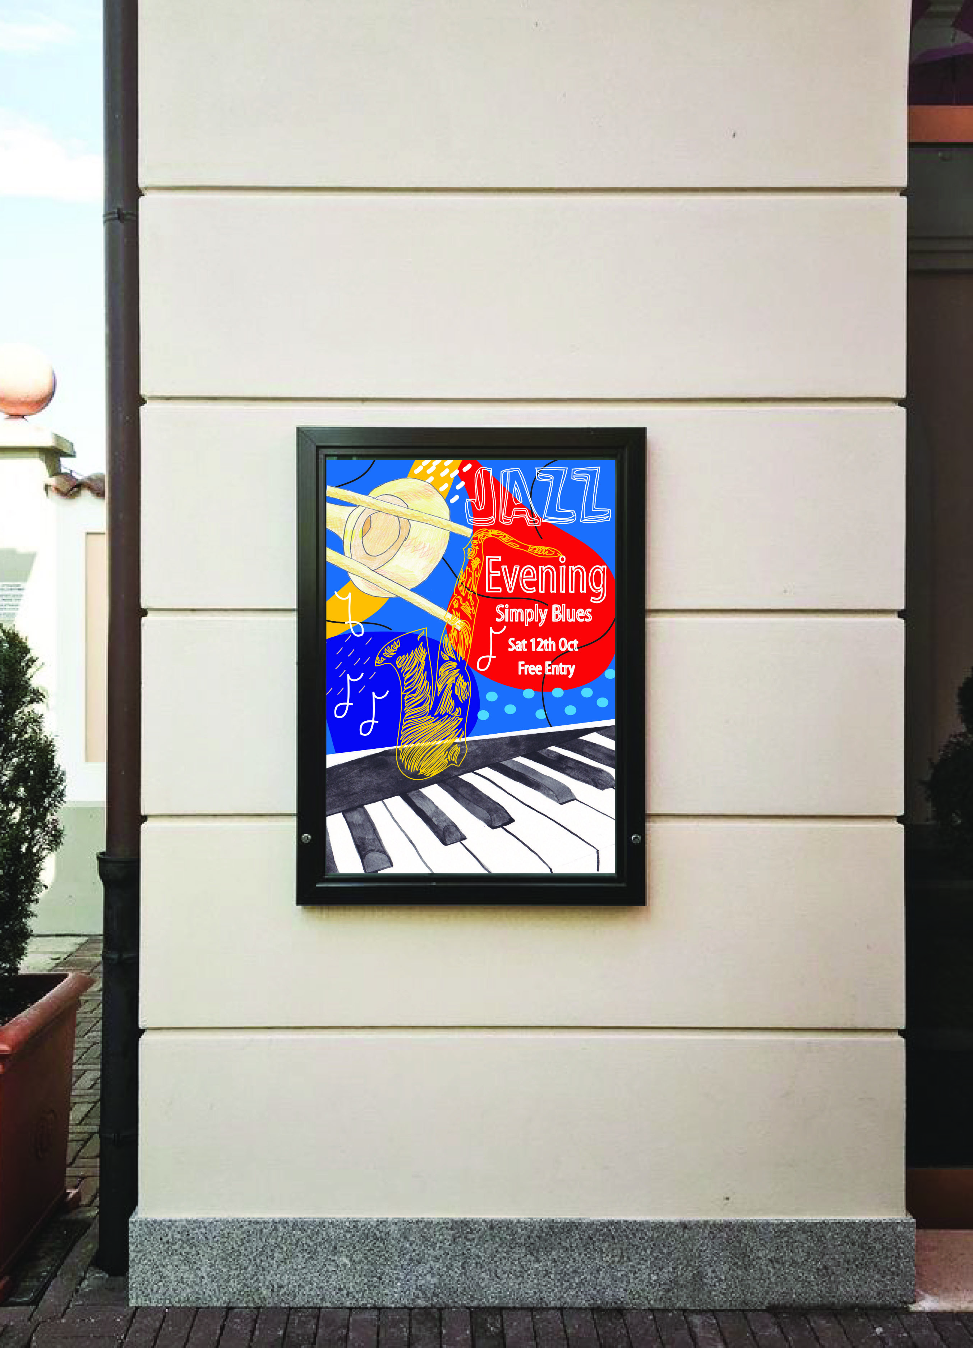
1. What have you enjoyed and why? How might I expand my knowledge in this area?
I really enjoyed this assignment, I think everything I’m learning through the exercises is now coming together, the steps that you go through to get to a final image are really important as usually you end up with something you were not expecting or originally thought of!
I enjoy creating the thumbnails, as I now try not to have a fixed idea in my head at the beginning of the assignments, this section of drawing the thumbnails is where you visualise ideas and they start to appear.
I also enjoyed creating the mock ups for this assignment, this is where it starts to look professional and a finished product, this really excites me.
I am going to look into mock up graphics more and try and download some more free ones, to practise on.
2. What are the strengths and weaknesses of this image? How might I tackle any weaknesses?
I think the strengths in this poster are the instrument elements, I think the piano has a very striking effect, the line work of the saxophone is very textural and different, and the pencil shading and mark making is very soft, these combined work well together.
I would say the typography is a weakness, although I love the ‘jazz’ word, I needed more time to create some of my own typography for the rest of the words, I am happy with the font I used, but to make it special, it would have been nice to finish all of them with hand designed fonts.
The mark making and organic shapes like Atelier Bingo are simple yet effective; it gives a gentle difference to the design, but pulls it all together.
3. It can be useful to return to your brief, check you are meeting the criteria (are the colours/ character/ feel of the image communicating the right idea?
I returned to my brief after I had finished the last annotation, to check I had completed everything that was asked and met all the criteria. I also re-read my own brief I created to check I had added in all those bits too.
I think doing the thumbnails early on, helps you to cement your idea and check you have added in all the elements on the brief at this point.
4. What have I learnt in this exercise and how might I use it on future projects?
I have learnt how to build up each section and step learnt into a final piece of art work, also how by doing each step you learn to chose and make decisions based more on the visual content and what looks right to you, it’s about building your confidence in those decisions.
5. Has this inspired me to go on and delve into any new research?
I am going to look into hand drawn typography more, and try to develop some ideas for some styles that would work well with my style of illustration. I will try out a sketch book on researching this. Also as I said above to look into some free downloads of professional mock ups.
After feedback from my tutor:-
There were no changes to be made from my tutor’s feedback, so I’ve just added the final design below.
