Assignment 1
The first assignment is to introduce yourself to your tutor and give them the opportunity to get to know you and your work, you are going to send a ‘greetings card’, telling your tutor about yourself, your interests and inspirations, the materials you feel happy working with and maybe what you would like to get from the course.
I started this assignment by thinking about what I wanted to achieve, so I decided to create a mind map.
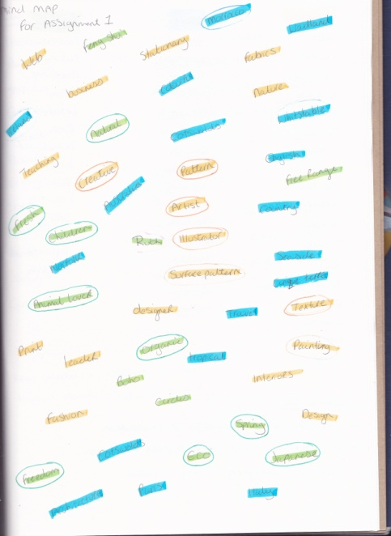
I wrote down randomly words which represent me, which I’m interested in or associate with myself in my sketch book. I noticed that they could be put into categories’ i.e. Personal, work, travel, etc.
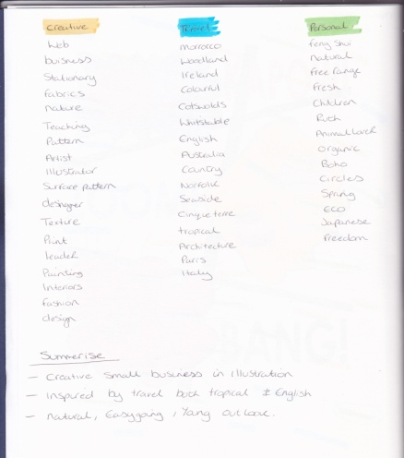
I highlighted these in different colours into columns of Creative, Travel and Personal. I then summarised each column into a short sentence that summed up what I got out of it.
I then wrote down some card ideas in my sketch book which I wanted to add into my design, I then condensed these down into 4 lines. I looked at inspiration days out also, then decided upon the idea I decided to go with:-
Kew Gardens orchid festival, tropical plants with a Japanese feel.
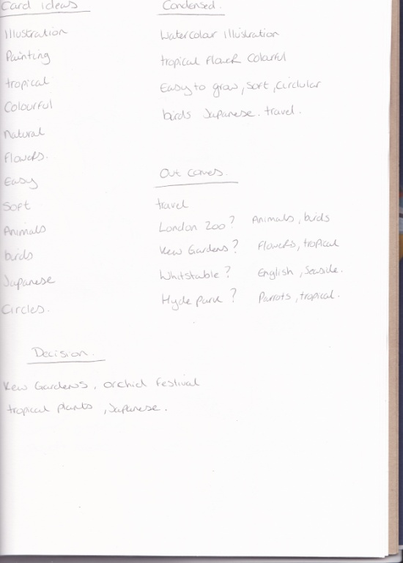
I had already been to Kew Gardens and the orchid festival in February, and had taken loads of great photographs and sketches, which I hadn’t done anything with since.
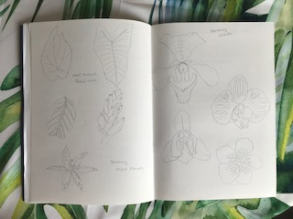
I started sketching some orchids from my photographs in my sketch books, and also looked at some unusual tropical leaves to think about expanding my design.
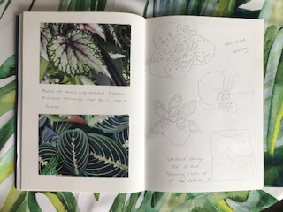
I started sketching some thumb nail sketches to think about unusual compositions, and some more different orchids.
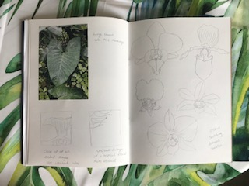
I wanted to then think about what medium I would use to colour in my illustration, my ‘go to’ paint which I’m most comfortable with is watercolour, so I did a few paint tests in the back of my sketch book for colours.

I had decided upon an orchid which I liked from the sketches and a unusual plant bud and a striped tiger look flower, I did a few more sketches of these in my sketch book.
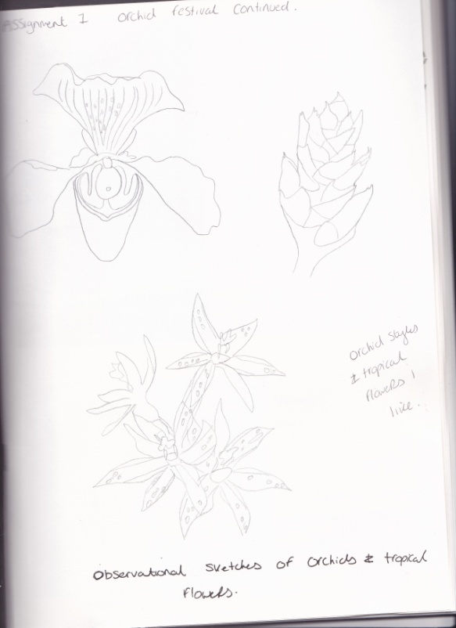
To expand on my illustration I researched what birds would be around orchids in nature, Hummingbirds came up and I love the meanings behind both the orchids and hummingbirds.
Orchid meaning: - Love, beauty and innocence
Humming bird meaning:- Healers, bringers of love, good luck and joy.
I thought these meanings would be great for greetings cards.
I found some research pictures of hummingbirds and started some sketches of these, I also wanted to add lots of colour into my illustration, I love the meanings behind colours also, so looked at the colours within the birds and researched the meanings behind the colours in my sketch book.
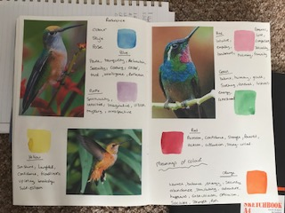
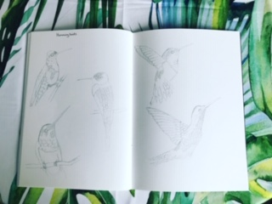
I started a watercolour illustration of the orchid, I kept the original natural colour of yellow for this, I had also just bought a new palette of watercolours so did a test of these in my sketch book too.
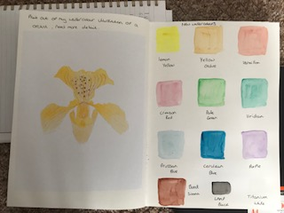
I did a test watercolour illustration of the tiger stripe plant, without too much detail to begin with, just the colours together, and the same for the tropical bud plant.
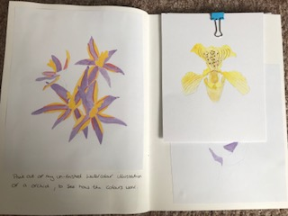
I then moved onto my hummingbirds, I decided on two I really liked from my sketches, in two different poses. I then did a test watercolour illustration for these too, looking at colours and style of painting to create the texture of the feathers.
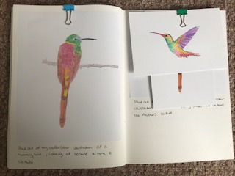
I then moved onto the style, size and shape of the card. I looked into and researched different shapes and drew these in my sketch book.
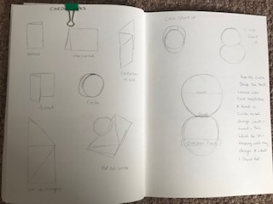
I really liked the round card idea, but felt it needed something more to it. I then found the style and shape I liked on Pinterest, it was an easel style card, which I thought was great and really appropriate for my card design, as it also represented my love of painting too.
I then drew some circles in my sketch book to draw some compositions of how I would like the design to be and where to put the elements together, there was two designs I liked so decided on putting these two together.
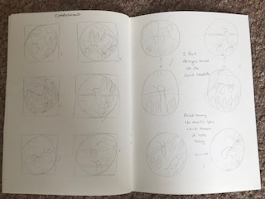
I then looked at which way round would be best for the composition. I liked the first one as it looks quite jungle and tropical at the bottom, and more serene and minimal at the top. Whereas the other design is a general balanced all over style.
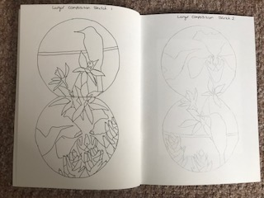
I stepped back after this to see if this is where I wanted the design to go, it lacked a little Japanese influence and a simple style, so I decided to see how it would look as line work, and scanned a sketch through illustrator, I chose a light background and dark line, I really like this design but don’t think its suitable for a greeting card, plus I don’t think it says a lot about me.
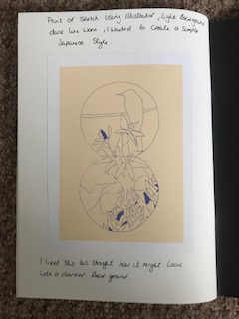
I tried it again just to be sure with a darker background and lighter line colour, again I really like this style but now I’m sure it’s not right for this card.
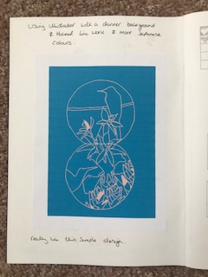
I coloured in my design in pens to see how this would look, it’s a striking design, but to me lacked detail and finesse, but I liked the colours I had chosen.
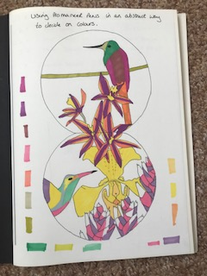
I then coloured the design in coloured pencils, this had a softer feel, but again I felt I could get a better colour, detail and finish with watercolours.
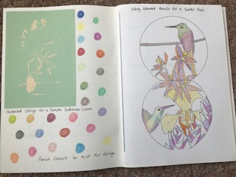
I completed the watercolour illustration and really liked how it had turned out, a couple of the colours I felt needed changing and did a few paint tests for new colours.
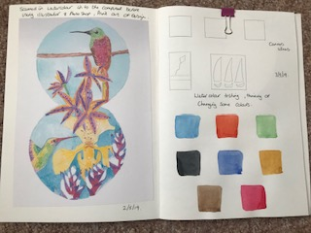
At this point I decided to use the critical analysis questions, as I was not sure how to proceed from this point onwards:-
I was not sure of the background.
I was not sure if it needed more elements to it
I tried the easel template for the card shape and it didn’t work, so I needed to re-think this.
1. What have I enjoyed and why? How might I expand my knowledge in this area?
I have enjoyed bringing all the elements I love into one picture and have enjoyed creating a card specifically to say Hello. I liked thinking about the card design and adapting in to my picture, so it was more unique. Because it was all the things I liked it made it easy to do.
2. What are the strengths and weaknesses of this image? How might I tackle any weaknesses?
Becoming an Illustrator I want to be able to use my illustrations for all areas, so they are flexible to lots of things, going forward I want to expand my knowledge of typography and card design. I am planning on designing 25 different cards over the years celebrations e.g. valentines, Easter etc. To gain experience and knowledge in this area.
I think the strengths of this picture are the colour, subjects and composition. The weaknesses are the background, typography and card design.
I am planning to look into textured backgrounds as I want more ‘feeling’ from the picture or atmosphere. I’m going to create some acrylic texture pictures to see.
The typography is more of placement on the card and size of type, again ill do a few mock up’s to see what looks best.
The card design is just a case of tweaking a template to fit my design
3. It can be useful to return to your brief, check you are meeting the criteria (are the colours/ character/ feel of the image communicating the right idea?
I returned to the brief and feel I am meeting the criteria.
4. What have I learnt in this exercise and how might I use it on future projects?
I have learnt more about myself, I always thought that my work was inspired by nature and animals and although that is something I am inspired by, I have realised the main thing is travel and experiences. I looked back at a lot of my work and most of it has been from holidays, days out, new places and experiences.
I have also taken part in a Facebook group called sketch book revival whilst I was doing this assignment and I have felt a need to explore acrylics in a expressional way, which is new to me as I more comfortable with watercolours and oils.
I can now use more of my experiences and explore travel more with my artwork. I am eager to start using acrylics in my work and create colourful and expressional pieces, I am eager to use this on my canvas art and to explore my love of tropical flowers. Which I think can also be used for backgrounds of illustrations and to give feeling to pictures and illustrations.
5. Has this inspired me to go on and delve into any new research?
For this greetings card I’m going to look into card design and typography and the use of acrylic textures for background work.

So I started back with a mock up of my easel template, I used the original template but added another round section and attached it in two places to keep it ridged, now it works better with my design and is more unique to me.
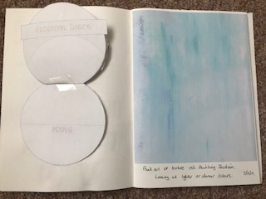
I have a large oil painting called ‘Paradise’ which I painted two years ago, which is full of texture and atmosphere. I scanned in different sections of this into the computer, some sections are more colourful than others and some have more texture than others. I printed these off and added them to my sketch book to see which ones I liked and would complement my design.
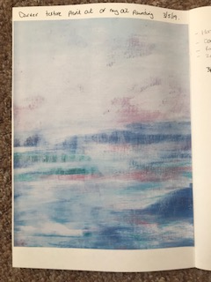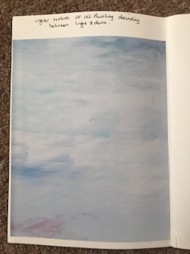
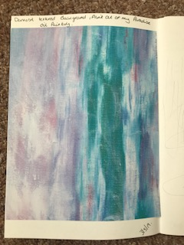
I researched some type fonts for my typography; I was looking for something which had a tropical or Japanese feeling to them. I tried out 13, and after testing these out I decided upon one which looked great.
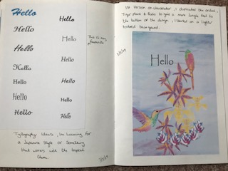
I transferred the design into illustrator, and started working on the composition; I added two more orchids by copying my original illustration, and then varied them in size. I did the same with the tiger stripe plant and did a 2nd one for the bottom, to create the more jungle feel, and added 2 more tropical buds. I printed this out with the background texture and typography; I feel this is really coming together now.
I preferred the lighter backgrounds and printed a few with my design to see which I liked, the darker backgrounds made the design too busy, which messed up the serene feeling I was trying to create. I then used a clipping mask on one so I could see how the card might look.
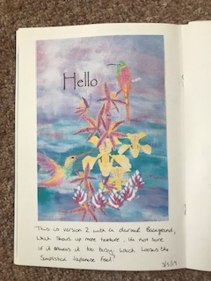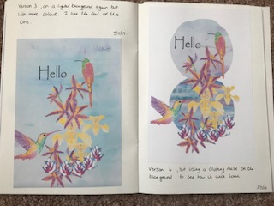
I decided that this was the design I wanted so printed this out with circle templates, so I could see where the design would end.
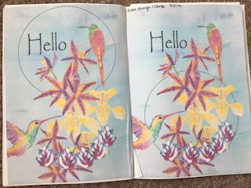
I got some white card and started to draw out the template then cut it out, I printed out 2 copies of the design onto separate sheets of paper, then drew around these with the template to get the discs I needed, I then used glue stick to glue these into place and then tidied up the edges with a craft knife to give a neater cleaner look.
I had to fiddle with the template to get it to stand up in the position I wanted, I ended up having to make and extra strip for the back to re-enforce it so it stood up straighter so you could see all of the design how I wanted it to be.
I am really pleased how this card has turned out, the template was the thing that stretched me the most, and I’m surprised how good it looks. I wanted the colours to be more brighter as I think this got lost through Illustrator and printing it out, but actually now the more pastel colours has given the feel and atmosphere that was lacking with the Japanese feel that I wanted to convey in the illustration.
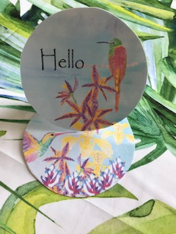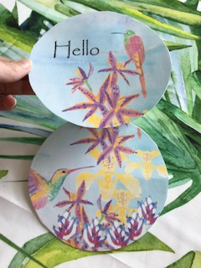
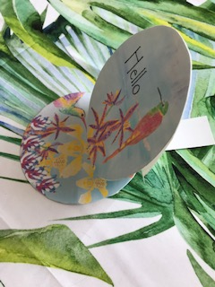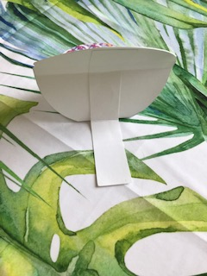
On the bottom of the card is a plain circle where you can write your message, this is what I wrote:-
So this is me:- Hello
I am a part time Illustrator, Artist and Surface pattern designer; I am hoping to grow my business through doing this degree. I currently sell my work through Etsy and have a portfolio website for my surface pattern design; I also exhibit my paintings in exhibitions in local galleries. I would like to gain the experience and knowledge to go into other areas of Illustration, for example Editorial work, teaching, children’s books, magazines etc.
I feel I have gaps in my knowledge and sometimes the finesse of professional looking work, which is also why I’m doing this degree.
I want to run my own illustration business at the end of this degree and feel this is the way to make it happen.
I am the most comfortable with drawing from nature and travel and this is what inspires me the most, I love using watercolours, coloured pencils and oil paints, but I’m looking to come out of my comfort zone and use different mediums like acrylics.
I am interested in Feng Shui and the Japanese culture of Wabi Sabi, I like natural products, organic, free range and eco concepts. I love the spring months the best, I am an animal lover and get on well with children. I have an open easy going temperament and would love to have more freedom in my work life.
I feel all of this sums up the greetings card and represents me, the easel design is because of my love of art, I like circle shapes as they have no edges, I am always positive and like bright and colourful colours and feel colours are important in life. My inspiration is nature and travel and the orchids and birds are from days out and holidays, the meanings behind them are from Japanese cultures and the colours are calming in a Japanese Wabi sabi way.
Up-dated 23/07/2019
After feedback from my tutor I have added the following:-
I have also looked into illustrators that have created portraits of themselves in order of how to see personal aspects of them.
I first looked up the definition of a portrait and it is a ‘basic most simple likeness’.
The Illustrator and Artist that I found did the most portraits of himself was Vincent Van Gogh, He painted himself more than 43 times between 1886 and 1889. In all of them he didn’t have his gaze directed straight ahead. The visual qualities of his face are an attempt to express his inner personality.
Some of Van Gogh’s self portraits have been seen as the compulsive, restless all over ornament of the background evidence that the paintings were painted in a psychotic state.
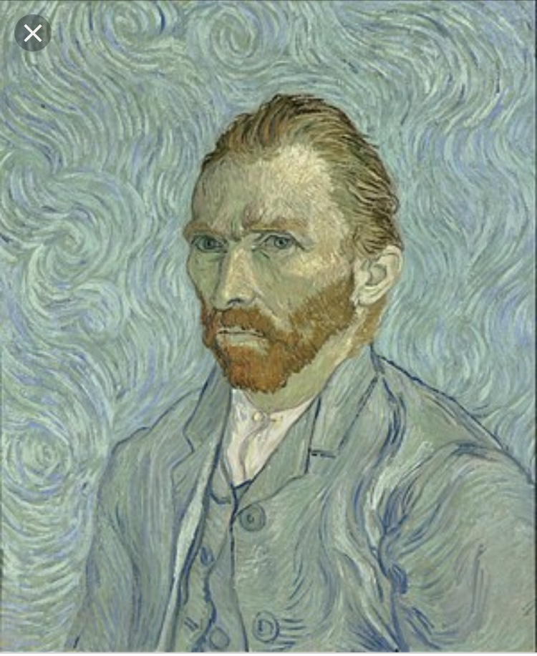
Van Gogh (1889) Self portrait [Oil on canvas] Musee d’Orsay Paris.
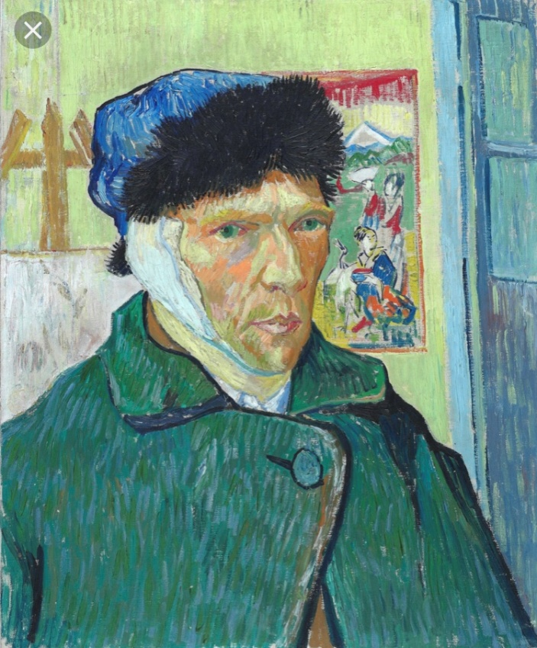
Van Gogh (1889) Self portrait bandaged ear [oil on canvas] Courtauld institute of art

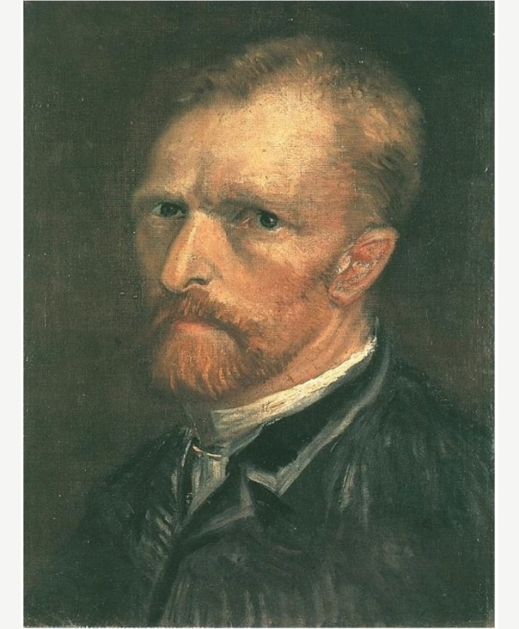
Van Gogh (1886) self portrait [Oil on canvas]
I think this self portrait is really good, I like the way Van Gogh is posed. The colours he has chosen and the style he has painted in here, it’s more classical. The lightness and highlights are placed well, as well as the shadows and darkness. The way Van Gogh comes across in this portrait is very normal and seems healthy in mind and body. Although I would say compared to some of his other portraits, it’s quite dark in colour!
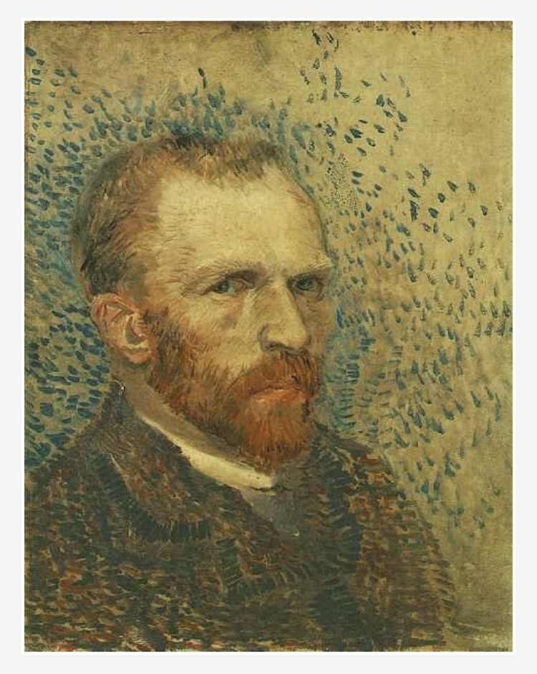
Van Gogh (1887) self portrait [oil on canvas] Van Gogh museum
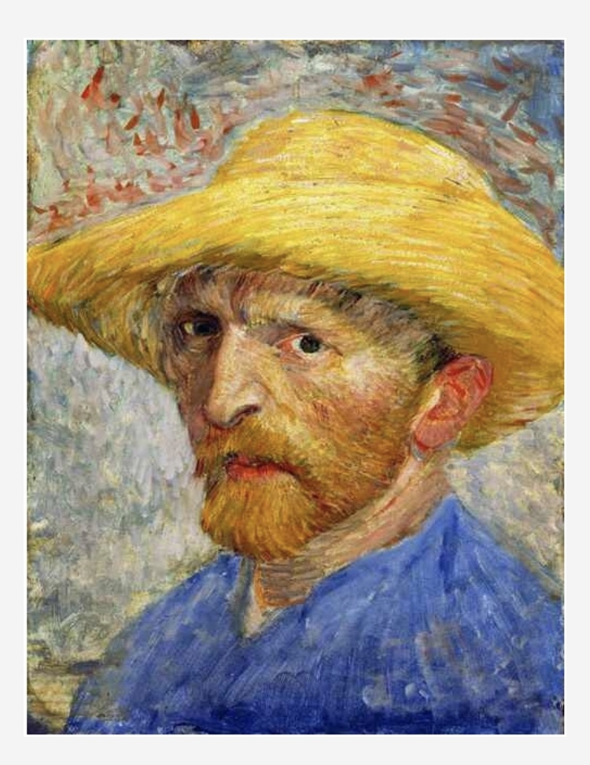
Van Gogh (1887) Self portrait with straw hat [oil on canvas] The Detroit institute of arts.
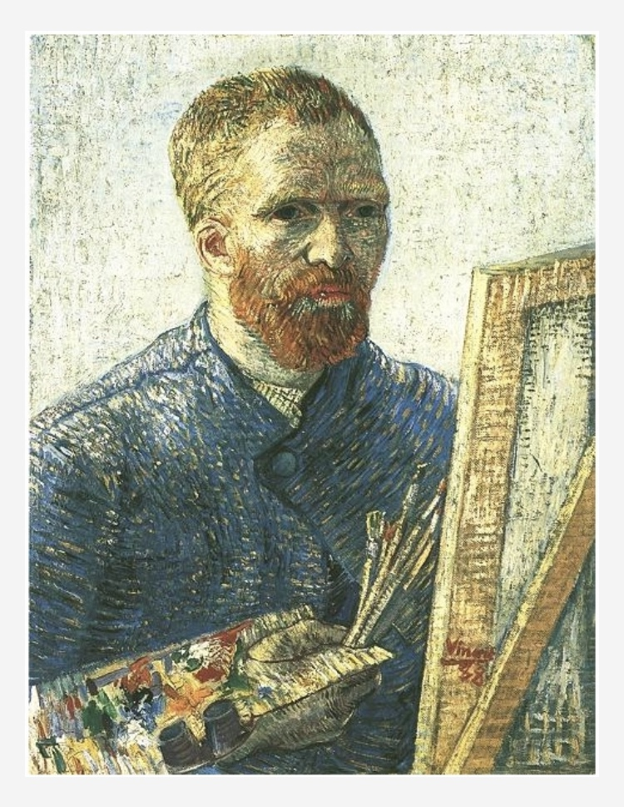
Van Gogh (1888) self portrait in front of easel [oil on canvas] Van Gogh museum.
This self portrait of Van Gogh I don’t like, to me the way he has painted the small short brush strokes make it look like it a scare crow! It looks as though he’s made of straw! I don’t know if this was something intentional, that he wanted to create a particular texture to the paint that made him seem un-real?
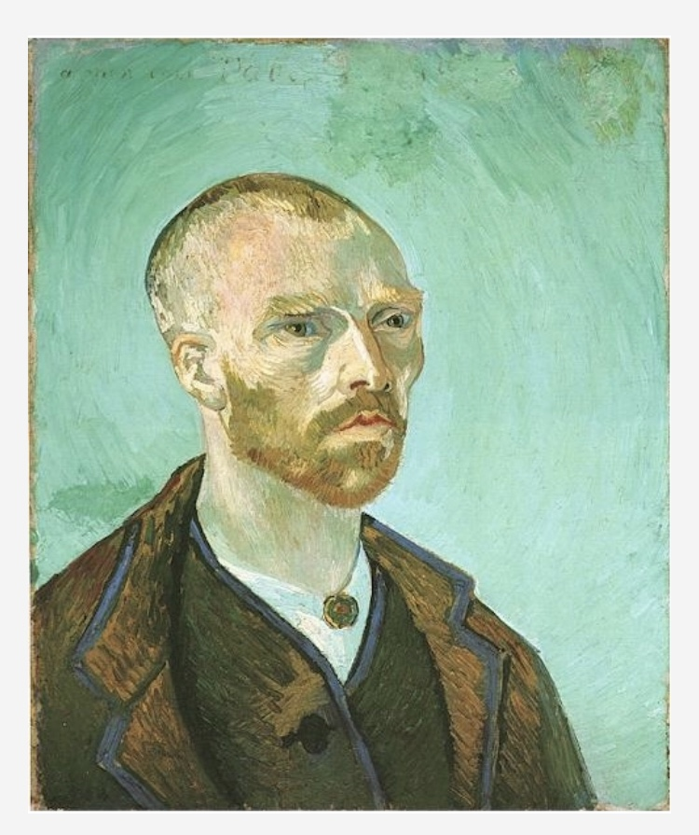
Van Gogh (1888) self portrait dedicated to Paul Gauguin [oil on canvas] Fogg art museum, Harvard university.

(I’m visiting the Van Gogh exhibition next week so I will add to this then)

Up-dated 23/07/2019
I have continued along the theme of portraits and have completed a few of myself in different mediums and had different ideas about them.
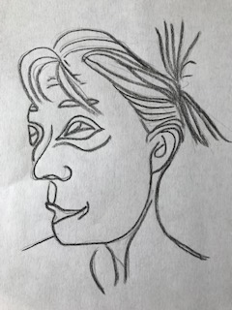
So this first picture is just a quick sketch using charcoal and looking in the mirror, I found it quite difficult to do, so I ended up taking a photograph and working from that, in just black and white and fairly simple. I asked some friends and they said there was a likeness there of me. I didn’t feel this represented myself and wanted to add colour, but first I felt it needed refining. I didn’t like the Picasso style.
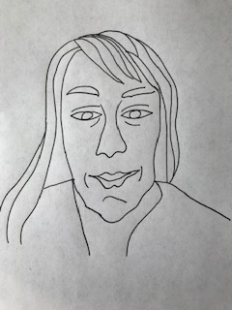
I used a fine liner pen for this, and felt this was more delicate and refined; and simple.
I then went on to draw another picture of me but from using the mirror again, I then used watercolour pencils to add colour and softness to the picture. I didn’t like just the pencils so I added the water to make them watercolours, which added even more softness and a better feeling to the painting.
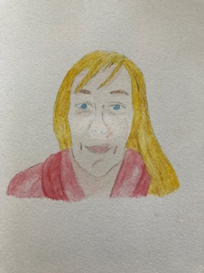

I would add this picture to my card under the inside flap, it then uses all sides of the card and makes the viewer move around the card as though looking at an object and exploring all of it.
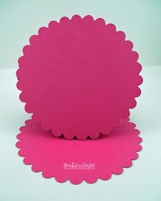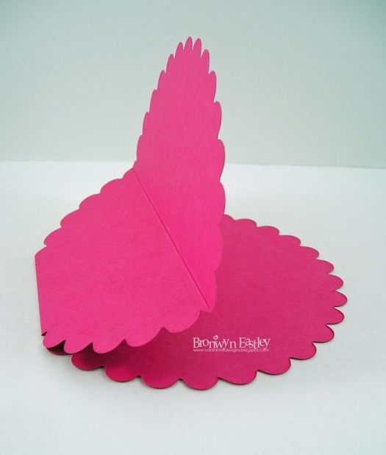
This is a card design similar to mine; I was looking to see how I could fold it so it would work for posting.
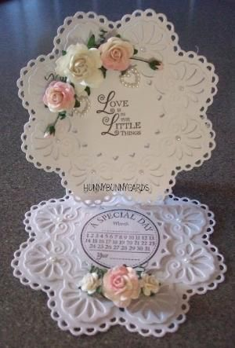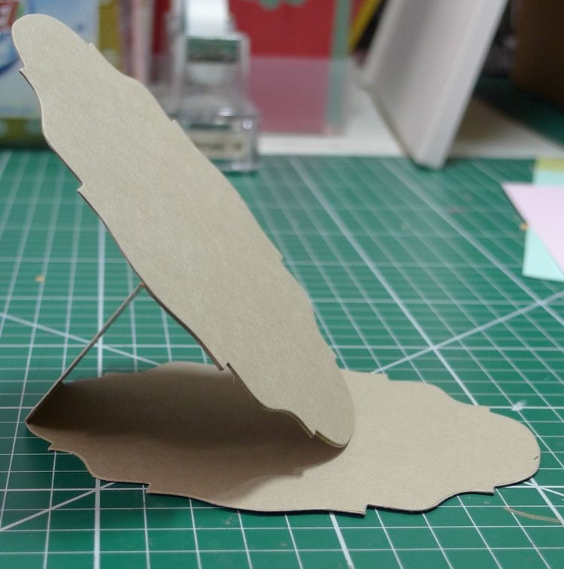

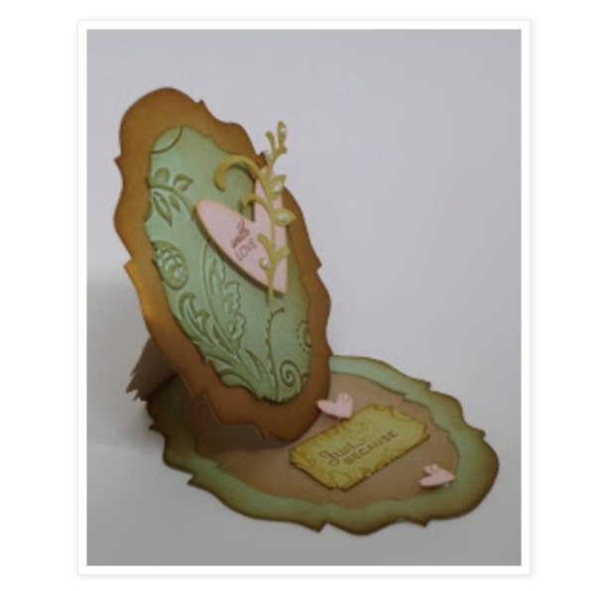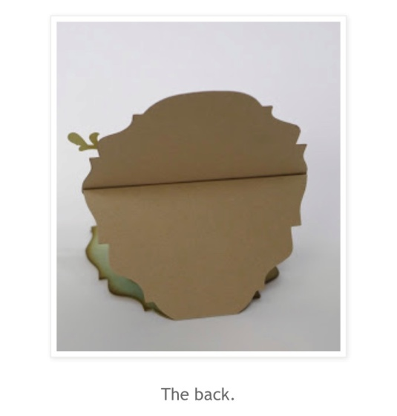

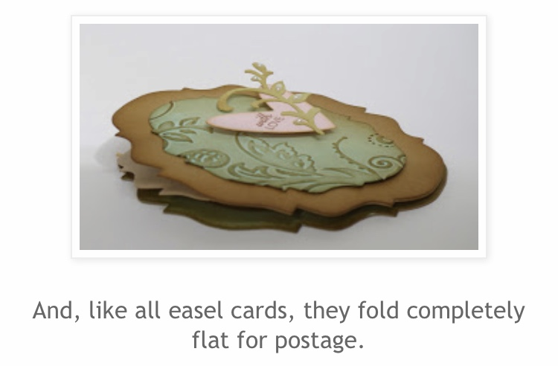
If I had a bend in the back stabiliser, then my card would fold down like this one, so it could be put in an envelope and be able to be posted. I feel the card shape is now fully capable of becoming a real card design; it is now a feasible piece in its own right.
I think exploring all sides of the card, and having a design on all sides, shows the many parts of my character, technically the easel shape/ object represents me.
This is the final mock up of the design after my tutor’s feedback:
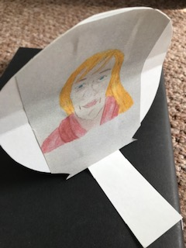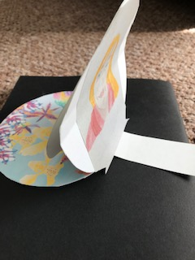

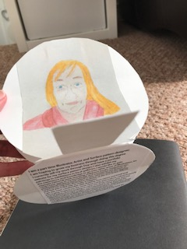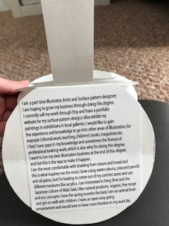

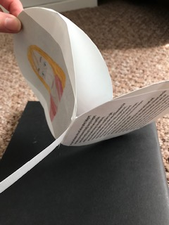
Up-dated 14/08/2019
After visiting the EY exhibition Van Gogh and Britain, at Tate Britain on 08/08/2019, I have added the following:-
After visiting the exhibition and writing up about it in my Exhibition section, and now writing this section up, I do feel I know more about Van Gogh and his life. I have focused on his portraits for this small written piece.
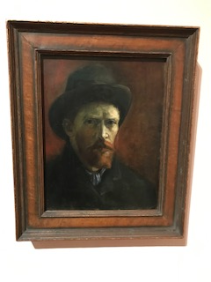
Gogh Van, (1886) Self portrait with felt hat [Oil paint on canvas] Van gogh museum, Amsterdam.
When in Paris Van Gogh completed 35 self portraits, this incorporated a series called ‘Heads of people’ were he was representing himself as a modern, working man with dignity and psychological depth.
In this portrait there seems to be some difference from his later work, here the colours are darker, smoother, the paint is less textural and the style is less like what we have come to know. It lacks the line execution that the later portraits are full of.
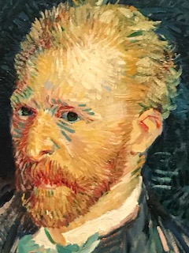
This is a close up to view the textures.
Gogh Van, (1887) Self portrait, Paris [Oil paint on canvas] Musee d’Orsay, Paris.
In this portrait you can see his style that we know, the brighter colours, the thick texture of the paint and the line work that he uses to create the contours and also the highlights using the lighter colours of creams, and yellows.
I must admit that after reviewing all of the paintings available in the exhibition, I would say that in his later years the style and colours Van Gogh used for his paintings showed a vigorous passion for his painting, wanting to paint every day. Although this could also be interpreted as being wired, frenzied and psychotic, it could just also be the passion for his work; he couldn’t get enough of painting?!

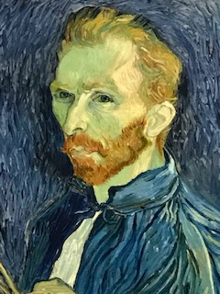
Gogh Van, (1889) Self portrait, Saint Remy [Oil paint on canvas] National gallery of art, Washington.
This is Van Gogh’s last self portrait before he killed himself, this up-close look at the marks on the canvas, to me show that his actual face and head has less lines work on it, it looks smoother, whereas the background and the jacket have the unmistakable Van Gogh style with the thick texture and line work. Does this then say that Van Gogh was in a calm state, but everything around was not?
On reflection of this research, I can see how you can put elements of your personality into self portraits. You can do this by colour, texture, and mark making. But I also feel you can paint what you want people to see, it could be a mask of what’s really going on!? On the subject of Van Gogh I can see to different sides to what people have written before, I can see how they could interpret his illness, but I could also see that it could have just been passion for painting and his illness was a separate thing. I think he used his painting as a way to heal himself.

