Character development
I started this exercise by pulling together some mood boards of different people and characters in photos the 4 main category headings I chose were:-
Toddlers
Sports people
Old people
Sports people
The mood boards are shown below.
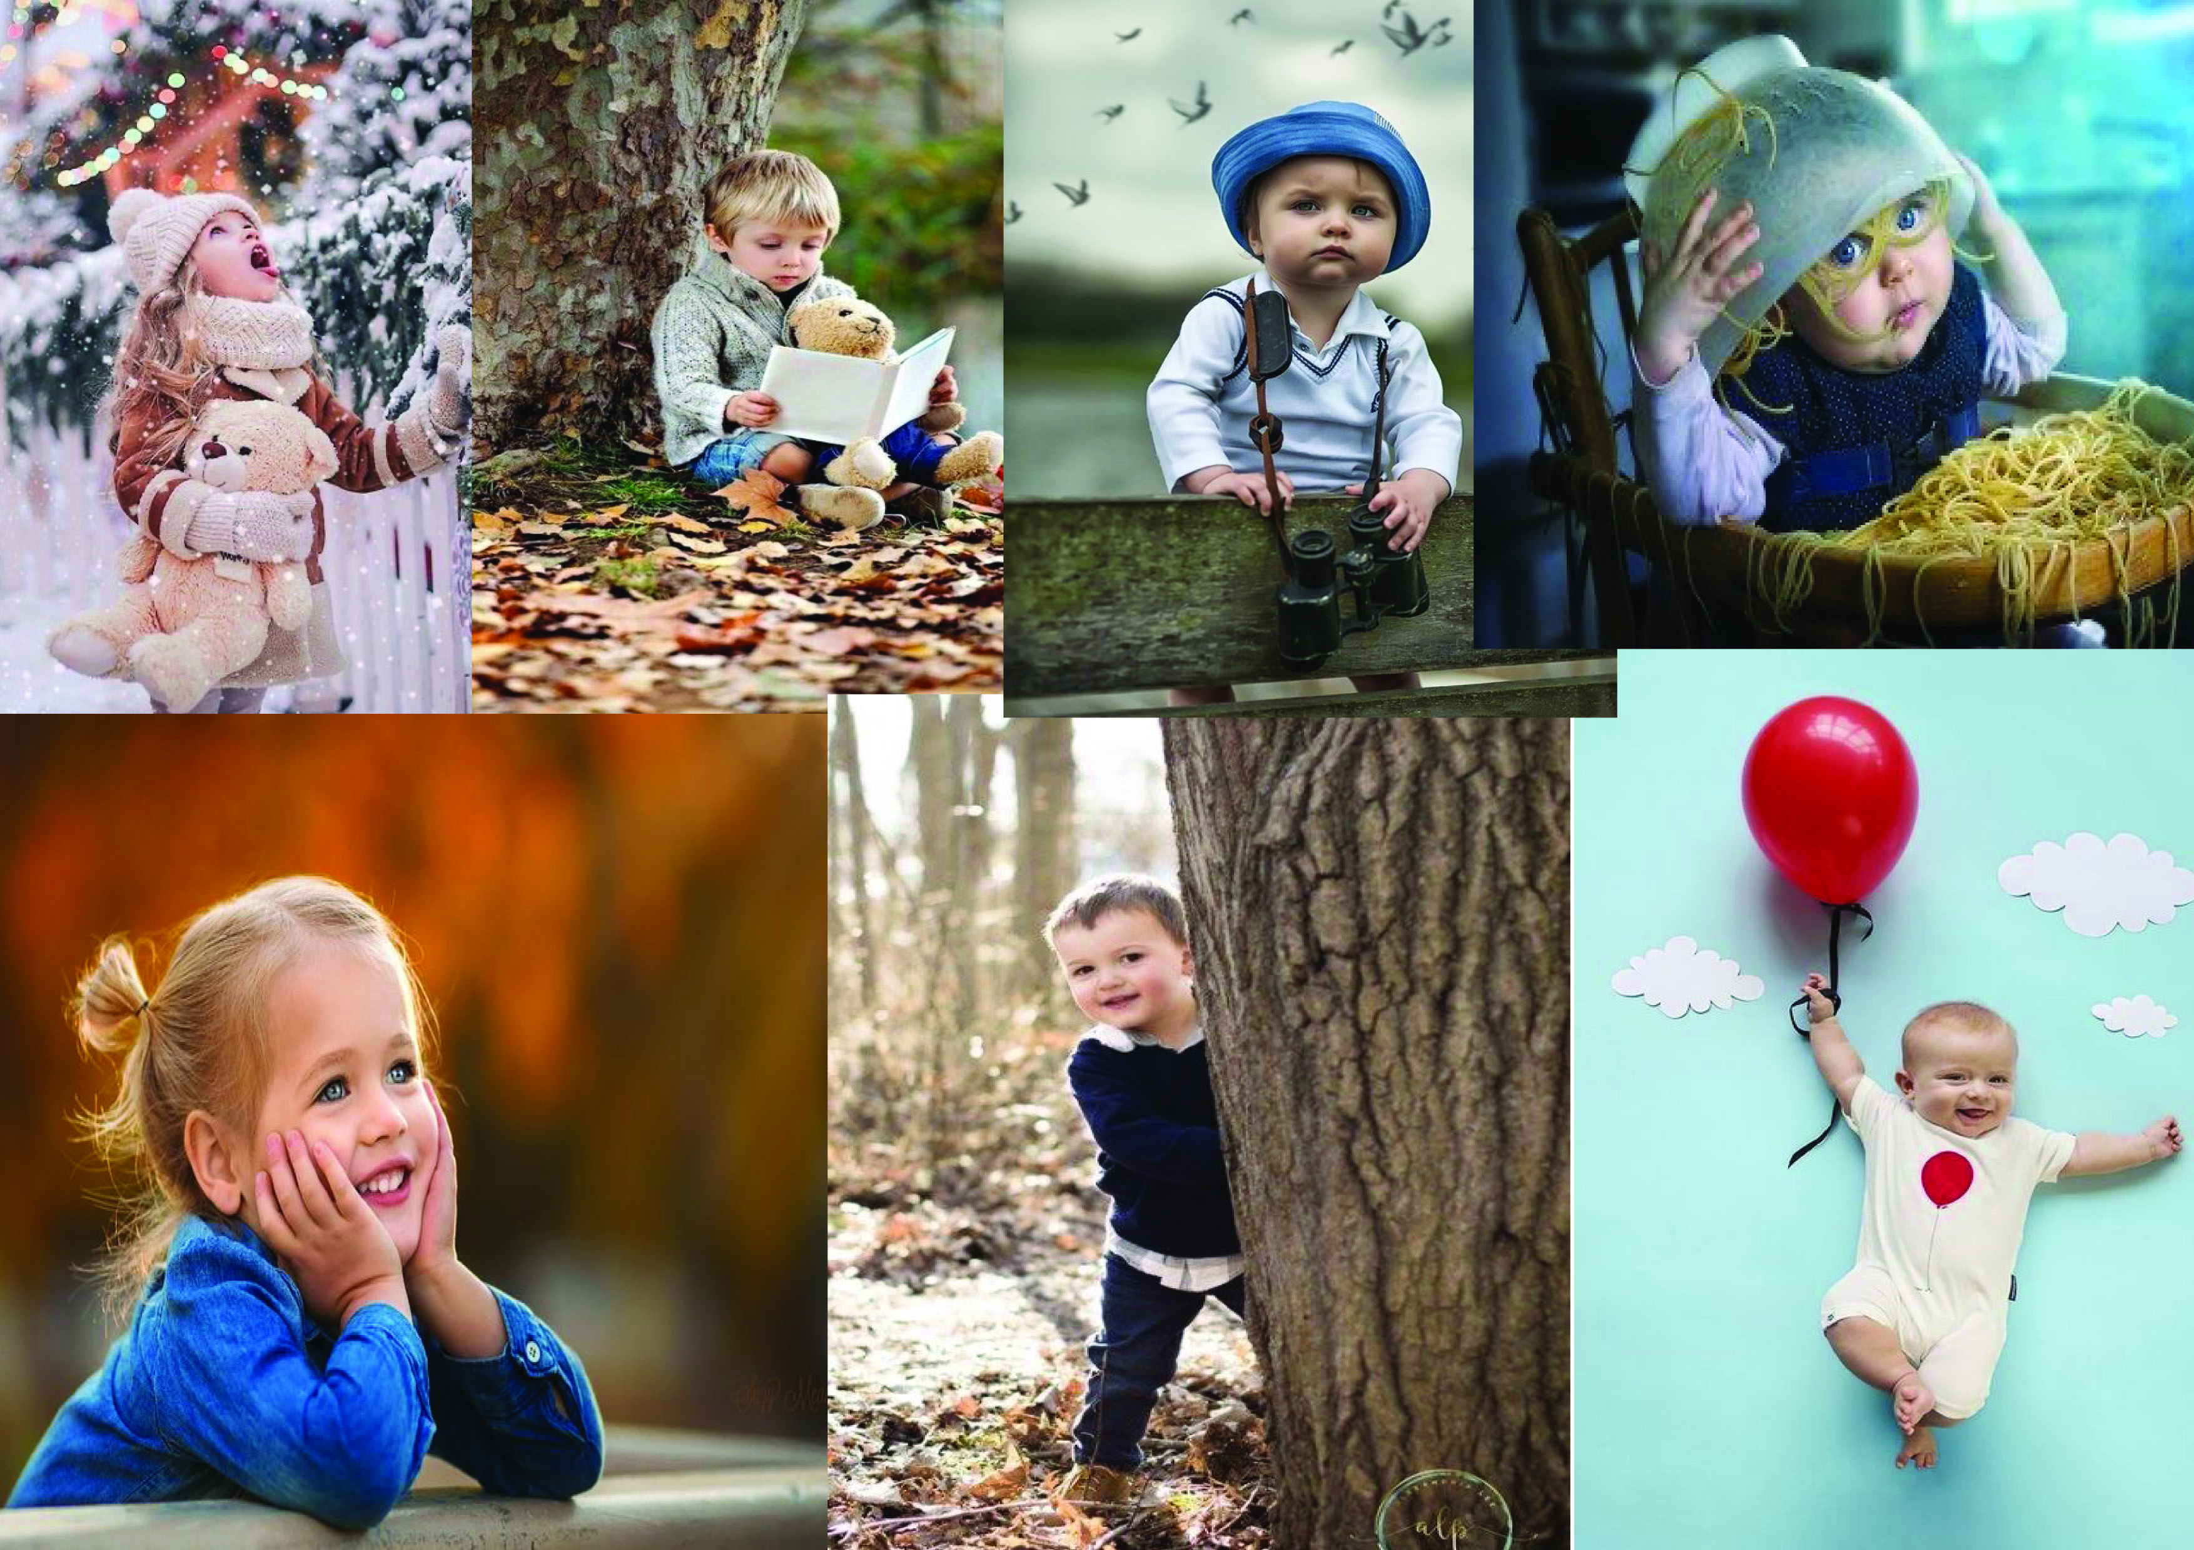
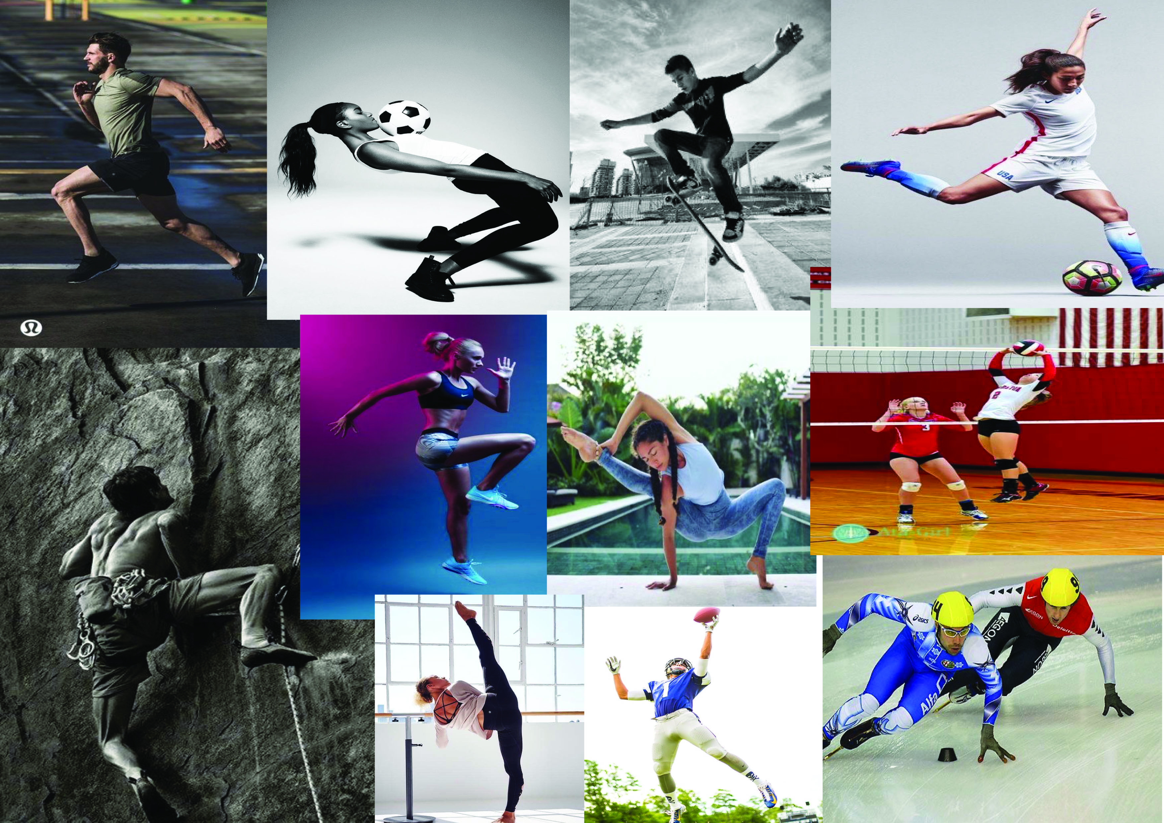
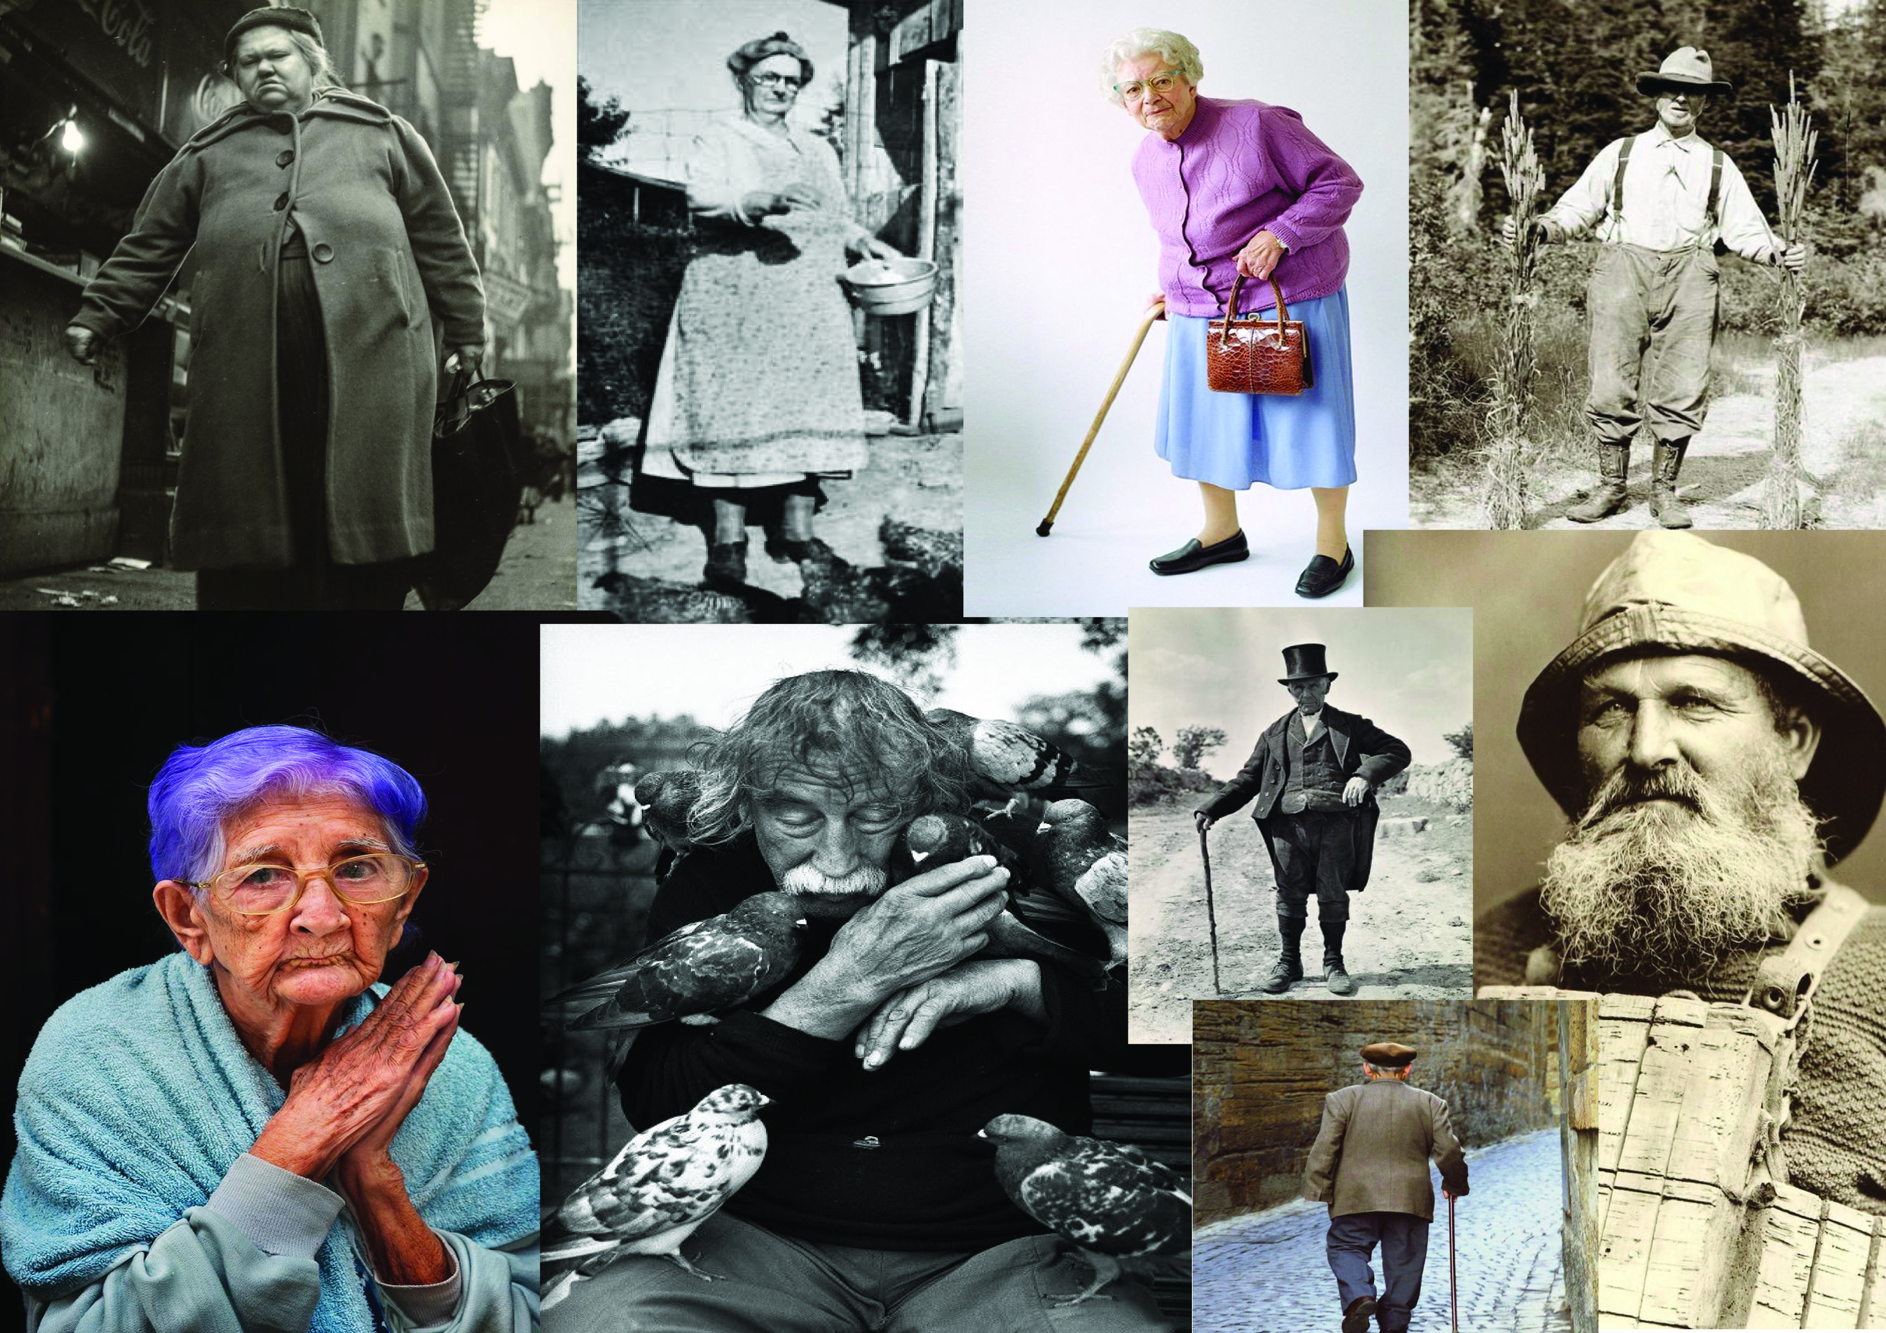
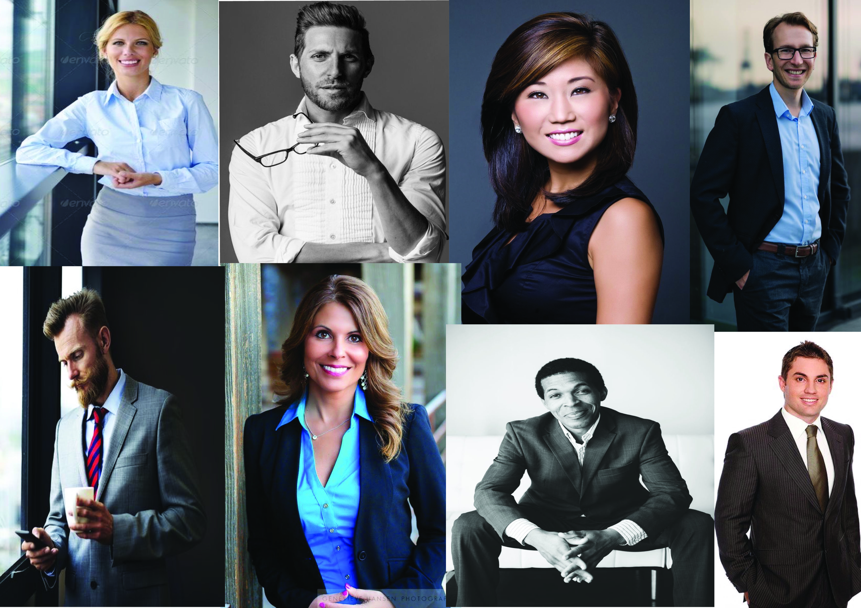

I then started to look at an illustrator that used mixed media like me but that drew characters as well. I found a local illustrator to me called Kris Miners, who uses watercolours, ink, coloured pencils and fine liners.
Kris lives in Chelmsford in Essex and has an extensive interest in the natural world; he has a degree in environmental and nature studies. Kris loves to draw nature, animals’ in a whimsical style which appeal to both adults and children.
Kris mainly draws seasonal art focusing on the holidays like Christmas, Halloween, and his style is relaxed and flowing, which look great in children’s books.
Kris has written and illustrated one of his own books called ‘Hornbeam Hollow’ which is a story about the hunt for the Halloween pumpkin.
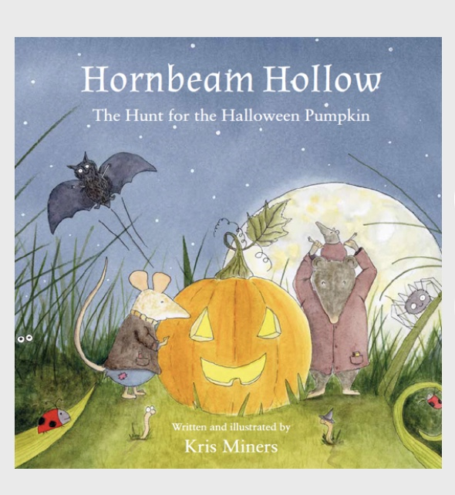
You can see the painterly qualities of the watercolours in the front cover of his book, the use of the black fine liner and some more pencil work in the grass.
Kris’s characters are very appealing; they are cute yet realistic with a cartoon feel also.
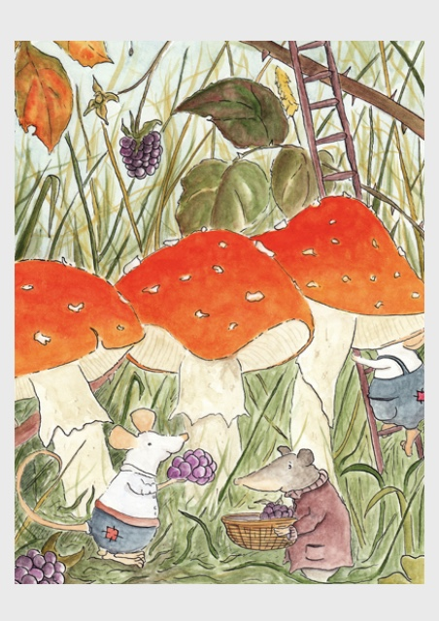
I love this little illustration it has a lot of texture to it with the busy background, the animals look little in the design, the composition is great.
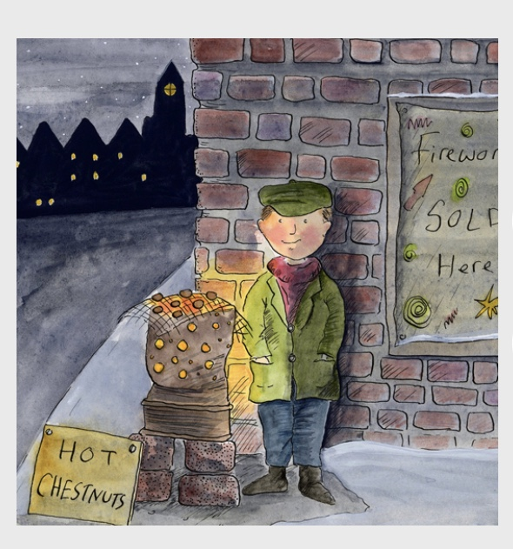
Here Kris has a character of a young lad; he uses the black finer liner as the outline and then fills in with watercolours and pencils. Again the character is realistic yet has a cartoon element which makes it more appealing to children.
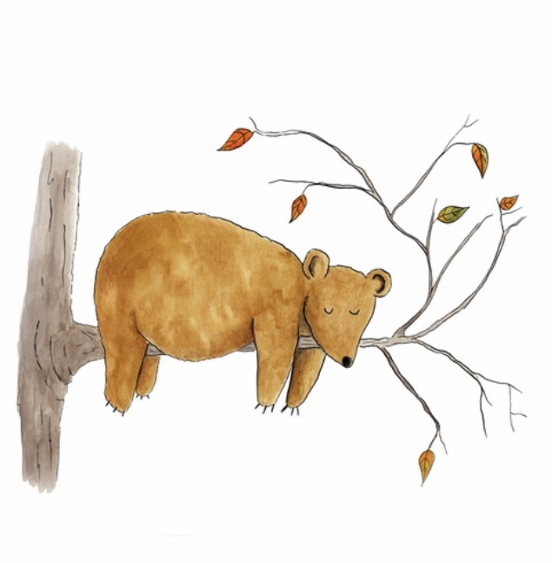
A cute bear, really simple yet effective.
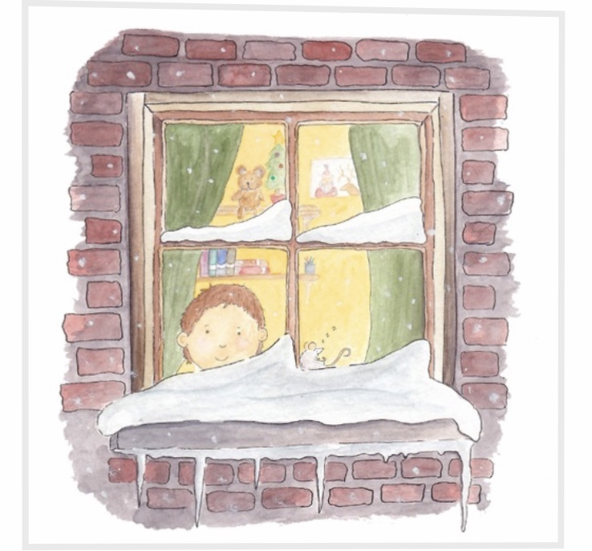
A nice Christmassy scene, with a lot of little details in the background, this illustration really has atmosphere.
© All images Copyright Kris Miners

After all my research I was looking to get a real feel of what character I wanted to develop first, my first idea is to take the character of my cat and to turn her into a little girl, how she would look if she was a person.
I am not very experienced in drawing people or characters, so I wanted to start with the basics, so I started with my wooden art mannequin and set it up in a simple pose to draw. I then changed the pose and turned it to the side to draw. Then again with the back view, I then started to think about the face, and drew some expression onto a circle to see how this would look.
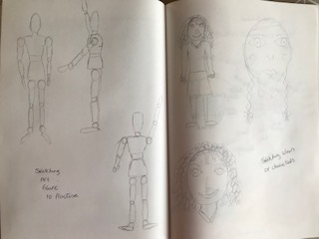
I found sketching the art mannequin fairly easy, but as soon as I started making it look more like a person I felt it didn’t have the same qualities, my drawings look quite child like. In one way I like them to look child like as I think they would appeal better to children, but I still think they need to have a more professional feel to them.
I I decided to complete a spider diagram on ‘Angel’ my cat to bring some elements together to see if I could achieve more of a personality together.
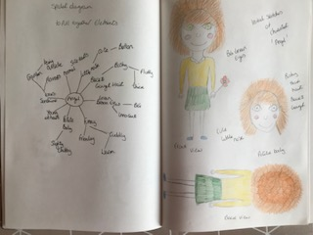
I then started to draw the character a few times to see if I could make it look better, I drew her from the front and back. I took some of the words I used from the spider diagram to build the facial features and what she might wear.
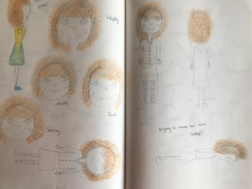
I then drew her from the side, but this I found most difficult to do, she ended up looking like the art mannequin and very stiff. I focused on the face and some expression and facial features. I drew her happy, sad, confused, unsure and smiley.
I started again on the front, back and side views, but still felt I couldn’t achieve what I wanted to. I guess it’s something I will have to focus on and practise with, to achieve the drawings I would like.

I started on the next character and decided after looking back over the mood boards I had done, was to do a professional man. I decided upon an architect.
I started with the spider diagram this time and listed all the characteristics I think a nice architect would have, facial features and what he would wear and also elements of his personality.
I started to draw him, the first drawing was again a bit youngish, so I tried again and to make him look older. I feel this one has worked better so far.

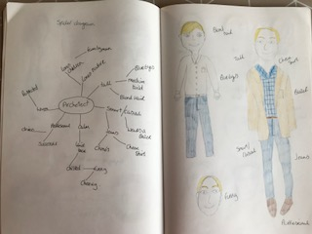
I added in the words I used for the spider diagram to build the character and personality and what he would wear.
I then concentrated on his face and features, i tried different face shapes, round, oval and square, I think he looks better with a oval face. His nose was too big at one point so I made that smaller. I tried his face with expression of sad, happy, smiley, confuse and unsure. I also drew him from the front, back and side also, the side view was again the hardest and the front and back views were not in proportion.
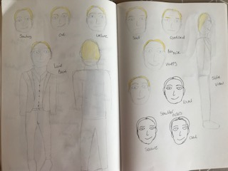
I tried drawing his face in black fine liner to see if this would add anything to the sketch or not.
I had another go at drawing some clothes, so I focused on the jacket, then the proportions might come from that and look better.
I decided to just go for it with a watercolour sketch of him, I thought the colour and the details, like his stripe shirt would bring it all together. I like the final outcome, it looks less childlike and the proportions are better, the shoes aren’t great and I didn’t even attempt the fingers or hands yet. I guess it’s a matter of practising and trying different parts first, and then hopefully you could piece them all together.
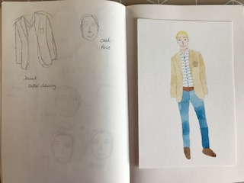
Because this one went better I decided to go back to the ‘Angel’ girl and see if it would look better in watercolours too, or at least one element that went better.
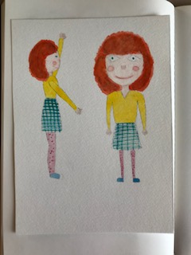
The side view is a little better, but she now looks like a wooden doll! I think the hair colour is too strong, but I like the clothes and the designs and her spotty tights give her a fun personality. I think I need to practise more with body parts and the basics of drawing people first.
What did you think of this exercise?
I was looking forward to this exercise very much, I really want to learn how to draw character, but drawing people is one of my worst areas, I really struggle with drawing people.
I liked creating the mood boards and looking at different sorts of people and trying to gauge their characters just from their photos.
What have you gained from doing this?
I have gained more of an understanding how to develop someone’s character and experimenting with facial features and how it changes the shapes and elements on the face based on the emotions they are feeling.
I defiantly know now in what ways I can help myself in developing my drawing skills of drawing people.
Are there any materials or ideas you would like to explore and what will you do?
I am going to keep a small sketchbook so I can practise drawing people, I think I will start with the basics and go back to my art mannequin and just draw the different poses, from that I will try to start to draw a basic person, then I will develop it from there. I will look at some books or tutorials online to see if I can get any tips or help with this. I have done a facial features course before, so maybe look for something more basic to start with in regards to drawing the whole person.
I have just started Illustration sketchbooks, sketching the everyday, so I think this will help also in practising and keep drawing and looking at people and forms.

Overall I was a little disappointed that I couldn’t draw people better, sometimes I seem to be able to draw better than others, but I guess it’s just practise. I must admit that the few characters I can draw are ones I keep drawing. Developing new one’s is possibly what I need to concentrate on.

