Visual distortion
I started this exercise by looking at some illustrators that use visual distortion within their work, I found the illustrator Kat Baxter. Kat is a Scottish artist who graduated from Duncan Jordanstone in 2011 with a degree in fine art.
Kat’s mixed media paintings, that include watercolour, ink and collage, were inspired by the ‘Day of the dead’ design.
Visual distortion is a way that Kat creates her artwork and illustrations by using flora and fauna to distort the image; it conveys an extra level and layer of nature within the paintings.
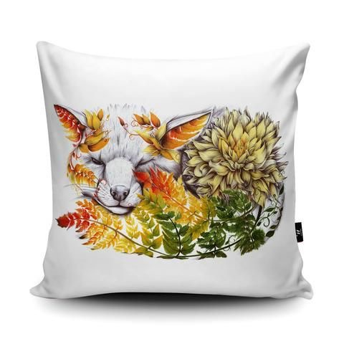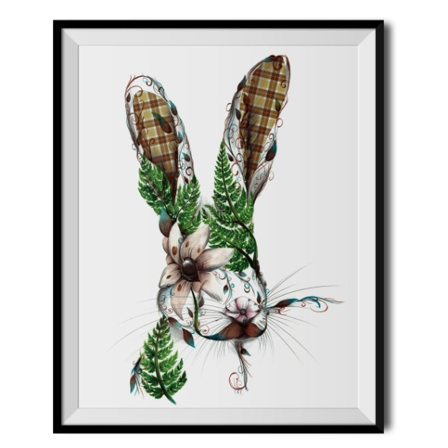

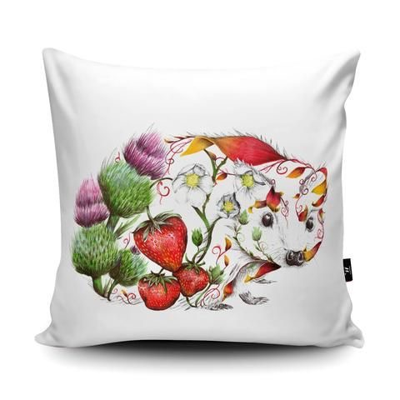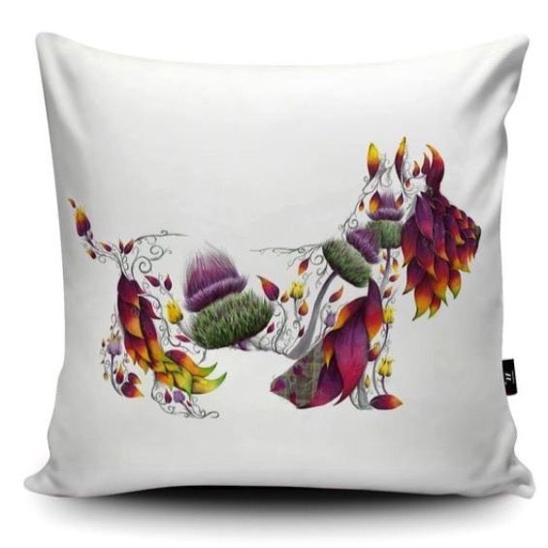
From this I looked up the definition of visual distortion, which means: In the art world, a distortion is any change made by the artist to the size, shape or visual character of a form to express an idea, convey a feeling or enhance visual impact.
I started to sketch a cat to begin within my sketch book, I looked at my own cat Angel for inspiration, I sketched her in different head poses, and then in full body poses.
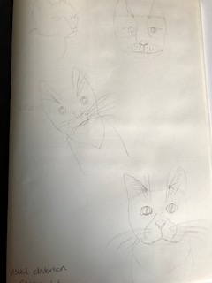
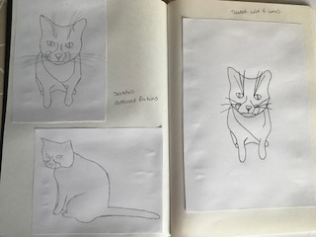
After deciding upon the final sketch, I then went on to draw this sketch with just 5 lines to simplify it.
I sketched it first, and then I went over it in black fine liner to count the lines I would need.
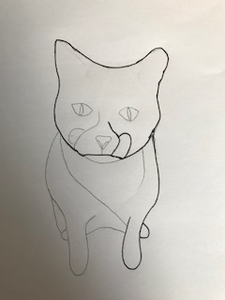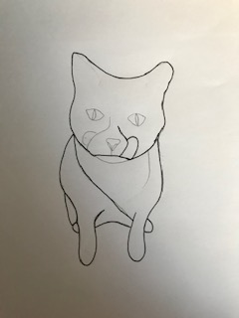

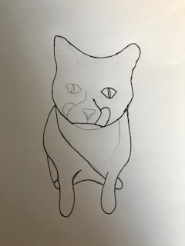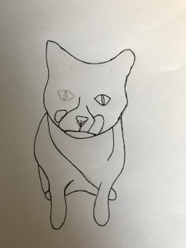

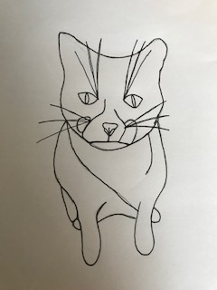
I had to re go over the 3-5 lines as I wanted to add in the whiskers because otherwise the cat looked like a dog!
But I still managed to get it within the 5 lines.
I then went on to pull together a mood board with textures on it, I wanted the textures to be as unusual as possible, so I looked up textures in the nature and found some great ones, I then had so many so I created two mood boards.
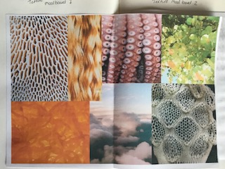
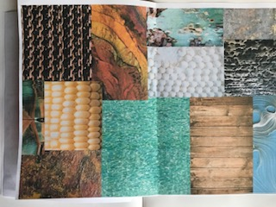
I then started to create my collage of my cat, it started off well but then it became more difficult as I had some small areas to fill.
I condensed the lines down a bit because of this but hopefully this will add to the editing part.
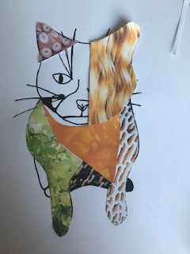

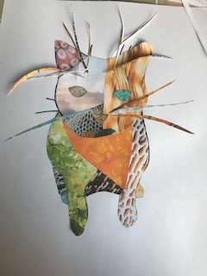
I finished the collage and then printed it out on the computer to see how a flat image would look like.
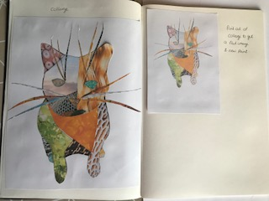
From this I sketched the cat again in black fine liner with the added elements of the textures. I didn’t add all the textures as I thought it was too busy, so I edited some bits.
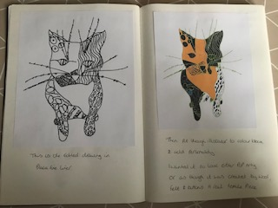
On the left is the drawing put through Illustrator, I wanted to give the picture a colour block feel, which I thought would add to the distortion element. I feel it looks quite pop art in style or even as though it’s been made out of wool, felt and buttons.

I then used a scene which I had a photo of a recent trip to Whitstable and a photo of one of the streets there.
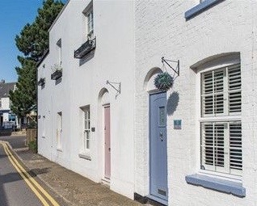
I put this photo through Illustrator and copied and expanded it to get the outline. I then filled this in colour block style to be in keeping with the cat.
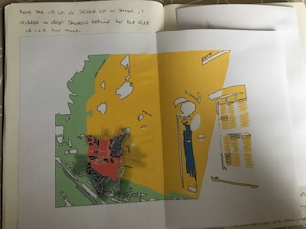
I used a drop shadow behind the cat, but it went too far and looks too dark and messy, I changed the background colours and tried again.
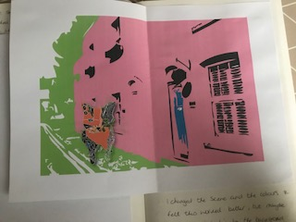
I think this looks much better and I got the drop shadow right this time, I thought that the image looked fairly normal, so I added in another change and increased the size of the cat, to add another element of ‘distortion’ to the image.
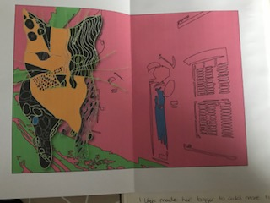
I feel this makes the story behind the image more interesting and its more eye-catching.
I wanted to see and feel how this would look in black and white and how it changes the atmosphere and potential story.
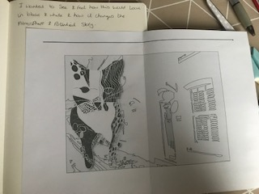
In black and white it feels more detailed and delicate, the atmosphere is more paired back , the cat stands out more as she has the darker elements on her, this would add to the hierarchy in the picture.
I think I personally prefer the black and white version that the colour blocked one, but it again surprises me how this simple change can change the image and story so much.
What did you think of this exercise?
I was not looking forward to this exercise much, I don’t really like distorted characters, and I’m quite traditional in my style. I must say though that I really liked the way the drawing turned out and how much of an interesting story you can achieve through distorting characters. I think testing out colours and styles helped to see different ways of seeing things and how using a few elements of ‘distortion’ you can layer your images.
What have you gained from doing this?
I have gained a better understanding of ‘distortion’ and more confidence of using colour and black and white. I think using this process is a good idea in creating collages to add texture, then to draw the textures after.
Are there any materials or ideas you would like to explore? What will you do?
I would take more pictures of textures when I’m out and about to add to my library and reference materials.
I would use this process again also if I needed to create unusual characters. I think it would be good to start up a little sketchbook of drawing textures too.

